



*The book is dedicated to the loving memory of Mama and Papa…   
for your love and sacrifice in raising me in the old town of* [*Suroboyo*](https://www.youtube.com/watch?v=5KNb8r5mqNg)*.*

I’ll try to make a dry topic exciting to read so this book does not end up being a sleeping solution.

|  |  |
| --- | --- |
| **What this book is** | It is the documentation of [Operationalize Your World](https://www.vmwareopsguide.com/oyw) (OYW), a workshop that [Kenon Owens](https://www.linkedin.com/in/kenon-owens/) and I created many blue moons ago. Thank you brother for the leadership in the early days! OYW customizes the product (VMware Aria). Think of it as the Pro Max Ultra edition😊  Operations are like fingerprints. Two companies can have identical architecture, yet their operations will not be the same. Their processes will differ, and so are the people and policies, hence this book supports the idea that you tailor the product to your unique operations. Now you know why it comes in an *editable format*. Keep the good parts, throw away the bad ones, add your unique contents, and voila you have documented your operations! Post a screenshot of a cool customization you’ve done and you’ll make my day! |
| **What this book is not** | It is a solution book, not a product book. It does not cover VMware Aria feature by feature. It is not a place where you learn the product. There are many materials on the Internet on how to use the product. There is also the [official manual](https://docs.vmware.com/en/vRealize-Operations-Manager/index.html). You do read them, don’t you? 😉  As this is not a product book, some contents of the book can be implemented using earlier releases. To assure you that you can do that, I have kept screenshots from older versions whenever possible. Now, that is also my excuse for not updating the old screenshots!  It focuses on the management of the [SDDC](https://www.vmware.com/asean/solutions/software-defined-datacenter.html) and [EUC](https://www.vmware.com/topics/glossary/content/end-user-computing), not the architecture. So, no coverage on design, deployment and product troubleshooting.  It also does not cover all aspects of operations, such as process innovation, organizational structure and financial management. |
| **Assumptions** | You have the latest release of the highest edition of Aria Operations.  The ability to customize Aria to your operations has been the hall mark of the product since it was released more than a decade ago. I was a pre-sales engineer when I first saw 1.0 many blue moons ago. The ability to slice and dice an environment was a godsend, as I spent a lot of time working with customers troubleshooting and optimizing their environment. This 4th edition continues the tradition of the book by showcasing the full potential. Until today, I see Aria Operations as both a platform and a product. |

How To Use This Book

The book is designed to be consumed as offline Microsoft Word document on Windows. It is not designed to be printed. Its table of content is the side menu of Microsoft Word. Follow the steps shown on following screenshot:

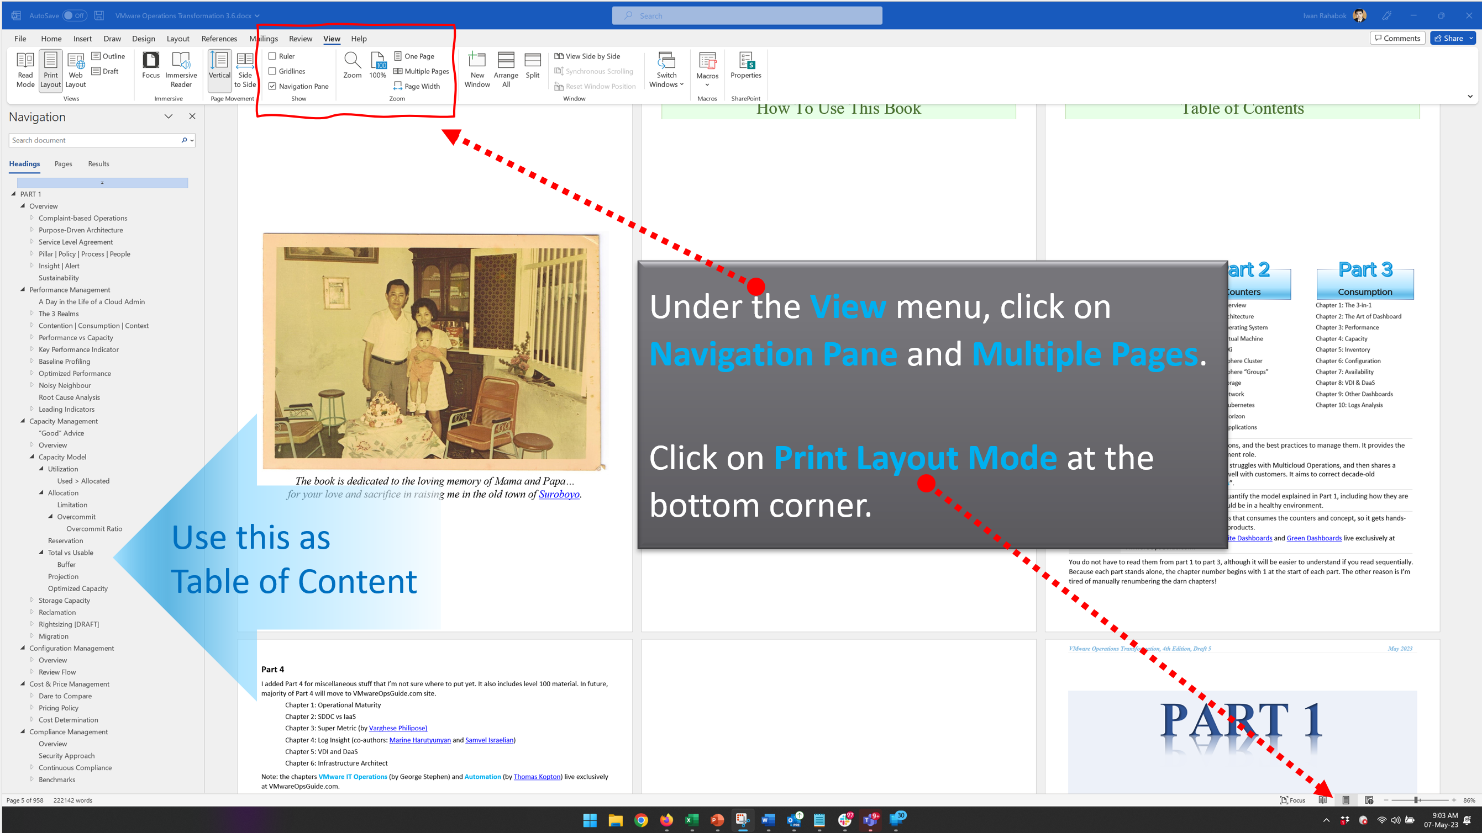

Use the navigation as a dynamic table of content, else it’s easy to be lost even when using 43” monitor. If you simply read it top down, without having the navigation on the left, you will feel that the chapter ends abruptly. The reason is each chapter does not end with a summary, which is required in printed books but redundant in online books.

Table of Contents

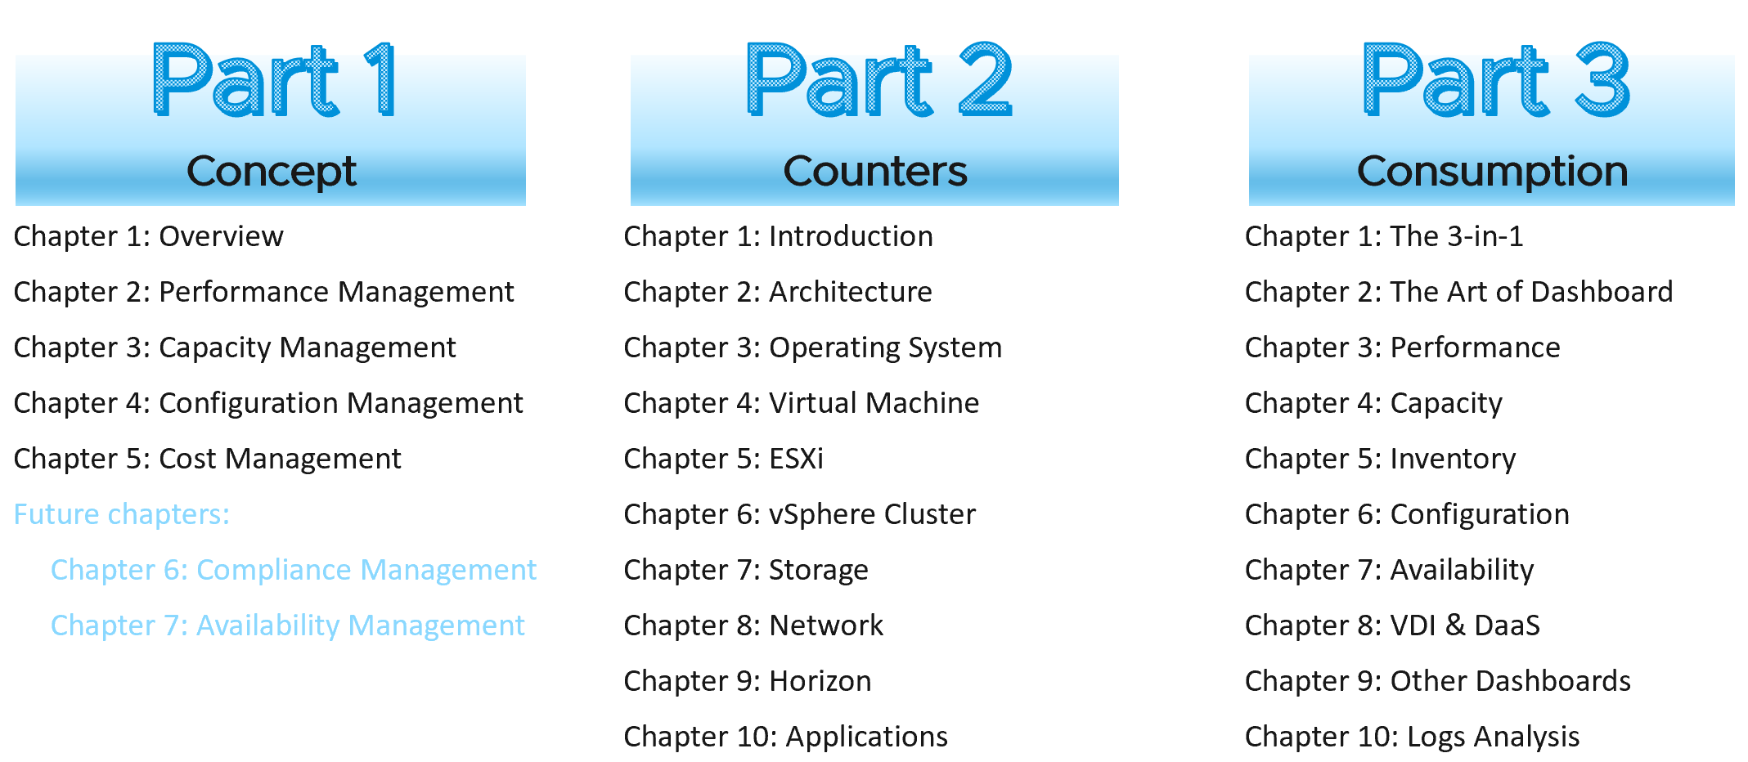

|  |  |
| --- | --- |
| Concept | It covers all the pillars of IT Operations, and the best practices to manage them. It provides the overview and suitable for management role.  It explains the root cause of why IT struggles with Multicloud Operations, and then shares a new paradigm that has resonated well with customers. It aims to correct decade-old misconceptions on “best practices”. |
| Counters | It goes deep into metrics used to quantify the model explained in Part 1, including how they are related and what a good value should be in a healthy environment. |
| Consumption | It covers dashboards, alerts, reports that consumes the counters and concept, so it gets hands-on and assumes knowledge of the products. |

You do not have to read them from part 1 to part 3, although it will be easier to understand if you read sequentially. Because each part stands alone, the chapter number begins with 1 at the start of each part. The other reason is I’m tired of manually renumbering the darn chapters!

**Part 4**

I added Part 4 for miscellaneous stuff that I’m not sure where to put yet. It also includes level 100 material. In future, majority of Part 4 will move to VMwareOpsGuide.com site.

Chapter 1: Operational Maturity

Chapter 2: SDDC vs IaaS

Chapter 3: Infrastructure Architect

**Removed Chapters**

Over the last decade, the book grew to over 1000 page. It makes it harder to digest, and even harder to edit as Microsoft Word is a single-thread application.

I’ve removed the following chapters. Some are available at [VMware Ops Guide](https://www.vmwareopsguide.com/) website by [Stellios Williams](https://www.linkedin.com/in/stellios-williams/).

I plan to keep each book maximum 500 pages, so there is a lot more to remove.

If you need them, just reach out to me on LinkedIn.

|  |  |
| --- | --- |
| Chapter | Reason |
| Availability Management | The content is not complete and deep enough to exist as a chapter. I plan to address in 2024 |
| Compliance Management | As above |
| Kubernetes | I’m spinning off K8 into a separate book as the content grew over 100 pages. Plus the target audience may not use vSphere. The book is target for end of 2023. |
| [True Visibility Suite Dashboards](https://www.vmwareopsguide.com/dashboards/chapter-8-true-visibility-suite-dashboards/) | Authored by [Brock Peterson](https://www.linkedin.com/in/brockpetersonvmware/) |
| [Green Dashboards](https://www.vmwareopsguide.com/dashboards/chapter-9-other-dashboards/3.9.1-green-operations/) | Authored by [Varghese Philipose](https://www.linkedin.com/in/varghesephilipose/) |
| VMware IT Story | Authored by George Stephen from VMware IT |
| Automation | Authored by [[Thomas Kopton](https://www.linkedin.com/in/thomas-kopton-618944106/)](https://www.linkedin.com/in/brock-peterson-5756534/) |
| Super Metric | Authored by [Varghese Philipose](https://www.linkedin.com/in/varghesephilipose/) |
| Log Insight |  |

This page is intentionally left blank.

*Why? I don’t know. Some people do it, so I just follow as IT behaves more like fashion nowadays…*

# PART 1

Concept

The first part of the book explains the art of Operations Management in the context of VMware cloud architecture.

What you architect is [**SDDC**](https://en.wikipedia.org/wiki/Software-defined_data_center). But what you handover as a business result to your CIO is [**IaaS**](https://en.wikipedia.org/wiki/Infrastructure_as_a_service). One is a system, the other is a service. They are 2 sides of the same coin. We can assess if the architecture is good or not, based on the actual result in production. Does it result in firefighting and blamestorming? Or do you have a peaceful operation where alerts are meaningful and actionable?

## Overview

**Part 1 Chapter 1**

This first chapter gives a tour of operations management, starting with why a reactive and hectic operations is *common*, and the paradigm shift required to proactive & predictive operations.

### Complaint-based Operations

How do you know that the Infrastructure as a Service (IaaS) Platform (be it on-prem [private cloud](https://www.vmware.com/topics/glossary/content/private-cloud.html) or externally in the cloud) is serving its workload *well*? If you depend on complaints, then you run a complaint-based operations.

Changing from reactive to proactive is unfortunately a complex undertaking, especially in large organizations where there are many roles and personas. It requires [operations transformation](https://www.vmware.com/content/dam/digitalmarketing/vmware/en/pdf/files/pdf/services/vmware-operations-transformation-services.pdf) and a paradigm shift. It is not easy to get customers to agree on a Service Level Agreement (SLA) when you’ve promised them “good” for years already. This book aims to provide practical guidance, something you can implement with the current version of Aria products.­

#### The Litmus Test

The following questions below helps you assess the maturity of your IaaS business.

##### Do your customers blame your IaaS?

If the answer is yes, take a moment to ponder why. There is a high chance you are relying on complaints in your operations so you actually encourage them. No complaint, no problem. That’s why it’s aptly named Complaint-based Operations.

The reason why you rely on complaint is the operations have no other means by which to measure success. You have not defined the performance of your IaaS. That’s the goal of this book.

A sign of matured operations is that you have complete, correct and accurate SLA. Complete means you have Performance SLAs and Compliance SLAs, not just Availability SLAs. Correct means the SLA is measured on each *paying* VM, and not at the infrastructure level. It also means you use the right metric. Accurate means the measurement has to be measured every 5 minutes, as any longer intervals than this can miss the problem.

##### Does troubleshooting mean all hands-on deck?

Do you have a process that is followed by all teams (network, storage, server, OS, application)? Does that process end with [Root Cause Analysis](https://en.wikipedia.org/wiki/Root_cause_analysis) (RCA)?

As part of RCA, do you set up alerts so the same issue can be detected faster if it happens again? Without an alert configured, the RCA is not closed. The alert is also critical as it will trigger the RCA process.

##### Does Help Desk provide a good first level defence?

If Help Desk simply passes issues through to the next level, you need to look at why.

Help Desk is your first line of defence. They are not as technical as you are. Equip them with a simple dashboard so that they can handle VM Owner complaints by discovering:

* Is the problem caused by IaaS not serving the VM well?
* If yes, which part of the Infra: CPU, RAM, Disk, Network?
* If not, how to prove it convincingly?

##### Is your IaaS cheaper than public cloud or hybrid cloud?

The commoditization of infrastructure means your IaaS is being compared with similar platforms such as VMware Cloud on AWS and Amazon Web Services.

If not, your CIO may question your business value. The primary reason for having an in-house architect is so you can bring better price/performance, after taking into account your salary.

##### Can you justify new infrastructure when utilization is ***not high***?

This is not referring to additional money that comes with new projects. This is referring to existing workload on existing clusters/storage.

Capacity is measured on utilization and performance. A cluster capacity is full if it can’t serve its VMs well. Since it takes time to buy hardware, you need to have an ***early warning*** system to detect this performance degradation.

##### Do you struggle with many over-provisioned VMs?

This is an indicator that you are operating as a System Builder as opposed to a Service Provider. As a System Builder, you are meddling with each System (read: Application). You size them and argue with the application team, who are actually your customers. You are busy as there are many applications and you are outnumbered.

If you are operating as an internal [Cloud Service Provider](https://azure.microsoft.com/en-us/overview/what-is-a-cloud-provider/), you should not be “in the way” of the business. You use an effective pricing model to drive the right behaviour. Does a public cloud provider block application teams when they buy 40 CPU [AWS EC2](https://aws.amazon.com/ec2/?ec2-whats-new.sort-by=item.additionalFields.postDateTime&ec2-whats-new.sort-order=desc) VMs when they only need 2 CPU? They don’t, hence neither should you.

#### Common Mistakes

“If you don’t have a problem, I don’t have a solution” summarizes how I engage customers. So after years and hundreds of customers, I see solutions that customers adopt and typical mistakes they correct.

Here are some examples of typical mistakes:

* Private Cloud is seen as *automation* project as opposed to operation. Private Cloud is not virtualization with automation and self service. It is the required technical foundation to tranform the business of enterprise IT from system builder to service provider. The automation, workflow and self service portal are merely supporting features. The primary component of Private Cloud is SLA and Class of Service, hence it’s operations-centric, not automation-centric.
* VMware Cloud Foundation is architected with server-consolidation mindset. That means the system has no awareness of IaaS and SLA. Different class of service can be mixed in the same cluster or datastore.
* There is class of service, but the system does not clearly state it. The naming standard does not include class of service.
* Performance is never defined properly. It’s designed for performance, but the benchmark does not align with what actually being sold. There is no Performance SLA, and often there is no Key Performance Indicators (KPI)[1].
* The infrastructure has no awareness of business units, applications, application-tier. The business is not reflected in the infrastructure.

#### Multi-Cloud Operations

A single private cloud, something you have complete control, is hard enough to operate, let alone operating multiple incompatible infrastructure. Multi-cloud operations, where you are responsible for something that you do not have complete controls take the operations challenge to the next level. Don’t be disheartened if your organisation is struggling with running a multi-cloud operations.

The complexity is due to the lack of maturity of the architecture. There are simply too many components involved, as shown in the [landscape diagram](https://landscape.cncf.io/) by Cloud Native Computing Foundation.

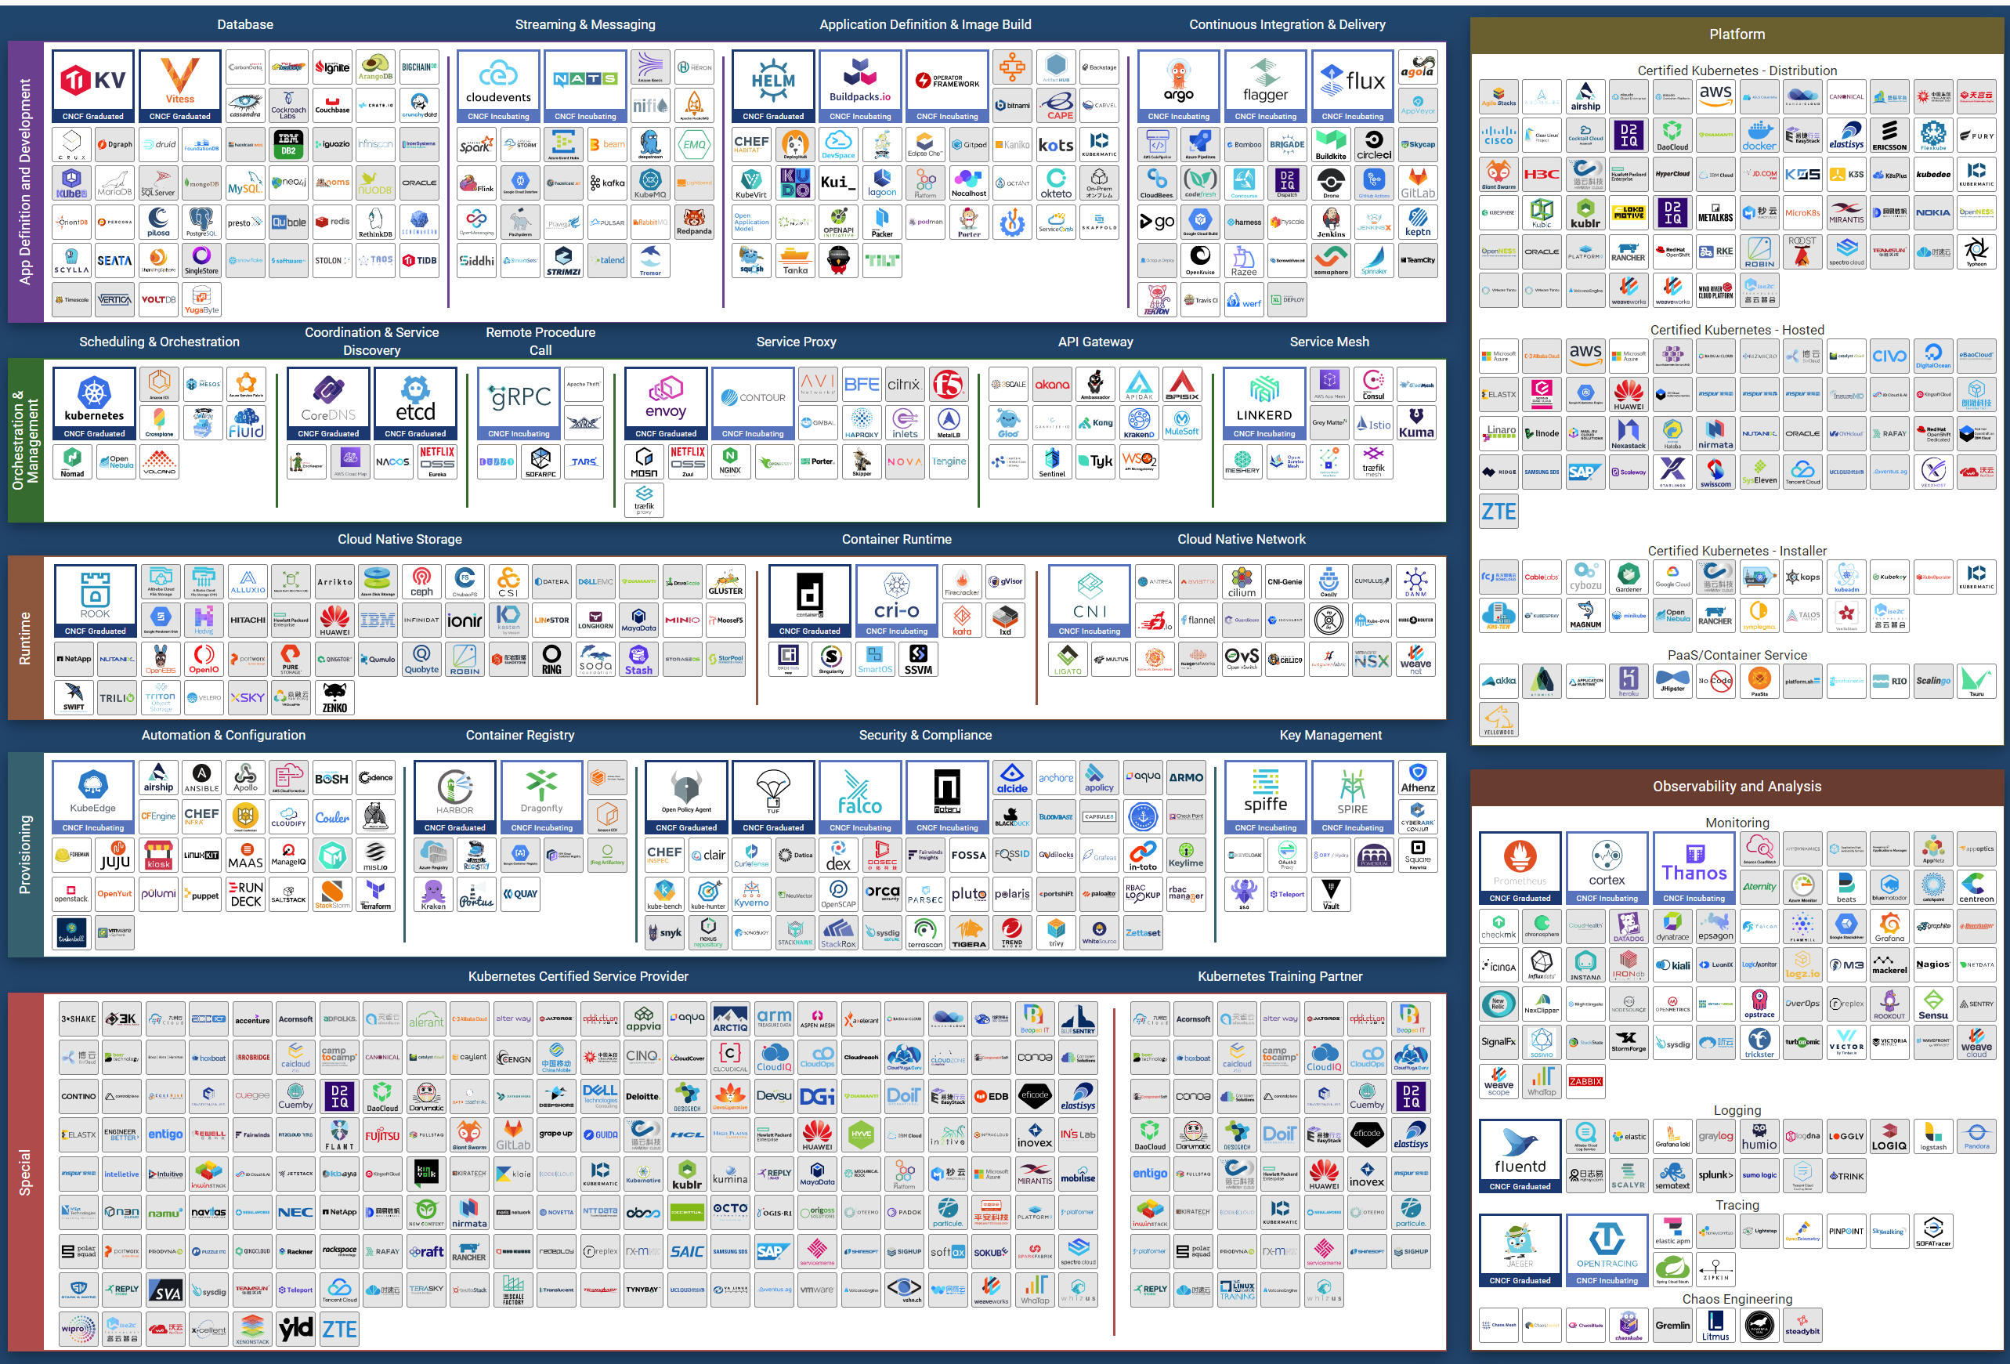

Eventually though…, the architecture will slowly mature and turn into a commodity. CIOs will begin focus on the operations as business will demand proper governance with SLA.

Regardless of the underlying system architecture, CIOs are still required to manage cost, capacity, compliance, performance and availability. The Pillars of Operations do not change just because you change the plumbing. We will cover more of these pillars here.

### Purpose-Driven Architecture

When you architect IaaS or Desktop as a Service ([DaaS](https://www.vmware.com/topics/glossary/content/desktop-as-a-service)), what goals do you have in mind? I don’t mean the design considerations, such as availability and performance best practices[2]. I mean the ***business results*** that your architecture has to deliver, viewed from the people who paid for the system, and by the people who will pay for the service. Set aside your opinion on the goal, as you neither pay for it or use it.

Logically, the answer depends on what is being sold. You can either sell application or infrastructure, broadly speaking. Some popular examples are:

|  |  |  |
| --- | --- | --- |
| Service | What you sell | Examples |
| **SaaS** | The software is provided as a service. Customers need not install on-site. Common among ISV who wants to avoid on-prem installation, avoid outdated installation, or mine their customer’s data. | vRealize Operations as a Service, vRealize Log Insights as a Service, Salesforce, VMware Skyline, Microsoft Office 365. |
| **DBaaS** | Database as a Service. There are 2 variants:  Instance. Customer shares the binary with others. Patching the software means all instances using the instance get patched. They all need to have common maintenance window.  Dedicated binary. Customer can have different version, patch levels, and downtime schedule. | Oracle DB as a Service, MS SQL as a Service are common among enterprise. The DBA provides this as service to the application team, who are not as deep on databases knowledge. |
| **PaaS** | Platform as a Service.  A set of services used by business applications. AWS provides many such PaaS and the main reason why customers choose them. | Central IT provides a set of common services (e.g. login, payment) to all business units websites. |
| **DaaS** | Desktop as a Service. Typically Windows 10 + End-User application. Application team must be involved, as a simple 10% CPU increase of your browser can impact as the ESXi host is heavily overcommitted.  The goal is to ensure End Users are getting a quality desktop experience while keeping the price per user low. We will discuss more on this here. | Many enterprise IT provides this for better security and PC-manageability. They may deploy this with thin client.  VMware Horizon Cloud, Microsoft Windows Cloud are cloud examples. |
| **IaaS** | There are 3 variants here. As this is the topic of the book, let’s explore in depth. | |

#### The Business of IaaS

There are 3 variants of IaaS business. They differ in terms of what you actually sell, how you do costing and pricing, and what SLA you put on the table.

|  |  |  |  |
| --- | --- | --- | --- |
| Item | Pricing | Availability SLA | Performance SLA |
| **VM** | Price depends on VM size. A larger VM has higher price.  Price depends on quality. A better tier has higher price.  Example of item purchased: 1 VM, 4 vCPU, 16 RAM, 200 GB disk, in Gold Tier. | Per VM.  Depends on the tier. | Per VM.  Depends on the tier. |
| **Resource Pool** | Sold per GHz, GB RAM, TB Disk.  Example of item purchased: 100 GHz CPU, 1 TB RAM, 80 TB Disk.  It can come with a 100% reservation; hence it’s guaranteed. Alternatively, it may have partial reservation. It typically comes with best effort burst, in the form of expandable resource pool.  On the other hand, it may come with limit but it’s always higher than what you paid for. For example, you pay for 1 TB of RAM. You can 0.5 TB guaranteed and 2 TB limit. | Per VM.  Limited tiering capabilities. | N/A.  While Resource is reserved, customer is allowed to overcommit within their own limit. It’s not something the IaaS imposes. |
| **Hardware** | Price per ESXi host. Customers decide how many VMs they want to place. HA is provided by vendor.  Example of item purchased: 8 ESXi Host.  Example provider is VMware on Azure. | On the Host or Cluster, not VM. | N/A  Customer can squeeze as many VMs. |

Class of service is harder to implement in resource pool as there are more moving parts. You can have cascading resource pools.

##### VM as a Service

The most popular variant of IaaS is VM as a Service. It is typical example of “buy wholesale sell retail” business. You buy hardware in bulk and commit DC space for years, then sell VM in small chunks. You make profit as your buy price is several magnitudes lower than your sell price, on a per unit basis.

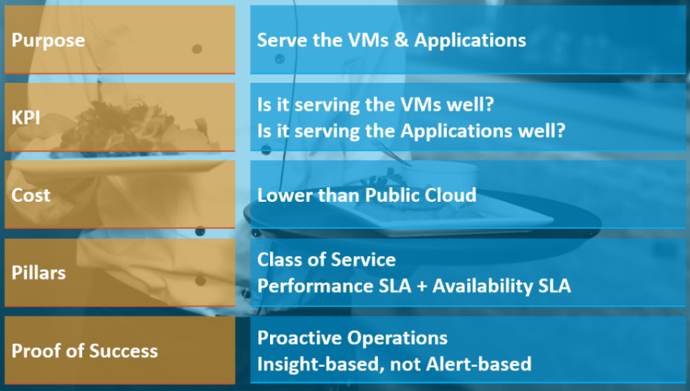

The business goal is to ensure the application and VMs are running ***well yet cost effective***. In this way, you keep the customers happy.

The cost part is easy to quantify. You know what you actually spend on hardware, software, services and salary. The “well” in *running well* is the hard part as there is a big unknown. This is also the source of argument between application team and infrastructure team.

Say you are architecting for 10K VMs in 2 data centers. You envisage 2K VMs in the first month, 5K VMs in the first half year, and eventually to 10K within the first year. Do you know the basic info about each of these 10K VMs, so that you can architect an infrastructure to serve them well?

* How big are they? What are their vCPU, RAM, Disk configuration?
* How intense are they? CPU utilization, RAM utilization, disk IOPS, network throughput?
* What are their workload patterns? Daily, weekly, monthly, no pattern, etc.

The answer is obviously no. Even application teams do not know as some of the applications may not be developed yet. Their vendors may not know either as the actual usage is not yet known.

Promising that the SDDC will serve all 10K VMs well is akin to promising the highway you architect will serve all the cars, buses and motorcycles well, when we can’t predict how many they are and how often they will use it. We will cover this more in the Performance section.

So how can we promise that your IaaS will serve your customers well?

We can by using the price/performance. The principle you share with your customers is the common sense used in all service industries:

* You want it cheap; it won't be fast.
* You want it fast; it won't be cheap.

This is where the Class of Service and the associated SLAs come in. The highest class of service provides the best uptime and performance but comes at a price. All these attributes are well defined in the SLA, leaving no room for ambiguity. The contract is not subject to interpretation. You define all the key metrics up front, assuring your customers that you are confident of delivering as promised.

You then architect your IaaS to deliver the above class of services. The class of service becomes your business offering. With that, you are ready to begin with the end in mind.

###### Capabilities

The platform should provide a complete self-service portal for all types of users. The features should cover all stages in the life cycle, starting from provisioning. Provisioning should have an SLA and be supported with workflow and electronic approval.

###### Key Metrics

You measure across the pillars of operations management. Each pillar is measured, hence managed, by a purpose-built metrics. This enable you to manage at scale.

|  |  |  |
| --- | --- | --- |
| Pillars | Metrics |  |
| Availability | Operational Availability (%) | Relative Availability, againsts your availability architecture |
| Actual Availability (%) | Absolute availability, reporting the fact as it is. |
| Performance | KPI (%) | Absolute performance, reporting the fact as it is |
| SLI (%) and SLA (%) | Relative performance, against your promised service level |
| Capacity | Capacity Remaining (%) |  |
| Time Remaining (days) | The number of days until Capacity Remaining (%) hits 0 |
| Compliance | Benchmark X (%) | Compliance against specific industry or internal benchmark |

#### Begin with The End in Mind

Architecture is Day 1, and Operations is Day 2. Day 1 happens before Day 2.

By Architecture, I mean the detail technical work, including building and commissioning the system. While the business plan and high level marketecture[3] is defined during Day 0 (Planning), the real architecture work is done on Day 1.

However, if we think deeper, Day 2 impacts Day 0, which is Planning. The reason is the End State drives your Plan. Your Plan drives your Architecture. So it’s 2 à 0 à 1, not 0 à 1 à 2.

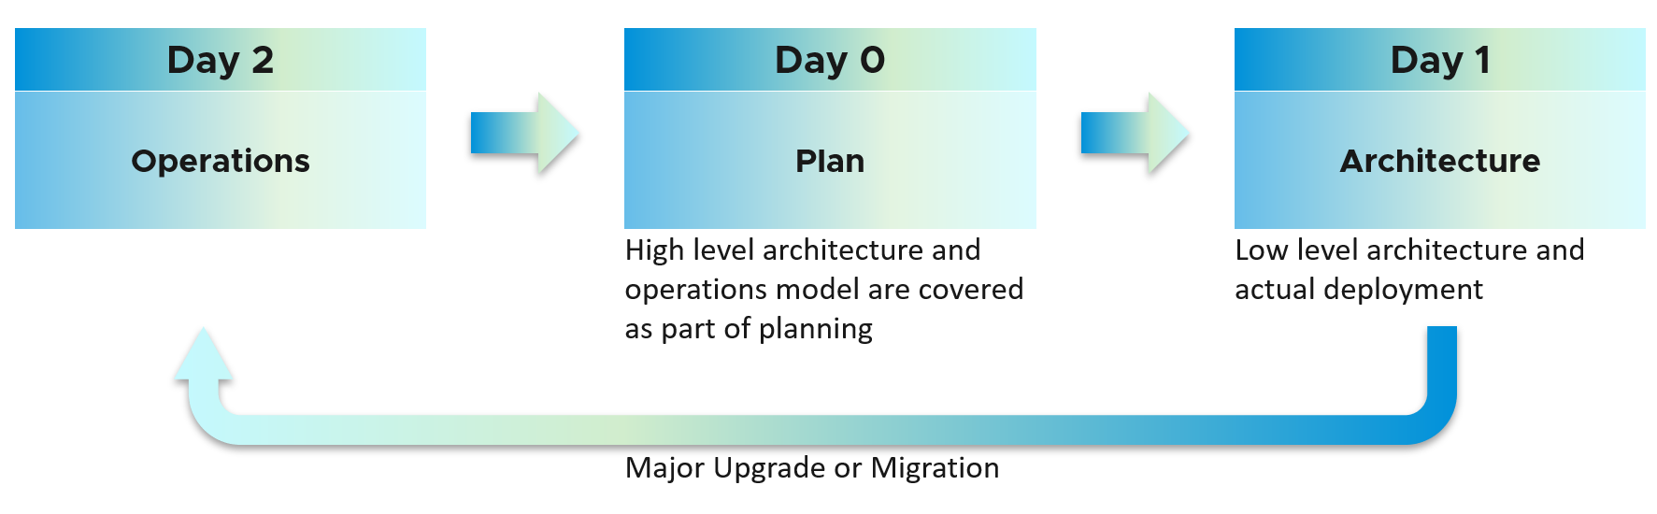

Day 2 is not simply the first few days after you go live. It’s the day you set sail[4].

Let’s use an example to illustrate how Day 2 impacts Day 0, which in turn impacts Day 1.

Say you are an internal cloud provider, and you plan to charge per VM. You plan to have 2 classes of offerings:

* **Gold**: suitable for production workloads. Performance optimized.
* **Silver**: suitable for non-production workloads. Cost optimized.

For Gold, you plan to not overcommit CPU and RAM. If 1 CPU typically uses 4 GB RAM, then a 40-core ESXi host will only need 160 GB. If you buy a host with 1 TB RAM, then you may end up in a position where you are not able to sell the remaining 864 GB as you have no vCPU to sell. This means your hardware specification is impacted. That’s an example of how Day 2 impacts Day 0.

For Silver, you plan to overcommit 4 : 1 for CPU and 2 : 1 for memory.

* You assume that 1 vCPU typically uses 4 GB RAM. Your customers are allowed to buy more or less memory, so this 4 : 1 ratio between CPU and RAM are just your planning guide.
* You plan to run vSAN with dedupe + NSX + vSphere Replication. You also expect heavy IO VMs, which requires kernel processing. For all these supporting, non-business workloads, you allocate 8 cores and 64 GB RAM.
* If you buy a 64-core ESXi, you have 56 cores left and you will be able to sell 224 vCPU.
* These 224 vCPU will need 896 GB RAM. Since you overcommit 2 : 1, you need 448 GB for VM. Total RAM you need is 448 + 64 = 512 GB.
* That means the hardware spec you need is 64 core and 512 GB RAM. If you buy more RAM than this, you may not be able to sell this extra RAM as you may not have vCPU to accompany them.

The above 2 examples show how your hardware spec can’t be decided without considering the average VM profile and the overcommit ratio you plan. Yes, Day 2 does dictates Day 0.

You also promise the concept of Availability Zone for Gold class, as they host mission critical business services. Your company policy for [Business Continuity](https://en.wikipedia.org/wiki/Business_continuity_planning) dictates that in the event of an entire cluster failure, you plan to cap the number of VMs affected. If you limit to say 300 production VMs, then your cluster size should not be too big as you won’t be able to fully utilize the resource. I’ve seen multiple customers having 32-node production clusters running 1K – 2K VMs.

##### Promise vs Reality

In a large environment, you may have the luxury of designing different infrastructure for different workload types. Common examples are GPU Intensive workload, Disk Intensive, etc. If the infrastructure is superior to your standard offering, you need to be careful in setting the right expectation.

Let’s take an example: you promise you can handle CPU Intensive workload as you’ve chosen the best CPU.

Notice the issues here?

There are at least 2 of them.

1. You probably heard of [Winston Churchill](https://en.wikipedia.org/wiki/Winston_Churchill) quotation “Sometimes doing your best is not good enough.” What you think is the best CPU may not be good enough for the workload, either in terms of GHz, number of threads, or power efficiency. For example, if your ESXi sports a 3.8 GHz speed but the application wants 5 GHz, giving it extra vCPU does not exactly meet the requirement.
2. Assuming you pass the first issue above, how do you prove that this so-called my best CPU is actually able to handle the workload? What metrics do you use? Remember it’s just a CPU. All you have as metrics are just GHz and vCPU. If you rely on the application team metric, you need to be prepared to spend time doing testing with them. You should also apply 100% reservation to eliminate infrastructure-level contention. The problem with reservation is you cannot overcommit. It means you defeat the purpose of virtualization to begin with.

So what can you do?

1. Set the right expectation. For example, you state that your infrastructure uses dynamic power management. In most cases, this is good for the application as they get Turbo Boost when they are running hard. In situation of light use, the application may run at lower speed.
2. Do not promise something you can’t measure. In this case, the main metric you want to measure is “Is the CPU available when the VM asks for it”. Metrics such as Ready, Co-stop, Overlap, and Other Wait track this contention moments. You provide great observability by showing these metrics.
3. Measure what is relevant to your business. If what you offer (read: the SLA) does not call guarantee that the *whole core* is available to the VM, then do not measure the time the VM vCPU runs on a shared core.

##### VCDX and VCTX

Why did we have a difference between promise and reality?

My take is because IT Architect does not include Day 2 in the architecture. Specific to VMware, hence I’m proposing VCDX should be accompanied by VCTX. Designing the architecture and transforming the operations are 2 different skills[5].

As a service provider, while your technical knowledge is important, your customer measures you on your service level. While they care about your systems architecture and its technological marvel, they measure you on service quality.

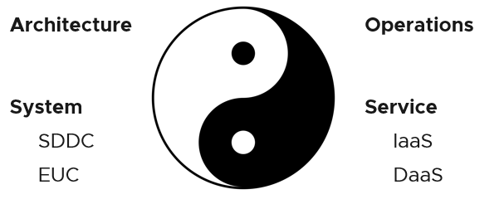

Architecture and Operations are two equally large realms. While we certainly consider Operations when designing a system, it is not a part of Architecture. This book is an example of Operations. Notice it goes deep into metrics as troubleshooting is at the heart of operations.

Architecture and Operations also differ in other industries. The person who designs the space shuttle is not the person operating it. You need to be an astronaut to be qualified to operate a space shuttle. The person who designs an F1 race car is not the person driving it. Different expertise is required. They complete each other and are inter-dependent, like [Yin and Yang](https://en.wikipedia.org/wiki/Yin_and_yang).

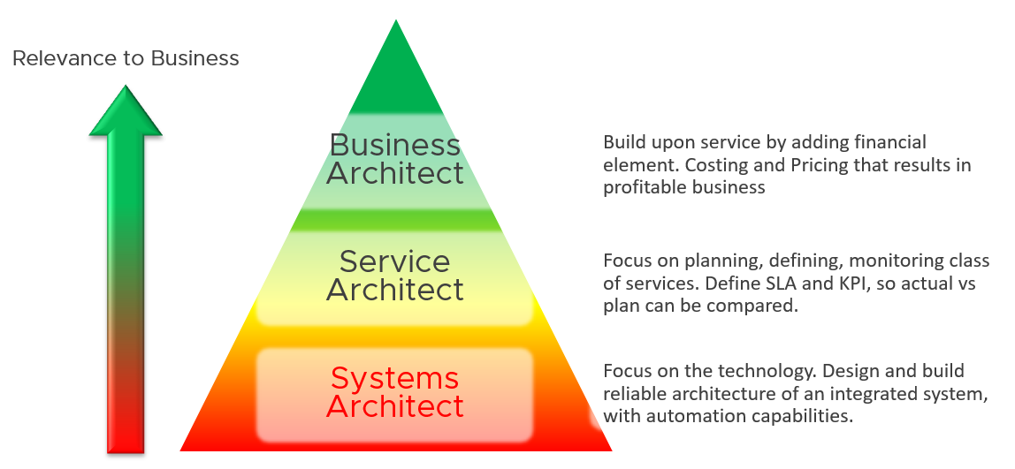

Since Infrastructure is becoming a service, you need to know how to architect a service (e.g., IaaS, Database as a Service, Desktop as a Service).

* What are the services the IaaS is providing? How do you define a service?
* What metrics do you use to quantify its quality?
* How many services? How do you distinguish between higher class service and normal one?

You also need to know what type of services are on demand. Service Architects go out, meet customers and understand their requirements. What class of services are on demand now and in the future? From there, you can architect the corresponding services to anticipate the demand.

As a Business Architect, you not only know the cost of running the service, but you also know how & when to break even. You are not responsible for profit and loss, as you are not the CIO or Cloud Service Provider CEO, but you do play a strategic advisor role to them. You know what to price, how to price and most importantly your price is competitive (at least you can provide the business justification).

From my interactions with customers, I notice that Infrastructure Architects are not leading Day 0 phase. They provide input to the Planning stage, but are not the lead architects driving it. The Infrastructure Architect tends to focus on technical bits, something that CFO and CIO value less (hence they spend less time on it). They also do not architect the operations. I see many seasoned VMware Architects not extending their influence beyond architecture. I think that’s a lost opportunity because Day 1 and Day 2 is actually part of the same side. Think of it as a [Mobius strip](http://en.wikipedia.org/wiki/M%C3%B6bius_strip).

Service Architect and Business Architect are the next steps for Infrastructure Architect. I shared story “The Chef and his cooking” back in 2014 during one of the [VMUG](https://www.vmug.com) session.

BTW, how do you know who is the real architect of a system? Let’s say you have mega VDI system, with integrated components such as NSX, vSAN, vRealize, Horizon, thin clients, office networks and many other things. Who is the true architect of this?

My answer:

The owner of the hands on the keyboard figuring out the root cause when there is a massive problem that noone knows why. That’s your real architect. The team who drew the architecture diagrams are not.

#### Business Context

It’s important to reflect the business in your operations. It makes the infrastructure team aware of the context and impact to the business. In their day-to-day operations, they need to be Business Application and VM centric. This calls for a paradigm shift.

In your service offering, you include the ability for the customers to check their own VM health, and how their VMs are served by the underlying platform. This means your architecture needs to know how to associate tenants with their VMs. At the very least, create a structure so they can browse or find their application and VM.

Your CIO wants a live information projected for his peers to see on how IT is serving the business. This requires you to have awareness of the business units and their critical applications.

##### Naming Convention

Heard of story of change was done to the wrong VM or ESXi or LUN because their names are similar and hard to read?

Yup. We all have been there 😊

Guidelines for naming convention:

* Easy to understand the business context (especially useful for new person)
* Reduce chance of making human error (e.g. typo)
* Reflect the criticality of the VM (class of service) and
* Provide some context (e.g. name of department owning it).

There is no need to provide the owner information in the name as it’s already covered via custom property and vSphere folders.

Design a naming convention for the following

* OS hostname. Ideally there is a way to map it to the VM, so keep them fairly similar.   
  WIN for Windows family.  
  LNX for Linux family. Avoid LIN as that is too close to WIN, both in spelling and in pronounciation.
* vSphere VM.
* vSphere Cluster. ESXi is not so important as it’s stateless operationally.
* vSphere Datastore
* vSphere Distributed Port Group

The name should reflect the object. This is less important in the UI as have you the context. But in code (programming), it helps to know what object you’re dealing with to reduce human error.

Here is naming convention I’d use for cluster and datastore name.

|  |  |  |  |
| --- | --- | --- | --- |
| Part | Value | Meaning | Reason |
| Purpose | GLD | SLV | BRZ | Gold, Silver or Bronze | I use this as the first part of the name as it’s the most important one.  I avoid Tier 1, Tier 2, Tier 3 as it could be unclear if Tier 1 is higher than Tier 3. Also, they also differ by 1 character. |
| Location | SGP | SFO | The physical location | This does not change. Typically it’s a city. |
| Environment | PRD | DEV | Production, Development | Different treatment or context. |
| Serial No | 1 | No meaning | Just in case you need to have more than 1. Note if you have 3 digit it increases the chance of making a mistake. Think of a way to group them. |

Using the above, you get names like VMW-CLS-GLD-SGP-DEV-1 for the first vSphere gold cluster in Singapore serving development workload, and VMW-CLS-SLV-SFO-PRD-9 for production silver cluster no 9 in San Francisco. I added VMW as you may have non VMware (such as AWS or mainframe).

Don’t be hesitant to use dash or underline as they make it easier to read.

For datastore, I’d add LOCL for local datastore, VSAN for vSAN, [VMFS](https://en.wikipedia.org/wiki/VMware_VMFS) for networked VMFS and NFS for NFS type. Raw Device Mapping LUN should have RDM or VMW, whichever easier for you.

##### vSphere Folder Structure

Infrastructure team should be driven by business applications, so your IaaS needs to be designed around that. The following structure shows Business Unit as the top folder. Each business unit can have 1 or more departments (Business Unit C spans 3 departments in the diagram below). Each department owns multiple business applications. A business application typically consists of multiple tiers (e.g. web tier, application tier, database tier). A tier is a group of VM performing the same function, running the same set of software and have identical hardware configuration. You expect the VMs are either scale-out (farm) or active/passive.

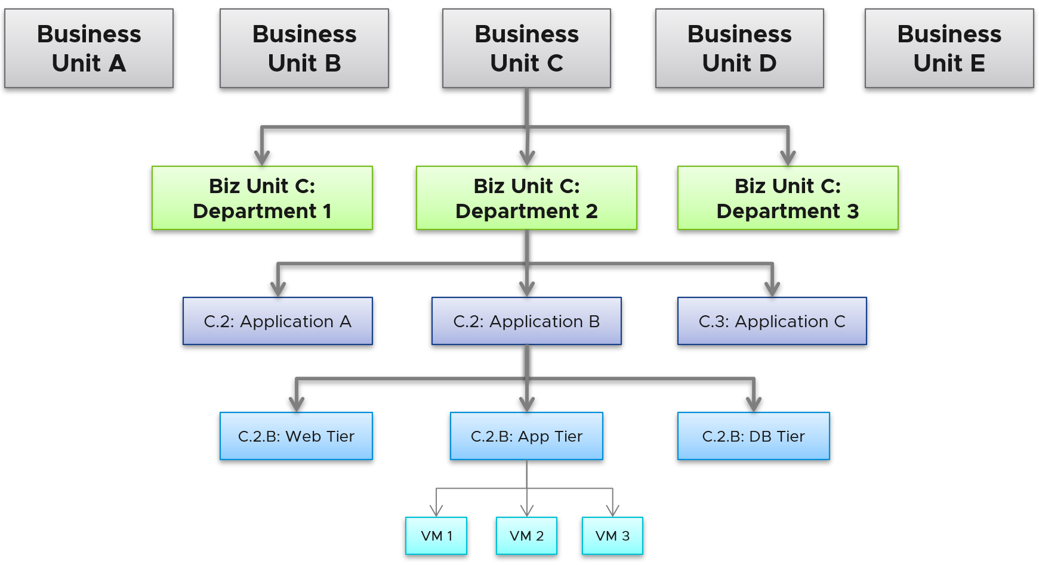

The limitation of the above is reorganisation. You will need to rename, move folders to the new parent folders, and delete folders that are no longer relevant. For example, if Business Unit B merges with Business Unit C and the combined entity has a new name, then you need to rename one of them, and delete the other. This is why I only have 2 levels of organisation in the above. Your goal is to have some level of context, not to replicate the entire organisation chart as that’s the job of HR department😊

The application name should be unique. If not, prefix with the department name.

The folder name needs to be unique. So it’s paramount to have the application name as prefix.

If you have multiple vCenter servers, the name should be consistent across all of them.

##### Tagging

Tagging needs to be designed top down, so they are complete and correct.

|  |  |
| --- | --- |
| **Department** | If you are using vCenter folder, then it’s automatic. |
| **Owner** | Name, phone and email. At the very least, you need the email so system can automatically notify them and ask for approval.  For mission critical, you should have mobile number too for emergency |
| **Criticality** | This should be inherited from the infrastructure where the VM is running.  Give a clear but short name such as high, medium, low. |
| **Environment** | Production, QA, Test, Development |

Minimally, set the following properties:

|  |  |  |
| --- | --- | --- |
| Object | Property | Values |
| **Cluster** | Class of Service | Gold, Silver, Bronze. |
| **VM** | Class of Service | Inherited from the cluster where the VM is running, so it’s automatically updated for new VM or relocated VM. |
| Owner | The email address. Full name may not be unique. |
| **Datastore** | Class of Service | Gold, Silver, Bronze. |

Use the vRealize Operations custom property as opposed to vSphere tags and annotation. These 2 features were designed much earlier and have limitations, all of which were addressed by vRealize Operations. For examples:

* Limited to vSphere only. Can’t cover Horizon, AWS, Microsoft, business applications, etc.
* Historical data not kept. You don’t know what the previous values are, and when it changed.
* No dynamic membership. Can’t automatically assign to objects that meet selected criteria, and membership do not automatically update.
* Values are all string. You can’t do numerical computation on them even if the values are actually numbers.
* The value in vSphere annotation is free-style string, meaning you can’t control the consistency of the content. On the other hand, vSphere tags have rigid value. You can’t type a value; it has to be chosen from predetermined list. It is not practical with information such as phone number, as it’s likely unique.
* Need to maintain copies across all vCenter servers.

The following screenshot shows how to dynamically tag all VMs that are in Gold Clusters as Gold VM. Gold Clusters are in turn a custom group whose members are clusters that provide gold class of service.

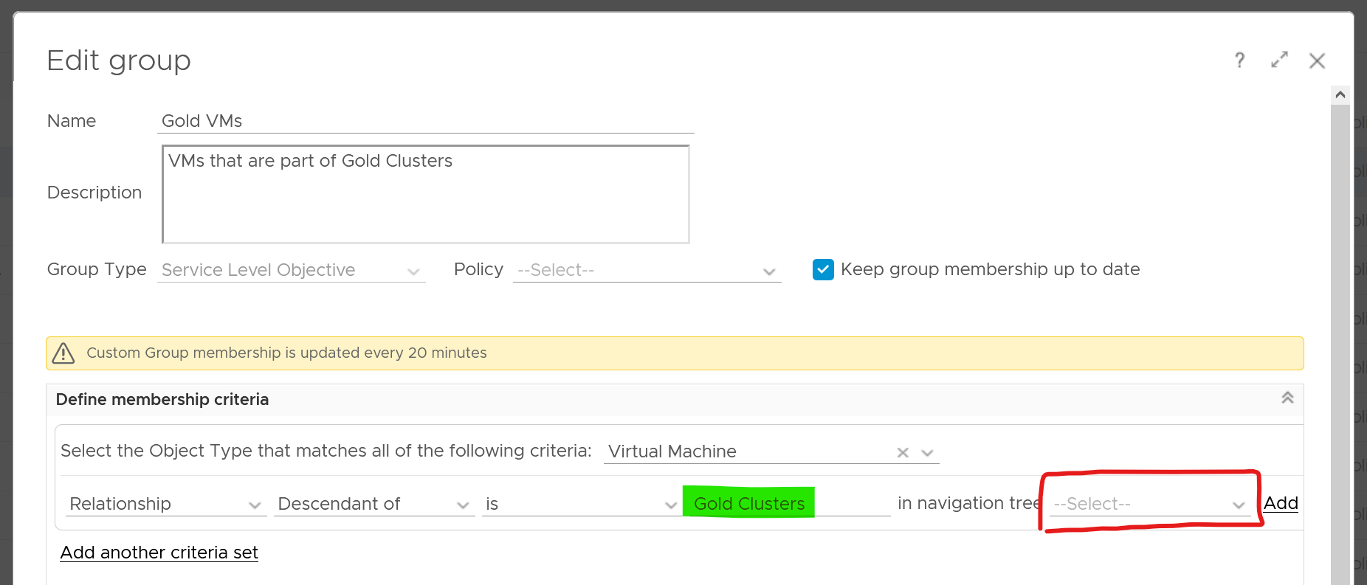

#### The Restaurant Analogy

[Sunny Dua](https://www.linkedin.com/in/duasunny/)[6] and I use the restaurant analogy when explaining the need of SLA. The analogy has resonated well with many customers. Humans can always relate to food!

Essentially, a restaurant has 2 areas, often with a clear demarcation line:

* The Dining Area.
* The Kitchen.

Think of your IaaS business like a restaurant business. It has a Dining Area, where your customers live, and a Kitchen, where you prepare the food. Guess which one is more important?

You are right. The dining area.

If everything runs smoothly in the dining area, customers are being served on time and on quality, and they are paying you well, it is a good day for the business. Whether you are running around in the hot kitchen is a separate, internal matter. The customers do not need to know about it.

We use the analogy to drive the message that you need to focus on the customers first, and your SDDC second. If you take care of your customers well, and they are happy with your service, the problem you have in your IaaS is a secondary and internal matter.

* The “dining area” is the Consumer layer. Look at the diagram below. It is where your customers’ VMs live. In the public cloud such as AWS, that’s all you can see.
* The “kitchen” is the Provider Layer. This is your infrastructure layer, where VMware and the hardware reside.

Public cloud is part of the kitchen. Just because you no longer own the infrastructure does not mean you don’t take management responsibility. The structure of enterprise IT means the infrastructure team end up being held accountable.

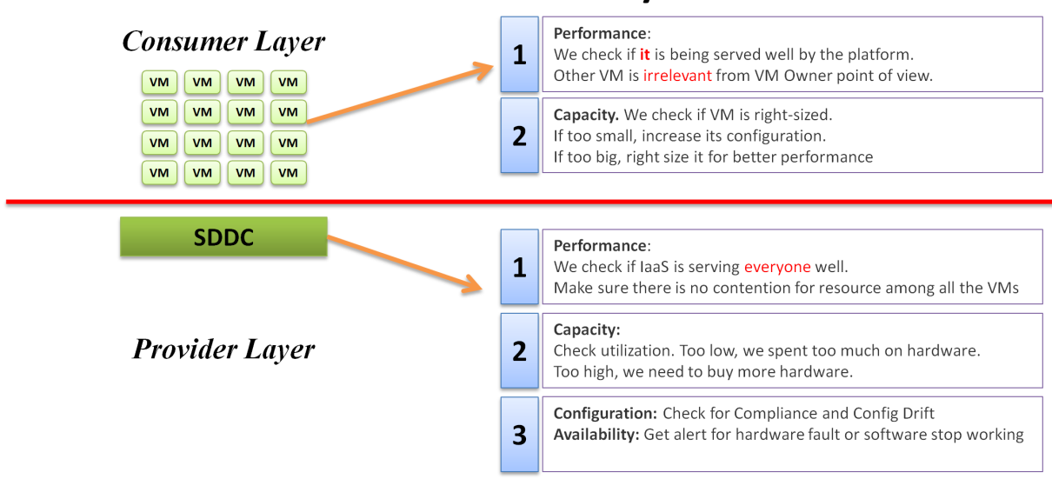

There is clearly a line of demarcation between the two layers. Your customers should not care about the details of your SDDC or EUC. The VM Owner does not care if you are firefighting in the data center. Because they do not care, whether you are using an older VMware Cloud Foundation or the latest, this is not something you want them to dictate to you. The same goes with your choice of hardware brand and specification.

Conduct a regular session with the application team on the following topics:

* How to run best on VMware, with optimal performance, highest availability, most secured while keeping cost minimal.
* How to monitor the performance, availability and security when you’re running on VMware. How to know you’re being served well by the IaaS platform according to the promised.
* Why rightsized is better than oversized.

Understand their expectation from infrastructure. In large environment, different VM Owners can have different expectation and level of knowledge.

The application team becomes a consumer of a shared service—the cloud platform. Depending on the SLA, the application team can be served as if they have dedicated access to the infrastructure, or they can take a performance hit in exchange for a lower price. For SLAs where performance is guaranteed, the VM running in the cluster should not be impacted by any other VMs. The performance must be as good as if it is the only VM running in the ESXi.

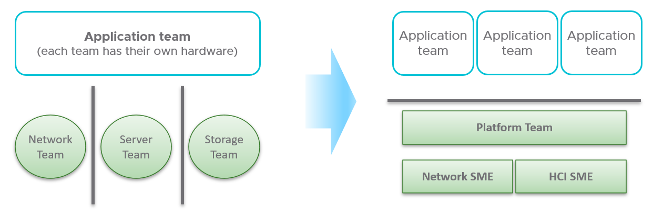

Let’s zoom into the kitchen area, as that’s also undergoing a transformation. The Server team or Windows team or Linux team typically took the ownership of the shared platform and evolved to become the platform team. With the evolution of [Hyper Converged Infrastructure](https://en.wikipedia.org/wiki/Hyper-converged_infrastructure), the storage is being absorbed into the platform. The boundary with the Network team is also becoming blurry with network virtualization. Many network services such a Firewall and Load Balancers are virtualized. Recently, with the arrival of the Kubernetes, the platform team begin owning containers and K8s, plus there is a new team that sits in between Platform team and Application team.

#### Automate | Operate

Last but not least, you need to account for problem. Real problems happen in Day 2 as that’s when you have business workloads doing revenue generating transactions. Do not architect something you are not willing to troubleshoot. Think of the roles and skills required to operate your architecture. Provide the necessary visibility into each component and define what constitutes health, risk and efficiency.

I hope the above examples show that Day 2 is where you want to start. Begin with the end in mind, says a famous [quote](https://www.franklincovey.com/the-7-habits/habit-2/).

Did you notice something missing in the discussion above?

Yes, I did not cover **Automation**.

Why is that?

For me, that’s part of Architecture. You should not automate what you cannot even operate. So, automation is not part of operations. Automation is a feature of your Architecture, meaning you design the system with automation in mind. Using an analogy, it’s like a plane with many automation features. Fly-by-wire. That’s a *feature* of the plane. How you operate the plane, so passengers arrive at the destination safely, comfortably, timely and fresh, that’s operation.

In terms of transformation journey, automation should be placed last.

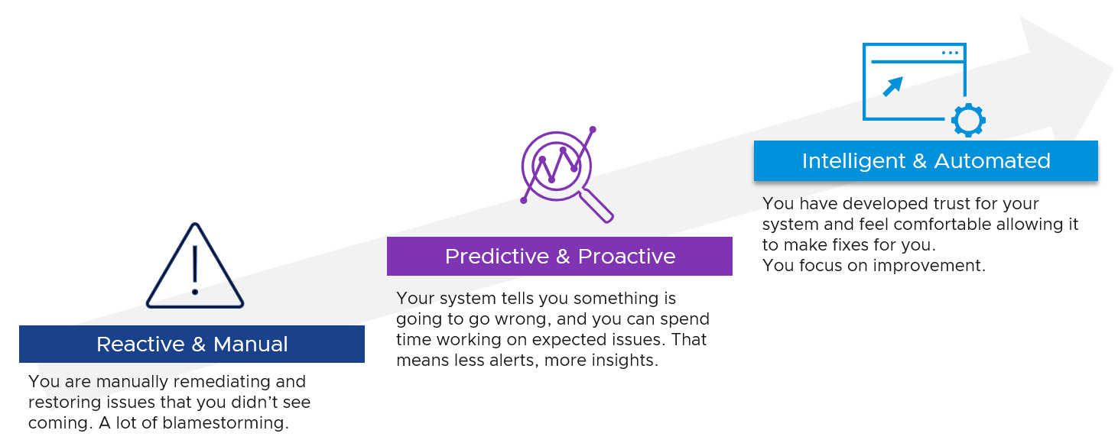

#### Observability

Observability needs to be built-in, not bolted-on, in your architecture. That means ensuring it can be monitored clearly, down to the smallest component. [Anthony Hodge](https://www.linkedin.com/in/anthonyhodge/) told me years ago, back when I was a presale, that vendors should not put system into production that can’t be monitored. Sadly, this is typically the last thing in our IT industry, especially with tight deadline, limited skills and low budget. Many applications, software and hardware do not systematically leave trail for post-mortem analysis with deep context. As a result, all you can do is function tracing and log reading, which are hard to do, not to mention intrusive. BTW, function tracing can be traced back (pun intended) to Solaris 10 [Dtrace](https://en.wikipedia.org/wiki/DTrace), back to 2005!

To “solve” the above problem, our IT industry came up with new buzzwords and make them larger than life. You hear jargons such as unknown unknown, golden signal, SLO, reliability and how observability is more than monitoring + troubleshooting.

It is certainly important to elevate the proactive work to detect unknown problems that you are not even aware of. I love slicing and dicing millions of data points (metrics, logs, events, trace, netflow) and discover new insight. It also helps me understanding the behaviour of low-level metrics better. Many times, they are not what the manual says as documentation on metrics are often not deep. I’ve discovered a few dozen bugs in the metrics in the last 1+ decade. In the 1st Edition of my book, published back in 2014, I wrote that [Ronald Buder](https://www.linkedin.com/in/ronald-buder/) saw vCenter Operations (as it was called back then) as a big data tool, as he could slice and dice. That’s one way I use Log Insight and vRealize Operations.

CIO should not only encourage, but also requires the subject matter experts to allocate time in this proactive research. It should be part of regular cadence to share the work and finding. It’s both a good exercise to keep the knowledge deep, plus you never know what you will discover!

Having said that, do we need a new term? I don’t think so since it has caused confusion. Many software can do these, along with many other things. It’s all part of monitoring and troubleshooting. It is not worth inventing a new *category* of software.

If we really want a new term, the word debug-ability carries more value as just because a system is observable does not mean you can do something to fix it, let alone to debug it. Plus, the act of observing a system requires CPU cycle, so you make the situation worse.

Observability is not more than monitoring. They are 2 different things. The first one is a property of system to be managed, while the second one is an action done by an actor. Monitoring & Troubleshooting are peers. Observability and Debugability are peers.

##### See, See and See

There are 3 types of metrics you need to see and verify. These **Triple C**[7] are in sequence, and they have their own purpose:

|  |  |
| --- | --- |
| ****Type of Metrics**** | Primary Application |
| **Contention** | Performance Management |
| **Consumption** | Capacity Management |
| **Context** | Configuration Management  Inventory Management |

Let’s explain further:

|  |  |
| --- | --- |
| **Contention** | They measure something bad. They can be further divided by their impact   * Performance. Metrics such as contention, latency, and queue, impact the performance of the system. The system is not down, meaning nothing is dropped, but the overall throughput is reduced. * Availability. Metrics such as errors and dropped impact the availability. Most system can recover from soft errors by re-attempting the operations (e.g. retransmit the dropped packet, recalculate the cache, resend the SCSI command). There is lack of observability for such automatic-recovery, and the even the logs may not reveal. For additional reading, I recommend this article by [Brendan Gregg](https://www.linkedin.com/in/brendangregg/). |
| **Consumption** | They measure something good. A high number is good for the business, if the load is useful (e.g. not a DDOS attack).  Consumption is a family of metrics, not all of them are real. It comes in many different names (workload, usage, demand, allocation, reservation, IOPS, throughput, active, consumed, etc.).  Utilization is the main input for the capacity family of metrics (Capacity Remaining, Time Remaining, VM Remaining, Recommended Size).  Reservation is an unreal measurement. It can overlap with utilization because an object can have lower or higher reservation relative to its utilization at different times.  Most administrators look at utilization, because they fear something wrong will happen if it’s high. That “something” is contention. Contention manifests in different forms. It can be queue, latency, loss, dropped, aborted, context switch. |
| **Context** | They provide answer to the “it depends” type of answer, by accounting for something (e.g. inventory, configuration) and provide context.  The context is obviously only useful to someone who can derive insight from that context, else there is no meaning to it. For example, a high number of vMotion depends on your expectation. If you’re doing cluster live migration after office hours, you expect the number to match the theoretical limit. |

While contention is what you care, consumption gets the limelight as it’s easier to monitor and simpler to explain. Also, many systems do not scale well. Their “performance” actually drops when reaching certain level of utilization. Take a parallel database. As you add more nodes, the overall throughput drops as the nodes spend more time maintaining overall integrity among them. The CPU utilization of each node gets higher, only to be spent on overhead activities. In this case, what you should do is measures the overhead and the metric you refer to as “performance”. Do not use the CPU utilization to represent all these metrics.

There is a tendency to monitor utilization as if it is a pillar of operations. Just like contention, utilization is not something you manage. Yes, you monitor utilization, but you monitor it for a reason. By itself, utilization has no meaning. The meaning depends on the purpose.

Contention is the primary counter for performance. Utilization is the primary counter for capacity.

BTW, I did not adopt the Golden Signal. Happy to discuss why The Triple C method and KPI framework provide better solution.

##### Input | Output

There are 6 types of inputs which work together to give you your alerts, dashboards and reports. Output is documented in PART 3 of the book.

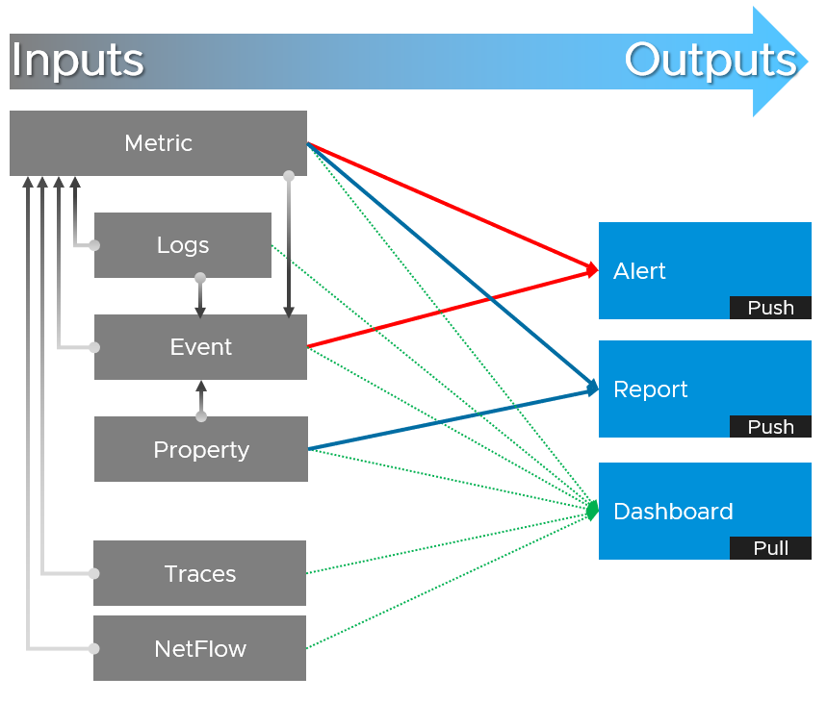

|  |  |
| --- | --- |
| **Metric** | It is a number, not string. The numbers could be a code, whose description is a string.  It is produced at regular interval, even if the value is constant. If it crosses certain threshold, it can trigger an event or an alert. |
| **Properties** | It is often a string, although it can be numbers. It is only produced upon change, which does not happen regularly. Property change is a type of event, which can trigger an alert. Since not all properties are important, the significant of the event is also impacted. |
| **Log** | It is a raw message, typically produced by developers directly.  Numbers can be extracted to form metrics, while text can describe an event. Metrics and Events then can trigger alert. |
| **Event** | It means something happened, which can be good, bad or neutral. It can be a setting change, a state change, or a label change. A label is “external”, meaning it is not an inherent property of the object. Event also traps the activities performed on those objects.  For examples:   * “Iwan the vSphere Admin enabled DRS on Cluster 007” is an example of activity. * “Cluster 007 DRS was enabled” is an example of the state change (from disabled to enabled) * “Cluster 007 DRS automation level was change from 2 to 5” is an example of setting change. The state remains fully automated. * Cluster 007 will be decommissioned and has a tag assigned to mark it. This is an example of a label change. There is no setting or state change |
| **Trace** | It is a record of codes in-motion. Some can produce numbers, which are metrics. |
| **Netflow** | captures path, typically flows of network packets. It can produce metrics. |

### Service Level Agreement

The difference between an enterprise grade Cloud and non-enterprise grade Cloud is the SLA. A cloud provider can state that they have the best technology, the most experienced professionals, the most innovative process, industry certifications, etc. to prove that they are the best. All those will not carry weight if they are afraid to back it up with the SLA in their contract. The SLA enables customers to hold the cloud provider accountable as it carries a financial penalty.

Once the SLA is defined, then customers want to know how it will be delivered. This is where the process, architecture, certification etc. come in. The **what** always come before the **how**.

Guess how many SLAs do you need?

It depends on the type of services. Most service providers will only commit to the simplest and most obvious one, which is availability. It’s the simplest as it’s binary. The darn thing is either up or down. Google only covers availability in [their SLA post](https://cloud.google.com/blog/products/devops-sre/sre-fundamentals-slis-slas-and-slos) here, which is based on Google Cloud [SLA](https://cloud.google.com/blog/products/devops-sre/availability-part-deux-cre-life-lessons). AWS only cover their infrastructure, and not your EC2 VM.

Just because something is up, does not mean it is fast. In fact, a service that is slow to the point it’s unusable is as good as down.

Just because something is fast, does not mean it’s secured. This is why Security SLA is necessary.

#### The 4 SLAs of IaaS

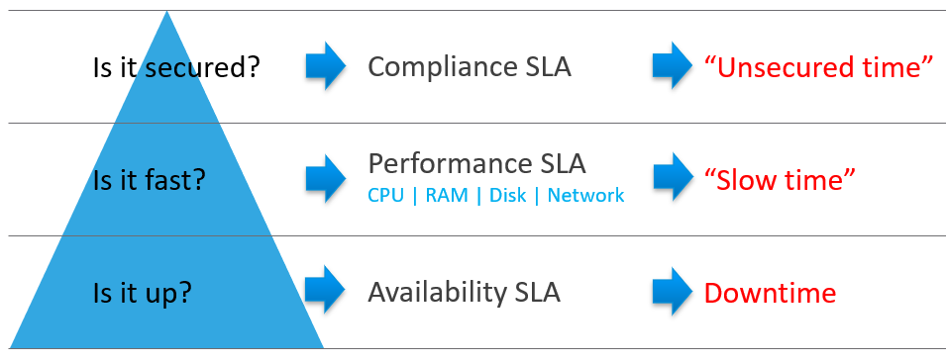

Wait, why am I not showing the 4th one?

Because it plays a secondary role. The first 3 covers the actual workload, while the 4th one covers the human (typically developers).

The business of IaaS should provide 4 SLAs, as customers want complete coverage.

|  |  |
| --- | --- |
| **Availability** | This is the most basic SLA. It is the eldest and most well-known.  In reality, it is largely a given. It does not matter what the agreed number is. If the darn thing is down, you better hurry to bring it up before there is a complaint or things get worse! |
| **Performance** | Performance SLA is far more valuable than Availability SLA. It is the solution to complaint-based operations by defining what exactly is fast.  In IaaS, it covers CPU, Memory, Disk and Network, hence there are four metrics used. |
| **Compliance** | This is hardly talked about, as customers and provider expect this to be 100%. This is why you need to provide SLA, as promising 100% will lead into disappointment.  It measures the security compliance to industry regulation or certification. |
| **Service** | Service provided by both human and system (typically in the form of self service portal) |

In Availability SLA, you measure downtime. In Performance SLA, you measure ”slow time”. In Compliance SLA, you measure unsecure time. Regardless, you measure something and expressed in 0 – 100%, with 100% being perfect relative to the contract.

The implementation though, is not so simple. Each has their own unique nature. Let’s dive into each.

##### Availability SLA

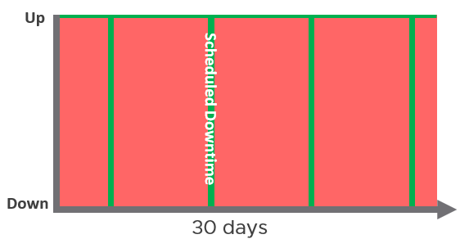

It’s black and white as it’s either up or down. This introduces a problem as 100% is practically too costly for business.

Luckily, there is scheduled downtime. This unique saving grace lets you state you’re 99.999% available even though the actual reality, experienced by end customer, is lower. This is why you need two metrics: one for SLA and one for actual. The actual will record every downtime, be it a part of SLA or not.

A challenge that impacts Availability but not Performance is recovery time. Your system may detect the VM is down within 1 minute, but the reboot process until the entire OS is properly up and running takes 5 minutes, as it needs to perform filesystem consistency check.

|  |  |
| --- | --- |
| Definition | Defined as Guest OS is pingable, because running but isolated fails the availability test.  The Ping Source is predefined and set by the IaaS, not customer. It pings the VM, not a specific process (e.g. web server). This is IaaS, not web server as a service.  The uptime only covers Guest OS. If it takes the application 15 minutes to fully operational as it has to load all files and services, that’s not counted. |
| Inclusion | If the crash caused by VMware Tools or IT Infra owned drivers/agents, then it’s counted. |
| Exclusion | If the crash is caused by bad applications behaviors, as that’s not within the control of IaaS provider.  Scheduled downtime. So the Guest OS upgrades, patches that requires reboot, Tools upgrade, VM Hardware version are not counted if you execute within the agreed scheduled downtime.  Unscheduled downtime caused by customer. As it takes time to figure out what caused the downtime, you need to be able to recalculate the metric.  VM owner initiated reboot as they might reboot their OS to solve problem or after installing software. How to track as developer may not inform IaaS team, as Windows does not fully trap this event? |

You need to back up your promise with solution that customers are convinced. Here are some solutions that you may offer to justify and support the higher availability SLA.

|  |  |  |
| --- | --- | --- |
| Backup | Gold Tier provides application-level back up. It also provides more frequent full back up, and customers is provided with self-service individual file restore. | |
| High Availability | Gold Tier provides application-level monitoring. Customers can also ask for specific boot up sequence of their VMs, and ask for VM-Host affinity rules to minimize risk. | |
| Disaster Recovery | Gold Tier provides lower [RPO and RTO](https://en.wikipedia.org/wiki/Disaster_recovery). Customers are also entitled to annual real test, where the production workload are run from the DR site. | |
| Snapshot | Gold Tier provides longer snapshot and larger snapshot. | |
| OS Management | Gold Tier provides flexibility in patching. Customers can specify delay in patching and request for custom patch package, where not all patches from Microsoft or Red Hat is applied. |
| VM Management | Gold Tier provides flexibility in updating Tools and VM Hardware. Customers are allowed to defer the update. |

##### Performance SLA

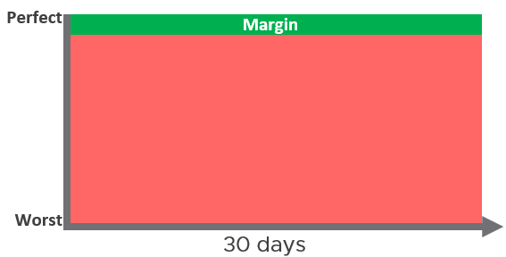

Unlike availability, which has the luxury of scheduled downtime, there is no such thing as scheduled “slow time” in performance. You can’t say that you’re doing infrastructure upgrade and use that as excuse that VM performance will be slow. As a result, you need to put your margin or buffer somewhere else.

Slow is not binary. It’s a spectrum from 0 contention to absolute worst (as good as dead). Some metrics such as disk latency can never be 0. It will be a small number, but it’s not 0. Same goes with the value of CPU Ready metric. So we need to define a threshold above 0.

|  |  |
| --- | --- |
| Definition | All are measured at VM level, not individual vCPU or vDisk. For disk, it’s also the average of Read & Write.  All are averaged of 300 seconds. |
| Inclusion |  |
| Exclusion | Received Packet Dropped. It’s not reliable enough to be used in contract due to false positive. The packet is dropped as it’s not for the VM. More details at the Network metric chapter.  Other forms of contention, such as CPU Overlap, CPU Other Wait and vMotion. They are too granular for contract purpose. You track them via KPI instead. |

Why should you only use CPU Ready and exclude CPU Co-Stop and CPU Contention from Performance SLA?

It took me years to vrealize the mistake.

You should exclude CPU Co-Stop because the reason for Co-stop could be the VM itself. IaaS SLA should not measure problems beyond your control. Read this for details.

You should exclude CPU Contention because its value can go as high as 37.5% without the application noticing any degradation. You can login to Windows or Linux and feel it’s responsive. Read [this](#_Contention_(%)) for details.

Use the above threshold as they are. There are 2 main reasons:

* Major changes in the value, such as changing CPU Ready from 2.5% to 0% or 5%, will impact your operations. You either gets too much alert or too little alert. On the other hand, minor changes, such as CPU Ready from 2.5% to 2% or 3%, may not make operational difference in terms of remediation action you’re taking.
* A common value in the industry will also enable you to compare with your peers and get an industry acceptable numbers. You can compare how well you serve your mission critical VMs, your Test/Development VMs, etc.

Just like in Availability, there are activity you can do to give confidence to customer. For example:

* Gold Tier VMs will be proactively monitored, not just relying on alerts.
* Gold Tier provides deeper visibility into the underlying physical infrastructure where customers VM are running. Customers are entitled for lower level internal metrics such as vMotion stun time and VMkernel latency.
* Gold tier provides self-service monitoring. Customers are given their own login to a portal where they can monitor their own VMs. They can initiate scheduled downtime.
* Customers will be alerted over email and messaging network.
* Gold Tier provides priority network. Customers can opt for periodic ping service to ensure network latency between their applications remain within the agreed threshold.

##### Compliance SLA

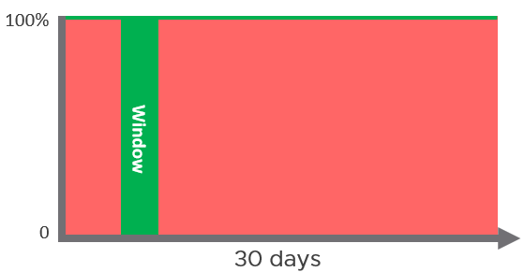

|  |  |
| --- | --- |
| Definition | Percentage of compliance against agreed security policy.  It’s binary, as you must comply with all the security settings. All it takes is 1 loophole.  It has a window, typically ad-hoc, to enable investigation or maintenance. |
| Inclusion | Internal security standard, typically an adaptation of VMware best practices.  Relevant industry regulation (e.g. PCI DSS). |
| Exclusion | Guest OS compliance, as what you do inside the VM is not within the control IaaS provider. |

##### Service SLA

IaaS is built on commodity hardware and provided as a utility. Having said that, there are many ways to differentiate your service vs your competitors. Use class of service to distinguish premium service. The following table lists some examples.

|  |  |
| --- | --- |
| **Provisioning Time** | In environment where the churn is high, the time taken to provision become important. You need to clearly define what “provisioned” here means, as it can range from bare Windows or Linux to complete set up with applications & database loaded. |
| **Provisioning Success** | Provisioning a complex set of multi-tier business applications with many VMs may fail from time to time. If this is relevant to your environment, then add it as part of SLA so you can focus on higher class of service. |
| **Support** | The two popular examples are response time and path to escalation. Do not promise resolution time unless it’s completely within your control.  Gold Tier provides faster response time and longer coverage hours (e.g. 24 x 7 x 365). Your ticket is also directly answered by Level 3, bypassing the front liners.  Regular business review, attended by your management. |
| **TAM** | Gold Tier comes with a Technical Account Manager, acting as single point of contact for customers. TAM is also the internal champion, representing customers interest within the vendor internal world. |

There are other metrics you can add to differentiate one class to another. However, be careful of adding metrics that do not actually serve your business. For example, it can be tempting to put accessible time of your self service portal, to protect you from scheduled downtime. You need to work on the basis that your “office” is open 24 x 7 x 365 days.

#### The Metrics of SLA

Do you set it per week, per month or per year? Let’s find out!

##### The Time Window

SLA is a *monthly* metric, not daily or yearly. You use an entire month of data to calculate it, averaging 8640 datapoints of 5-minute average.

In the following table, notice 99.999% in a year is actually easier than 99.95% in a week. Your customers would not accept a yearly metric as they can be exposed to a long downtime. You would not accept a daily metric as there is no room for error. The monthly metric provides a balance between service quality and cost to deliver the service. It also makes reporting easier as you simply follow the calendar month.

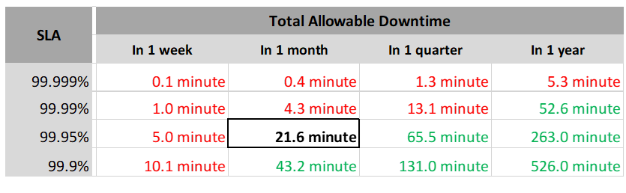

Each additional “9” shrinks your SLA window by 10x. That’s why each decimal can cost a lot more money, as a different architecture may be required.

Even if you measure the SLA once a month, it can still be very difficult to meet. Take a look at the following table.

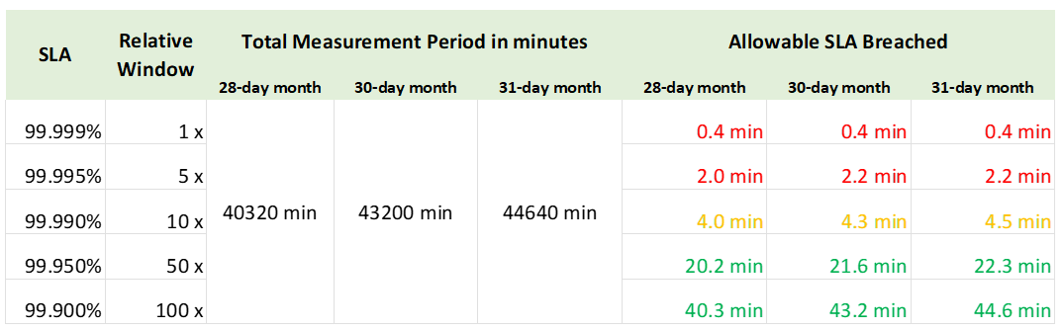

If you promise 99.99%, you only have 4.0 minutes – 4.5 minutes of downtime per calendar month. That means your architecture must be able to detect the issue and then complete remediation in just a few minutes. That’s a tight space to manoeuvre.

Let’s analyse the size of failure window we have per month. The table below gives you a better gauge into what SLA you want to set for each class of service.

|  |  |  |
| --- | --- | --- |
| 30-day SLA | Failure Window | Failure Chance per SLA |
| 99.99% | 4.3 minutes | < 1 time |
| 99.98% | 8.6 minutes | < 2 times |
| 99.97% | 13.0 minutes | < 3 times |
| 99.96% | 17.3 minutes | < 4 times |
| 99.95% | 21.6 minutes | < 5 times |
| 99.90% | 43.2 minutes | < 9 times |
| 99.80% | 86.4 minutes | < 18 times |

##### The 2 Sides of SLA

This is one of those things in life where it’s so obvious that we overlook it.

There are 2 sides of an SLA.

|  |  |
| --- | --- |
| **Promise** | What you promise to your customers.  Obviously, the higher the price, the better the service, the higher the SLA. So there can be multiple numbers, matching the number of class of services. |
| **Reality** | What is actually delivered.  There is only one number, regardless of the class of service. A Gold VM can fail SLA even though the reality it’s getting a higher number. |

##### SLA Calculation

The above four elements of IaaS (CPU, Memory, Disk, Network) are evaluated on every collection cycle. The default collection cycle is 5 minutes, which is an appropriate balance for SLA monitoring. An SLA that is based on a 1-minute collection cycle will be too tight and result in either a cost increase or a reduction in threshold.

The following example, taken on vRealize Operations 8.2, shows that this VM was served well by the IaaS. It’s getting the four IaaS resources it asked for in the last 24 hours with only one exception. The chart counts each time a VM is not getting a resource. A VM that is not served on all four will register a value of 4 in the chart. You can use 100% - 0% range instead of 1 – 4, where 4 = 0%

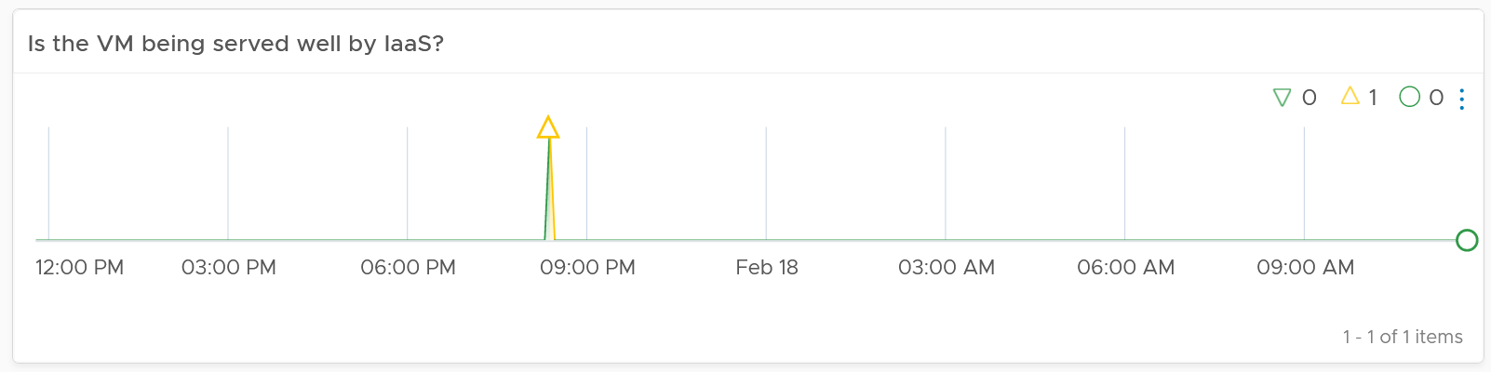

The following example shows the opposite. There are many instances where the VM is not getting at least one of the four IaaS resource, and one instance where it did not get two them. The chart also shows 7 days, so pattern or spike can be seen.

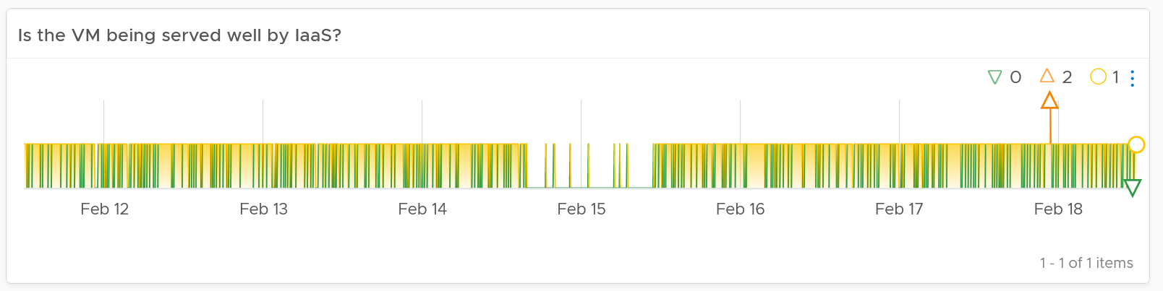

The VM SLA (%) value is simply the average of the 5-minute datapoints over the last 30-days.

There are 4 SLA metrics, so each contributes 25% weightage.

Example:

* Take 99.95%, which is 21 minutes.
* For simplicity, let’s focus on 20 minutes. That means 4 values from each, total 16 values.
* Failing one resource for 16x is as good as failing all 4 resources, 4 times each. 16 x 1 = 4 x 4.

Now that we have the numbers, we need to apply them into class of services. Gold should be higher than Silver, but exactly by how much?

Let’s find out.

#### Class of Service

Now that you have the 4 SLAs, you complement it with Class of Service. If you only have 1 offering and you promise them good, well they all would expect business class experience.

[Kim Ramirez](https://www.linkedin.com/in/kimkiser1/) advises that from a pricing psychology standpoint it might make sense to offer Gold, with the expectation that nobody will buy it, and it only serves to make Silver look like a good deal. In life, one way we know something is good or bad is via comparison. Relative value can complement absolute value in educating customers.

Having a comparison also addresses a potential confusion where customers wonder where Gold is, if they only see Silver and Bronze offers.

If you do not wish to offer a certain class available, provide the reason to your customers or management.

##### Price/Performance

The [price-performance ratio](https://en.wikipedia.org/wiki/Price%E2%80%93performance_ratio) is widely accepted as it is simple to understand and it’s built on fairness. You probably heard of this: “I offer 3 types of variants. Cheap, good, and fast. Pick any two. You want it cheap and good, it won’t be fast. You want it cheap and fast, it won’t be good. You want it good and fast, it won’t be cheap!”.

In IaaS, how do you apply the above principle?

* For Availability, this is measurable. If you reduce the downtime window by 2x, logically you should pay 2x.
* For Performance, how do you quantify since it depends on the utilization? Since that does not exist yet, you use overcommit ratio. If there are 2x vCPU in the cluster, then each of them pay half price. This is fair as the cost must be distributed to all.
* For Compliance, this is clear. Plus it’s in your own interest to secure every environment.

The class of service impacts many parts of operations, so it needs to be central to your plan. The following diagram shows how the quality of the service and overcommit ratio serve as input to operations management.

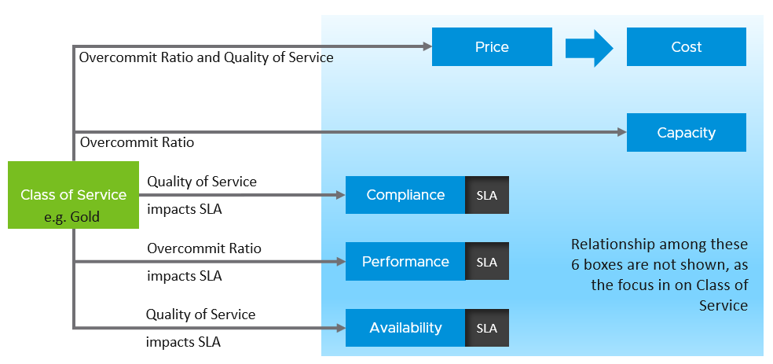

The following table shows a basic and generic guideline to a class of service. The actual model that you will implement will differ, taking into account actual hardware model and business demand. In the capacity management section, we walk through an actual example.

|  |  |  |  |  |
| --- | --- | --- | --- | --- |
| Tier | Price | Overcommit | Performance | Positioning |
| **1 (Gold)** | 1.00 X | 1:1 | Perfect | Performance “Guarantee”. Suitable for latency-sensitive mission critical applications. |
| **2 (Silver)** | 0.50 X | 1:2 | Great | 50% discount for much less than 50% penalty. Great value compared with Gold Tier.  Suitable for most Production workload. |
| **3 (Bronze)** | 0.25 X | 1:4 | Good | 75% discount for much less than 75% penalty.  Suitable for Test & Dev workload. |
| **4 (Free)** | 0.00 X | Max | Average | Suitable for temporary project.  No Availability SLA, no Performance SLA |

I put “guarantee” in quote because for CPU this is not possible as the VM CPU Ready counter does not register 0.00% when there is no contention.

The **Free Tier** must be funded by higher tiers. If you have a free tier, meaning there is no SLA, then it’s acceptable for them to have inferior quality. Commercial cloud providers provide free tier that are intentionally designed to be slower and less reliable, because they want you to upgrade and pay.

The performance column in the table above is further defined by their SLA, because you need to quantify what the penalty exactly translates into.

##### The Benchmark to Rule Them All

A Gold class has higher SLA than Silver. For that to happens, that means they are measured against the same threshold or benchmark.

* For availability, you measure all classes against the ideal, which is no downtime.
* For performance, you measure them against the same threshold, which is the “slow time”.
* For compliance, you measure them against the ideal, which is perfect compliance.
* For service, you measure them against the ideal, which is the best possible service.

A VM in Silver environment will expect that it does not get what it demands as often as a VM in Gold. If the VM Owner wants to have more *consistent* service in performance, then simply pay more and upgrade to the Gold cluster.

This approach is easier than setting up a different performance threshold for each tier. Say you set the following:

* **Gold**: VM Memory Contention: 0.5%
* **Silver**: VM Memory Contention: 1.5%

You notice the problem already?

It is hard to explain the delta or gaps between the class of services. Why is Silver 3x the value if it is only half the price? Shouldn’t it be proportionate?

There is a 2nd problem. If you set *different* standards, it is possible that Silver will perform better than Gold, because it has lower standard. This can create confusion.

This means the performance in production is expected to have a higher score than the development environment. Development environments will obviously perform worse than Production environments.

How much worse, exactly?

Let’s find out by applying all the above into actual numbers. You have 9 numbers, 3 SLA x 3 Class of Service.

##### Recommended SLA

Let’s put all the above SLA in an example. The following is what I’d recommend:

|  |  |  |  |
| --- | --- | --- | --- |
| Tier | Availability SLA | Performance SLA | Compliance SLA |
| **1 (Gold)** | 99.975% | 99.95% | 99.95% |
| **2 (Silver)** | 99.950% | 99.90% |
| **3 (Bronze)** | 99.900% | 99.80% |

Why they are all different numbers? Isn’t easier to have 1 number for each class?

Well, they measure different things:

|  |  |
| --- | --- |
| **Availability** | It can afford to have the highest SLA because scheduled downtime and downtime caused by customer is not included.  I put 99.975% as Windows or Linux may need to run filesystem integrity check.  If you have many IT services or Security services that must be started before application services are started, adjust the SLA accordingly.  Notice the downtime windows is 1x, 2x, and 4x. It helps in justifying the price when the gaps are clear and consistent. |
| **Performance** | Lower SLA due to stringent standard. It’s stringent so it can cover the mission critical environment. As a result, the Bronze environment will have a harder time meeting it. If you think that’s too strict, reduce the SLA not the threshold. To see how bad the reality, use KPI.  Notice the number for performance is 1x, 2x and 4x. Silver failure window is 2x bigger because its price is 2x cheaper. Remember the Price/Performance principle? The basic concept is you pay double you get something 2x better.  Why not 100% for Gold since there is no overcommit?  Because that’s just the compute portion. You do not control the network and storage portion. |
| **Compliance** | It has identical SLA for all classes as it’s in your interest to secure everyone. You don’t want to have a security loophole, which can be used as jump box to attack the rest. I did not put 99.99% as that’s not even 1 chance of mistake. As the value for compliance is the last value of collection, that could be as short as 1 second.  Consider how fast it takes for you to effect a change. If you rely on manual change, then adjust the number accordingly. |

##### Sample Offering

Putting the above together, what does a sample class of service actually look like?

###### Price & SLA

SLA is the hard product, the main thing that you when you pay for the price. Using the airline business, the hard product is the seat. Other things such as in-flight entertainment and meals are soft products.

In IaaS, since you do not typically care about the hardware specification (e.g. the type of SSD for storage, the memory brand and technology), you focus on the SLA.

|  |  |  |  |
| --- | --- | --- | --- |
|  | Gold | Silver | Description |
| Price | 2x | 1x | Gold is priced 2x Silver. |
| Over Commit | CPU 2:1  RAM 1:1 | CPU 4:1  RAM 2:1 | The reason why Silver is half price is there are twice as many consumers. |
| Availability SLA | 99.975% | 99.950% | Gold has 2x less downtime |
| Performance SLA | 99.95% | 99.90% | Gold has 2x less “slow time” |
| Compliance SLA | 99.95% | 99.95% | Silved is bumped up to Gold to protect Gold |

If you mix the environment, should you apply reservation and shares. Give Gold 2x the value over Silver to justify the 2x price. The contraint you face here is the values of reservation can’t be high as it impacts overcommit.

The preceding table is a generic guideline. As part of your planning with IT Management, you help them define and decide on each Class of Service. This planning session requires vendors input as you want to optimize cost. Use vendors discounting and licensing model to complement the plan, not dictate the plan.

Yes, it’s a balancing between ideal solution and what actually give the best bang for the buck.

At the end of the planning session, you may end up with something like this.

|  |  |  |  |
| --- | --- | --- | --- |
| Tier | Price | Compute | Storage |
| Gold | Highest | 1:1 | All Flash |
| Silver | Good  (67% of Gold) | CPU 1:3  RAM 1:1 | All Flash |
| Bronze | Low  (33% of Gold) | CPU 1:6  RAM 1:2 | All Flash |
| Free | Free | N/A | Magnetic |

For Silver and Bronze, to maximize consumption of hardware, you base on average ratio of 1 vCPU to 4 GB RAM. This is a common ratio. If you want to tailor, use vRealize Operations to give you the actual ratio.

For Silver, you decide on 3:1 CPU overcommit and no RAM overcommit. Based on 1 vCPU 4 GB RAM, you need to buy 12 GB RAM for each physical core. Buying 64 core maximizes your vSphere license. That means you need 64 x 12 = 768 GB of RAM. If you run vSAN and NSX, you need to add accordingly.

The 3:1 overcommit enables you to lower the price by 3x for CPU portion. If you do 50/50 split between CPU and RAM, the overall price is 67% of Gold, yielding a 33% discount.

For 33% discount, what’s a reasonable performance penalty? What’s acceptable to both your CIO and application team?

CIO also decided that free tier is not offered as that’s not the business you want to be in.

As you can see, the hardware spec is driven by the business model. Decide on the overcommit & price first.

If you want your customers to right size in advance, then a 64 vCPU VM needs to be *more* than 64x the price of 1 vCPU VM. If the pricing model is a simple straight line, there is no incentive to go small and no penalty to over provision. You will end up forcing rightsizing in production, which is a costly and time-consuming process.

Refer to Cost Management for pricing example as Cost and Price go hand in hand.

Because you overcommit, you run the risk of contention. To minimize it, one way is to control the size of the VM. You want to avoid monster VMs dominating your overcommitted ESXi host. The following table provides an example of the size limit you associate with each class of service.

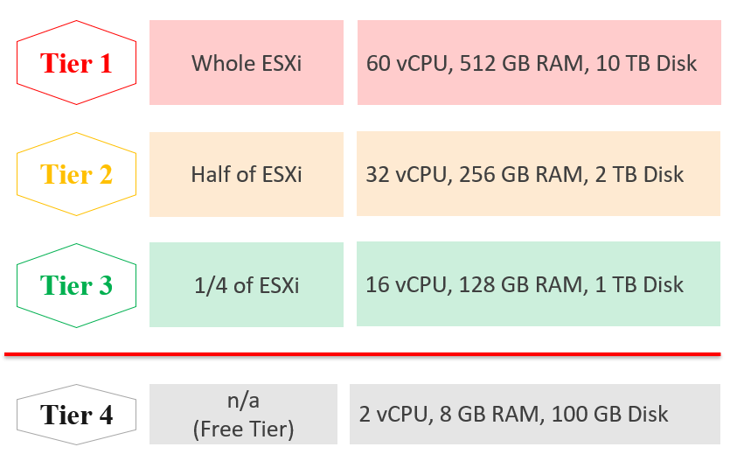

Capping the size at each tier is a good way to prevent monster VM from causing performance problem in environment with higher overcommit ratio.

If you allow a single VM to be the same size with the ESXi, you practically can’t do overcommit if you want good performance.

Free Tier may also be limited further by capping the number of free VM per customer, else you’d go bankrupt.

For comparison, [AWS free tier](https://aws.amazon.com/free/) for EC2 VM is only 1-2 vCPU, 1 GB RAM as it’s based on t2.micro and t3.micro.

###### Service

Beside the hard product, soft products play a critical role that further differentiates Gold from Silver. Support, both reactive and proactive, is one major area where different class of service can show the value of higher tier.

|  |  |  |  |
| --- | --- | --- | --- |
|  | Gold | Silver | Description |
| Response Time | 2 hours | 4 hours | Gold has 2x faster response time |
| Support Hours | 24 x 7 | 12 x 7 | Gold has 2x support hours |
| Support Process | Level 2 | Level 1 | Gold bypass the first level help desk. |
| Root Cause Analysis | Provided | Additional Charge | The RCA includes setting alert to ensure the same incident is identified immediately. |
| Proactive Support | Daily | None | Gold VM gets daily health check (KPI and alerts). |
| NOC Dashboard | Yes | No | Silver VM is not included in our live dashboard. Reason is the need to focus on the Gold VM |
| Report | Weekly | Monthly | Gold has more details report. |
| Business Review | Monthly | None | Face to Face discussion where we review the SLA and support issue |
| Critical Patch | Higher priority | Lower priority | We patch all Gold VMs first before protecting the lower tier VM. |
| Optimization | Yes | No | Performance and capacity optimization |

###### Availability

This is another soft product in IaaS. Ensure that Gold has much better offering here so the 2x price is clearly shown.

|  |  |  |  |
| --- | --- | --- | --- |
|  | Gold | Silver | Description |
| Snapshot | 1 week | 1 day | For Gold, we will also remind you just in case you forget. For Silver, it’s auto-delete. |
| Size of snapshot | No limit | 100 GB |  |
| No of snapshots | 2 | 1 | Gold can have 2x as many snapshots at any give time |
| Back up | Higher priority | Lower priority | We back up all Gold VM before backing up Silver VM |
| Full back up | Weekly | Fortnightly | Gold has 2x full back up frequency |
| Back up level | Application | OS | We will install & manage back up agent |
| Back up report | Yes | No | We provide report for back up status |
| Disaster Recovery | Separate add-on service | | Both services do not have DR as default |

#### Compute & Storage

A VM runs in a cluster but stored in a datastore. How do you architect both the compute and storage subsystems to support the class of service?

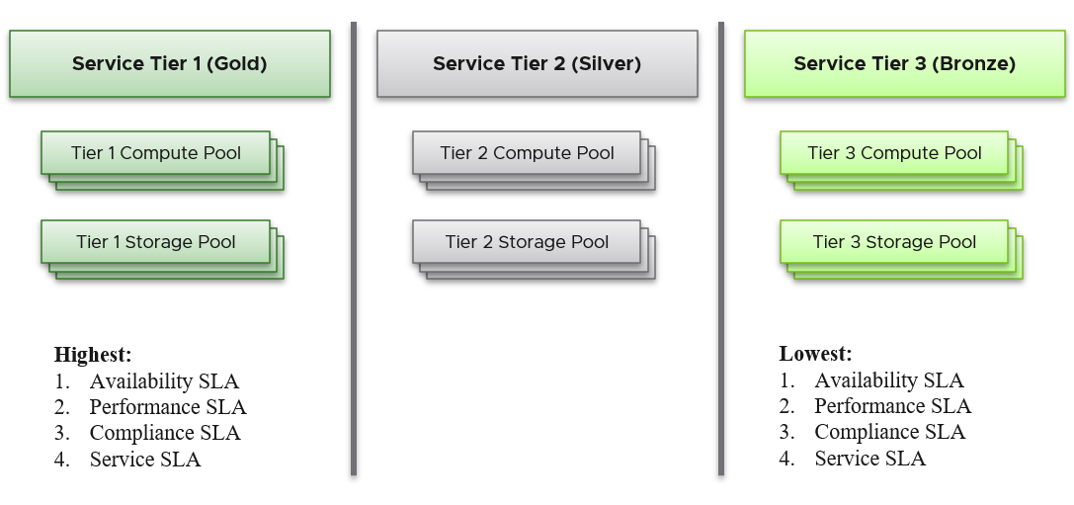

From the performance management point of view, vSphere cluster + vSAN Cluster form the smallest logical building block of the resources. While the resource pool and VM Host affinity can provide a smaller slice, they are operationally complex, and they cannot deliver the promised quality of IaaS service. Resource pool cannot provide a differentiated class of service. For example, your SLA states that Gold is two times faster than silver because it is charged at 200% more. The resource pool can give Gold two times more shares. Whether those extra shares translate into half the CPU readiness cannot be determined up front.

Same with storage. A VMFS datastore is not able to provide differentiated service level. Even if they can, it’s not based on latency, which is what your customers care. The same limitation applies in vSAN. Let’s take an example.

* You promise Gold VM that get will get 10 ms latency at worst. For Silver VM, you promise up to 20 ms latency. Reason for 2x the latency is they pay 2x cheaper. So far so good.
* You set your storage policy and IO Control, favouring the Gold while trying to ensure Silver gets something.
* Since none of the QoS is based on latency, you may end up with 9 ms for Gold and 21 ms of Silver, where you could have gotten 10 ms and 20 ms.

##### Mix and Match

Should we provide flexibility, where customers can choose Gold Compute but Bronze Storage?

|  |  |
| --- | --- |
|  | In this IaaS, mixing is partially allowed. Tier 1 cannot mix with Tier 3.  Result is 7 combinations instead of 9. |

It looks operationally visible.

Now let’s see if the above idea scales….

We will just add 1 cluster for each tier. Only 6 clusters.

|  |
| --- |
|  |

Simply adding 1 cluster for each tier dramatically increases the permutation. What if you have 10 clusters each?

This is a classic case of flexibility turns complexity. Flexibility has its price, so you need to make the business call. In smaller environment, you can afford to be more flexible.

There is further complication. You need to have 2 tags, one for compute and 1 for storage. What do you call a VM whose compute is gold but its storage is silver?

Separating storage from compute also means 2x the tagging. You now need to tag both the clusters and datastores.

We can create a logic where the virtual disks inherit the class of service from the datastore. But what if we have RDM? Yes, that’s still a rather popular choice.

If you further allow different storage class for different VMDK, then you need to tag each virtual disk. This makes reporting difficult as now you need to list each disk.

Performance troubleshooting also becomes difficult. Say you allow a VM to buy Bronze Compute but Gold Storage, because the load is storage sensitive but the application team does not care about CPU. What if the VM disk latency is caused by CPU contention?

### Pillar | Policy | Process | People

Best practices of operations management require you to implement the 4P above in Product, which is the hardware or software product. Together, they will answer the 5W, which is “who does what when where and how”.

How do you know you’ve mastered operations management?

When you can go on long vacation in peace, without the worry of urgent escalation calls asking for information or decision that only you can make or provide.

|  |  |
| --- | --- |
| **Pillar** | There are 5 pillars of operations.  These are what you care (not just the means to an end). |
| **Policy** | This starts with a business policy, which is then translated into IT policy. They typically cover availability, performance and security. For example, a bank policy may state that customers must be able to access critical banking services. This then gets translated into multiple metrics in both application and infrastructure. |
| **Process** | They are the major activities within each pillar.  It begins with a Plan, which is part of Day 0. |
| The regular cadence of Standard Operating Procedure (SOP). |
| **People** | Organization chart. Roles and their responsibilities, which is documented in policies.  Be aware that politics may influence the policy and process |
| **Product** | The technology that puts all the above into a system, so it becomes clearer to the people. It also enforces or implements the process and policy. |

What do you manage, actually? What does your customers want you to take care? How do you manage what you need to manage?

Among the roles and department, there are handover and boundary. What’s the Exit Criteria and Entry Criteria? Take for example between L1 and L2.

* L1 Exit Criteria defines the set of analysis they have performed on the issue. If it’s not in their capability, they have the right to escalate to L1. They have performed the check listed in their Exit Criteria.
* L1 combines their Exit Criteria, and add additional information that L2 needs. This becomes the Entry Criteria for L2, documenting they have all the context they need to perform their job. The list of information can be basic information, such as owner of the VM. It can also be a set of additional low level counter or test result that Level 1 Team ran but does not have the skills to analyse. It’s like you seeing a medical specialist who ask you to bring test results.

The most basic is you need to have visibility into the environment. There are thousands of objects (e.g. VM, application, firewall) with complex relationships and interdependence. Inventory gives you this. That’s why it’s the first box in the diagram below. I had a large telco telling me that their entire DC can go down (say for scheduled DR exercise) but not vRealize Operations as that’s how they monitor the downtime.

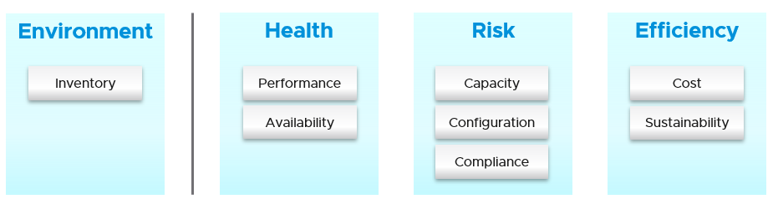

Once you know what you manage, you can then move on towards making sure they are healthy. If there is no problem, then you move to address potential problem. If there is no risk, then you look for optimization.

#### Other Frameworks

Before I came up with the pillars of operations, I studied other IT frameworks. I’m documenting my analysis here so you have the context on why I came up with my own framework.

There are many frameworks in running the business of IT. [ITSM](https://en.wikipedia.org/wiki/IT_service_management), [IT4IT](https://www.opengroup.org/it4it), ITIL, [COBIT](https://en.wikipedia.org/wiki/COBIT) and many others where you can learn about overall IT Management. In this book, I’m focusing on area that’s related to VMware, and only on Day 2. Compared with ITIL 4, which has 34 management practice for entire IT Business, I only see 5. ITIL 4 groups these 34 into 3 broad areas (general management, service management and technical management), while I take a more grounded approach.

Interestingly, ITIL 4 merges Capacity and Performance as 1, while I see them as distinct, done by different persona and have different processes. The book covers both disciplines in-depth, while ITIL 4 does not.

I find 34 are simply too many to manage. You end up managing the management. This defeats the purpose to begin with.

The philosophy of ticket and incident based operations are reflected in ITIL 4. There are many items in the 34 management areas that I do not see as pillar. They are either unnecessary or just providing support to Operations Management. I’ve listed some of them for clarity.

|  |  |
| --- | --- |
| **Continual Improvement** | To me, this is more of culture, realized as a set of process, policies and structure. See [Kaizen](https://en.wikipedia.org/wiki/Kaizen) as an example. While it’s important, it’s not a pillar of operations |
| **Measurement and Reporting** | I’d rather call this Monitoring, as Measurement is a noun.  Reporting, as covered in in Part 3 Dashboard, is just a way for computer system to talk to human. The other 2 are alerts and dashboard. |
| **Service Level Management** | An SLA is not something you manage, as it is a by-product. You manage availability, performance, compliance, and if you do that well you will pass your promised SLA. |
| **Service Continuity Management** | This is part of your architecture, not something you manage. A good architecture is a living system, as it’s designed to handle update and upgrade without compromising the SLA. |
| **Monitoring and Event Management** | Monitoring is a process, an activity. It is not something you manage. The following diagram shows how Process and Pillar are related.  Unlike alert, event could be neutral or even positive. Event is an accounting of something happened, and related to tasks or activities. Just like a metric is an accounting of utilization or contention. Log is a record of something happened. You don’t manage metrics, event, logs as you don’t have full control over them.  So Event is just an input to your operations. It’s one of the 5 data types to monitoring. The other 4 are metrics, properties, logs, and netflow. All these 5 measures the observability of an architecture, and they feed into your monitoring tool. Their values or meaning are defined by the context of the pillar. |
| **Service Desk** | This is a technique, a solution you design as part of your monitoring strategy. While the team needs to be managed, it can span thousands of people, it is not a pillar of operations. |
| **Incident management** | To me, incident (e.g. your website goes down) and problem (e.g. your core router hit a rare bug) are not something you manage. You manage the impact, such as availability and performance. As part of availability, performance and compliance management, you are bound to have incidents, which were caused by problems (e.g. incompatible configuration, bug).  You should focus on why you have so many availability, performance, compliance, configuration, capacity problem. By reducing them, you will reduce your incidents. Aim towards minimizing incidents and problems, instead of accepting their prevalent existence as acceptable and invest on their management. |
| **Service request management** |
| **Problem management** |

I hope you get the idea. In general I found many frameworks to be heavy. It has a lot of big words that are subject to interpretation in the real world as you try to implement them. Some of them also overlap, or even mix up concepts altogether. For examples:

|  |  |
| --- | --- |
| **Monitoring and Alerting** | They are not peers.  When you monitor a system, you will arrive at one of these 3 conclusions:   1. You need to troubleshoot (because they broken or wrong) 2. You can optimize. They are not broken or wrong, but you can save money or improve performance. 3. Nothing you can do.   Alerting is one of the 3 ways for your monitoring system to communicate to you. You interface to the tools via alerts, dashboards and reports. |
| **Automate and Orchestrate** | Automation is the “big item”. Orchestrate is just one of the techniques in automation. It typically strings a number of different scripts, which could be in different programing languages. |
| **Operations and Governance** | They are the same. You manage operations by having governance. Operations management covers risk (availability risk, capacity risk, security risk) and applies control (compliance to approved configuration, clear accountability for each role, manage cost so they don’t overrun) |
| **Demand Management** | This is part of Capacity, as the art of capacity management is about making sure there is just enough supply to meet demand. Both insufficient and too much are problems. |
| **Continuity Management** | This is part of Availability, which cover snapshot, HA, DR, replication, active/active, back up, etc. |

##### Maturity Model

It’s a good practice to assess the level of operational maturity, as it allows you to summarize where you are. There are different variants of this models, so don’t be hesitant to tailor to your goals. I’ve included a short assessment at Part 4 Chapter 1 to get you going.

When scoring yourself, assign score on the following area:

* Policy. Is your policy outdated? Best Practice typically means proven or common practice.
* People. How skilful is the team vs the need? This includes the way the team is organised.
* Process. How effective is the key processes (e.g. planning process, troubleshooting process)?
* Pillar. How mature is each pillar of operations? For example, if your capacity management is mature you are balancing cost and capacity very well. If your performance management is mature you’re not reactive to endless complaints because you have SLA formally agreed.
* Technology. This covers both the technology supporting the business workload, and the IT tools used by the operations team to support the former. For example, if you do not have clear visibility, you’re flying blind.

#### The Pillars

What do you actually care? Because that is what you will manage. How do manage them? What are the key processes required to run multicloud operations?

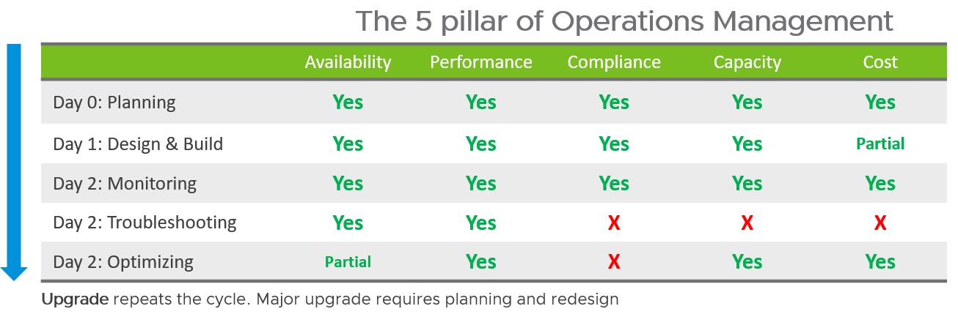

Each pillar is an individual unit of management. They represent individual disciplines and are compatible with one another. The complexity of each pillar depends on the technology, for example, vSAN capacity is more dynamic than a central array. In vSAN, changing the storage policy can create a sudden spike.

What’s missing in the 5 pillars?

* Inventory. It is a by-product. You plan for capacity, with certain configuration. Inventory merely accounts for what you have in which location, and how they change over time. As you manage your cost & capacity, the inventory will adjust accordingly.
* Configuration. Configuration is often both the problem and solution to all the above pillars. You do not manage it for the sake of managing it. The settings are there for a reason. It is a mean to an end.
* Sustainability. It’s covered by both capacity and cost. The only thing unique is the source of power. It’s simply looking at the same things, albeit from a different angle. It does not replace any of the existing pillars of operations management.

I put Security outside as it’s typically managed by a different department. Their scope extends beyond Data Center to physical building security and employee work-from-home solution.

What else are missing in the above diagram?

* Tickets.
* Incidents.
* Service Requests
* Etc., you get the point 😊

Why are they all excluded?

Because they are not something you manage, and neither your operations should be ticket based or revolve around incidents. I’m not against the principle of using ticket as a unit of work, but majority of the implementation has been disappointing to the users. That’s odd as the very purpose of the help desk is to help the users. When you call your telco, bank, airline, etc. for support and you get a ticket, how has the experience been to you?

It’s terrible.

So why impose that bad experience to your customers?

##### Interdependence

The 5 pillars of Operations Management are interdependent. Knowing the relationship is as important as knowing the individual. Relationship matters as the symptom and the root cause are often two different things. A performance problem could be caused by configuration problem, such as outdated configuration or incompatible versions.

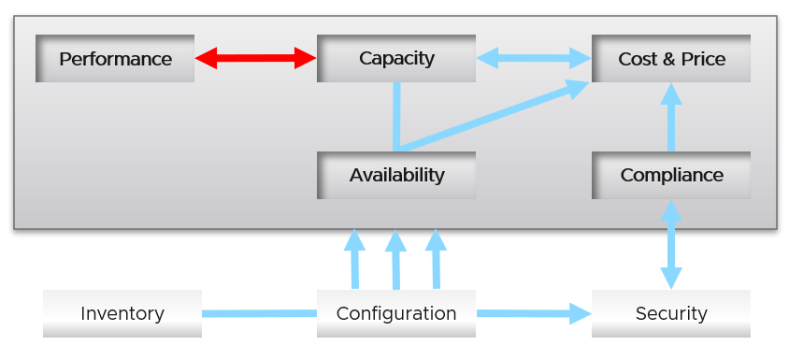

I chose a red line as it’s a complex relationship. As Capacity goes down, Performance is steady. As Capacity drops below 0%, performance takes a hit.

Line with arrow head means there is impact.

* Availability increases your cost, as you’re adding extra resources for no capacity benefit.
* Compliance typically increases your cost

Line without arrow head means there is relationship but not impact.

* Availability and Capacity should not overlap. You calculate capacity after taking out availability.
* Inventory and Configuration do not impact each other.

Let’s elaborate each pillar.

##### Availability

Why do I start with availability as the first pillar?

Because it is the most fundamental part of operations management. The rest of the pillar are irrelevant if the whole environment is down. You have no security issue if your entire DC is down 😊

There is a spectrum of availability solution, from snapshot, back up, HA, Fault Tolerant and SRM. Each can have impact on cost. Most of them requires additional resources so they must be part of capacity planning, so they do not impact performance. For example, load balancers and replication need to be accounted for.

You also need to include the potential workload caused by DR events in your capacity planning.

There are 2 metrics for availability

* Actual Availability (%)
* Operational Availability (%)

The first one simply measures the fact as it is. It does not consider HA (high availability) setting and scheduled down time.

Operational Availability complements it by considering the above. So its value will be higher, as it reflects the operational impact. This is also the number used in SLA.

The higher the Availability SLA, the higher the cost of the service. There is a big increase for each additional 9 of availability. Five 9s of availability costs 10x more than four 9s as the margin of error is reduced by 10x.

Why isn’t there a line to Performance?

Availability problem, when it’s accounted for in the design, should not impact performance, as it does not lead to a drop of usable capacity.

##### Performance

Just because something is up, does not mean it’s fast. On the other hand, if you have catered for HA, you can have part of the system down but no impact on performance.

Performance is more time sensitive and important than capacity. Manage performance first, capacity second. Using the restaurant analogy, you focus on the dining area first, then the kitchen.

This is probably the single largest pillar of operations. This is why the next chapter is Performance Management.

The primary metric for performance is contention. You don’t have performance issue is there is no contention. One common cause for contention is utilization over capacity or limit. This is why I drew a line between Performance and Capacity.

Why isn’t there a line from Consumption?

Because there is no definite correlation.

BTW, I do not put Reliability as a pillar as that’s already covered by performance and availability. For example, if your website performance is not reliable or its uptime is not stable, you will troubleshoot from performance or availability angle. There is no need to elevate a function or nature of something into an entity, as you end up with overlap.

##### Capacity

There are 2 types of capacity:

|  |  |  |
| --- | --- | --- |
|  | Short Term | Long Term |
| Performed by | Day to day Operations | Capacity Planning |
| Availability Management | Highly relevant | Not so much |
| Performance Management | Highly relevant | Not so much |
| Cost Management | Not so much | Highly relevant |
| Timeline | Minutes to a few days | 1 week to 1 year |
| Scope | Resources that can be provisioned within an hour or so | Resources that are not yet purchased |
| Focus | Hardware | Software (as they are more expensive) |

Short term capacity is related to performance. They are interdependent; hence one is often mistaken by the other.

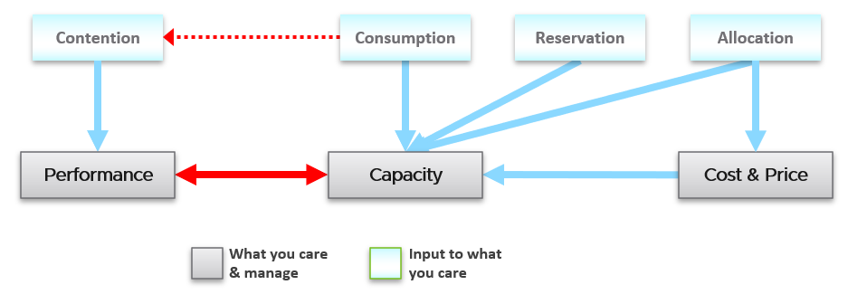

Capacity is affected by Performance as it needs to consider contention metrics not just utilization. If you can’t satisfy existing demands, then you won’t provision new workload, hence capacity is practically full. The utilization metrics may not be high yet, but that’s a secondary consideration as you stop adding new workloads until you figure out why.

Unlike performance, Capacity is measured against usable capacity, not absolute capacity. There is no such thing as usable performance.

Capacity also considers demands that do not manifest yet. This is why you need to consider reservation and allocation.

Price can help address capacity. The best way to address oversized VM is having a price plan that encourage smaller size VM. If price is free then use business justification.

##### Compliance and Security

Just because a system up and fast, does not mean it’s secured.

Security is related, but not the same as Compliance. Security covers issues such as attack (be it by internal employee or by external threat). Compliance deals with configuration settings or values that may expose security loopholes or conform to specific sets of standards.

Compliance is measured against both internal and industry standards. It’s also measured continuously.

Compliance is closely related to configuration as you comply by applying settings.

In Security you worry about being attacked. This means you track malicious activities, such as inappropriate usage of administator account, or denial of service attack.

##### Cost and Price

Last but not least, money. Cost and Price are critical in the transformation towards a real service provider.

|  |  |
| --- | --- |
| **Price** | With hardware becoming commodity and infrastructure becoming invisible, price has naturally become a common denominator among all IaaS providers. The general expectation is price per VM is similar across cloud providers. One way to provide differentiated pricing is SLA.  While Price should be higher than Cost, it can be set independently of cost. Use discount and progressive pricing to set the correct price for the right terms and conditions. Progressive pricing will also discourage large unused VMs to be provisioned in the first place. It’s easier to handle than when these VMs are already in production.  The better the Performance SLA, the higher the price customer is willing to pay, hence the term Price/Performance. |
| **Cost** | Cost goes hand in hand with capacity. The higher the utilization of the IaaS, the lower the cost per VM. Cost is separate from capacity as it can be optimized without reducing capacity.  Cost and capacity can also go independently of each other. You can increase capacity without increasing cost via technology refresh. You can reduce cost without reducing capacity by lowering non-capacity costs such as the rate you pay for services. |

##### Configuration and Inventory

Why don’t I consider them pillars of operations?

Because they are not something you directly care. You care about configuration because it impacts security, capacity, performance and availability.

Inventory is related, but not identical to configuration.

Configuration is a setting, that you either intentionally set or have to accept. Inventory uses a small subset of settings as the focus is on counting the number of objects. The majority of properties/settings managed by configuration are not relevant to inventory.

Inventory is an account of what you have where. So the count matters. Configuration is the properties of what you have. The count is just another property of the object.

Inventory generally asks what do we have where? By that, it's focusing on the quantity, not specifications. Examples:

* Number of VMs in a cluster is a part of inventory. It’s not a part of configuration.
* Number of ESXi hosts in a cluster is a part of inventory. But it’s also part of configuration as that’s the design of that cluster. The cluster is configured with 8 ESXi hosts for a reason, and deviation may need to be explained in documentation.

Deviation is central to configuration management, but not relevant to inventory.

Inventory has concepts such as stock take, which typically involve physical items. Configuration does not.

Inventory also deals with the *change* of inventory. A high number of churns is an inventory problem, not configuration problem. For example, as part of inventory management, you may want to check how many VMs were added, were deleted, were changed in your environment in the last 1 month.

There is a subtle difference between volume of change and the rate of change. Volume typically covers a longer period (e.g. 5 minutes, 1 hour, 1 day), while rate covers shorter period (e.g. per second, per minute).

To make inventory management easier, you typically group them by function. For example, in IaaS, you may have:

|  |  |
| --- | --- |
| **Consumer Layers** | Business Applications (typically this spans multiple pods or VM)  Software (e.g. Microsoft SQL Server)  Container or pod  VM (which could be in cloud) |
| **Provider Layers** | Cloud services (AWS something)  Kubernetes  vSphere + vSAN + NSX  Physical (network, array, server, UPS, racks) |

For DaaS, you naturally have different types of items you care, such as Horizon VDI Pool or RDS Farm.

#### The Processes

Day 0 & Day 1 are typically done by the Architecture team, and Day 2 is typically done by the day-to-day operations team. In large organisation, the Day 1 could be different as there is enough workload for them to continuously upgrade. For example, if you have 3600 ESXi, and you have a 3 year deprecation policy, you’re basically upgrading 100 per month. That means 25 hosts per week on average.

Troubleshooting is often wrongly elevated as importance or status, as if it’s a singular or major area of operations. It is not. What you can troubleshoot, and how you troubleshoot it, should be planned during system architecture phase. Another word, think of what can go wrong, how they can be detected, and the remediation action. If you do not plan the troubleshooting element of your architecture, each actual troubleshooting will be more painful that it needs be.

##### Day 0

|  |  |
| --- | --- |
| Plan | This is where you set the goals. The goal should follow the [SMART](https://en.wikipedia.org/wiki/SMART_criteria) criteria. Make sure they are aligned with the business deliverable.  For example, if you plan to build a private cloud, how do you measure success? What are the metrics so you know how successful you are? |
| Size | A big chunk of planning is sizing the environment.  Some companies perform stress tests and load tests, so they know what to expect when the real load occurs. Without planning and testing, you don’t know if the reality should be, as you do not have a measured goal.  When you architect that vSAN, how many milliseconds of disk latency did you have in mind? For example, you set the goal of 10 ms measured at VM level (not vSAN level and not at individual virtual disk level) based on 5-minute average. |

##### Day 1

|  |  |
| --- | --- |
| Design | This is where you design, build the system and launch the service. This includes configuring the various operations input such as cost drivers (e.g. application license cost, electricity rates). This is not part of the book as there are plenty of materials on it.  Day 1 is generally closer to Day 0, as it’s a realization of your plan. |
| Build | Ideally this is automated to ensure what is designed is 100% identical to what is built.  This includes deployment of the infrastructure, physical and virtual. |
| Test | Ensure what is built works as intended. For example, if you build a vSphere cluster, test that each ESXi can recover from HA. |
| Upgrade | I do not consider Upgrade as part of Day 2. Day 2 is managing what you have, not changing it. Upgrade also varies from a simple patch to complete rearchitecting, where you are running the old and new system side by side. This type of upgrade is basically a migrate, as you have the luxury of a new build. It also involves substantial planning, so you might have to circle back to Day 0. |

##### Day 2

Day 2 should include proactive test of the system resiliency and security. Monitoring is more than checking dashboard. It’s about ensuring that the system is able to handle emergency and remain secured.

|  |  |
| --- | --- |
| Deploy | This refers to the deployment of workload, not infrastructure. |
| Migrate | This refers to existing workload that is already running. They are being migrated to the new environment. |
| Monitor | This is where you compare Plan vs Actual. That’s why the goal must be clearly defined. Does the reality match what your architecture was supposed to deliver? If not, then you need to adjust your plan. That’s why Plan and Monitor form a circle.  For example, you plan to deploy VDI for 10K users. At 1K, you find out that the users are consuming more resources than plan. You either need to scale down your deployment, or add more resource. |
| Prove | You have redundancy (HA) and DR right? How do you know they work if you never test them in years? A pair of core switch that has been left untouched for years may give you a surprise when there is an unplanned HA event. Once a year, test your HA to make sure they work.  Annual reboot could be a good idea to clear cache and logs. As part of firmware, drivers, OS, Tools updates you may need to reboot anyway. Take advantage of this downtime by testing the resiliency of your infrastructure.  Another area you need to test is security. Conduct independent penetration test. |
| Troubleshoot | You do this when reality is worse than plan, or something amiss, not when there is a complaint. You want to take time in troubleshooting, so it’s best done proactively. And quietly with no one rushing you for results 😊  That means redefining what each color means. Red should not mean you drop everything you do and start firefighting right away.  Text  Description automatically generated |
| Optimize | As part your monitoring, you may not discover problem, but you spot opportunity to make performance even better, reduce cost even further, and free up wastage in capacity. It’s common for new version to deliver performance improvement. Again, you do this proactively, not waiting for complaint to happen. |

##### Monitor vs Troubleshoot

Monitor is **What**, while Troubleshoot is **Why**.

Troubleshoot requires expert team. The expert team is also the team setting up the thresholds used by the Level 1 team. Troubleshoot involves logs analysis, as many systems do not generate complete metrics, and there can be many different causes behind a common problem. At the end, the actual root cause may not even be closely related to the problem. Troubleshooting is much more than simply “finding out” and goes beyond just gathering facts. It focuses on why, and then formulates a solution to prevent future incidents. Incidents mean something is dead, slow or breached. You troubleshoot availability, performance, and security. Capacity and cost are not something you troubleshoot.

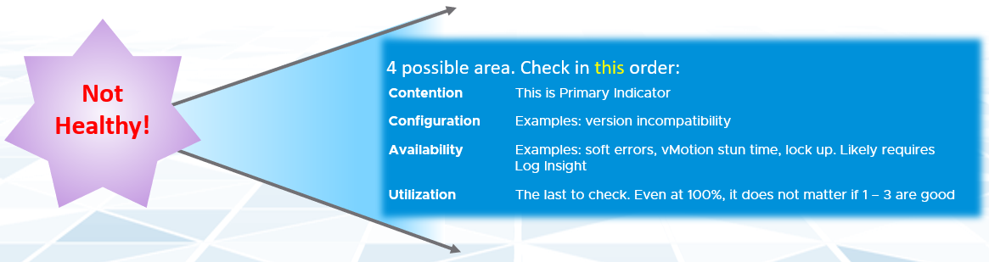

Due to its complex nature, the first time an incident happens is forgiveable.

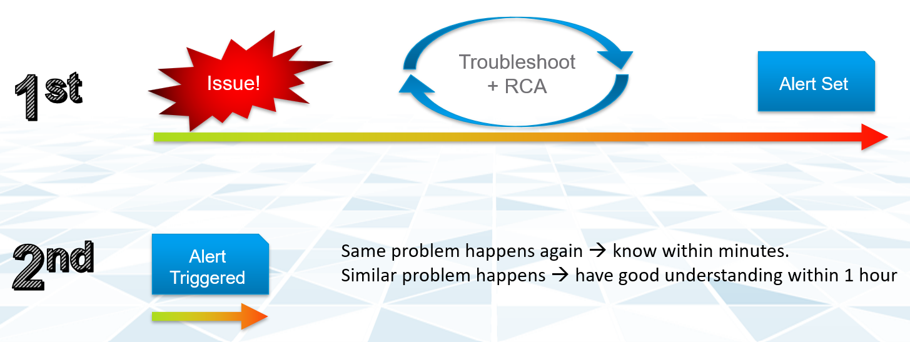

Day to day operations become more systematic when you distinguish between monitor and troubleshoot. The following table shows the difference:

|  |  |  |
| --- | --- | --- |
|  | **Monitor** | **Troubleshoot** |
| Question answered | What is the problem? | Why does it happen? What is the actual cause of the problem? |
| Nature | Proactive. | Reactive |
| Expertise | Low. A junior IT person is better suited, as it’s repetitive tasks, with the aid of predefined dashboard and alerts | High. Needs experienced IT Pro as there is wide variances on the steps taken. Also needs someone who understands the environment. |
| Metric | Generally, 1 metric. And this metric is also the SLA. This is the 1st metric you or your customer check.  Primary metric. You check it proactively as part of your SOP | Always many metrics. There are layers of metrics, one impacting another.  Secondary metric. You only check if the primary is reaching threshold |
| SLA | SLA is applicable in monitoring | Yes. It becomes urgent if SLA is breached. |
| KPI | Use KPI in monitoring instead of individual metrics. | Yes, but as a starting point. You then drill down into supporting metrics, which are often raw metrics. |
| Duration | Should take just 5 minutes | Can take days, with back and forth discussion among various team. |
| Frequency | Performed daily.  Gold Class will have higher frequency of regular monitoring than Bronze, as part of SLA | On demand. |
| Timeline | Now and Future. You consider future load and anticipate. | Now. Future is irrelevant. Your focus is to put out the fire or potential fire. |
| Logs | Not required. Metrics, properties and Event suffice. | Almost always required. For network troubleshooting, also need netflow data. |

In most cases, monitoring is best done using a 5-minute interval, as 1 minute of bad metrics may not have business impact. Troubleshoot on the other hand may require per second granularity. However, that does not always mean you need to see each and every counter, if your remediation action is the same.

If you want to codify troubleshooting, then consider a layered approach. This makes it easier for the less technical team. Classify your troubleshooting metrics, events and properties into 2:

|  |  |
| --- | --- |
| Primary Metric | This defines performance. It is the What. This is always expressible as 0 – 100%, so it’s easier for Level 1 team. It’s almost always a hybrid metric.  Example: Kubernetes Cluster Performance (%) |
| Secondary Metrics | This provides some explanation to the primary metric. It is the Why. Aim for this to be expressible as 0 – 100%, so it’s easier for Level 1 team.  Example: Highest ESXi Memory Consumed (%) in a Cluster.  Metrics that can’t be color coded is harder for Level 1 team, as the meaning depends on the context.  Example: VM Disk IOPS |

##### Optimize

Optimization delivers many practical benefits and real business results. Here are some of them:

|  |  |
| --- | --- |
| Lower Cost | Reclamation: Orphaned VMs, powered off VM, Idle VM, Oversized VM, snapshot  Reduce DC footprint: Saves Software (MS, RedHat, VMW, etc.) and Hardware (server, storage, network) + Data Center (rack, space, cooling, UPS)  Move burst capacity from Own to On-Demand. |
| Better Performance | Performance Profiling. Enable proactive monitoring via actual baseline.  Establish Performance SLA, complementing Availability SLA  NOC Dashboards. Insight, then Alerts.  Faster business service via self service + approval workflow |
| Lower Complexity | Standardize architecture  Simplify business policy or security policy  Standard Operating Procedure  Reduce human error by automation  Replace ageing hardware, and upgrade outdated software. |
| Higher Customer Satisfaction | Internal IT department. Reputation among Applications Team.  External SP. Repeat business  Ability to justify or defend pricing. Price/Performance |
| Higher Compliance | Internal compliant (e.g. vSphere hardening)  Industry regulation (e.g. PCI DSS, HIPAA) |

I’m sure there are more of them. Drop me a note with your real-world story!

##### Standard Operating Procedures

Define your [Standard Operating Procedure](https://en.wikipedia.org/wiki/Standard_operating_procedure)s (SOP) to ensure knowledge is captured and lessons are learned. It’s also important to know “who does what when” to ensure gaps are covered. If your operations are partly or fully outsourced, ensure the vendor provide the documentation.

Having SOP does not mean that you do not have ad-hoc task at all. You do however, want to keep them minimum and so they are manageable.

Let’s review some examples of SOPs that you should have.

###### Live!

This is assisted with a set of live dashboards on the big screen in NOC, showing real-time metrics and events. As the time duration is basically minutes, capacity is typically not relevant. You focus on availability, performance and security.

The focus is to gain early warning, hence buying time if operations turn into an emergency. That means there is no alert triggered yet.

You want to put out fire fast.

|  |  |
| --- | --- |
| **Availability** | Focus on undesirable event. Make sure they match your expectation of what is actually happening in your environment at that time. For example, if you’re not deleting VMs and the live screen shows many VMs being deleted, something amiss. |
| **Performance** | Focus on overall performance and make sure the fluctuation is within your expectation. |
| **Security** | Focus on suspicious activity such as loosening of firewall rules and usage of administrator account |

###### Daily

The daily SOP should look ahead, using the historical data and business context as a guide.

|  |  |
| --- | --- |
| **Availability** | Check for soft errors. This likely require you to look at the logs from each hardware and software vendors. For example, vSphere has proactive HA. |
| Ensure back up is performed. For example, if you take a snapshot of 1549 VM and only removed 1518, the backup likely failed to consolidate the snapshot. |
| **Performance** | Insight analysis. Look at the overall environment.  Mission Critical VM Performance. Focus on looking forward to the next 1 day, by considering the pattern in the last 1 week. Know the expected workload, by working closely with the business owner. |
| **Compliance** | Ensure non-compliant is remediated. |
| **Security** | Check for potential security attack, such as loosening of firewall rules and usage of administrator account |
| **Configuration** | Check for misconfiguration that can cause issue. |
|  | Implement urgent patches, after appropriate validation |
| **Capacity** | VM provisioning. Ideally this is automated, so it happens throughout the day. In this way, your developers need not wait for end of the day. What you need to ensure if the aggregate load do not overwhelm the shared environment. |
|  | Snapshot deletion. Set up a policy to delete snapshot older than say 3 days. You do not want to wait until 1 week.  Ensure the exclusion is properly implemented, so you do not delete from VM whose snapshot you’ve agreed to keep. |
|  | Powered off VM deletion. Once a VM passes the powered-off definition, there is no need to wait for another week before you delete them. You do have back up, don’t you? |
|  | Powering off Idle VM. Once a VM passes the idle definition, there is no need to wait for another week before you gracefully shut the OS down. |

###### Weekly

Weekly or longer is suitable for different type of tasks. As you have more time and are working on longer time horizon, you should look at both the big picture and look ahead.

The end of the week is a good time to document the changes and lesson learned from the week, and plan ahead for the next week.

|  |  |
| --- | --- |
| **Capacity** | Capacity monitoring and planning. Check actual growth vs projection (plan) |
| Reclamation Process. VM rightsizing, Idle VM, etc. This can be done weekly as you need to deal with the VM owners. |
| **Compliance** | Root cause for non-compliance is documented and preventive measurement is put in place so it does not happen again. |
| **Configuration** | Minor update. For example, from vSphere 7.0 U1 to U2. This is typically part of standard IT tech stack hygiene, where you keep up with the update from all your vendors while making sure they are compatible. This protects you from security non-compliant and emergency patch during business hours.  Review does not mean immediate implementation. For example, there is a newer version of VMware Tools. You may decide to start implementation in 2 months, as you have 15K VM and you need to prioritize and batch them. |
| Major upgrade. For example, from vSphere 6.5 to 8.0. This is typically a one-off project, as opposed to regular maintenance. The implementation is typically executed within a green zone, so other regular maintenance may be deferred to make space. |
| **Overall** | Weekly Management Report. Focus on reviewing the operations of the week, and plan for next week. |
| Review of ad-hoc events. What’s the lesson learned and can they be turned into an SOP and alert set up? |

###### Monthly

The month serve as logical time period as human and business we relate well with the calendar months. There are different activities at the end of the month or the start of the month.

|  |  |
| --- | --- |
| **Availability** | Restore test of backup. Make sure it can be restored and the data is readable. |
| **Configuration** | Less urgent update. Review new versions and ensure you do not fall too far behind |

###### Longer Cadence

You complement the above frequent SOP with regular cadence with longer time horizon. Naturally, the focus on big picture, major project, and strategy.

|  |  |  |
| --- | --- | --- |
| **Quarterly** | Overall | Quarterly Management Report. Focus on longer term items such budgeting. |
| Cost | Budgeting. Review actual versus plan |
| Availability | DR Test (Production is still running). Isolate the network. To ensure users are comfortable with the procedure when actual DR strikes. |
| **Half-yearly** | Availability | HA Test. Actual test that your HA works as intended. Covers vSphere, physical switches, storage array, etc. |
| **Yearly** | Availability | Actual DR Failover (Production not running) and Failback to primary DC |
| Capacity | Inventory Stock Take. To discover unused VMs and physical items in datacenter |
| **Ad-hoc** | Capacity | Unexpected demand. This is why it’s important for capacity team to stay close with the business, especially the one working on major initiatives. |

##### VM Life Cycle

This should be supported with an approval system, so all Change Request and associated actions are properly recorded. This eliminates finger-pointing in the future. It will also support audit, who is keen on “who did what change to which object on when”

|  |  |
| --- | --- |
| Stage | Notes |
| Request | If VM is free (price is basically $0), then rely on business justification and IT policy. Policy states the criteria for the different class of services.  VM size is requested by the application team, approved by their management. For size or quantity above certain threshold, IT should review. |
| Creation | The actual deployment of the VM in vCenter. This is ideally automated.  This stage generates the actual VM name, create folders if necessary, place the VM into the correct folder,  Once the VM object is registered in vRealize Operations, create the custom group is necessary, and set the custom property |
| Changes | Changes on VM size needs to be approved as it impacts capacity and performance. If you have to use shares and reservation, ensure they are updated accordingly. |
| Retire | Delete the VM and remove it from inventory. |

#### The People

There are many personas required to keep the operations running well. Some are directly involved on the day-to-day operations, while others focus on the big picture, hence requiring longer time frame. In small organisation, the roles are played by the same few people, backing up each other. You can have 3 people doing everything with no structure, or 300 people with clear demarcation and formal hierarchy. Regardless, the jobs still need to be done, so document all the roles and responsibilities.

There is a many to many relationship between “jobs to be done” and persona. It reflects the dynamic nature of live operations. You have team members taking leave or away, hence need someone else to step in on an ad-hoc basis.

|  |  |
| --- | --- |
| **Level 1 Operators** | Deal with the production environment. Perform a regular check on the overall environment. Use both insight and alert. Typically does not require reading logs.  Responsible to close alert. Alert should be closed only when root cause is known, not when symptom disappear. Closing alerts without knowing why they happened prevents lesson learned and can potentially backfire.  Perform simple troubleshooting, following SOP. SOP is ideally automated, taking input parameters, so the chance of human error is minimized if the number of manual steps or frequency is high.  Focus on Health, which is Availability and Performance.  Typically stationed at NOC and called the Help Desk.  On larger organization, the network team is typically separate. |
| **Level 2 Operators** | Activated when Level 1 is unable to solve the problem. For each problem solved, this role should update the troubleshooting guide so Level 1 can be empowered.  Focus on insight, not alert. Look at the big picture and try to prevent alert from happening. They focus on risk (e.g. configuration risk, compliance risk).  More senior than Level 1. May specialize is some areas (e.g. vSAN, networking). They document the knowledge base and develop SOP. They automate the SOP as much as possible.  Perform advance troubleshooting, which often requires logs analysis. Work with architecture team.  Lead or involve in the evaluation of operations management tools. Design and maintain vRealize dashboards and alerts.  Focus on Health, Risk and Efficiency.  In larger organization, there can be more levels. |
| **Operations Manager** | Manage the level 1, level 2, level 3 operators.  Deal with business on SLA. |

The above roles focus on the day-to-day operations. There are other roles that Ops Team need to deal with. Here are some of them. In larger organisation, each could be a team on their own.

|  |  |
| --- | --- |
| **Security** | In large organization, this could be a department by itself. It could also report outside IT.  They work closely with the Compliance persona |
| **Compliance** | Set the compliance settings to agreed internal and industry standard.  Verify that non-compliance alert was addressed timely and correctly by the operations team. Report & discuss the compliance status with upper management.  Focus on Risk (Configuration, Compliance) |
| **Capacity** | Plan the supply side of capacity, working with architect role.  Plan the demand side of capacity, working with line of business or sales team.  Does not get involve in the day-to-day capacity. ESXi Host going into maintenance mode is an operational problem, not capacity management matter. |
| **IT Finance** | Typically work with Capacity Team |
| **IT Management** | There can be multiple levels here, all the way to the CIO.  Look at the big picture, trend over time, and future. Not so much what’s going on hour by hour.  Generally does not get involved in troubleshooting and architecture.  Primary focus is Compliance and Cost. Performance is not as that was likely promised to be good by the Architect as part of the design. |
| **Architecture** | Design the system architecture. Needs to get input from Day 2 team, and design with the end in mind.  Look at the future. Evaluate new technology and assess if technology refresh or migration to a new architecture makes business sense.  May lend support on complex troubleshooting.  On larger organization, the network team is typically separate. |

There is a newer role, called Site Reliability Engineer ([SRE](https://en.wikipedia.org/wiki/Site_reliability_engineering)), which focuses on the automation and are closer to the application stack. They are involved in the life cycle of application, hence it’s related to [DevOps](https://en.wikipedia.org/wiki/DevOps). I see them as a variant of Level 2 Operators, because the philosophy in this book is SLA-based and proactive operations. To have SLA, the Sys Admin needs to run an application-centric operations.

##### Desktop Operations

We covered the various roles required in IaaS operations earlier, so let’s dive into the roles specific for DaaS operations. Depending on the size & complexity of the VDI architecture, there can be many roles involved in operations.

|  |  |
| --- | --- |
| **Level 1 Ops** | Reactive: respond to user complaint or alerts and perform simple remediation. Typically does not require reading logs.  Proactive health check of the environment, as part of the SOP. Look at availability, performance and compliance. |
| **Level 2 Ops** | Reactive: Perform advance troubleshooting. Likely require reading logs and Windows Events.  Proactive: Analyse the overall environment, especially from performance and availability. Should do this at least once a week. |
| **Architecture** | Day 1: design and deploy the architecture.  Day 2: Using the actual consumption data in production, think of improvement to improve performance, lower cost and reduce complexity. This gets fed into Day 1, forming an upgrade cycle. |
| **Capacity** | Day 1: plan and size the capacity. Pod, Pools, Farm, etc.  Day 2: Review the pool and farm capacity. Depending on the volatility, this could be done monthly. |
| **Compliance** | Set the compliance settings to agreed internal and industry standard.  Verify that non-compliance alert was addressed timely and correctly by the operations team. Report the comp |
| **IT Management** | Weekly report, focusing on the overall health and not individual users or pools.  Monthly presentation and review, supported for live dashboard for an interactive discussion. |

The responsibilities cover all the pillar of operations. As Horizon requires vSphere, Microsoft ADAM Database, Microsoft Active Directory (MS AD) and other components, you need to manage all of them as a system.

|  |  |
| --- | --- |
| **Availability** | Any desktops that are in bad state?  Any availability problems in Horizon servers, vSAN, NSX, vSphere, DC network switches, WAN network? |
| **Performance** | There are 2 sides of performance: a single user and the whole DaaS.   * A single user troubleshooting may require going deep into the user’s desktop and user’s specific settings (e.g. MS AD group policy, MS Outlook plugins). Tools such as [SysInternals](https://docs.microsoft.com/en-us/sysinternals/) and Windows Event analyser can come in handy. * DaaS-wide troubleshooting requires going broad into all the users (affected and not affected with the issue). It requires analyses across the stacks. You likely need various adapters of vRealize Operations and Log Insights, and develop your own custom dashboard that’s specific to your architecture. |
| **Capacity** | There are 4 parts of DaaS capacity.   1. The desktop, pools and farms. Make sure the desktop is rightsized, and the pools & farms can meet the load. 2. Horizon servers and infrastructure. This covers Horizon servers (Connection Servers, Universal Access Gateway and App Volume Managers), non Horizon servers (Microsoft SQL Servers, MS AD, Load Balancers, AV servers, single sign on servers, security servers). 3. The network. This excludes the data center network, but includes the client network and the Wide Area Network (WAN). The client network can be in the form of shared office, café or mall, airport or home. The WAN can be a mixed of mobile, wireless or leased lines. 4. Underlying SDDC where the EUC is running. |
| **Cost** | VDI has a direct comparison to a physical laptop or desktop. One reason why VDI does not dominate End User Computing market despite being decades in the market is their cost is comparable with laptop or desktop, and laptop provides the offline capability.  One way to keep the cost down is the consolidation ratio. How many desktops or users can you pack into a single cluster? |
| **Compliance** | Different users may require different compliance. How do you prove that you’ve delivered continuous compliance? |
| **Configuration** | Any misconfiguration, outdated configuration, incompatible configuration or suboptimal configuration? This needs to be checked across the entire stack, especially the lower stack as problem in a stack will impact the stack above it. |

From the brief summary above, you can see that VDI operations management is complex. It’s much more than waiting for user to complain and then troubleshoot a single desktop. Minimize the time troubleshooting single users by optimizing the Windows image, so you can focus on wide-spread problems. Using [VMware OS Optimization Tool](https://flings.vmware.com/vmware-os-optimization-tool), you can get improvements such as reducing CPU Usage, disk IOPS and login time.

### Insight | Alert

|  |  |  |
| --- | --- | --- |
|  | Alert | Insight |
| **Goal** | To fix | To prevent |
| **What it is** | A formal event with ticket recorded in the system. May have an incident | Not a formal event. No incident. |
| **Timeline** | Hours (Today) | Tomorrow – Next Week |
| **What For** | Urgent matters. Hopefully not important | Important matters. Hopefully not urgent. |
| **Nature** | Reactive. System tells you | Proactive. Start of Day SOP and Health Check |
| **Starting Point** | A specific alert | The big picture of overall environment |
| **Situation** | Known problem | No known problem |
| **User Interface** | Start with Email or notification on your mobile phone | Start with a big Dashboard on desktop/laptop |
| **Expertise** | Low. Follow steps | High. No steps to follow |
| **Familiarity** | Does not need to know the environment and workload well | Must know well. |

Many operations rely on alerts as the starting point. Actions are taken based on alerts, resulting in reactive day-to-day operations.

IT Operations cover a wide area of systems. It’s common to see > 1K alerts definition across all the systems under monitoring. As the team wants to be alerted early, a conservative threshold is set up. This results in alert storm.

Since automation is wrongly perceived as the holy grail of solution, alerts are typically set to auto close if the symptom disappears. The creates a bigger problem, common in large enterprise with a large IT team. That problem is “lazy operations” when no alert is associated with no problem.

Alerts rely on threshold, be it dynamic or static. Threshold has an inherent limitation. It misses the big picture, as it can only see what has crossed the threshold. For one object that reached this threshold, there could be many just beneath it. For one alert, there could many supporting metrics that have shown the potential root cause. Think of an iceberg. The small portion above sea level, the visible part, is an alert. It misses the total picture.

To turn this situation around, vRealize Operations provides insight. Insights complement alerts, it does not replace it. Insight does not have “auto close” concept as it does not involve help desk ticket. It’s recording a fact that something has gone wrong, and that something could potentially cause an alert.

Insight requires an expert, someone who knows what he is doing. He knows the environment well and proactively try to prevent problems. Insights answers much harder questions, which are typically fuzzy hence they can’t be defined as alerts. Examples of questions are:

* Are we being attacked? Are they events and activities that happens in parts of our environment where they are not supposed to happen?
* Is performance degrading? Is there any common pattern and cause?
* Is the environment behaving differently to what we expect?

There is a common misconception that Insight is simply alerts that use different threshold on the same metric. So insight is basically an alert with lower threshold. This is valid, but incomplete. Implementing insight this way can result in an alert storm and a lot of tickets. Insight uses many more metrics than alerts, especially the supporting metrics.

Insight focuses on the underlying problem. It also helps buy you time so you can address the problem before the user complains. In the following example, the alerts use the SLA metrics and threshold. The insights use more granular metrics and supporting metrics.

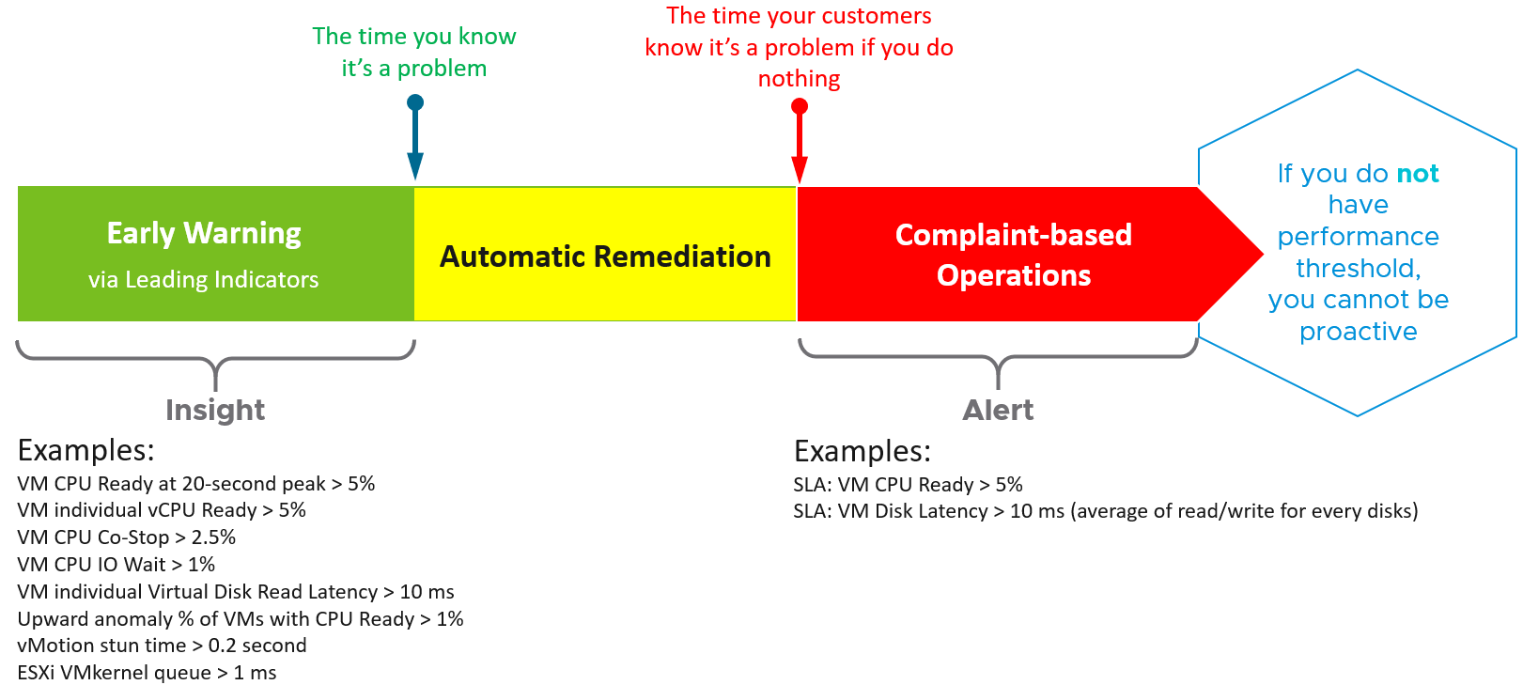

What do you think of the preceding example? Would it result in less alerts but also less reactive troubleshooting?

The main limitation is proactive is false positive. It also requires the daily operational discipline.

Insight is useless to those who are not familiar with the environment. The numbers shown by insight should match reality, and only a person intimately involved with the actual operations can sense if the numbers are not correct. Let’s take an example. The insight shows your total IOPS throughput is low. If you don’t know what to expect on that day, that number is meaningless. But if on that day you expect a high throughput because it is the largest sales in your company history, then you know the sales is not happening as per expectation. Proactively check before your CEO complains why business is not doing well.

## Performance Management

**Part 1 Chapter 2**

Performance is about ensuring workloads get the necessary resources. KPIs should be used as leading indicators, giving early warnings before SLA is breached.

### A Day in the Life of a Cloud Admin

To understand what Performance actually is, it is always good to begin with the customer. As shared earlier, what you bought from your vendor is SDDC, but what you sell to your customers is IaaS. We have seen this in almost all customers. Whether the Application Team or VM Owner pays for the service with a chargeback model or not, it is a service. VM Owners no longer own, hence care, about the underlying infrastructure.

Here is a common story often told in the virtualization community, which will resonate with you as an IaaS provider.

A VM Owner complains to you that her VM is slow. It was *not* slow yesterday. Her application architect and lead developer have verified that:

* The VM CPU and RAM utilization did not increase and are within a healthy range.
* The application team has verified that CPU Run Queue is also in the healthy range.
* The disk latency is good. It is below 5 milliseconds.
* There are no network packets loss.
* No change in the application settings. In fact, the application has not had any changes in the past 1 month.
* No recent patches were installed into Windows.
* There was no reboot. It has been running fine for weeks.

She said your VMware environment is a shared environment, and perhaps an increase in the number of VMs and an increase in the workload of other VMs are straining your IaaS.

She also said that her other VM, which was [P2V](https://en.wikipedia.org/wiki/Disaster_recovery) recently, was performing much faster in physical.

You are right. She is saying it’s your fault 😊

What do you do?

It is certainly a difficult situation to be in. You oversee more than 10,000 VMs. You have successfully consolidated them into 500 ESXi Hosts, saving the company 9500 servers, not to mention a lot of money. You built your reputation during the process, so this is not just a matter of her VM not performing. Your reputation is at stake here 😊

You also recall that your team has been adding new VMs regularly in the past several months so she could be right. In addition, there have been several soft errors in your network and storage, and your team has been investigating for weeks. But why did she say it only happened today, but not yesterday or a few days ago?

It’s a hard question. To answer it, we need to take a step back and elaborate. Let’s dive in!

### The 3 Realms

In the big picture, there are three main realms of enterprise applications. Each realm has its own set of teams. Each team has a set of unique responsibility and hence skills required. The following diagram explains the 3 realms, alongside with typical layers within each realm and questions being asked.

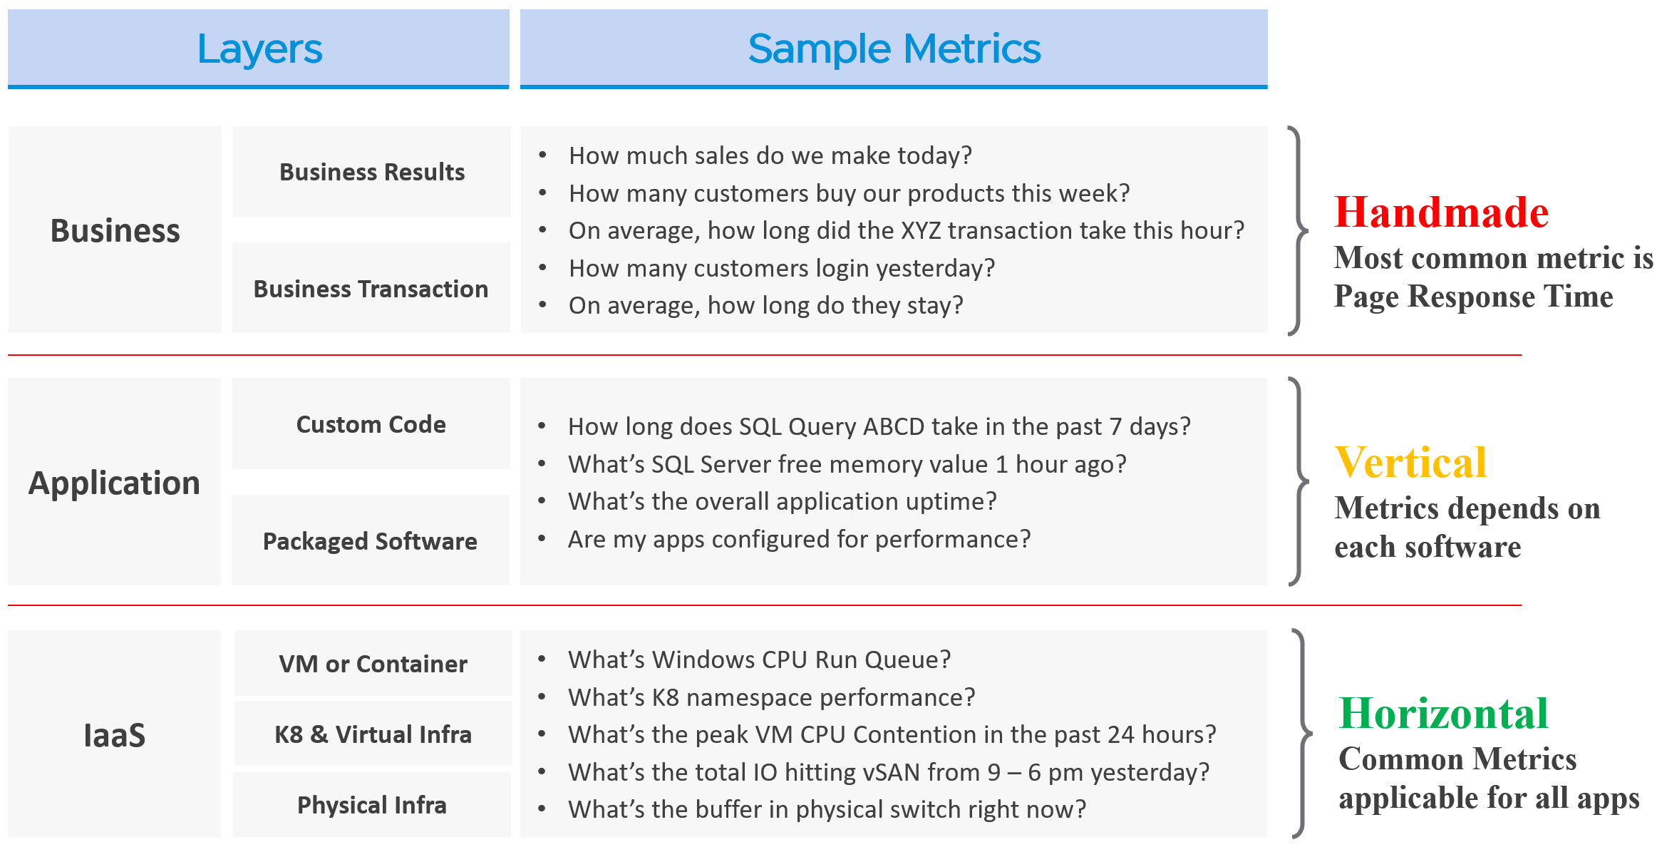

The fight typically happens between Team 1 and Team 2, as both are IT. The business folks are real consumers or end users and not technical enough to provide solution. Each team need to have their own KPI, and there must be SLA between them.

While business runs on IT, not all business KPIs are depending on IT. Some depends on marketing, discount, and what your competitors are doing. Take an ecommerce portal. Its top business KPIs are certainly revenue generated and gross profit. As you can imagine, if your competitors are doing a massive discount, you may not be able to achieve your sales and profit target.

That means there are 2 types of business KPIs: one relying on IT, one does not.

Examples for the ones relying on IT are business transactions (e.g. buy a product, update personal information, transfer fund) that are provided by the system. They can be online (real time, a user is waiting) or batch (runs at the background) in nature. They can be user to system, or system to system. The online is sometimes called Online Transaction Processing ([OLTP](https://en.wikipedia.org/wiki/Online_transaction_processing)) and is often measured in time taken to process a single transaction (typically less than a few seconds). The batch is often measured in time taken to process many transactions (which can be hours).

As you can imagine, different transactions require different amount of time. Even the same amount of transaction (e.g. generate a report), can vary as it depends on the amount of data or records. As an application architect, define the expected time taken to complete commonly used business transactions. Obscured business transactions that are rarely used can be given low priority. However, this effort is not scalable if you have hundreds of business applications.

If you want universal metrics for all business applications, then page response time and error returns are the only metrics.

By the way, for those who use enterprise architecture framework, the 3 realms above actually map to TOGAF[8] by [The Open Group](https://www.opengroup.org/togaf).

* Business maps to Business Architecture
* Application maps to Information Systems Architecture
* IaaS maps to Technology Architecture

Performance troubleshooting is largely an exercise in elimination. The methodology slices each layer and determines if that layer is causing the performance problem. Hence it is imperative to have a single metric to indicate if a particular layer is performing or not. This primary metric is aptly named Key Performance Indicator. We will cover it more here.

The upper layer depends on the layer below it, and hence the infrastructure layer is typically the source of contention. As a result, focus on the bottom layer first, as it serves as the foundation for the layer above it. The good part is this layer is typically a horizontal layer, providing a set of generic infrastructure services, regardless of what business applications are running on it.

Now, we don’t know the impact to the application when there is latency in the infrastructure. That depends on the application. Even on the same identical software, e.g. SQL Server 2019, the impact may differ as it depends on how you use that software. Different natures of business workload (e.g. batch vs OLTP) get impacted differently even on the identical version of the software.

#### The Layers

Depending on the application and infrastructure architecture, there can be more stacks or layers. The following example shows 5 layers. The challenge in performance troubleshooting is the layers may not share context.

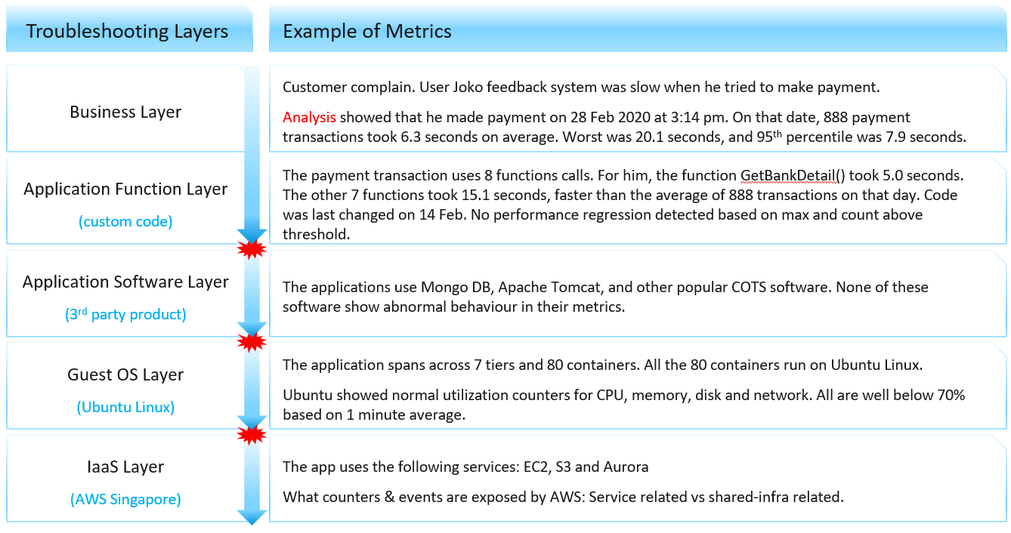

Using the example above, we can demonstrate how the lack of visibility is making troubleshooting virtually impossible. Let’s run through the above. The story starts with a complaint as that resonates better.

At the Business Layer, you can see the performance of each business transaction. You not only know which user was affected, you know what transaction was affected as the metric has transaction ID. You can trace it in the code as you know how long each function calls take place, assuming you log for every single transaction.

The problem starts when you move beyond your code and into Commercial of the Shelves (COTS) software. The software may show that its queue is 10000, which is 5000 more than what the manual say it can handle. But you have no idea if user Joko transaction was in that queue or not. The COTS software metrics do not relate to users anymore, let alone individual transactions. The red explosive icon marks where context is lost.

Moving from application to infrastructure resulted in another loss of context. Windows or Linux has no idea what applications you’re running. As far as the OS is concern, every application is just a process. It will report basic CPU, Memory, Disk and Network utilization per process. More advanced metrics are reported at OS-level, system wide. For example, you do not know if your process was the one experienced network [packet loss](https://en.wikipedia.org/wiki/Packet_loss). The packet loss metric is a system-wide metric.

Moving from individual EC2 or VM to the shared infrastructure results in another loss of context. In the case of public cloud, you may not get visibility into the physical layers at all.

#### IaaS

Let’s apply the layers to IaaS.

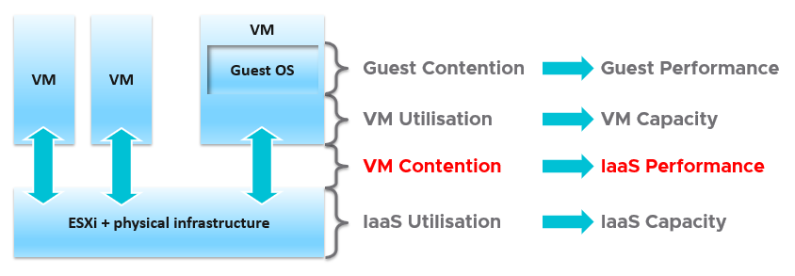

The 1st level is the Guest OS contention. This is beyond the control of the IaaS. It’s completely up to Guest OS to manage their given resources.

The 2nd level is useful for tracking the VM capacity. Say a VM is given 8 vCPU. If you want to know if it’s using it, this is the area where you measure it. Whether you measure it In-Guest or VM level, it depends on the specific use case because each layer lacks visibility into the other.

The 3rd level is where the VM meets the provider. This is where you track if IaaS is serving the VM.

The 4th level is the underlying IaaS. This level is irrelevant to the VM Owner. This is normally the domain of Capacity Planner and troubleshooting specialists.

Let’s drill down further, breaking the layers more.

#### IaaS Layers of Metrics

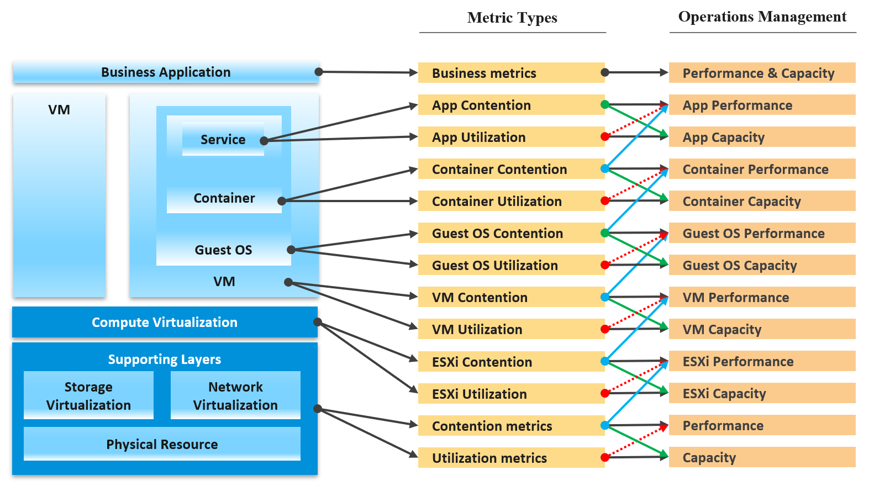

Notice how consumer and provider metrics are intertwined. The consumer contention becomes the performance metric for the provider.

The Consumer group consists of

* Business Application. This can span multiple VM, container and serverless. The metrics here are business metrics, not IT metrics. They are the best at measuring the application performance, but they can’t explain why it’s not performing,
* Service. This is a process running inside Windows or Linux. We normally call this application. An example is a database server.
* Guest OS. There are 2 kinds of performance metrics. One at Windows/Linux layer, one at driver layer (e.g. PVSCSI, vmxnet)
* Container. This typically runs inside a VM. If there are more than 1 container in a VM, it makes operations management harder.
* VM.

The Provider group consists of

* Compute virtualization, also known as hypervisor. This is where the VM or container is running.
* Storage and Network virtualization. They act as subsystem, supporting layer. Ideally, they should have VM-level metrics, so you can observe how a single VM performance deep into the storage and networking stack.
* Physical resource. With hyperconverged, the only remaining is basically network equipment, due to their function as interconnect.

Contention is placed above utilization as that’s what you should drive your operations. As [Mark Achtemichuk](https://blogs.vmware.com/vsphere/author/mark_achtemichuk) said in [this article](https://blogs.vmware.com/vsphere/2015/11/vcpu-to-pcpu-ratios-are-they-still-relevant.html), drive by contention. For each layer, you have a set of metrics. The black line indicates that contention is the primary counter for performance, and utilization is the primary metric for capacity.

The green line shows that contention metrics give valuable input to capacity by showing how much additional capacity is required. For example, the number of queues in the CPU should be used to determine the amount of CPU to add.

The blue line shows that contention in the underlying layer directly impacts the performance of the layer above. For example, if a Guest OS experiences disk latency, the application will feel the impact. That can result in a ripple effect to the top layer.

The red line is not solid, as it’s showing a misconception. If contention = 0, then utilization at 100% is in fact maximum performance. If we can’t measure the contention, then add the buffer (e.g. 90% utilization) as queue tends to develop at high utilization. On the other hand, you can have poor performance at low utilization. Many things can cause this as there are many possible configuration errors. Here are just some.

#### Impact on Capacity

The following diagram shows 3 different scenarios on how contention and consumption can play out:

* What you think will happen. You theorize that contention will only happen when utilization is high, and the unused capacity acts as cushion to prevent unmet demand from happening.
* What actually happens in most environment. Demand is unmet even though utilization is not high, due to suboptimal configuration or constraint. Imbalance and incorrect cluster configurations are two typical causes of contention at low utilization.
* What would happen if your environment is optimized. You have very high utilization yet you keep unmet demand within the promised SLA.

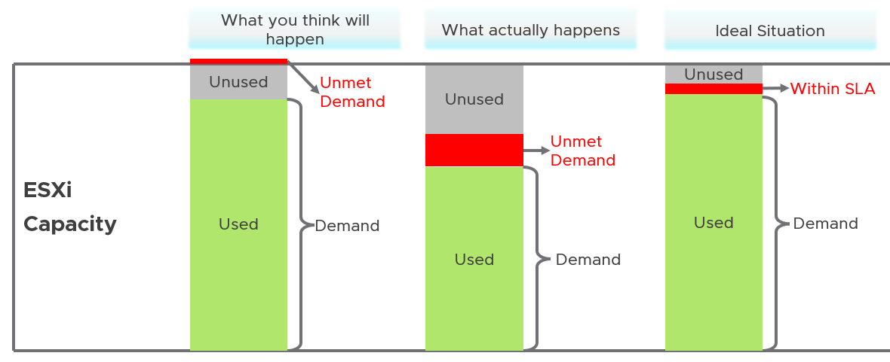

Don’t confuse “**ultra-high**” utilization indicators as a performance problem. High utilization does not compromise performance, so long as there is no queue or contention. Just because an ESXi Host is experiencing ballooning, compression, and swapping does not mean your VM has memory performance problem.

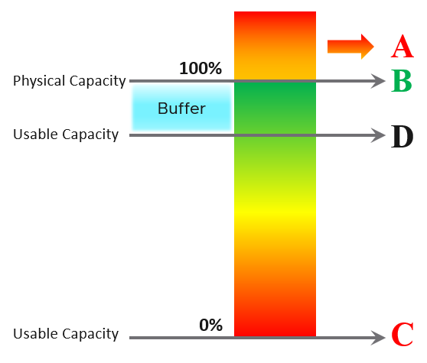

|  |  |
| --- | --- |
| A | It’s a common misperception that performance problem happens mostly here. It actually rarely happens here as utilization rarely exceeds 100% |
| B | Maximum utilization is achieved at 100% utilization. Consequently, the overall Performance is best here as it completes the most amount of work. |
| C | Worst performance actually happens when utilization = 0% as nothing gets done. The demand is not being met at all (for whatever reason). |
| D | This is the threshold of Usable Capacity. It has nothing to do with Performance. Performance is in fact better above this threshold. |

### Performance vs Capacity

Think of it as Speed vs Space.

The relationship between capacity and performance varies depending on the object. Consumer objects (e.g. VM, K8S Pod) have different natures than provider objects (e.g. vSphere Cluster, vSAN Cluster). For provider objects, performance is always bottom up. You start with the VM running inside in the provider object, and then aggregate the metrics. Capacity is always top down. You look at the big picture first, then drill down. For example, you start with the vSphere cluster, then drill down to ESXi.

For an IaaS provider, the following tables explains how performance and capacity differ. From the viewpoint of the customers (VM Owner, Application Team), there is no such thing as IaaS Performance. There is only IaaS Capacity. The capacity is capable of handling certain amount of workload demanded by the Consumers.

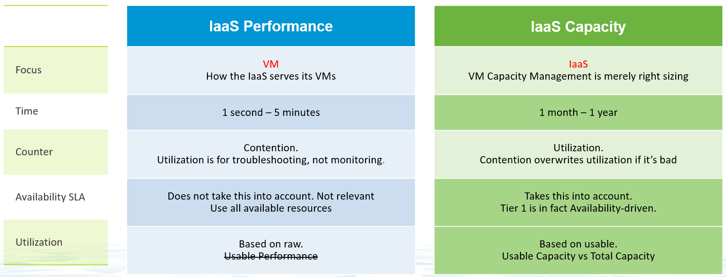

Capacity has HA, Buffer, Overhead and Reservation. None of these are relevant to performance monitoring. In Performance, you don’t care about them, as performance is about reality (what actually happens). They may cause performance problem, but they are not considered in the performance metric.

In larger organizations, they are typically managed by two different teams. The capacity team does not get involved in the day-to-day operations as they focus on longer term resource availability. Capacity *planning* is about maximizing utilization, without compromising performance. It also considers latent workload and future demand, which performance does not consider.

The capacity team may not have the technical skills to troubleshoot performance. On the other hand, the day-to-day operations deals with “what’s on the floor” of the data center. Their primary focus is meeting the demand from applications. It is consumer driven, while capacity is provider driven.

#### Utilization vs Demand

Performance uses utilization metrics. Capacity uses demand metric, which takes the highest of utilization & reservation.

Performance will be absolute (real value), Capacity will be relative (it depends on settings).

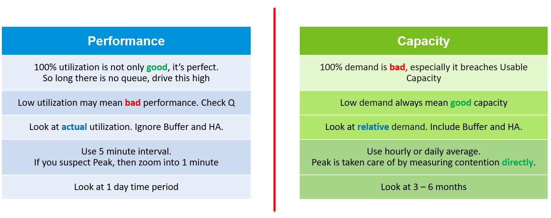

Now that we’ve looked at purpose, now let’s look at object.

Take vSphere Cluster. Say you have a 16-node cluster.

* From performance, taking the average utilization of 16 hosts are too late. It’s also not practical, as you don’t typically wait until all 16 have problem. In this case, you want to take the highest among the host as your primary counter for cluster utilization. If the counter shows no issue, then there is no need to look at the remaining host.
* From capacity, taking the average makes sense, as you do capacity at cluster level. You will continue adding until either you run out of capacity or you hit performance problem.

#### Metrics Example

Let’s take an example to see how contention and utilization differ. The following is using a cluster object as the example. There are two metrics, each expressed in percentage.

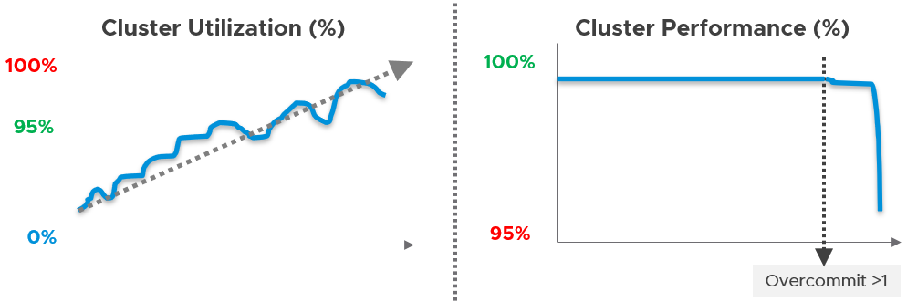

You want your utilization to be as high as possible, as you’ve paid for the hardware already. So, you start from 0% but want to move up as far as possible.

Performance is different. It depends on the class of service. Your Gold Class should deliver higher performance than your free tier else you may breach your SLA. Metrics wise, there are 2 metrics: SLA and KPI.

### Key Performance Indicator

Google VMware “performance SLA”, and you will find only a few relevant articles. The string performance SLA must be within a quote, as it is not performance and SLA, but **Performance SLA**. Yes, I’m after web pages with the words Performance SLA together. You will get many irrelevant results if you simply google VMware Performance SLA without the quote.

I just tried it again on 17 January 2023. Google returned ~7K results, which is surprisingly down from 19K in March 2021, but up from 1.6K results in October 2015. The first few are shown below. Most of them are from . VMwareOpsGuide.com, my book, or speaking event. One item from [Sunny Dua](https://sunnydua.com/), talking about the same performance SLA concept we came up with, appears on the top 10.

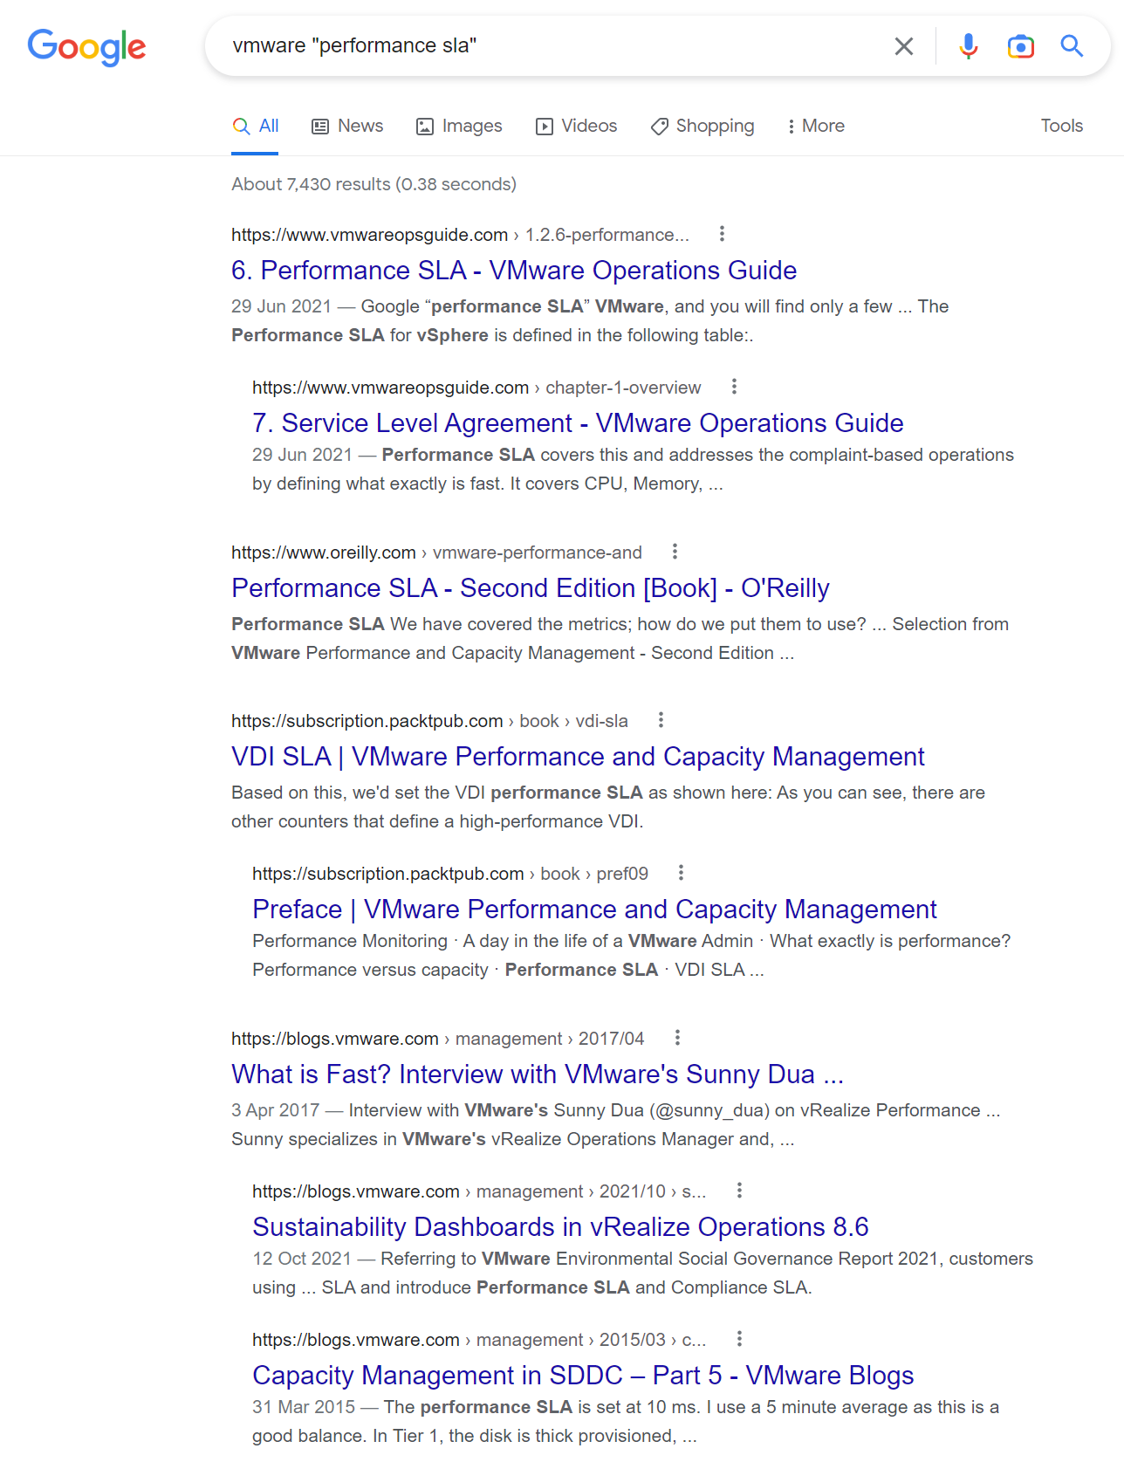

I checked beyond the first 10 results. Other than my own articles, Google returned only a handful of relevant articles. The rest are not in fact relevant if you read them carefully. The relevant articles mention Performance SLA, but they do not define and quantify what a Performance SLA is. If something is not quantified, it is subjective. It’s hard to reach formal agreement with customers quickly and consistently when the line is not clearly drawn. If you have a disagreement with your customers, especially paying customers, guess who wins 😊

As SLA is obviously hard to vrealize, what can you do today?

This is where KPI comes into play.

#### KPI as Stepping Stone

KPI and SLA work hand in hand.

KPI complements SLA by providing the stepping stone in your operations transformation. It is a necessary step towards operations with formal business SLA.

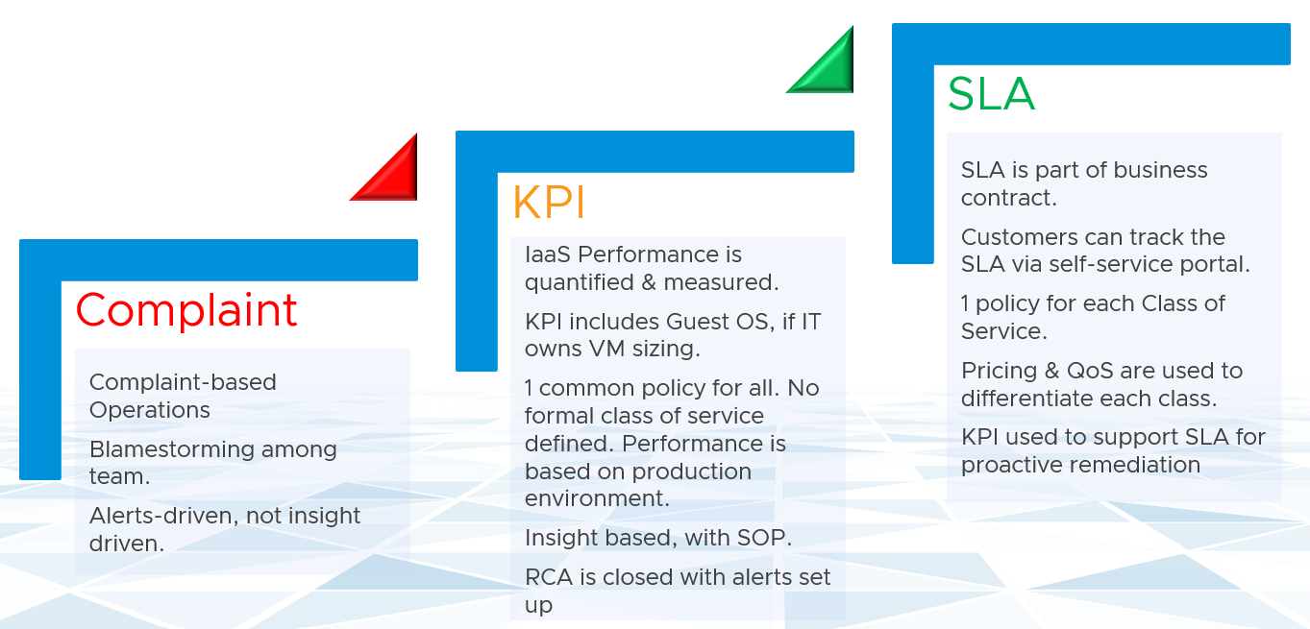

You walk from where you stand. Adopt KPI first as you don’t have to worry about class of service. If you have different expectation set for Production and Non-Production VMs, then create a group for each. Create a super metric that averages the performance of each group. You should expect production VMs to have a better KPI overall.

KPI is also better suited when infrastructure team takes ownership (and responsibility) for sizing the VM. Since sizing the VM basically means sizing the Guest OS resource, you’re now responsible for metrics at Windows and Linux level.

#### KPI vs SLA

The whole point of having performance management is to be able to know the problem *before* the customers complain. If you can’t see the problem before customers do, then you don’t have performance management in place. The word manage implies proactive. Passively waiting for an alert or complaint to trigger the troubleshooting process is not management. Proactive requires an internal threshold that is more stringent than the external, formally agreed SLA. This is yet another benefit of KPI.

The other reason for creating a KPI metric is ease of monitoring. KPI is color coded. yellow and orange are added in between green and red, so you can react faster. The goal is in fact to enable proactive remediation, before the situation degrades too deep.

In this book, my definition for KPI is strictly on *performance*, because the word *performance* has a specific meaning. To me, KPI as a term does not apply to availability management and compliance management. We should call the key indicators that determine availability as **KAI**, and the key indicators that determine compliance as **KCI**[9]. This will prevent confusion as implementation-level solution requires us to be non-ambiguous with terminology.

Broader definition of KPI that includes non-performance is not used in this book so we can be precise in the implementation. For an overall business KPI, [Norman Dee](https://blogs.vmware.com/services-education-insights/author/ndee) has written a series of blog post [here](https://blogs.vmware.com/services-education-insights/2020/05/getting-started-with-kpis-and-metrics-part-1-their-importance-and-value.html).

|  |  |
| --- | --- |
| KPI | SLA |
| A single metric that quantifies the true performance of a logical entity.  VM and Guest OS are 2 separate objects but they are 1 logical entity due to 1:1 permanent relationship, hence they are combined in 1 KPI number. | A set of metrics written in the business contract between service provider and service consumer. Typically, this is between the IaaS provider (the infrastructure team) and the IaaS consumer (the application team or business unit).  What happens inside Guest OS is not even relevant to the VM SLA. |
| Simple to operationalize. | Complex.  It needs[**Operations Transformation**](https://blogs.vmware.com/services-education-insights/services/operations-transformation-services), much more than technical changes. You need to look at contract, price (not just cost) process, people, class of service, etc. |
| It tends to be absolute, as it’s reporting raw metrics | It is always relative. Compared to an agreed threshold. |
| Leading Indicator.  5-minute window. They are used as the starting point to troubleshoot, before user complaint | Lagging Indicator.  30 days backward looking, to be precise. You complement it with SLI, a 5-minute tracking.  If you breach, you’re talking penalty already. Typically it’s a credit for the next billing cycle as opposed to actual refund. |
| 20-second  It tracks at higher intensity and it covers more metrics and events. | 5-minute |
| Based on day (e.g. last 24 hours), which is moving. | Based on date (e.g. June 1972), which is fixed |
| Comprehensive coverage.  Covers the SLA metrics, plus relevant additional metrics that provide early warning before the SLA metrics are breached.  There are many KPI for a given SLA because not all metrics should be in the contract, while almost all performance metrics need to be monitored. | Limited.  Only critical metrics are included. Having too many metrics in SLA makes it harder to comply.  Guest OS metrics should not be included as that’s part of “application KPI” or VM KPI, not IaaS SLA. They impact the VM performance, but nothing the IaaS can do, meaning the remediation is at the Guest OS layer. |

#### KPI Limitation

I agree that a set of metrics that determine the health of complex object such as VM or application will never be accurate in 100% of the case. This is normal, just like in real life. We take annual health check, performing all sort of tests, and the results will be a series of metrics (e.g. your bad cholesterol level). Are they 100% accurate for you from young until you are old? Are the results 100% accurate for everyone in your city?

No, and you know that.

But they are good enough, and certainly much better than nothing. Beside the absolute value, the relative movement of the value over time is also able to give you insight. For example, if the KPI drops on a quiet Sunday morning when the environment is not supposed to have known activities, perhaps there is something *bad* going on?

The challenge is there are typically many components that makes up this metric. There is a need to consolidate all the performance metrics into a *single* KPI so you can manage at scale.

Say you have 1000 AWS EC2 to be monitored. You have a bunch of metrics, and you then consolidate them into 2 KPIs instead of 1. How would you know which EC2 has issues? You need to show 2 sets of heat map or table. That means you need to manually corelated the first table with the second. It’s not scalable.

Having >1 metric also presents challenge as you roll up to higher level object. How do you show a trend chart of performance over time at vSphere data center levels when you have >1 metric? We will cover this in Part 2 Chapter 1.

#### KPIs in IaaS

Within the context of VM as a Service, here are the KPIs and SLA.

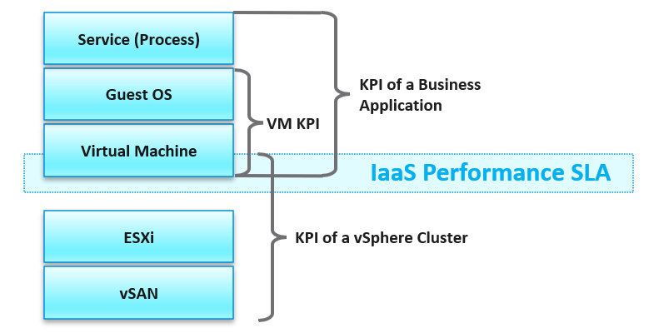

Why are there only 1 SLA, yet many KPIs?

There is only 1 SLA as there is only 1 service in IaaS. The SLA metric is derived from 4 metrics, as IaaS provides CPU, memory, disk and network as a service.

|  |  |
| --- | --- |
| **VM KPI** | It excludes the application or service running inside Guest OS as infrastructure team stops at Windows or Linux. |
| **Business Application KPI** | There are actually 3 levels of KPI. The highest and most important tracks the business transaction (e.g. user login). If the number is below expectation, you check for application software KPI (e.g. Apache web server) and infrastructure KPI (which is basically the VM KPI) |
| **vSphere Cluster** | It includes only the contention metrics of the running VMs. The utilization metrics are excluded as that has no direct correlation to the cluster performance.  If the cluster is running vSAN, then the KPI should include metrics measuring vSAN performance. |
| **vSAN KPI** | I do not add in the diagram to keep the diagram simple. vSAN KPI includes VM disk latency of all VM accessing the vSAN datastore (from the same vSphere cluster or from other cluster). |
| **NSX KPI** | I do not add in the diagram as it has a many to many relationship to vSphere cluster. |

### Baseline Profiling

How do you determine what’s an acceptable performance by your customers? Is their expectation unrealistic (read: not impossible but costly to implement)? What’s the value of profiling your environment if the application team is unhappy with your service level?

Let’s look at 3 scenarios. The first 2 are corner cases, and the 3rd one is the most common, especially in large environment with many application teams.

|  |  |  |
| --- | --- | --- |
| Happy | Unhappy | Mixed |
| If your application team is happy, then the profiling is a proactive exercise to ensure performance is maintained as your environment grow or change. | If your application team is not happy, then the profiling quantifies the complaints so they can be measured. It reveals the full picture as it analyses the entire VMware environment, not just the complaints. | Likely, some are happy and while others are not. |
| This prevents infrastructure from being blamed for application-level changes. For example, if your database size grow, it can slow down the application. | It might prove the blame on infrastructure is not right, if the metrics are good. | In large environment with many VM Owners, it’s common to see different owners have different threshold. A 10% CPU Ready may be fine for Owner A yet a 2.5% CPU Ready causes Owner B to be upset, even though both VMs are in the same class of service |
| It helps you establish the SLA while everyone is still happy. | It shows how bad the situation is, and how much improvement is needed. This can help in justifying additional capacity | Profiling brings up these facts to facilitate discussion to get everyone agree on the same SLA, because it’s a shared platform |

This is why education is important. As you have promised to serve everyone well, you need to have a threshold that works with 99% of your customers, and not 98%. While 100% is a better target, it’s also far more expensive.

#### Methodology

Now that we know the value and purpose, let’s discuss how to implement it. The following flowchart shows the overall process

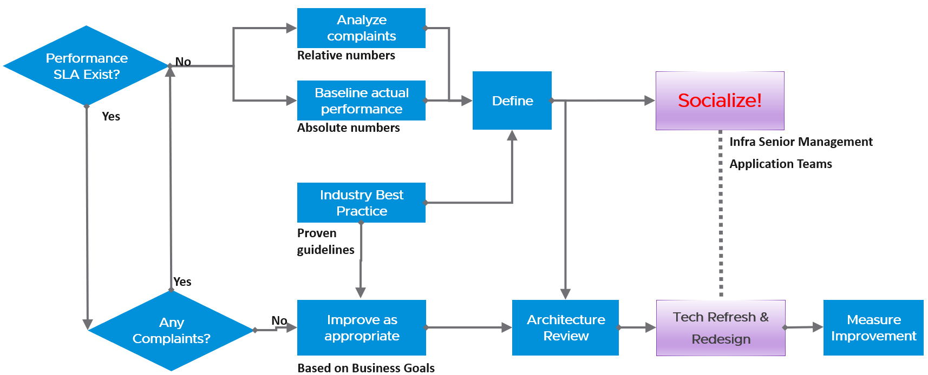

Do you have a performance SLA implemented?

If yes, that’s great!

* Do you get complain from your customers? If yes, go back and follow the no performance SLA flow.
* If there is no complaint, how is your actual SLA compared with your contractual SLA? The first one is what was actually delivered in your DC, while the contract is just a promise written on a piece of paper.
* How is your promised SLA compared with industry best practices? If there is a room for improvement that both your customers want and your management supports, then it’s worth looking at the system and process to improve it. This may result in a technology refresh, reducing your cost while increasing both capability (availability, performance, capacity, and compliance).

If no, then how do you set? There are 3 factors to consider:

|  |  |
| --- | --- |
| **Complaint** | This gives the relative number, as complaint is subject to the person giving the complaint. Different people have different tolerance when it comes to how slow a system is.  This is the most time consuming, as most of the time there is neither data nor analysis. You might have to interview the actual users one by one. In some political cases, you will need to get the business users, the application developers and the infrastructure team in a room or zoom.  Compile the list of actual complaints. Analyse each complaint to ensure the problem is indeed with the infrastructure (and not application-level issue). If it is due to infrastructure, write down *the actual* metric or event that prove the problem. |
| **Actual** | This gives the absolute number, as it’s based on actual number.  This number should be based on the 20-second peak, as the 5-minute average is not sufficient. |
| **Best Practice** | This comes from the makers of the product. For example, Microsoft has a guideline for disk latency for its SQL Server database |

##### Outcome

What are the possible outcomes of the analysis? There are 1 – 4 action items you can do. The action “align with best practice” include configuration changes, design changes and version upgrade.

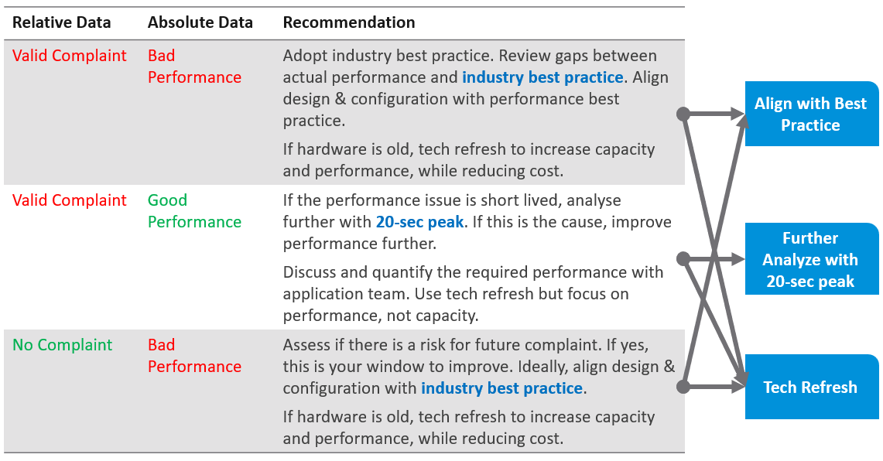

What if you have no complaint and the profiling proves the performance is good?

That’s certainly a good news. It is the ideal situation and you may not have to do anything. However, make sure you set expectation at the right level (and not too high).

Proactively, check if present both performance & capacity are enough for future demand.

##### Complaint Analysis

Why do we start with complaint?

Because this is what the business experience.

End users normally complaint on 2 types of problems:

* The system is down. This is easier to confirm as the proof is clear. You typically have log files too.
* The system is slow. This is much harder as it’s subjective.

They don’t normally complain about the system is not secured.

The problems above can be major or minor. Major problems are easier to analyze, and they tend to be reproducible. You have many users, or many applications, or many VMs affected over long period of time. In this case, the problem is likely something common, and you can see the metrics.

Minor problem is hard to analyze. You likely need to interview the actual user. When you do, gather the following

|  |  |
| --- | --- |
| **Time** | This is not the time the complaint was lodged, but the time the problem actually happened. For example, the developer may complain at 12:34 pm that her application was slowed at 09:51 am, and it lasted 14 minutes. |
| **VM** | The VM affected. Ideally, this was analyzed by developer as the VM causing the problem, not the VM receiving the problem. |
| **Analysis** | What is the root cause? If the actual cause is not directly related to the symptom, it needs to be explained as it becomes less convincing. |
| **Proof** | What’s the metric or event that prove that the root cause was indeed correct? The acid test is alert. The expectation from senior management is if the same problem happens again, you know right away. How can you know it right away? The alert. You set up an alert to trap the root cause.  If your root-cause alert does not detect the problem, you have not found the root cause. |

#### Consideration

What things must you consider when doing the profiling?

|  |  |
| --- | --- |
| **Time** | Take the last 3 months data. If you do not have 3 months’ worth of data, do at least 1 month. This ensures that any peak within that period is not left out.  On the other hand, there is a risk of comparing 6 months of data. There could be changes in the application, VM or infrastructure. |
| **Representation** | Since vRealize Operations stores this counter every 5 minutes, you will have 288 datapoints in a day and 26,298 datapoints in 3 months. Taking the worst among 25+ K data points will likely return you with an outlier. To address it, you take the percentile value. Since there are 26298 data points, I’d recommend you take the 99.9th percentile, eliminating the worst 26.3 data points. Since each data point is 5 minutes, you eliminate the worst 131 minutes in 3 months.  If you only have 1 month of data, that means only 8766 data points. In this case, you exclude the worst 8.8 data points or 44 minutes.  What if you cannot wait for 1 month as your vRealize Operations is newly installed? If you want to see the data after just 1 day, as a temporary result, use the worst metric and 20-second metric. |
| **Resolution** | Profile based on 5-minute average, not the 20-second metrics. This matches your SLA |
| **Scope** | Profile Compute and Storage.  Why is network not included?  Network needs to be analysed separately due to its nature as interconnect and not nodes. |
| **Focus** | Profile all the VMs, not just the VMs you care. This gives you the complete picture. The only time you exclude VMs is when you’re 100% sure they cannot impact the performance of the VMs that matter to you. Typically, this means the environment is physically isolated, including separate physical network and storage. For example, if there is a physical data center where you don’t care at all, you can exclude them.  In large environment, split by Class of Service. The higher one should be performing better than the cheaper tier.  You profile the VM, not the cluster or datastore, as that’s where the SLA is. |

##### Metrics to Use

Now that you know how to profile, what metrics do you choose?

|  |  |
| --- | --- |
| VM CPU Ready | It’s good enough to represent the 4 types of CPU contention metrics as we’re taking 20-second peak. I don’t think it’s worth the extra effort to include Co-stop, Overlap and Other Wait. You need to wait for 3 months as you need to create the super metric first. |
| VM Memory Contention | Do you know why we do not choose Balloon counter?  It is not a contention metric as it does not measure actual performance issue. |
| VM Disk Latency | For profiling purpose, there is no need to split Read and Write. Overall is good enough as the improvement will be across the board. |

When you have time, profile the following metrics

* CPU Overlap. I expect the value to be <1%, with >90% of them below 0.25%
* CPU Other Wait. I expect the value to be <1%, with >90% of them below 0.25%. Read the documentation of this metric as there is a false positive.

##### Metrics not to Use

You do not need to profile utilization metrics. For contention metrics, you do not have to profile less important metrics.

|  |  |
| --- | --- |
| CPU Run Queue | These are Windows or Linux level metrics. They are application dependent, meaning not something the IaaS platform controls. |
| CPU Context Switch |
| CPU Usage Disparity | This is also application dependent. |
| CPU Co-stop | This typically happens when the VM is oversized. |
| Disk Outstanding IO | This is impacted by IOPS, which is not something the IaaS platform control |
| Disk Queue Length | This depends on the storage driver. I recommend you use PVSCSI |
| Free Memory | It depends on the application. Certain applications such as JVM and DB manage their own memory, not something Windows or Linux can control. |
| Page-in rate |
| Page-out rate |
| VM Balloon | Not a VM performance counter, but an ESXi capacity counter. |
| VM Compressed |
| VM Swapped |

### Optimized Performance

Optimized Performance is difficult because the best performance is achieved when utilization/throughput is at 100%. Running at that level requires a perfect level of mastery due to many dimensions of inter-dependencies. In addition, majority of loads have peaks so on average you could be well below 100%.

|  |  |
| --- | --- |
| **Type of Dependency** | **Description** |
| **Vertical** | There are layers in the stack, and a problem in a lower layer can impact an upper layer. |
| **Horizontal** | The four elements of IaaS are not standalone. When CPU is paused, RAM & Disk will experience latency as time shifts as far as the Guest OS is concerned. |
| **Flow** | A problem in your NSX Edge VM on the NSX Edge Cluster can impact a business VM sitting on another cluster, because of the traffic flow. If you don’t understand the flow, you can waste time troubleshooting at the wrong cluster. |
| **Version** | There are valid reasons behind What Works With What. It’s a known problem that not all versions of all components work well together. Drivers, Firmware, etc. can cause interoperability problem, which can manifest itself as performance. |

#### Consumer Layer

The consumer layer consists of applications, which run on top of Guest OS. Guest OS in turn runs inside a VM and Container (which often runs inside a VM). So if you are running containers, you are adding a new layer to monitor. As you can see here, adding a new layer alters the metrics in the adjacent layers.

##### Operating System

|  |  |  |
| --- | --- | --- |
| Layer | Metric | Optimize or Remediate |
| **Process** | Runaway process | It goes into an infinite loop. Remedy is to kill it.  In a large VM with many vCPU, this can be impossible to detect if the process is only consuming 1 CPU. |
| What metric? | If you know the answer, email me |
| **Container** | What metric? | If you know the answer, email me |
| **Guest OS** | CPU Run Queue | Ideally, measure both the queue per CPU and the total queue. A 64 vCPU having 1 queue on each CPU means 64 processes were waiting. Performance could be affected.  If utilization is high, then add vCPU. If utilization is not high, check if there is imbalance among the vCPU. Some applications may need to be configured to use all vCPU. |
| CPU Context Switch | IO causes context switch. If utilization is not high, reduce vCPU to minimize ping pong. More on [CPU Context Switch](https://en.wikipedia.org/wiki/Context_switch) is covered here. |
| Network latency | Change driver. More CPU to process network packets |
| Disk Queue Length | Problem could be inside the Guest or outside. Check if VM outstanding IO and VM disk latency is high. If not, then the issue is with Guest OS, not underlying infra. Check if Guest OS latency is high. If yes, change SCSI driver to PVSCSI is one good remediation. If not, leave for now. |
| Driver Queue | Storage driver such as LSI Logic and PVSCSI has their own queue. If you know how to get the value, let me know. |
| Network Buffer | The ring buffer in the virtual NIC card. This can get filled up. |
| Memory Page Fault | Look inside the Guest OS and Process to see if it’s memory settings aligns with configured RAM. It’s common for JVM or DB to have memory settings that don’t match Guest OS configuration.  Need [Telegraf](https://www.influxdata.com/products/integrations/) agent as it is not tracked by Tools. |

##### VM layer

We have better visibility at vSphere VM level due to the various metrics provided. The following table lists the metrics and associated actions you can perform to address the issue.

|  |  |
| --- | --- |
| Problem | Optimize or Remediate |
| CPU Ready | Check config: Limit, Shares (also relative to other VM, not just its absolute amount)  Check if it’s caused by resource pool  Check ESXi utilization. A sign of ESXi struggling is other VMs are affected too.  Check vMotion stun time (requires Log Insight) |
| CPU Co-Stop | As per CPU Ready, but note that VM with many CPU has higher chance of experiencing co-stop. If VM utilization is not high, reduce vCPU. |
| CPU Overlap | VM has high IO (disk or network), causing its own CPU to be interrupted for IO by VMkernel. Check if ESXi cores utilization is balanced. |
| RAM Contention | High ESXi memory utilization. Check ESXi Balloon, ESXi reservation.  Check vMotion stun time (this requires Log Insight) |
| CPU IO Wait | High disk latency causes high CPU. Check for snapshot as snapshot requires double IO processing. |
| Network Dropped Packet | After verifying this is not a false positive, check for packet retransmit and underlying infrastructure. If packets are broadcast packets it might be dropped by the network. |
| Network retransmit | When a packet is loss, it needs to be retransmit (unless it’s UDP protocol). |
| Network latency | Latency caused by hops. Optimize the traffic. Note this needs vRealize Network Insight |
| Disk Latency | Check VM outstanding disk IO  Check if IOPS Limit has been placed. |
| Outstanding Disk IO | Check underlying ESXi or datastore |
| vMotion | Check DRS automation setting  If the actual vMotion is too long, check if the active memory. You can use Log Insight to see the throughput.  For stunned time, you need Log Insight as it’s not shown in the UI. |

I do not put AWS EC2 or Azure VM here as the visibility is rather limited. If you have the solution, I’m keen to collaborate.

#### Provider Layer

At any given moment, a running VM always resides on an ESXi Host. Due to DRS and HA, it’s easier to monitor at cluster level. Since a cluster can have hundreds of VMs, you need consolidated metrics that can represent the experience of all the running VMs in the cluster. vRealize Operations 8.2 provides the following metrics:

|  |  |
| --- | --- |
| Problem | Optimize or Remediate |
| Worst VM CPU Ready.  Worst VM RAM Contention | These are the highest value among all the running VMs. It shows you the depth of the problem.  Check how many VMs are affected to see pattern. |
| % VMs experienced CPU Ready  % VMs experienced RAM Contention | Since it’s impacting many VMs, the problem is likely not at VM setting, but at ESXi or cluster level. Some possibilities:   * There is 1 or more sibling VM to Resource Pool, causing VMs in the pool to suffer. * Imbalance shares. 1 or more VM has relatively large shares. * High ESXi utilization. However, Cluster utilization is unlikely to be high, due to HA and Buffer. So check for imbalance among hosts, which is common in large clusters.   Imbalance could be due to   * DRS settings * VM – Host affinity, or VM – VM affinity * Resource Pool * Cluster inconsistent configuration (e.g. storage or network not available to all hosts) |
| vSAN CPU Ready | It’s not something you can change, unless via ESXi advanced settings to modify the VMkernel scheduler behaviour? |
| ESXi Error Packets | Check the vmnic driver and firmware |

##### Datastore

A running VM also consumes datastore service or has [Raw Device Mapping](https://docs.vmware.com/en/VMware-vSphere/7.0/com.vmware.vsphere.storage.doc/GUID-9E206B41-4B2D-48F0-85A3-B8715D78E846.html) (RDM) disk.

Here is the list of potential problems at the provider layer:

|  |  |  |
| --- | --- | --- |
| Layer | Metric | Optimize or Remediate |
| **Datastore** | Worst VM Disk Latency  Worst VM Outstanding IO | Check if it happens on 1-2 virtual disk, or impact all the VM disks. If no other VM has problem, check the VM shares, limit, CPU ready, CPU Co-Stop and IO wait.  Note this excludes RDM.  If it’s VMFS, check if queue in the ESXi kernel. Any value >1 ms should be investigated. Check the HBA queue and queue depth.  If it’s NFS, check the NFS server performance. |
| % VM experienced Disk Latency  % VM experienced Outstanding IO | Since it’s widespread, check if it happens across multiple datastores. If it’s, check for VM CPU ready, VM CPU Co-stop, and ESXi kernel queue. Check underlying LUN latency, be mindful it’s an average number of all VMs in the datastores.  For VMFS, check HBA queue (KAVG). |
| **vSAN** | vSAN KPI | If it’s vSAN, check for vSAN KPI metrics. vRealize Operations sports a number of KPI metrics.  Check the Read/Write ratio and compare it against plan. If the time of incident happened to match with the spike in ratio, it could be related. |
| **vSwitch** | Dropped packets | Drill down to find out which VMs or ESXi are affected.  Ensure it’s not false positive by checking broadcast and multicast packets. |
| **NSX** | NSX Edge performance | Ensure Edge is performing (CPU, RAM, Disk, Network). |

### Noisy Neighbour

In a shared environment where there is practically no limit or control placed on consumer (e.g. VM, Container), you can get into Victim Villain problem. This is where a small percentage of consumer cause performance problem to others. It could be as simple as 1 constant consumer causing the problem to the same few victims, so you know who the villain and who the victims. It could be as complex as transient problems, where you can not even see a pattern. Both the villains and victims are random, and they may even trade position over time. Sometimes the victim is the villain, causing self harm.

The real villain may not be the VM, meaning the real request of the load is coming from outside the VM. Windows or Linux was simply executing what a central command center asked.

The cause of the problem may not even be related to the symptom.

A story I remember well is the Head of IT Operations asked me to “find the b@$t@rd that did this to me”. He believed there is a villain VM in this environment that randomly attacked other VMs. The symptom is the victims became unresponsive, sometimes to a simple ping, but the problem always disappeared within 15 minutes. The victims were spread across multiple clusters, multiple datastores and multiple datacenters. There is no pattern on the victim. They varied in size, and both Windows and Linux were affected. There is no pattern on the time, so he did not know when the next attack would be.

We did a lot of analysis, working with both storage team (they were on EMC high end array) and network team (they have synchronous replication for mission critical datastores over Cisco switches and routers).

At the end, we found out it was the anti virus signature update. It was not randomized over long period. When hundreds of VMs were updated, the combined IOPS saturated the WAN link, reducing the synchronous replication. That basically paused IO commands, so the VMs were frozen.

What are the 3 knobs you have to control noisy neighbour?

|  |  |
| --- | --- |
| Control | Analysis |
| Limit | The most basic form of control. It sets the upper limit that the consumer can’t exceed. It is a hard limit.  If the shared resource is actually available, it will go wasted instead of being used.  On the other than, this guarantees that consumer will not exceed what they pay for. You can also contain the damage of denial of service attack.  From the above, you can see it cuts both ways. You need to balance cost and performance. |
| Reservation | Complement limit by setting the floor. This is also another form of guarantee, so your total reservation can not exceed your total capacity.  Take note Disk has no reservation for IOPS and throughput. |
| Share | Share is only effective if there is enough resources left to share. If you have 80% reservation, then you only have 20% left to share.  This complements reservation by specifying shares. I’m not 100% sure if this is on top of reservation. If it’s not, then it could be ineffective in protecting the victim from the big villain. The reason is share is relative to the configured size. A VM that is 10x bigger is given 10x share by default. |

What knob is missing from the above?

Do you think Priority is missing? I think priority is too strong a knob. It gives 0% to the lower priority ask, which is not what you want. You still want each consumer to get something, which is basically what share does.

Let’s now apply the above knobs into the 4 main resource types. In future I will include GPU.

Just like there are many nuances on metrics, there are also nuances in addressing noisy neighbour.

You will see that the settings are complex. Adding Resource Pool complicates further as you have another management layer.

#### CPU

Let’s begin with CPU as this is typically where the problem is.

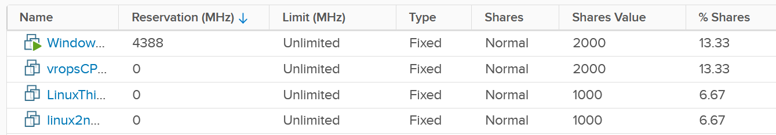

|  |  |
| --- | --- |
| Control | Analysis |
| Limit | There is a default limit, which is the configured CPU size of the VM or container. The problem of this limit is most of the time it is too high, driven by cheap pricing. A VM that only needs 8 vCPU bought a 32 vCPU configuration. Why? Because the buyer can afford it.  After years of practice, IaaS operators started overcommitting the shared infrastructure, because they see their vSphere cluster utilization averages around 25%, with occasional peak to 75%.  Let’s take an example:   * Cluster size: 10 ESXi hosts * ESXi specification: 40 cores, HT enabled, 2.5 GHz each. Total 100 GHz, not counting HT. * Total cluster capacity: 1000 GHz (not counting HT benefit) * Overcommit ratio is 4:1. So 1 core is assigned to 4 vCPU. The core can run 2 vCPU at the same time, buy at 37.5% performance penalty. * No of running VM: 400 * Average size: 4 vCPU. Total is 1600 vCPU on 400 physical cores.   In the above example, all you need is a few 32 vCPU VM to create the problem. If you have 10 of them, there is a chance each fills up 1 ESXi host. This is why both overcommit ratio and maximum VM size are both in your pricing policy.  While you can set a limit on the VM, it can result in unpredictable performance as Windows or Linux does not know. The limit is also applied in GHz, not vCPU. So the impact can vary each second as the frequency fluctuate. |
| Reservation | Can you solve the above problem by reserving CPU to all the VMs?  The answer is no. You can only reserve 25% of the configured capacity of each VM. That means a 2 vCPU VM is only given 1.25 GHz. This loosely translates into 0.5 vCPU only, not enough to run anything useful.  One adjustment you can do is to guarantee the first vCPU. So each VM gets 2.5 GHz, regardless of size. Since there are 400 VM, you reserve 1000 GHz.  Your total capacity is only 1000 GHz, so the cluster is filled up. This actually exceed your usable capacity, as you need to account for HA.  On the other hand, you have 25% boost due to HT.  Reservation becomes less effective as you increase the overcommit ratio. At 8:1 overcommit, you can not give more than 0.5 CPU worth of resource. |
| Share | If you follow the default share, the monster VM will still get more in absolute amount.  If you do not follow, the larger VMs will be affected. And if they run genuine business load, they will be the victim.  It’s tricky to balance and determine the right share as it depends on the situation. |

#### Memory

Memory virtualization differs at fundamental level to CPU virtualization. We cover that in-depth in Part 2 Chapter 4 Memory Metrics, so I will only touch on the impact on noisy neighbour here.

Memory is relatively less problematic due to its nature. It’s basically a damn fast disk, so fast that you care about space more than speed. As a result, the memory utilization metric tends to be flat over time, both at the VM level and ESXi level. The exception here is transient VM or container. ESXi clears its consumed metrics when the associated VM is powered off. So in environment like Horizon Instant Clone, you get higher fluctuation.

Because of this flat utilization, the overcommit ratio is lower. This results in relatively less problem. The problem of this solution is money. You are basically paying for a lot of cache.

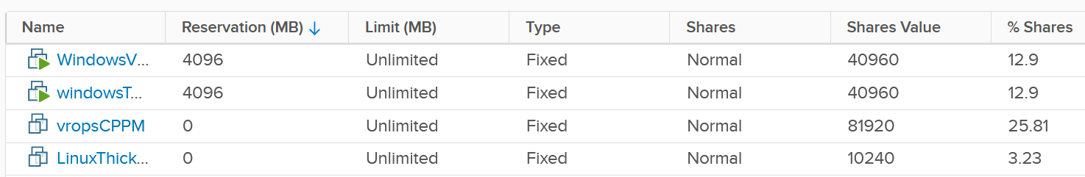

|  |  |
| --- | --- |
| Control | Analysis |
| Limit | The memory utilization at both Guest OS level and VM level consist of mostly cache, pages that are not used. Since there is no limit within Guest OS, should you apply at VM level then?  This carries the risk of memory contention, as the 2 layers are independent of each other. You need to track the memory contention closely if you are doing this. Considering the lack of real-time remediation solution, I’d recommend you stay away from this, and focus on right-sizing at the Guest OS level instead. |
| Reservation | Unlike CPU, memory reservation is “sticky”. Once the VM touches that page, it’s permanently reserved regardless of subsequent usage. The problem is VMkernel does not know if that page is useful or not. As a result, I’m not recommending you use this.  Unlike CPU, where you frequently go beyond 2 : 1 overcommit, you typically do not overcommit beyond 2 : 1. If you overcommit, tracks for early warning using balloon counter.  For your highest class of service, where you guarantee memory performance, there is no overcommit. Per-VM reservation becomes irrelevant when the entire cluster does not overcommit. |
| Share | See CPU, as the behaviour is the same. |

#### Disk

There are actually 2 types of problems, as disk has both space (GB) and speed (IO commands). The speed dimension is more problematic as the limit is much higher and the spike is unpredictable. You can have either IOPS or throughput giving you problem.

Unlike compute, there is no defined upper limit by default. A VM can generate unlimited IOPS or throughput. This creates risk, as it can take just a single developer doing IO Meter to saturate your shared storage.

Compared with compute, storage has more layers, as the actual storage provider is outside the hypervisor. Even in the case of hyperconverged like vSAN, the vSAN kernel module is a separate stack and you need to deal with vSAN network. In the case of central storage array, you likely need to deal with storage fabric.

Because they are separate, there are multiple places of the control:

* Non vSAN: VM, datastore, storage array. If the fabric has control, you can set it there too to throttle IO going into the central array.
* vSAN: VM and vSAN.

The control for VM can be seen at Cluster object. The following shows that I’ve set 4000 IOPS limit and give Hard disk 1 a higher share value.

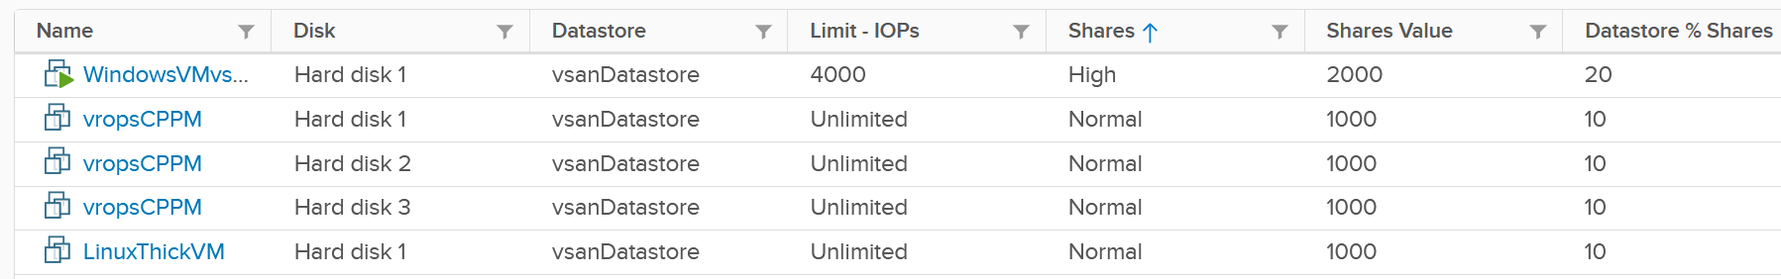

The problem is: should you set it? If yes, what numbers?

|  |  |
| --- | --- |
| Control | Analysis |
| Limit | There is a limit for IOPS, which is per virtual disk. Can you see the problem with this?  There are different variations (block size, read/write ratio, random or sequential). That means 1000 IOPS can vary. The problem is your application team typically do not know this level of details. Guess who lose when you argue with your customer?  If you are going to set, ensure the number is on the high side, as what you primarily sell is latency. If you set a low IOPS limit, it impacts latency. However, the number must be a small fraction of your actual storage capabilities. If your storage is supporting 1000 VM, then the limit of each VM has to be below 1% of what your array can deliver. If you set higher, for example 5%, then it only takes 2% of the VM population (20 VM in this case) to saturate your storage. And this is assuming their IOPS are perfectly distributed in all your SSD. In reality, you have hot spots.  For VM, you can consider limit for the OS disk, if applications do not use it. This at least prevents rogue agents or system-level service for running amok.  What about the control at datastore level (non vSAN)? SIOC provides 2 choices for congestion threshold. As you expect, both have their own pro’s and con’s, else you just need the best and no need a choice.  What about the control at vSAN level?  We certainly need to dive a lot deeper in this area, before applying limit to each virtual disk.  What about disk space? How do you prevent your datastore running out of space when you overcommit? For thin provisioned, you can’t control when the disk space will be used. The only thing you can do is snapshot age, to prevent them from growing too large. |
| Reservation | There is no reservation for VM Disk. See earlier screenshot listing 5 VMs in a table. None of the column show reservation. |
| Share | Unlike CPU, the share does not care about the size. Ideally, what you want is IOPS per GB. The reason is when you sell disk space, it actually comes with a certain amount of IOPS and throughput at certain latency threshold. This is how you justify gold storage higher price per GB. |

##### Storage I/O Control

The control at datastore level is for a different purpose. Storage I/O Control (SIOC) is a datastore-wide throttling. There is no share and reservation, only limit. This means every VM on that datastore is “equally” affected. I wrote the word “equally” in quote as I’m unsure that’s per virtual disk, per IOPS, or per throughput.

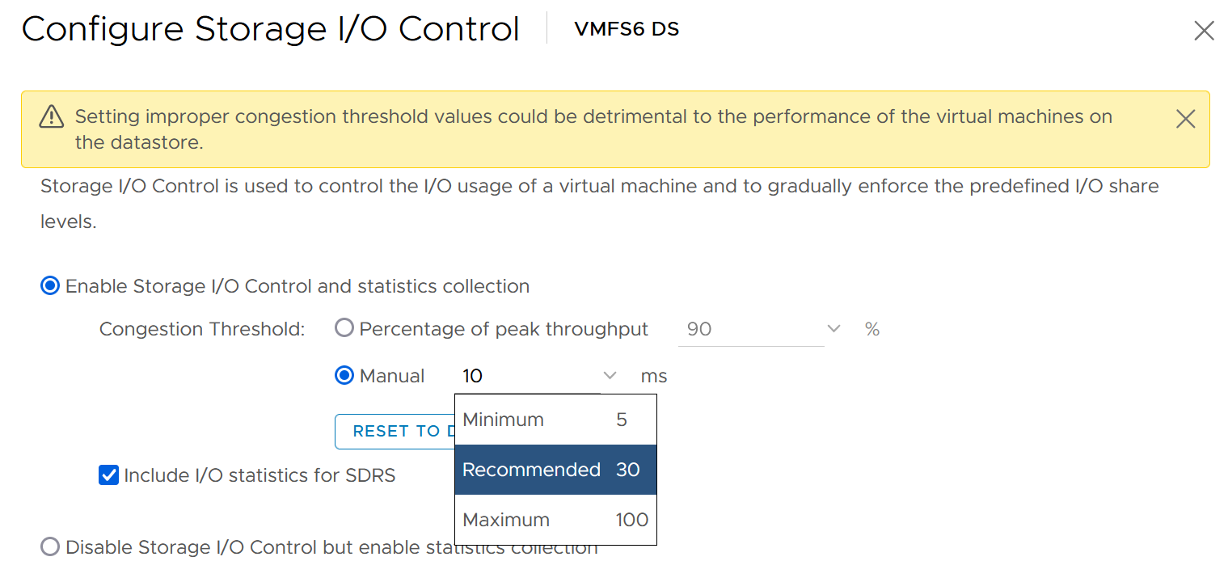

You can enable SIOC on each datastore, including local datastore.

Take note because vSAN has its own mechanism, SIOC does not apply to it.

#### Network

Network is the hardest to solve, due to its unique nature as interconnect. I cover it in-depth here in the Network metric chapter. Read at least the first section “Why Network Monitoring is Unique".”

Done?

Great, now let’s discuss how noisy neighbour is harder in network.

We start with a single ESXi, not distributed switch, as that’s where the villain VM is running. Let’s say the ESXi has 2x 25 Gb/s physical NIC. Total is 50 Gb although you typically count this as 40 Gb, giving you 20% headroom. In these 2 cards, you run both the VMK traffic (vSAN, vMotion, vSphere Replication, etc.) and VM. Let’s say you have 25 running VM on average. Assuming you allocate around 20 Gb for VMK, that leaves 20 Gb for 25 VM.

Now, a single villain VM can hit 10 Gb. For example, Hadoop worker node receives large amount of data over the network, sustaining 5 Gb over 300 seconds period. That leaves 10 Gb to be shared among the remaining 24 VM. Each only gets 400 Mb/s on average. If they are not network intensive, they may not feel the impact.

But the above calculation is done on 2 x 25 Gb network. If you only have 2 x 10 Gb, you increase your risk significantly. In a sense, it goes back to fundamental of capacity management, which is your overcommit ratio.

Review the following diagram, which shows a vSphere Cluster. Why is network missing on Resource Allocation?

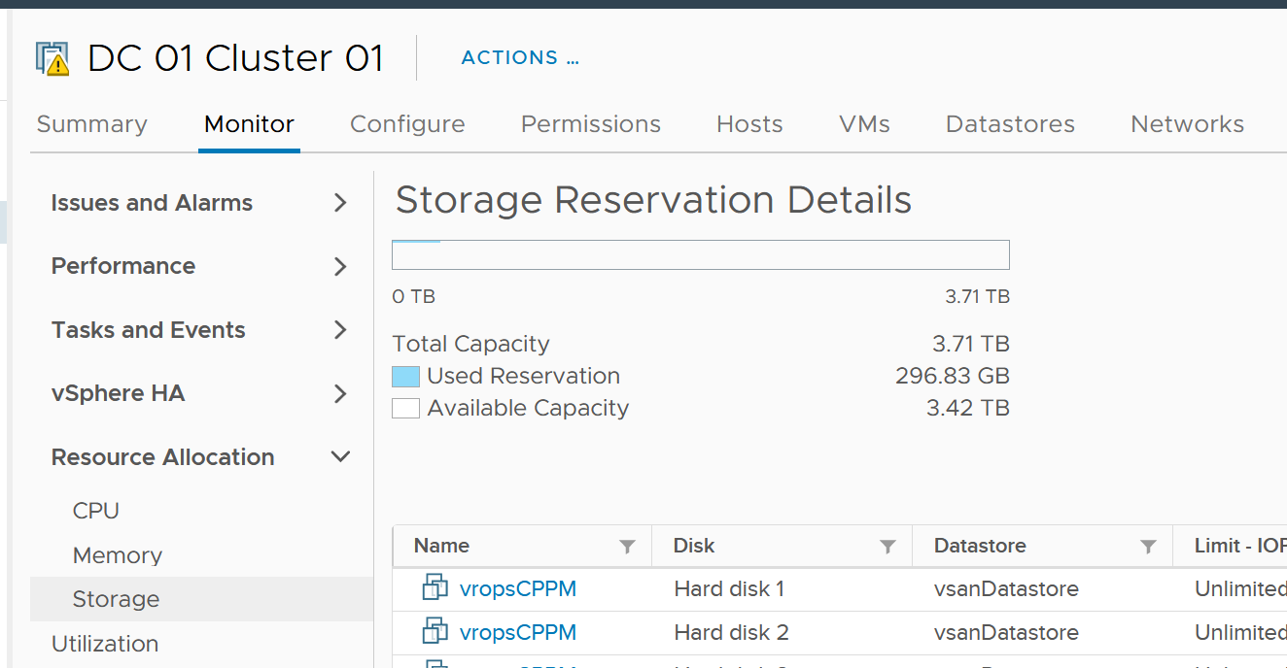

The reason is you configure it at the distributed switch.

Just like compute, you can set on each VM network adapter the shares, reservation and limit.

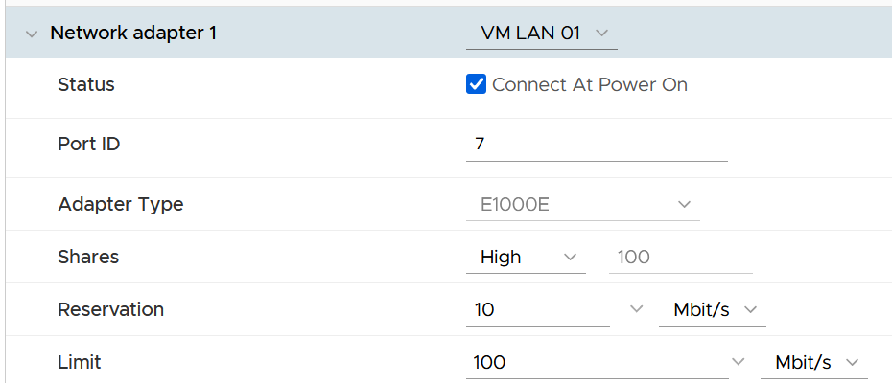

|  |  |
| --- | --- |
| Control | Analysis |
| Limit | Just like compute and storage, if you set limit you need to ensure it’s high enough for the VM, yet low enough for the ESXi physical NIC card. So what number do you set?  I think it should be 8 Gb/s. That’s good for the VM, but it’s too close to your ESXi. There is also management challenge, as the settings are buried deep and set in multiple places. So at the end of the day, it might not be practical. |
| Reservation | If you have plenty of bandwidth, consider setting 100 Mb/s per VM. Use the metric profiling technique to arrive at number specific to your environment. |
| Share | The main thing you need to check is actually between VM and non VM. By default, the share is larger for VMkernel, such as vMotion. I think VM network should be given higher shares than vMotion and vSphere Replication, but lower shares than vSAN and Fault Tolerant. |

#### Solution

So what can you do to avoid it altogether, instead of just minimizing it?

Well, if you overcommit, the answer is it is not possible. It’s like the highway. You overcommit the lanes, so during peak hour there will be some congestion. You can minimize the impact by having the right capacity planning.

Start with the right pricing policy.

* It should be a function of your overcommit ratio. In a nutshell, your message to your customer is “if you all want to pay half price, there will be 2x as many of you as I need to break even”.
* Have progressive pricing tier, so a 64 vCPU VM is not simply 64x the price of 1 vCPU VM. More about pricing here.

If you do not charge, then use Class of Service as the policy. The size of VM or Container is less in the lower class of service, as the class has higher overcommit ratio.

Educate your customers, and communicate clearly the different quality of service. For example, the following shows the SLA for memory.

|  |  |  |
| --- | --- | --- |
| Class of Service | Overcommit | Performance Threshold |
| Gold | 1 : 1 | VM Contention are all 0% for entire month |
| Silver | 1.5 : 1 | VM contention is <1% for 99.99% of the time in the entire month |
| Bronze | 2 : 1 |  |

As SLA is calculated at the end of the month, it’s a lagging indicator. It’s only useful for business reporting, not proactive operations. To complement it, you need to implement an early warning system that tracks in real time (or maximum every 5 minute). You need to know when to stop provisioning, as you don’t want to make the matter worse and eventually breach SLA.

In fact, knowing when to stop provisioning is also too disruptive for your operations, if VMs are provisioned via self service. What do you do for VMs already in the queue of being provisioned?

You need a predictive metric, a leading indicator showing that the risk is getting higher. This enables you to still provision those VMs in the queue, or better still give 1 week worth of heads up.

|  |  |  |
| --- | --- | --- |
| Class of Service | Stop Provisioning | Early Warning |
| Gold | When overcommit reaches 1:1 | Not applicable, as there is no overcommit. |
| Silver | When any VM in the cluster experiences VM Contention >1% in any given 5 minute | Cluster Consumed > 95%, or  Cluster Balloon > 1%, or  Cluster Swap + Compress > 0% |
| Bronze | As above | Cluster Consumed > 95%, or  Cluster Balloon > 2%, or  Cluster Swap + Compress > 1% |

Consider your SDDC overhead. Your overcommit ratio is smaller if you have kernel modules such as vSAN and NSX. For example, if VMkernel takes up 4 cores and 32 GB of RAM, deduct this from your capacity first, then you do your overcommit maths.

The following table provide guidance on the maximum VM size.

|  |  |
| --- | --- |
| Overcommit | Maximum VM Size |
| 1 : 1 | Maximum size = ESXi logical CPU.  Logical means HT enabled. An ESXi with 48 cores 96 threads means 96 logical CPU. |
| 2 : 1 | Maximum 0.5 of ESXi logical CPU  As there can be 2 large VMs running, they will feel the 37.5% penalty as each of them actually want the entire physical cores. To avoid that, reduce from 0.5x to say 0.4x, giving 20% headroom. |
| 4 : 1 | 0.25x  Same as above. You can have 4 medium size VM, each of them taking up 1 entire socket in a 2 sockets ESXi host. So a pair of VM compete for 1 physical socket. |
| 8 : 1 | 0.125x.  This level of overcommit is generally only suitable for lab, dev or simple VDI (where the desktop is 2 vCPU each). It’s not suitable where a lot of VMs are 25% of entire cores. For example, if your ESXi has 48 cores total, then avoid doing 12 vCPU VM. Keep them at 4 – 6 vCPU instead, so they can be slotted more easily in the cluster |

Set CPU Reservation, especially if your overcommit ratio is less than 5 : 1. While you should still do it at higher overcommit, don’t count on it too much.

BTW, noisy neighbour happens in non VMware environment too, as it’s a function of overcommit and shared environment. Here it is for [Microsoft Azure](https://docs.microsoft.com/en-us/azure/architecture/antipatterns/noisy-neighbor/noisy-neighbor).

### Root Cause Analysis

There are many things that can go wrong, especially in production and on the eve before you take a vacation. On the other hand, what settings you can change is relatively limited.

I’m assuming you have followed the configuration best practice, as that’s a big topic on its own. You will need to review and apply Windows, Linux, vSphere, NSX, vSAN, server hardware, and network hardware performance best practices. If you use Horizon, then you will need to apply its best practice too, alongside the 3rd party technology used in your VDI architecture. In a large environment with multiple versions and vendors, it can be difficult to ensure the entire stack is compatible. It is a never-ending job as you need to keep up with the versions and product end of life.

Assuming you have done all the configuration check, then the remaining of what you can do is rather limited. For a performance problem, it basically boils down to capacity, either VM capacity or infrastructure capacity.

vMotion as a topic keeps coming up. If your application team has concerns, [this](https://blogs.vmware.com/vsphere/2019/07/the-vmotion-process-under-the-hood.html) article goes deep into how it works and [this](https://blogs.vmware.com/vsphere/2020/03/vsphere-7-vmotion-enhancements.html) covers the enhancement in vSphere 7.

[Root Cause Analysis](https://en.wikipedia.org/wiki/Root_cause_analysis) report varies among customers, even if the issue they are troubleshooting is essentially the same. What should be the #1 content in the report?

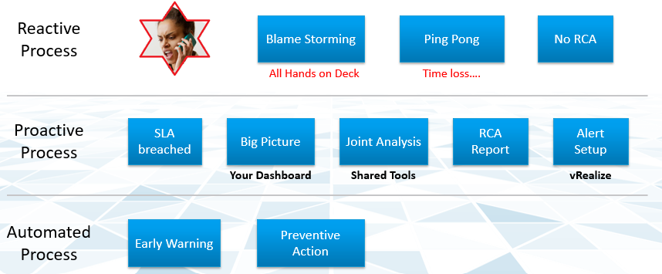

The main content of the report should be the alert that is set up to track just in case the problem happens again. Without this alert set up, you will not be able to detect the issue and can potentially lose valuable time.

There is a good chance that the root cause is different than the symptom. It may happen on a different object altogether and the error message could be seemingly unrelated. A root cause typically starts as a log message, meaning it has not bubbled up into the screen (UI) as formal alarm. When the vendor support team recommends you a specific log message to trap, how do you validate it is correct?

You need to ensure that the alert is valid. That means it should not result in false positive.

Let’s take an example. This was a [VDI](https://www.vmware.com/topics/glossary/content/virtual-desktop-infrastructure-vdi) mass disconnect issue, where >100 users had their sessions disconnected at the same time. The analysis concludes that the problem started with the “resuming traffic on DV port”, so we need to trap this message when it appears again.

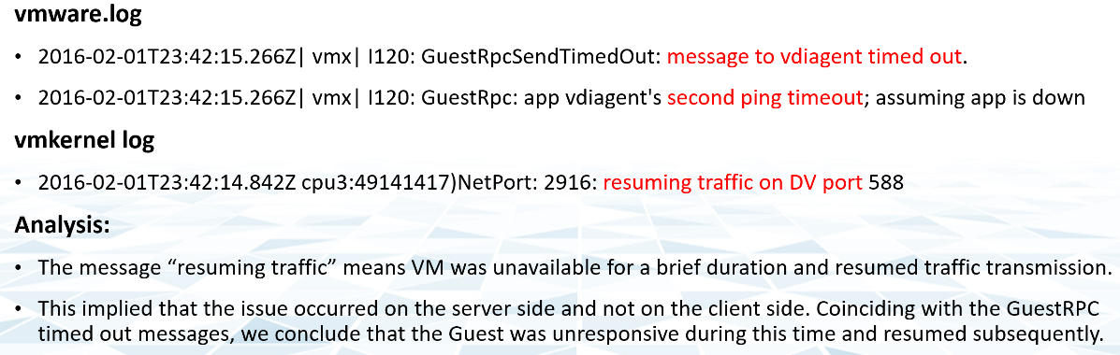

The first thing you need to do is validate the above alert. Using tools like Log Insight, you cross check the message against your entire environment, especially the healthy (in this case, unaffected users). Ideally, you cross check for entire week, not just during the time the incident happen.

The following was the result when I cross checked against all the users in the last five working days. It happens more than 1000 times, meaning that “resuming traffic on DV port” is not the message that I should base my alert on. There are too many of them and there is a clear pattern following office hours.

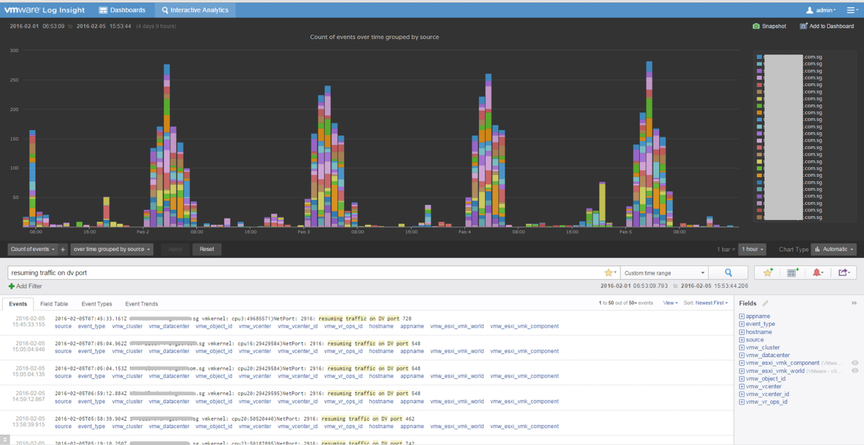

## Capacity Management

**Part 1 Chapter 3**

At the heart of capacity management is balancing demand and supply. It is about meeting demand with the lowest possible cost while remaining compliant to security and availability best practice.

### Overview

#### “Good” Advice

Let’s begin with this as I keep seeing it in VMware-based environment. The scope of the advice is about a VMware vSphere Cluster, but the principle applies to others such as Kubernetes, VDI or physical switches.

Can you figure out why the following statements are wrong? They are all well-meaning advice on the topic of Capacity Management. We’re sure you have heard them, or even given them.

Regarding vSphere Cluster RAM:

* We recommend 1:2 overcommit ratio between physical RAM and virtual RAM. Going above this is risky.
* Memory Usage on most of your clusters is high, around 90%. You should aim for 60% as you need to consider HA.
* Memory Active should not exceed 50-60%. You need a buffer between Active Memory and Consumed Memory.
* Memory should be running at high state on each host.

Regarding vSphere Cluster CPU:

* CPU Ratio on cluster “XYZ” is high at 1:5, because it is an important cluster.
* The rest of all your clusters’ overcommit ratio looks good as they are around 1:3. This gives you some buffer for spikes and HA.
* Keep the over commitment ratio to 1:4 for Tier 3 workload as they are not mission critical.
* CPU usage is around 70% on cluster “ABC”. Since they are UAT servers, don’t worry. You should get worried only when they reach 85%.
* The rest of your cluster’s CPU utilization is around 25%. This is good! You have plenty of capacity left.

From a capacity monitoring point of view, vSphere cluster is the *smallest logical building block*, due to HA + DRS + DPM. So it is correct to assume that we do capacity planning at Cluster level, and not at Host level or Data Center level.

Can you figure out where the mistakes are?

You should notice a trend by now. They have something in common. If not, read Chapter 1, especially the part discussing contention versus consumption.

#### Stages

Capacity Management requires an end-to-end plan and adjustment, because at the end of the day it is about comparing the reality you face with the plan you set. Good or bad is relative to your plan. If you plan for no overcommit because performance is absolute and budget is not an issue, then you’ll never run out of capacity. In other cases, that could be considered bad as you could end up with a lot of wastage.

There are 4 phases of capacity management:

|  |  |
| --- | --- |
| **Plan** | Within this phase, you perform sizing and estimate how long the infrastructure will last. Depending on the project, you may even size a multi-year capacity up front. The longer the plan, the bigger the margin you need to allocate. Higher margin or buffer certainly increases the risk of excess capacity.  As not all plans are confirmed, you may run multiple What If scenarios.  This is the phase where you buy hardware. |
| **Monitor** | This phase starts after the deployment. You begin tracking and compare the reality against plan.  For example, you expect the capacity for your new DaaS project to last for 1 year. 3 months into the deployment, you have 25% of your users consuming the DaaS. However, your overall utilization is already at 70%. This is a red warning, indicating your plan is off by significant margin. |
| **Optimize** | You optimize both the supply and the demand.  To optimize supply, you typically perform a tech refresh. Newer hardware can bring 2x the capacity at the same cost.  To optimize demand, you perform reclamation and rightsizing. |
| **Upgrade** | As the hardware reaches end of life, you either upgrade or migrate.  This typically involve technology version refresh and |

Capacity Management becomes easier if you begin at the planning stage. This is where you define your offering, setting the price and performance expectation. Without expectation being quantified as metrics, your customers will demand high performance as you’ve promised them “good” performance.

Balancing demand and supply require you to look at these 6 components below. Steps 1 and 2 are done together, and the remaining 4 steps can be done in parallel.

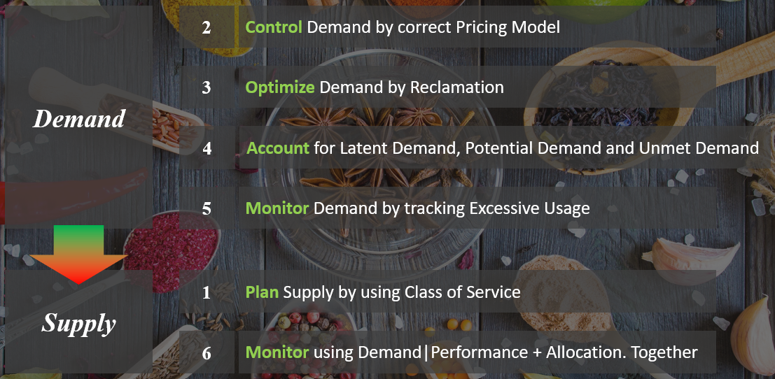

Relative to Performance Management, this pillar of operations require much less technical knowledge. Let’s check your technical skills if you don’t trust me.

* Can you architect a cluster where the performance matches physical?   
  Easy, just don’t overcommit, or put 100% reservation for that VM.
* Can you architect a cluster that can handle monster VMs?   
  Easy, just get lots of cores per socket.  
  Easy, just get lots of core in the box.
* Can you architect with very high availability?   
  Easy, just have more HA hosts, more vSAN FTT with failure domains spread across different racks, more NSX Edges.
* Can you architect a cluster that can run lots of VMs?   
  Easy, just get lots of big hosts.
* Can you optimize the performance?   
  Sure, follow performance best practices and configure for performance. Just be prepared to pay.
* Can you squeeze the cost?   
  Sure, minimize the hardware and software cost, and choose the best bang for the buck. You know all the vendors and their technology. You know the pro and cons of each.

The above is not hard to do if you do it right from the start, which is why we need to begin at the planning phase. If you start from Step 6 and ignore Step 1 and 2, you will play the lead role in a [Mission Impossible](https://en.wikipedia.org/wiki/Mission:_Impossible_(film_series)) movie, because you can end up with many over-provisioned VM issue. These VMs are typically the larger ones, and more critical to the business. It is hard to solve this in production environment as it will involve downtime and the burden is on you to prove it will not have performance impact. Politically, it may make the team who sized the VM and justified the cost look bad. Your best bet is to prevent the problem from happening in the first place, by using progressive pricing. This is covered in the Pricing section of the book.

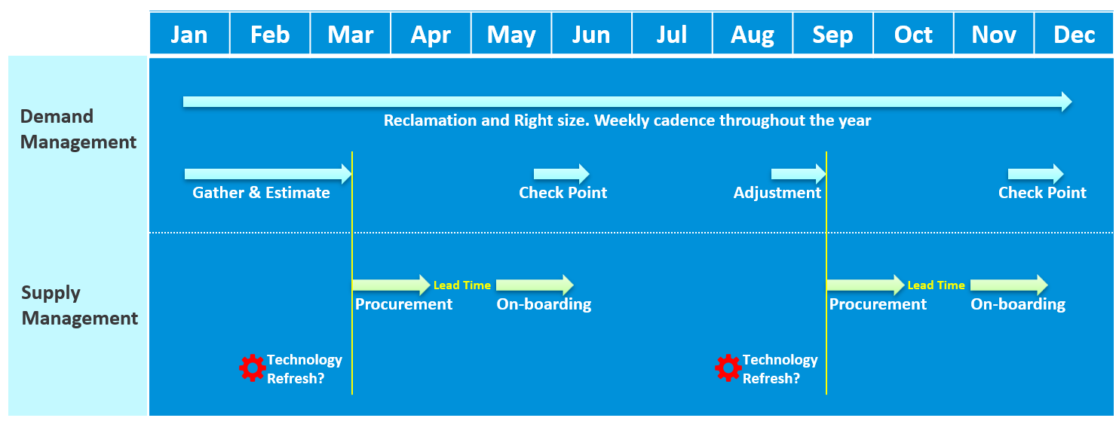

Discipline in capacity optimization is critical due to excess wastage. Establish a weekly cadence that is executed regularly (depending on the size of the environment)

Technology Refresh is an integral part, as new technology delivers both lower cost and higher capacity, not to mention faster performance and tighter security.

#### IaaS Capacity

Your IaaS consists of 4 large components

* Compute
* Storage
* Network
* VM

Compute gets the most attention as the consumer (VM or Pod) runs in a cluster of ESXi host. It’s a good starting point, especially if you have 1:1 relationship between compute and storage.

Storage needs to be managed equally well, if you have many to many relationship between cluster and datastore. If you use vSAN HCI Mesh, then you also need to manage the storage portion carefully.

Network is typically less of an issue for VMware Architect, as it’s typically done by the Network Architect. In addition, it’s common for ESXi to sport 20 – 50 Gb of bandwidth. So unless you run high bandwidth applications, such as networking VMs and web servers, running on the same ESXi hosts, you may not hit the limit.

VM impacts capacity in 2 ways:

* Rightsizing
* Reclamation.

#### Capacity Planning

For IaaS or DaaS, capacity management begins long before hardware is deployed. It begins with a business plan, which decides on what class of service will be provided to serve which locations. Class of Service was covered earlier in SLA. You should also read the Performance SLA portion here, as it’s required when you overcommit the capacity.

|  |  |
| --- | --- |
| Input |  |
| Cost | It impacts the architecture and location. |
| Class of Service | It’s related to the type of service. In addition to IaaS, you may have VDI, Database as a Service, K8 as a service, etc. |
| Location | The physical location, which could be data sovereignty or network latency requirements. |
| Security | It might require traditional physical or air gap separation. |
| Availability | This includes HA and DR |
| Environment | Other than production, you may need to provide test, development and a few others. |

As you can see, it’s complex to balance all the above. To make it worse, what worked last year for you may not work next year as many factors change. Regardless, make an overall plan that lists all the input you need. In a large environment, list all the input consideration for vSphere Clusters.

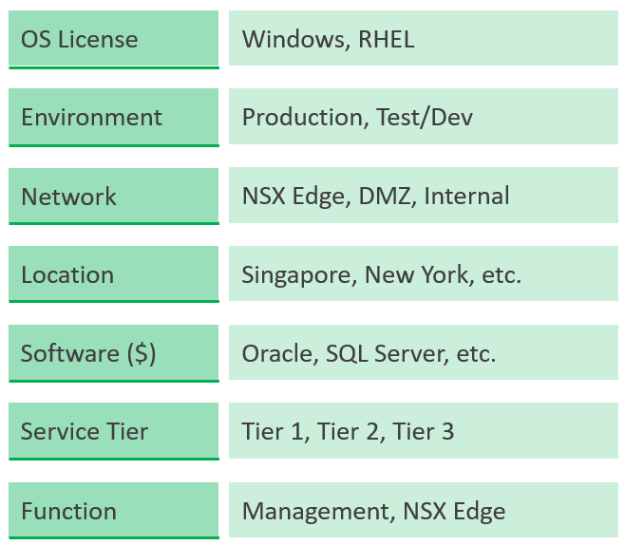

Group your operations by clusters or group of clusters. The following shows an environment with just 2 physical locations but 18 unique clusters. It has 7 clusters for business workloads and 2 clusters for non business loads.

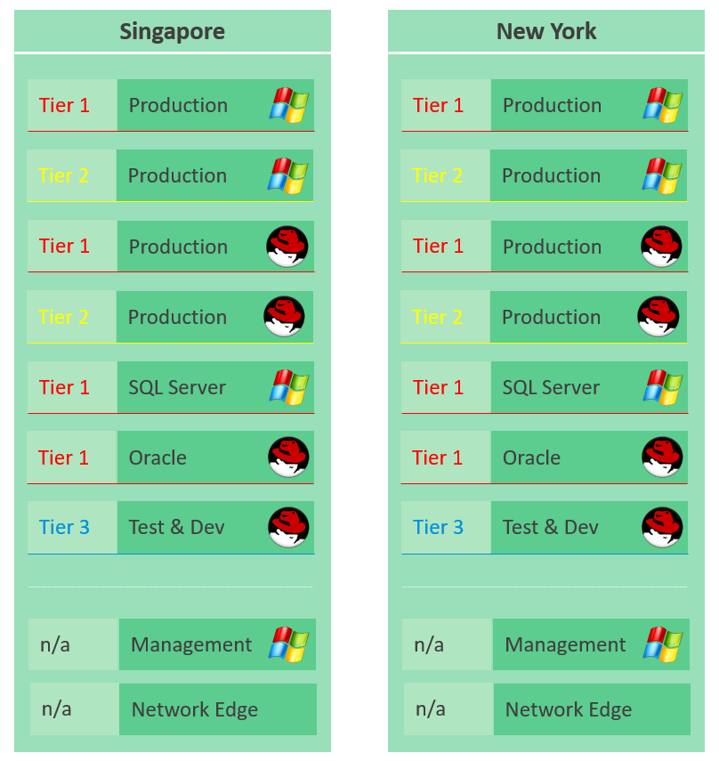

### Capacity Model

Capacity is only possible if we can model. That means defining the difference type of capacity dimension. For each dimension, we need to define the formula for total capacity, usable capacity and consumption metrics.

#### 4 Dimensions of Capacity

Manage capacity by considering the 4 types of input below.

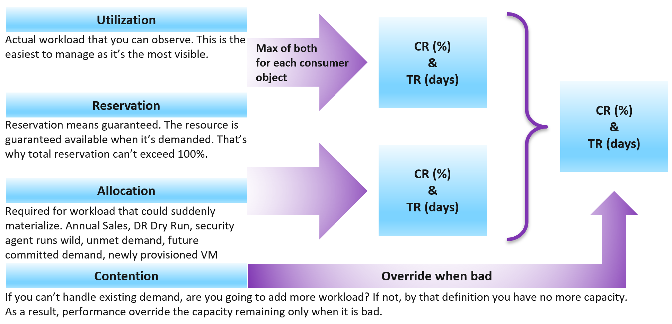

Use Utilization when you overcommit the environment. In mission critical where the business value of the workload far exceeds the cost of infrastructure, you do not need to monitor utilization. Reservation also becomes irrelevant, and you simply manage by allocation (which is 1:1).

For the rest of environment, where you overcommit, it’s mandatory to monitor utilization. Use Reservation to prevent overcommit from going too high, especially in a mixed-class environment. Utilization and Reservation form a single input for each consumer. We call this Demand.

Demand = Max (Utilization, Reservation)

For example, a VM that uses 4 GHz but reserve 5 GHz should be considered as having 5 GHz, as that extra 1 GHz is guaranteed for that VM.

Allocation is the metric you use when selling the capacity to your consumers. If you charge half price relative to full price, then your overcommit should not exceed 2:1.

Use Allocation when you want to protect the shared infrastructure from sudden spike.

The ideal scenario is the cluster is running at 100% utilization but 0% contention, because it’s working as productively as possible. You get your investment well used. This is why performance is an override, but only used when it’s bad.

Why is reclamation not included?

Because it only changes the capacity remaining (%) value when you reclaim the actual wastage.

However, wastage should be part of your SOP. It can impact your decision as wastage is prevalent. Capacity can be low, but if you can reclaim a sizeable chunk of wastage, you can defer hardware purchase.

Depending on the business policy, you may have to comply with [Business Continuity Policy](https://en.wikipedia.org/wiki/Business_continuity_planning) or security policy. Examples:

* Define the blast radius to contain major outage. This may translate that you do not design a large cluster containing ___ VM, as a cluster may go down.
* Define the concentration risk. The number of mission critical VMs in the same datastore is capped below ___ VM.
* Contain the security risk. Internet facing VM and internal facing VM do not share the same ____.

#### Utilization

Utilization against usable capacity is the primary counter for capacity, as it reflects the actual, live usage of the resources. If utilization is high, it does not matter if the overcommit ratio is far below your target, the cluster is full. vRealize Operations has this enabled by default without any configuration and cannot be disabled.

A concept that is unique in utilization is wastage. It is not applicable in allocation, reservation and contention.

In utilization, if utilization is very low, that is not a good thing. Unless it’s a newly provisioned object that is yet to grow to its full usage, that could indicate wastage.

How should we fit wastage in the model?

The following is my recommendation. I divide the capacity into 10 equal chunks. The green zone is in the middle. That means the capacity is green when it’s around 30 – 70% used.

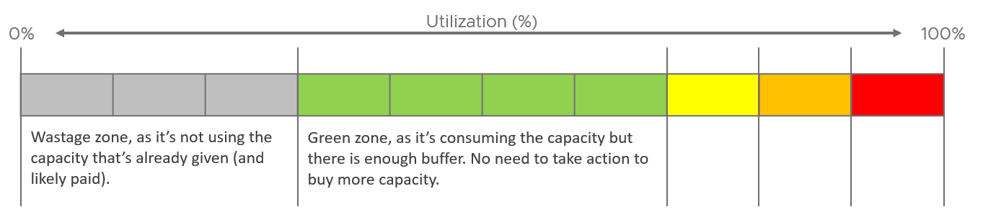

##### Used > Allocated

Can you use more than what you’re allocated?

Certainly. This especially happens in software-defined storage such as vSAN.

The following screenshot shows a VM configured with 10 GB hard disk. That means the guest OS is allocated with 10 GB.

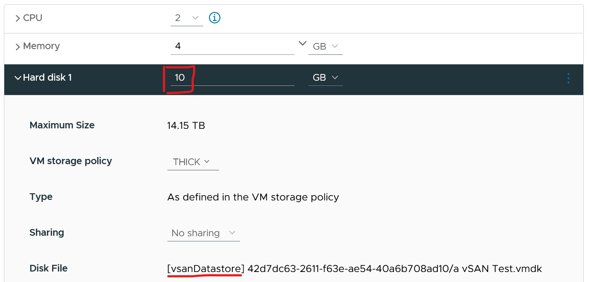

It’s thick provisioned as specified by vSAN policy.

Guess how much disk space it actually consumes at the VMFS layer?

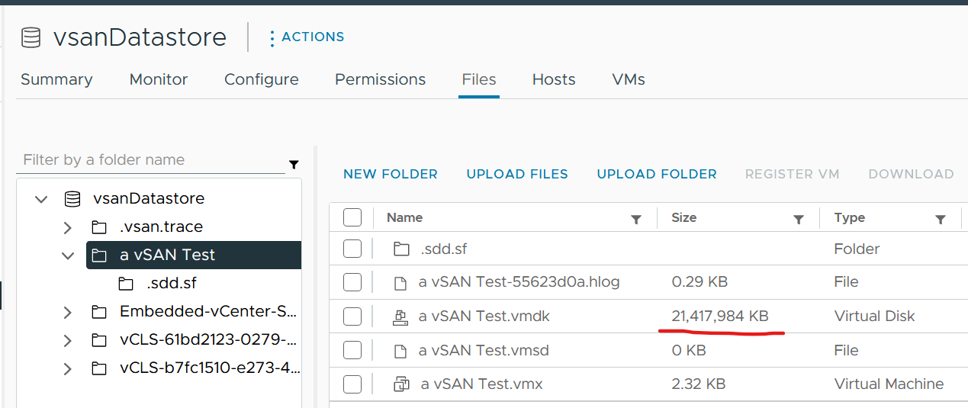

You’re right. It is 20 GB.

#### Reservation

Reservation that is not yet consumed impacts capacity but not performance. Using a restaurant analogy, if all your tables are reserved but only 20% turns up, you have 0 capacity left but can easily serve all customers as the real demand is only 20%.

From the above you can tell that the demand metrics should not include reservation. On the other hand, you do need to calculate your restaurant capacity. That means you need 3 metrics

* Utilization
* Reservation
* Sum of individual consumer Max (utilization, reservation). This is the metric you should use as the demand.

Let’s take an example of a restaurant with 2 floors. The 1st floor is 100% filled up with diners. The 2nd floor is 100% reserved. What’s your capacity left?

Answer is 0%. You can’t take any more diners unless they are reservation holders.

Applying the above to vSphere, how do you know who are the reservation holders that are yet to consume what they are entitled?

For compute, those are VMs already powered on but have not consumed CPU and memory at their reserved threshold. When you get to the actual metric, you will notice there is some complication we need to take care.

For storage, those are thin provisioned VMDK files that are yet to grow to their full size.

#### Allocation

The total demand is more than the visible demand, the active load that is consuming your capacity. Active load is the visible demand, which you can monitor with the utilization metrics. There are demand that are not visible, because it has no utilization at present.

Use the Allocation Model and buffer settings in vRealize Operations to cater for this invisible demand. Note that buffer is applied *after* Availability.

|  |  |
| --- | --- |
| **Sudden Demand** | This can wreak havoc in a shared environment. A group of highly demanding VMs can collectively impact overall performance of the cluster or datastore. An example of this is annual sales. In this case, the capacity team should set an appropriate overcommit ratio and drive by allocation as the demand is low most of the time.  A rare part of sudden demand is disaster, like stock market crash. It can’t be predicted. Whether your CIO wants to pay in advance for such rare thing is a business decision, not within the call of Capacity Planner. |
| **Latent Demand** | Many critical VMs are protected with Disaster Recovery. During a DR drill or actual disaster, this load will ‘wake up’ and consume. You should consider the Site Recovery Manager [Recovery Plans](https://docs.vmware.com/en/Site-Recovery-Manager/8.4/com.vmware.srm.admin.doc/GUID-AF6BF11B-4FB7-4543-A873-329FDF1524A4.html) into your capacity.  Be careful with the complexity as 1 Recovery Plan can have many Protection Groups, yet 1 Protection Group can be included in many Recovery Plan. |
| **Potential Demand** | Many newly provisioned VMs take time to reach their full expected demand. It takes time for the database to reach the full size, the user base to reach the target, and the functionalities to be complete. Newly provisioned VM tend to be idle (which can be months) and may suddenly grow. When this happens, it will result in an increase in demand. |
| **Unmet Demand** | There are 2 parts to it: inside the VM and outside the VM.  If the VM is undersized, the unmet demand will *not* be visible to the underlying infrastructure. Unless that is intentional, it is wise to include undersized VM in the cluster capacity monitoring.  The visible part of unmet demand becomes part of IaaS KPI and SLA, covered in Performance Management chapter. |

The next use case for allocation is showback and reporting. There are typically restrictions such as contractual obligations or SLAs that mandate capacity shall not be overcommitted beyond an agreed upon ratio. Note these restrictions are usually non-technical.

Buffer does not mathematically apply to allocation. The reason is you can simply use a lower allocation. For example, if you do 10 : 1 ratio and set 10% buffer, that’s basically 9 : 1 ratio with 0% buffer. The buffer is provided for the very reason, give you a buffer, secretly 😉

##### Limitation

The allocation model has the following limitations:

|  |  |
| --- | --- |
| **VM Size** | VM size is not considered in the overcommit ratio. It assumes that scheduling two monster VMs is as easy as scheduling many small VMs. The ESXi scheduler can juggle higher number of small VMs than a few large ones, especially if they peak at different times.  Utilization is completely ignored. The consumer part is simply based on the configured amount. In cases where there is additional workload, the allocation model can report lower capacity consumed than actual. |
| **Overhead** | Any form of utilization is not considered, including consumption because of virtualization. For example, software-defined storage such as vSAN actually puts the availability protection data in the same datastore with the actual data. So you end up with double the consumption. |
| **IaaS Workload** | IaaS workload that does not take the shape of VM is not considered. VMkernel, vSAN, vSAN HCI Mesh, NSX, vSphere Replication, and vMotion all need to be considered.  On the other hand, Agent VM is included as it takes the shape of a VM, although it tends to use local datastore. |

##### Overcommit

Overcommit is the main technique to reduce cost of shared infrastructure or shared service. So long the contention or queue is acceptable, it reduces the cost to everyone. In daily life, queueing or waiting for service is common.

If you do not overcommit, you may not be able to compete on cost.

The allocation model is *not* enabled by default as the overcommit ratio varies among customers. You should configure it appropriately to account for all the types of demand that is relevant for that cluster. By using both, you can account for both inputs (real demand and unreal demand).

Some customers do procurement planning based on overcommit ratios. A comfortable overcommit ratio is determined, and that’s what is used to project utilization into the future. The overcommit ratio is intended to be a rough estimate of utilization, e.g. 5:1 CPU overcommit ratio means that on average each vCPU should only run 20% utilization else you will have contention.

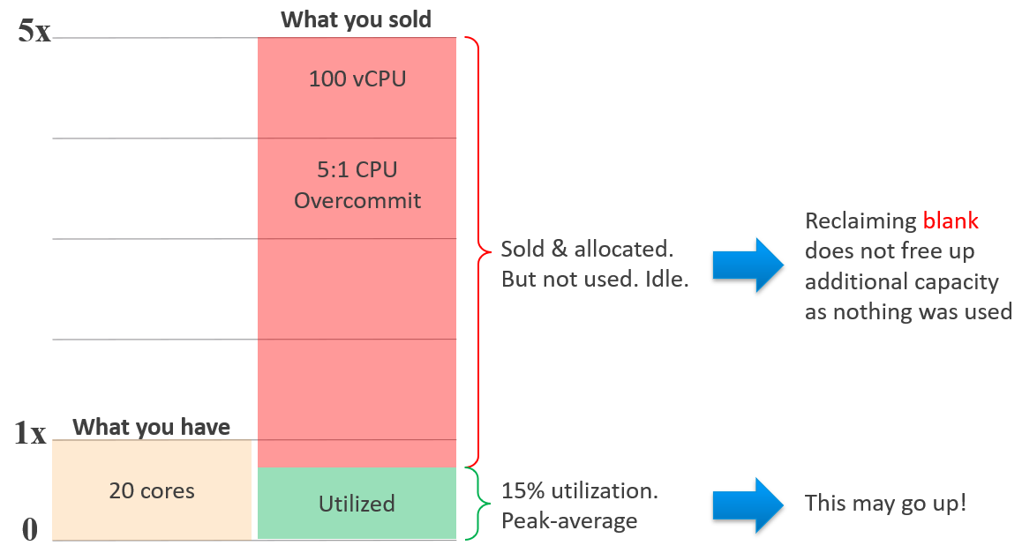

###### Overcommit Ratio

Overcommit ratio looks simple on the surface. As we dive deeper, it’s not as straight forward. For examples:

* CPU hyperthreading. This can be turned on and off. Should the ratio change accordingly? Do we consider it since there are only 2 threads per core? What if future CPU has 4 threads?
* Datastore. Do you consider the snapshot space? How about the availability protection created by vSAN?

To answer the question, I think it’s best to remember that allocation model does not consider utilization. Since allocation is about allocating to consumer, the provider part should be excluded too.

|  |  |
| --- | --- |
| **CPU** | Exclude hyperthreading. That means you only count the physical core. I see this as better approach than including the thread, as threads do share the core, which means overcommit. I am aware that AWS includes the threads and then implies there is no overcommit. Accounting wise this is true.  Exclude the VMkernel overhead. Kernel modules do get reservation, and if you have many software-defined infrastructure such as vSAN and NSX, they do consume resources. The reason I exclude them is ease of comparison, such as migration use case. Also, utilization is already included in utilization model, which is always enabled. |
| **Memory** | Exclude the VMkernel overhead. |
| **Disk** | For datastore, only consider the VM virtual disks. Exclude other VM disk space such as snapshot and memory swap. If you have a lot of snapshots and high memory overcommit, this can result in higher actual disk space consumption.  If the datastore is vSAN, exclude the vSAN availability protection (Failure To Tolerate). The downside of this the overcommit ratio may fail to serve its purpose, which is to give early warning before actual utilization happens. So set a lower number, matching to the FTT setting. For example, if your FTT doubles the disk space consumption, then your overcommit ratio has to be halved. |
| **Network** | For physical switch, exclude the inter-switch link.  For ESXi, only include the physical ports used by the VM. |

#### Total Capacity

To define total capacity, first determine whether its value is fixed or not. If it’s not fixed, the next question is whether the change is Scale Up or Scale Out.

* Scale Up happens on a single object. Example is the just in time capacity such as storage LUN, where the size can be increased on the fly or upon request.
* Scale Out happens on a cluster of objects. The cluster members or nodes are typically identical in size. Examples are K8 cluster, K8 Workload, Horizon VDI Pool, and VMC vSphere Cluster. Scale Out is more popular than scale out as it’s cheaper. It does not work when the data can’t be partitioned.

Total capacity becomes dynamic only if you *intentionally* change the numbers, as you still want your availability buffer. Some examples

* Horizontal auto-scaling solution such as VMware on AWS
* vSphere Distributed Power Management.

##### Usable Capacity

This is an imaginary number that you get after deducting total capacity with the portion that capacity team decide to exclude. The number is non-real as actual utilization can exceed it.

This portion typically accounts for availability. In addition, you may need to add buffer.

Usable Capacity = Total capacity – Availability protection - Overhead - Buffer

|  |  |
| --- | --- |
| **Availability protection** | For hardware, this means the part that is added to cater for unavailability period. Common examples are RAID in disk, hot spare in storage array, vSphere HA in vSphere Cluster. Many hardware deployments come in a pair (e.g. network switches) because one of the nodes is for availability, not capacity.  In vSphere Cluster, you typically design with at least 1 host as spare, so you can perform maintenance, upgrade without service degradation. While this host is actively participating in reality, you exclude this in your usable capacity.  In Kubernetes, there is no such thing as HA as the node itself is transient. |
| **Overhead** | This is the portion that is not available for “consumer” or business workload. Examples:   * VMkernel in ESXi * Kubernetes supervisor cluster. * Load of the OS in K8 Node. |
| **Buffer** | Buffer is required when you want to exclude certain portion from usable capacity.  It’s calculated based on capacity after HA, and not on the total capacity. |

##### Buffer

Peak is often used as the reason to have buffer. The actual reason behind is performance avoidance. Since it’s about avoiding the contention from happening, the contention counters cannot be used. Take for example, a large cluster (could be vSphere, Kubernetes, or Horizon) where imbalance can happen among the cluster nodes. You have witnessed that it happens at say 95% utilization. In order to avoid that, you set buffer at 10%, effectively setting the usable capacity at 90%. This in theory gives you 5% buffer, as the last 5% can be measured using contention counter.

Overhead is another valid reason. In VMware SDDC, the “overhead” such as VMkernel, vSAN dedupe, and NSX kernel modules take up resource. In your planning stage, you need to reduce the usable capacity as they are already reserved.

Disaster Recovery is a valid use case for buffer. Some examples are:

* A pair of vSphere Clusters protecting each other in a DR pair.
* A production cluster and DR cluster. The DR cluster typically run test and development workload, which will be powered off in the event of DR drill or actual DR.
* A stretched cluster.

Let’s elaborate the first example

* Say you design a pair of 10 node cluster to protect each other. Each has 9+1 set up for HA to give you room to do the usual cluster maintenance and upgrade.
* You want to limit the utilization of each site at 50% of the 9 hosts. This translates into 45% utilization on each of the 10 hosts, if there is no imbalance.
* To monitor the above, you set 50% buffer on the capacity after HA.
* Now, since the VMs typically run well below their configured size, you use allocation model and cap it at say 3:1.
* To complicate matters, say 60% of the workload can be turned off during DR. In this case, you allow utilization to reach 160%.

#### Projection

The accuracy of the prediction depends on the amount of data and the length of the cycle. A workload with quarter end peak will naturally need at least 6 months for it to be accurate. If there is enough data, vRealize Operations will consider 6+ months worth of data. While it gives extra weight to recent data, if there is a sudden but short-lasting change, it may not be enough to impact the projection.

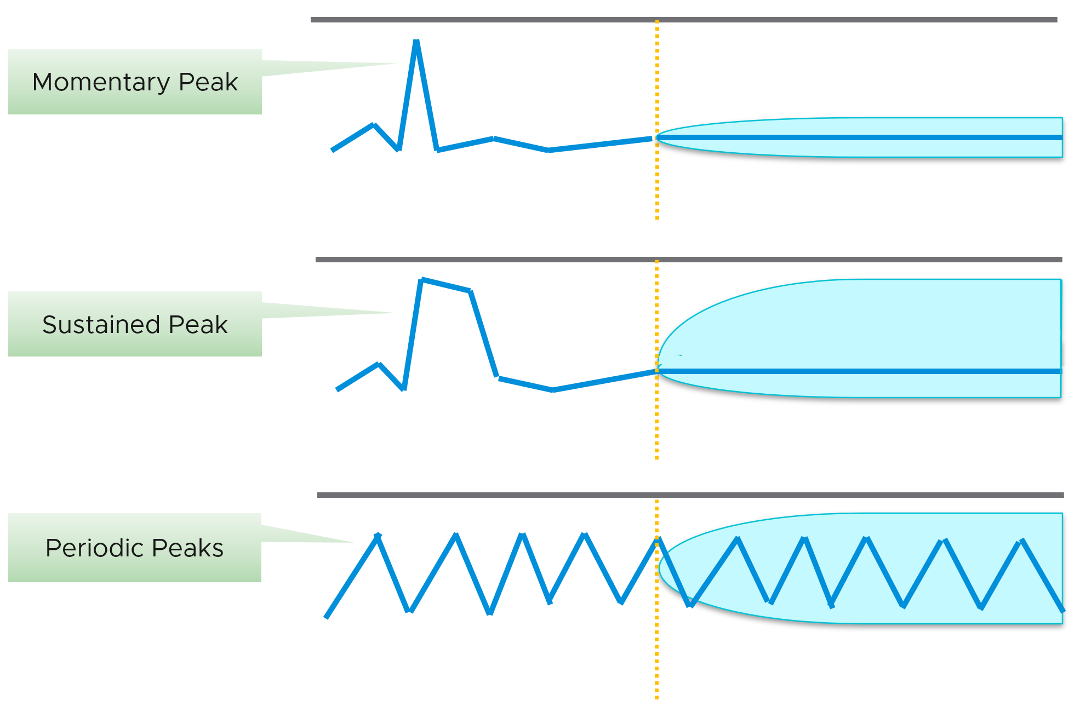

Momentary peaks that are short lived and one-off should not impact capacity planning so the impact may not be noticeable in the projection.

Sustained peaks last for a longer time and do impact projections. If the peak is not periodic, the impact on the projection lessens over time due to exponential decay. Data is exponentially weighted based on how far back in time they are, giving recent data points more important than older ones.

Periodic peaks exhibit cyclical patterns or waves, such as hourly, daily, weekly, and last day of the month. There can be multiple overlapping cyclical patterns, which will also be detected. While you should not make capacity decision based on just a few days of data, you do need the 5-minute granularity as input. A 5-minute peak that gets repeated every hour should be considered.

Exponential decay is important as newer data is more relevant, but it might make the projection visually odd. The following projection looks “make sense”, because your eyes see the whole period and give equal weightage to all data points.

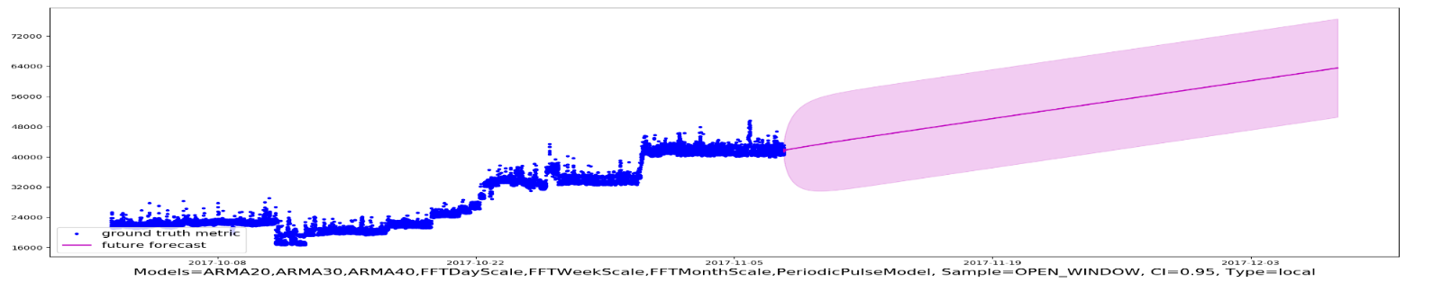

If you give higher weightage to newer data, it can potentially look like this.

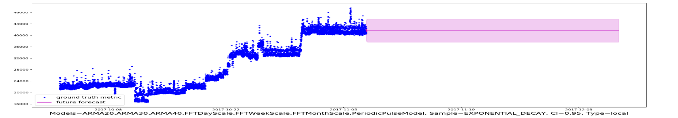

If you do not have 3 months and just need an overall sizing, consider using the 97th percentile value. Why 97th percentile? It's based on standard deviation principle. Two [Standard Deviation](https://en.wikipedia.org/wiki/Standard_deviation) away from the midpoint equals to 95%, and 3 Standard Deviation = 99.7%. 97th percentile hence provides a good balance between 2 SD and 3 SD. By and large, it captures just the right amount of peak and outlier.

#### Optimized Capacity

Optimized Capacity means you run utilization at 100%, without wastage or compromising performance. There are two areas where you can optimize: consumer and provider.

In the consumer layer (process, guest OS, container, VM), optimize the following:

|  |  |
| --- | --- |
| **CPU** | Use CPU Run Queue as primary counter, as utilization should be 100% to minimize ping pong and NUMA.  Make sure all the CPU is used well by check the CPU Usage Disparity metric, as some applications tend to gravitate towards the first 8 vCPU. |
| **Memory** | Utilization should be near 100% as it contains cache (majority of pages not active). Check page fault to see if there are excessive page fault. |
| **Disk** | Rightsize the filesystem. Note this requires Windows or Linux partition modification.  Reduce the usage of RDM. If you do, and you use thin provisioning at array level, check for wastage using unmap |
| **VM** | Imbalance cluster with low ESXi utilization can be caused by monster VM. Can the applications scale horizontally instead? |
| **Container** | Do you use 1 container per VM or >1 containers per VM? If it’s >1, how do you ensure one does not dominate the others, since their size is not capped. If you use 1:1, how do you prevent container sprawl? |

In the provider layer (ESXi, cluster, datastore & datastore cluster, distributed switch and port group, hardware), you can optimize the following:

|  |  |
| --- | --- |
| **Compute** | Compute covers ESXi, cluster, resource pool, and physical server.  Reduce pockets of resource by using larger cluster, removing Host/VM Affinity and setting DRS to be fully automated.  Increase supply while keeping cost the same by doing a technology refresh.  Avoid usage of CPU pinning.  Reduce reservation. VMs in the same cluster should have same priority |
| **Storage** | Storage covers datastore, datastore cluster vSAN, RDM, VVOL, physical array, back up infrastructure, etc.  Use larger datastore to minimize island of buffers.  Use local datastores for agent VM or applications that do not need HA.  Reduce islands of datastores by consolidating datastores that are lowly utilized. |
| **Network** | Network covers virtual and physical. It also includes switch, router, firewall, load balancer, etc.  Use larger physical pipe. For example 2x 25 Gb instead of 4x 10 Gb.  Use load-based teaming.  Remove unused network. While network is good for segregation, VXLAN or VLAN sprawl make both management and security harder. |

### Storage Capacity

Storage Capacity differs to Compute Capacity and presents a challenge on its own. Unlike compute capacity, which is basically vSphere cluster, storage varies in shape. The two major ones are datastore and vSAN, as local datastore and RDM are rarely used. In addition, storage has thin provisioning at both virtualization layer and physical layer.

We will discuss vSAN capacity separately as it has its own unique factors such as FTT, plus it needs to consider compute too.

#### Utilization | Allocation

Similar to compute capacity, storage capacity is driven by performance first. If the datastore is unable to serve its existing VMs, meaning they are getting bad latency, are you going to add more VM? You are right, the datastore is full, regardless of how space it has left.

Once you cover that, you need to deal with utilization and allocation. Review the following table. What differences do you notice?

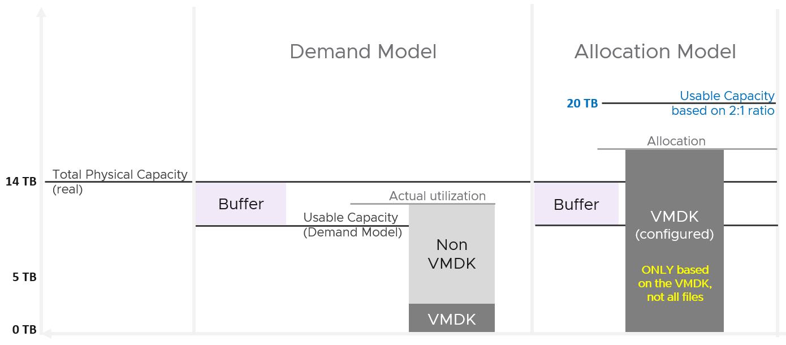

They both share the same total capacity and buffer. However, they arrive at a different usable capacity number.

* Utilisation: the usable capacity cannot exceed the physical capacity.
* Allocation: the usable capacity can and typically exceed the physical capacity. If your overcommit ratio is less than 1, the allocation model becomes mute.

Utilization model counts all types of utilization, not just the virtual disk. Allocation only considers the VMDK and nothing else.

Due to thin provisioning, both models need to be used. Take a look at the following two datastores.

Which one has lower capacity remaining? Which one would you choose to deploy additional VM?

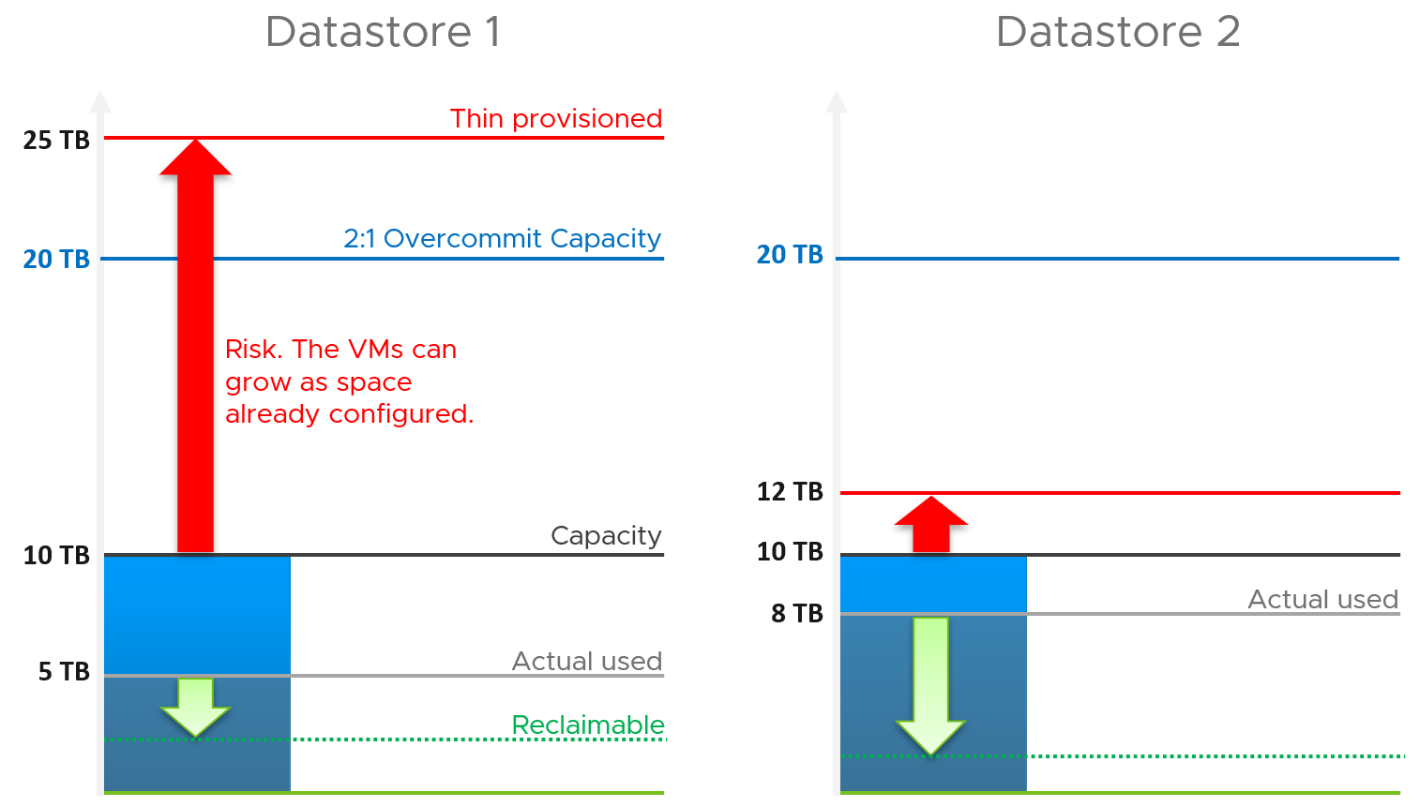

Both have identical usable physical capacity at 10 TB, as shown by the black line. Both have identical allocation model, based on 2:1 overcommit. But they have different utilization and actual overcommit ratio. Datastore 1 has 5 TB used but 25 TB thin provisioned. Datastore 2 has 8 TB actual used but 12 TB thin provisioned. The red arrow shows the risk.

|  |  |  |  |
| --- | --- | --- | --- |
|  | Total Capacity | Used Capacity | |
| Utilization model | 10 TB | Datastore 1 = 5 TB  Datastore 2 = 8 TB | Datastore 1 = 50%  Datastore 2 = **80%** |
| Allocation Model | 20 TB | Datastore 1 = 25 TB  Datastore 2 = 12 TB | Datastore 1 = **125%**  Datastore 2 = 60% |

Datastore 1 has lower actual usage, but higher risk because it has more space over-committed than reclaimable. You should take the lower of the two capacity models. In this case, Datastore 2 is what you should choose.

Thin provisioning brings another complexity in the form of newly provisioned VMs, as their growth are not predictable. They can remain idle for months and suddenly grow their storage consumption. Their growth becomes relatively more predictable after they mature, which vary per business application.

Lastly, there is reclamation. I added the green arrow to indicate that you can have different reclaimable values. In the example above, Datastore 1 happens to have has more reclaimable space.

#### Aggregation

Now that we know how to calculate the capacity of a single datastore, we are in the position to solve the roll up for ease of management.

Datastore may belong to datastore cluster. As datastore cluster groups datastores into a larger pool, we can treat them as one logical pool. This simplifies the capacity calculation. As a bonus, you need not manually exclude local datastore, and you need not manually group the shared datastores, which can be complex if you have multiple clusters.

It also makes capacity management easier in large environment with many datastores, as you treat the cluster as one. It makes the information & visualization more compact and manageable. From the datastore cluster, build a drill down.

For the overcommit ratio, we should allow a lower overcommit ratio at the datastore cluster level to account for the fact that the distribution among the datastore is not granular. The following diagram illustrates why.

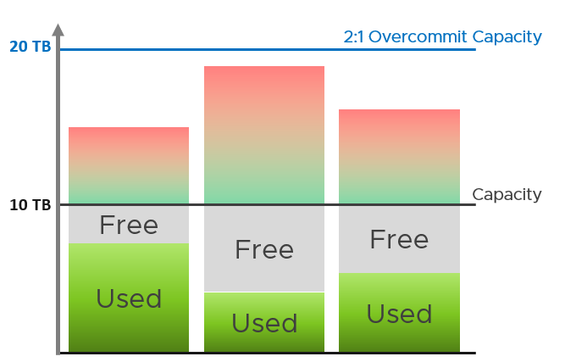

Unlike ESXi Host in a compute cluster, the unbalance among the member datastores will be greater. It takes much longer to storage vmotion, and there is no HA in Datastore Cluster. You can account for this by having a lower overcommit ratio at the datastore cluster level. For example, you have 2:1 overcommit at each datastore, but 1.7:1 at datastore cluster level.

How about rolling up to Data Center or vSphere?

This is not advisable. Different datastores in a vCenter can have different purposes, such as NSX Edge and business workload. The capacity they have are not interchangeable. Yes, that means we should not even calculate Total Capacity. If you have 1000 datastores globally with each having 1 TB of remaining space, you do not have 1 PB of space.

So what can you roll up?

You can roll up VM Remaining. This is simply the sum of VM Remaining on each datastore. Take note the corner case where a VM has virtual disks in multiple datastores. In this situation, you will over-report.

You can also takes the free space, in percentage and not in GB. If this free space is going down, and you have many datastores, that’s not a good sign. If you’re concern that average is too late, you add a buffer for each datastore (e.g. 20%), then you do the average.

### Reclamation

Reclamation delivers many benefits, and some of them are listed below

|  |  |  |
| --- | --- | --- |
|  | Area | Benefit |
| **Unused VM** | CPU  Memory  Storage | This delivers the highest benefit, but it’s also hardest to find as the VMs may not be idle nor undersized. They appear like an active VM.  Improve on the underlying IaaS capacity and performance.  Savings on storage only happen when you delete the VM. |
| **Oversized VM** | CPU  Memory  Storage | VM Performance. Especially if Guest OS does a lot of CPU context switch and VM size exceeds whole box total core counts.  The rest of benefit is the same with Idle VM as the portion you’re reducing is idle. |
| **Idle VM** | CPU  Memory  Storage | Cluster Capacity, especially if you use allocation model.  Cluster RAM as idle RAM pages tend to occupy ESXi memory. One quick way to free up is the reboot the VM.  Negligible savings on CPU demand as idle loop hardly occupies real CPU cycles.  Savings on storage only happen when you delete the VM. |
| **Powered off VM** | Storage | Datastore Capacity |
| **Orphaned VMDK** | Storage | Datastore Capacity. Does not impact cluster capacity |
| **Snapshot** | Storage | Datastore Capacity. |
| **Unmapped** | Storage | Datastore Capacity |

There are 6 areas of reclamation, from the easiest to the hardest. Naturally, the logic differs for each.

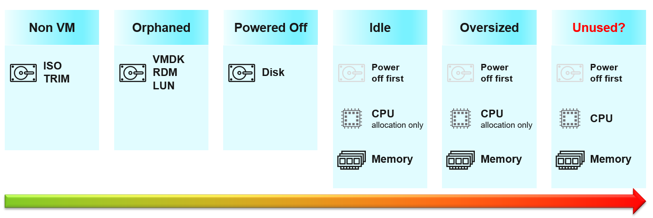

Non VM files are the easiest, because they are not owned by someone else. They are yours! Non VM objects, such as templates and ISOs should be kept in 1 Datastore per physical location. Naturally, you can only reclaim Disk, and not CPU & RAM.

An orphaned file is a file in the datastore that is no longer associated with any VM. Orphaned VMs and orphaned [VMDK](https://en.wikipedia.org/wiki/VMDK)’s are not even registered in vCenter. If they are, they may appear italicized, indicating something wrong. They may not have owners too.

For orphaned RDM, look from the storage array if there is any ESXi mounting it. You need an adapter for the specific storage you want to monitor.

Snapshots are not backups, and they do cause performance problems to the VM if kept for extended periods of time. Keep them only for the purpose of protection during change. Once the change is validated as successful, keeping the snapshot does a disservice to the VM. A Snapshot is easier to reclaim, hence vRealize Operations lists them separately.

#### Reclamation Approach

Active VM is politically the hardest, as they serve business workload. Focus on large VMs first. Take on CPU and RAM separately as they are easier to tackle when you split them. Divide and conquer. If you reduce both, and application team claim performance impact, you need to restore both. Claiming CPU and RAM from small VMs can be futile, regardless of idleness. An idle VM with one vCPU cannot be further reduced. Focus on the large VMs, for the reason covered here.

##### Focus on Monster VMs

When reducing oversized VM or powering off idle VMs, focus on large VMs. Let’s take an example for comparison:

* Reduce 20 large VM. Average reduction is 10 vCPU.
* Reduce 100 small VM. Average reduction is 2 vCPU.

In both scenarios, you reclaim 200 vCPU. But the large VM option delivers more benefits and is easier to realize. Here is why:

* Every downsize is a battle because you are changing paradigm with “Less is More”. Plus, it requires downtime, which requires approval and change request process.
* Downsizing from 4 vCPU to 2 does not buy much nowadays with >20 core Xeon.
* No one likes to give up what they are given, especially if they are given little. By focusing on the large ones, you spend 20% effort to get 80% result.
* Large VMs are also bad for other VMs, not just for themselves. They can impact other VMs, large or small. ESXi VMkernel scheduler has to find available cores for all the vCPUs, even though they are idle. Other VMs may be migrated from core to core, or socket to socket, as a result. There is a counter in esxtop that tracks this migration.
* Large VMs tend to have slower performance. ESXi may not have all the available vCPU for them. Large VMs are slower as all their vCPU have to be scheduled. The counter CPU Co-stop tracks this.
* Large VMs reduce consolidation ratio. You can pack more vCPU with smaller VMs than with big VMs.

#### Powered Off VM

Compared with orphaned VMDK, Powered Off VMs are harder to remove, as there is now an owner of the VM. You need to deal with the VM Owner before you delete them. This is where tagging them with the owner email or Business unit would have been useful. We discussed proposed tagging in Chapter 1, specifically here.

There are different technique to define power off:

* Non Stop. In this technique, you want the VM to be continuously powered off. A quick power on to check something in the VM will remove the VM from powered off list.
* Percentile. In this technique, you can turn on the VM for a short period of time.

Each technique has their own pro and cons. vRealize Operations use the non-stop as it is safer.

##### Powered Off as Brake

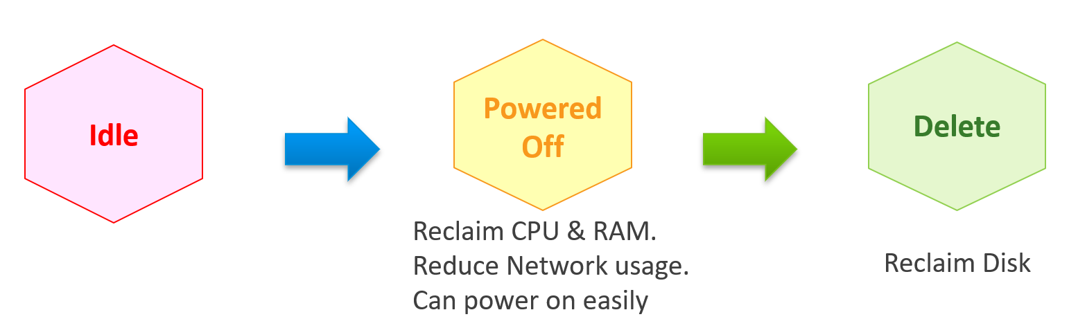

Why do cars have brakes?

So they can go faster!

Take advantage of Powered Off as the brakes for your Idle VMs. If you treat Idle and Powered off as 1 continuum, you can power off the Idle VMs earlier. You get the benefit of CPU and RAM reclamation. It’s a safer procedure too, as you can simply power it back on if you find that the VM is actually being used.

One major caveat if you do this, is the average utilization of the remaining VMs in the cluster becomes higher. As a result, you may not be able to achieve the overcommit ratio needed to break even.

#### 2 Sides of a Running VM

There are two reclamation formula for running VM (idle or not). The formula is complex as it has 2 different stages:

|  |  |
| --- | --- |
| **Before** | Determine *if* the VM falls under the category. For example, does the VM qualify as an Idle VM? This should look inside the VM, as that’s where the workload runs. Measuring at the ESXi level could yield incorrect results because:   * Some metrics include loads not generated by the VM that are charged to the VM, such as vSphere replication and vMotion. * Some CPU metrics affected by power management. |
| **After** | Determine *what* can be reclaimed. Since what is being reclaimed is ESXi resources, the usage inside the Guest OS is irrelevant. The queue inside the Guest does not impact the hypervisor, so there is nothing to reclaim at the ESXi layer. All metrics are from ESXi. Guest OS metrics are not applicable as we’re not reclaiming from inside the Guest. |

So you need to apply 2 different types of logic.

#### Idle VM

By definition, idle means it’s not doing useful business workload. A VM that is doing only non-business workload (e.g. AV scan, Windows regular update) should be considered as idle. This non-business workload is hard to detect via unless you have process-specific whitelisting. This is also not fool proof as some non-business software uses Windows or Linux system services as proxy.

Idle VM is a great target, as you can now claim CPU and RAM when you power them off. You cannot claim disk yet as you are not deleting them yet. Take note that you are not reclaiming real CPU cycle as it’s idle to begin with. Idle VM does not actually consume any ESXi CPU cycles. So reclaiming a 10 vCPU VM running only 1 vCPU does not give you 9 vCPU. You are reclaiming blank air. For memory, you will reclaim real ESXi memory as idle VMs tend to have its consumed memory remained on ESXi.

Idle VM has a default threshold of 100 Mhz. This means 5% utilization in a single vCPU VM running on a 2 GHz ESXi. This also means 0.25% on a 20 vCPU on the same ESXi. The reason for static is idle by definition is absolute, not relative to the VM size. Oversized VM is relative.

While a VM uses CPU, RAM, Disk and Network, we only use CPU as a definition for Idle. There is no need to consider all 4, and require all 4 to be idle, because they are inter-related. It takes CPU cycles to process network packets and perform disk activity. Data from the network card and disk must be copied to RAM before processing, and the copying effort requires CPU cycles.

Take note of a corner case limitation of VM with runaway CPU, where CPU is high but no meaningful memory access, network transmission (TX) and disk processing. Idle VM will fail to detect it. It’s a corner case, hence I think it’s not worth the complexity. Also, the CPU runaway typically happens on a process, which likely a single threaded. Use the CPU Usage Disparity (%) metrics to detect that.

Idle has to be defined so it’s measurable and not subjective. Declare it as a formal policy so you don’t end up arguing with your customers.

VM that is rarely used can appear idle, if you measure idleness over a long period of time. For example, if a VM is only productive (from business viewpoint) for 2 hours a week, that means the remaining 166 hours should be classified as idle. That’s 98.8% idle.

To counter the above, you want to evaluate idleness on a daily basis. A VM has to be idle every single day for ‘N’ number of days. This daily calculation is stored in the counter **Idleness Indicator**.

It is a rolling counter. That means it is calculated every 5 minutes, but each value takes the last 24 hours of data. This is better than calculating only once a day so that VM does not have to wait before it gets declared as idle or not.

As you can see in the following example, its value is only stored if there is a change. This makes it easier to see when and if it changes.

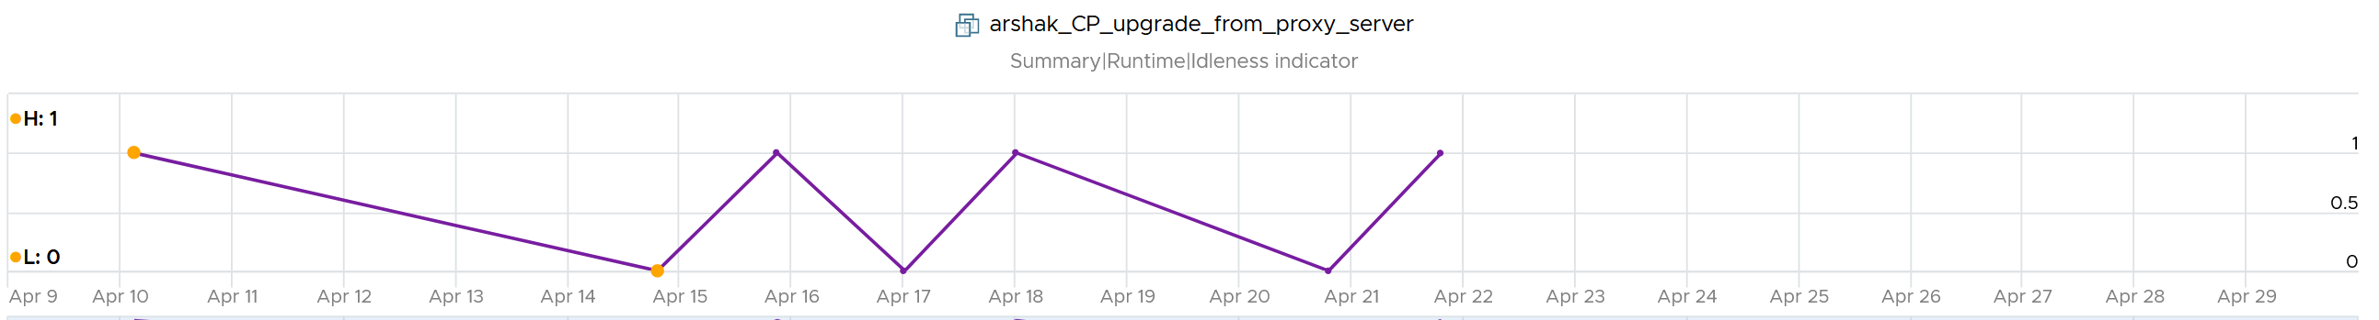

Now that you have it daily, it’s a matter of rolling up to the whole period (default value is 7 days). We set the value to just 7 days so you can see the calculation result within a week. Note that we set to 100% and we ignore newly provisioned VM.

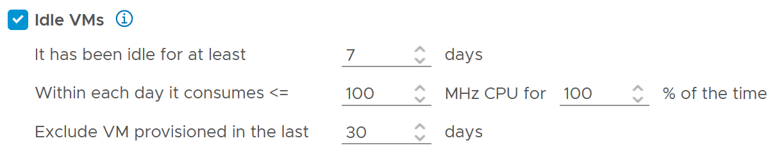

Think of the various situation before extending from 1 week. For example, a VM has been in production for a few years. A new version of the application has been developed, and this VM is being decommissioned. The VM goes idle. As the application team does not inform infrastructure team, the VM will take at least 7 days before it’s marked as idle. If you change that to 1 month, it will take longer.

On the other hand, a month-end VM that processes payroll can be idle for 29 days.

The counter that covers the whole period is called **Reclaimable Idle**.

It is a daily counter, that’s set to 1 (true) if the VM meet the idle criteria.

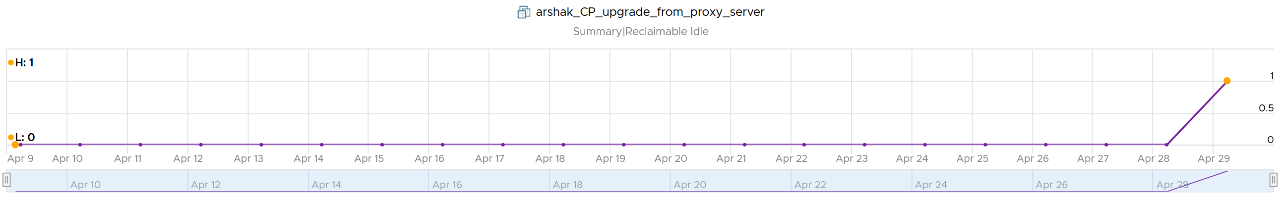

To list the idle VM, you need both metrics to be true.

Why can’t you just use Reclaimable Idle?

Because it’s a daily counter. You can mistakenly assume a VM is idle even though it’s recent activity shows it’s not idle anymore.

In some environment, it can take time before a newly provisioned VM is used. Check the creation date of the VM before powering it off.

Have we got all cases covered?

Nope. There is a corner case, where you tighten the definition (say from 100 MHz to 50 MHz). What was Idle may no longer qualified for idle. We can recalculate the daily metric, but this consumes performance. So to be safe, we will restart again from Day 1. So if the Idle Window is 2 weeks, customers have to wait 2 weeks.

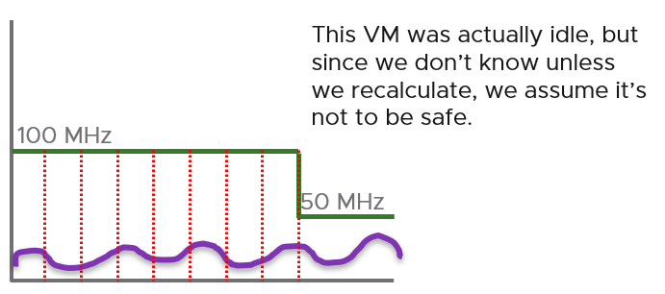

#### Oversized VM

Oversized VM has different logic than idle VM since the Idle VM definition does not depend on the size of the VM. The Idle VM definition simply measures if the VM is generating enough workload or not. Idle is about GHz, while Oversized is about %.

Oversized VM depends on the size of the VM. A 64 vCPU VM running 7 vCPU is oversized, while an 8 vCPU running 7 vCPU is not.

|  |  |
| --- | --- |
| **VM Is undersized** | Calculated based on CPU & RAM total capacity and recommended size values.  If for at least one of the containers (CPU or RAM) the recommended size > total  The lowest value for increasing the CPU is 1 vCPU and for memory is 1 GB |
| **VM is oversized** | The VM is oversized if it is possible to reclaim a CPU or Memory.  Calculated based on CPU & RAM total capacity and recommended size values. |
| **VM Reclaimable CPU** | Calculated based on socket counts and core counts of VM  = Minimum (( reclaimable Sockets * cores Per Socket + reclaimable Cores In Remaining Sockets), CPU Core Count - 2)  Will not suggest the reclamation if the CPU Reclaimable value < MHz Per Core value |
| **VM Reclaimable Memory** | = total Capacity – recommended Size  Must be ≥ 1 GB and the remaining capacity after reclamation should be ≥ 2 GB |

Limitation: the implementation in vRealize Operations is based on projection, not a mere 5-minute or 1 day data. So if you power off an oversized VM, it remains considered as oversized until it passed the definition.

#### TRIM and Unmap

When Guest OS delete files or parts of it, it does not replace the value with 0 and just leave the block. This is more efficient and also enable recovery. But this cause the underlying VMDK to grow. The same thing happen at the array level. This is where [Trim and Unmap](https://en.wikipedia.org/wiki/Trim_(computing)) come in.

vRealize Operations tracks the unmap operations via 2 metrics at ESXi Host. The first one is Unmap IO, which tracks the number of unmap SCSI instructions. For example, if the value is 100, that means ESXi has sent 100 requests of unmap to its datastore. So think of it like IOPS, except the IO is not writing/reading actual block, but more of a request to delete (unmap) the block in the back end array. The value is the sum of 20 seconds since vSphere reports per 20 seconds, then averaged over 5 minutes. In the example below, you can see the host sends unmap commands frequently in the last 30 days.

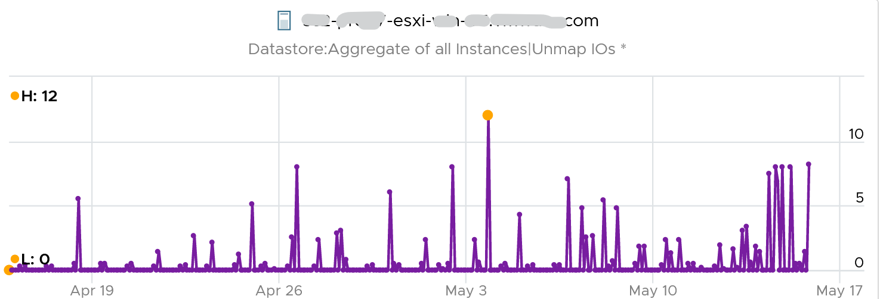

The second metric is Unmap Size, which tracks the total unmapped space from the operations above. The value is shown in MB.

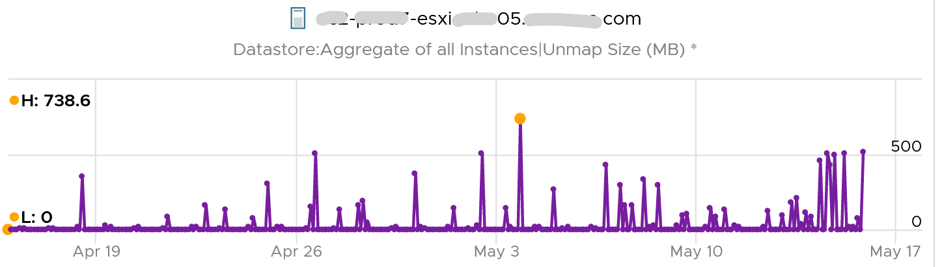

You can track both operations on each datastore, but you can’t aggregate them per datastore.

For further reading on TRIM and Unmap in vSAN, read [this detail article](http://www.patrickkremer.com/save-money-using-vsan-unmap-trim-in-vmware-cloud-on-aws/) by [Patrick Kremer](https://twitter.com/KremerPatrick).

The problem only happens on thin provisioned disk. So if you want to check how much space you can reclaim, create a view that compare the value inside the Guest vs the value shown at VMDK level.

#### Unused VM

Unused VM is not idle, but they do not provide *business value* anymore. The application team may have stopped using it, but left the application running just in case they need in the future. The VM is not idle as it still generates CPU activity. The activity can be business workload, IT workload, or both.

This makes unused VM much harder to find, as what works for VM 00001 may not apply to VM 10000.

The IT workloads take many forms. Guest OS upgrade, Guest OS patches, and application patches can be 3 different workloads with different patterns. VMware Tools patches, anti-virus scan, intrusion detection scan and agent based back up are other common examples. In an environment with high security, there can be many security related agents running. Or worse, they can be agentless, executed via network.

Business workloads can be batch jobs, reports or monitoring. No one is using the application anymore but the application continues running. It could be generating report and send email to someone who just ignore that emails. This is harder to identify than the one running pure IT workload as it’s more unique.

Unused VM is hard to detect as the infra team lack the business context, and the patterns vary widely. The owner verification is required before you power off the VM. This is why it’s important to have ability to relate a VM to a department or owner. We discussed the criticality of business-centric infrastructure in Part 1 Chapter 1.

There are some checks you can do to find the unused VMs when their CPU usage is not low. Find VMs that exhibit multiple of these behaviours. Take note that each of these can be false positive, so you need multiple of them for better conclusion.

##### Configuration

Configuration is easier to interpret than utilization, as they tend to have clear cut rules. The following list some configuration items you can consider.

|  |  |
| --- | --- |
| Isolated | It’s no longer connected to a virtual NIC |
| Guest OS | It’s running older version, especially those nearing End of Life. It indicates the application team may have written a replacement applications running somewhere else.  Running old version of Windows, Linux and/or Kubernetes.  Expired license. |
| Application | It’s running older version, especially those nearing End of Life.  It’s running application that you no longer license. In this case, there is urgency to power it off.  It’s running without license, or with evaluation license, or expired license.  It has no business application installed. Just base OS + IT security applications. |
| Owner | It belongs to a folder in vCenter that is no longer owned.  Unable to figure out the tagging for the VM.  Request to contact the owner has gone unanswered.  Owner has changed organization. |
| Report | The application is no longer listed in any of the reports to the department owning it. This could be performance report, capacity report, compliance report, chargeback report, etc. |
| Location | It runs on a cluster that is due for decommissioned. It is stored on a datastore, that sits on an array that is due for decommissioned.  It’s folder has names like “old”, “decommissioned”, and “archived”. |
| Relationship | The VM is talking to other VMs. You can check which services is talking at which port. Check what services it’s using over the network. This is useful for VMs in the cloud, which uses cloud services from AWS, Azure, etc.  As these neighbors could also be unused, using this alone is not reliable. |
| Alert | Alerts associated with VM have disabled. |

##### Utilization

|  |  |
| --- | --- |
| CPU | While usage is not idle, or even high, it’s the same CPU. There is very little context switch, indicating the same processes are running. If the CPU Usage Disparity (%) metric is stable, that indicates constant run. |
| Memory | While the In Use metric is high, it’s passive. There is lack of paging, both in and out. |
| Disk | While IOPS and throughput is not low, its filesystem is stable, rarely change in both size and activities.  The IOPS and throughput also eventually form a pattern over the long run. |
| Network | The network it belongs to is no longer reachable, or has been isolated. That means access to it is non-existent or highly restricted.  The VM sends very little packets out, indicating it is not talking much on the network. At the same time, it’s only talking to a fixed and small group of other servers. Take note that secure application that store data typically is restricted.  It belongs to a VLAN that is due for decommissioning. |
| Log | The amount of logs or Windows Event is much lower relative to its peers. The pattern is also predictable over time. |

##### Other Signs

|  |  |
| --- | --- |
| No login | No one has ever logged into the Guest OS, be it from UI or the console (e.g. SSH into Linux).  If user log in, it’s for a very brief period of time. |
| Process | It’s the same set of processes that are running. The number of process also remains steady and predictable.  The process that takes up the most CPU is not business software. It’s system process or IT application. |
| Availability | It never gets rebooted, or it gets rebooted often. Essentially, it seems like no one cares about its state.  Reboot happened during business hours and no one complained. |
| Performance | Severe performance issue and you don’t get a complaint. If someone owns it, you will get a formal ticket if the performance is terrible for a long time during business hours. At night, a VM can experience slowness for 1 hour and no one may notice. |

Bottom line, what can you do if you are *unsure*?

You’ve announced to everyone that the VM would be deleted if no one claims it repeatedly, yet no one replied. Anything safer you can do than powering off the VM, as powering off disrupts the running process and close opened files? Powering off does not guarantee that it can be brought online successfully.

You have 2 choices:

* Disconnect it from the network. This makes the VM isolated, without shutting down the application. If it’s used, the VM Owner will know it.
* Apply CPU limit to it. This slows down the VM. The VM Owner will feel the impact and complain it’s slow.

When you do that, ensure you tag the VM or move them into a “Unused VM” folder. If these unused VMs spans multiple vCenter servers, use vRealize Operations custom property. If there are many of them, create a dedicated dashboard so you can see them at a glance.

##### Annual Stocktake

Unused VM is hard to detect. If you don’t have the VM owner, perform a stocktake on those unidentified VMs.

Stocktake is applicable if your IT business is not profit oriented. This means it applies to internal IT department even though you have chargeback as you aim to be a good corporate citizen.

The [stocktake](https://en.wikipedia.org/wiki/Stock-taking) actually starts from Day 0, where VM is being requested. Make expiry date mandatory, to catch those temporary VMs. For permanent VM, set it to 1 year. If you set beyond 1 year, you increase the risk of change of owners and you lose the contacts. Reorganisation can result in the department or team owning the VM no longer exist. What was meant to be permanent VM suddenly becomes unused VM.

You need to have a process to keep unused VM in check. Have a simple process so that you can get an agreement from all your customers. As business owners may not know the VM name, include the following information

* Hostname. Take the one from inside the Guest OS, not from vCenter.
* Application name
* IP Address. They may login with IP address and it rings a bell to them.
* Guest OS name and version.
* vCenter Folder name. This should be the business unit it belongs to. See Part 1 Chapter 1.
* 95th percentile utilization in the last 3 months.
* Any other information and context you think will help them remember it’s their VM.

### Rightsizing

What do you rightsize? Not all objects are relevant for rightsizing. Take for example, an ESXi host. Once you buy it, you rarely change the size over the lifetime of the server. You may increase the size, but that was already part of your plan when you bought the hardware initially.

|  |  |
| --- | --- |
| **vSphere Cluster** | You do not typically remove hosts from the cluster, especially if the cluster has < 6 ESXi hosts.  If you plan to add hosts, you need to plan the supporting infrastructure. That means network switch ports (including for ILO management, which is typically a separate physical switch), rack space, power cable, and power. |
| **vSphere Datastore** | You do not typically decrease the size of the datastore. |

Over Provisioning is a common malpractice in real life SDDC for a variety of reasons. P2V is a common reason, as the VM was simply matched to the physical server size. Another reason is conservative sizing by the vendor, which was then further added by Application Team.

I’ve seen large enterprise customers try to do a mass adjustment, downsizing many VMs, only to have the effort backfire when the VM performance suffers.

Since performance is critical, you should address it from this angle. Take serious time and effort to educate the VM Owner that right sizing actually improves performance, despite the seemingly odd logic. A carrot is a lot more effective than a stick, especially for those with money. Saving money is a weak argument in most cases, as VM Owners have paid for the VMs.

#### Benefits

Rightsizing is important for a VM, more so than for a physical server. Here are some benefits:

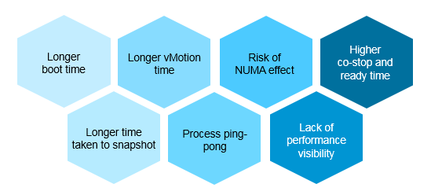

The processes inside the Guest OS may experience less ping-pong. The Guest OS may not be aware of the [NUMA](https://en.wikipedia.org/wiki/Non-uniform_memory_access) nature of the physical motherboard, and think it has a uniform structure. It may move processes within its own CPUs, as it assumes it has no performance impact. If the vCPUs are spread into different NUMA node, example a 20 vCPU on a box with 2-socket and 20 cores, it can experience the ping-pong effect.

Lower risk of NUMA effect. Lower risk that the RAM or CPU is spread over a single socket. Due to NUMA architecture, the performance will not be as good.

Lower co-stop and ready time. Even if not all vCPU is used by the application, the Guest OS will still demand all the vCPU be provided by the hypervisor.

Faster snapshot time, especially if memory snapshot is included.

Faster boot time. If a VM does not have a reservation, vSphere will create a swap file the size of the configured RAM. This can impact the boot time if the storage subsystem is slow.

Faster vMotion. Windows and Linux use memory as cache. The more it has, the more it uses, all else being equal.

#### Severity of Over Provisioning

If you have thousands of large VMs, how do you communicate easily to your senior management that many of the large VMs do not use the CPU given to them in the last few months?

You need to present a convincing chart, that shows the utilization of hundreds of large VMs (which you defined as having > 16 vCPU) every 5 minutes, so a short peak is not excluded in your presentation.

The first thing you need is to create a dynamic group that captures all the large VMs. Create 1 group for CPU, and one for RAM. You then plot their utilization, every 5 minutes, in the last 3 months.

In a perfect world, if all the large VMs are right sized, which scenario will you see?

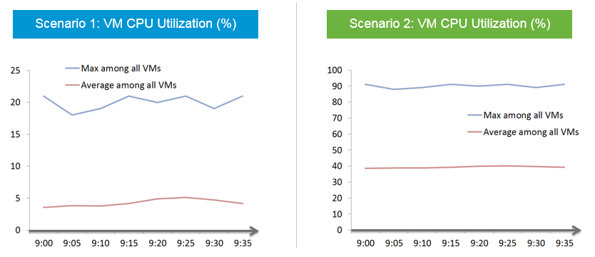

That’s right. Scenario 2. Because the group has hundreds of members, there is a good chance that one of the large VMs is using the CPU given to it. On average, they should be hovering around 40 – 50%, as at any given 5-minute interval, some may be idle while others may be busy.

The technique we use for both CPU and RAM are the same. I’d use CPU as an example.

Once you create a group, the next step is to create two [super metrics](https://blogs.vmware.com/management/2020/09/my-top-15-vrealize-operations-super-metrics.html):

|  |  |
| --- | --- |
| **Maximum()** | Maximum CPU Workload among these large VMs.  You expect this number to be hovering around 80%, as it only takes 1 VM among all the large VMs for the line chart to spike.  If your Maximum line is constantly ~100% flat, you may have a runaway process.  If you have many large VMs, one of them tends to have high utilization at any given time.  If this number is low, that means a severe wastage! |
| **Minimum()** | Average CPU Workload among these large VMs.  You expect this number to hovering around 40%, indicating sizing was done correctly.  If this chart is below <20% all the time for the entire month, then all the large VMs are oversized. |

Why is it not needed to create the Minimum?

There is bound to be a VM who is idle at any given time.

The two line chart shows us the degree of over provisioning. Can you tell a limitation?

It lies in the counter itself. We cannot distinguish if the CPU usage is due to real demand or not. Real demand comes from the application. Non-real demands comes from the infra, such as:

* Guest OS reboot.
* AV full scan.
* Process runaway. This can potentially result in 100% CPU Demand if the application is multi-threaded. How to distinguish a runaway process from legitimate high workload is the challenge.

#### Solution

How do you prevent oversized VM to begin with?

Hint: why doesn’t cloud providers like AWS have oversized VM issue? In fact, their profit margin is higher on oversized VM.

One effective solution is progressive pricing. We cover this in Part 1 Chapter 5 Cost Management.

If you do not charge for VM, then you’re left with official approval and corporate policy. For example, the bigger the VM, the higher the approval chain. You can also make the form more complex, needing more justification for monster VM.

Regardless of the pricing, make sure each VM has life span. While they can live forever, they are subjected to annual confirmation that they are still required by the business.

##### Start Small?

Considering the above problem, how do you prevent the problem to begin with?

One idea is to give every VM a minimal size regardless of their requirements. As this standard is small, majority of VMs will end up needing an upsize over time. So you need to be prepared for CPU Hot Add and memory Hot Add.

There are a few things to consider before taking this approach:

* It goes against the service provider business model. This is classic System Builder, where IT acts as the infrastructure architect, getting involved on VM sizing discussion. Ideally, you use price as your primary lever for sizing, as you may not be familiar with the load of their applications.
* Upsizing logic is more complex than downsizing. You need to consider NUMA impact on performance. The maximum size also depends on the ESXi hosting the VM.
* Upsizing needs to be more responsive. While application team can tolerate weeks before you downsize their VMs, they probably want their VM to be upsized within the same day. And if performance is affected, they may even ask for it to be done within an hour or so.

### Migration

The arrival of the cloud makes migration more common than before. While the destination differs, the sizing methodology does not. There are many examples of migration. Popular ones are:

* From old DC to new DC.
* From on-premises to cloud. This is typically VMware-based cloud as you can simply move without changing VM. Examples are Amazon VMC and Microsoft AVS
* From Cloud to on-premises. This is typically due to high cost. It’s hard to beat owning with renting if you apply a 5 year TCO. Cloud used to give newer hardware, which is no longer the case.

In the above, you typically change all infrastructure. New server, new network, new storage, new SDDC. You may virtualize network & security by adding NSX. You may also virtualize storage by going vSAN.

Migration ranges from a simple 1:1 to complex M:N migration. It also ranges from a single cut over done over the weekend to multiple migrations lasting years. Destination can be on-prem (e.g. cluster ugprade) or cloud. I’ve seen both directions.

#### Challenges

Regardless of the migration type and scope, there are some common changes and basic requirements. These could create challenge in the migration project.

##### Faster Destination

You are using **faster & bigger hardware**. You have higher CPU speed, more CPU cores, faster RAM, faster storage, bigger network, less network hops, etc. It’s faster by at least 4x compared to the ageing environment it replaces.

And that’s exactly where the problem might *start*.

A VM that takes 8 hours to complete its batch job may now take 2 hours, all else being equal. So it completes the same amount of work, doing as many disk, network, CPU, memory operations in 4x shorter duration.

So what happens to the VM IOPS? Yes, it went up by 400%, all else being equal.

What happens to VM CPU Usage? It also went up by 400%, as it has to complete the same amount of logic. Suddenly, a VM that runs relatively idle at 20% becomes highly utilized 80%. What was an oversized VM has become an undersized VM.

I call the above as Performance Multiplier. Unfortunately, it’s hard to guess the impact. This is why you are better off testing with a few well known VM first, such as infrastructure VMs or applications that are owned by IT. Examples are email servers, file servers and your Active Directory services.

Because of the above, my recommendation is to keep the VM size. Do not rightsize and migrate at the same time. If you change the size, you will be in the defensive position if there is performance issue.

##### Different Architecture

The destination could be using software-defined storage and network. Both vSAN & NSX consume ESXi CPU and memory, not to mention storage and network. You must also be aware that certain vSphere disk space counters got affected by vSAN FTT policy.

If you’re migrating to the cloud, take note that the management load and SDDC load, such as vCenter and NSX Edge appliances are also residing on the same cluster. The unique nature of VMware-based cloud migration creates situations that you need to address. For example, you need to watch Elastic DRS if you do not want it to get triggered.

##### Cost Pressure

How do you typically justify the budget for the new infrastructure, since it’s both faster and bigger?

Yes, you promise higher consolidation. You have more CPU cores, more RAM, so logically you use higher [over-commit ratio](https://blogs.vmware.com/vsphere/2015/11/vcpu-to-pcpu-ratios-are-they-still-relevant.html). As [Mark Achtemichuk](https://blogs.vmware.com/vsphere/author/mark_achtemichuk) said in [this article](https://blogs.vmware.com/vsphere/2015/11/vcpu-to-pcpu-ratios-are-they-still-relevant.html), use it carefully.

Since you have to increase overcommit ratio, how do you then prove that performance will not be affected as you drive utilization higher? That calls for a Before vs After performance comparison.

Enterprise IT (read: Infrastucture Team) is also using the opportunity to right-size VM, but VM Owners are against downsizing. How to down-size VM without impacting performance?

##### Long Migration Project

The problem with project that lasts months is things change. The application may change due to business or technology requirements. The people (application team, infrastructure team, management team) may change and politically this can complicate matter. In large scale project, the inter-DC pipe can be a choked point if large number of VMs on both sides are communicating at the same time. For example, if you only have 10 Gb/s bandwidth for inter-DC, it may not be enough when you have 500 VM on Site A + 500 VM on Site B using the pipe. You essentially only have 10 Megabit/sec per VM. You can try to group the applications but you can’t control if they change.

This is why I’d rather choose intensity over time. Migration is not one of those projects that are best done slowly.

The following shows an example where the migration takes 6 months.

I drew 1 source cluster and 1 destination cluster. In reality, there can be many to many relationships.

The source cluster has both less capacity (hence smaller area) and slower performance (hence darker color). This is a typicaly scenario as the new hardware typically delivers faster speed and more space for the same cost.

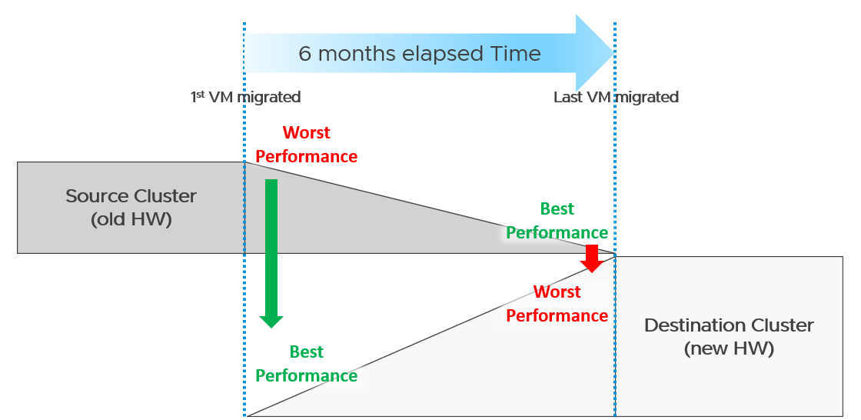

What potential problem did you spot?

This long migration period created an undesirable situation where the first few VMs enjoyed the whole cluster. They could run with 0 contention as there was enough resource for everyone.

Application team felt the responsiveness. Everyone was happy. They might start new features or load the systems even more. Overall utilization went up. So far so good as there was enough capacity.

As more and more VMs get added, the new infrastructure hit the point of *overcommit*. At this point, the VMs would begin experience contention.

On the other hand, the remaining VMs in the old clusters began to experience less contention. So their performance actually improved. The application team felt good, and started taking advantage of the newly found performance. They begin changing the application or increasing the datasize. The users’ expectation also went up as they can do more work. Everyone is feeling more productive.

The last VM to be migrated might get a shock. The performance might actually drop from the end user’s viewpoint.

The above could result in mismatch expectation. This is why SLA matters. You also need to have the SLA agreed *prior* to the migration. Do not rely on users’ complaint or user-level metrics as that’s beyond your control.

##### Best Practices

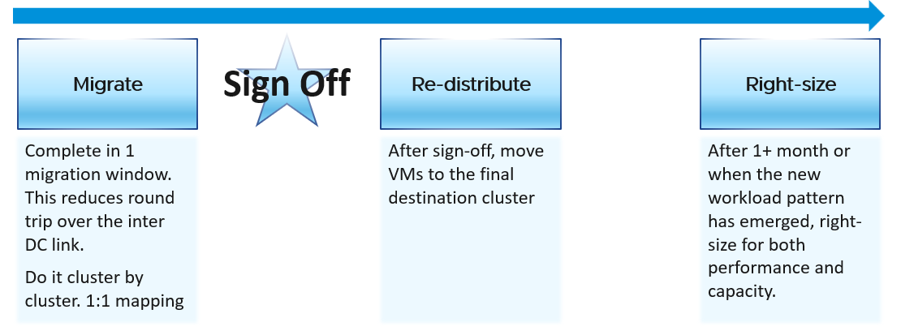

Migration is best done as soon as possible, ideally in one migration window. This minimize inter-DC traffic. For example, if VM 1 talks to VM 2 and VM 2 talks to VM 3, if you somehow forgot to migrate VM 2, you have a ping pong traffic. The latency and bandwidth could cause application performance. So pick the longest window you can get, such as major public holiday or company shutdown.

Migrate 1:1. This means 1 source cluster and 1 destination cluster. Obviously, you exclude the powered off VMs 😊 This makes migration management, and VM troubleshooting easier.

Within a week, get a sign off. Before sign-off, do not allow changes as that can make comparison invalid. Changes include application, business functions and infrastructure.

Do not right-size using the utilization data of the old Data Center. Wait until the new pattern establish itself. I recommend resetting the capacity engine starting date.

#### Infrastructure Sizing

You are planning a tech refresh for Cluster X. It has 24 ESXi and 1000 VM. You are hoping to reduce infrastructure to 12 ESXi, hence you buy newer CPU, increase the clock speed and add cores per socket. With such major changes, do you consider individual VM one by one, or you do see how they behave as a group?

The answer is the latter, as 1000 VM will not peak at the same time.

Do you consider what happens inside Windows or Linux, or do you see their footprint on your ESXi? The correct answer is the latter, as what happens inside is irrelevant.

##### Simple Migration

Aim to do a 1:1 migration. 1 cluster to 1 cluster. After you migrate successful and got the sign off, you then move the VMs into their final destination cluster.

If you do this 1:1, your sizing becomes much simpler. You simply add headroom for the next 3 years or so at the cluster level. If your new cluster sports vSAN and NSX, you need to consider their overhead. Speaking of overhead, you also need the VMkernel overhead, which varies.

The issue of you have with the single VM gets amplified here. Instead of dealing with just 1 faster VM, you now deal with many. Even if the workload is identical, since they complete the job in much less time, your workload pattern turns to spiky. What took 1 minute now take 20 seconds. If your monitoring is 5 minutes, your observability is 300 second average. You can have microbursts that you cannot see. This is why using the 20-second peak metrics is critical.

Be aware of heavy hitters VM. Consider 2 VMs. Both have 16 vCPU. Both are running hot, but one of them is heavy on IO. It sends a lot of network packets and doing lots of disk IOPS. This 2nd VM has a different footprint on the ESXi. It’s much more demanding. All those IO processing need to be processed by other physical cores. That’s why your sizing should include disk IOPS, disk throughput and network throughput.

###### Generic Formula

New Sizing = (Sum of VMs Usage x Future Growth x Performance Multiplier) + Overhead

Where:

|  |  |
| --- | --- |
| Sum of VM Usage | It is the chosen number to represent all the data in the assessment period. Ideally, you capture 1+ year so you do not miss annual data. Now that’s ~105K datapoints as there are that many 5-minutes in a year.  So what numbers do you pick?  If the chart is trending, especially upwards, you need to account that the workload is increasing. So I’d use a projection, instead of simply take say the 95th percentile. The percentile also treats recent data as more relevant.  For such large data sets, there can be outlier. Both projection and percentile handle this. |
| Future Growth | The headroom you need before you top up hardware. So if you buy every year, then you need at least 1 year of buffer |
| Performance Multiplier | An additional buffer you put to account that faster performance. |
| Overhead | Virtualization layer, which is vSAN + NSX + VMkernel load.  This is the reason why you can’t take your existing cluster load. Your new cluster overhead is different. It’s likely higher as your hardware is bigger, and you may have vSAN and NSX. |

Notice something missing?

Yes, it’s reservation. I exclude it as you need to avoid using it. If you want to use it, take the maximum of Usage or Reservation.

###### Specific Formula

The generic formula we have needs to be applied to each of the 4 elements of infrastructure. CPU, memory, disk and network need to be treated differently.

We also need to apply to specific object. Let’s start with vSphere Cluster as that’s the most common.

|  |  |
| --- | --- |
| CPU | Your main number is in GHz.  You support that with another number, in vCPU. For vCPU, the performance multiplier does not apply as you maintain constant. Usage is based on allocation. Overhead is expressed in physical core, so you apply it on the Usable Capacity instead.  Allocation Sizing = (Sum of VMs vCPU configured x Future Growth)  Make sure this number is within your comfort level. |
| Memory | You only have 1 number. It’s in GB.  Performance Multiplier does not apply to memory as it’s just a storage space.  New Sizing = (Sum of VMs Usage x Future Growth) + Overhead |
| Disk | Your main number is in GB. It only covers disk space, hence Performance Multiplier does not apply here.  You typically do not migrate snapshot. You will also exclude non VM such as orphaned vmdk and template.  New Sizing = (Sum of VMs Usage x Future Growth) + Overhead  You support that with 2 numbers, one for IOPS and one for Throughput. Performance Multiplier applies here.  vSAN migration needs to consider vSAN overhead. You’re moving the redundancy from hardware level to VMDK level. |
| Network | Your main number is in Gigabit/second.  You support that with number of packets/second.  Make sure both numbers are within what the new hardware can deliver. |

###### Sample Output

You do the above exercise per cluster. You get something like this:

|  |  |  |  |  |
| --- | --- | --- | --- | --- |
|  | CPU | Memory | Disk | Network |
| Old Cluster 01 | 145 GHz  3504 vCPU | 3.9 TB | 8.2 TB space  8374 IOPS  49 GB/s throughput | 38 Gbps  83K packets/s |

The above is only valid for a 1:1 migration. Anything more complex takes us to the realm of complex migration.

##### Complex Migration

From that simple migration above, you can see that a simple sizing exercise becomes complex when the destination is much faster. This turbocharges the VMs, changing the workload pattern.

This becomes a real issue in complex migration, defined as migration that you cannot complete in a single shot or migration where you mix the VMs across clusters.

###### Long Migration Project

If you need to migrate over multiple greenzones, stretching the period into months, you need to treat sizing as an iterative process.

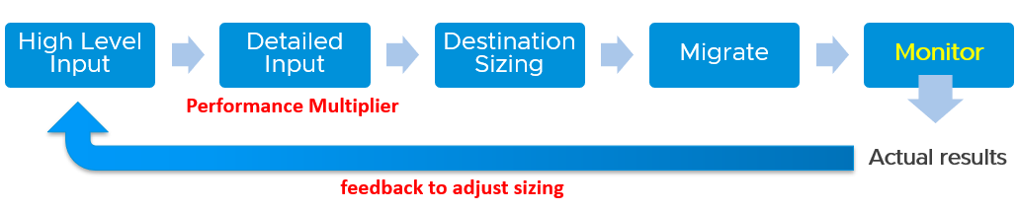

In complex migration, it does not begin with what you to migrate. It begins with the destination. You plan your end state first, add what you want to migrate, and then work back and forth between the 2 sides.

The reasons why you go back and forth are:

|  |  |
| --- | --- |
| Speed | See Performance Multiplier |
| Time | In a large-scale migration, it can take months. During that time, the workload may change. The new features added by the application team may alter your sizing |
| New workload | Because the migration period stretches over time, you get new VMs that do not exist in the old clusters. |
| Selection | You typically do not migrate everything and you may use the migration as opportunity to regroup. For example, you may move from per department to per class of service, as your IT business changes from System Builder to Service Provider. |

###### Migration Group

What happens when your consolidation is not One to One, but Many to Many?

For example, you are consolidating from 47 clusters to 19, but the VMs in a single source cluster will end up in multiple destination clusters. The following examples shows 5 old clusters being consolidated into 3 new clusters. However, the VMs are being reclassified.

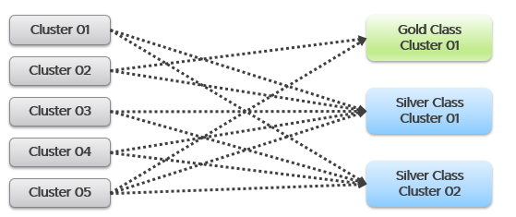

This is more challenging as each VM can potentially have itw own usage pattern.

Take for example, you have 500 VM in a cluster, but you only need to migrate 100 of them.

Do you take the individual utilization one by one, estimate the size for that VM, repeat for each VM, and finally simply sum all the VMs up?

You can’t do that as they may peak at different time.

This makes the sizing process cumbersome as you must create group. 1 group for each destination cluster. If you have 30 destination clusters, you need 30 groups. This migration groups become a central piece of your migration monitoring and sizing. They form a pair of “Before” and “After”. The group should consist of just VMs because that’s what you’re migrating. As a bonus, these groups help you in tracking and adjusting later on in the project. As you migrate a VM, remove it from this group.

The main limitation of the migration group is it has no historical data. The data starts from the time the group is created. To see the past, use super metric preview as a workaround.

###### Rolling Up

As part your overall planning, you need a total number. How do you prevent this number from being inaccurate?

The answer is you cannot.

Take for example, 2 clusters. They have highly cyclical workload, which goes up to 90% and down to 10%. Their workload pattern happens to be complimentary. When Cluster 1 is highly utilized, Cluster 2 is lowly utilization. If you combine them, you get a flat line utilization.

Each cluster has 10 hosts. But because their workload do not overlap, when you combine, the total utilization is only 11 hosts, not 20 hosts.

So what is your sizing requirement at vCenter level?

11 hosts or 20 hosts?

The answer depends on whether you plan to combine them or not in the destination cluster. That’s why you need to begin with the end in mind. If you plan to combine, the answer is 11. If not, the answer is 20. Big difference.

What if you do not know yet?

That means you have 2 numbers, serving as rough estimate of the minimum and maximum.

Use these numbers as the guide. As you migrate, you adjust your sizing.

#### Reporting

When you are migrating your customers workload to another infrastructure, the onus is on you to prove that you are not causing problems to the VMs or Applications. This is especially true if it’s your idea to migrate, and you are not giving them a choice.

To you as infrastructure team, the migration is a capacity exercise. To your customer the application team, they care more about their VM availability, performance and security. This means you need to quantify the “Before” and “After” to avoid misunderstanding at the VM level. If you have 1000 VM, you need to do 1000 comparisons.

This comparison cannot be done immediately after a VM is migrated. It needs to consider a longer timeline, such as 1 week, for a more complete comparison.

On the other hand, you do not and cannot make the post-migration comparison too long. Compare 3 months of before against 1 week of after.

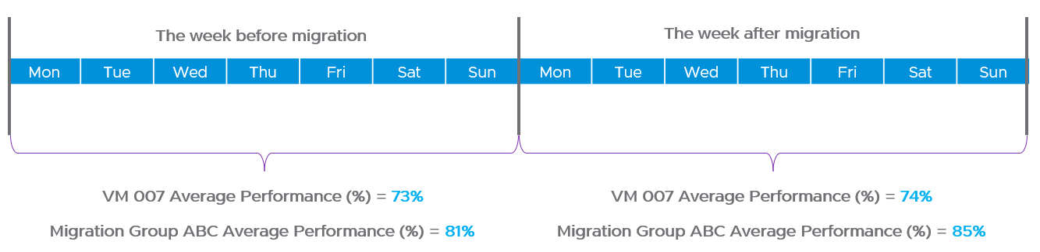

How do you report that the migration does not result in availability, performance and security degradation? If you promise improvement, how do you quantify that?

|  |  |
| --- | --- |
| Consumption | First, you prove that the VM is not doing less work. That means CPU utilization, Disk IOPS and Network Throughput.  Expect the numbers not to drop.  We cannot combine these counters as they can’t be standardized into 0 – 100%.  Why is memory not included? Memory is basically disk space and it’s a form of cache. The memory counter at VM level is irrelevant, and the memory counter at Guest OS level is not within your control. |
| Contention | Second, you prove that your IaaS is serving the VM well. That means CPU Ready, Memory Contention, Disk Latency and Network Dropped Transmitted Packet.  Plot the contention number using the 20-second peak counter.  Expect the numbers to drop. If it increases, it remains below the promised SLA.  If you are responsible for the Guest OS, then you need to show that queues are not higher post migration. This is why I recommend to keep the VM size. Let the oversized VM be migrated as it is, and right-size it after migration is signed off. |

Once you have the above numbers, it’s a matter of plotting them over time.

The above solves it for 1 VM. How to measure for many VMs?

As usual, you create a group to help manage at scale. For each migration batch, you create 1 group. So if you plan to migrate over 35 windows, you have to create 35 groups.

1 migration window should be kept within the day. This makes your before vs after comparison easier. If you’re migrating 3x on Friday night, Saturday night and Sunday night, then it’s 3 migration windows.

##### Migration Groups

The purpose of the groups is to get a sign off from VM Owner, preferably a bulk sign off if you’re migrating a large number of VMs in one migration window.

Create 1 group for each batch. Batch means VMs that will be migrated together. Ideally they are from the same owner or they have high dependency.

Create the group as early as possible. In this way, you get the longest historical data. This can be useful if there are many VMs with monthly or quarterly workload.

Make sure the group members do not change when comparing Before and After, as it makes comparison invalid. This includes any configuration change at both application and infrastructure level. For example, if after migration the workload increases due to whatever reason, it’s unfair to compare with before migration as it’s no longer apple to apple.

It’s critical that you have deadline to minimize risk of changes. I recommend 1 week as your migration schedule is probably over the weekend. This enables you to move on and focus on the next batch.

Avoid very large group. Keep it below 100 VM. A large group can mask details. For example, a group of 1000 VM can have 50 VM performing worse. If the remaining VMs are performing better, the average number may not reveal that.

The group KPI is simply the average of its VM KPIs. Expect this to remain good or improve post migration.

The following screenshot shows the group. Notice the Group Type is Location. That’s the object type used in the super metric.

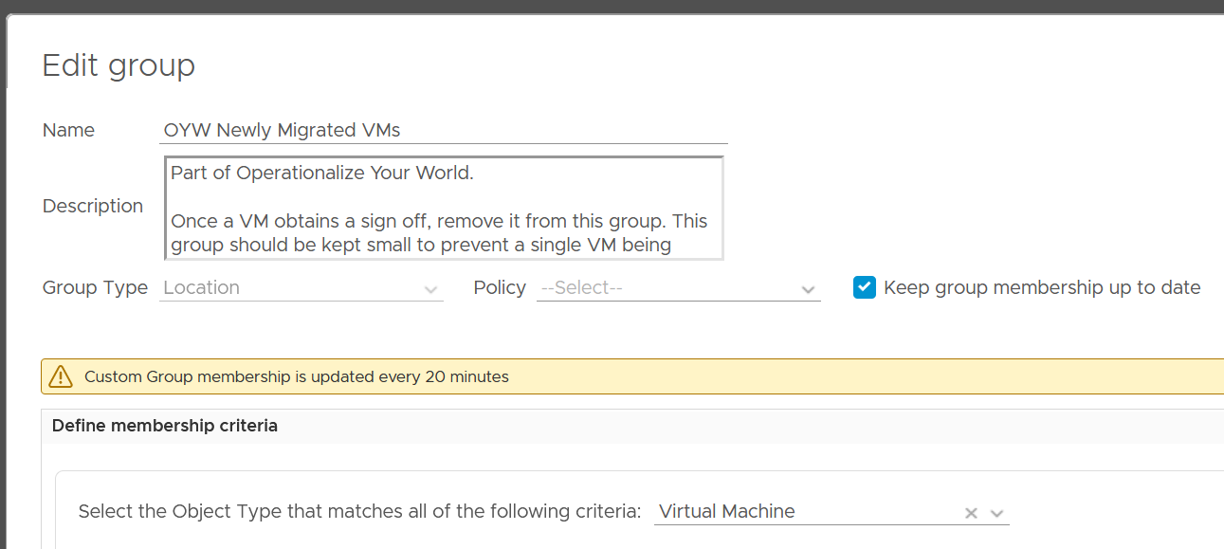

The group needs to have super metrics to summarize the overall performance.

The following screenshot shows the 2 super metrics used.

* The super metric “Migration Group Performance” is simply the average of the “VM Migration KPI”. Average is a suitable function as it represents all the members VM in the group.
* The super metric “VM Migration KPI” takes a subset of the VM KPI metrics. It excludes the utilization metrics as they can create confusion when comparing before and after.

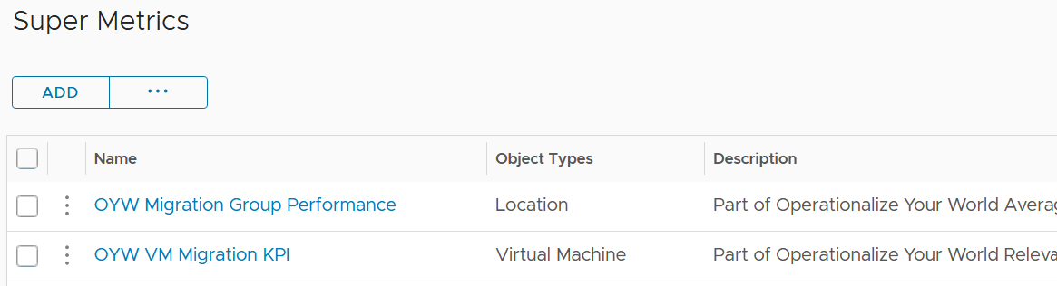

##### Migration KPI

How do you compare the performance of a VM since there are many metrics? One way is to plot multiple line charts per VM.

This is time consuming since there are at least 9 metrics to check:

* Guest OS CPU Queue Length
* Guest OS Disk Queue Length
* Guest OS RAM page-out rate
* VM CPU Co-Stop
* VM CPU Ready
* VM CPU Overlap
* VM Memory Contention
* VM Disk Latency
* VM Network Dropped Transmitted Packet

Notice the above focuses on contention. No consumption metrics are used as their values are expected to go up.

The group KPI is simply the average of its VM KPIs. Expect this to remain good or improve post migration.

The solution is to create a metric. It’s basically the same KPI used to calculate VM Performance (%) minus the consumption metrics.

I call this Migration KPI (%).

##### To be Migrated VMs

This is an optional group as it does not involve VM Owner.

This group only contains VMs that are scheduled for the next migration window. Do not put VMs that are not going in the next schedule, as their load changes the group value.

If the VMs in the group are going to multiple destination, then you need to create 1 group per destination.

Once a VM is migrated, remove it from this group.

## Configuration Management

**Part 1 Chapter 4**

Configuration Management is about ensuring the actual configuration settings matches the intended or desired value. The configuration of hardware and software products must be identical with the documented systems architecture. Deviation can result in security or compliance issue, performance degradation or availability risk.

### Overview

Configuration impacts performance, cost, capacity and compliance. Therefore, it is one of the primary focus of [optimization assessment](https://www.vmware.com/professional-services/technical-account-management-services.html). Settings need to be checked across the entire stack, especially the lower stack as problem in a stack will impact the stack above it.

Configuration management starts with a plan, where you decide what settings are suitable for what objects. It also includes tagging as it gives context to various persona running your operations. The context is critical. Many customers struggle with tag management as it spans many parts, across software and hardware from all the vendors that you have in your environment.

Categorize your tag, so it’s easier to manage them. There are customer-facing tags, and internal-tags.

|  |  |
| --- | --- |
| Business | These are the tags that application team or your customers care. Have an agreement with them. Note that different department will have different requirements, but you only have 1 set of tags, so plan before meeting them.  Example tags:   * Cost Center. This enables chargeback and reporting * Class of Service |
| IT | These are the internal tags for your infrastructure team.  Example tags:   * Refresh Date. The date or month or quarter where the hardware is due for a tech refresh. Use the end of warranty as a consideration, and establish a policy on when to upgrade. * Location. For hardware, it helps to know the physical location within a DC floor. |

Balance your tag. Too many tags and it becomes a challenge to update them. For example, if you have 10K VM and each VM is tagged with the direct, actual owner, you can end up with hundreds of names. These people may change department, role, or leave. It’s easier to establish a business agreement where you have 1 contact person per department.

Wrong configuration can be costly. In fact, there are 5 areas of impact. The following table shows some examples.

|  |  |
| --- | --- |
| Compliance | Insecure settings in ESXi and distributed port. Review the hardening guide, especially industry specific security compliance requirements. |
| Performance | Many settings can impact performance. The challenge here is “what works with what when”. You’re running hardware and software from multiple vendors, and they don’t always work best in every possible permutation. Upgrading one component often requires upgrading adjacent stack.  Drivers and VMware Tools often include performance bug fix as part of a release. |
| Capacity | Disabling HT. While HT is good for VM performance, it’s not good for ESXi capacity. |
| Cost | Outdated hardware, underused infrastructure, oversized VM have financial implication to your IT business.  Power management. While setting to highest performance is best for performance, it comes as a cost of power. |
| Availability | Insufficient HA, backup, and DR can impact availability. And if you have SLA, this can impact your reputation. |

#### Vantage Point

As an operation management software, vRealize Operations focuses on the impact to day-to-day operations a product has, rather than the feature of the product itself. It takes the view from Day 2, not Day 1. Products under monitoring, such as vSphere and vSAN, can have features that are related, but have different impact to operations. Take for example, vSphere provides Limit, Reservation and Share for VM. As feature, they are closely related, appear in the same dialog box in vCenter client UI and should be mastered as one. However, they impact operations differently. The following table describes that in more details.

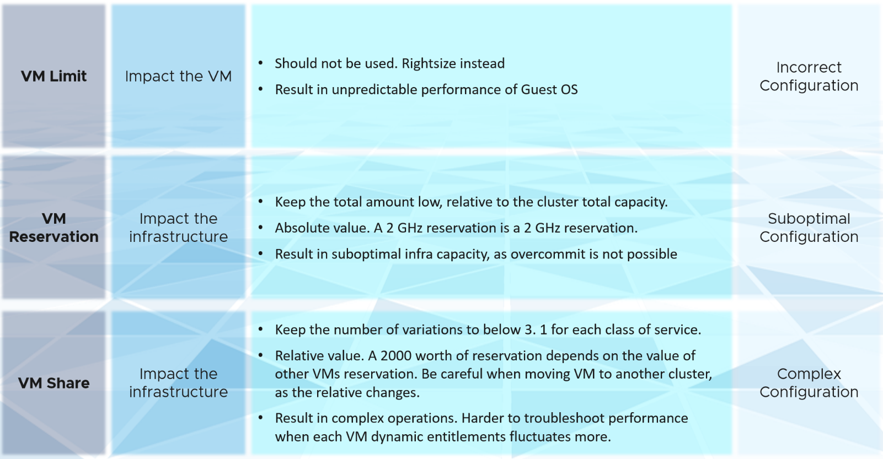

vRealize Operations takes the principle that there are different impacts to operations, and applies a methodology for looking at configuration. It does not group the settings by features or objects. Rather, it begins with the impact in mind, and prioritize what can be done.

#### Plan vs Reality

The actual configurations you have in production should reflect your current architecture standard. Your architecture or standard may change over the years, but it should be documented. You then use the configuration dashboards to compare the reality versus intended standard. If they differ, one of them is wrong and needs to be addressed.

Standards make operations simpler and are often required for compliance. For example, you have a standard for VMware Tools versions, and you choose one version as your standard, but allow 2 other versions across your environment as it takes time to upgrade. You can create a pie chart showing the distribution of VMware Tools version. Each slice in the pie chart counts the occurrence of a particular value. You should expect to see only three slices. If You are seeing more than three, then the reality differs to your standard.

### Review Flow

There are literally thousands of settings that you need to manage to ensure security, performance and availability. To ensure the critical ones are tracked and resolved first, consider prioritizing them. Use a 4-step check, starting from the most urgent.



|  |  |
| --- | --- |
| **Step 1** | Address settings that are incorrect, insecure, not following your corporate standards or against best practice. You should correct them as appropriate.  This is typically the most urgent step. |
| **Step 2** | The settings are correct, but on older version. It’s hard to keep up with all the vendors releases, so you should prioritize those oldest versions, especially those no longer supported.  As part of operations best practices, keep the infrastructure up to date. Running outdated components that are too far behind the latest version, can cause support problems or upgrade problems. It is common that the fix for the problem is only available in the later versions. Outdated hardware can also result in higher operating costs. Outdated hardware might cost more data center footprint, such as rack space, cooling, and UPS. Refreshing your technology and consolidation are two common techniques to optimize cost.  A typical SDDC or EUC architecture spans many components. While each can run the latest version, they may not be compatible or supported. |
| **Step 3** | The settings are correct and up to date, but they complicate your IaaS operations. Since you are unlikely to eliminate them all, establish policy that minimize them as part of simplifying your operations.  Complexity can come from many things, lack of standard being one of them. Think of the standards in your SDDC architecture or EUC architecture, and customize the configuration dashboard to shine light on the issue.  I think having flexible VM vCPU and memory size do not create complexity, as the permutation is not something you manage. |
| **Step 4** | The last step is about cost and capacity, as there is nothing wrong already. You want to maximize the usage of your resources while minimizing your cost. It’s a balancing act! |

Note that each customer runs their operations in unique way. Each operation is like a human fingerprint. So what is right for other customers, may not be right for you. Even in the same environment, what is right for development environment may not be appropriate for production.

Tools wise, use Log Insight, Skyline, and other health check that comes with vSphere, vSAN or NSX.

Review from the Consumer Layer, and then the Provider Layer.

* Consumer layer consists of VM and everything that runs inside the VM, such as process, applications, Guest OS and Container.
* Provider layer consists of the software and hardware infrastructure, such as Telegraf, ESXi, vSphere cluster, datastore & datastore cluster, resource pool, distributed virtual switch and port group, vSAN, NSX and certainly hardware.

#### Correct It

The following table provides example of configuration that you want to correct, assuming they do not meet your standard.

##### Consumer Layer

|  |  |
| --- | --- |
| JVM or DB | Java Virtual Machine or Database with memory config too large relative to Guest OS. This can cause performance issue. |
| VM Limit | CPU, Memory and Disk IOPS Limit. Avoid using limit as it can result in unpredictable performance. The Guest OS is not aware of this restriction as it is at the hypervisor level. It is recommended that you shrink the VM instead. |
| VM Shares | A VM 2x larger should have 2x share, all else being equal. If you right size VM manually via vSphere Client UI, it auto adjust the share. If you do via API, it does not. Check for VMs whose size are not aligned with their share. On the other hand, to prevent villain VM, apply less share. So this depends on the situation.  Also, check those VMs whose share you manually change, to ensure the number is still valid. |
| VM Reservation | If you have situation of noisy neighbors, you may have to use Reservation to guarantee minimum resources for everyone. If not, this is best left to 0. |
| Guest metrics | vRealize Operations uses VMware Tools to retrieve Guest OS metrics. Without this, right-sizing VM memory can be inaccurate. |
| Broadcast packet | Most VMs should not be sending excessive broadcast or multicast packets, as traffic should be unicast.  This can be checked either at Guest OS or VM level. |
| VMware Tools | The lack of support from [Independent Software Vendor](https://en.wikipedia.org/wiki/Independent_software_vendor) (ISV) owning the application is the most common reason that VMware Tools is not installed in the Guest OS. The ISV vendor may claim that no additional software is installed in their appliance unless they have certified it.  If VMware Tools is installed, there might be reasons why the application team disables it. The Infrastructure team should inform and educate their application team, and document the technical recommendations on why VMware Tools is strongly recommended to run all the time.  For more information about VMware Tools, see the [VMware Tools documentation](https://docs.vmware.com/en/VMware-Tools/index.html).  Using VMware Tools has multiple benefits. For the list of benefits, refer to [KB 340](https://kb.vmware.com/s/article/340). |
| VM on local datastore | Are they any VM running on local datastores? These should be limited to agent VM or VM that do not need vMotion and backup. Backing up from a slow storage can cause performance problem to the VM as the local disk may not be able to serve both.  It’s not a place you put back up as you can forget. |
| Snapshot | Ensure that the snapshot is removed within one day after the change request. If not, it might be forgotten, resulting in a large snapshot and impacting the performance of the VM. |
| Guest OS Type | The actual Guest OS may not match the type specified during VM creation. This could be due to Guest OS upgrade, or reformat. Update the value in vCenter to avoid confusion. Do this by comparing these 2 properties:   * Guest OS from vCenter * Guest OS from Tools |
| vSphere Replication | Incorrect replication setting. A VM that is no longer could still be replicated if the VM Owner never inform infrastructure team. |
| Hostname | Hostname not following your naming convention. This is typically common when self-service provisioning is used. |
| NUMA | NUMA effect. VM spanning NUMA nodes |
| VM Hardware | VM drivers, such as LSI Logic queue can get filled up. Establish a design standard and ensure it’s followed. |

##### Provider Layer

|  |  |
| --- | --- |
| ESXi | ESXi with vMotion disabled.  Standalone ESXi, not part of a cluster.  ESXi with Network Time Protocol disabled. Incorrect time can turn logs from useful to potentially misleading. Logs are a critical component of operations, and are the main source of information in troubleshooting. While troubleshooting performance across objects, the sequence of logs determines which event is the likely root cause as the oldest event started the chain of events.  A disconnected ESXi host indicates that the ESXi host is not participating in HA and you cannot migrate any VM on it.  Log is not sent externally, and not analyzed.  Incorrect multi-pathing setting. |
| Cluster | Clusters with DRS set to manual. This means that DRS initiated vMotion does not take place unless it is manually approved by administrator. Since DRS calculates every five minutes, your quick approval is required to prevent a change of condition.  Clusters with HA disabled. Without high availability provided by the infrastructure, each application must protect itself from infrastructure failure.  Clusters with DRS disabled. DRS focuses on performance and capacity, while HA focuses on availability. Without DRS, you must build a buffer on every ESXi host to cope with peak demand.  Clusters with Admission Control disabled. Reservation is respected only when Admission Control is enabled  Cluster HA Failover %. Make sure this number matches your design. |
| Resource Pool | Resource Pools shares do not match the number of VMs.  Resource Pool with VM as sibling. |
| Cluster Inconsistency | A cluster is the smallest logical building block for compute. Consider it as a single computer with physically independent components for high availability. As a result, consistency matters. Check at least the following settings are identical:   * [BIOS](https://en.wikipedia.org/wiki/BIOS) version and ESXi versions. * BIOS Power Management and ESXi Power Management. Ideally, should be set to OS controlled. The ESXi level should be set to balance level. * ESXi Storage Path. Ensure that the number of paths and the path policies are identical. * ESXi hardware specifications. Different specifications can result in inconsistent performances experienced by the VM. |
| Datastore Cluster | Inconsistency among the member datastores can result in capacity or performance issue. |
| Datastore | Datastore with single path carries risk as there is no redundancy.  Datastore with no path means there is no ESXi accessing it.  Datastore with no ESXi or no VM.  Datastore with low activities. That means the VMs are idle or unused. |
| Network | Unnecessary or too many hops. Especially horse-shoe design.  Ensure the redundancy for both NSX Controller and Manager match your plan.  NSX Edge configuration not following best practice. |
| Distributed Switch | Based on your security settings, add a table to check Distributed Switch and Port Group to ensure that security settings such as promiscuous mode are used correctly.  MTU mismatch. |
| LUN | Unused LUN. That means there is no VMFS or vVOL on top of it.  Inconsistent priority. For example, it gets gold priority at the physical array level but silver at vSphere level. |
| Storage | Mismatch of queue depths along the various storage stack. Need to calibrate all the way to physical array |

#### Update It

The following table provides example of configuration that you want to update, assuming they do not meet your version standard.

##### Consumer Layer

* Tools version. If you are running older version of Tools, you may not have the following Guest OS performance metrics: CPU Run Queue, CPU Context Switch, and Disk Queue Length.
* Microsoft Windows version
* Linux version
* vRealize Operations Telegraf agent
* VM Hardware (vmx)

##### Provider Layer

The following table provides example of configuration that you want to update, assuming they do not meet your version standard.

* Cloud Proxy server and Cloud Proxy agent
* ESXi BIOS
* ESXi HBA firmware
* ESXi driver
* ESXi hardware, such as CPU and server model. Ensure they are still under support.
* vCenter and ESXi version
* ESXi using 1 Gb NIC.
* NFS version
* Datastore VMFS version
* vSAN version
* Distributed vSwitch version
* NSX version
* Array firmware version
* Switch firmware version. Especially the switch directly connected to ESXi

#### Simplify It

The following table provides example of configuration that you want to simplify

##### Consumer Layer

|  |  |
| --- | --- |
| VM Identity | You want to avoid flying blind. After all you have some responsibility for everything that runs on your platform. Just because the VM name or hostname say webserver does not mean it’s running web server. Using tools such as Telegraf or Service Discovery, find out what application (key process) are running and who is it talking to.  Since your workloads are sharing resources and are over-committed, your operations are easier if you know what is running inside. This helps with monitoring and troubleshooting. It is also required by some ISV for software licensing. |
| Logs | For critical VMs, consider logging the Guest OS (e.g. Windows, Linux) to capture errors that do not surface as metrics. These errors typically appears as events in the log files, or Event database it the case of Microsoft Windows.  Use Log Insight to parse Windows events into log entries that can be analyzed. |
| Large VM | A large VM, relative to the underlying ESXi host and datastore, requires more careful planning (Day 0) and monitoring (Day 2).  Ensure that the VM size does not exceed the size of the underlying ESXi host. If your ESXi host has CPU hyper-threading, do not count the logical processors. Instead, count the physical cores only.  Large VM that matches the size of the ESXi can occupy the entire host when it runs at high utilization. That means you might not be able to run other VMs without some performance compromise.  Large VMs can impact the performance of other VMs, especially if it’s given higher shares. Only when the large VM is under-utilized, can the ESXi run other VMs.  If the number of configured vCPUs on a VM is higher than number of cores per socket on the ESXi, the VM can experience NUMA effect. If the ESXi has more than one physical CPU (socket), cross-NUMA access negatively impacts performance. For best performance, keep it within the CPU socket.  The larger the VM, the longer time is required to vMotion, Storage vMotion, and backup. |
| VM disks | It is simpler to have a 1:1 mapping between Guest OS partitions and the underlying virtual disk (VMDK or RDM). While you can run logical volume at Windows or Linux level, it creates complexity.  For performance and capacity, evaluate the disks and partitions. Each virtual disk must be monitored in terms of IOPS, throughput, and latency. Having multiple virtual disks increases the monitoring and troubleshooting need.  If the reason for having many virtual disks is performance, identify which counter serves as proof that multiple virtual disks are required. It is possible that the performance required is met by a single virtual disk.  For disk space, if the disk is thin-provisioned and under-utilized, you can deploy other VMs in the same datastore. Ensure that the snapshot is tracked closely, as the risk of capacity running out is higher for a large virtual disk.  Minimize VM that spans multiple datastores. This can make performance troubleshooting and capacity planning difficult as you create a M:N relationship between VM and datastore. |
| VM networks | A VM might need multiple networks, such as production, back up, and management. Route the network interfaces through security VM such as NSX-Edge VM.  A VM that has multiple network interfaces can bridge the network, causing security risks or network issues.  Take note that a VM that is part of multiple networks can do so with just a single NIC card. A single NIC can be configured to access multiple networks, with each interface having their own IP configuration . |
| Fault Tolerant | Any feature, especially something as powerful as this one, comes with its own set of complexity. So make sure the VMs with FT are the correct VMs. |
| RDM | Keep the usage minimal as they result in LUN sprawl. |
| SRM | Are all the VMs protected by SRM meant to be protected? Some VMs could be no longer use but are still protected. Review the Recovery Plan. How frequent was it run and when was the last run? |
| Hot Add | CPU Hot Add and Memory Hot Add. Are those applied at the correct VMs?  CPU Hot Add results in NUMA optimization disabled. So memory is being interleaved between the nodes. Hence, only use Hot Add if the benefit outweigh the cost. |

##### Provider Layer

|  |  |
| --- | --- |
| ESXi | Too many variations of vendors, models, generations and specification. No standard creates complexity.  Too many storage paths. While redundancy is good, having too many may not bring the result you expect. Compare this with airplane with 2 engines versus 4 engines. |
| Cluster | Cluster with 32 nodes or more. Large clusters are harder to operate.  Sub-cluster technique, such as VM to Host affinity creates operational complexity.  Cluster with many Resource Pools, especially cascading ones, are more complex to operate.  Cluster with many VM Shares (CPU and memory) make performance troubleshooting difficult. Each share should map to exactly one class of service, such as one for Gold and one for silver, as the shares defines the class of service. Shares are also relative, meaning the value depends on the value of sibling objects such as, resource pool or VM.  If you move VM across clusters, ensure that the values of shares are consistent across clusters to avoid unintended consequences while moving the VM to another cluster.  Stretched Cluster is more complex than traditional cluster. They provide Disaster Avoidance (DA), not Disaster Recovery (DR). Having a DA does not remove the requirements for DR. |
| Datastore | Datastores that are shared by >1 cluster are more complex from both capacity monitoring and performance troubleshooting.  Datastores with too many paths  Too many variants in the datastore size |
| Network | Load Based Teaming  Network MAC Address change |

#### Optimize It

The following table provides example of configuration that you want to optimize for improve performance or efficiency.

##### Consumer Layer

|  |  |
| --- | --- |
| JVM or Database | Memory config way too small relative to Guest OS. Unless you’re running other application, the extra memory is not accessible by the application. |
| Container | Ideally, you do 1:1 between container and VM so you avoid resource contention among the containers. A container that’s smaller than the parent VM will result in wastage. |
| VM Reservation | VM reservation causes a positive impact on the VM, but a negative impact on the cluster. Total reservation cannot exceed cluster capacity. This creates a suboptimal cluster as VMs do not use the entire assigned memory at the same time. The working set is typically much as smaller as the purpose of memory is cache.  VM reservation places a constraint on the DRS placement and HA calculation. Avoid using reservation as a means to differentiate performance SLA among all the VMs in the same cluster. It is difficult to correlate CPU Ready with CPU Reservation. A VM CPU Ready does not improve two times because you increase its CPU reservation by two times. There is no direct correlation. |
| Snapshot | Old snapshots tend to be larger. They consume more space and have a higher chance of impacting performance |
| Tools | If it does not meet your standard, then avoid VMware Tools version = “unmanaged” by updating Tools |

##### Provider Layer

|  |  |
| --- | --- |
| ESXi | An ESXi host that is in maintenance mode or powered off does not contribute resource to the cluster (or data center in the case of standalone ESXi).  ESXi with HT Disabled. While it provides a more predictable performance to the VM, it comes at a high price.  ESXi with 4 socket or higher. Considering the high core metrics and risk of NUMA, newer ESXi hosts are sporting 1-2 sockets only.  A small host faces scalability limits in running a larger VM. While a 2-socket, 32-cores, 128 GB memory ESXi can run 30 vCPU, 100 GB memory VMs, the VM experiences a non-uniform memory access (NUMA) effect.  For CPU cores, a change in vSphere licensing means that the ideal core is 32 cores per CPU socket. This maximizes the software license. For more information, see vSphere [Pricing Model](https://www.vmware.com/company/news/updates/cpu-pricing-model-update-feb-2020.html).  For memory, if performance is more important than cost, then do not disable large page. |
| Cluster | Cluster with EVC Mode means it’s not able to take advantage of the newer capabilities.  Cluster DRS Automation Level. Ensure this meets the requirements of that cluster.  Cluster with DPM disabled. Discuss with VMware if you should have this enabled.  A small cluster has a higher HA overhead when compared to a large one. For example, a three-node cluster has 33% overhead while a 10-node cluster has 10%. For vSAN, a low number of hosts limits the availability option. Your choice of FTT is relatively more limited.  Many small clusters result in silos of resources. As a cluster behaves like a single computer, ensure that it has enough CPU cores, CPU GHz, and Memory. For ESXi in 2021, it is typical to have at least 512 GB of memory. This results in 12 TB of memory for a 12-node cluster, which is enough for DRS to place many VMs as it balances them.  Reservation limits your ability to overcommit, resulting in less optimal usage. High total reservation, especially both CPU and memory, also complicates the cluster operations as it impacts the HA slot calculation and limits the DRS choice of placement. |
| vSAN | All Flash but with Dedupe disabled or Compressed disabled |
| Datastore | Small datastores run a relatively higher risk of being full from snapshot or over-provisioning.  Datastore with low VM count. If you have many of them, it results in datastore sprawls and pockets of unused space. |
| Distributed Switch | Unused network (distributed port group) is a potential security risk as you may have the tendency of not monitoring it. Network is basically a path or road, so it can be used by unauthorized user. |

## Cost & Price Management

**Part 1 Chapter 5**

With hardware becoming commodity and infrastructure becoming invisible, price has become a common denominator among all IaaS providers. Applications can run spanning multiple cloud, so whichever cheaper gets the deal to run the applications.

### Dare to Compare

In the cloud era, application teams today are provided with more choice of infrastructure. All they need is a credit card and application development can start. No need to deal with internal red tape just to get a bunch of hardware, since they are all available as an on-demand service.

By, the public cloud providers are competitors to internal on-prem cloud. As an internal cloud provider, you need to turn the public cloud providers into allies. That requires a shift in your business model, from infrastructure provider to a multi-cloud service broker. You broker the request for infrastructure with the most appropriate provider. You evaluate, choose and deliver multiple clouds if the on-prem cloud does not meet the business needs. Even the on-prem cloud can be a service that you procure (meaning you do not own the hardware and software), if that fits your business requirements better.

It is indeed possible for a small and no-frill internal IT infrastructure team to complement a much larger cloud provider. Being small, especially since you are on-site and work in the same company, enables you to offer a better service. Nobody likes dealing with the *bureaucrazy*, pun intended, of a large corporation’s support organization. You can get lost in the mountain of policies.

You also need to do an apple-to-apple comparison. List the entire components of the service. The following table provides an example, where you add your private cloud alongside externally hosted cloud. You should complement this table with another table comparing the SLA and price. I’ve provided a sample of SLA table in the Capacity Management section.

|  |  |  |  |  |
| --- | --- | --- | --- | --- |
| Component | EC2 | VMware on AWS | On-Prem Cloud | Remarks |
| Server Hardware | Identical | Identical | Identical | Comparable hardware spec |
| Storage | Excluded | Included (vSAN) | Included (vSAN) | Cost under Storage |
| Backup & DR | Excluded | Excluded | Excluded | Cost under Storage |
| MS Windows | Included | Included | Included |  |
| Hypervisor | AWS | vSphere | vSphere |  |
| Management Tool | Excluded | vRealize Suite | vRealize Suite |  |
| Support | Excluded | Included (remote) | Included (on-site) | IT provide full time on-site support |
| Sys Admin | Included | Included | Included |  |
| Security | Excluded | Included | Included | AV, Firewall, IDP, IDS, etc |
| Network: Bandwidth | Excluded | Excluded | Included |  |
| Network: Core | Add it | Included | Included | NSX + physical + People  LBaaS, FWaaS |
| DC Facility | Included | Included | Included |  |

#### Cost versus Price

Cost and Price are related, which means they are different. Cost is determined (by your expenses), while Price is set (you decide on the price you compete on). Many start ups have cost that exceed their price, as their goal is top line and market share.

Price is what your customers care as that’s what they pay. If you increase your prices too high because your costs are high, your customers will just move to public cloud.

Be consistent with the terminology. What is Price to you is Cost to your customer. It’s easier to use the term price when describing cost to your customers. Otherwise, you can get mixed up, such as demonstrated in the following sentence: “Cluster with plenty of capacity is more expensive as the cost is only shared by few VMs”.

What that sentence meant is Cost per VM, which is a hypothetical cost as you do not incur that cost.

You need to develop both the Pricing Model and the Cost Model together. They are essentially 2 sides of the same coin.

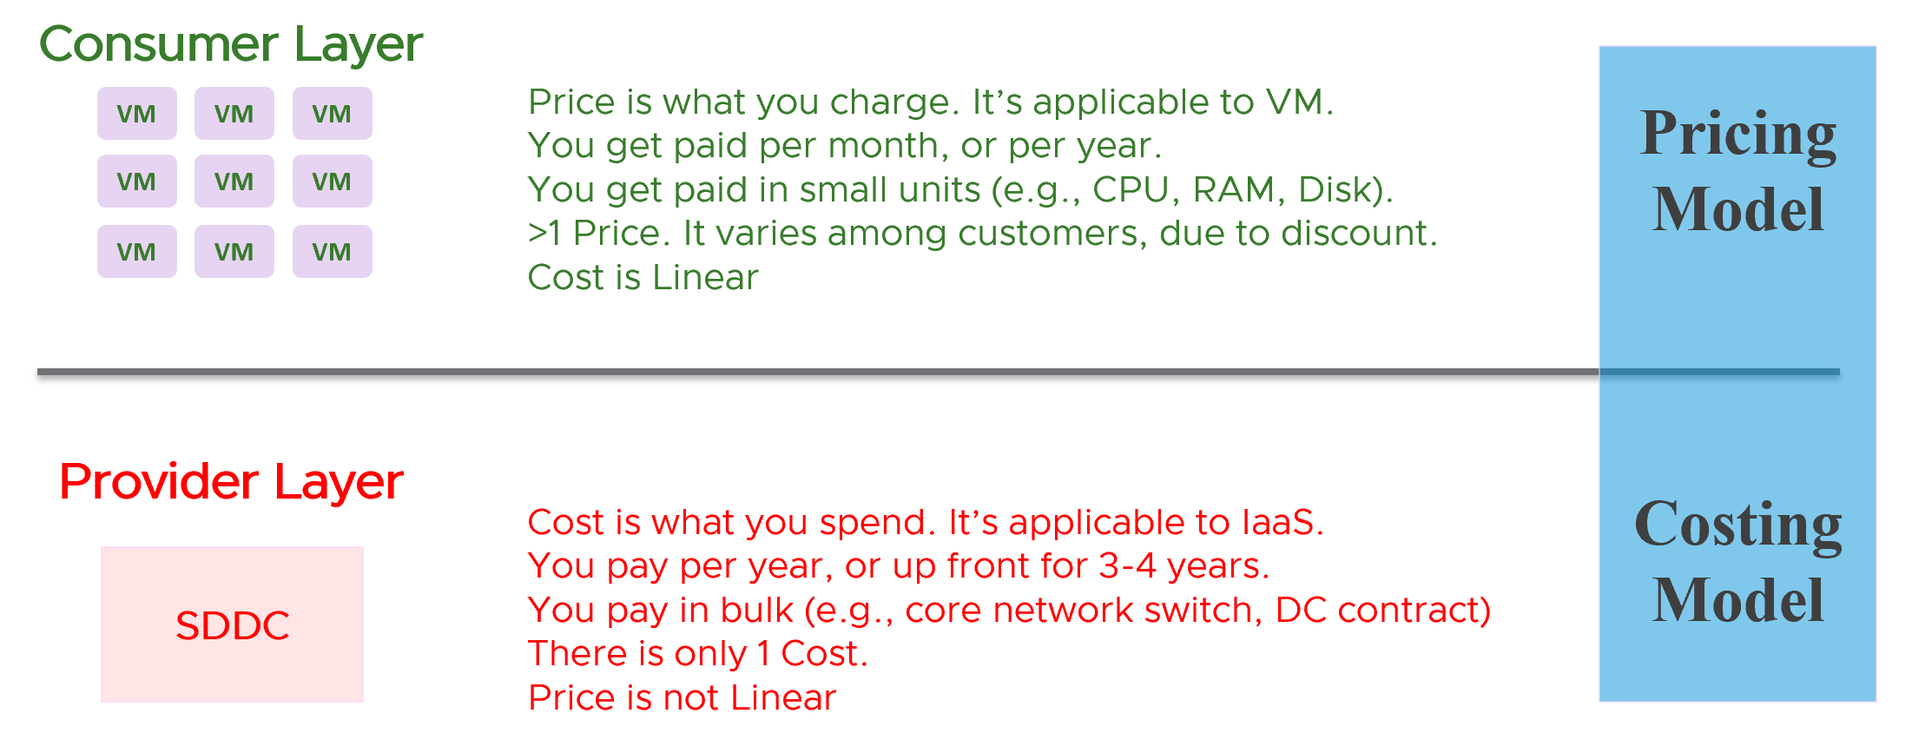

Let’s look at price first, as we need to start with the customer.

### Pricing Policy

Price is not simply cost adjusted with margin, discount and penalty. Price is determined by the value perceived by the paying customer. The cost is actually irrelevant as customers do not and do not have to care about how you manage your profit and loss.

Use price to drive the right behaviour and encourage adoption.

As an internal cloud provider, what business problems do you want to solve with pricing?

Oversized VM is a problem that is best solved before the VM hits production. So design your pricing model to encourage the right size from the beginning. Right size, right from the start. Create a progressive pricing and apply discounts for smaller VM sizes. The following diagram shows an example of tiered pricing. Premium pricing is applied on VMs larger than 16 vCPU, while discounted pricing is applied on VMs smaller than 8 vCPU.

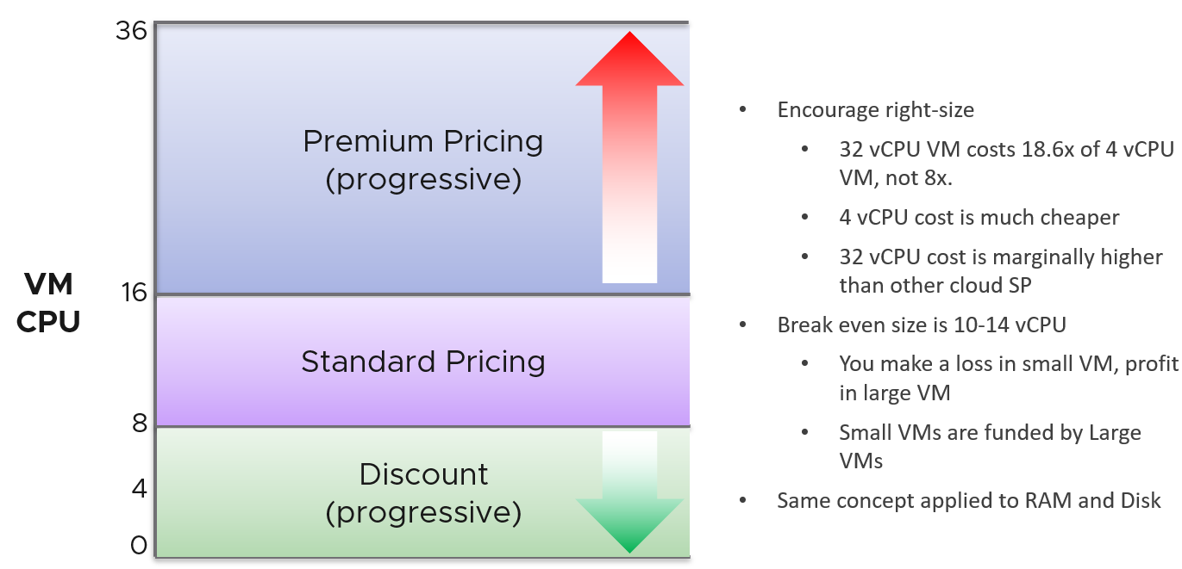

#### Class of Service

How do you apply the progressive pricing above into different Classes of Service? How much of a premium should you put on the big VM? How deep should you discount the small VM? The multiplier effect (the progressive tax) cannot be too high because public cloud does not have such tax. They follow a linear pricing. If you use a high multiplier, your price will be too high, or you will absorb a deep loss.

The following table provides an example of multiplier.

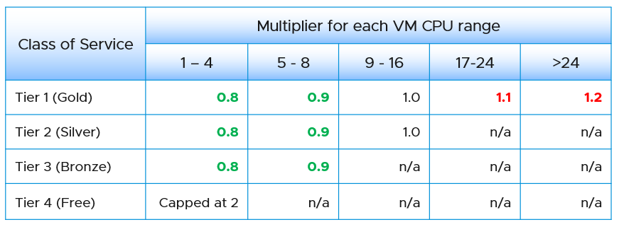

We apply the same principle for RAM.

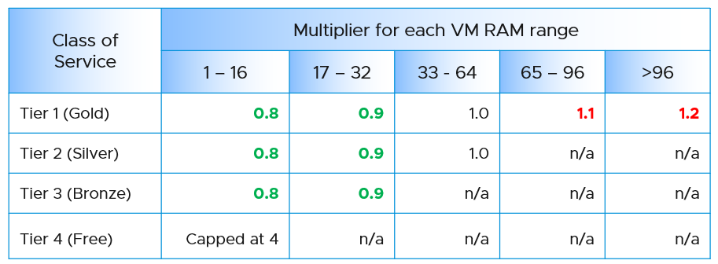

Keep your pricing model simple. The more complex your bill, the more you have to explain. The following table provides a suggestion of what to charge and what to bundle. Bundling means you include it in your overall cost but not charge explicitly for it. You are certainly trading off accuracy with simplicity.

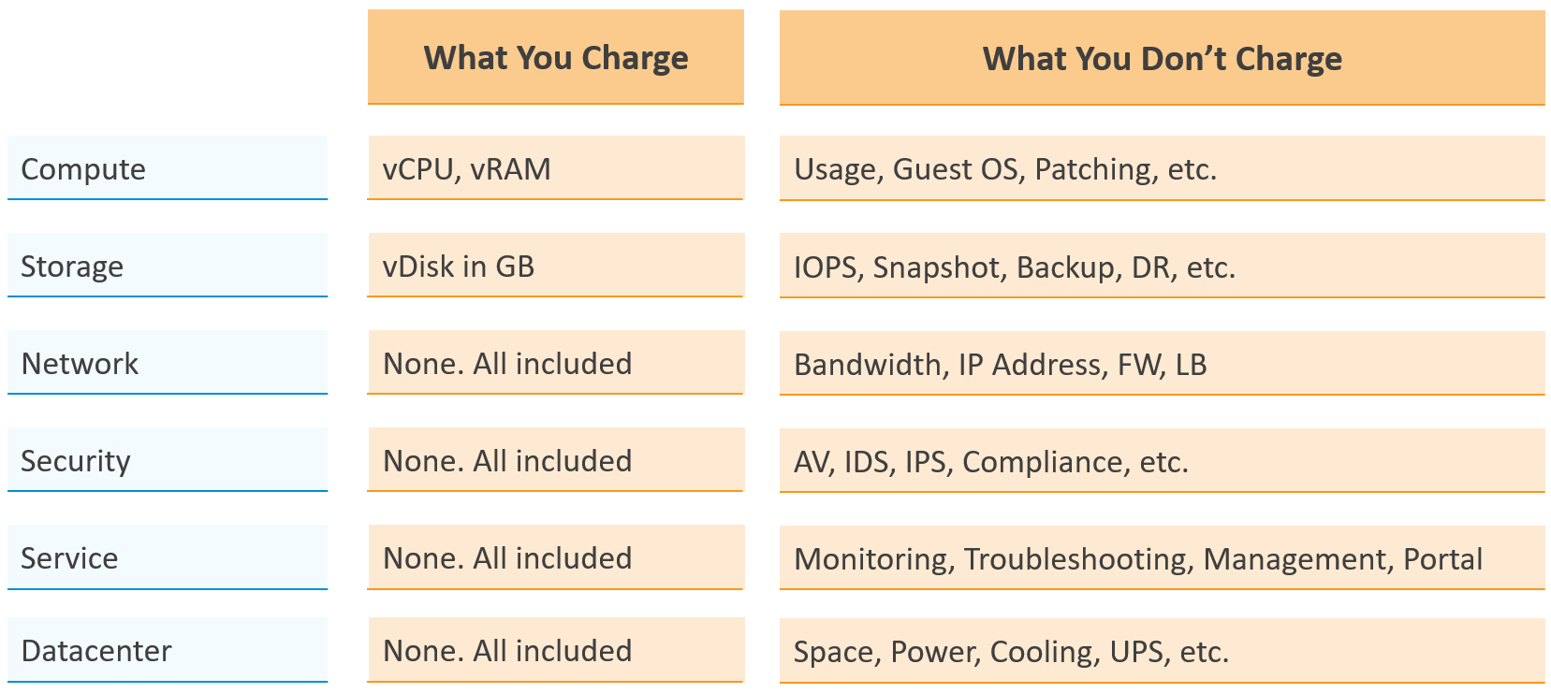

Overly simplified pricing could be unfair to customers, but that’s common in other industries. Take the airline industry, where my favourite airline is Singapore Airlines. I notice they have at least 4 generations of planes. The new plane is more efficient, costs less to operate and is more enjoyable to customers. On the other hand, if you take into account depreciation, the old plane is already fully depreciated. And yet, the price is the same across all generations.

#### Break Even

When planning your pricing, think of the time required to reach the breakeven point. That period should leave enough time for you recoup your expenses. It should be way before the depreciation ends.

The [break even point](https://en.wikipedia.org/wiki/Break-even) depends on the break even level. You may not be able to fully sell all the resources at the end. So if your plan is based on 80% sold, then the price of this 80% has to be able to cover the cost of everything.

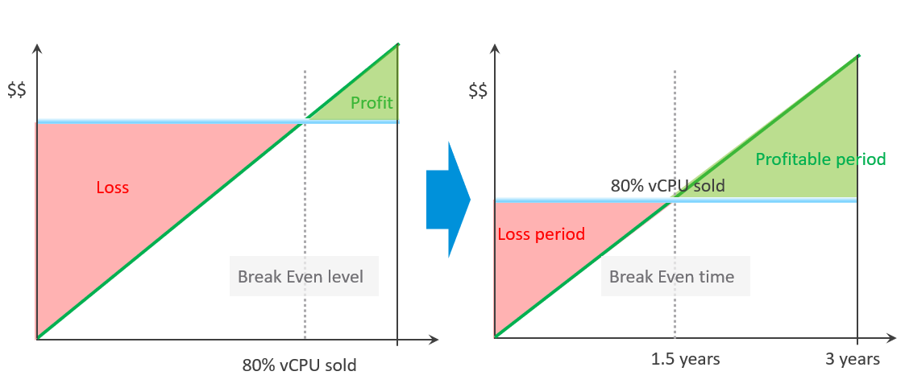

#### Usage-based Pricing

What exactly is “usage”?

The answer actually varies, depending on the service.

Let’s say you provide desktop as a service. If you truly charge based on usage, then if a user does not log in, then there is no usage. The problem here is you need to provide the desktop available 24 x 7, as you do not when the user will login. If you have 1000 users, you need to make sure you can cater for the peak demand, else there will be complaint from users who do not get a desktop when they ask for it.

A good comparison is NetFlix or Internet Broadband. You pay a fix fee, regardless of your usage. Whether you are watching 24 x 7 or just occasionally, you are paying the same rate. The same with your home broadband.

### Cost Determination

It’s important to calculate unit cost, despite the fact it does not actually exist. When you bought that cluster, you did not pay $1 per GHz of CPU. You paid $100,000 for the entire thing, hardware, software and services. The $1 is just for ease of calculation so you do not end up with a loss.

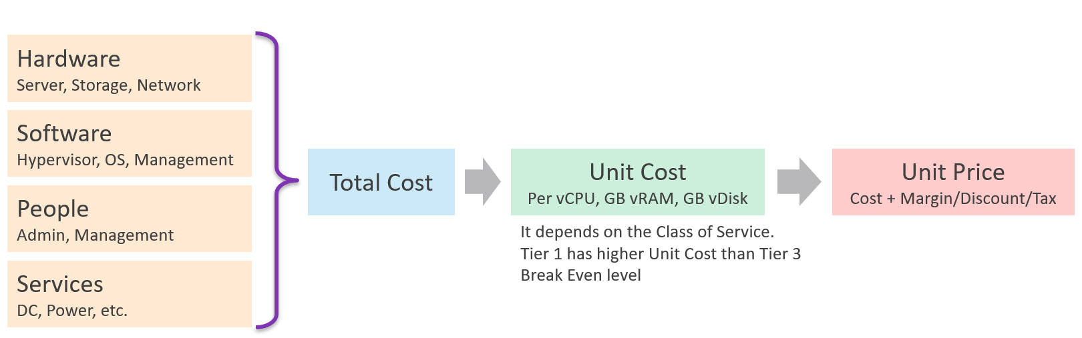

The Unit cost per VM depends on Overcommit Ratio, since the hardware cost is identical. If cluster A has 2x overcommit ratio, then the cost per VM is 2x cheaper, all else being equal.

Overcommit Ratio is the way you justify a higher price, hence it’s imperative to disclose upfront to your customers.

Unit Cost has to be associated with VM, not ESXi. It is expressed in vCPU, not per physical core or GHz. How many vCPU you plan to pack determines the cost per vCPU.

Unit Cost depends on hardware and software. New cluster should cost less due to bigger hardware.

Unit Price should remain the same within the same class of service. Back to the airline industry example, the price does not depend on the plane generation.

Notice the limitation?

What if you do not have overcommit ratio configured? Some customers base their cost simply on expected utilization of the hardware. Since you do not intend to run at 100% capacity, you need to spread the cost based on a lower number (e.g. 90% expected utilization).

#### Cost Allocation

Allocating the cost back to consumer (VM) rarely result in a complete distribution. There are times you have unallocated cost, as there is not enough consumer.

What if there is the demand exceed the Unit Cost?

For example, you plan no overcommit but end up with a 2:1 overcommit. The sum of VM allocated cost will exceed the cost of the entire ESXi.

##### Complication with CPU

The above works well with memory and disk space. CPU needs a translation between vCPU and GHz. Use the static, rated speed and not the actual as it varies depending on power management.

CPU also poses a challenge due to Hyper Threading and Turbo Boost. The sum of VM utilisation can exceed the capacity of the ESXi when both kick in. This means the actual sum of VM cost will exceed the cost of the whole box (ESXi). This is not right as there is VMkernel overhead.

Let’s take an example

* Your ESXi has 10 cores 20 threads, running at 2 GHz.   
  I’d ignore memory and disk as they are not required to highlight the issue
* What’s the total capacity?   
  Is it 20 GHz or 25 GHz or 40 GHz?  
  This will impact your cost per GHz.  
  Choose the lower amount if you want higher chance to “recover your cost”. There is no right or wrong answer. I’d take 25 GHz as that’s the correct answer from capacity management.
* The cost of the ESXi is $50K over 3 years. You somehow translates into a $500 daily cost.  
  For simplicity, let’s assume this amount is correct, as the accuracy is not important in this case.
* You calculate your cost based on 80% utilization, giving you 20% buffer so you’re not making “loss” when you’re not getting the utilization you want.
* So what’s the cost per GHz?  
  If you take 20 GHz, then it is $1000 / (20 GHz x 80%) = 62.5 GHz.  
  If you take 40 GHz, then it is half. Your cost is lower, so you better have higher utilization to cover the cost.
* Months pass by….
* You run 10 large VMs. Turbo Boost kicks in and the sum of VM Utilization is 44 GHz.  
  Yes, it’s possible to exceed even 40 GHz.  
  This means the cost you allocate to VM exceeds $500.

One workaround is to use 2x instead of 1.25 when determining the ESXi capacity.

#### Cost Savings | Cost Avoidance

**Cost Savings** is when you actually save money. The amount appears in your accounting book. You can’t save on what you’ve already spent.

**Cost Avoidance** is when you avoid or defer a purchase or spending. Since this is about the future, you should not use historical or past value as the value of money changes over time.

Let’s take a simple example:

* You spent $3 million on a hyper-converged infrastructure (HCI) solution 5 years ago.
* It has been used well, and capacity remaining is now 0%, so you need to buy a new HCI. This will cost you only $1 million as the cost of HCI solution has gone down by 2/3 in the last 5 years.
* Via a diligent and arduous reclamation process, you manage to free up capacity. As a result, you do not need to spend the $1 million. You can defer this purchase to the next fiscal year.
* What’s your cost savings from this reclamation: $3 millions or $1 million?

Accounting wise, it’s $1 million only as that’s the amount you defer to spend. While that HCI cost you $3 millions 5 years ago, a brand new set with equivalent capacity costs a lot less. In accounting fundamental, you should not mix numbers from different date, let alone from different fiscal years.

BTW, depreciation is not relevant here as you’re talking about new system, and not the old one. Depreciation applies to the old storage.

The $1 million cost avoidance is certainly an *estimation*. The actual cost to be avoided or to be spent depends on vendor quotation, and your negotiation skills. Take note that the actual cost typically is more than the HCI cost. Additional costs can exceed the hardware cost. You need to include the full loaded cost, such as data center facility, implementation service, back up storage, administration service, software licence, management, etc.

Reclamation alone does *not* save cost. How much do you save when you delete files in your notebook?

Right. Zero.

Only when it helps you defer buying a new drive that the reclamation becomes real. But it’s a cost avoidance, not cost saving.

How about service? We like to cite productivity improvement as a cost saving. While this delivers business value, it is not a hard cost savings. It is a soft benefit with no accounting value. The hard savings only happen when the need to buy additional resource/headcount is deferred, or reduction in Managed Services contract value.

##### Cost Savings

So how do you save costs?

For organizations with a large infrastructure footprint, tech refresh is a great way to reduce cost. Going down from 100 racks to 50 racks will reduce both capital and operating cost if you can reduce software licensing cost. Nowadays the software, especially business application software and not infrastructure software, costs than the hardware.

|  |  |
| --- | --- |
| Area | Action |
| Hardware | Technology refresh. Moving from FC SAN + Array to ethernet based HCI should deliver lower cost.  Virtualize. While server virtualization is widely practiced, there is much more work to be done for storage and network virtualization. |
| Software | Technology refresh that standardize or reduce license count. |
| People | Do away with less staff. Be careful with accounting engineering where headcount is saved but the work is outsourced |
| Facility | Power off equipment and reduce rack footprint  Change DC Provider to cheaper one. |

##### Cost Avoidance

|  |  |  |
| --- | --- | --- |
| Area | Action | Calculation |
| Storage | Delete orphaned files and powered off VMs.  Delete unused files from Guest OS | GB of disk deleted x  Cost per GB of new capacity |
| Compute | Power off idle VMs  Reduce oversized VM | Total GB of Consumed RAM saved.  Total vCPU saved.  Express the above in No of ESXi and Cluster. |
| Network | Consolidate and power off hardware |  |
| Facility | Power off equipment  Change DC Provider to cheaper one |  |
| Service | Move from cloud to on premises for long term workload. Cloud gets expensive with long term contract.  Optimize cost so it does not grow as fast as business demand |  |

IT needs to be ahead of business. When calculating the cost savings, includes committed projects and future growth. You should also take into account undersized VMs, as the application team may demand that they are upsized.

Calculate CPU, RAM and Disk. If possible, include network too. It is harder to calculate, as by nature it’s just interconnect. For each of these three IaaS resources, calculate both the demand and the reclamation. For the demand, don’t forget to include the full cost. When a VM needs 100 GB, it translates into a lot more as you factor is DR, back up, snapshot, etc.

The following table provides an example.

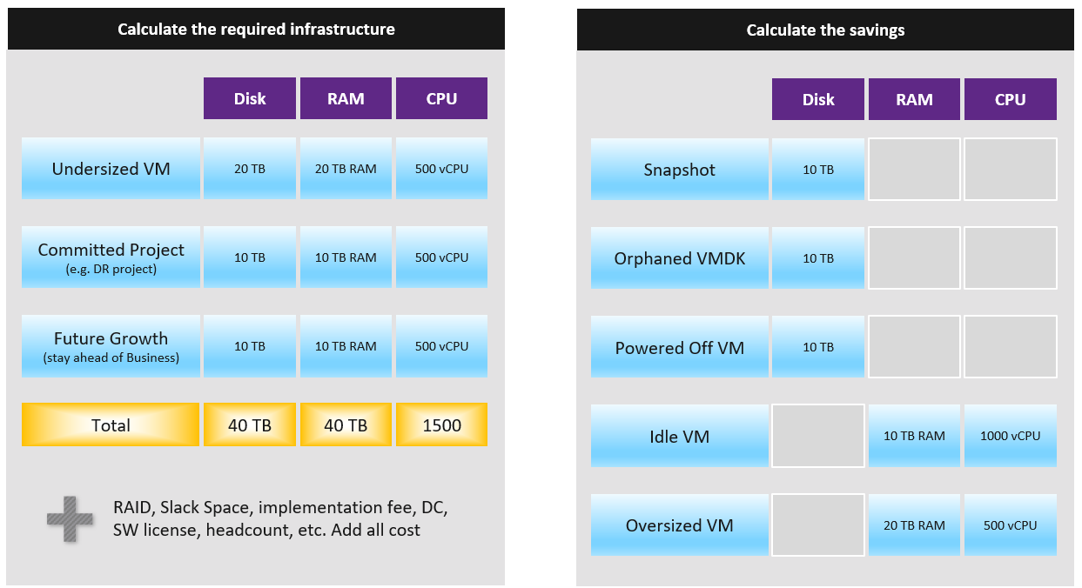

You need to prepare the above table per physical location. Just because you have 10 TB RAM in Singapore does not mean the VMs in Armenia can use it.

#### Optimized Cost

The above exercise will help in optimizing cost. There are certainly other avenues to optimize cost, as cost covers more than just capacity. It covers People, Process, Architecture.

The following table summarizes the activities you can do to optimize cost.

|  |  |  |
| --- | --- | --- |
|  | Level | What |
| Consumer | Process  Guest OS  Container  VM | Remove wastage, such as Orphaned VMDK, Snapshots, Powered off VM and Idle VM  Reclaim by shrinking oversized VM. Only useful for allocation based from cost viewpoint  Automate, with approval workflow & audit trail |
| Provider | ESXi  Cluster  Datastore & DS Cluster  Switch and Port Group  Hardware | Hardware tech refresh. Newer hardware have more capacity and faster performance, at the same price. You can also save expensive software license (e.g. database, middleware).  Virtualize storage and network, not just compute.  Consolidate. Small clusters have higher HA overhead, smaller datastore have higher overhead. Optimize cost by consolidating them.  Increase utilization of clusters and datastores, without compromising performance.  Reduce overhead. Review if the applications truly justify active/passive, resulting in 50% overhead.  Standardize the architecture. This reduces complexity, not cost. |

#### Cost and Capacity

Cost provides complimenting perspective to capacity. It provides visibility into capacity to be optimized. A cluster with plenty of capacity is more expensive as the cost is only shared by few VM.

Is old hardware more expensive? It depends on the maintenance cost and cost avoidance.

Cost is not perfectly corelated to Capacity. 2 clusters with identical capacity can have different cost

Cost covers more than Capacity. It covers people, process, and architecture. You can reduce cost by improving process effectiveness, typically achieved by business process reengineering exercise. You can reduce cost by improving process efficiency by automation. E.g. deletion of powered off VM with approval workflow.

Complexity has cost, but hard to quantity. Human error can be costly but you need to resort into probability theory to quantify that.

Simplifying operations, such as not mixing VMs with different class of services in the same cluster, will reduce complexity. But it also comes at a cost of larger infrastructure. The same thing goes with t-shirt sizing.

Take note that standardization will reduce complexity. But this also means less flexible configuration, which can increase cost.

# PART 2

Counters

Aria Operations ships with thousands of metrics and properties. If we take object by object, and document metrics by metrics, it would be both dry and theoretical. You will be disappointed as it does not explain how your real world problems are solved.

This document begins with *you*. It focuses on the problems you are trying to solve when running your multi-cloud operations. It looks at all the use cases and breaks down the metrics from there, which helps you appreciate why the metrics are layered in such manner.

## Introduction

**Part 2 Chapter 1**

There are 5 data types for each object, and relationship among objects.

* Metric
* Property
* Event
* Log
* [Netflow](https://en.wikipedia.org/wiki/NetFlow)

Each of those types has their own purpose and format. So typically different tools excel on each.

Property is a setting. It’s mostly used in configuration management.

Event is a record of something happened. It could be bad or good, planned or unplanned. The bad ones may warrant an alert. Unlike metric, it does not happen on regular interval.

Alert is not a data type as it’s a trigger you create based on the values of the data types. For example, you create an alert when certain log events occur, certain property changes and certain metrics threshold being crossed.

### Nuances in Metrics

I find it useful to know the subtle differences in the behaviour of the metrics and properties. By knowing their difference, you can apply the appropriate solution.

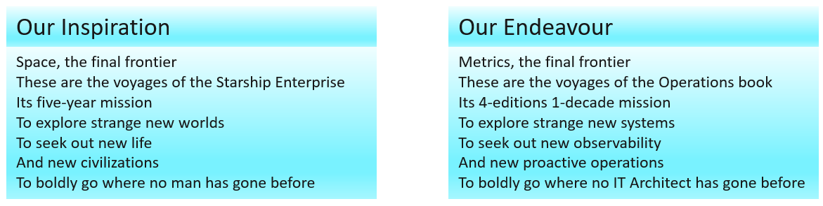

My goal is to take raw metrics from the systems under monitoring, and formulate higher-level metrics that mask out the underlying complexity.

#### Naming Complexity

|  |  |
| --- | --- |
| **Same name, same object, different formula** | The metrics have the same name, belong to the same object, yet they have a different formula depending on where in the object you measure it.  Example: VM CPU Used in vCPU level does not include System time but at the VM level it does. The reason is that System time does not exist at vCPU level since the accounting is charged at the VM level. |
| **Same name, different formula** | Metrics with the same name do not always have the same formula in different vSphere objects.  Memory Usage: in VM this is mapped to Active, while in ESXi Host this is mapped to Consumed. In Cluster, this is Consumed + Overhead. Technically speaking, mapping usage to active for VM and consumed for ESXi makes sense, due to the 2-level memory hierarchy in virtualization. At the VM level, we use active as it shows what the VM is actually consuming (related to performance). At the host and cluster levels, we use consumed because it is related to what the VM claimed (related to capacity management). This confusion has resulted in customers buying more RAM than what they need. Aria Operations uses Guest OS data for Usage, and falls back to Active if it’s not available.  Memory Consumed: in ESXi this includes memory consumed by ESXi, while in Cluster it only includes memory consumed by VM. In VM this does not include overhead, while in Cluster it does.  VM Used includes Hyper Threading but penalty is 37.5%. ESXi Used is also aware of HT but the penalty is 50%.  Virtual Disk: in VM includes RDM, but in Datastore it does not. Technically, this makes sense as they have different vantage points  Steal Time in Linux only includes CPU Ready, while stolen time in VM (CPU Latency) include many other factors including CPU frequency. |
| **Same name, different meaning** | Metrics with the same name, yet different meaning. Be careful as you may misinterpret them.  VM CPU Usage (%) shows 62.5% when ESXi CPU Usage (%) shows 100%. This happens since VM CPU Usage considers Hyper Threading, while ESXi CPU Usage does not. It happens when the ESXi core that the VM vCPU runs is also running another thread.  Disk Latency and Memory Latency indicate a performance problem. They are in fact the primary counter for how well the VM is being served by the underlying IaaS. But CPU Latency does not *always* indicate a performance problem. Its value is affected by CPU Frequency, which can go up or down. Sure, the VM is running at a higher or lower CPU speed, but it is not waiting to be served. It’s the equivalent on running on older CPU. |
| **Same name, different behaviour** | Memory Reservation and CPU Reservation have different behaviors from monitoring viewpoint.  In Microsoft Windows, the CPU queue includes only counts the queue size, while the disk queue excludes the IO commands being processed. |
| **Same purpose, different name** | You would expect if the purpose is identical then the label or name will be identical.  Swapped Memory in VM is called Swapped, while in ESXi is called Swap Used.  Static frequency CPU utilization in VM is called Run, while ESXi calls it Utilization.  What vCenter calls Logical Processor (in the client UI) is what ESXi calls Physical CPU (in esxtop panel)  vCenter uses Consumed (%) and Usage (%) for the same ESXi CPU utilization. |
| **Confusing name** | The name of the counter may not be clear.  VM CPU Wait counter includes idle time. Since many VMs do not run at 100%, you will see CPU Wait counter to be high. You may think it’s waiting for something (e.g. Disk or Memory) but it’s just idle. If we see from the viewpoint of VMkernel schedule, that vCPU is waiting to be used. So the name is technically correct.  The term virtual disk actually includes RDM. It’s not just VMDK. The reason is RDM appears as virtual disk when you browse the directory in the datastore, even though the RDM file is just a pointer to an external LUN. |

#### Architecture Complexity

The 4 basic elements of infrastructure have their own unique nature. This in turn creates complexity in observability. The following table list some example of nuances. We will explain in-depth in the next chapter.

|  |  |
| --- | --- |
| **CPU** | The primary speed metric (GHz) is not comparable across different hardware generation or architecture. 1 GHz in today’s CPU is faster than 1 GHz in older CPU. |
| **Memory** | Its function is caching, so its counters tend to be near 100%, and that is what you want.  CPU and memory metrics have different nature. 95% utilization for memory could be low, while 85% for CPU could be high already.  It’s a form storage, so its metrics are mostly disk space. |
| **Storage** | It has 2 sides (speed and space) but both have utilization metrics.  The speed has 2 components for utilization: IOPS and Throughput |
| **Network** | While server and storage are nodes, network is interconnect. This makes it more challenging. |

Their complexity results in difference in type of metrics applicable:

|  |  |  |  |
| --- | --- | --- | --- |
|  | Utilization | Reservation | Allocation |
| CPU | Yes | Yes | Yes |
| Memory | Yes | Yes | Yes |
| Disk | Yes | Not Applicable | Yes |
| Network | Yes | Yes | Yes |

And lastly, beyond metrics there are also further complications such as:

|  |  |
| --- | --- |
| **VM vs ESXi** | The CPU metrics from a VM viewpoint differs to the CPU metrics from ESXi viewpoint. A VM is a consumer. Multiple VMs can share the same physical core, albeit at the price of performance. So metrics such as Ready does not apply to ESXi. The core and the thread are always ready. |
| **ESXi vs vCenter** | While ESXi is the source of metrics, vCenter may add its own metrics and the formula don’t always match 100% in all scenarios, such as Used vs Usage.  ESXi provides Run (ms), Used (ms), Demand (MHz) for VM CPU. vCenter adds Usage (MHz) and Usage (%), which create confusion as there are now 5 choices.  ESXi shows Used (%), while vCenter shows Used (ms). The first one affected by CPU frequency and can go beyond 100%. |
| **ESXi ≠ VMs + VMkernel** | The metrics at ESXi is more complex than the sum of its VM + VMkernel. We dedicate a subchapter for this within ESXi chapter. |
| M:N relationship | A VM with multiple virtual disks can span across multiple datastores, and even RDMs. On the other hand, a datastore typically hosts many VMs. An ESXi may mount multiple LUNs and a LUN is typically presented into multiple ESXi or even multiple clusters. These many to many relationships make the metrics across VM, datastore, ESXi, Cluster, Data Center inconsistent when viewed overall. Each of them is correct as each has to look from their own vantage point. |
| Windows vs Linux | Windows CPU queue excludes the running thread, Linux includes the threads being executed.  Windows memory metrics are different to Linux memory metrics. |
| Aria vs “Source” | As far as possible, Aria Operations shows the raw metrics as what you see them in the source (e.g. vCenter, vSAN, NSX, Windows). This prevents confusion. This is not 100% possible. For example, we do not reproduce the %VMWait counter of esxtop. We have another counter called Other Wait instead. |

There is also a scalability concern. Take for example, vCenter has 17 CPU metrics available at the VM level, and 12 of them are available at a vCPU level too. In addition, each VM comes with 28 memory metrics. That means a VM with 4 vCPUs will have 93 metrics (17 + 4 x 12 + 28). A vSphere environment with 1,000 VMs with 4 vCPUs as the average VM size will have process 93K metrics each time it collects. If you do that every minute, you will collect almost 134 million metrics per day. Since many customers like to keep for at least 6 months, that’s 24+ billion metrics!

With so many metrics, the amount of business value received becomes a valid concern. At the end of the day, you are not in the business of collecting metrics.

I’m not a fan of simply *regurgitating* the metrics that the source system has. We should start by understanding the unique behaviour of the system we want to manage (e.g. vSphere, Windows), then simplifying it by consolidating and standardizing the metrics. For example, Aria Operations creates derived metrics such as KPI and capacity metrics, then applies them to CPU, RAM, disk, and network as appropriate.

#### Other Nuances

|  |  |
| --- | --- |
| **Mixing terminology** | Allocation and reservation are different concepts.  When you allocate something to someone, it does not mean it’s guaranteed. If you want a guarantee, then do reservation. Allocation is a maximum (you can’t go beyond it), while Reservation is a minimum. The actual utilization can be below reservation but can’t exceed allocation.  You cannot overcommit reservation as it’s a guarantee. You can overcommit allocation as it is not a guarantee.  Avoid using metric names like these:   * Allocation Reservation. This makes no sense. * Maximum Reservation. Simply use Allocation instead. * Minimum Allocation. Simply use Reservation instead. |
| **Confusing roll up** | Why is VM CPU Ready above 100%? If you look at esxtop, many VM level metrics are >100%.  vCenter measures every 20000 ms, but the maximum value for a completely idle thread is 10000. The reason is 20000 is the value set at the core level. Since a core has 2 threads when HT enabled, each was allocated 10000. |
| **Confusing unit** | Why are CPU metrics expressed in milliseconds instead of percentage or GHz? How can a time counter (milliseconds in this case) account for CPU Frequency? There is a good reason for that!  Is 1 Giga = 1000 Mega or 1024 Mega?  Esxtop and vSphere Client use different units for the same metric. For example, esxtop use megabit while vCenter UI use kilobyte for networking counter. |
| **“Missing” Metrics** | You will find VM CPU Demand, but not VM Memory Demand. Demand does not apply to memory as it’s a form of storage, just as there is no such thing as a Demand metric for your laptop disk space. |
| **Too many choices** | When you have 2 watches showing different times, you become unsure which watch is the correct one.  There are 5 metrics for VM CPU “utilization”: Run, Used, Usage, Usage in MHz, and Demand. Why so many metrics just to track utilization, different to what Windows or Linux tracks?  There are 6 metrics for ESXi CPU “utilization”: Core Utilization, Utilization, Used, Usage, Usage in MHz, and Demand.  Why so many? You’ll find out in this book. |
| **Confusing formula** | ESXi CPU Idle (ms) includes CPU Frequency. |
| **Inconsistent implementation** | There is reservation for CPU, memory and network, but not for Disk.  There is limit for disk IOPS, but not for disk throughput. |
| **Incorrect name** | Task Manager in Windows is not correct as the kernel does not have such concept. The terminology that Windows has is actually called Job. A job is a group of processes that can be managed as one. Do you want it to be called Job Manager? 😊  I think Process Manager is better as that’s what running on top of the kernel. |

#### Limited Observability

One major difference between Guest OS and VM is that Windows or Linux has a lot of processes. The problem is there is minimal observability. There seems to be limited useful information for troubleshooting. For example, there is no CPU queue metric, memory page fault, network dropped packet, and disk latency at process level.

The following shows [Windows Sysinternal](https://docs.microsoft.com/en-us/sysinternals/)[10], a great tool for Windows troubleshooting. As you can see, they are just utilization metrics. There is no contention metric.

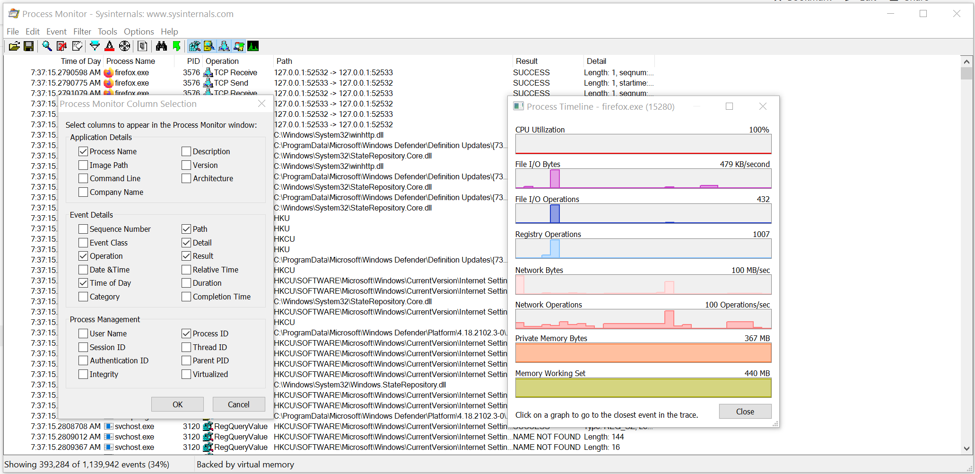

#### Documentation Challenges

To master metrics, you need to be able to see them from 3 different perspectives:

|  |  |
| --- | --- |
| **Product** | Product such as vSphere, Horizon, and Kubernetes bring their own set of objects.  Each type of object (e.g. VM, K8 Pod, AWS S3, Oracle DB) has their own set of metrics. Since objects typically have relationship with other objects and are grouped under a parent (e.g. a K8 Cluster has multiple nodes, which in turn can have multiple pods), you end up with multiple parallel hierarchies or overlapping hierarchies. |
| **Technology** | Computer architecture has not fundamentally changed since the first day of the mainframe. You have CPU, memory, disk and network. Documenting via this route is useful for infrastructure.  There are variants such as GPU and APU, and components become distributed and virtual. You need to be able to see how the metrics behaviour change. |
| **Pillars of Operations** | Each pillar brings their own set of metrics.  For examples:   * Capacity creates new metrics such as Time Remaining and Recommended Size * Cost creates new metrics such as Month-to-Date Cost * Performance creates new metric such as KPI (%) |

As a book has a simple and fixed structure, I’m struggling to document in 3 different ways. Ideally we use an interactive website where you can browse from different perspectives.

### Virtualization Impact

From observability viewpoint, a VM is not what most of us think it is. It changes the fundamental of operations management. It introduces a whole set of metrics and properties, and relegates many known concepts as irrelevant.

For example, you generally talk about these types of system-level metrics in Windows or Linux

* Processes
* Threads
* System Calls/sec

But when it comes to VM, you don’t. The reason these OS-level metrics are not relevant is because a VM is not an OS.

To master vSphere metrics, you need to know VMkernel. The kernel is a different type of OS as its purpose is to run multiple virtualized motherboard (I personally prefer to call VM as virtual motherboard). As a result its metrics are different to typical OS such as Windows and Linux.

From VMkernel’s vantage point, a VM is just a collection of process that needs to be run together. Each process is called World. So there is a world for each vCPU of a VM, as each can be scheduled independently. The following screenshot shows both VM and non VM worlds running side by side. I’ve marked the kernel modules with red dot. You can spot familiar process like vpxa and hostd running alongside VM (marked with the yellow line).

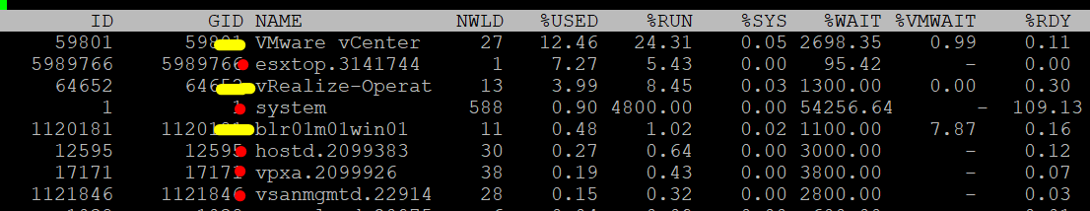

vSphere and vSAN metrics are more complex than physical machine metrics because there are many components as well as inconsistencies that are caused by virtualization. When virtualized, the 4 elements of infrastructure (CPU, RAM, Disk, Network) behave *differently*.

The complexity created by a new layer because it impacts the adjacent layers below and above it. So the net effect you need to learn 3 layers. That’s why from a monitoring and troubleshooting viewpoint, Kubernetes and [container](https://en.wikipedia.org/wiki/OS-level_virtualization) technology require an even deeper knowledge as the boundary is even less strict. Think of all the [problems](https://www.settlersoman.com/ftf-012-resource-pools-in-practice/) you have with vSphere Resource Pool performance troubleshooting, and now make it granular at process level.

Not all VMware-specific characteristics are well understood by management tools that are not purpose-built for it. Partial understanding can lead to misunderstanding as wrong interpretation of metrics can result in wrong action taken.

#### Visibility

Guest OS and VM are 2 closely related due to their 1:1 relationship. They are adjacent layers in SDDC stacks. However, the two layers are distinct, each provide unique visibility that the other layer may not be able to give. Resource consumed by Guest OS is not the same as resource consumed by the underlying VM. Other factors such as power management and CPU SMT also contribute to the differences.

The different vantage points result in different metrics. This creates complexity as you size based on what happens inside the VM, but reclaim based on what happens outside the VM (specifically, the footprint on the ESXi). In other words, you size the Guest OS and you reclaim the VM.

The following diagram uses the *English* words demand and usage to explain the concept, where demand consists of usage and unmet demand. It does not mean the demand and usage metrics in vSphere and Aria Operations, meaning don’t assume these metrics actually mean this. They were created for a different purpose.



I tried adding application into the above diagram, but that complicated the whole picture that I removed it. So just take note that some applications such as Java VM and database manage their own resources. Another virtualization layer such as Container certainly takes the complexity to another level.

We can see from the above that area A is not visible to the hypervisor.

|  |  |
| --- | --- |
| **Layer A** | Queue inside the Guest OS (CPU Run Queue, RAM Page File, Disk Queue Length, Driver Queue, network card ring buffer). These queues are not visible to the underlying hypervisor as they have not been sent down to the kernel. For example, if Oracle sends IO requests to Windows, and Windows storage subsystem is full, it won’t send this IO to the hypervisor. As a result, the disk IOPS counter at VM level will under report as it has not received this IO request yet. |
| **Layer B** | What the Guest actually uses. This is visible to the hypervisor as a VM is basically a multi-process application. The Guest OS CPU utilization somehow translates into VM CPU Run. I added the word “somehow” as the two metrics are calculated independently of each other, and likely taken at different sampling time and use different roll up technique. |
| **Layer C** | Hypervisor overhead (CPU System, CPU MKS, CPU VMX, RAM Overhead, Disk Snapshot). This overhead is obviously not visible to the Guest OS. You can get some visibility by installing Tools, as it will add new metrics into Windows/Linux. Tools do not modify existing Windows/Linux metrics, meaning they are still unaware of virtualization.  From VMkernel viewpoint, a VM is group of processes or user worlds that run in the VMkernel. There are 3 main types of groups:   * VM Executable (VMX) process is responsible for handling I/O to devices that are not critical to performance. The VMX is also responsible for communicating with user interfaces, snapshot managers, and remote console. * VM Monitor (VMM) process is responsible for virtualizing the guest OS instructions, and managing memory mapping. The VMM passes storage and network I/O requests to the VMkernel, and passes all other requests to the VMX process. There is a VMM for each virtual CPU assigned to a VM. * Mouse Keyboard Screen (MKS) process is responsible for rendering the guest video and handling guest OS user input. When you console into the VM via vCenter client, the work done is charged to this process. This in turn is charged to the VM, and not specific vCPU.   If you want to see example of errors in the above process, review [this KB article](https://kb.vmware.com/s/article/1019471). |
| **Layer D** | Unmet Demand (CPU Ready, CPU Co-Stop, CPU Overlap, CPU VM Wait, RAM Contention, VM Outstanding IO).  The Guest OS experiences a frozen time or slowness. It’s unaware what it is, meaning it can’t account for it. |

I’ve covered the difference in simple terms, and do not do justice to the full difference. If you want to read a scientific paper, I recommend [this paper](https://link.springer.com/chapter/10.1007%2F978-3-642-29737-3_26) by Benjamin Serebrin and [Daniel Hecht](https://dblp.org/pid/73/11144.html).

#### Overhead vs Not Overhead

Be careful not to lump every additional load as overhead.

* Overhead means it’s mandatory (cannot be avoided) and has negative impact (such as slower performance or more resource required). They typically do not bring additional, new capabilities.
* Not Overhead means it’s optional. You do not have to use the feature. Also, it brings new capabilities so it bring value that is often not possible to achieve without virtualization.

Let’s list some examples:

|  |  |
| --- | --- |
| **Overhead** | Cache. The only purpose of cache is performance. It does not increase capacity.  IO processing by hypervisor. There is an additional processing done by VMkernel, which could result in IO blender effect.  VM CPU and Memory overhead for the VM Monitor layer. This is a small amount and operationally negligible.  vSAN. The actual ESXi memory consumed and CPU used by vSAN processes.  VM log files. VM is a layer on its own and the log provides necessary observability. |
| **Not Overhead** | VM snapshot. Snapshot is optional and it delivers new functionalities not available in Guest OS.  VM memory snapshot. This does not have the same purpose with hibernation file inside Windows or Linux. This feature enables memory overcommit at ESXi level.  vSAN Failures-to-Tolerate policy. They provide availability protection since vSAN does not use hardware-level redundancy. For workloads where the VM is transient and you have the master template, you can set this to 0 (no protection). |

What about VMkernel consumption and reservation? Do you consider that as overhead?

My take is yes. While it delivers value, it’s not optional and it’s not negligible. It impacts your usable capacity too. We will cover this in-depth in vSphere ESXi chapter.

#### Resource Management

vSphere uses the following to manage the shared resources:

* Reservation
* Limit
* Share
* Entitlement

Reservation and Limit are absolute. Share is relative to the value of other VMs on the same cluster.

Unlike a physical server, you can configure a Limit and a Reservation on a VM. This is done outside the Guest OS, so Windows or Linux does not know. You should minimize the use of Limit and Reservation as it makes SDDC operations more complex.

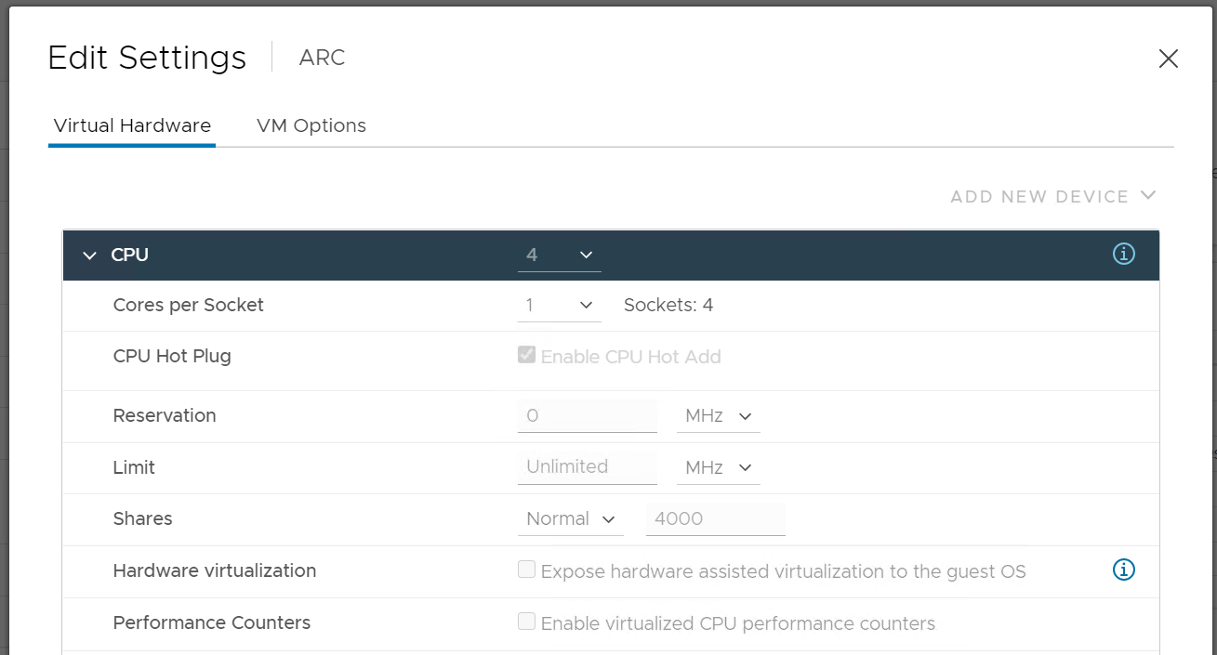

Reservation represents a guarantee. It impacts the Provider (e.g. ESXi) as that’s where the reservation takes place. However, it works differently on CPU vs RAM.

|  |  |
| --- | --- |
| **CPU** | CPU Reservation is on demand. If the VM does not use the resource, then it does not come into play as far as the VM is concerned.  Accounting wise, it does not impact CPU utilization metrics. Run, Used, Demand, Usage do not include it. Their value will be 0 or near 0 if the Guest OS is not running. |
| **RAM** | Memory Reservation is permanent, hence impacts memory utilization metric. The Memory Consumed counter includes it even though the page is not actually consumed yet. If you power on a 16 GB RAM VM into a BIOS state, and it has 10 GB Memory Reservation, the VM Consumed memory counter will jump to 10 GB. It has not actually consumed the 10 GB, but since ESXi has reserved the space, it is not available to other VMs.  If it’s not yet used, then it does not take effect. Meaning ESXi Host does not allocate any physical RAM to the VM. However, once a VM asks for memory and it is served, the physical RAM is reserved. From then on, ESXi continues reserving the physical RAM even though the VM is no longer using it. In a sense, the page is locked despite the VM become idle for days. |

Limit should not be used as it’s not visible to the Guest OS. The result is unpredictable and could create a worse performance problem than reducing the VM configuration. For CPU, it impacts the CPU Ready counter. For RAM, in the VMX file, this is sched.mem.max.

Reservation, Share and Limit are relatively static. They do not fluctuate unless they are manually changed. Hence, they behave more like a property than a metric.

##### Entitlement

Entitlement means what the VM is entitled to. It's a dynamic value determined by the hypervisor. It varies every second, determined by Limit, Shares and Reservation of the VM itself and any shared allocation with other VMs running on the same host. For Shares, it certainly must consider shares of other VMs running on the same host. A VM can’t use more than what ESXi entitles it.

Obviously, a VM can only use what it is entitled to at any given point of time, so the Usage counter cannot go higher than the Entitlement counter.

In a healthy environment, the ESXi host has enough resources to meet the demands of all the VMs on it with sufficient overhead. In this case, you will see that the Entitlement and Usage metrics will be similar to one another when the VM is highly utilized.

The numerical value may not be identical because of reporting technique. vCenter reports Usage in percentage, and it is an *average* value of the sample period. vCenter reports Entitlement in MHz and it takes the *latest* value in the sample period. This also explains why you may see Usage a bit higher than Entitlement in highly-utilized vCPU. If the VM has low utilization, you will see the Entitlement counter is much higher than Usage.

### Collection

Before we cover the metrics, you need to know the various units and how they get

* collected within a collection period (e.g. 20 second)
* rolled up across time (e.g. from 20 second to 5 minutes)
* aggregated to higher level object (e.g. from ESXi to Cluster)

#### Collection

When you collect a metric you have a choice on what to collect:

1. Collect the data at that point in time.
2. Collect the average of all the data within the collection cycle.
3. Collect the maximum (or minimum) of all the data within the collection cycle.

The 1st choice is the least ideal, as you will miss majority of the metric. For example, if you collect every 5 minutes, that means you collect the data of the 300th second, and miss 299 seconds worth of data points. Unfortunately, many products have chosen this choice.

The 2nd choice gives you the complete picture, as no data is missing. The limitation is your collection interval can’t be too long for the use case you’re interested in.

Comparing the 2 choices, the 1st choice will result in wider fluctuations. You will have higher maximum and lower minimum over time. Telegraf chooses the 2nd choice, while Tools choose the 1st choice. You can see below the result. Overall their pattern will be similar, especially for something relatively stable such as memory consumption and disk space consumption.

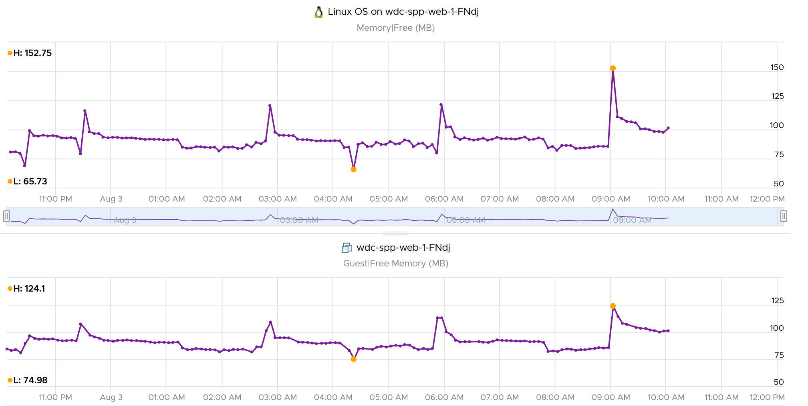

The 3rd choice complements the 2nd choice by picking the worst. That means you need 2 number per metrics for certain use case.

As you collect regularly, you also need to decide if you reset to 0, or you continue from previous cycle. Most metrics reset to 0 as accumulation is less useful in operations.

Let’s take a look at what you see at vCenter UI, when you open the performance dialog box. What do the columns Rollups and Stat Type mean?



Stat Type explains the nature of the metrics. There are 3 types:

|  |  |
| --- | --- |
| **Delta** | The value is derived from a running counter that perpetually accumulates over time. What you see is difference between 2 points in time. As a result, all the units in milliseconds are of delta type. |
| **Rate** | The value measures the rate of change, such as throughput per second. Rate is always the average across the 20 second period.  Note: there are metrics with percentage as unit and rate as stat type. I’m puzzled why. |
| **Absolute** | The value is a standalone number, not relative to other numbers.  Absolute can be latest value at 20th second or the average value across the 20 second period. |

Some common units are milliseconds, MHz, percent, KBps, and KB.

Metrics in MHz is more complex as you need to compare with the ESXi physical CPU *static* frequency. In large environments, this can be operationally difficult as you have different ESXi hosts from different generations or sport a different GHz. This is one of the reasons why I see vSphere cluster as the smallest logical building block. If your cluster has ESXi hosts with different frequencies, these MHz-based metrics can be difficult to use, as the VMs get vMotion-ed by DRS.

##### Why Milliseconds as Unit?

vSphere uses 3 types of units for CPU: millisecond, MHz and %.

Of the 3, the millisecond is the source. Time is the raw unit, meaning both the percentage unit and the MHz unit are derived from it, because they are expressed as the average/minimum/maximum over time. When we see the CPU demand is 2 GHz at 9:00:00 am what vSphere likely means is it the average from previous collection. It is not a point in time.

Time as a unit to measure CPU utilization does not seem logical. Where does it come from and why?

Hint: the stat type is Delta.

To answer that, we need to see from the ESXi VMkernel scheduler point of view. Think in terms of the passage of time and the amount of CPU cycles that get completed during that time. A CPU core running at 2 GHz will get 2x CPU cycles completed compared with a core running at 1 GHz. The same goes with Hyper Threading. You get less cycles completed when there is a peer thread competing at the same time.

What you think as utilization or usage or demand or used, it will be easier if you see them as cycles, once you make that small paradigm shift.

Let’s take VM CPU Ready. The following is taken from ESXi [vsish](https://williamlam.com/2010/08/what-is-vmware-vsish.html)[11] command. It shows that the original, raw counter is actually a running number. To calculate the CPU ready of a given time period, we need to subtract the last number from the first number. To convert to percentage, we divide over the collection, which is 20000 ms in the screenshot.

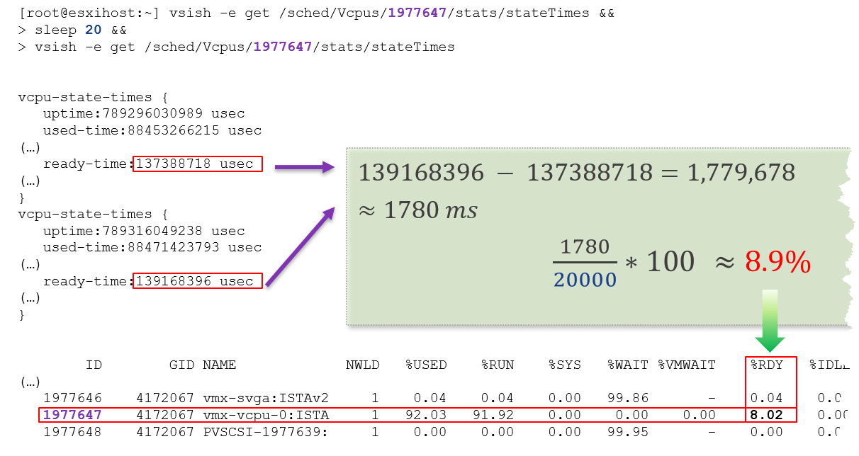

In the above, the slightly different values are due to different time in sample interval start and end.

I’ll take another example, to show that the original unit is time (microsecond, not millisecond).

/sched/groups/169890525/stats/cpuStatsDir/> cat /sched/groups/169890525/stats/cpuStatsDir/cpuStats  
group CpuStats {  
   number of vsmps:7  
   size:19  
   used-time:905379300543 usec  
   latency-stats:latency-stats {  
      cpu-latency:798578245914 usec   
      memory-latency:memory-latency {  
         swap-fault-time:0 usec  
         swap-fault-count:0  
         compress-fault-time:0 usec  
         compress-fault-count:0  
         mem-fault-time:17939139 usec  
         mem-fault-count:3834600  
      }  
      network-latency:0 usec  
      storage-latency:0 usec

In vSphere UI and API, the counter for CPU Latency is percentage. But in the above, you can see that it’s true unit is microseconds.

##### Summation

The **Rollups** column tells you how the data is rolled up to longer time period. Average means the average of 5 minutes in the case of vRealize Operations. What about **Summation**? Why does the number keep going up as you roll up?

It is actually average for those metrics where accumulation makes more sense. Let’s take an example. CPU Ready Time gets accumulated over the sampling period. vCenter reports metrics every 20 seconds, which is 20000 milliseconds. The following table shows a VM has different CPU Ready Time on each second. It has 900 ms CPU Ready on the 5th and 6th second, but has lower number on the remaining 18 seconds.



Over a period of 20 seconds, a VM may accumulate different CPU Ready Time for each second. vCenter sums all these numbers, then divides it by 20,000. This is actually an average, as you lose the peak within the period.

**Latest**, on the other hand, is different. It takes the last value of the sampling period. For example, in the 20-second sampling, it takes the value between 19th and 20th seconds. This value can be lower or higher than the average of the entire 20 seconds period. Latest is less popular compared with average as you miss 95% of the data.

Rolling up from 20 seconds to 5 minutes or higher results in further averaging, regardless whether the rollup technique is summation or average. This is the reason why it is better to use Aria Operations than vCenter for data older than 1 day, as vCenter averages the data further, into a 0.5 hour average.

Because the source data is based on 20-second, and Aria Operations by default averages these data, the “100%” of any millisecond data is 20,000 ms, not 300,000 ms. When you see CPU Ready of 3000 ms, that’s actually 15% and not 1%.

By default, Aria Operations takes data every 5 minutes. This means it is *not* suitable to troubleshoot performance that does not last for 5 minutes. In fact, if the performance issue only lasts for 5 minutes, you may not get any alert, because the collection could happen exactly in the middle of those 5 minutes. For example, let's assume the CPU is idle from 08:00:00 to 08:02:30, spikes from 08:02:30 to 08:07:30, and then again is idle from 08:07:30 to 08:10:00. If Aria Operations is collecting at exactly 08:00, 08:05, and 08:10, you will not see the spike as it is spread over two data points. This means, for Aria Operations to pick up the spike in its *entirety* without any idle data, the spike *may* have to last for 10 minutes.

Aria Operations is capable of storing the individual 20-seconds data. But that would result in 15x more data. In most cases, what you want is the peak among the 15 data points. This is where a new set of troubleshooting metrics come in.

The [Collection Level](https://docs.vmware.com/en/VMware-vSphere/7.0/com.vmware.vsphere.monitoring.doc/GUID-25800DE4-68E5-41CC-82D9-8811E27924BC.html) in vCenter, shown in the following table, does *not* apply to Aria Operations. Changing the collection level does not impact what metrics get collected by Aria Operations. It collects majority of metrics from vCenter using its own filter, which you can customize via policy.

|  |  |
| --- | --- |
| Statistics Levels | Metrics |
| Level 1 | Cluster Services (VMware Distributed Resource Scheduler) – all metrics  CPU –entitlement, total MHz, usage (average), usage MHz  Disk – capacity, max Total Latency, provisioned, unshared, usage (average), used  Memory – consumed, mem entitlement, overhead, swap in Rate, swap out Rate, swap used, total MB, usage (average), balloon, total bandwidth (DRAM or PMem)  Network – usage (average), IPv6  System – heartbeat, uptime  VM Operations – num Change datastore, num Change Host, num Change Host datastore |
| Level 2 | Level 1 metrics, plus the following:  CPU – idle, reserved Capacity  Disk – All metrics, excluding number Read and number Write.  Memory – All metrics, excluding Used, maximum and minimum rollup values, read or write latency (DRAM or PMem).  VM Operations – All metrics |
| Level 3 | Level 2 metrics, plus the following:  Metrics for all metrics, excluding minimum and maximum rollup values.  Device metrics |
| Level 4 | All metrics, including minimum and maximum rollup values. |

Take note: vSAN API, Telegraf API, and Horizon API give you the last data, not the average or peak of the entire period. Since Aria Operations collect every 5 minutes, you get the data of the 300th second.

#### Real Time Collection

Do we really need real-time collection and analysis for every single metrics, on every single objects, 24 x 7?

We collect the metrics for a reason, such as performance and capacity. The reasons dictate the frequency for each type of metrics.

Take note that how frequent you collect is not the same with how granular the data points. For example, Aria Operations collect every 5 minutes by default from vCenter, but it grabs 15 data points in 1 collection cycle. For majority of the data, it averages these 15 data points and store as 1 number.

|  |  |  |
| --- | --- | --- |
| Use Case | Collection Point | Collection Frequency |
| Performance: Profiling | 1 – 20 seconds for all counters | 1 – 20 seconds |
| Performance: Troubleshooting | 1 - 20 seconds for raw contention, 5 minutes for everything else. More explanation after this table. | 5 minutes for both |
| Performance: SLA | 5 minutes. Why SLA differs to troubleshooting and why 5-minute is the sweet spot is covered here. | 5 minutes |
| Capacity | 15 minutes for all. Value is the average over 15 minutes, not the peak.  Functionally, you do not need 15-minute granularity. Operationally, it’s safer to do 15 minutes. If there is collection failure, either due to collector or target system, you only lose 15 minutes worth of data. | |
| Cost |
| Compliance |
| Sustainability |
| Inventory |

##### Performance Troubleshooting

For troubleshooting, you want per-second data. Who does not want sharper visibility? However, there are potentialproblems:

1. It may not be possible. The system you’re monitoring may not be able to produce the data, or it comes with capacity or performance penalty.
2. It’s expensive. Your monitoring system might grow to be as large as the systems being monitored. You could be better off spending the money on buying more hardware, preventing the problem to begin with.
3. You get diminishing return. The first data point is the most valuable. Subsequent data points are less valuable if they are not providing new information.
4. The remediation action is likely the same as there are only a handful of things you can do to fix the problem. The number of problems outweigh the actual solution.

So what can you do instead?

Begin with the end in mind. Look at the solution (e.g. add hardware, change some settings) and ask what metrics are required. For each required metrics, ask what granularity is required.

I find that 1 – 20 second is only required for the contention-type of metrics. For utilization-type and contextual-type, I think 5 minute is enough. You need higher resolution when the contention-type metrics do not exist. For example, there is no metric for network latency and packet retransmit at VM level. All you have is packet dropped. To address the missing metrics, use utilization metric such as packet per second and network throughput.

We’ve done the analysis of what metrics are required and document them here.

#### Units

Before we cover aggregation, we need to clarify unit as aggregation often using a different unit.

##### 1000 vs 1024

There is confusion between 1024 and 1000. Is 1 gigabyte = 1024 megabyte or 1000 megabyte?

Is 1 Gigabit = 1000 Mb or 1024 Mbit?

The answer is 1000. Because both are byte, so the only change is from giga to mega. The following screenshot is taken from Google.

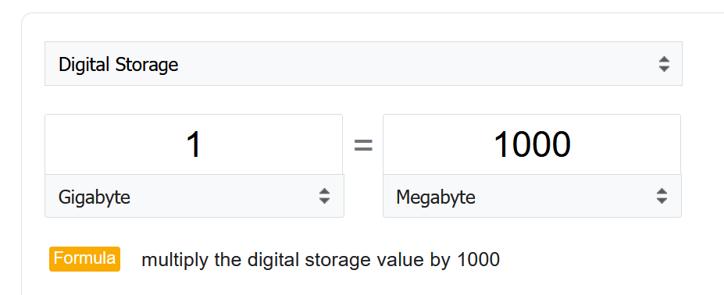

However, many products from many vendors use the binary conversion instead of decimal. This is one of those issue between what’s popular in practice vs what it should be in theory.

To add further confusion, there is consistency among storage and network vendors.

Microsoft Windows use 1024 for storage. My 1,000,202,039,296 bytes physical SSD is shown at 931 GB, not 1024 GB.

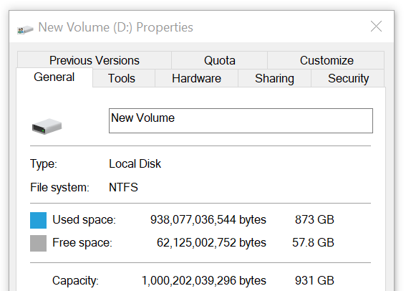

The disk vendor states that’s a 1 TB disk.

Another vendor, Samsung also uses 1000. It states the SSD as 250 GB. Microsoft shows 232.87 GB, including hidden partitions.

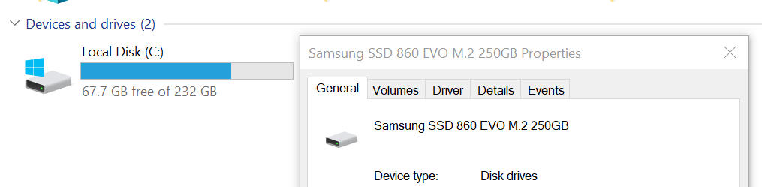

Aria Operations use 1024. As it’s a universal conversion, it applies 1024 to both disk space and speed.

##### Kilo vs Kibi

To address the confusion, the committee at [International System of Quantities](https://en.wikipedia.org/wiki/International_System_of_Quantities) came up with a new set of name for the binary units. Instead of kilo, mega, giga, they use kibi, mebi and gibi.

I find it confusing to drop familiar terms like kilo, mega and giga. Personally I’d have preferred kilobi, megabi and gigabi as it shows the relationship to the commonly known units. Or if you want to emphasize the binary nature, perhaps kilo2byte, mega2byte, giga2byte as the name.

Let’s take an example

* 1 Kibibyte = 1024 bytes. That means 1 Kibibyte = 1.024 KB.
* 1 Gibibyte = 1024 Mebibytes = 1,073,741,824 bytes

The abbreviation is also changed from K, M, G to Ki, Mi, Gi, where the letter ***i*** is small case.

Note the conversion from byte to bit remains. 1 byte = 8 bit.

##### Bit vs Byte

Do you use Byte/second or bit/second?

To me, it depends on the context. If you talk about disk space, you should use byte. You measure the amount of disk space read or written per second. If you talk about network line, you should use bit. You measure the amount of SCSI blocks travelling inside ethernet or FC cable. [Pearson](https://qualifications.pearson.com/content/dam/pdf/subject-updates/ICT/KB-vs-kpbs.pdf) uses 1024 for disk space, and 1000 for transmission speed, in their certification. There are other references, such as [gbmb.org](https://www.gbmb.org/gbps-to-mbps), [NIST](https://physics.nist.gov/cuu/Units/prefixes.html), and [Lyberty](http://www.lyberty.com/encyc/articles/kb_kilobytes_archived1.html). In short, there is really no standard.

The following is network transmit. It’s showing 30.81 MBps. So this is a rate, showing bandwidth consumption or network speed.

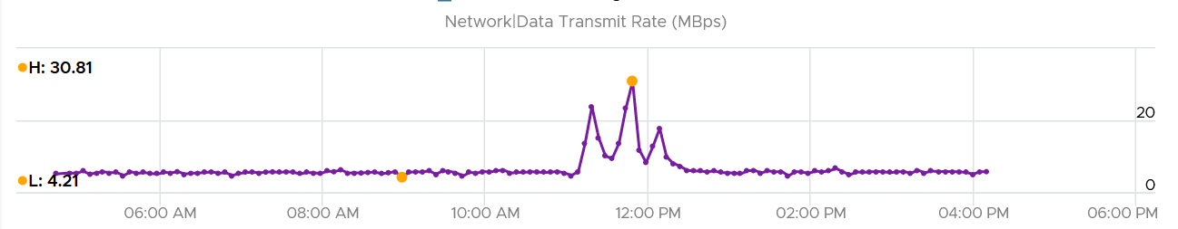

What would it show if you convert into KBps?

30810, if it uses 1000.

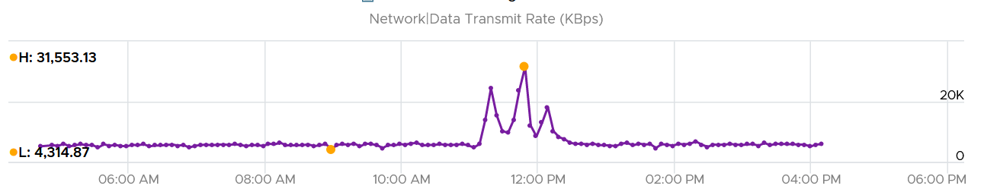

Since vRealize treats 1 Mega = 1024 Kilo, the above is what you get.

Since it’s network, let’s convert into bit.

What do you expect you get in Mbps?

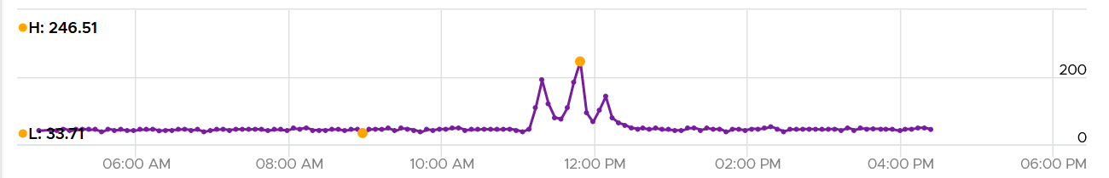

You get 31 x 553.13 x 8 bits / 1024 = 246 / 51

### Aggregation

We discussed in previous heading about collecting the data. After collecting lots of data, how do you summarize?

Aggregating to a higher-level object is complex as there is no lossless solution. You are trying to represent a range of values by picking up 1 value among them, so you tend to lose the details. The choices of techniques are mean, median, maximum, minimum, percentile, sum and count of. The default technique used is the average() function. The problem with average is it will mask out the problems unless they are widespread. By the time the average performance of 1000 VMs is bad, you likely have a hundred VMs in bad shape.

Let’s take an example. The following table shows ESXi hosts. The first host has CPU Ready of 149,116.33 ms. Is that a bad number?



It is hard to conclude. It depends on the number of running vCPU, not the number of physical cores.

That host has 67 running VMs, and each of those VMs can have multiple vCPU. In total there are 195 vCPU. Each vCPU could potentially experience CPU Ready of 20,000 ms (which is the worst possible scenario).

If you sum the CPU Ready of the 67 VM, what number would you get?



You’re right, you get the same number reported by the ESXi host.

This means the ESXi CPU Ready = Sum (VM CPU Ready), and the VM CPU Ready = Sum (VM vCPU Ready).

Because it’s a summation of the VMs, to convert into % requires you to divide with the number of running VM vCPU.

ESXi CPU Ready (%) = ESXi CPU Ready (ms) / Sum (vCPU of running VMs)

Are the CPU Ready equally distributed among the VMs? What do you think?

It depends on many settings, so there is a good chance you get something like the following. This heat map shows the 67 VMs on the above host, colored by CPU Ready and sized by VM CPU configuration. You can see that the larger VMs tend to have higher CPU ready, as they have more vCPU.



You also need to consider performance requirements in analysing millions of data points. Averaging from 100K object every 5 minutes will require a lot of resource. For VMware Horizon, we apply a 2-step roll up technique to minimize the calculation cost. Mathematically, it is less accurate as a small VDI Pool or RDS Farm is treated equally with the large ones. Operationally, just because they are smaller do not mean they are less important.

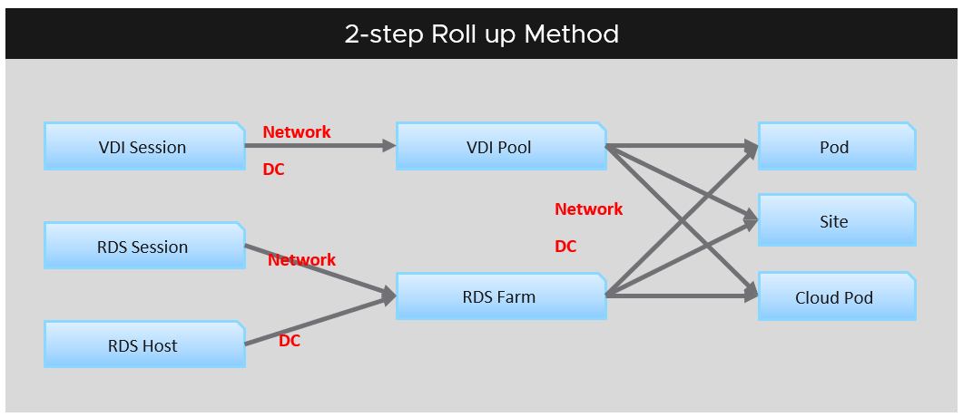

#### Leading Indicator

You want to be able to see performance problem while it’s still early, when only a small percentage of users or applications are affected. For that, you need a leading indicator, not a lagging indicator (after the fact). Leading indicators complement the lagging indicator by giving the early warning, so you have more time to react.

Performance use the contention metric as its primary input. The problem with contention metrics is it drops (or spike, depending on how you see it) suddenly, typically at the point of overcommit. It differs to consumption metrics which goes up towards 100%.

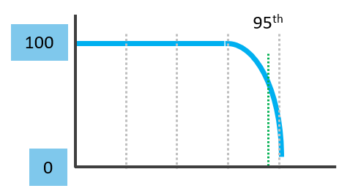

As a result, average is not suitable for rolling up performance metrics to higher level parents. For example, a VDI system that was designed for 1000 users should serve the first 1000 well, and it should struggle after the capacity is exceeded.

Average is a lagging indicator. The average of a large group tends to be low, so you need to complement it with the peak. On the other hand, the absolute peak can be too extreme, containing outliers.

The following chart shows where Maximum() picks up the extreme (outlier) while average fails to detect the problem. This is where the worst 5th percentile or the worst 1st percentile makes more sense.

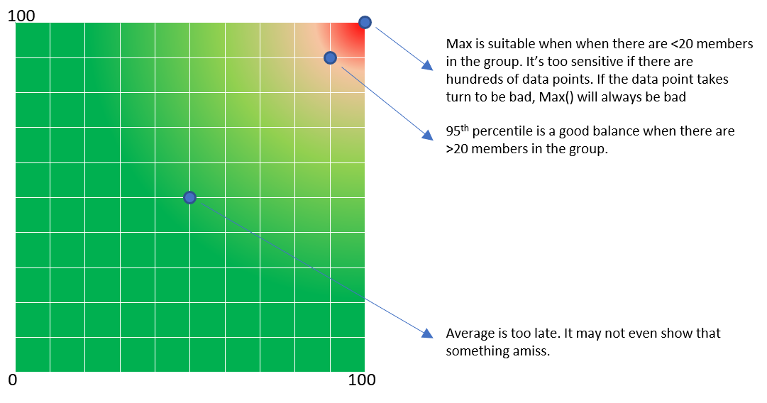

These are the technique to complement average() and maximum(). Depending on the situation, you apply the appropriate technique.

|  |  |
| --- | --- |
| **Worst()** | This returns the worst value of a group. It’s suitable when the number of members are low, such as ESXi hosts in a cluster or containers in a Kubernetes pod.  If you want to ignore outlier, then use Percentile function. |
| **Percentile()** | It is similar to the Worst() function, but it returns the number after eliminating a percentage of the worst. See this [handy calculator](https://www.calculatorsoup.com/calculators/statistics/percentile-calculator.php) to learn the percentile function. I’ve summarized the most common scenarios, showing the worst 5th percentile works well the number of members are less than 100. If the number of members are >250, I’d take 97th percentile (3 standard deviations).   |  |  |  | | --- | --- | --- | | **Count** | **Worst 5th Percentile** | **Exclusion** | | 10 | 9.50 | 0.50 | | 20 | 19.00 | 1.00 | | 30 | 28.50 | 1.50 | | 40 | 38.00 | 2.00 | | 50 | 47.50 | 2.50 | | 75 | 71.25 | 3.75 | | 100 | 95.00 | 5.00 | | 150 | 142.50 | 7.50 | | 200 | 190.00 | 10.00 | | 300 | 285.00 | 15.00 | | 400 | 380.00 | 20.00 | | 500 | 475.00 | 25.00 |   The problem with percentile is it picks a single member. It cannot tell if there is a population problem. |
| **Average of Worsts** | This solves the percentile by averaging all the numbers above the percentile. If you take the average from 95th percentile to 100th percentile, you represent all these numbers. This results in a number that is more conservative than 95th percentile.  This is superior to percentile as the band between 95 – 100 may vary. By not hardcoding at a single point, you pick a better representation.  The limitation of this technique is when you have outlier. It can skew the number. If you suspect that, choose a lower percentile, such as 90th or 92.5th percentile. |
| **Count()** | This is different to the Worst() or Percentile(), as you need to define the threshold first. For example, if you do Count of VM that suffers from bad performance, you need to define what bad is. That’s why Count() requires you to define the band for Red, Orange, yellow and Green. You can then track the number of objects in the Red band, as you expect this number to be 0 at all times. Waiting until an object reaches the red band can be too late in some cases, so consider complimenting it with a count of the members in orange band.  Count() works better than average() when the number of members is very large. For example, in a VDI environment with 100K users, 5 users affected is 0.005%. It’s easier to monitor using count as you can see how it translates into real life. |
| **Sum()** | Sum works well when the threshold for green is 0. Even better, the threshold for yellow is 0.  The main limitation of Sum() is setting the threshold. You need to adjust the threshold based on the number of members. If there are many members, it’s possible that they are all in the green, but the parent is in the red. |
| **Disparity()** | When members are uniformed and meant to share the load equally, you can also track the disparity among them. This reveals when part of the group is suffering when the average is still good. |

In some situations, you may need multiple metrics for better visibility. For example, you may need Worst for the depth and Percentile for the breadth. In this case, pick one of them as the primary and the rest as secondary metrics.

#### “Peak” Utilization

One common requirement is the need to monitor for peak. Be careful in defining what peak actually is, as by default, *averages* get in the way.

How do you define peak utilization or contention without being overly conservative or aggressive?

There are two dimensions of peaks. You can measure them across time or members of the group.

Let's take a cluster with 8 ESXi hosts as an example. The following chart shows the 8 ESXi utilizations.

What’s the cluster peak utilization on that day?

The problem with this question is there are 1440 minutes in a day, so each ESXi Host has at least 288 metrics (based on the 5-minute reporting period). So this cluster has 288 x 8 = 2304 metrics on that day. A true peak has to be the highest metric among these 2304 metrics.



To get this true peak, you need to measure across members of the group. For each sample data, take the utilization from the host with the highest utilization. In our cluster example, at 9:05 am, host number 1 has the highest utilization among all hosts. Let’s say it hit 99%. We then take it that the cluster *peak* utilization at 9:05 am is also 99%.

You repeat this process for each sample period (e.g. 9:10 am, 9:15 am). You may get different hosts at different times. You will not know which host provides the peak value as that varies from time to time.

What’s the problem of this true peak?

Yup, it might be too sensitive. All it takes is 1 number out of 2304 metrics. If you want to ignore the outlier, you need to use percentile. For example, if you do 99th percentile, it will remove the highest ~23 datapoints.

Take note that the most common approach is to take the *average* utilization among all the 8 ESXi hosts in the cluster. So you lose the true peak, as each data point becomes an average. For the cluster to hit 80% average utilization, at least 1 ESXi host must have hit over 80%. That means you can't rule out the possibility that one host might hit near 100%.

The same logic applies to a VM. If a VM with 64 vCPUs hits 90% utilization, some cores probably hit 100%. This method results in under-reporting as it takes an average of the “members” at any given moment, then take the peak across time (e.g. last 24 hours).

This “averaging issue” exists basically everywhere in monitoring, as it’s the default technique when rolling up. For a more in-depth reading, look at [this](https://bravenewgeek.com/everything-you-know-about-latency-is-wrong/) analysis by [Tyler Treat](https://bravenewgeek.com/about-me/).

#### Depth vs Breadth

What do you notice from the following screenshot? There are 2 metrics, the maroon line shows the worst among all the VMs in the cluster, the pale blue shows the cluster wise average.

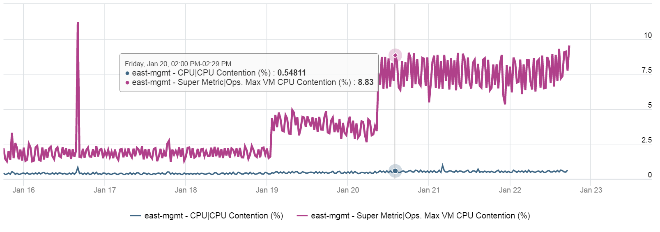

Notice the Maximum is >10x higher than the average. The average is also very stable relative to the maximum. It did not move even though the maximum became worse. Once the Cluster is unable to cope, you’d see a pattern like this. Almost all VMs can be served, but 1-2 were not served well. The maximum is high because there is always one VM that wasn’t served.

*Be careful* when you look at metrics at parent object such as cluster and datastore, as average is the default counter used in aggregation. Here is another example. This shows a cluster wise average. What do you think of the value?

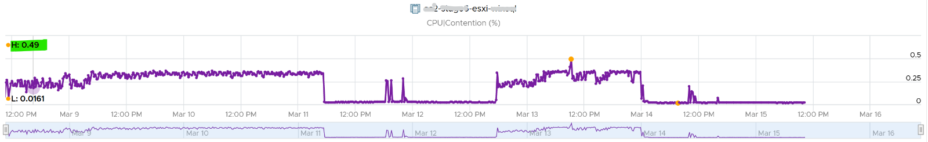

That’s right. No performance issue at all in the last 7 days. The cluster is doing well. This cluster run hundreds of VMs. What you see above is the average experience of all these VMs, aggregated at cluster level. If there is only a few VMs having a problem, but the majority are not, the above fails to show it.

Now look at the pattern. You can see there are changes in that 1 week period.

What do you expect when you take the worst of any VM? Would you get the same pattern?

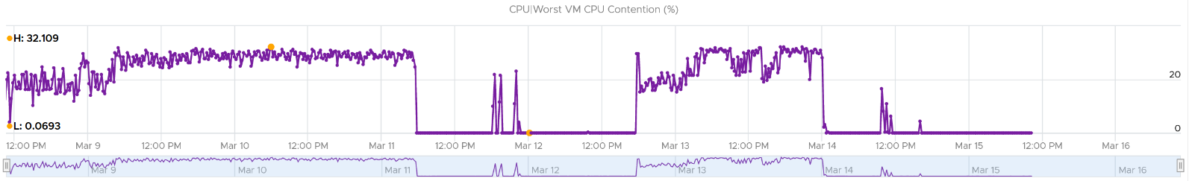

Answer is possible (not always!), if every VM is given the same treatment. They will take turn to be hit.

Notice the scale. It’s 60x worse.

The following diagram explains how such thing can happen.

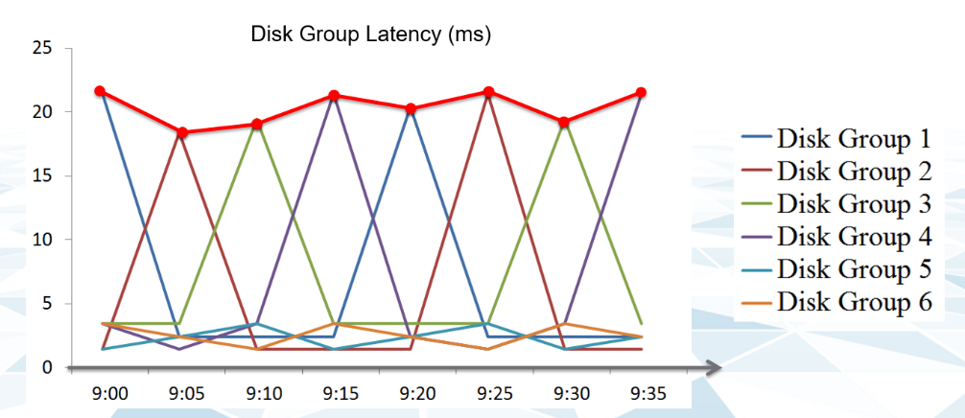

The above charts show 6 objects that have varying disk latency. The thick red line shows that the worst latency among the 6 objects varies over time.

Plotting the maximum among all the 6 objects, and taking the average, give us two different results as shown below:

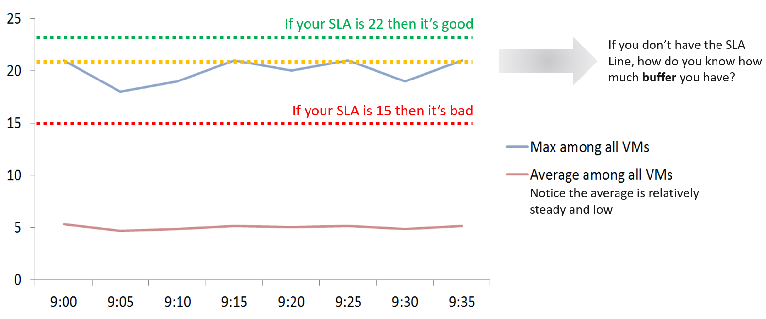

Only when the cluster is unable to serve ~50% of its VMs, will the average number become high. Therefore, the average is a poor roll up technique. It’s a lagging indicator.

Tip: instead of using average, use 95th percentile to complement the 100th percentile.

Proactive monitoring requires insights from more than one angle. When you hear that a VM is hit by a performance problem, your next questions are naturally:

* How bad is it? You want to gauge the depth of the problem. The severity also may provide a clue to the root cause.
* How long did the problem last? Is there any pattern?
* How many VMs are affected? Who else are affected? You want to gauge the breadth of the problem.

Notice you did not ask “What’s the *average* performance?”. Obviously, average is too late in this case.

The answer to the 3rd question impacts the course of troubleshooting. Is the incident isolated or widespread? If it’s isolated, then you will look at the affected object more closely. If it’s a widespread problem then you’ll look at common areas (e.g. cluster, datastore, resource pool, host) that are shared among the affected VMs.

When calculating the breadth of the problem, you need to use a stringent threshold. Without this, you will not be able to catch values that are just below the threshold. On the other hand, if you set it too low, you will get a lot of early warning.

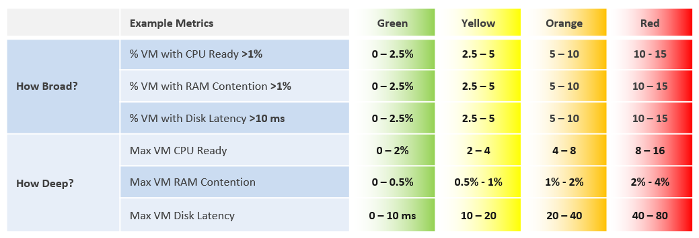

We’ve chosen the thresholds so that they work in tandem. The following shows an example where both types confirm you the problem.

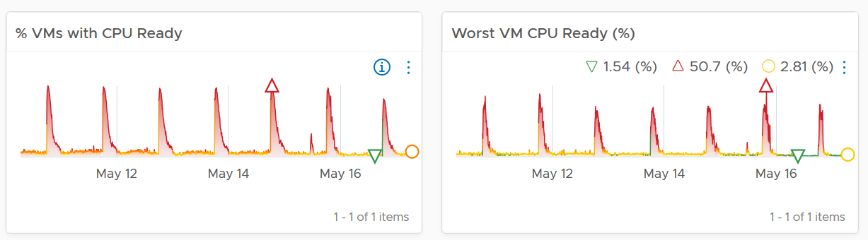

#### Usage Disparity

Imbalance among utilization can reveal a problem, as there are many examples where you expect balance utilization:

* Usage among VM vCPU. If a VM has 32 vCPU, you don’t want the first 8 are heavily used while the last 16 are not used.
* Usage among ESXi in a cluster
* Usage among RDS Hosts in a farm
* Usage among Horizon Connection Server in a pod
* Usage among disk in a vSAN disk group
* Usage among web server in a farm

There are 2 options to calculate imbalance:

* Divide over total. This is a fixed number, as the total is a constant number.
* Divide over max (highest). This is a dynamic number, as the max is fluctuating. The imbalance is relative, as it depends on the value of the Max metric.

Both use cases have their purpose. We are taking the first use for these reasons:

1. That’s the most common one. The second use case is used in low level application profiling or tuning, not general IaaS operations.
2. It’s also easier to understand.
3. It does not result in high number when imbalance is low in absolute terms. See the charts below

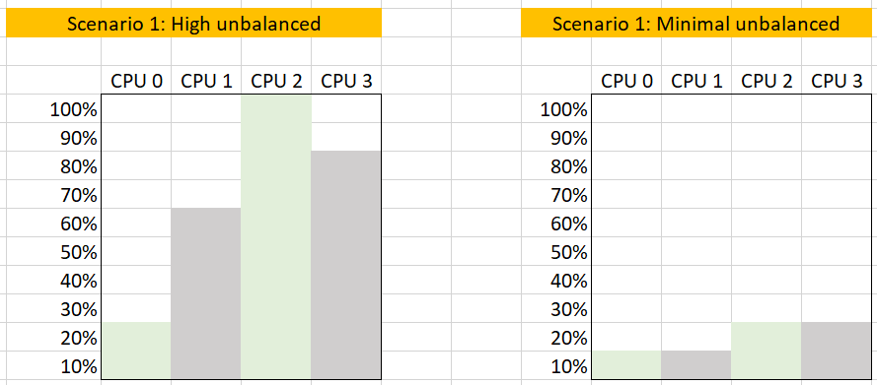

The following calculation shows that using the relatively imbalance results in a high number, which can be misleading as the actual imbalance is only 10%

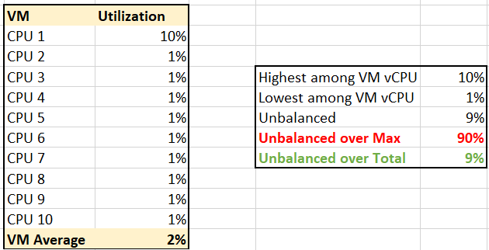

### Health | Risk | Efficiency

You certainly want your environment to be healthy. The desire to achieve that nirvana state results in a definition that is too broad as you try to cover everything. When the health metric covers too many things, you can end up with low score and yet everything is running well!

Health is actually hard to define, as it depends on the context and object. The English word health itself is subject to interpretation. How healthy are you? For example, I exercise regularly and can perform many rounds of pull ups, push up, deadlift and squats. I’m physically healthy. Biologically though, I’ve been suffering from irritable bowel syndrome. As for mental, I’m not sure about the state of my mental health 😉

Let’s try another real life context. How healthy is your country? Let’s take the world super powers (USA and China). Both are well accepted as super powers, in both economy and military. But how healthy are they?

The answer depends on which aspect and which provinces you’re talking about. It needs to have more context.

That’s why you do not have a single score for health.

If you insist on defining “health”, then my recommendation is map it to the pillars of operations. When you do that, you vrealize that there are actually 3 sides of health, not 1. Since there are 3, you need to have 3 different metrics.

|  |  |
| --- | --- |
| **Present Health** | Health is the *present* time. It covers real problem that has happened and/or is still ongoing.  There are 2 problems that can impact health:   * Availability * Performance   Availability and Performance are related, which means they are not the same thing. You can have one without the other.  Health only includes reality. It does not include possibility. That’s covered under Risk. |
| **Future Health** | Risk is the *future*. It covers potential problem. There is no problem at this moment, but if you do not act on it, you increase the risk of it becoming a problem.  Using a day-to-day life analogy, you are healthy now, but have a risk of heart problems if you do not stop smoking, lack of sleep, unhealthy diet, and overweight.  There are 3 problems that create risk in operations:   * Compliance * Configuration * Capacity   In all the above problems, Health is not impacted as there is neither slowness or downtime. What you have is a risk, as your applications and operations continue as if nothing happens. Your customers may not notice, and your business is not affected.  Let’s take an example. You do not configure HA in a vSphere cluster. If all ESXi hosts are running, your availability is 100%. Your performance is also not impacted. However, you have a risk. |
| **Optimization** | Efficiency is optimization. There is no health problem at present, nor there is a health risk for future problem.  You want to optimize your health as it lowers cost and improve performance.  Hardware refresh is one common way to increase efficiency as you often get faster performance and more capacity at the same price point.  Wastage (oversized, unused EC2, idle, unmapped disk space, orphaned file, etc.)  Cost. Compare your cost with other cloud providers as IaaS is essentially a commodity.  Green Operations fits efficiency as sustainable operations calls for lean operations. |

As you can see from above, different roles are interested in different badge.

* Day to Day Operations persona cares about Health.
* Capacity persona cares about Risk and Efficiency
* Cost persona cares about Efficiency
* Compliance persona cares about Risk

#### Present Implementation

In the present implementation of vRealize Operations, these 3 badges are defined by their respective alerts. It’s based on Health, Risk, Efficiency category.

The score is hardcoded. Green = 100, Yellow = 75, Orange = 50, Red = 25, Unknown: -1.

That means there is no value below 25, and the range is not 0 – 100%

END OF PART 2  
Okay… now that the counters make sense to you, let’s dive into how to consume them.

### Performance Metrics

Can performance of a complex system be quantified?

For example, what is the performance of vSphere? How to define the performance of a large system such as NSX, Horizon or Kubernetes? Quantifying something complex with many components is difficult. It’s like trying to figure out the inflation rate of a country. It’s impossible to have the [Consumer Price Index](https://www.investopedia.com/terms/c/consumerpriceindex.asp) that properly represents the economy as different individuals have different basket of goods. Even if we could develop the basket for each individual, that basket changes each year, rendering comparison with previous year invalid.

However, a country needs the number in order to manage its economy.

After years of trials and improvements on the model, I’m happy to share that we can define system performance as a metric. This means you can have the performance metric for any object, such as vSphere Cluster Performance (%) and Kubernetes Node Performance (%).

For ease of use, we will simply call it Performance (%) instead of KPI.

#### Calculation

Performance is defined as 0 – 100%, where 100% means best possible performance. 0% means it’s at your worst expectation, not the absolute slowest possible. For example, if you expect 40 ms as the least you can tolerate, then the value will turn to 0% when disk latency hits 40 ms.

We use 4 colors, so we can divide 100% into 4 equal parts. So Green is simply 75% - 100% and Red is simply 0% - 25%. This is more natural than dividing into 3, where you end up with odd numbers such as 33.33% and 66.67%.

The other advantage is it gives you leading indicator (shown as yellow).

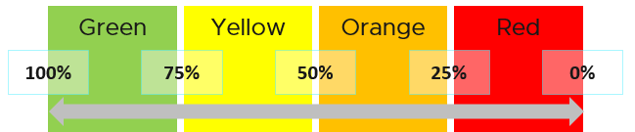

Why don’t we make green 95% - 100%? 75% for green sounds rather bad or low.

My answer is if you create an unequal distribution, some bands will have to be narrower than others. With uneven bands, you also need to be extra careful when defining the threshold for each metric that make up the KPI. I made the 4 bands equal, so the thresholds are easier to set.

Making the threshold easy to set is critical. As you design your KPI, you will vrealize that the threshold is the hardest part. In fact, there are times where I drop a metric as I do not feel comfortable with the threshold.

The following KPI uses 4 metrics as its input. Each metric has a set of thresholds for green, yellow, orange and red.

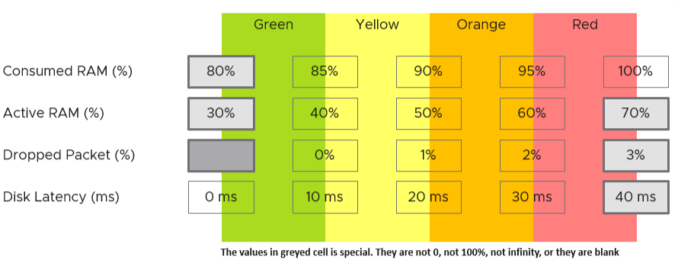

Now that we have the threshold for each metric, we can convert each metric into Green – Red. The model is also able to handle when the entire range is defined by a single number. This is useful when you want to define green = 0. That means a single packet loss will put the metric into the yellow range already.

What if anything above 0 is red?

You simply set 0 for green, yellow and orange. Within the red zone, you can set 0 – 1, or 0 to something.

##### Translation

How do we translate a row?

Let’s use an example. Take the Disk Latency (%) metric. It has range from 0 to 40 ms, which maps into the 0 – 100% using the following mapping table.

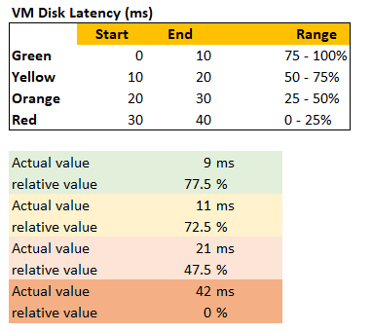

With the above mapping, we can be precise in assigning the value. For examples:

* 9 millisecond disk latency translates into KPI value of 77.5%, which is green. The reason is green ranges from 75% to 100%, where 0 ms equals to 100% and 10 ms equals to 75%. So each millisecond is around 2.5%.
* 42 millisecond disk latency translates into 0%. It is above the upper threshold of 40 millisecond. Since we do not show negative, anything above the limit is shown as 0%

##### Threshold Design

If you have many metrics that make up the KPI, and one of them is red but the remaining is all green, the overall KPI value may not reveal that there is problem. That single red does not have enough weight to bring down the rest.

So how do we solve it?

Enter progressive weightage.

We assign weightage so that yellow is 2x Green, Orange is 2x yellow and Red is 2x Orange. Mathematically, a single red has equal weightage with 8 green. The following table shows that 1 perfect red and 8 perfect green will result in the score of 50.

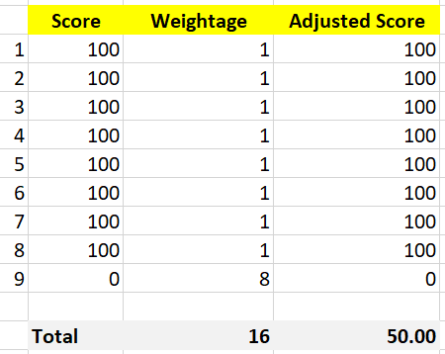

That also means that if you have 1 perfect red, and your green are not perfect, you can expect your value to be in the orange category.

This relative weightage plays a key role in determining the threshold. Try to match the actual value so they also correspond to 1x 2x 4x 8x. For example, set the VM disk latency so it goes up from 20 ms 🡪 40 ms 🡪 80 ms 🡪 160 ms. Notice they always double.

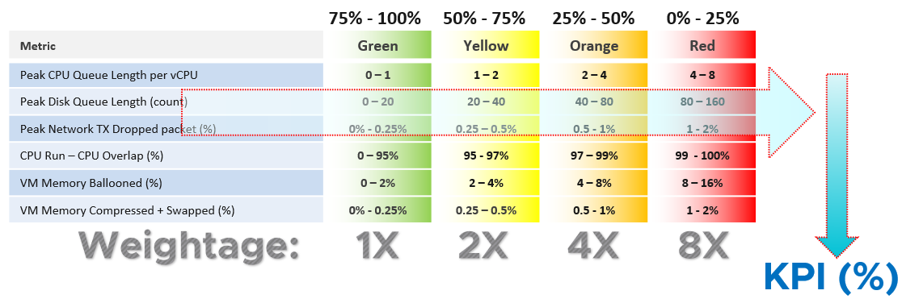

Note that this method does not replace assigning different weightage to each metric. You can still do that.

See this for the actual implementation in super metric, as it’s pretty complex.

##### Optional Features

The above model is capable of handling many cases. To handle more complex requirements, apply any of these optional techniques. They can also be used together.

###### Important Metric

What if some metrics are relatively more important than others?

Give it a higher weightage. If metric A is 2x more important than metric B, then ensure metric A weightage is 2x of metric B.

If both are equally important, but the chance of metric B hitting bad is 2x higher, then give it 2x the weightage if you want an earlier warning.

The sum of all weightages is 100%. In the following example, the CPU is given highest weightage. Notice they sum to exactly 100%

|  |  |
| --- | --- |
| Metric | Weightage |
| CPU Usage | 40% |
| Memory Usage | 20% |
| Disk Usage | 20% |
| Network Usage | 20% |

###### Multi-table KPI

What if you have a long list of metrics and they are equally important? For example, if you have 21 metrics, and one of them is red while others are green, that single red will not be able to pull the overall KPI down low. If you want the KPI to be low because the issue is severe, you need to split the large table into smaller table. Ensure the grouping is logical.

For example, a Kubernetes cluster can be affected by either infrastructure problem or application (workload) problem. If we combine all the metrics, each metric has a relatively low weightage, as their sum is 100%. We solve this by combining them into 2. We then take the lowest of the 2 sub-KPI metrics.

Creating a 2nd table is also useful for over-ride.

How do you deal with a serious problem that *rarely* happens? What weightage do you give it? Take for example, error packet in Kubernetes. Say you give it 40%, because it is a serious hit on performance. But since it rarely happens, then this 40% is basically a given. If you want to avoid taking 40% from the total weightage, you take this metric from the row, and place it on a separate table. This 2nd table overrides the first table with its value if it produces a lower value.

For example, if there is any error packet, you want to set the KPI value to red to reflect that there is a severe problem happening.

##### Validation

Once you design the KPI for a specific object, always do a validation. This helps you validates if the thresholds, weightage, metrics actually deliver the score that matches your expectation. Write down the common scenarios along with the expected value.

I got a surprise on the result, that I thought there was a bug in the formula. Remember that 1 red has the weight of 8 green? So when I see 3 reds and 9 greens, I expect the value to be in the red, which is below 25. But I got a low orange.

So let’s do some validation. I find testing the corner case useful. So let’s see what value we get when we have 9 perfect green and 3 worst red. What value do you expect?

A simple, non-weighted average will give a value of 75. This is right in the border of green or yellow.

What color does the weightage score give us?

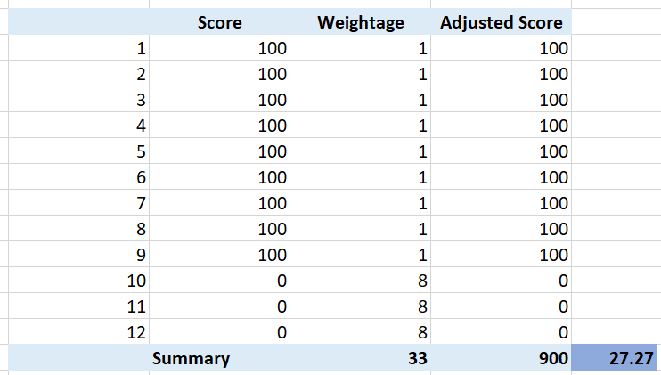

It gives us a low orange. It is not red, but close enough to be red. This is why the score is important too, not just the color.

What if your red is not the worst, but barely red? How many borderline red (near 25%) required before a perfect green (100%) is showing red?

The following table shows 1 perfect green score and 11 barely-red scores. What color do you get at the end?

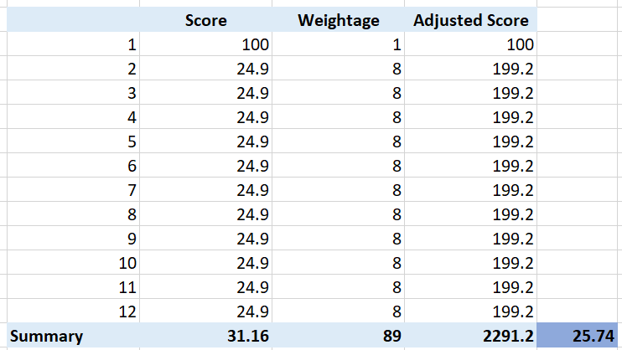

Yup, you get orange, not red. It takes many red scores, which makes it practically impossible to get a red if each red is barely there. That’s why your red threshold needs to be 2x your orange threshold. If you make it too big, you will get barely-red in most cases.

In actual environment, you certainly do not want to see red, even in development environment. Each VM will have their own score, but overall you want to see majority green. Use heatmap to show, as it will automatically order them by the value.

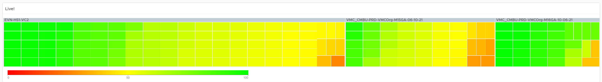

### Capacity Metrics

There are concepts and nuances in capacity that makes the metrics more complex than simple metrics such as utilization.

One main concept is Usable Capacity, which is unique to capacity. There is no usable performance, usable compliance and usable availability. In the context of capacity, you measure the utilization against it instead of against total physical capacity. Because of this, your utilization can exceed 100%, making your Capacity Remaining (%) = 0%.

#### Capacity Remaining | Time Remaining

These 2 metrics need to be reviewed together, because the ideal situation is the object (VM, cluster, etc.) is highly utilization yet you do not need to increase capacity. It’s well used and nothing wasted.

##### Capacity Remaining

Capacity Remaining (%) metric is a complex metric as it depends on the time. Let me use an analogy as it’s easier when the demand has end date:

* You operate a restaurant business. It has 100 seats.
* It’s 4 pm in the afternoon, and you have plenty of seats as it’s not a busy hour. But you’re fully booked for dinner.
* What is your Capacity Remaining (%)?
* The answer is it depends on what time.
* What is your Time Remaining (Days)?
* The answer depends on your projection.   
  If you only reject a small percentage of customers and the additional potential revenue is not worth the capital expansion, your Time Remaining is forever.   
  If you reject enough customers and foresee demand will grow, you take the risk of adding more capacity. In this case, your time remaining is 0 days.

The Capacity Remaining (%) metric is a projected value, 3 days into the future, hence it might differ with currently used capacity. The 3-days is hardcoded, not something you can change. No, it does not and should not care about the future demand, even though they are already committed.

As it is a future value, there is confidence band. You can choose between aggressive (based on the upper limit of the band) and conservative (based on the actual trajectory).

The projection algorithm is based on ARIMA, DFT, Spike and Plateau models. A year's worth daily aggregated (currently average) data is used, with more weight given to more recent data (this feature is called exponential decay). A limitation is it won’t handle workload with annual cycle.

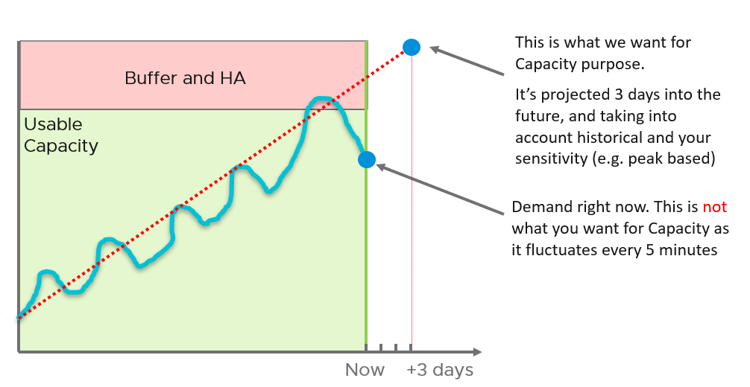

Note that the value of will be set to 0 if during the given collection cycle the demand breaches the usable capacity. This is because at that moment there is really no capacity. This can cause fluctuating value of Capacity Remaining metric if the load regularly touches the usable capacity threshold.

Take note that CPU Capacity Remaining (%) and Memory Capacity Remaining (%) appear in the policy as enabled but cannot be used. That’s an internal metric which should have been hidden.

##### Time Remaining

It measures the number of days before capacity runs out. For conservative projection, this measures the time required from now to when the upper confidence interval of Long Term Forecast intersects/crosses Usable Capacity. The projection is up to 1 year, with time remaining above 1 year is simply shown as 1 year.

Formula wise, it’s based on the utilization metric. It’s *not* a projection of the Capacity Remaining metric. But should it be? Let me know your thought!

#### Recommended Size

It is based on the *highest* projected value within the planning window, not the value of projection at the end of the window. By default, the planning window is 60 days for VM. This comes from 30 days provisioning buffer + 30 days (the default threshold for Time Remaining to be in the green zone, as shown in the screenshot).

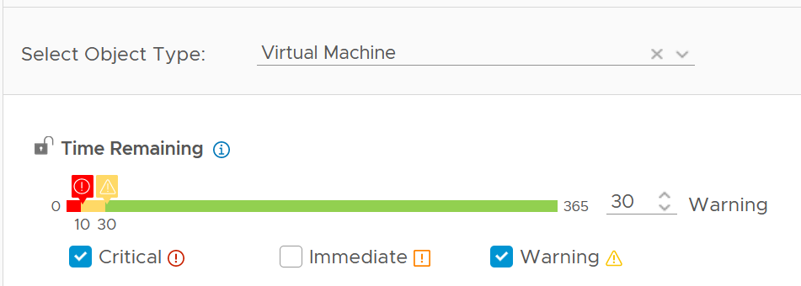

If the VM usage is increasing over time, the projection will likely follow, and you will get a number that exists 60 days into the future.

If your operations is able to make frequent adjustment, change the Time Remaining window to 0. This will give 30 days adjustment period.

Take note that the recommended size for Memory is rounded to the nearest GB.

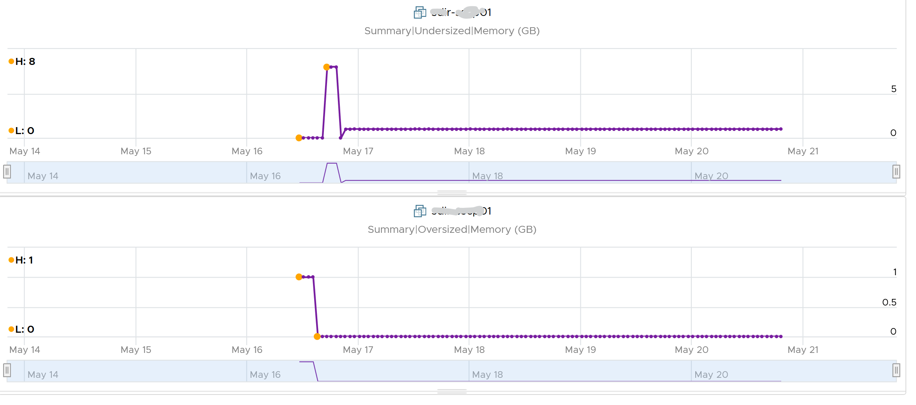

## System Architecture

**Part 2 Chapter 2**

We cover in previous chapter that system architecture contribute to metric complexity. Understanding the architecture becomes essential in mastering the metrics.

Metric is essentially an accounting of systems in operation. To understand the counter hence requires a knowledge of how the system works. Without internalizing the mechanics, you will have to rely on memorizing. In my case, memorizing is only good for exam. So do take time to truly understand it. Spend time doing actual troubleshooting to complement the theoretical knowledge.

Throughout this book, I’d cover them in the sequence of CPU 🡪 Memory 🡪 Storage 🡪 Network.

### CPU

What used to be Windows or Linux running on a server has transformed into Guest OS 🡪 VM 🡪 ESXi. There 3 distinct layers resulted in complexity documented in Part 2 Chapter 1. This is not as complex as memory, where you have 4 layers as process running inside a Guest OS represents another layer.

The following infographic shows how the nature of CPU metrics change as a result of virtualization.

[12]

Specifically for CPU, we need to be aware of dynamic metric. This means their values fluctuates depending on CPU clock speed and HT effect. As a result, the values are harder to *figure out* due to lack of observability on the fluctuation. This is not an issue if the range is negligible. It is not. For example, HT can increase the value of CPU Latency anywhere from 0% to 37.5%.

#### Guest OS vs VM

CPU metrics for a VM differ greatly from those in the Guest OS. For example, vCenter provides 5 metrics to account for the utilization of VM CPU, yet none directly maps to Windows/Linux CPU utilization.

The following diagram shows some of the differences.

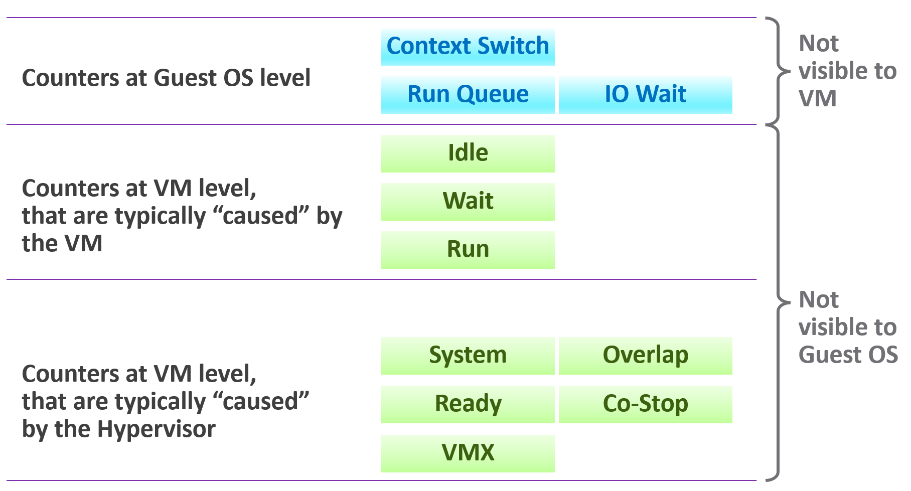

When the VMkernel de-schedules a VM to process something else (e.g. other VM, kernel interrupt) on the same physical thread or core, the Guest OS does not know why it is interrupted. In fact, it experiences frozen time for that particular vCPU running on the physical core. Time jumps when it’s scheduled again. Because of this unique visibility, it’s important to use the correct metrics at the correct layers.

On the other hand, ESXi cannot see how the Guest OS schedules its processes. ESXi can only see what’s being sent out by the Guest.

Both layers need to be monitored, as each measure different performance problems. Hence it’s imperative to install VMware Tools. It reports the statistics about Guest OS to the ESXi host every 20 seconds by default.

The following example summarizes that mapping between Guest and VM is not possible.

|  |  |  |
| --- | --- | --- |
| Type | Guest OS Metric | VM Metric |
| Contention | Run Queue | None.  All these are internal operations of Windows or Linux. |
| DPC Time |
| Context Switch |
| C1 Time  C2 Time  C3 Time | None. ESXi does not break down per VM as it focuses on the physical core. |
| None | CPU Ready, CPU Co-Stop, CPU System |
| Utilization | Usage | None. |

#### VM vs ESXi

Just like Guest OS and VM have different vantage point, the same complexity happens between VM and ESXi.

For VM, you discuss vCPU. It has virtual socket and virtual core. Physical cores and physical sockets do not apply, meaning they are referring to different things. The CPU metrics in ESXi are also more than the summation of its running VM and VMkernel.

##### State of a VM vCPU

ESXi Scheduler keeps in mind the following goals:

* To balance load across physical cores.
* To preserve cache state, minimize migration cost.
* To avoid contention from hardware (hyperthreading, low level cache, etc.) and sibling vCPUs (from the same VM).
* To keep VMs or threads that have frequent communications close to each other.

With the above understanding, now look at the life of a single vCPU of a VM.

At the most basic level, a VM CPU is either being utilized or not being utilized by the Guest OS. At any given moment, it either runs or it does not, there is no walk state.

|  |  |
| --- | --- |
| **Being used** | The hypervisor must schedule the vCPU. A multi vCPU VM has multiple schedules, 1 for each vCPU. For each vCPU:   * If VMkernel has the physical CPUs to run it, then the vCPU gets to **Run**. The Run counter is increased to track this. * If VMkernel has no physical CPUs to run it, then the vCPU is placed into **Ready** State. The VM is ready, but the hypervisor is not. The Ready counter tracks this. |
| **Not being used** | There are 2 possible reasons why it’s used:   * The CPU is truly idle. It’s not doing any work. The **Idle Wait** counter accounts for it. * The CPU is waiting for IO. CPU, being faster than RAM, waits for IO to be brought in. There are 3 sub cases here (Co-stop, VM Wait and memory wait), and they will be covered later. |

With the above understanding, we’re ready to examine the following state diagram. The diagram shows a single schedule (1 vCPU, not the whole VM). It’s showing the view from hypervisor (not from inside the Guest OS):

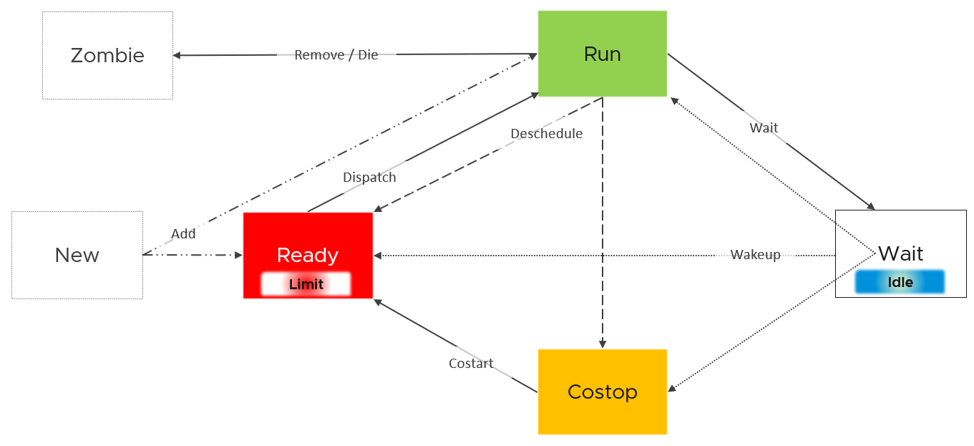

ESXi places each vCPU of the VM in one of the 4 above states. A vCPU cannot be in 2 states *at the same time*. This is fundamental in understanding the formula behind CPU metrics.

* Run does not check how fast it runs (frequency) or how efficient it runs (hyperthreading). Run measures how long it runs, hence the counter is in milliseconds, not GHz.
* Ready and Co-stop. They are mutually exclusive states. If a vCPU is in Co-stop, it is not in Ready state.
* Wait handles both Idle and Wait. The reason is the hypervisor cannot tell whether the Guest OS is waiting for IO or idle. As far as the hypervisor concern, it’s not doing anything. This also measures the state where the wait is due to hypervisor IO.

Those of you familiar with Operating Systems[13] [kernel](https://en.wikipedia.org/wiki/Kernel_(operating_system)) will notice that the diagram is similar with a physical OS scheduler state diagram. I’m taking [Huawei Harmony OS](https://device.harmonyos.com/en/docs/develop/kernel/oem_kernal_user_process-0000001050032733) as an example as it’s the newest OS and it’s designed for a range of device[14].

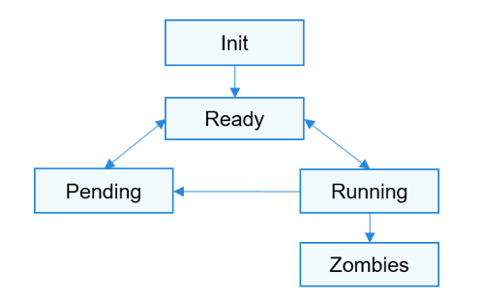

|  |  |
| --- | --- |
| Init | The process is being created.  Maps to New in VMkernel |
| Ready | The process is in the ready list and waits for being scheduled by the CPU.  Maps to Ready in VMkernel |
| Running | Maps to Run in VMkernel |
| Pending | The process is blocked and suspended. When all threads in a process are blocked, the process is blocked and suspended.  Maps to Wait in VMkernel. Notice they also include Idle here in their Wait state. |
| Zombies | Maps to Zombies in VMkernel |
| “none” | Our Co-stop is unique as VM is a multi-process scheduled entity |

Back to our VMkernel 4 possible states, you can conclude that:

Run + Ready + Co-stop + Wait = 100%

VM 2 can run when VM 1 is on Co-stop state, Ready state, or Wait state. This is because the physical thread is available.

##### State across Time

The above is at any given moment. To measure over time and report it (say every 20 seconds), we need to add a time dimension. The following example shows the above state diagram repeated over time, where each block is 1 second. In reality, the scheduler checks more frequently that this.



vCenter happens to use 20000 milliseconds as the reporting cycle, hence 20000 milliseconds = 100%.

The above visually shows why Ready (%) + Co-stop (%) needs to be seen in context of Run. Ready at 5% is low when Run is at 95%. Ready at 2% is very high when Run is only 10%, because 20% of the time when the VM wanted to run it couldn’t.

The above is *per vCPU*. A VM with 24 vCPU will have 480,000 as the total. It matters not if the VM is configured with 1 vCPU 24 vCores or 24 vCPU with 1 vCore each.

You can prove the above by stacking up the 4 metrics over time. In this VM, the total is exactly 80000 ms as it has 4 vCPU. If you wonder why CPU Ready is so high, it’s a test VM where we artificially placed a limit.

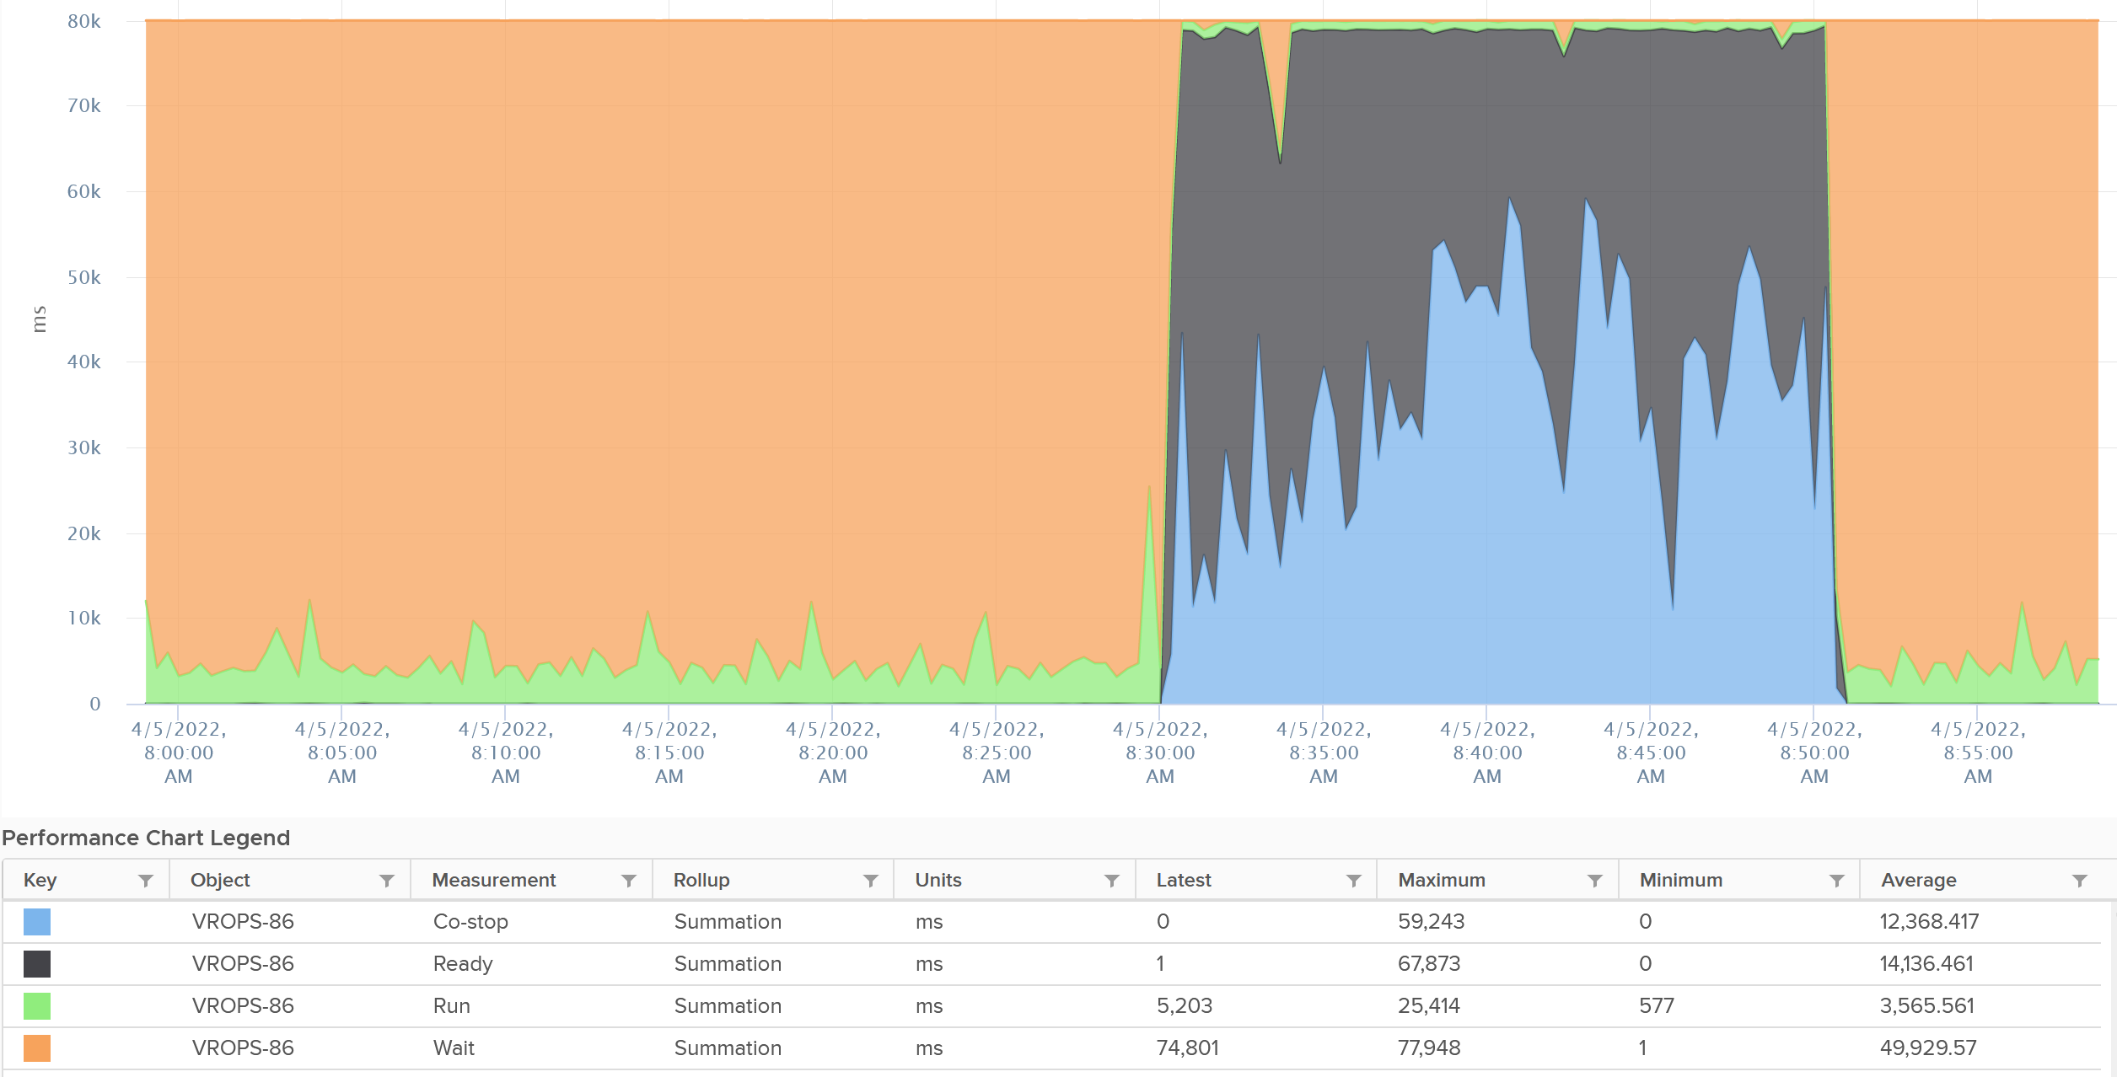

The formula for the millisecond metrics in vRealize Operations are also not normalized by the number of vCPU. The following shows the total adds up to 80000 as the VM has 4 vCPU.



This is why you should avoid using the millisecond counter. Use the % version instead. They have been normalized.

#### Simultaneous Multithreading

We’ve covered a lot of metrics. Before we cover the rest, we need to cover CPU [SMT](https://en.wikipedia.org/wiki/Simultaneous_multithreading) (Hyper Threading as Intel calls it), as it impacts their value.

SMT is known to deliver higher *overall throughput*. It increases the overall throughput of the core, but at the expense of individual thread performance. The increase varies depending on the load.

Accounting wise, ESXi records this overall boost at 1.25x regardless of the actual increase, which maybe less or more than 1.25x. That means if both threads are running at the same time, the core records 1.25x overall throughput but each thread only gets 62.5% of the shared physical core. This is a significant drop from the perspective of each VM. From the perspective of each VM, it is better that the second thread is not being used, because the VM could then get 100% performance instead of 62.5%. Because the drop could be significant, enabling the latency sensitivity setting will result in a full core reservation. The CPU scheduler will not run any task on the second HT.

The following diagram shows 2 VMs sharing a single physical core. Each run on a thread of the shared core. There are 4 possible combinations of Run and Idle that can happen:



Each VM runs for half the time. The CPU Run counter = 50%, because it’s not aware of HT. But is that really what each VM gets, since they have to fight for the same core?

The answer is obviously no. Hence the need for another counter that accounts for this. The diagram below shows what VM A actually gets. The allocation is fixed.



The CPU Used counter takes this into account. In the first part, VM A only gets 62.5% as VM B is also running. In the second part, VM A gets the full 100%. The total for the entire duration is **40.625**%. CPU Used will report this number, while CPU Run will report **50%**.

If both threads are running all the time, guest what CPU Used and CPU Run will report?

62.5% and 100% respectively.

##### Quiz Time: VM vs ESXi

Review the following chart[15]. It shows a cluster with 2 metrics. The first counter sums all the ESXi CPU Usage, while the second counter sums all the VM CPU Usage.

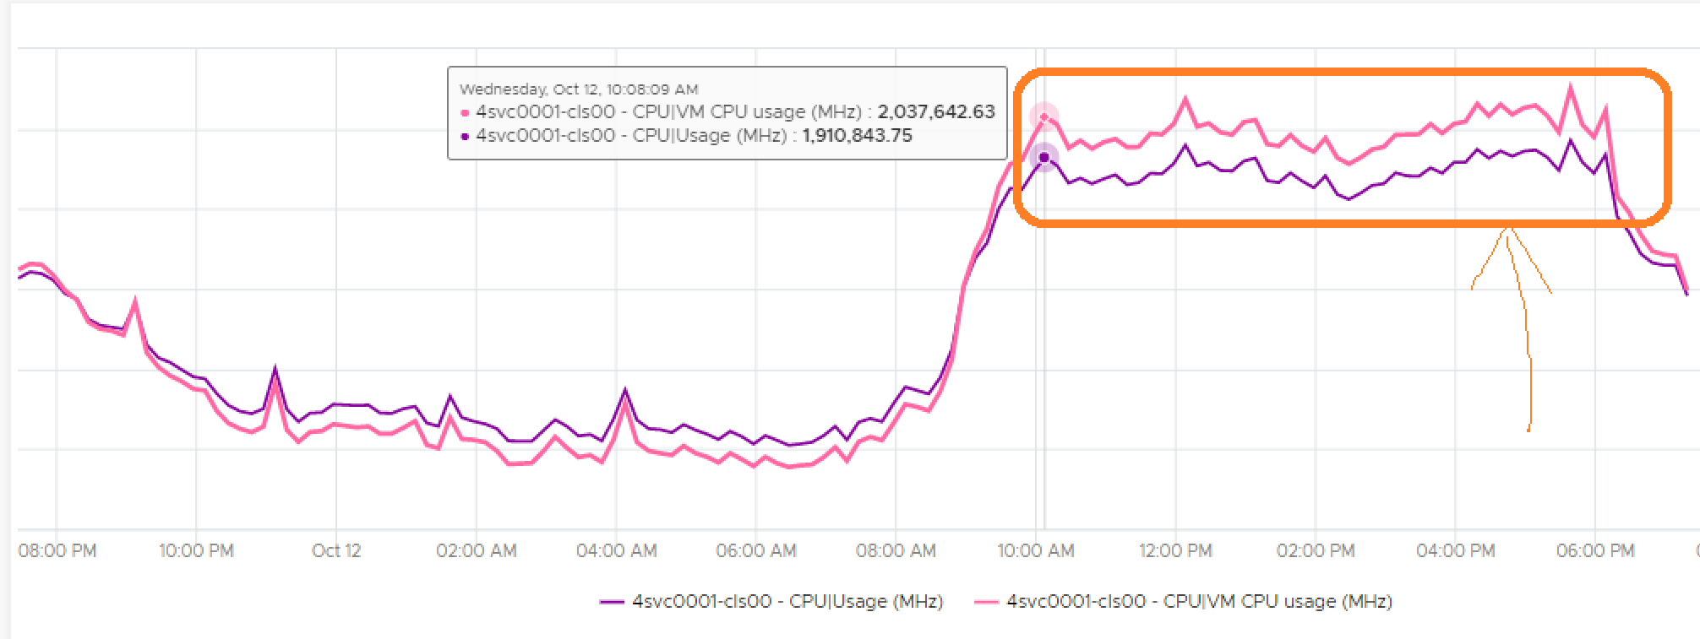

Did you spot something that does not make sense?

They intertwine. How is that possible?

Clue: Notice the sum of VM is lower during lower utilization, but higher during high utilization.

During low utilization, the sum of VM is lower as it does not include VMkernel.

During high utilization, the sum of VM is higher due to hyper-threading. Each vCPU sees the full GHz, because the VM does run at that speed, albeit with less efficiency. At the physical core level, there is only 1 core running both thread, so ESXi uses 1.25x multiplier while VM uses 2x multiplier.

#### Power Management

The 2nd factor that impacts CPU accounting is CPU clock speed. The higher the frequency (GHz), the faster the CPU run. Ceteris paribus, a CPU that run at 1 GHz is 50% slower than when it runs at 2 GHz. On the other hand, Turbo Mode can kick in and the CPU clock speed becomes higher than stated frequency. Turbo Boost normally happens together with power saving on the same CPU socket. Some cores are put to sleep mode, and the power saving is used to turbo mode other cores. The overall power envelope within the socket remains the same.

Each core can have its own frequency. This makes rolling up the number to ESXi level more complex. You can’t derive one throughput counter from the other. Each has to be calculated independently at core level.

##### CPU Architecture

As CPU architecture moves towards [System on a Chip](https://en.wikipedia.org/wiki/System_on_a_chip) design, it’s important not to assume that a CPU socket is a simple and linear collection of cores. Take a 64-core [AMD EPYC](https://www.amd.com/system/files/documents/overview-amd-epyc7003-series-processors-microarchitecture.pdf) for example. It’s actually made of 8 Core Complex Dies. From the following diagram (taken from page 5 on the AMD link above), you can see that a thread on CCD 0 is relatively close to a thread that runs on the same CCX, but far to a thread that runs on another CCD. You can see an example of the performance impact [here](https://blogs.vmware.com/performance/2020/04/amd-epyc-rome-application-performance-on-vsphere-series-part-1-sql-server-2019.html).



Another consideration you need to be aware of is [NUMA](https://en.wikipedia.org/wiki/Non-uniform_memory_access). NUMA Node = Socket / Package, as 1 socket can have >1 package (if you enable Cluster-on-Die feature of Intel Xeon).

##### CPU States

There are 2 types of power states as defined by [ACPI](https://en.wikipedia.org/wiki/Advanced_Configuration_and_Power_Interface) standard.

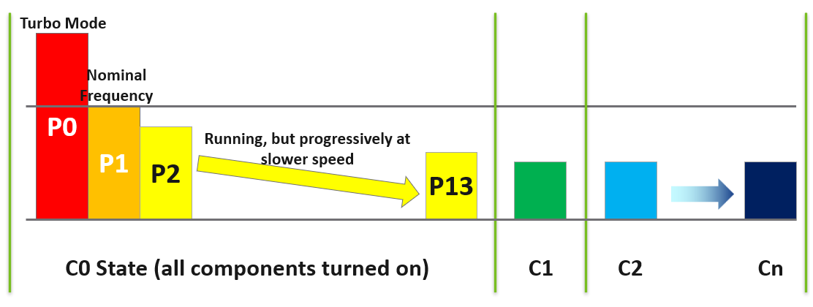

|  |  |
| --- | --- |
| **C-State** | When a core is idle, ESXi applies deep halt states, also known as C-states. The deeper the C-state, the less power the CPU uses, but the longer it takes for the CPU to start running again. ESXi predicts the idle state duration and chooses an appropriate C-state to enter.  There are 3 possible sub-states in C-state:  C0 = fully running. Within this C0 state, there is a further dimension called P-State.  C1 = a shallow state where the clock is gated (switched off). However, all the modules remain active, and the processor can go back to the active C0 state instantaneously. powered on. In power management policies that do not use deep C-states, ESXi stops at C1.  C2 - Cn= varying degrees of CPU sections turned off. The higher the C state, the deeper the sleep. |
| **P-State** | There are 14 grades of CPU performance, measured by its frequency. You can see all the frequencies in esxtop if your hardware supports it.  P0 state where Turbo Boost happens.  P1 is where it runs at Nominal Frequency (NF).  P13 is the lowest CPU frequency. |

For details on P-State and C-State, see Valentin Bondzio and [Mark Achtemichuk](https://twitter.com/vmMarkA), [VMworld 2017, Extreme Performance Series](https://www.youtube.com/watch?v=EYggYAwjz3g).

##### Impact on Performance

How high can Turbo/Boost go?

It turns out that it is high enough that your performance and capacity need to account for it.

The following diagram is taken from page 12 of “Host Power Management in VMware vSphere 7.0**”** whitepaper by [Ranjan Hebbar](https://www.linkedin.com/in/ranjan-h-199b9ab2/) and [Praveen Yedlapalli](https://www.linkedin.com/in/praveen-yedlapalli-a9821324/). It shows that Intel Xeon Platinum 8260 can increase its speed by 1.29x (from 2.4 GHz to 3.1 GHz). If it only needs to increase 1 core, that single core can go up by 1.62x. This will be noticeable by application that is CPU intensive. Consider this benefit before you decide to disable power management. The high performance is static, it runs at the same frequency throughout.

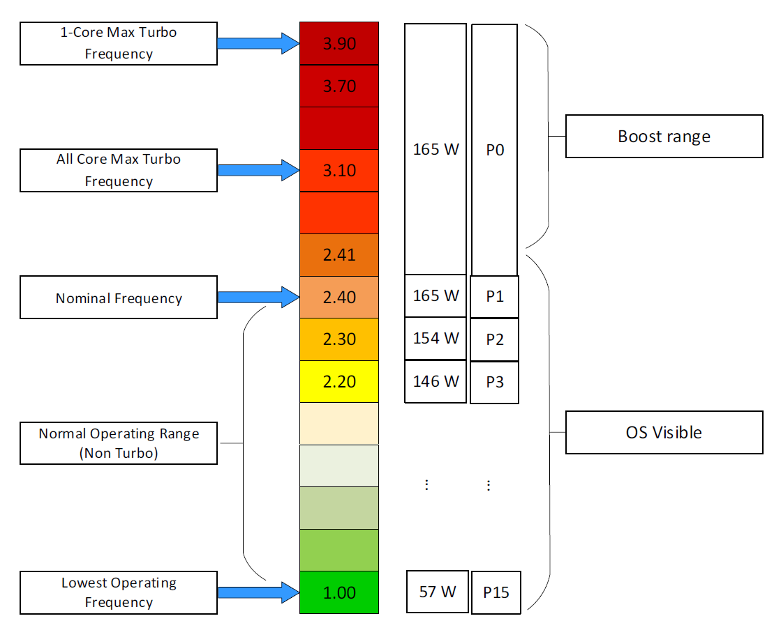

##### Viewing the Impact

Let’s say a physical chip comes with 2 GHz as its standard speed. If ESXi increases the clock speed to 3 GHz, Used counter will be 50% higher than the Run counter. The Guest OS (e.g. Windows or Linux) is not aware of this performance boost. It reports a value based on the standard clock speed, just like Run does. On the other hand, if ESXi decreases the clock speed to 1.5 GHz, then Used will report a value that is 25% lower than what Run reports.

Let’s take an example. What do you notice?



As you can see from the preceding chart, the impact is noticeable. The System and Overlap metrics hovers averages <10 ms (negligible as this VM is basically idle), but the gap between Used and Run averages around 20% Used is ~20% higher than Run, likely due to Turbo Boost.

Let’s take another example, this time from a busy VM. I’ve removed System and Overlap as they are also negligible in this example. This is a 32 vCPU VM running Splunk. Notice Used is consistently higher than Run.



Now let’s look at the opposite scenario. This VM is a 64 bit Ubuntu running 4 vCPU. Used (ms) is around 44% of Run (ms). The VM had minimal System Time (ms) and Overlap (ms), so Used is basically lowered by both power savings and CPU SMT. In this example, if Run is far from 100% and the application team want faster performance, your answer is not to add vCPU. You should check the power management and CPU SMT, assuming the contention metrics are low.



Does it mean we should always set power management to maximum?

No. ESXi uses power management to save power without impacting performance. A VM running on lower clock speed does not mean it gets less done. You only set it to high performance on latency sensitive applications, where sub-seconds performance matters. VDI, VoIP, video calling, Telco NFV are some examples that are best experienced with low latency.

### Memory

Let's now take a trip down memory lane, pun intended.

Memory differs from CPU as it is a form of storage.

* CPU is highly transient in nature. Instructions enter and leave the execution pipelines in less than a nanosecond.
* Memory is a lot more stable. We are comparing nanoseconds to seconds (or longer, up to months, depending upon the uptime of your VM).

As a storage, memory is basically a collection of blocks in physical DIMM. Information is stored in memory in standard block sizes, typically 4 KB or 2 MB. Each block is called a page. At the lowest level, the memory pages are just a series of zeroes and ones. MS Windows initializes its pages with 0, hence there is a zero-page counter in ESXi.

Keeping this concept in mind is *critical* as you review the memory metrics. The storage nature of memory is the reason why memory monitoring is more challenging than CPU monitoring. Unlike CPU, memory has 2 dimensions:

|  |  |  |
| --- | --- | --- |
| **Speed** | nanoseconds | The only counter ESXi has is Memory Latency. This counter increases when the time to read from the RAM is longer than usual. The counter tracks the percentage of memory space that’s taking longer than expected. It’s not tracking the *actual* latency in nanosecond.  This is the opposite of Disk, where we track the actual latency, but not the percentage of amount of space that is facing latency.  Both are storage, but “server people” and “storage people” measure them differently 😊 |
| **Space** | Bytes | This is the bulk of the metrics |

#### Virtual Memory

Before we talk about memory counter, we need to cover virtual memory, as it’s an integral part of memory management. The following shows how Windows or Linux masks the underlying physical memory from processes running on the OS.



From the process’ point of view, this technique provides a contiguous address space, which makes memory management easier. It also provides isolation, meaning process A can’t see the memory of process B. This isolation provides *some* level of security. The isolation is not as good as isolation by container, which in turn is inferior to isolation by VM.

Virtual Memory abstraction provides the possibility to overcommit. The machine may have 16 GB of physical RAM, but by using pagefile the total memory available to its processes can exceed 16 GB. The process is unaware what is backing its virtual address. It does not know whether a page is backed by Physical Memory or Swap File. All it experiences is slowness, but it won’t know why as there is no counter at process level that can differentiate the memory source.

On the other hand, some applications manage its own memory and do not expose to the operating system. Example of such applications as are database and Java VM. [Oleg Ulyanov](https://www.linkedin.com/in/oulyanov-vmware/) shared in this [blog](https://blogs.vmware.com/apps/2020/11/monitoring-and-rightsizing-memory-resource-for-virtualized-sql-server-workloads.html) SQL Server has its own operating system called SQLOS. It handles memory and buffer management without communicating back to underlying operating system.

With virtualization, VM object adds yet another layer.

If you add ESXi, we actually have 4 layers from Process à Guest OS à VM à ESXi.

The only layer that manages the actual physical memory is the last layer. IMHO, the term “Guest physical memory” is illogical.

Each of these layers have their own address space. And that’s where the fun of performance troubleshooting begins 😉



From the VMs point of view, it provides a contiguous address space and isolation (which is security). The underlying physical pages at ESXi layer may not be contiguous, as it’s managed differently. The VM Monitor for each VM maps the VM pages to the ESXi pages[16]. This page mapping is not always 1:1. Multiple VM pages may point to the same ESXi pages due to transparent page sharing. On the other hand, VM page may not map to ESXi page due to balloon and swapped. The net effect is the VM pages and ESXi pages (for that VM) will not be the same, hence we need two sets of metrics.

|  |  |
| --- | --- |
| **VM memory** | Metrics tracks the VM Pages. There are 2 sets, one for each VM, and one a summation at ESXi level for all running VMs. Do not confuse the summation with ESXi memory metrics.  Examples: Granted or Memory Shared |
| **ESXi memory** | Metrics tracks the ESXi Pages. There are also 2 sets, but the summation at ESXi level contains VMkernel own memory and VM overhead  Examples: Consumed or Memory Shared Common |

This abstraction provides the possibility to overcommit, because the VM is unaware what is backing the physical address. It could be Physical Memory, Swap File, Copy On Write, zipped, or ballooned.



Take note the position of Granted and Consumed. While both are metrics for VM, their context is different. One looks at it from the VM viewpoint, the other from ESXi.

Understanding the vantage point is required to make sense of the metrics. It will prevent you from comparing metrics that are not comparable (e.g. granted vs consumed) as they have different context.

Further reading: [vSphere Resource Management](https://www.vmware.com/techpapers/2006/resource-management-with-vmware-drs-401.html) technical paper.

If you need more convincing, here is from **VMware vSphere 6.5 Host Resources Deep Dive** by [Frank Denneman](https://frankdenneman.nl/) and [Niels Hagoort](https://www.linkedin.com/in/nielshagoort/). You will find it at Chapter 11 VMkernel Memory Management, page 243. I have highlighted in green the part you need to pay attention 😊

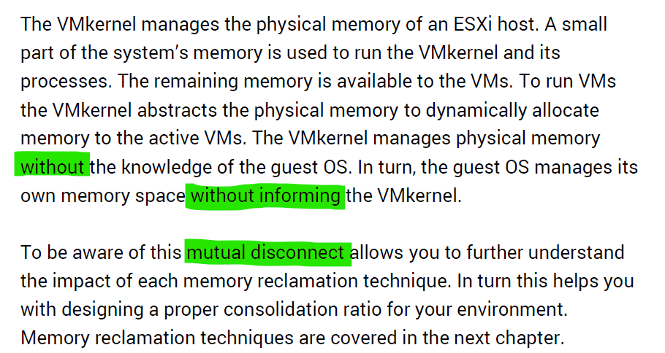

Read further and you will see that VMkernel large page setting contributes more to ESXi capacity and the VM performance.

#### Guest OS vs VM

Both come with dozens of metrics. Compared with Guest OS such as Windows, can you notice what’s missing and what’s added?

The following diagram compares the memory metrics between VM and Guest OS,



Guest OS and VM metrics do not map to each other. Neither the VMkernel nor the Guest OS have full visibility into each other.

Right off the bat, you will notice that popular metrics such as Consumed, Shared, and Reservation do not even exist in Windows.

|  |  |  |
| --- | --- | --- |
| Type | Guest OS Metric | VM Metrics |
| Contention | Paging | None |
| None | Latency |
| Utilization | In Use | None |
| Cache | None |
| Free | None |
| Compressed | None |
| None | Swapped or Compressed |

ESXi Host cannot see how the Guest OS manages its memory pages, how it classifies the pages as Use, Modified, Cache and Free. ESXi also cannot see the virtual memory (page file).

ESXi can only see when the Guest OS performs reads or writes. That’s why vSphere VM main metrics are basically what is active recently and what has been active. The first one is called Active, the second is called Consumed. All other metrics are about ESXi memory management, and not about VM memory utilization. VM memory utilization impacts ESXi memory management, but they are clearly not the same thing.

##### Example: Guest OS More Accurate

Let’s take an example with a simple Microsoft Windows server running Active Directory. It has 4 GB of memory as it’s just serving a small number of objects in the Singapore office lab. Take a look at the following table, where I compared the counter from inside the Guest OS and the VM memory active counter.



There are four periods above where I made changes inside Windows. Let’s step through them.

|  |  |
| --- | --- |
| **Period** | **What happened** |
| A | Microsoft AD server in normal running condition. vCenter is reporting low utilization, around 15-20%. Note vCenter users the Active metric, not Consumed. |
| B | I installed the vRealize Operations agent, which is based on the open source [Telegraf](https://www.influxdata.com/time-series-platform/telegraf/). This gives the Guest OS metric, which is shown by the blue color. The agent collects data every 5 minutes, hence the regular spike. So far so good.  Notice the value from VM Active metric jumps to 100%. That’s fine, but then it stays at 100% for more than 12 hours. All I did was installing a small collection agent and that’s it.  I actually got an alarm in vCenter, even though the VM does not need the RAM obviously. What happened here prove that the Active counter is based on sampling, and that sampling could be wrong. More on that here. |
| C | The next morning, I decided to generate some load as the pattern does not change at all. Since Windows has not been patched for a long time, I started Windows patch. The entire process is mostly downloading and installing, which last for several hours.  The two metrics show no correlation at all. |
| D | After several hours, the entire Windows update process is completed. |

##### Example: VM More Accurate

Let’s now look inside the VM. I will use another VM to show a different example. This time around, I will take an idle VM so we can see how the metrics behave. An idle VM will have minimal or 0 activity.

You can see that this Windows Server 2016 VM has 16 GB, but 0 GB is active. It is expected as we know the Guest OS is idle as nothing is installed. vCenter is showing the data correctly. So far so good….



What do you think you will see inside Windows?

Will the Windows In Use counter show that it’s using 0 GB or somewhere near there? You know that it won’t show 0 GB as it’s impossible that any OS does not use any memory while it’s running. So what number will the In Use counter show?



It’s showing 7.2 GB! That’s no where near 0%.

Look at the chart. What do you notice?

It portrays that it has been constantly or actively using that much of memory. In reality, we know it’s idle because ESXi is the one doing the actual reading and writing. The other proof that it is idle is Windows actually compressed 1.5 GB of this 7.2 GB.

One possible reason why Windows is showing high usage when there is none is applications that manage their own memory. These applications will ask for the memory upfront in 1 contiguous block. You can see in the example below:

|  |  |
| --- | --- |
| http://virtual10.com/wp-content/uploads/2016/01/Performance4.png | You can see that java.exe takes up 26 GB.  JVM (Java Virtual Machine) manages that memory and Windows can’t see inside this block. Windows sees the entire block as used and committed, regardless whether the application actually uses it or not. |

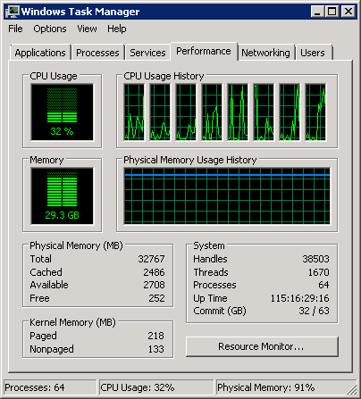

BTW, the above is taken from old blog article of Manny Sidhu. The blog no longer available, hence I could not provide the link.

I hope the above simple experiments shows that you should use the right counter for the right purpose.

### Storage

Virtualization increases the complexity in both storage capacity and performance. Just like memory, where we have more than one level, we have multiple layers of storage and each layer only has control over its own. In addition, each layer may not use the same terminology.

Storage in VMware IaaS is presented as datastore. In some situation, RDM and network file shares are also used by certain VM.

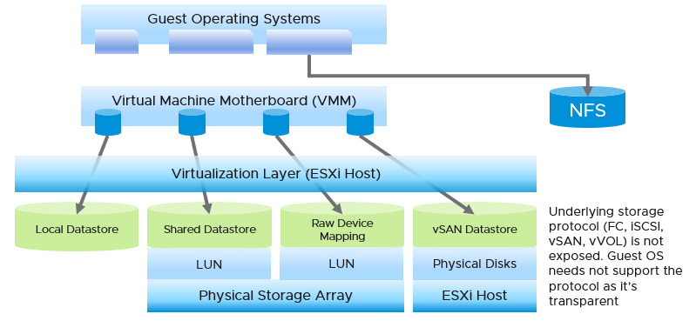

|  |  |
| --- | --- |
| ****Layer**** | Description |
| **Guest OS** | The most upper layer is the Guest OS. It sees virtual disks presented by the VM motherboard. Guest OS typically has multiple partition or drive. Each partition has its own filesystem, serving different purpose such OS drive, paging file drive, and data drive. A large database VM will have even more partitions. Partition may *not* map 1:1 to the virtual disk. There is no visibility to this mapping. This makes calculating unmapped blocks accurately an impossible task in the case of RDM disk.  To make it more complex, there is also networked drive. Windows or Linux mounts them over protocol such as SMB. These filesystems are not visible to the hypervisor, hence they are not virtual disk. The disk IO is not visible to the VM as it goes out via vNIC. |
| **VM** | The main file is virtual disks. This can be RDM, VMDK, vSAN and vVOL. Both are presented as Local SCSI disk so the Guest OS does not know of the underlying protocol. For example, you can actually have MS-DOS using drive on Fibre Channel network!  They are identified as scsiM:N, starting with scsi0:0, where M is the adapter number.  The discrepancy between VM layer and Guest OS utilization happens because each layer works differently.   * If there is RDM or thick VMDK, VM can’t see the actual used inside Guest OS. It simply sees 100% used, regardless of what Windows or Linux uses. * If there is unmapped block, Guest OS can’t see this overhead.   We are interested in data both at the VM aggregate level, and at the individual virtual disk level. If you are running a VM with a large data drive (for example, Oracle database), the performance of the data drive is what the VM owner cares about the most. At the VM level, you get the average of all drives; hence, the performance issue could be obscured. |
| **ESXi** | In this layer we have the ESXi storage subsystem and the storage adapter. We do not deep dive into ESXi in our discussion of storage metrics as in general it is not a cause of storage bottleneck. Yes, the VMkernel prioritizes and queues the I/Os, but all these operations should be less than 1 millisecond. If the I/O is held at the kernel, there is a good chance that the physical device latency is more than 10 milliseconds.  In a typical shared storage, multiple VMs run on the same ESXi, and multiple VMs share a datastore. So it is common to have an I/O blender effect, where sequential writes on individual vmdk files become random writes at the datastore level. It also changes the read/write ratio. This can occur in either VMFS or NFS. This certainly increase complexity in troubleshooting. Complexity also increases when the IO needs to go over the network, especially across different physical data centers asynchronously. |
| **Datastore** | What you can see at this level, and hence how you monitor, depends on the storage architecture.  The underlying storage protocol can be files (NFS) or blocks ([VMFS](https://en.wikipedia.org/wiki/VMware_VMFS)). vSAN uses VMFS as its *consumption* layer as the underlying layer is unique to vSAN, and hence vSAN requires its own monitoring technique. Because vSAN presents itself as a VMFS datastore you need to know that certain metrics will behave differently when datastore type is vSAN.  For NFS datastore, as it is network file share (as opposed to block), you have no visibility to the underlying storage. The type of metrics will also be more limited, and network metric becomes more critical.  Datastore is not the sum of its VMs that VMs may span multiple datastores, or use RDM. There can also be orphaned files outside the VM folder, which are not associated with VM. |
| **Storage Subsystem** | This can be virtual (e.g. vSAN) or physical (e.g. physical array).  The datastore is normally backed one to one by a LUN, so what we see at the datastore level matches with what we see at the LUN level. Multiple LUNs reside on a single array. |

|  |  |  |
| --- | --- | --- |
| Type | Guest OS Metrics | VM Metrics |
| Contention | OS Queue | None |
| Driver Queue | None |
| Latency | Latency.  They should be similar, especially when plotted over time. |
| Utilization | IOPS | They should match with the metrics at VM level, especially when plotted over time. If not, there is something wrong. |
| Throughput |

#### Multi-Layer Management

The layers present challenge in management, as they create limitation in end to end visibility and raise different questions. They also do not have consistent terminology. For example, the term disk, LUN and device may mean the same thing. A device is typically physical (something you can hold, like an SSD card). LUN is typically virtual, a striping across physical devices in a volume.

Storage metrics can be largely grouped into 2:

|  |  |
| --- | --- |
| **Speed** | Performance is measured in 2 ways (contention and utilization).  Utilization is further divided into IOPS and Throughput. Throughput = IOPS x Block Size.  Contention can happen at all 3 stages of IO processing:   * pre-processing: each layer has their own queue or outstanding IO. * processing: aborted SCSI commands, dropped frame, etc. * post-processing: latency. |
| **Space** | Capacity has no concept of slowness in modern, SSD based storage as access to data is no longer relying on spinning platter. 1% disk space full is not slower/faster than 99% full as defragmentation is no longer causing latency. However, it impacts availability. At 100% full, the storage will stop processing IO and your application will crash as a result.  Capacity, as in disk space, is measured in bytes.  Storage differs to compute as reality overwrites projection. In compute, you use a projected capacity remaining number, which takes into account the past. In storage, if you have 0 bytes left, the number overwrites whatever number shown by capacity engine.  You should also focus on reclamation as the amount tends to be substantial. |

##### Performance

Latency can happen when IOPS and throughput are not high, because there are multiple stacks involved and each stack has their own queue. It begins with a process, such as a database, issuing IO request. This gets processed by Windows or Linux storage subsystem, and then send to the VM storage driver.

Ensure that you do not have packet loss for your IP Storage, dropped FC frames for FC protocol, or SCSI commands aborted for your block storage. They are a sign of contention as the datastore (VMFS or NFS) is shared. The metrics Bus Resets and Commands Aborted should be 0 all the time. As a result, it should be fine to track them at higher level objects. Create a super metric that tracks the maximum or summation of both, and you should expect a flat line.

Once you have ensured that you do not have packet loss on IP Storage or aborted commands on block storage, use the latency counter and outstanding IO for monitoring. For troubleshooting, you will need to check both read latency and write latency, as they tend to have different patterns and value. It’s common to only have read or write issue, and not both.

Total Latency is not (Read Latency + Write Latency) / 2. It is not a simple summation. In a given second, a VM issues many IOPS. For example, the VM issues 100 reads and 10 writes in a second. Each of these 110 commands will have their own latency. The “total” latency is the average of these 110 commands. In this example, the total latency will be more influenced by the read latency, as the workload is read dominated.

If you are using IP storage, take note that Read and Write do not map 1:1 to Transmit (Tx) and Receive (Rx) in Networking metrics. Read and Write are both mapped to Transmit counter as the ESXi host is issuing commands, hence transmitting the packets.

#### VM Layer

A VM does not see the underlying shared storage. It sees local SCSI disks only. So regardless of whether the underlying storage is NFS, VMFS, VSAN or RDM, it sees all of them as virtual disks. You lose visibility in the physical adapter (for example, you cannot tell how many IOPSs on vmhba2 are coming from a particular VM) and physical paths (for example, how many disk commands travelling on that path are coming from a particular VM).



VM can consume storage via:

* Virtual disk.   
  Each virtual disk has label, type (RDM or VMDK), provisioning type (thin, lazy zero, eager zero). If it’s RDM, need to know additional properties such as RDM type (physical or virtual).
* Compute virtualization. Snapshots, Swapped, Logs. Guest OS can’t see them.This can be overhead and non-overhead. This is not visible to the Guest OS. They are shown in blue in the following diagram.
* Storage virtualization. This includes vSAN protection, deduplication and decompression. We need this number to reported separately as it’s not applicable in non vSAN.



There are more file types than shown above. However, from monitoring and troubleshooting viewpoint, the above is sufficient.

##### Files

At the end of the day, all those disk space appear as files in the VMFS filesystem. You can see them when you browse the datastore. The following is a typical example of what vSphere Client will show.

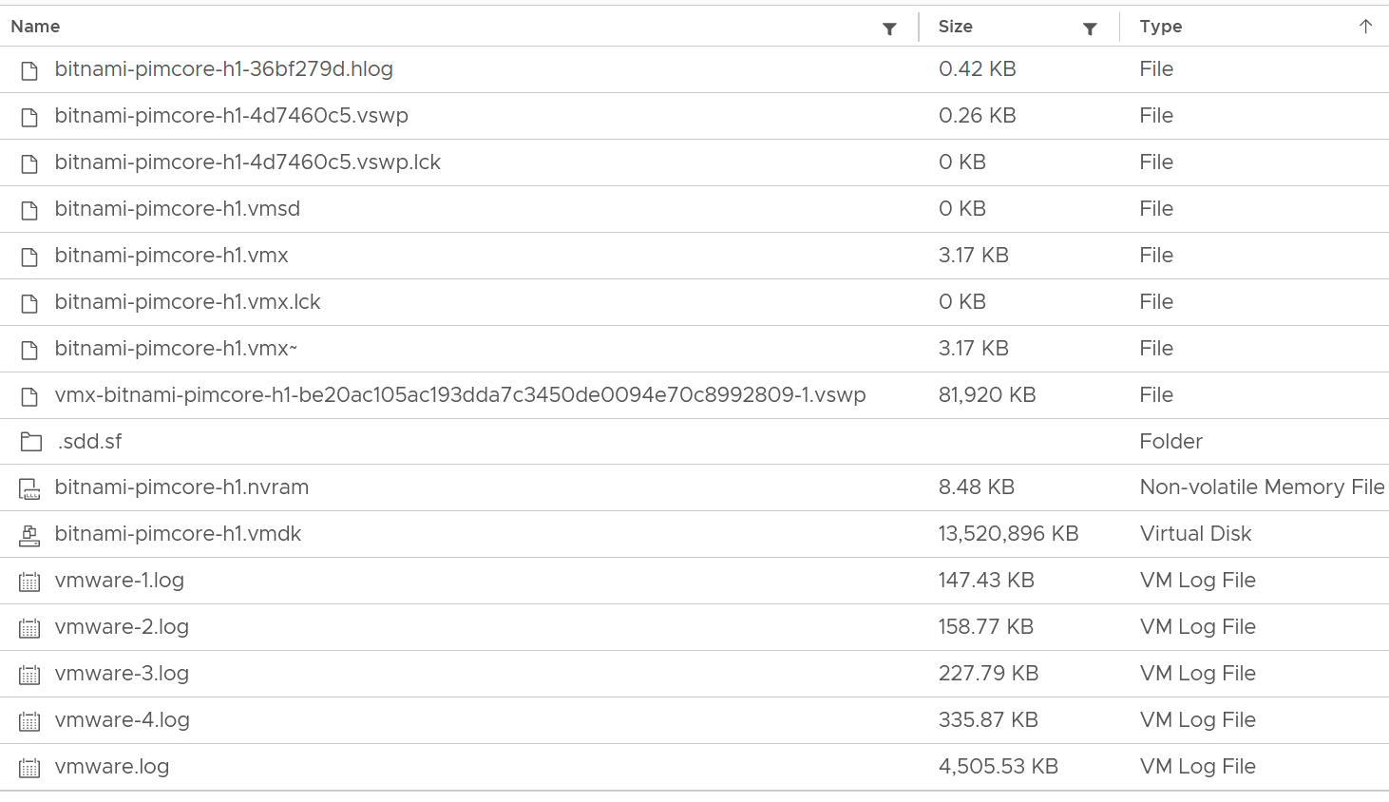

Yes, a lot of files 😊

We can categorize them into 4 from operations viewpoint:

|  |  |
| --- | --- |
| **Disk** | Virtual disk or RDM. This is typically the largest component. This can be thin provisioned, in which case the provisioned size tends to be larger than the actual consumption as Guest filesystem typically does not fill 100%.  All virtual disks are made up of two files, a large data file equal to the size of the virtual disk and a small text disk descriptor file which describes the size and geometry of the virtual disk file.  The descriptor file also contains a pointer to the large data file as well as information on the virtual disks drive sectors, heads, cylinders and disk adapter type. In most cases these files will have the same name as the data file that it is associated with (i.e. MyVM1.vmdk and MyVM1-flat.vmdk).  A VM can have up to 64 disks from multiple datastores. |
| **Snapshot** | Snapshot protects 3 things:   * VMDK * Memory * Configuration   For VMDK, the snapshot filename uses the syntax **MyVM-000001.vmdk** where MyVM is the name of the VM and the six-digit number 000001 is just a sequential number. There is 1 file for each VMDK.  Snapshot does not apply to RDM. You do that at storage subsystem instead, transparent to ESXi.  If you take snapshot with memory, it creates a **.vmem** file to store the actual image.  The **.vmsn** file stores the configuration of the VM. The **.vmsd** file is a small file, less than 1 KB. It stores metadata about each snapshot that is active on a VM. This text file is initially 0 bytes in size until a snapshot is created and is updated with information every time snapshots are created or deleted. Only 1 file exists regardless of the number of snapshots running as they all update this single file. This is why your IO goes up. |
| **Swap** | The memory swap file (**.vswp**). A VM with 64 GB of RAM will generate a 64 GB swap file (minus the size of memory reservation) which will be used when ESXi needs to swap the VM memory into disk. The file gets deleted when the VM is powered off.  You can choose to store this locally on the ESXi Host. That would save space on vSAN. The catch is vMotion as the swap file must be transferred too.  [e1: There is also a smaller file (in MB) storing the VMX process swap file. But I’m unsure about this and have not seen it yet] |
| **Others** | All other files. They are mostly small, in KB or MB. So if this counter is large, you’ve got unneeded files inside the VM directory.  Logs files, configuration files, and BIOS/EFI configuration file (**.nvram**)  Note that this includes any other files you put in the VM directory. So if you put a huge ISO image or any file, it gets counted. |

##### Raw Device Mapping

RDM appears clearly as LUN in the VM Edit Settings dialog box:

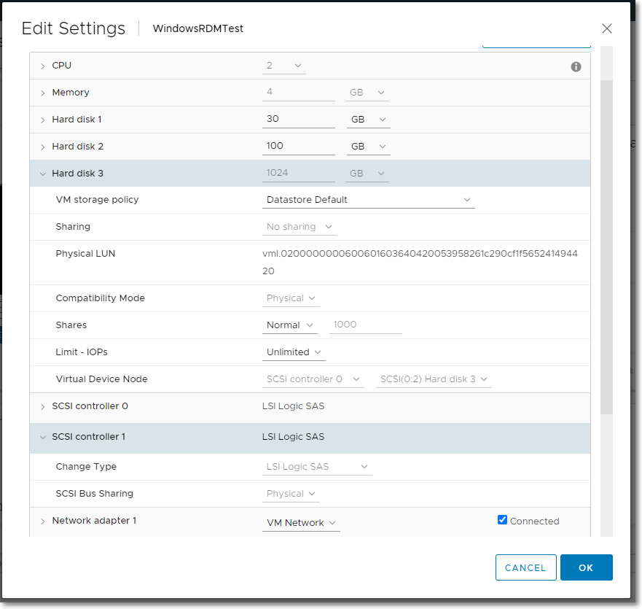

But what does it appear when you browse the VM folder in the parent datastore?

RDM appears like a regular VMDK file. There is no way to distinguish it in the folder.

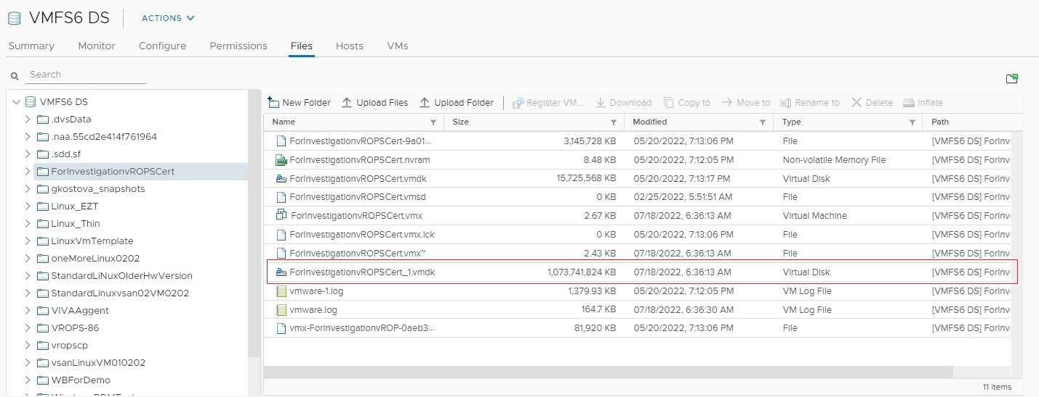

##### Multi-Writer Disk

Shared disk can be either shared RDM or VMDK. The following screenshot shows the option when creating a multi-writer VMDK in vCenter Client.

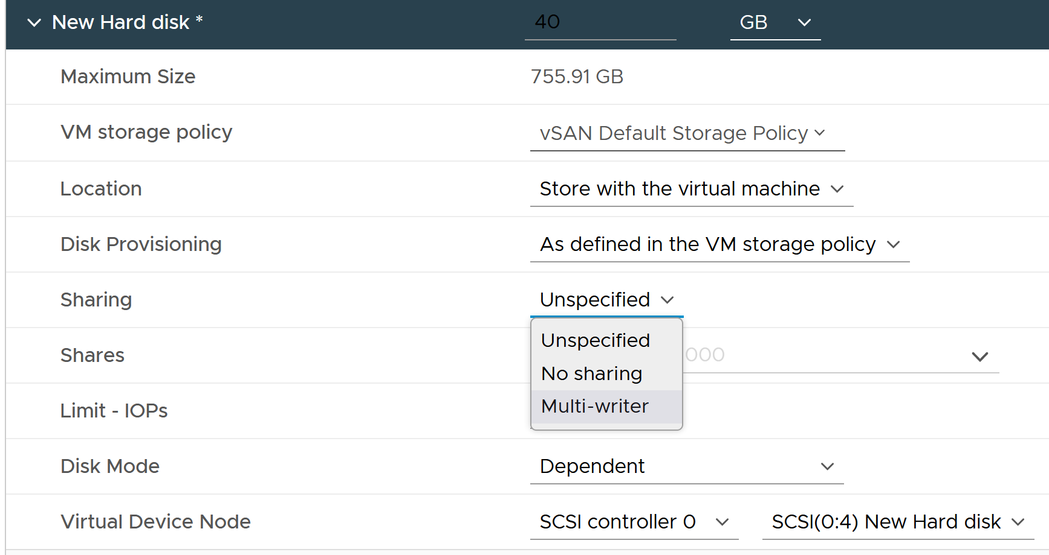

When multiple VMs are sharing the same virtual disk or RDM, it creates additional challenge in capacity, cost and performance management.

#### ESXi

Storage at ESXi is a lot more complex than storage at VM level. Reason is ESXi virtualizes the different physical storage subsystem, and VM simply consumes all of them as local SCSI drive.

The kernel does the IO on behalf of all the VMs. It also has its own kernel modules, such as vSAN, that also need to be served. This creates what is popularly termed “IO Blender” effect. Sequential operations from each VM and kernel modules become random when combined together. The opposite is when the kernel rearranges these independent IOs and try to sequence them, so on average the latency is lower.



The green boxes are what you are likely to be familiar with. You have your ESXi host, and it can have NFS Datastore, VMFS Datastore, vSAN Datastore, vVOL datastore or RDM objects. vSAN & vVOL present themselves as a VMFS datastore, but the underlying architecture is different. The **blue** boxes represent the metric groups you see in vCenter performance charts.

In the central storage architecture, NFS and VMFS datastores differ drastically in terms of metrics, as NFS is file-based while VMFS is block-based.

* For NFS, it uses the vmnic, and so the adapter type (FC, FCoE, or iSCSI) is not applicable. Multipathing is handled by the network, so you don't see it in the storage layer.
* For VMFS or RDM, you have more detailed visibility of the storage. To start off, each ESXi adapter is visible and you can check the metrics for each of them. In terms of relationship, one adapter can have many devices (disk or CDROM). One device is typically accessed via two storage adapters (for availability and load balancing), and it is also accessed via two paths per adapter, with the paths diverging at the storage switch. A single path, which will come from a specific adapter, can naturally connect one adapter to one device. The following diagram shows the four paths:



The counter at ESXi level contains data from all VMs and VMkernel overhead. There is no breakdown. For example, the counter at vmnic, storage adapter and storage path are all aggregate metrics. It’s not broken down by VM. The same with vSAN objects (cache tier, capacity disk, disk group). None of them shows details per VM.

Can you figure out why there is no path to the VSAN Datastore?

We’ll do a comparison, and hopefully you will realize how different distributed storage and central storage is from performance monitoring point of view. What look like a simple change has turned the observability upside down.

##### Storage Adapter

The screenshot shows an ESXi host with the list of its adapters. We have selected vmhba2 adapter, which is an FC HBA. Notice that it is connected to 5 devices. Each device has 4 paths, giving 20 paths in total.



What do you think it will look like on vSAN? The following screenshot shows the storage adapter vmhba1 being used to connect to two vSAN devices. Both devices have names begin with “Local”. The storage adapter has 2 targets, 2 devices and 2 paths. If you are guessing it is 1:1 mapping among targets, devices and paths, you are right.

We know vSAN is not part of Storage Fabric, so there is no need for Identifier, which is made of WWNN and WWPN.



Let’s expand the **Paths** tab. We can see the LUN ID here. This is important. The fact that the hypervisor can see the device is important. That means the VMkernel can report if there is an issue, be it performance or availability. This is different if the disk is directly passed through to the VM. The hypervisor loses visibility.



##### Storage Path

Continuing our comparison, the last one is Storage Path. In a fibre channel device, you will be presented with the information shown in the next screenshot, including whether a path is active or not.



Note that not all paths carry I/O; it depends on your configuration and multipathing software. Because each LUN typically has four paths, path management can be complicated if you have many LUNs.

What does Path look like in vSAN? As shared earlier, there is only 1 path.



##### Storage Devices

The term drive, disk, device, storage can be confusing as they are often used interchangeably in the industry. vSphere Client uses the terms device and disk interchangeably. In vSphere, this means a physical disk or physical LUN partition presented to ESXi host.

The following shows that the ESXi host has 3 storage devices, all are flash drive and the type = disk. The first two are used in vSAN datastore and are accessed via the adapter vmhba1.



A storage path takes data from ESXi to the LUN (the term used by vSphere is Devices), not to the datastore. So if the datastore has multiple extents, there are four paths per extent. This is one reason why you should not use more than one extent, as each extent adds 4 paths. If you are not familiar with VMFS Extent, Cormac Hogan explains it [here](http://blogs.vmware.com/vsphere/2012/02/vmfs-extents-are-they-bad-or-simply-misunderstood.html).

For VMFS (non vSAN), you can see the same metrics at both the Datastore level and the Disk level. Their value will be identical if you follow the recommended configuration to create a 1:1 relationship between a datastore and a LUN. This means you present an entire LUN to a datastore (use all of its capacity). The following shows a VMFS datastore with a NetApp LUN backing it.



In vSAN, there is no connectivity and Multipathing menu. There is no also Capability Sets menu. vSAN datastore is not mapped to a LUN. It is supported by disk groups.

### Network

Network monitoring is complex, especially in large data centers. Adding network virtualization takes the complexity of performance troubleshooting even higher.

Just like CPU, Memory and Disk, there is also a new layer introduced by virtualization. There are virtual network cards on each VM, and software-based switch on each ESXi bridging the VM card to the physical NIC card. The various ESXi VMkernel modules also do not “talk” directly to the physical card. Basically, what used to be the top of rack switch are now living inside each ESXi as an independent switch.

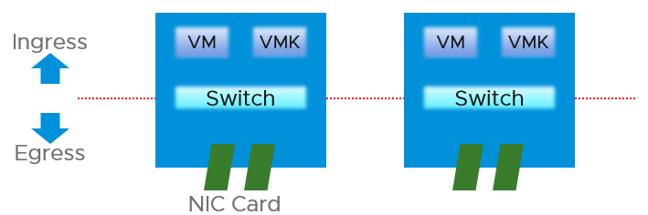

From performance and capacity management point of view, network has different fundamental characteristics to compute or storage. The key differences are summarized below.

|  |  |  |
| --- | --- | --- |
|  | Compute or Storage | Network |
| Net available resource to VM | Relatively high | Low |
| Resource allocation at VM level | Granular | Coarse |
| Hardware | Single purpose | Multi-purpose |
| Nature | A node | An interconnect |
| Upper Limit | Yes | No |
| Monitoring | Simpler | Harder |
| Location | Fewer | Many |
| Workload Type | 1 | Many |

#### Network Observability

Let’s explain the preceding table, covering each row one by one.

##### Net Available Resource

At the end of the day, the net available resources to the VMs are what we care about. What the IaaS platform used is considered an overhead. The more ESXi VMkernel, NSX, vSAN, vSphere Replication use, the lesser you have left for the business workload.

An ESXi host has a fixed specification (for example, 2 CPUs, 60 cores, 512 GB RAM, 2 x 25 GE NIC). This means we know the upper physical limit. How much of that it available to the VMs? Another word, what is the usable capacity for the business workload?

For compute, the hypervisor consumes a relatively low proportion of resources. Even if you add a software-defined storage such as vSAN, you are looking at around 10% total utilization but depends on many factors.

The same cannot be said about network. Mass vMotion (for example, when the host enters maintenance mode), storage vMotion (in IP storage case), VM provisioning or cloning (for IP storage), and vSAN all take up significant network bandwidth. In fact, the non-VM network takes up the majority of the ESXi resources. If you have 2 x 25 GE NIC, majority of it is *not* used by VM. The following screenshot shows that VM only gets 100 shares out of 500 shares. So the overhead can be as high as 80%!



##### Allocated Resource

This means the resource that is given to a single VM itself. For compute, we can configure a granular size of CPU and RAM. For the CPU, we can assign one, two, three, four, etc. vCPUs.

With network, we cannot specify the vNIC speed. It takes the speed of the ESXi vmnic assigned to the VM port group. So each VM will either see 1 GE or 10 GE or 25 GE (you need to have the right vNIC driver, obviously). You cannot allocate another amount, such as 500 Mbps or 250 Mbps in the Guest OS. In the physical world, we tend to assume that each server has 10 GE and the network has sufficient bandwidth. You cannot assume this in a virtual data center as you no longer have 10 GE for every VM at the physical level. It is shared and typically oversubscribed.

A network intensive VM can easily hit 1 Gbps for both egress and ingress traffic. The following chart shows a Hadoop worker node receiving more than 5 Gbps worth traffic multiple times. You need to be careful in sizing the underlying ESXi if you want to run multiple VMs. While you can use Network I/O Control and vSphere Traffic Shaping, they are not configuration property of a VM.



##### Hardware

The networking hardware itself can provide different functionalities.

For compute, you have servers. While they may have different form factors or specifications, they all serve the same purpose—to provide processing power and a set of working memory for hypervisor or VM.

For network, you have a variety of network services (firewall and load balancer) in addition to the basic network functionalities (switch, router, and gateway). You need to monitor all of them to get a complete picture. These functionalities can take the form of software or hardware.

Unlike storage, network has concept of duplex. A full duplex means it has 100% on both direction. For example, an ESXi with a 25 Gb port can theoretically handle 25 Gb TX + 25 Gb RX as its [full duplex](https://en.wikipedia.org/wiki/Duplex_(telecommunications)).

Blade servers and other HCI form factors blur the line between server and network.

##### Nature of Network

The fourth difference is the nature of network. Compute and storage are nodes. When you have a CPU or RAM performance issue on one host, it doesn't typically impact another host on a different cluster. The same thing happens with storage. When a physical array has a performance issue, generally speaking it does not impact other arrays in the data center.

Network is different. A local performance issue can easily be a data center-wide problem. Here is a good [read](https://blog.ipspace.net/2019/05/real-life-data-center-meltdown.html) by shared [Ivan Pepelnjak](https://www.ipspace.net/About_Ivan_Pepelnjak). To give a recent example (H2 2021), here is one from a world-class network operator[17]:

[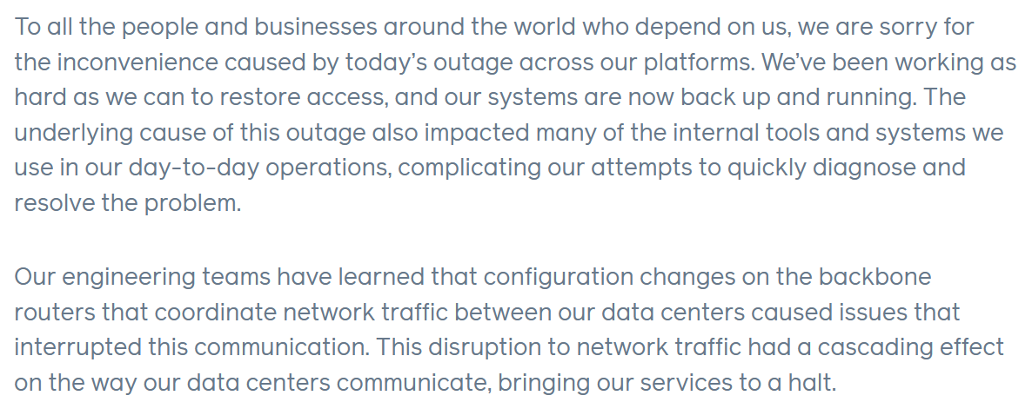](https://engineering.fb.com/2021/10/04/networking-traffic/outage/)

Being an interconnect, it also connect users and servers to the Internet. If you have a global operations, you likely have multiple entry points, provided by different providers. These connectivity needs to be secured and protected with HA, preferably from 2 different ISPs.

There are typically many paths and routes in your network. You need to ensure they are available by testing the connectivity from specific points.

##### Upper Limit

CPU or RAM workload have a per VM physical limit. This makes capacity management possible, and aids in performance troubleshooting.

While network has a physical limit, it can be misleading to assume it is available to all VMs all the time. Because the physical capacity of the network is shared, you have a dynamic upper limit for each workload. The VM Network port group will have more bandwidth when there is no vMotion happening. Furthermore, each VM has a dynamic upper limit as it shares the VM Network port group with other VMs.

The resource available to VM also varies from host to host. Within the same host, the limit changes as time progresses. Unlike Storage I/O Control, Network I/O Control does not provide any metrics that tell you that it has capped the bandwidth.

In many situations, the bandwidth within the ESXi host may not be the smallest pipe between the originating VM and its destination. Within the data center, there could be firewalls, load balancers, routers, and other hops that the packet has to go through. Once it leaves the data center, the WAN and Internet are likely to be a bottleneck. This dynamic nature means every VM has its own practical limit.

##### Monitoring and Troubleshooting

A distributed system is harder to monitor than a single node, especially if workload varies among the components that make up the system.

The network resource available to VM also varies from host to host. Within the same host, the limit changes as time progresses. Unlike Storage I/O Control, Network I/O Control (NIOC) does not provide any metrics that tell you that it has capped the bandwidth.

NIOC can help to limit the network throughput for a particular workload or VM. If you are using 10 GE, enable NIOC so that a burst in one network workload does not impact your VM. For example, a mass vMotion operation can saturate the 10 Gb link if you do not implement NIOC. In vCenter 7, there is no counter that tracks when NIOC caps the network throughput. As a result, vRealize Operations will not tell you that NIOC has taken action.

The primary contention metrics are

* Latency.
* Dropped Packets
* Retransmit Packets. For TCP, dropped packets will be retransmitted.
* Jitter. This measures the inconsistency of the latency. An application may tolerate poor latency better than variable latency.

Note there is no latency and retransmit metrics in vSphere.

Remember that Storage has 2 metrics (IOPS and Throughput) for consumption? Network also has these 2 types, except the more popular one is the throughput. The PPS (packet per second) is less popular although they are useful in gaining insight into your network. It can take up a significant CPU time to process high number of packets, as you can see in NSX edge VM.

##### Location

Server and storage tend to be located fewer places. Even in the [ROBO](https://www.vmware.com/asean/products/vsphere/remote-office-branch-office.html) office, they are typically located in a rack, with proper cooling and physical security. Network switch, especially Wireless Access Points, need to be placed in multiple places within the building, if that’s required to provide enough network coverage.

Solution such as SDWAN even requires a network device to be deployed at employee home. I actually have the Dell edge device at my home.

##### Workload Type

In network, not all packets are of the same type. You can have unitcast, multicast and broadcast.

Majority of traffic should be unicast, as ESXi or VM should not be broadcasting to all IP addresses in the network or multicasting to many destination. The challenge is there are purposes for each type so you need to monitor if the broadcast and multicast happens at the wrong time to the wrong network.

Storage and Server only has 1 type. From operations management viewpoint, for almost all customers, A CPU instruction is a CPU instruction. You do not care what it is. The same goes with memory access and disk IO commands.

##### Conclusion

Because of all these differences, the way you *approach* network monitoring should also be different. If you are not the network expert in your data center, the first step is to partner with experts.

BTW, there are other things which I did not cover. For example, in network there are basic services such as DNS and NTP. All these services need to be monitored, typically for availability and reliability.

#### SDDC Network Monitoring

The arrival of software-defined infrastructure services also changes the way you monitor your network. The following diagram shows a simplified setup of an ESXi host.

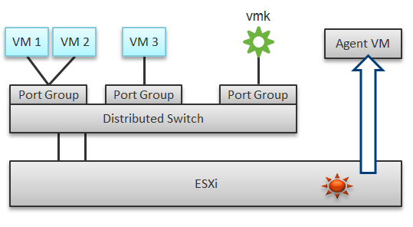

In a single ESXi host, there are 4 areas that need to be monitored for a complete network monitoring:

* VM network
* VMkernel network
* ESXi kernel modules
* Agent VMs

In the preceding example, we have 3 VMs running in the host. VM 1 and VM 2 are connected to the same VXLAN (or VLAN). VM 3 is on a different VXLAN (or VLAN), hence it is on a different port group. Monitoring at port group level complements monitoring at VM level and ESXi level.

Traffic at Distributed Switch level carries more than VM traffic. It also carries VMkernel traffic, such as vMotion and VSAN. Both VMkernel network and VM network tend to share the same physical uplinks (ESXi vmnic). As a result, it’s easier to monitor at port group level.

Sounds good so far. What is the limitation of monitoring at distributed port group level?

The hint is at the word **distributed**.

Yes, the data is the aggregate of all the ESXi hosts using that distributed port group!

By default, VM 1 and VM 2 can talk to each other. The traffic will not leave the ESXi. Network monitoring tools that are not aware of this will miss it. Traffic from VM 3 can also reach VM 1 or VM 2 if NSX Distributed Logical Router is in place. It is a VMkernel module, just like the NSX Distributed Firewall. As a result, monitoring these kernel modules, and the host overall performance, becomes an integral part of network monitoring.

The 4th area we need to monitor is Agent VM. An Agent VM is mapped to 1 ESXi Host. It does not need HA protection as every ESXi host has one, hence it typically resides on the host local datastore.

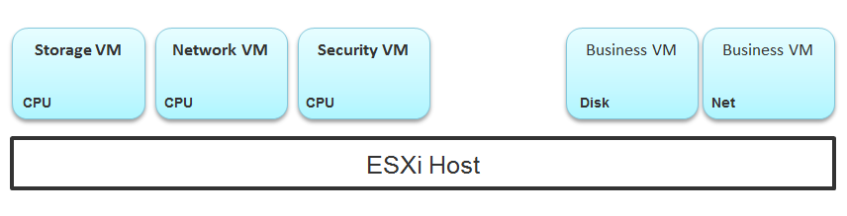

The above example shows an ESXi host with 3 agent VMs. The first VM provides a storage service (an example is Nutanix CVM), the second VM provides Network service, and the 3rd VM provides a Security VM.

Let’s use the Security service as an example. A popular example here is Trend Micro Deep Security virtual appliance. It is in the data path. If the Business VMs are accessing files on a fileserver on another network, the files have to be checked by the security virtual appliance first. If the agent VM is slow (and it could be due to factor that is not network related), it will look like a network or storage issue as far as the business VMs are concerned. The Business VMs do not know that their files have been intercepted for security clearance, as it is not done at the network level. It is done at the hypervisor level.

##### Source of Data

A complete network monitoring requires you to get the data from 5 different sources, not just from vSphere. In SDDC, you should also get data from the application, Guest OS, NSX and NetFlow/sFlow/IPFIX from VDS and physical network devices. For VDI, you need to get data at application level. We have seen packet loss at application-layer (Horizon Blast protocol) when Windows sees no dropped packet. The reason was the packet arrives out of order and hence unusable from protocol viewpoint.

The following shows a simplified stack. It shows the five sources of data and the 4 tools to get the data. It includes a physical switch as we can no longer ignore physical network once you move from just vSphere to complete SDDC.

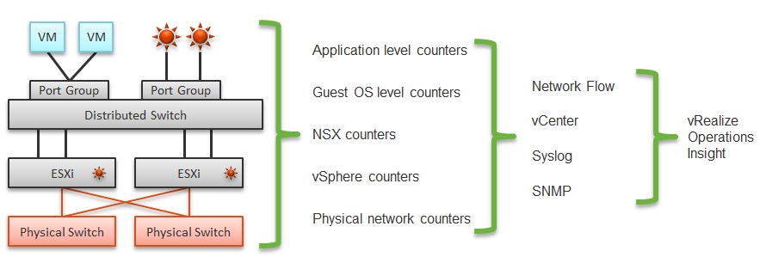

The network packet analysis comes in 2 main approaches: Header analysis and full packet analysis. The header analysis is certainly much lighter but lack the depth of full analysis. You use this to provide overall visibility as it does not impose heavy load on your environment.

The impact of virtualization on network monitoring goes beyond what we have covered. Let’s add NSX Edge into the above, so you can see the traffic flow when the edge services are also virtualized. You will see that a network problem experienced by a VM on one ESXi could be caused by another VM running on another ESXi. The following diagram is a simplified setup, showing a single NSX Edge residing on another cluster.

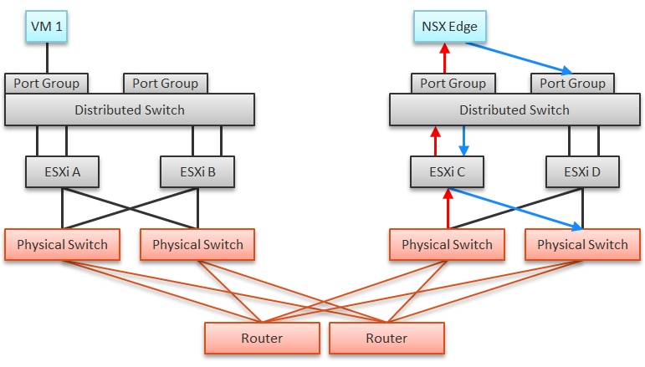

In the above example, let’s say VM 1 needs to talk to outside world. An NSX Edge VM provides that connectivity, so every TCP/IP packet has to go through it. The Edge VM has 2 virtual NICs, one for each network. If the NSX Edge VM has CPU issue, or the underlying ESXi has RAM issue, it can impact the network performance of VM 1.

|  |  |  |
| --- | --- | --- |
| Type | Guest OS Metric | VM Equivalent |
| Contention | Dropped Packet | None, as the dropped packet at VM is a different level. |
| Latency | None, no such metric available in vSphere |
| Utilization | Throughput | They should match with the metrics at VM level. If not, there is dropped packets.  They should be reported based on traffice type: unicast, multicast, broadcast. |
| Packet/second |

##### Traffic Type

vRealize Operations provides these metrics at VM, ESXi, Distributed Port Group and Distributed Switch level. As vSphere Tanzu Pod is basically a VM, it also has the metric.

BTW, one way to check what objects in what adapter have the specific metric is in the vRealize Operations policy. Open any policy, and search the metric using its name. The list of matching metrics will be shown, grouped by the objects.

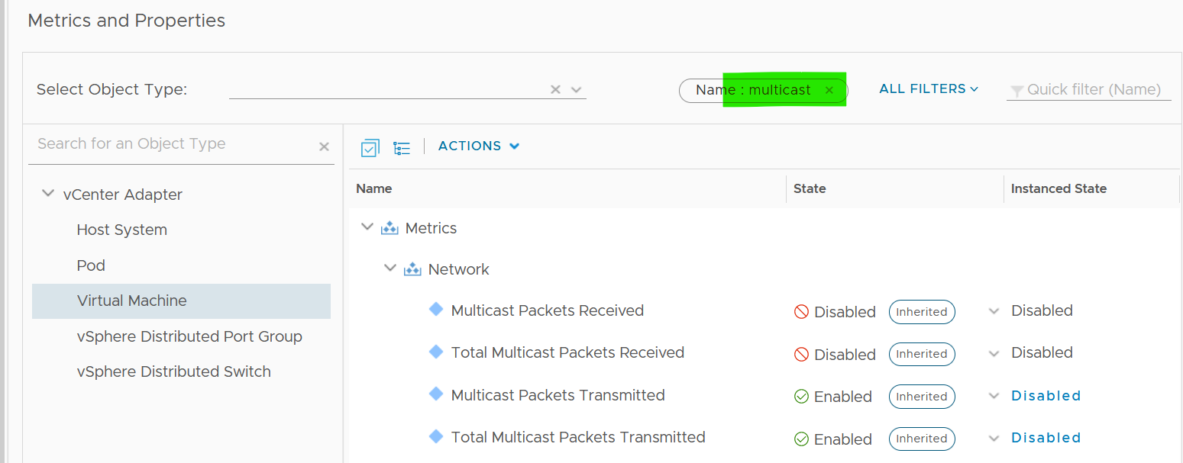

As you can see from above, there is no aggregation at higher level, so create super metric for the time being. I have not created those metric out of the box as I’m yet to use them in dashboard or alert.

###### Packet Size

It’s typically 1600 byte with NSX, or 9000 bytes if you enable [jumbo frames](https://en.wikipedia.org/wiki/Jumbo_frame)).

Special purpose packet such as [ping](https://en.wikipedia.org/wiki/Ping_(networking_utility)) test is smaller. But they should be a small percentage of your network.

##### NSX Edge

You may be wondering if an Edge VM does a lot of processing. Let’s look at a real example. How much traffic do you think this Edge VM is doing? The number is kilobytes not kilobit, so don’t forget to multiply by 8.

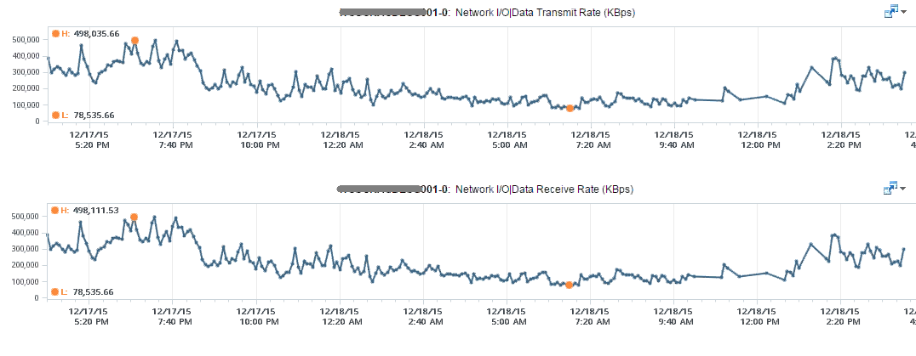

At near 1 million KBps, the application VM is processing a total of 8 Gbps worth of data on both network cards, 4 Gbps incoming from one vNIC and 4 Gbps outgoing on another vNIC at the same time. This number is the sum of Receive and Transmit, so the theoretical limit is 20 Gbps as this VM uses a 10 Gbps NIC. Notice the pattern for both Receive and Transmit is identical, as NSX Edge is practically a gateway.

This NSX Edge happens to be the only VM on a host. This means we can expect the data at the Host level to mimic that. The host does not run distributed storage (e.g. VSAN) so there is no other traffic other than this VM. The following chart below confirms that.

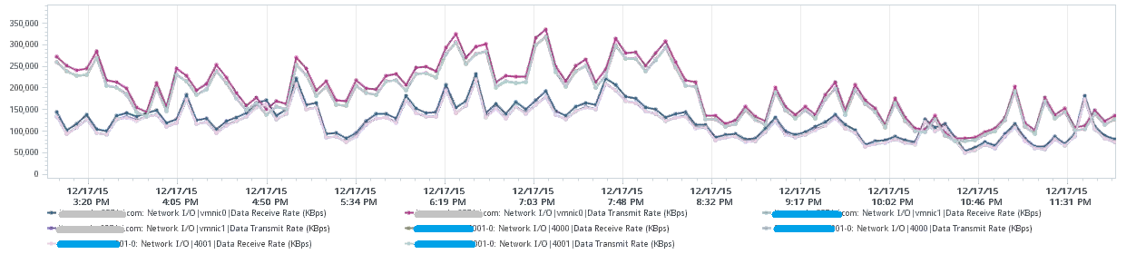

There are practically 2 lines, even though we actually plot 8 line charts. What do the 2 lines map to?

Yes, they map to North-South traffic and South-North traffic. An end user requesting data from a web server would be South to North, while the web server response would be North to South.

“Wait!” you might say. There should only 4 lines. Why do we have 8 lines?

Can you figure it out from the following diagram?

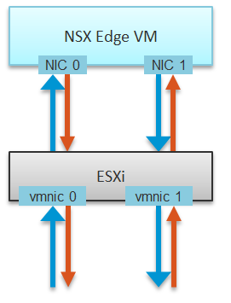

The above 8 arrows map to the 8 lines. There is 1 line chart for every arrow. There are 4 NICs, and each has Receive and Transmit.

If you use NSX, there is a good chance that you will have multiple NSX Edge VMs. We have a customer with >100 VMs. On the same host, you may also run distributed storage (e.g. VSAN) as an Edge cluster is typically isolated. We have customers with multiple Edge VMs, and monitoring the health of these Edge VMs becomes an integral part of network monitoring.

Good network management is about understanding the application. In a way, we should treat VMware Cloud Foundation as an application. There are now two layers of applications in SDDC:

* Infrastructure applications (e.g. vSAN, NSX, F5, Trend Micro)
* Business Applications (e.g. your company intranet, database, web server)

This is consistent with the fact that you will have two layers of network, when the network is virtualized. You will use VXLAN for your VM and VLAN for your infrastructure.

## Operating System

We will cover Windows and Linux. Both the server variants of Windows and the desktop variants of Windows use the same set of metrics. While there are many flavours of Linux, they are essentially identical from observability viewpoint.

**Part 2 Chapter 3**

### Microsoft Windows

#### CPU

From what I know, Performance Monitor is still the main tool for Windows, despite it showing its age and it has not been enhanced for years. Go to docs.microsoft.com and browse for Windows Server. It took me to [this article](https://docs.microsoft.com/en-us/learn/modules/monitor-windows-server-performance/2-use-performance-monitor-to-identify-performance-problems), which cover PerfMon. Many explanations on metrics at <https://learn.microsoft.com/> are still based on end of life Windows.

PerfMon groups the counters under Processor group. However, it places the Processor Queue Length and Context Switches metrics under the System group. The System group covers system wide metrics, not just CPU.

The following screenshot show the counters under Processor group.

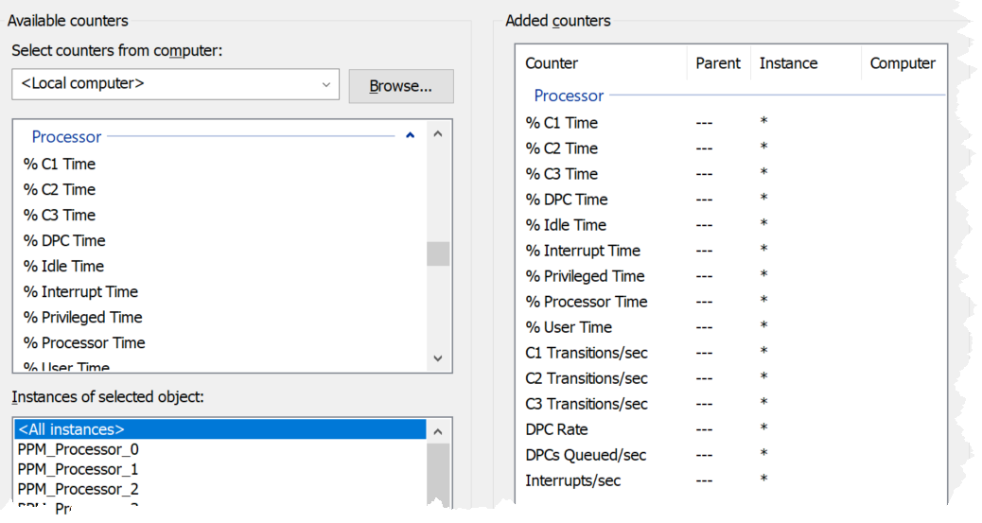

PerfMon UI provides a description, which I use as a reference below:

|  |  |
| --- | --- |
| % C1 Time  % C2 Time  % C3 Time | Based on this April 2004 article, Windows can operate in 4 different power level. The C0 is the highest, while C3 consumes the least amount of power.  If you set dynamic power management, expect the lower power to be registering higher value during idle period.  Reference: [here](https://docs.microsoft.com/en-us/previous-versions/ms804036(v=msdn.10)?redirectedfrom=MSDN). |
| C1 Transitions/sec  C2 Transitions/sec  C3 Transitions/sec | The amount of time on each power level does not tell the full picture. You also need to know how frequent you enter and exit that level.  These 3 metrics track the number of transitions into the respective level. For example, a high numbers on all 3 counters mean Windows is fluctuating greatly, resulting in inconsistent speed. |
| % DPC Time | Deferred Procedure Calls (DPC). According to [this](https://learn.microsoft.com/en-us/previous-versions/ms804036(v=msdn.10)), this counter is a part of the Privileged Time (%) because DPCs are executed in privileged mode. They are counted separately and are not a component of the interrupt counters. |
| % Interrupt Time | Interrupt means the processor was interrupted from executing normal thread. This can happen for a variety of reasons, such as system clock, incoming network packets, mouse and keyboard activity. Interrupt can happen on regular basis, not just ad hoc. For example, the system clock does it every 10 milliseconds in the background.  A high interrupt value can impact performance. |
| % Processor Time  % Idle Time | These 2 add up to 100% |
| % User Time  % Privileged Time | These 2 add up to 100%. |
| DPCs Queued/sec | Unlike the CPU Run Queue, this metric captures per processor. It can be handy to compare across processors as there can be imbalance.  Note this is a rate counter, not a count of the present queue. It tracks the speed per second. |
| DPC Rate | This is an input to the above, as the above is calculated as the delta of 2 rates, divided over sampling period. |
| Interrupts/sec | As above, but for interrupts. |

We start with the contention type of metrics as that’s the primary metric for performance, followed by utilization type of metrics.

##### DPC Time

According to [System Center wiki](https://systemcenter.wiki/?GetElement=Microsoft.Windows.Server.10.0.Processor.PercentDPCTime&Type=UnitMonitor&ManagementPack=Microsoft.Windows.Server.2016.Monitoring&Version=10.0.3.0), the system calls are deferred as they are lower priority than standard interrupts. A high percentage of deferral means Windows was busy doing higher priority requests.

They can happen even during low CPU utilization if there is issue with driver or application. The following screenshot is taken on Performance Monitor in Windows 11 laptop which was not running high. Notice the DPC time for CPU 0 is consistently higher than CPU 15, indicating imbalance. It did exceed >5% briefly. My Dell laptop has 8 cores 16 threads.

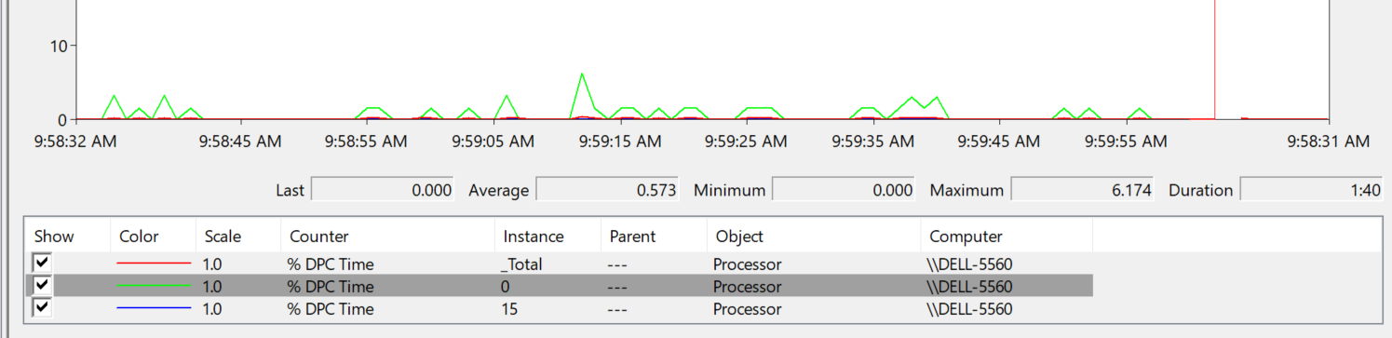

Set the graph scale to 1 for ease of reading, and change the axis scale accordingly.

##### CPU Run Queue

Number of threads in the processor queue. Unlike Linux, Windows excludes the threads that are running (being executed).

Let’s take a VM configured with 8 vCPUs. The Guest OS sees 8 threads so it will schedule up to 8 parallel processes. If there is more demand, it will have to queue them. This means the queue needs to be accounted for in Guest OS sizing.

Because it reports the queue, this is the *primary* counter to measure Guest OS performance. It tells you if the CPU is struggling to serve the demand or not.

What is a healthy value?

Windows Performance Monitor UI description is not consistent with MSDN documentation (based on Windows Server 2016 documentation). The description shown in Windows UI is “Processor Queue Length is the number of threads in the processor queue. Unlike the disk counters, this counter shows ready threads only, not threads that are running. There is a single queue for processor time even on computers with multiple processors. Therefore, if a computer has multiple processors, you need to divide this value by the number of processors servicing the workload. A sustained processor queue of less than 10 threads per processor is normally acceptable, dependent of the workload.”

MSDN document states that a sustained processor queue of greater than 2 threads generally indicates processor congestion. SQL Server document states 3 as the threshold. Let me know if you have seen other recommendation from Microsoft or Linux.

Windows or Linux utilization may be 100%, but as long as the queue is low, the workload is running as fast as it can. Adding more vCPU will in fact slow down the performance as you have higher chance of context switching.

There is a single queue for processor time even on computers with multiple processors. Therefore, if a computer has multiple processors, you need to divide this value by the number of processors servicing the workload. That’s why Tools reports the total count of the queues. This counter should play a role in the Guest OS CPU sizing.

You should profile your environment, because the number can be high for some VMs. Just look at the numbers I got below, where some VMs have well over 10 queues per vCPU. Share the finding with the VM Owner, as the remediation to reduce the queue could mean changing the application settings.

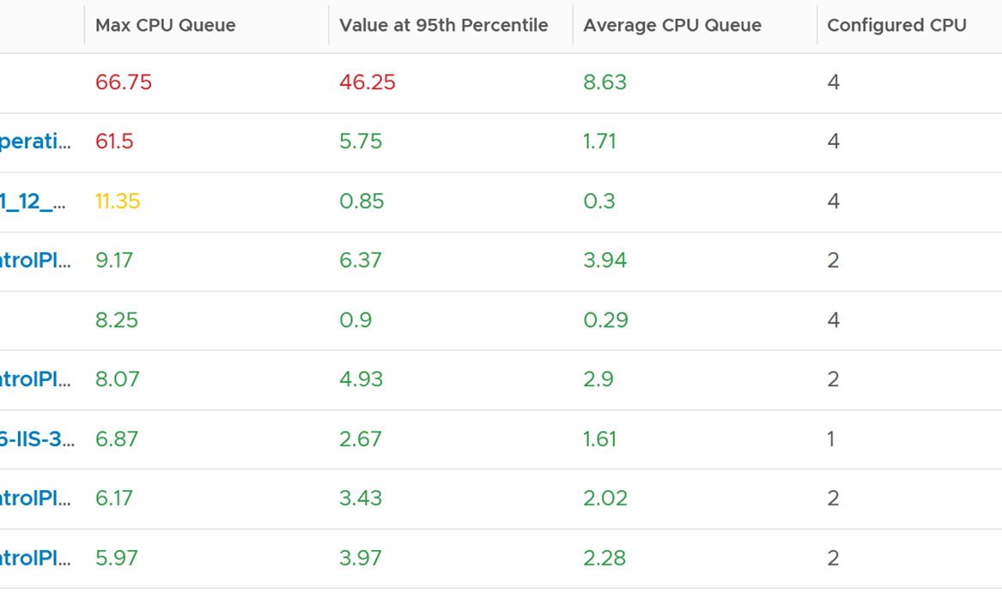

Based on the overall guidance of 3 queue per vCPU, the first 2 VM shows a high value. Both VM are only 4 vCPU, so we expect the queue value to be less than 20, preferably less than 10.

The first VM shows a sustained value as it’s still relatively high at worst 5th percentile. Let’s drill down to see the first VM.



The CPU Run Queue spikes multiple times. It does not match the CPU Usage and CPU Context Switch Rate in pattern. I’m unsure how to explain this so if you know drop me a note. I notice the data collection is erratic though, so let’s look at another VM.

The following is a 2 vCPU VM running Photon OS. CPU Queue is high, even though Photon is only running at 50%. Could it be that the application is configured with too many threads that the CPU is busy doing context switching? Notice the CPU Queue maps the CPU Context Switch Rate and CPU Run. In this situation, you should bring it up to the application team attention, as it may cause performance problem and the solution is to look inside. As a proof that it’s not because of underlying contention, I added CPU Ready.



This property displays the last observed value only; it is not an average. Windows & Linux do not provide the highest and lowest variants either.

The counter name in Tools is guest.processor.queue. It is based on Win32_PerfFormattedData_PerfOS_System = @#ProcessorQueueLength from WMI

Reference: [Windows](https://msdn.microsoft.com/en-us/library/aa394272(v=vs.85).aspx)

I can’t find documentation that states if CPU Hyper Threading (HT) technology provides 2x the number of queue length. Logically it should as the threads are at the start of the CPU pipelines, and both threads are interspersed in the core pipeline.

##### CPU Context Switch

[CPU Context Switch](https://en.wikipedia.org/wiki/Context_switch) costs performance “due to running the [task scheduler](https://en.wikipedia.org/wiki/Scheduling_(computing)), TLB flushes, and indirectly due to sharing the [CPU cache](https://en.wikipedia.org/wiki/CPU_cache) between multiple tasks”. It’s important to track this counter and at least know what’s an acceptable behaviour for that specific application.

Context switches are considered “expensive” operations, as the CPU can complete many instructions within the time taken to switch context from one process to another. If you are interested, I recommend reading [this paper](https://www.inf.ed.ac.uk/teaching/courses/os/coursework/lcpusched-fullpage-2x1.pdf).

Based on Windows 10 Performance Monitor documentation, context switches/sec is the combined rate at which all processors on the computer are switched from one thread to another. All else being equal, the more the processors, the higher the context switch. Note that thread switches can occur either inside of a single multi-thread process or across processes. A thread switch can be caused either by one thread asking another for information, or by a thread being pre-empted by another, higher priority thread becoming ready to run.

There are context switch metrics on the System and Thread objects. vRealize Operations only report the total.

The rate of Windows or Linux switching CPU context per second ranges widely. The following is taken from a Windows 10 desktop with 8 physical threads, which runs around 10% CPU. I observe the value hovers from 10K to 50K.



The value should correlate with CPU “utilization”, since in theory the higher the utilization the higher the chance of CPU context switch. The following chart shows a near perfect corelation. Every time CPU Usage went up, CPU Context Switch also.



CPU context switch can happen even in a single thread application. The following shows a VDI VM with 4 vCPU. I plotted the CPU Usage Disparity vs CPU Context Switch. You can see the usage disparity went up to 78%, meaning the gap between the busiest vCPU and the most idle vCPU is 78%. This was running a security agent, which is unlikely to be designed to occupy multiple vCPU.



Let’s plot the context switch at the same period. There is a spike at the same time, indicating that the agent was busy context switching. Note that it does not always have to be this way. The red dot shows there is no spike in context switch even though the vCPU Usage Disparity went up.



The values of CPU Context Switch vary widely. It can go well beyond 0.5 million, as shown in the following table, hence it’s important to profile and establish a normal base line for that specific application. What is healthy for 1 VM may not be healthy for another.



You can see from the table that some VM experience prolonged CPU context switch, while others do not. The VM #4 only has a short burst as the value at worst 5th percentile dropped to 3796. Momentary peak of context switch may not cause performance problem so in general it’s wiser to take the value somewhere between 95th and 99th percentile.

Let’s drill down to see the first VM. This CentOS VM sporting only 4 vCPU constantly hit almost 1 million context switch. The pattern match CPU Usage.



On the other hand, majority of Guest OS spends well below 10K. I profiled around 2200 production VMs and here is the distribution of their CPU Context Switch. You can see that the values between 0 – 12000 accounts for 80%.



In your environment, you can profile it further. In the following example, I adjusted the bucket threshold by grouping all the values above 10K as one bucket, and splitting 0 – 10K bucket into multiple buckets. You can see more than half has less than 1K CPU Context Switch Rate.



###### Thread Ping Pong

The following is a Windows Server 2019 DC edition VM with 10 vCPU. It’s basically idle, as you can see below.

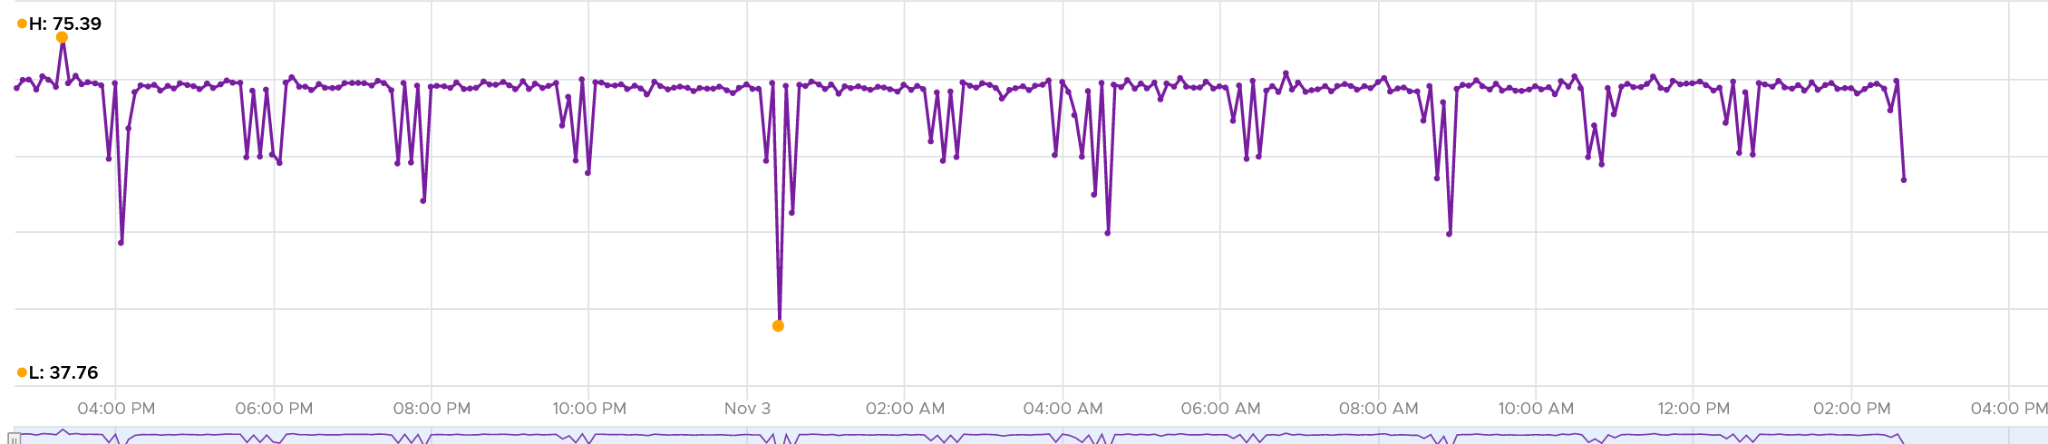

But if we zoom into each vCPU, they are taking turn to be busy.

In the span of just 1 hour, the 10 vCPU inside Windows take turn.

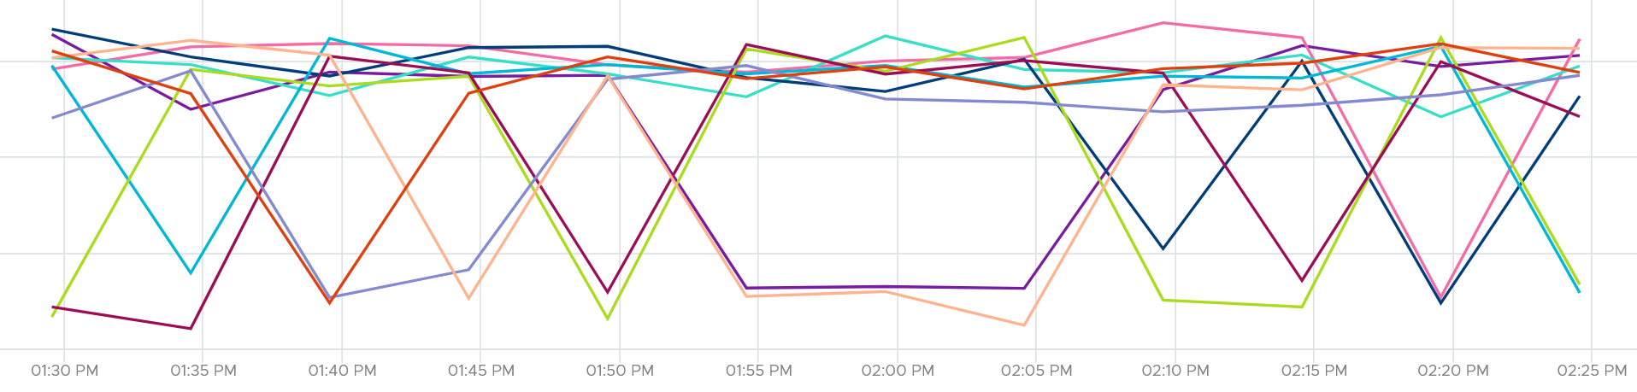

This is a bit illogical. Is this a process ping pong?

We can see them clearer if we stack them up. Notice they take turn, except the 3rd one from the top (I drew a green line on it). That one is actually fairly stable.

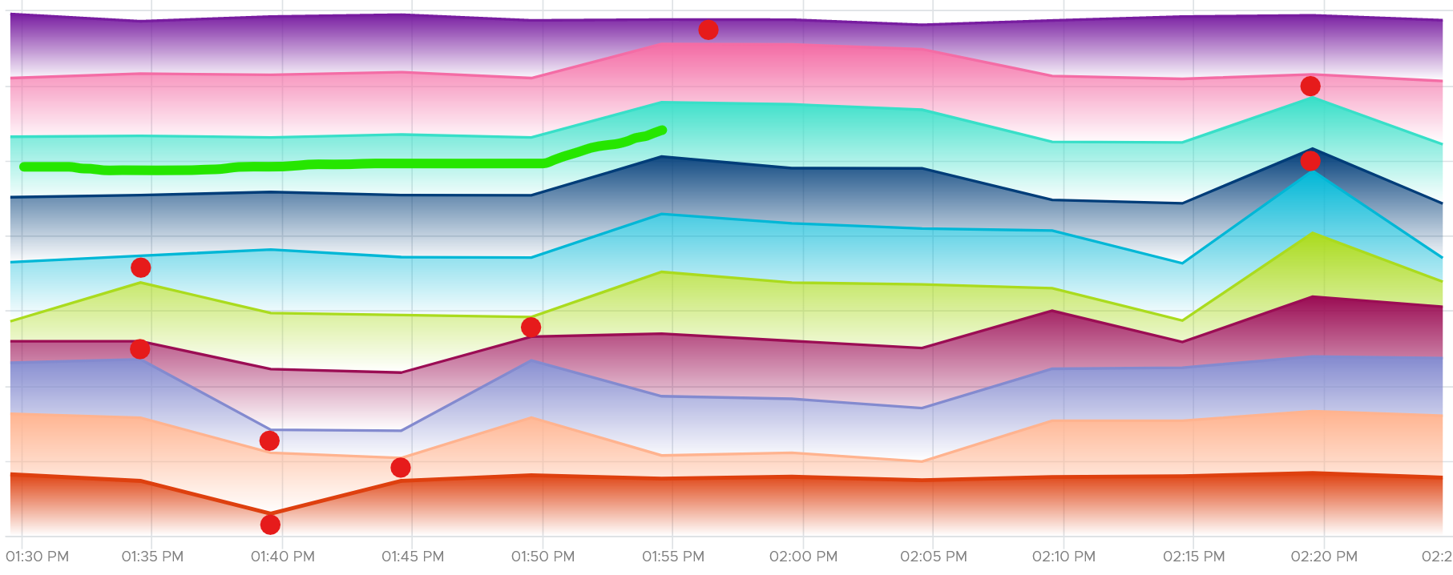

It is running Horizon Connection Server. It has around 118 – 125 processes, but much higher threads.

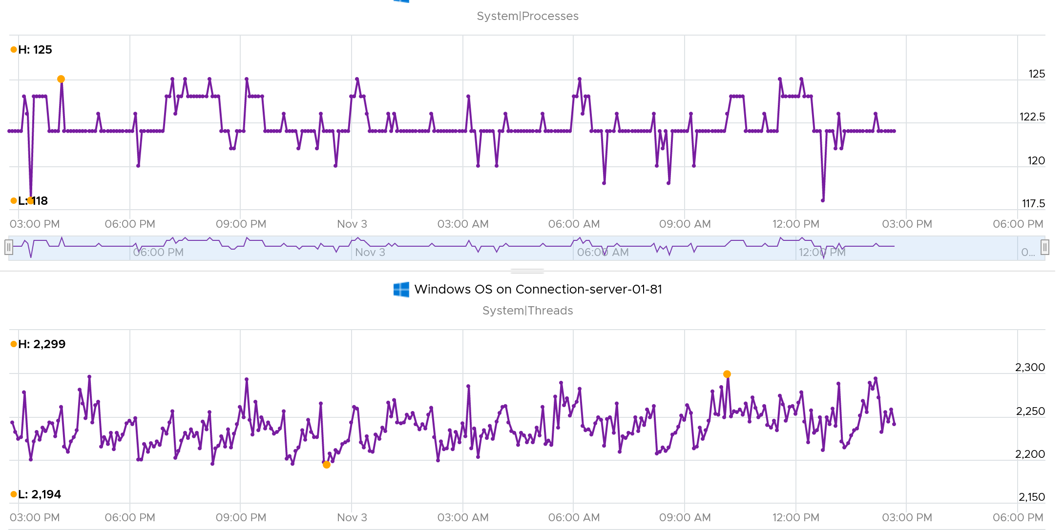

CPU Run Queue is very low, which is expected.

Context switches is fairly steady. This is expected as it consistently run >2K threads on >100 processes on just 10 CPU.

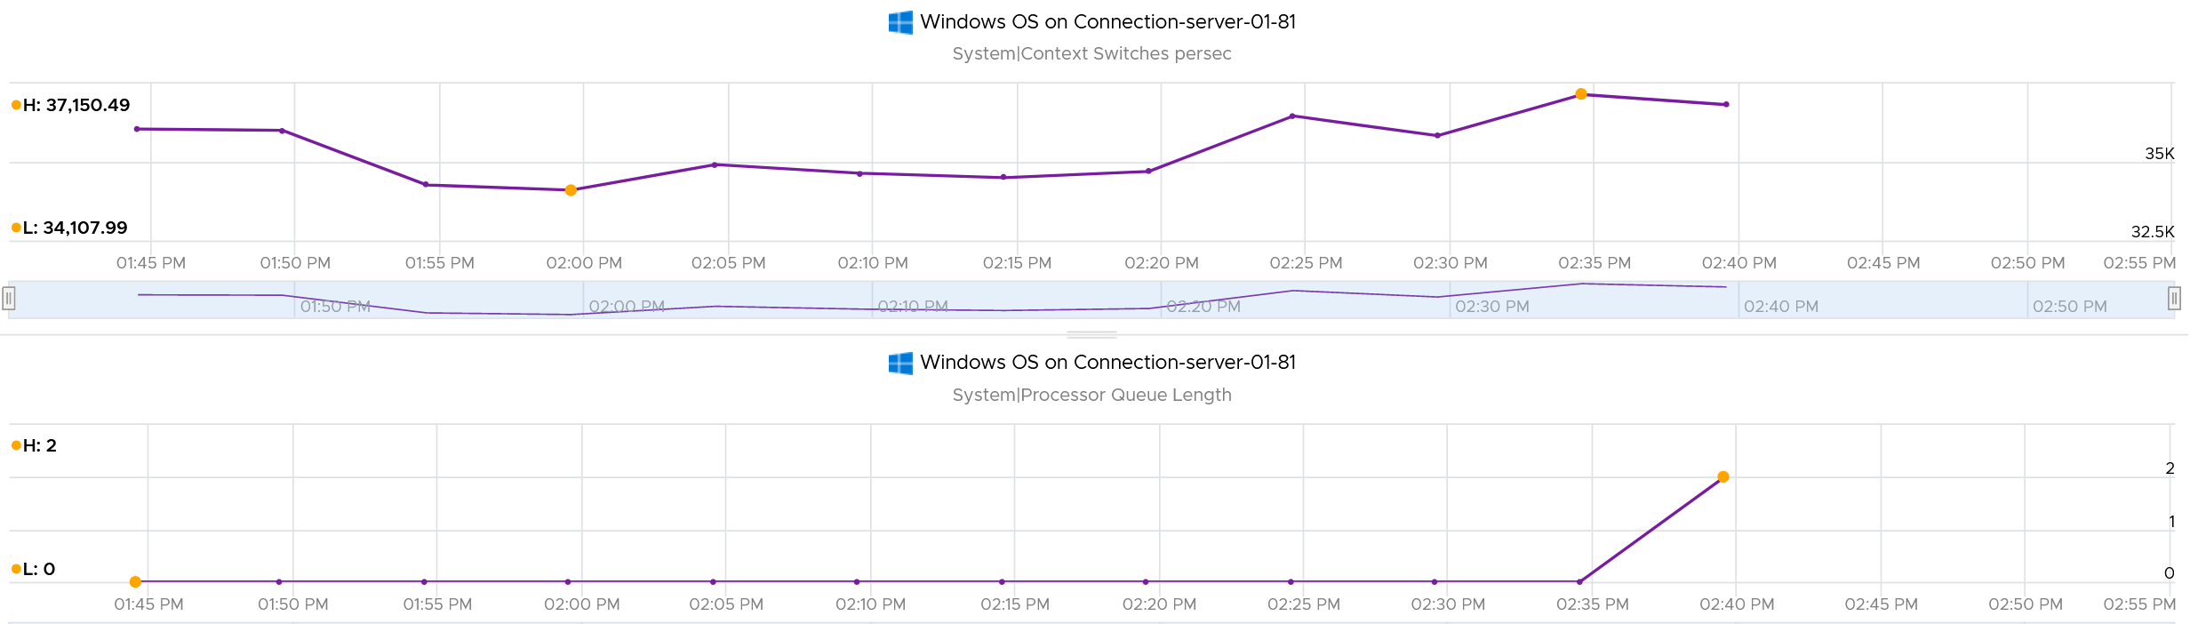

##### Runaway Process

What do you see from the CPU charts below? There are 8 CPU as seen by Windows 10. Hint: look at the total picture, no need to see each in detail. That’s why I made the screenshot tiny.

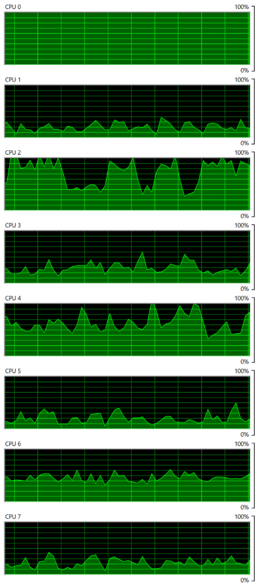

Yes, you’re right. CPU0 is running flat. The reason was one of Windows common service went into infinite loop. Ironically, this is the troubleshooting service (Diagnostic Policy Service) itself. So it’s chewing up CPU flat out non-stop. But since there are 7 other CPU, Windows overall is responsive. I could still do my work.

A counter that tracks at entire Guest OS level will not capture it. You need to complement it with a counter that tracks the highest among its CPU. If this is flat out all the time, you likely have a runaway process.

##### CPU Usage

CPU Usage in Windows is not aware of the underlying hypervisor hyper-threading. When Windows run a CPU at 100% flat, that CPU could be competing with another physical thread at ESXi level. In that case, what do you expect the value of VM CPU Usage will be, all else being equal?

62.5%.

Because that’s the hyper-threading effect.

What about VM CPU Demand? It will show 100% .

However, CPU Usage is affected by power management. Windows 8 and later will report CPU usage >100% in Task Manager and Performance Monitor when the CPU Frequency is higher than nominal speed. The reason for the change is the same with what we have covered so far, which is the need to distinguish amount of work being done. More [here](https://docs.microsoft.com/en-us/troubleshoot/windows-client/performance/cpu-usage-exceeds-100).

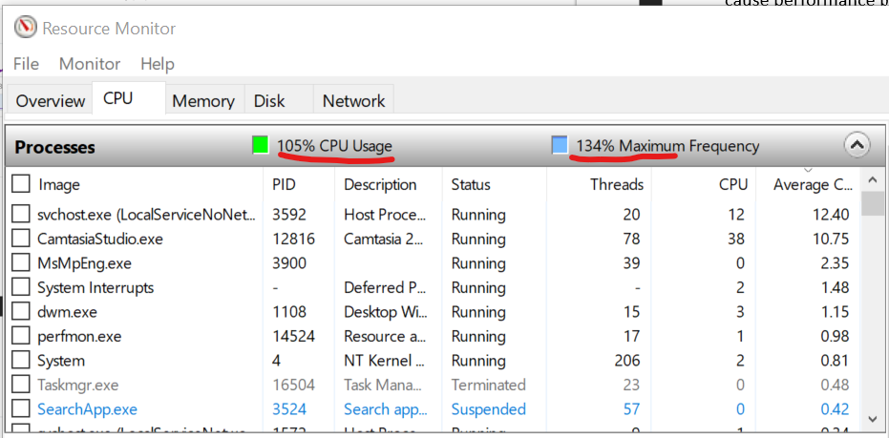

What happens to CPU Usage when VM is experiencing contention? VM Contention = Ready, Co-Stop, Overlap, Other Wait.

Time basically stops. So there is a gap in the system time of Windows. How does it deal with the gap? Does it ignore the gap, or artificially fills it with best guess values? I’m not sure. If you do let me know.

The above nature of CPU Usage brings an interesting question. Which VM counters can be used when you have no visibility into the Guest? Let’s do a comparison:

|  |  |  |  |
| --- | --- | --- | --- |
| Metric | Frequency Scaling | Hyperthreading | VM Contention |
| Guest CPU Usage | Yes | No | No |
| VM CPU Run | No | Yes | No |
| VM CPU Usage | Yes | Yes | No |
| VM CPU Demand | Yes | No | Yes |

If there is slowness but utilization is low, it’s worth checking if the utilization is coming from lower power state. This is important for application that requires high frequency (as opposed to just lots of light threads).

Windows provides the time the CPU spent on C1, C2 and C3 state. The following is taken from my laptop. Notice a dip when the total of C1 + C2 + C3 < 100%. That’s basically the time on C0.

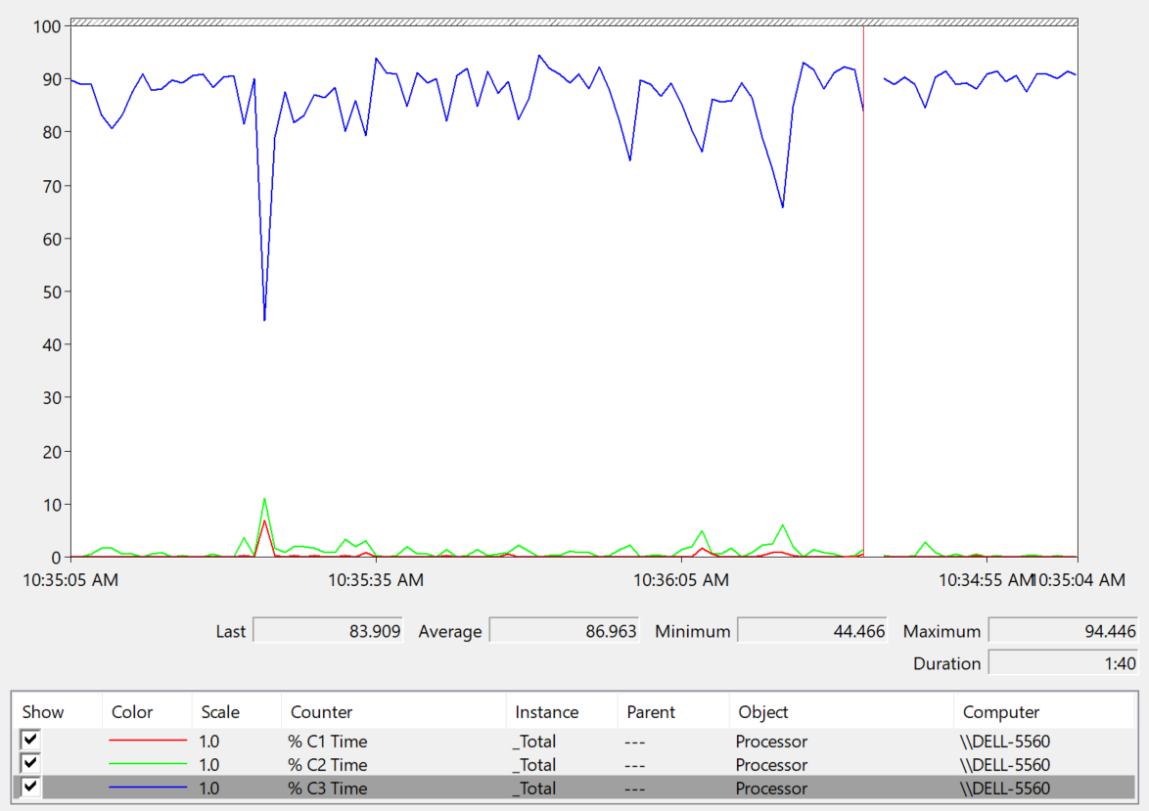

The Idle loop is typically executed on C3. Try plotting the Idle Time (%) and C3 Time (%), and they will be similar.

###### OS vs Process

CPU imbalance can happen in large VM.

Review the following chart carefully. It’s my physical desktop running Windows 10. The CPU has 1 socket 4 cores 8 threads, so Windows see 8 logical processors. You can see that Microsoft Word is not responding as its window is greyed out. The Task Manager confirms that by showing that none of the 3 documents are responding. Word is also consuming a very high power, as shown in the power usage column.

It became unresponsive because I turned on change tracking on a 500 page document and deleted hundreds of pages. It had to do a lot of processing and it did not like that. Unfortunately I wasn’t able to reproduce the issue after that.

At the operating system, Windows is responding well. I was able to close all other applications, and launched Task Manager and Snip programs. I suspect because Word does not consume all CPUs. So if we track at Windows level, we would *not* be aware that there is a problem. This is why process-level monitoring is important if you want to monitor the application. Specific to hang state, we should monitor the state and not simply the CPU consumption.

From the Windows task bar, other than Microsoft Word and Task Manager, there is no other applications running. Can you guess why the CPU utilization at Windows level is higher than the sum of its processes? Why Windows show 57% while Word shows 18.9%?

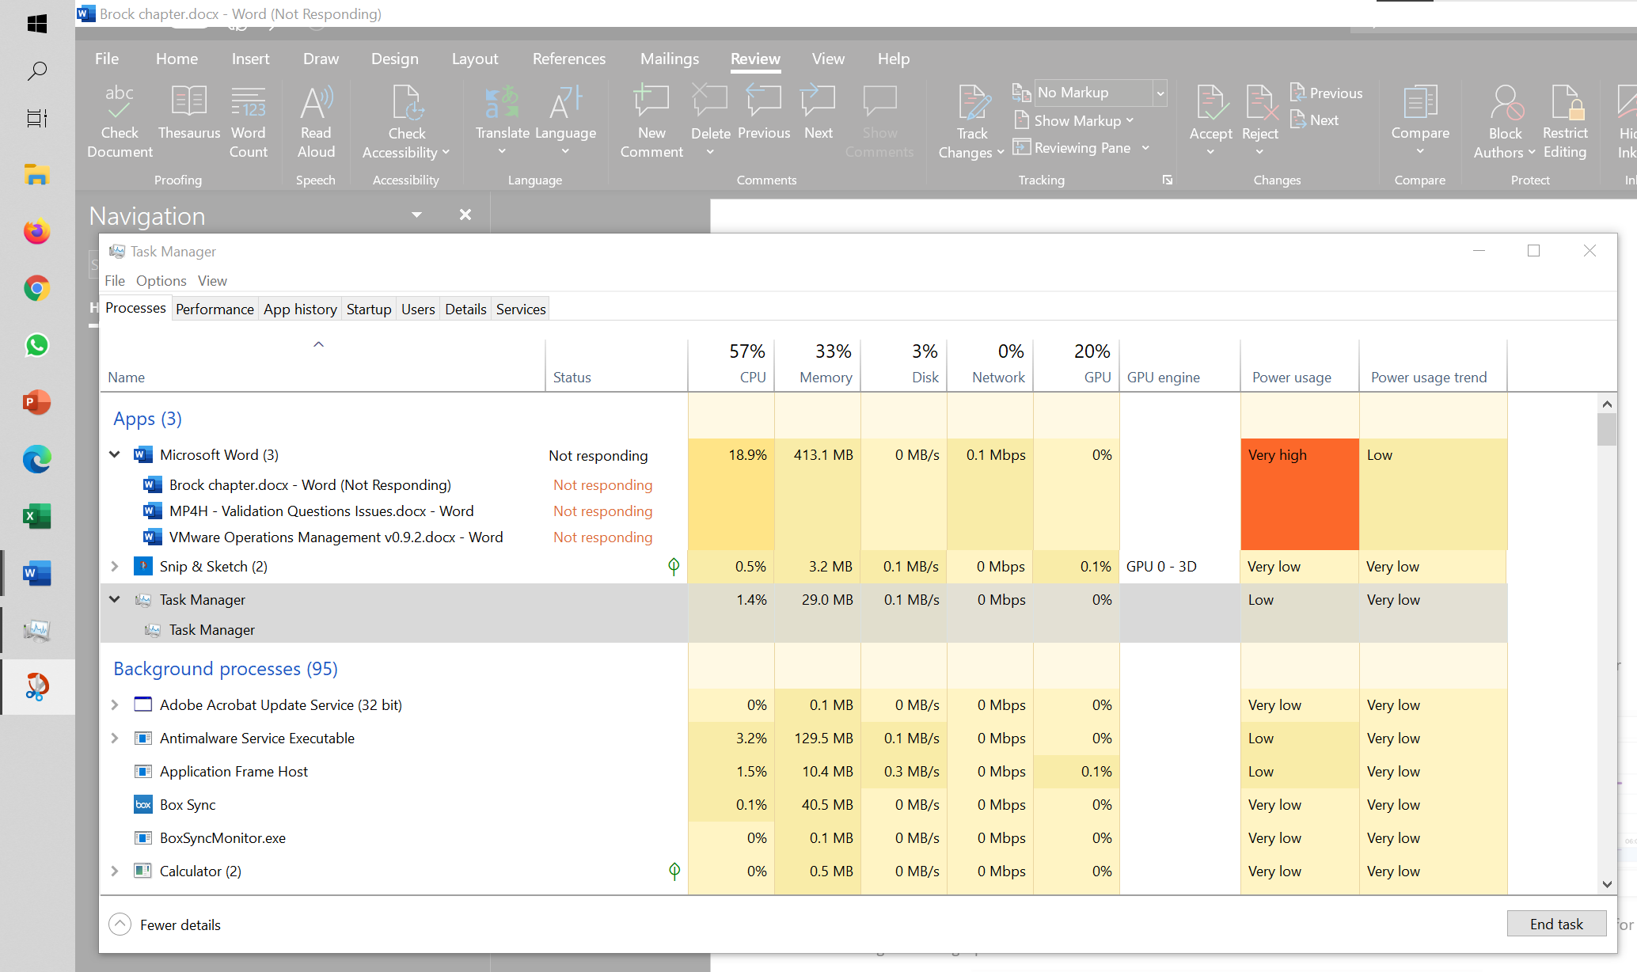

My guess is Turbo Boost. The CPU counter at individual process level does not account for it, while the counter at OS level does.

I left it for 15 minutes and nothing change. So it wasn’t that it needed more time to process the changes. I suspect it encountered a CPU lock, so the CPU where Word is running is running at 100%. Since Windows overall only reports 57%, it’s important to track the peak among Windows CPU. This is why vRealize Operations provides the peak value among the VM vCPU.

##### Other Metrics

A program’s process can switch between user mode and kernel mode (when executing system service call). This does not incur CPU context switch as it’s the same thread. As a result I’m not seeing the use case of knowing the split between kernel mode and user mode.

Reference: [Windows](https://msdn.microsoft.com/en-us/library/aa394279(v=vs.85).aspx)

Windows or Linux provides priority for foreground activities, as that’s what the user experience. For Windows, there are 6 levels as shown below. Ensure all your agents are given lower priority and limited CPU resource.

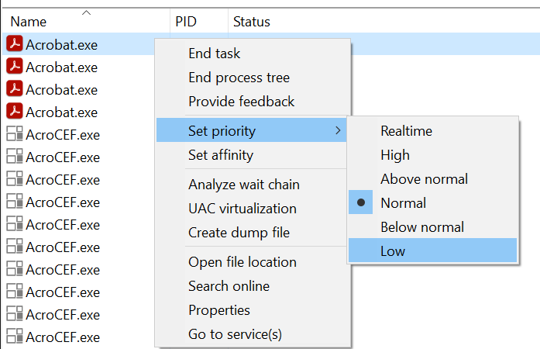

#### Memory

Windows memory management is not something that is well documented. [Ed Bott](https://www.zdnet.com/meet-the-team/us/ed-bott/) sums it [this](http://www.zdnet.com/article/windows-7-memory-usage-whats-the-best-way-to-measure/) article by saying “Windows memory management is rocket science”. Like what Ed has experienced, there is conflicting information, including the ones from Microsoft. [Mark Russinovich](https://www.linkedin.com/in/markrussinovich/), cofounder of Winternals software, explains the situation in [this](https://blogs.technet.microsoft.com/markrussinovich/2008/11/17/pushing-the-limits-of-windows-virtual-memory/) TechNet post.

Windows Performance Monitor provides many metrics, some are shown below.

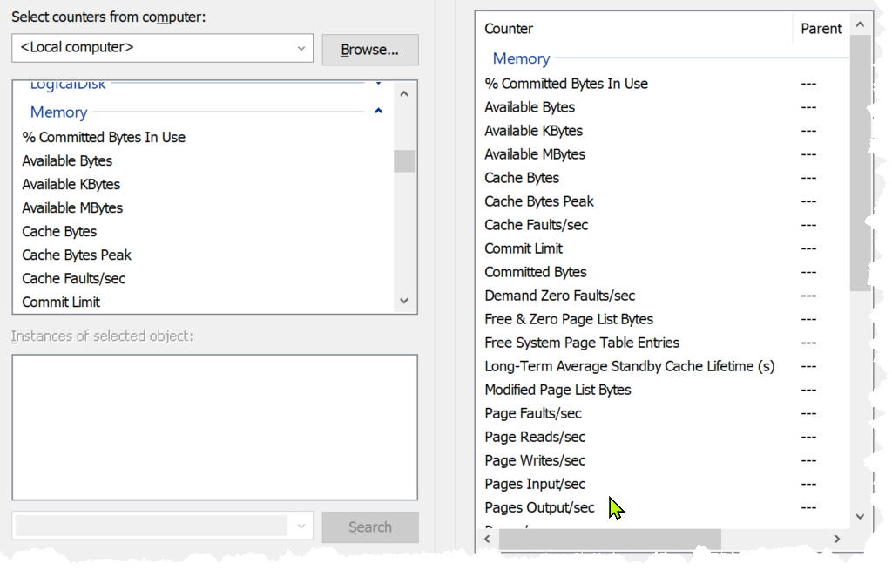

|  |  |
| --- | --- |
| Page Faults/sec |  |
| Transition Faults/sec |  |
| Demand Zero Faults/sec |  |
| Pages/sec |  |
| Page Reads/sec |
| Page Writes/sec |
| Pages Input/sec |
| Pages Output/sec |
| Available (Mbytes) | Available means exactly what the word means. It is the amount of physical memory immediately available for use. Immediately means Windows does not need to copy the existing page before it can be reused.  They are also available in Bytes and Kbytes. |
| Cache (Bytes) |  |
| Cache Bytes Peak |
| Cache Faults/sec |
| Standby Cache Core (Bytes) |  |
| Standby Cache Normal Priority (Bytes) |
| Standby Cache Reserve (Bytes) |
| System Cache Resident (Bytes) |
| Modified Page List Bytes |  |
| Commit Limit |  |
| Committed (Bytes) |
| % Committed Bytes in Use |
| Transition Pages Repurposed/sec |  |
| Write Copies/sec |  |
| Pool Pages Allocs |  |
| Pool Paged (Bytes) |  |
| Pool Paged Resident (Bytes) |  |
| Pool Nonpages Allocs |  |
| Pool Nonpaged (Bytes) |  |
| System Code Resident (Bytes) |  |
| System Code Total (Bytes) |
| System Driver Resident (Bytes) |
| System Driver Total (Bytes) |
| Free & Zero Page List(Bytes) |  |
| Free System Page Table Entries |  |

In formula, here is their definition:

* Cached = Standby + Modified
* Available = Standby + Free

It is easier to visualize it, so here it is:



A popular tool for Windows monitoring is SysInternal. In addition to the above, it shows Transition and Zeroed.



##### ****In Use****

This is the main counter used by Windows, as it’s featured prominently in Task Manager.



This is often thought as the minimum that Windows needs to operate. This is not true. If you notice on the preceding screenshot, it has compressed 457 MB of the 6.8 GB In Use pages, indicating they are not actively used. Windows compresses its in-use RAM, even though it has plenty of Free RAM available (8.9 GB available). This is a different behaviour to ESXi, which do not compress unless it’s running low on Free.

Look at the chart of Memory Usage above. It’s sustaining for the entire 60 seconds. We know this as the amount is too high to sustain for 60 seconds if they are truly active, let alone for hours.

Formula:

In use = Total – (Modified + Standby + Free)

A problem related to the In Use counter is [memory leak](https://en.wikipedia.org/wiki/Memory_leak). Essentially, the application or process does not release pages that it no longer needs, so over time it accumulates. This is hard to detect as the amount varies by application. The process will continue growing until the OS runs out of memory.

Take note this is a new metric in vRealize Operations 8.6. We call it Used Memory. You’re welcome.

##### ****Modified****

Page that was modified but no longer used, hence it’s available for other usage but requires to be saved to disk first. It’s not counted as part of Available, but counted as part of Cache.

OS does not immediately write all inactive pages to disk, especially if the disk is on power saving mode. It will consolidate these pages and write them in one shot, minimizing IO to the disk. In the case, of SSD disk, it can shorten the life span as SSD has physical limits on the number of writes.

##### ****Standby****

Windows has 3 levels of standby. As reported by VMware Tools, their names are:

* Standby Core
* Standby Normal
* Standby Reserve

Different applications use the memory differently, resulting in different behaviour of the metrics. As a result, determining what Windows actually uses is difficult.

The Standby Normal counter can be fluctuating wildly, resulting in a wide difference if it’s included in rightsizing. The following VM is a Microsoft Exchange 2013 server mailbox utility.



Notice the Standby Normal fluctuates wildly, reaching as high at 90%. The other 2 cache remains constantly negligible. The chart above is based on >26000 samples, so there is plenty of chance for each 3 metrics to fluctuate.

Now let’s look at another example. This is a Windows Server 2016. I think it was running Business Intelligence software Tableau.



Notice the VM usable memory was increased 2x in the last 3 months. Standby Normal hardly move, but Standby Reserve took advantage of the increments. It simply went up accordingly, although again it’s fluctuating wildly.

##### Cache

Cache is an integral part of memory management, as the more you cache, the lower your chance of hitting a cache miss. This makes sense. RAM is much faster than Disk, so if you have it, why not use it? Remember when Windows XP introduced pre-fetch, and subsequently Windows SuperFetch? It’s a clue that memory management is a complex topic. There are many techniques involved. Unfortunately, this is simplified in the UI. All you see is something like this:



##### ****Free****

As the name implies, this is a block of pages that is immediately available for usage. This excludes the cached memory. A low free memory does not mean a problem if the Standby value is high. This number can reach below 100 MB, and even touch 0 MB momentarily. It’s fine so long there is plenty of cache. I’d generally keep this number > 500 MB for server VM and >100 MB for VDI VM. I set a lower number for VDI because they add up. If you have 10K users, that’s 1 TB of RAM.

When Windows or Linux frees up a memory page, it normally just updates its list of free memory; it does not release it. This list is not exposed to the hypervisor, and so the physical page remains claimed by the VM. This is why the Consumed counter in vCenter remains high when the Active counter has long dropped. Because the hypervisor has no visibility into the Guest OS, you may need to deploy an agent to get visibility into your application. You should monitor both at the Guest OS level (for example, Windows and Red Hat) and at the application level (for example, MS SQL Server and Oracle). Check whether there is excessive paging or the Guest OS experiences a hard [page fault](https://en.wikipedia.org/wiki/Page_fault). For Windows, you can use tools such as pfmon, a page fault monitor.

This is one the 3 major metrics for capacity monitoring. The other 2 metrics are Page-in Rate and Commit Ratio. These 3 are not contention metrics, they are utilization metrics. Bad values can contribute to bad performance, but they can’t measure the severity of the performance. Windows and Linux do not have a counter that measures how long or how often a CPU waits for memory.

In Windows, this is the Free Memory counter. This excludes the cached memory. If this number drops to a low number, Windows is running out of Free RAM. While that number varies per application and use case, generally keep this number > 500 MB for server VM and >100 MB for VDI VM. The reason you should set a lower number for VDI because they add up quickly. If you have 10K users, that’s 1 TB of RAM.

It’s okay for this counter to be low, so long other memory metrics are fine. The following table shows VMs with near 0 free memory. Notice none of them are needing more memory. This is the perfect situation as there is no wastage.



##### ****Page File****

[Memory paging](https://en.wikipedia.org/wiki/Memory_paging) is an integral part of Guest OS Memory Management. OS begins using it even though it still has plenty of physical memory. It uses both physical memory and virtual memory at the same time. Microsoft recommends that you do not delete or disable the page file. See [this](http://windows.microsoft.com/en-us/windows/change-virtualmemory-size) for reference.



As shown on the diagram, processes see virtual memory, not physical memory. Guest OS presents this as system API to processes. The virtual memory is backed by the page file and physical memory. Guest OS shields the physical memory and hardware. Paging is an operation of reading/writing from the page file into the physical memory, not from physical disk into the page file.

Let Windows manages the pagefile size. This is the default setting, so you likely have it already. By default, windows sets the pagefile size to the same size with the physical memory. So if the VM has 8 GB of RAM, the pagefile is an 8 GB file. Anything above 8 GB indicates that Windows is under memory pressure.

The VM metric Guest \ Swap Space Remaining tracks the amount of swap space that's free.

The size of Page File is not a perfect indicator of the RAM usage, because they contain pages that are never demanded by the application. Windows does SuperFetch, where it predicts what pages will be used and prefetch them in advance. Some of these pages are never demanded by the application. Couple with the nature that Guest OS treats RAM as cache, including the page file will result in oversized recommendation. Paging rate is more realistic as it only considers the recent time period (300 seconds in vRealize Operations case)

A page would be used as cache if it was paged out at some point due to memory pressure and it hasn’t been needed since. The OS will reuse that page as cache. That means that at some point the OS was constrained on memory enough to force the page out to happen.

A page that was paged out earlier, has to be brought back first before it can be used. This creates performance issue as the application is waiting longer, as disk is much slower than RAM.

There are 2 types of page operations:

* Page In. This is a potential indicator for performance.
* Page-out. This is a potential indicator for capacity.

While Paging impacts performance, the correlation between the paging metrics and performance varies per application. You can’t set a threshold and use it to monitor different applications or VM. The reason is paging is not always used when Guest OS runs out of memory. There are a few reasons why paging may not correlate to memory performance:

* Application binary. The initial loading causes a page-in. Nobody will feel the performance impact as it’s not even serving anyone.
* Memory mapped files. This is essentially a file that has a mapping to memory. Processes use this to exchange data. It also allows the process to access a very large file (think of database) without having to load the entire database into memory.
* Proactive pre-fetch. It predicts the usage of memory and pre-emptively reads the page and bring it in. This is no different to disk where the storage array will read subsequent blocks even though it’s not being asked. This especially happens when a large application starts. Page-in will go up even though there is no memory pressure (page out is low or 0).
* Windows performs memory capacity optimization in the background. It will move idle processes out into the page file.

If you see both Page-in and Page-out having high value, and the disk queue is also high, there is a good chance it’s memory performance issue.

The rate pages that are being brought in and out can reveal memory performance abnormalities. A sudden change, or one that has *sustained over time*, can indicate page faults. Page faults indicate pages aren’t readily available and must be brought in. If a page fault occurs too frequently it can impact application performance. While there is no concrete guidance, as it varies by application, you can judge by comparing to its past behaviour and its absolute amount.

Operating Systems typically use 4KB or 2MB page sizes. Larger page size will result in more cache, which translates into more memory required.

The counter %pagefile tracks how much of the pagefile is used, meaning the value 100% indicate the pagefile is fully utilized. While the lower the number the better, there is no universal guidance. If you know, let me know!

Reference: [this](https://docs.microsoft.com/en-US/troubleshoot/windows-server/performance/ram-virtual-memory-pagefile-management) is an old article as it covers 32 bit Windows. If you find a newer one, kindly let me know.

##### Guest OS Paging metrics

There are 2 metrics. Page-in and Page-out.

The unit is in number of pages, not MB. It's not possible to convert due to mix use of Large Page (2 MB) and Page (4 KB). A process can have concurrent mixed usage of large and non-large page in Windows. The page size isn’t a system-wide setting that all processes use. The same is likely true for Linux Huge Pages.

The page-in rate metric tracks the rate OS brings memory back from disk to DIMM per second. Another word, the rate of reads going through paging/cache system. It includes not just swap file I/O, but cacheable reads as well (so it’s double pages/s).

Page Out is the opposite of the above process. It is not as important as Page In. Just because a block of memory is moved to disk that does not mean the application experiences memory problem. In many cases, the page that was moved out is the idle page. Windows does not page out any Large Pages.

The following shows the page out value at 99th percentile in the last 4 months. What do you observe?

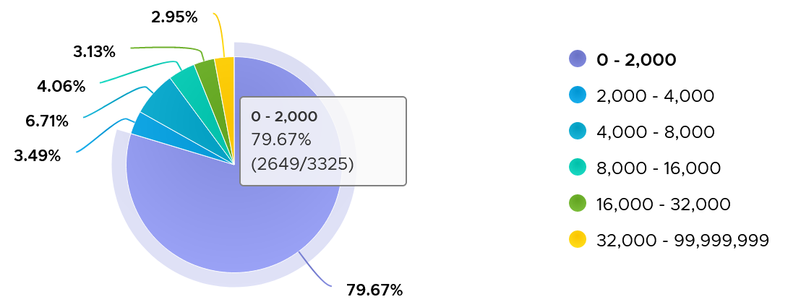

There are 3325 VM in the above chart. In the last 4 months, 97% of them have page-out rate of less than 32000 pages, on a 5-minute average basis.

How about the remaining 3%?

Surprisingly, a few of them can be well 500000, indicating there is a wide range. So majority of VMs do not page out, but those that do, they do it excessively.

The block size is likely 4 KB. Some applications like Java and databases use 2 MB pages. Using 8 KB as the average, 10000 pages per second sustained over 5 minutes means 80000 KB x 300 = 24 GB worth of data.

You can profile your environment to see which VMs are experiencing high paging. Create a view with the following 6 columns

* Highest Page-In. Color code it with 1000, 10000, and 100000 as the thresholds. That means red is 10x orange, which in turn is 10x yellow.
* Page-In value at 99th percentile. Same threshold as above.
* Highest Page-Out. Same threshold as above.
* Page-Out value at 99th percentile. Same threshold as above.
* Sum of Page-In
* Sum of Page-Out

Set the dates to the period you are interested, but make it at least 1 week, preferably 3 months. There 2016 data points in a week, so the 99th percentile ignores the highest 20 datapoints.

In the following example, I used 4 months. I listed the top VMs in terms, sorted by the highest page-in. What observation do you see?

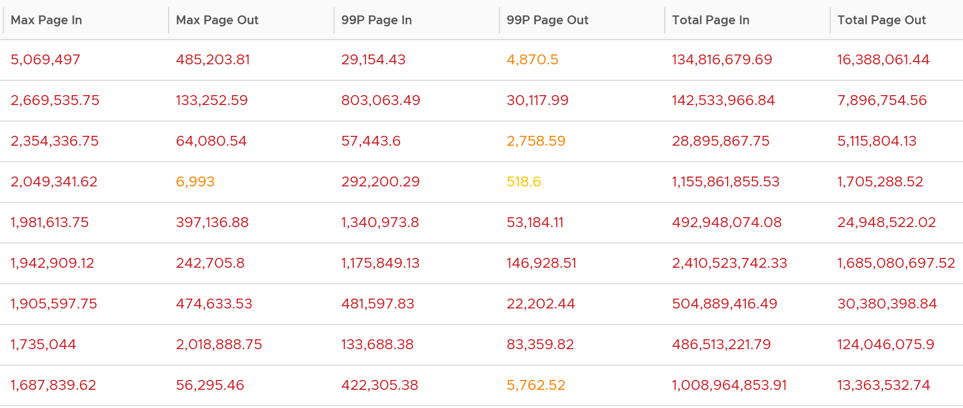

For a start, some of those numbers are really high!

They are above 1 millions. Assuming 8K block size, that’s 8 GB per second, sustained for 300 seconds.

What else do you notice?

Page-In is higher than Page-Out. I average all the 3K VMs and I got the following result:



Page-In is 4x higher in the max value. Page-In also sustains longer, while Page-Out drops significantly. At the 99th percentile mark, Page-In is 9x higher. I suspect it is the non-modifiable page, like binary. Since it cannot be modified, it does not need to be paged out. It can simply be discarded and retrieved again from disk if required.

The good news is both do not sustain, so the paging is momentary. The following shows that the value at 99th percentile can drop well below 5x.

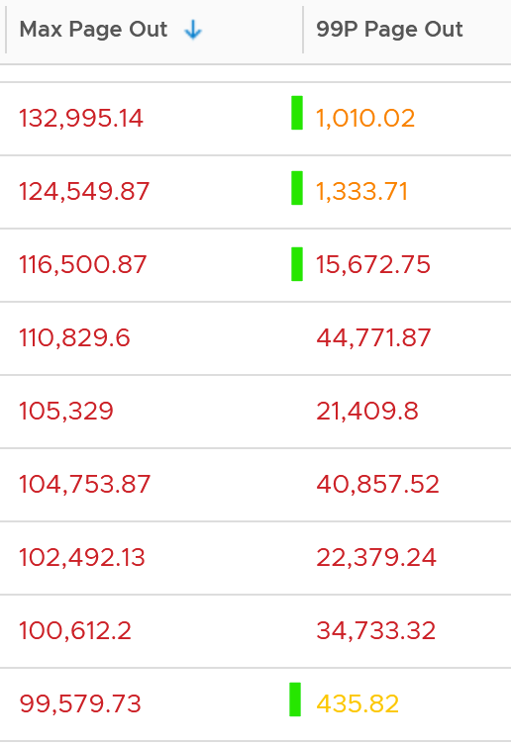 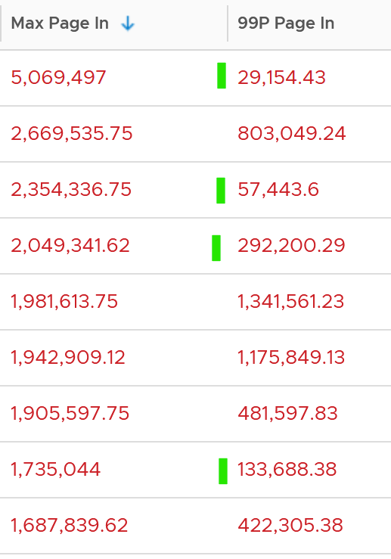

To confirm the above, I downloaded the data so I can determine if the paging is indeed momentarily. Using a spreadsheet, I build a ratio between the 99th percentile value and the maximum value, where 10% means there is a drop of 10x. I plotted around 1000 value and got the following.

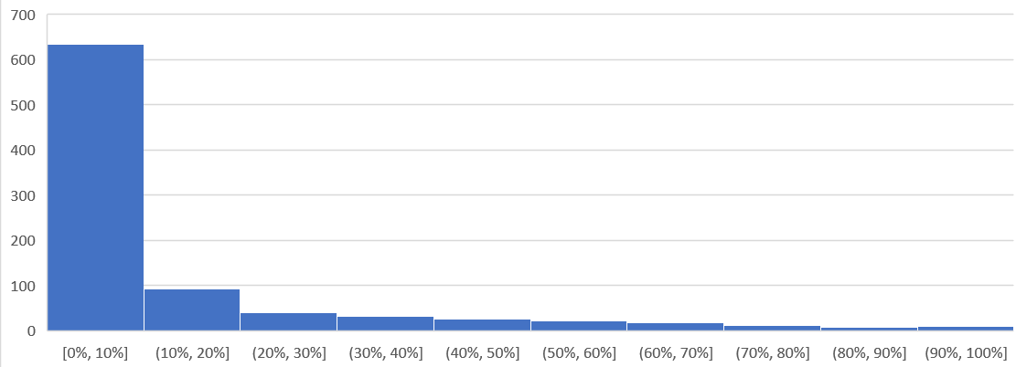

As you can see, majority of the paging drops drastically at 99th percentile.

Let’s dive into a single VM, so we can see pattern over time. I pick a database, as it does heavy paging. The following is a large Oracle RAC VM. Notice this has a closer ratio between page in and page out, and there is correlation between the two.

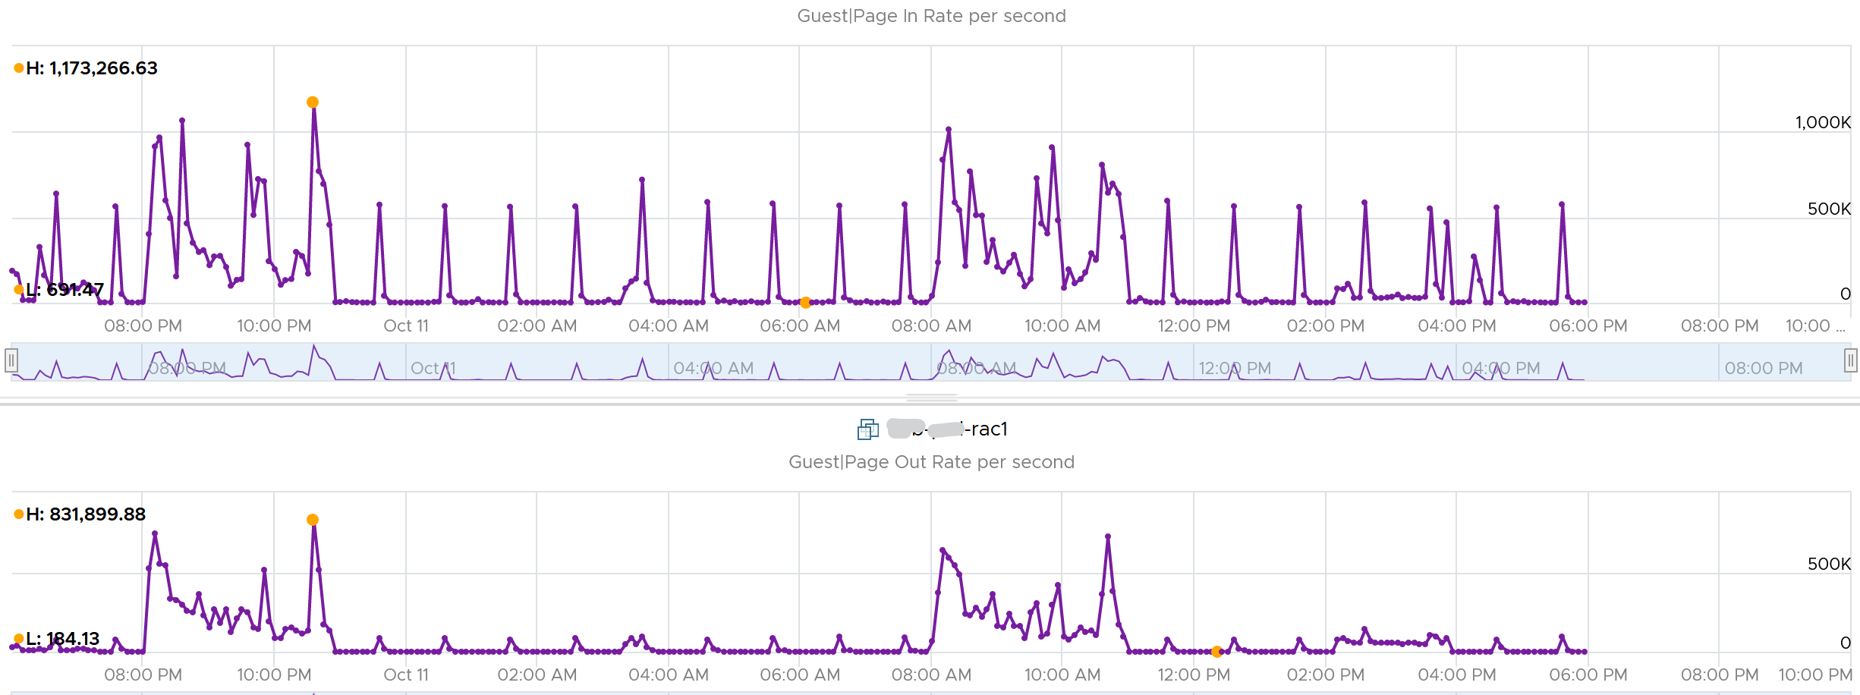

Assuming the page size is 4 KB, that means 100,000 pages = 400 MB/sec. Since vRealize Operations averages the value over 300 seconds, that means 400 MB x 300 = 120 GB worth of paging in 5 minutes!

##### Active File Cache Memory

This is the actively in-use subset of the file cache. Unused file cache and non-file backed anonymous buffers (mallocs etc) are not included.

This is the size of the portion of the system file cache which is currently resident and active in physical memory. The System Cache Resident Bytes and Memory \ Cache Bytes metrics are equivalent. Note that this counter displays the last observed value only; it is not an average during the collection period.

In Linux, this is the amount of file cache memory, in kibibytes, that is in active use, or was in active use since the last time the system reclaimed memory. This is retrieved via the command:

$ cat /proc/meminfo | grep Active

Active: 50955636 kB

Active (anon): 30148196 kB

Active (file): 20807440 kB

For further reading, refer to [Windows](https://wutils.com/wmi/root/cimv2/win32_perfrawdata_perfos_memory/#systemcacheresidentbytes_properties)

##### Committed

Commit sounds like a guaranteed reservation, which means it’s the minimum the process can get.

**This tracks** the currently committed virtual memory, although not all of them are written to the pagefile yet. It measures the demand, so commit can go up without In Use going up, as Brandon Paddock shares [here](http://brandonlive.com/2010/02/21/measuring-memory-usage-in-windows-7/). If Committed exceeds the available memory, paging activity will increase. This can impact performance.

**Commit Limit**: Commit Limit is physical RAM + size of the page file. Since the pagefile is normally configured to map the physical RAM, the Commit Limit tends to be 2x. **Commit Limit** is important as a growing value is an early warning sign. The reason is Windows proactively increases its **pagefile.sys** if it’s under memory pressure.

The pagefile is an integral part of Windows total memory, as explained by [Mark Russinovich](https://www.linkedin.com/in/markrussinovich/) explains [here](https://blogs.technet.microsoft.com/markrussinovich/2008/11/17/pushing-the-limits-of-windows-virtual-memory/). There is Reserved Memory, and then there is Committed Memory. Some applications like to have its committed memory in 1 long contiguous block, so it reserves a large chunk up front. Databases and JVM belong in this category. This reserved memory does not actually store meaningful application data or executable. Only when the application commits the page that it becomes used. Mark explains that “when a process commits a region of virtual memory, the OS guarantees that it can maintain all the data the process stores in the memory either in physical memory or on disk”.

Notice the word **on disk**. Yes, that’s where the pagefile.sys comes in. Windows will use either the physical memory or the pagefile.sys.

So how do we track this committed memory?

The metric you need to track is the Committed Byte. The % Committed metric should not hit 80%. Performance drops when it hits 90%, as if this is a hard threshold used by Windows. We disabled the pagefile to verify the impact on Windows. We noticed a visibly slower performance even though Windows 7 showing >1 GB of Free memory. In fact, Windows gave error message, and some applications crashed. If you use a pagefile, you will not hit this limit.

We have covered Free Memory and Committed Memory. Do they always move in tandem? If a memory is committed by Windows, does it mean it’s no longer free and available?

The answer is no. Brandon Paddock demonstrated [here](http://brandonlive.com/2010/02/21/measuring-memory-usage-in-windows-7/) that you can increase the committed page without increasing the memory usage. He wrote a small program and explained how it’s done. The result is Windows committed page is double that of memory usage. The Free Memory & Cached Memory did not change.

##### Guest OS Needed memory

We shared earlier that the purpose of memory is to act as disk cache. So you want to utilize all the cache given to you. Because the static nature of memory consumption, you can create a heat map that plots all your VMs memory consumption. You want it near 100% while making sure the page in and page out rate within normal expectation.



This is *not* a raw counter from Windows or Linux. This is a derived counter provided by VMware Tools to estimate the memory needed to run with minimum swapping. It’s a more conservative estimate as it includes some of the cache.

The counter Needed memory tracks the amount of memory needed by the Guest OS. It has 5% buffer for spike, based on the general guidance from Microsoft. Below this amount, the Guest OS may swap.

= physical memory - Maximum of (0, ( Unneeded - 5 % of physical ))

where Unneeded = Free + Reserve Cache + Normal Priority Cache

Example: the VM has 10 GB of RAM. So the Physical RAM = 10 GB

So 5% of physical = 0.5 GB

**Situation 1: max memory utilization.**Memory Available = 0 GB.   
Tools will calculate Needed memory as  
= 10 GB - Maximum (0, 0 – 0.5)  
= 10 - Maximum (0, -0.5)  
= 10 - 0 GB  
= 10 GB  
Needed memory is the same as it’s already maxed.

**Situation 2: high memory utilization.**Memory Available = 2 GB.   
Tools will calculate Needed memory as  
= 10 GB - Maximum (0, 2 – 0.5)  
= 10 - Maximum (0, 1.5 GB)  
= 10 - 1.5 GB  
= 8.5 GB  
You actually still have 2 GB here. But Tools adds around 5%

**Situation 3: low memory utilization.**Memory Available = 8 GB.   
Tools will calculate Needed memory as  
= 10 GB - Maximum (0, 8 – 0.5)  
= 10 - Maximum (0, 7.5 GB)  
= 10 - 7.5 GB  
= 2.5 GB  
Again, Tools adds around 5%.

We’ve covered that you need to look at more than 1 metric before you decide to add more memory. I’m afraid it is case by case, as shown in the following table. All these VMs are low on free memory, but other than VM on row no 3, the rest has sufficient memory.



##### ****Other Metrics****

**Page Size:** Size of the page. In Windows, this is 4 KB by default. This is not the size of the pagefile.sys in c:\.

**Paged pool**: this is a part of Cache Bytes. Based on [this](http://www.appadmintools.com/documents/windows-performance-counters-explained/) great article, it includes Pool Paged Resident Bytes, the System Cache Resident Bytes, the System Code Resident Bytes and the System Driver Resident Bytes.

**Non-paged pool**: this is kernel RAM. It cannot be paged out. It’s part of In Use.

**Working Set:** this measures the active usage by all processes. If this number exceeds the available memory, Windows decreases the working set of processes to minimize paging.

**Remaining Swap**: The amount of swap space remaining, taking into account the possibility of swap file growth where possible. A low remaining will trigger paging. If the system is configured to run without a swap file, this will return zero

#### Storage

This is the layer that application team care as it is what is presented to them.

|  |  |
| --- | --- |
| ****Questions**** | Description |
| Configuration | For each partition, need to know name, filesystem type (e.g. NTFS, ext4), network or local, block size.  Ideally, we get the mapping between partition and virtual disk. |
| Capacity | For each partition, need to know the configured space and used space. For free space, we need to know both in absolute (GB) and relative (%).  Need to alert before running out of disk space, else the OS crashes.  We should not include the networked drive in Guest OS capacity, because the networked drive is typically shared by many. An exception is in VDI use case, where the user personal files is stored on the network. |
| Reclamation | This can be determined from the free space. Reclamation is tricky as it needs to shrink partition. |
| Performance | Queue, Latency (read and write), IOPS, Throughput |

##### Overview

Windows provides rich set of metrics, both at disk and filesystem. I’m not sure if this includes networked fileshare.

###### Disk Metrics

You will find the disk metrics in Performance Monitor under Physical Disk. It’s interesting it’s still called Physical. Does it mean it’s unaware it’s actually virtual?

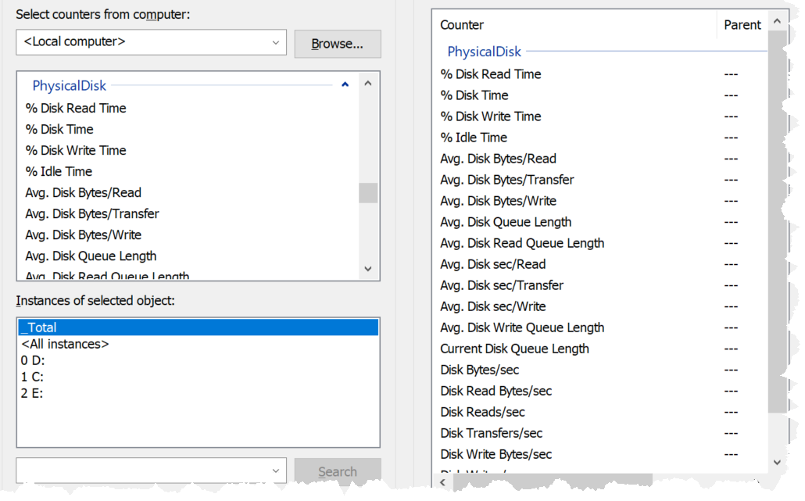

Source is [here](https://docs.microsoft.com/en-us/previous-versions/ms804037(v=msdn.10)?redirectedfrom=MSDN).

|  |  |
| --- | --- |
| Current Disk Queue Length | This is the primary counter for performance, hence I show it first. It is covered in-depth after this summary. |
| Avg. Disk Queue Length |
| Avg. Disk Write Queue Length |
| Avg. Disk Bytes/transfer | This is block size in bytes. It should be 4KB or 2 MB. |
| Avg. Disk Bytes/read |
| Avg. Disk Bytes/write |
| Avg. Disk Sec/transfer | This is latency, but strangely shown in second instead of millisecond. |
| Avg. Disk Sec/read |
| Avg. Disk Sec/write |
| Disk Bytes/sec | This is disk throughput in bytes. So you have the total throughput, read throughput and write throughput.  The word transfer here means being read from or written to the disk. |
| Disk Read Bytes/sec |
| Disk Write Bytes/sec |
| Disk Transfers/sec | This is IOPS |
| Disk Reads/sec |
| Disk Writes/sec |
| Free (Megabytes) |  |
| Split IO/sec | From the manual: Shows the rate at which that I/O requests to the disk were split into multiple requests. A split I/O may result from requesting data in a size that is too large to fit into a single I/O or that the disk is fragmented on single-disk systems. |

##### Disk Queue

With VMware Tools, you get Guest OS visibility into the partitions and disk queue. The first one is critical for capacity, while the second is critical for performance.

This counter tracks the queue inside Linux or Windows storage subsystem. It’s not the queue at SCSI driver level, such as LSI Logic or PVSCSI. If this is high then the IO from applications did not reach the underlying OS SCSI driver, let alone the VM. If you are running VMware storage driver, such as PVSCSI, then discuss with VMware Support.

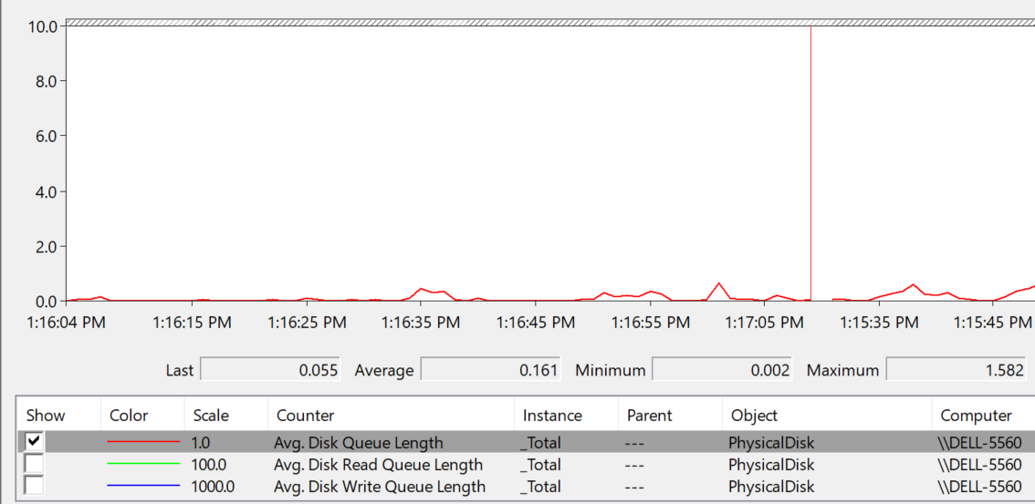

There are actually 2 metrics: One is a point in time and the other is average across the entire collection cycle. Point in time means the snapshot at the collection period. For example, if the collection is every 5 minute, then it’s number on the 300th second, not the average of 300 numbers.

[Windows documentation](https://docs.microsoft.com/en-us/previous-versions/ms804035(v=msdn.10)?redirectedfrom=MSDN) said that “Multi-spindle disk devices can have multiple requests active at one time, but other concurrent requests await service. Requests experience delays proportional to the length of the queue minus the number of spindles on the disks. This difference should average < 2 for good performance.”

|  |  |
| --- | --- |
| guest.disk.queue | Win32_PerfFormattedData_PerfDisk_PhysicalDisk.Name = \"_Total\"#CurrentDiskQueueLength" from WMI |
| guest.disk.queueAvg | Win32_PerfFormattedData_PerfDisk_PhysicalDisk.Name = \"_Total\"#AvgDiskQueueLength" from WMI |

High disk queue in the guest OS, accompanied by low IOPS at the VM, can indicate that the IO commands are stuck waiting on processing by the OS. There is no concrete guidance regarding these IO commands threshold as it varies for different applications. You should view this in relation to the Outstanding Disk IO at the VM layer.

Based on 3000 production VMs in the last 3 months, the value turn out to be sizeable. Almost 70% of the value is below 10. Around 10% is more than 100 though, which I thought it’s rather high.

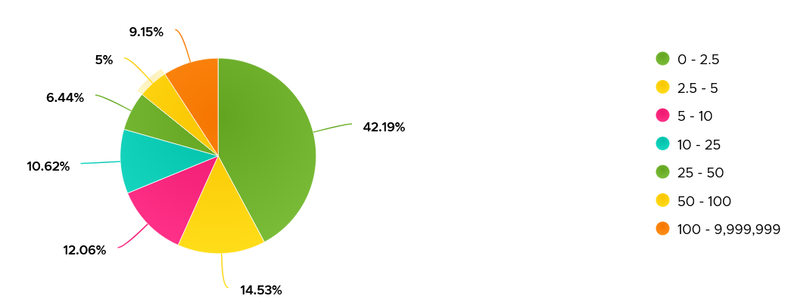

Strangely, there are values that seem to *off the chart*. I notice this in a few metrics already, including this. Look at the values below. Do they look like a bug in the counter, or severe performance problem?

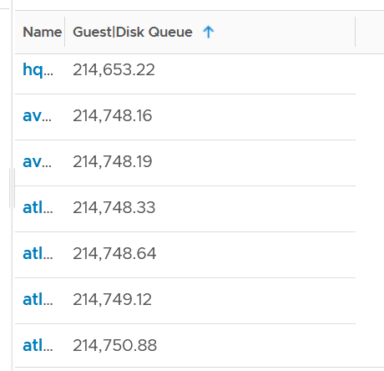

Unfortunately, we can’t confirm as we do not have latency counter at Guest OS level, or even better, as application level. I am unsure if the queue is above the latency, meaning the latency counter does not start counting until the IO command is executed.

I plot the values at VM level, which unsurprisingly does not correlate. The VM is tracking IO that has been sent, while Guest OS Disk Queue tracks the one that has not been sent.

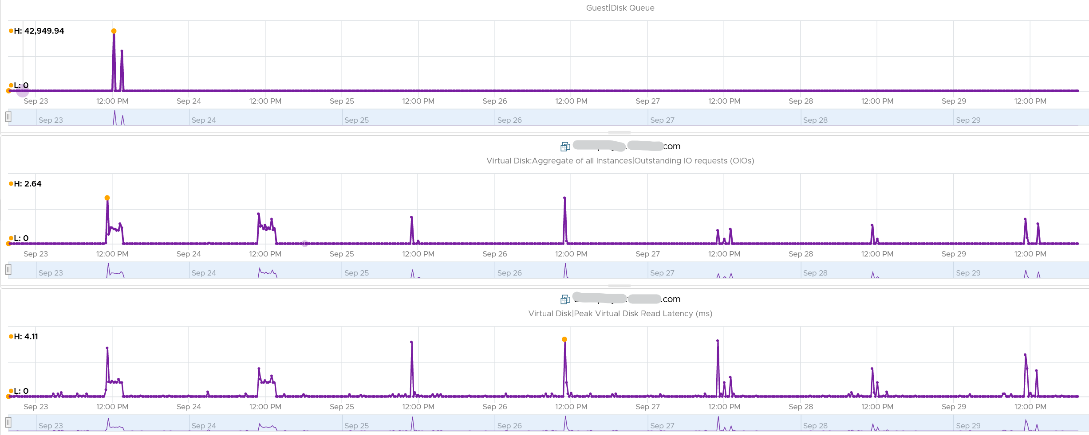

The preceding line chart also reveals an interesting pattern, which is disk queue only happens rarely. It’s far less frequent than latency.

Let’s find out more. From the following heat map, you can see there are occurrences where the value is >100.

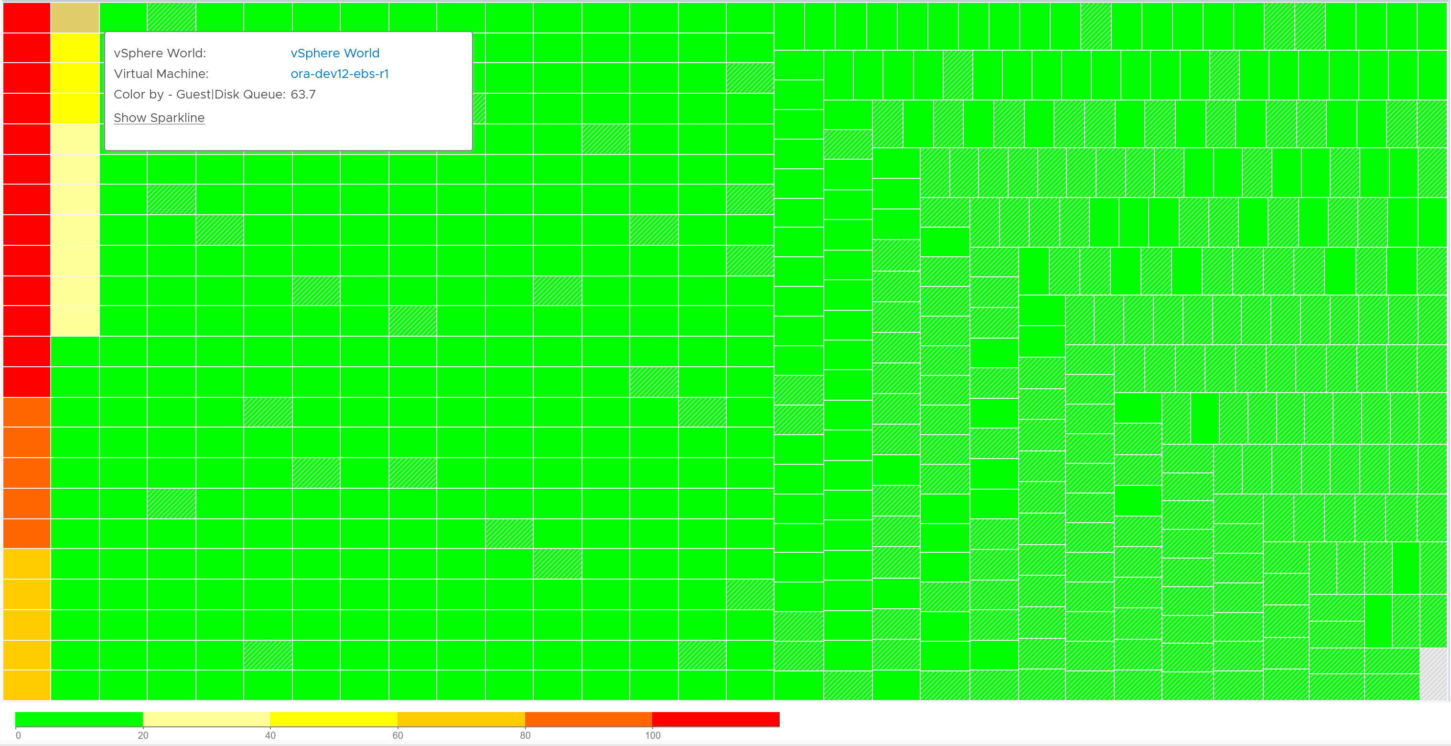

However, when we compare between current value and maximum value, the value can be drastically different.



Let’s take one of the VMs and drill down. This VM has regular spikes, with the last one exceeding 1000.



Their values should correlate with disk outstanding IO. However, the values are all low. That means the queue happens inside the Guest OS. The IO is not sent down to the VM.



Which in turn should have some correlation with IOPS, especially if the underlying storage in the Guest OS (not VM) is unable to cope. The queue is caused by high IOPS which cannot be processed.



Finally, it would manifest in latency. Can you explain why the latency is actually still good?



It’s because that’s from the IO that reaches the hypervisor. The IO that was stuck inside Windows is not included here.

The application feels latency is high, but the VM does not show it as the IO is stuck in between.

Can the disk queue be constantly above 100?

The following VM shows 2 counters. The 20-second Peak metric is showing ~200 – 250 queue, while the 5-minute average shows above 125 constantly. The first counter is much more volatile, indicating the queue did not sustain.

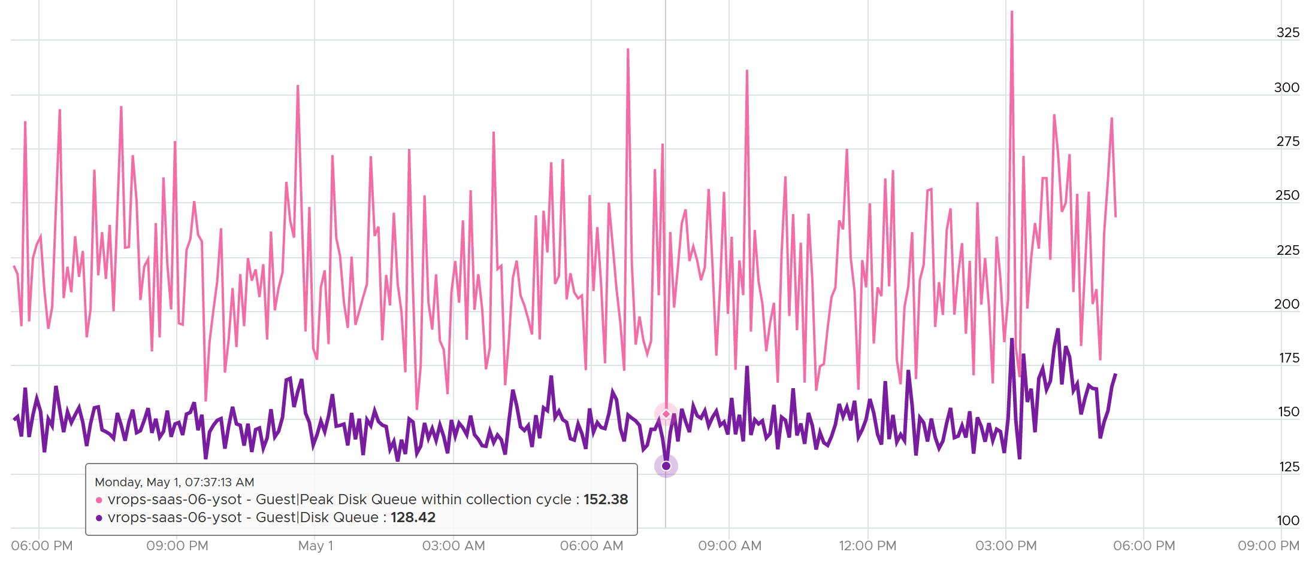

##### Disk Throughput

You can test the disk throughput by doing comparison test between parallel vs serial, and between small files and large files. Make sure the test is reproducible, especially with variances. In the following, I tested using large files (almost 3 GB each). I found that Windows 11 deliver better throughput when it does serial (one file at a time) vs parallel (3 files). Notice the 4 red dots. It shows the overall throughput started around 38 MB/s, then dropped when I added 2 more threads, then went up again when I paused the 2 threads (became serial).

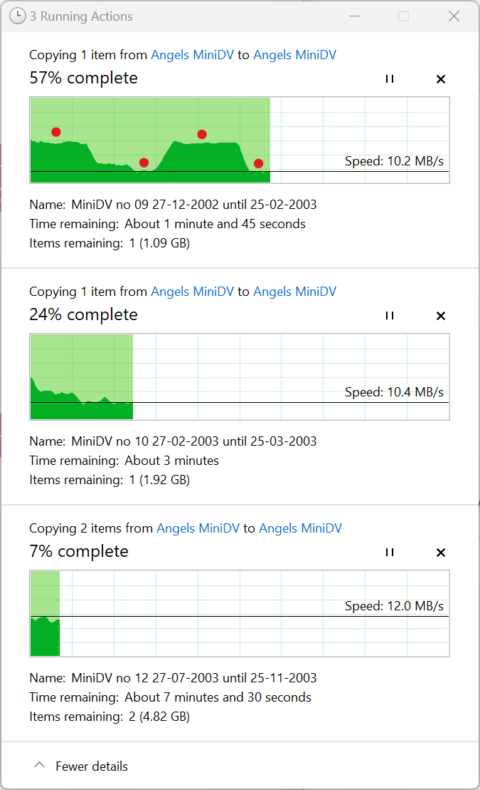

By increasing the parallel threads, the total throughput dropped from 37.5 MB/s to just 32, which is significant drop.

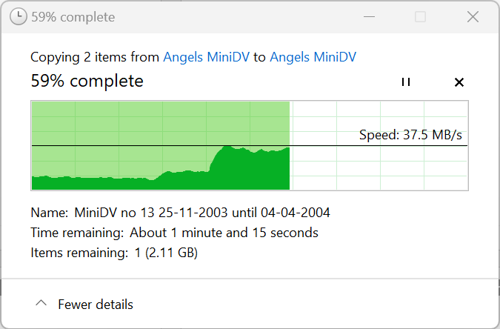

By the way, if this is for production application, I’d test with more variances. The more the combination, the more confidence you are on your assumption.

##### Defragmentation

The following screenshot shows Windows defragmentation dialog box. I’m not sure why solid state drive needs it as there is no spinning plate, meaning it is random access.

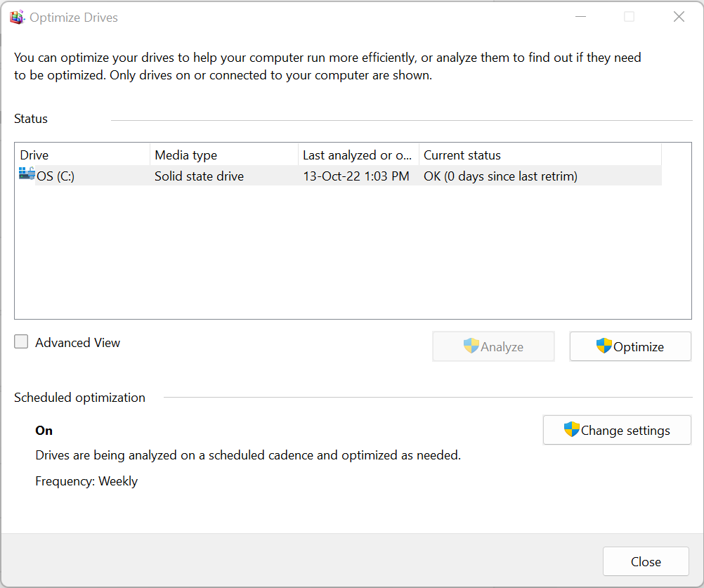

##### Disk Space

Guest OS partition and virtual disks have M:N relationship. The following Windows 11 screenshot shows an example where multiple partitions share a virtual disk.

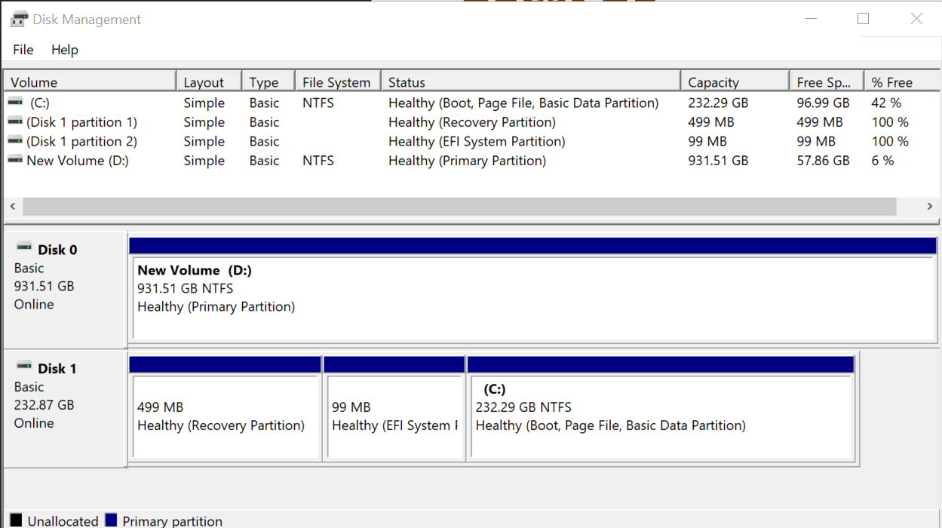

You can also make a single partition spans across multiple virtual disks.

Guest OS also does not have to allocate all the space in a virtual disk. For those space allocated, it does not have to make it visible to users.

vRealize Operations show the partitions as instanced metrics, under Guest File System metric group

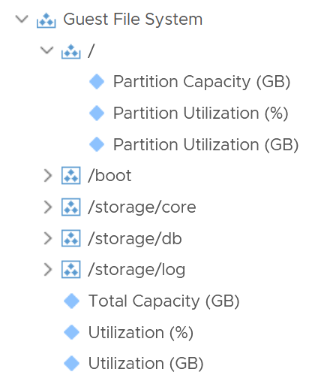

For each partition, you get the configured capacity, used capacity (in relative) and used capacity (in absolute). You also get the overall number, which is handy for trim/unmap calculation.

You can see if any of the Windows drives or Linux partitions are running out of storage. You can also compute the potential savings from trim/unmap.

Note that only local disk device partitions are shown. Network mounted filesystems or drives require the Telegraf agent.

#### Network

Understanding network counter at Guest OS level is important as the data inside the guest relates better to the application.

Windows provides visibility at multiple levels. It provides a good set of metrics at each of these levels:

* adapter
* interface
* process (only in Task Manager. No network metric at Performance Monitor at process level)
* TCP and UDP connection

The following screenshot from Performance Monitor shows some of the metrics at Network Adapter and Network Interface

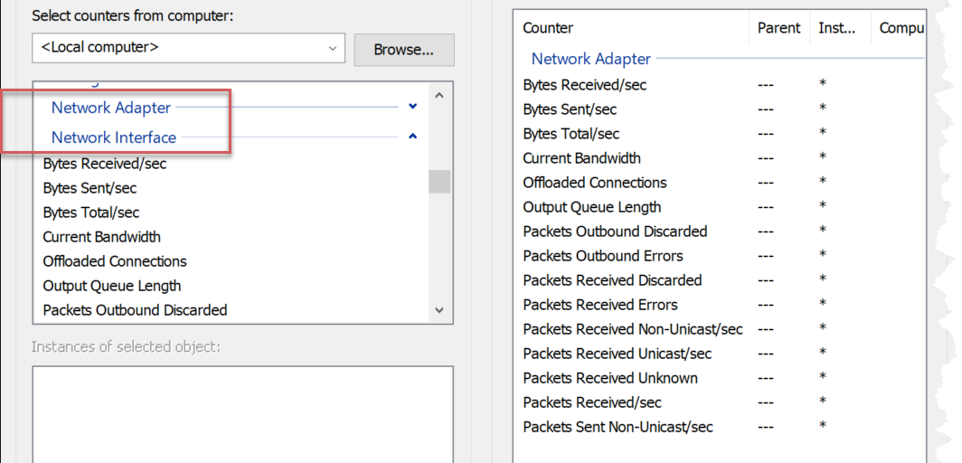

Let’s look at the metrics at the adapter level, as that’s the one closest to the VM level metric.

##### Contention Metrics

|  |  |
| --- | --- |
| Packets Received Errors | Expect these to be 0 at all times?  While error packets are obviously discarded, I think the value is not included in the discarded metric below. |
| Packets Outbound Errors |
| Packets Received Discarded | The packet is not an error packet but it is dropped, typically due to buffer overflow.  The sum of all 4 metrics should be 0 at all times. |
| Packets Outbound Discarded |
| Output Queue Length | It measures the length of the output packet queue, in packets.  Windows manual states that saturation exists if this value is >2. If you know why the queue length is low, let me know. However, the value is always 0 in Windows 10 and 11 “since the requests are queued by the Network Driver Interface Specification (NDIS) in this implementation” |
| Packets Received Unknown | Interesting to see that Windows also has unknown protocol packet. ESXi VMkernel, being an OS, also has this unknown packet.  Take note that there is no unknown packet sent, because all packets sent are of known type. |

##### Consumption Metrics

Let’s start with the basic or common metrics first

|  |  |
| --- | --- |
| Current Bandwidth | This is interesting as Windows tries to determine the actual bandwidth, which is typically lower than the configured bandwidth. |
| % Usage |  |
| % Usage Peak |  |
| Bytes Sent/sec | It measures the rate at which bytes are sent and received over each network adapter, including framing characters.  Windows manual in this [link](https://docs.microsoft.com/en-us/learn/modules/monitor-windows-server-performance/2-use-performance-monitor-to-identify-performance-problems) states that the network is saturated if >70% utilization. I think this is on the low side, and I’d like to see proof of saturation (e.g. dropped packet, retransmit) |
| Bytes Received/sec |
| Bytes Total/sec |
| Packets Sent/sec | This can be an important counter as typically there is a limit in number of packet that can be processed per second. |
| Packets Received/sec |
| Packets/sec |

##### Additional Consumption Metrics

Windows also provides a set of metrics that reveals more than the basic utilization

|  |  |
| --- | --- |
| Packets Sent Unicast/sec | Majority of the applications should be unicast. |
| Packets Received Unicast/sec |
| Packets Sent Non-unicast/sec | Non unicast covers broadcast and multicast. I was hoping Windows would split the counter into 2 as they have different purpose.  It’s worth checking those applications doing excessive non-unicast packets. |
| Packets Received Non-unicast/sec |
| Paging File |  |
| Offloaded Connections | The number of TCP connections offloaded to the TCP Offload Engine. Compare this value to the expected value from your NIC vendor. |
| TCP Active RSC Connections | A set of metrics on Receive Segment Coalescing. RSC is basically a technique to combine network processing in one go to reduce overhead.  There is no equivalent at VM layer. More about RSC at [this](https://learn.microsoft.com/en-us/windows-hardware/drivers/network/overview-of-receive-segment-coalescing) link from Microsoft and in the Performance Monitor metric description. |
| TCP RSC Average Packet Size |
| TCP RSC Coalesced Packets/sec |
| TCP RSC Exceptions/sec |

The following screenshot shows Windows 10 Resource Monitor. You will notice quickly that a lot of this information is not available at the hypervisor layer. The VM does not report process level information. Looking at the columns in the table, what critical metrics are missing at the VM layer?

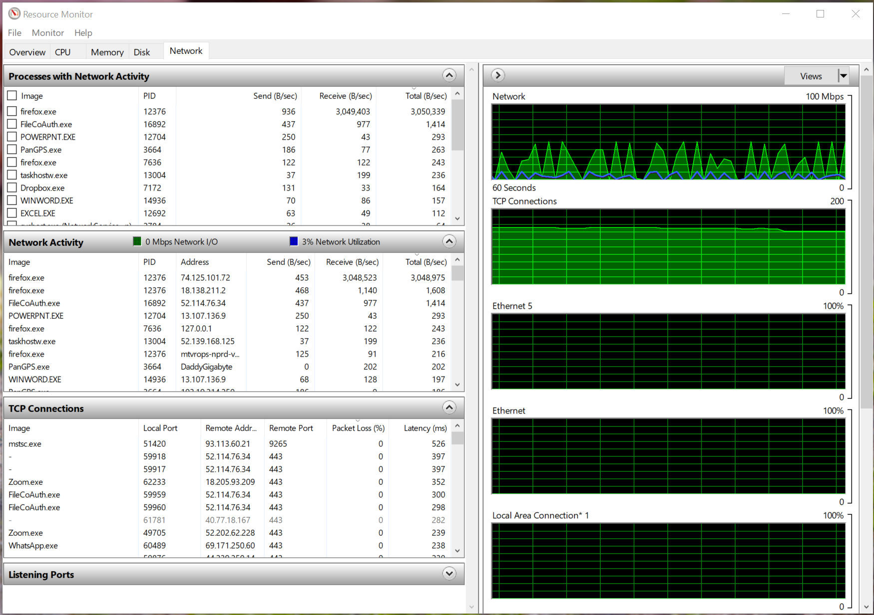

Windows reports the packet loss (%) and latency (ms) metrics per TCP connections. This is crucial in troubleshooting at application level. Unfortunately, Windows does not report the overall latency and overall packet loss.

Take note that Windows mixes bit and byte, which it should not. The chart is showing in bit, while the table is showing in byte.

[e1: need to document which metrics important and what Telegraf call them [https://docs.microsoft.com/en-us/windows-server/networking/technologies/network-subsystem/net-sub-performance-metrics](https://docs.microsoft.com/en-us/windows-server/networking/technologies/network-subsystem/net-sub-performance-counters)

#### Crash Analysis

For a software that is used by a billion people, Microsoft provides limited troubleshooting for availability problem (hang or crash). Its recommendation is also limited to uninstalling or disabling 3rd party driver, 3rd party software and external hardware.

The primary tool from Windows is Event Viewer. It’s an old which has not been updated for a long time. It has 2 main limitations: limited information provided, and the one provided is hard to use. The following example shows that it provided no information other than unexpected shutdown. I knew that as my Windows hang and nothing I could do other than a power cycle.

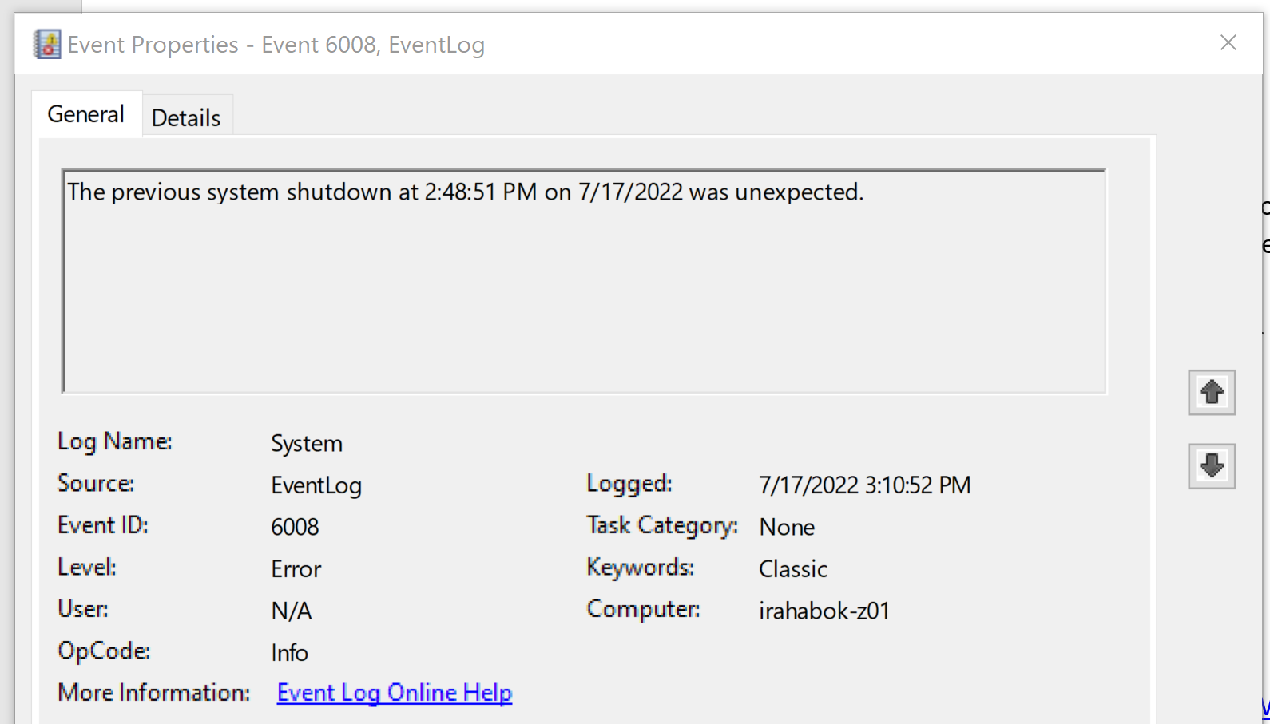

The link for more information does not work. However, you can manually search for the event ID. In some cases, the event ID documentation does not reveal much beyond 3rd party software and hardware.

There are alternatives, which you can find [here](https://www.raymond.cc/blog/a-built-in-system-monitor-thats-easier-to-read-than-event-viewer/). Let me know if you have more useful tools.

##### NirSoft

This one-man website has a collection of utilities. The ones I’ve tried are [BlueScreenView](https://www.nirsoft.net/utils/blue_screen_view.html), [WhatIsHang](https://www.nirsoft.net/utils/what_is_hang.html) and [WinCrashReport](https://www.nirsoft.net/utils/application_crash_report.html). They help in opening the file (such as the core dump file below) and parse the information.

BTW, your anti virus may block from launching some of his software. Nir wrote an explanation [here](http://blog.nirsoft.net/2009/05/17/antivirus-companies-cause-a-big-headache-to-small-developers/) back in in 2009 that many anti-virus softwares mistakenly thought some of the utilities as malware. Unsurprisingly, today’s security software still does it. I could not launch WinCrashReport.

###### Windows Crash Analysis

From the following screenshot, you can see my Windows 10 had multiple Driver Power State Failure, and the crash was caused by Win NT OS Kernel. Yes, the kernel is still named after [Windows NT](https://en.wikipedia.org/wiki/Windows_NT), which was released a long time ago (July 1993). No, the NT stands for New Technology, not [Neanderthal](https://en.wikipedia.org/wiki/Neanderthal) Technology.

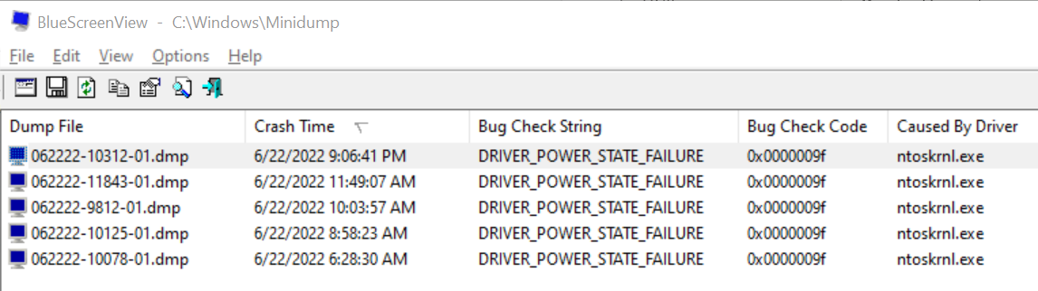

You could see I had 5 crashes in 1 day. All are due to power state failure of a driver. My hardware is a Dell laptop, and I expect a driver update is not compatible with the power sleep model.

For more information on the Bug Check String, refer to [this](https://support.microsoft.com/en-us/sbs/windows/troubleshoot-blue-screen-errors-5c62726c-6489-52da-a372-3f73142c14ad) Microsoft document. Note that it does not list all the error codes. For example, mine is not listed. The ones that it lists are:

* CRITICAL_PROCESS_DIED
* SYSTEM_THREAD_EXCEPTION_NOT_HANDLED
* IRQL_NOT_LESS_OR_EQUAL
* VIDEO_TDR_TIMEOUT_DETECTED
* PAGE_FAULT_IN_NONPAGED_AREA
* SYSTEM_SERVICE_EXCEPTION
* DPC_WATCHDOG_VIOLATION

I think each Bug Check has a unique string and code.

Unfortunately, clicking on the dump file does not reveal much, and it gets technical fast. It does not tell which driver. The following is what I got from the above.

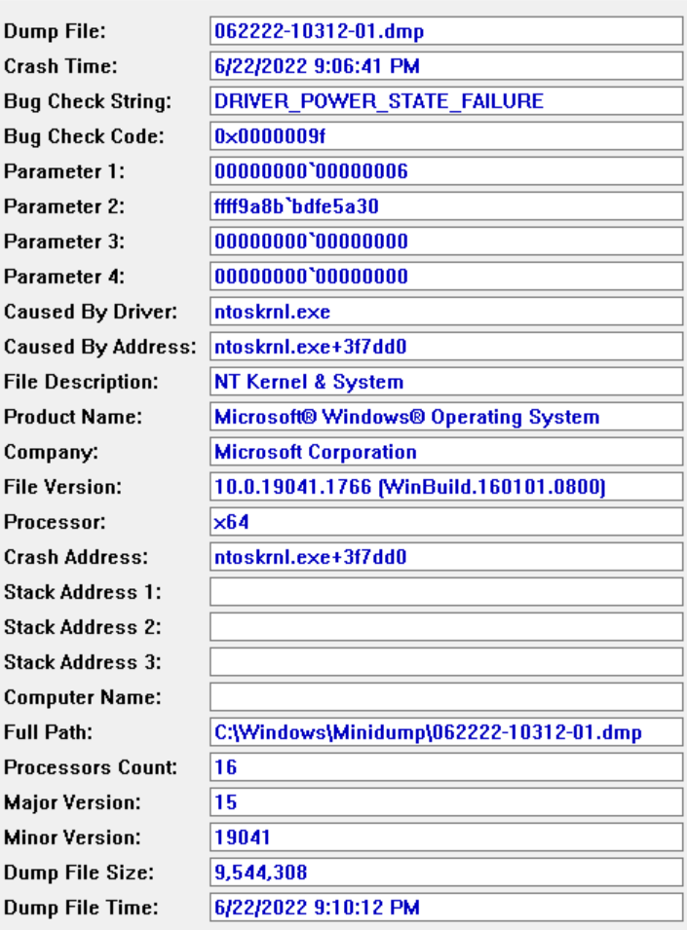

You need to configure Windows to create the dump file. Just the small memory dump option will do.

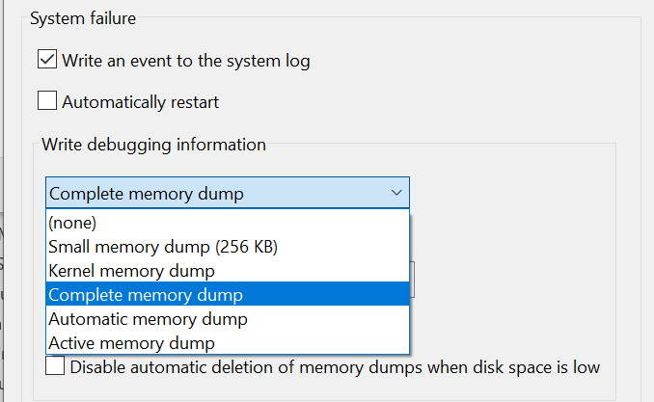

###### Application Crash Analysis

Use the WhatIsHang to check the reason why an application crash. If you have an application that is hanging, launch WhatIsHang to help. Upon launching, it automatically lists all applications that are in hang state or wait state (for example, your screen capture is waiting for you to take the screenshot).

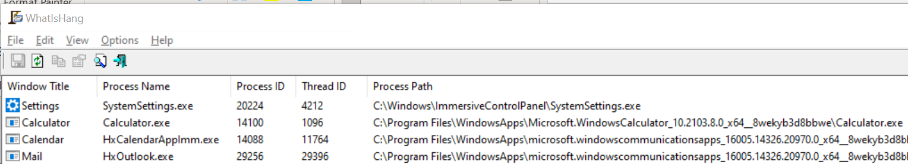

Just like the case with Windows crash, the information gets technical fast. From the above list, I clicked calculator.

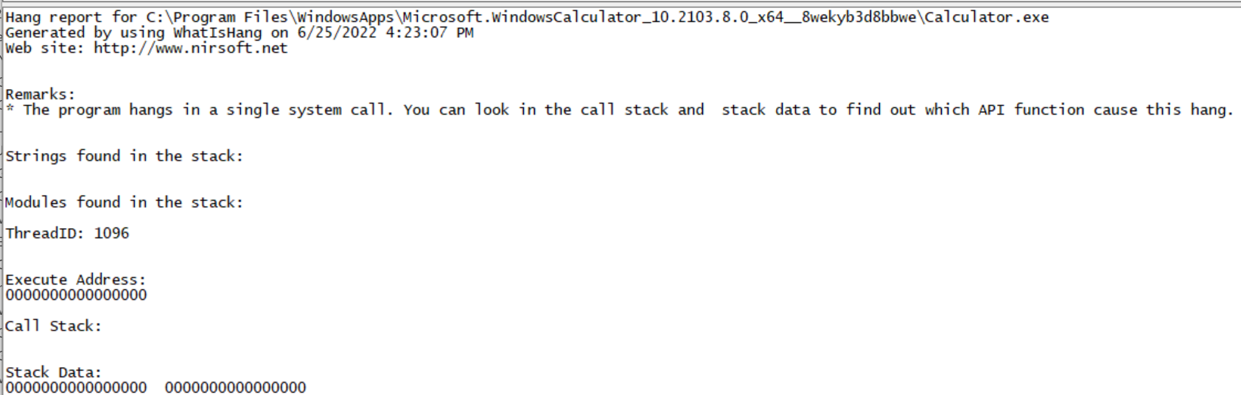

If you scroll down, you get information on processor register, memory data, all threads and modules/

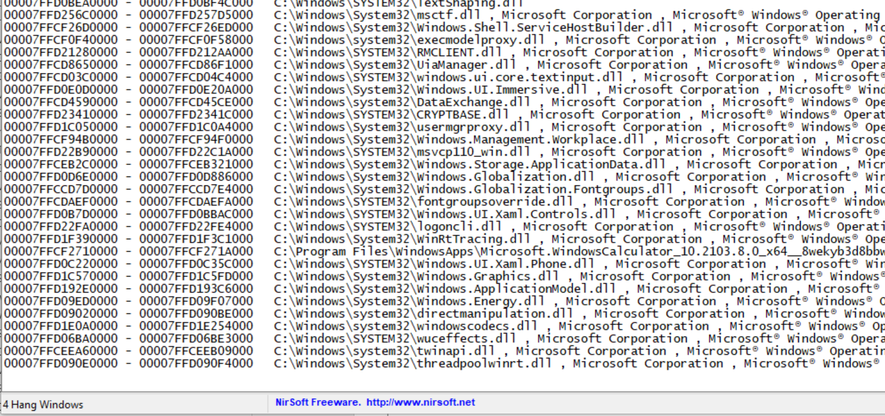

In some “Not Responding” situation, I find that Windows denies access for the thread information without explaning it. Windows Event Viewer does not list anything. The following screenshot shows that Slack.exe is not responding. This problem is reproducible. The reason is the 2FA, which Slacks opens a web browser to complete the single sign on.

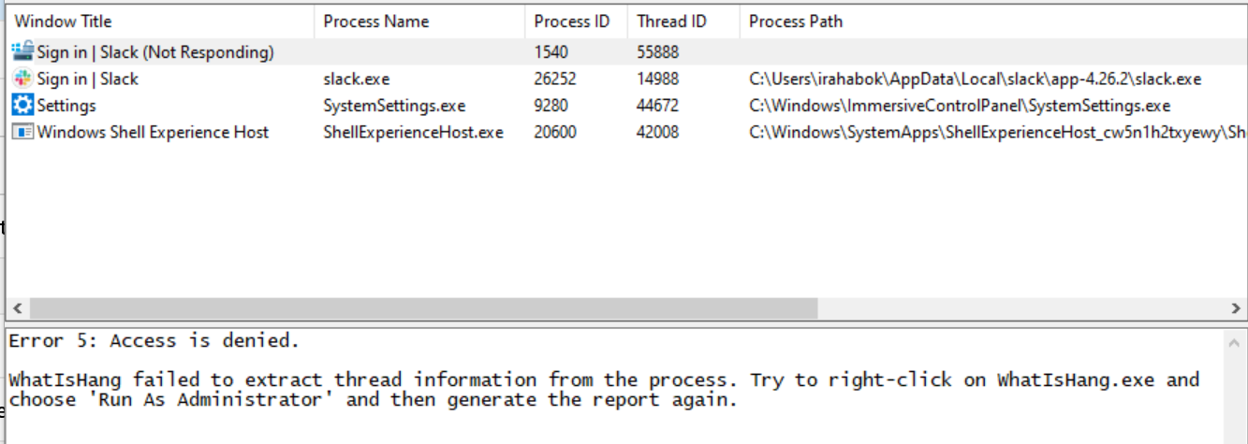

##### Reliability Monitor

More info available [here](https://docs.microsoft.com/en-us/learn/modules/monitor-windows-server-performance/4-review-reliability-with-reliability-monitor).

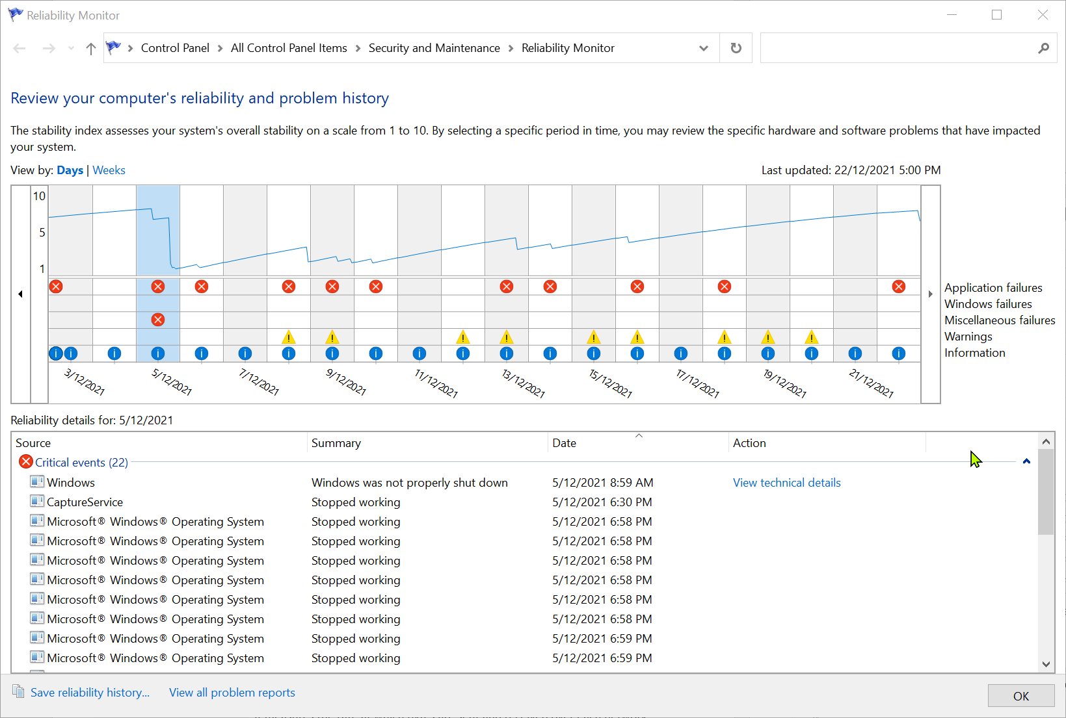

There are 5 types of errors. The one that you’re interested in is Windows failures. You can’t search, but you can click on each red x icon. The following shows a hardware error. There is no details.

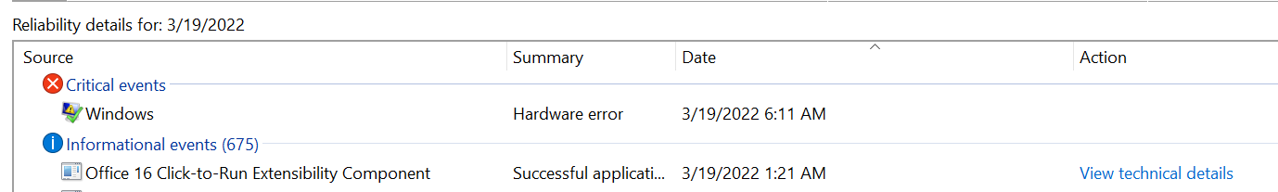

You can select it and get more details. Unfortunately, the information is rather low level. The information provided by [Nir Sofer](https://www.nirsoft.net/about_nirsoft_freeware.html) is richer.

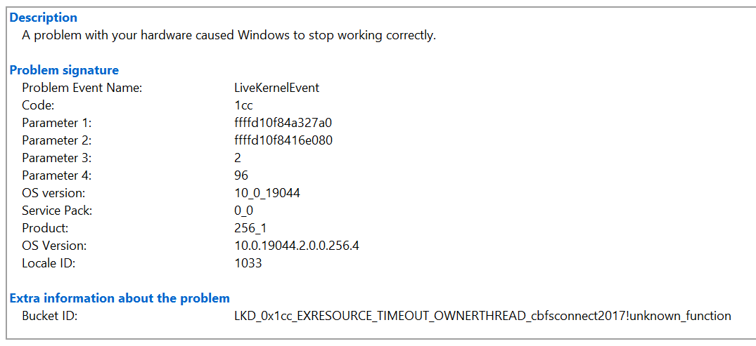

### Linux

|  |  |
| --- | --- |
| kernel.boot.time |  |
| kernel.context.switches |  |
| kernel.interrupts |  |
| kernel.processes.forked |  |

|  |  |
| --- | --- |
| processes.blocked |  |
| processes.dead |  |
| processes.idle |  |
| processes.paging |  |
| processes.running |  |
| processes.sleeping |  |
| processes.stopped |  |
| processes.total |  |
| processes.total.threads |  |
| processes.unknown |  |
| processes.zombies |  |

|  |  |
| --- | --- |
| system.load1 |  |
| system.load15 | 15 minute average.  What is the use case as 15 minutes is too long for CPU  https://www.brendangregg.com/blog/2017-08-08/linux-load-averages.html |
| system.load5 |  |
| system.n.cpus |  |
| system.n.users |  |
| system.uptime |  |

#### CPU

|  |  |
| --- | --- |
| cpu.usage.guest |  |
| cpu.usage.guest.nice |  |
| cpu.usage.idle |  |
| **cpu.usage.iowait** |  |
| Cpu.usage.irq. | What is this? |
| cpu.usage.nice |  |
| cpu.usage.softirq |  |
| cpu.usage.steal |  |
| cpu.usage.system |  |
| cpu.usage.user |  |

Reference: [Linux](http://man7.org/linux/man-pages/man5/proc.5.html). [e1: to add CPU scheduler and states <https://www.bogotobogo.com/Linux/linux_process_and_signals.php>]

##### CPU Run Queue

Number of threads in the processor queue. Unlike Windows, Linux includes the threads in the CPU pipeline.

For Linux, VMware Tools use the value of procs_running from /proc/stat (kernel/system statistics). VMware Tools labels it as guest.cpu.runQueue. It shows the number of processes in runnable state. It is same as the value from /proc/loadavg. It is the sum of all CPU thread run queue. The nr_running field includes currently running tasks and ready but not running tasks.

Reference: [Linux](http://man7.org/linux/man-pages/man5/proc.5.html).

##### Linux Steal Time

According to Red Hat [documentation](https://access.redhat.com/documentation/en-us/red_hat_enterprise_linux/7/html/virtualization_deployment_and_administration_guide/sect-kvm_guest_timing_management-steal_time_accounting), Steal Time is the amount of CPU time needed by the VM that is not provided by the hypervisor. It occurs when the host allocates the CPU resource for its own process or to another guest.

While Linux has this counter, it is 0 when it runs on ESXi because it’s not enabled by default. Even if it’s enabled, it only accounts for Ready time. It does not account for other time such as Co-stop, VM Wait and memory wait.

CPU Ready includes Limit. I have not verified if Linux Steal Time accounts for it.

The metric Guest OS CPU Usage isn’t aware of stolen time. For this counter to be aware, its code has to be modified. If you know that Microsoft Windows has modified this counter, let me know in which version they make the change.

##### Linux IO Wait

A high IO Wait could be caused by bottleneck within Linux, or bottleneck in the underlying infrastructure (e.g. VM). How do you know which one is the cause?

If you do not see any network or disk issue at VM level, there is a good chance the issue is at the upper layer. The reason is the lower layer (VM in this case) processes whatever network packets or SCSI commands sent by Guest OS promptly. Check the Disk Queue Length metric. If this is also high, then you need to troubleshoot at Linux level, such as changing the SCSI driver.

If you are seeing VM disk outstanding IO or disk latency is high, there is a good chance the IO wait and latency at upper layer is just an overflow of underlying symptom.

#### Memory

Windows and Linux manage memory differently, and they also name their metrics differently. VMware Tools provide a set of universal metrics from these two popular types of Guest OSes. The following shows what it looks like in Linux

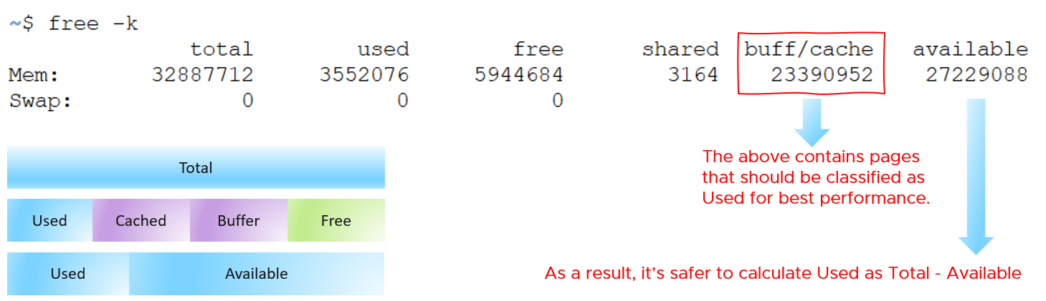

These are the metrics that we’re interested from right sizing use case.

Linux has 2 types of cache: Slab Reclaim and Cached.

vSphere Tools 10.3.5 provides the following metrics:

* Total
* Available
* Free
* Buffers
* Used = total - free - buffers - cached
* Cached = guest.mem.cached + guest.mem.slabReclaim

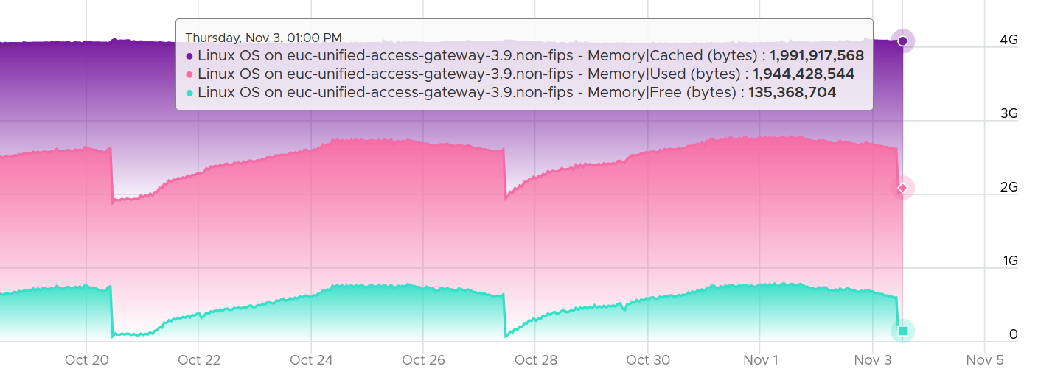

From the [kernel documentation](https://git.kernel.org/pub/scm/linux/kernel/git/torvalds/linux.git/commit/?id=34e431b0ae398fc54ea69ff85ec700722c9da773), the definition are:

* “Cached includes memory that is not freeable as page cache, for example shared memory segments, tmpfs, and ramfs, and it does not include reclaimable slab memory, which can take up a large fraction of system memory on mostly idle systems with lots of files.”
* Available = An *estimate* of how much memory is available for starting new applications, without swapping. Calculated from MemFree, SReclaimable, the size of the file LRU lists, and the low watermarks in each zone. The estimate takes into account that the system needs some page cache to function well, and that not all reclaimable slab will be reclaimable, due to items being in use. The impact of those factors will vary from system to system.
* Buffers: Relatively temporary storage for raw disk blocks shouldn't get tremendously large (20MB or so)

Further reading for Linux, read [this](http://www.chrisjohnston.org/ubuntu/why-on-linux-am-i-seeing-so-much-ram-usage).

Linux has its fair share of simplifying how it uses cache. This [Linux Ate My RAM](http://linuxatemyram.com) documents it well. For ESXi, a common misperception is “we are short on RAM, but fine on CPU”, when it is actually the other way around. To prove it, check the **performance** metrics for each cluster. You may see that the VMs have CPU performance while cluster CPU utilization is lower than cluster memory utilization.

##### Guest OS Needed memory

Formula for Linux = physical memory – Maximum of (0, ( Available - 5 % of physical ))

##### Active File Cache Memory

In Linux, this is the amount of file cache memory, in kibibytes, that is in active use, or was in active use since the last time the system reclaimed memory. This is retrieved via the command:

$ cat /proc/meminfo | grep Active

Active: 50955636 kB

Active (anon): 30148196 kB

Active (file): 20807440 kB

For further reading, refer to [Linux](https://stackoverflow.com/questions/45487506/what-is-inactivefile-and-activefile-in-proc-meminfo) and [Windows](https://wutils.com/wmi/root/cimv2/win32_perfrawdata_perfos_memory/#systemcacheresidentbytes_properties)

BTW, I notice the above was committed by Linus himself, on Jan 2014. Hats off for doing low level things like this!

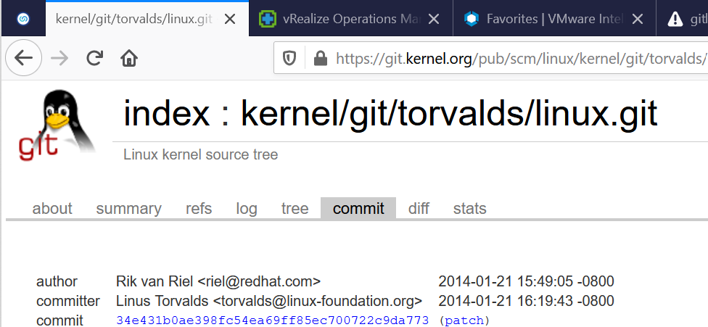

What is inactive?

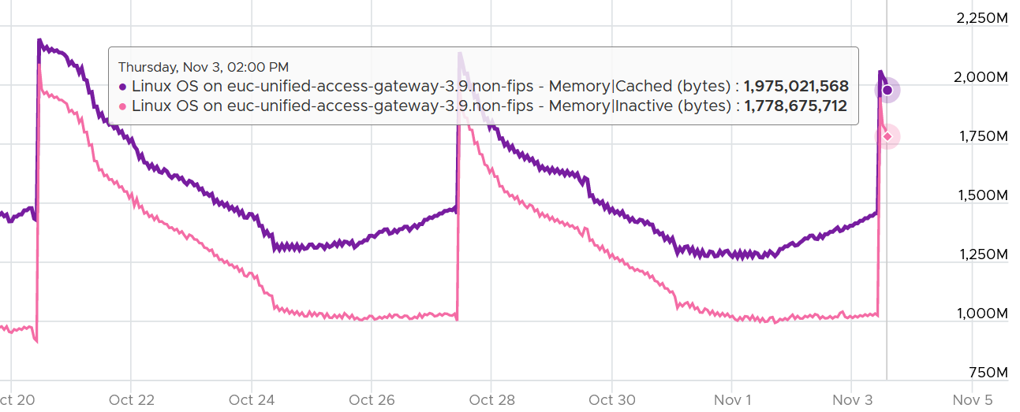

|  |  |
| --- | --- |
| mem.active |  |
| mem.available |  |
| mem.available.percent |  |
| mem.buffered |  |
| mem.cached |  |
| mem.free |  |
| mem.inactive |  |
| mem.slab |  |
| mem.total |  |
| mem.used |  |
| mem.used.percent |  |
| swap.free |  |
| swap.in |  |
| swap.out |  |
| swap.total |  |
| swap.used |  |
| swap.used.percent |  |

### VMware Guest OS Metrics

VMware provides visibility into Windows and Linux via the following products:

* VMware Tools.
* Telegraf.
* Service Discovery

#### VMware Tools

Take note that Tools collect every 20 seconds. vRealize Operations then average 15 sets of these and form the 5-minute data point. This is why the value can differ to the one reported by Telegraf. Telegraf does not average all the data point. It only returns a single data point, which is the last data.

BTW, if you notice a rare intermittent collection, check vmware.log of the VM. It could be that **vmtoolsd** daemon in Guest OS paused for a while, due to guest workload or other issue in Windows or Linux.

vRealize Operations provide 3 properties for Tools

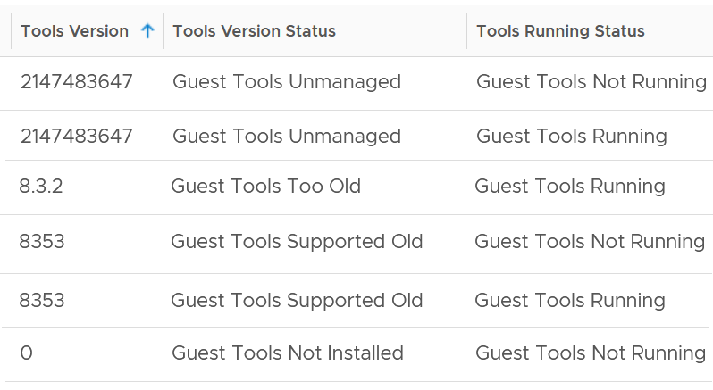

Tools Running Status. As you can see from above, it captures if tools are running or not running. That’s all. Note its actual value does not use binary (1 or 1) or true/false.

Tools Version. This captures the version number. I’m not sure why some versions numbers is a 10-digit number. If this is not installed, it returns 0.

Tools Version Status. The following table explains the meaning of the values:

|  |  |
| --- | --- |
| **Value** | **Description** |
| Guest Tools Not Installed | Tools are not installed on the VM. You should install it as you get both drivers and visibility |
| Current | Tools version matches with the Tools available with ESXi. Each ESXi has a version of Tools that comes with it. See this for the list. This is the ideal scenario |
| Supported New | Newer than the ESXi VMware tools version, but it is supported |
| Supported Old | The opposite of New. It is also supported. Even it is older by 0.0.1 is considered old. It does not have to far behind |
| Too Old | Tools version is older than the minimum supported version of Tools across all ESXi versions. Minimum supported version is the oldest version of Tools we support. Basically, guest is running unsupported Tools. You should upgrade. As of now for Linux and Windows guests. minimum supported version is the Tools version bundled with ESXi 4.0 which is 8.0.1. Supporting such old versions is challenging. We are planning to change this in future to something newer. In the meantime, you should upgrade as might not work as expected |
| Unmanaged | Tools installed in the guest did not come from ESXi, so Tools is not being managed by ESXi host. It may be supported or maybe not, depends on what type of Tools is running in the guest. We support open-vm-tools packaged by Linux vendors and OSPs, which both show up as unmanaged.  If a customer builds their own open-vm-tools from source code, we may not support that because we will not know if they have done it correctly or not |

##### Windows

Unlike Linux, Windows API provides the value. So Tools do not have to calculate.

The units are identical to the correspondent counter from Linux, hence not shown.

|  |  |
| --- | --- |
| Stat Name | Source |
| guest.contextSwapRate | Win32_PerfFormattedData_PerfOS_System = @#ContextSwitchesPersec from WMI |
| guest.mem.activeFileCache | Win32_PerfRawData_PerfOS_Memory = @#SystemCacheResidentBytes from WMI |
| guest.mem.free | Win32_PerfRawData_PerfOS_Memory = @#FreeAndZeroPageListBytes from WMI |
| guest.mem.physUsable | Win32_OperatingSystem = #TotalVisibleMemorySize from WMI |
| guest.mem.needed | guest.mem.physUsable - max(0, UNNEEDED_BYTES - 5% of guest.mem.physUsable),  where UNNEEDED_BYTES = "Win32_PerfRawData_PerfOS_Memory =@#FreeAndZeroPageListBytes" + "Win32_PerfRawData_PerfOS_Memory =@#StandbyCacheReserveBytes" |
| guest.page.inRate | Win32_PerfFormattedData_PerfOS_Memory = @#PagesInputPersec from WMI |
| guest.page.outRate | Win32_PerfFormattedData_PerfOS_Memory = @#PagesOutputPersec from WMI |
| guest.swap.spaceRemaining | (maximum possible - used) swap space |
| guest.page.size | [SYSTEM_INFO.dwPageSize](https://docs.microsoft.com/en-us/windows/desktop/api/sysinfoapi/ns-sysinfoapi-_system_info) returned by [GetSystemInfo()](https://docs.microsoft.com/en-us/windows/desktop/api/sysinfoapi/nf-sysinfoapi-getsysteminfo) |
| guest.hugePage.size | [GetLargePageMinimum()](https://docs.microsoft.com/en-us/windows/desktop/api/memoryapi/nf-memoryapi-getlargepageminimum) |
| guest.mem.neededReservation | 5% of "guest.mem.physUsable" |
| guest.mem.availableToMm | Win32_PerfRawData_PerfOS_Memory = @#AvailableBytes from WMI |
| guest.mem.standby.normal | Win32_PerfRawData_PerfOS_Memory = @#StandbyCacheNormalPriorityBytes from WMI |
| guest.mem.standby.reserve | Win32_PerfRawData_PerfOS_Memory = @#StandbyCacheReserveBytes from WMI |
| guest.mem.standby.core | Win32_PerfRawData_PerfOS_Memory = @#StandbyCacheCoreBytes from WMI |
| guest.mem.modifiedPages | Win32_PerfRawData_PerfOS_Memory = @#ModifiedPageListBytes from WMI |

##### Linux

VMware Tools collects every 20 seconds. It takes the last value and compare it with the previous value (20 second ago) and calculate the rate.

|  |  |  |
| --- | --- | --- |
| Tools Stats Name | Source | Unit |
| guest.contextSwapRate | "ctxt" from /proc/stat | Number/sec |
| guest.mem.activeFileCache | "Active(file)" from /proc/meminfo | KB |
| guest.mem.free | "MemFree" from /proc/meminfo | KB |
| guest.mem.physUsable | Sum of /proc/zoneinfo#present across all zones. Equals to VM configured RAM. | KB |
| guest.mem.needed | "guest.mem.physUsable" - max(0, "MemAvailable" from /proc/meminfo - 5% of "guest.mem.physUsable") | KB |
| guest.page.inRate | "pgpgin" from /proc/vmstat  The rate of reads going through the underlying paging/cache system. It includes not just swapfile I/O, but cacheable reads as well. | Pages/sec |
| guest.page.outRate | "pgpgout" from /proc/vmstat  The rate of writes going through the underlying paging/cache system. It includes not just swapfile I/O, but cacheable writes as well. | Pages/sec |
| guest.swap.spaceRemaining | "SwapFree" from /proc/meminfo  The amount of swap space remaining, taking into account the possibility of swapfile growth where possible. If the OS is configured without a swapfile, this will return zero. | KB |
| guest.page.size | sysconf(_SC_PAGESIZE) | Bytes |
| guest.hugePage.size | "Hugepagesize" from /proc/meminfo | KB |
| guest.hugePage.total | "HugePages_Total" from /proc/meminfo  Total large pages allocated | Large page count |
| guest.mem.neededReservation | 5% of "guest.mem.physUsable" | KB |
| guest.mem.available | "MemAvailable" from /proc/meminfo | KB |
| guest.mem.slabReclaim | "SReclaimable" from /proc/meminfo | KB |
| guest.mem.buffers | "Buffers" from /proc/meminfo | KB |
| guest.mem.cached | "Cached" from /proc/meminfo | KB |
| guest.mem.total | "MemTotal" from /proc/meminfo | KB |

The above mapping and calculation are based on latest Linux [document](http://man7.org/linux/man-pages/man1/free.1.html) and [source code](https://gitlab.com/procps-ng/procps). As older Linux has used different formula, the future may change.

#### VM Metrics in the Guest

You can provide visibility into the underlying VM to the application team by enabling some CPU metrics. The metrics are described in [this](https://kb.vmware.com/s/article/2030221) KB article.

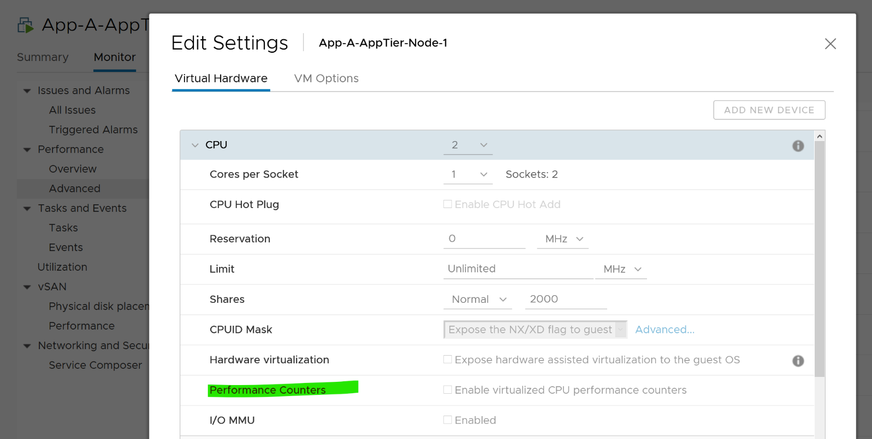

#### Service Discovery

If you do credential-based discovery via Service Discovery adapter, you get 4 extra metrics

CPU Usage (%). This is useful as VMware Tools do not provide. Use this counter to see if Windows or Linux need more CPU.

IO read throughput in KBps. Compare this with the one see at VM level. It should be matching over time.

IO write throughput in KBps.

Memory Usage (KB). Not useful as already covered by VMware Tools

## Virtual Machine

We start with CPU, Memory, Storage and Network. Once that’s covered, we will apply to performance and capacity. Lastly, we document miscellaneous metrics and properties that don’t fit well.

**Part 2 Chapter 4**

### CPU

Take note that some metrics are for VMkernel internal consumption, and not for vSphere administrators. Just because they are available in the UI and have names that sound useful do not mean it’s for your operations. Their name is written from CPU scheduler viewpoint.

I will use the vSphere Client as the source of metrics in the following screenshots.

vSphere Client provides 6 metrics to track contention.

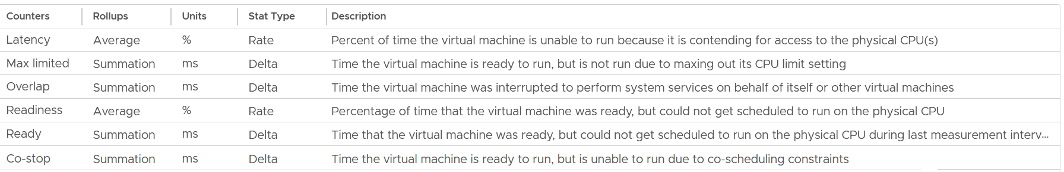

You get 9 metrics for consumption.

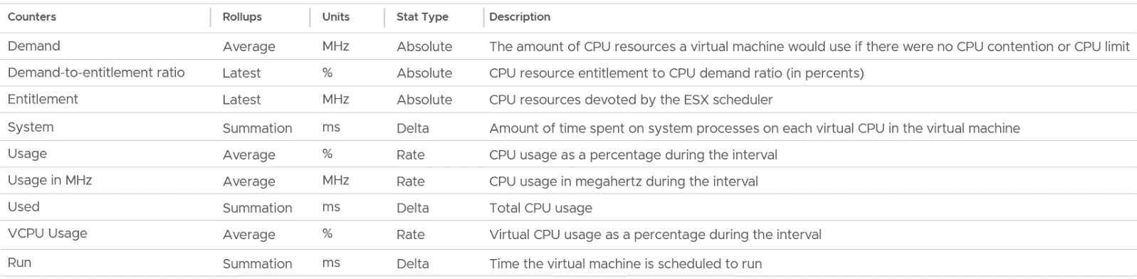

I group Wait metrics separately as it mixes both contention and consumption.

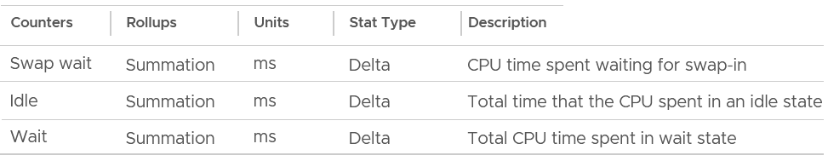

#### Contention Metrics

Let’s dive into each counter. As usual, we start with contention type of metrics, then utilization.

##### Ready

Ready tracks the time when a VM vCPU wants to run, but ESXi does not have a physical thread to run it. VMkernel places the VM vCPU into Ready state. Ready also accounts when Limit is applied, as the impact to the vCPU is the same (albeit for a different reason altogether). When a VM is unable to run due to Limit, it accumulates limbo time when sitting in the limbo queue. Be careful when using a Resource Pool, as it can unintentionally cause limits.

Take note that Ready is unaware of contention due to hyperthreading. The vCPU is not placed in ready state because both threads can execute at the same time. The contention for shared resources happens at low level hardware and essentially transparent to ESXi scheduler. If you are concerned about this certain degradation in throughput when two worlds execute at the same time on the same core, what counter should you use?

You’re right. It’s CPU Contention. Different purpose, different counter.

Take a look at the high spikes on CPU Ready value. It hits 40%!



Notice the overall pattern of the line chart correlates very well with CPU Usage and CPU Demand. The CPU Usage hit 3.95 GHz but the Demand shot to 6.6 GHz. This is a 4 vCPU VM running on a 2.7 GHz CPU, so its total capacity is 10.77 GHz. Why did Usage stop at 3.95 GHz?

What’s causing it?

If your guess is Limit you are right. This VM had a limit set at 4 GHz.

Ready also includes the CPU scheduling cost (normally completed in microseconds), hence the value is not a flat 0 on idle VM. You will notice a very small number. Ready goes down when Guest OS is continually busy, versus when a process keeps waking up and going to sleep, causing the total scheduling overhead to be higher. The following shows Ready is below 0.2% on an idle VM (running at only 0.8%). Notice Co-stop is basically flat 0.



CPU Ready tends to be higher in larger VMs, because Ready tends to hit all vCPU at the same time. Instead of thinking of CPU ready in 2D (as shown in the first chart below), think in 3D where each vCPU moves across time. The 2nd chart below shows how the 8 vCPUs move across time better.

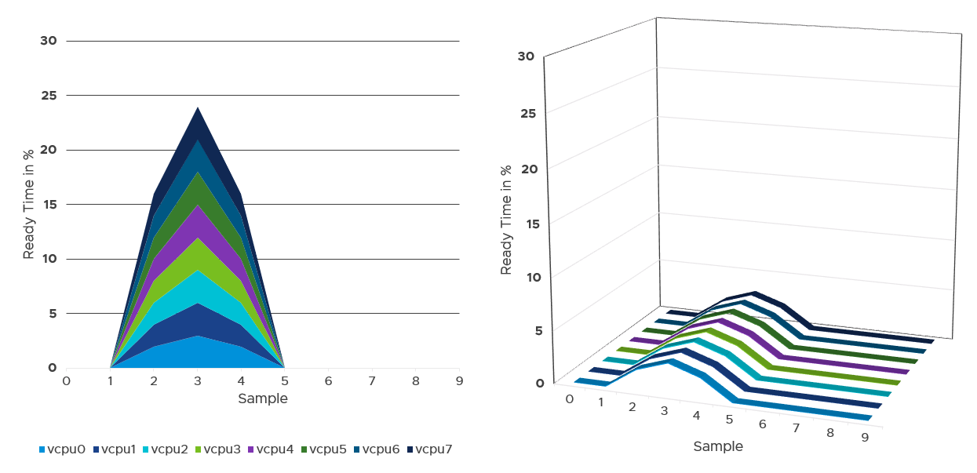

###### Best Practice

I sample 3937 VMs from production environment. For each of them, I took the 20-second peak and not the 5-minute peak.

Why do I take the 20-second?

Unless the performance issue is chronic, CPU Ready tends to last in seconds instead of minutes. The following is one such example.

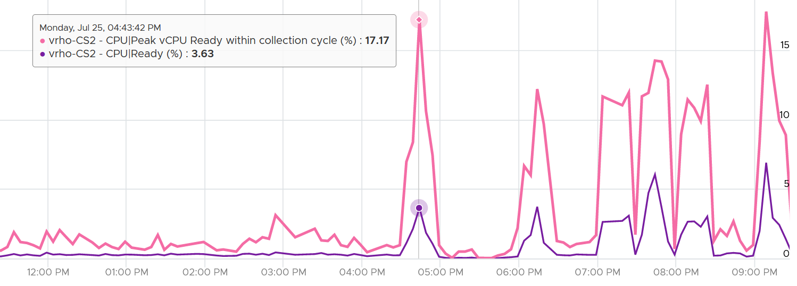

The following shows a different behaviour. Notice initially both metrics are bad, indicating severe CPU ready. However, the gap is not even 2x. I think partly because the value is already very high. Going beyond 50% CPU Ready when CPU Usage is high will result in poor performance. This VM has 16 vCPU.

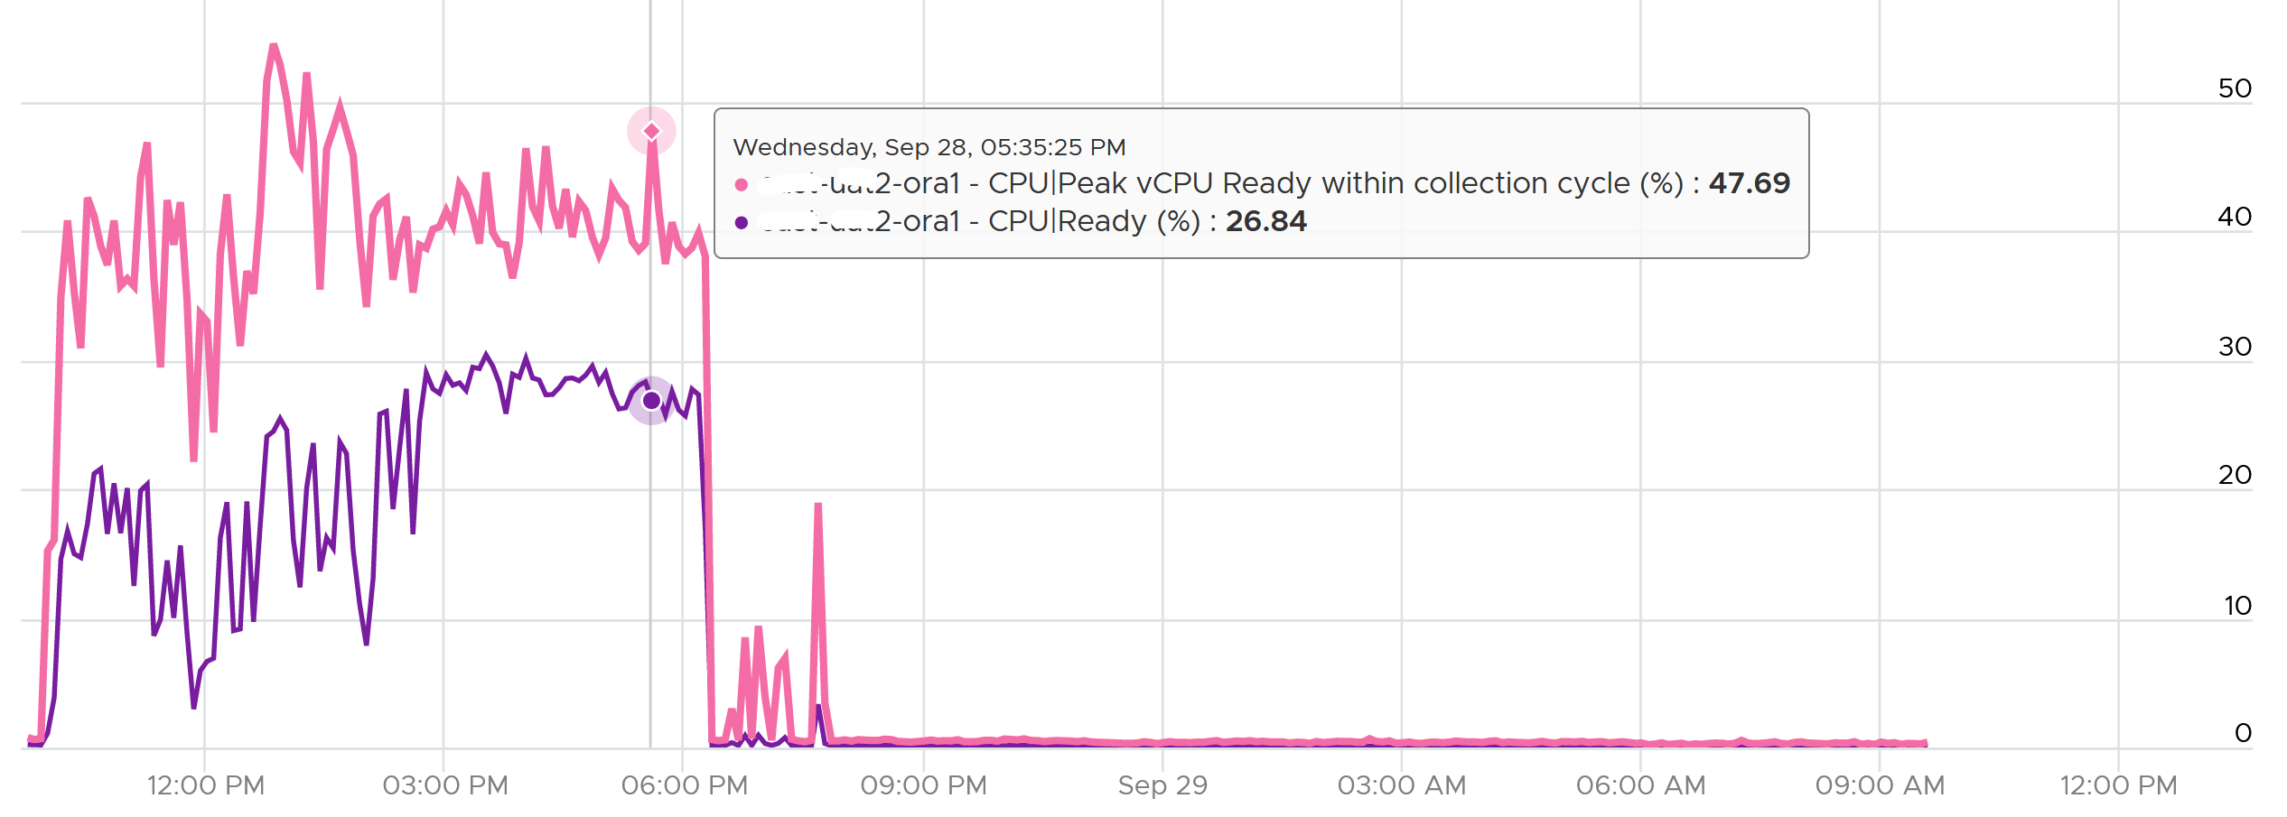

Subsequently, the performance improved, and both values became very similar and remained in a healthy range.

I collected 4 months’ worth of data, so it’s around 35040 metrics per VM.

The following screenshot was my result. What do you expect to get in your environment?

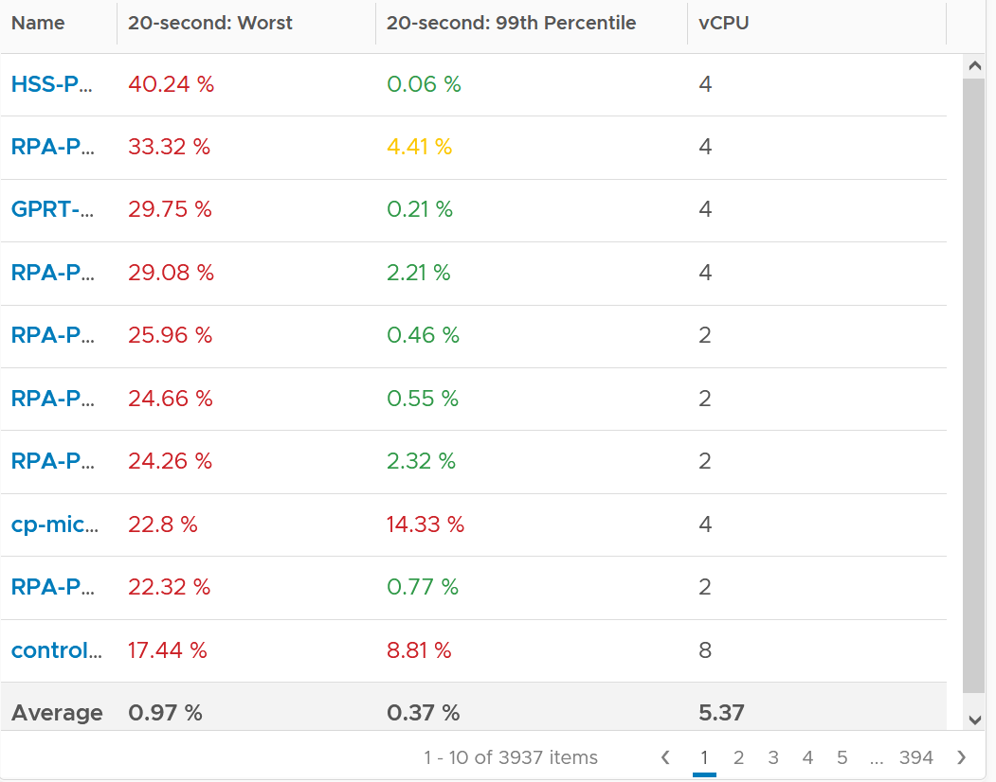

The first column takes the highest value from ~35K data points. The table is sorted by this column, so you can see the absolute worst from 35040 x 3937 = 137 million data points. Unsurprisingly, the number is bad. Going down the table, it’s also not surprising as the worst 10 are bad.

But notice the average of these “worst metrics”. It’s just 0.97%, which is a great number!

The 2nd column complements the first one. I eliminate the worst 1% of the data, then took the highest. So I took out 350 datapoints. Since vRealize Operations collects every 5 minutes, that eliminates the worst 29 hours in 4 months. As you can expect, for most VMs the values improve dramatically. The 2nd column is mostly green.

###### vCenter Metrics

There are 2 metrics provided: Ready (ms) and Readiness (%).

I plotted both of them. They show identical pattern. This is a 4 vCPU, hence the total is 80000 ms.

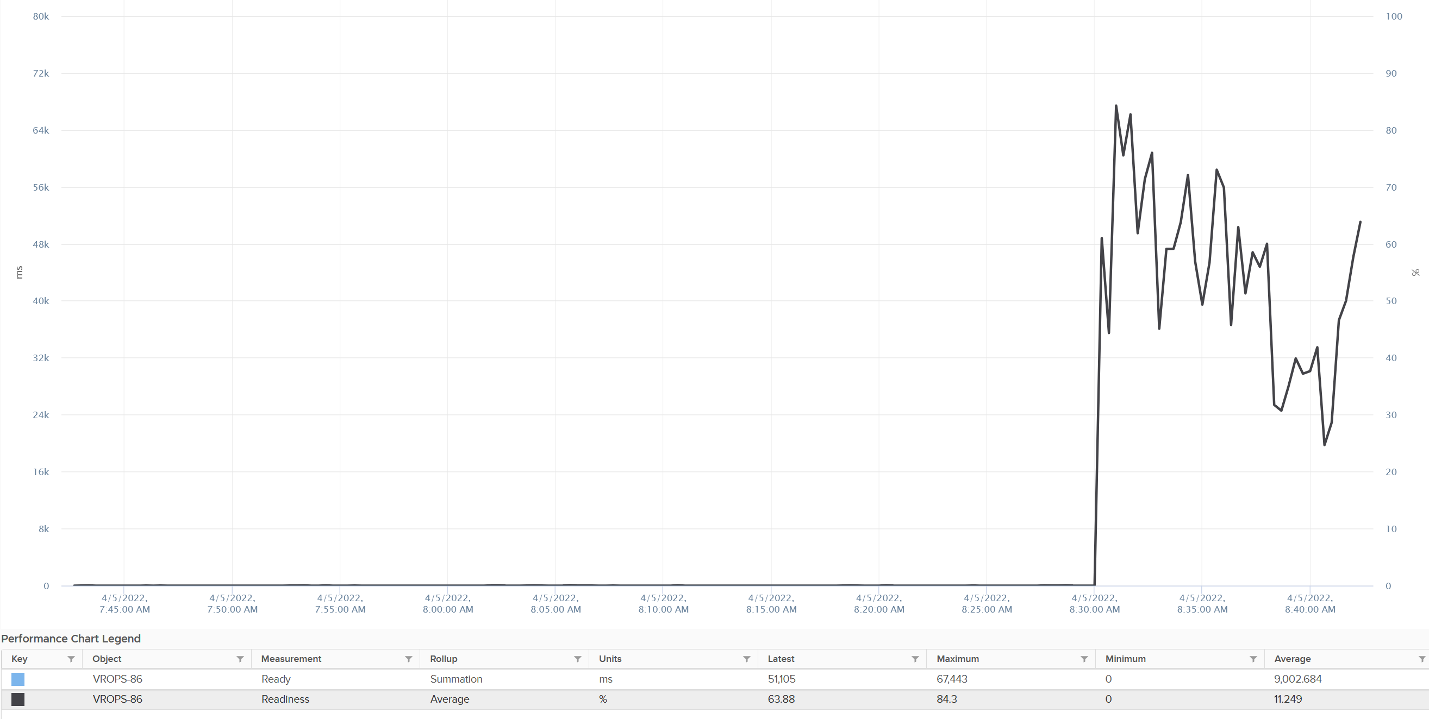

The Readiness (%) has been normalized, taking into account the number of vCPU. Notice 80000 ms matches with 100%. If it is not normalized, you will see 80000 as 400%.

##### Co-stop

Co-stop is a different state than Ready because the cause is different.

Co-stop only happens on Simultaneous Multi Processor (SMP) VMs. SMP means that the OS kernel executes parallel threads. This means Co-stop does not apply to 1 vCPU VMs, as there is only 1 active process at any given time. It is always 0 on single vCPU VM.

In a VM with multiple vCPUs, ESXi VMkernel is intelligent enough to run some of the VM vCPUs when it does not have all physical threads to satisfy all the vCPU. At some point, it needs to stop the running vCPU, as it’s too far ahead of its sibling vCPU (which it cannot serve, meaning they were in ready state). This prevents the Guest OS from crashing. The Co-stop metrics track the time when the vCPU is paused due to this reason. This explains why Co-stop tends to be higher on a VM with more vCPUs.

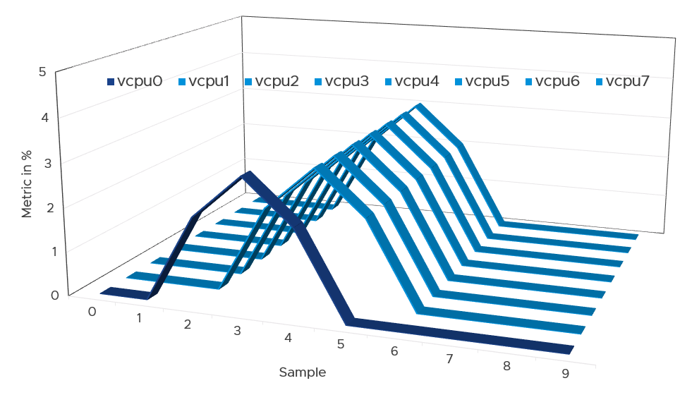

If only one or some vCPU are in ready state, then the remaining ones will soon be co-stopped, until all the vCPU are co-started. The preceding diagram show vCPU 0 hit a ready state first. Subsequently, the remaining 7 vCPU hit a co-stop.

Just like Ready, Co-stop happens at the vCPU and not the VM level.

One reason for Co-stop is snapshot. Refer to [this KB article](https://kb.vmware.com/s/article/2000058?lang=en_US) for details.

Guest OS is not aware of both Co-stop and Ready. The vCPU freezes. “What happens to you when time is frozen?”[18] is a great way to put it. As far as the Guest OS is concerned, time is frozen when it is not scheduled. Time jumps when it’s scheduled again.

The time it spends under Co-stop or Ready should be included in the Guest OS CPU sizing formula as the vCPU wants to run actually.

By the way, there is a performance improvement in the VMkernel scheduler in handling Co-stop in ESXi 7.0 Update 1. Prior to the improvement, the application performance dropped after 384 vCPU. If you have a monster VM with > 128 vCPU, let me know.

###### Best Practice

The value of Co-stop should be <0.5% in healthy situation. This is based on 63.9 million datapoints, as shown on the following pie chart.

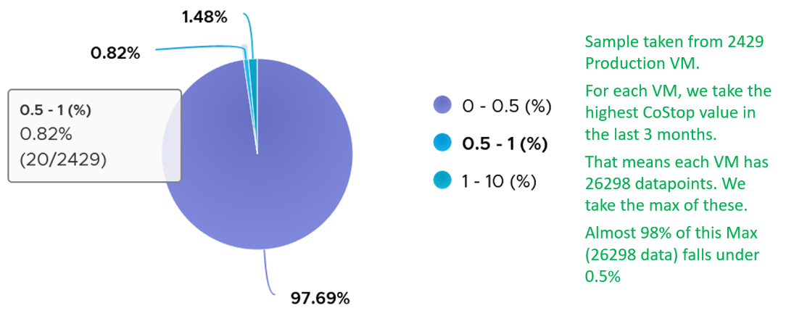

Note that the value of Co-stop tends to be larger for large VM. Its value also tends to be smaller than Ready, as shown below. Ready and Co-stop may or may not corelate with Usage. In the following chart you can see *both* the correlation and lack of correlation.



##### Overlap

When ESXi is running a VM, this activity might get interrupted with IO processing (e.g. incoming network packets). If there is no other available cores in ESXi, VMkernel has to schedule the work on a busy core. If that core happens to be running VM, the work on that VM is interrupted. The counter Overlap accounts for this, hence it’s useful metric just like Ready and Co-stop counter.

The interrupt is to run a system service, and it could be on behalf of the interrupted VM itself or other VM.

Notice the word *system services*, a process that is part of VMkernel. This means it is not for non-system services, such as vCPU world. That’s why the value in general is lower than CPU Ready or even Co-Stop. The value is generally affected by disk or network IO.

Some documentation in VMware may refer to Overlap as Stolen. Linux Guest OS tracks this as Stolen time.

When a vCPU in a VM was interrupted, the vCPU Run counter is unaware of this and continues tracking. To the Guest OS, it experiences freeze. Time stops for this vCPU, as everything is paused. The clock on motherboard does not tick for this vCPU. Used and Demand do account for this interruption, making them useful in accounting the actual demand on the hypervisor. When the VM runs again, the Guest OS experiences a time jump.

Review the following charts. It shows CPU Usage, CPU Overlap and CPU Run. See the green highlights and yellow highlights. What do you notice?

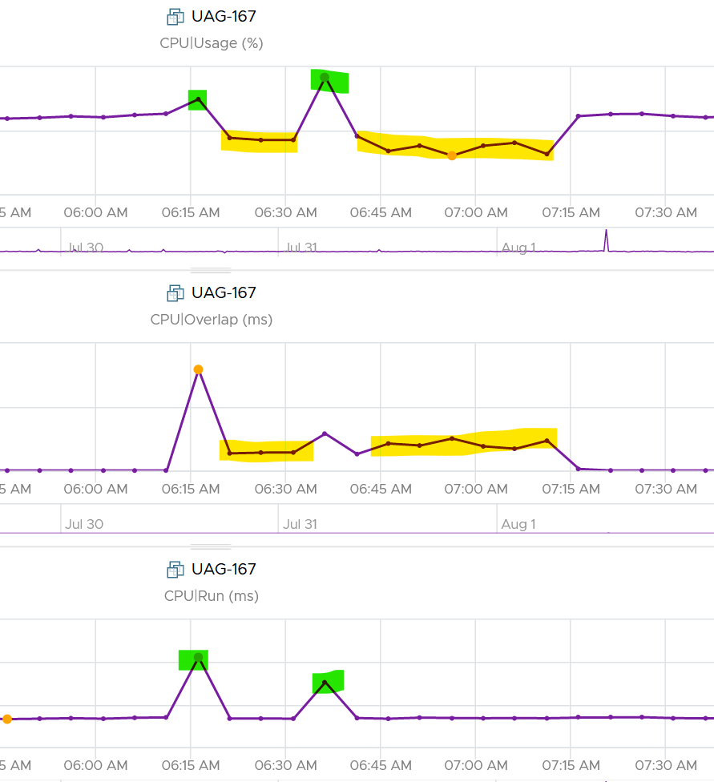

The above prove that Run is not aware of overlap. Notice when overlap went up, Run did not go lower. CPU Usage however, did go down as it’s aware of overlap.

The correlation is not perfect as Usage is also aware of hyperthreading and CPU frequency.

The Overlap counter is useful to troubleshoot performance problem, complementing Ready, Co-stop, Other Wait and Swap Wait. Ready does not include Overlap as the VM remains on the Run State (see the CPU State Diagram).

The unit is millisecond, and it’s the summation of the entire 20 seconds. vRealize Operations averages over 300 seconds. So the amount at 300 seconds is max 20000 (this is 100%), and must be multiplied by 15 if we want to see the actual average in the 300 second period.

The amount is the sum of all vCPU, so you need to divide by the number of running vCPU if you are converting into a percentage. Divide over 20000 ms x 100%. When I did that, and plot the highest 5 among ~3K production VMs, I get this.

|  |  |  |
| --- | --- | --- |
| Overlap (ms) | vCPU | Overlap (%) |
| 6,169 | 30 | 1.03% |
| 284 | 2 | 0.71% |
| 509 | 4 | 0.64% |
| 484 | 4 | 0.61% |
| 237 | 2 | 0.59% |

The above indicates the VMs only experienced minimal interruption by VMkernel.

Let’s dive into a single VM. The following is a 68 vCPU VM running Splunk. In the last 7 days, it experienced a low but sizeable CPU overlap. 10K is relatively low for a 68 vCPU VM, but it still represents half a vCPU worth of interruption.



Overlap should be included in **Guest OS sizing** as the Guest OS wants to run actually. The effect is the same with an unmet Demand.

A high overlap indicates the ESXi host is doing heavy IO (Storage or Network). Look at your NSX Edge clusters, and you will see the host has relatively higher Overlap value versus non IO-intensive VM.

##### Contention | Latency

This metric tracks the “stolen time”, which measures the CPU cycle that could have been given to the VM in ideal scenario.

The metric is called Contention in vRealize Operations, but Latency in vCenter, which in turns maps to ESXi LAT_C counter.

The diagram shows what it includes. LAT_C excludes Max Limited in Ready, but it includes Co-stop even if the Co-stop was the result of Limit.

Notice that HT and CPU Frequency are effect and not metrics. You can see the impact of CPU Frequency in [esxtop](http://www.yellow-bricks.com/esxtop/) %A/MPERF counter.



It measures the full possible contention a VM may have, that is not intentionally imposed on the VM by the vSphere Administrator. It considers CPU SMT effect. In ESXi CPU accounting, Hyper Threading is recorded as giving 1.25x throughput. That means when both threads are running, each thread is recorded as only getting 62.5%. This will increase the CPU Contention to 37.5%. All else being equal, VM CPU Contention will be 37.5% when the other HT is running. This is done so Used + Latency = 100%, as Used will report 62.5% when the vCPU has a competing thread running.

In the above scenario, what’s the value of CPU Ready?

Yup, it’s 0%.

CPU Contention also accounts for power management. What happens to its value when frequency drops by 25%. It can’t go to negative right? If you know the answer, let me know!

Because of these 2 factors, its value is more volatile, making it less suitable as a formal Performance SLA. Use CPU Ready for Performance SLA, and CPU contention for performance troubleshooting. You can do a profiling of your environment by calculating the value of CPU Ready at the time CPU Contention hits the highest, and vice versa. The following table only shows 5 VM out of 2500 that I analyzed. These 2 metrics do not have good correlation, as they are created for different purpose.



In many cases, the impact of both threads running is not felt by the application running on each thread. If you use CPU Contention as formal SLA, you may be spending time troubleshooting when the business does not even notice the performance degradation.

The following screenshot shows CPU Contention went down when both Ready and Co-stop went up.



How about another scenario, where Contention is near 0% but Ready is very high? Take a look at this web server. Both CPU Demand and CPU Usage are similar identical. At around 1:40 am mark, both Demand and Usage showed 72.55%, Contention at 0.29%, but Ready at above 15%. What’s causing it?



The answer is Limit. Unlike CPU Ready, it does not account for Limit (Max Limited) because that’s an intentional constraint placed upon the VM. The VM is not contending with other VMs. [VMware Cloud Director](https://www.vmware.com/products/cloud-director.html) sets limit on VM so this counter will not be appropriate if you aim to track VM performance using Contention (%) metric.

Here is a clearer example showing contention consistently lower than Ready due to limit.

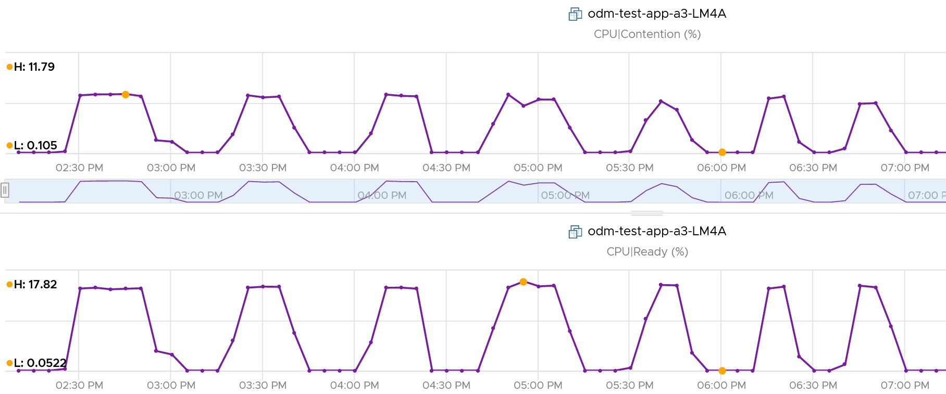

A better and more stable metric to track the contention that a VM experience is Ready + Co-stop + Overlap + VM Wait + Swap Wait. Note that the raw metric for all these are millisecond, not GHz.

Where do you use CPU Contention then?

Performance troubleshooting for CPU-sensitive VM.

If the value is low, then you don’t need to check CPU Ready, Co-stop, Power Management and CPU overcommit. The reason is they are all accounted for in CPU Contention.

If the value is high ( > 37.5%), then follow these steps:

* Check CPU Run Queue, CPU Context Switch, “Guest OS CPU Usage“, CPU Ready and CPU Co-stop. Ensure all the CPU metrics are good. If they are all low, then it’s Frequency Scaling and HT. If they are not low, check VM CPU Limit and CPU Share.
* Check ESXi power management. If they are set to Maximum correctly, then Frequency Scaling is out (you are left with HT as the factor), else HT could be at play. A simple solution for applications who are sensitive to frequency scaling is to set power management to max.
* Check CPU Overcommit at the time of issue. If there is more vCPU than pCore on that ESXi, then HT could be impacting, else HT not impacting. IMHO, it is rare that an application does not tolerate HT as it’s transparent to it. Simplistically speaking, while HT reduces the CPU time by 37.5%, a CPU that is 37.5% faster will logically make up for it.

There is a corner case accounting issue in %LAT_C that was resolved in ESXi 6.7[19]. VMs with Latency Sensitive = High on ESXi 6.5 or older, will show any “guest idle” time of vCPUs as LAT_C, for those VMs the counter should not be relied on. This is a corner case because majority of VM should not be set with this, as it impacts performance of other VMs.

##### Unmet Demand

Unmet demand should only care about whether the VM gets to run or not. It should not care about how fast it will run when it gets to run, because it does not know. As a result, we should not account for HT. The demand was met, albeit at efficiency dropped by 37.5% due to HT effect.

This is not a built-in counter. I created it using vRealize Operations super metric.

While the need for such counter sounds logical, the detail is more complex. What do we need this counter for?

* If it’s for Cluster Capacity, then CPU Ready caused by Limit should not be considered. You intentionally place the limit, so the CPU Ready is not caused by the inability of the host.
* If it’s for VM Performance, then it’s debatable. If you do not include it, you may miss it. If you include it, the solution is to remove the limit. The problem is the limit could be caused by setting in the resource pool where the VM belongs to. For example, if customer only wants to pay for 10 GHz of resource but insists on running more than that, well, performance will definitely take a hit.

The above 2 metrics are for CPU slowness. CPU, being the fastest component, typically wait for RAM, Disk and Network.

* CPU Swap Wait. CPU is waiting for Memory. Had RAM were faster, it would have been executed. For example, adding RAM may result in higher CPU usage.
* CPU Other Wait. CPU is waiting for IO (Disk or Network) and other things (e.g. vMotion stun time). Had they been faster, it would have been executed. For example, replacing storage subsystem with much lower latency would result in CPU completing the task in less time. A 10 hour batch job may take 1 hour, so the CPU usage would be 10x. If disk is outside the ESXi, changing the array can have ramification on ESXi usage. So we should account for it.

Should we account for this wait? They are not real demand. It’s not an unmet demand. It’s a potential demand, which would happen if the other component is improved. Let me know your thought!

The formula I use is

Ready + Co-stop + Overlap + Swap Wait + Other Wait.

#### Wait

CPU is the fastest component among infrastructure resources, so there are times it must wait for data. The data comes from memory, disk or network.

There are also times when there is nothing to do, so the CPU is idle. Whether the upper-layer (Guest OS vCPU) is truly idle or blocked by pending IO, the VMkernel does *not* have the visibility. It can only see that Windows or Linux is not doing any work.

There are 3 sub-metrics that make up Wait.

* Idle. Waiting for work..
* Swap Wait. Waiting for memory.
* Other Wait. Waiting for other things.

Guest OS isn’t aware of both Other Wait and Swap Wait. Just like other type of contention, it experiences freeze. The time it spends under Other Wait and Swap Wait should be included in the Guest OS CPU sizing formula as the VM wants to run actually.

Idle counter tracks when VM is not running. Regardless of the reason in the upper-layer, VM Idle should not be included in both VM sizing, and definitely not in Guest OS sizing. The reason is the vCPU is not running and you can’t predict what the usage would be. You should address the IO and memory bottleneck in Guest OS level, using Windows and Linus metrics.

Swap Wait tracks the time CPU is waiting for Memory page to come in from ESXi swap. This metric was superseded by Memory Contention metric.

Other Wait tracks the time CPU is being blocked by other things, such as IO and vMotion. For example, the VMM layer is trying to do something and it’s blocked. The number of reasons vary and it’s hard to pinpoint exactly which one, as you need low level debug logs such as stats vmx, schedtraces, and custom vprobes. You’re better off removing the common reasons. Snapshot is a common reason here[20], that it was mistakenly named as IO Wait.

##### Other Wait

Take note of a [known bug](https://kb.vmware.com/s/article/85393?lang=en_US) that wrongly inflates the value of Other Wait and esxtop %VMWait.

Actions you can do to reduce Other Wait:

* vMotion the VM.
* Remove Snapshot
* Update to the latest build of ESXi (incl. physical device drivers), virtual HW and VMware Tools (virtual device drivers).
* If this happens to multiple VMs, find commonality.

If the above is not helping in your case, file a Support Request with VMware GSS and tag me. Please mention that you get it from here, so I have a context.

I plotted Other Wait for 4000 production VMs. Surprisingly, the value is not low.

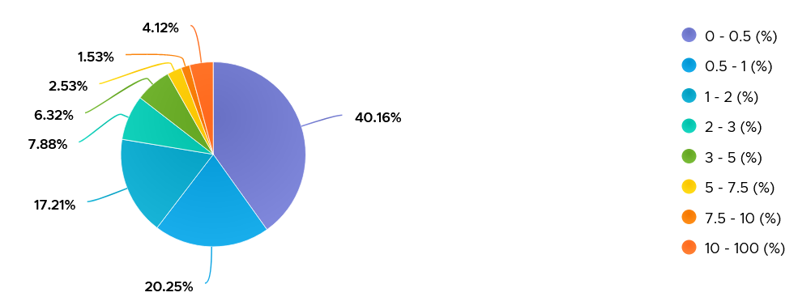

I was curious if the value corelates with CPU Ready or Co-stop. From around 4000 production VM in the last 1 month, the answer is a no.

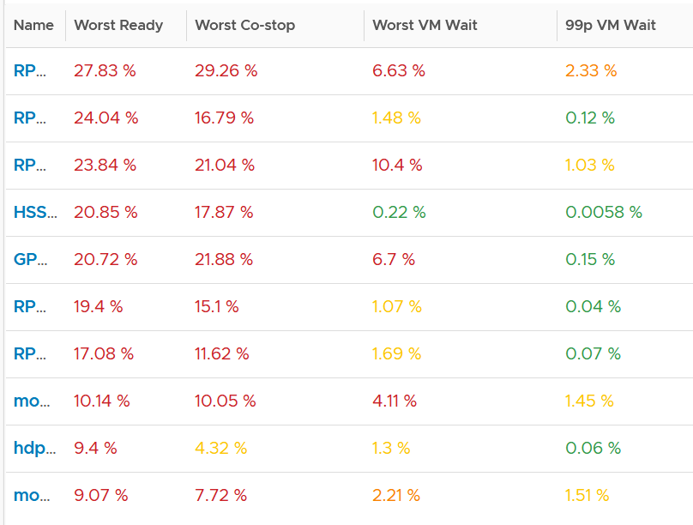

Since snapshot is another potential culprit, let’s compare with disk latency and outstanding IO.

What do you expect?

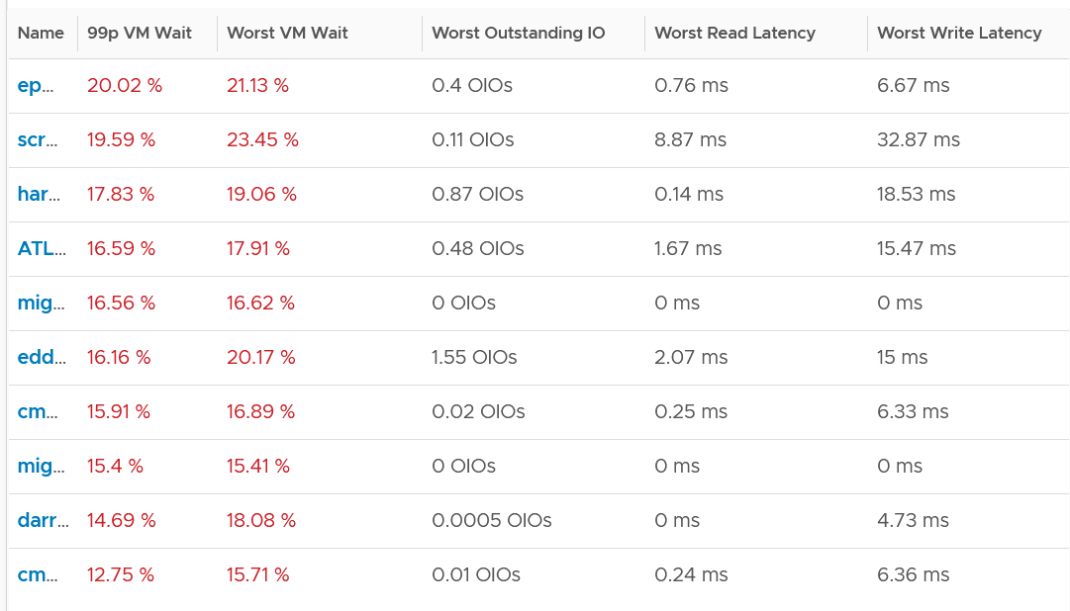

Again, negative corelation. None of the VMs with high VM Wait is experiencing latency. Notice I put a 99th percentile, as I wanted to rule out a one time outlier. I’m plotting the first VM as the value at 99th is very near to the max, indicating sustained problem.

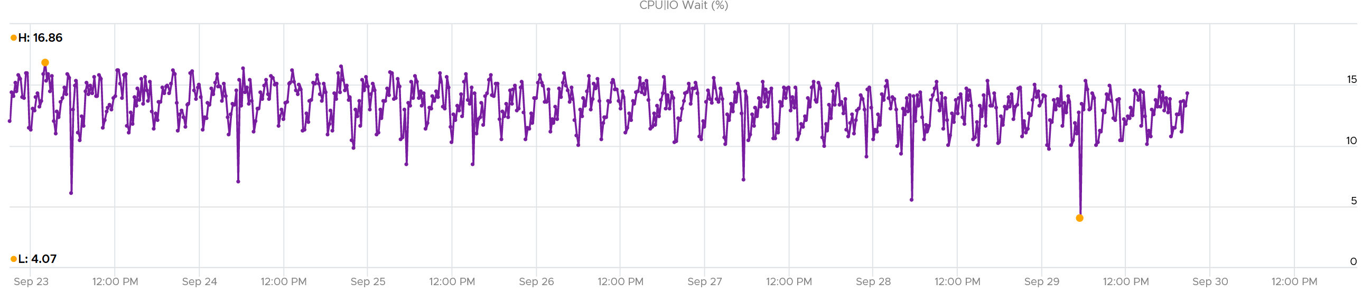

It turned out to be true. It has sustained VM Wait value around 15% (above is zoomed into 1 week so you can see the pattern).

I’m curious why it’s so high. First thing is to plot utilization. I checked Run, Usage and Demand. They are all low.

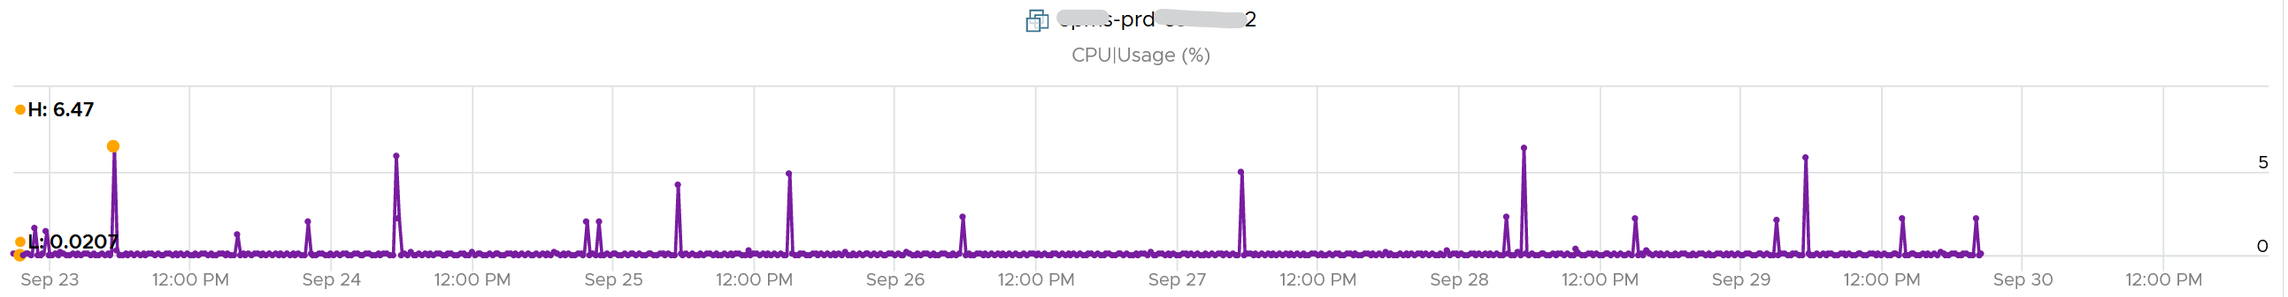

Using vRealize Operations correlation feature, I checked if it correlates with any other metric. The only metric it founds is Idle, which is logical they basically add up to 100% when Run is low.

#### Consumption Metrics

This covers both utilization and reservation. Allocation is a property for VM.

##### Run

Run is when the Guest OS gets to run and process instruction. It is the most basic counter among the 4 CPU utilization metrics. It’s the *only* counter not affected by CPU frequency scaling and hyper threading. It does not check how fast it runs (frequency) or how efficient it runs (SMT).

Run at VM level = Sum of Run at vCPU levels

This means the value of CPU Run at VM level can exceed 20000 ms in vCenter.

The following screenshot shows CPU Run higher than CPU Used. We can’t tell if the difference is caused by power management or hyperthreading, or mix of both.



If the above was all we need to know, monitoring VMware vSphere would have been easy. You wouldn’t need a book like this. In reality, the following factors must also be considered:

* Interrupt
* System time
* Power Management or CPU Frequency Scaling
* Simultaneous Multithreading (Hyper Threading as Intel calls it)

Because CPU Run do not take into account this external work, and not aware of CPU speed and HT, we will see later in the right-sizing section that this property makes it *suitable* as input to size the Guest OS.

##### Used | Usage | Demand

As covered earlier, CPU Run does not account for the following:

* How fast is the “run”? All else being equal, a 5 GHz CPU is 5x faster than a 1 GHz CPU. Throughput impacts utilization. The faster it can complete a task, the shorter it has to work. That’s why you see some metrics in MHz, because they account for this speed.
* How efficient is the “run”? If there is competing thread running in the same core, the 2 threads have to share the core resource. ESXi accounting records this as 1.25x overall gain, hence each thread drops to 62.5% only. This is a significant drop that should be accounted.
* IO work. IO performed by hypervisor has to be charged back to the VM.

This is where Used and Demand come in. vCenter then adds Usage (MHz) and Usage (%) metrics. The following table shows the 5 VM utilization metrics.

|  |  |  |  |  |  |
| --- | --- | --- | --- | --- | --- |
| **Counter** | **Available at** | **Unit** | **Source** | **CPU Frequency** | **SMT** |
| Run | vCPU level | Millisecond | ESXi | No | No |
| Used | vCPU level  VM level (include System) | Millisecond | ESXi | Yes | Yes |
| Usage | vCPU level | MHz | vCenter | Yes | Yes |
| Usage | VM level | % | vCenter | Yes | Yes |
| Demand | VM level | MHz | ESXi | Yes | No |

##### Used

CPU Used covers uses cases that CPU Run does not.

* VM Migration. Moving VM to another ESXi requires that you know the actual footprint of the VM, because that’s what the destination ESXi needs to deal with.
* VM Chargeback. You should charge the full cost of the VM, and not just what’s consumed inside the VM. In fairness, you should also charge the actual utilization, and not rated clock speed.

Here is how Used differs to Run:



Based on the above, you can work out the formula for VM level Used, which is:

VM level Used = Run + System - Overlap + VMX +/- **E**

Where **E** is the combination of

* efficiency gained from CPU Turbo Boost or efficiency loss from power savings. For example, if the frequency is dropped to 40% of the nominal frequency, we consider 60% of the CPU time was stolen.
* 37.5% efficiency loss from CPU SMT.

VMX is typically negligible. It accounts for CPU cycles spent on things like consoling to the VM. In esxtop, System time is charged to the VM VMX world.

Because Used accounts for the actual frequency, you may expect it to be measured in GHz and not millisecond. Think of the number of cycles completed instead of simply frequency. You then convert it back to time. I know it requires a bit of mental mathematics 😊

Quiz:

* Why does the formula state VM level, and not individual vCPU level. What’s the reason?
* How will Used compare with Run in general? Do you expect it to be higher or lower? If it’s higher, what can cause it?

The impact of Power Management can be noticeable. For example, a physical chip comes with 2 GHz as its standard speed. ESXi may increase or decrease this speed dynamically, resulting in Turbo Boost or power saving. If ESXi increases the clock speed to 3 GHz, Used counter will be 50% higher than the Run counter. The Guest OS (e.g. Windows or Linux) is not aware of this performance boost. It reports a value based on the standard clock speed, just like Run does. On the other hand, if ESXi decreases the clock speed to 1.5 GHz, then Used will report a value that is 25% lower than what Run reports.

Let’s take an example. What do you notice?



As you can see from the preceding chart, the impact is noticeable. The System and Overlap metrics hovers averages <10 ms (negligible as this VM is basically idle), but the gap between Used and Run averages around 20% Used is ~20% higher than Run, likely due to Turbo Boost.

Let’s take another example, this time from a busy VM. I’ve removed System and Overlap as they are also negligible in this example. This is a 32 vCPU VM running Splunk. Notice Used is consistently higher than Run.



Now let’s look at the opposite scenario. This VM is a 64 bit Ubuntu running 4 vCPU. Used (ms) is around 44% of Run (ms). The VM had minimal System Time (ms) and Overlap (ms), so Used is basically lowered by both power savings and CPU SMT. In this example, if Run is far from 100% and the application team want faster performance, your answer is not to add vCPU. You should check the power management and CPU SMT, assuming the contention metrics are low.



Take note: CPU Used has a different formula at VM level and vCPU level. At vCPU level, it does not include System Time. At VM level, it includes the work done by VMkernel that is charged at VM level, such as System and other worlds.

##### Usage

There are two metrics: Usage (MHz) and Usage (%).

These 2 metrics do not exist in ESXi, meaning they only exist in vCenter.

My guess is

Usage (%) = ( Average of (Usage MHz for each core) / VM Static CPU Speed ) + VM level load

The reason is Usage (%) is not available on a per vCPU basis, while Usage MHz is. The 2 charts are also *very* similar are not 100% identical. Notice in the following screenshot there is time where they are 100% identical, and there is time they are not. My guess is Usage (%) contains VMX load as it’s not available on a per vCPU basis.



Let’s compare Usage with Used instead. We will compare Usage MHz as that’s the raw counter. The percentage value is derived from it.



From the preceding chart, we can see they are basically the same, with the difference due to y-axis scales. Formula wise, Usage (MHz) includes all the VM overhead, such as the time spent by VMX process.

Aria Operations Usage (MHz) and Usage (%) metrics map 1:1 to the respective metrics from vCenter.

###### Usage (GHz)

We stated that CPU power management & HT impact Usage.

Review the following example. This is a single VM occupying an entire ESXi.

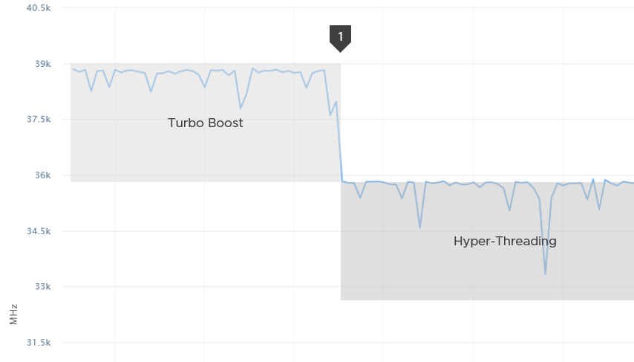

The ESXi has 12 cores with nominal frequency of 2.4 GHz. The number of socket does not matter in this case.

Since HT is enabled, the biggest VM you can run is a 24 vCPU. The 24 vCPU will certainly have to share 12 cores, but that’s not what we’re interested here.

What do you expect the VM CPU Usage (GHz) when you run the VM at basically 100%?

36 GHz, if you did not enable dynamic power management.

Why not 57.6 GHz, because it’s 24 vCPU x 2.4 GHz?

Because HT does not yield 2x. It yields 1.25x only. At the end of the day, the one that does the computation is the core not the thread.

12 cores x 2.4 GHz 1.25 HT = 36 GHz total capacity with hyperthreading enabled.

In the preceding example, power management was enabled. Naturally Turbo Boost kicked in, albeit not so dramatic as the VM already used up the entire ESXi CPU cores.

You got around 39 GHz, a small increase over 36 GHz. Formula is 2.4 GHz x 12 cores x 1.25 HT x 1.08x Turbo Boost. Notice it is 12 not 24.

What happens when we disable turbo boost? That’s what we did at point 1 in the diagram above..

CPU Usage drops to slightly below 36 GHz.

###### Usage (%)

The following is a single vCPU production Windows Server. Both CPU Usage (MHz) and Demand jump to over 100%. Their values are identical for almost 30 days. The VM had near 0% Contention (not shown in chart), hence the 2 values are identical.



However, when we plot the value in %, we see a different number. Usage (%) is strangely capped at 100%.



The VM experienced some contention around May 12. That’s why Demand was higher than Usage.

##### Demand

Demand differs to Usage as it assumes the VM does not share the physical core. It’s unaware of the penalty caused by hyperthreading. It’s what the VM utilization would be had it not experienced any contention.

In the event the VM vCPU is sharing, the value of Usage will be 37.5% lower, reflecting the fact that the VM only gets 62.5% of the core. This makes sense as the HT throughput benefit is fixed at 1.25x.

If there is no contention, Demand and Usage will be similar.

Take a look at the following screenshot from vCenter. It’s comparing Demand (bold) and Usage.

What do you notice?

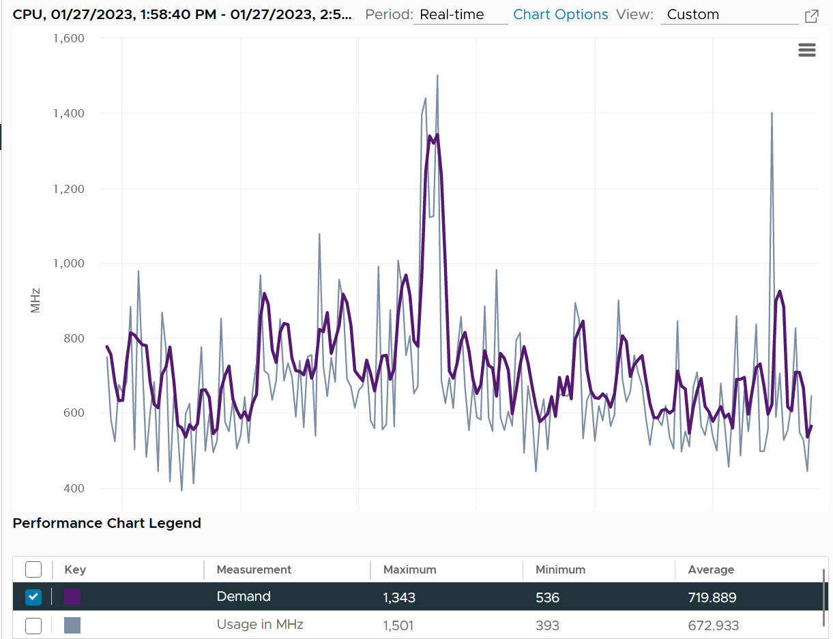

How can Usage be higher than Demand at some of the point?

The reason is Demand is averaged over a longer time, giving it a more steady value. That’s why the peak is shorter but wider. Notice the average over 1 hour is higher for Demand.

Demand could be lower than Run if there is power management savings, as it accounts for speed & efficiency of the run.

Demand (MHz) and Usage (MHz) can exceed 100%. The following is a 32-vCPU Hadoop worker node. Notice it exceeds the total capacity multiple times. Demand and Usage are identical as it’s the only VM running and the has more than 32 cores, hence there is 0 contention.



Okay, now that you have some knowledge, let’s test it 😊

Quiz Time! Looking at the chart below, what could be causing it?

Notice Demand jump while Usage dropped. VM CPU Contention (%) jumped even more. What is going on?



And why is that Contention is much more than Demand – Usage?

The reason why Demand metric jumps while Usage drops is contention. The VM experiences contention, which includes hyperthreading sharing. I should have included the screenshot of CPU Ready, Co-stop, Overlap, VM Wait and Swap Wait.

From the chart you can see that the formula for VM CPU Contention > Demand – Usage. Contention (%) is around 20% when Demand is 25% and Usage is 15%. The reason is Contention accounts for both CPU frequency and hyper threading, while the difference between Demand and Usage is hyper-threading.

Aria Operations provides a percentage metric for Demand. The formula is

Demand (%) = Demand (MHz) / Total Capacity (MHz) x 100

In older release of vRealize Operations, this counter used to be computed as maximum (CPU Utilization for Resources \ CPU Active (1 min. average) / Configuration \ Hardware \ Number of CPUs, CPU Usage) * CPU Total Capacity / 100. This is no longer the case as vRealize Operations now simply maps to vCenter metric.

Source wise, the metric in vRealize Operations simply maps to vCenter counter cpu.demand.average.

##### Used vs Run vs Usage

By now I hope you vrealize that the various “utilization” metrics in the 4 key objects (Guest OS, VM, ESXi and Cluster) varies. Each has their own unique behaviour. Because of this, you are right to assume that they do not map nicely across the stack. Let’s test your knowledge 😊

Review the following chart carefully. Zoom in if necessary.



The vCenter chart[21] above shows a VM utilization metrics from a single VM. The VM is a large VM with 24 vCPUs running controlled CPU test. The power management is fixed so it runs at nominal clock speed. This eliminates CPU frequency scaling factor.

The VM starts at 50% “utilization”, with each vCPU pinned to a different physical core. It then slowly ramps up over time until it reaches 100%.

Can you figure out why the three metrics moved up differently? What do they measure?

Now let’s look at the impact on the parent ESXi. It only has a single VM, but the VM vCPU matches the ESXi physical cores. The ESXi starts at 50% “utilization”, then slowly ramp up over time until it reached 100%.



Can you figure out why the 3 metrics moved up differently? What do they measure?

Let’s break it down…

###### At the start of the test

The VM runs 12 vCPU, but each vCPU was pinned to each ESXi core. So all cores are 100% utilized, but each running 1 thread.

VM CPU Run (ms) is 240K milliseconds, which is 20K milliseconds x 12 (half of its 24 vCPU).

VM CPU Used (ms) is also at 240K milliseconds. There is no loss from overlap, the VM does not do much IO, and no efficiency loss/gain due to HT.

VM CPU Usage is 50%.

So at this point, all 3 metrics of VM CPU are 50%.

The counter at ESXi tells a different story. The ESXi Core Utilization (%) immediately went up to 100% while Utilization went up to only 50%. The reason is Core Utilization measures whether the core is used or not. It’s unaware of HT.

Usage (%) is identical to Core Utilization in this case.

On the other hand, ESXi Utilization (%) looks at if each thread HT is running or not. It does not care about the fact that the 2 threads share a core, and simply roll up to ESXi level directly from thread level. This is why it’s showing 50% as it only cares whether a thread is running or not, at any point in time.

###### During Ramp Up period

VM is being ramped up steadily. You can see all 3 metrics went up in steps.

VM CPU Run (ms) ramps up from 240K to 480K. All 24 vCPU has 20K ms value, which equals to 100%.

VM CPU Used (ms) barely moved. From 240K to 300K. That’s 1.25x, demonstrating that Used understands HT only delivers 1.25x throughput.

VM CPU Usage (%) ramp up from 50% to 62.5%, also demonstrating awareness of contention due to HT.

Used (ms) = Usage (%)

ESXi CPU Usage (%) counter stayed flat at 100%. The reason is all 12 cores were already busy. That means VM CPU Usage (%) is aware of HT, but ESXi CPU Usage (%) is not.

ESXi CPU Core Utilization (%) matches VM Run. Both went 2x.

###### Towards the end of the run

VM CPU Run is at 480K ms. This counter is suitable for VM Capacity sizing, as it correctly accounts that each vCPU is used by Guest OS.

VM CPU Used is at 300K milliseconds, which is 62.5%

VM CPU Usage (%) is at 62.5%. On average, each of the VM vCPU only gets 62.5%. If you use this for your VM capacity, you will get the wrong conclusion as it’s already running 100%

ESXi CPU Usage (%) is at 100%. This makes it suitable from Capacity viewpoint, albeit too conservative. It is not suitable from Performance, as you can not tell if there is still room.

ESXi CPU Utilization (%) is at 100%. Because it tracks the ramp correctly, it can be used from Performance. You can use it for Capacity, but take note that 100% means you get performance hit from. In fact, at 50% the HT effect will kick in.

##### CPU Usage Disparity

This metric is required to convince the owners of the VM to downsize their *large* VMs. It’s very common for owners to refuse sizing it down even though utilization is low, because they have already paid for it or cost is not an issue.

Let’s an example. This VM has 104 vCPU. In the last 90 days, it’s utilization is consistently low. The Usage (%) counter never touch 40%. Demand is only marginally higher. Idle (%) is consistently ~20%.

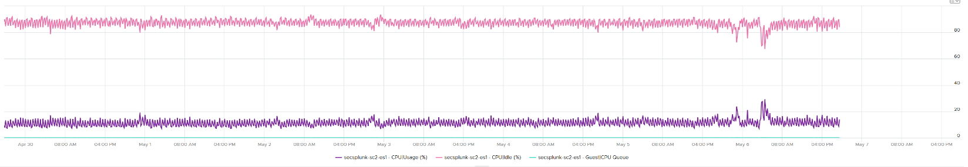

All the key performance metrics such as Guest OS CPU Run Queue are low.

Obviously the VM does not need 104 vCPU. How to convince the owner if he is not interested in refund? The only angle left is performance. But then we’re faced with the following:

1. CPU Run Queue inside the Guest OS is low. Decreasing CPU will in fact increase it, which is worse for performance.
2. CPU Context Switch is high from time to time.
3. CPU Co-Stop is very low (max of 0.006% in the last 90 days). Decreasing CPU may or may not make it lower. Regardless, it’s irrelevant. Same goes with VM Wait and Swap Wait.
4. CPU Ready is very low (max of 0.14% in the last 90 days).

The only hope we have here to convince VM owner is to give insight on how the 104 vCPU are used. There are 2 ends of the spectrum:

|  |  |
| --- | --- |
| At one end, all 104 are balanced | All are running at that low 20%. This triggers an interesting discussion on why the application is unable to even consume a single vCPU. Is this inefficiency the reason why the application vendor is asking for so many vCPU? Commercially, it’s wasting a lot of software license |
| Imbalance | Some are saturated, while others are not.   * The Peak among vCPU metric will capture if any of them is saturated. This is good insight. * The Min among vCPU is not useful as there is bound to be 1 vCPU among 104 that is running near 0%. * The delta between Max and Min will provide insight on the degree of the usage disparity. Does it fluctuate over time? This type of analysis helps the application team. Without it they have to plot 104 vCPU one by one. |

In reality, there could be many combinations in between the 2 extremes. Other insights into the behaviour of the 104 vCPU are:

1. Jumping process. Each vCPU takes turn to be extreme high and low, as if they are taking turn to run. This could indicate process ping pong, where processes either do frequent start/stop, or they jump around from one vCPU to another. Each jump will certainly create context switch, like the cache needs to be warm up. If the target CPU is busy, then the running process was interrupted.
2. CPU affinity. For example, the first 10 vCPU is always much busier than the last 10 vCPU. This makes you think why, as it’s not normal.

Naming wise, vCPU Usage Disparity is a better name than Imbalance vCPU Usage. Imbalance implies that they should be balanced, which is not the case. It’s not an indication that there is a problem in the guest OS because vRealize Operations lacks the necessary visibility inside the guest OS

##### System

A VM may execute a privilege instruction, or issue IO commands. These 2 activities are performed by the hypervisor, on behalf of the VM.

IO processing differs to non-IO processing as it has to be executed twice. It’s first processed inside the Guest OS, and then in the hypervisor storage subsystems, because each OS has their own storage subsystem. For ESXi, its network stack also have to do processing if it’s a IP-based storage.

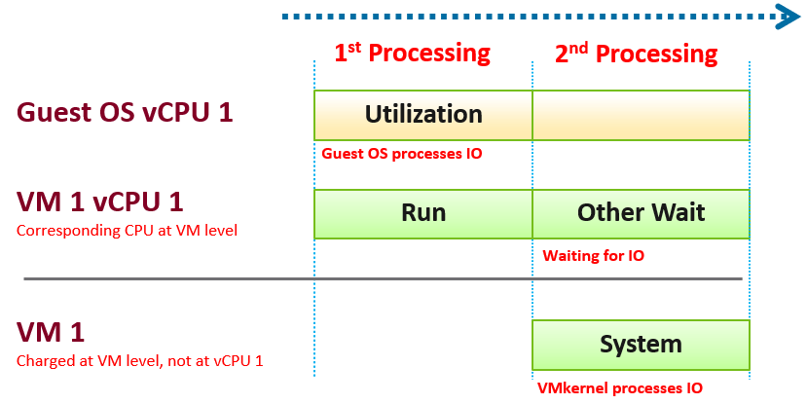

ESXi typically uses another core for this work instead of the VM vCPU, and put that that VM vCPU in wait state. This work has to be accounted for and then charged back to the associated VM. The System counter tracks this. System counter is part of VMX counter.

Guest OS isn’t aware of the 2nd processing. It thinks the disk is slower as it has to wait longer.

If there is snapshot, then VMkernel has to do even more work as it has to traverse the snapshot.

The work has to be charged back to the VM since CPU Run does not account for it. Since this work is not performed by any of the VM CPU, this is charged to the VM CPU 0. The system services are accounted to CPU 0. You may see higher Used on CPU 0 than others, although the CPU Run are balanced for all the VCPUs. So this is not a problem for CPU scheduling. It’s just the way VMkernel does the CPU accounting.

The System counter is not available per vCPU. Reason is the underlying physical core that does the IO work on behalf of the VM may be doing it for more than 1 vCPU. There is no way to break it down for each vCPU. The following vCenter screenshot shows the individual vCPU is not shown when System metric is selected.



ESXi is also performing IOs on behalf of all VMs that are issuing IOs on that same time, not just VM 1. VMkernel may serialize multiple random IO into sequential for higher efficiency.

Note that I wrote to CPU accounting, not Storage accounting. For example, vSphere 6.5 no longer charges the Storage vMotion effort to the VM being vMotion-ed.

Majority of VMs will have System value less than 0.5 vCPU most of the time. The following is the result from 2431 VMs.



On IO intensive VM like NSX Edge, the System time will be noticeable, as reported by [this KB article](https://kb.vmware.com/s/article/59640). In this case, adding more vCPU will make performance worse. The counter inside Linux will differ to the counter in vSphere. The following table shows high system time.



### Memory

I will use the vSphere Client as the source of metrics in the following screenshots as that is, well, the source 😊

Just like the case for CPU, some metrics are for VMkernel consumption, not your operations.

#### Overview

For performance use case, the only counter tracking actual performance is Page-fault Latency.

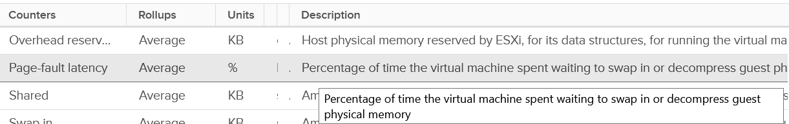

Next, check for swapping as it’s slower than compressed. You get 6 metrics for it

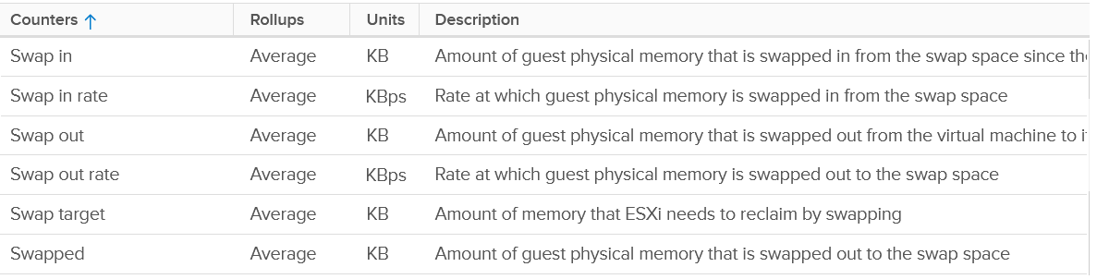

Next is compressed

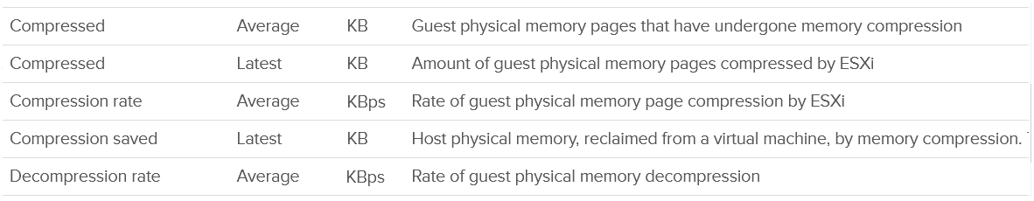

Host Cache should be faster than disk (at least I assume you designed it with faster SSD), so you check it last.

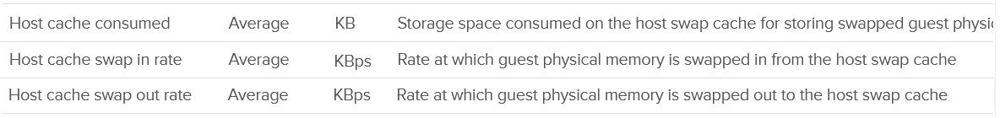

Lastly, there is the balloon.



Wait! Where is the Intel Optane memory metrics?

It does not exist yet, as that’s supposed to be transparent to ESXi.

Performance is essentially the only use case you have at VM level. For Capacity, you should look at Guest OS. The VM capacity metrics serve as input to the host capacity and are used in determining the VM memory footprint (e.g. when migrating to another ESXi).

You’ve got 5 metrics, with consume being the main one.

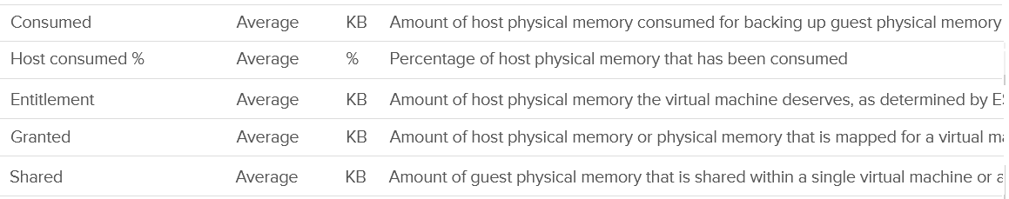

I’m going to add Active next, although I don’t see any use case for it. It’s an internal counter used by VMkernel memory management.



Lastly, you get the shared pages and 0 pages.

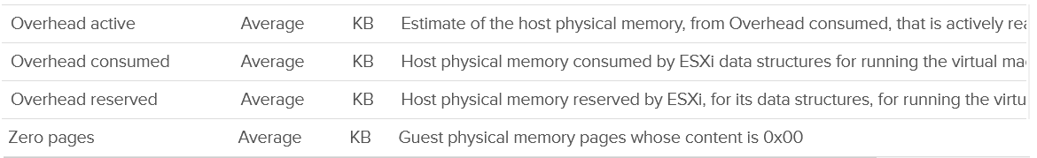

Now that we’ve got the overview, let’s dive into the first counter!

#### “Contention” Metrics

I use quote because the only true contention counter is latency. The second reason is Aria Operations has a metric called Contention, which is actually vCenter counter called latency.

##### Latency

Memory Latency, aka "Page-fault latency" is tracking the amount of time a vCPU spends waiting on the completion of a page fault. Its value is probably mostly swap wait, and probably minimally page decompression / copy-on-write-break. The counter is called %LAT_M in esxtop, while CPU Contention is called %LAT_C. This counter has the effect of reduced value of the Compressed metric and/or Swapped metric, and increased the value of Consumed & Granted.

This is the *only* performance counter for memory. Everything else does not actually measure latency. They measure utilization, because they measure the disk space occupied. None captures the performance, which is how fast that memory page is made available to the CPU.

Consider the hard disk space occupied. A 90% utilization of the space is not slower than 10%. It’s a capacity issue, not performance.

If a page is not in the physical DIMM, the VM has to wait longer. It could be in Host Cache, Swapped or Compressed. It will take longer than usual. vSphere tracks this in 2 metrics: CPU Swap Wait and RAM Latency.

* CPU Swap Wait tracks the time for Swapped In.
* RAM Latency tracks the percentage of time VM waiting for Decompressed and Swapped In. The RAM Latency is a superset of CPU Swap Wait as it caters for more scenarios where CPU has to wait. vRealize Operations VM Memory Contention metric maps to this.

Latency is >1000x lower in memory compared to disk, as it's CPU basically next to the CPU on the motherboard. Time taken to access memory on the DIMM bank is only around 200 nanoseconds. Windows/Linux does not track memory latency. The closest counter is perhaps page fault. The question is does page fault includes prefetch? If you know, let me know please.

Does it mean we don’t track balloon, swapped and compressed?

No.

The higher the value is for balloon, swapped, and compressed, the higher the chance of a performance hit happening in the future if the data is requested. The severity of the impact depends on the VM memory shares, reservation, and limit. It also depends upon the size of the VM's configured RAM. A 10-MB ballooning will likely have more impact on a VM with 4 GB of RAM than on one with 512 GB.

Latency does not include balloon as that’s a different context. In addition, the hypervisor is not aware of the Guest OS internal activity.

Actions you can do to address high value:

* Store vswp file on higher throughput, lower latency storage, such as using Host Swap Cache.
* Increase memory shares and/or reservation to decrease amount of swapping. If the VM belongs to a resource pool, ensure the resource pool has sufficient for all its VMs.
* Reduce assigned memory. By rightsizing, you reduce the size of memory reclamation, hence minimizing the risk.
* Remove VM Limit.
* Unswap the swapped memory. You cannot do this via API, but you can issue the command manually. Review [this article](https://www.yellow-bricks.com/2016/06/02/memory-pages-swapped-can-unswap/) by Duncan Epping and Valentin Bondzio.
* If possible, reboot the VM as part of regular maintenance. This will eliminate the swap file, hence avoiding future, unexpected swap wait on that swapped page. Note this does guarantee the same page to be swapped out again.

###### Best Practice

In an environment where you do not do memory overcommit and place limit, the chance of hitting memory contention will be basically 0. You can plot the highest VM Memory Contention counter in all clusters and you will basically see a flat line. That would be a lot of line charts, so I’m using a pie chart to analyze 2441 VM in the last 4 months. For each VM, I took the highest value in the last 4 months. Only 13 VM had its worst VM Contention above 1%.



##### Balloon

Balloon is an application (kernel driver to be precise) running inside the Guest OS, but it can take instruction from VMkernel to inflate/deflate.

When it receives an instruction to inflate, it asks the Guest OS to allocate memory to it. This memory in the Guest OS is not backed up by physical memory in ESXi, hence it is available for other VMs. When ESXi is no longer under memory pressure, it will notify the Balloon to release its requested page inside Guest OS. This is a proactive mechanism to reduce the chance of the Guest OS doing paging. Balloon will release the page inside the Guest OS. The Balloon counter for the VM will come down to 0.

Guest OS will start allocating from the Free Pages. If insufficient, it will take from Cache, then Modified, then In Use. This by itself does *not* cause performance problem. What will cause performance is when the ballooned page is requested by Windows or Linux. The following shows a VM that is heavily ballooned as limit was imposed on it. Notice the actual performance happens rarely.



Just because Balloon asks for 1 GB of RAM, does not mean ESXi gets 1 GB of RAM to be freed. It can be less if there is TPS.

To use ballooning, Guest OS must be configured with sufficient swap space.

How much will be asked depends on Idle Memory Tax. I do not recommend playing with this setting.

Guest OS initiate memory reallocation. Therefore, it is possible to have a balloon target value of 0 and balloon value greater than 0. The counter **Balloon Target** tracks this target, so if you see a nonzero value in this counter, it means that the hypervisor has asked this VM to give back memory via the VM balloon driver.

Balloon is a memory request from ESXi. So it’s not part of the application. It should not be included in the Guest OS sizing, hence it’s not part of reclamation.

Balloon impacts the accuracy of Guest OS sizing. However, there is no way to measure it.

* When Balloon driver asks for pages, Guest OS will allocate, resulting in In Use to go up. This is because the balloon driver is treated like any other processes.
* If the page comes from Free, then we need to deduct it from In Use.
* If the page comes from In Use, then we can’t simply deduct the value of In Use. Guest OS pages out, so we need to add Page Out or Cache.

##### Swap & Compress

Swap and Compress go hand in hand as the block that cannot be compressed go into swapped. A memory block size is 4 KB, so when the compression does not result in savings (below 2 KB or below 1 KB), then it makes no sense to compressed and the page is moved to swapped file.

Compressed and Swapped are different from ballooning, as the hypervisor has no knowledge of the free memory inside the Guest OS. It will *randomly* compress or swap. As a result, any value in this counter indicates that the host is unable to satisfy the VM memory requirement. This can have potential impact on performance.

You may notice that there is no compression target. Right?



The Consumed counter *includes* this metric. To be accurate, the Compressed counter should track the result of the compression, as that’s the actual amount consumed by the compressed pages.

It is possible to have balloon showing a zero value while compressed or swapped are showing nonzero values—even though in the order of ESXi memory reclamation techniques, ballooning occurs before compression. This indicates that the VM did have memory pressure in the past that caused ballooning, compression, and swapping then, but it no longer has the memory pressure. These events could have happened at different time. Data that was compressed or swapped out is not retrieved unless requested, because doing so takes CPU cycles. The balloon driver, on the other hand, will be proactively deflated when memory pressure is relieved.

There are other compression related metrics that are provided.

|  |  |
| --- | --- |
| **Metrics** | **Description** |
| Average Compressed | Average amount of compressed memory in the reporting period. In vCenter case, this is the average of the last 20 seconds. In vRealize Operations case, this is the average of the last 5 minutes. |
| Latest Zipped | Last amount of compressed memory in the reporting period. In vCenter case, this is data in the 20th second. vRealize Operations then averages 15 of these datapoints to make a 300 second average. |
| Zip Saved | The present amount of memory saved from the compression. |
| Compression Rate | This complements the compressed size as it covers how much memory is compressed at any given period. A 10 MB compressed in 1 second is different to 10 KB compressed over 1000 seconds. Both results in the same amount, but the problem is different. One is a acute but short fever, the other is low grade but persistent fever. You don’t want neither, but good to know what exactly you’re dealing with. |
| Decompression Rate | Same as above, but for the opposite process. |
| Swap Target | We have a balloon target and swap target, so we should expect a compression target too right?  No, because both swap and compression work together to meet the swap target counter, the counter should actually be called Compression or Swap target.  This counter tracks the amount of RAM that is subjected to the compression process. It does not track what the resultant compressed amount. There are 2 levels of compression (4:1 and 2:1), so a 4 KB page may end up as 1 KB or 2 KB. If the compression result is less than that, the page will be swapped instead as that’s a cheaper operation. So it’s completely possible to have 0 swapped as all the pages were compressed instead |

Which one should you pay attention to?

The answer always goes back to: when you see the value, what are you going to do about it? Basing on the purpose or use case helps in applying the metrics in the context of operations.

##### Limit

Does limit result in Balloon?

The answer is no. Why not?

They are at different level on memory management. Limit results in swapped or compressed.

Let’s take an example with a VM that is configured with 16 GB RAM. This is a My SQL database running on RHEL. You can see in the last 7 days, it’s using around 13.4 GB and increasing to 13.6 GB.

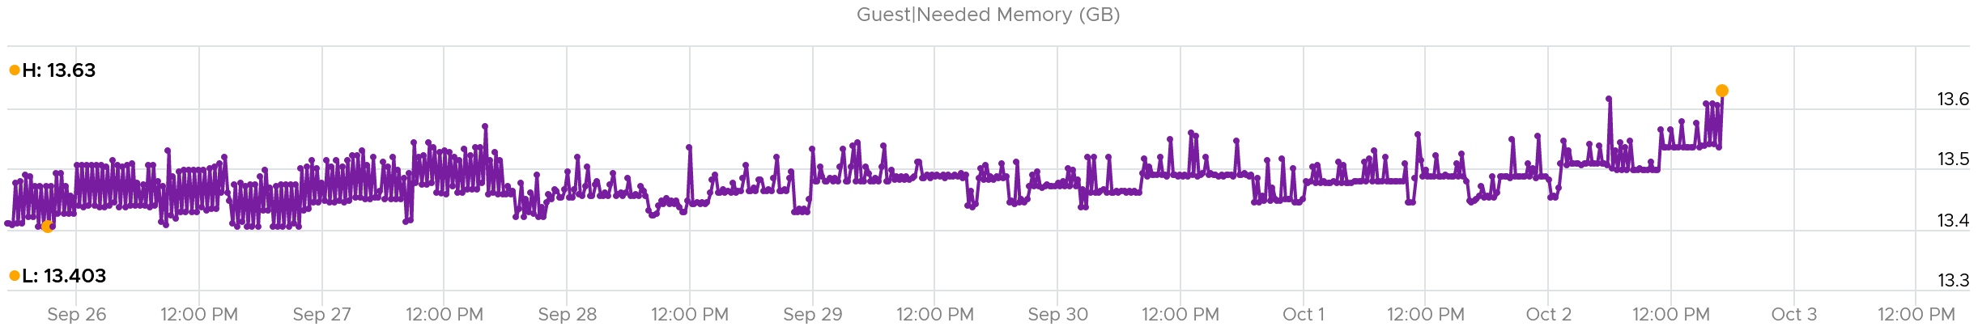

It’s given a bad limit of 2 GB.

In the last 7 days, we can see the limit is a perfectly flat line. It’s 2.12 GB as it includes the overhead value.

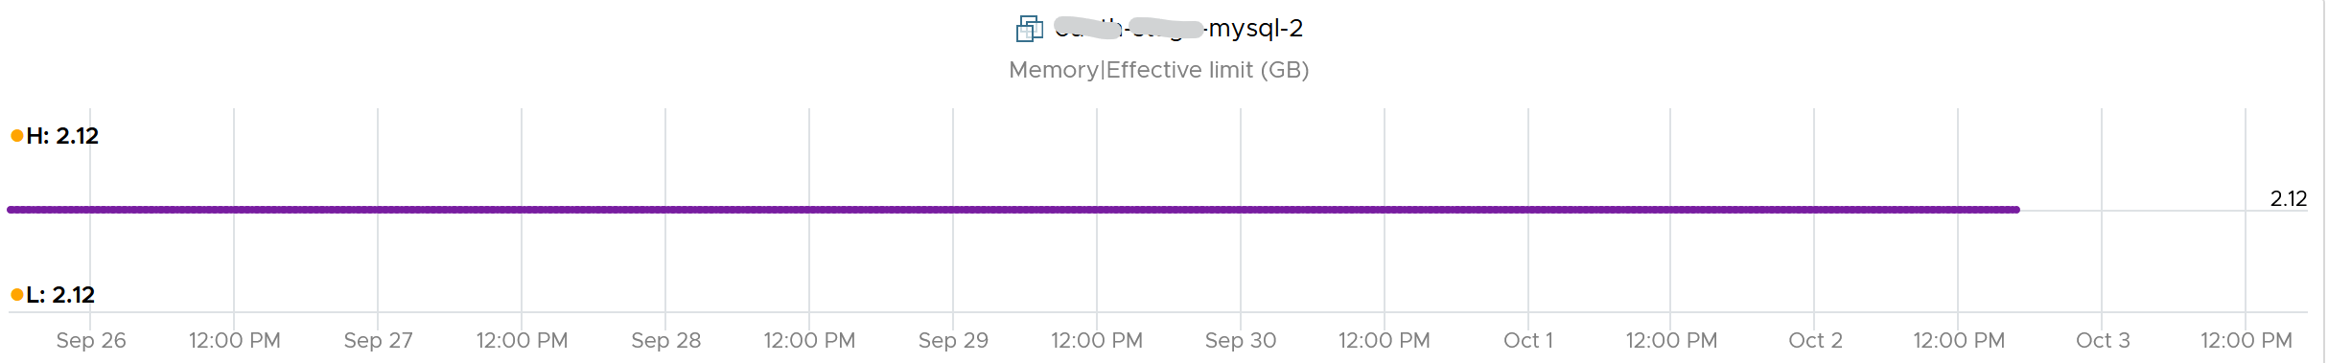

The VM, or rather the Guest OS, did ask for more. You can see the demand by looking at the Granted or Compressed or Swapped metrics. I’m only showing Granted here:

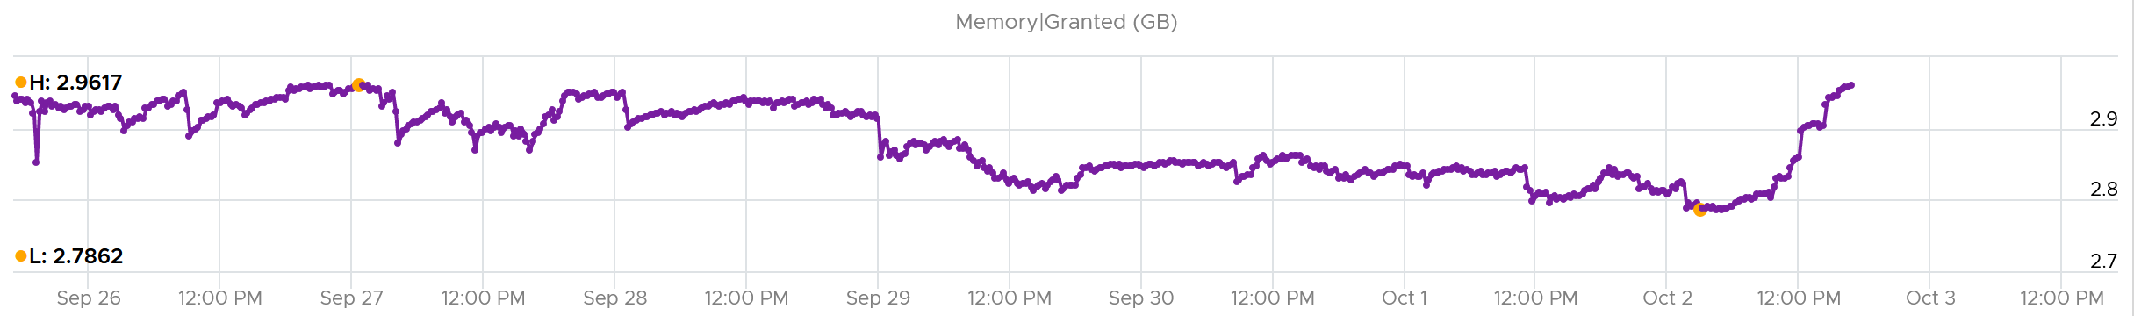

Because of the limit, the Consumed counter did not past the 2 GB. It’s constantly hovering near it as the VM is asking more than that.

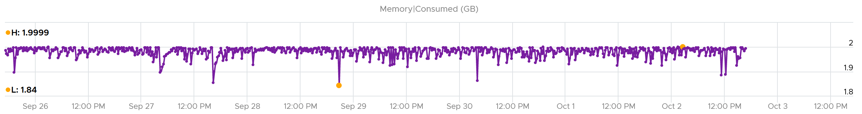

What do you expect to see the Balloon value?

If Balloon has something to do with it, it would not stay a perfectly flat line.

But this is what you got. A perfectly flat line, proving Limit had nothing to do with Balloon.

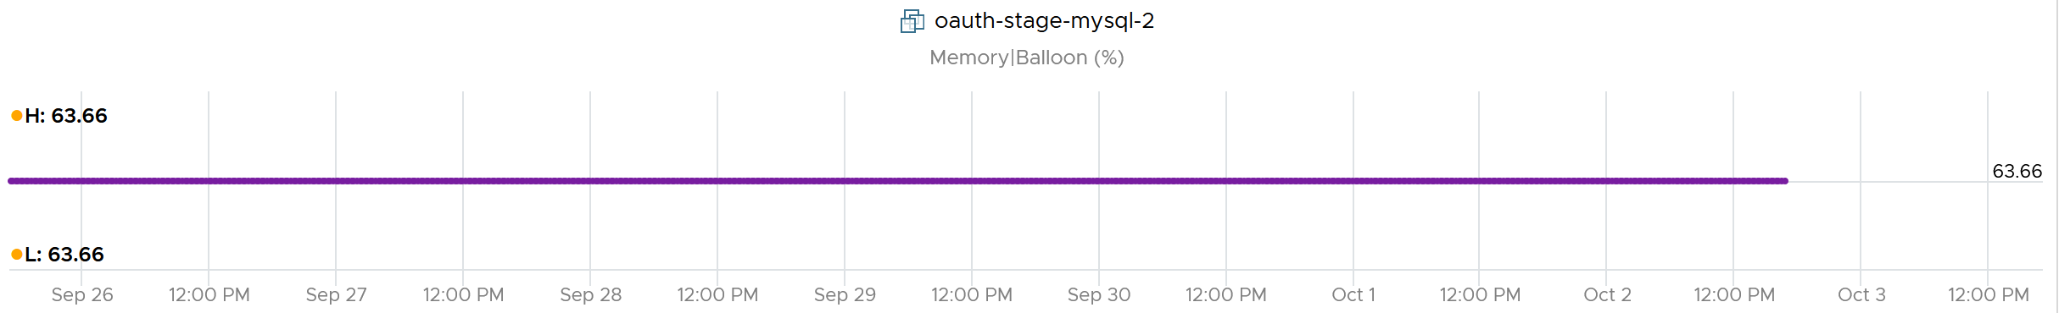

#### Consumption Metrics

This covers both utilization and reservation.

##### Granted

The English word granted accurately defines this metric, so I will just put a picture for you to conclude what it is.

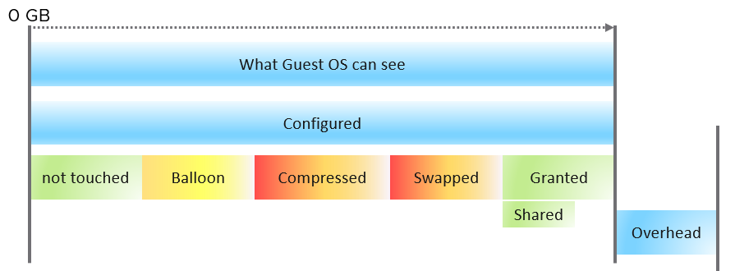

What the Guest OS can see is what is configured by vSphere. Guest OS can’t see the hypervisor memory overhead. Overhead is mostly negligible, as it’s just storing metadata or index information required by virtualization, such as the shadow page tables. Overhead value goes up as you configure more vCPUs and memory.

Say you have a VM configured with 16 GB RAM. Any part of these 16 GB of memory pages can fall under one of these:

|  |  |
| --- | --- |
| **Not touched** | The VM never uses the page since it’s powered on. |
| **Ballooned** | The page was reclaimed by the balloon driver. It has not been asked back by the Guest OS, hence it’s just seating there collecting pixie dust.  I put in yellow color as that’s not a green situation. The higher the balloon, the higher the chance a page will be required in the future |
| **Compressed** | These 2 are mutually exclusive and go together. What can’t be compressed will be swapped. Compressed is preferred as unzipping memory from DRAM is faster than bringing it from SSD disk. |
| **Swapped** |
| **Granted** | Whatever left is called Granted 😊  Granted metric includes the Shared memory. Shared counts the number of memory pages that are pointing to the same underlying block. Granted does not care about underlying usage as its vantage point is VM, not ESXi. |
| **Entitlement** | = Granted + Overhead. |

Ok, the above is the theory. How do you know I’m not making this stuff up, considering I’m pretty good at it?

Let’s take a VM and plot its value over time. As you can see, the value in the last 4 weeks is a constant 16 GB.

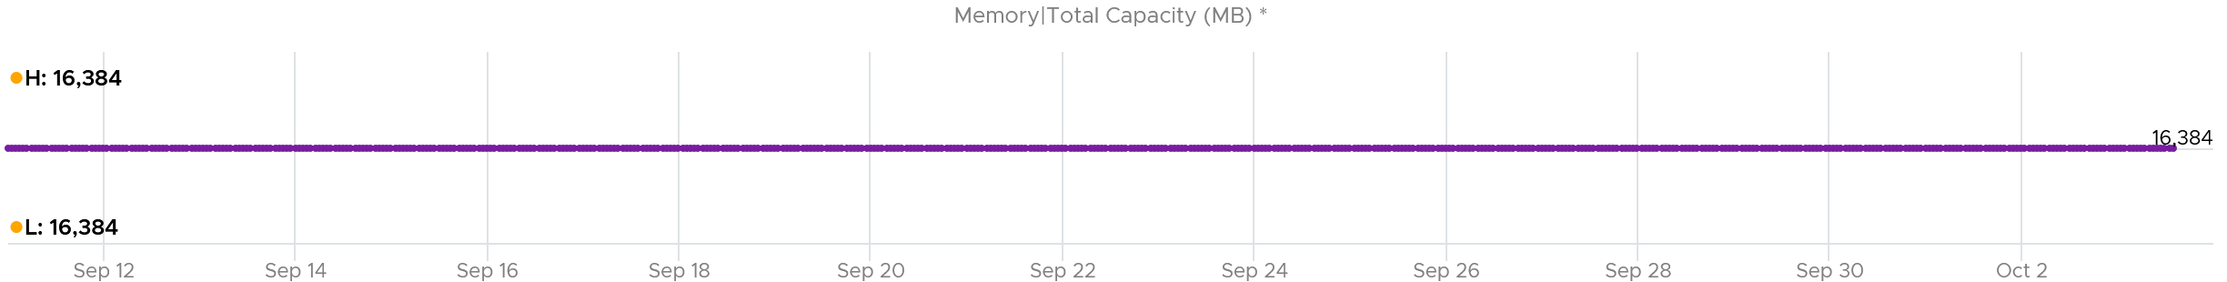

The line is a perfect flat. Both the Highest value and Lowest value show 16,384 MB.

The VM was ballooned. 63.66% of its memory was reclaimed. That’s a whopping 10,430 MB!

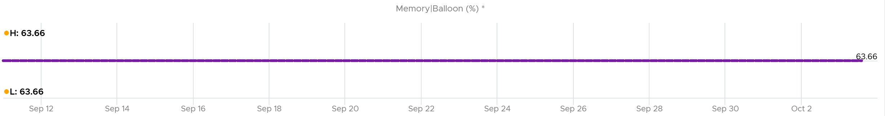

Why is the Ballooned not moving at all?

Because the Guest OS never needs any of those 10+ GB.

So Guest was playing with the remaining 6 GB.

So what do you expect if we plot Granted + Swapped + Compressed?

You got it. A flat line.

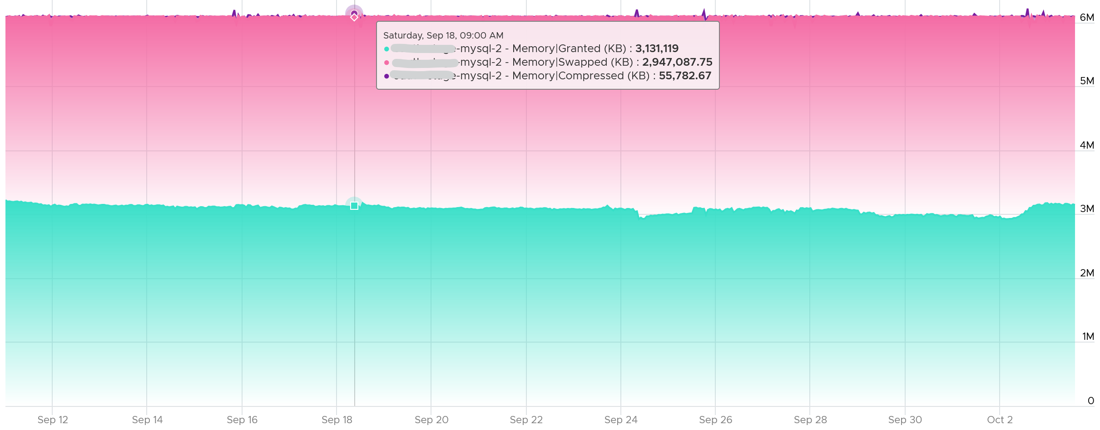

Looking at the diagram in Granted metric, can you explain why Limit is not there?

You are right, it operates at a different layer. Limit is about limiting the usage at the physical layer.

Let’s take an example. The following is VM is a Windows 2016 server, configured with 12 GB of RAM, but was limited to 8 GB (the flat line in cyan near the bottom). The purple line jumping up and down is Granted. Granted ignores the limit completely and run way above it.



Notice Consumed (KB) is consistently below Limit. Granted does not exceed 12 GB as it does not exceed configured.

##### Shared

There are 2 types of shared pages:

* Intra-VM sharing: sharing within the same VM. By default, each page is 4 KB. If Guest OS uses the Large Page, then it’s 2 MB. The chance of sharing in 4 KB is much higher than 2 MB.
* Inter-VM sharing. Due to security concern, this is by default disabled in vSphere.

A commonly shared page is certainly the zero page. This is a page filled with just zeroes.

For accounting purpose, the Shared page is counted in full for each VM. Example:

* VM 1: 1 GB private, 100 MB Shared within itself, 10 MB shared with other VMs (it does not matter how many and what VMs).
* The 100 MB is the amount that is being shared. If not shared, they would consume 100 MB. But how much is actually consumed as a result of this sharing?
* The 10 MB is shared with other VMs. VM 1 could be sharing 1 MB each with 10 other VMs, or the entire 10 MB with just 1 VM. The Shared counter merely counts that this 10 MB is being shared. VM 1 definitely consumes this 10 MB, and it’s not sharing within itself.

Shared includes zero pages. The following screenshot shows the 2 moved in tandem over several days.

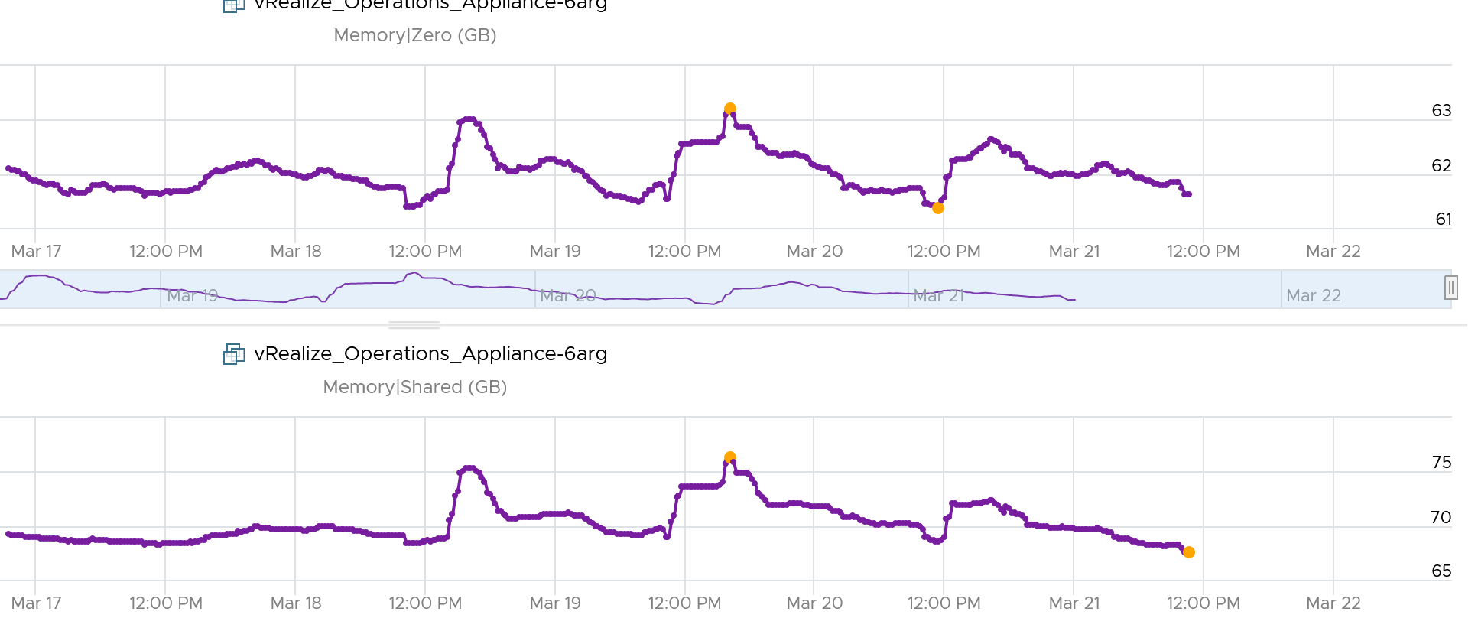

Shared Saved metric tracks the estimated amount of machine memory that are saved due to page sharing.

Because the ESXi machine page is shared by multiple Guest OS physical pages, this metric charge "1/ref" page as the consumed machine memory for each of the guest physical pages, where "ref" is the number of references. So, the saved machine memory will be "1 - 1/ref" page. For example, if there are 4 pages pointing to the same physical DIMM, then the savings is 3 pages worth of memory.

##### Consumed

Consumed = Granted – Saving from Sharing

Consumed does not include overhead memory, although this number is practically negligible. I’m not sure why it does not, as the page is indeed for the VM.

Consumed does not include compressed memory. My guess is because the pages are not readily available for use.

Consumes includes memory that might be reserved.

Consumes tracks the ESXi Memory mapped to the VM. ESXi assigns large pages (2 MB) to VM whenever possible; it does this even if the Guest OS doesn’t request them. The use of large pages can significantly reduce TLB misses, improving the performance of most workloads, especially those with large active memory working sets.

The above is one reason why the Consumed metric is higher than the Guest OS In Use. The other reason is it contains pages that were active (and no longer active), but still mapped to the VM.

Here is a screenshot comparing Windows 10 Task Manager memory metrics with vRealize Operations Memory \ Non Zero Active (KB) and Memory \ Consumed (KB). As you can see, none of the metrics match.



When a Guest OS frees up a memory page, it normally just updates its list of free memory, it does not release it. This list is not exposed to the hypervisor, and so the physical page remains claimed by the VM. This is why the Consumed counter in vCenter remains high when the Active counter has long dropped.

It is a common mistake to think they are calculated in a similar, and simply differ based on aggressive vs conservative. The following test shows Active going down while Consumed going up!



Consumed does not include Shared page. When you see Consumed lower than Guest OS Used, check if there are plenty of shared pages. The following screenshot shows Guest OS Used consistently higher. It’s also constant, around 156 GB throughout. Consumed was relatively more volatile, but never exceed 131 GB. The reason for it is Shared. Notice the value is high, around 61 – 63 GB.

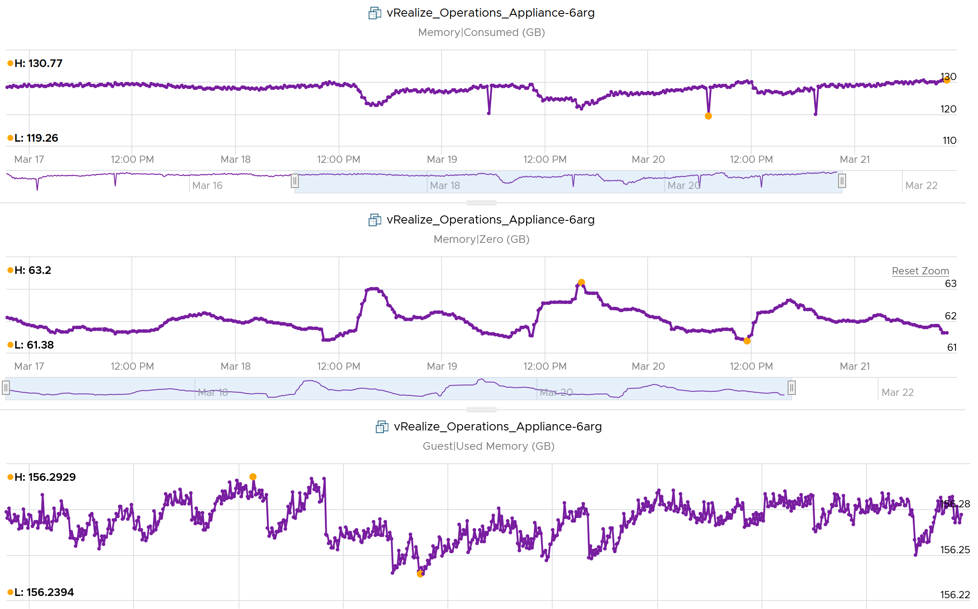

Consumed is affected by Limit. The following is a VM configured with 8 GB RAM but was limited to 2 GB.



##### Active

This is a widely misunderstood counter. ESXi calls this Touch as it better represents the purpose of the metric. Note that vCenter still calls it Active, so I will call it Active.

This counter is often used to determine the VM utilization, which is not what it was designed for. To know why, we need to go back to fundamental. Let’s look at the word **active**. It is an English word that needs to be quantified before we can use it as metric. There are 2 dimensions to consider before we apply it:

* Definition of active. In RAM context, this means read or write activity. This is similar to disk IOPS. The more read/sec or write/sec to *a page*, the more active that page is. Note that the same page can be read/written to many times in a second. Because a page may be accessed multiple times, the actual active pages could be lower. Example: a VM do 100 reads and 100 writes on its memory. However, 50 of the writes are on the page that were read. In addition, there are 10 pages that were read multiple times. Because of these 2 factors, the total active pages are far fewer than 300 pages. If the page is average 4 KB, then the total active is way less than 1200 KB.
* Active is time bound. Last week is certainly not active. Is 300 seconds ago active? What exactly, is recent? 1 second can be defended as a good definition of recent. Windows shows memory utilization in 1 second interval. IOPS is always measured per second, hence the name IOPS. So I think 1 second seems like a good definition of recent.

Applying the above understanding, the active counter is actually a rate, not a space. However, the counter reported by vCenter is in KB, not KB/s.

To translate from KB/s to KB, we need to aggregate based on the sampling period. Assuming ESXi samples every 2 seconds, vCenter will have 10 sampling in its 20 second reporting period. The 10 samplings can be sampling the same identical pages, or completely different ones. So in the 20 seconds period, the active memory can be as small as 1 sampling, or as large as 10 samplings.

Examples:

* First 2 seconds: 100 MB Active
* Next 2 seconds: 150 MB Active

In the above 4 seconds, the active page ranges from 150 MB to 250 MB.

Each sampling is done *independently*, meaning you could be sampling the same block again. But the value is then averaged it with previous samples. Because sampling and averaging takes time, Active won't be exact, but becomes more accurate over time to approximate the amount of active memory for the VM. This is why there is actually a longer version of Active, which you will see in esxtop (it is not available in vSphere Client).

VM Active is typically different from Guest OS working set estimate. Sometimes the difference may be big, because Guest OS and VMkernel use different working set estimate algorithm. Also, VM has a different view of active memory, due to ballooning and host swapping. Logically, ballooned memory is considered inactive, so, it is excluded from the sampling.

If you plot a vRealize Operations VM in vCenter real-time performance chart, you will see 12 peaks in that one-hour line chart. The reason is vRealize Operations pulls, process, and writes data every 5-minutes. The chart for CPU, disk and network will sport the same pattern. This is expected.

But if you plot the memory metrics, be it total active, active write or consumed, you will not see the 12 peaks. This is what I got instead.



Consume is completely flat and high. Active (read and write) and Active Write (write only) is much lower but again the 12 peaks are not shown.

Can you figure it out?

My guess is the sampling size. That’s just a guess, so if you have a better answer let me know!

Now let’s go to vRealize Operations. In vRealize Operations, this metric is called Memory \ Non Zero Active (KB).

vCenter reports in 20 seconds interval*.* vRealize Operations takes 15 of these data and average them into a 300-second average. In the 300 second period, the same page can be read and written multiple times. Hence the active counter over reports the actual count.

Quiz: now that you know Active over reports, why is it lower than Consumed? Why is it lower than Guest OS metrics?

Active is lower than both metrics because these 2 metrics do *not* actually measure how actively the page is used. They are measuring the disk space used, so it contains a lot of inactive pages. You can see it in the general pattern of Consume and Guest OS used metrics. The following is vRealize Operations appliance VM. Notice how stable the metrics are, even over millions of seconds.



Both Active and Consumed are *not* suitable for sizing the Guest OS. They are VM level metrics, with little correlation to the Guest OS memory usage. Read Guest OS Used counter for the counter we should use.

The reason is the use case. It is not about the IOPS. It is about the disk space used. Guest OS expects the non-active pages to be readily available. Using Active will result in a lot of paging.

Reference: [Active Memory](https://blogs.vmware.com/vsphere/2013/10/understanding-vsphere-active-memory.html) by [Mark Achtemichuk](https://blogs.vmware.com/vsphere/author/mark_achtemichuk).

##### Usage (%)

Usage metric in vCenter differs to Usage metric in vRealize Operations.

What you see on the vCenter UI is Active, not Consumed.



Mapping to Active makes more sense as Consumed contains inactive pages. As covered earlier, neither Active nor Consumed actually measures the Guest OS memory. This is why vRealize Operations maps Usage to Guest OS. The following shows what Usage (%) = Guest OS Needed Memory over configured memory. The VM has 1 GB of memory, so 757 MB / 1024 = 74%.

Take note that there can be situation where Guest OS metrics do not make it to vRealize Operations. In that case, Usage (%) falls back to Active (notice the value dropped to 6.99%) whereas Workload (%) falls back to Consumed (notice the value jump to 98.95%).



##### Utilization

Utilization (KB) = Guest Needed Memory (KB) + ( Guest Page In Rate per second * Guest Page Size (KB) ) + Memory Total Capacity (KB) – Guest Physically Usable Memory (KB).

Because of the formula, the value can exceed 100%. The following is an example:

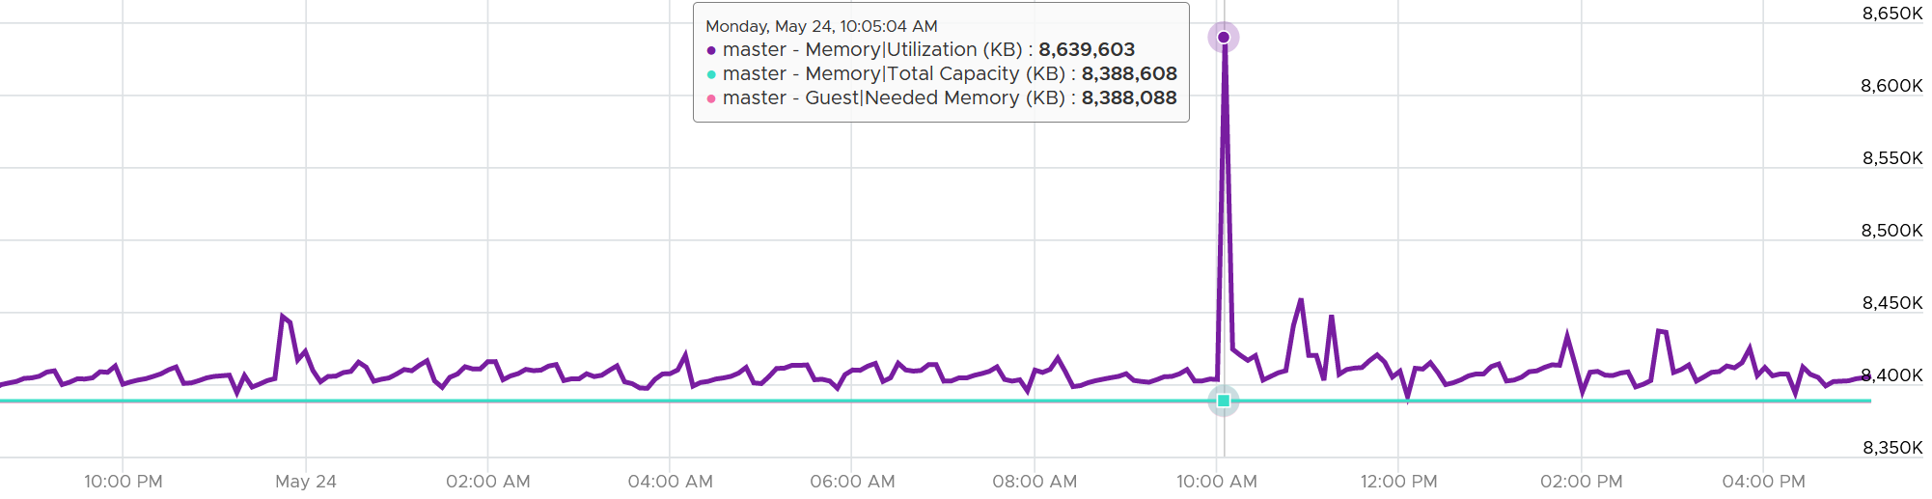

It’s possible that vRealize Operations shows high value when Windows or Linux does not. Here are some reasons:

* Guest metrics from VMware Tools are not collecting. The value falls back to Consumed (KB). Ensure your collection is reliable, else the values you get over time contains mixed source. If their values aren’t similar, the counter values will be fluctuating wildly.
* Guest Physically Usable Memory (KB) is less than your configured memory. I’ve seen in one case where it’s showing 58 GB whereas the VM is configured with 80 GB. My first guess is the type of OS licensing. However, according to [this](https://www.compuram.de/blog/en/how-much-ram-can-be-addressed-under-the-current-32-bit-and-64-bit-operating-systems/), it should be 64 GB not 58 GB.
* Low utilization. We add 5% of Total, not Used. A 128 GB VM will show 6.4 GB extra usage.
* Excessive paging. We consider this. The tricky part is excessive is relative.
* We include Available in Linux and cache in Windows, as we want to be conservative.

[e1:

I think the metric used in the object capacity page is Memory \ Host Demand metric. This metric matches Utilization]

##### Demand

Can you spot a major counter that exists for CPU, but not for RAM?

That’s right. It’s Demand. There is no memory demand counter in vCenter UI.

To figure out demand, we need to figure out unmet demand, as demand is simply unmet demand + used (which is met demand). Since the context here is VM, and not Guest OS, then unmet demand includes only VM level metrics. The metrics are ballooned + swapped + compressed.

Do you agree with the above?

If we are being strict with the unmet demand definition, then only the memory attributed to contention should be considered unmet demand. That means balloon, swap, or compressed memory can’t be considered unmet demand. Swap in and decompression are the contention portion of memory. The problem then becomes the inability to differentiate contention due to limits using host level metrics, which means we’d need to look at VM level metric to exclude that expected contention.

##### Examples

Let’s apply the knowledge.

###### Balloon vs Consumed

This 64-bit CentOS VM runs My SQL and is configured with 8 GB of RAM.

Linux was heavily ballooned out (default limit is around 63%). Why is that so?



In this VM case, we set a limit to 2 GB. As a result, Consumed did not exceed 2 GB.



Did you notice the common deep in Balloon and Consumed?

Can you explain them?

Balloon dropped by 0.46 GB then went back to its limit again. This indicated Guest OS was active.

Consumed went down from 2.09 GB to 1.6 GB, and then slowly going back up. Why did it suddenly consume 0.4 GB less in the span of 20 minutes? Both the configured limit and the runtime limit did not change. They were constant at 2 GB. This makes sense, else the Consumed would not be able to slowly go up again.



There must be activity by the VM and pages were compressed to make room for the newly requested pages. The Non Zero Active counter shows that there are activities.



The pages that are not used must be compressed or swapped. The Swapped value is negligible, but the Compressed metric shows the matching spike.



So far so good. Windows or Linux were active (2.4 GB in 5 minute at the highest point, but some pages were probably part of Consumed). Since Consumed was at 100%, some pages were moved out to accommodate new pages. The compression resulted in 0.6 GB, hence the uncompressed amount was in between 2x and 4x.

Consumed dropped by 0.4 GB as that’s the gap between what was added (new pages) and what was removed (existing pages).

###### Granted vs Consumed

This is a mystery to me.

Boot a Windows VM. Windows writes zeroes to initialize the pages, but VMkernel is smart enough to do a copy-on-write, so all the pages are pointing to the same physical page. After a while, as the pages are replaced with actual data.

If the above is true, why Consumed shoots up ahead of Granted? It should be the other way around.

### Storage

At the VM level, you can look at metrics at the individual virtual disk level, at the datastore level, and at the disk level. Which ones should you when?



|  |  |
| --- | --- |
| **Virtual Disk** | Use the **virtual disk** metrics to see VMFS vmdk files, NFS vmdk files, and RDMs. However, you don’t get data below the virtual disk. For example, if the VM has snapshot, the data does not know about it. Also, a VM typically has multiple virtual disks (OS drive, swap drive, data drive), so you need to add them manually if you use vCenter. In vRealize Operations, you use the “aggregate of all instances”. |
| **Datastore** | Use the **datastore** metrics to see VMFS and NFS, but not RDM. Because snapshots happen at Datastore level, the counter will include it. Datastore figures will be higher if your VM has a snapshot. You don’t have to add the data from each virtual disk together as the data presented is already at the VM level. It also has the Highest Latency counter, which is useful in tracking peak latency |
| **Disk** | Use the **disk** metrics to see VMFS and RDM, but not NFS. The data at this level should be the same as at Datastore level because your blocks should be aligned; you should have a 1:1 mapping between Datastore and LUN, without extents. It also has the Highest Latency counter, which is useful in tracking peak latency |

If all the virtual disks of a VM are residing in the same datastore, and that datastore is backed by 1 LUN, then all the metrics will be identical. The following VM has 2 virtual disks (not shown). Notice all 3 metrics are identical over time.

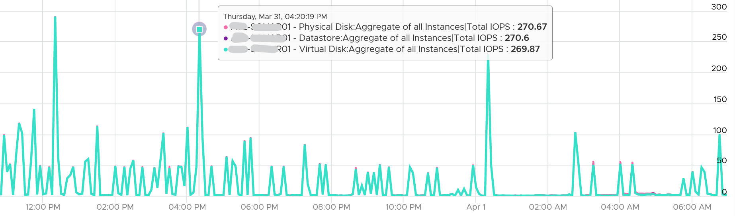

#### Virtual Disk

Take note that vSphere Client does not provide summary at VM level. Notice the target objects are individual scsiN:N, and there is no aggregation at VM level as the option in Target Objects column below.

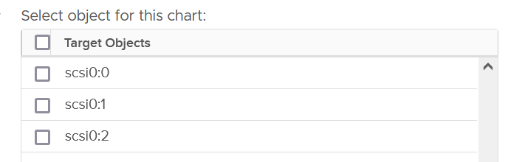

##### Latency metrics

The main metrics are latency. They are provided in both ms and microsecond.

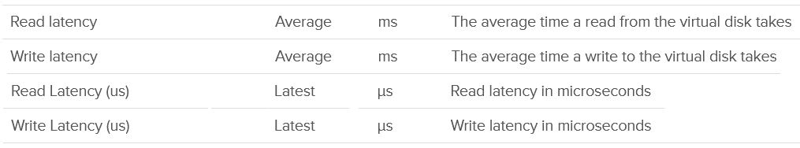

##### Outstanding IO

vSphere also provides information about the number of I/Os that have been issued, but not yet completed. They are waiting in the queue, indicating a bottleneck



The formula is

Outstanding IO = Latency x IOPS

You can prove the above formula by plotting the latency metric. In the following example, this Windows 10 VM has good latency, constantly below 5 ms except for 1 occasion.

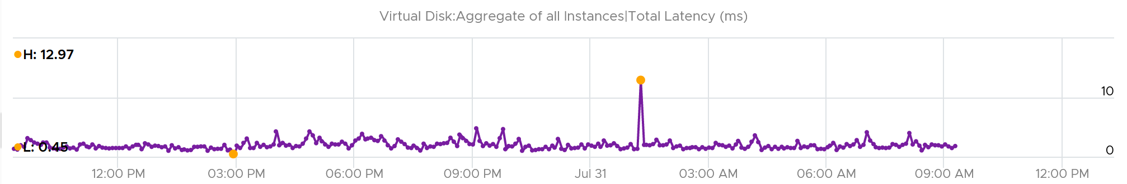

If we plot the IOPS, it reveals a different pattern. There is a regular spike, albeit the number is very low. There is a one time spike near the start of the chart.

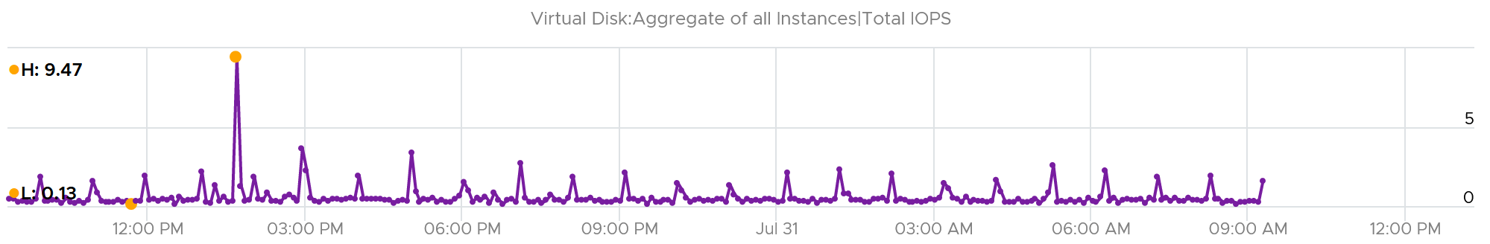

What do you expect the Outstanding IO chart to look like?

Well, since we know the formula, we expect the chart to “combine” both latency and IOPS. And the following is exactly what we got:

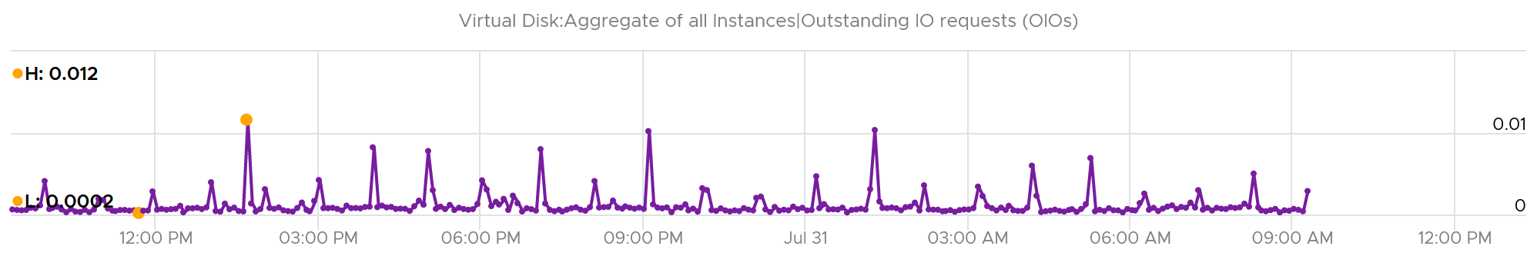

Outstanding IO should be seen in conjunction with latency. It can be acceptable to have high number of IO in the queue, so long the actual latency is low.

Since your goal is maximum IOPS and minimum latency, the metric is less useful as its value is impacted by IOPS. See [this KB article](https://kb.vmware.com/s/article/2150017) for VSAN specific recommendation on the expected value.

What should be the threshold value?

That depends on your storage, because the range varies widely. Use the profiling technique to establish the threshold that is suitable for your environment.

In the following analysis, we take more than 63 million data points (2400 VM x 3 months worth of data). Using data like this, discuss with the storage vendor if that’s inline with what they sold you.



##### Utilization metrics

A typical suspect for high latency is high utilization. As you can expect, you’re given both IOPS and throughput metrics.

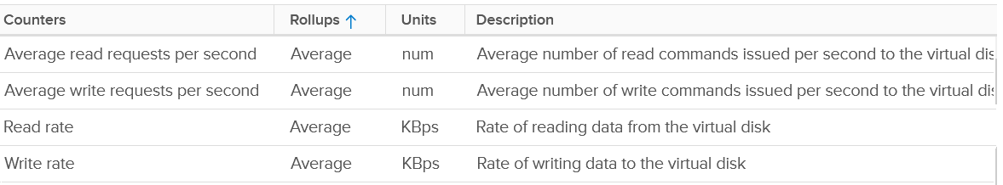

If the IOPS is low, but the throughput is high, then the block size is large. Compare this with your expected block size, as they should not deviate greatly from plan.

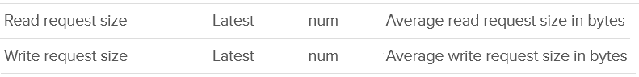

###### Real-World Profiling

VM Disk IOPS and throughput vary widely among workload. For a single workload or VM, it also depends on whether you measure during its busy time or quiet time.

In the following example, I plotted from a 3500 production VMs. They are sorted by the largest IOPS on any given 5 minute. What’s your take?

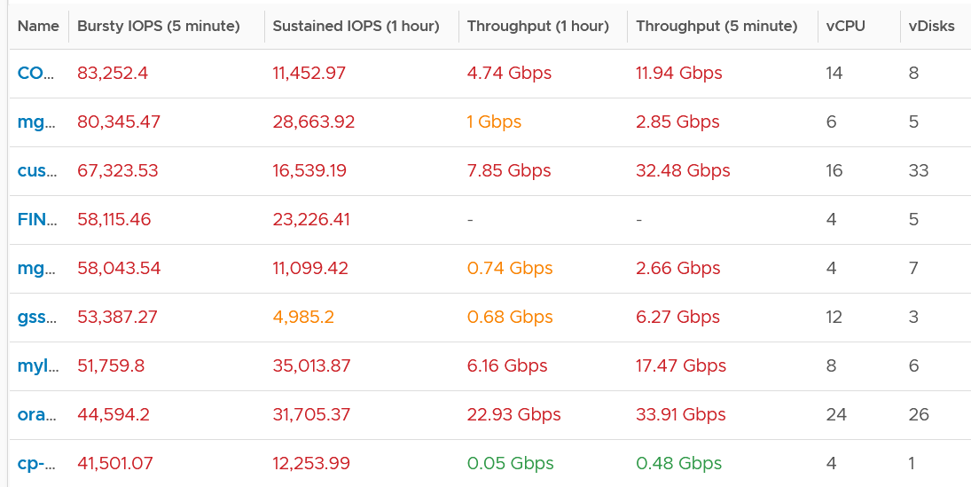

I think those numbers are high. At 1000 IOPS averaged over 5 minutes, that means 300,000 total IO commands that need to be processed. So 10K IOPS translates into 3 millions commands, which must be completed within 300 seconds.

A high IOPS can also impact the pipe bandwidth, as it’s shared by many VMs and VMkernel. If a single VM chews up 1 Gb/s, you just need a handful of them to saturate 10 Gb ethernet link.

There is another problem, which is sustained load. The longer the time, the higher the chance that other VMs are affected.

In the following example, it’s a burst IOPS. Regardless, discuss with the application team if it is higher than expected. What’s normal from one application may not be for another.

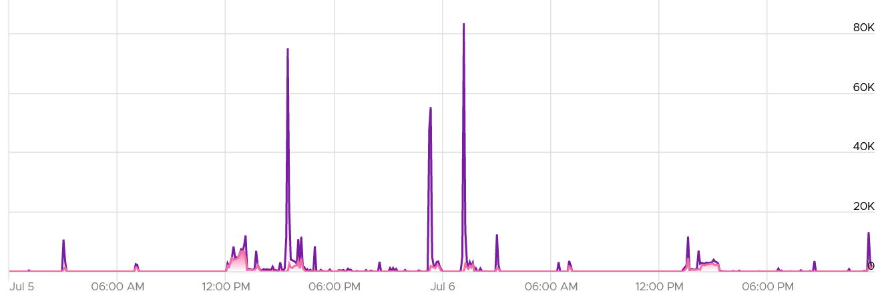

While there is no such thing as normal distribution or range, you can analyse your environment so you get a sense. I plotted all the 3500 VMs and almost 85% did not exceed 1000 IOPS in the last 1 week. The ones hitting >5K IOPS only form around 3%.

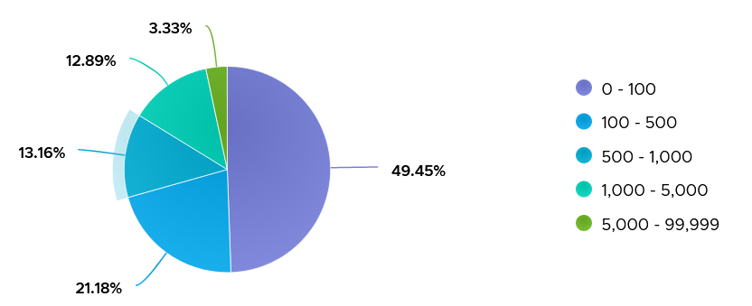

Lastly, there are storage DRS metric and seek size.

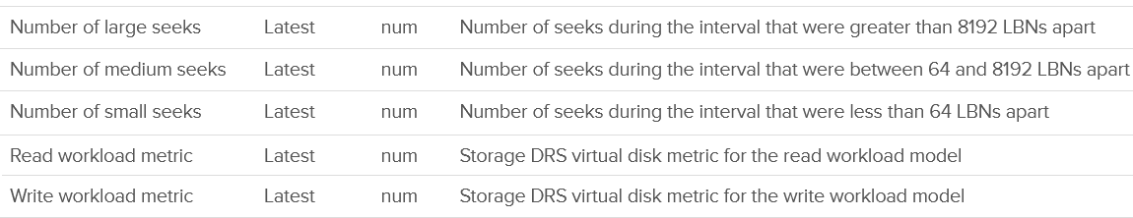

###### IOPS Limit

You can set the limit for a VM. Note that the limit is per virtual disk, not per VM.

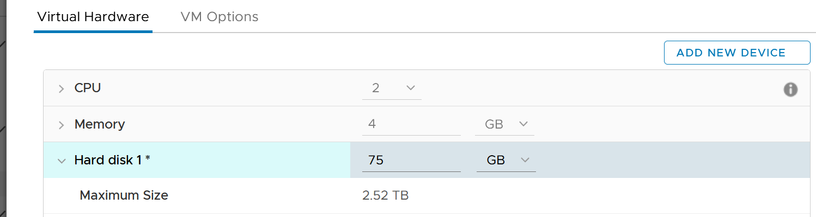

A few rows below, and you will see the following.



The default setting is no limit, which is what I recommend.

Take note that since the limit is applied at VM level, the metrics that will show high latency is at Guest OS levels. The VM metric will not show high latency, as the IO that were allowed to pass was not affected by this limit. This is no different to any problem at Guest OS layer. For example, if LSI Logic or PVSCSI driver is causing problem, the VM will not report anything as it’s below the Guest OS driver.

Aria Operations have the following related data at each virtual disk

* IOPS Limit property.
* IOPS per GB metric.

#### Disk

I think this should be called Physical Disk or Device, as the terminology “disk” sounds like a superset of virtual disk.

Disk means device, so we’re measuring at LUN level or RDM level. It’s great to know that we can associate the metrics back to the VM. Notice we can’t associate it to specific virtual disk. This is one benefit of keeping all the VM files in 1 datastore.

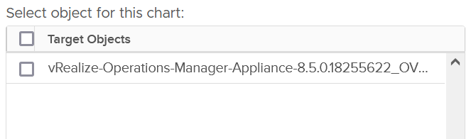

Also, depending on the metric, the association is at the disk level. So I’m not 100% sure if the value is per VM or per disk (which typically has many VM).

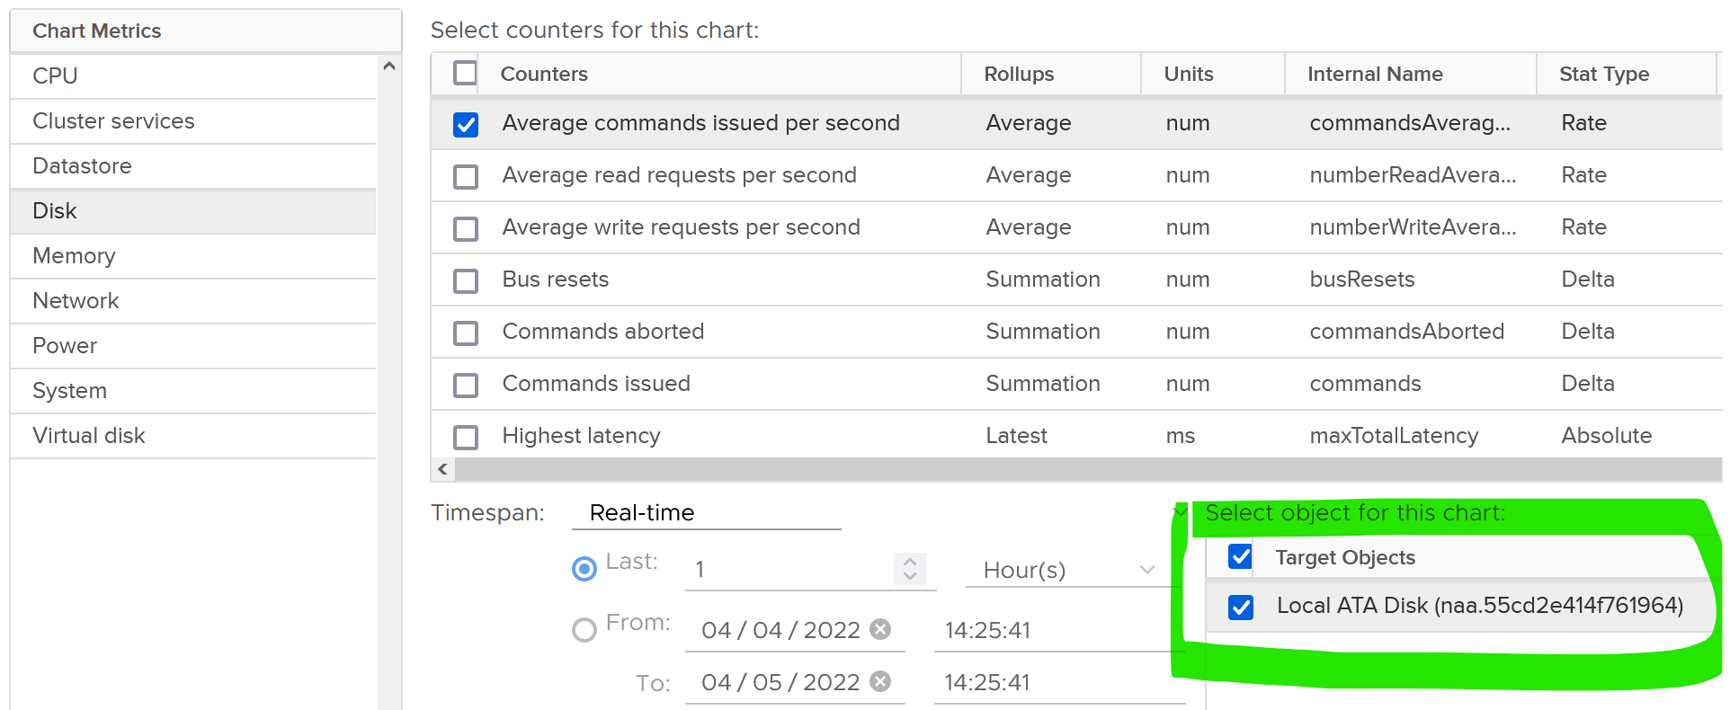

As usual, we start with error metrics before we look at latency.



For latency, there is no breakdown. It’s also the highest among all disks. Take note the roll-up is latest.



There are 2 sets of metrics for IOPS. Both are basically the same. One if the total number of IO in the collection period, while the other one is average of 1 second.

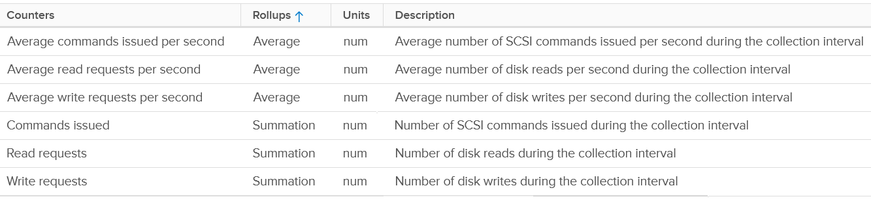

There are the usual metrics for throughput.



It will be great to have block size, especially the maximum one during the collection period.

#### Datastore

Just like LUN level, we lose the breakdown at virtual disk. The metric is only available at VM level.



For contention, only latency is provided. There is no outstanding IO.

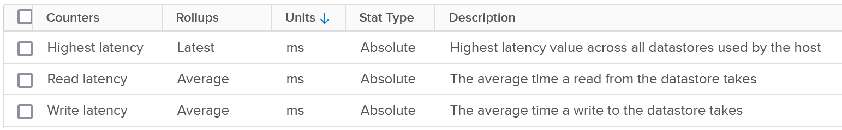

The highest latency is useful for VMs with multiple datastores. But take note the roll-up is Latest, not average.

For the read and write latency, the value in vRealize Operations is a raw mapping to these values datastore.totalReadLatency.average and datastore.totalWriteLatency.average

For utilization, both IOPS and throughput are provided.

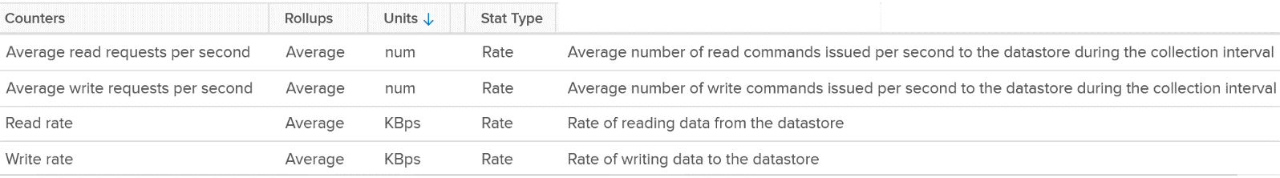

For the IOPS, the value in vRealize Operations is a raw mapping to these values datastore.numberReadAveraged.average and datastore.numberWriteAveraged.average

Review the following screenshot. Notice something strange among the 3 metrics?

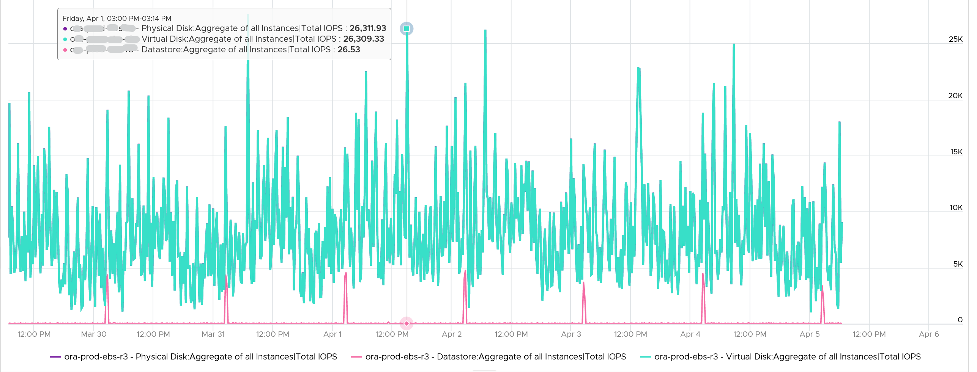

Yes, the total IOPS at datastore level is much lower than the IOPS at physical disk and virtual disk levels. The IOPS at physical disk and virtual disk are identical over the last 7 days. They are quite active.

The IOPS at datastore level is much lower, and only spike once a day. This VM is an Oracle EBS VM with 26 virtual disks. Majority of its disks are RDM, hence the IOPS hitting the datastore is much less.

#### Snapshot Impact

Snapshot requires additional read operations, as the reads have to be performed on all the snapshots. The impact on write is less. I’m not sure why it goes up so high, but logically it should be because many files are involved. Based on the manual, a snapshot operation creates .vmdk, -delta.vmdk, .vmsd, and .vmsn files. Read more [here](https://docs.vmware.com/en/VMware-vSphere/7.0/com.vmware.vsphere.vm_admin.doc/GUID-38F4D574-ADE7-4B80-AEAB-7EC502A379F4.html).

For Write, ESXi just need to write into the newest file.



The pattern is actually identical. I take one of the VM and show it over 7 days. Notice how similar the 2 trend charts in terms of pattern.



You can validate if snapshot causes the problem by comparing before and after snapshot. That’s exactly what I did below. Notice initially there was no snapshot. There was a snapshot briefly and you could see the effect immediately. When the snapshot was removed, the 2 lines overlaps 100% hence you only see 1 line. When we took the snapshot again, the read IOPS at datastore level is *consistently* higher.



How I know that’s IOPS effect as the throughput is identical. The additional reads do not bring back any data. Using the same VM but at different time period, notice the throughput at both levels are identical.



And here is the IOPS on the same time period. Notice the value at datastore layer is consistently higher.



For further reading, [Sreekanth Setty](https://blogs.vmware.com/performance/author/sreekanth_setty) has shared best practice [here](https://blogs.vmware.com/performance/2021/06/performance-best-practices-for-vmware-snapshots.html).

In addition of latency and IOPS, snapshot can also consume more than the actual space consumed by the virtual disk, especially if you are using thin and you take snapshot early while the disk is basically empty. The following VM has 3 virtual disks, where the snapshot file _1-00001.vmdk is much larger than the corresponding vmdk.

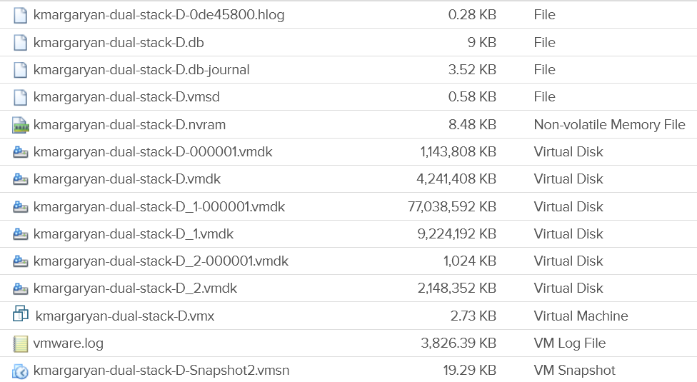

#### Disk Space

I’m splitting disk space separately as operationally you manage performance and capacity differently.

##### Simple Example

Let’s start with a single virtual VMDK disk. Review the following diagram. What potential operational complexity do you see?

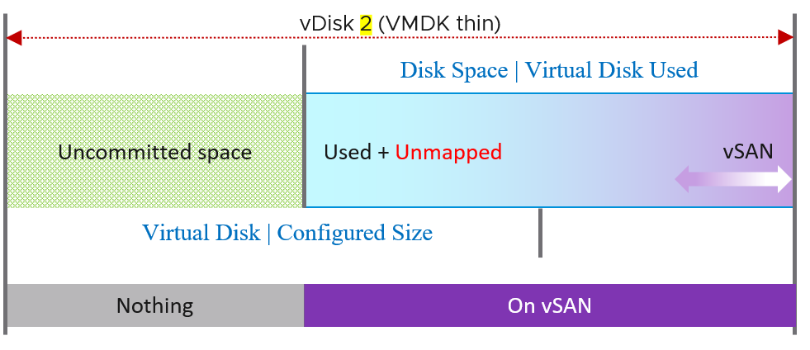

The above disk is thin provisioned. It still has uncommitted space as it’s not yet fully used up.

There are actually 4 types of consumption in Virtual Disk.

* Actual used by Guest OS
* Unmapped block
* vSAN protection (FTT)
* vSAN savings (dedupe and compressed).

##### Advanced Example

Let’s take an example of a VM with 3 virtual disks, so we can cover all the combinations. We’re using vSAN so we can show the additional disk space consumed by vSAN.

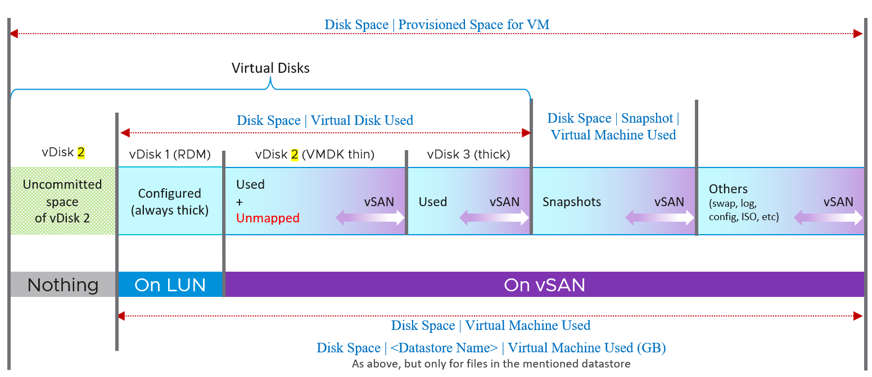

The various vRealize Operations metrics are shown in Times New Roman font.

The boxes with blue line show the actual consumption at VM layer. Let’s go through each rectangle.

|  |  |
| --- | --- |
| **vDisk 1** | RDM.  That’s why it’s not on vSAN as can’t be on a VMFS datastore. It’s mapped to a LUN backed by an external storage.  It’s always thick provisioned, regardless of what Windows or Linux uses. The LUN itself could be thin provisioned but that’s another issue and transparent to ESXi (hence VM). |
| **vDisk 2** | VMDK thin.  We blended vSAN protection into a single box as you can't see the breakdown. It's inside the same file (so there is only 1 file but inside there is actual data + vSAN protection - vSAN dedupe - vSAN compressed).  Thin Provisioned can accumulate unmapped block over time. You should reclaim them by running a trim operation.  Uncommitted space is the remaining amount that the VMDK can grow into. Since it’s not yet written, it does not have vSAN overhead yet. |
| **vDisk 3** | VMDK thick.  The Used size equals the configured size as it’s fully provisioned regardless of usage by Guest OS.  I’m not sure the final of dedupe and compression. I expect it will be near 100% saving in both lazy zero and eager zero. |

vSAN protection (Failure To Tolerate) is shown in purple. It applies to every file in the datastore. Yes, even your snapshot and log files are protected if you choose so.

##### Metrics and Properties

These are the fundamental metrics you use to see the VM disk space consumption.

|  |  |
| --- | --- |
| **Metric** | **Description** |
| Disk Space | Virtual Disk Used (GB) | The actual consumed size of the VMDK files + the configured size of the RDM files. It excludes other files such as snapshot files. Note: RDM actually appears as a VMDK in the datastore folder, when you browse files of a VM.  Note: For RDM the used space is the configured size of the RDM, unless the LUN is thin provisioned by the physical storage array. So its disk space consumption at VM level works like a thick provisioned disk.  If this is higher than Guest OS used, and you’re using thin provisioned, then run unmap to trim the unmapped blocks. |
| Disk Space | Virtual Machine Used (GB) | Just like above, but includes non virtual disks. So this metric is always larger.  The actual consumed size of the VM files + the configured size of the RDM files. It includes all files in the VM folder in the datastore(s).  Formula:  Sum ( [layoutEx.file] uniqueSize != null ? uniqueSize : size) / (1024 * 1024 * 1024) |
| Disk Space | <Datastore Name> | Virtual Machine Used (GB) | Just like above, but only includes files in that specific datastore only. For VM that only resides in 1 datastore, the value will be identical to above. |
| Disk Space | Provisioned Space for VM | Just like the Disk Space | Virtual Machine Used (GB), but thin provisioned is based on configured not actual usage. So this metric will have higher value if the thin provisioned is not fully used.  This metric is useful at the datastore level. When you overcommit the space and want to know what the total space would be when all the VMs grow to the full size.  This metric is not useful for capacity as it mixes both allocation and utilization.  BTW, there can be cased where the number here is reported as much higher number. See [KB 83990](https://kb.vmware.com/s/article/83990). This is fixed in [7.0.2 P03 or 7.0 U2c](https://docs.vmware.com/en/VMware-vSphere/7.0/rn/vsphere-esxi-70u2c-release-notes.html), specifically in PR 2725886. |

###### Snapshot

|  |  |
| --- | --- |
| Disk Space | Snapshot | Virtual Machine Used (GB) | Disk Space used by all files created by snapshot (vmdk and non vmdk). This is the total space that can be reclaimed if the snapshot is removed. Use this to quickly determine which VMs have large snapshot.  Formula:  Sum of all files size / (1024 * 1024 * 1024)  where aggregation is only done for snapshot files. A file is a snapshot file if its layoutEx file type equals to snapshotData, or snapshotList or snapshotMemory |
| Disk Space | Snapshot | Access Time (ms) | The date and timestamp the snapshot was taken. Note you need to format this. |

###### Multi Writer Disk

|  |  |
| --- | --- |
| **Name** | Description |
| Disk Space | Active Not Shared (GB) | The total amount of disk space from all the VMDK and RDM that are exclusively owned by this VM.  Shared means the virtual disk is mounted by multiple VMs. So, this metric is useful only when we have multi-writer disks.  Active means the disks minus snapshot. Snapshot is considered as non active.  Formula: Disk Space|Not Shared (GB) - Disk Space|Snapshot Space (GB) |

###### Virtual Disk

The following properties is available on each virtual disk:

|  |  |
| --- | --- |
| Property Name | Values |
| Virtual Device Node | Virtual disks SCSI bus location. Virtual disks are enumerated starting with the first controller and moving along the bus. |
| Compatibility Mode | Physical  Virtual  Virtual mode specifies full virtualization of the mapped device. Physical mode specifies minimal SCSI virtualization of the mapped device. |
| Disk Mode | Dependent  Independent – Persistent  Independent – Nonpersistent |
| SCSI Bus Sharing | None  Physical  Virtual |
| SCSI Controller Type | BusLogic Parallel  LSI Logic Parallel  LSI Logic SAS  VMware Paravirtual |
| Virtual Disk Sharing | Unspecified  No Sharing  Multi-Writer |
| Encryption Status |  |
| Number of RDMs | Number of RDMs attached to the VM.  Pro Tip: sum these for all the VMs in a single physical array. Compare the result with the number of LUNs carved out for RDM purpose.  If there are more LUNs than this number, you have unused RDM. You can’t have less 😊  You need to do the above per physical array so you know which array needs attention. |
| Number of VDMK | This excludes RDM. |
| Is RDM | true  false  False means the virtual disk is a VDMK not RDM. |

###### vSphere Client UI

I’m adding this just in case you got curious 😊

Let’s start with the basic and progress quickly. In the following example, I would create a small VM from scratch, with 2 VMDK disk.

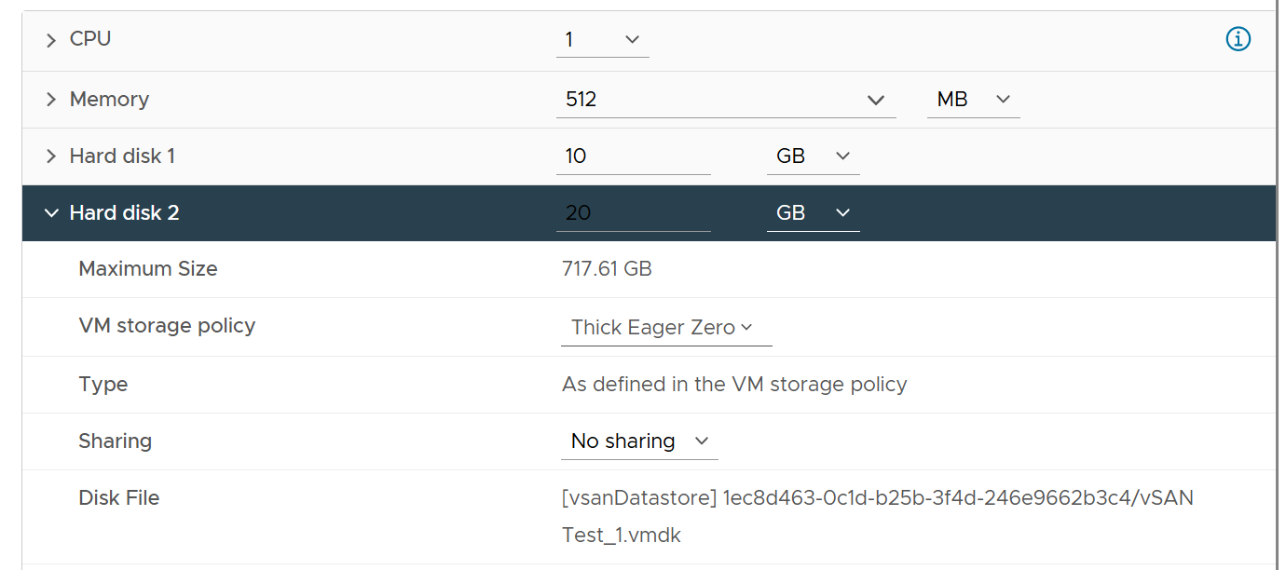

Hard disk 1 is 10 GB. Thin Provisioned. On vSAN.

The VM is powered off. All other settings follow default setting.

I created the VM with just the first disk, to validate the metrics value that will be shown upon creation. What do you expect to see on the vCenter UI?

Here is what I got on vSphere 7.

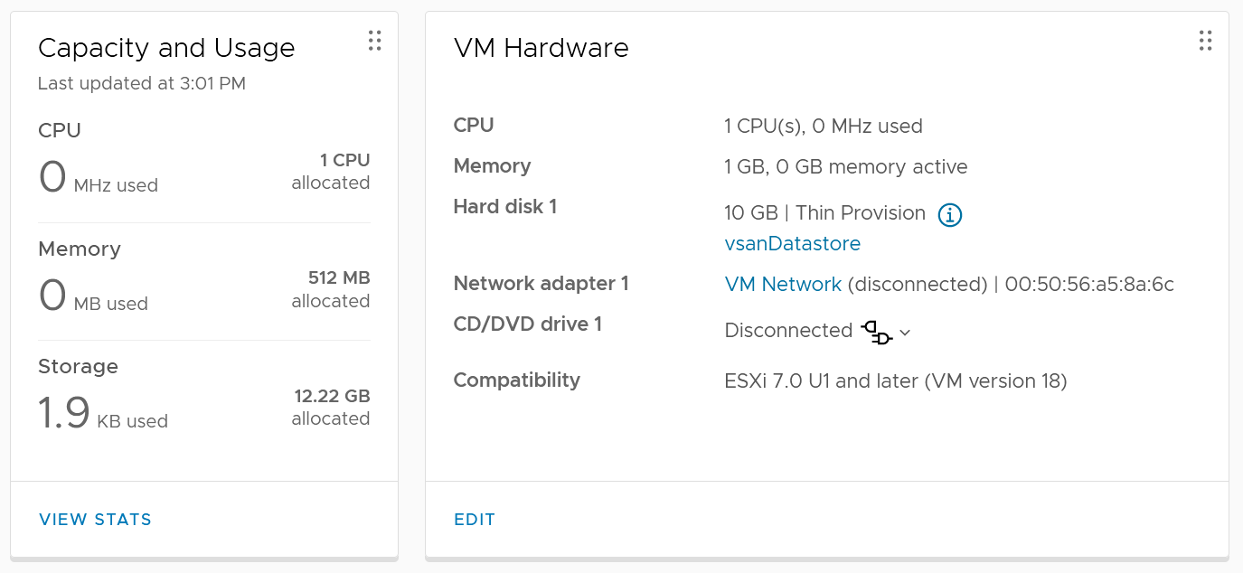

You get 2 numbers, used and allocated, as shown in the Capacity and Usage section.

Used is only 1.9 KB. This is expected as it’s thin provision and the VM is powered off. This is very low, so let’s check the next number….

Allocated is 12.22 GB. This is 10 GB configured + 2.22 GB used. The hard disk 1 size shows 10 GB not 20 GB. This is what is being configured, and what Guest OS see. It is not impacted by vSAN as it’s not utilization.

So you have 2 different numbers for the use portion: 1.9 KB and 2.22 GB.

Why 2 different values?

Let’s see what the files are. We can do this by browsing the datastore and find the VM folder.

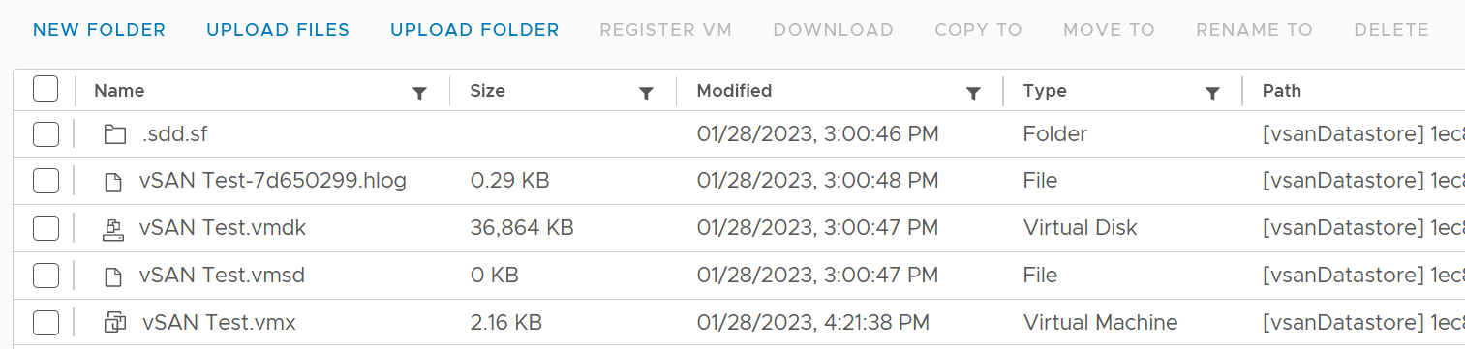

The total from the files above is 36 MB. This does not explain 1.9 KB nor 2.22 GB.

Let’s continue the validation. This time I added Hard disk 2 and configure it with 20 GB. Unlike the first disk, this is Thick Provisioned so we can see the impact. It is also on vSAN.

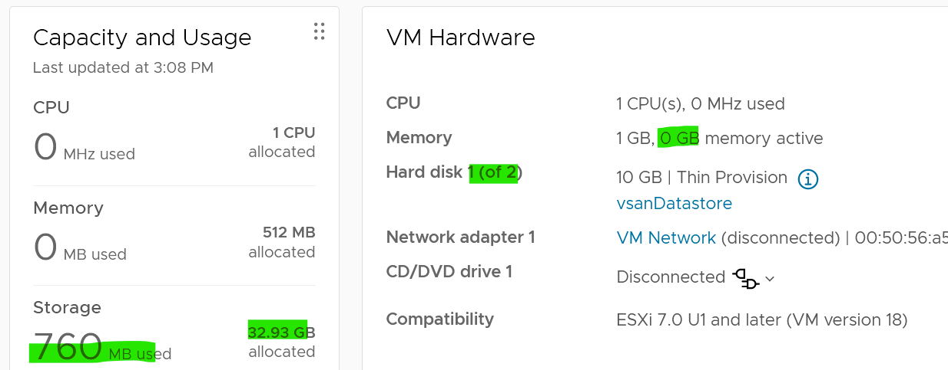

Used has gone up from 1.9 KB to 760 MB. As this is on vSAN, it consists of 380 MB of vSphere + 380 MB of vSAN protection. The vSAN has no dedupe nor compression, so it’s a simple 2x.

Allocated is 32.93 GB as it consists of 30 GB configured and 2.93 GB. This 2.93 is half vSphere overhead + vSAN protection on the overhead.

Looking at the datastore level, the second hard disk is showing 40.86 GB. It maps to hard disk 2.

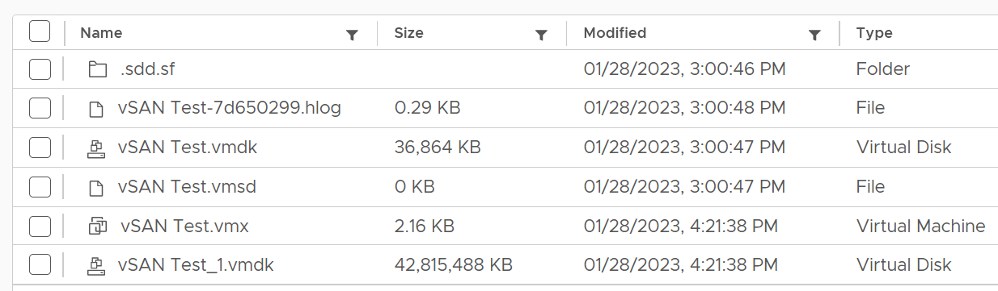

From this simple example, you can see that Allocated in vCenter UI actually contains used and allocated. By allocated it means the future potential used, which is up to the hard disk configured size. The used portion contains vSAN consumption if it’s on vSAN, while the unused portion does not (obviously since vSAN has not written any block).

### Network

VM is not an Operating System, so it has far less networking metric than Windows or Linux.

#### Overview

We will cover each metric in-depth, so let’s do an overview first.

As usual, we start with contention. There is no latency metric

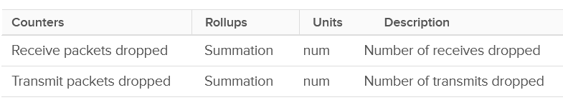

Next, you check if there are unusual traffic. Your network should be mostly unicast, so it’s good to track the broadcast and multicast packets. They might explain why you have many dropped packets.

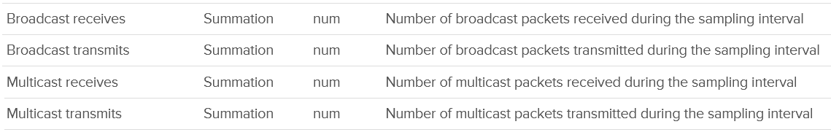

Next you check utilization. There are 6 metrics, but I think they are triplicate.

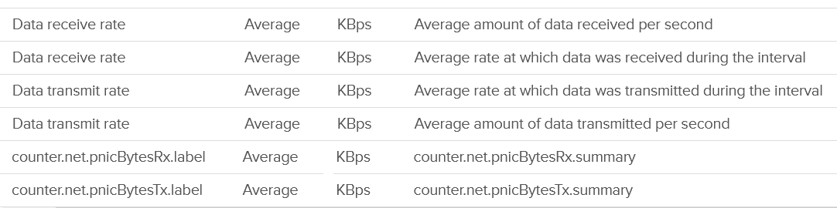

Each packet takes up CPU for processing, so it’s good to check if the packet per second becomes too high



The metrics are available at each individual vNIC level and at the VM level. Most VMs should only have 1 vNIC, so the data at VM level and vNIC level will be identical.

The vNICs are named using the convention "400x". That means the first vNIC is 4000, the second vNIC is 4001, and so on. The following is a vCenter VM. Notice it receives a few broadcast packets, but it’s not broadcasting (which is what you expect). It also does not participate in multicast, which is again expected.

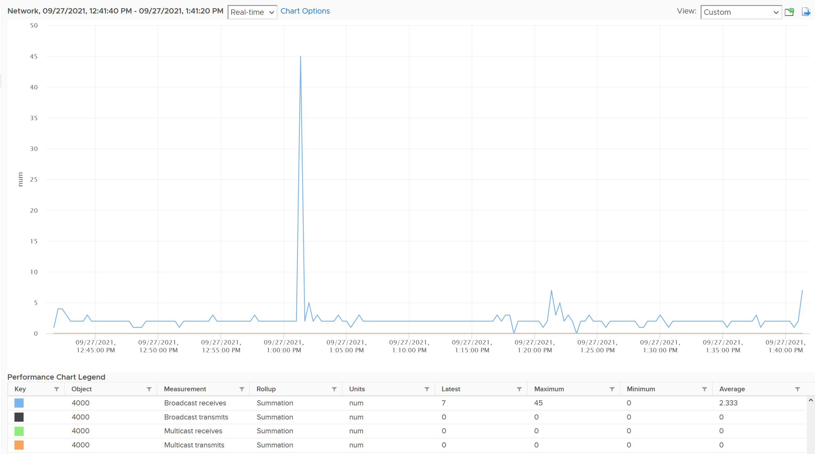

The metrics are grouped into 2:

* Transmit for outgoing
* Receive for incoming.

For each group, the following metrics are provided:

|  |  |
| --- | --- |
| Broadcast packets | Count of packets.  It is the sum during the sampling window, not the rate (which is packet/second).  Multicast packet and broadcast packet are listed separately. This is handy as they are supposed to low for most VM. Understand the nature of the applications so you can check if the behaviour is normal or not. |
| Multicast packets |
| Packet dropped |
| Total packets | The total includes the broadcast and multicast, but not the dropped ones. |
| Throughput per second | This is measured in kilobyte, as packet length is typically measured in bytes. While there are other packet size, the standard packet is 1500 bytes.  BTW, esxtop measures in megabit.  I assume this includes broadcast and multicast, but not the dropped packet. |

Guess what metrics are missing?

* Retransmit. This can be useful in troubleshooting TCP packet. It naturally does not apply to UDP traffic.
* Latency. A normalized latency would help, especially if it’s broken into internal network and external network. Network latency could be impacted by CPU. CPU might not fast enough to process the packet. In VM, this could also be due to the VM having CPU contention.
* Packets per second. This can be derived by packet count / sampling window. If you have 200 packets in 20 seconds, that means 10 packets per second.
* Packet size. This can be computed by throughput / packet count. Expect this to be around 1500 byte.

BTW, if you see a pair of metric with identical name, but one of them is prefixed with “Total”, avoid the one without Total. They are averaged over 15 data points, so their value is 15x lower.

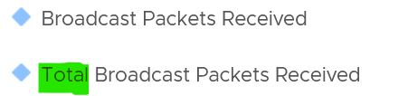

#### Dropped Packet

As usual, let’s approach the metrics starting with Contention. There are no latency counter nor retransmit counter so you cannot track how long it takes for a packet to reach its destination. There are, however, metrics that track packet loss.

For TCP connection, dropped packet needs to be retransmitted and therefore increases network latency from application point of view. The counter will *not* match the values from Guest OS level as packets are dropped before it’s handed into Guest OS, or after it left the Guest OS. ESXi dropped the packet because it’s not for the Guest OS or it violates the security setting you set.

The following summary proves that receive packet gets dropped many more times than transmit packet. This is based on 3938 VMs. Each shows the last 1 month, so approximately 35 million data points in total. The average of 35 million data points show that dropped RX is significantly higher than dropped TX. This is why it’s not in the SLA.

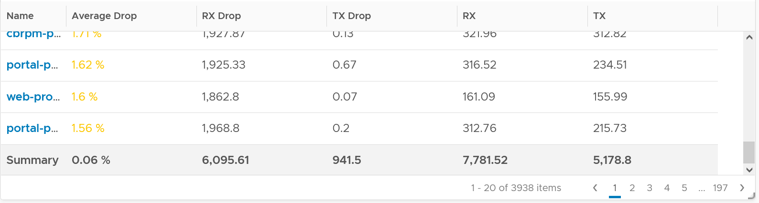

The following table shows that the drop is short and spiky, which is a good thing. The value at 99th percentile is 35x smaller than the value at 100th percentile.

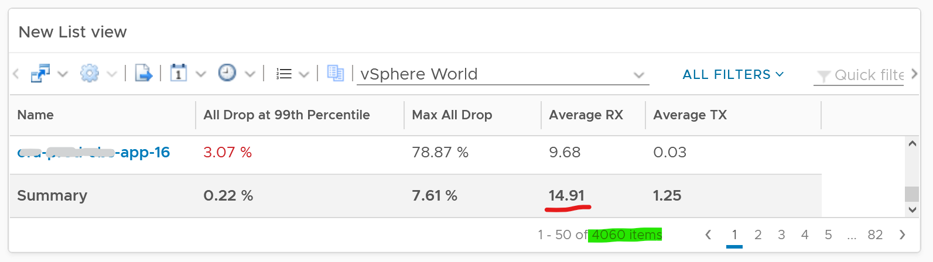

The high value in receive can impact the overall packet dropped (%) counter, as it’s based on the following formula

dropped = Network|Received Packets Dropped + Network|Transmitted Packets Dropped

total = Network|Packets Received + Network|Packets Transmitted

Network|Packets Dropped (%) = dropped / total * 100

I’ve seen multiple occurrences where the packet dropped (%) jumps to well over 95%. That’s naturally worrying. They typically do not last beyond 15 minutes.

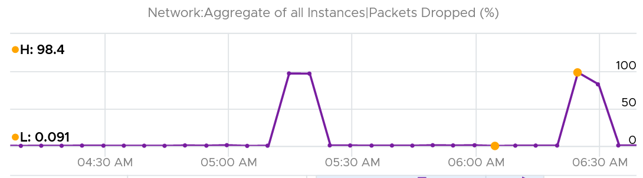

In this, plot the following 4 metrics. You will likely notice that the high spike is driven by *low* network throughput and *high* received packet dropped.

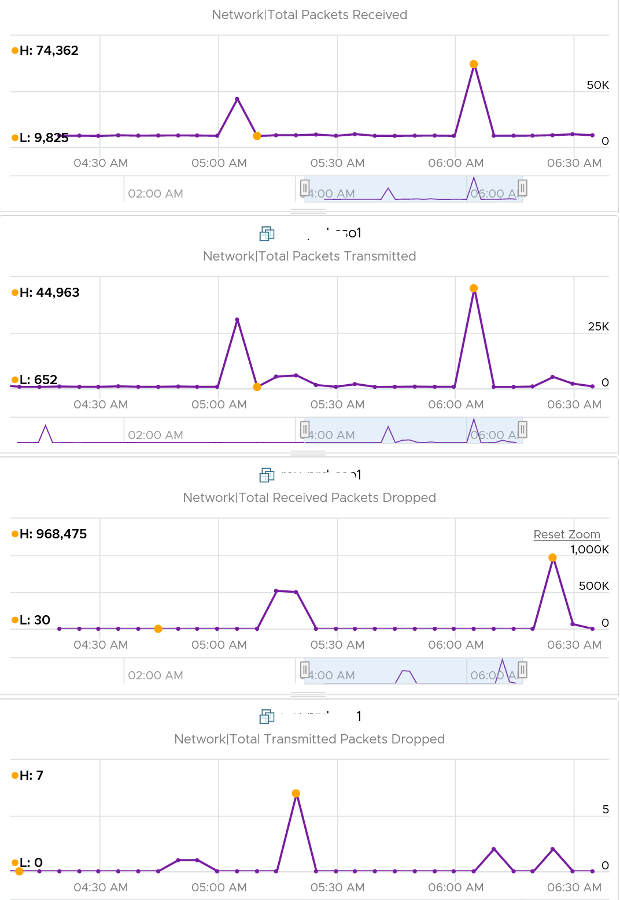

Because of the above problem, profile your VM dropped packets, focusing on the transmit packets. I notice in several customers production environment they exist, yet no one seem to complain. The following is one way to do it, giving surprising results like this:

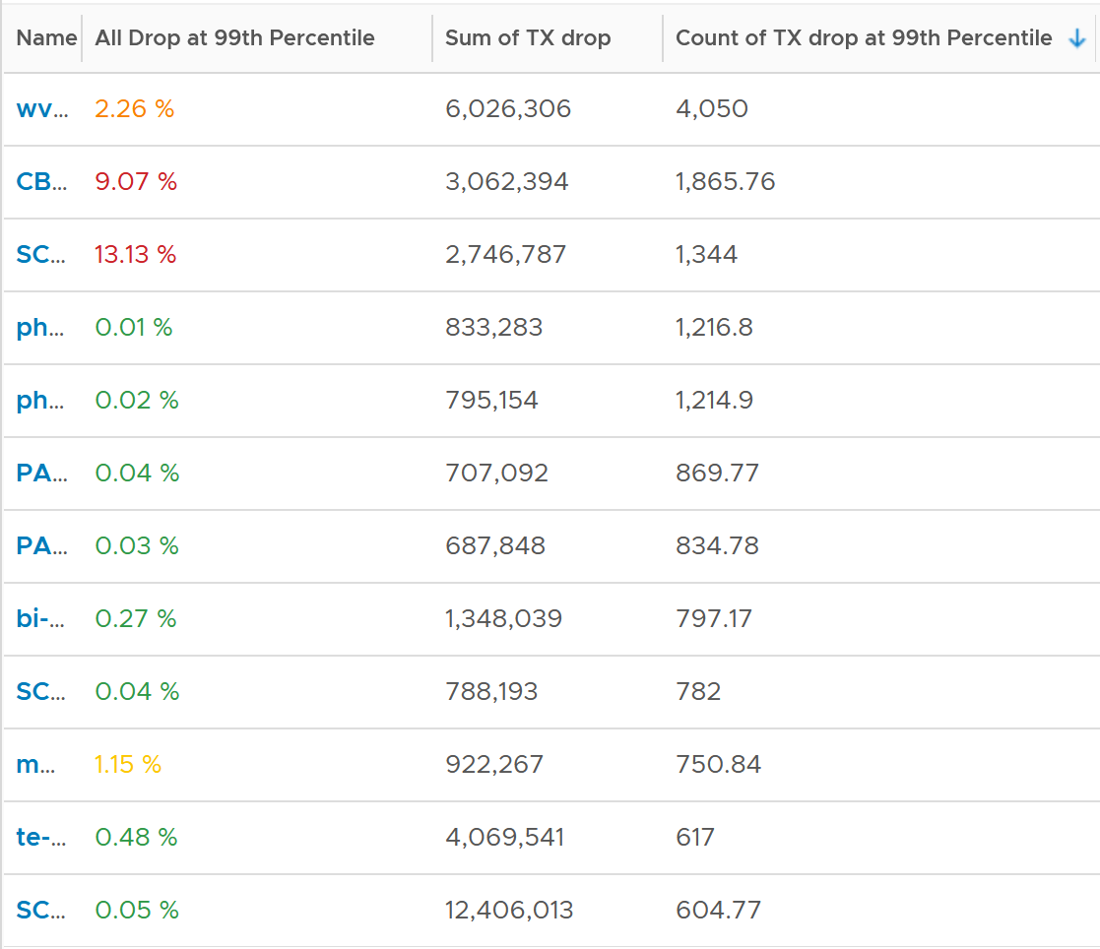

The design of the preceding table is:

* First column calculates the percentage packets dropped. I took 99th percentile else many of the results will be 100%.
* Second column sums all the transmitted dropped packets (actual packet counts).
* Third column takes the 99th percentile maximum of dropped packet within any 300 seconds. Each network packet is typically 1500 bytes. Using 1.5 KB packet size, 1 thousand packets dropped = 1500 MB worth of packets within 300 seconds.

I don’t expect dropped packets in data center network, so to see millions of dropped packets over a month needs further investigation with network team. More over, those metrics are Transmit, not Received. So the VM sent them but they got dropped.

What I typically notice is the spike rarely happens. They look like an outlier, especially when the number is very high. The following is an example. I only showed in the last 1 month as the rest of the 6 months had similar pattern. The jump is well cover 100 millions packets, and they were all dropped. Assuming each packet is 1 KB, since vRealize Operations reports every 5 minutes, that’s 333 MB per second sustained for 300 seconds.

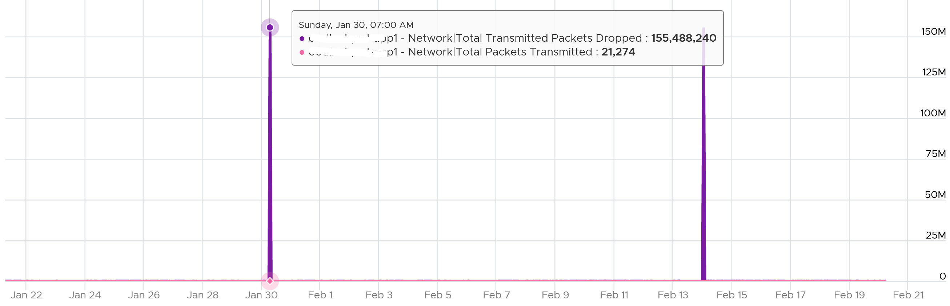

I also notice regular, predictable pattern like this. This is worth discussing with network team. It’s around 3800 packets each 5-minute, so it’s worth finding out.

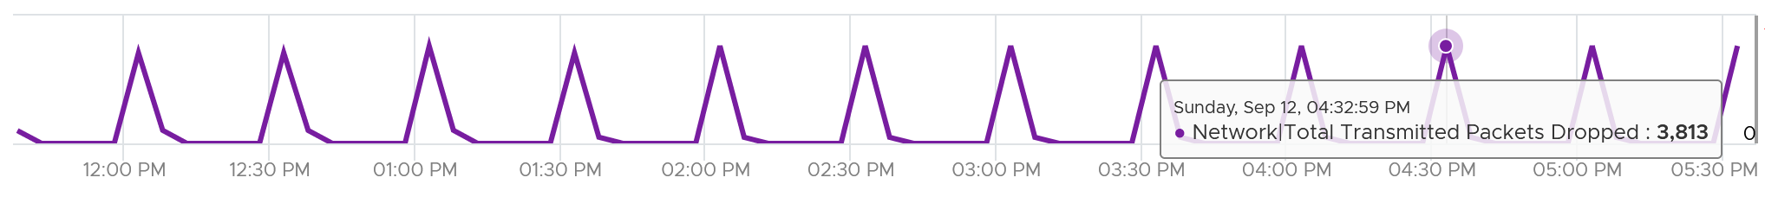

[Packet loss in Guest OS using VMXNET3](https://kb.vmware.com/s/article/2039495): When using the VMXNET3 driver, you may see significant packet loss during periods of very high traffic bursts. The VM may even freeze entirely. This issue occurs when packets are dropped during high traffic bursts. This can occur due to a lack of receive and transmit buffer space or when receive traffic which is speed constrained.

#### Consumption

There are 2 main metrics to measure utilization: throughput and packets.

Both matter as you may still have bandwidth but unable to process that many packets per second. [This outage](https://communities.vmware.com/t5/VMware-vSphere-Discussions/Limit-on-network-packets-per-second-for-VMs/td-p/2312644) shows 700K packets per second that only consumes 800 Mbps as the packet is small. The broadcast packet is only 60 bytes long, instead of the usual 1500 bytes.

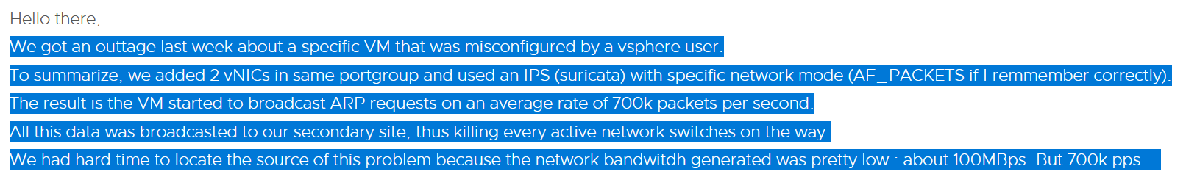

### Performance

With so many metrics, how do you monitor at scale? Say you have 1000 VM and you want to monitor every 5 minutes and see the performance trend in the last 24 hours. That would be far too many trend charts.

Enter Performance (%) metric.

VM KPI includes Guest OS metrics as operationally we troubleshoot them as one, due to their 1:1 relationship.

Let’s now put together all the metrics from Guest OS and VM. For completeness, I added the utilization metrics to act as leading indicators.

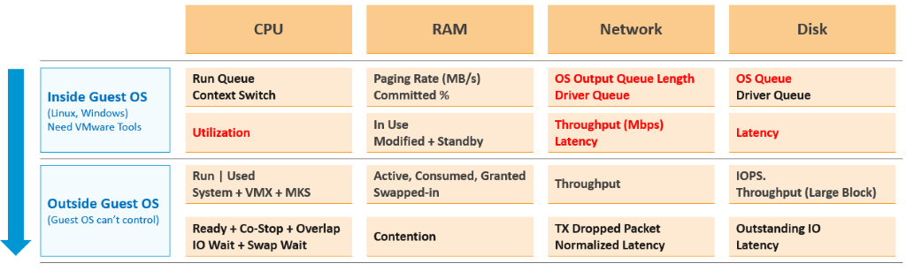

The KPI metrics maybe too technical for some users. You also need to reduce them into a single metric so you can manage at scale. As each metric has their own units, we need to convert them into a *unit-less* range. I picked 0 – 100 range as that’s easier to understand.

Pick the metrics that’s relevant to your environment. Here is what I recommend, including their threshold.

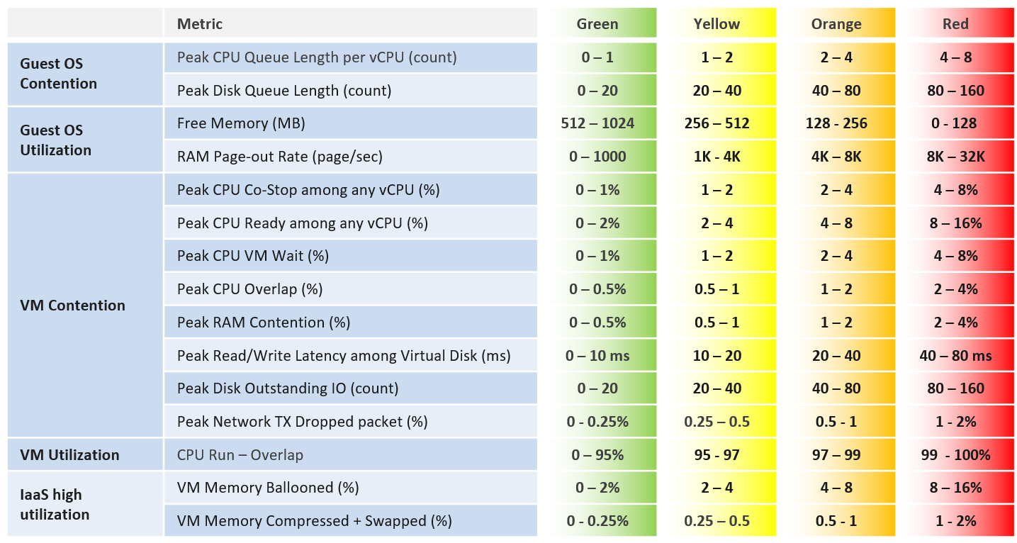

Memory Ballooned, Swapped, Compressed are added even though their presence do not indicate real performance as they are leading indicators. Swapped and Compressed are combined as they are the result of the same action. Together they tell the complete picture.

Do you know why we use CPU Run – Overlap as opposed to CPU Usage? Read Part 2 Chapter 2 CPU Metrics.

We can only put metric here if they can be quantified in to the 4 brackets. Else it might do a disservice. Hence majority of utilization metrics (e.g. disk IOPS, network throughput) are not here.

The threshold is designed to support proactive, not alert based operations. Hence, the red range does not mean emergency and you must drop everything. It means you need to take a look within the next 24 hours. This also gives you time to evaluate how many times it falls into the red zone and the overall trend.

#### 20-second Peak Metrics

vRealize Operations collects and stores data every 5 minutes. This is good enough for *monitoring* use case, but not for troubleshooting. 300-second average is not granular enough, as performance problem may not be sustained that long. Even a performance issue that last days may consist of *repeated microbursts*. I check if repeated burst exist by profiling a few thousand VMs. Here are some of the results. I compare 3 metrics (disk latency, network throughput and CPU context switch).

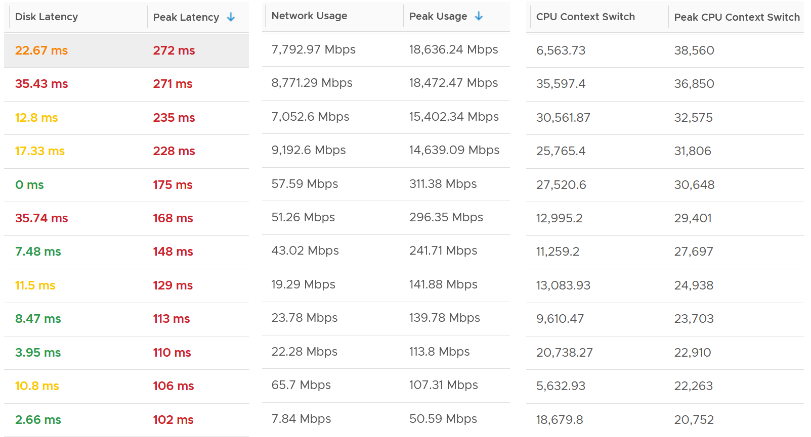

The peak column is based on 20-second average. So it’s 15x sharper than the 300-second average. It gives better visibility into the microbursts. If the burst exists, you will see something like this, where the 20-second shows much worse value consistently.

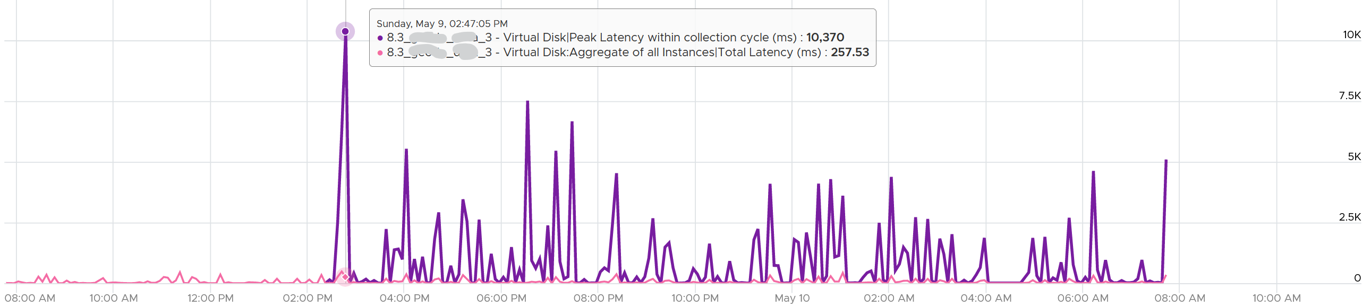

Are you surprised to see that the 20-second peak is a lot worse than 15x worse? The preceding chart shows 10370 ms latency at 20-second vs 257 ms at 300 second.

The huge gap is due to 2 things

* There is only 1 or 2 microbursts, and it’s much higher than the average. This can happen on counter such as disk latency and CPU context switch, where the value can be astronomically high.
* There are many sets. A VM can have many disks. For example, a database VM with 20 virtual disks will have 40 sets of metrics. Each set has 15 datapoints, giving a total of 600 metrics. The peak is reporting the highest of 600 metrics. If the remaining is much lower, then the gap will naturally be high.

##### How are they chosen?

Take a look at the table below. It shows a VM with 2 virtual disks. Each disk has its own read latency and write latency, giving us a total of 4 metrics.

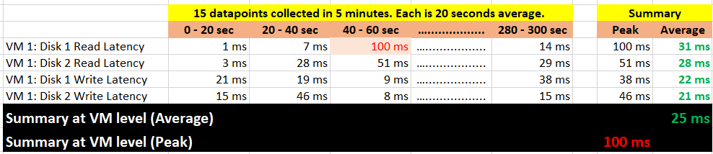

What vRealize Operations 8.3 does is to add a new metric. It does not change the existing metric, because both have their own purpose. The 5-minute average is better for your SLA and performance guarantee claim. If you guarantee 10 ms disk latency for every single IOPS, you’d be hard pressed to deliver that service. These new metrics act as early warning. It’s an internal threshold that you use to monitor if your 5-minute SLA is on the way to be breached.

vRealize Operations 8.3 takes the peak of these 15 data points, and stores them every 5 minutes. It does *not* store all 15 data points, because that will create a lot more IOPS and consume more storage. It answers the question “Does the VM or Guest OS experience any performance problem in any 20-second period?”

Having all 20-second data points are more natural to us, as we’re used to 1 second in Windows and 20 second in vCenter performance charts. But how does that additional **14** data points change the end remediation action? If the action you take to troubleshoot is the same (e.g. adjust the VM size), why pay the price of storing 15x more data points?

If you need to store them all, vRealize Operations Cloud does it for you. Note that it’s limited to 7 days, while this technique lets you store for 6 months as it’s just like any other regular metric.

In the case of virtual disk (as opposed to say memory), a VM can have many of them. A database VM with 20 virtual disks will have 40 peak metrics. That also means you need to check each one by one. So vRealize Operations 8.3 takes the peak among all virtual disks read and writes. It does the same thing with vCPU. A monster VM with 64 vCPU will only have 1 metric, but this metric is the highest among 64 virtual CPU. There is no need to have visibility into each vCPU as the remediation action is the same. Whether it’s vCPU 7 or vCPU 63 that has the problem, it does not change the conclusion of troubleshooting in most cases.

What’s the limitation?

* You can’t see a pattern within the 300 seconds window as you only have 1 data point. This is largely mitigated by having the average counter also. If the delta between the maximum and average is high that means the maximum is likely a one-off occurrence. The pattern can also be seen over longer period of time.
* The peak can be from a different time period. That means you can’t associate that the contention is caused by high utilization as the 2 metrics can come from different time.

##### Metric Used

|  |  |  |
| --- | --- | --- |
|  | 5-minute Average | 20-second Average |
| Guest OS | CPU Run Queue | Peak CPU Queue within collection cycle |
| CPU Context Switch | Peak CPU Context Switch within collection cycle |
| Memory Page-out Rate | Peak Guest OS Page-out Rate within collection cycle |
| Disk Queue Length | Peak Disk Queue within collection cycle |
| VM CPU | Ready (%) | Peak vCPU Ready within collection cycle |
| Co-Stop (%) | Peak vCPU Co-Stop within collection cycle |
| IO Wait (%) | Peak vCPU IO Wait within collection cycle |
| Swap Wait (%) | Peak vCPU Swap Wait within collection cycle |
| Overlap (second) | Peak vCPU Overlap within collection cycle |
| System (%) | Peak CPU System within collection cycle |
| VM Memory | Contention (%) | Peak Memory Contention within collection cycle |
| VM Disk | Read Latency (ms) | Peak Latency within collection cycle |
| Write Latency (ms) |
| VM Network | Usage Rate (KB/s) | Peak Usage Rate within collection cycle |
| Packet/sec | Peak Network Packets/sec within collection cycle |

The VM network dropped packets is not included as seeing the number over 20 second or 5 minutes do not result in a different remediation action.

Notice all of them are VM or Guest OS metrics. No ESXi, Resource Pool, Datastore, Cluster, etc metrics. Why?

The reason is the metrics at these “higher-level” objects are mathematically *an average* of the VMs in the object. A datastore with 10 ms disk latency represents a normalized/weighted average of all the VMs in the datastore. Another word, these metrics give less visibility than the 12 above, and they can be calculated from the 12.

And 1 more reason:

You troubleshoot VM, not infrastructure. If there is no VM, there is no problem 😊

The next question is naturally why we picked the above 12. Among the 12 metrics, you notice only 1 counter tracks *utilization*. The other 11 tracks *contention*. The reason is covered here.

Why are Guest OS level metrics provided?

Because they do not have VM equivalent, and they change the course of troubleshooting. If you have high CPU run queue, you look inside Windows and Linux, not at the underlying ESXi Host as it’s transparent to the host.

For CPU, the complete set of contention is provided. There are 6 metrics tracking the different type of contention or wait that CPU experiences.

For Memory, popular metrics such as Consumed, Active, Balloon, Swap, Compress, Granted, etc are not shown as they do *not* indicate performance problem. Memory Contention is the *only* counter tracking if the *VM* has memory problem. VM and Guest OS can have memory problem independently. In future, we should add Guest OS memory performance metrics, if we find a good one. Linux and Windows do not track memory latency, only track memory disk space consumption, throughput and IOPS. These 2 OSes do not track latency, which unfortunately is the main counter for performance.

For Network, vCenter does not have latency and re-transmit. It has dropped packet, but unfortunately this is subject to false positive. So we have to resort to utilization metric. In future, we should add packets per second.

Lastly, just in case you ask why we do not cover Availability (e.g. something goes down), it’s because this is better covered by events from Log Insight.

##### Metrics Not Used

What metrics are missing from the tables?

The following metrics are not included, along with the reason why:

* Guest OS IOPS : VM IOPS Ratio. They should be near 1 or a stable number, as the block size should be identical. The actual numbers may not match, as Guest OS tends to report the last value, while VM tends to report average value. If they fluctuate greatly, something amiss. I do not include as I do not have the data yet.
* Guest OS: No of dead process. Not sure what value to set for each bracket, as we need to profile first.
* Guest OS: CPU Context Switch. The profiling shows this metrics has a very wide band.
* Guest OS: Memory page-in. This could contain application binary, so its value could be over reported. Based on our profiling of 3300 production VM, the page-in is more volatile so I’m less confident of applying a threshold.
* Guest OS: Swapped File remaining size. Not sure if they impact performance.
* VM Balloon. We covered the reason here.
* Outstanding IO. Adding it will be duplicating as it’s a function of IOPS x latency.
* vMotion. This is an event, not a metric. It does not happen regularly, in fact most of the time it does not happen.
* VM vMotion stunned time. I do not have enough data to decide the value to put for each range. It should be within 0.2 second for Green, but what about yellow? Typically, I used 2K – 4K VMs over 3 months to convince myself that the thresholds are representing real world.
* Latency due to disk snapshot. The metric VM Wait already covers it, so no need to double count.
* Undesired network packets, such as broadcast and multicast. They do not actually cause performance.
* Network RX Dropped Packets. Too many false positive.
* VM DRS Score. [Niels Hagoort](https://blogs.vmware.com/vsphere/author/nhagoort) states [here](https://blogs.vmware.com/vsphere/2020/05/vsphere-7-a-closer-look-at-the-vm-drs-score.html) that “a VM running a lower score is not necessarily not running properly. It is about the execution efficiency, taking all the metrics/costs into consideration.” Reading the blog and other material, this metric is more about the cluster performance than the individual VM performance. Plus, it’s using metrics that are already included in the KPI, so it’s double counting.

The threshold can be argued from 2 ways

* Scientifically
* “Practically”

Scientifically, a VM does not care what’s stopping it. Whether it’s Ready or Co-Stop or Overlap, the Guest OS does not know. Using this logic, you should set all the threshold the same way. On the other hand, you can follow what happens in production, in healthy environment. These metrics do not follow the same scale.

I take the lowest of the two, as the requirement is proactive monitoring.

##### Implementation

The following shows part of the formula. It shows the metrics used and the label I use to increase readability. I found label handy to shorten the overall length.

I’ve copied into an external editor so I can show each metric as 1 line so you can see them more easily. I’ve rearranged the metrics so you can see the 20 second peak metrics first.

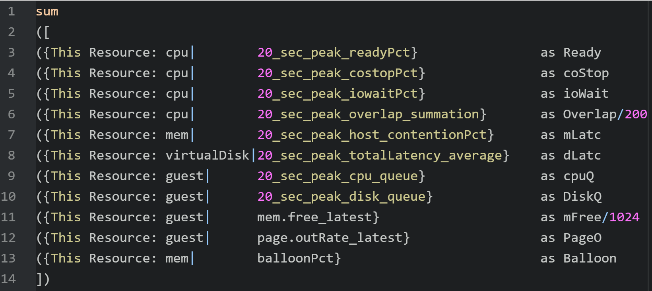

I have not included VM Transmit Packet Drop to avoid false positive.

I have not added Swapped + Compressed yet.

I have not added Run – Overlap yet.

###### The Green Range

To see the threshold more easily, I rearranged the metrics. The last row uses a threshold that goes from high to low, so the formula is different. Notice it uses **>** operator instead of **<** operator.

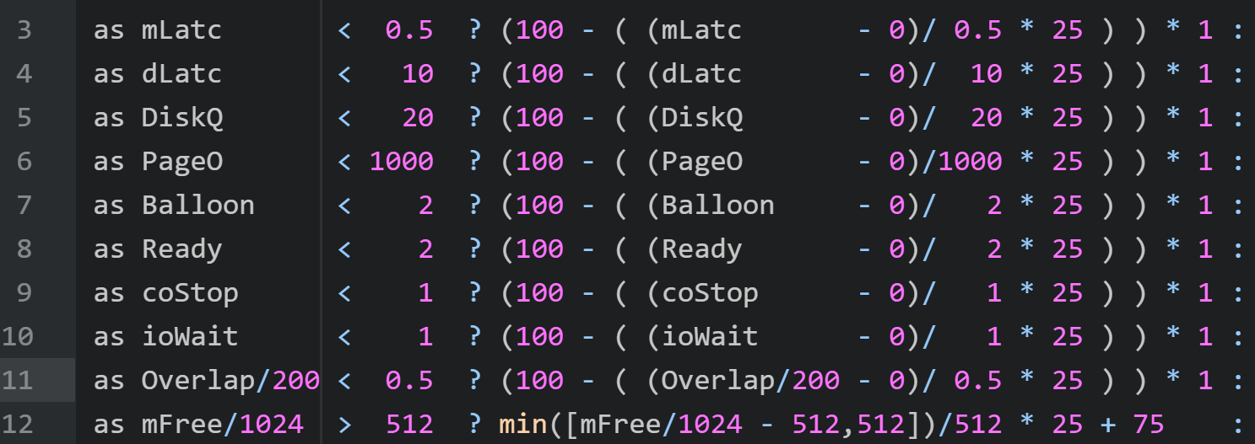

Let’s go through the first line. It basically checks if memory latency is < 0.5% then it will translate its value within the 0% - 25% range. A value of 0% will translate into 100%, while the value near 0.5% will translate into near 75%.

The **\* 1** at the end is the weightage multiplier. Green is given a 1x weightage, while yellow is 2x, orange is 4x and red is 8x. The value is amplified, and then normalized again at a later portion (not shown in the screenshot)

Let’s look at the 2nd last line. The CPU Overlap is in millisecond, where 20000 equates to 100%. To translate into a percentage, I need to divide by 200. BTW, I should also divide by the number of vCPU. But since the value is already very low, I think it’s better to be conservative.

Let’s look at the last line. We want the value of free memory > 512 MB of RAM to translate into 100%. Since the formula returns 0% - 25%, I had to add 75.

BTW, I didn’t add the **\* 1** weightage multiplier at the end to keep the formula simpler.

###### The Yellow Range

When the metric value does not within green threshold, we compare against yellow.

The range is 50% - 75%, hence the formula deducts from 75.

The **\* 2** at the end is the weightage multiplier for yellow.

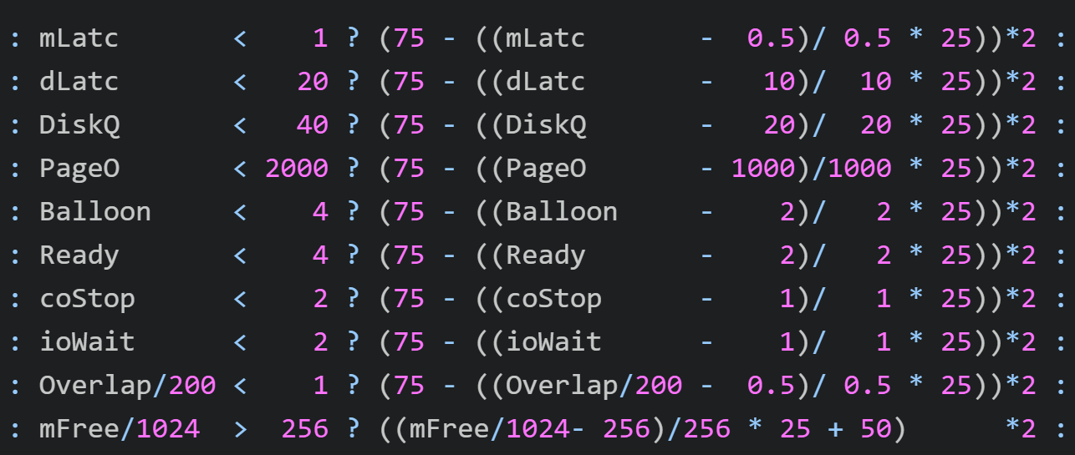

Let’s run through an example When the memory latency is 0.75%, it will return a value of 0.5. This is then spread over 25, so we will get a value of 12.5. We then deduct it from 75, to get a value of 62.5%. Lastly, we multiply it by 2 to get 125.

###### The Orange Range and Red Range

I’m showing them together as it’s an IF THEN ELSE. Whatever not caught by the orange is handled by red.

The **50 –** caps the value of Orange at 50%, while the red is capped at 25.

The **\* 4** at the end is the weightage multiplier for orange.

The red range needs to use a Min() logic as the requirement is a value above certain amount returns 0%. Using the memory latency, any value above 2% returns 0% already.

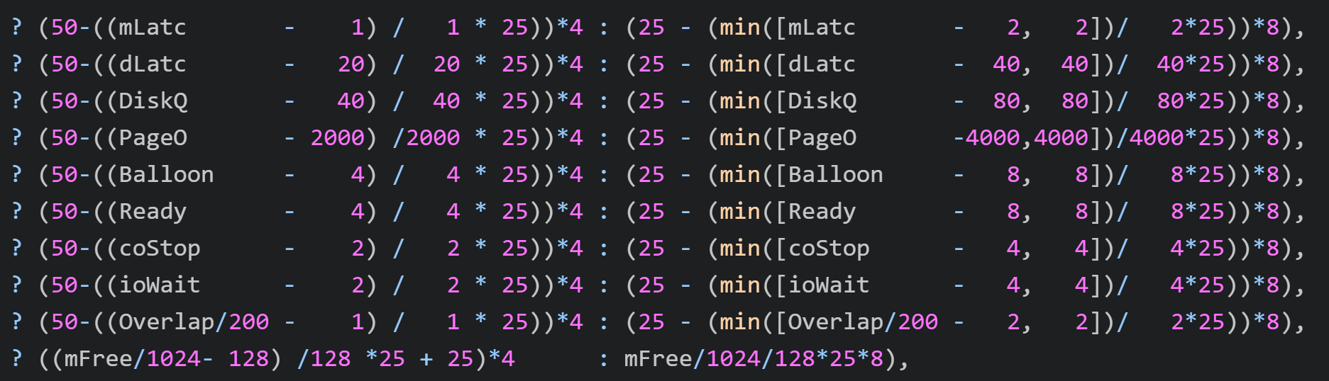

###### Metrics Keys

|  |  |
| --- | --- |
| Metric Key | Remarks |
| guest|20_sec_peak_cpu_queue / cpu|corecount_provisioned | Normalized to per vCPU |
| guest|20_sec_peak_disk_queue | Count of queue |
| guest|mem.free_latest | In MB |
| guest|page.outRate_latest | In pages/second |
| cpu|20_sec_peak_costopPct | In % |
| cpu|20_sec_peak_readyPct | In % |
| cpu|20_sec_peak_iowaitPct | In % |
| cpu|20_sec_peak_overlap_summation / cpu|corecount_provisioned | Normalized to per vCPU |
| mem|20_sec_peak_host_contentionPct | In % |
| virtualDisk|20_sec_peak_totalLatency_average | In ms |
| virtualDisk|vDiskOIO | Count of OIO |
| Network|Total Transmitted Packets Dropped / Network|Total Packets Transmitted * 100 | In % |
| (CPU|Run (ms) - CPU|Overlap (ms) ) / cpu|corecount_provisioned / 200 | Normalized to per vCPU and in % |
| mem|balloonPct | In % |
| (Memory|Swapped (KB) + Memory|Compressed (KB) ) / Memory|Consumed (KB) * 100 | In % |

#### Latency Sensitivity

You can reduce the latency and jitter caused by virtualization by essentially “reserving” the physical resource to a VM. In the vSphere Client UI, edit VM settings, and go to VM Options tab.

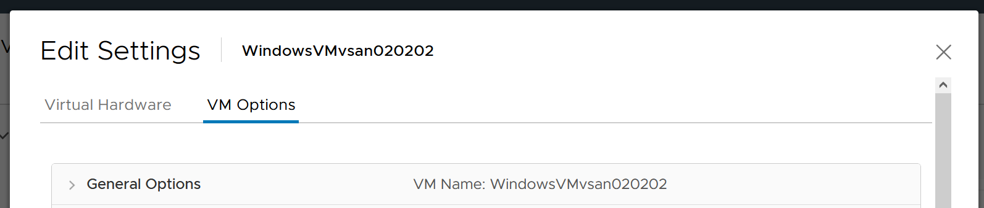

Scroll down until you see this option.

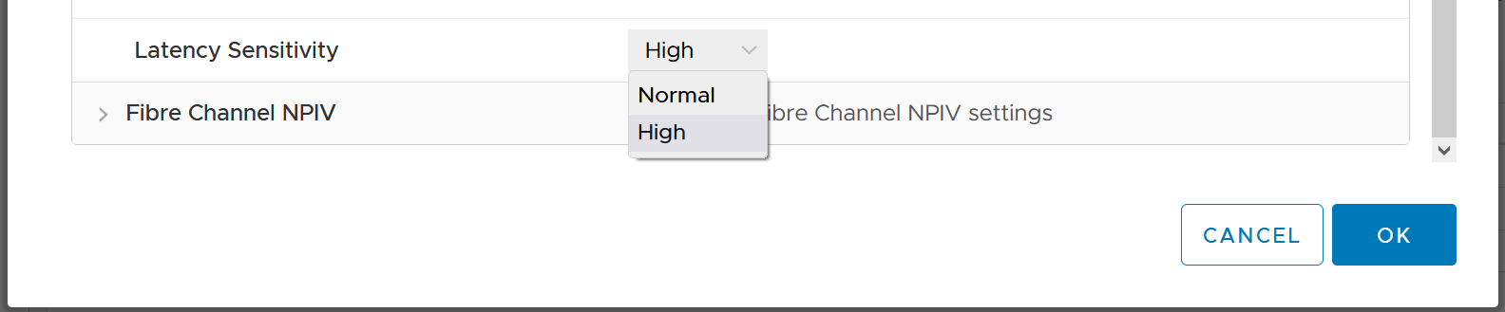

What happens to the metrics when you set Latency Sensitivity = High?

##### CPU Impact

The CPU “pipeline” has to be made available. In a sense, the CPU is scheduled 100% of the time. This prevents any wakeup or scheduling latencies that result of having to schedule a vCPU when it wakes up in the first place. Yes, the exclusive bit of exclusive affinity is literal.

Let’s see what it looks like in esxtop. I’ve removed unnecessary information so it’s easier to see. What do you notice?

GID NAME %USED %RUN %SYS %WAIT %IDLE

153670 vmx 0.03 0.03 0.00 100.00 0.00

153670 NetWorld-VM-2127520 0.00 0.00 0.00 100.00 0.00

153670 NUMASchedRemapEpochInitialize 0.00 0.00 0.00 100.00 0.00

153670 vmast.2127520 0.00 0.00 0.00 100.00 0.00

153670 vmx-vthread-212 0.00 0.00 0.00 100.00 0.00

153670 vmx-filtPoll:WindowsTest 0.00 0.00 0.00 100.00 0.00

153670 vmx-mks:WindowsTest 0.00 0.00 0.00 100.00 0.00

153670 vmx-svga:WindowsTest 0.00 0.00 0.00 100.00 0.00

153670 vmx-vcpu-0:WindowsTest 0.31 100.21 0.00 0.00 0.00

153670 vmx-vcpu-1:WindowsTest 0.16 100.21 0.00 0.00 0.00

153670 vmx-vcpu-2:WindowsTest 0.15 100.21 0.00 0.00 0.00

153670 vmx-vcpu-3:WindowsTest 0.15 100.21 0.00 0.00 0.00

153670 LSI-2127520:0 0.00 0.00 0.00 100.00 0.00

153670 vmx-vthread-212:WindowsTest 0.00 0.00 0.00 100.00 0.00

We can see Run shot up to 100%. This means Wait has to go down to 0%.

Strangely, Used remains low, so we can expect that Usage remains low too. This means the formula that connect Run and Used do not apply in this extreme scenario. You’re basically cutting a physical core to the VM.

But what about Demand?

Demand shot up to 100% flat out.

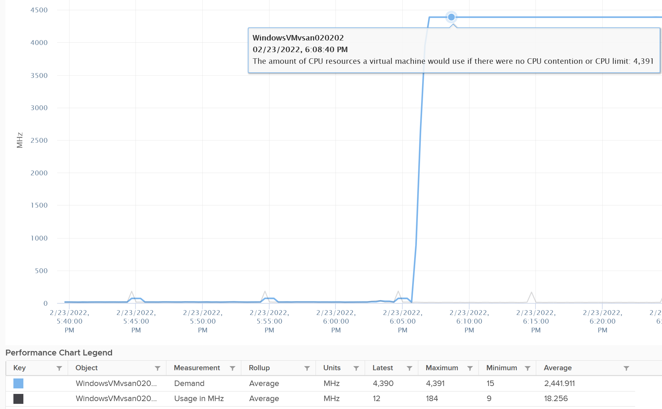

So you have an interesting situation here. Demand is 100%, Usage is 0%, yet Contention is 0%.

Now let’s plot what happened to Wait and Idle. Notice both went from 100% to 0%.

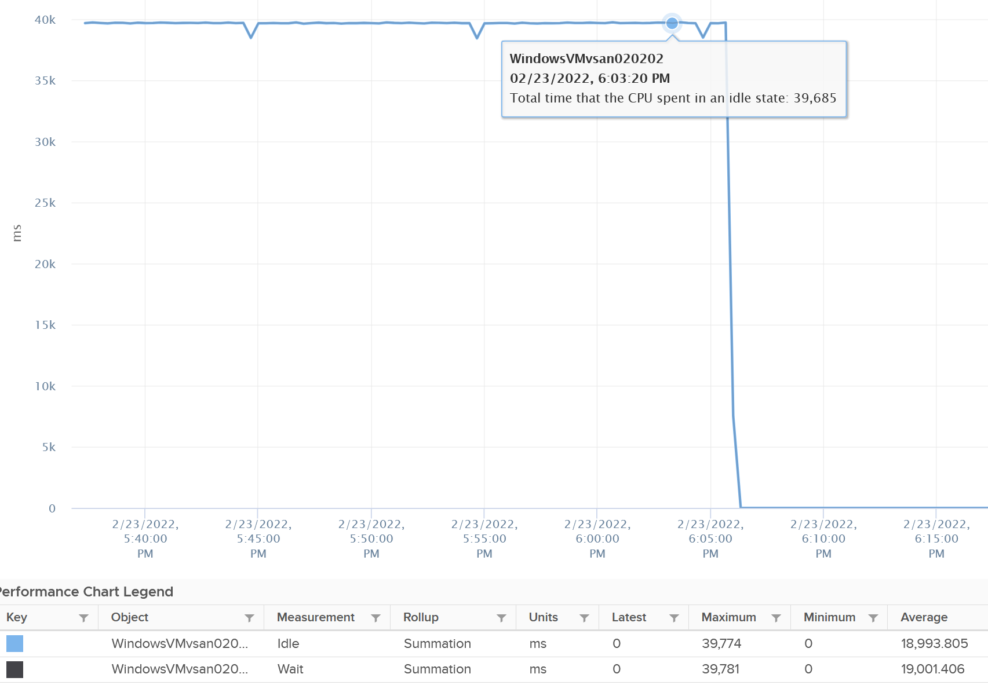

So if you combine Run, Demand, Wait and Usage metrics, you can see basically Run and Demand shot up to 100% as Wait drops to 0%, while Usage is oblivious to the change.

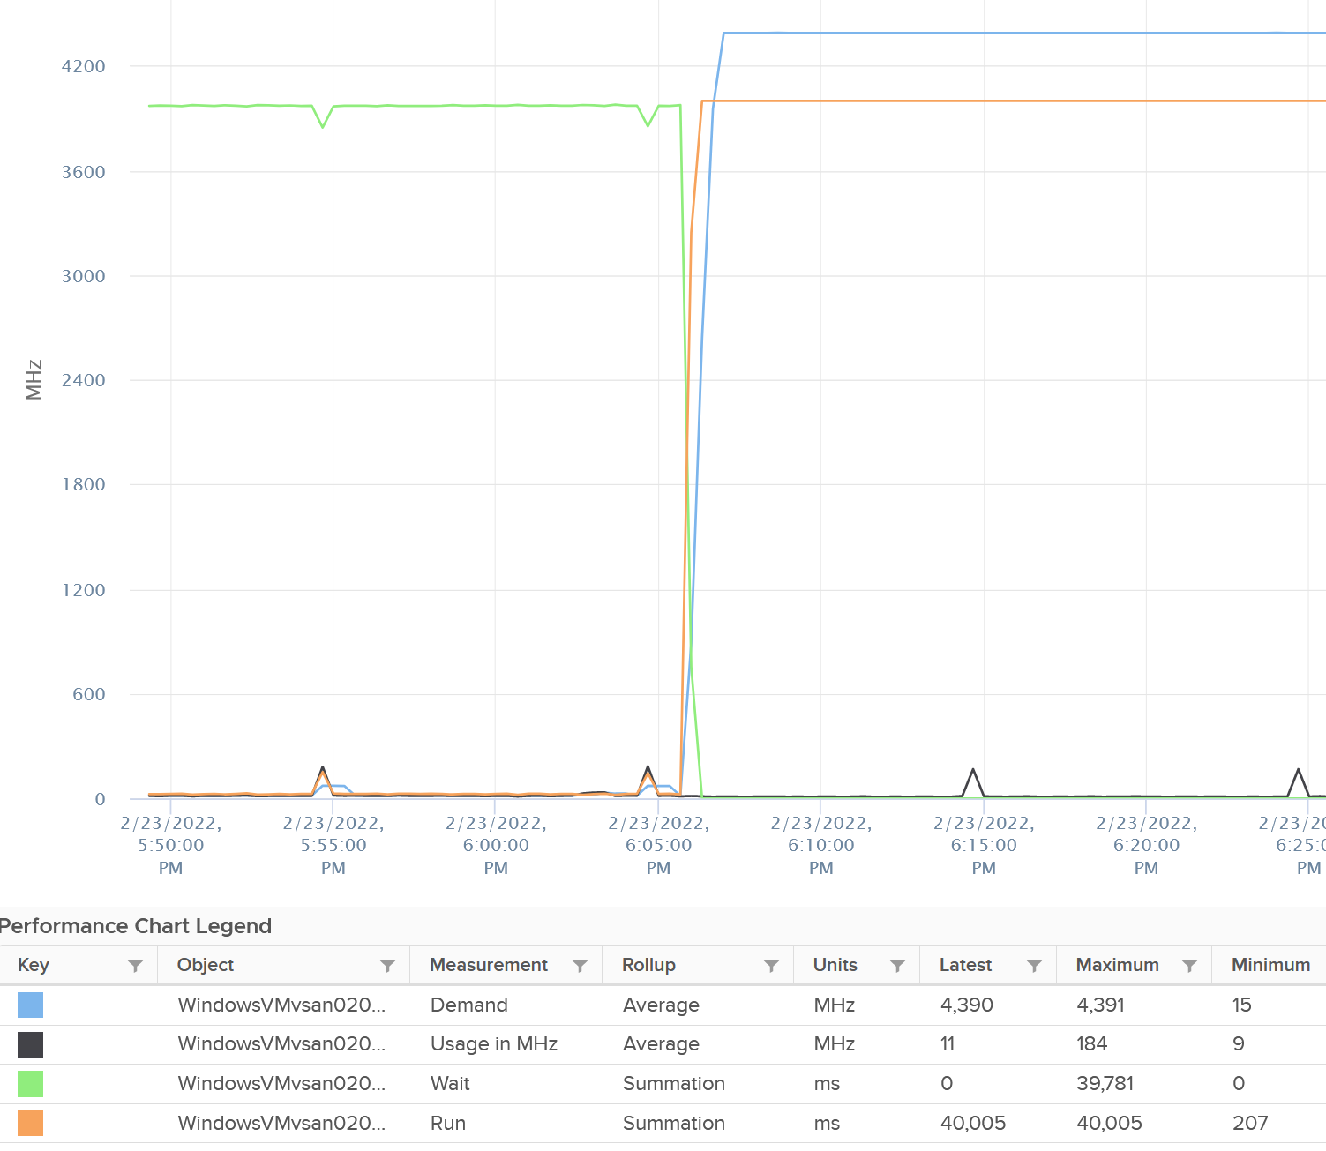

Just for documentation purpose, System and Ready are obviously not affected.

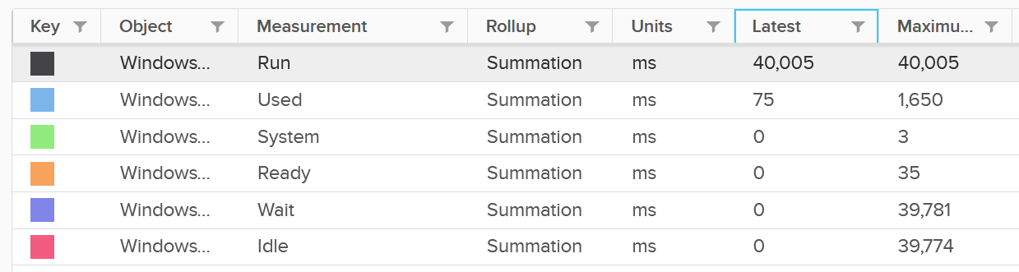

##### Memory Impact

Memory is fundamentally storage. So I do not expect any of the counters to go up. They will go up when the VM actually needs them.

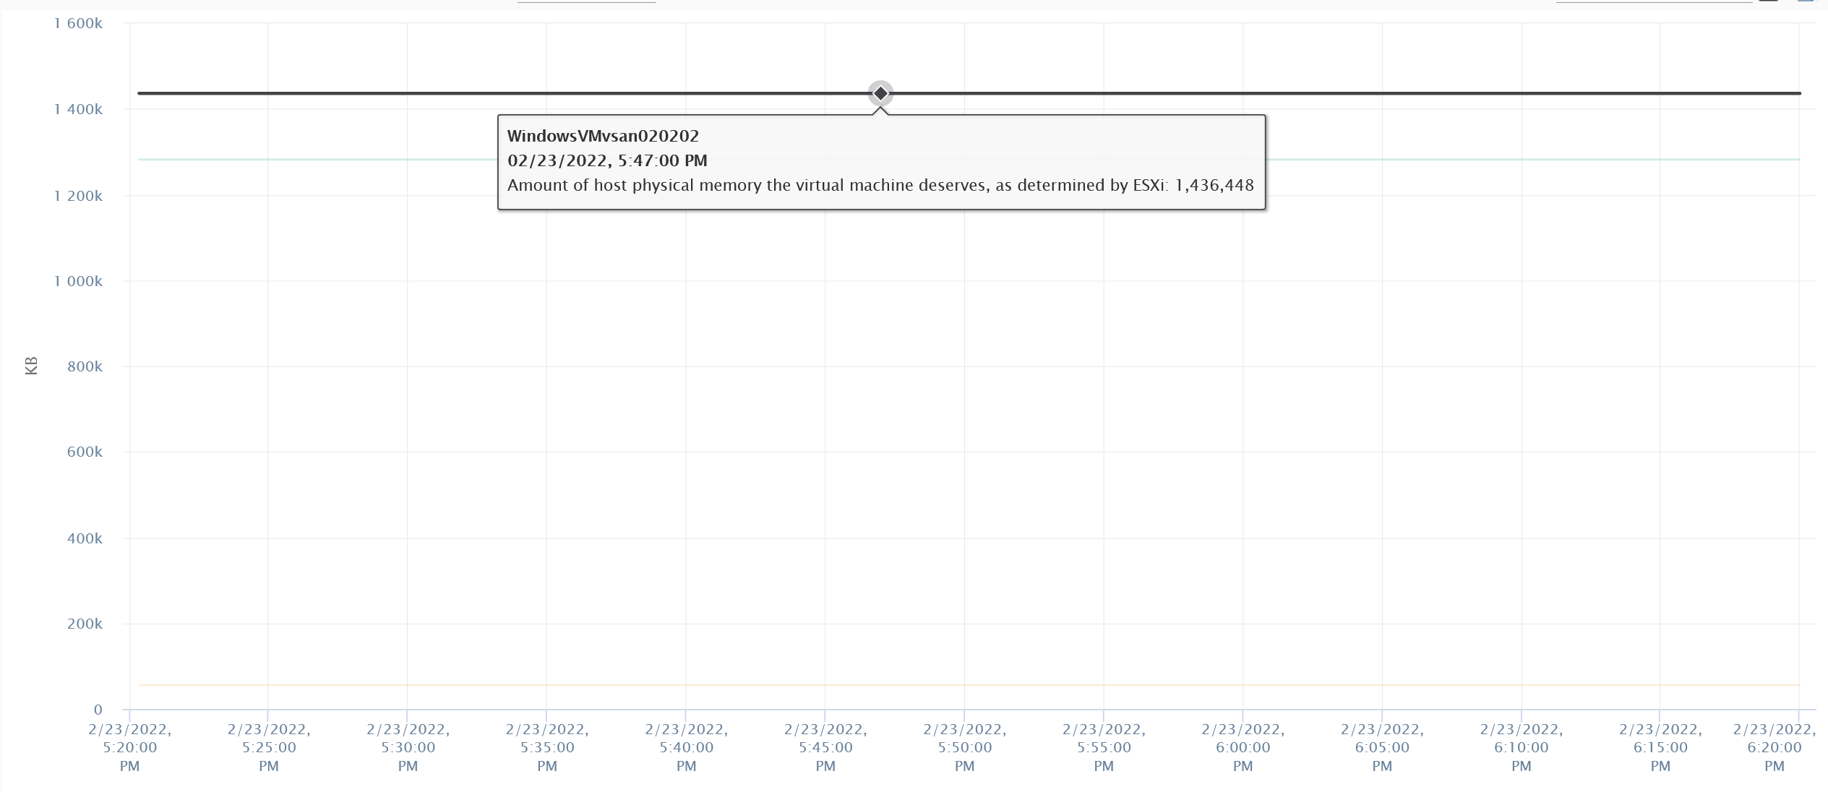

The above VM has 4 GB of RAM, fully reserved. But since it’s basically idle, there is no change on the counter.

### Capacity

#### 2 Sides of the Formula

VM right-sizing is a commonly misunderstood term because there are actually multiple use cases, with each use case having their own factors to consider. What does this mean?

Different scenarios require different metrics. It is not a one size fits all, hence there are more than one formula.

Here are some popular use cases:

* Your Application Team asks for extra vCPU. In this case, the hypervisor overhead is irrelevant. When you size NSX edge vCPU, you do not need to add extra vCPU for the overhead. It’s done outside of Linux.
* You are migrating a VM to a new ESXi with CPUs that are 2x the speed. For example, from a 2 GHz ESXi to 4 GHz. All else being equal, you can cut down the VM size by 2. A 16 vCPU becomes 8. But you are worried about causing queue inside the Guest OS as the application may expect 16 slow threads vs 8 fast ones. In this case, you need to look inside.
* Your boss asks you to properly charge customers, accounting for what they are actually demanding. Let’s say you have 2 VM with identical size. However, one is idle and the other is running hot. Would you charge the two VMs above the same way? You might for practical reasons, quietly distribute the cost equally as it’s just impractical to consider real utilization.

From the above 3 use cases, we need at least two different formulas:

* **Guest OS Sizing**. Excludes VM overhead, includes Guest OS Queue.
* **VM Sizing**. Includes VM overhead, excludes Guest OS Queue.

The VM sizing is used for calculating the footprint of the VM on the underlying infrastructure. It’s not to size the VM per se. In fact, I’d argue that there is no such thing VM sizing. For example, there is no such thing as virtual disk rightsizing. What you have is Guest OS Partitions sizing. You have Guest OS sizing and “Impact on Infra” sizing.

We might argue that queue or unmet demand within the Guest OS should be included for VM sizing. Reason is when you increase the Guest OS size, that unmet demand will translate into real demand. My recommendation is not to include it, as it’s not something that is a fact yet.

|  |  |
| --- | --- |
| **Rule** | **Description** |
| It’s not just utilization | It needs to consider unmet demand. CPU wants to run, but it cannot. Memory has lots of page fault in Guest OS memory. |
| It’s not just demand | Size base on what the Guest OS needs to perform well, not just base on what it demands at present. Applicable for RAM, where Guest OS can’t operate optimally without buffer.  In capacity, we size not just for demand, but also for performance. While we can satisfy the demand for memory with just the In Use, it might come at the expense of performance. The only thing faster than memory is CPU. So make sure CPU is not waiting for data. This is done by caching as much as possible, as it's hard to predict what pieces of data is required by the program. |
| Includes peak | Consider the busy or peak period, because that’s when the VM needs to work the most |
| Consider big picture | A single 5-minute burst is too short a timeframe to determine the entire next 3 months. Consider long term pattern. This alone makes sizing an art, as you need to know the nature of the workload. |
| Excludes IT load | Exclude the time when the Guest OS is not doing business workload. There are a few IT workloads that cause high utilization. Common ones are Guest OS reboot, Guest OS updates, anti-virus full scanning, agent-base full back up. So long as these tasks don’t prevent the Guest OS from doing useful work, you can exclude them. The exception is when your VM needs to run at these non-business hours too. So it depends on the VM.  This is the hard part, as it requires awareness of the footprint (read: process name) |

Sizing upwards and downwards should have identical formula.

* The only difference is they have different boundaries. The lower boundary applies to downsizing, and the upper boundary applies to upsizing.
* For downsizing, Guest OS needs a minimum amount of RAM to operate.
* For upsizing, consider the NUMA boundary. Also, a VM should not be larger than the total number of logical processors on the ESXi Host, else it won’t even boot. In fact, it should be smaller as you want to account for the VMkernel overhead.

As you can see from above, sizing is complicated. And the above is just Guest OS. We have not considered other things that need sizing such as Containers and Business Applications.

The art of sizing has 2 parts: time and metric.

* First, we calculate the value for a given point in time. The correctness of the input value matters, else you have [GIGO](https://en.wikipedia.org/wiki/Garbage_in,_garbage_out) effect.
* Second, we plot thousands of these values over time, and project it over time. The projection has to consider the peak cycle, meaning it has to be geared towards conservative sizing. It also has to consider the business cycle. If you have annual sales, then consider annual data.

You’ll see below that CPU and RAM require different approach.

#### Guest OS CPU Sizing

You exclude all the VM overhead, as it’s not used by the Guest OS. For example, all the IO overhead performed by the hypervisor should not be included when determining how much CPU Windows or Linux should be configured with. For disk sizing, the snapshot is not part of your VMDK sizing.

|  |  |
| --- | --- |
| **Rule** | **Description** |
| Exclude Hyper-Threading | The Guest OS is running, regardless of speed and throughput. With lower efficiency, it will simply run longer. Instead of 40% for 5 minutes, it may run 90%. If it exceeds 100%, then queue will develop inside the Guest OS.  The Demand and Usage metrics are not suitable as their values are affected by CPU Frequency and HT |
| Exclude CPU Frequency | As above. The only exception here is the initial sizing, when the VM is not yet created. The application team may request 32 vCPU at 3 GHz. If what you have is 2 GHz, you need to provide more vCPU. |
| Exclude idle time | The CPU is not running. It does not matter whether it’s because the Guest OS CPU is waiting for Guest OS IO. The net result is the Guest OS is not running its CPU. While making the IO subsystem faster will result in higher CPU utilization, that’s a separate scope. |
| Exclude CPU Context Switch | It is not something you can control. Plus it is impossible to translate its value into the right sizing formula. In addition, a high context switch could be caused by too many vCPU or IO. Guest OS is simply balancing among its vCPUs.  The Utilization may be high, but if CPU is doing a lot of context switch, it’s less productive. |
| Include Co-stop & Ready | The Guest OS actually wants to run. Had there been no blockage, the CPU would have been utilized. Adding/Reducing CPU does not change the value of these waits, as this represents a bottleneck somewhere else. However, it does say that this is what the CPU needs, and we need to reflect that.  Guest OS number will be inaccurate because there is no “no data”, due to its time being frozen. |
| Include VM Wait, Swap Wait | Guest OS becomes idle as CPU is waiting for RAM or IO (disk or network). So this is the same case with Ready and Co-stop. |
| Include Overlap | The Guest OS actually wants to run, but it’s interrupted by the VMkernel. Note that this is already a part of CPU Run, so mathematically is not required if we use CPU Run counter. |
| Include Guest OS CPU Run Queue | This is the primary counter tracking if Windows or Linux is unable to cope with the demand. |
| Exclude hypervisor overhead | MKS, VMX, System. While it’s part of Demand, it’s not a demand coming from within the Guest.  The VM CPU Used, Demand, Usage counter include system time at VM level, hence they are not appropriate. |

Based on all the above, the formula to size the Guest OS is:

Guest OS CPU Needed (vCPU) = ( (Run + Co-stop + Ready + Other Wait + Swap Wait) / 20000 ) + CPU Run Queue factor

The result is in the number of vCPU. It is not in % or GHz. We are sizing the Guest OS, not the VM.

We need to divide by 20000 because 20000 milliseconds represent 100% of a single vCPU. More about this unit is explained here.

Guest OS CPU Run Queue metric needs some conversion before it can be used. Let’s take an example:

* VM has 8 vCPU.
* CPU Run Queue = 28 for the entire VM.
* VM can handle 8 x 3 = 24 queues.
* There is a shortage of 28 – 24 = 4 queues.
* Each additional vCPU can handle 1 process + 3 queues.
* Conclusion: we add 1 vCPU.

Compared with CPU Usage, Guest OS Needed without the CPU run queue factor tends to be within 10% difference. Usage is higher as it includes system time, and turbo boost. Usage would be lower in HT and CPU frequency clocked down case.

Here is an example where Usage is higher.

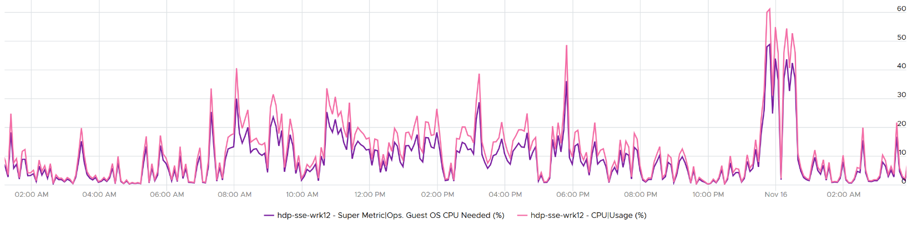

Here is an example where Usage is lower.

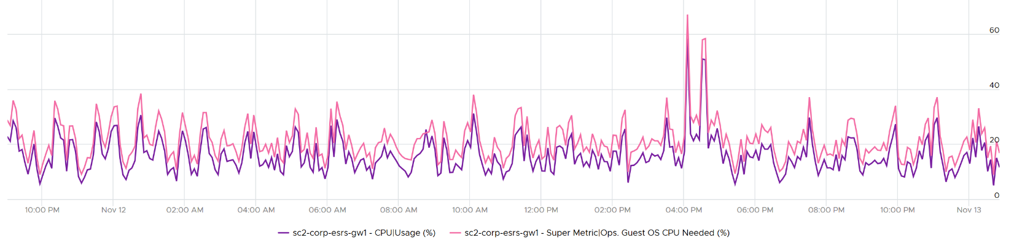

Once we know what the Guest OS needs, we can then calculate the recommended size. This is a projection, taking lots of value. Ideally, the recommendation is [NUMA aware](https://blogs.vmware.com/management/2019/09/26212.html). It is applied *after* the sizing is determined. You size, then adjust to account for NUMA. This adjustment depends on the ESXi Host. So it can vary from cluster to cluster, if your vSphere clusters are not identical.

Guest OS Recommended Size (vCPU) = round up NUMA (projection (Guest OS Needed (vCPU))

For basic NUMA compliant, use 1 socket many cores until you exceed the socket boundary. That means you use 2 vCore 1 vSocket instead of 2 vSockets with 1 vCore each.

With the release of Windows 2008, switching the [Hardware Abstraction Layer](https://www.sciencedirect.com/topics/computer-science/hardware-abstraction-layer) (HAL) was handled automatically by the OS, and with the release of 64-bit Windows, there is no concept of a separate HAL for uniprocessor and multi-processor machines. That means one vCPU is a valid configuration and you shouldn’t be making two vCPU as the minimum.

You should use the smallest NUMA node size across the entire cluster, if you have mixed ESXi with different NUMA node sizes in the cluster. For example, a 12-vCPU VM should be 2 socket x 6 cores and not 1 socket x 12 core as that fits better on both the dual socket 10 core and dual socket 12 core hosts. Take note that the amount of memory on the host and VM could change that recommendation, so this recommendation assumes memory is not a limiting factor in your scenario.

Notice the number is in vCPU, not GHz, not %. Reason is the adjustment is done at a whole vCPU. In fact in most case, it should be an even number, as odd numbers don’t work in NUMA when you cross the size of a CPU socket.

Note that when you change the VM configuration, application setting may need to change. This is especially on applications that manage its own memory (e.g. database and JVM), and schedule fixed number of threads.

You can enable Hot Add on VM, but take note of impact on NUMA.

Reference: [rightsizing](https://blogs.vmware.com/management/2020/01/rightsizing-vms-with-vrealize-operations.html) by Brandon Gordon.

#### VM CPU Sizing

Sizing the VM is required for the migration use case or chargeback use case.

|  |  |
| --- | --- |
| **Rule** | **Description** |
| Include Hyper-Threading | When a VM runs on a thread that has a peer thread running, it’s getting less CPU cycle. |
| Include CPU Frequency | Moving a VM to cluster with lower frequency may require more vCPU |
| Include VM overhead | Examples are Fault Tolerant. They need to be chargeback. |
| Exclude Guest OS queue | It’s transparent to the VM |

Based on all the above, the formula to size the VM is:

VM CPU Needed = (Used + Co-stop + Ready + Other Wait + Swap Wait) + System / 20000

You express in GHz (utilization model) and vCPU (allocation model). The GHz is especially important when you need to migrate into another ESXi with different clock speed. To convert into GHz, we multiply the number by the nominal, static clock speed. You can also enhance this by considering [CPU generation and speed](https://www.spec.org/cpu2017), although this can introduce a new problem if not done properly. An application may perform poorly after the reduction in vCPU if it works better with many slow threads vs a few fast threads.

Once we know what the VM needs, we need to project and recommend. We apply the same technique we did for Guest OS.

#### Guest OS Memory Sizing

Accuracy of Guest OS memory has been a debate for a long time in virtualization world. Take a look at the following utilization diagram. It has two bars, showing memory utilization of 2 VMs. They use different set of thresholds.

Which one should you use for memory?

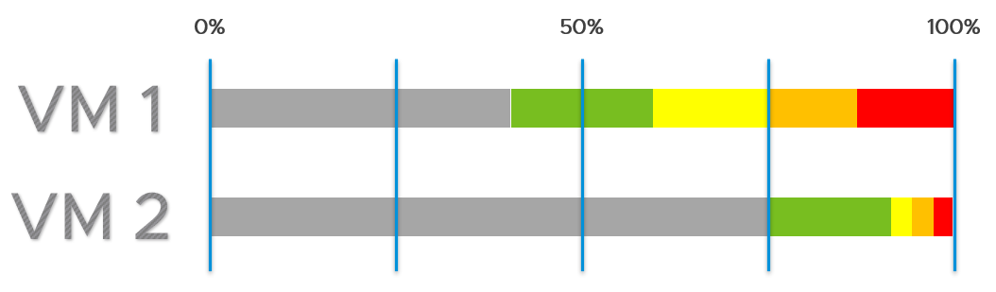

My recommendation is no 2.

The reason is memory is a form of cache. It stays even though it’s not actively used.

When you spend your money on infrastructure, you want to maximize its use, ideally at 100%. After all, you pay for the whole box. In the case of memory, it even makes sense to use the whole hardware as the very purpose of memory is just a cache for disk.

The green range is where you want the utilization to fall. Below the green threshold lies a grey zone, symbolizing wastage. The company is wasting money if the utilization falls below 50%. So what lies beneath the green zone is not an even greener zone; it is a wastage zone. On the other hand, higher than 75% opens the risk that [performance](http://virtual-red-dot.info/vmware-performance-sla/) may be impacted. Hence I put a yellow, orange and red threshold. The green zone is actually a relatively **narrow** band.

In general, applications tend to work on a portion of its [Working Set](https://en.wikipedia.org/wiki/Working_set) at any given time. The process is not touching all its memory all the time. As a result, the rest becomes cache. This is why it’s fine to have active + cache beyond 95%. If your ESXi is showing 98%, do not panic. In fact, ESXi will wait until it passes 99% before it triggers ballooning process. Windows and Linux are doing this too. The modern-day OS is doing its job caching all those pages for you. So you want to keep the Free pages low.

|  |  |
| --- | --- |
| **Rule** | **Description** |
| Include cache | Guest OS uses RAM as cache. If you size the OS based on what it actually uses, it will have neither cache nor free memory. It will start paging out to make room for Cache and Free, which can cause performance problems. As a result, the name of this proposed counter should not be called Demand as it contains more than unmet demand. It is what the OS needs to operate without heavy paging. Hence the counter name to use is Needed memory, not Memory Demand.  The challenge here is how much cache do you want to include? |
| Exclude Page File | Including the pagefile will result in sizing that is too conservative as Windows and Linux already has cache even in their In Use counter.  Guest OS uses virtual RAM and physical RAM together. They page-in proactively, prefetching pages when there is no real demand due to memory mapped files. This makes determining unmet demand impossible. A page vault does not distinguish between real need versus proactive need. |
| Don’t fallback to VM metric | Since we are sizing the Guest OS, we use Guest OS only. No falling back to VM as it’s inaccurate. |
| Exclude latency | RAM contention measures latency, hence not applicable. We’re measuring the disk space, not latency. Space, not Speed. Utilization, not Performance. |

Unlike CPU, there are more difference between Windows and Linux when it comes to memory.

For vRealize Operations specific implementation, review [this](https://blogs.vmware.com/management/2020/01/rightsizing-vms-with-vrealize-operations.html) post by [Brandon Gordon](https://blogs.vmware.com/management/author/brandon_gordon).

#### VM Memory Sizing

Since the goal is to calculate the total footprint, you need to include all the pages associated to the VM.

= Consumed + Overhead + Swapped + Compressed + Ballooned

The effect of Transparent Page Sharing should be included as that likely persist when you vMotion the VM.

Memory contention is not included as that measures speed, not space.

## vSphere ESXi

Now that you’ve read the VM metrics, it’s easier to understand the ESXi metrics. Be prepared to look at the metrics from physical viewpoint.

**Part 2 Chapter 5**

### ESXi ≠ VM + VMkernel

In theory, we can say that the consumption type of metrics at ESXi is the sum of its VMs + VMkernel, while the contention type of metrics is the sum of its VMs + non vSphere kernel modules (e.g. vSAN world and NSX world). The reason the 2 metric types are different is the VMkernel practically does not experience contention as it gets the highest priority.

In practice, it is often easier to measure direct at ESXi level and avoid VM level counters altogether.

#### VMkernel

VMkernel consumes its own resources in all aspects (CPU, memory, disk, and network). With vSAN and NSX, the consumption is no longer something you can ignore. BTW, metric VMkernel Usage does not include vSAN & NSX.

All the processes that run in VMkernel belong to one these 4 top-level resource groups:

|  |  |
| --- | --- |
| **System** | host/system resource pool for low-level kernel services and drivers. You will find world such as minfree, kernel, helper, ft, vmotion, and drivers.  The CPU reservation value for this world is surprisingly low. It’s below 1 GHz.  The memory reservation value for this world is high. It’s ~20 – 30 GB depending on the ESXi.  Compared with the VIM resource, it tends to have much lower CPU reservation but much higher memory reservation |
| **VIM** | host/vim resource pool for host management process such as vpxa, DCUI, and hostd  The CPU reservation value for this world is relatively high. I notice it’s around 4 – 12 GHz depending on the ESXi.  The memory reservation value is surprisingly low. It could be even 0 GB. |
| **IO Filter** | host/iofilter resource pool  The IO Filter processes are grouped here.  vSphere Client UI does not display the CPU or memory reservation metrics. |
| **User** | host/user resource pool  All the running VMs are children of the User resource pool. This includes the VM overhead as it’s part of the VM.  vSphere Client UI does not display the CPU or memory reservation metrics. |

In the vSphere Client UI, you will see the list of resource grouping in the Target Objects section in the performance chart. I’ve highlighted them in the following screenshot:

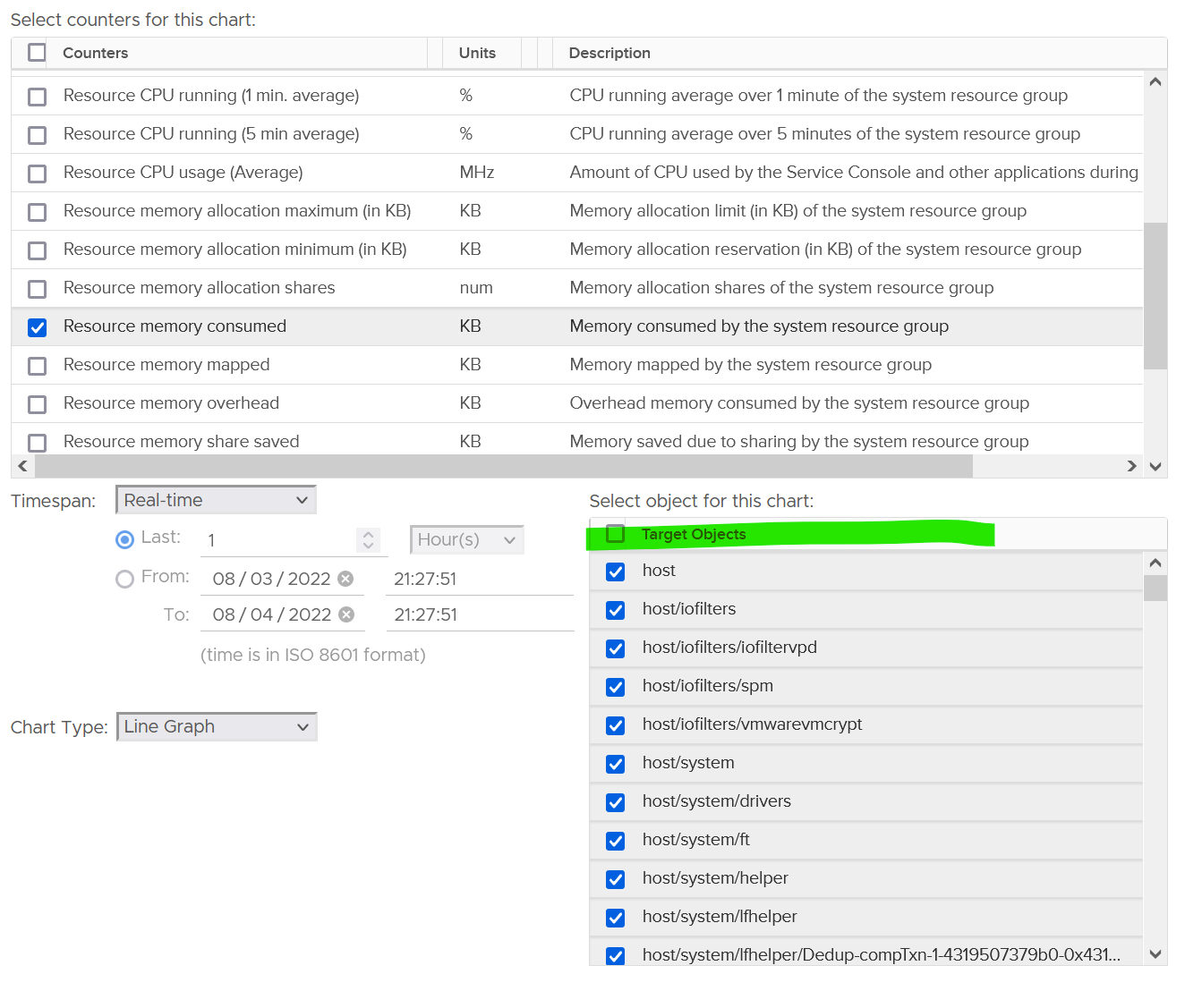

The VMkernel scheduler uses share, limit and reservation to manage all the above. This is fairly complex, so let’s elaborate.

There are 3 types of metrics:

|  |  |
| --- | --- |
| Type | Analysis |
| Utilization | This is the actual, visible, consumption.  Utilization can be lower than reservation, but not higher than allocation.  Since you’ve already paid for the hardware, you want to drive ESXi utilization as high as possible so long there is no contention. Since VMkernel has higher priority than VM, we can safely assume we can use VM contention as the proxy for overall contention (assuming manual VM Limit is not set).  The ESXi utilization metric considers both VMkernel and VM. There is no need to separate VMkernel in this case. The only time we need to separate is when we’re migrating the VMs into another architecture. |
| Reservation | For VMkernel processes, the maximum amount is taken care of by allocation, while the minimum amount is by reservation. This is a safety mechanism to ensure VMkernel can still run when all the VMs want 100% resource.  Processes that run at kernel level does not get its reserved memory up front. It’s granted on demand. CPU, being an instruction in nature, does not use the reserved amount unless it needs to run. If you plot in vSphere Client UI, you will see the value of utilization can be lower than reservation. |
| Allocation | For VM, allocation is useful as there is overcommit between virtual and physical.  For VMkernel, it is not useful since there is no overcommit because there is no virtual part. You notice that some VMkernel processes have no limit. If you plot them in vSphere Client UI, you will find their limits are either blank or 0. |

I recommend you plot the values across all your ESXi hosts. You will notice the values vary. Why is it hard to determine the size of the above 3 values up front? Taking from page 258 of [Frank Denneman](https://frankdenneman.nl/) and [Niels Hagoort](https://www.linkedin.com/in/nielshagoort/)’s book, with my own addition:

* Some services have static values (allocation and reservation) regardless of the host configuration. Ok, this is the easy part.
* Some services have relative values. It scales with the memory configuration of the host. Ok, that means you need to know the percentage for each.
* Some services have relative values that are tied to the number of active VMs. Ok, that means you need to know how many VMs are active.
* Some services consume more when they do more work. Example is storage and networking stack.
* Some services consume more depending on the configuration. For example, vSAN consumes more when you turn on dedupe and compression.

Since an ESXi host has many services, it is impossible to predict the overall values of the above 3 metrics.

##### VMkernel CPU

The following screenshot shows the counter names used by vSphere Client UI

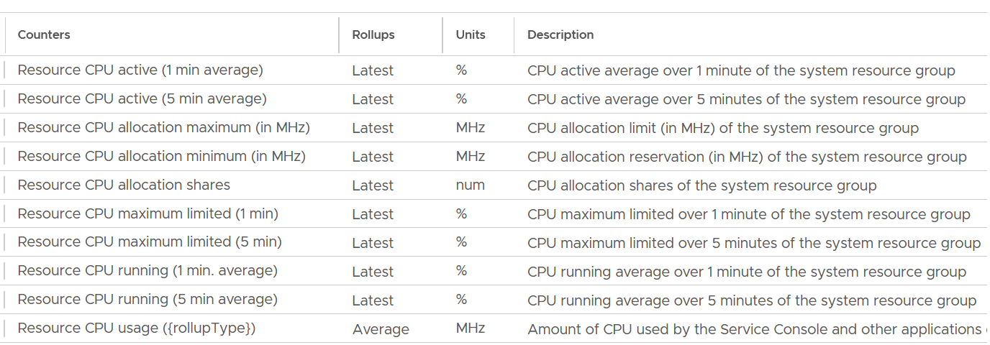

|  |  |
| --- | --- |
| **Active (1 minute)** | My guess this maps to the Used metric. Reason is there are only 2 basic metrics at physical layer: Utilization and Used.  It’s an average over the last 1-minute.  Take note this is the latest amount, not the average. Since the collection interval is 20 seconds, that means it’s value at the 20th second, not the average of all values in the entire 20 seconds period. Since the value itself is the average of the last 1 minute, you’re looking at the average taken every 20 second. So there is 40-second overlap |
| **Active (5 minute)** | As above, but the overlap between each data point is 4:40 minutes. |
| **Running** | My guess is this maps to the Utilization metric. Reason is it's consistently lower than Active. I also compare at ESXi Usage vs ESXi Utilization, and the comparison kinda match. |
| **Allocation maximum** | Limit. That’s the upper limit as lower limit does not make sense in counters like utilization as it’s always 0.  For ease of use, let’s just call this allocation. |
| **Allocation minimum** | This is reservation, which is the guaranteed minimum it will get when it asks for CPU cycles. |
| **Shares** | Relative shares of each VMkernel world.  This is VMkernel internal metric, not something vSphere Administrator should change |
| **Maximum Limited** | is the time limit was applied to throttle because usage wanted to exceed allocation. You should expect this to be 0 all the time |
| **Running** | I think this maps to the Utilization metric |
| **Usage** | I think this maps to the Used metric. |

###### Reservation

Utilization is relatively much more volatile or dynamic, while reservation is stable. The following screenshot shows CPU Usage fluctuates every 20 seconds, while reservation remains perfectly constant.

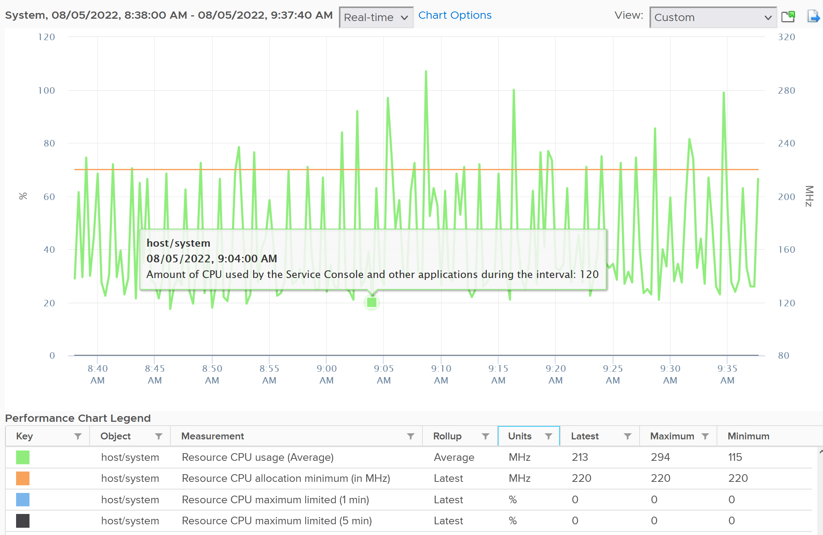

Notice the maximum limited value is perfectly flat. That’s what you want.

The above is for host/system. The reservation is surprisingly low.

Now let’s look at host/vim. What do you notice from the following screenshot?

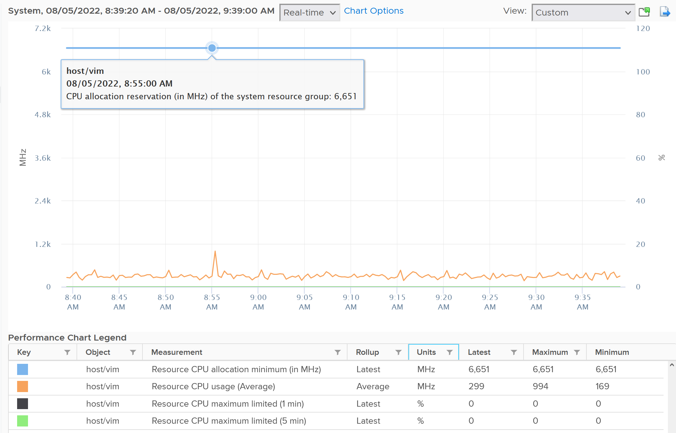

Surprisingly the reservation is not low. It’s around 6.6 GHz.

The above is from 1 ESXi. We need to plot for many to get a better understanding. The following diagram shows the distribution of VMkernel overhead based on a sample of almost 400 ESXi in production environment.



By far the majority of the values lie in 6 – 10 GHz.

Their values tend to be stable over days, although from time to time I see fluctuating metrics, which is reasonable as there are multiple factors impacting the reservation.

The following chart shows both the fluctuating pattern and steady pattern (most common). They are from 2 ESXi hosts.



ESXi CPU reservation

CPU|Reserved Capacity - The sum of the reservation properties of the (immediate) children of the host’s root resource pool.

SUM([Host)“cpu|reservedCapacity_average”) which matches VC’s counter cpu.reservedCapacity.average

This is different to the metric CPU \ Overhead (MHz). I think the formula is

CPU \ Overhead (MHz) = Number of CPU Cores * (hardware|cpuInfo GHz) – CPU |totalCapacity_average

[e1: Where Total Capacity is the capacity available to VM? But how is this metric derived? ]

###### Utilization

To see the actual usage, choose the metric Resource CPU Usage.



You need to select host/iofilters, host/system, and host/vim.

Everything else runs under one of the 3 resource pools above. You can plot their values in vCenter by stacking up their values, as shown below.



The above is for one ESXi Host.

Here is a sample from ~400 ESXi hosts, where I sort the top 7 from highest System usage.



The bottom two rows show the summary. The first summary is the average among all the hosts, while the last row is the highest value.

##### VMkernel Memory

The following screenshot shows the counter names used by vSphere Client UI

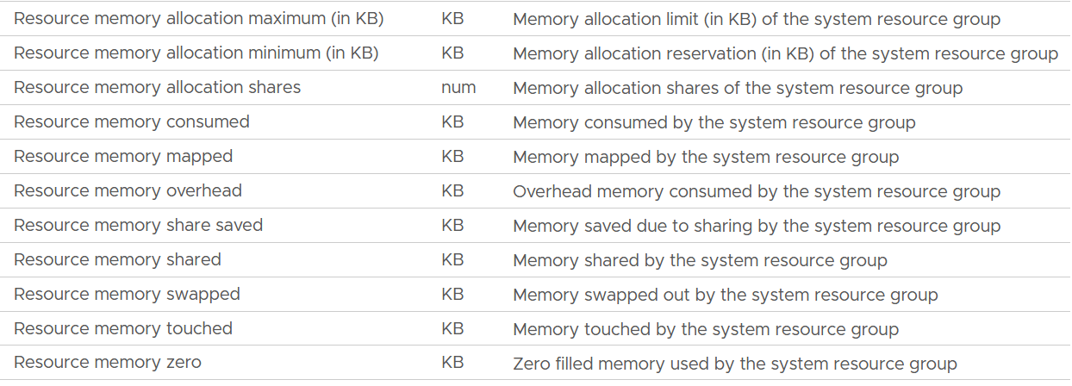

The Rollups column values are all Latest, and the Stat Types column values are all Absolute.

|  |  |
| --- | --- |
| **Allocation maximum** | As per CPU, this is the limit. |
| **Allocation minimum** | As per CPU, this is reservation. |
| **Shares** | Relative shares of each VMkernel world.  This is VMkernel internal metric, not something vSphere Administrator should change |
| **Consumed** | The actual consumption. Just like CPU, this can be lower than the reservation.  The host/vim world has no reservation. |
| **Mapped** |  |
| **Overhead** |  |
| **Share Saved** |  |
| **Shared** |  |
| **Swapped** |  |
| **Touched** |  |
| **Zero** | The entire block contains just a series of 0. |

###### Reservation

ESXi memory overhead = Memory \ ESX System Usage (KB)

This reservation is actually a raw counter from vCenter.

Capacity Available to VMs = Total Capacity – ESX System Usage

mem|memMachineProvisioned - mem|totalCapacity_average

Where capacity available to VMs is the capacity reserved by and available for VMs.

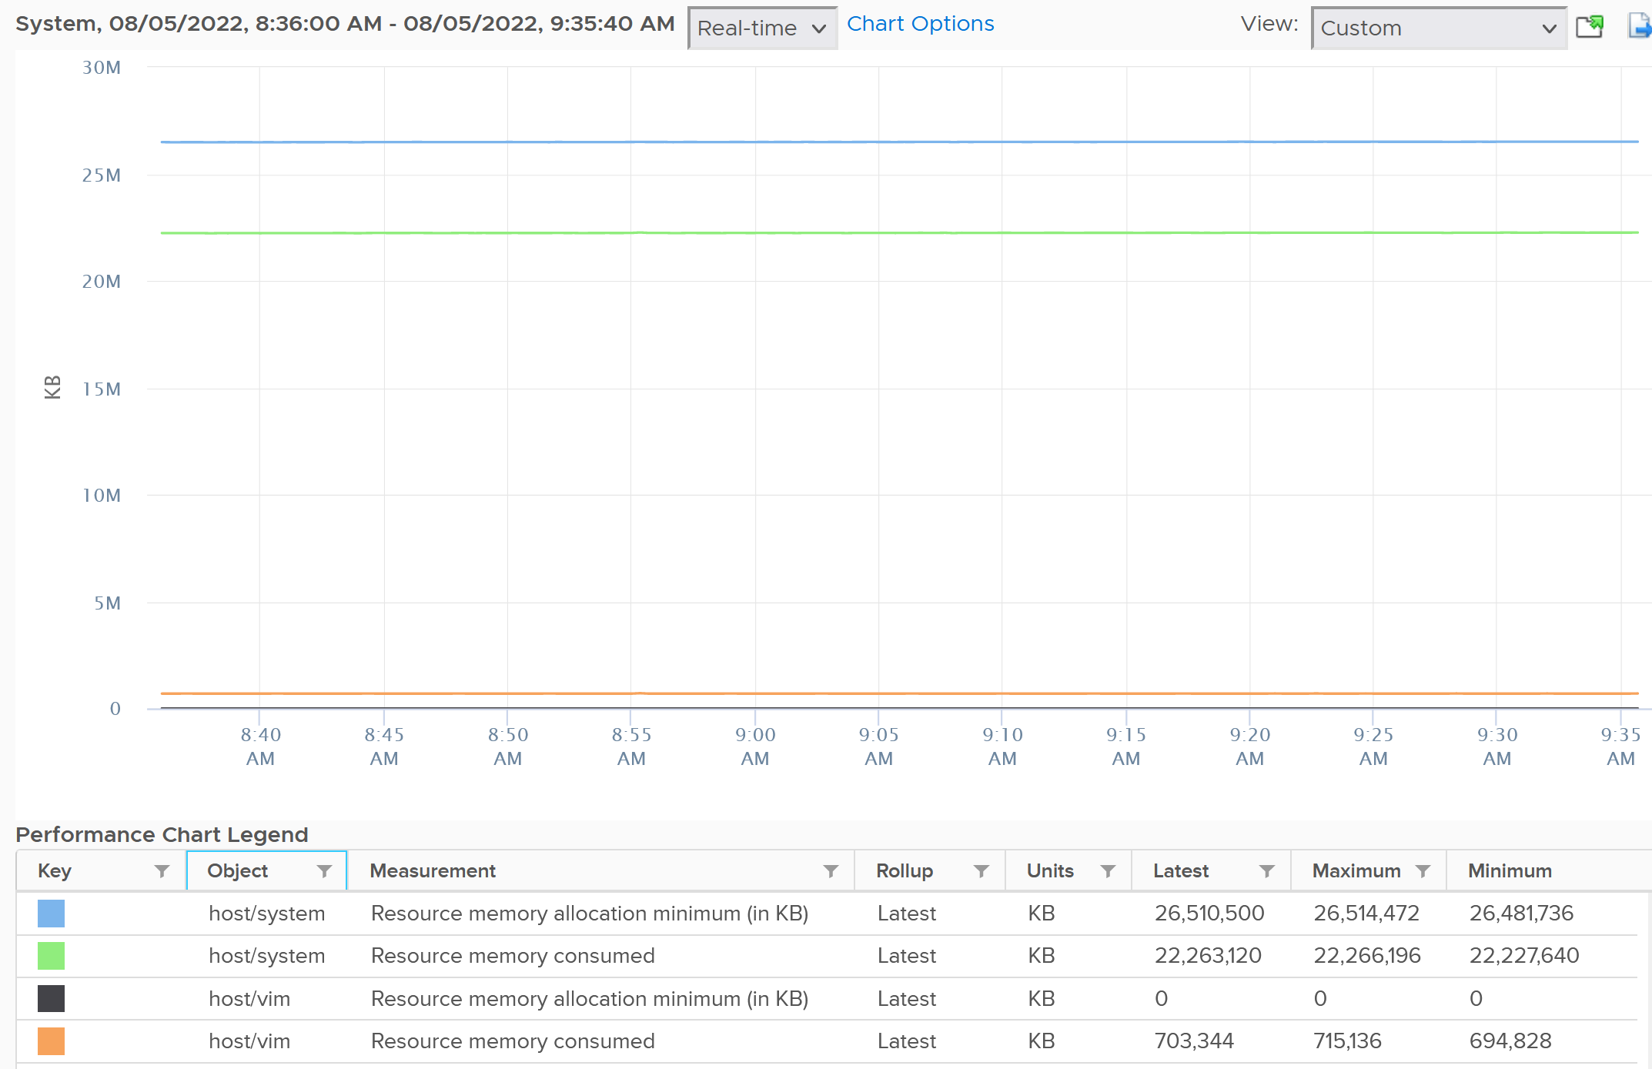

For memory, based on 310 production ESXi, the reservation ranges from 6 GB to 88 GB. It’s a big range.

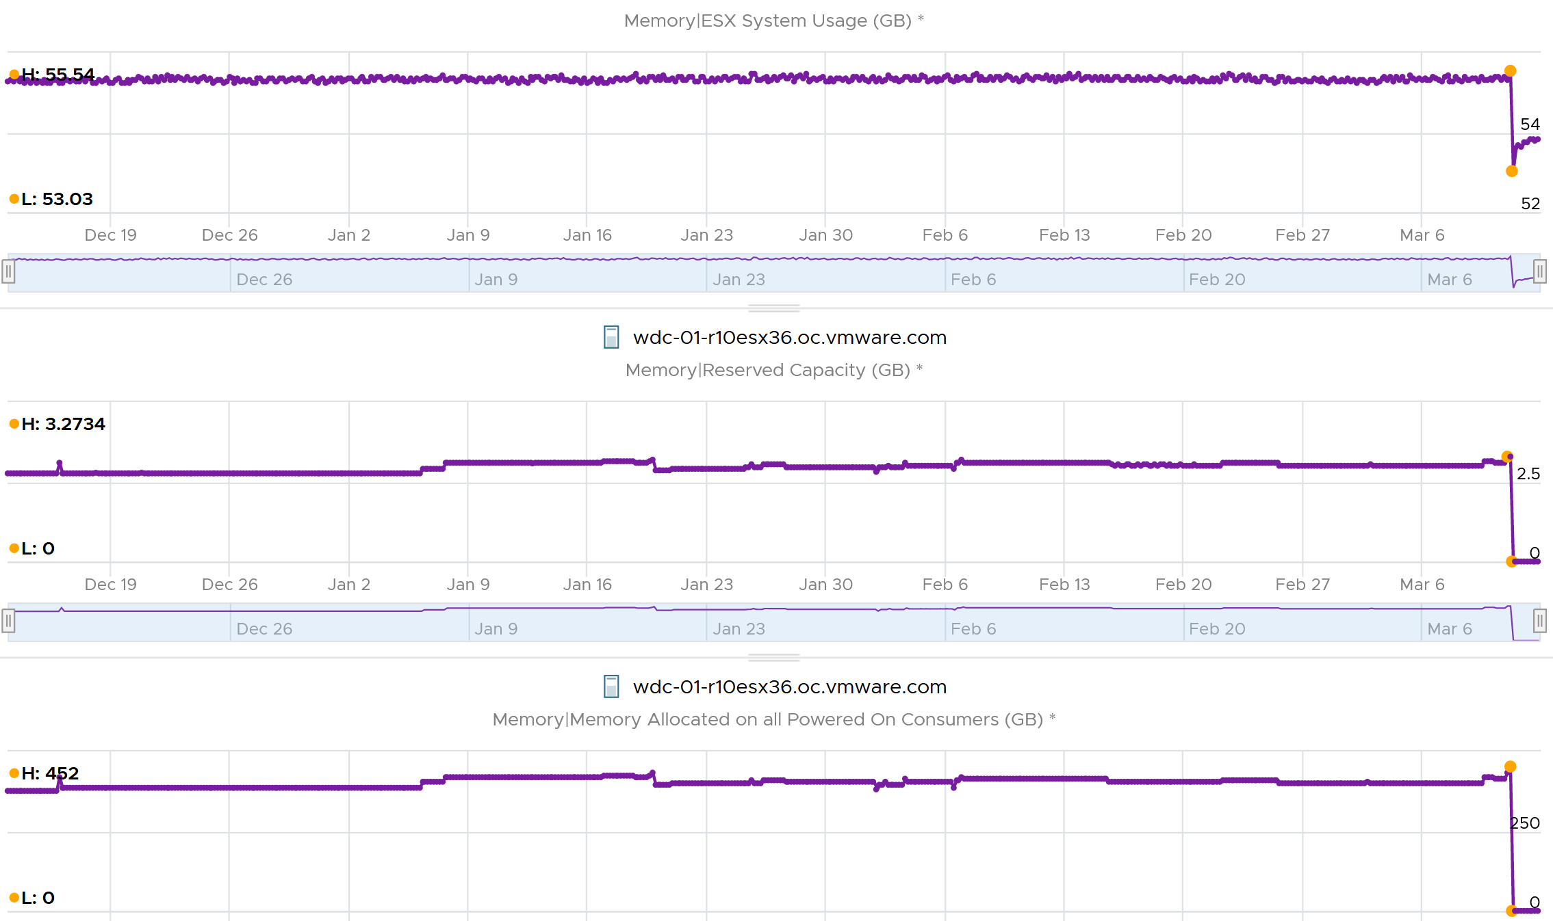

The following is an ESXi 6.7 U3 host with 1.5 TB of memory. Notice the VMkernel values remains constant over a long period. The number of running VM eventually dropped to 0. While the Granted counter drops to 1.5 GB (not sure what it is since there is no running VM), the VMkernel did not drop. This makes sense as they are reservation and not the actual usage.

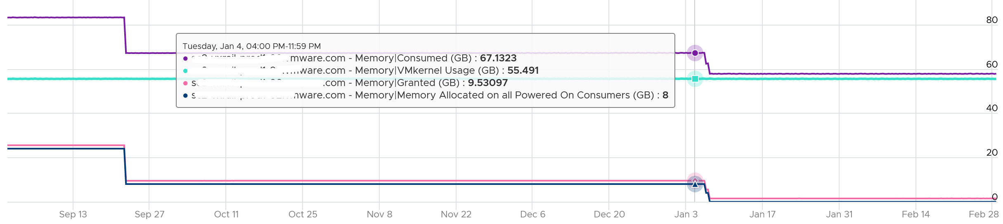

The metric ESX System Usage measures VMkernel reservation, which varies from 2 GB to 64 GB. The following shows the distribution of values among 185 ESXi hosts:

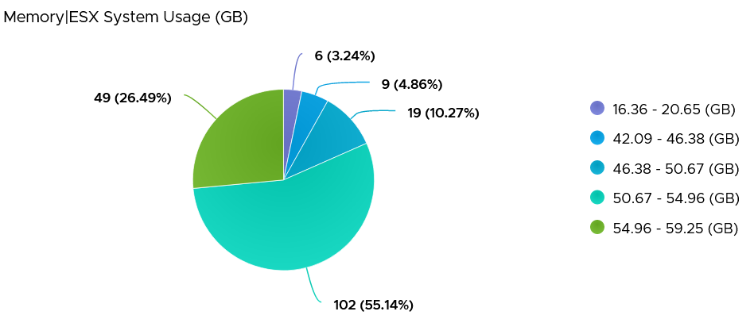

###### Utilization

Utilization is typically lower than the reserved amount. It also does not always correspond to the reserved amount. The following chart shows the reservation remains steady when the actual drops by 90%, from 40 GB to single digit.

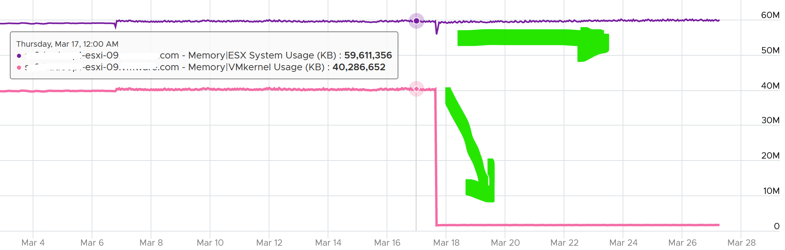

To see the actual usage, choose the metric Resource Memory Consumed metric from vSphere Client. Stack them, and you see something like this. The system part typically dwarfs the other 2 resources.

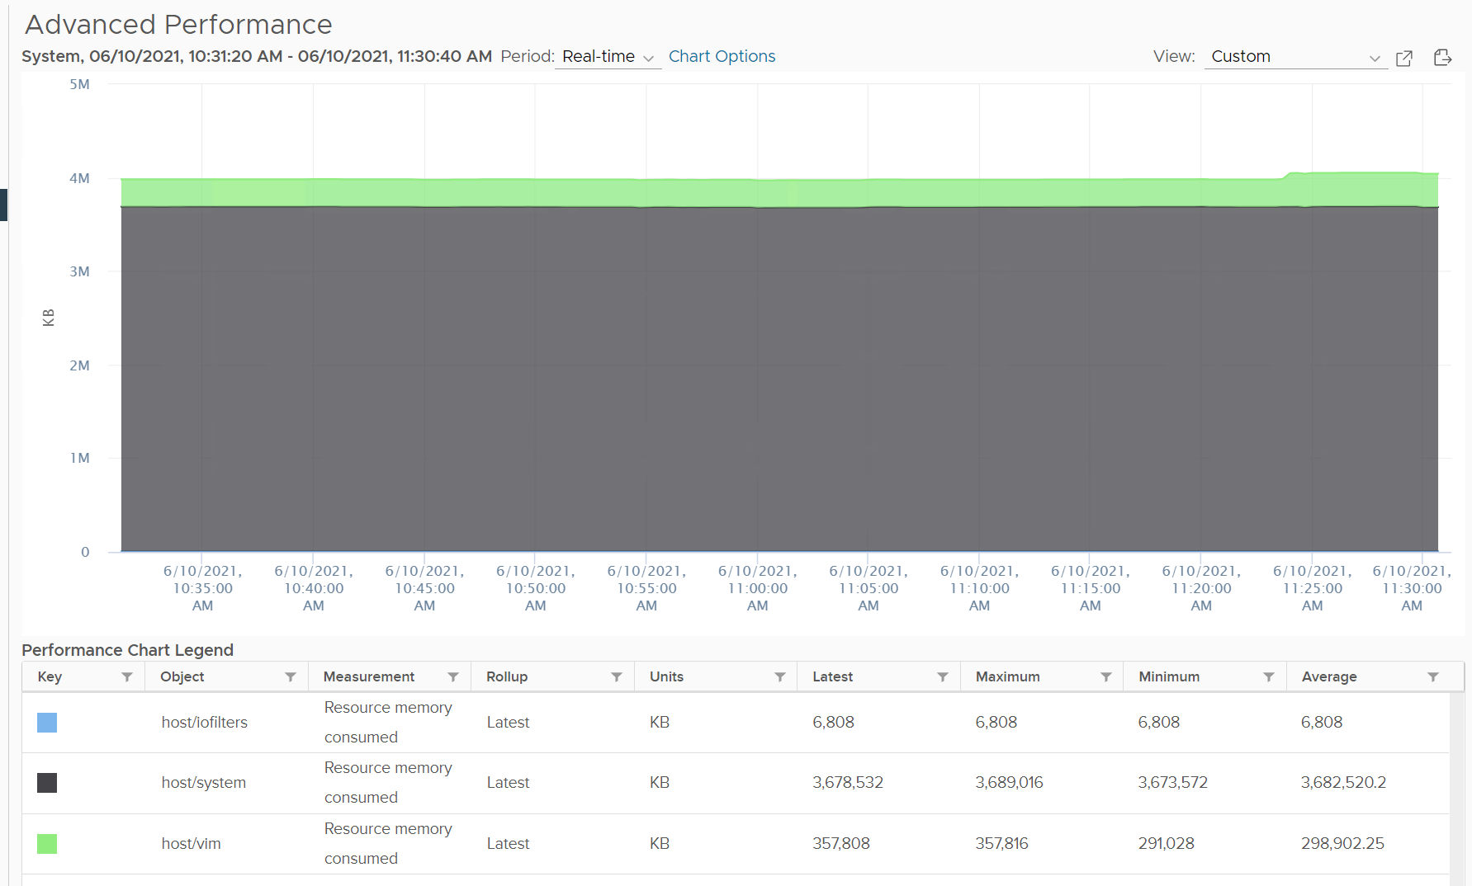

Do not take the value from Memory \ VMkernel consumed counter. That’s only the system resource. You can verify by plotting this and compare against host/system resource. You will get identical charts.

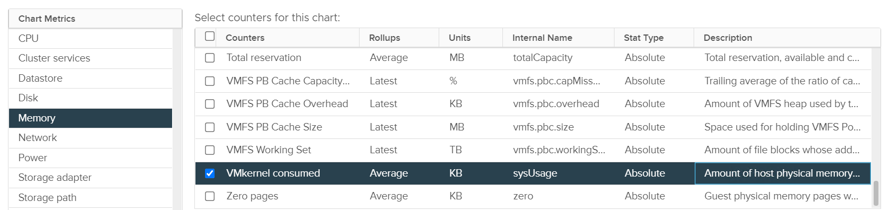

This value is for vSphere kernel modules. It does not include vSAN.

Based on the preceding 185 ESXi hosts, how do you think the actual VMkernel usage compare with their reservation?

It’s much lower. This means you should not confuse one for the other.

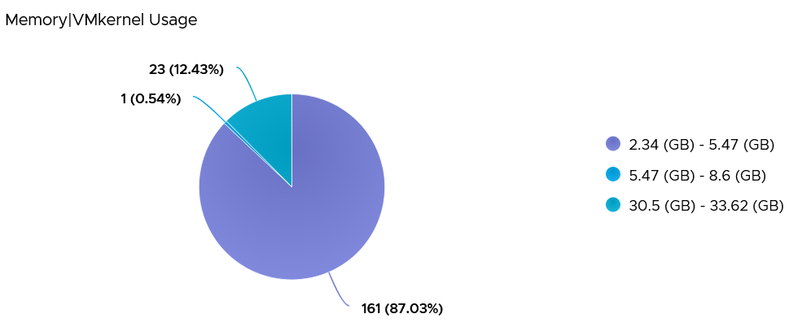

#### Compute

|  |  |
| --- | --- |
| **CPU Consumption** | It’s simpler and faster to directly look at the physical cores and their thread. There is no need to view from VM level, and then sum them up. Whether a core is running a VMkernel or VM is irrelevant.  At the physical core level, there is no such thing as Ready and Co-stop. A core either runs or idle.  As a result, ESXi CPU consumption is the sum of its cores. The VM metrics are not involved at tall.  Both types of consumption metrics are needed.   * Is the core running or not? * When it’s running, how fast and how efficient is the run? |
| **CPU Contention** | I think this is the normalized average of all the VMs + non vSphere kernel modules, as the VMkernel modules do not experience ready and co-stop. |
| **Memory Consumption** | Balloon should not be included as it happens at a different realm altogether.  Just like CPU, it’s simpler to look at the physical DIMM. It’s also more accurate if there is memory savings across >1 VM. |
| **Memory Contention** | Similar to CPU, I think VMkernel modules do not experience swap or compression. |

#### Storage

Disk is a little tricky as there are space and speed.

For speed, you’re looking at IOPS and latency as storage adapter, storage path and disk device. For

For space, you’re looking at disk space used at datastore level. RDM is not applicable as ESXi cannot see the used metric.

|  |  |
| --- | --- |
| **Disk Speed Consumption** | It’s simpler and faster to directly take the metrics from physical storage adapters and LUNs. There is no need work at the VM level and then sum all the VMs. Whether the HBA is serving IO from VMkernel or VM is irrelevant.  Overall, the total IOPS is the sum of all VM IOPS + VMkernel. The difference is sequential IO might become random due to IO blending effect.  Same approach applied for Storage Path and Storage Disk Device. |
| **Disk Speed Contention** | At the storage adapter level, there is no more association between an IO and VM. The physical card also has its own queue depth. As a result, you do not want to compute from the VM metrics.  Same approach applied for Storage Path and Storage Disk Device. |
| **Disk Space Consumption** | This is the sum of all VMs. |
| **Disk Space Contention** | This is not applicable as it’s basically overcommit (capacity model) |

#### Network

The virtual network consists of VM and VMkernel (e.g. vMotion). If the traffic is a VM to VM traffic within the same ESXi, the packets does not reach the physical network, hence the vmnic metrics do not register it. The virtual network does not have the limit that physical network does, if the traffic remains in the box. This makes it harder to use this metric as the 100% is not statically defined. So instead of just monitoring the throughput metric, you should also check the packet per second metric.

The physical network means traffic going through the physical network card. At this level it’s no longer aware of VM and VMkernel.

### CPU

Throughout this book, I always cover the contention metrics first, then consumption. Why is it that I swap the order for ESXi Host?

The reason is your operations can’t wait until problem become serious. All the built-in metrics are averaged of all the running VMs. So by the time they are high, it’s time to prepare your resume and not start troubleshooting 😉

I’d provide a set of leading indicators to replace them. In the meantime, let’s dive into the utilization metrics with a quiz.

#### Quiz: 50% or 75% or 100%?!

Hope you like the tour of VM CPU accounting. Can you apply that knowledge into ESXi and explain the following?



The above is an ESXi host, showing 3 types of utilization metrics.

* One shows 50%, indicating you have capacity.
* The second one shows 100%, indicating you do not have capacity.
* The 3rd shows 75%.

Which metrics do you take for the ESXi CPU “consumption” then?

Since the graph is a bit small, let’s zoom in

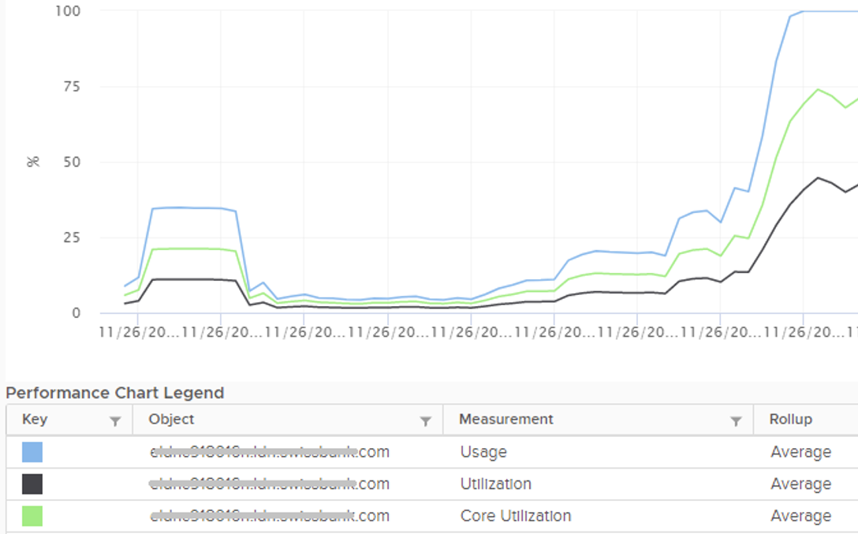

Notice they have similar pattern, but their *sensitivity* differs.

* Why is Usage (%) = 100% when Utilization (%) is around 47%? The gap is more than double. What could be causing it?
* Why is Utilization (%) fluctuating yet Usage (%) remains constant? Notice both Utilization varies between 45% and 55% while Usage remains flat at 100%
* Why is Core Utilization (%) in the “middle”? What does it actually measure then?

To answer the above, we need to cover some fundamental. Note that we must take the vantage point of ESXi, not VM. I know they are similar so it’s easy to get mixed up. From ESXi physical threads viewpoint, things such as Ready and Co-Stop are not applicable as the physical threads are provider of resource.

Unlike RAM, CPU performance varies widely among different CPU models. Speed matters in CPU, whereas in RAM we can generally ignore it. DDR5 RAM is faster than DDR4 but for general monitoring reason it can be ignored. Because of this significant difference in CPU, we need to have metrics to account for:

* How often it runs. How much the CPU runs in a time period. E.g. if it runs 60% of the time in the last 100 seconds, that means it runs for 60 seconds accumulatively in that period. That’s why you see many metrics in millisecond. They track the consumption over time.
* How fast it runs. All else being equal, a 5 GHz CPU is 5x faster than a 1 GHz CPU. Throughput impacts utilization. The faster it can complete a task, the shorter it has to work. That’s why you see some metrics in MHz.
* How efficient it runs. CPU SMP impacts the core efficiency. This is covered more here. This efficiency is then translated into MHz, for ease of *accounting*. Unfortunately, this simplification creates confusion as HT and Power Management are not the same thing.

These 3 dimensions of run are the reason why CPU consumption is hard to measure. It becomes “it depends on what you consider”. It can’t be a single number. Insisting that the CPU has a single, static, total capacity and use this as the only 100% for all use cases will result in confusion in “consumption” numbers.

#### Utilization

Let’s dive into the first two fundamental metrics: Utilization and Core Utilization.

We need to start at the fundamental, a single physical core of a socket. The socket can have many cores, we are just interested on 1 core only. It has 2 threads as it supports CPU SMT.

In a time period of say 20 seconds[22], this core had the following consumption:



Looking at esxtop, you will see near the top the PCPU Used and PCPU Utilization metrics. Note that their values are in percentage, meaning you need to know what they use for 100%.

If you guess that they eventually map into vSphere Client metrics Usage (%) and Utilization (%), respectively, you are right. However, you need to know how they map.

PCPU means a physical, hardware execution context. That means it is a physical core if CPU SMT is disabled, or a physical thread inside a core if SMT is enabled. It does not mean CPU socket. A single socket with 10 cores and 20 threads will have 20 PCPU metrics.

PCPU Utilization (%) tracks is a physical thread is used or not over time. At any given moment, a thread is either running (unhalted) or not (halted). So it’s binary (0% or 100%). But over the 20 second period, the value is averaged. So when you see the number as 50%, it does not mean it’s running 100% at half the “speed”. It means it’s running half the time, for only 10 seconds. Using a human analogy, think of it as a person who is either running or standing, and never walking. It’s not considering CPU Frequency.

Core Utilization (%) tracks at the core level. If one of the threads is running, then the value is 100%. At the core level, the average utilization in that entire period is 75%. In the last portion, the core still runs at 100%. The CPU Utilization (%) tracks this. As a result, CPU Utilization (%) is only relevant when hyper-threading is enabled.

Going back to our example, here are metrics reported:

* PCPU Utilization (%) for HT 0 = 10 seconds / 20 seconds = 50%
* PCPU Utilization (%) for HT 1 = 10 seconds / 20 seconds = 50%
* Core Utilization (%) for entire core = 15 seconds / 20 seconds = 75%

BTW, in vSphere Client, you can’t choose a core if you enable HT. You choose PCPU, which is a thread. So what happens on the Core Utilization counter at thread level?

Does it get split into half?

As you can see below, no. The value is duplicated.

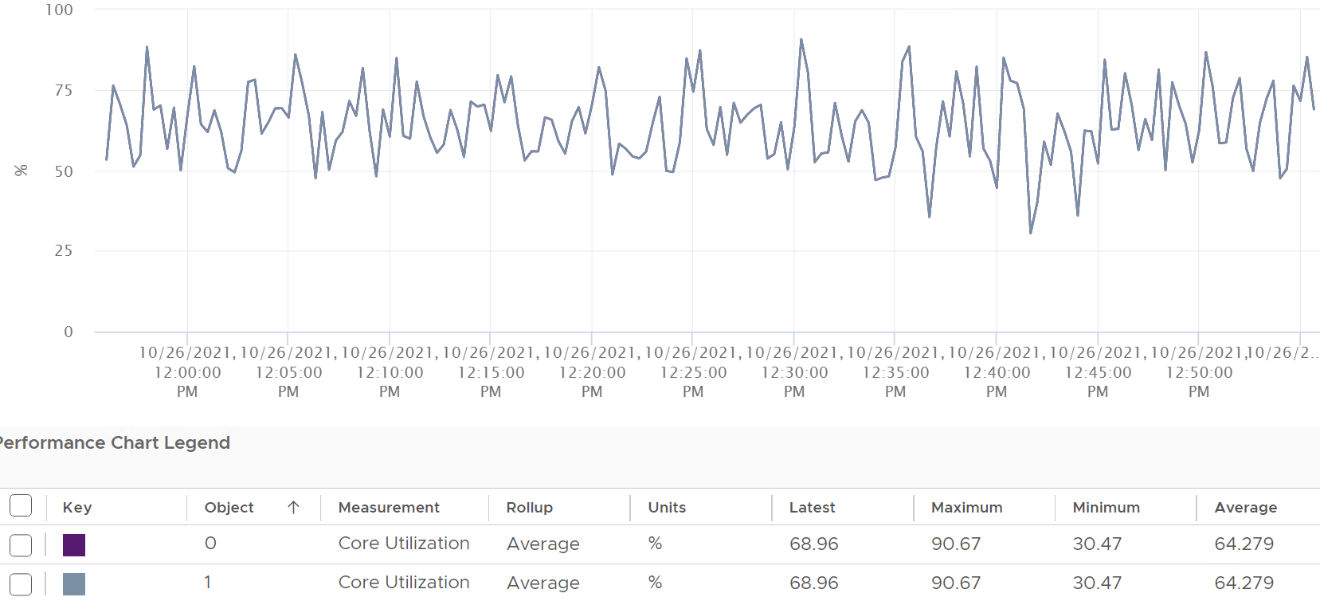

Notice in the above chart, the 2 have identical value.

Utilization (%), on the other hand, will be different. Each thread has different value.

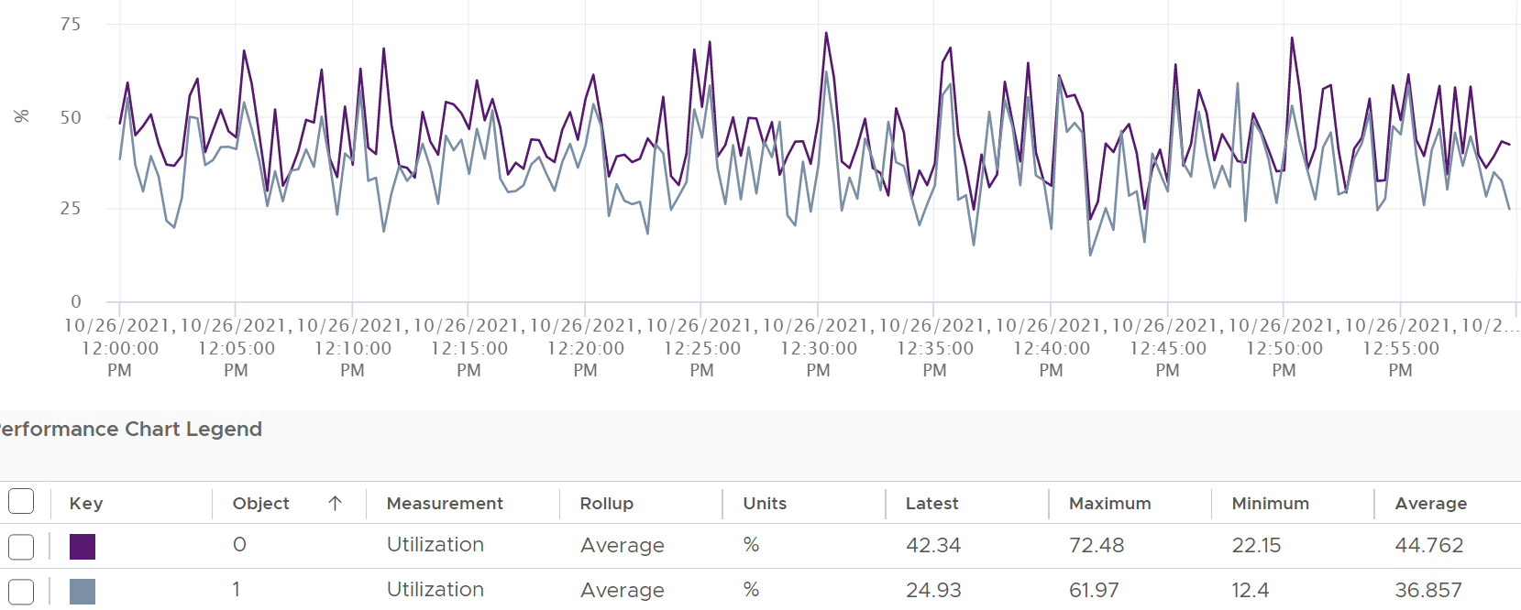

If you simply sum them up, you get more than 100%, so don’t!

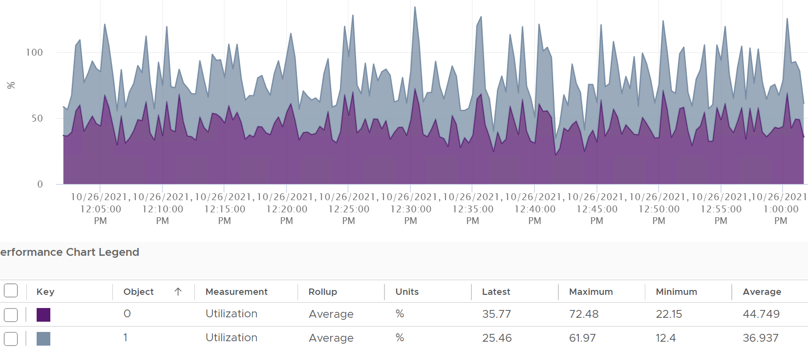

Now let’s roll this up to the ESXi level. The following show a tiny ESXi with 2 cores, where each core has 2 threads.



The metrics at ESXi level is

* CPU Utilization (%) = 40 seconds / **80** seconds = 50%.
* CPU Core Utilization (%) = 30 seconds / **40** seconds = 75%

Utilization = 50% because each thread is counted independently. There are 4 threads in the preceding ESXi, each runs 50%, so the average at ESXi level is 50%. This counter basically disregards that HT does not deliver 2x the throughput.

This is why the Core Utilization (%) will tend to be consistently higher than Utilization (%). The following chart demonstrate that.

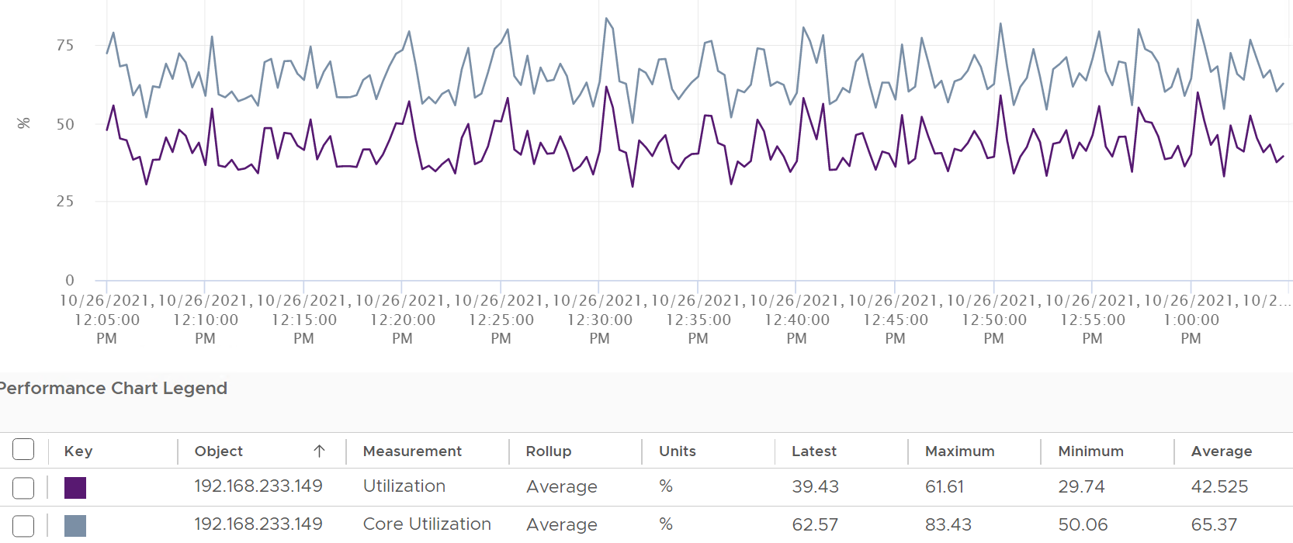

Now let’s go back to the chart shown earlier. Can you now explain Utilization (%) and Core Utilization (%)?

Great! Let’s move to the next one.

In the following example, this ESXi has no hyper-threading. What do you notice?



Yup, the Core Utilization is identical with Utilization.

I’d use Utilization (%) but will always accompany it with the contention metrics. Since it’s about performance troubleshooting, I’d set the threshold around 90% - 95%.

#### Used

Done reading the Utilization metric?

Great! You are now ready to tackle the next metrics, which are Used (%) and Used (ms). Used considers CPU frequency (both Turbo Boost and power saving). Used consider HT, although it assumes it delivers no benefit and halve its value to 50% instead of 62.5%.

Here is how Utilization (%) and Used (%) are related at PCPU level:

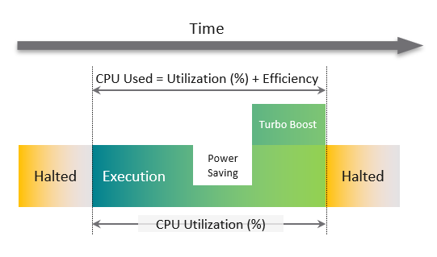

A physical Thread is either executing (running) or halted (idle). While it’s running, it can run at lower/higher CPU clock speed. CPU Used accounts for this.

Its execution will be less efficient if its paired thread is also running at the same time. CPU Used accounts for both.

CPU frequency scaling is caused by power management, so let’s dive into it.

##### Used (%)

Now that we have covered CPU Clock Speed, we can add this dimension into the same scenario above. For that, we will go back to our tiny ESXi:



In Core 0, the first thread was running at half the CPU frequency in the first period. While Utilization (%) records this as 100% run, Used (%) is aware of this reduction and records 50% instead. The second thread wasn’t running so Used is not impacted.

In the 4th period, the thread is competing with another thread. Used (%) recognises the drop in efficiency and register *50%* instead of 100%. Personally, I’d prefer this to register 62.5% as it’s caused by HT. This will also make it consistent with CPU Latency and VM CPU Demand, which applies 37.5% as HT penalty.

On the other hand, when Turbo Boost increases the clock speed by 1.5x on the 2nd thread, Utilization (%) is unaware and record 100%, but Used registered 150%.

Here is all the possible permutation of a core. Take note that the frequency can be less than 1.

|  |  |  |  |  |  |  |  |  |
| --- | --- | --- | --- | --- | --- | --- | --- | --- |
| Thread 1 | Thread 2 | Thread 1 | Thread 2 | Core | Frequency | Thread 1 | Thread 2 | Core |
| Run | Run | 50% | 50% | 100% | 1.3x | 65% | 65% | 130% |
| Run | Not Run | 100% | 0% | 100% | 1.3x | 130% | 0% | 130% |

So when happens when the CPU frequency goes down?

|  |  |  |  |  |  |  |  |  |
| --- | --- | --- | --- | --- | --- | --- | --- | --- |
| Thread 1 | Thread 2 | Thread 1 | Thread 2 | Core | Frequency | Thread 1 | Thread 2 | Core |
| Run | Run | 50% | 50% | 100% | 0.5x | 25% | 25% | 50% |
| Run | Not Run | 100% | 0% | 100% | 0.5x | 50% | 0% | 50% |

##### Used (ms)

The following is taken from an ESXi with 24 cores and 48 threads. I’m showing logical processor 46 and 47. They are from core no 24, meaning they share a physical core.

I stack the chart. Do you see something strange?

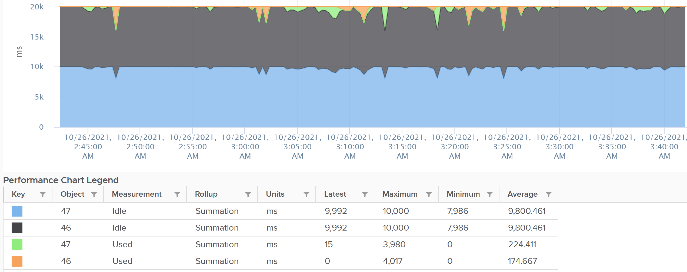

The total is exactly 20000.

Each thread is only given *10000*. This is not intuitive as the data is measured every 20000 ms.

Notice the maximum value for Idle is 10000, not 20000. You expect the total for 2 threads to be 40000 as there are 2 threads.

BTW, this 10000 matches the 50% we covered earlier. So Used (ms) and Used (%) are consistent with each other.

Any other thing you notice from the chart?

The sum of the 4 metrics is a perfect line.

CPU Idle (ms) + CPU Used (ms) = 100%.

That’s a bit odd, because power saving brings down the value of Used. So Idle needs to be adjusted if the total has to remain 20000. This is a bit odd, as by definition idle means CPU is not doing work. It’s 0. So the frequency

|  |  |  |  |  |  |  |  |  |
| --- | --- | --- | --- | --- | --- | --- | --- | --- |
| Thread 1 | Thread 2 | Frequency | T1 Used | T2 Used | Core Used | T1 Idle | T2 Idle | Core Idle |
| Run | Run | 0.5x | 5000 | 5000 | 10000 | 5000 | 5000 | 10000 |
| Run | Not Run | 0.5x | 10000 | 0 | 10000 | 0 | 10000 | 10000 |

You can see the peak where Used (ms) shot well above 10000 multiple times.

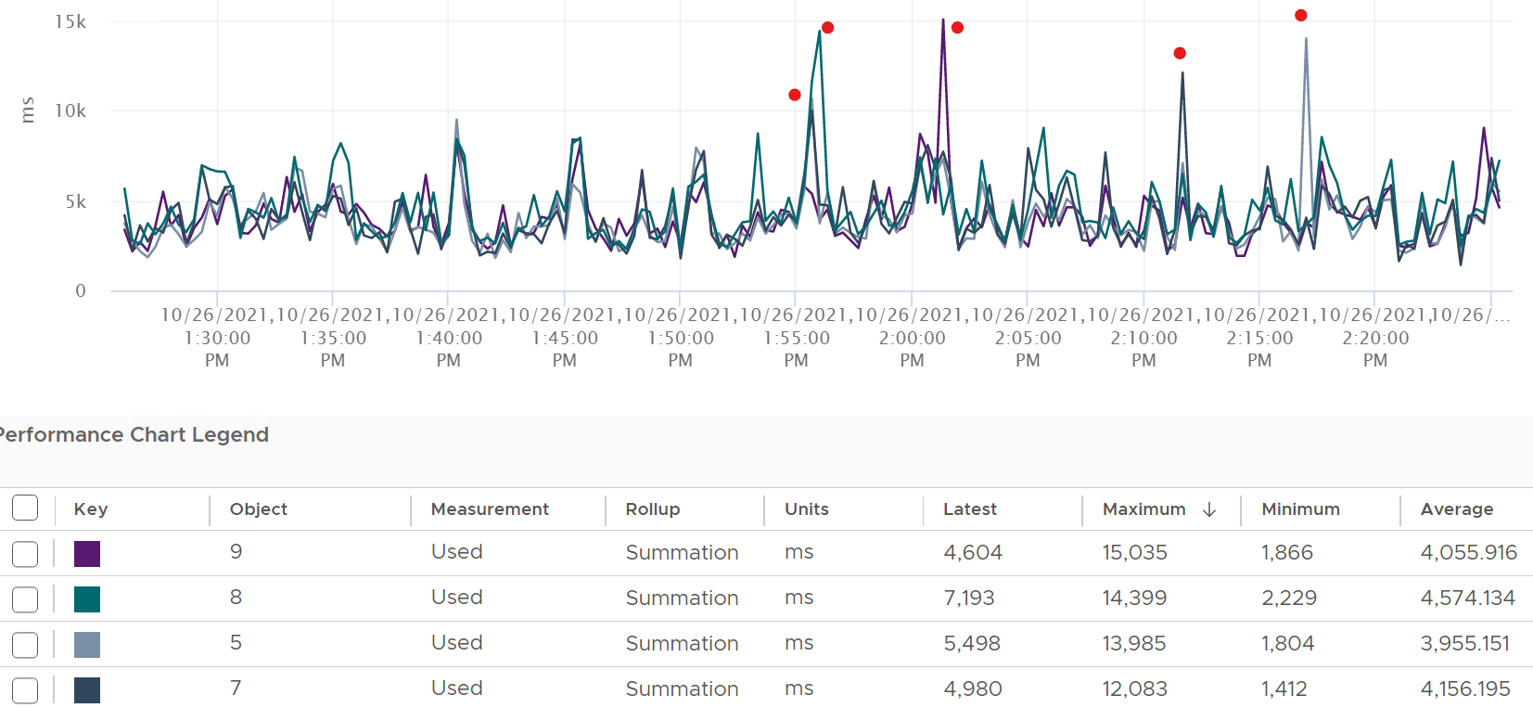

Can you guess how many physical cores the following ESXi has?



Answer: 20 cores, 40 threads.

Notice the total sum is constant at 400K ms. Divide this by 20K ms and you get 20 cores. While the graph visually shows the line is slightly above 400K, the sum of the 2 values shown is actually 400,000.01 ms.

If you want to verify with vCenter, the following ESXi host has 24 cores 48 threads. Notice the sum is 480,000 ms, not 960,000 ms.

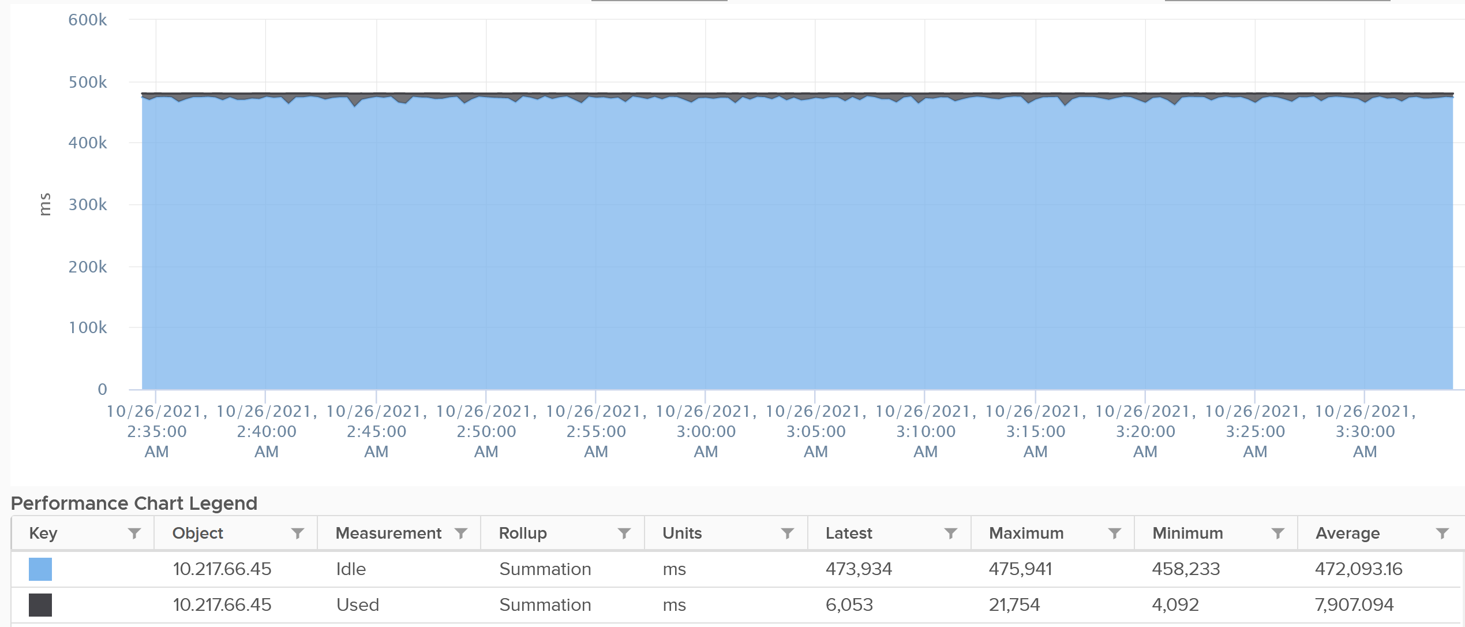

The vCenter counter Used (ms) maps to PCPU Used (%) counter in esxtop.

#### Usage

vCenter adds this counter, meaning it does not exist at ESXi level. In some parts of the UI, vCenter uses the name Used instead of Usage. But in the metrics chart, it uses Usage. I’m going to assume that Used (MHz) = Usage (MHz) as vCenter does not have Used in MHz.

If you see in esxtop, you will find Used (%) and Utilization (%) but not Usage. Usage basically maps to Used, but showing in MHz and use 20000 as opposed to 10000.

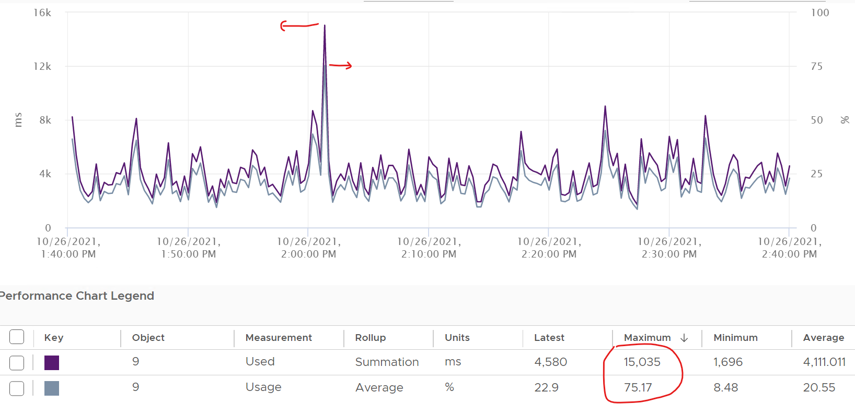

This is great as using millisecond is hard to account for “how fast you run” and “how efficient you run”. With MHz, we can plot the value across time.

With this knowledge, now the screen on vCenter client UI will be clearer.

You see both the Capacity of 35.18 GHz and Used of 11.3 GHz. There is no concept of Usable Capacity in vSphere, so the Free amount is basically Capacity – Used.



vCenter shows Used in GHz. The value is actually the value of Usage metric, as the Used counter is percentage or millisecond.

The Used CPU is summary.quickStats.overallCpuUsage.



The value above is likely some average of say 5 minutes as it remains static for a while and it does not exactly match the number below as the roll up period is not the same.

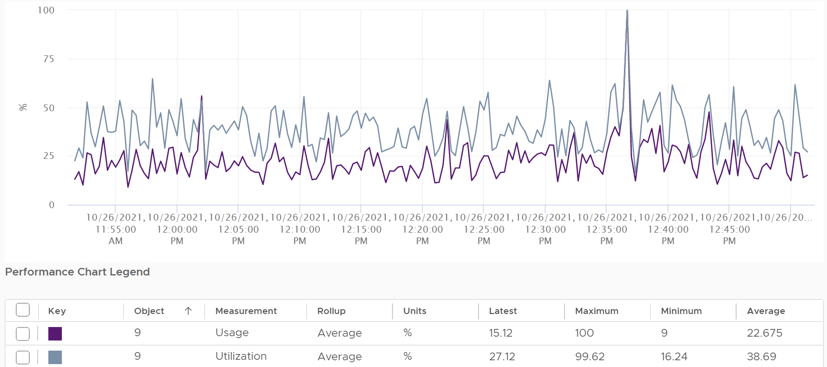

Usage is capped at 100%, even at the thread level.

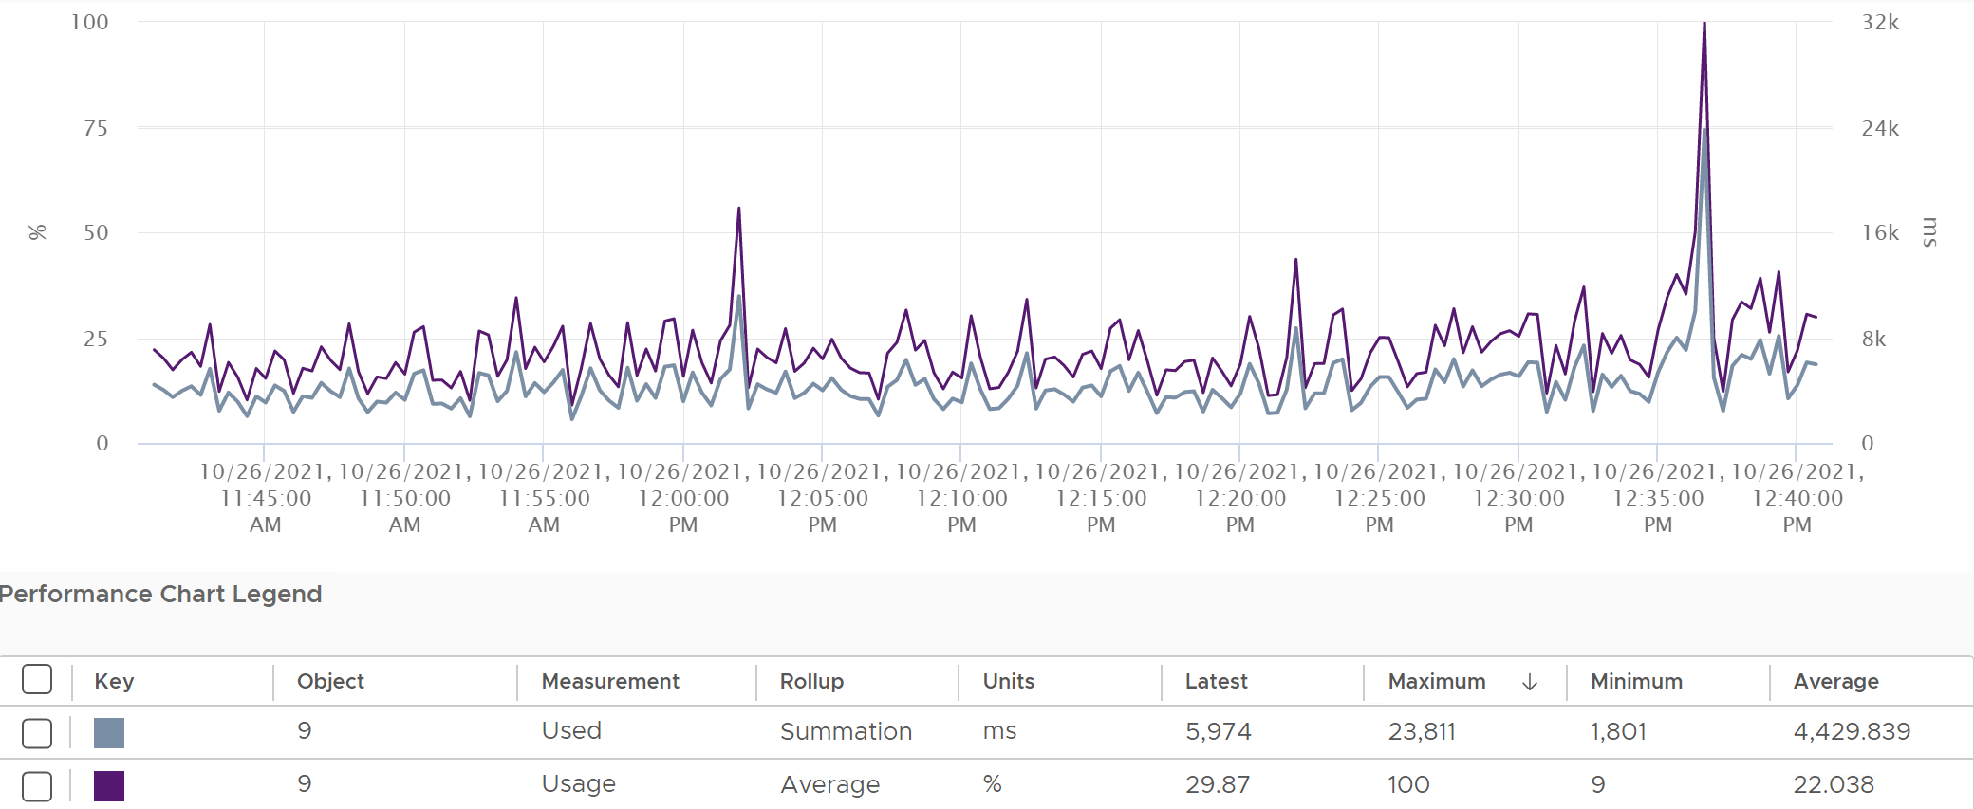



Let’s see if Used (ms) = Usage (MHz).

To prove it, we plot 180 data points from each, and compare the average. For completeness, let’s compare the latest value too.



Let’s compare the above value to prove the formula. We need to translate them into a common unit for comparison.



Bingo!

Both the average values and the latest values match.

Just like Used, Usage tops out at 100% when all cores run at least one thread at nominal frequency, even if there is still "headroom" for Turbo Boost or scheduling "capacity" on other threads. This is why its value will be lower than Core Utilization if there is power savings, as shown below.



ESXi CPU Usage (%) = CPU Usage (MHz) / CPU Total Capacity (MHz), where Total Capacity = total cores x nominal clock speed. It does not consider hyper threading. This accounting technique of removing hyperthreading is consistent with Used.

The following chart prove the above equation.



When is Usage (%) higher than Core Utilization (%)?

The answer has to be Turbo Boost. The following shows an ESXi where Usage is consistently higher than Core Utilization (%) in the last 24 hours. Notice that the value of Usage was capped at 100%. It did not breach 100%



I’ve marked some areas of the above chart with red dot. Those areas is where Usage turns out to be lower than Core Utilization.

Why?

The answer is power saving, which typically happens on low utilization. In an aggressive power savings, Usage can even be lower than Utilization, as shown below. This makes sense, as the idles cores consumes are run at lower frequency, hence the average at ESXi level is low.



#### Demand

This is actually an internal counter. It’s for VMkernel CPU scheduler to optimize the running of VM as the kernel is aware that hyper-threading has performance impact. So it’s not a capacity counter.

Demand looks at different *context* than Utilization/Used/Usage. It looks at the VM world, not the physical cores. That’s why it’s not available at per core or thread level. The value you see at ESXi is the summation of all the VMs, not logical CPU.

Because Demand considers all types of contention, as a result, its value tends to be higher than all the other metrics. It does not include the VMkernel load, so at lowly utilization, Demand will be lower than Usage.



One good thing about Demand metric is it can go above 100%. All the other metrics are capped at 100%. Demands lets you see how high above 100% the demand. It does not mean the VM is experiencing performance, as there is Turbo Boost and Hyperthreading to assist.

In older release of vRealize Operations, this counter used to be computed as Sum ( VM CPU \ Host Demand for Aggregation ) + CPU Overhead. This is no longer the case as vRealize Operations now simply maps to vCenter metric.

#### Consumption Metrics

Let’s summarise the metrics we have covered so far. vCenter provides 6 metrics to account for the utilization of ESXi CPU. Since esxtop uses the Used (%) metric but ESXi uses the Used (ms) metric in the vCenter client, I’m including both.

|  |  |  |  |  |  |
| --- | --- | --- | --- | --- | --- |
|  | Available at | Unit | Source | HT | CPU Speed |
| Utilization | Thread level | % | ESXi | 2x | No |
| Used | Thread level | ms | vCenter |  | No |
| Used | Thread level | % | esxtop only | 2x | Yes |
| Core Utilization | Core level | % | ESXi | Any | No |
| Usage | Thread level | % | vCenter |  | Yes |
| Usage in MHz | Host level | MHz | vCenter |  | Yes |
| Demand | Host level | MHz | ESXi |  | Yes |

The column HT indicates how the counter treats HT. 2x means it doubles the number of capacity. I put “Any” for Core Utilization because if any of the thread runs, the counter goes up to 100%. If both run, it’s still 100%.

You know that only Utilization (%) and Used (%) exist at the thread level because they are the only one you see at esxtop[23], as shown below.



With so many metrics, which one should you choose?

Let’s now evaluate all the possible scenarios so you can compare the values returned by the metrics. We will use a simple ESXi with 2 cores. Each core has 2 threads. In each of the scenario, a thread is either running or not running. There is no partial run within a thread as that’s mathematically covered in our scenarios.

I will also use 20000 ms as that’s more familiar. The following table shows an ESXi with 2 cores. There are 6 possible permutations in their utilization.



The table shows clearly that Used splits the Utilization into 2 when both threads are running.

Look at scenario 1. While Utilization charges 20000 ms to each thread, Used charges 10000. This is not intuitive as ESXi considers HT to deliver 1.25x. Personally I find 12500 easier to understand. The good news is this number is normalized back when it is rolled up to the ESXi host level.

How will those scenarios roll up at the ESXi level?

The following table shows the 4 metrics (Utilization, Used, Core Utilization, Usage). I have expressed each in % so it’s easier to compare.

There are 6 different scenarios, so logically there should be 6 different values. But they are not, so I added my personal take on what I like them to show. I’m keen to hear your thought.

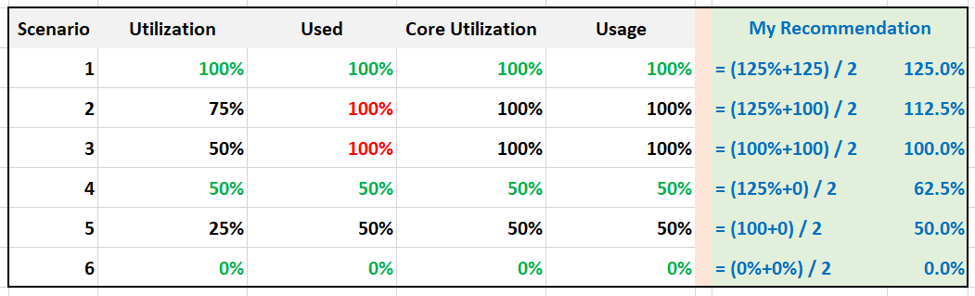

What’s causing the difference?

Yup. Hyper Threading.

Why do I choose 125% instead of 100%?

To me, the 1.25x bonus factor has to be shown. Without HT, it’s 100%. HT is a bonus. While it provides 1.25x overall throughput, each thread pays an expensive price, as each suffers 37.5% penalty.

The other reason is why I choose 125% as the upper limit is it’s easier when thinking in GHz.

Example: say the CPU specification is 3 GHz for its nominal frequency. It has HT enabled, and power management disabled.

What’s the CPU Capacity?

To me, 3 GHz is easier to explain than 3.75 GHz. It’s also more correct, as the CPU does not actually run at 3.75 GHz. It runs 2 threads at 3 GHz each, but at 62.5% efficiency, so accounting wise it’s

= 3 GHz x 62.5% + 3 GHz x 62.5%

= 3.75 GHz, which is 125% of 3 GHz

|  |  |
| --- | --- |
| Scenario | Analysis |
| 1 | Do you notice something strange with the value of Used (%)?  Yes, it’s no longer 50%. It’s 100%. The average of 50% is 100%  The reason is the accounting does not count each thread as 20000. Each core has 20000 and not 40000. If you say that is similar behaviour to Core Utilization, you’re right. |
| 3 | Utilization is only showing 50% when both cores are utilized. I prefer this to show 80% as HT only delivers 1.25x, not 2x.  On the other hand, Usage goes up too fast. It's already showing 100% when there is still 25% room left. |
| 5 | Utilization is again showing too low a value, and Usage too high a value. |

Now let’s add CPU clock speed. What happens when there is power management?

I’d focus on just Used and Usage to highlight the difference.

What do you notice from the table below?

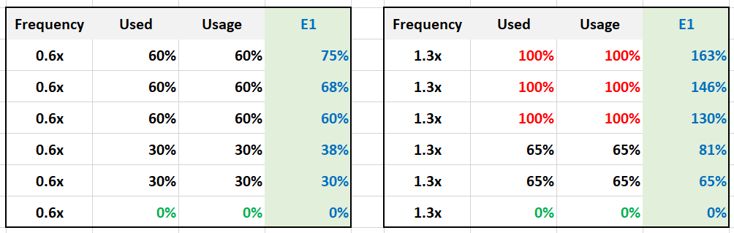

Both Used and Usage are capped at 100%. I prefer this not to be capped, to distinguish it from the other 100%. The good part is Demand metric is not.

For comparison, I put forth what I think the counter should be.

Let’s take some ESXi hosts running production workload to see how the values compare in real world. Each row represents an ESXi host. What’s your conclusion from reviewing the following table?



I’ve marked two of the rows with a red dot.

* The first one happens because of CPU scaling. Not all cores are busy, since Core Utilization shows 72%. The busy ones were dynamically boosted by VMkernel by an average of 21%, hence the Usage counter registers 88%
* The second example is the opposite. This ESXi is not even 50% utilized, as the core utilization shows 48.88%. VMkernel decides that it could complete the job with less power, and clocks down by an average of 43%.

Notice that Usage (%) does not count the hyperthreading. The Total Capacity metric is simply based on cores x nominal speed.

Now that we know more about the metrics, which ones should we use and how?

To answer that, we need to first determine the “100%”. That’s the ceiling, the total capacity.

#### Consumed

vSphere Client introduces a new counter: Consumed.

What does it map to?

When vSphere UI lists ESXi Hosts, it typically includes the present utilization. It lists the metrics as Consumed CPU (%) and Consumed Memory (%).

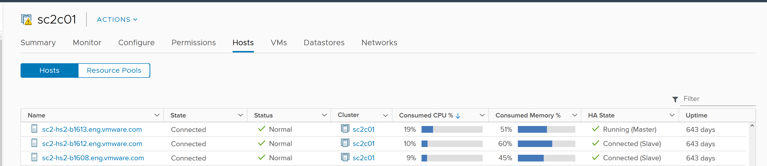

Consumed CPU maps to CPU Usage (%). Consumed Memory (%) maps to Memory Consumed (KB).

To confirm it, simply plot CPU Usage value. The last value is what you see at the table.

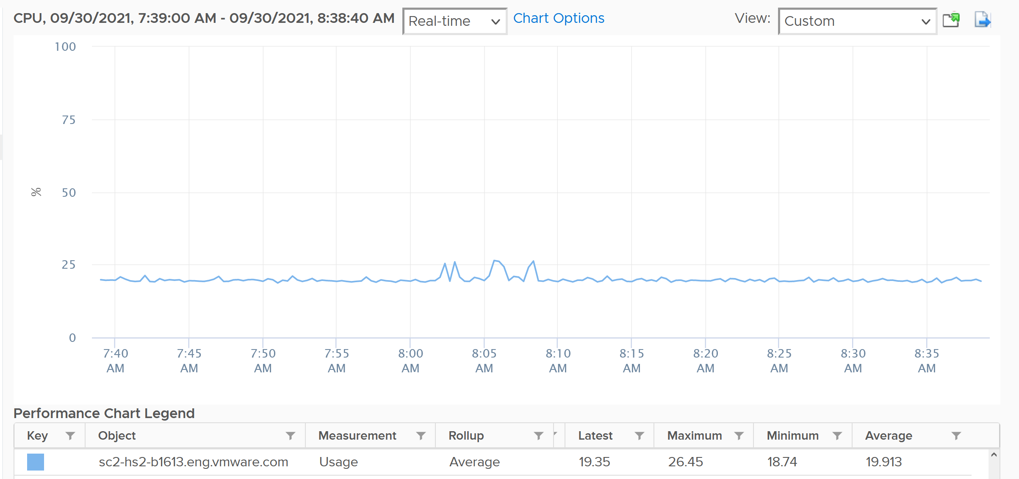

You also see them in vSphere Host Client.

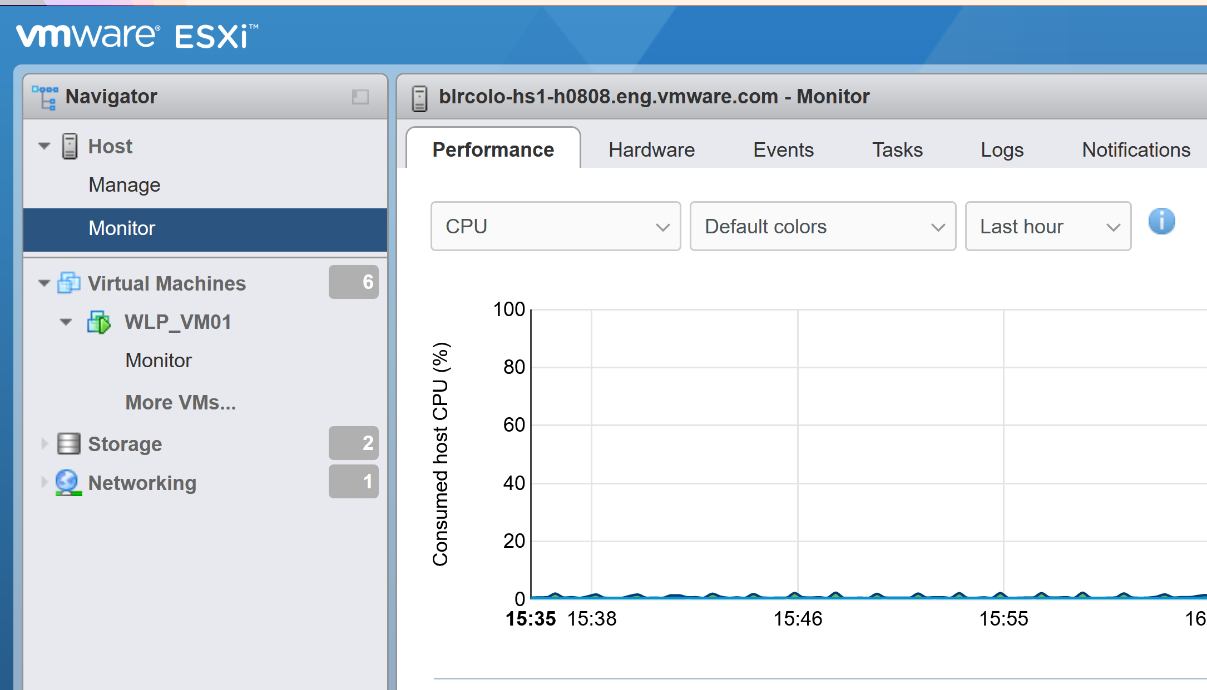

As a bonus, you get the breakdown by CPU package.

#### Peak Core CPU Usage

Is any of the physical threads running hot?

An ESXi with 72 CPU cores will have 144 logical processors. Hence it’s possible that one of them is running hot, while the rest is not. You will not be able to see that single core peak at ESXi Host level as it’s the average of 144 metrics. If you are concerned that any of them is running hot, you need to track the peak among them.

Peak CPU Core Usage (%) tracks the highest CPU Usage among the CPU cores. A constantly high number indicates that one or more of the physical cores has high utilization. So long the highest among any cores at any given time is low, it does not matter which one at a specific point in time. They can take turn to be hot, it does not change the conclusion of troubleshooting. Max() is used instead of 95thpercentile as both result in the same remediation action, and Max() can give better early warning.

The imbalance value among the cores is not needed because it is expected when utilization is not high. When a VM runs, it runs on a few cores, not spread out to all ESXi cores. It’s more efficient to schedule that way, as will requires less context switches.

#### Contention Metrics

The nature of average is also one reason why ESXi “consumption” does not correlate to ESXi “contention”. The 4 highlighted area are examples where the metrics don’t correlate, even go the opposite way in some of them. Can you guess why?



These are the reasons why they don’t match:

* One looks at physical CPU, the other the virtual CPU. One looks at ESXi, while the other looks at VM.
* Hyperthreading and Power Management.
* Imbalance utilization. There are many VMs in this host. Their experience will not be identical.
* Limit may impact the VM, either directly or via resource pool.
* CPU pinning, although this is rarely happen.

So what metrics should you use?

The Performance (%) metrics. We will cover them in later part of the book. In the meantime, here are the latency metrics provided by vSphere Client.

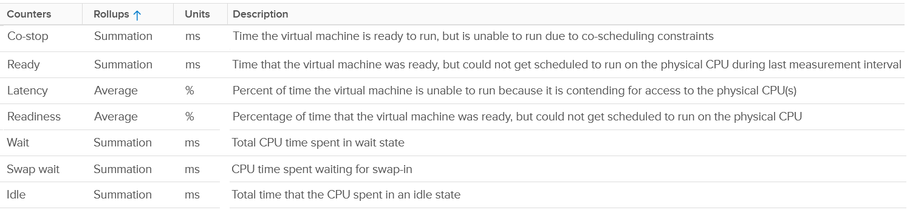

### Memory

vCenter provides even more metrics at ESXi level: 38 metrics for RAM plus 11 for VMkernel RAM. VMkernel has around 50 processes that are tracked. As a result, a cluster of 8 ESXi can have > 800 metrics just for ESXi RAM! Most of them are not shown as a percentage, making it challenging to compare across ESXi hosts with different memory sizes.

We will cover each metric in-depth, so let’s do an overview first.

#### Overview

Just like the case for VM, the primary counter for tracking performance is Page-fault Latency. Take note this is normalized average, so use the Max VM Memory Contention instead.

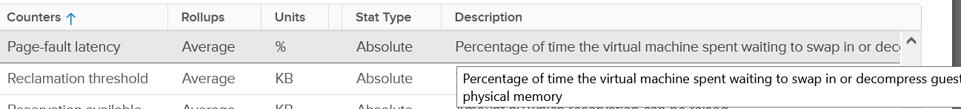

The contention could be caused by swapping in the past. You’ve got only 5, not 6 metrics for swap. Which counter is missing?

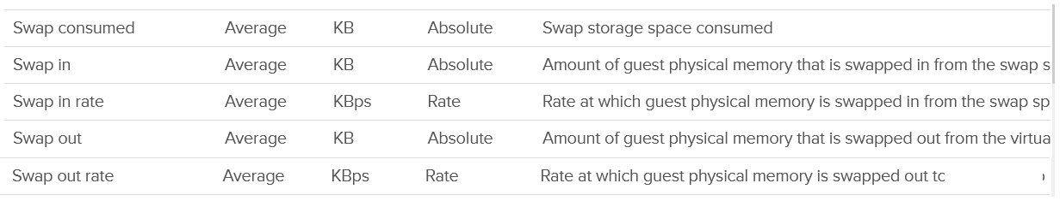

Swap target is missing. It can be handy to see the total target at ESXi level.

Swap and Compress go hand in hand, so we should check both together. Here are the compressed metrics.

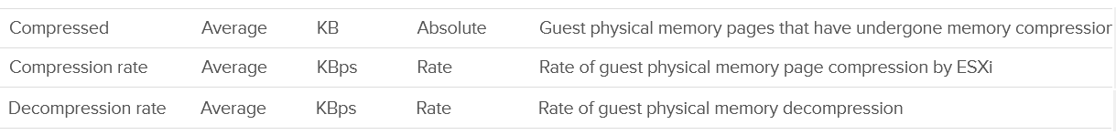

Lastly, the performance could be caused by memory being read from the Host Cache. While they are faster than disk, they are still slower than physical memory.

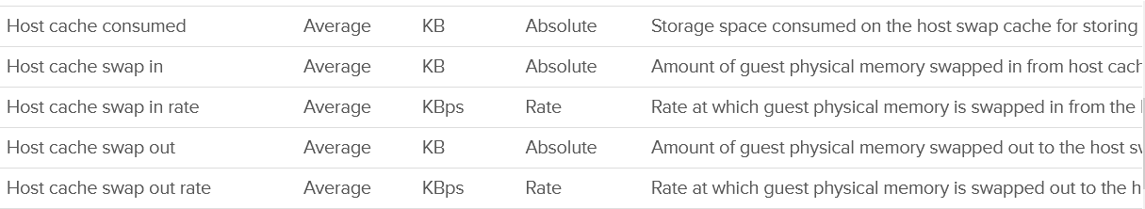

Wait! What about Balloon?

As will cover in-depth shortly, that’s more of capacity than performance metrics. One can even say that other than Page-fault Latency, the rest of the metrics are actually for capacity not performance.

The famous balloon is a warning of capacity, assuming you do not play with limit.



When will ballooning kick in? There is a counter for that!



The memory state level shows one of the 5 possible states. You want to keep this at Clear state or High state.



For environment where performance matters more than cost, you want Balloon to be 0. That means Consume becomes your main counter for capacity. It is related to Granted and Shared.

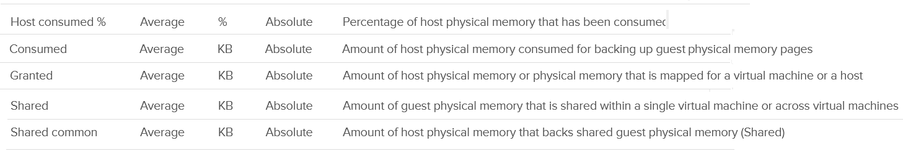

Reservation plays a big part in capacity management as it cannot be overcommitted.

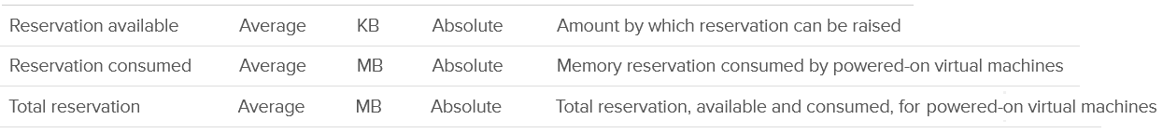

Active is not a counter for capacity or performance. It’s for VMkernel memory allocation.



There are a few metrics covering 0 pages and overhead.

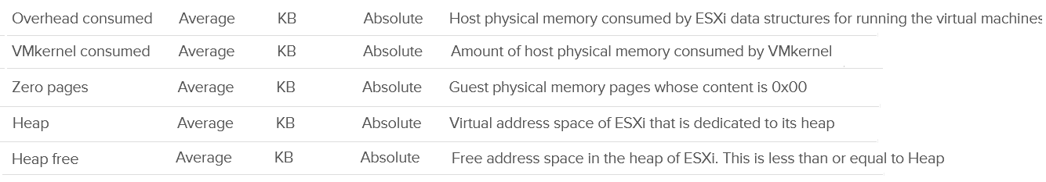

Persistent Memory



Lastly, there are a few metrics for VMFS. I think they are internal, only used by VMkernel. Let me know if you have a real world use case them.

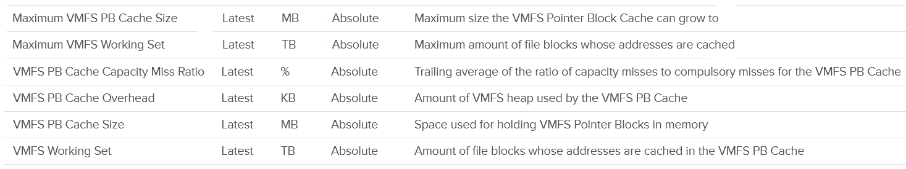

#### “Contention” Metrics

I put the title in “quote” as none of these counters actually measure contention.

I do not cover the Latency metric as that’s basically a normalized average of all the running VMs on the host.

##### Balloon

Balloon is a leading indicator that an ESXi is under memory pressure, hence it’s one of the primary metrics you should use in capacity. Assuming you’re not using Limit to artificially cap the resource, you should ensure that the balloon amount does not cause VM to experience contention.

We know that contention happens at hypervisor level, not at VM level. The VM is feeling the side effects of the contention, and the degree of contention depends on each VM's shares, reservation and utilization. ESXi begins taking action if it is running low on free memory. This is tracked by a counter called State. The State counter has five states, corresponding to the Free Memory Minimum (%) value

|  |  |  |  |
| --- | --- | --- | --- |
| **ESXi State** | **Threshold** | **1 TB ESXi** | **Example based on ESXi with 1 TB RAM** |
| High | 300% | 32.4 GB | First, we calculate the Free Memory Minimum value. There is many website to help you with this, such as [this](https://blogs.virtualmaestro.in/2020/06/02/vmware-vsphere-7-x-memory-reclamation-part-2-mem-memminfreepct/).  For 1 TB, the value is 10.8 GB. |
| Clear | 100% | 10.8 GB |
| Soft | 64% | 6.9 GB. Balloon starts here |
| Hard | 32% | 3.5 GB. Compress/Swap starts here |
| Low | 16% | 1.7 GB. Block execution |

Using the example above, let’s see at which point of utilization does ESXi triggers balloon process.

|  |  |  |  |
| --- | --- | --- | --- |
| **ESXi State** | **512 GB ESXi** | **1 TB ESXi** | **1.5 TB ESXi** |
| Balloon Threshold | 3.7 GB | 6.9 GB | 10.2 GB |
| Threshold | 508.3 GB | 0.99 TB | 1.49 TB |
| Threshold in % | 99.3% | 99.3% | 99.3% |

As you can see from all the 3 ESXi, balloon only happens after at least 99% of the memory it utilized. It’s a very high threshold. Unless you are deliberately aiming for high utilization, all the ESXi should be in the **High** state.

In addition, the spare host you add to cater for HA or maintenance mode will help in lowering the overall ESXi utilization. Let’s use example to illustrate

* No of ESXi in a cluster = 12
* Provisioned for HA = 11
* Target ESXi memory utilization = 99% (when HA happens or planned maintenance)
* Target ESXi memory utilization = 99% x 11 / 12 = 90.75% (during normal operations)

Using the above, you will not have any VM memory swapped as you won’t even hit the ballooned stage. If you actually see balloon, that means there is limit imposed.

The **Low Free Threshold** (KB) counter provides information on the actual level below which ESXi will begin reclaiming memory from VM. This value varies in hosts with different RAM configurations. Check this value only if you suspect ESXi triggers ballooning too early.

ESXi memory region can be divided into three: Used, Cached and Free

* Used is tracked by Active. Active is an estimate of recently touched pages.
* Cached = Consumed - Active. Consumed contains pages that were touched in the past, but no longer active. I'm not sure Ballooned pages are accounted in Consumed, although logically it should not. It should go to Free so it can be reused.
* Free = Total Capacity - Consumed.

The nature of memory as cache means the active part is far lower than the non-active part. It’s also more volatile. The following shows an ESXi with low memory usage, both active and consumed, in the last 3 months.



Let’s look at an opposite scenario. The following ESXi is running at 100%. It has granted more memory than what it physically has. Initially, since the pages are inactive, there is no ballooning. When the active rise up, the consumed counter goes up and the balloon process kicks in. When the VM is no longer using the pages, the active counter reflects that and ESXi begin deflating the balloon and giving the pages back.



I shared in the VM memory counter that just because a VM has balloon, does not mean it experiences contention. You can see the same situation at ESXi level. The following ESXi shows a constant and significant balloon lasting at least 7 days. Yes the worst contention experienced by any VM is not even 1%, and majority of its 19 VMs were not experiencing contention at all.



##### Swap & Compress

The metrics are essentially the summation of running VMs and VMkernel services.

|  |  |
| --- | --- |
| Metrics | Description |
| Swap Consumed | Sum of memory swapped of all powered on VMs and vSphere services on the host. This number will reduce if pages are swapped back into the DIMM.  I think this is swapped out – swapped in. |
| Swap In | The total amount of memory that have been swapped in to date. |
| Swap Out | As above, but for swapped out pages. |
| Swap In Rate | I think this includes compressed, not just swapped, but I’m not 100% sure as I can’t find a proof yet. |
| Swap Out Rate |

Pages can and will remain in compressed or swapped stage. The following screenshot shows compressed remains around 5 GB for around 1 year.

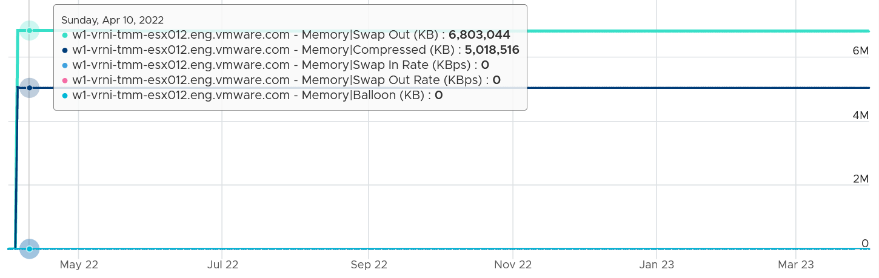

The above happened because there was no need to bring back those pages. Notice ballooning was flat 0, indicating the ESX host was not under memory pressure.

The following screenshot is why I think Swap Out is simply an accumulative counter. Notice the value did not reduce even though there was swapped in and there was no swapped out. I suspect because the pages that were swapped in were not the pages in the swapped file.

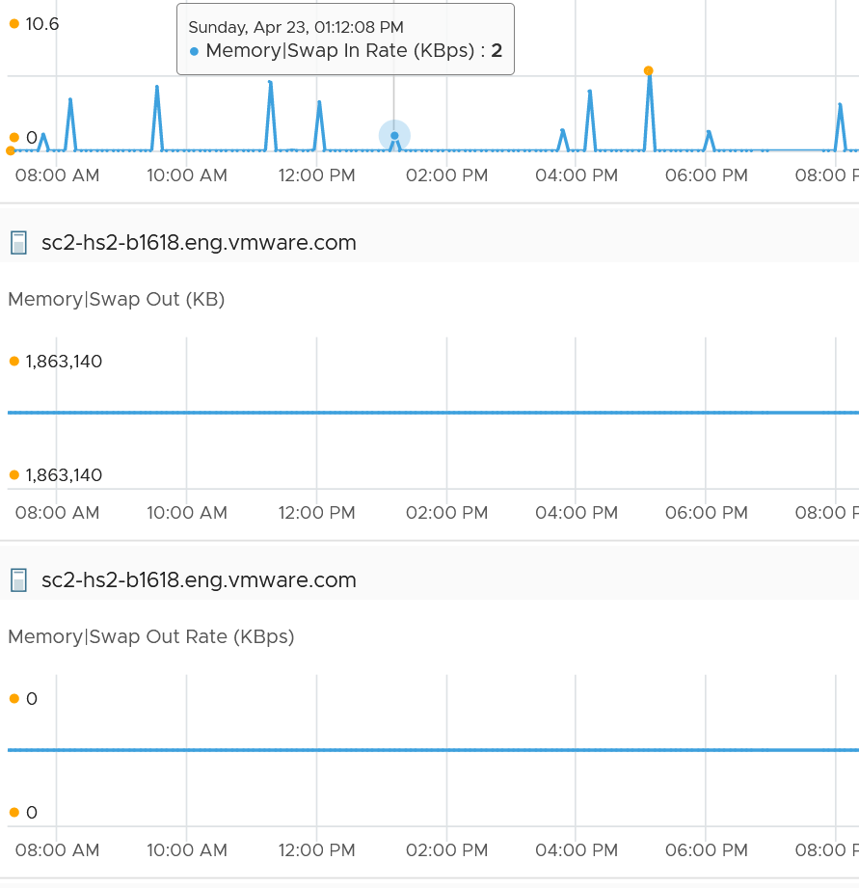

#### Consumption Metrics

Consumption covers utilization, reservation and allocation.

##### Consumed

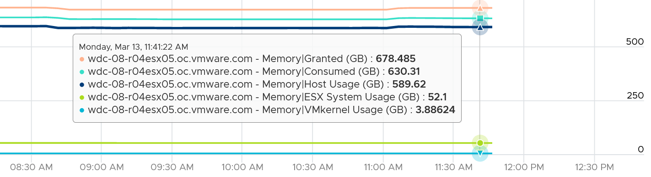

I find eliminating the components that make up a metric helps in validating their value. So let’s compare when there is no running VM.

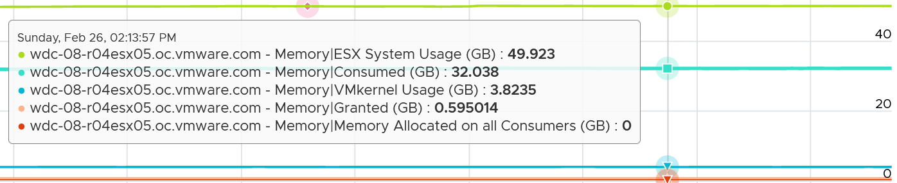

Consumed = VMkernel utilization (not reservation) + Granted to VM

Let’s take a look! This ESXi has 130693 MB, as vCenter use 1024 to convert from GB to MB.

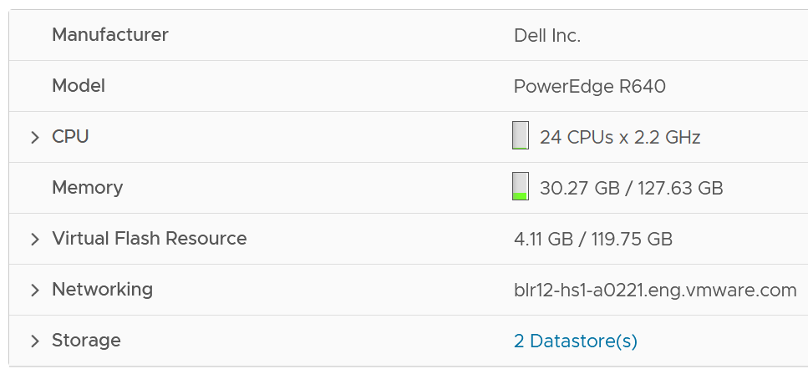

The box has 3 running VMs. One of them does not have VMware Tools.

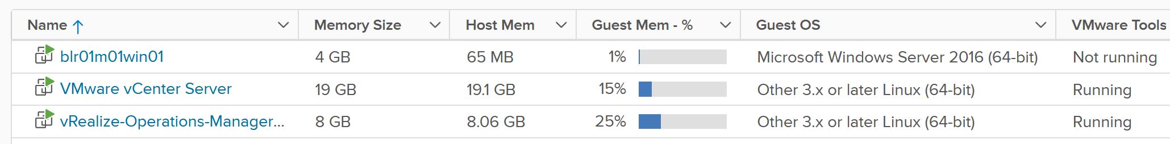

As we’re interested in ESXi level, look at the number under Host Mem column. They add up to 27876 MB.

I’m not 100% what the number under Guest Mem is. Need to validate if it’s based on Tools or not.

Now let’s see what ESX consume reports.

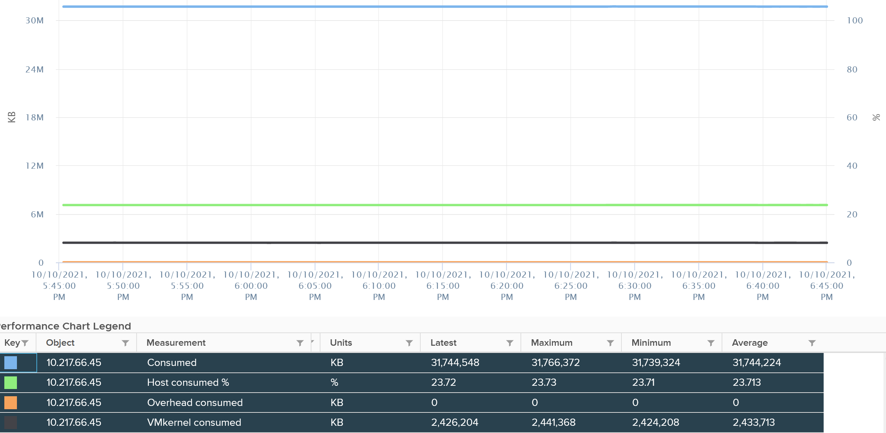

It reports 31744 MB. That means there is 3876 MB unaccounted. That should be VMkernel.

vCenter reports VMkernel is only consuming 2426. So there is 1441 MB unaccounted.

Regardless, it shows that Consumes includes VMkernel already.

You can also check at esxtop also match. See the PMEM total value. VMkernel consumes 2370 MB, and while VMs consumes 28245 MB. Free is 100076, which is 130692 – 2370 – 28245.

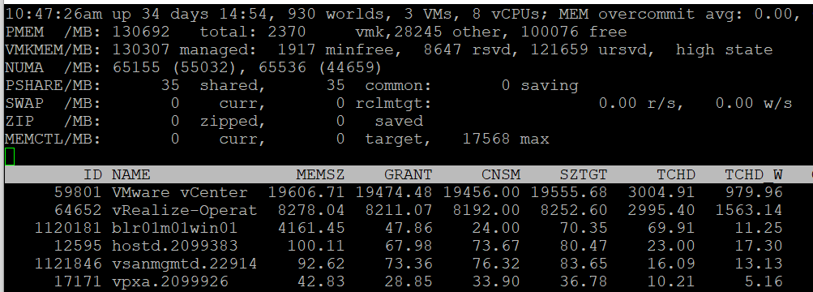

The ESXi runs 3 VM, shown above as the first 3 lines. If you sum them up, you get 28245.

What’s interesting is the numbers between esxtop and vCenter UI do not perfectly tally. I need to run more tests to figure it out.

Consumed does not include Ballooned. This makes sense as the pages no longer backed by physical pages.

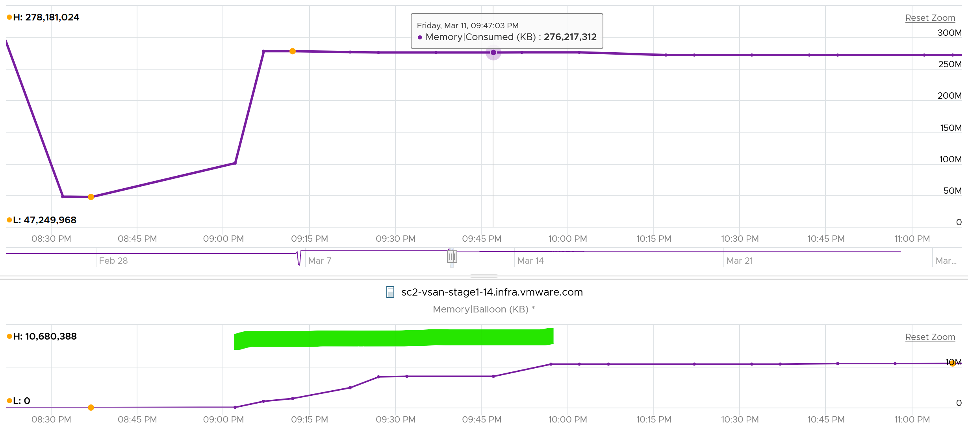

Consumed does not include swapped. This makes sense as the page are no longer in the physical memory.

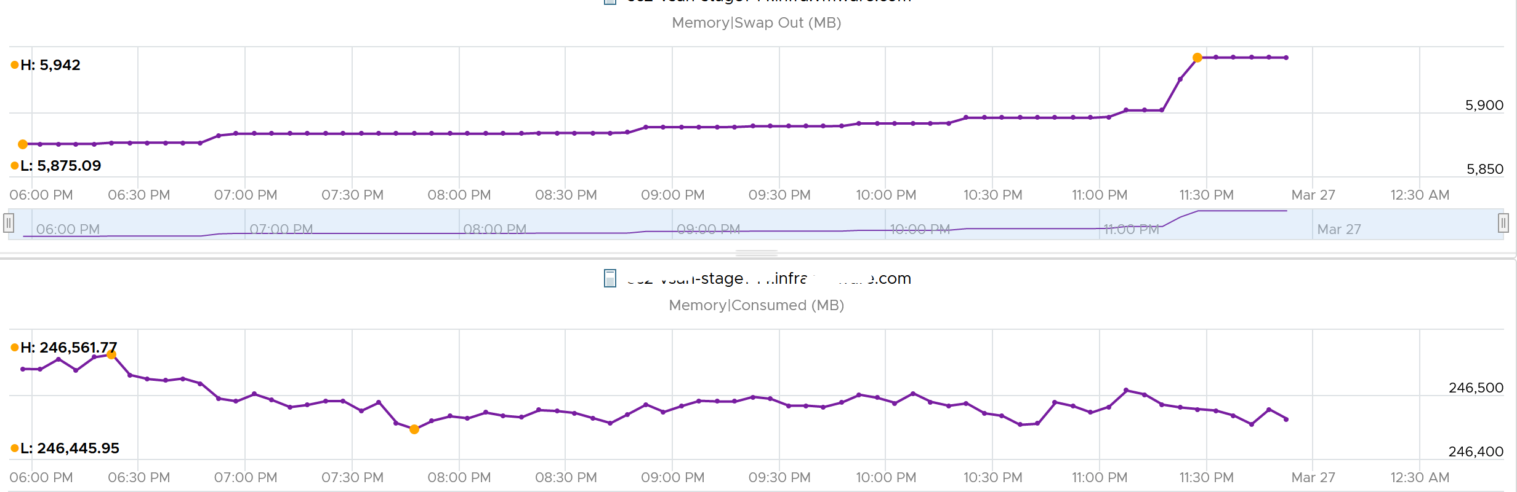

Consumed seems to include compressed. This seems logical as the pages still consumed the physical memory (it’s in the DIMM).

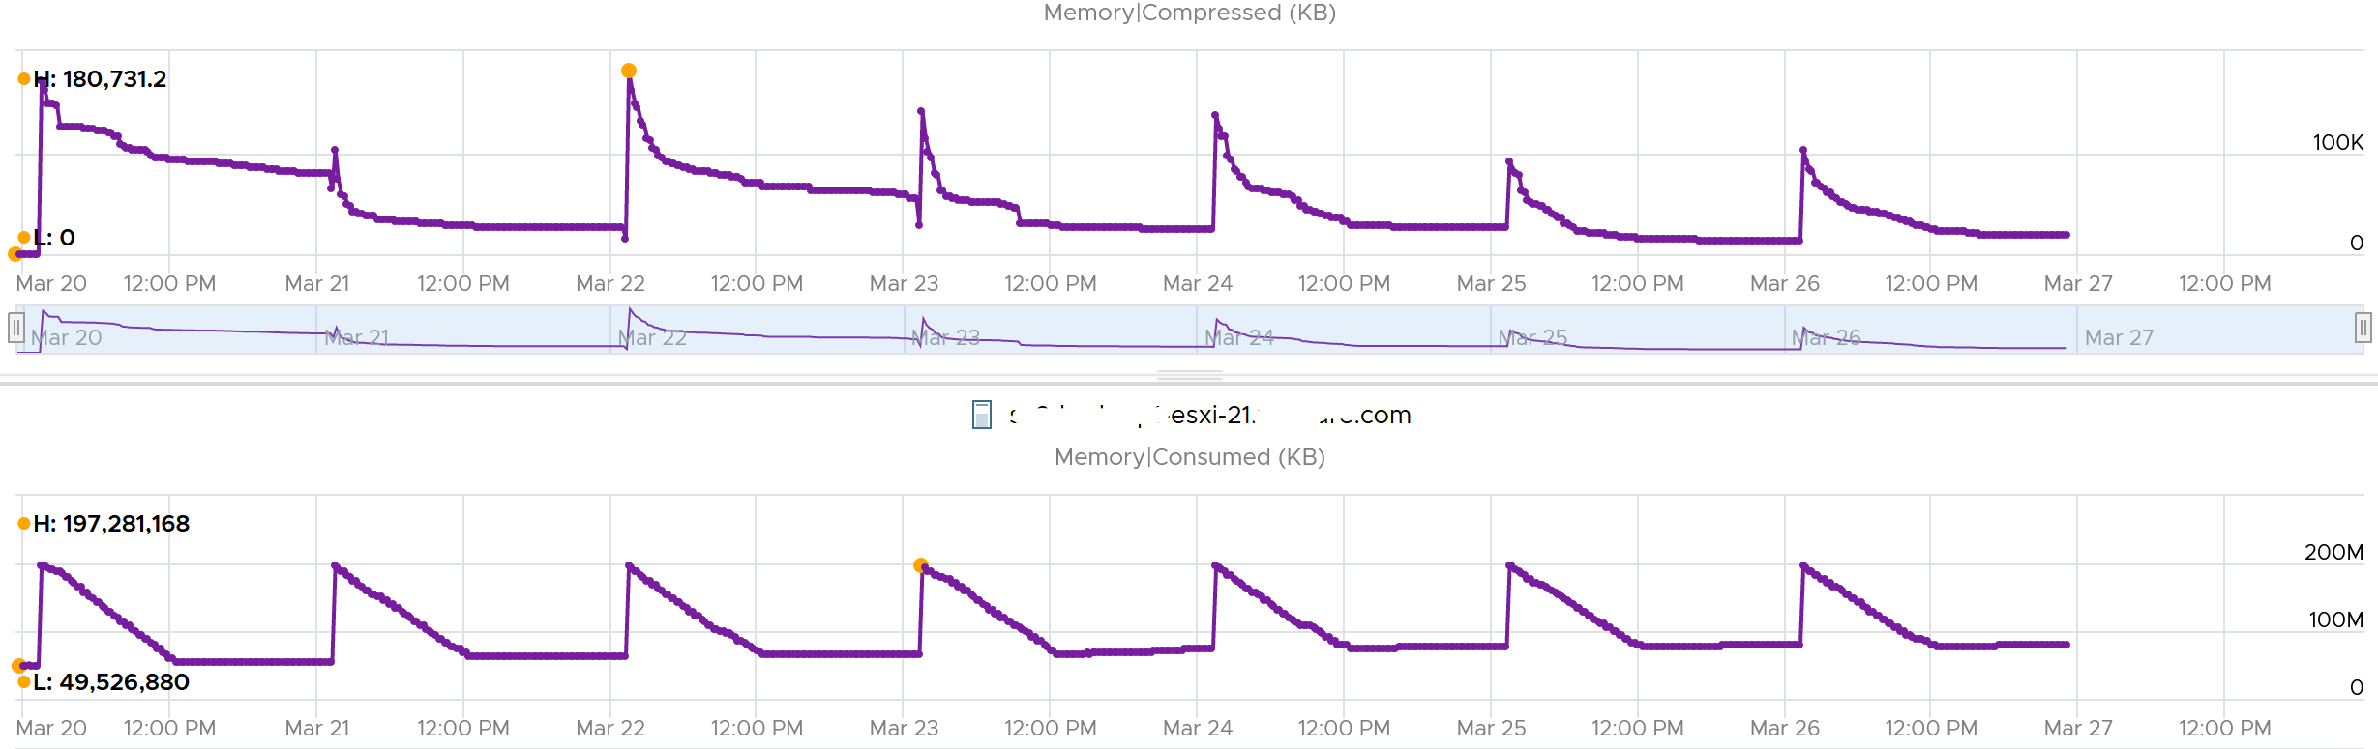

###### VMkernel

The other part of Consumed is non VM. This means VMkernel, vSAN, NSX and whatever else running on the hypervisor. Because ESXi Consumed includes non VM, it can be more than what’s allocated to all running VMs, as shown below.

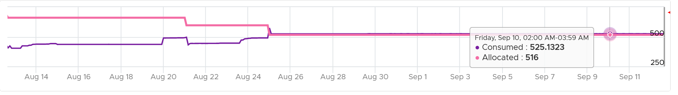

Take note that Consumed includes the actual consumption, not the reservation. The following ESXi has 0 running VM, so the Consumed is just made of VMkernel. You can see the utilization is much lower than the reservation.

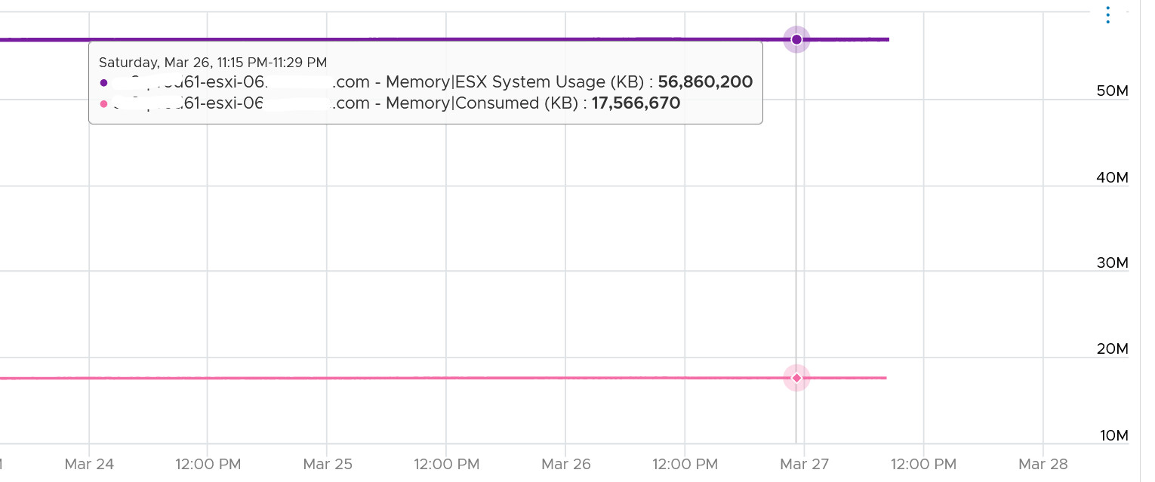

If you’re wondering why it’s consuming 17 GB when there is 0 VM, the likely answer is vSAN. Just because there is no VM does not mean vSAN should stop running.

Just like any other modern-day OS, VMkernel uses RAM as cache as it's faster than disk. So the Consumed counter will be near 100% in overcommit environment. This is a healthy utilization.

##### Granted

The following example shows ESXi hosts with no running VM, so the Consumed counter is mostly made up of VMkernel. From the table, you can see that Consumed = VMkernel Consumed + Granted to VM.

I’ve sorted them by the **Granted** counter, as I’m not expecting it to have any values. Granted at the host is the total of the granted metrics of VMs running on the host, so it should be 0 in this case. It includes the shared memory. My guess the extra memory is for non-VM user world process.



Let’s take one of the ESXi to see the value over time. This time around, let’s use vCenter instead.



You can verify that ESXi Consumed includes its running VMs Consumes by taking an ESXi with a single running VM. The ESXi below has 255 GB of total capacity but only 229 GB is consumed. The 229 GB is split into 191 GB consumed by VM and 36 GB consumed by VMkernel.



The VMkernel consumption is the sum of the following three resource pools.



##### Shared

|  |  |
| --- | --- |
| **Metrics** | **Description** |
| Shared | The sum of all the VM memory pages & VMkernel services that are pointing to a shared page. In short, it’s Sum of VM Shared + VMkernel Shared.  If 3 VMs each have 2 MB of identical memory, the shared memory is 6 MB. |
| Shared Common | The sum of all the shared pages.  You can determine the amount of ESXi host memory savings by calculating Shared (KB) - Shared Common (KB) |

Memory shared common is at most half the value of Memory shared, as sharing means at least 2 blocks are pointing to the shared page. If the value is a lot less than half, then you are saving a lot.

I typically validate the theory with actual values. The following shows the shared common exceeding half many times in the last 7 days.

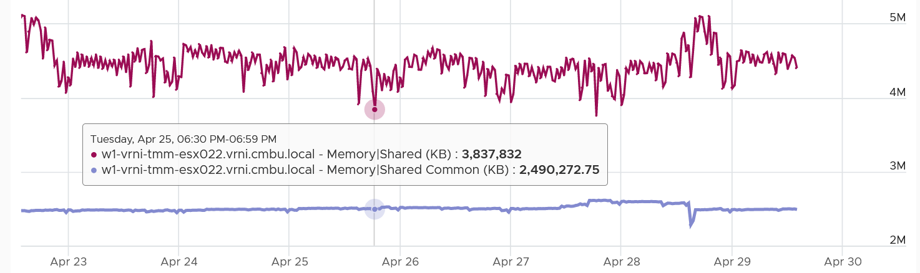

I’m not sure why. My wild guess is large pages are involved. ESXi hosts sport the hardware-assisted memory virtualization from Intel or AMD. With this technology, VMkernel uses large pages to back the VM memory. As a result, the possibility of shared memory is low, unless the host memory is highly utilized. In this high consumed state, the large pages are broken down into small, shareable pages. The smaller pages get reflected in the shared common. Do let me know if my wild guess is correct.

You can also use the Memory shared common counter as leading indicator of host breaking large page into 4K. For that, you need to compare the value over time, as the absolute value may be normal for that host. The following table shows 11 ESXi hosts with various level of shared pages. Notice none of them is under memory pressure as balloon is 0. That’s why you use them as leading indicator.

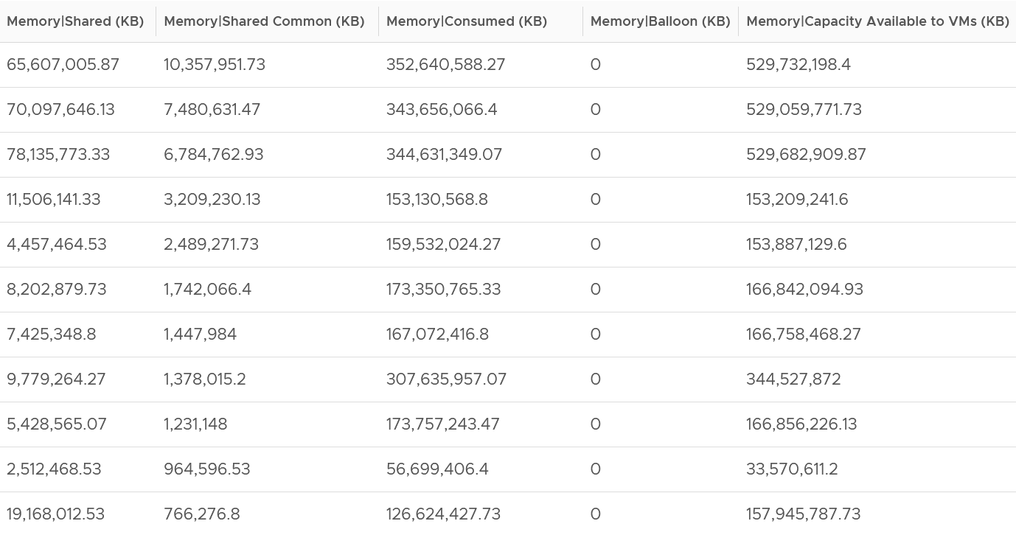

With Transparent Page Sharing limited to within a VM, shared pages should become much smaller in value. I’m not sure if salting helps address the issue. From the vSphere manual, “With the new salting settings, virtual machines can share pages only if the salt value and contents of the pages are identical”.

I’m unsure if the above environment has the salting enabled or not. Let me know what level of sharing in your environment, especially after you disable TPS.

##### Reservation

The metric Reserved Capacity (MB) metric only counts reservation by powered on VM. It does not include powered off VM and VMkernel reservation. Aim for this value to be low, as you should use reservation only if you mix VM with different class of service.

The following screenshot shows an ESXi where the CPU reservation was flat 0 MHz. I then set one of its VM reservation to 888 MHz. Notice the immediate yet constant change.

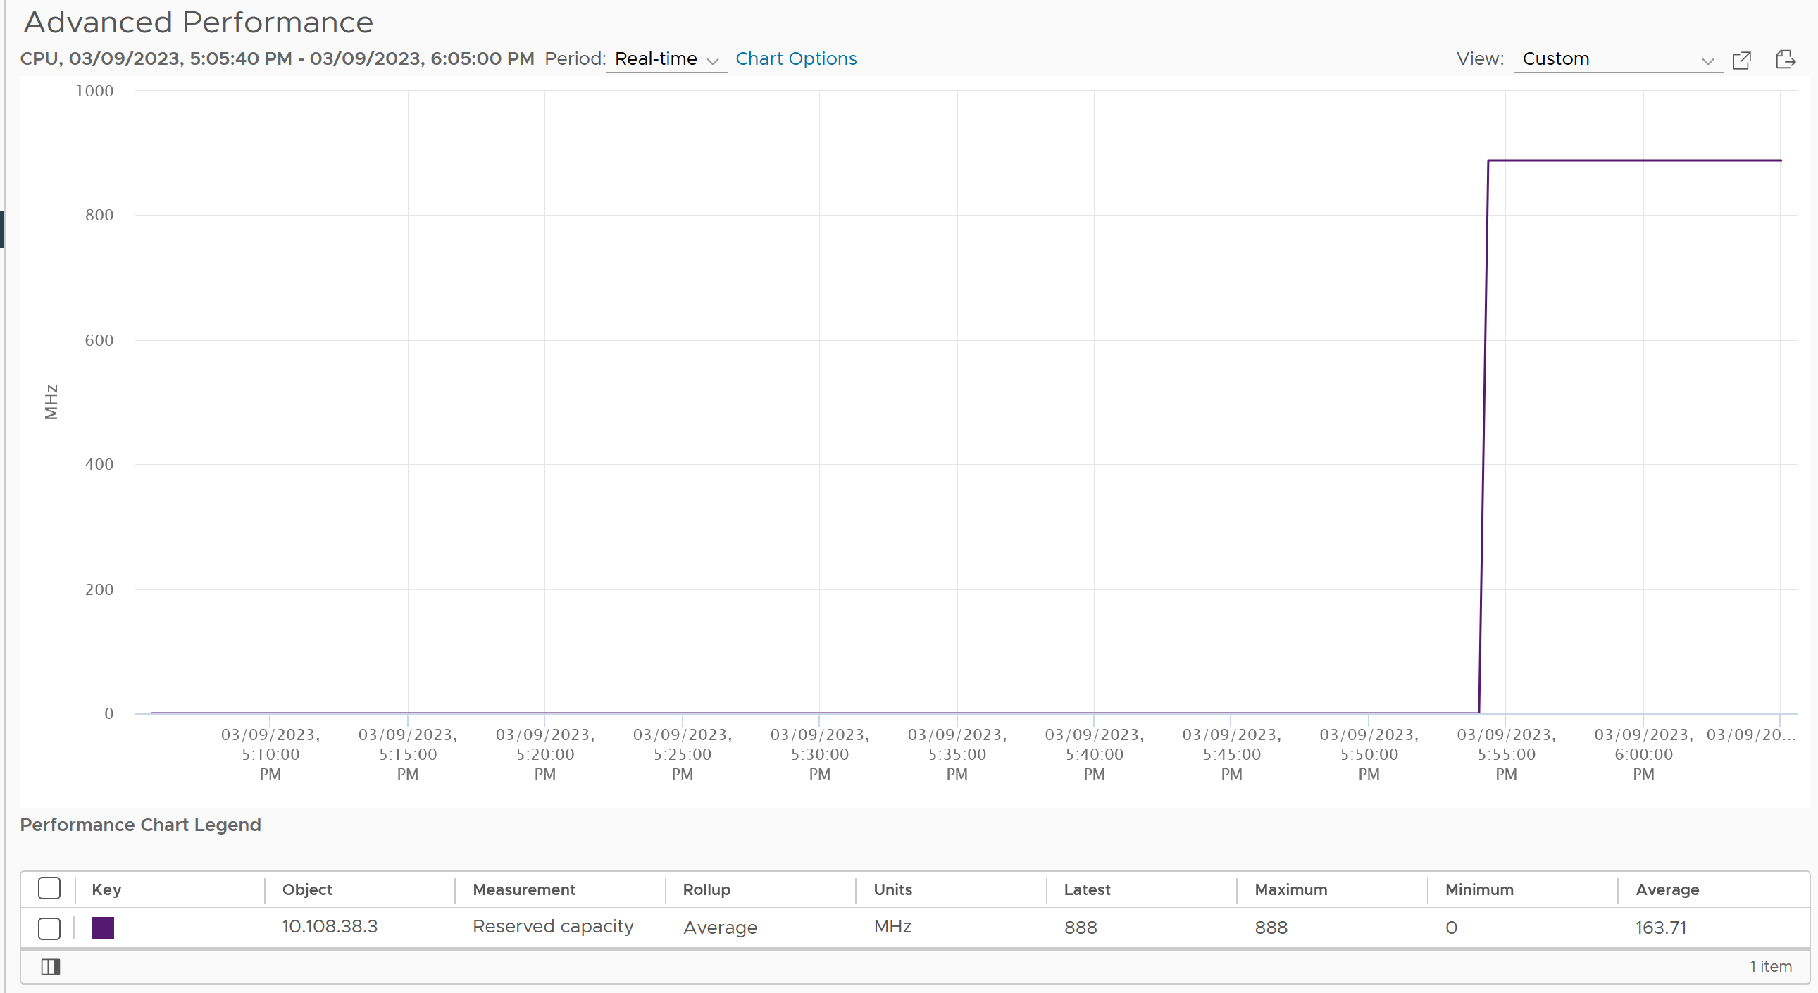

##### Utilization

We’ve seen that Consumed is too conservative as mostly cache and Active is too aggressive as it’s not even designed for memory sizing.

This calls for a metric in the middle. This is where Utilization comes in.

It’s the sum of running VM Utilization metrics + VMkernel reservation.

I plotted from 192 ESXi. I averaged the data to remove outlier. Based on 6840 running VMs, the Utilization counter is lower than Consumed by 122 GB. If you include Shared Common, your savings goes up to 152 GB on average.

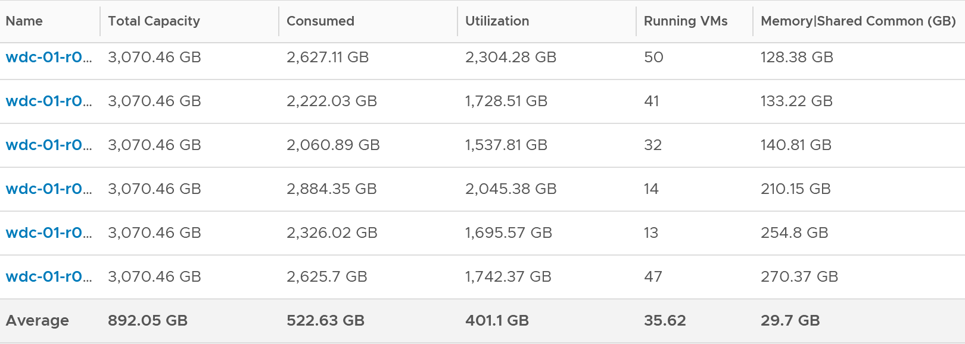

Utilization uses the reservation amount for VMkernel, instead of the actual utilization. This is technically not accurate but operationally wise as it gives you buffer.

#### Validation

The following screenshot shows that ESXi had all its VM evacuated. Not a single VM left, regardless of power on/off status.

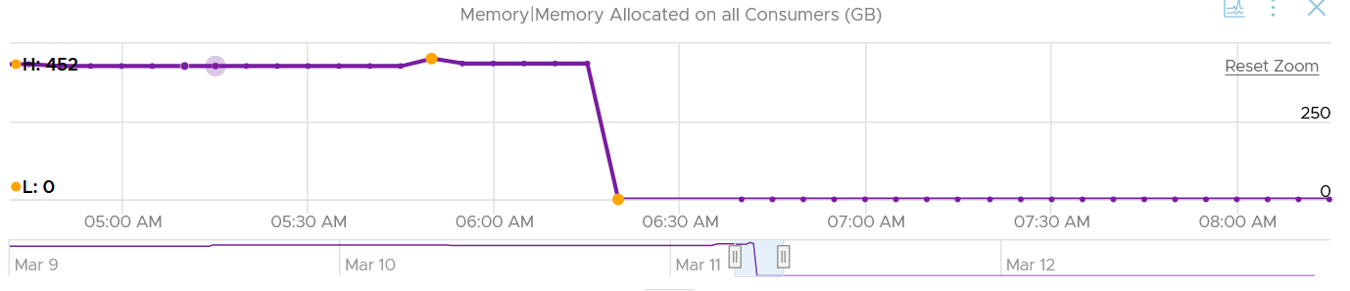

In the preceding chart, we could see the metric Memory Allocated on All Consumers dropped from 452 GB to 0 GB, and it remained flat after that.

Checking the Reserved Capacity metric, we can see it dropped to 0. This is expected.

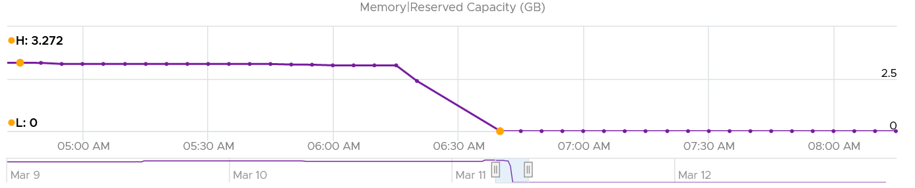

How about Consumed?

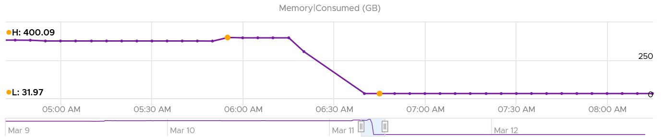

Memory Consumed also dropped. The value was 400 GB, less than 452 GB of allocated to all VM. This indicated some VM had not used the memory, which could happen.

The value dropped to 32 GB, not 0 GB. This is expected as Consumed includes every other process that runs. In this case, it is majority vSAN, which run in the kernel.

Let’s check VMkernel utilization.

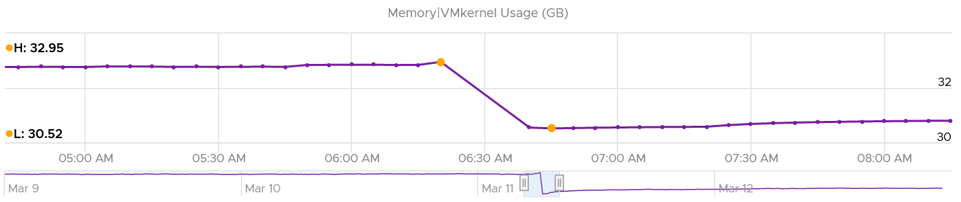

Notice it’s a bit smaller than Consumed, indicating Consumed has other thing. I suspect it’s BIOS and the console in vSphere Client UI.

How come the value didn’t change much? I kinda expect some changes, based on the theory that some kernel modules memory footprint depends on the number of running VM. If you know, let me know!

How about VMkernel reservation? What do we expect the value to change?

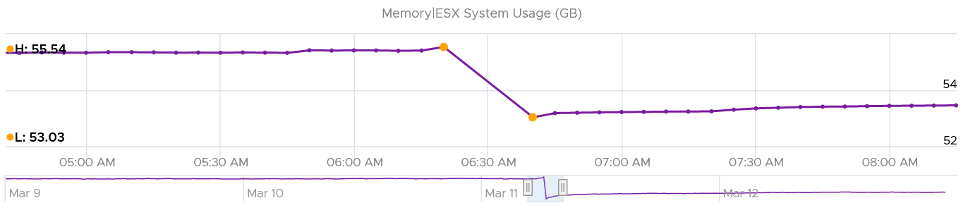

Well, it won’t since the actual usage does not change.

##### Analysis

I compare 185 production ESXi hosts to understand the behaviour of the metrics. I averaged their results to eliminate outlier.

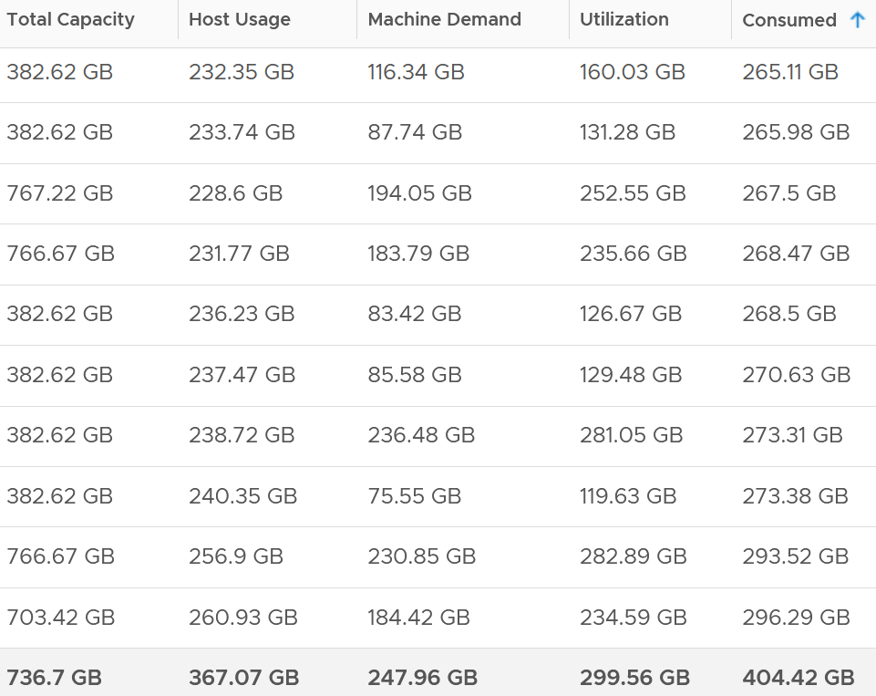

The average of all the 185 ESXi hosts have total capacity of 737 GB. This is the physical configured memory.

The metric Memory \ Usable Memory is 729 GB (not shown in above table). It’s 1% less or 8 GB than Total Capacity. I suspect this maps to Managed metric in vCenter. It is the total amount of machine memory managed by VMkernel. VMkernel "managed" memory can be dynamically allocated for VM, VMkernel, and User Worlds. I need to check what exactly this is as I don’t see a use case for it.

The metric Memory \ VMKernel Usage is 7.6 GB (not shown in above table). This is much lower than the reservation, which is 51.6 GB.

Consumed is generally higher than the other 3 metrics. The only time it’s lower is when there is a lot of savings from shared pages.

What are these?

* Host Usage. Sum of VM Consumed. ESX System Usage is not included. Use case is only for migration, where we don’t want the ESXi consumption.
* Machine Demand. The sum of VM Utilization
* Utilization. Machine Demand + ESX System Usage. You can see that the value equats ESX System Usage when there is 0 running VM.
* Workload = Utilization against Usable

### Storage

The following screenshot shows the ESXi metric groups for storage in the vCenter performance chart.

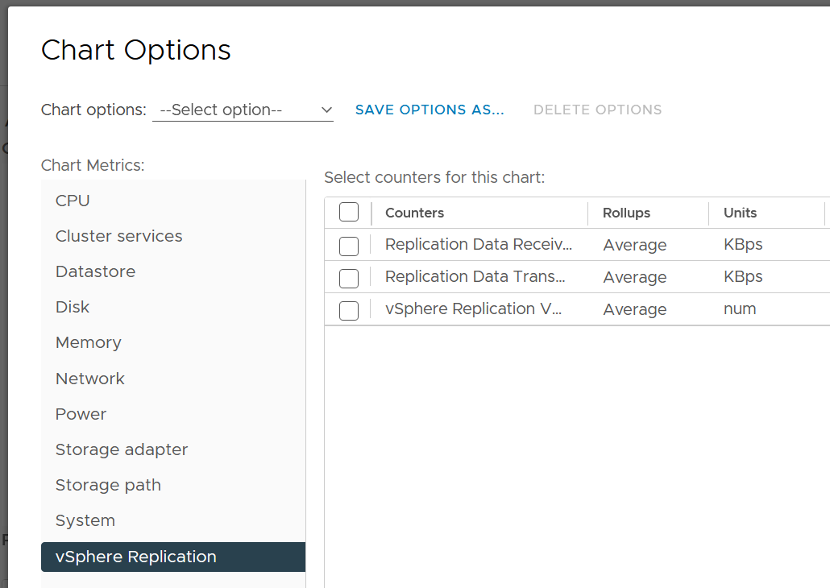

There are 4 metrics groups: datastore, disk, storage adapter and storage path.

We’ve covered in the previous chapter how they work together. We also covered how vSAN impacts them.

#### Storage Adapter & Path

They have identical set of counters. I was hoping adapter to have more metrics such as adapter buffer, queue and utilization.

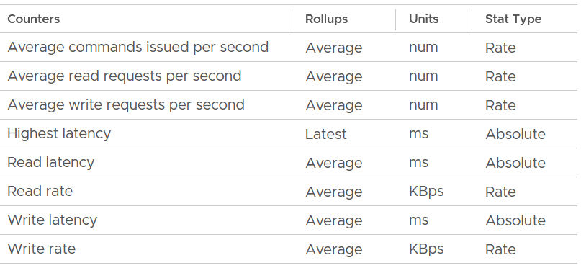

What metrics are missing from the above? I’d like to see block size. Average block size, largest block size, minimum block size. Those will help in troubleshooting.

The highest latency metric takes the worst value among all the adapters or the paths. This can be handy compared to tracking each of them one by one. However, it averages each adapter first, so it’s not the highest read or write. You can see from the following screenshot that its value is lower than the read latency or vmhba0. What you want is the highest read or write among all the adapters or paths.

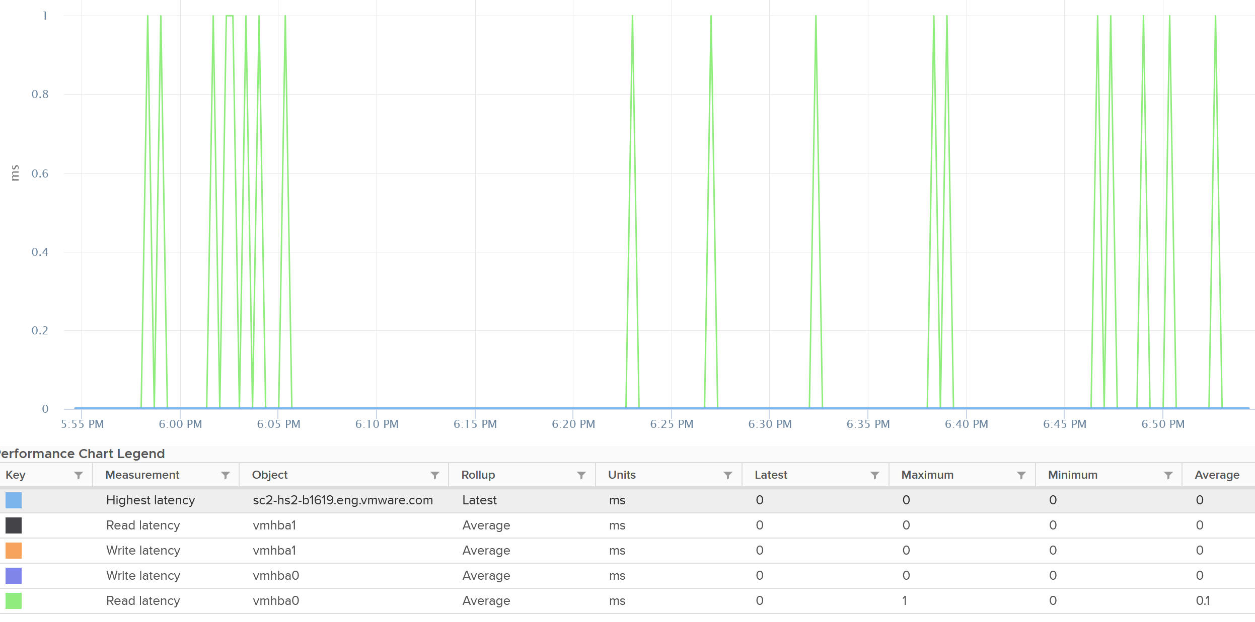

I plotted 192 ESXi host and checked the highest read latency and highest write latency among all their adapters. As the data was returning mostly < 1 ms, I extended to 1 week and took the worst in that entire week. You can see that the absolute worst of write latency was a staggering 250 ms. But plotting the 95th percentile value shows 0.33 ms, indicating it’s a one off occurrence in that week. The 250 ms is also likely an outlier as the rest of the 191 ESXi shows maximum 5 ms, and with much lower value at 95th percentile.

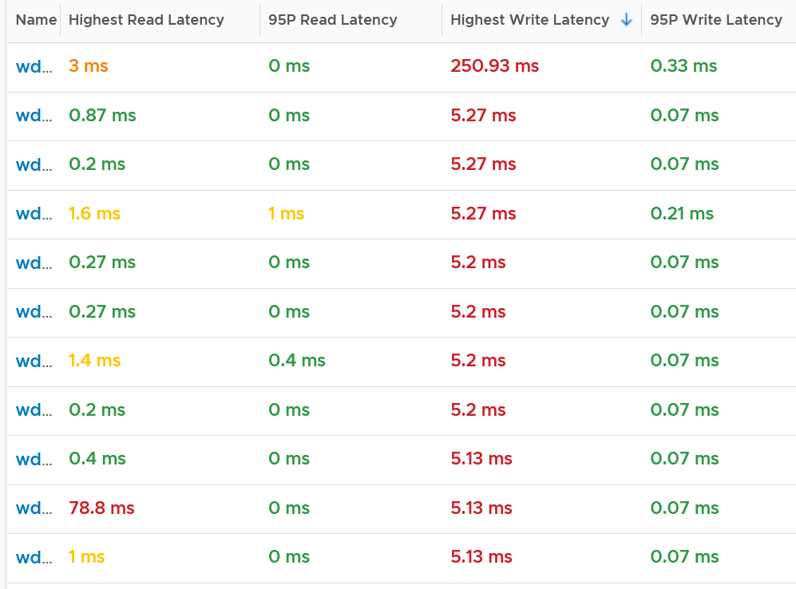

Plotting the value of the first ESXi over 7 days confirmed the theory that it’s a one off, likely an outlier.

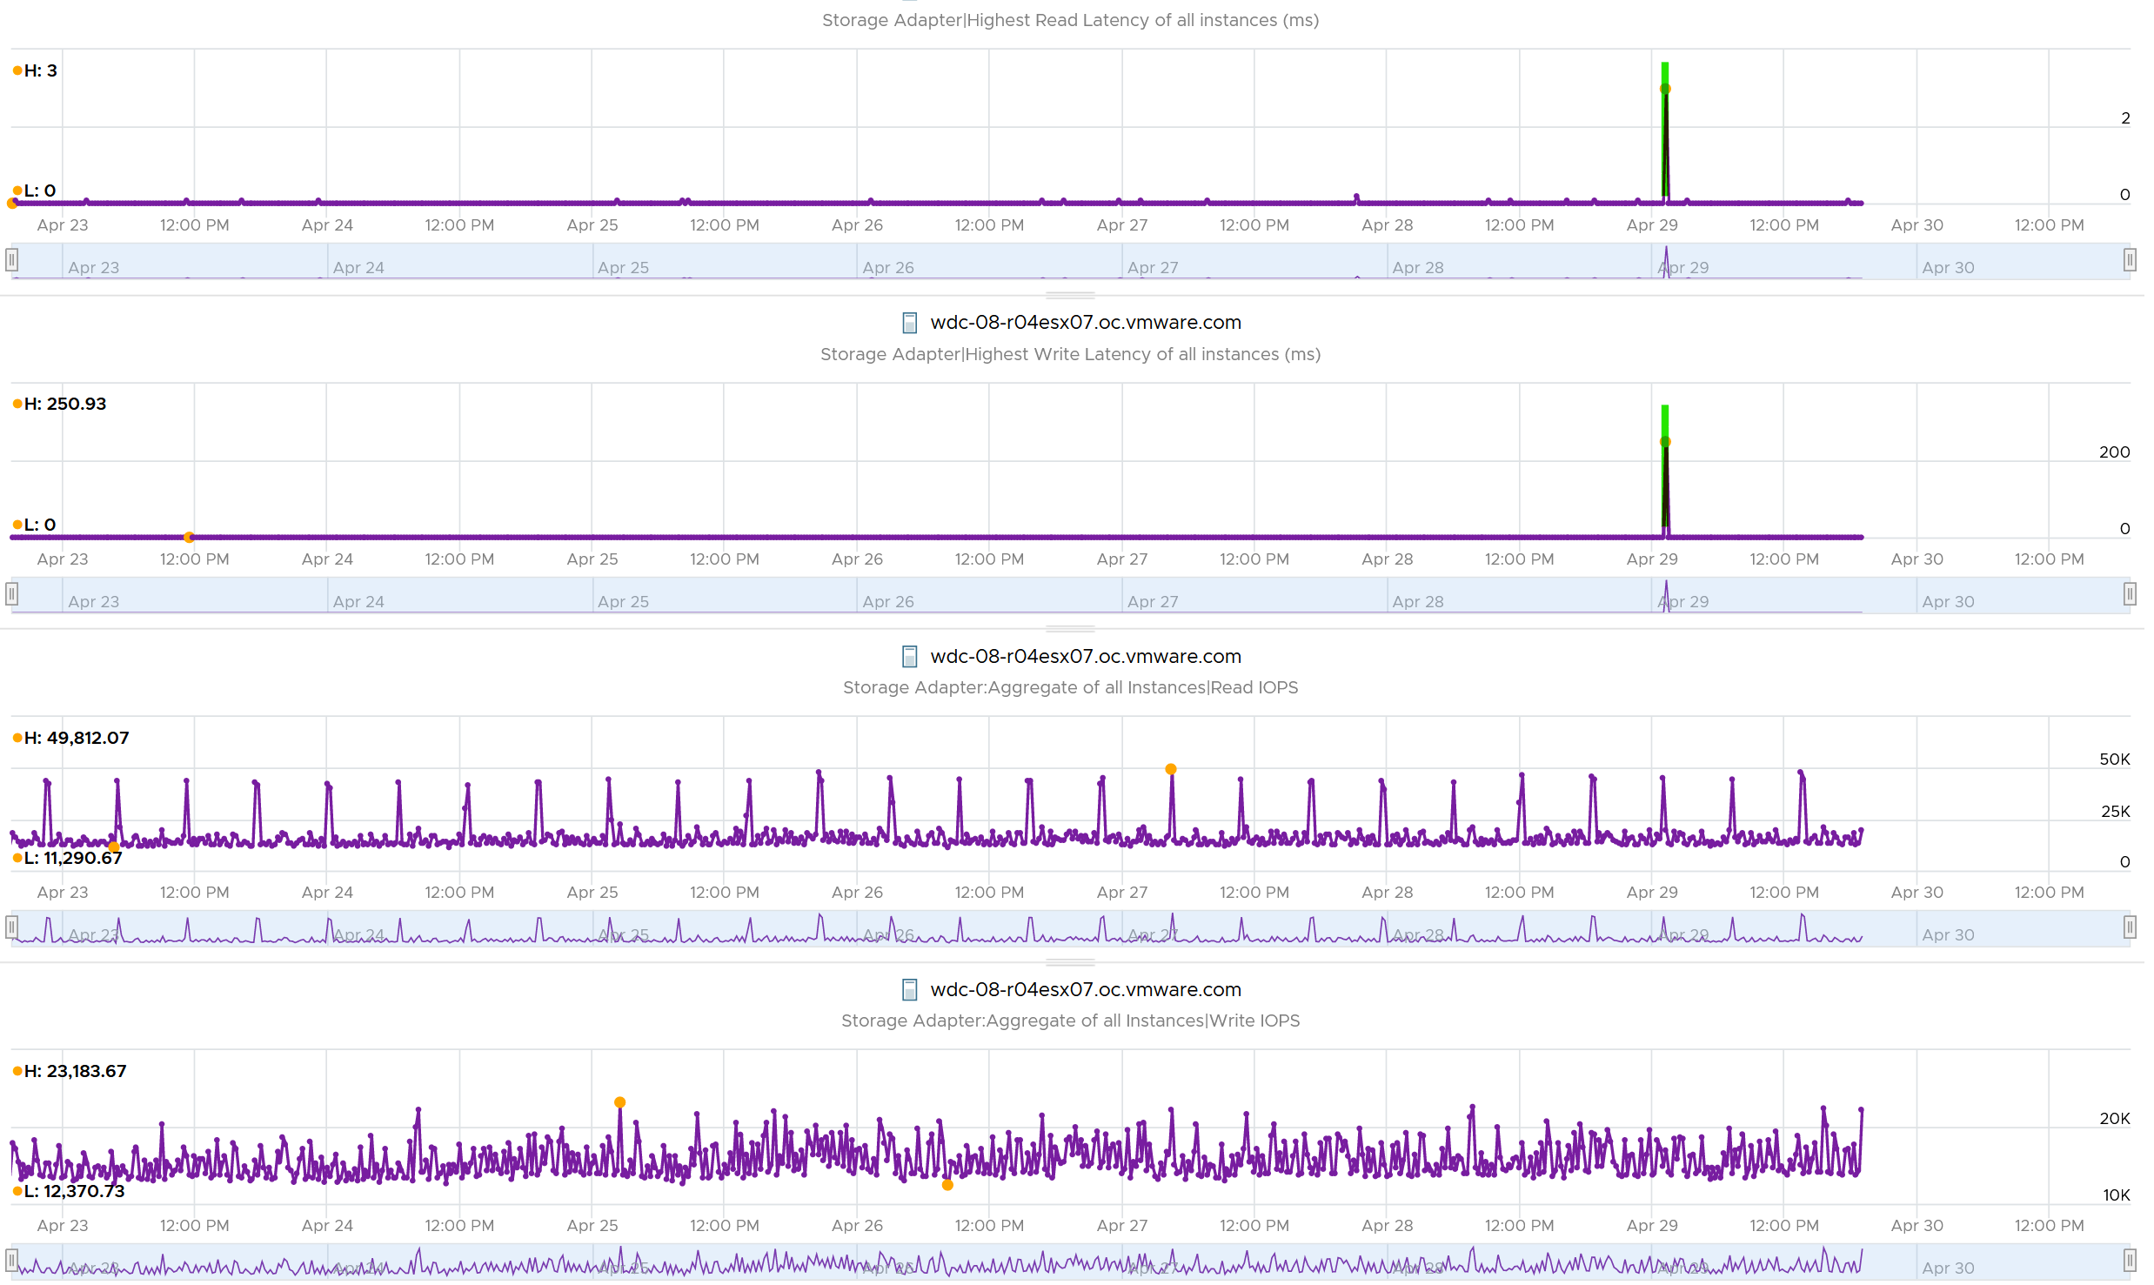

Does it mean there is no issue with the remaining of the 191 ESXi hosts?

Nope. The values at 95th percentile is too high for some of them.

I modified the table by changing Maximum with 99th percentile to eliminate an outlier. I also reduced the threshold so I can see better. The following table shows the values, sorted by the write latency.

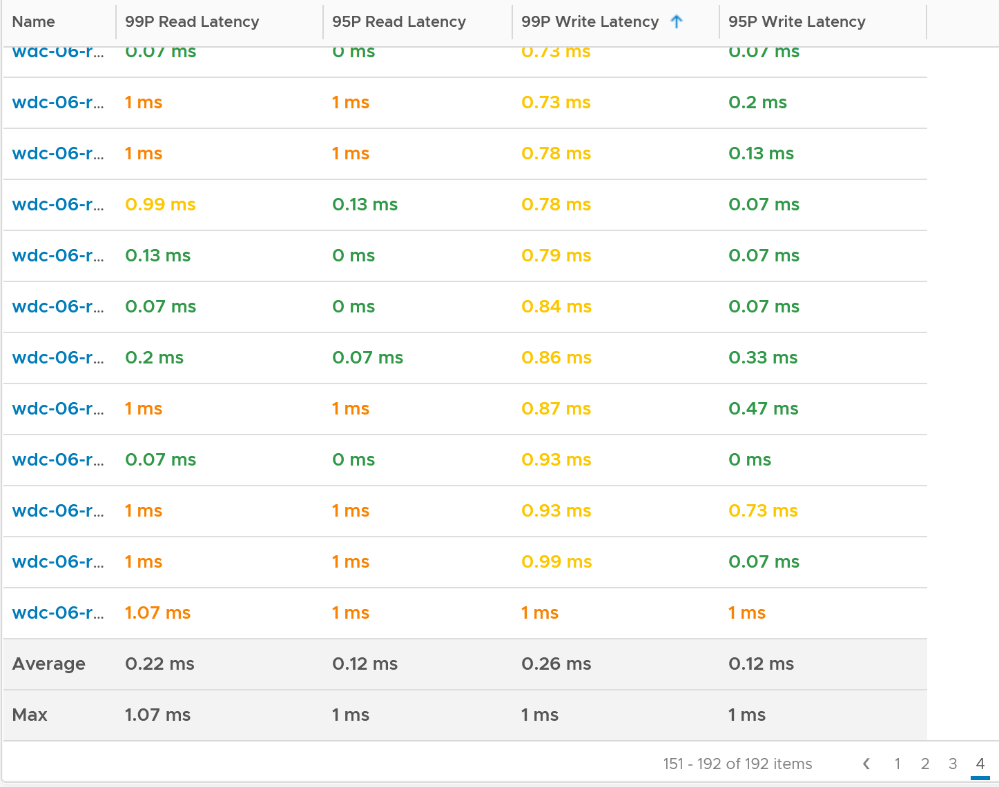

The table revealed that there are indeed latency problem. I plotted one of the ESXi and saw the following.

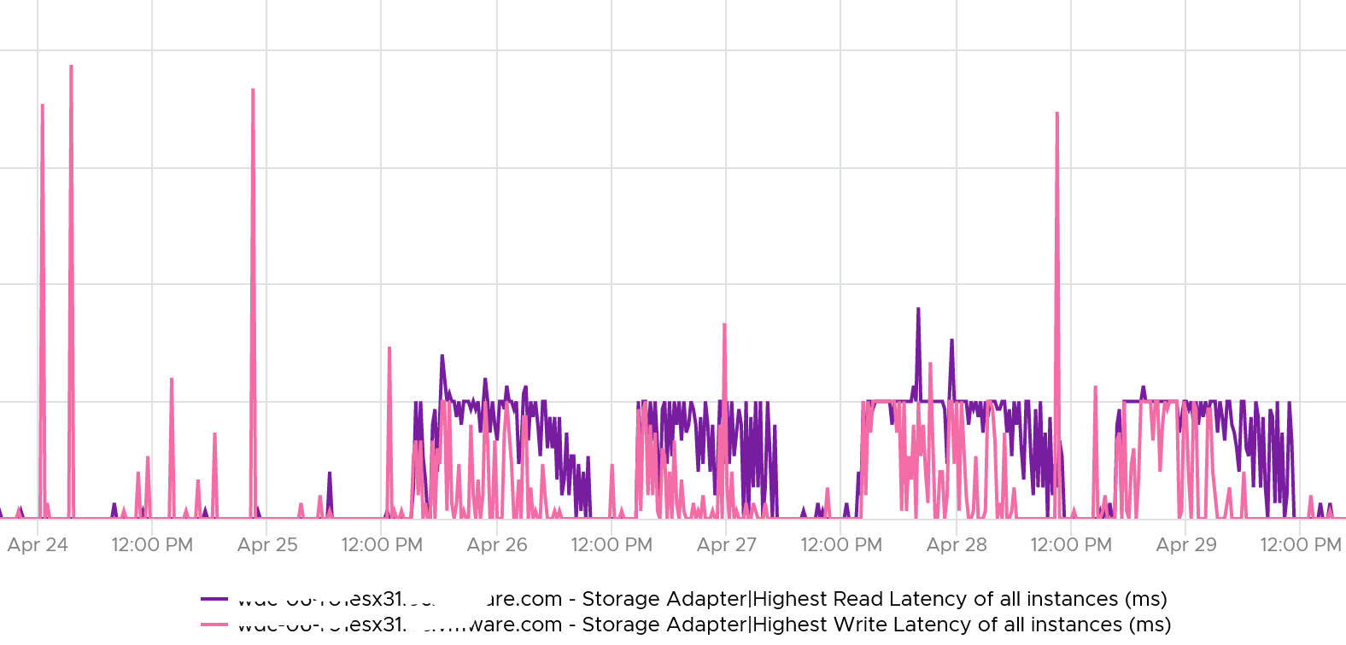

From here, you need to drill down to each adapter to find out which one.

vRealize Operations provide the Storage Adapter|Outstanding Requests metric, which is required to track if the adapter is struggling to meet demands.

[e1: useful???!!!

#### Disk or Device

Compared with Adapter or Path, you get a lot more metrics for disk or device. However, there is no breakdown as VMkernel cannot actually see anything in between the HBA and the device. So no metrics such as number of hops as it’s not even aware of the fabric topology.

From ESXi viewpoint, there are 3 major layers in the VMFS storage stack:

* VM. This
* VMkernel. This is measured by the KAVG counter and QAVG counter.
* Device.

##### Contention Counters

[Frank Denneman](https://frankdenneman.nl/), whose blog and book are great references, shows the relationship among the counters using the following diagram:

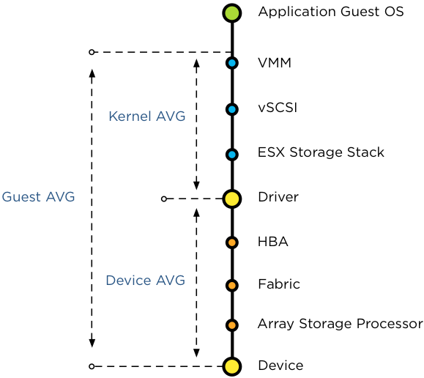

For further reading, review [this](https://frankdenneman.nl/2012/07/23/to-which-host-level-latency-statistic-is-the-sioc-congestion-threshold-related/) explanation by Frank, as that’s where I got the preceding diagram from.

|  |  |  |
| --- | --- | --- |
| Guest Average | **GAVG** | Guest here means VM, not Guest OS as the counter starts from VMM layer not Windows or Linux. |
| Kernel Average | **KAVG** | ESXi is good in optimizing the IO, so in a healthy environment, the value of Q Latency should be within 0.5 ms |
|  | **QAVG** | QAVG, which is queue in the kernel, is part of KAVG. If QAVG is high, check the queue depths at each level of the storage stack. [Cody](https://www.codyhosterman.com/about/) explains why QAVG can be higher than KAVG [here](https://www.codyhosterman.com/2018/03/what-is-the-latency-stat-qavg/). |
| Device Average | **DAVG** | The average time from ESXi physical card to the array and back. Typically, there is a storage fabric in the middle. The array typically starts with its frontend ports, then CPU, then cache, backend ports, and physical spindles. So if DAVG is high, it could be the fabric or the array. If the array is reporting low value, then it’s the fabric of the HBA configuration.  I’m unsure what DAVG measures when it’s vSAN and the data happens to be local. |

For each of the above 4 sets, you expect read latency, write latency and the combined latency. That means 12 counters and here are what they are called in vSphere Client UI:

|  |  |
| --- | --- |
| Device |  |
| Kernel |  |
| Queue |  |
| Guest | The counters are not prefixed with Guest, so they are simply called:   * Command Latency * Write Latency * Ready Latency |

With the above understanding, let’s validate with real world values.

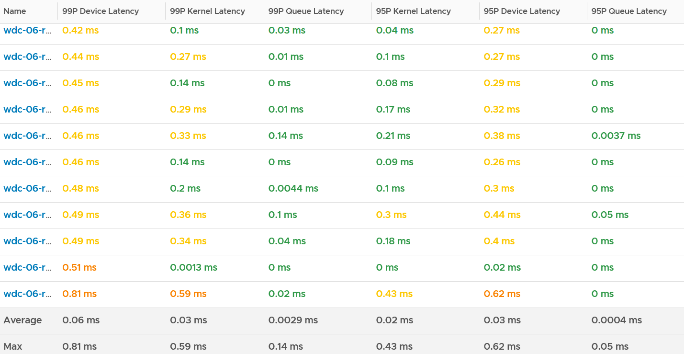

I chose the last ESXi since that’s the one with worst latency.

I plotted Kernel vs Device.

What do you notice? Can you determine which is which?

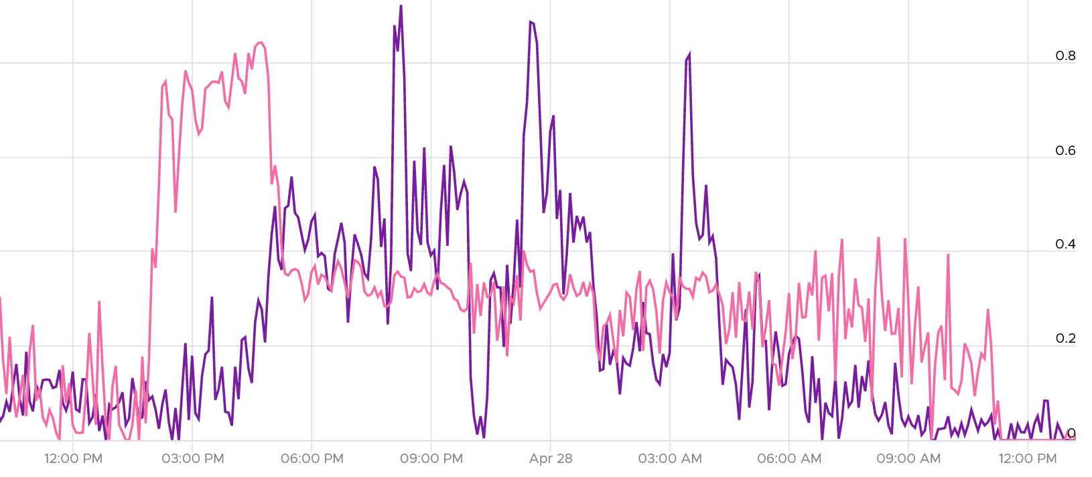

They don’t correlate. This is expected since both have reasonably good value (my expectation is below 0.5 ms).

The bulk of the latency should come from the Device. In a healthy environment, it should be well within 5 ms. With SSD, it should be even lower. As you can see below, it’s below 1.75 ms. Notice the kernel latency is 0.2 ms at all times except in 1 spike.

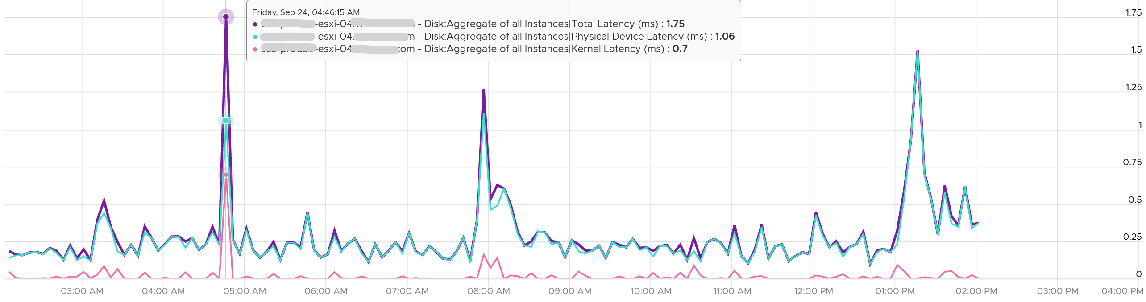

What about the Queue latency? It’s part of the kernel latency, so it will be 100% within it. When the kernel latency value is in the healthy range, the 2 values should correlate, as the value is largely dominated by the Queue. Notice the pattern below is basically identical.

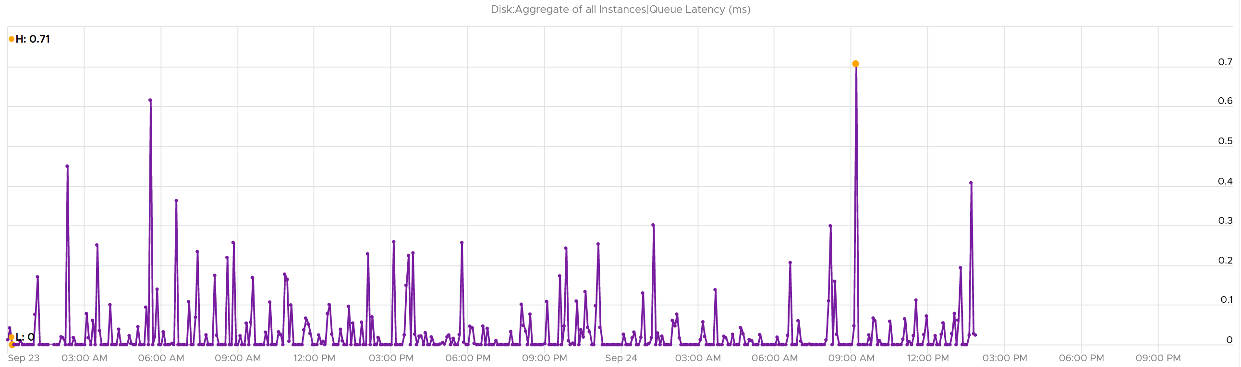

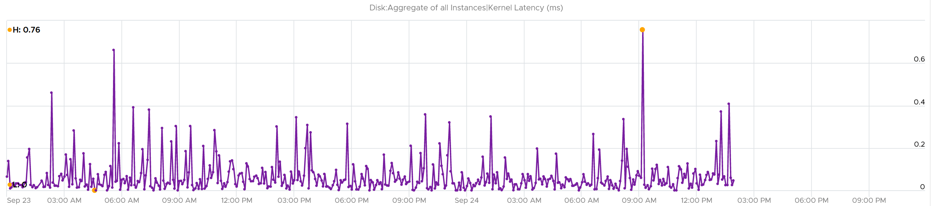

###### Other Counters

I find the value of Bus Resets and Commands Aborted are always 0

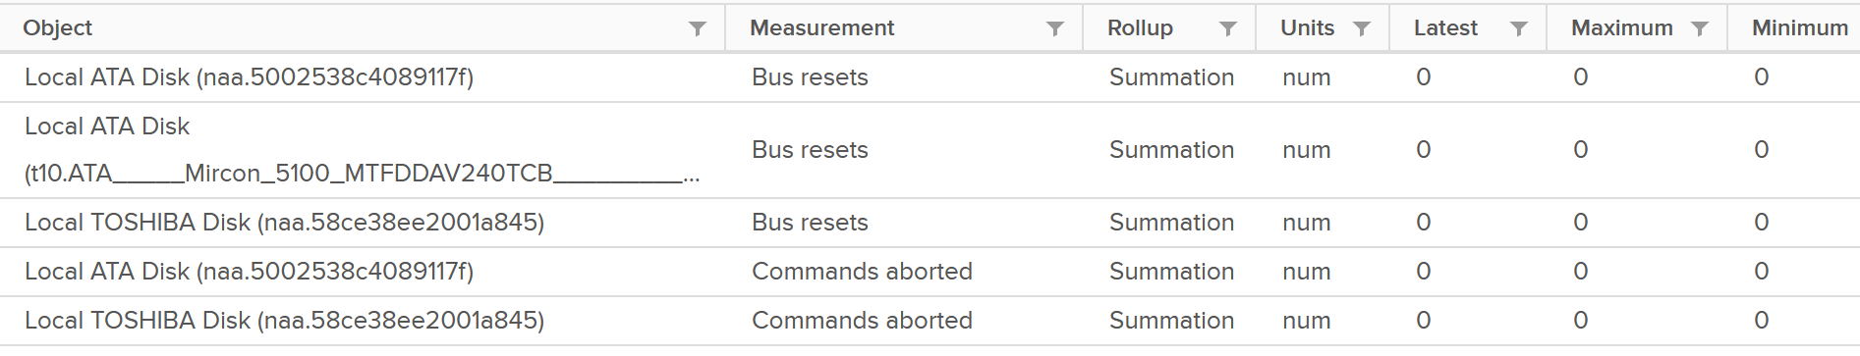

If you’ve seen a non zero let me know.

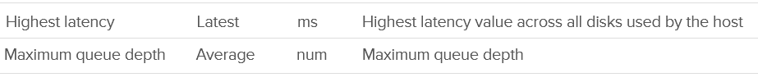

I’m not sure what highest latency refers to (Guest, Kernel, or Device).

Maximum Queue Depth is more of a property than a metric, as it’s a setting.

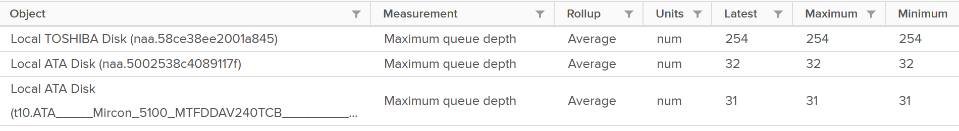

##### Consumption Counters

You get the standard IOPS and Throughput metrics.

|  |  |
| --- | --- |
| IOPS |  |
| Throughput | The counters names are   * Read Rate * Write Rate * Usage   All their units are in KB/s |
| Total IO | This is just the number of Read or Write in the time interval.  The counters names are   * Read Requests * Write Requests * Commands Issued |

#### Datastore

For shared datastore, the metrics do not show the same value with the one at datastore object. All these metrics are only reporting from this ESXi viewpoint, not the sum from all ESXi mounting the same datastore.

##### General metrics

For each datastore, you get the usual IOPS, throughput and latency. They are split into read and write, so you have 3 x 2 = 6 metrics in total. These are the actual names:

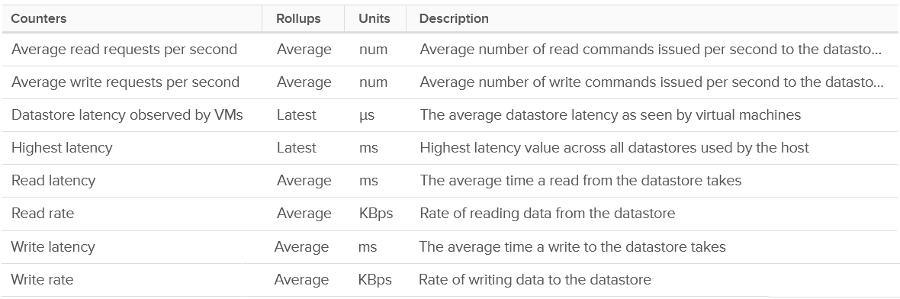

You also get 2 additional counters:

* Datastore latency observed by VMs
* Highest latency.

I plotted their values and to my surprise the metric Datastore latency observed by VMs is much higher. You can see the blue line below. It makes me wonder what the gap is as there is only VMkernel in between.

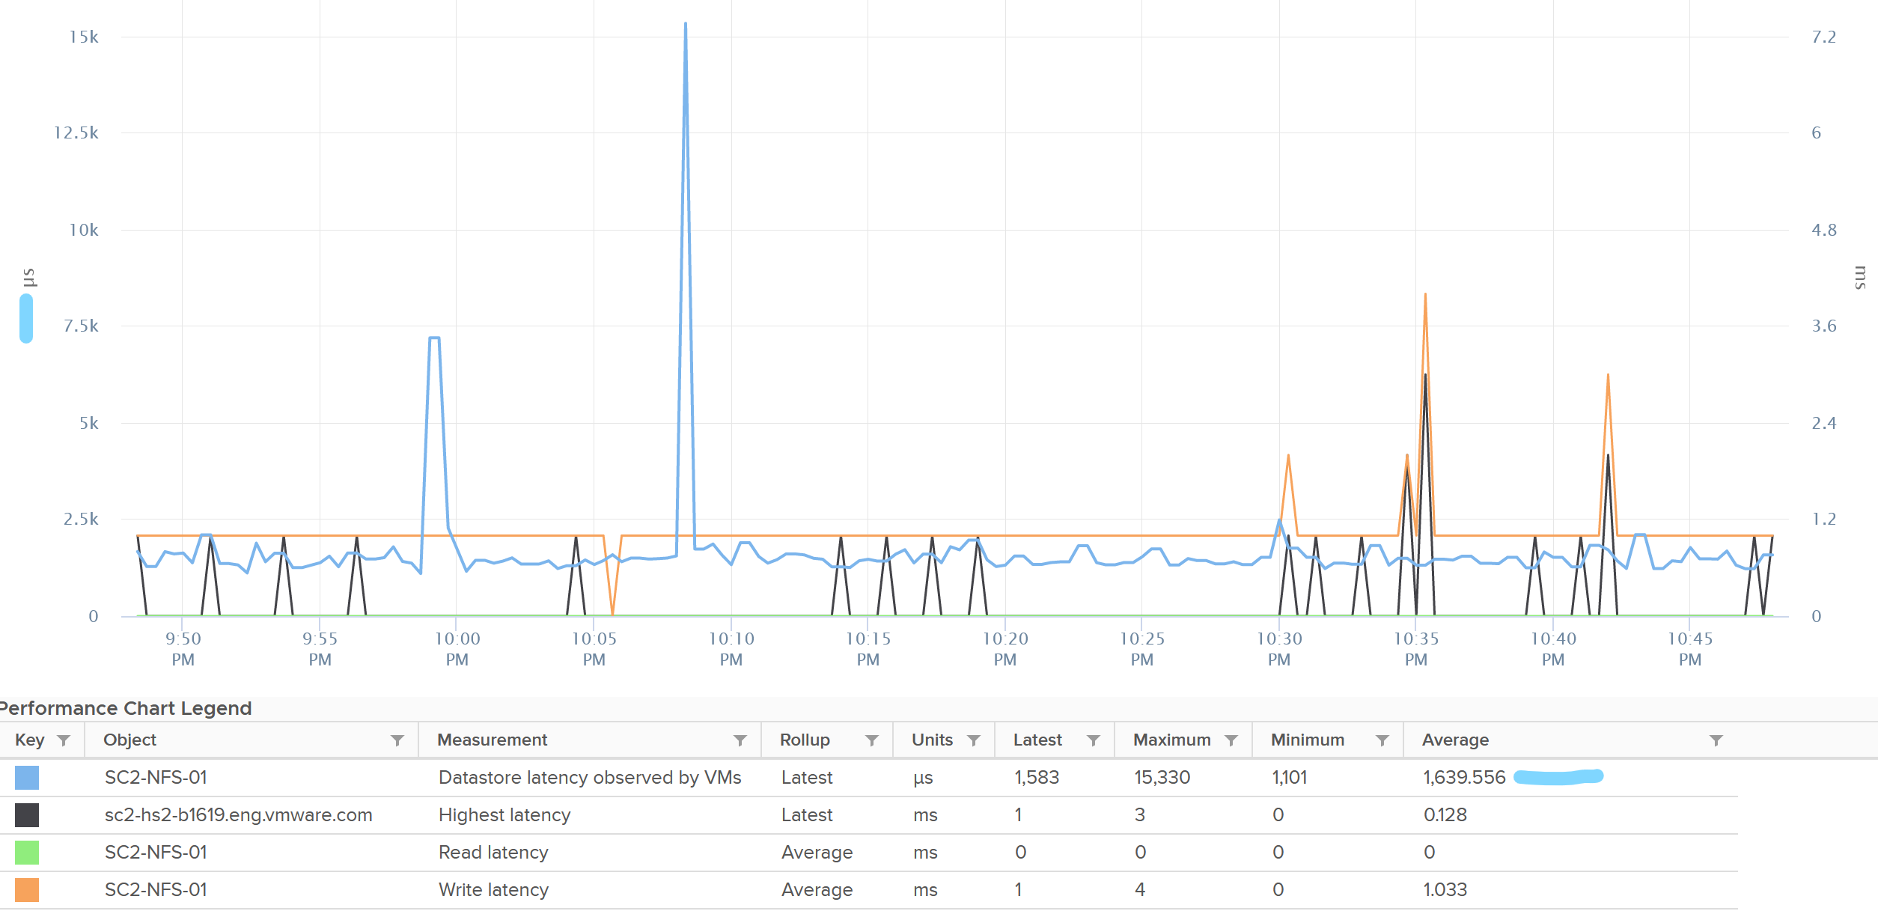

The metric Highest Latency is a normalized averaged of read and write, hence it can be lower.

There is no block size but you can derive it by dividing Throughput with IOPS.

###### Outstanding IO

You can derive the outstanding IO metric from latency and IOPS. I think latency counter is more insightful. For example, the following screenshot shows hardly any IO being in the queue:

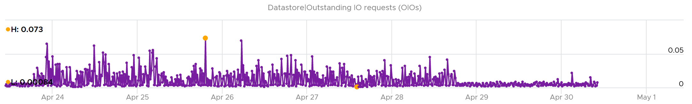

However, if you plot latency, you get same pattern of line chart but with higher value.

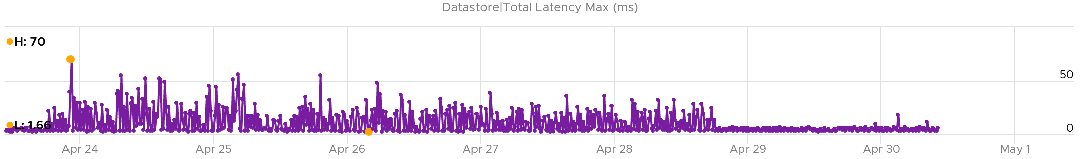

You can check whether it’s read or write by plotting each.

The following screenshot shows it’s caused by write latency. It’s expected if your read is mostly served by cache.

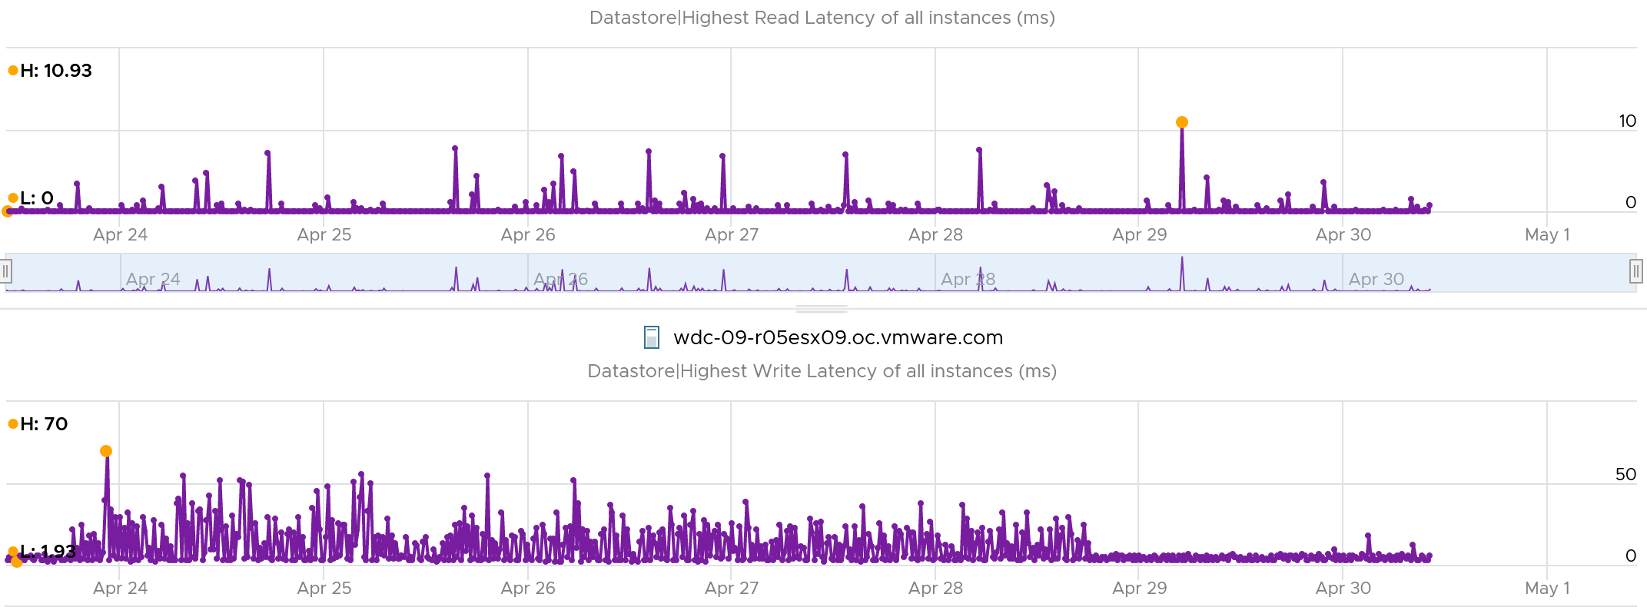

##### Queue Depth

You can also see the queue depth for each datastores. Ensure that the settings are matching your expectation and are consistent. You can list them per cluster and see their values.

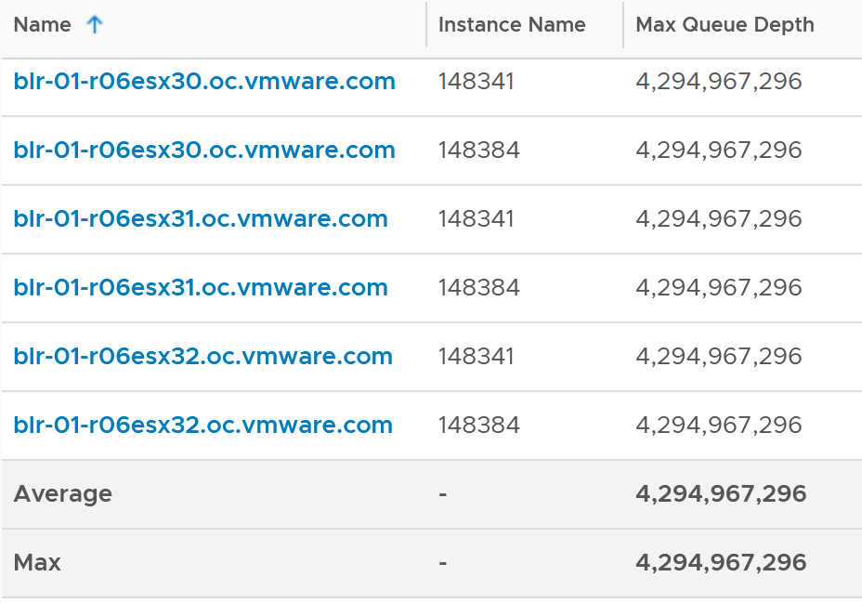

##### Unmapped

vSphere 7 provides observability into unmap.

They do not measure the potential amount to be reclaimed. They measure the unmap operations, both the IOPS generated by unmap operations and the amount being unmapped.



BTW, the counters are not available for vSAN datastore. The ESXi below is part of vSAN but the Target Objects only list non vSAN.

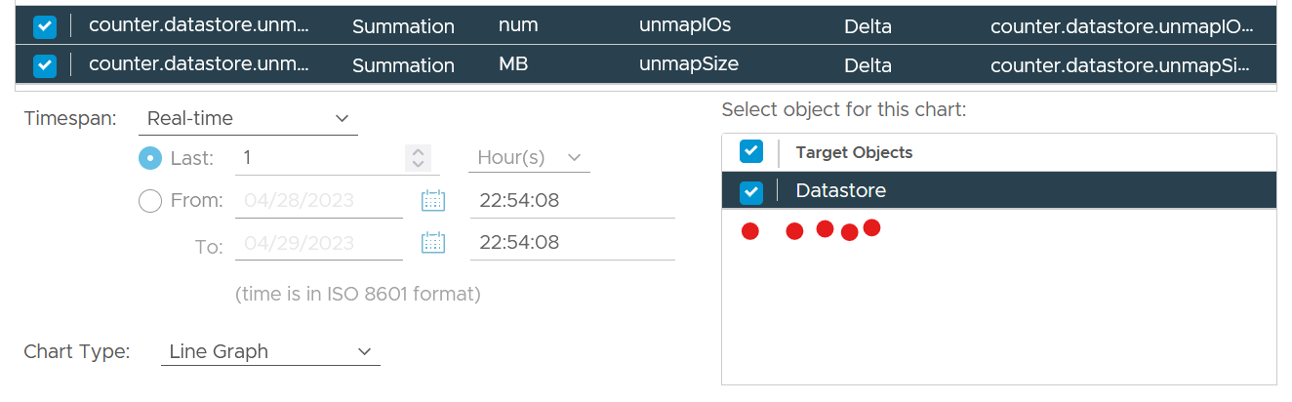

##### Storage DRS

vSphere Client also provides 10 metrics for storage DRS.

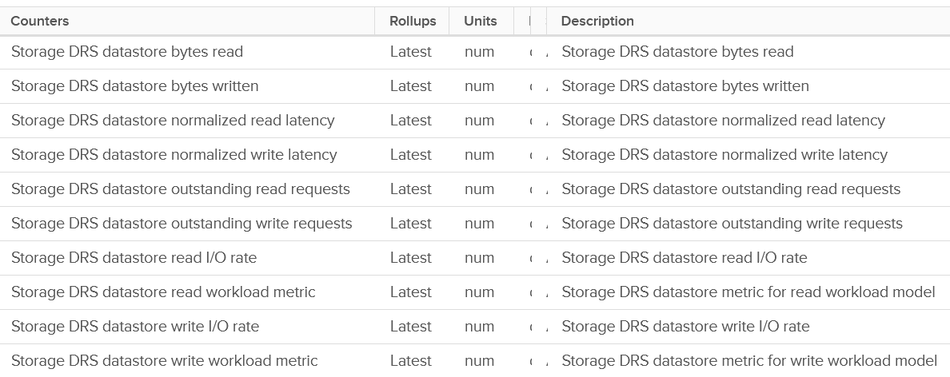

|  |  |
| --- | --- |
| Read latency | Name: Datastore normalized read latency |
| Write latency | Name: Datastore normalized write latency |
| Read IOPS | Name: Datastore read I/O rate |
| Write IOPS | Name: Datastore write I/O rate |
| Read OIO | Name: Datastore outstanding read requests |
| Write OIO | Name: Datastore outstanding write requests |

There is no throughput metric. Notice none of the units are in per-second. They are all count of something (unitless).

You also get total bytes read and written. If you divide this by the collection period, you get the throughput metric.

I’m not sure what workload metrics are. Is it in percentage? If yes, what is the 100% and how is it determined as that depends on many factors.

##### Storage IO Control

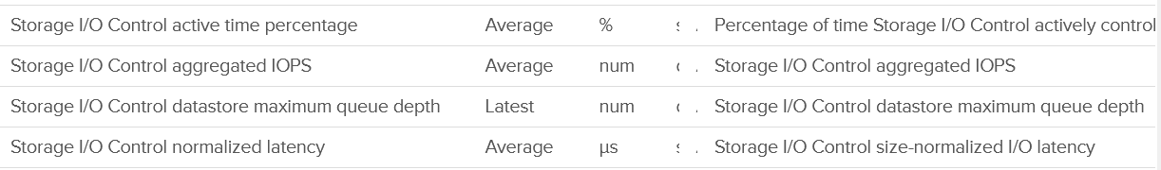

I profiled 47 ESXi and found they consistently doing ~18 IOPS when measured at 5 minute interval.

Take note the value for latency in wrongly shown as millisecond.

### Network

Just like the case for CPU, memory and disk, there are also 2 layers of networking. The virtual network does not have the limit that physical network does, if the traffic remains in the box. This makes it harder to use this metric as the 100% is not statically defined. So instead of just monitoring the throughput metric, you should also check the packet per second metric.

vSphere Client shows the 2 layers side by side (personally I prefer up and down, with the physical layer placed below).

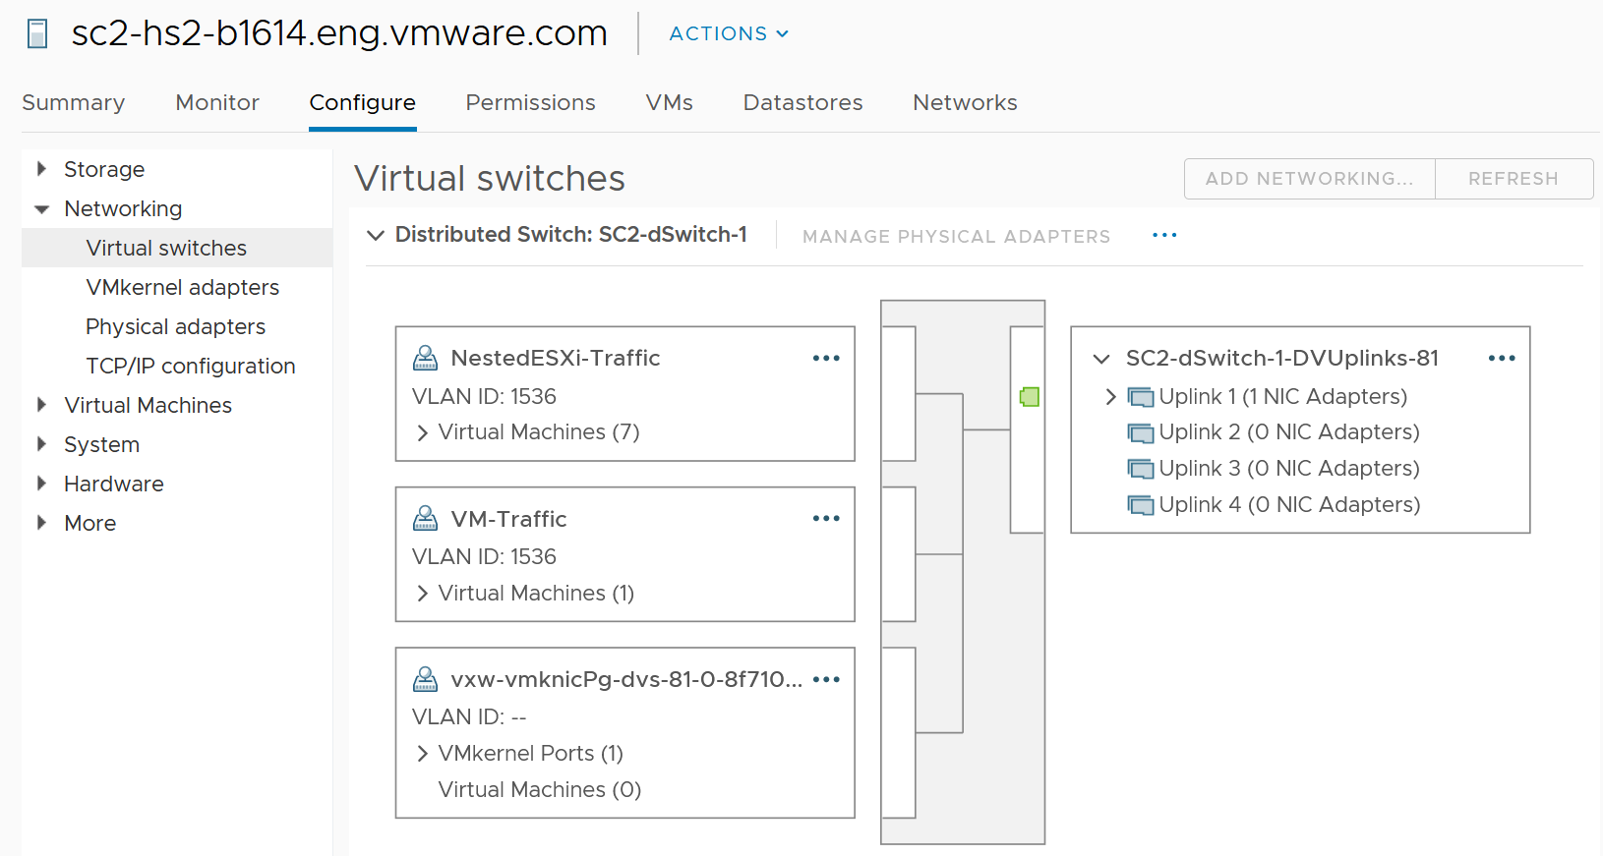

The 2 layers are the physical network and the virtual network:

* Virtual is the port groups.   
  There are 2 types: VMkernel and VM.   
  They do not mix, for security reason.  
  The VMkernel port group runs specific traffic, such as vMotion and vSAN.  
  The VM port group runs VM.
* Physical is the physical network card, although they are called vmnic. Metrics at this level do not have per-VM breakdown, or per VMkernel interface breakdown.

In vSphere Client, you can’t see the virtual network traffic. The following shows that you can only see the physical network card.

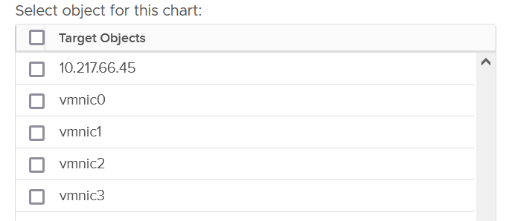

The metrics are provided at both physical NIC card and ESXi level. The counter at host level is basically the sum of all the vmnic instances. There could be small variance, which should be negligible.

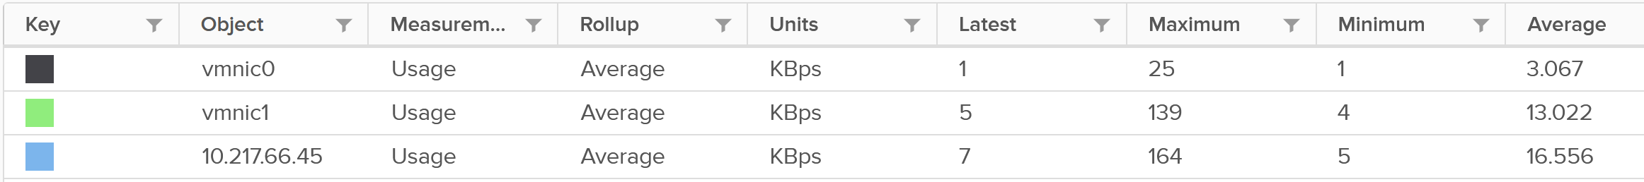

[e1 Aria Operations ?????

#### Bad Packets

As usual, the first thing to check if there is anything wrong. Compare with VM metrics, vCenter UI provides three additional metrics for ESXi. It can track Packet receive errors, Packet transmit errors, and Unknown protocol frames.

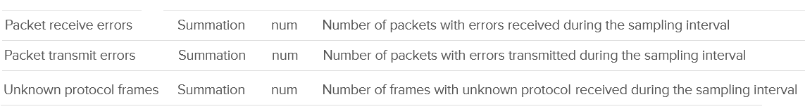

A packet is considered unknown if ESXi is unable to decode it and hence does not know what type of packet it is. You need to enable this metric in vRealize Operations as it’s disabled by default.

Expect these error packets, unknown packets and dropped packets to be 0 at all times. The following shows from a single ESX:

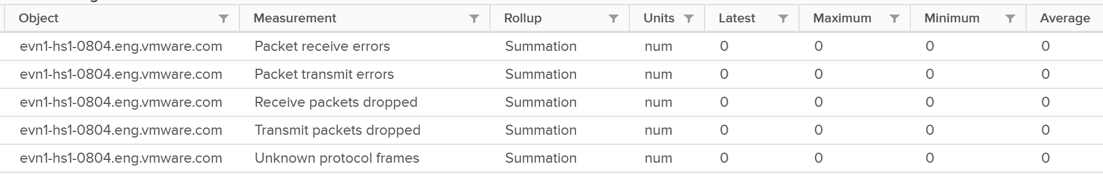

To see from all your ESXi, use the view “vSphere \ ESXi Bad Network Packets”.

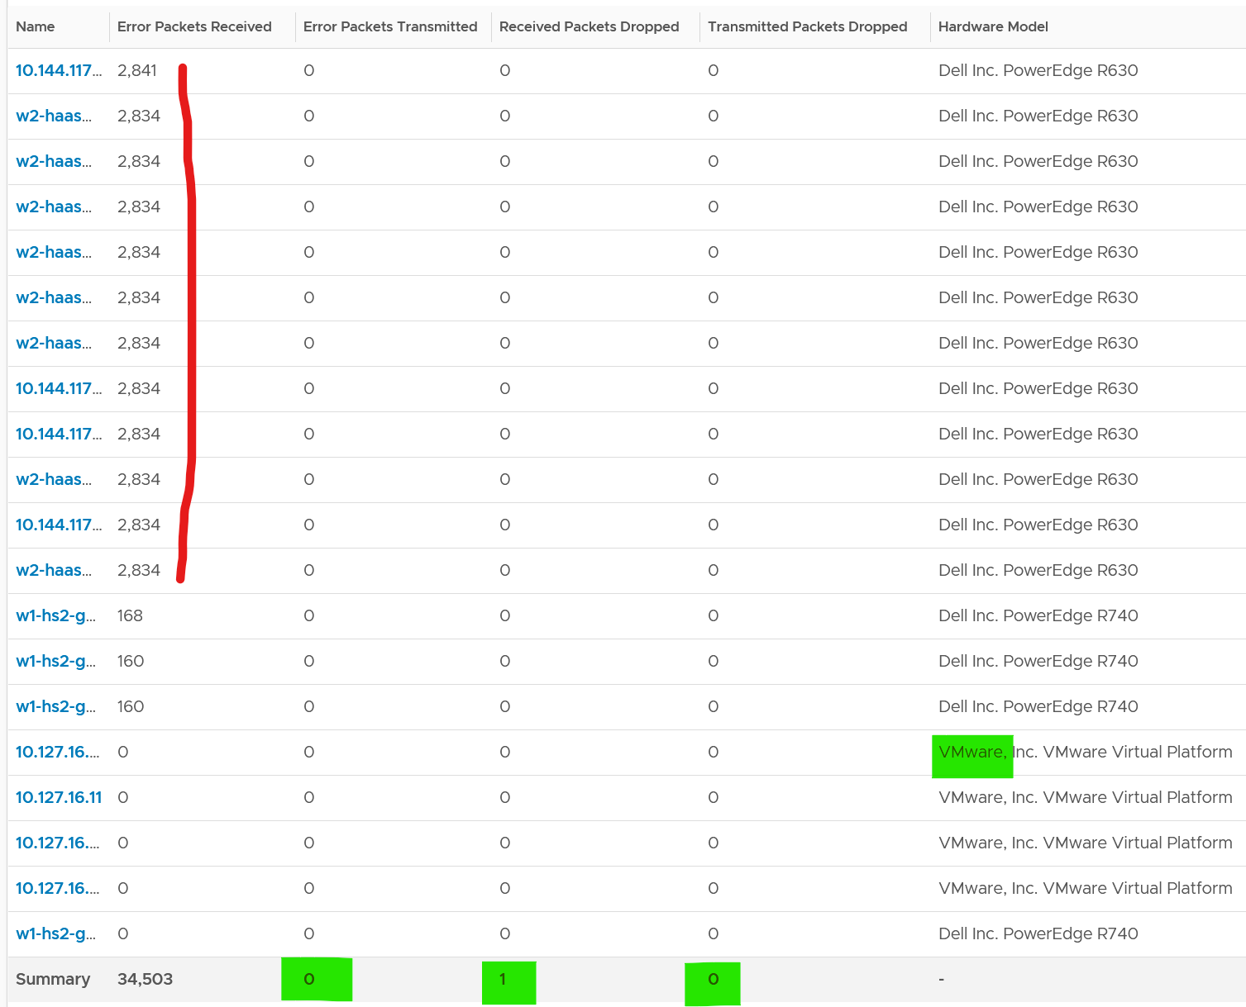

The hosts with error RX spans across different clusters, different hardware models and different ESXi build number. I can’t check if they belong to the same network.

If you see a value, drill down to see if there is any correlation with other types of packets. In the following example, I do not see any correlation

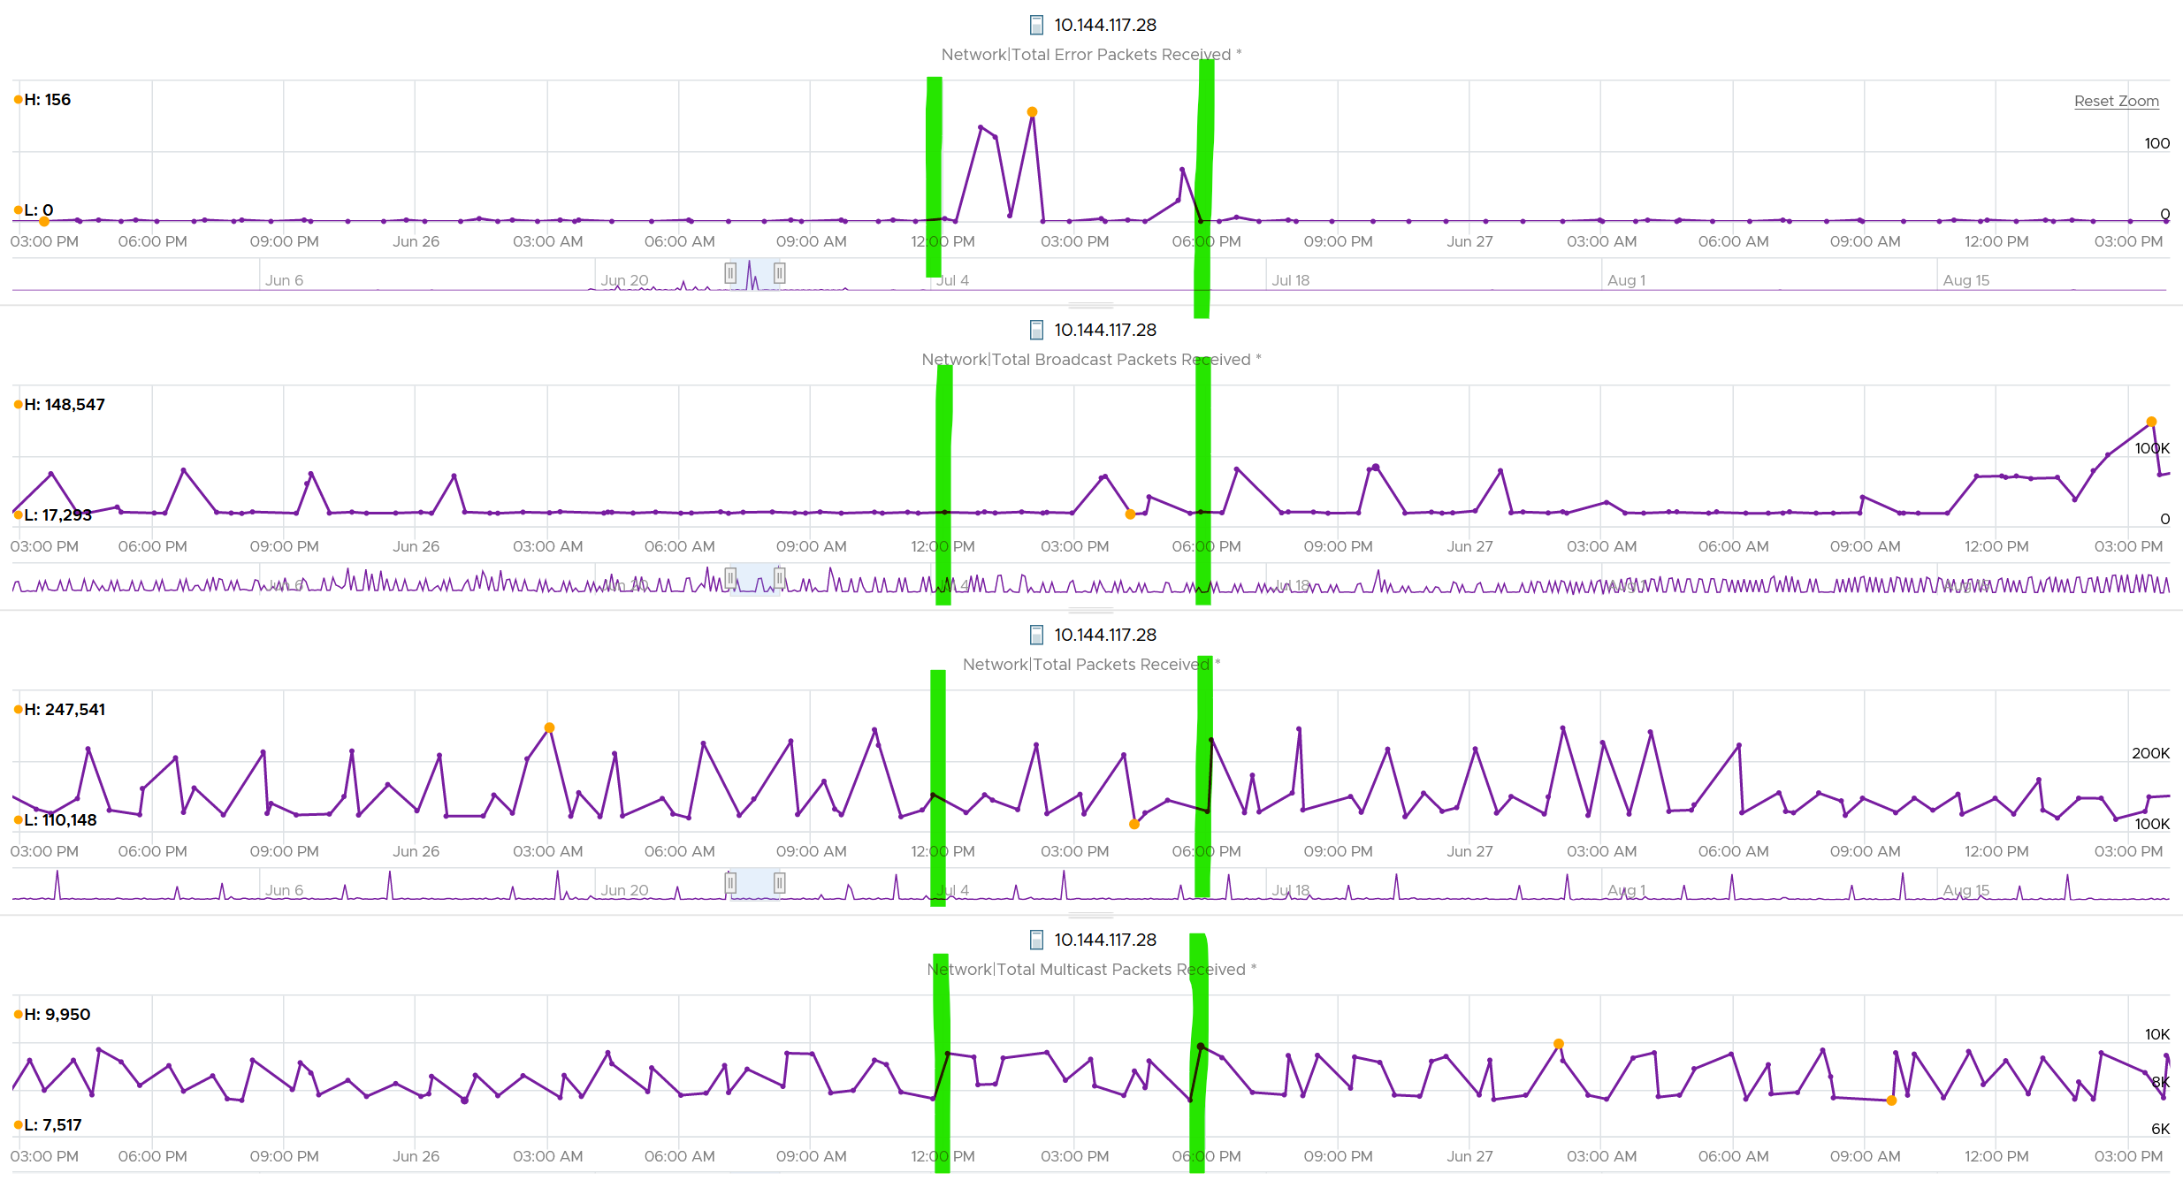

What I see though, is a lot of irregular collection. I marked with red dots some of the data collection.

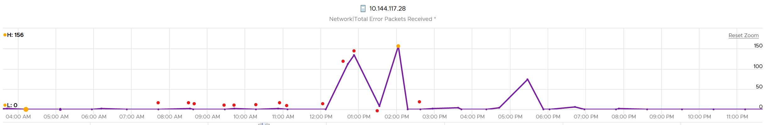

You can see they are irregular. Compare it with the Error Packet Transmit counter, which shows a regular collection.

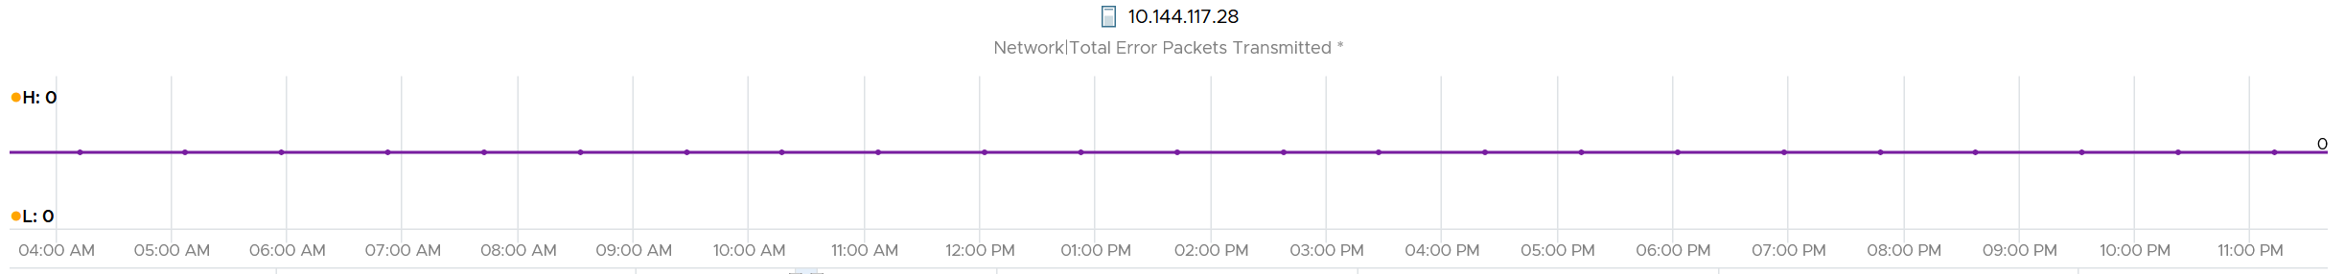

#### Dropped Packet

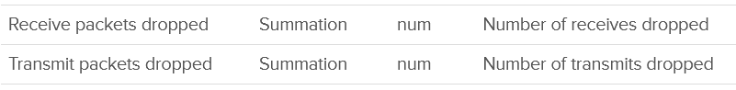

You’ve seen the dropped packet situation at VM. That’s a virtual layer, above the ESXi. What do you expect to see at ESXi layer, as it’s physically cabled to the physical top of rack switches?

I plotted 319 production ESXi hosts, and here is what I got for Transmit. What do you think?

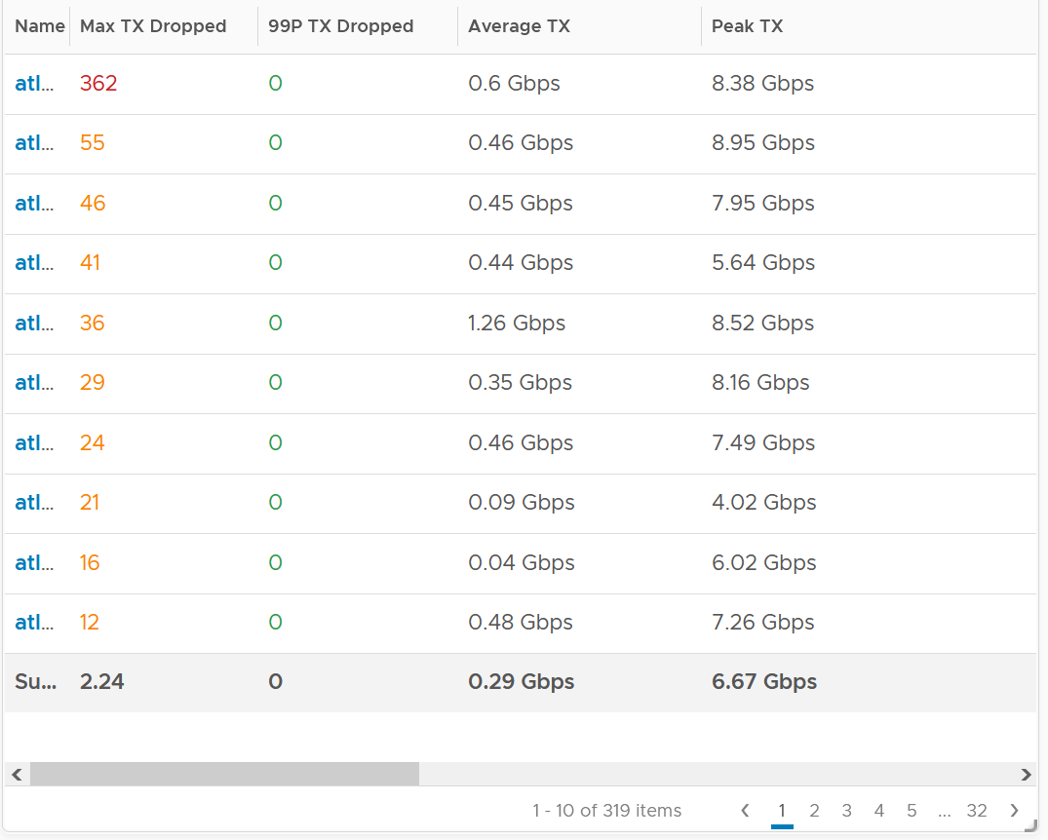

There are packet drops, although they are very minimal. Among 319 hosts, one has 362 dropped transmit packet in the last 3 months. That host was doing 0.6 Gbps on average and peaked at 8.38 Gbps.

As expected, the dropped packet rarely happened. At 99th percentile, the value is perfectly 0.

I tested with another set of ESXi hosts. Out of 123 servers, none of them has any dropped TX packet in the last 6 months. That’s in line with my expectation. However, a few of them experienced rather high dropped RX packets.

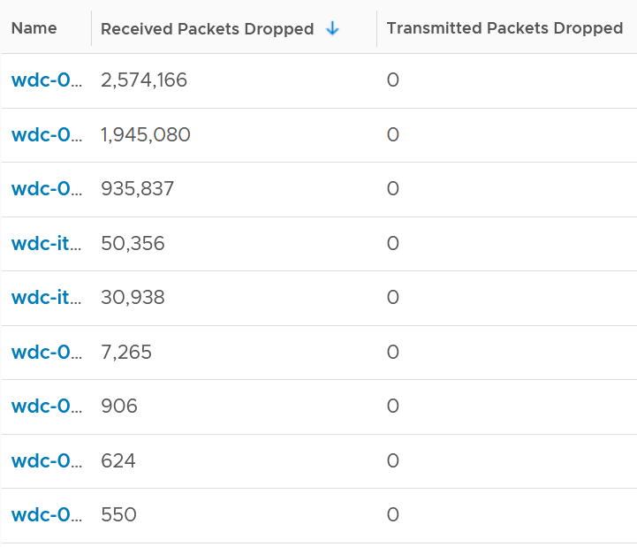

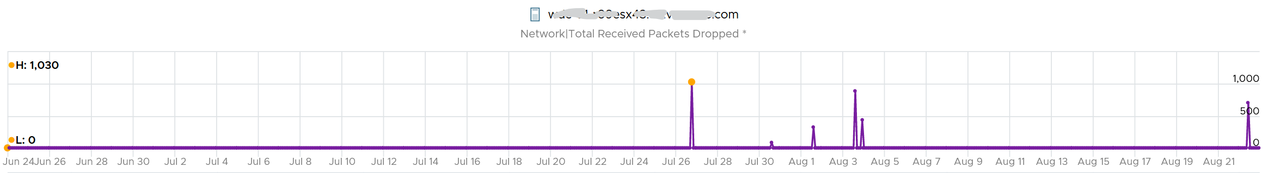

The dropped only happened since the ESXi had an increased load

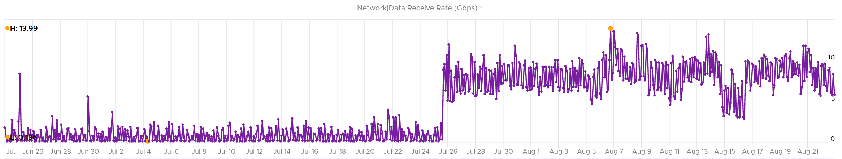

If you see something like this, you should investigate which physical NIC card is dropping packet, and which VMK interface is experiencing it.

While the number is very low, many hosts have packet drops, so my take is I should discuss with network team as I expect datacenter network should be free of dropped packets.

##### Received

What do you think you will see for Received?

Remember how VM RX is much worse than VM TX? Here is what I got:

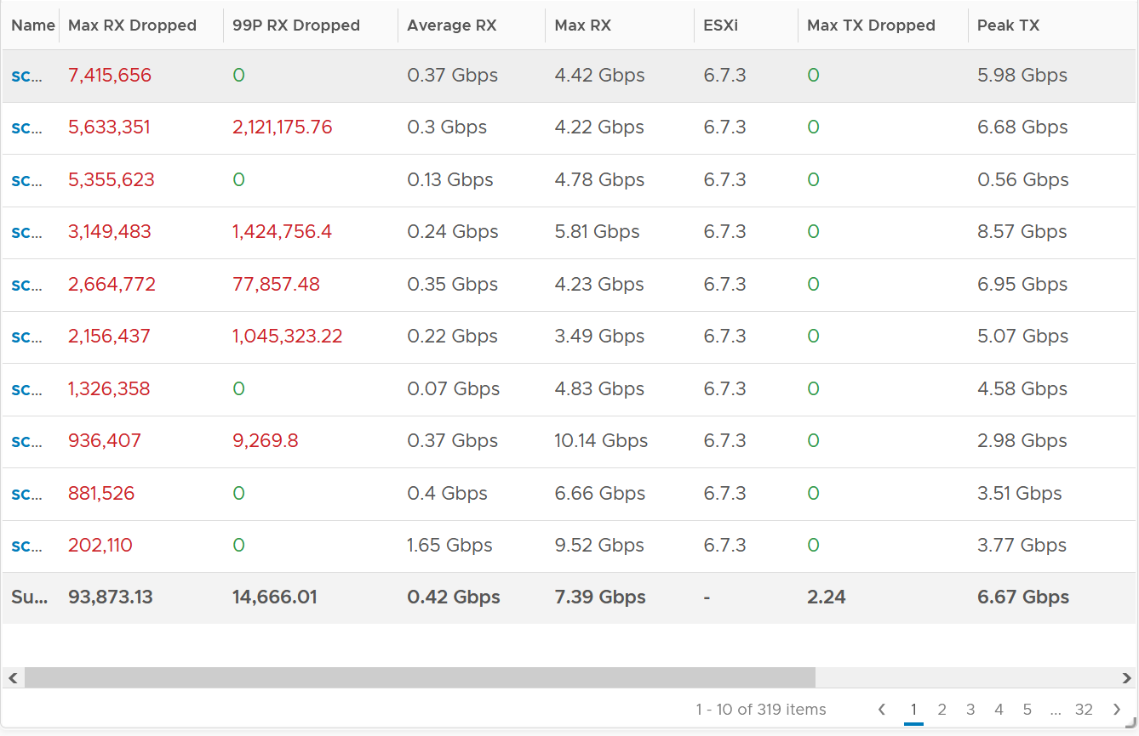

Surprisingly, the situation is the same for ESXi.

Some of them have >1 millions packet dropped in 5 minute. Within these set of ESXi, some have regular packet dropped, as the value at 99th percentile is still very high. Notice none of the ESXi is dropping any TX packet.

I plotted the 2nd ESXi from the table, as it has high value at 99th percentile. As expected, it has sustained packet dropped lasting 24 hours. I marked the highest packet drop time, as it mapped to the lowest packets received.

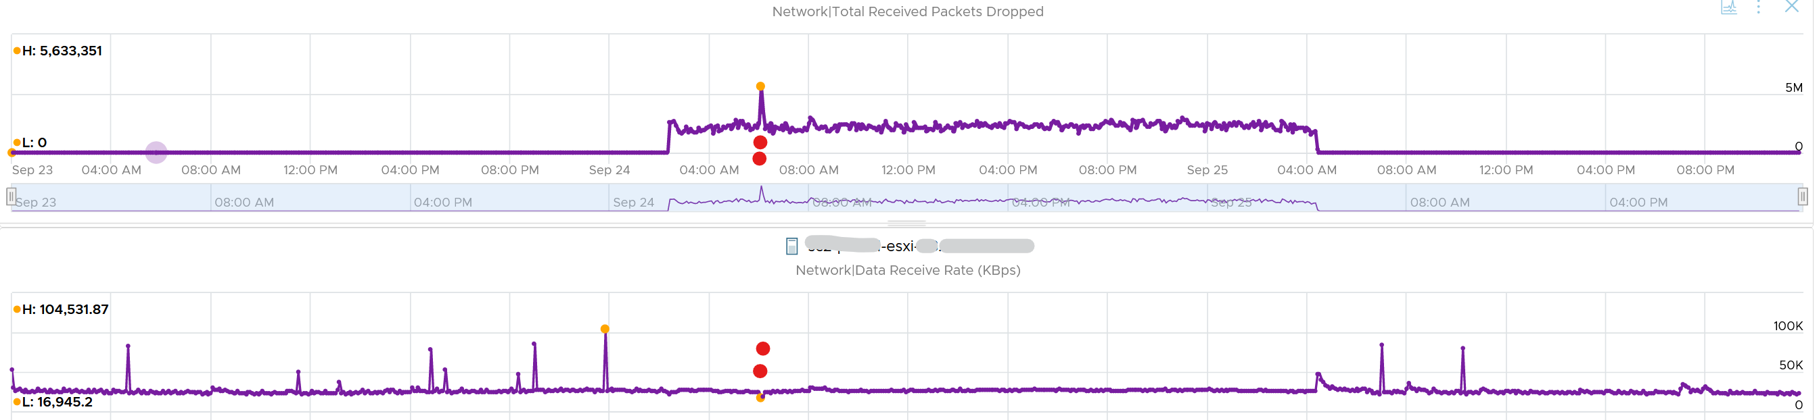

##### vsish

vsish provides more information that is not available in vSphere Client UI and vRealize Operations.

vsish -e get /net/portsets/DvsPortset-0/ports/67109026/clientStats

port client stats {

pktsTxOK:154121

bytesTxOK:63326625

droppedTx:0

pktsTsoTxOK:0

bytesTsoTxOK:0

droppedTsoTx:0

pktsSwTsoTx:0

droppedSwTsoTx:0

pktsZerocopyTxOK:45817

droppedTxExceedMTU:0

pktsRxOK:339700

bytesRxOK:257901191

droppedRx:2620 🡨 the reason will appear on the next output below

pktsSwTsoRx:0

droppedSwTsoRx:0

actions:0

uplinkRxPkts:0

clonedRxPkts:0

pksBilled:0

droppedRxDueToPageAbsent:0

droppedTxDueToPageAbsent:0

}

We saw dropped packets, so we probe deeper for the reason

vsish -e get /net/portsets/DvsPortset-0/ports/67109026/vmxnet3/rxSummary

stats of a vmxnet3 vNIC rx queue {

LRO pkts rx ok:0

LRO bytes rx ok:0

pkts rx ok:340093

bytes rx ok:257984247

unicast pkts rx ok:253678

unicast bytes rx ok:245663220

multicast pkts rx ok:42220

multicast bytes rx ok:7497292

broadcast pkts rx ok:44195

broadcast bytes rx ok:4823735

running out of buffers:2620 🡨 the reason for 2620 packets dropped

pkts receive error:0

1st ring size:512

2nd ring size:512 🡨 the ring size is on the small side. I’d say set to 2K.

# of times the 1st ring is full:354 🡨 this line shows the first ring is full 354x

# of times the 2nd ring is full:0

fail to map a rx buffer:0 🡨 other reasons look good

request to page in a buffer:0

# of times rx queue is stopped:0 🡨 other reasons look good

failed when copying into the guest buffer:0 🡨 other reasons look good

# of pkts dropped due to large hdrs:0

# of pkts dropped due to max number of SG limits:0

pkts rx via data ring ok:0

bytes rx via data ring ok:0

Whether rx burst queuing is enabled:0

current backend burst queue length:0

maximum backend burst queue length so far:0

aggregate number of times packets are requeued:0

aggregate number of times packets are dropped by PktAgingList:0

# of pkts dropped due to large inner (encap) hdrs:0

number of times packets are dropped by burst queue:0

number of times packets are dropped by rx try lock queueing:0

number of packets delivered by burst queue:0

number of packets dropped by packet steering:0

number of memory region lookup pass in Rx.:0

number of packets dropped due to pkt length exceeds vNic mtu:0

number of packets dropped due to pkt truncation:0

}

Networking VMs, such as firewall and routers, or any high VMs expecting high packet rates, check if the VM is requesting NetQ RSS.

#### Unusual Packets

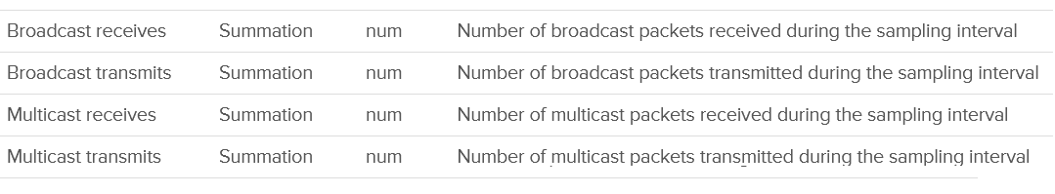

Your VM network should be mostly unicast traffic. So check that broadcast and multicast are within your expectation. Your ESXi Hosts should also have minimal broadcast and multicast packets.

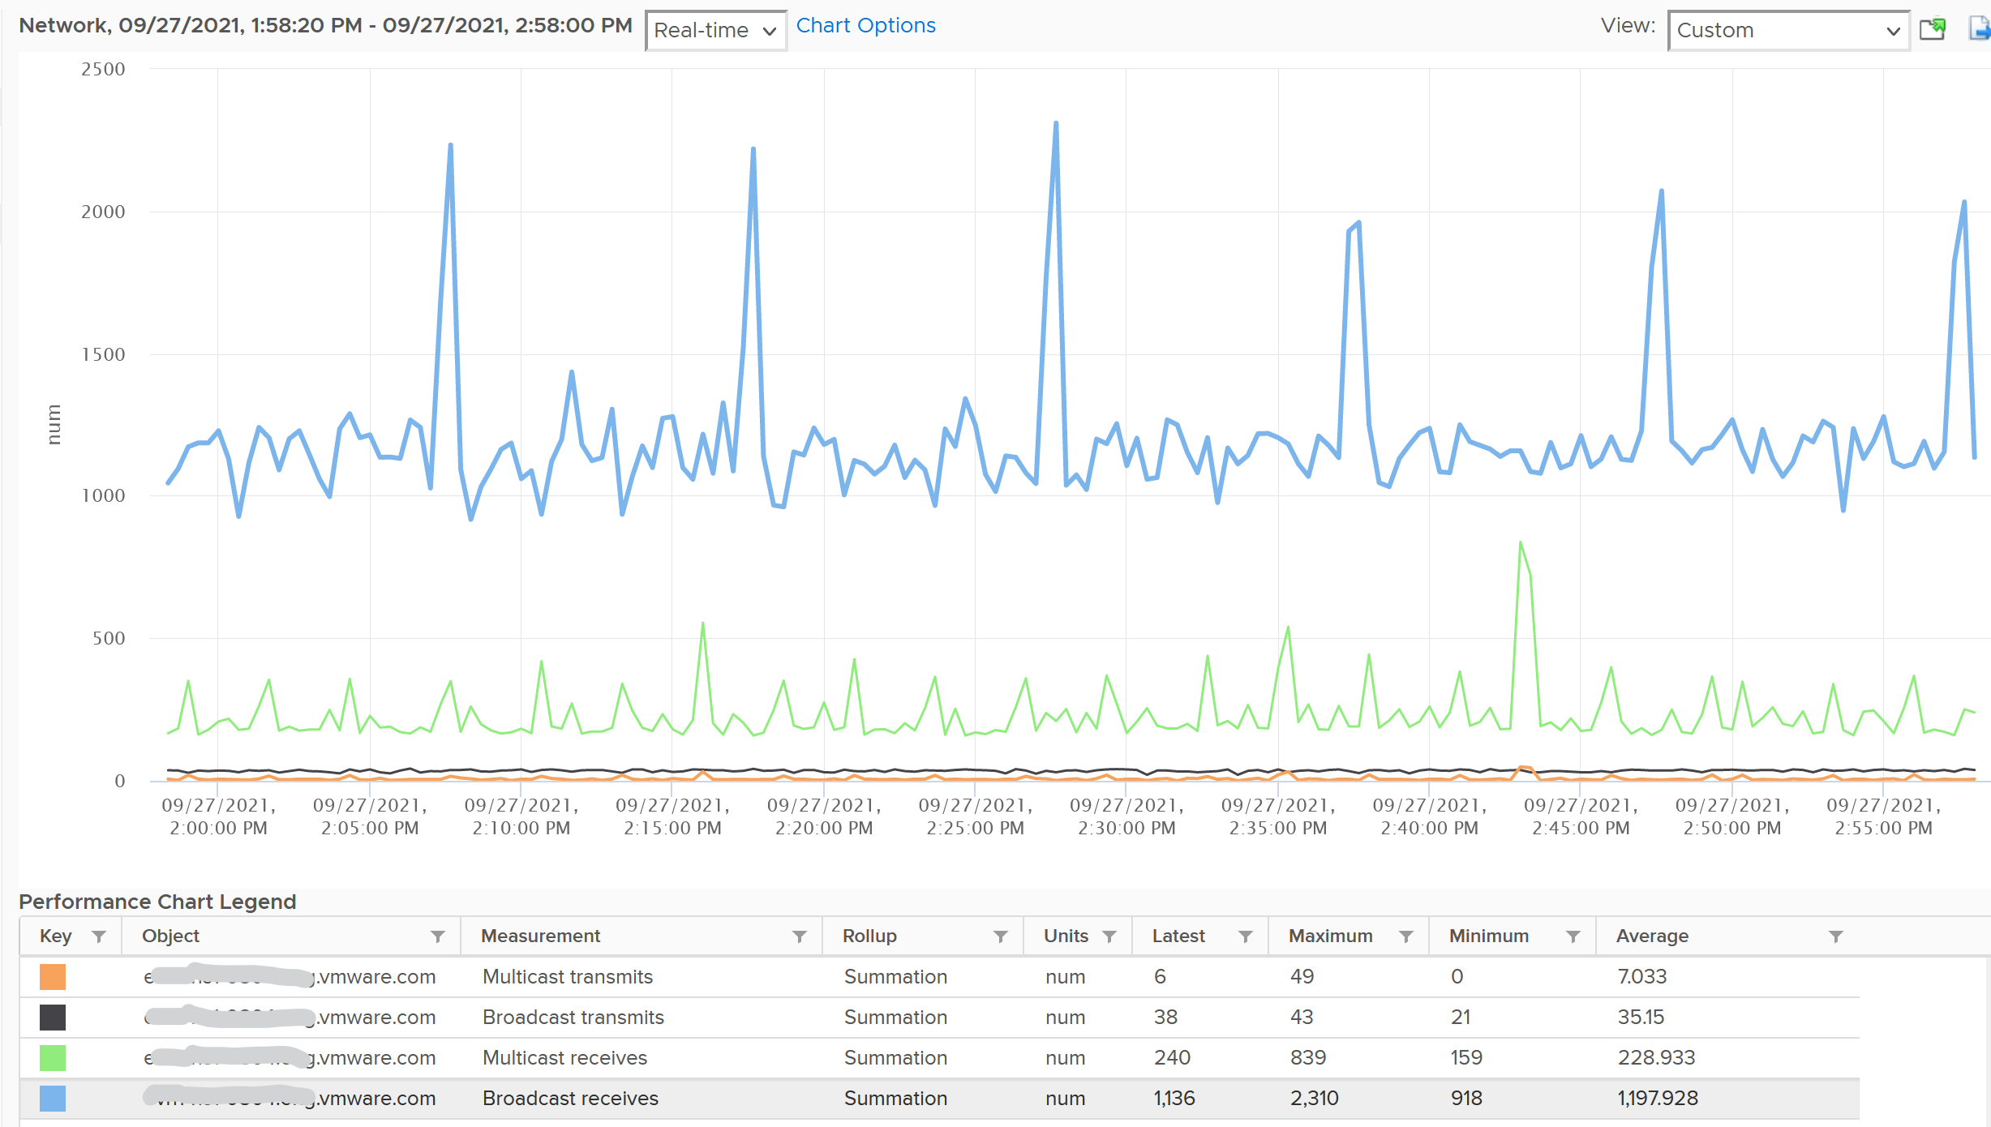

#### Consumption Metrics

The throughput (bandwidth consumption) metrics are:

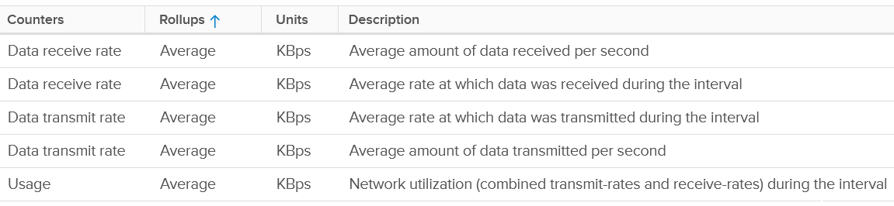

I’m unsure why there are duplicates metrics.

The packet per second metrics are:

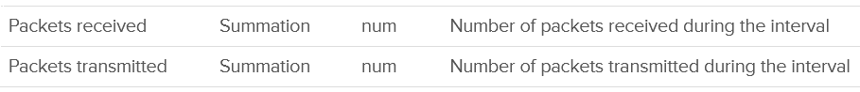

### esxtop

I put esxtop under ESXi as it is about a single ESXi at a time. The metric covers both the ESXi and its running VMs. While the manual uses the term Guest, esxtop does not actually have any Guest OS metrics. You should distinguish between Guest OS and VM.

The view from a VM (consumer) and the view from ESXi (provider) are different. vCPU is construct of a VM, while core and thread are construct seen by ESXi. I hope future version of esxtop segregates this better. You get to see both VM level and ESXi level objects at the same time. It is confusing for newbie, but convenient for power user, and if you’re looking at esxtop, you are a power user 😊

Now that we have covered many of the metrics, the esxtop output would be easier to understand. This documentation is not about how to use esxtop, but about what the metrics mean and their relevance in operations management.

The nature of esxtop meant it is excellent for performance troubleshooting, especially real time and live situation where you know the specific ESXi Host. The tool is not so suitable for capacity management, where you need to look at long term (often weeks or months). As a result, I cover the contention metrics first, followed by consumption.

I have not had the need to use some of the metrics, hence I don’t have much guidance on them. If you do, let’s collaborate.

#### Grouping

The esxtop screen groups the metrics into 10, as shown below:

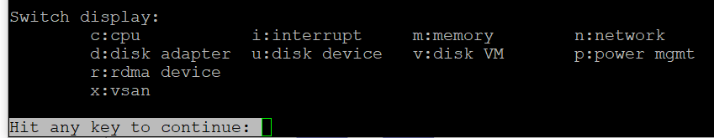

There are relationships among *some* of the 10 panels, but they are not obvious as the UI simply presents them as a list. To facilitate understanding of the metrics, we need to group them differently.

So instead of documenting the 10 panels, I’d group them into 4.

|  |  |  |  |
| --- | --- | --- | --- |
| **Group** | **Consumer** | **Provider** | **Remarks** |
| CPU | Yes | Sort of | The CPU panel has a 4 line summary that provides the provider’s viewpoint.  I moved Power Management panel here as it only covers CPU. It does not cover memory, disk, network and other parts of the box (e.g. fan, motherboard). It complements the CPU panel as it covers the provider’s viewpoint. Take note that it does not show at socket level. And if you enable HT, it does not show at core level.  I moved interrupt panel here as it’s about CPU. |
| Memory | 1 shared panel for both | | Provider and Consumer are shown in 1 panel. The panel has a summary at the top, which cover the provider’s viewpoint |
| Storage | Yes | Almost | The Disk VM panel covers from consumer’s viewpoint.  The Disk Adapter panel and Disk Device panel cover from provider’s viewpoint, and are best to be analyzed together.  BTW, do you notice the Path panel is missing?  I moved vSAN panel here as all the metrics are disk metrics. There is no vSAN network and CPU counter, but you can see them in the respective network and CPU panel. |
| Network | 1 shared panel for both | | Provider and Consumer are shown in 1 panel  I moved RDMA device here as it’s about network card |

#### CPU

The CPU panel begins with a summary of the load average in the last 1 minute, 5 minute and 15 minutes, respectively. As shared, utilization is a secondary counter, supporting contention. So focus on contention first before looking at these 3 numbers. In addition, in a large ESXi with many cores, an imbalance can mask out a busy core.



The next 3 lines covers Used (%), Utilization (%) and Core Utilization (%). The reason why I swapped the order in the book is Used (%) is built upon Utilization, and it’s a more complex counter.

The white vertical line shows where I cut the screenshot, as the text became too small and unreadable if I were to include all of them. Anyway, it’s just repeating for each CPU thread.

At the end of each 3 lines (after the white line in preceding screenshot), there are NUMA information. It shows the average value across each NUMA node (hence there are 2 numbers as my ESXi has 2 NUMA nodes). The number after **AVG** is the whole box, system wide average. The per NUMA node metric values are useful to easily identify if a particular NUMA node is overloaded.

Take a look at the panel below. It mixes VM and non VM processes in a single table.

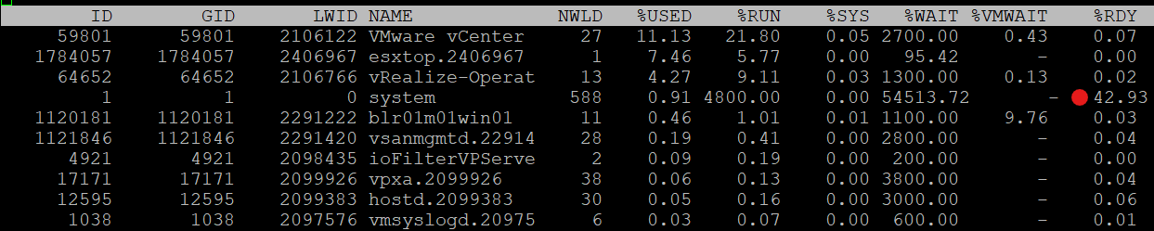

If you want to only show VMs, just type the capital letter **V**.

* Name based filtering allows [regular expression](https://en.wikipedia.org/wiki/Regular_expression) based filtering for groups and worlds.
* Type the capital letter **G** to only show groups that match given string. This is useful when a host has large number of VMs and you want to focus on a single or set of interesting VMs.
* Once a group is expanded you can type the small letter **g** to show only the worlds that match the given string. This is useful when running a VM with many vCPUs and you want to focus on specific worlds like storage worlds or network worlds.

If you want to see all, how to tell which ones are VM? I use %VMWAIT column. This tracks the various waits that VM world gets, so it does not apply to non VM.

Notice the red dot in the picture. Why the Ready time is so high for system process?

Because this group includes the idle thread. Expand the GID and you will see Idle listed.

There are many columns, as shown below. The most useful one is the %State Times, which you get by pressing **F**.

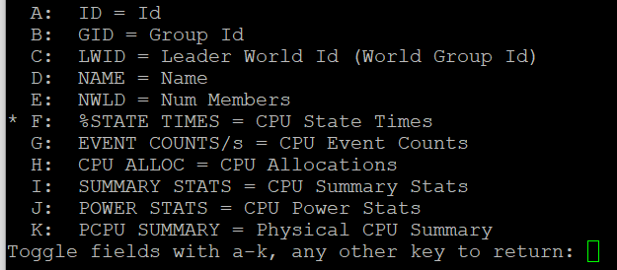

The rest of the information are relatively static or do not require sub-20 second granularity.

##### CPU State

We covered earlier in the CPU Metric that there are only 4 states. But esxtop shows a lot more metrics.

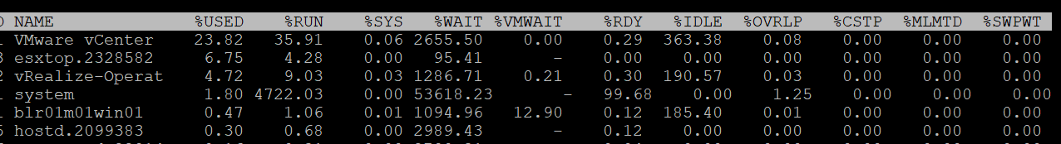

So what does it mean? How come there are more than 4 states?

The answer is below. Some of these metrics are included in the other metrics.

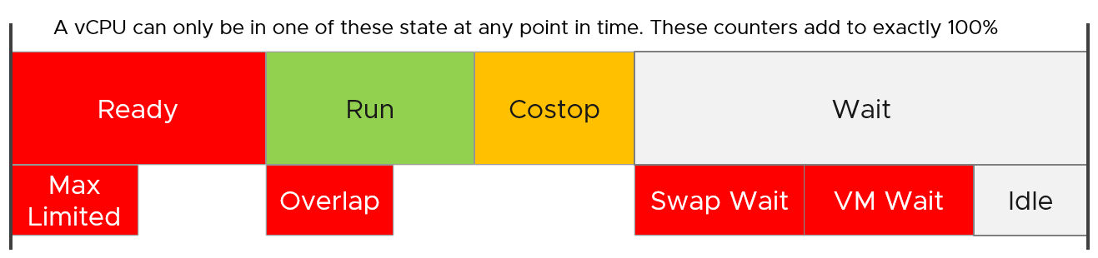

Review the metrics below, starting with %USED. Which one does *not* actually belong to a CPU state, meaning it’s not something you mix with the rest?

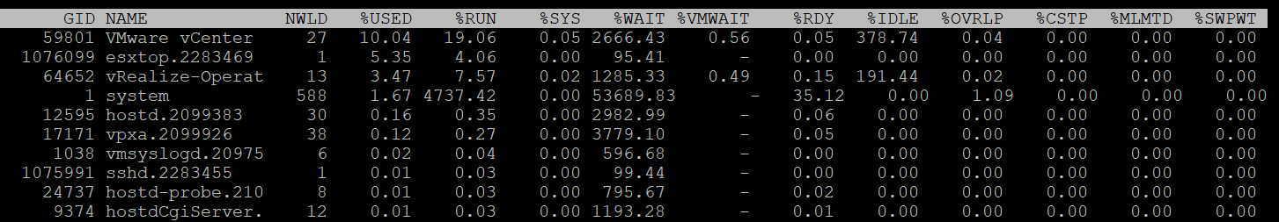

That’s right, it’s %USED.

|  |  |
| --- | --- |
| %USED | It should be excluded from this panel as it is influenced by power management and hyperthreading. We explained the reason why in CPU Metric chapter. That’s why it’s necessary to review the VM CPU states before reading each esxtop metric. |
| %RUN | Run is covered in-depth here under VM CPU Metrics. |
| %SYS | System time is covered in-depth here under VM CPU Metrics. |
| %WAIT | The wait counter and its components are covered in-depth here under VM CPU Metrics.  VMWAIT includes SWPWT. vRealize Operations does not show VM Wait and uses a new counter that excludes Swap Wait. The reason is the remediation action is different. You’re welcome. |
| %VMWAIT |
| %SWPWT |
| %IDLE |
| %RDY | Ready is covered in-depth here under VM CPU Metrics. As discussed in the CPU scheduling, each vCPU has its own ready time. In the case of esxtop, the metric is simply summed up, so it can go >100% in theory. |
| %CSTP | Co-Stop is covered in-depth here under VM CPU Metrics. This is also 100% per vCPU. |
| %OVRLP | Overlap is covered in-depth here under VM CPU Metrics. |
| %MLMTD | MLMTD is Max Limited, not some Multi Level Marketing scam 😊. It measures the time the VM was halted due to manual limit, as opposed to VMkernel has no CPU resource. |

##### CPU Event Count

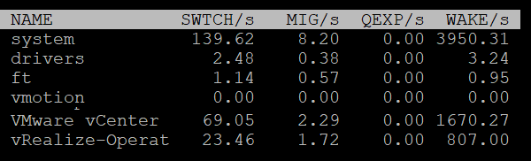

|  |  |
| --- | --- |
| SWTCH/s | Number of world switches per second, the lower the better. I guess this number correlates with the overcommit ratio, the number of VM and how busy they are.  What number will be a good threshold and why? |
| MIG/s | Number of NUMA and core migrations per second. It will be interesting to compare 2 VM, where 1 is the size of a single socket, and the other is just a bit larger. Would the larger one experience a lot more switches? |
| WAKE/s | Number of time the world wakeups per second. A world wakes up when its state is changes from WAIT to READY. A high number can impact performance. |

The metric QEXP/s (Quantum Expirations per second) has been deprecated from ESXi 6.5 in an effort to improve vCPU switch time.

In rare case where the application has a lot of micro bursts, CPU Ready can be relatively higher to its CPU Run. This is due to the CPU scheduling cost. While each scheduling is negligible, having too many of them may register on the counter. If you suspect that, check esxtop, as shown below:



##### Power Stats

This complements the power management panel as it lists per VM and kernel module, while the power panel lists per ESXi logical CPU.

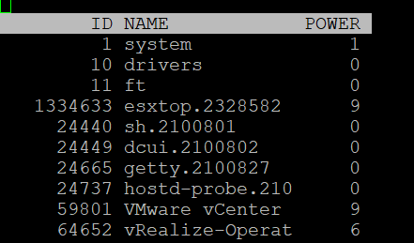

|  |  |
| --- | --- |
| POWER | Current CPU Power consumption in Watts. So it does not include memory, disk, etc. |

##### Summary Stats

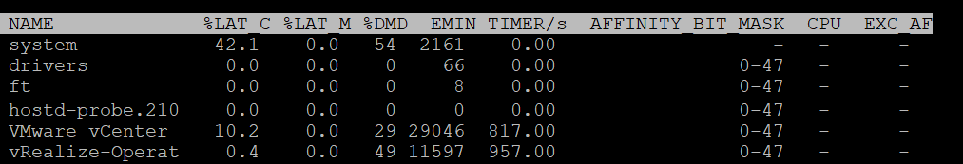

Other than the first 3 (which I’m unsure why they are duplicated here as they are shown in the CPU State already), the other metrics do not exist in vSphere Client UI and vRealize Operations.

|  |  |
| --- | --- |
| %LAT_C | This is covered in-depth here: CPU Contention |
| %LAT_M | This is covered in-depth here: Memory contention |
| %DMD | This is covered in-depth here: CPU Demand |
| EMIN | This is the minimum amount of CPU in MHz that the world will get when there is not enough for everyone. |
| TIMER/s | Timer rate for this world |
| AFFINITY BIT MASK | Bit mask showing the current scheduling affinity for the world.  Not set for Latency Sensitive = High VMs |
| CPU | The physical or logical processor on which the world was running when esxtop obtained this information. I’m not 100% as this is always blank for me |
| EXC_AF | Yes means the VM has exclusive affinity. This happens when you enabled the Latency Sensitivity setting. Use this feature very carefully. |

The column HTQ is no longer shown in ESXi 7.0. In earlier release, this indicates whether the world is quarantined or not. ‘N’ means no and ‘Y’ means yes.

##### CPU Allocation

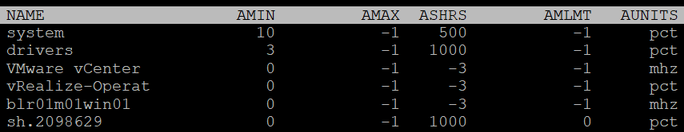

|  |  |
| --- | --- |
| AMIN | Allocation Minimum. Basically, the reservation |
| AMAX | Allocation Maximum. Basically, the limit. |
| ASHRS | Allocation shares |
| AMLMT | Max Limited. I’m unsure if this is when it’s applied or not. |
| AUNITS | Units. For VM, this is in MHz. For VMkernel module, this is in percentage. |

##### Power Consumption

Power management is given its own panel. This measures the power consumption of each physical thread. If you disable hyper-threading, then it measures at physical core

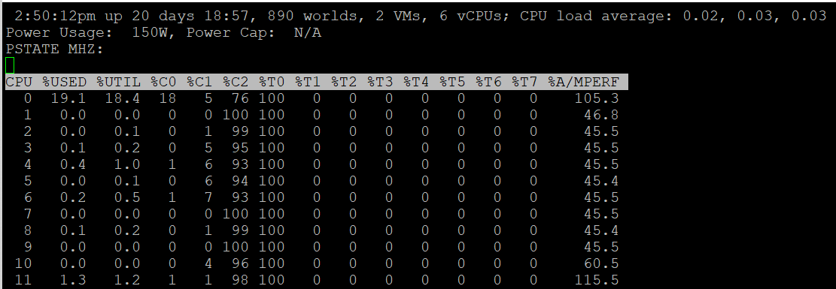

The Power Usage line tracks the current total power usage (in Watts). Compare this with what the hardware specification. Power Cap shows the limit applied. You only do this hard limit when there is insufficient power supply from the rack.

The PSTATE MHZ line tracks the CPU clock frequency for each state.

Now let’s go into the table. It lists all the physical core (or thread if you enable HT). Note it does not group them by socket.

|  |  |
| --- | --- |
| %USED | Used (%) metric is covered in-depth here under ESXi CPU metric section. |
| %UTIL | Utilization (%) metric is covered in-depth here under ESXi CPU metric section. |
| %CState | Percentage of time spent in a C-State, P-State and T-State.  Power management is covered here under ESXi CPU metric section. |
| %TState |
| %A/Mperf | Actual / Measured Performance, expressed in percentage. The word measured in this case means the nominal or static value. So a value above 100% means Turbo, while a value below 100% means power saving kicked in. If this number is not what you are expecting, check the power policy settings in BIOS and ESXi |

The following screenshot shows ESXi with 14 P-States, where P0 is represented as 2401 MHz. Each row is a physical thread as HT is enabled.

See PCPU 10 and 11 (they share core 6). What do you notice?



Utilization (%) shows 100% for both. This means both threads run, hence competing.

The core is in Turbo Boost. The %A/MPERF shows frequency increase of 30% above nominal. The core is in C0 state and P0 state. [This](https://www.vmware.com/content/dam/digitalmarketing/vmware/en/pdf/techpaper/performance/whats-new-vsphere65-perf.pdf) counter was introduced in ESXi 6.5. No they are not in vSphere Client UI.

Why is Used (%) for PCPU 10 and 11 are showing ~63% and 62.9%?

Unlike Utilization (%) which adds up to 200%, Used (%) adds up to 100%. So each thread is maximum 50%

But Used (%) considers frequency scaling. So 50% x 130% = 65%. Pretty close to the numbers shown there.

##### Interrupt

This panel captures the interrupt vectors. In the following screenshot, I’ve added 2 vertical white lines to show where I cropped the screenshot. It’s showing the value of each CPU thread, so the column became too wide.

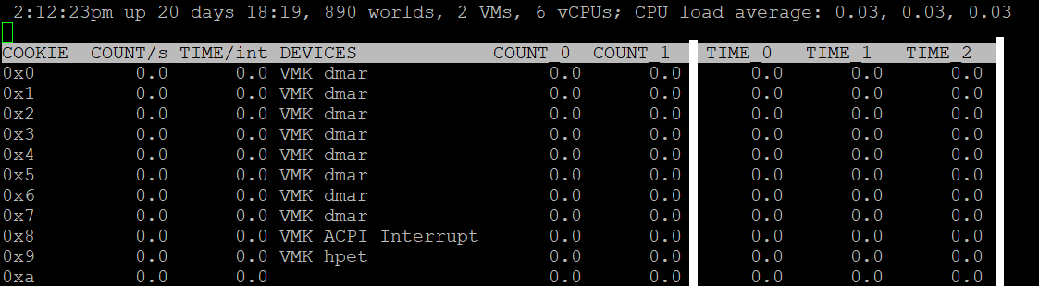

|  |  |
| --- | --- |
| COUNT/s | Total number of interrupts per second. This value is cumulative of the count for every CPU. |
| COUNT_x | Count 0, Count 1, etc.  Interrupts per second on CPU x. My guess is CPU 0 is the first thread in the first core in the first socket. |
| TIME/int | Average processing time per interrupt (in microseconds).  It will be interesting to profile this for each type of interrupt. |
| TIME_x | Time 0, Time 2, etc.  Average processing time per interrupt on CPU x (in microseconds). |
| DEVICES | Devices that use the interrupt vector. If the interrupt vector is not enabled for the device, its name is enclosed in angle brackets (< and >). |

To see the list of devices, issue the command at ESXi console: sched-stats -t sys-service-stats. You will get something like this:

service count time maxElapsed maxService name

32 98973493 171.267 0.000 0.000 VMK-lsi_msgpt3_0

33 93243036 153.993 0.000 0.000 VMK-lsi_msgpt3_0

34 1783955246 1841.025 0.000 0.000 VMK-igbn-rxq0

36 4 0.000 0.000 0.000 VMK-Event

37 167025903 418.733 0.000 0.000 VMK-xhci0-intr

51 242318260 792.014 0.000 0.000 VMK-0000:19:00.1-TxRx-0

60 21281764 80.125 0.000 0.000 VMK-vmw_ahci_00003b000

244 176227 0.090 0.000 0.000 VMK-timer-ipi

245 1250405 0.163 0.000 0.000 VMK-monitor

246 1868139923 340.709 0.000 0.000 VMK-resched

248 414047027 189.255 0.000 0.000 VMK-tlb

4096 3193917027 1321.416 0.000 0.000 0_2nd-level-intr-handler

4097 304258696 193.711 0.000 0.000 1_smpcall

4099 246 0.003 0.000 0.000 3_VOB-Wakeup

4100 35706272 6.186 0.000 0.000 4_TimerBH

4101 399313616 10339.744 0.000 0.000 5_fastSlab

4104 859208 7.851 0.000 0.000 8_logEvent

4105 109560008 158.914 0.000 0.000 9_netTxComp

4106 26 0.197 0.196 0.196 10_keyboard

4107 56 0.001 0.000 0.000 11_SMIEnableCountPCPU-bh

4165 365305096 2433.530 0.001 0.001 TCPIPRX

4167 54024607 55.359 0.000 0.000 SCSI

4171 54520415 124.983 0.000 0.000 START-PATH-CMDS

4173 55109136 254.927 0.000 0.000 COMPL.-ADAPTER-CMD

4174 55102189 85.804 0.000 0.000 START-ADAPTER-CMDS

4180 5254928064 13877.461 0.001 0.001 Netpoll

BTW, some services maybe combined and reported under VMK-timer. For example, IOChain from vSphere Distributed Switch does not appear on its own.

#### Memory

The top part of the screen provides summary at ESXi level. They are handy in seeing overall picture, before diving into each VM or VMkernel modules.

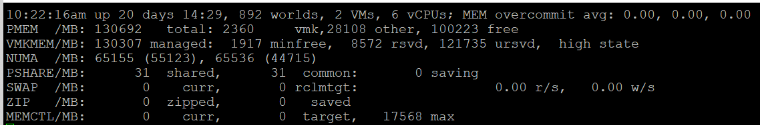

|  |  |
| --- | --- |
| **MEM overcommit avg** | Average memory overcommit level in the last 1-minute, 5-minute, and 15-minute, respectively. Calculation is done with [Exponentially Weighted Moving Average](https://en.wikipedia.org/wiki/Moving_average).  Memory overcommit is the ratio of total requested memory and the "managed memory" minus 1. According to [this](https://communities.vmware.com/t5/Storage-Performance/Interpreting-esxtop-4-1-Statistics/ta-p/2786881), VMKernel computes the total requested memory as a sum of the following components:   1. VM configured memory (or memory limit setting if set), 2. the user world memory, 3. the reserved overhead memory.   If the ratio is > 1, it means that total requested VM memory is more than the physical memory available. This is fine, because ballooning and page sharing allows memory overcommit.  I’m puzzled why we mix allocation and utilization. No 1 and no 3 make sense, but what exactly is no 2? My recommendation is you simply take the configured VM memory and ignore everything else. While it’s less accurate, since the purpose is capacity and not performance, it’s more than good enough and it’s easier to explain to management. There is no need to get other details. |
| PMEM | Physical Memory.  Total = vmk + Other + Free  Total is what is reported by BIOS.  vmk is ESXi VMkernel consumption. This includes kernel code section, kernel data and heap, and other VMKernel management memory.  Other is memory consumed by VM and non VM (user-level process that runs directly on the kernel) |
| VMKMEM | VMkernel memory. The following metrics are shown:   * Managed. The memory space that ESXi manage. Typically this is slightly smaller than the total physical memory, as it does not contain all the components of vmk metric. It can be allocated to VM, non VM user world, or the kernel itself. * Minfree. The minimum amount of machine memory that VMKernel would like to keep free. VMKernel needs to keep some amount of free memory for critical uses. Note that minfree is included in Free memory, but the value tends to be negligible. * Reserved. The sum of the reservation setting of the groups + the overhead reservation of the groups + minfree. I think by group it means the world or resource pool. * Unreserved. It is the memory available for reservation.   I have not found a practical use case for the above 4 metrics. If you do, let me know!  State is the memory state. You want this to be on high state. |
| NUMA | In the preceding screenshot, there are 2 NUMA nodes.  For each node there are 2 metrics: the total amount and the free amount.  Note that the sum of all NUMA nodes will again be slightly smaller than total, for the same reason why VMkernel managed is less than total.  If you enable Cluster-on-Die feature in Intel Xeon, you will see 2x the amount of nodes. For details, see [this](https://www.youtube.com/watch?v=pcNfxdMnpmc&t=3s) by Frank Denneman. |
| PSHARE | **shared**: the amount of VM physical memory that is being shared.  **common**: the amount of machine memory that is common across Worlds.  **saving**: the amount of machine memory that is saved due to page-sharing. |
| SWAP | Swapped counter is covered here under VM memory. What “cannot” be zipped is swapped. What you see on this line is sum of all the VMs.  The metric rclmtgt shows the target size in MB that ESXi aims to swap. |
| ZIP | Zipped counter is covered here under VM memory. What you see on this line is sum of all the VMs. |
| MEMCTL | Memory Control, also known as ballooning is covered here under VM memory. What you see on this line is sum of all the VMs. |

There are a lot of metrics in many panels. It’s easier to understand if we group them functionally.

##### Contention

As usual, we start with the contention-type of metrics.

###### Balloon

I start with Balloon as this is the first level of warning. Technically, this is not a contention. Operationally, you want to start watching as Balloon only happens at 99% utilization. So it’s high considering you have HA enabled in the cluster.

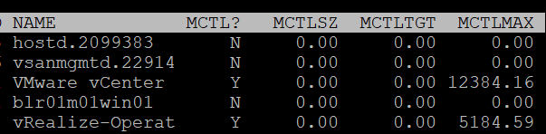

|  |  |
| --- | --- |
| MCTL? | ‘Y’ means the line is a VM, as VMkernel processes is not subjected to ballooning. |
| MCTLSZ (MB) | Memory Control Size is the present size of memory control (balloon driver). If larger than 0 hosts is forcing VMs to inflate balloon driver to reclaim memory as host is overcommitted |
| MCTLTGT (MB) | Amount of physical memory the ESXi system attempts to reclaim from the resource pool or VM by way of ballooning. If this is not 0 that means the VM can experience ballooning. |
| MCTLMAX (MB) | Maximum amount of physical memory the ESXi system can reclaim from the resource pool or VM by way of ballooning. This maximum depends on the type of Guest OS. |

###### Compressed & Swapped

I think that Swap and Compressed should be shown together as what can’t be compressed is swapped.

Why am I showing Compressed first?

Because it’s faster than swapped.

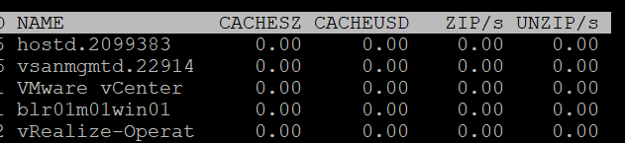

|  |  |
| --- | --- |
| CACHESZ (MB) | Compression memory cache size. |
| CACHEUSD (MB) | Used compression memory cache |
| ZIP/s (MB/s) | The rate at which memory pages are being zipped. Once zipped, it’s not immediately available for the VM.  This is a capacity problem. Your ESXi needs more RAM. If the pages being zipped is unused, the VMs will not experience memory contention.  Keep this number 0. See Capacity chapter for details. |
| UNZIP/s (MB/s) | The rate at which memory pages are being unzipped so it can be used by VM.  This is a performance problem. The pages are being asked. The VM CPU is waiting for the data. If you check the VM memory contention counter, it will not be 0%. Make sure that number is within your SLA or KPI. |

###### Swapped

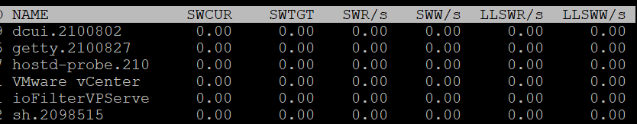

|  |  |
| --- | --- |
| SWCUR (MB) | Swapped Current is the present size of memory on swapped. It typically contains inactive pages. |
| SWTGT (MB) | The target size the ESXi host expects the swap usage by the resource pool or VM to be. This is an estimate. |
| SWR/s (MB) | Swapped Read per second and Swapped Write per second. The amount of memory in megabyte that is being brought back to memory or being moved to disk |
| SWW/s (MB) |
| LLSWR/s (MB) | These are similar to SWR/s but is about host cache instead of disk. It is the rate at which memory is read from the host cache. The reads and writes are attributed to the VMM group only, so they are not displayed for VM.  **LL** stands for Low Latency as host cache is meant to be faster (lower latency) than physical disk.  Memory to host cache can be written from both the physical DIMM and disk. So the counter LLSWW/s covers all these sources, and not just from physical DIMM. |
| LLSWW/s (MB) |

###### NUMA

Logically, this statistic is applicable only on NUMA systems.

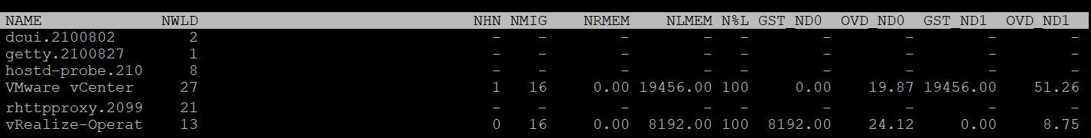

|  |  |
| --- | --- |
| NHN | The count of NUMA Home Node for the resource pool or VM. If the VM has no home node, a dash (-) appears. You want to see If you see the number 2, that means the VM is split into multiple nodes, which could impact performance.  When you enable CPU Hot Add, esxtop will report multiple home nodes as NUMA is disabled. It also does not distinguish remote and local memory as memory is interleaved. For more information, see [this](https://frankdenneman.nl/2016/08/22/numa-deep-dive-part-5-esxi-vmkernel-numa-constructs/) by Frank. |
| NMIG | Number of NUMA migrations. It gets reset upon VM power cycle, meaning this counter is accumulative. Be careful as you could be looking at past data. Use Log Insight to plot the event over time.  Migration is costly as all pages need to be remapped. Local memory starts at 0% again and grow overtime. Copying memory pages across NUMA boundaries cost memory bandwidth. |
| NRMEM (MB) | Current amount of remote memory allocated to the VM or resource pool. Ideally this amount is 0 or a tiny percentage.  You decrease the chance by decreasing the VM configured RAM. A VM whose configured memory is larger than the ESXi RAM attached to a single CPU socket have higher chance of having remote memory. |
| N%L | Current percentage of memory allocated to the VM or resource pool that is local.  Anything less than 100% is not ideal. |
| GST_NDx (MB) | Guest memory allocated for a resource pool on NUMA node x, where GST_ND0 means the first node. The following screenshot shows the VMware vCenter VM runs on node 2 while the vRealize-Operat VM runs on node 1. |
| OVD_NDx (MB) | VMM overhead memory allocated for a resource pool on NUMA node x, where x starts with 0 for the first node. |

##### Consumption

I group metrics such as consumed, granted, and overhead under utilization as they measure how much the VM or VMkernel module consumes.

###### Consumed

What are the use cases where you actually need these metrics? I think it’s quite rare. Review this rightsizing and reclamation, as the answers might surprise you 😉

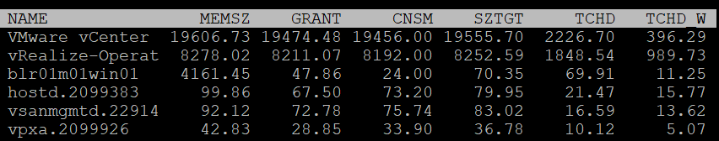

|  |  |
| --- | --- |
| MEMSZ (MB) | Amount of physical memory allocated to a resource pool or VM. The values are the same for the VMM and VMX groups.  MEMSZ = GRANT + MCTLSZ + SWCUR + "never touched" |
| GRANT (MB) | Granted is covered here. Do not confuse it with Consumed. |
| CNSM | Yup, this is that legendary Consumed metric. |
| SZTGT (MB) | Size Target in MB.  Amount of machine memory the ESXi VMkernel wants to allocate to a resource pool or VM. The values are the same for the VMM and VMX groups. |
| TCHD (MB) | Amount of touched pages in MB  Working set estimate for the resource pool or VM. The values are the same for the VMM and VMX groups. |
| TCHD_W | As per above, but only for the write operations. A relatively much lower value compared to TCHD means the activities are mostly read. |

###### Overhead

I find overhead is a small amount that is practically negligible, considering ESXi nowadays sports a large amount of RAM. Let me know the use case where you find otherwise.

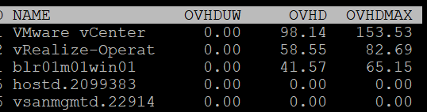

|  |  |
| --- | --- |
| OVHD (MB) | Current space overhead for resource pool. |
| OVHDMAX (MB) | Maximum space overhead that might be incurred by resource pool or VM. |
| OVHDUW (MB) | Current space overhead for a user world. It is intended for VMware use only. |

###### Shared

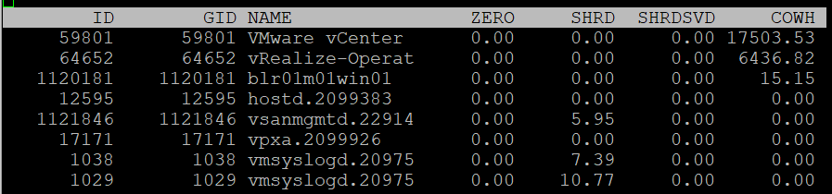

|  |  |
| --- | --- |
| ZERO (MB) | Resource pool or VM physical pages that are zeroed. |
| SHRD (MB) | Resource pool or VM physical pages that are shared. |
| SHRDSVD (MB) | Machine pages that are saved because of resource pool or VM shared pages |
| COWH (MB) | Copy on Write Hint. An estimate of the amount of Guest OS pages for TPS purpose. |

###### Active

The manual uses the word Guest to refer to VM. I distinguish between VM and Guest. Guest is an OS, while a VM is just a collection of processes. Guest has its own memory management that is completely invisible to the hypervisor.

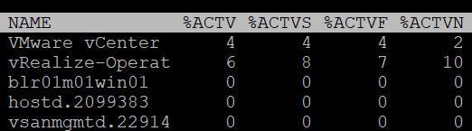

|  |  |
| --- | --- |
| %ACTV | Active is covered in-depth here. |
| %ACTVS | Percentage Active Slow and Percentage Active Fast.  Slow is the slow moving average, taking longer period. Longer is more accurate.  I don’t have a use case for the fast moving average. |
| %ACTVF |
| %ACTVN | Percentage Active Next. It predicts of what %ACTVF will be at next sample estimation. It is intended for VMware use only. |

###### Committed

Committed page means the page has been reserved for that process. Commit is a counter for utilization but it’s not really used, especially for VM.

Note: none of these metrics exist in vSphere Client and vRealize Operations, as they are meant for internal use.

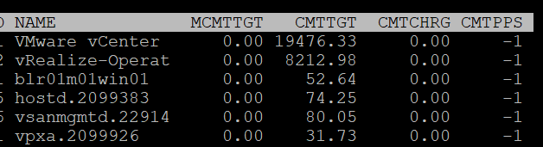

|  |  |
| --- | --- |
| MCMTTGT | Minimum Commit Target in MB. I think this value is not 0 when there is reservation, but I’m not sure. |
| CMTTGT | Commit Target in MB. |
| CMTCHRG | Commit Charged in MB. I think this is the actual committed page. |
| CMTPPS | Commit Pages Per Share in MB |

##### Allocation & Reservation

I’m not placing them under utilization as they are not actual consumption.

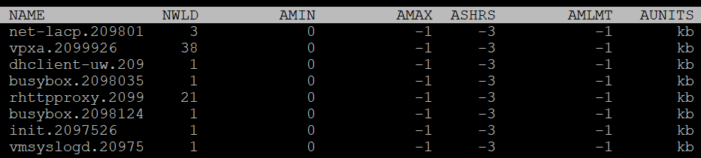

|  |  |
| --- | --- |
| AMIN | Allocation minimum.  This is the term esxtop uses for memory reservation for this resource pool or VM. A value of 0 means no reservation, which is what you should set for most VM. Reservation for VMkernel modules should be left as it is. |
| AMAX | Allocation maximum.  This is the term esxtop uses for memory limit for this resource pool or VM. A value of -1 means Unlimited.  Limit for VMkernel modules should be left as it is. |
| AMLMT | Limit. You should expect the value -1, means no limit assigned.  I’m not sure how this differs to AMAX. |
| ASHRS | Memory shares for this resource pool or VM. |
| AUNITS | This is just displaying the units of allocations counters |

##### Checkpoint

Checkpoint is required in snapshot or VM suspension. You can convert a VM checkpoint into a core dump file, to debug the Guest OS and applications.

|  |  |
| --- | --- |
| CPTRD (MB) | Checkpoint Read. Amount of data read from checkpoint file. A large amount can impact the VM performance. |
| CPTTGT (MB) | Checkpoint Target. The target size of checkpoint file that VMkernel is aiming for.  I’m unsure why it needs to have a target, unless this is just an estimate of the final size and not a limit. |

#### Storage

The Storage monitoring sports 3 panels:

* VM
* Adapter
* Device

We covered in Part 2 that an ESXi host has adapter, path and devices. I’m unsure why esxtop does not have a panel for path. It would be convenient to check dead path or inactive path as the value will be all 0. If your design is active/active, it can be useful to compare if their throughput is not lopsided.

Datastore is also missing. While VMFS can be covered with Device (if you do 1:1 mapping and not using extent), NFS is not covered.

On the other hand, esxtop does provide metrics that vSphere Client does not. I will highlight those.

ESXi uses adapter to connect to device. As a result, their main contention and utilization metrics are largely similar. I’ve put them side by side here, and highlight the similar metric *groups* with vertical green bar. I highlighted the word group, as the group name may be identical, but the actual metrics within the group differ.

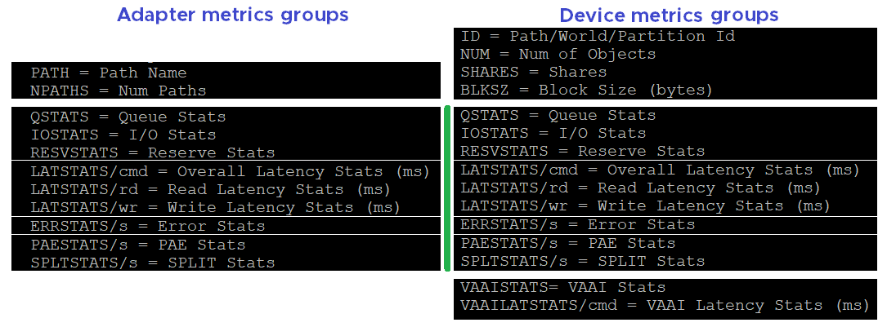

##### Disk VM panel

We begin with VM as that’s the most important one. It complements vSphere Client by providing unmap and IO Filter metrics.

You can see at VM level, or virtual disk level. In the following screenshot, I’ve expanded one of the VM.

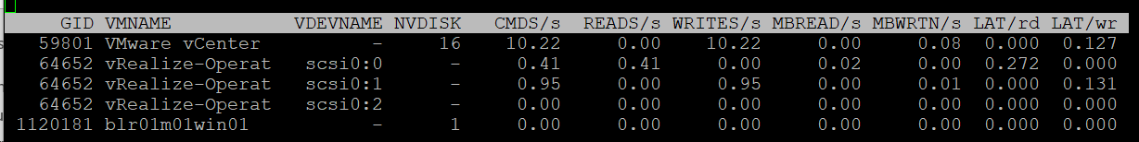

###### Contention

There are only 2 metrics. There is no outstanding IO metric.

|  |  |
| --- | --- |
| LAT/rd | Average latency (in milliseconds) per read. |
| LAT/wr | Average latency (in milliseconds) per write. |

###### Utilization

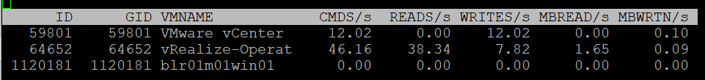

|  |  |
| --- | --- |
| CMDS/s | Count of disk IO commands issued per second. This is basically IOPS.  Both the Read IOPS and Write IOPS are provided. |
| READS/s |
| WRITES/s |
| MBREAD/s | Total disk amount transferred per second in MB. This is basically throughput.  Both the read throughput and write throughput are provided. |
| MBWRTN/s |

###### Unmap

It has unmap statistics. This can be useful that there is no such information at vSphere Client. In the UI, you can only see at ESXi level.



|  |  |
| --- | --- |
| SC_UMP/s | Successful, Failed and Total Unmaps per second.  Unmap can fail for a variety of reason. One example that was addressed in vSphere 6.7 Patch ESXi670-202008001 and documented in in KB is Guest OS does not refresh unmap granularities and keep sending unmap based on older value. Eventually limit is reached and the operation fail. |
| FL_UMP/s |
| UMP/s |
| SC_UMP_MBS/s | As above, but in MB/second. |
| FL_UMP_MBS/s |

###### IO Filter

I/O Filter in ESXi enable VMkernel to manipulate the IO sent by Guest OS before processing it. This obviously opens up many use cases, such as replication, caching, Quality of Service, encryption.

There is no such metric at vSphere Client. You will not find IO Filter metrics at both VM object and ESXi object.

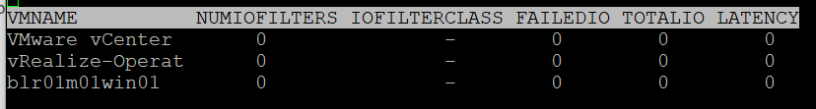

|  |  |
| --- | --- |
| NUMIOFILTERS | Number of IO Filters |
| IOFILTERCLASS | Type of IO Filter Class |
| FAILEDIO | I think Failed IO should be 0 at all times. |
| TOTALIO |
| LATENCY | I’m unsure if this latency measures the additional overhead introduced by IO Filter, or the total latency as seen by the VM. |

###### Configuration

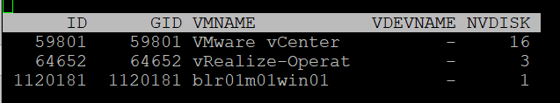

|  |  |
| --- | --- |
| ID | Resource pool ID or VSCSI ID of VSCSI device. |
| GID | Resource pool ID. |
| VMNAME | Name of the resource pool. |
| VSCSINAME | Name of the VSCSI device. |
| NDK | Number of VSCSI devices |

##### Disk Adapter

ESXi uses adapter to connect to device, so let’s begin with adapter, then device.

The panel has a lot of metrics and properties, so let’s group them for ease of understanding.

###### Errors

Since you check availability before performance, let’s check the errors first. This type of problem is best monitored as accumulation within the reporting period as any value other than 0 should be investigated.

BTW, none of these metrics are available at vSphere Client UI.

|  |  |
| --- | --- |
| FCMDS/s | Number of failed commands issued per second. How does this differ to Reset and Aborted?  Number of failed read commands issued per second.  Number of failed write commands issued per second. |
| FREAD/s |
| FWRITE/s |
| FMBRD/s | Megabytes of failed read operations per second.  Megabytes of failed write operations per second. |
| FMBWR/s |
| CONS/s | Number of SCSI reservation conflicts per second. This number should stay 0?  Number of failed SCSI reservations per second, if the conflict can’t be solved timely.  Number of SCSI reservations per second. This number should stay within the limit, but how to know what the limit is? |
| FRESV/s |
| RESV/s |
| ABRTS/s | Number of commands cancelled per second. |
| RESETS/s | Count of disk commands reset per second. |

###### Queue

For storage, the queue gives insight into performance problem. It’s an important counter so I was hoping there will be more, such as the actual queue.

|  |  |
| --- | --- |
| AQLEN | Current queue depth of the storage adapter. The storage adapter queue depth. This is the maximum number of ESX Server VMkernel active commands that the adapter driver is configured to support  This counter is not available in vSphere Client UI |

###### Contention

You expect to get 4 sets (Device, Kernel, Guest, Queue). For each set, you expect read, write, and total. 12 metrics, and that’s exactly what you got below.

|  |  |
| --- | --- |
| DAVG/cmd | Average latency per command in milliseconds.  It’s an average number, not the last number in the reporting period. If you have 1000 IOPS, that means 5K IOPS over the 5 second reporting period.  It’s a weighted average between read and write. If the IO commands are mostly read, then high latency from write could be masked out. |
| KAVG/cmd |
| GAVG/cmd |
| QAVG/cmd |
| DAVG/rd | Average read latency per read operation in milliseconds. The same set of metrics as above, except it only counts the reads.  It’s useful to see read and write separately as the numbers tend to be different. More importantly, the remediation action is different. |
| KAVG/rd |
| GAVG/rd |
| QAVG/rd |
| DAVG/wr | The same set of metrics as above, except it only counts the writes. |
| KAVG/wr |
| AVG/wr |
| QAVG/wr |

###### Utilization

Now that we get the more important metrics (errors, queue, and contention) done, you then check utilization counter. In this way you have better context.

|  |  |
| --- | --- |
| ACTV | The definition is “ Number of commands that are currently active”. I don’t know how it differs to IOPS, and what does the word “active” exactly mean here.  This is worth profiling. |
| CMDS/s | I combine these 3 metrics as they are basically IOPS. Total IOPS, read IOPS and write IOPS. |
| READS/s |
| WRITES/s |
| MBREAD/s | I combine them as they measure throughput. Interestingly, there is no total throughput metric, but you can simply sum them up.  Read the string MBWRTN as MB Written. |
| MBWRTN/s |

###### PAE and Split

|  |  |
| --- | --- |
| PAECMD/s | PAE Command per second and PAE Copy per second.  I think PAE (Physical Address Extension) no longer applicable in 64-bit and modern drivers/firmware/OS, as the size is big enough. Copy operations here refer to VMkernel copies the data from high region (beyond what the adapter can reach) to low region.  This statistic applies to only paths. |
| PAECP/s |
| SPLTCMD/s | Split Commands per second.  Disk IO commands with large block size have to be split by the VMkernel. This can impact the performance as experiences by the Guest OS. |
| SPLTCP/s | Number of split copies per second. A higher number means lower performance |

###### Configuration

The panel provides basic configuration. I use vSphere Client as it provides a lot more information, and I can take action on them. The following is just some of the settings available.

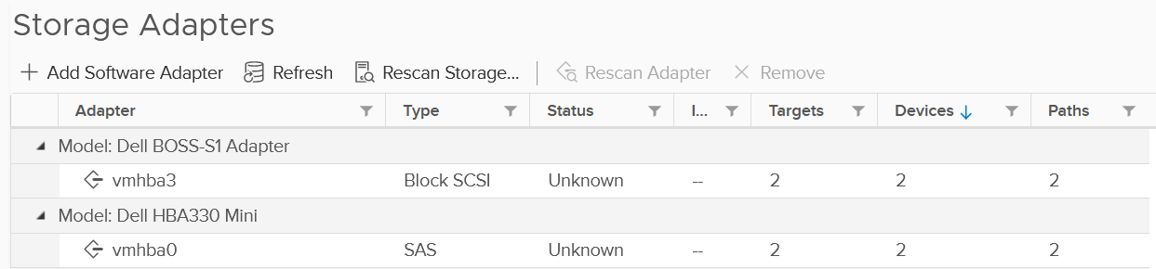

Compare the above with what esxtop provides, which is the following:

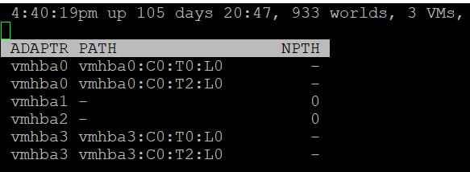

|  |  |
| --- | --- |
| NPTH | Number of path. This should match your design. An adapter typically has more than 1 path, which is why I said it would be awesome to have a panel for path |

##### Disk Device panel

The device panel has a lot of metrics and properties, so let’s group them for ease of understanding.

###### Errors

I’m always interested in errors first, before I check for contention and utilization.

|  |  |
| --- | --- |
| ABRTS/s | Number of commands cancelled per second. Expect this to be 0 at all times. |
| RESETS/s | Number of commands reset per second. Expect this to be 0 at all times. |

###### Queue

You’ve seen that there is only 1 counter for queue in Disk Adapter. How many do you expect for Disk Device?

Interestingly, there are 6 metrics for queue, as shown below.

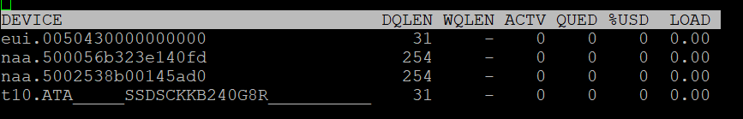

|  |  |
| --- | --- |
| LOAD | The formula is  (active commands + ESXi VMkernel queued commands) / queue depth.  If LOAD > 1, check the value of the QUED counter. |
| QUED | Number of commands in the ESXi VMkernel that are currently queued. You want this to be as low as possible, well below the queue depth. |
| %USD | USD (%) = ACTV / QLEN  For world stats, QLEN is WQLEN. For LUN (aka device) stats, QLEN is DQLEN.  Percentage of the queue depth used by ESXi VMkernel active commands.  So this does not include the queued command? Does it mean that if this number is not 100%, then there is nothing in the queue, as queue should only develop when it’s 100% used?  Obviously when Used = 100% it means the queue is full. That will introduce outstanding IO, which in turn will increase latency |
| DQLEN | I combine this together as a device can have 1 or more world, and there is a per-device maximum.  DQLEN is the device configured queue length. The corresponding counter for adapter is called AQLEN  WQLEN is the world queue depth. The manual states “This is the maximum number of ESXi VMkernel active commands that the world is allowed to have”. So it does not look like a present number. I am confused why we show max for world, and present for device. |
| WQLEN |
| ACTV | The definition is “Number of commands that are currently active”. I think this means the IO in flight, which makes it an interesting counter. This is worth profiling and I expect it to be small most of the time. |

###### Contention

See Disk Adapter as both sport the same 12 metrics.

###### Utilization

See Disk Adapter as both sport the same 5 metrics.

###### PAE and Split

See Disk Adapter as both sport the same 4 metrics.

###### Configuration

As you can expect, esxtop provides minimal configuration information. They are shown below.

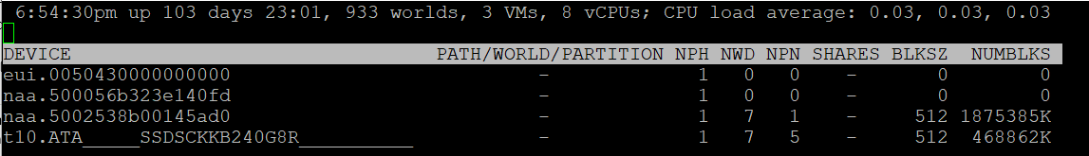

Path/World/Partition

They are grouped as 1 column, and you can only see one at a time.

By default, none of them is shown. To bring up one of them, type the corresponding code. In the following screenshot, I’ve type the letter **e**, which them prompted me to enter one of the device.

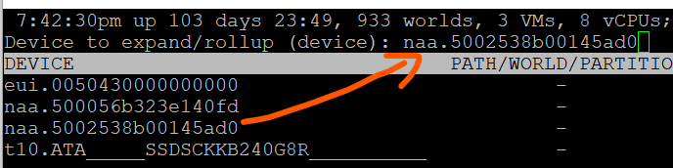

Path is obviously the path name, such as vmhba0:C0:T0:L0.

A disk device can have >1 world, which I’m unsure why. You can see each world ID, and you get the statistics per world.

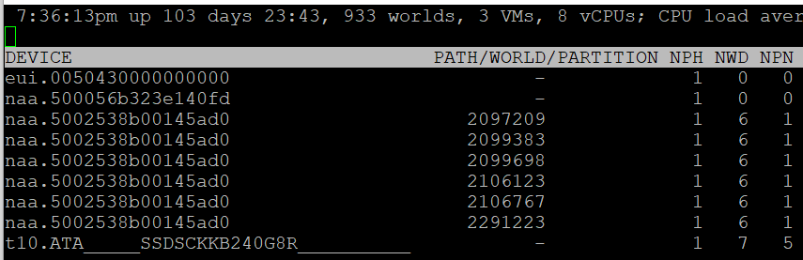

Partition shows the partition ID. Typically this is a simple number, such as 1 for the first partition. vSphere Client provides the following, which is more details yet easier.

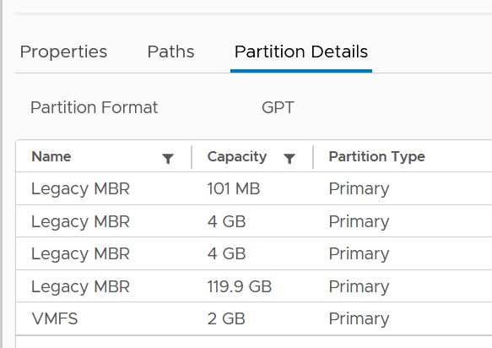

Others

Let’s cover the rest of the metrics.

|  |  |
| --- | --- |
| NPH | Number of paths. This should not be 1 as that means a single point of failure. |
| NWD | Number of worlds. If you know the significance of this in troubleshooting, let me know. |
| NPN | Number of partitions. Expect this to be 1 for VMFS |
| SHARES | Number of shares. This statistic is applicable only to worlds.  This is interesting, as that means each world can have their own share? Where do we set them then? |
| BLKSZ | Block size in bytes.  I prefer to call this sector format. International Disk Drive Equipment and Materials Association (IDEMA) increased the sector size from 512 bytes to 4096 bytes (4 KB).  This is important, and you want them to be in 4K ([Advanced Format](https://en.wikipedia.org/wiki/Advanced_Format)) or at least 512e (e stands for emulation). Microsoft provides additional information [here](https://docs.microsoft.com/en-us/troubleshoot/windows-server/backup-and-storage/support-policy-4k-sector-hard-drives). |
| NUMBLKS | Number of blocks of the device. Multiply this with the block size and you get the total capacity. In vSphere UI, you get the capacity, which I think it’s more relevant. |

For configuration, I use vSphere Client as it provides a lot more information, and I can take action on them. The following is just some of the settings available. More at Part 2 Chapter 4 Storage Metrics.

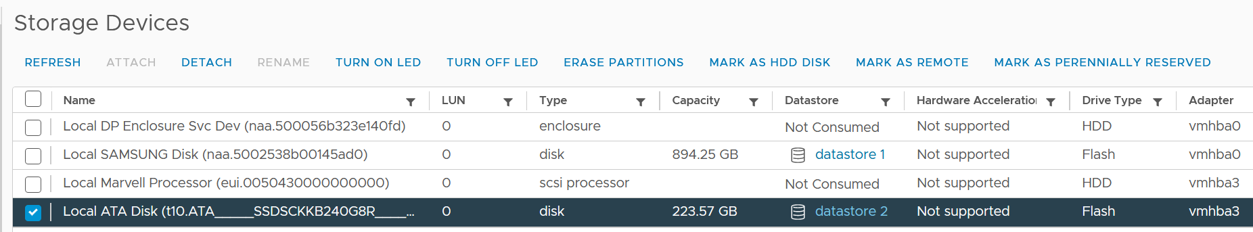

###### VAAI

VMware vSphere Storage APIs - Array Integration ([VAAI](https://docs.vmware.com/en/VMware-Validated-Design/5.0/com.vmware.vvd.sddc-design.doc/GUID-6FE55EFD-6A7D-4A2F-8142-6A88126BB7D6.html)) offloads storage processing to the array, hence improving performance or reducing overhead. This is obviously vendor-dependant. There is no VAAI counter at adapter level or path level, as the implementation is at back-end array.

The VAAI has a lot of metrics. They are grouped into 2 (non latency and latency metrics). I find it more logical to group by function, which is also what [this](https://kb.vmware.com/s/article/2065193) KB article does. It’s last updated on 14 May 2017 and does not cover vSphere 7.0, so I’m following up.

As with metrics, check for contention type of metrics first. There are metrics that track failed operations, such as CLONE_F, ATSF and ZERO_F.

I saw this note from VMware vSphere Storage APIs – Array Integration (VAAI) document by Cormac Hogan, which I think it’s worth mentioning. Because the nature of VAAI as an offloads, you will see higher latency value of KAVG metric. Other latency metrics are not affected, so there is no issue unless there are other symptoms present.

At this moment, I have not found the need to document them further. So what you get here is mostly from the KB article above. [Andreas Lesslhumer](https://www.linkedin.com/in/andreas-lesslhumer-2bb2725b/) also has useful information in [this](https://www.running-system.com/esxtop-vaai-counters/) blog article.

Extended Copy

Hardware Accelerated Move (the SCSI opcode for XCOPY is 0x83)

|  |  |
| --- | --- |
| Clone_RD | RD stands for reader.  The number of CLONE commands successfully completed where this device was a source.  WR stands for writer.  The number of CLONE commands successfully completed where this device was a destination  The number of failed CLONE commands |
| Clone_WR |
| Clone_F |
| LCLONE_RD | The same set of 3 metrics, except for Linked Clone. |
| LCLONE_WR |
| LCLONE_F |
| MBC_RD/s | MBC = megabytes of clone data.  RD/s is read per second, and WR/s is written per second |
| MBC_WR/s |
| AVAG/suc | The average clone latency per successful command  The average clone latency per failed command |
| AVAG/f |

Atomic Test & Set

Hardware Accelerated Locking on Single Extent Datastore or on Multi Extent Datastore (SCSI code 0x89)

|  |  |
| --- | --- |
| ATS | The number of Atomic Test & Set (ATS) commands successfully completed |
| ATSF | The number of ATS commands failed. Expect this to be 0? |
| AAVG/suc | The Average ATS latency per successful command |
| AAVG/f | The Average ATS latency per failed command |

Write Same

Hardware Accelerated Initialize or Zeroed out blocks (SCSI code 0x93 or 0x41)

|  |  |
| --- | --- |
| ZERO | The number of ZERO commands successfully completed |
| ZERO_F | The number of ZERO commands failed |
| MBZERO/s | The megabytes zeroed per second |
| ZAVG/suc | The average zero latency per successful command |
| ZAVG/f | The average zero latency per failed command |

Unmapped

Unmapped block deletion (SCSI code 0x42). We discussed unmapped block (TRIM) in Part 1 Chapter 3 Capacity Management.

|  |  |
| --- | --- |
| DELETE | The number of successful DELETE commands |
| DELETE_F | The number of failed UNMAP commands, this value should be 0 |
| MBDEL/s (MB/s) | The rate at which the DELETE command getting processed. Measured in Megabytes per second |

Others

|  |  |
| --- | --- |
| RESSPACE | Reservation Space.  The number of commands which were successful while doing space reservation for a VMDK file in thick Provisioning format.  RESSPACE_F captures the failure. |
| RESSPACE_F |
| EXTSTATS | Extended Statistics  The number of commands which were successful in reporting extended statistics of a clone after the cloning process had been completed.  EXTSTATS_F captures the failure |
| EXTSTATS_F |
| CAVG/suc | The average clone latency per successful command. Unit is millisecond per clone.  CAVG/f captures the failures. |
| CAVG/f |
| LCAVG/suc | As per above, but for Linked Clone. |
| LCAVG/f |
| RAVG/suc | The average latency (in ms) per successful VAAI Space Reservation command.  RAVG/f captures the failures |
| RAVG/f |
| ESAVG/suc | As per above, but for Extended Statistics |
| ESAVG/f |

##### vSAN

I group the vSAN panel under Disk as esxtop only covers storage related information. There is no network or compute (vSAN kernel modules).

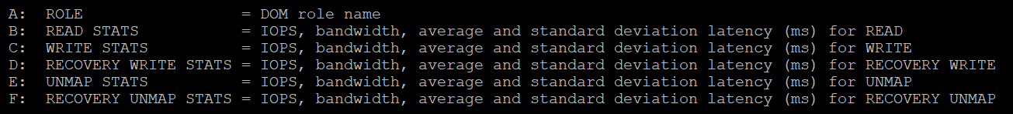

The panel provides visibility into 5 types of IO operations:

* Read
* Write
* Recovery Write
* Unmap
* Recovery Unmap

For each, it provides the IOPS, bandwidth, average latency (ms) and standard deviation latency (ms). Take note that some use MB, while others use GB.

|  |  |
| --- | --- |
| ROLE | The Distributed Object Manager (DOM) role of that component, such as client, owner, and component manager. |
| READS/s  MBREAD/s  AVGLAT  SDLAT | Reads/second is the number of reads operations. This is IOPS.  MBReads/s is read throughput in Megabytes/second.  AvgLat is the average latency.  Standard deviation of latency, when above 10ms latency. |
| WRITES/s  MBWRITE/s  AVGLAT  SDLAT | Same set of metrics, like above, but for write |
| RECOWR/s  MBRECOWR/s  AVGLAT  SDLAT | Same set of metrics, like above, but for Recovery Write. Recovery covers component rebuild task (e.g. from disk failure).  Read the string MBRECOWR as MB Reco Wr. |
| UNMAPS/s  GBUNMAP/s  AVGLAT  SDLAT | Same set of metrics, like above, but for unmap operations. I think this number should be within your expectation, as excessive unmap can impact performance.  GBUNMAP/s = Unmapped rates in Gigabytes/second  Read the string GBUNMAP as GB Unmap |
| RECOUN/s  GBRECOUN/s  AVGLAT  SDLAT | Same set of metrics, but for Recovery Unmap operations.  Read the string GBRECOUN as GB Reco Un.  RecoUn/s is the number of recovery unmapped operations per second.  GBRecoUn/s is the amount of disk space in GB/second by Recovery Unmapped. |

#### Network

There are 2 levels of network due to virtualization, and their utilization logically do not match. There is virtual network and physical network. Virtual network consist of VM and VMK ports. If the traffic is just a VM to VM traffic, within the same ESXi, the packets does not reach the physical network, hence the metrics do not register it.

Network traffic are grouped into 2 by their direction:

* TX for outgoing (sent) and
* RX for incoming (received).

##### Contention

As usual, we check contention first. There is no network latency and packet retransmit metric.

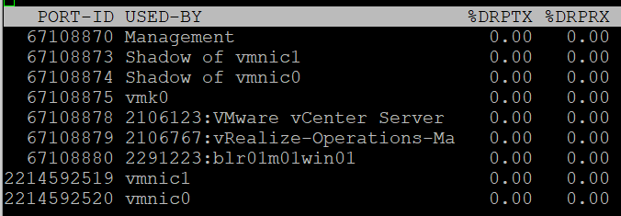

|  |  |
| --- | --- |
| %DRPTX | Percentage of Dropped Packet.  Expressed in percentage, which makes it easier as you expect this not to exceed 0.x%. In dedicated network such as vSAN and vMotion, this should be flat 0% non stop for every single ESXi.  Transmit and Receive have different nature. A high drop in transmit means your physical NIC card or uplink switch is unable to cope. A high drop in receive means your ESXi or VM may not have enough CPU to process the packet, or the ring buffer size is too small.  [esxtop show dropped packets](https://kb.vmware.com/s/article/1010071): The screen output show dropped receive packets at the virtual switch port. They are actually dropped between the virtual switch and the guest OS driver. The dropped packets can be reduced by increasing the Rx buffers for the virtual network driver. |
| %DRPRX |

##### Utilization

As usual, check the non-unicast packets first.

###### Non-Unicast Packets

|  |  |
| --- | --- |
| PKTTXMUL/s | Number of multicast packets transmitted or received per second.  Read the string PKTTXMUL as Pkt Tx Mul, which is Packet TX Multicast. Same with PKTRXMUL. |
| PKTRXMUL/s |
| PKTTXBRD/s | Number of broadcast packets transmitted or received per second.  Read the string PKTTXBRD as Pkt Tx Brd, which is Packet TX Broadcast. Same with PKTRXBRD |
| PKTRXBRD/s |

###### All Packets

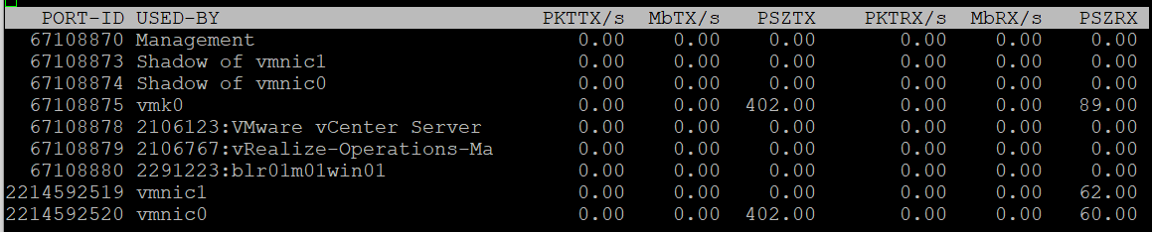

|  |  |
| --- | --- |
| PKTTX/s | This is the total packets, so it includes multicast packet and broadcast packet.  Multicast packet and broadcast packet are listed separately. This is handy as they are supposed to low most of the time. |
| PKTRX/s |
| MbTX/s | This is measured in bit, unlike vCenter Client UI which shows in byte.  Packet length is typically measured in bytes. A standard packet is 1500 bytes, so a 10 Gb NIC would theoretically max out at 833,333 packets on each direction.  Compare this with your ESXi physical network card. |
| MbRX/s |
| PSZTX | This is convenient. If you see a number far lower than 1500, it’s worth discussing with network team. |
| PSZRX |

There is another metric **ACTN/s, which is the n**umber of actions per second. The actions here are VMkernel actions. It is an internal counter, not relevant to day to day operations.

##### Configuration

This panel mixes physical and virtual. For virtual, it shows both the VMkernel network and VM network. I find it easier to use the information in vSphere Client.

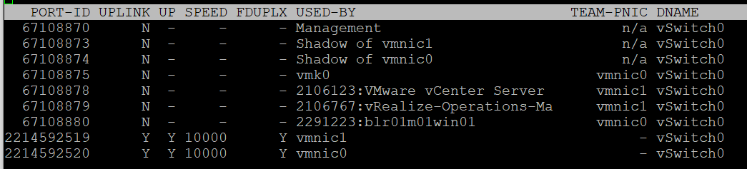

|  |  |
| --- | --- |
| PORT-ID | Virtual network device port ID. |
| UPLINK | ‘Y’ means that the corresponding port is an uplink. ‘N’ means it is not. The physical NIC cards (vmnic0, vmnic1, etc.) serve as the uplink |
| UP | ‘Y’ means that the corresponding link is up. ‘N’ means it is not. |
| SPEED | Link speed in Megabits per second. |
| FDUPLX | ‘Y’ means the corresponding link is operating at full duplex. ‘N’ means it is not, which is a problem. |
| USED-BY | Virtual network device port user. |
| DNAME | Virtual network device name. |

The metric DTYP (Virtual network device type, where H means Hub and S means switch) does not seem to be available anymore.

vSphere Client separates the components. You can see the virtual switches, VMkernel network and physical cards. The level of details is more comprehensive.

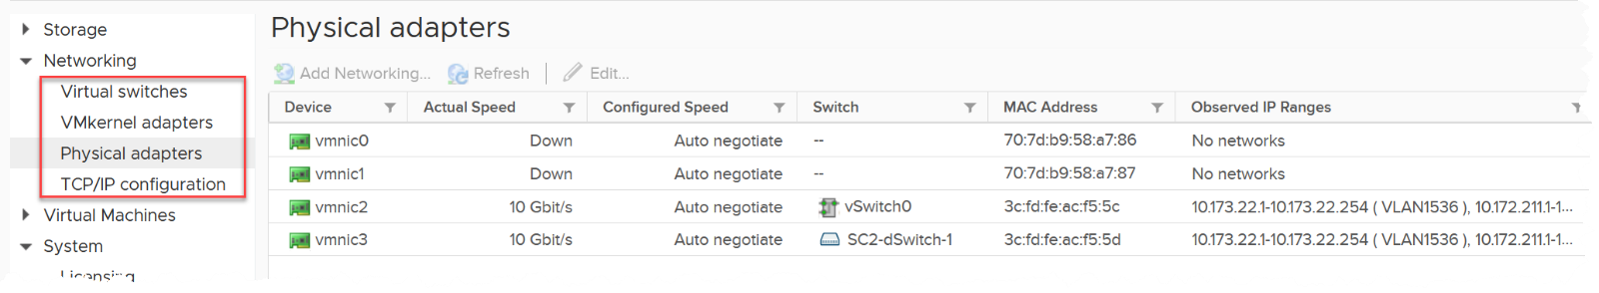

##### RDMA Device

Remote Direct Memory Access ([RDMA](https://en.wikipedia.org/wiki/Remote_direct_memory_access)) enable direct access to the physical network card, bypassing the OS overhead. The following screenshot, taken from [here](https://core.vmware.com/resource/basics-remote-direct-memory-access-rdma-vsphere#section1), shows 2 types of access from application (that lives inside a VM. The VMs are not shown).

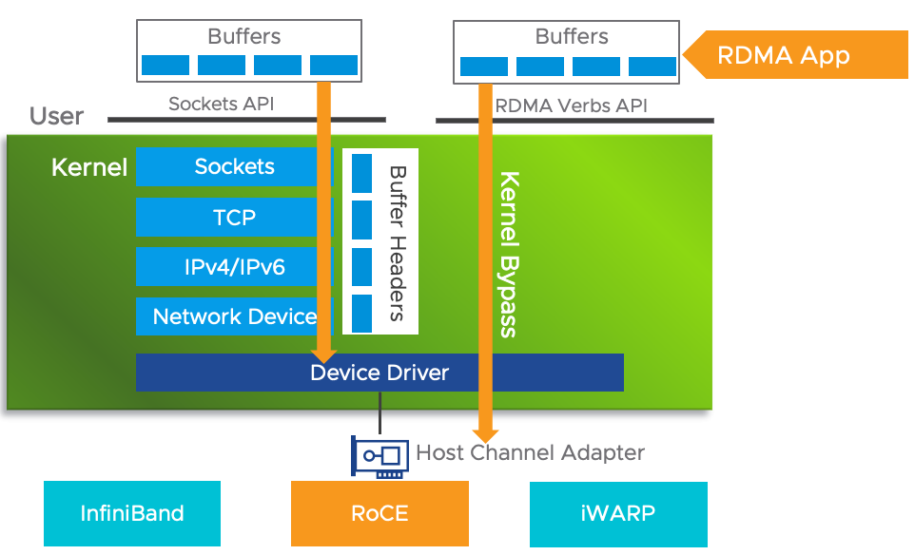

###### Usage

Since it’s about network, you get both the TX (transmit or sent) and RX (received or incoming).

For contention, there is only packet dropped. There is no packet retransmit or latency. The metrics are:

|  |  |
| --- | --- |
| %PKTDTX | Percentage of packet dropped relative to number of packets sent. |
| %PKTDRX |

For utilization, you get them in both amount of data, and number of packets. Both are important metrics. There is no breakdown on the type of packets (broadcast, multicast, unicast).

|  |  |
| --- | --- |
| PKTTX/s | Packets per second.  Check the limit for packet per second in your specific card. |
| PKTRX/s |
| MbTX/s | Network throughput in Megabit/second. |
| MbRX/s |

There is no packet size. This can be handy to determine if they are much smaller or larger than you expect. For example, if you expect jumbo frame but the reality is much smaller.

These metrics are not available in vSphere Client UI, so you need to use esxtop to get the visibility. Just in case you’re wondering where I got the following screenshot from, they are courtesy of [Shoby Cherian](https://www.linkedin.com/in/shobycherian/) and [Aditya Kiran Pentyala](https://www.linkedin.com/in/pentyala/).

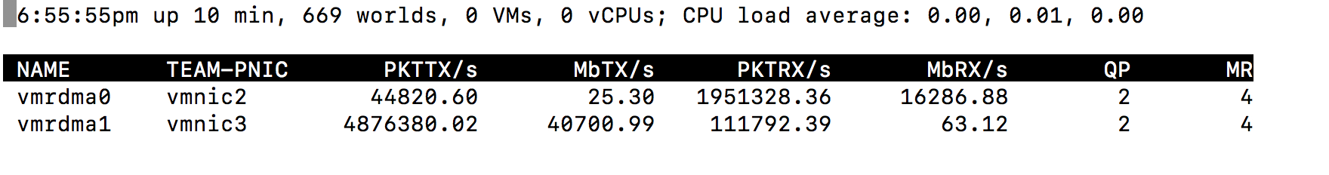

You also get the queue usage information.

|  |  |
| --- | --- |
| QP | Number of Queue Pairs Allocated and Completion Queue Pairs Allocated.  RDMA uses these queues for communication. |
| CQ |
| SRQ | Number of Shared Receive Queues Allocated  I think this is required in virtualization as the physical NIC card can be shared. |
| MR | Memory Regions Allocated.  Check that this is inline with your expectation. |

For more reading on RDMA, I found [this](http://www.reports.ias.ac.in/report/12829/understanding-the-concepts-and-mechanisms-of-rdma) academic paper, title “Understanding the concepts and mechanisms of RDMA” useful.

###### Configuration

vSphere Client provides the following information. You get the first 4 columns in esxtop.

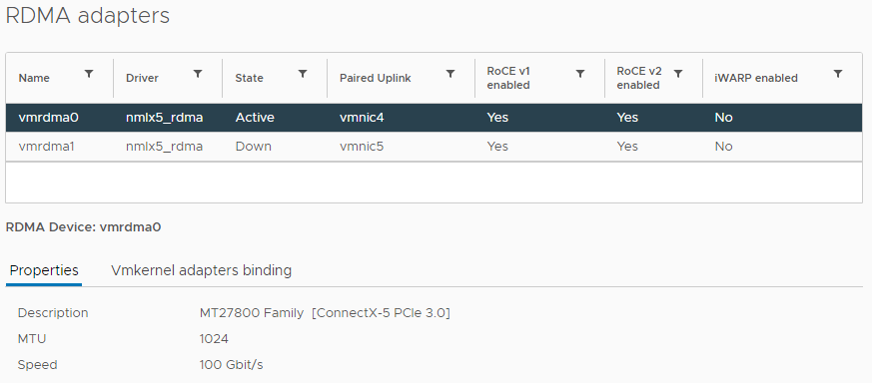

The information you get in esxtop covers the first 4 columns in the preceding screenshot. They are:

|  |  |
| --- | --- |
| NAME | Name of the device |
| DRIVER | Name of the driver |
| STATE | Active or down |
| TEAM-PNIC | The physical Network Interface Card that the RDMA adapter is paired with. |

### Capacity

This is often misunderstood. Both the supply side and the demand side are complex. CPU and memory also have different formula. There are actually 12 different metrics.

|  |  |  |  |
| --- | --- | --- | --- |
|  |  | Demand | Allocation |
| **CPU** | Total Capacity | Unit is GHz | Unit is physical core (not thread) |
| Overhead | = VMkernel reservation |  |
| Buffer |  |  |
| Usable Capacity |  | Manual sizing of vSAN + NSX + VMkernel |
| Consumption |  | Configured VM vCPU |
| **Memory** | Total Capacity | Same unit for both models, and we can and should use 1 metric only. | |
| Overhead | = VMkernel reservation | |
| Usable Capacity |  | Same, assuming it reflects vSAN and NSX |
| Consumption | Complex, see details below for formula | Configured VM memory |

#### CPU

When you buy a CPU, what *exactly* is the capacity?

It is tricky as there are 3 factors to consider:

|  |  |  |
| --- | --- | --- |
|  | Demand Model | Allocation Model |
| Unit | GHz.  It brings complexity as a CPU with 28 cores at 1 GHz is not the same with a CPU with 14 cores at 2 GHz. You can’t run a 16 vCPU VM on a 14-core (assuming it has no HT). On the other hand, a CPU intensive application will prefer faster CPU. | Cores.  The speed is irrelevant. |
| Hyperthreading (HT) | Add 25% to total capacity, but take note of performance impact. | Count the threads but take note of performance impact. HT provides 2x the number of logical processors, but it comes at a high cost. As the core is split into 2, each thread only runs at 62.5% of its potential. That’s 37.5% reduction |
| Power Management | It dynamically increases or decreases individual cores speed. It does this in basically real time, and it varies per core. I recommend you ignore it so the Total Capacity does not become a variable. By fixing your capacity, you can see if the CPU is on Turbo Boost. The limitation of this approach is your demand metric likely exceed 100% when Turbo Boost kicks in. So where do you consider this actual speed? You should consider it in cost, performance and sustainability management | Not relevant |

##### Total Capacity

The good part is the above 3 factors do not alter the fact that the CPU comes with a certain *nominal* frequency. As total capacity should be a steady number, we will take this static frequency and ignore power management.

Let’s take a simple example. The CPU has 4 cores, sports hyperthreading, and has 1 GHz nominal frequency (the rated speed as per specification).

* Each core runs at 1 GHz. If you enable HT, each core can run 2 threads, at 0.625 GHz, accounting wise. I said accounting wise as each thread actually runs at 1 GHz but at 62.5% efficiency. So you get better throughput at the expense of single thread performance.
* Each core has 1.25 GHz total capacity if you enable HT, and 1 GHz if you disable.
* It’s easier to express the above in percentage. Your 100% is 1.25 GHz. This is where it gets complex as you need to decouple capacity (space) and performance (speed), because you do not have a 1.25 GHz CPU. It’s not able to run at that speed. An application expecting 1.25 GHz will not have its expectation met.
* You can run at 100% utilization, but at a high performance penalty. For workload where performance is highly sensitive, stop at 80% (better still, track the CPU Latency counter).

So far so good?

Great, now let’s talk about allocation model.

* You have 4 cores, 8 threads. What’s the capacity? 4 logical CPU or 8 logical CPU?
* The CPU can run 8 vCPU worth of VMs concurrently. By that definition, that means you do not overcommit when you run 8 vCPU. This approach works with dual-threading core. In core with 4 or more threads, this model will not work as each thread becomes too small.
* The VMs won’t experience CPU Ready. Sure, they will run slower but that’s a performance, and not capacity question. The effect would be the same as having a slower hardware, as the VMs are not put in ready state.
* Core and thread are useful in Allocation Model, where you do not care about clock speed. If you care about clock speed, you would change the VM vCPU depending on the ESXi clock speed. For example, if a 8 vCPU VM is migrated from a 1 GHz ESXi to 4 GHz ESXi, you would change the VM to 2 vCPU. You obviously don’t do this as that’s not the same thing.

Recall that the CPU has 4 cores, 1 GHz nominal clock speed and sports HT.

|  |  |  |
| --- | --- | --- |
| Capacity Model | 100% is | Things to note |
| Demand-based | 5 GHz | Running both threads means 100%  Running at 80% means one of the thread is likely fully saturated while the other is likely idle. |
| Allocation-based | 8 Logical CPU | Running 8 vCPU means it’s 1:1 overcommit.  BTW, this is what AWS uses. Yes, they use allocation model and not utilization model. |

You might be curious. What does vSphere Client use?

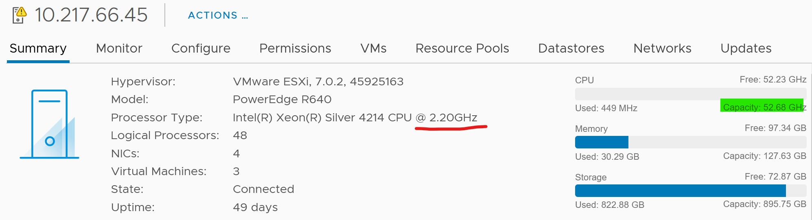

If you divide 52.68 GHz by 2.2 GHz, you get 24. The box has 24 cores. It consists of 2 sockets x 12 cores per socket

The ESXi above has 48 logical processor, because HT is enabled.

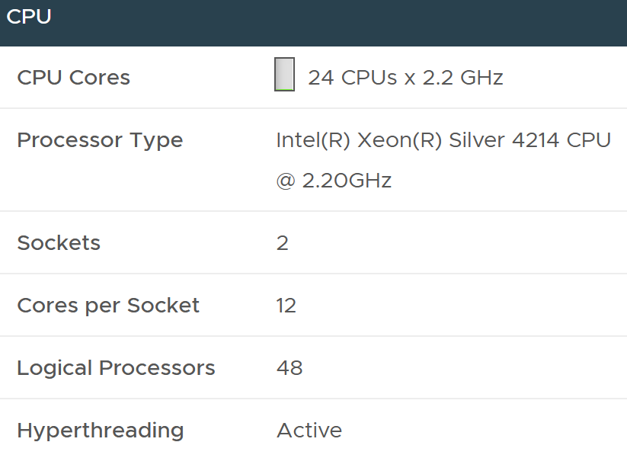

In the vSphere API, the metric for CPU capacity is derived from summary.hardware.numCpuCores x summary.hardware.cpuMhz.

##### Usable Capacity

Since we have 2 different models for total capacity, we have to have 2 answers for usable capacity.

|  |  |
| --- | --- |
| Capacity Model | Formula |
| Demand-based | Take out highest of VMkernel reservation and utilization.  This is consistent with memory. |
| Allocation-based | 2 – 4 cores? It all depends on the number of cores you think VMkernel + vSAN + NSX will consume. |

##### Demand

Compare with the Demand (%) counter to see how high above 100%. The following shows it exceeds 100% but only marginally and momentarily. When Demand passes 100% it means the CPU is running hot (high power consumption) and both threads are busy. Buying more cores or higher frequency could result in the VMs running faster, assuming CPU is the gating factor.



I’d use Utilization (%) for aggressive and Core Utilization (%) for conservative. Frequency scaling is not relevant; hence I do not use Usage. Usage will also inflate the numbers as VMkernel will take advantage of turbo boost. The drawback of this approach is you may see a different number to what vCenter uses as it uses Usage.

If Core Utilization is not yet 100% or Utilization is not yet 50% then there is still physical cores available. You can go ahead deploy new VMs.

If Core Utilization = 100% (meaning Utilization is at least 50%) then review Utilization and ensure it’s not passing your threshold. I’d keep it around 80% - 90% per ESXi, meaning the level at cluster level will be lower as we have HA host.

If you want to see the number in GHz, then use Usage and Total Capacity. Just don’t be alarm if Usage hits 100%. Check the contention metrics, as always 😊

#### Memory

In theory, the memory counter should be as simple as this:

Total = VMkernel + VM + Overhead + Free, where

* Total is the hardware memory as reported by BIOS to ESXi. This is basically the physical configured memory.
* VMkernel is the memory used by VMkernel and its loadable modules such as vSAN and NSX.
* VM is the memory used by VM
* Overhead is the hypervisor virtualization overhead on each VM. This is typically negligible.
* Free is not yet used.

##### Capacity

The total capacity is the configured memory. You can use this number for both utilization model and allocation model.

The usable capacity though, is tricky.

You can’t ignore VMkernel as it does consume resources. It’s also you size your ESXi especially when you plan to have vSAN and NSX.

ESXi Usable Capacity = Total physical capacity – VMkernel reservation

Using the actual metrics name in Aria Operations:

Capacity Available to VMs = Total Capacity - ESX System Usage

Just in case you’re wondering, the name ESX System Usage is a legacy name 😊

Since you take the VMkernel reservation from the usable capacity, you need to take it out from the demand side to prevent double deduction.

What if the usage exceeds reservation? We need to account for this extra. This is a rare occurrence. Since usable capacity metric should be stable for ease of planning, we will account for this in the demand metric. It’s also the right thing to place as when usage is higher than reservation, you want to show a higher demand.

##### Demand

Unlike CPU, there is no metric for memory demand from vSphere that you can use right away.

Reservation has to be considered. You can have memory not used but if there are reservation from existing powered on VMs, you should not deploy new VM. As different VM can have different reservation and utilization, this means the total demands has to be based on Sum of Max of (VM Reservation, VM Consumption).

###### VM Demand

First, we need to calculate the demand from each VM.

Demand = Highest of VM Reservation and VM Utilization

Do we include the powered off VM?

This is not so straight forward as the VM is already provisioned and can be turned on anytime. However, since vSphere does not consider it, then I recommend we do not for consistency.

We then sum all the powered on VMs.

Total VM Demand = Sum of ( Max (VM Reservation, VM Consumption) )

BTW

Memory Workload (%) = sum of Memory|Utilization (KB) of all VMs / Memory|Demand|Usable Capacity after HA and Buffer (KB).

###### VMkernel Demand

Remember the corner case where VMkernel usage exceeds its reservation?

This is how we take care of it.

ESXi VMkernel Demand = Max (VMkernel Reservation, VMkernel Usage – VMkernel Reservation)

###### Unmet Demand

ESXi uses 3 levels to manage memory:

|  |  |
| --- | --- |
| TPS | This happens automatically even if ESXi has plenty of RAM as it makes sense to do so. It’s not an indicative of unmet demand. Sharing the same page is the right thing to do, and not something that should be started only when physical pages are running low |
| Balloon | The first sign of unmet demand. It happens proactively, before ESXi is unable to meet Demand. Ballooning reduces cache. It does not mean ESXi unable to meet Demand. Demand is not met when Contention happen. That’s the only time it is not met. |
| Compress/Swap | This happens proactively too.  It does not mean VMs were contending for RAM. It merely means ESXi Consumed is very high. That Consumed can contain a lot of cache |

Based on the above, my recommendation if you need to calculate demand is

Unmet Demand = Ballooned + Compressed + Swapped + Swapped to Host Cache

Practically, I think consumed is good enough. It’s operationally hard for it to reach 99%, so in most cases the other 4 metrics are near 0.

Why is memory latency not included? Because that’s about speed, which is not relevant in this context.

###### Total Demand

Total ESXi Demand = Total VM Demand + VMkernel Demand + Unmet Demand

## vSphere Cluster

While a cluster focuses on compute, it is where VM runs and consumes network and storage. This is why I see vSphere Cluster as the smallest logical building block. From operations management, it’s basically a single computer.

**Part 2 Chapter 6**

But it’s a huge and complex machine. From monitoring point of view, a cluster is more than just a group of ESXi hosts. Features such as stretched cluster, Host-VM Affinity, and resource pools complicate its capacity and performance management. Capacity adds a HA, Buffer, and allocation model, which must be accounted for in capacity management.

The above makes simple metrics such as utilization more challenging.

* Is cluster utilization simply the average of all its hosts? What if there is imbalanced? It will get buried if the cluster has many hosts.
* What about stretched cluster? The utilization of the 2 physical sites may be intentionally unbalanced, because one acts as primary site while the other as DR site.

That’s why I advocate purpose-based metrics. They map to the context better. Use super metrics and create your own dashboard.

### Basic Metrics

#### HA Metrics

|  |  |
| --- | --- |
| Name | Description |
| HA Enabled | The most basic setting to begin HA configuration. Without this, there is no HA at all. |
| Admission Controlled Enabled | The next setting, but equally important. If this is disabled, then Usable Capacity will no longer consider HA buffer. This impacts the capacity calculation. |
| HA Admission Control Policy | The mapping between code to name is  -1 = Disabled  0 = Cluster Resource percentage  1 = Slot Policy (Powered-on VMs)  2 = Dedicated Failover Hosts |
| HA CPU Failover (%) | These 2 metrics are auto-calculated to match the number of hosts. It requires Admission Controlled to be enabled. |
| HA Memory Failover (%) |
| HA Default CPU Reservation | This is ignored if Admission Controlled is disabled even though HA is enabled.  There is no equivalent metric for memory |
| HA Max CPU Slot Size |  |
| HA Max Memory Slot size |  |
| HA Fixed CPU Slot Size |  |
| HA Fixed Memory Slot Size |  |

#### Event Metrics

vSphere Cluster, being the main object where VM runs, has a set of event metrics. They count the number of times an event, such as a VM gets deleted, happens. This provides insight into the dynamics of the environment.

You will find them in vSphere Client UI under the group VM Operations.

Take note that the metric is accumulative. So it starts since the day the cluster was created. Aria Operations converts into rate, and also make them available at higher level objects (Data Center, vCenter and vSphere World).

|  |  |  |
| --- | --- | --- |
| Category | Metric Name | Description |
| **Change of State** | VM guest reboot count |  |
| VM guest shutdown count | I think this triggers VM Power Off too. |
| VM standby guest count |  |
| VM power off count | I think this is direct, abrupt power off. It does not include Guest OS metrics. |
| VM power on count |  |
| VM reset count | Power cycle, different to Guest OS restart. |
| VM suspend count | Deeper than Guest OS Standby. Is this like hibernate in Windows? |
| **Change of Inventory** | VM create count | All creation, be it from template, direct, or cloning. So this is the total amount. |
| VM clone count | Creation via cloning only. |
| VM template deploy count | Creating v |
| VM reconfigure count | Log Insight tracks the actual changes. |
| VM register count | Add into vSphere inventory |
| VM unregister count | Take note the VM file can still exist in datastore and LUN |
| VM delete count | All deletion, be it API or UI. |
| **Change of Location** | vMotion count | Change of ESXi host only |
| Storage Motion count | Change of datastore only. |
| VM host and datastore change count | Both change in one event. Powered-on VMs only |
| VM datastore change count | Only for powered-off VMs |
| VM host and datastore change count | Only for powered-off VMs |
| VM host change count | Only for powered-off VMs |

You certainly have some expectation on the dynamics of your environment. Does the reality match your expectation?

In production environment, these numbers should be low. Some numbers such as shutdown should also match the change request and happens during the green zone.

Unless it’s VDI, and you include scheduled reboot as part of your architecture.

#### Storage Metrics

Typically, all the memver ESXi hosts share the same set of datastores, although there can be complication such as non-uniformed cluster and stretched cluster.

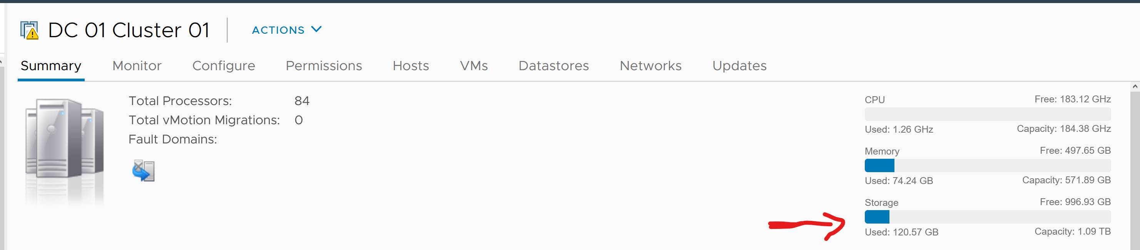

Cluster can have a many to many relationship with datastores. So the roll up has to be done via VM.

Custer Compute Resource  
Disk Space|Virtual Machine used (GB) = Sum([VM] Disk Space|Virtual Machine used)

In the What If scenario

* Guest File System | Utilization is the metric used to determine VM consumption (without the vSAN overhead due to FTT)

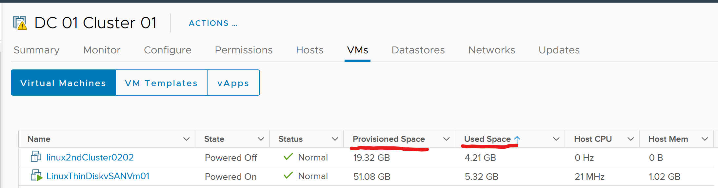

Thin Provisioned Disk = true if any of the virtual disk is thin provisioned. Note that a VM can have mix thin and thick.

Disk Space|Virtual Machine used (GB) = The size of files of a VMs.  
Note: For the file size we take the value of uniqueSize property if it is not null, otherwise we take size property.

#### Network Metrics

In vCenter, there is no networking metric. The UI has metrics for CPU, memory, cluster services and VM operations.

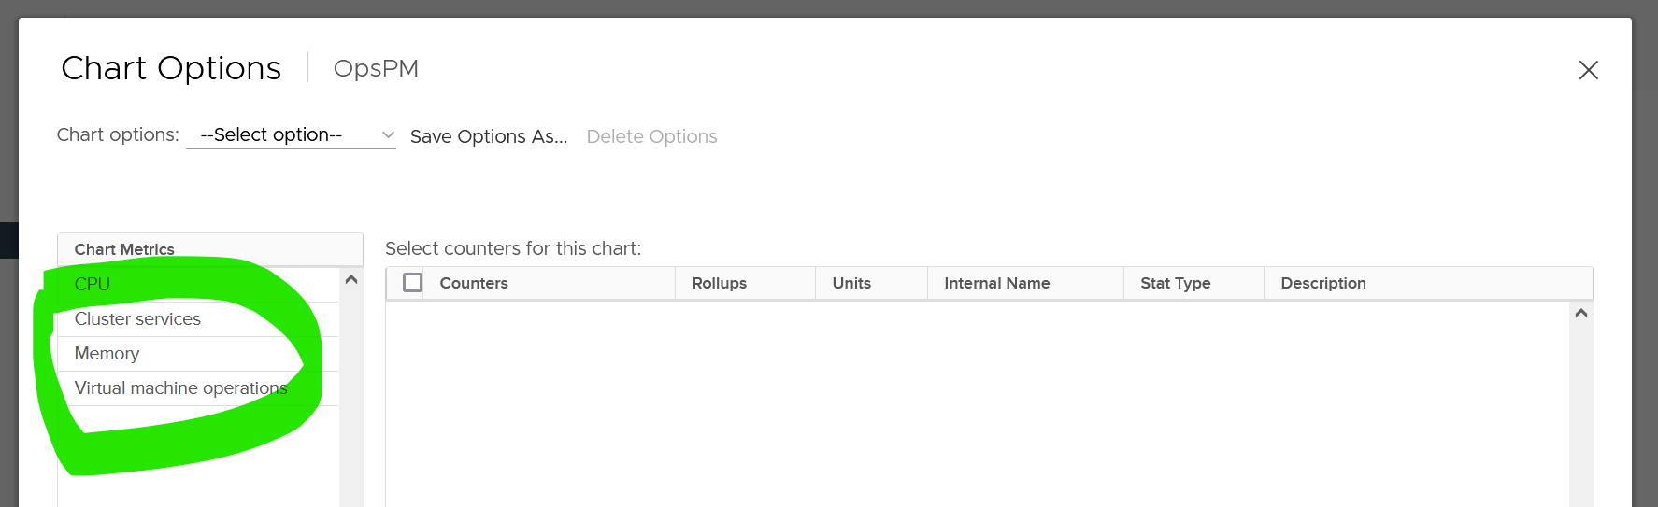

Use vRealize Operations to analyze at cluster level. There are 2 levels of network traffic:

|  |  |
| --- | --- |
| **VM level** | Sum of traffic from each VM.  This includes VM to VM communication within the ESXi. If both are on the same port group, then the packets do not travel down to the physical NIC. This makes sense as the physical NIC is actually “at the other side” of the virtual switch as it’s an uplink |
| **ESXi level** | Sum of traffic from each ESXi.  This takes the metrics from each physical network card. At this level, the metrics do not distinguish each VM but includes all traffic from VM and VMkernel.  vRealize Operations report on each VMK interface (e.g. vMotion, Management, vSphere Replication) |

Which level do you think have more traffic?

I compare 50 clusters and the physical is clearly more. This is expected as it has VM + VMkernel.

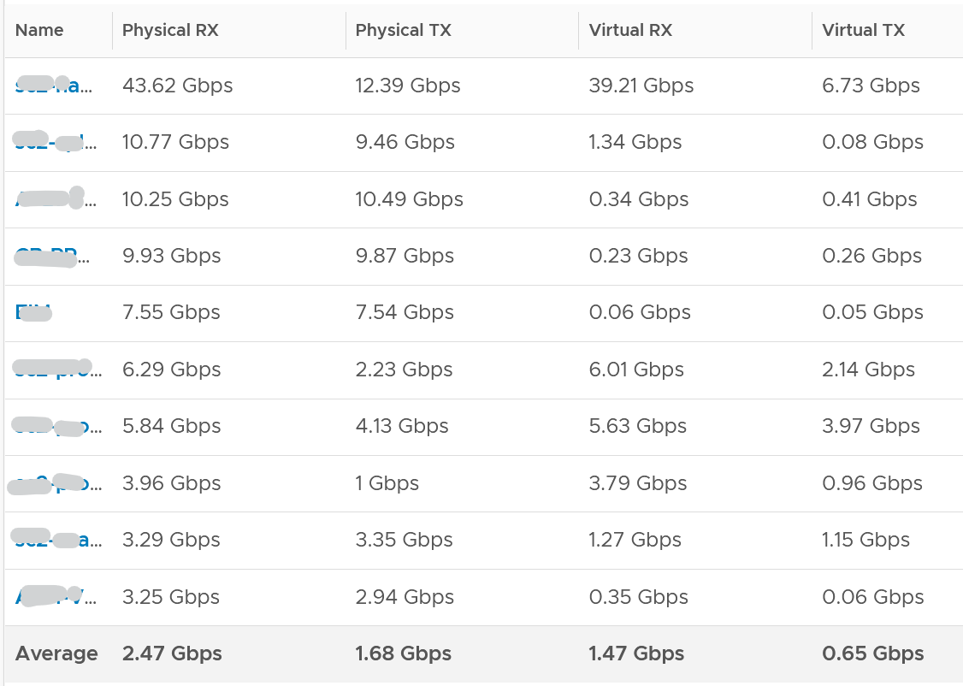

Within a cluster, if you plot the virtual versus physical, you get to see the VMkernel network such as vSAN and vMotion. It’s quite interesting to see their absolute amount.

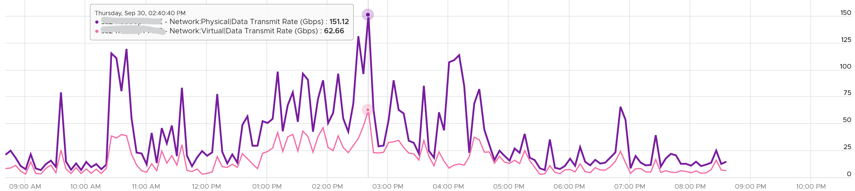

### Performance

Operationally, you manage at cluster level, not at Resource Pool, ESXi host, or data center level. It’s the sweet spot for starting your monitoring and troubleshooting. As usual, we start with the contention metric, followed by the utilization metric.

By definition, the metrics are *average* numbers. So be careful as there can be VM that has issue but obscured in the cluster wide average. Even the so-called total or summation is mathematically an average. For example, the Total CPU Wait counter is the sum of all ESXi CPU Wait metrics, which in turn is the sum of all the VMs. At the end you get a large number, which you need to normalize and convert into average. Since you divide it against the cluster total, you get average.

#### Utilization vs Contention

There is a common misconception that you cannot have performance issue when cluster has low utilization. We introduced that problem as a story earlier here.

Is there corelation between cluster utilization and cluster contention?

I’ll show 2 opposite examples.

##### Example showing Correlation

If every VM is given the same treatment by the cluster, then yes.

Here is a cluster experiencing regular high utilization in the last 7 days. You can clearly see the peak. The cluster has 14 ESXi Hosts.

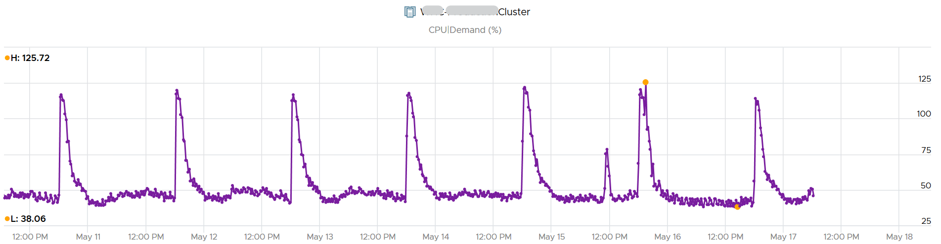

A logical question here would be what’s the impact on VM performance? Are they getting the CPU they asked? The cluster has 550 running VM.

This is where the contention metrics come in. One tracks the depth of the problem, the other the breadth of the problem.

The counter Percentage of VMs facing CPU Ready > 1% shows a nearly identical pattern. We can see that a big percentage of the VM population is affected.

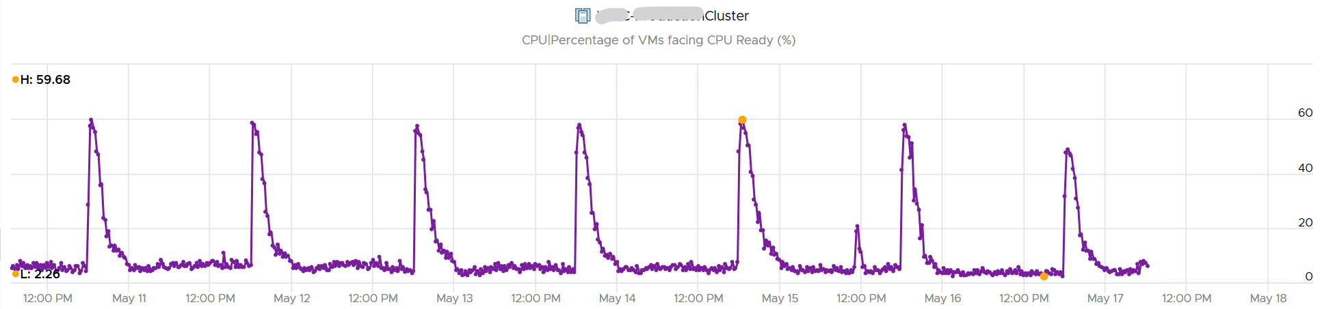

The second counter tracks the depth, giving the absolute worst CPU Ready value experienced by any VM in the cluster.

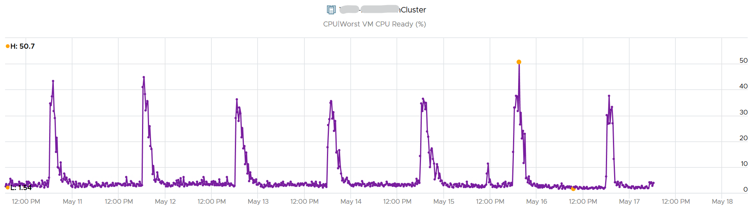

##### Example showing no Correlation

Performance is unmet demand. VM 007 can face very high contention when all other VMs on the same cluster face no contention.

It is possible for VMs in the cluster to suffer from poor performance, while the cluster utilization is low. One main reason is cluster utilization looks at the provider layer (ESXi), while performance looks at individual consumer (VM).

The following cluster has 32 ESXi supporting 2357 VM. The average demand across the cluster is <40%. Since it has 32 ESXi and 2357 VM, we can retire 8 ESXi or add 1K VM.

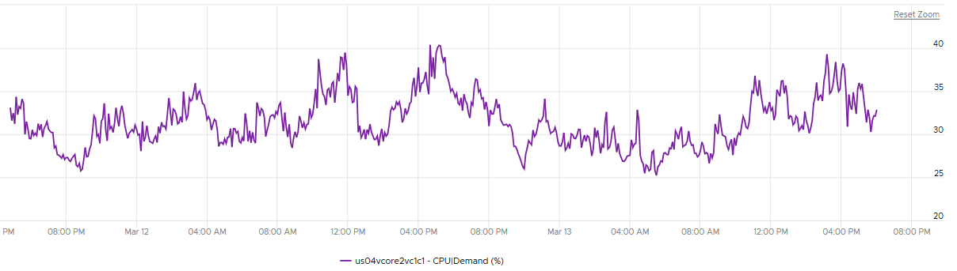

And yet the VMs in the clusters are facing contention. Both VM CPU Ready and CPU Co-stop are high.

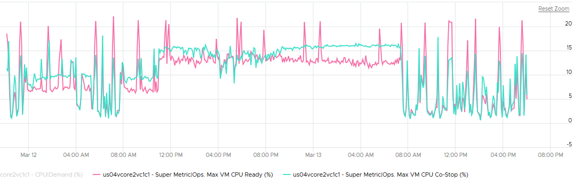

Let me take another example, where you can see the corelation between cluster utilization and VM contention in the cluster. My apology that the picture is not sharp. You can see the cluster has 774 running VM at the start. One month later it has dropped to 629, a drop of 145 VM or 19%. The second line chart reveals the number of running vCPU dropped from 3019 to 1980, a whopping 1039 vCPU or 34%. That indicates the big VMs were moved out.

This cluster was running mission critical VMs. What’s going on?! What caused the mass evacuation.

Notice the mass evacuation happened multiple times, so it’s not accidental.

Looking at the last chart. It has 2 line. Maroon showing utilization, blue showing contention. Can you figure out what happened?

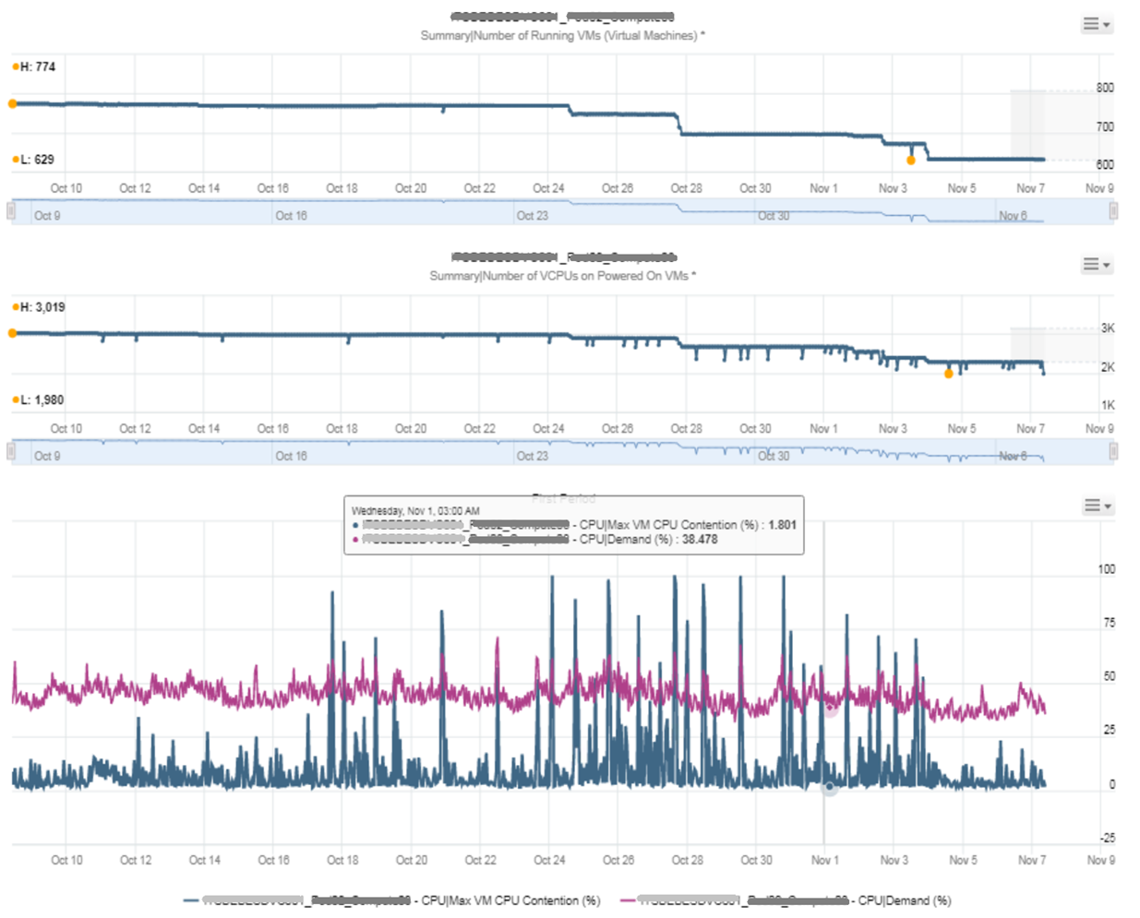

The cluster utilization was hovering around 50%. In that entire month, it barely moved. This cluster was probably 16 nodes, so 50% utilization means you can easily take out a few ESXi hosts actually.

The Max VM CPU Contention told a different story. Notice it spiked well above 75%. That impacted at least 1 VM. There were multiple spikes, leading to multiple complaints, and eventually infrastructure was forced to evacuate the cluster to fix the performance problem. Notice the counter dropped gradually in November, despite utilization remains fairly stable.

##### Example for Memory

We covered 2 examples for CPU. What about memory, since it’s a form storage. It’s just a disk space basically, so can VM experience contention when Cluster consume metric is not high?

I’d zoom into ESXi, so it’s easier to see. What do you deduce from this ESXi? This chart shows 1 month worth of data.

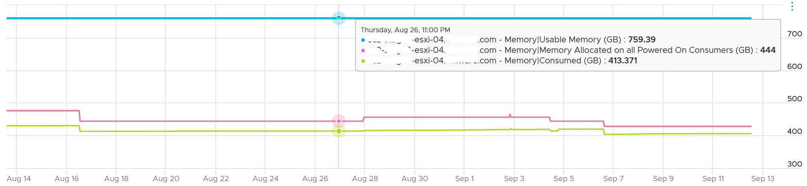

It has 759 GB of usable memory. All the powered on VM has 444 GB configured, out of which only 413 GB is mapped to physical DIMM. So there is plenty of memory left.

To confirm that it has plenty of memory, let’s plot Balloon. What do you expect?

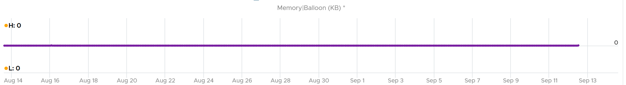

There is no ballooning. ESXi was under no memory pressure whatsoever.

So that’s the situation at provider level. How about consumer level?

vRealize Operations has a metric that tracks the highest memory contention experienced by any VM in the host. This is a good leading indicator as all it takes is 1 VM, it matters not which VM.

As we can see here, there is a problem.

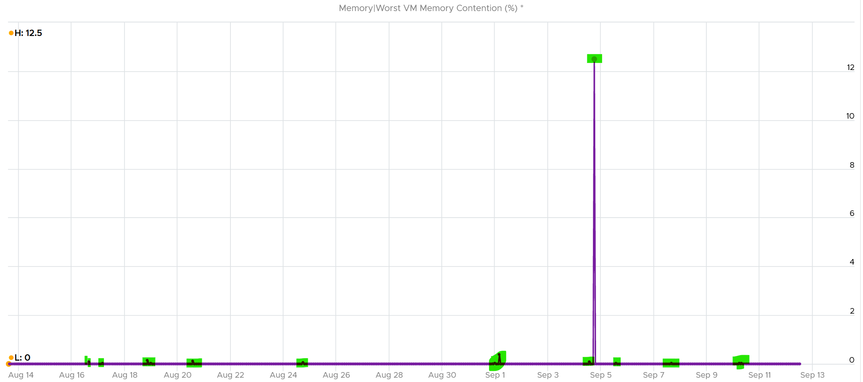

Can you explain why?

A VM experiences contention when the page is not in the DIMM. It was compressed or swapped out. Checking the compressed metric, it reveals that pages had to be brought it. Notice the swap metric lagged a bit, which makes sense.

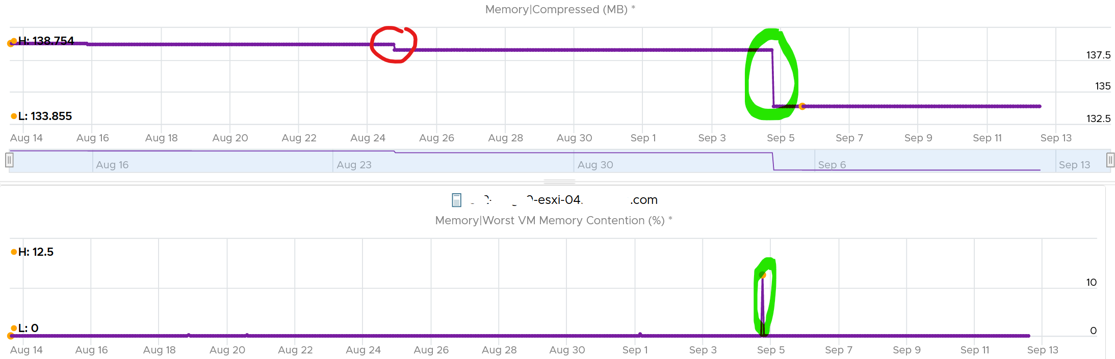

I am not able to explain the earlier dropped, the one in red circle. If you can drop me a note.

Let’s complete by plotting Swapped. I’m plotting all the way to the beginning of tracking.

It’s all 0. What happened?

That means all the pages could be compressed, so ESXi decided to compress instead of putting them into swapped file.

Now that we know it’s due to compression, we know the contention on 5 September was caused by compression. When was that page compressed, no one knows. Plotting back, the compression started around 2 August.

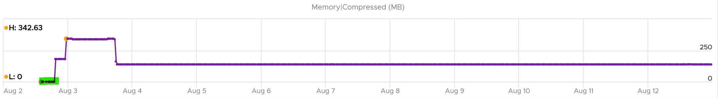

The compression was only 342 MB. Not even 0.1% of consumed memory. But if you are unlucky, it was the active VM that got hit, as in the case here.

The past is harder to debug, as we lack the ability to travel back in time and see the environment as it was. My guess here is the VM had limit, be it indirectly via resource pool or directly.

#### Cluster Performance (%)

Now that we can quantify the KPI of a single VM, we are in a position to define the cluster performance. How would you represent all the VMs in the cluster? Do you simply average the VM KPI (%)?

The answer is no. A cluster has a different purpose to a VM, so we need to see it from cluster point of view. For examples:

* Contention within the VMs (e.g. in Windows or Linux) is not a good indicator of cluster performance.
* Slow vMotion impacts the VM performance. At cluster level, this is not necessarily explaining that the cluster is struggling. It could be DRS is set to aggressive. This is a secondary KPI to the cluster, not primary.

Review the following metrics carefully. What do you notice?

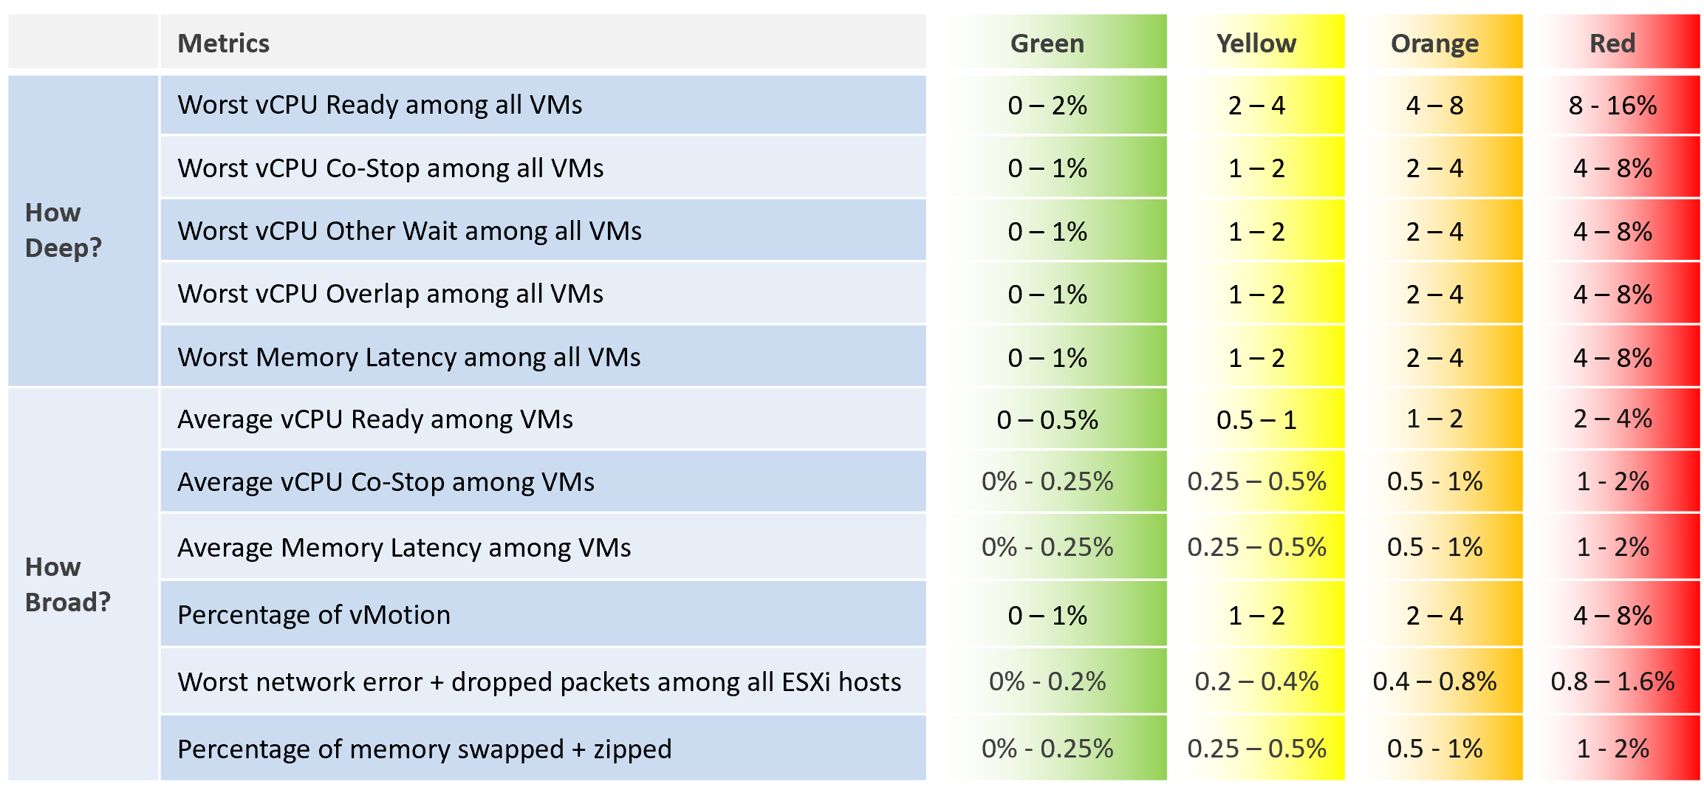

The metrics are grouped into 2: breadth and depth. We cover why we need both earlier in Part 1 Performance Management chapter.

If you think average is too late, use 95th percentile instead.

##### Big Data

Notice the sheer number of metrics involved to properly represent the cluster performance. It is important to provide complete coverage.

Say you have a cluster with 1000 VM and 20 ESXi hosts. The average VM size is 4 vCPU.

The first counter in the preceding table is “Worst vCPU Ready among all VMs”.

* Based on average VM size of 4 vCPU, we can roughly say that each VM contributes 4 metrics, 1 for each vCPU. From this counter, we take the maximum value and derive a new metric. This means each VM has 5 metrics (4 details + 1 worst).
* There are 1000 VMs in the cluster. So there are 1000 x 5 = 5000 metrics required just to give you the first counter.

The second counter in the preceding table is “Worst vCPU Co-Stop among all VMs”.

* Just like the first counter, there are 5000 metrics required.
* This brings the total to 10K metrics from the first 2 metrics.

The 3rd counter also requires 5K metrics.

The 4th and 5th metric bring 1K metric each.

By now you get the point. The metric is easily made of thousands of raw metrics.

##### Metrics

Go back to the table and review the list of metrics. Do they match your expectation? Why are some metrics included and others are not?

vMotion is included as it does impact the VM performance (although the end users may not notice in most cases) and it’s a leading indicator that the cluster is struggling to serve the load hence it has to shuffle the VMs around.

Take a look at this cluster. It has 488 running VMs on 16 ESXi host. Notice the percentage of VM being vMotion jumped to 5.3%, as 26 VMs were vMotion.

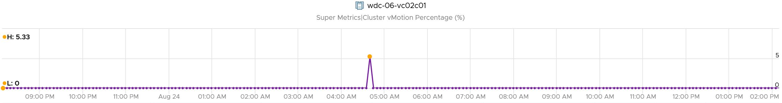

What do you think will happen to the VM CPU Ready and CPU Co-stop? 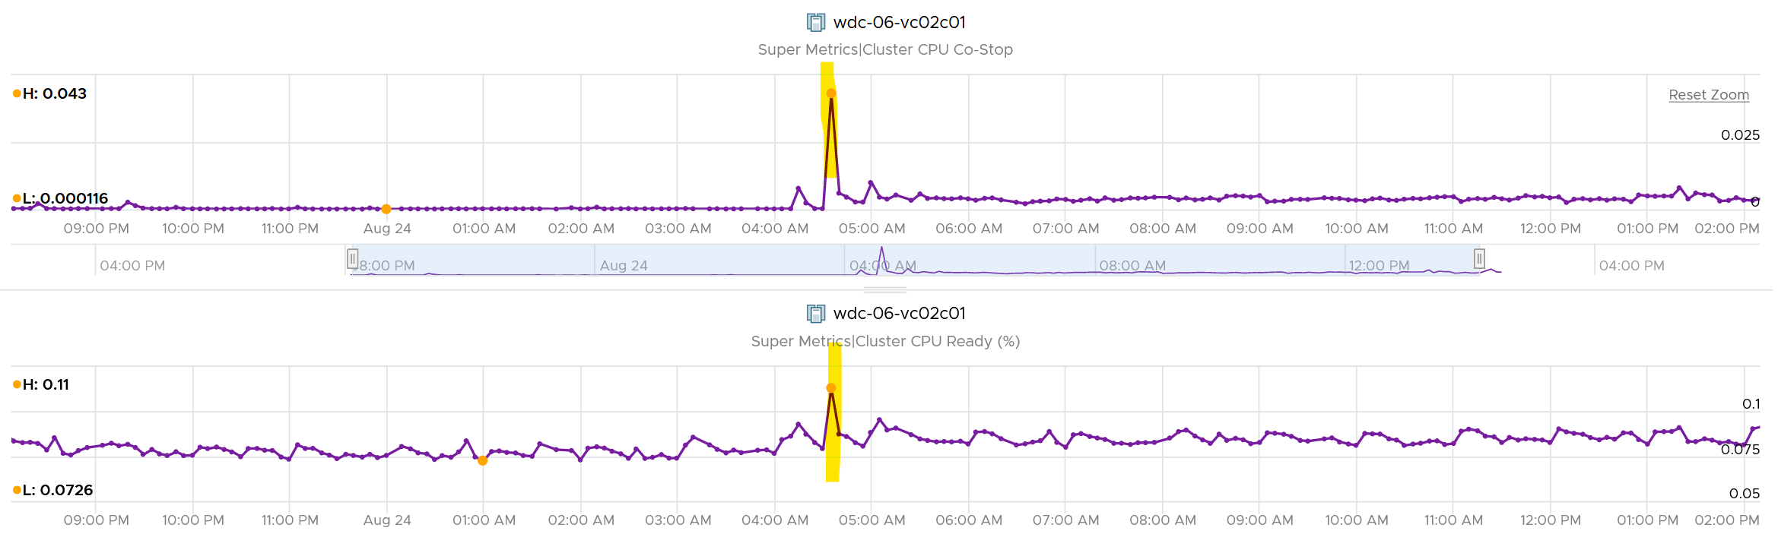

They rose. Since only 5% was impacted, the rise will be minimal.

The threshold should reflect reality. For examples:

* While the impact on VMs are the same with Ready, using the same range for CPU Co-stop, CPU Overlap and CPU Other Wait will elevate the KPI score, as practically these 3 have lower score.
* Dropped packet and error packets are very rare. Instead of summing them up, which will result in a average, I took the worst among ESXi host. Since many ESXi sports 25 Gb NIC, I set the threshold to be very low. On the other hand, I did not set green = 0, so the KPI do tolerates some issue.
* Ballooning does not actually impact performance. But since many clusters sport 2 TB of RAM, I set the threshold low as 1% is 20 GB.

##### Metrics Not Used

The following metrics are not included:

* “Percentage of VM population experience CPU Ready > 1%” and “Percentage of VM population experience Memory Contention > 0%” as they measure the same purpose with the average.
* VM utilization. They are irrelevant. Use the metrics at ESXi level instead.
* ESXi Consumed. The higher the consumed, the better the performance. We use balloon, swapped and compressed metrics instead. Since they do not directly impact performance, we put as secondary KPI.
* ESXi CPU Usage. I do not include them yet, as they do not actually impact performance. If you plan to include them, take the highest among ESXi instead of cluster wide average, as average is too late.
* VM DRS Score. It’s using metrics that are already included in the KPI, so it’s double counting.
* Disk latency. Storage troubleshooting differs to compute troubleshooting. The exception here is Hyperconverged Infrastructure, as the compute and storage are integrated.
* Percentage of VMs facing Disk Latency. It should be part of datastore KPI, not the cluster. The reason is if there is a population problem, you troubleshoot the datastore not the cluster(s) mounting it.

##### Implementation

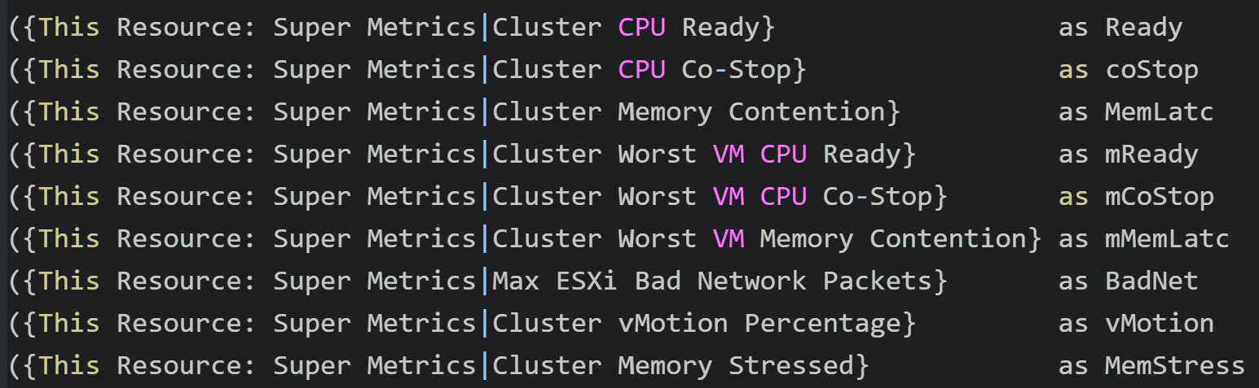

I have not implemented CPU Other Wait and CPU Overlap. Reason is I find their values to be very low that they might mask out problems.

Future enhancements:

* Add 90th percentile metrics to complement Worst and Average. This helps you capture at 3 diffferent points. Notice I set the thresholds for worst to be 4x the average. We will set threshold for 90th percentile at 2x average.
* There are metrics that are only available in esxtop. They are not available in vCenter REST API, so they are not retrieveable. Examples are Local:Remote memory ratio for VM.

#### Service Level Metrics

There are only 2 metrics (SLI and SLA) as covered in Part 1.

##### Cluster SLA

How to roll up the VM SLA into total SLA for the whole environment? Your CIO likely wants to see this number over time.

Calculating SLA per vSphere cluster also makes management easier. You know which cluster to attend to. The problem is SLA is a lagging indicator. It is based on the last 30 days or the last month.

Cluster SLA is derived from the VM SLA. It is simply the percentage of VMs that fail the SLA. How bad each VM fails the SLA, or how comfortable it exceeds the SLA, is *irrelevant* at this stage. At the cluster level, you care about pass/fail first.

That means the Cluster SLA is not the average of its VM SLA. Doing an average can be too late unless your SLA is 100%.

Once you know how many VM fails, you want to know who the VMs are and troubleshoot if there is a common reason.

##### Cluster SLI

SLA is a 30-day counter. You can’t wait that long before you do something. This is where SLI comes in. It’s an indicator, and not mentioned in the SLA contract.

Let’s take an example of a cluster with 500 VM. Each VM consumes 4 IaaS resource (CPU, Memory, Disk, Network). It must pass all else it’s counted as 1 SLI fails.

The Cluster SLI (%) is simply the percentage of VM that fails the SLI. As a recap, this is the single threshold we use for all classes of service:

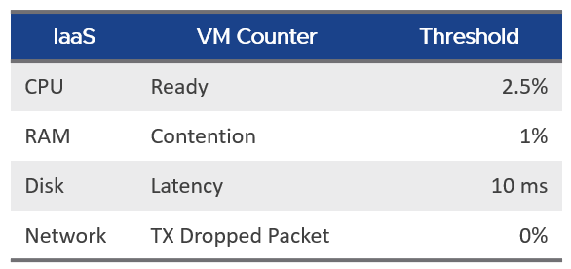

It’s a normalized average of the VM SLI, taking into account the actual SLI failures. That means it will give a lower number if the VMs are experiencing worse SLI individually. 1 VM experiencing 4 SLI failure will result in the same value as 4 VM experiencing 1 SLI value each.

The formula is

100 –

(

( Sum([VM]Performance|Number of KPIs Breached) + Sum([Pod]Performance|Number of KPIs Breached ) )

/

( Summary|Number of Running VMs + Summary|Number of Pods ) * 100 / 4

)

### Capacity

CPU and memory metrics have different nature.

* For memory, I’d not be worried so long high utilization metrics such as balloon, swapped and compressed are all 0. There are enough inactive pages at ESXi level to not worry about high consumed value. However, Balloon happens at 99.3% consumed and it ignores HA and buffer. So when Balloon happens and there is no limit, you’ve exceeded 100% of usable capacity
* For CPU, my answer depends on my HA setting. For example, if it’s 9+1, then cluster average utilization at 100% means each host is averaging 90%.

Long Term Forecast = Forecast of (Usage and Contention (aka Demand) + Overhead (if applicable).

Usable Capacity = Total Capacity - (vSphere HA reservation + capacity buffer).

Capacity buffers defined in vRealize Operations policy (default 0%).

Since it is just a reservation (allocation), the value can exceed Consumed. It is not included in the calculation of the parent cluster usable capacity.

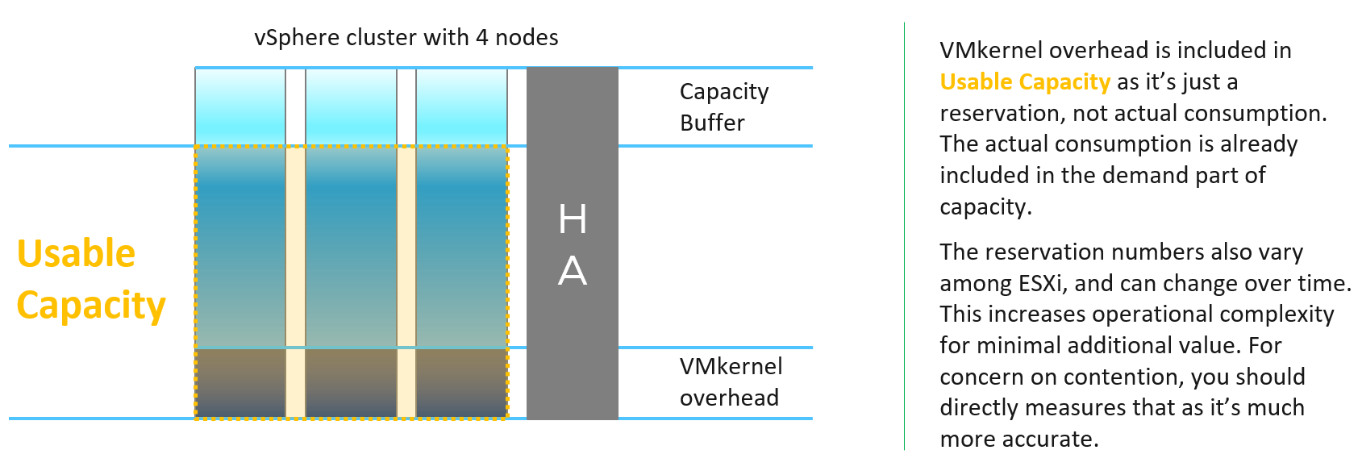

Let’s take an example.

Assuming 10 hosts in a cluster, with N+1 HA setting, and Buffer is set to 0%.

Usable Capacity is 9 hosts, so 9 is the 100% operationally. SLA is also based on 9.

From here, if a host is out, the calculation depends on what actually caused it. There are 3 different scenarios:

|  |  |  |  |
| --- | --- | --- | --- |
|  | Intentional? | Desired | Impact |
| vSphere DPM | Yes | Yes | Total Capacity |
| Maintenance Mode | Yes | No | Usable Capacity |
| HA happen | No | No! | Usable Capacity |

Intentional means it’s something you knowingly execute. In the case of vSphere DPM, it’s also something you want to happen. In the case of Maintenance Mode, you intentionally do it but it’s not something you want. So the 2 have different impact. vSphere DPM does not impact your HA as you still want HA even though you take out host(s). The length of DPM can be as long as there is no request for extra host. The length of maintenance mode should be as short as possible, hence the name maintenance.

HA events is an outage. It is obviously not something desired.

Undesired event impacts usable capacity and not total capacity.

|  |  |  |  |
| --- | --- | --- | --- |
|  | DPM event | Maintenance Mode | HA event |
| Total Capacity | 9 | 10 | 10 |
| Usable Capacity | 8 | 9 | |
| Actual Availability | 9/9 = 100% | 9 / 10 = 90% | |
| Operational Availability | 9 / 8 = 100%  (capped) | 9 / 9 = 100% | |

For completeness, let’s follow with a 2nd host out

|  |  |  |  |
| --- | --- | --- | --- |
|  | DPM event | Maintenance Mode | HA event |
| Total Capacity | 8 | 10 | 10 |
| Usable Capacity | 7 | 8 | |
| Actual Availability | 8 / 8 = 100% | 8 / 10 = 80% | |
| Operational Availability | 8 / 7 = 100% | 8 / 9 = 89% | |

The metric Total Capacity only counts those ESXi hosts that are connected. If a host is connection state = disconnected, its values becomes blank, so the Total Capacity is affected.

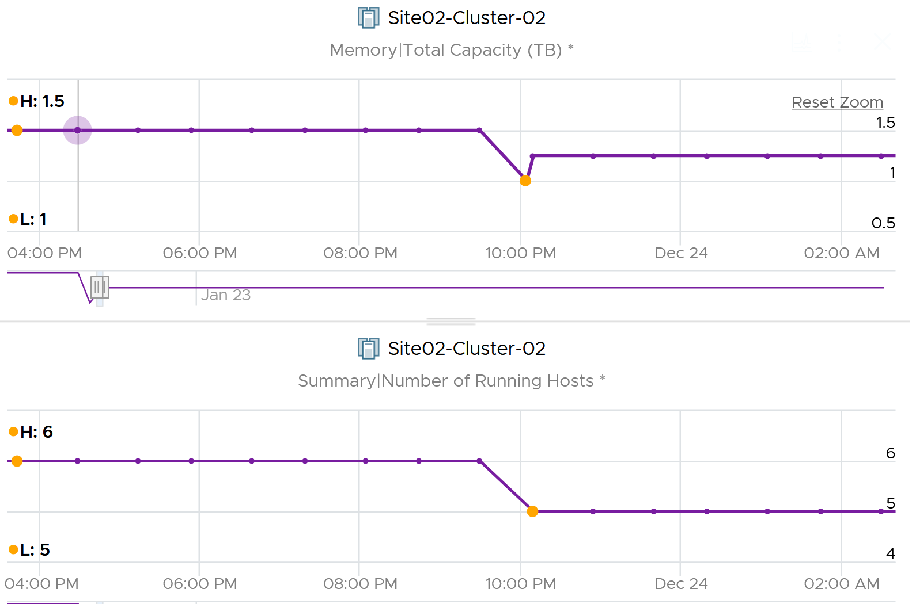

#### CPU

|  |  |
| --- | --- |
| **Metric Name** | Formula |
| Total Capacity (MHz) | The sum of all the physical cores in MHz.  It does not consider Hyper-Threading, meaning turning in on does not increase the value.  It does not consider CPU power Management, as it would be confusing to have volatile total capaciy. |
| Usable Capacity (MHz) | Usable CPU resources after deducting vSphere Cluster HA and vRealize Operations buffer field.  If HA is not enabled, then it takes CPU \ Total Capacity value  It considers the 3 types of Admission Control policies: slot size, resource percent, and failover host.  CPU Usable Capacity  = CPU \ Demand \ Usable Capacity after HA and Buffer (GHz)  = Sum ( ESXi CPU \ Capacity Available to VMs ) * ( 100 – Cluster HA CPU Failover ) % |
| Usage (MHz) | Sum of all the ESXi Host CPU \ Usage  This includes the overhead (e.g. vSAN, NSX, VMkernel) |
|  | Sum of all the VM CPU Demand  This is useful in the migration use case. The metric used is Demand, not Usage, as it should be based on the ideal that the VM does not shared the core. |
| Cluster Demand | Cluster CPU Demand contain only limits, CPU Reservation is excluded as it’s on demand. |
| Capacity Usage (%) | CPU \ Usage divided by CPU \ Total Capacity  Value is then * 100 as it’s percentage. |

#### Memory

Memory is tricky as the primary metric (Consumed) does not account for memory pressure. So it does not reflect unmet demand. This is technically correct as those pages that were ballooned, swapped, and compressed are no longer backed by physical pages.

|  |  |
| --- | --- |
| **Metric Name** | Formula |
| Total Capacity |  |
| Usable Capacity | For cluster:  = Memory \ Demand \ Usable Capacity after HA and Buffer (GB)  = ( Sum ESXi Memory \ Capacity Available to VMs ) * ( 100 - Cluster HA Memory Failover) % |
|  | Highest ESXi Consumed among all the hosts in the cluster |
|  | Normalized average of ESXi Consumed among all the hosts in the cluster |
| Usage (%) | Memory Consumed in %  ( Sum[HostSystem](Memory|Consumed) /  Sum[HostSystem](Memory|Total Capacity) ) * 100 |
|  | Memory utilization contains limits and reservations. |

## Storage

**Part 2 Chapter 7**

We will cover vSAN, vSphere and physical as they are closely related.

### Datastore

The metrics value at datastore exclude VMDK that is *not* on the datastore. It also excludes RDM.

Just like Part 1 of the book, we begin with performance, then capacity, and closing it with configuration.

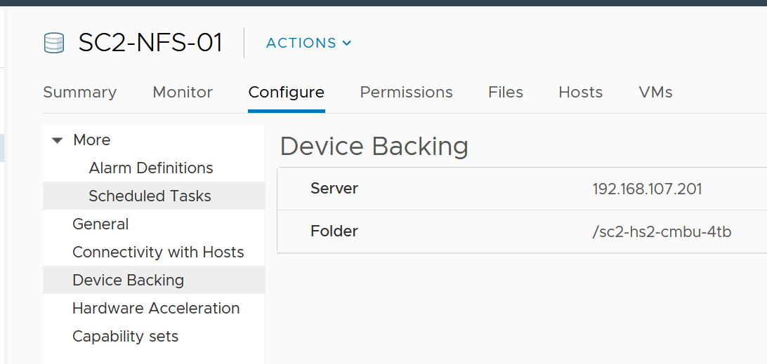

#### Performance

Take note that datastores that share the same underlying physical array can experience problem at the same time. The underlying array can experience a hot spot on its own, as it is made of independent magnetic disks or SSD.

VMs in the same datastores can experience different latency. The following heat map shows all the VMs in a single VMFS datastore, backed by ExtremeIO. Notice two of the VMs experience latency above 10 ms, while many other VMs experience less than 1 millisecond.

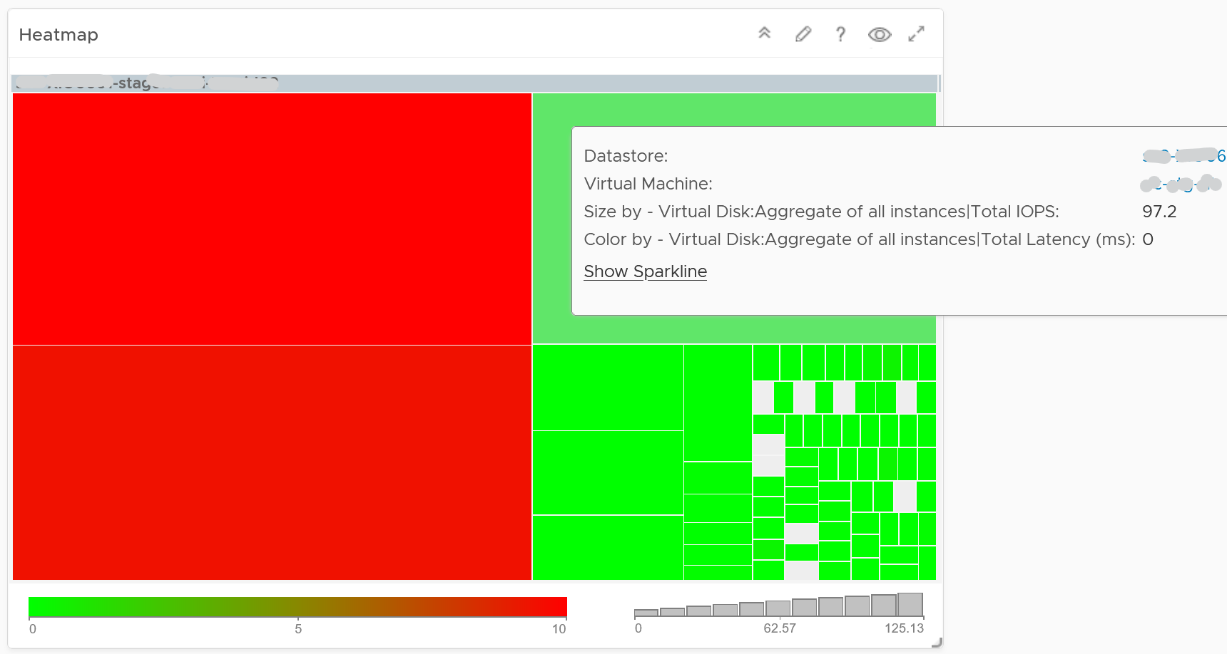

There are more metrics available via vCenter API than what’s presented in the UI. Just to recap, this is what you get in the UI.

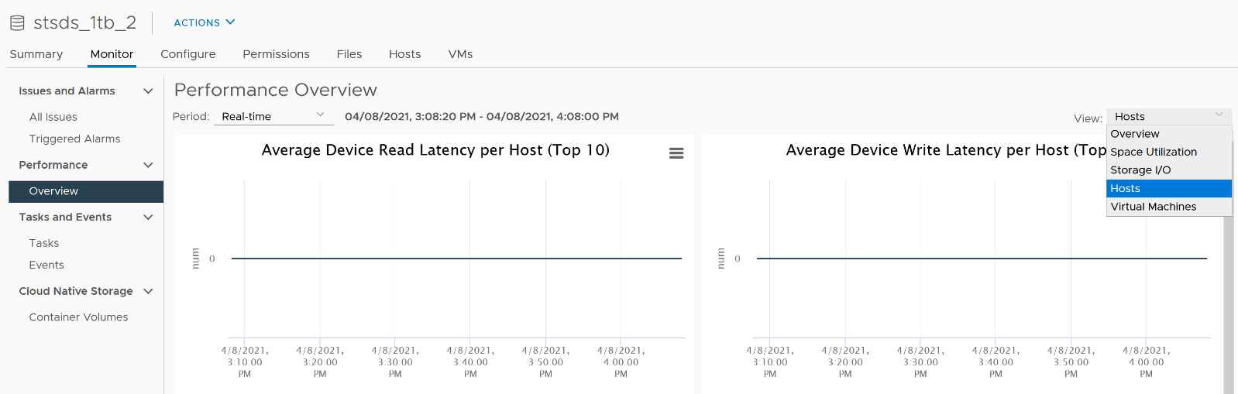

Metrics such as Datastore \ Outstanding Read Requests and Datastore \ Outstanding Write Requests are available only in the API. They are required for performance troubleshooting and capacity monitoring.

#### Capacity

There are 2 types of capacity metrics

* Allocation
* Utilization

Utilization can be greater than allocation because there are other files beside virtual disk, such as snapshot. For virtual disk, utilization can be greater if you use vSAN.

When you create a virtual disk, you have to define the size. This is called the configured size. If this is thin provisioned, then the actual consumption will be less at the time of creation. As Guest OS starts using it, writing and deleting in its filesystem, the underlying VMDK file size will grow as it contains both mapped block and unmapped block.

There are 2 types of numbers:

|  |  |
| --- | --- |
| Real numbers | Based on actual usage and total capacity. Useful for day to day operations. If free space = 0 then VMs will hang. If free space is low, then avoid taking snapshots.  Key metrics: Total Capacity, Used (and its breakdown), Free |
| Capacity-management numbers | Based on imaginary usage, numbers that do not exist in actual. Only useful for capacity monitoring. If usage = 100% there is no impact on availability as there is still buffer.  Key metrics: Usable Capacity, Usage against Usable, Uncommitted Space, Overcommit ratio |

For Datastore Cluster, the capacity and reclamation metrics are the sum of its datastores.

##### Total Capacity

|  |  |
| --- | --- |
| Metric Name | Disk Space \ Total Capacity |
|  | This is the total capacity of a datastore. It’s a raw metric from vCenter, not a computed metric by vRealize Operations |
| Formula | summary.capacity / 1024 * 1024 * 1024 |

Note there is no metric for Buffer. See the values from vRealize Operations policy.

##### Basic Utilization

Basic means the one you use the mos. All customers will use them as they are fundamental to operations.

|  |  |
| --- | --- |
| **Metric** | **Description** |
| Disk Space | Virtual Machine Used (GB) | Actual disk space used by all the files in the VM folder in the datastore. Logically, it includes unmapped block overhead.  VMDK files that are shared by multiple virtual machines are not calculated twice, as there is only 1 file in the datastore folder. The other file in other VMs is just a link (pointer).  Formula:  Sum([layoutEx.file] uniqueSize != null ? uniqueSize : size) / (1024 * 1024 * 1024) where aggregation is done for VM files on that datastore only as VM can have files in other datastores |
| Capacity | Used Space (%) | Percentage of space used in the datastore.  Formula:  Capacity|Used Space (GB) / Capacity|Total Capacity (GB) * 100 |
| Disk Space | Freespace (GB) | The actual disk space available in datastore. It’s unaware of thin provisioned (provisioned but not yet used) as it simply measures what’s actually available.  Formula:  summary.freeSpace / 1024 * 1024 * 1024 |

##### Specific Utilization

Specific means additional metrics that measures a specific area. Not all customers may use them.

|  |  |
| --- | --- |
| Disk Space \ Virtual Disk Used | Sum of all the VM metric Disk Space \ Virtual Disk Used |
| Disk Space \ Snapshot Space | Sum of all the VM metric Disk Space \ Snapshot Space  Use this to find which datastores are plagued by huge amount of snapshot. |
| Disk Space \ Other VM Space | Calculated internally by summing all the VM files that do not belong to virtual disk, snapshot and swap file.  Use this to find which datastores have potentially unused files |
| Disk Space \ Swap File Space | Calculated internally by summing all the VM swap file.  BTW, I fail to see a purpose of this metric. If you have let me know. |
| Disk Space \ Overhead | Amount of VM disk space other than the virtual disk. Includes files such as memory swap, snapshot and logs.  This is a computed metric and not available in vSphere UI. |
| Disk Space | Total Provisioned Disk Space With Overhead (GB) | The theoretical amount of total consumption that would happen if all the VMs fully use the allocated virtual disk in the datastore.  Formula:  Capacity| Total Capacity (GB) - Capacity| Available Space (GB) + Capacity| Uncommited Space (GB) |
| Capacity \ Total Provisioned Consumer Space | As above, but only for the virtual disk file.  Formula:  Sum([VM]virtualDisk.capacityInKB / 1024 * 1024)  where aggregation is done for each virtual disk which is residing on this datastore. |

The following table shows examples. Note the value of the last metric is blank if there is no VM in the datastore

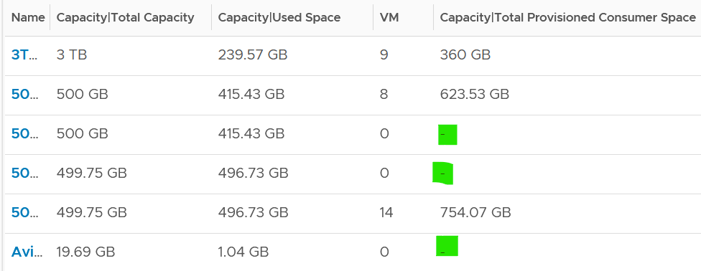

##### Capacity Model

Avoid mixing the metrics of utilization model and allocation model. Use both models and take the lowest capacity remaining number.

|  |  |  |  |
| --- | --- | --- | --- |
|  | Allocation Model | Utilization Model | |
| Total capacity | Disk Space \ Total Capacity. Same for both models | | |
| Buffer | Information not available as metric. See the value in policy | | |
| Usable Capacity |  | |  |
| Utilization  (always against usable, not total) |  | For overcommit ratio, use ___ | |
|  |  | For uncommitted space, use ___ | |

#### Properties

|  |  |
| --- | --- |
| **Property** | Description |
| Datastore Accessible | Possible values: PoweredOff, PoweredOn  Powered Off = datastore is completely inaccessible by any ESXi. |
| Maintenance Mode | Datastore in maintenance mode is still powered on and accessible. You can view files on it but cannot write anything to it.  Entering maintenance mode is a quick process however in case of widely shared datastores like NFS it might take time as that is shared among hosts. The datastore cannot be stuck for hours in entering maintenance mode. Trigger the alert if that’s the case.  Possible values:   * Entering Maintenance Mode. * In Maintenance Mode * Normal Mode   Newly added in Aria Operations |
| Type | Possible values: VMFS, NFS, vsan |
| Path | Typically it begins with ds:///vmfs/volumes / regardless of the type. NFS has shorter path name compared with VMFS and vSAN |
| VMFS version | Possible values: VMFS 6 |

### vSAN

There are 2 characteristics of vSAN that makes its operations management differs to physical array.

* Distributed. The actual disks are spread across many physical gears, which are typically ESXi servers. From monitoring and troubleshooting viewpoint, not all distributed storage are equal. vSAN runs as a kernel module in VMkernel, which results in a different context than if vSAN were running as a VM. The metrics are different because the architecture is different.
* Software-defined. The availability protection for the VM disks is done above the VMFS layer, not below the LUN. That turns capacity planning & availability management upside down. The datastore consumption is much higher, often 2x depending on the vSAN storage policy, due to the need to protect the VM data from disk failure.

In vSAN, you need to know where VM storage is located. So a VM now has 1 Compute Host and >1 Storage Hosts. The storage hosts vary, depending on which part of the disks are being accessed.

#### Performance

While vSAN provide storage service, network is a mandatory component of vSAN. So we need to look at both storage and network in analysis. Since vSAN run inside ESXi Host, so we need to consider compute metrics also.

A large vSAN cluster can have many components. Each of these components can have multiple performance metrics. The total number of KPI can reach hundreds of metrics. Take the following example, which is a 10 node cluster.

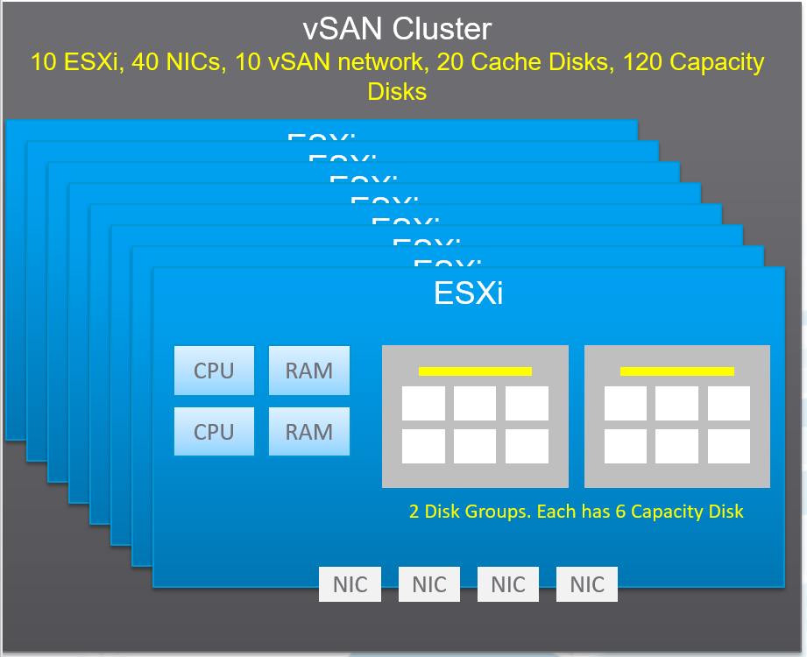

Here are some of the questions you want to ask in day-to-day operations:

* Is any of the ESXi hosts in the cluster running high CPU utilization?
* Is any of the ESXi hosts running high Memory utilization?
* Is any of the NIC cards in any of the ESXi hosts running high utilization?   
  In the above example, with 4 NIC cards per ESXi, you have 40 TX + 40 RX metrics.
* Is the vSAN VMkernel network on any of the ESXi hosts congested?
* Is the Read Cache on any of the Disk Groups sufficient? If you have a lot of cache miss, it can impact performance.
* Is the Write Buffer on any of the Disk Groups sufficient?
* Is the Cache Tier performing fast? Each disk has 4 metrics: Read Cache Read Latency, Read Cache Write Latency, Write Buffer Write Latency, Write Buffer Read Latency. Since there are 20 disks, you need to check 80 metrics
* Are the Capacity Disks performing fast? Check both Read and Write latency as they typically have different results.  
  In our example above, there are 120 x 2 = 240 metrics.
* Is any of the Disk Groups running low on space?
* Is any of the Disk Groups facing congestion? You want to check both the max and count the number of occurrences > 50 or 60. Congestion is an internal vSAN metrics. Congestion can happen at relatively low IOPS if the throughput is high (due to large block size).
* Is there outstanding IO on any of the Disk Group?

If you add them up, you are looking at 530 metrics for this vSAN cluster. And that’s just 1 point in time. It will be difficult to show hundreds of datapoint on a screen, even if you can color code them all. We need a way to zoom in on the early warning.

The above is just a point in time. What if you want to see the trend *over time*? In 1 month, you are looking at 530 x 8766 = 4.6+ million data points. And that’s just for 1 cluster. So there is a need for a better technique.

vRealize Operations use the formula Min(), Max(), and Count() to pick the early warning. This was covered earlier in this section. It combines the key metrics into a set of KPI. With these vSAN KPIs, you only have 12 metrics to check instead of 530, without losing any insight. In fact, you get better early warning, as we hide the average. Early Warning is critical as buying hardware is more than a trip to local DIY hardware store.

The following tables show the KPIs and their formula.

|  |  |
| --- | --- |
| Name | What it is |
| Max Capacity Disk Latency (ms) | Highest Latency among all Capacity Disks. We take the worst, not average, as the latency in a single Capacity Disk is already an average of all its VMs. If there are 50 VMs on the disk, and 30 are issuing IO on it, then it’s a average among 30. |
| Min Disk Group Write Buffer Free (%) | Lowest free capacity among all the Disk Group Write Buffers. If this number is low, one of your buffer is not enough. While you want to maximize your cache, a low number is an early warning for capacity management. |
| Max Disk Group Read Cache/Write Buffer Latency (ms) | Each disk has Read Cache Read Latency, Read Cache Write Latency (for writing into cache), Write Buffer Write Latency, Write Buffer Read Latency (for de-staging purpose). This takes the highest among these 4 numbers, then the highest among all disk groups. It’s the Max of Max, because each of 4 datapoint is average of all the VMs on it. |
| Sum Disk Group Errors | Sum of Bus Reset + Sum of Commands Aborted among all the Disk Groups. We sum, not get the max, as each member should return 0. |
| Count Disk Group Congestion Above 60 | The number of Disk Group congestion greater than 60. 60 is hardcoded in the MP as it’s good starting point. As any congestion above 60 serves as early warning, we count how many of such occurrence happens. |
| Max Disk Group Congestion | The highest congestion among all the disk groups. A high number indicates at least 1 Disk Group is not performing. See [this KB](https://kb.vmware.com/s/article/2150012) for details. |
| Min Disk Group Capacity Free (%) | The lowest free capacity among all disk groups. A low space will trigger rebalance. |
| Min Disk Group Read Cache Hit Rate (%) | The lowest hit rate among the disk group read cache. Ensure this number is high, indicating read is served by cache. |
| Sum vSAN Port Group Packets Dropped (%) | Sum of all vSAN VMkernel port RX Dropped Packet + TX Dropped Packet.  You should expect no dropped packet in your vSAN network |

From the above, we need to reduce it to a single metric so we can report many vSAN clusters. The following diagram shows why.

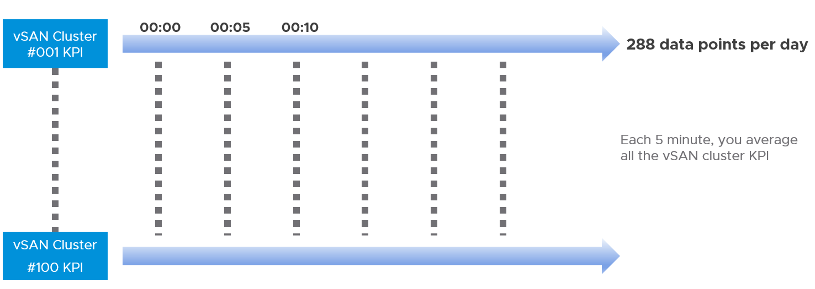

##### Congestion

If you’re experiencing slowness, [this KB article](https://kb.vmware.com/s/article/2150012) provides more details on what to look.

Congestion is a feedback mechanism to reduce the rate of incoming IO requests from the vSAN DOM client layer to a level that the vSAN disk groups can service. This reduction of the incoming IO request rate is done by introducing an IO delay that is equivalent to the delay the IO would have occurred due to the bottleneck at the lower layer. Thus, it is an effective way to shift latency from the lower layers to the ingress without changing the overall throughput of the system. This avoids unnecessary queuing and tail dropped queues in the vSAN LSOM layer and therefore avoids a lot of wasted CPU cycles in processing IO requests that might eventually be dropped.

Hence, regardless of the type of congestion, temporary and small values of congestion are usually OK, and not beneficial to the system performance. However, sustained and large values of congestion may lead to higher latency and lower throughput than desired, and therefore warrant attention and resolution in order to get a better benchmark performance.

##### Performance Troubleshooting

The above KPI metrics are good enough for monitoring. It tells you if there is a problem. To know what’s causing the problem, you need to deeper. The first step is to recognise that there are two broad layers: VM layer and back end layer.

I’ve put the two screens side by side for ease of comparison. What do you notice?

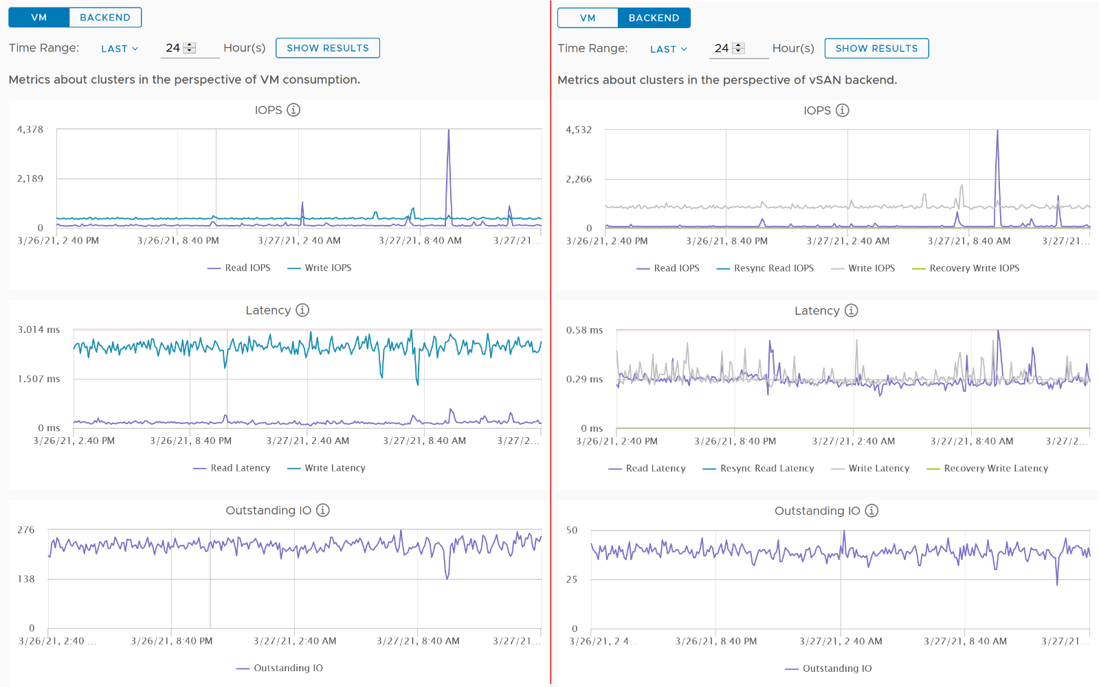

Just like other storage subsystems, you will expect the latency & outstanding IO at the backend layer to be lower. This is because it’s a subset of the entire path taken by the IO command of the VM.

Let’s dive deeper to peel the layer. The following diagram shows the key components and how the latency metrics are measured. It visualizes the hardware and software component using different box style.

* Software: VM, vSAN software and Network kernel loadable module
* Hardware: IO Controller Card, Cache Disk, Capacity Disk, and Network Card

The white arrows show a single Write command, and the yellow arrow show a single read command. Both have double arrows to show the acknowledgement when the command has been completed.

* The write request is written to the cache disk, and acknowledged. The de-staging to capacity disk is done post acknowledgement, hence it’s not part of the VM disk latency. In this example, we are showing that the writing happens to be on local ESXi host.
* The read request is shown as remote so we can cover both local and remote scenarios. Notice the read does not touch the local IO Controller Card. It goes into the network subsystem, which drives the physical network card. On the destination host, the vSAN software will first read from the cache. If there is a miss, it will read from the capacity disk.

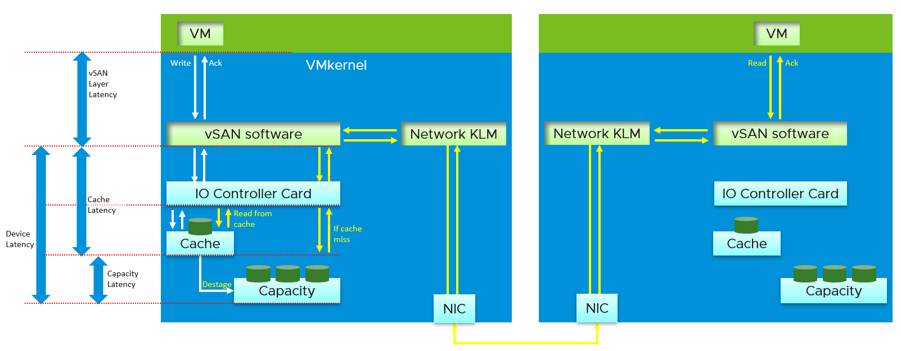

[Pete Kohler](https://www.linkedin.com/in/pekoehler/) shares the following diagram in [this](https://core.vmware.com/blog/performance-troubleshooting-understanding-different-levels-vsan-performance-metrics) blog. I recommend you read it.

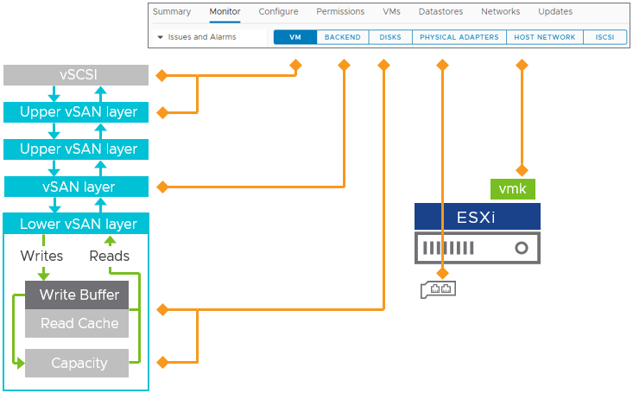

#### Capacity

Certain things are so obvious that we overlook its ramification. I had to draw this diagram to remind myself that vSAN, being a software defined storage, does not have a layer “below the LUN”. It provides the storage services (availability, compression, deduplication) within the VMFS datastore.

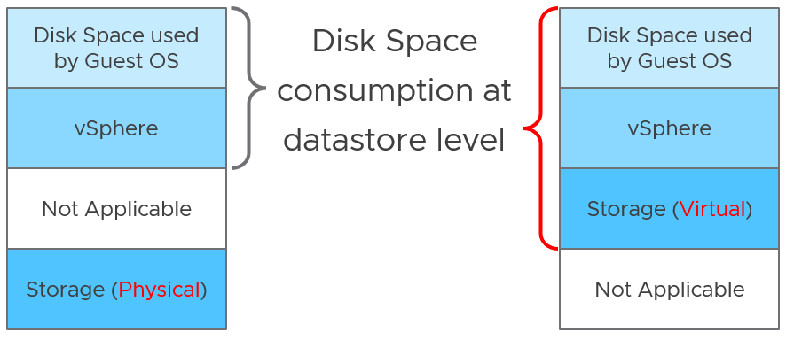

This shifts the complexity of storage management into vSphere. vSphere metrics now combine data from vSAN. Tthe consumed space includes the amount used by the availability protection (the exact amount depends on the vSAN FTT policy of that virtual disk) minus the amount saved by vSAN compression and deduplication.

Let’s take an example to illustrate. I provisioned a simple VM with 1 thick provisioned hard disk. The size is 10 GB.

vSphere shows used 10 GB and allocated 20 GB.

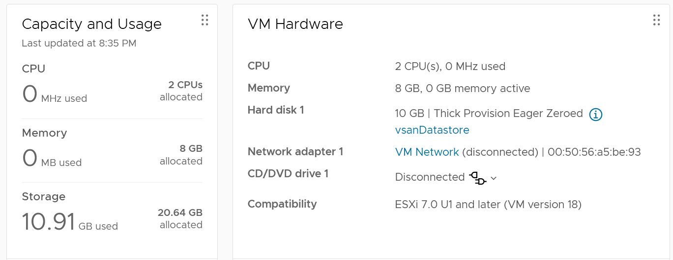

What do you get when you browse the datastore?

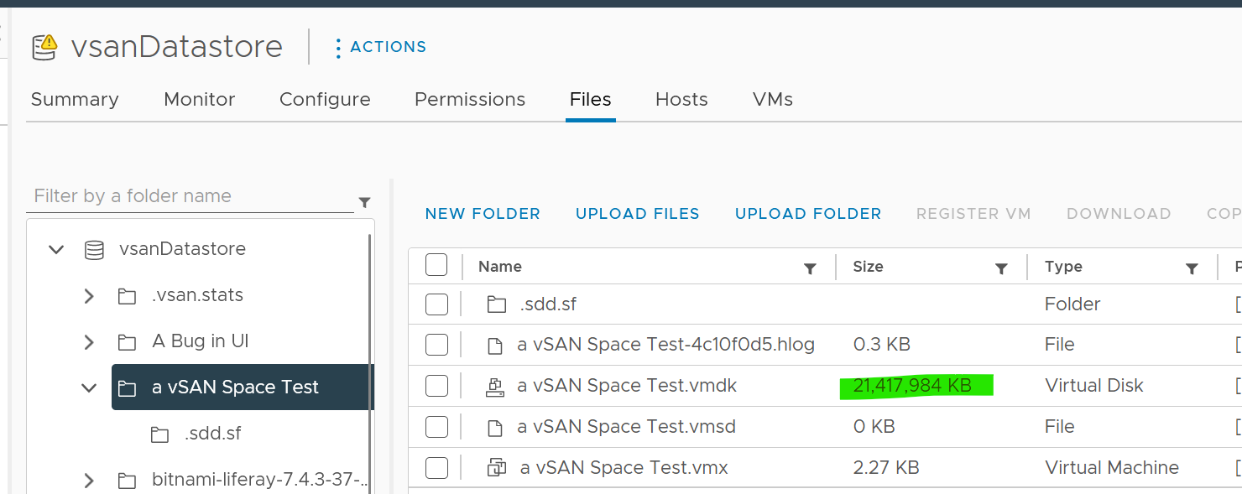

You see only 1 file, not 2. The file contains both vSphere and vSAN “parts”. In this case, you know they are 10 GB each. But if you use thin provision, enabled dedupe and compress, and have unmapped blocks, then you won’t know the breakdown anymore.

## Network

**Part 2 Chapter 8**

We will cover NSX, vSphere and physical as they are closely related.

### Distributed Switch

Just like vCenter, vRealize Operations also does not provide the metrics at the Standard Switch and its port groups. This means you cannot aggregate or analyze the data from these network objects point of view. You need to look at the parent ESXi one by one. This is one reason why you should use Distributed Switch. It simply has a richer monitoring capability.

Distributed switch is a virtual object that spans across ESXi. From the following screenshot, you can see that there is a logical network (VLAN or VXLAN) and physical network (ESXi uplinks).

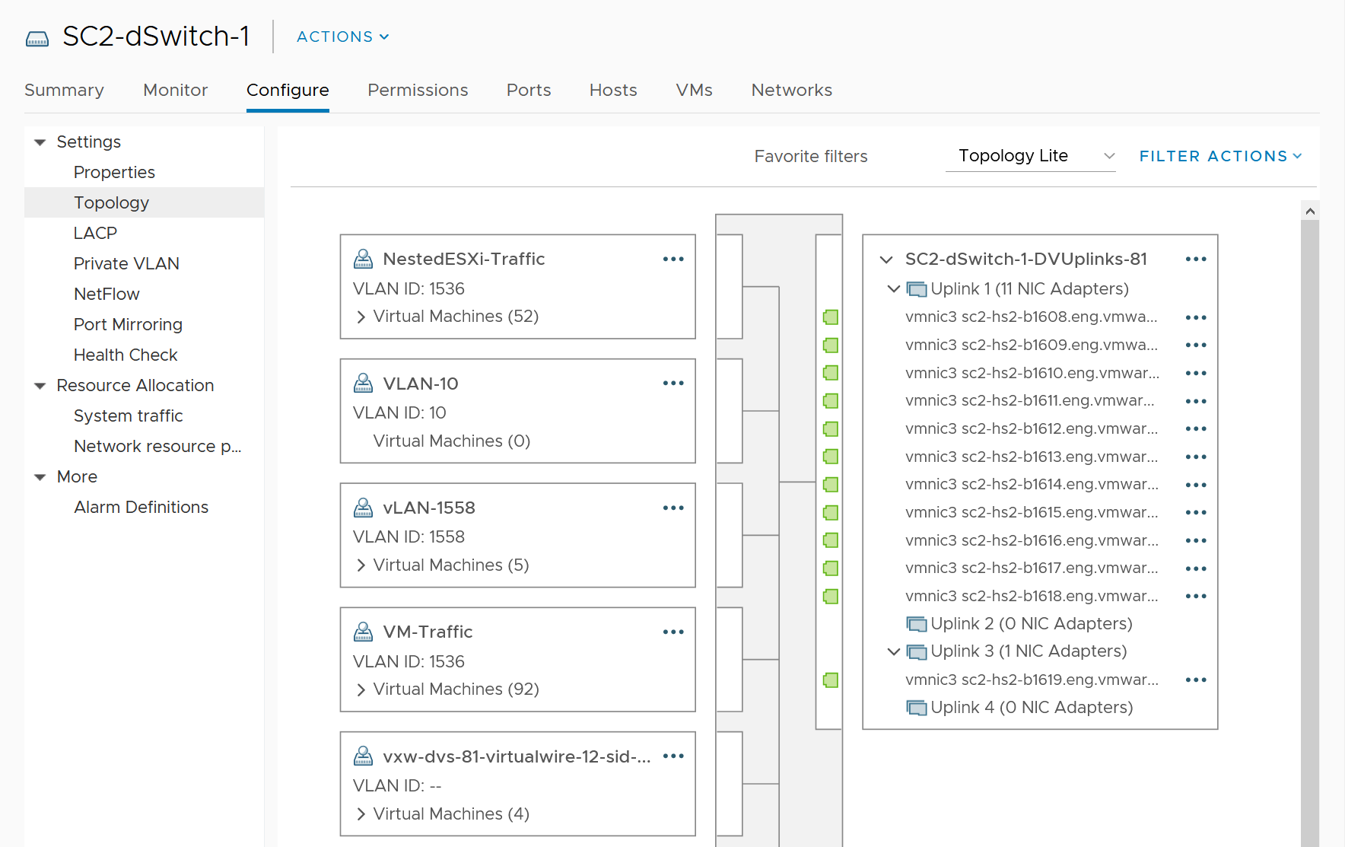

vSphere network is by nature distributed. Each ESXi contributes to the physical NIC. This represents the physical capacity as each NIC cards have a limit, such as 25 Gbps full duplex. Distributed switch and its port groups span across these independent network cards, and dynamically share the cards. This distributed and dynamic nature makes it practically impossible to define and measure network capacity and performance. Imbalance can happen among ESXi or physical NIC. In a sense, it’s like distributed storage (e.g. vSAN).

vCenter does not provide information at the individual port group level. This makes monitoring difficult, as you cannot slice the data from the switch point of view. vRealize Operations addresses that by providing the necessary metrics at the Distributed Switch level and its Port Groups. It shows a relationship between ESXi, the port group and the switch.

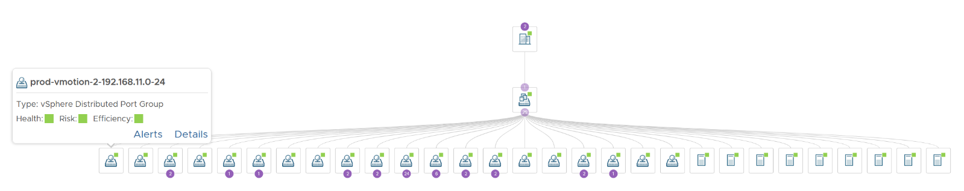

You can drill down into a port group, and see the VMs connected to that port group

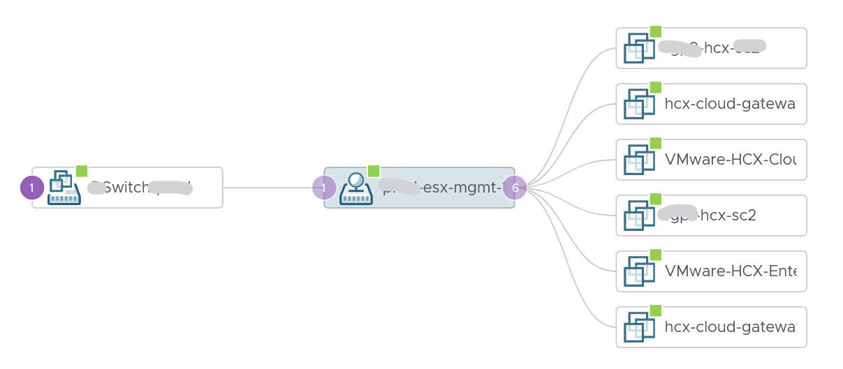

For each distributed virtual switch, you get the following metrics. All the metrics are

|  |  |  |
| --- | --- | --- |
|  | Port Statistics metrics |  |
| Egress | Dropped Packets per second | Primary counter for performance. |
| Broadcast Packets per second | Undesired type of packets, as most packets are supposed to be unicast. Make sure they are within your expectations |
| Multicast Packets per second |
| Unicast Packets per second | Note this is not a raw counter.  Formula is Total – Broadcast - Multicast |
| Traffic (KBps) | Metrics for utilization. Both are useful as there is a limit for both. |
| Total Packets per second |
| Ingress | Broadcast Packets per second | As per above, except from traffic entering the switch from outside world. |
| Dropped Packets per second |
| Multicast Packets per second |
| Unicast Packets per second |
| Traffic (KBps) |
| Total Packets per second |
| Total | Dropped Packets per second |  |
| Utilization (KBps) |  |

For each distributed port group, you get the following metrics:

|  |  |  |
| --- | --- | --- |
|  |  | vCenter API Metric Key |
| Egress | Broadcast Packets per second | Sum of ESXi hosts net.throughput.vds.pktsTxBcast.average |
| Dropped Packets per second | Sum of ESXi hosts net.throughput.vds.droppedTx.average |
| Multicast Packets per second | Sum of ESXi hosts net.throughput.vds.pktsTxMcast.average |
| Packets per second | net.throughput.vds.pktsTx.average |
| Unicast Packets per second | Note this is not a raw counter.  Formula is Total – Broadcast – Multicast |
| Ingress | Broadcast Packets per second | As per above, except from traffic entering the switch from outside world. |
| Dropped Packets per second |
| Multicast Packets per second |
| Packets per second |
| Unicast Packets per second |
| VM | Egress Traffic (KBps) | Sum of VM vNIC net.received.average metric, only if it’s backed by distributed port group. |
| Ingress Traffic (KBps) | As above, but using the net.transmitted.average metric. |
| Utilization (KBps) | From vRealize Operations Egress + Ingress metrics |

Capacity management does not apply to a port group, since its upper limit (also known as the physical capacity) can vary by even a minute. You can use static binding if that helps in capacity and performance management.

At the physical layer, you need to use adapter to gain visibility. This gets you interesting metric such as CRC errors, input drop (system unable to cope with incoming packets), input error (likely due to physical layer issues, such as bad hardware, a noisy line, a bad connection, or incorrect data conversion), interface reset (due to issues such as congestion on the line), output drop (system tries to hand off a packet to a transmit buffer but it has no more buffers). More is covered [here](https://www.cisco.com/E-Learning/bulk/public/tac/cim/cib/using_cisco_ios_software/07_basic_commands_tasks.htm).

You should expect error to be 0 or below 1%.

## Horizon

**Part 2 Chapter 9**

### RDS vs VDI

At the end of the day, users just wants to access their desktops (e.g. to organise their files) and use their applications (e.g. browser, spreadsheet). There are 2 competing architecture to deliver the above (desktop and application):

* Shared Windows. This is typically Windows Server.
* Dedicated Windows. This is almost always Windows 10

The shared architecture is called RDS and the dedicated architecture is called VDI. As you can guess, the shared is cheaper as it has less overhead, but harder to troubleshoot. Shared technology also carries higher availability risk. When the application or Windows crash, more than 1 user are affected. Windows 2019 also does not have concept of shares, limit and reservation. All the sessions compete freely for its resources.

Another complication for RDS is user to host mapping is not deterministic. It’s a many to many relationship and it can change even on one user over time. As a result, it’s meaningless to include BLAST/PCoIP data in RDS Host monitoring. This relationship changes frequently that there is no point to do pattern analysis.

[Hilko Lantiga](https://www.linkedin.com/in/hilkolantinga/) shares another limitation of RDS is the load balancer does not balance based on actual load. It’s simply distributing the session based on initial placement. The initial placement can consider any metrics, but there is no “session vMotion” subsequently within the RDS Farm. If you are unlucky all the heavy users could end up on the same RDS session host. That’s why vRealize Operations introduces the Usage Disparity metrics. 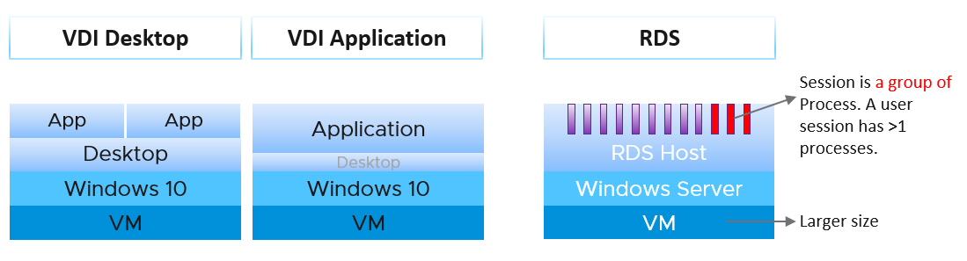

Horizon Admin UI shows both VDI desktop pool and RDS desktop pool in a combined list. The following screenshot shows both types.

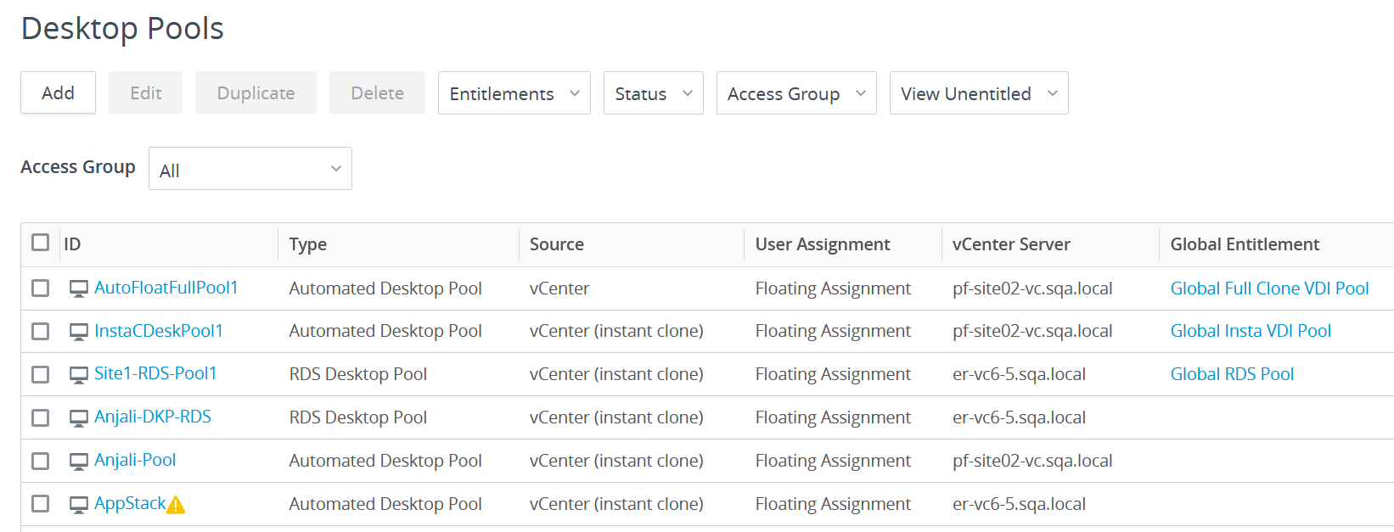

VDI can be used to deliver application session. It’s not common as the overhead is the same with giving entire desktop. The primary use case is usability. If you’re delivering Windows applications to Mac users, showing them a Windows desktop will be more confusing than simply showing them the individual applications. Showing the individual application will make them feel like an Apple Mac application.

RDS presents another challenge as it introduces Farm and Host concept. A farm can have many hosts and many pools, and pool has M:N relationship to host. A session connects to a pool, and runs on the host. So a session has 2 parents: pool and host. To keep it simpler operationally, limit to 1 pool per RDS farm. But this results in smaller farms and more farms.

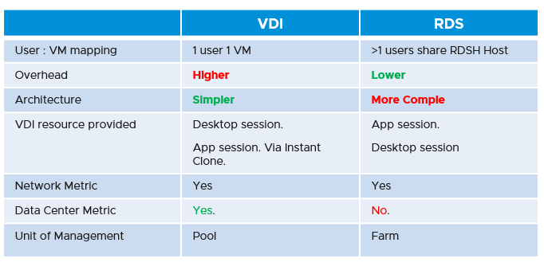

In terms of monitoring and troubleshooting, VDI provides more metrics, as it’s just a VM. RDSH provides limited metrics, as they are just a collection of processes. For example, process level contention (be it CPU, memory, disk and network) are not exposed. At present, RDS only provides the following

* CPU Usage (%).
* Disk IOPS
* Memory Usage (%)

You might notice that the above 3 metrics matches what you see at Horizon console.

The following diagram shows the possible permutation that you can give to a user. Let’s start with RDS first.

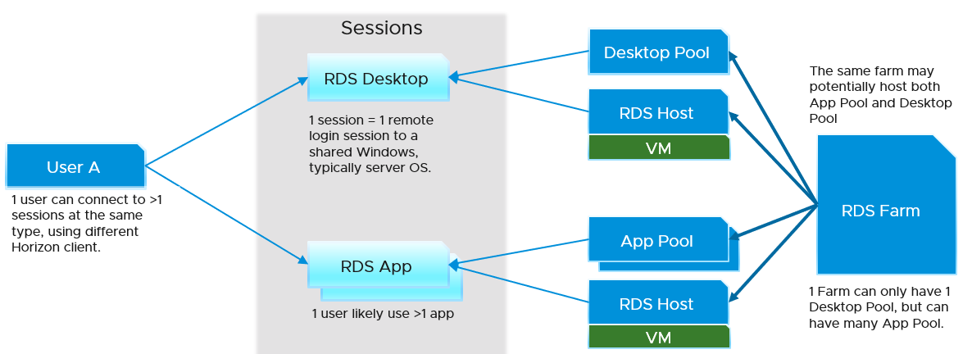

For VDI, this is what the connection looks like. The pool cannot be both desktop pool and application pool.

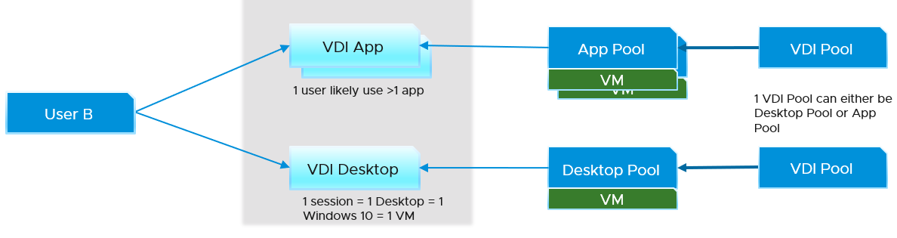

I did not draw the permutation where a user accesses all 4 types of sessions. You can certainly have it. When you design, think of complexity in operations. Flexibility can reduce cost but often comes at the price of complexity. A few human errors in a year can negate the benefit of cost savings, or reduce customer satisfaction.

Horizon sessions are ephemeral objects. In solution such as Instant Clone, the vSphere VM is also a temporary object that gets destroyed after usage. This means the historical data will be lost too. To enable troubleshooting past data, we keep a copy of the data in the User object.

### Object Model

A critical foundation in managing a mission critical VDI is the object model. This means the objects and relationship among the objects. It will be impossible to roll up if the correct hierarchy is not in place. The object model also plays a critical role in navigating the structure of a large Horizon set up. It complements the tabular presentation by showing relationship and hierarchy clearly.

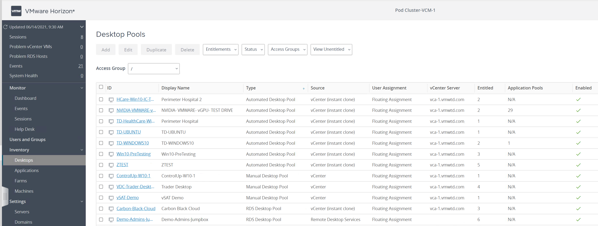

vRealize Operations 8.4 sports a new adapter, replacing the previous adapter (called V4H). It sports a revamped object model, blending vSphere and Horizon objects as one traversal path, as shown in the following diagram.

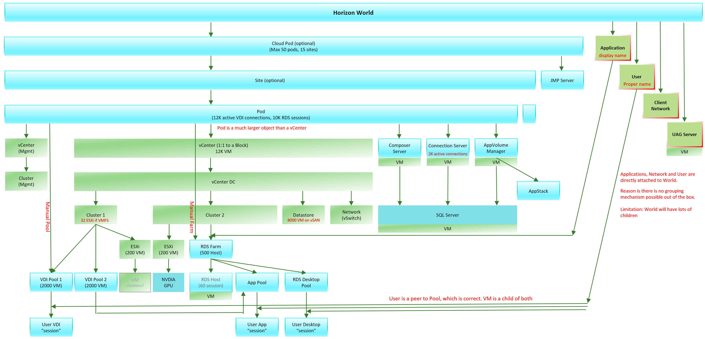

The object model introduces a new super parent object called Horizon World, to make dashboard creation easier and support cloud provider who provides Horizon as a service. There are actually 3 such objects, as UAG and Users are not part of Cloud Pod.

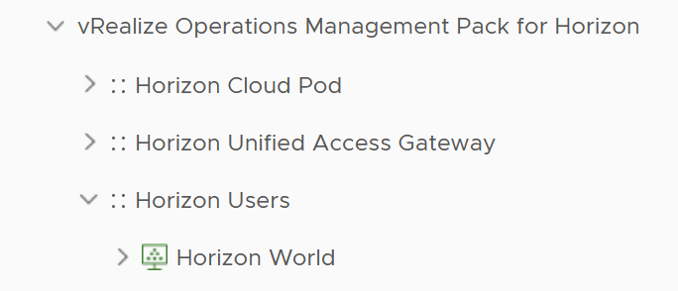

Because of the revamped object model, and major differences in metrics, there is *no migration* from the old adapter (V4H) to this new adapter.

There are 2 types of application in Horizon, pool and non-pool. Non pool means the application is installed or accessed directly or “individually”. It’s not accessed via application pool (such as RDS application pool or VDI application pool). Monitoring on this non-pool is naturally harder as they are “embedded” as part of Windows, hence an agent is required. Agent is good when they are well behaving.

#### User

A Horizon user can have >1 sessions at the same time even with 1 client. A Horizon client may connect to a VDI desktop session, which then launches a few RDS applications sessions.

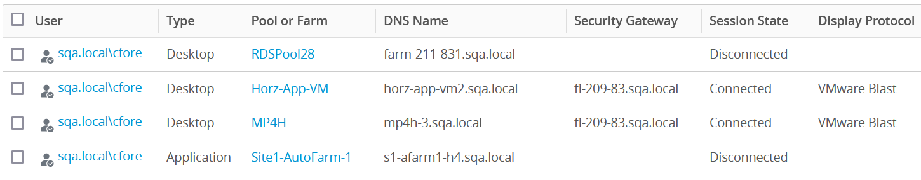

vRealize Operations shows the relationship between user and session. The following shows a user (with the blue human icon) has 2 sessions. The first is RDS Desktop (with small satellite icon) and the second one is a VDI one.

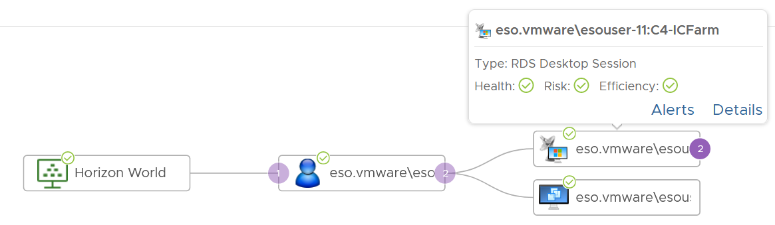

Depending on the architecture, a user can connect to both VDI and RDS, use both desktop session and application session, connect to different vCenter servers, and use different protocol. The following screenshot shows user Cameron Fore (sqa.local\cfore) have a wide variety. This level of flexibility can make monitoring and troubleshooting difficult.

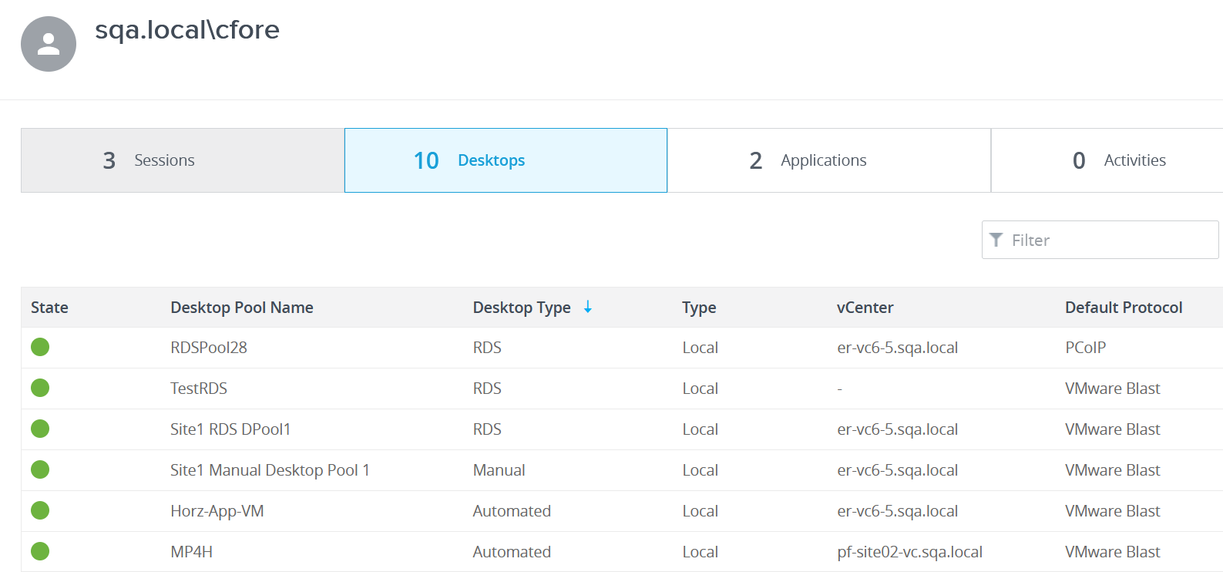

#### Network

vRealize Operations does not have object for each network. If your network varies in performance, it’s useful to group them. As a workaround, create a group for each network or location you want to monitor. This makes it easier to check if the problem is isolated in specific network.

I recommend you establish a naming standard, using the location or commonality among the network. For the group type, take either Location, or create something like Horizon Network. The following screenshot shows an example where I create a group for users based in Singapore office.

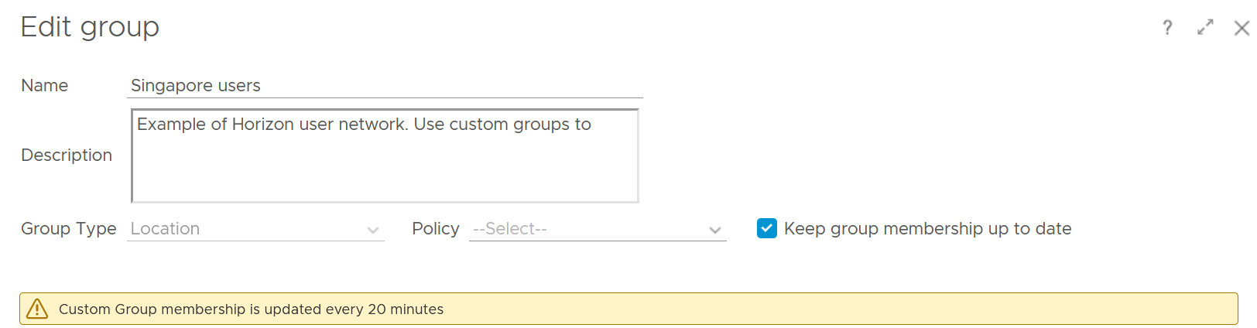

The members of the group is session, not users.

There are 4 types of possible sessions, so choose the one relevant in your environment. You can either be specific (if there is only 1 network) or get a few networks. Yes, you can use regular expression to get specific set of network. You’re welcome.

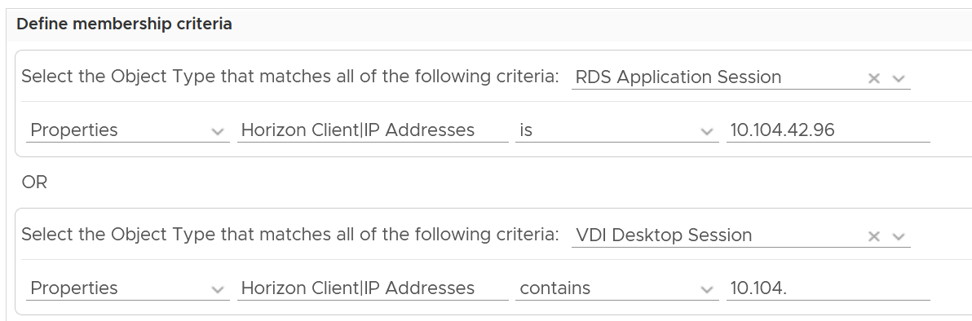

Once you create them, you get the relationship hierarchy. The following screenshot shows the that the Singapore users access the environment via the 4 types of sessions (RDS application session, RDS desktop session, VDI application session, and VDI desktop session)

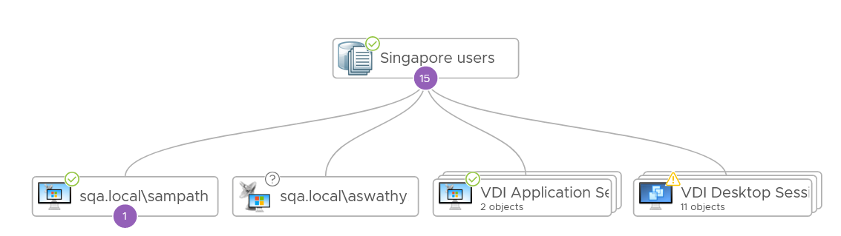

Once you have the groups, you need to create the usual set of super metrics to analyse the members.

#### Horizon + vSphere

The following shows an example of how the implementation is vrealized. Notice how vSphere objects and Horizon objects are blended in a single hierarchy. The object in blue is Horizon, while the object in green is vSphere.

The interwoven hierarchy is required for summarizing information.

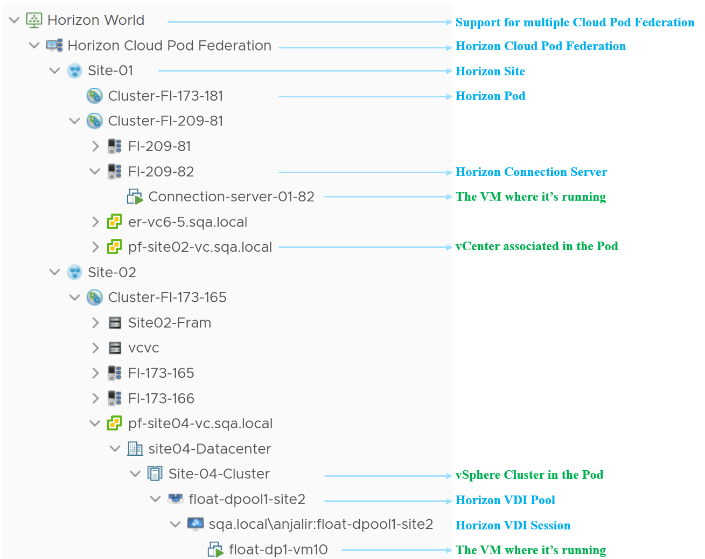

Notice the farm name Site02-Fram. Why is it directly under a Pod?

The answer is it’s a manual farm. The hierarchy is aware that you can have manual pool across vCenter and will show it accordingly.

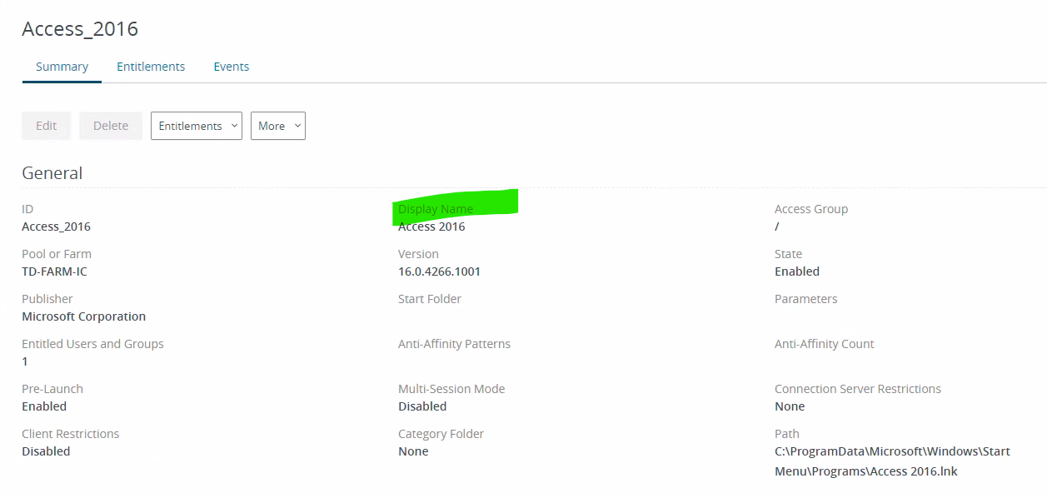

#### Horizon Infrastructure

Other than the desktops and RDS hosts, Horizon uses many types of application servers and databases.

|  |  |
| --- | --- |
| **Connection Server** | The Connection Server is also a VM. At present, the KPI is identical to the RDS Host |
| **Universal Access Gateway** | There are 2 types (Internal and External) |
| **App Volume Manager** | We do not have this yet. As a workaround, create a custom group and use super metric. |
| **MS SQL Server** | This is covered in Part 3 True Visibility Dashboards, but we need to integrate the KPI with Horizon |
| **MS Active Directory Server** | This section is for rent. That means we need a contributing author! Reach out to me if you want to collaborate |
| **MS ADAM Database** | Active Directory Application Mode (ADAM) can be monitored via Windows Event, which you can convert into log via Log Insight agent, so it can be analysed together with other logs. |
| **Load Balancer** |  |

Horizon Servers are just Linux or Windows servers, meaning you can probe deeper by installing Log Insight agent or Telegraf agent.

##### Unified Access Gateway

UAG is related to Connection Servers, VDI sessions and VM (because UAG is a VM). The following screenshot shows a UAG that is fronting 2 Connection servers and 2 VDI desktop VMs, and it’s running on VM named UAG-167.

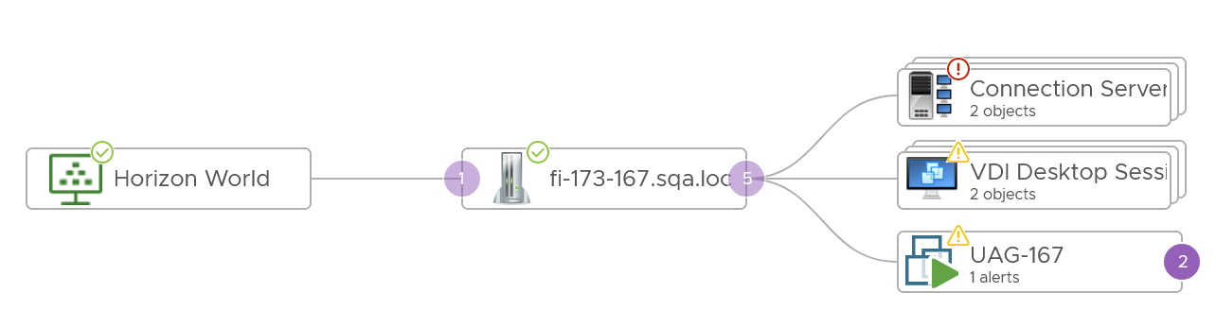

You can also see the above in the side navigation. In the following screenshot, I’ve expanded the VM to show the Telegraf agent. The agent shows that HTTP Test has been configured.

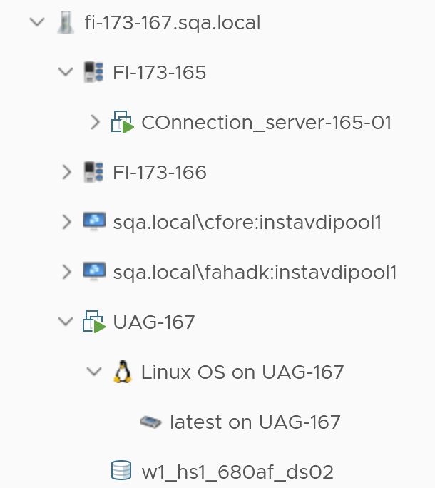

#### Unmanaged Machines

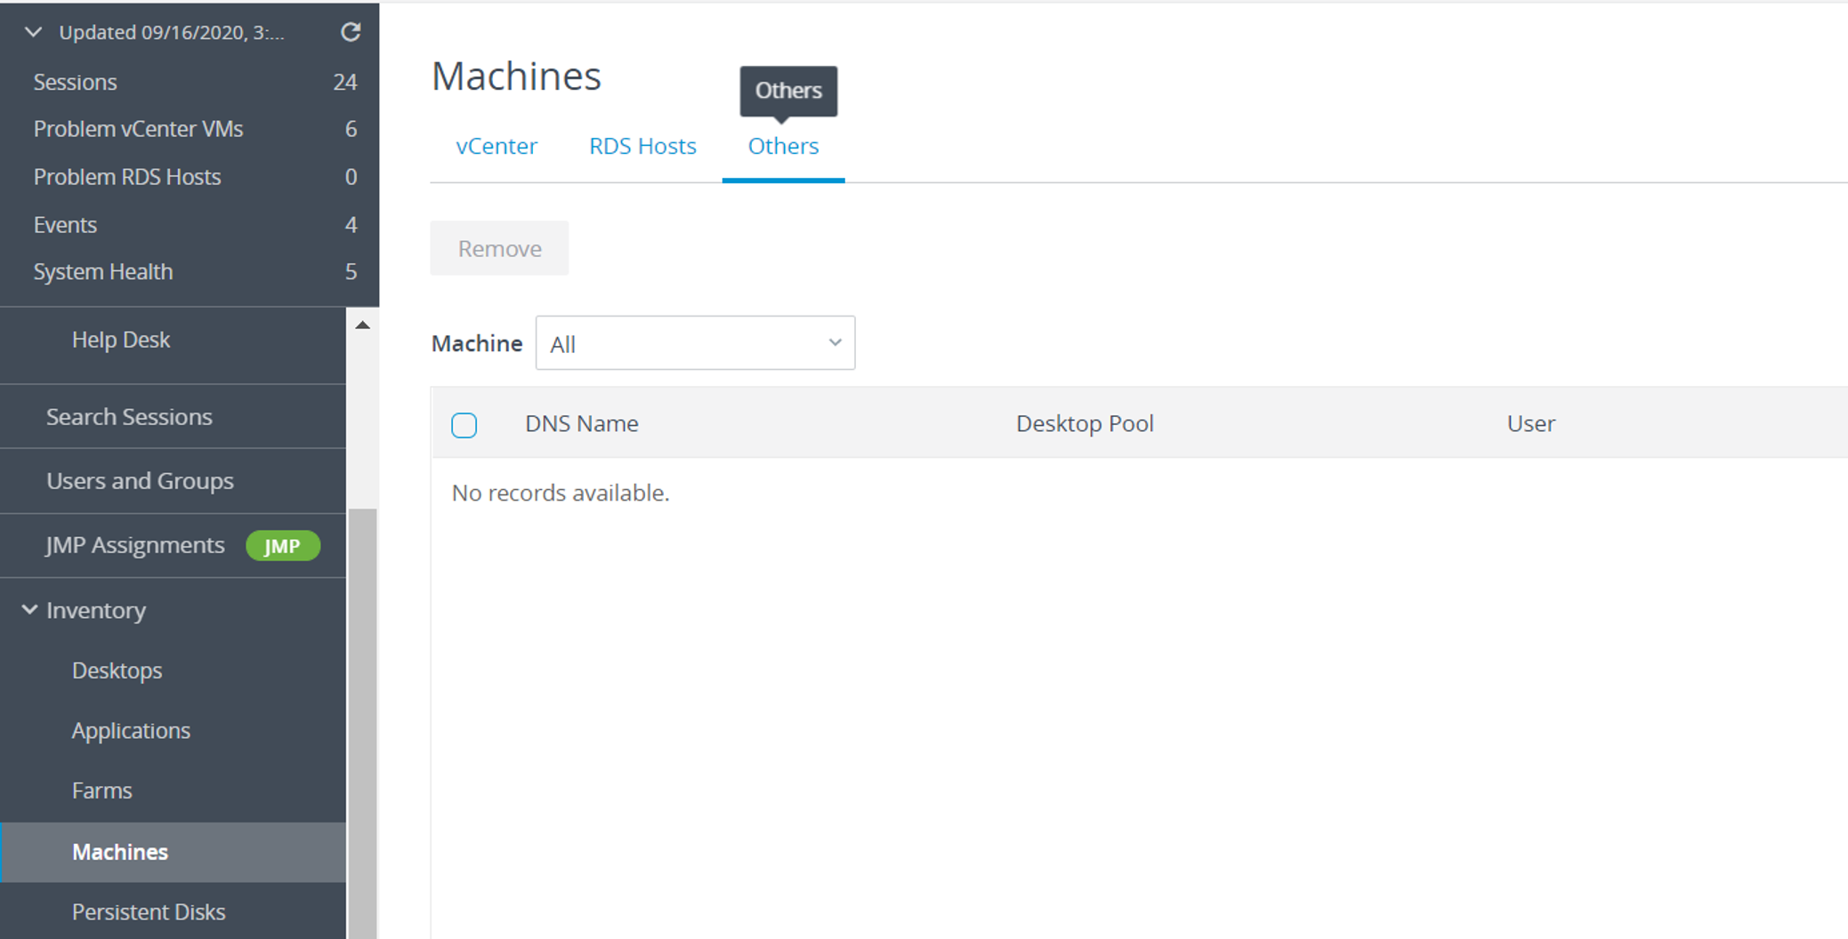

Refer to preceding screenshot. In short, it is a list of physical machines (laptops, servers etc) which have Horizon agent installed and are linked to Horizon Connection Server. There are few customers who use this feature. Since they are not managed by VC, you don't get any meaningful metrics. In vRealize Operations, they are represented as Unmanaged Machine object.

### Performance

Performance ranks high in VDI operations management so let’s start with it. Horizon is a complex architecture with many components and layer. How do you know Horizon is performing?

One good way to answer is to begin with the end in mind. The purpose of DaaS is to provide acceptable user experience. To deliver that, there are 3 components (Edge, Network, Data Center) that must work well. Horizon is a client/server architecture, meaning it has a Horizon Client software that runs at the edge, talking via the network to a server agent software residing in the data center.

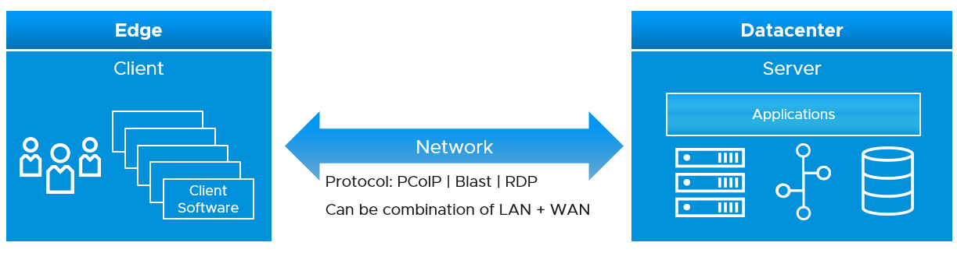

The client software does the screen rendering. Due to lack of contention and utilization metrics, we can’t measure its performance. Some thin client or zero client has a tiny OS that support syslog.

The network consists of the protocol and the physical network. Typically, the physical network carries more than Horizon protocol. For example, you have IP telephony system, security cameras or remote servers in your branches. You need to have visibility at the consumer (Horizon protocol) level and provider (physical network) level. In most cases, the network is not owned by the EUC team, so EUC team is consuming a shared service. Because of this, the physical network metrics play the supporting role. They are not primary metrics used in the KPI.

The data center part is where the bulk of EUC component resides. This includes both VMware and non-VMware components.

The network part and the data center part are two independent parts, typically managed by different teams. You can have network problem without the data center problem, and vice versa. By separating them as separate KPI, you can see what kind of problems you have and do the necessary follow up. By combining them, you can potentially lose visibility as the good one can mask the bad one.

Be mindful of the difference between the user has performance problem and the user causes performance problem.

|  |  |
| --- | --- |
| **Victim** | The user experiences problem.  Contention is high, utilization is low. Not getting work done, so productivity is impacted.  User is upset. |
| **Villain** | The user causes performance problem.  Utilization is very high. Contention is irrelevant in this case. The user may get a lot of work done.  You are upset, as other users could be affected. Depending on your design, the victim could be VIP users. |

#### KPI Metrics

KPI metric follows the reason and technique we use for vSphere. As some components of Horizon takes a shape of a VM, the vSphere VM KPI metric is used.

##### Network KPI

What are the networks in VDI? A large VDI farm can have >100 networks, with different latency, reliability and bandwidth. The LAN network can have issue if it’s wireless and there is congestion, or there are too many hops (range extender).

Relative to DC KPI, network KPI is easier to measure as it has fewer metrics and only has 1 type of resource, which is packet protocol.

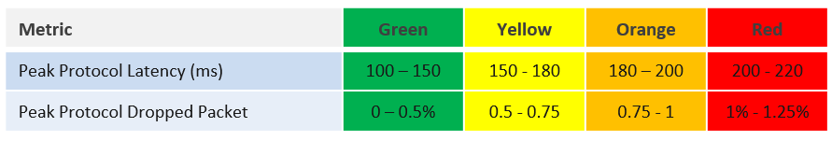

The latency is measured at PCoIP or Blast protocol layer, not TCP/UDP layer. Measuring at upper layer is more accurate as we can have packet loss at application-layer but Windows sees no dropped packet. The reason was the packet arrives out of order and hence unusable from Horizon viewpoint.

We’ve set the threshold value to be conservative yet realistic. If your users are accessing over the WAN or unreliable connection, then you may not see green. This is acceptable so long user actual productivity is not impacted.

Time taken to load the user profile and time taken to logon are not included in the KPI because they are one time value. KPI needs to be a metric that can be evaluated regularly.

At this moment, we do not include variance in the latency. If you think we should, do recommend the value for each threshold.

The session network utilization is not part of the KPI as we can’t put the value into the range. The [Blast Extreme](https://techzone.vmware.com/resource/blast-extreme-display-protocol-vmware-horizon-7) protocol may be doing minimal work at that time for that user, so a low network throughput may not indicate poor user experience.

##### Data Center KPI

The DC KPI only applies to VDI session and RDS Host. RDS session does not have contention metrics. It only has utilization metrics and they cannot be used to determine if a user experience degrades. As a result, the KPI is taken from the RDS Host, which is a server VM serving many users concurrently. The drawback is RDS Host does not provide visibility into the performance of each session.

Since both RDS Host and VDI Session is basically a Window VM, we are using the same KPI. Other than RDSH specific counter such as [this one](https://docs.microsoft.com/en-us/windows-server/remote/remote-desktop-services/rds-rdsh-performance-counters), there is no application level specific metrics to measure contention. vRealize Operations uses the following metrics and threshold to form the KPI.

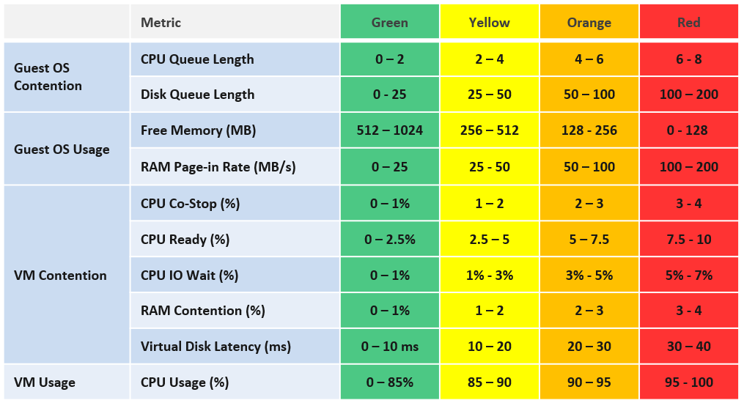

We provide the threshold as they reflect Horizon best practice, which should work for most customers. Your situation may differ, which is why we provide the raw metrics too as the KPI metric cannot be modified. In the event your design calls for a different threshold, you can build the KPI using super metric, as documented here.

We do not include CPU Context Switch and Disk Outstanding IO, as I’m not yet convinced on the threshold, based on the profiling data. The numbers vary too wide. Send me your profiling result so I can consider it too.

We do not include CPU Overlap as the value is negligible most of the time. It will be green most of the time, hence inflating the value unnecessarily.

Do you know why we include Page-in but not Page-out? How about balloon, swapped and compressed? How come none of them are here? Refer to Part 2 Memory chapter for the answer.

We do not include Memory In Use as we have Free Memory. In Use is better for capacity, while Free is better for performance.

VM CPU utilization is included because it’s possible that we have a runaway process that it’s impacting user performance. A runaway process typically consumes 1 vCPU so if the VM has 4 CPU the increase is only 25%.

Now that we have the DC KPI and Network KPI at the smallest object, we can roll up to higher level object. For that, we need a correct hierarchy. The hierarchy is also required by other pillar of operations management.

##### KPI Roll Up

Using the above as the foundation, we can build the KPI at higher level object. Here is how we do it.

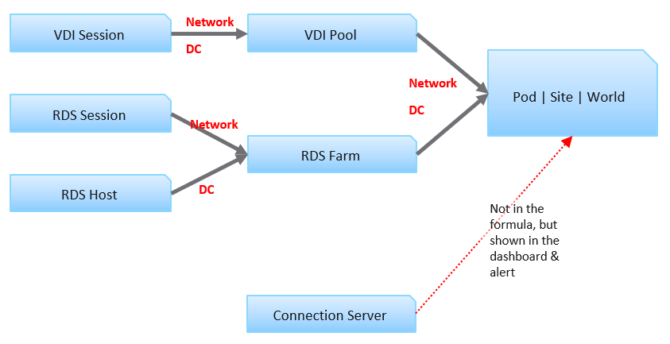

Each VDI session has 2 KPI: Network KPI and Data Center KPI.

The VDI Pool Network KPI is simply the average of all its VDI Session Network KPI. While average is a lagging indicator, it best represents the entire reality, which is required for further roll up to the higher level object. We certainly will complement it with leading indicators.

The VDI Pool DC KPI is also the average of its session DC KPI. Because these 2 KPIs operate independently, we do *not* combine them.

For RDS, the corresponding object is RDS Farm, not RDS Host. It’s more logical to monitor at this level, just like we monitor at vSphere cluster level and not the individual ESXi. Just like a VM moves within a cluster, a user does not always get the same RDS host in the next session. We take the network KPI from RDS sessions and DC KPI from RDS hosts.

We combine both the VDI and RDS KPI at the Pod level. Again, we simply take the average of both. If you have more VDI Pools than RDS Farms, then the Pod KPI value will be driven by the VDI part of your architecture.

Pod DC KPI = Average (VDI Pool DC KPI, RDS Farm DC KPI)

The limitation of the above is it each pools and farms are given the same weightage. The number of sessions do not matter. The reason is you manage at pool and farm level, not individual session.

The KPI for higher level objects cannot be the average of Pod KPI, as Pod is basically a group. The KPI is still taken from VDI Pool and RDS Farm levels, as these objects provide the resource. This is to ensure fair representation if you have Pod of different size.

Horizon World DC KPI = Average (VDI Pool DC KPI, RDS Farm DC KPI)

We do not include the Horizon server infrastructure at the KPI level. The reason is they are supporting metrics. They do *not* directly measure the user experience as none of their metrics are session-specific. This is an example where we’re being careful in choosing KPI. Each KPI is ideally a primary metric, directly measuring the session performance. If you include supporting metrics, you can get false positive or false negative.

##### Leading Indicator

We covered in Part 1 Chapter 2 Performance Management that you need a leading indicator. The true KPI is a lagging indicator, so we need to complement it. The roll up technique matters so you balance the information.

A Pod can have thousands of sessions, so how do you roll up?

* Each session has a KPI (%). This is a balanced approach, so we can take its value.
* At Farm or Pool level, if you take the worst among sessions, the value may be bad most of the time. A better way is to take the worst 5th percentile, and then complement with a count of sessions in the red.
* At Pod level, take the same approach, which is worst 5th percentile, complemented with a count of sessions in the red

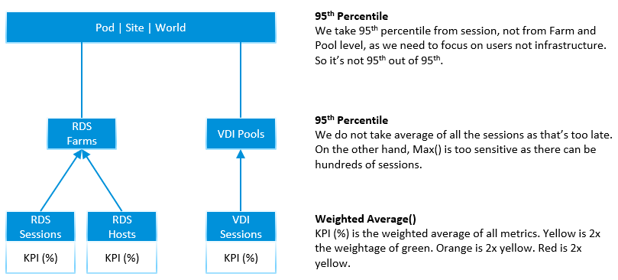

Using the above, here are the KPI metrics we have at the top level

* Worst 5th percentile Pod DC KPI = the worst 5th percentile of all its (Farm KPIs, Pool KPIs) values, regardless their size.
* Worst 5th percentile World DC KPI. Identical formula to Pod, so expect this to be lower than the average of all pods
* Worst 5th percentile Pod Network KPI. Same approach with DC KPI, but obviously using Network KPI as input.
* Worst 5th percentile World Network KPI. You got the idea.

Yes, just 2 each for Pod and World, and 2 each for DC and Network. You need to keep it minimum so it’s easier to see over time.

At the Farm and Pool level, it’s the same approach.

* Worst 5th percentile Farm DC KPI = 95th Percentile of all its RDS Hosts DC KPI values, regardless of farms.
* Worst 5th percentile Farm Network KPI. Same approach with DC KPI, but obviously using Network KPI as input.
* Worst 5th percentile Pool DC KPI. Same approach with RDS Farm, but obviously using VDI Session DC KPI as input.
* Worst 5th percentile Pod Network KPI. You got the idea 😊

Now that we have the KPI, let’s look at the Horizon objects one by one, starting with the smallest/lowest one. We will also include all other performance metrics to complete the picture. To keep the list short and topic manageable, we will not include non performance metrics and properties. We will cover them separately.

#### Baseline Profiling

Horizon is one of the largest applications in a company, as it can span thousands of VMs and locations. It’s important to profile so you know what to expect. Different deployments can have a different performance characteristics, making it hard to establish best practice threshold. In a large scale deployment, different pools or farms can have different numbers. If your design expects a different performance for certain farm or pool, then profile them separately.

Take time to profile your actual environment while it’s healthy so you have a baseline.

We cover the profiling technique earlier in Part 1 Chapter 2. Specific for Horizon, you should profile the following metrics.

|  |  |
| --- | --- |
| RDS Session | Disk IOPS  Frame Rate |
| RDS Host | CPU Queue  CPU Context Switch  Memory Page-in Rate  Disk Queue  Disk Outstanding IO  Read IOPS and Write IOPS. Profile them side by side, and compare both against expectation.  CPU Usage and Memory Usage. Compare against plan. |
| RDS Farm | Read IOPS and Write IOPS. Profile them side by side, and compare against expectation.  CPU Usage in MHz. Make sure this number is within what the cluster can provide. Check the average does not exceed your sizing. |
| VDI Session | Same sets of metrics as RDS Host, as both are just VMs. You need to profile separately as your desktop pattern may differ to your server. |
| VDI Pool | Same sets of metrics as RDS Farm, as both are just collection of VMs. |
| Connection Server  (and other Horizon servers) | Same sets of metrics as RDS Host. You need to profile separately as their pattern may differ. The profiling will also be useful after a major upgrade. For examples   * If the new version is supposed to deliver 10% performance improvement, does the reality support it? * If the new version delivers 2x scalability but at cost of 1.5x footprint, what do you actually get in your own environment? The lab may not be identical to your real world situation. |
| Horizon World | Disk IOPS. Make sure this number is within what your storage subsystem can handle.  Network Bandwidth. Make sure this number is well within what your WAN link can handle, as majority of traffic is non-protocol traffic. |

As part of the baselining, you will know the typical size of a session, a user, an RDS Host. They form the building block for your sizing. Compare these numbers against the numbers you put in your sizing document (during the time you architected the system). If the reality is higher, you need to revise your plan and buy additional hardware.

#### RDS Session

Compared with VDI Session, RDS Session has less metric as it’s not the whole VM. An RDS Session is sharing one Windows OS with many other sessions. Windows do not provide many contention metrics for each session, and mostly report utilization metrics. The following screenshot shows that Windows Server 2019 only provides 1 metric for CPU and 1 metric for memory for each process.

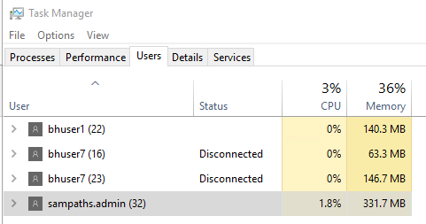

To get details, you click on Details tab. To see more metrics, right click on the column and choose Select columns. It pops up a simple dialog box, as shown below. The dialog box does not group the metrics, so it’s a long list simply sorted by name. It does not explain what those metrics are. From the name, I do not see metrics that indicates the process is experiencing CPU contention (e.g. it is paused or running at lower frequency), memory contention (e.g. it’s heavily paging), disk latency, network latency or dropped packet.

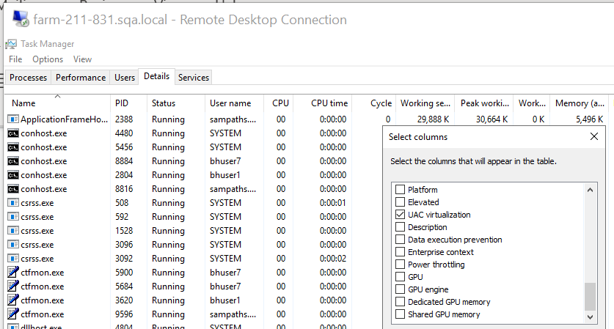

##### Contention Metrics

The following contention metrics are provided to troubleshoot further if the Network KPI (%) metric shows bad value.

|  |  |
| --- | --- |
| Latency (ms) | The protocol round trip time taken between Horizon agent (on DC) and Horizon client (in end user device).  Keep this below the best practice shown in the KPI, or your acceptable number. |
| Packet Loss Receive (%)  Packet Loss Transmit (%) | The guidance for *overall* packet loss is anything above 1% is red. So the guidance for the receive and transmit should be the same, or a bit more stringent.  The Agent sends pixels to the Client. If the Agent determines that it needs to drop packets due to network condition it drops them. So TX & RX are from the agent point of view. |

While the following metrics only impact at the initial stage, they are important to user experience.

|  |  |
| --- | --- |
| Time taken to load profile | The time starts after user has been fully authenticated, when Windows begins the profile loading process and ends when the profile is fully loaded.  The guidance for performance is   * Green = below 5 seconds * Yellow = 5 - 15 seconds * Orange = 15 - 25 seconds * Red = Above 25 seconds   The guidance is lower than VDI because RDS sessions share the same Windows. The first user logging into Windows takes the biggest performance hit because Windows has to load all GPO policies, system settings, and services that load at login. The subsequent users don’t suffer the same time penalty, because those items have already been loaded.  There are features like “Session Pre-Launch” to mask the initial login time delay |
| Time taken to logon | The time starts when the user ID and password is submitted to Windows, and ends when the session is fully authenticated. It does not include the time taken to load the profile and launch start up application.  The guidance for performance is   * Green = below 30 seconds * Yellow = 30 - 45 seconds * Orange = 45 - 60 seconds * Red = above 60 seconds |

##### Utilization Metrics

Once you determine there is a problem, the next step is to narrow down if it’s CPU, Memory, Disk or Network

One common reason behind contention is high utilization. Not all usage metrics are relevant to performance, so the following only lists the relevant ones.

|  |  |
| --- | --- |
| CPU Usage (%)  Memory Usage (%) | These values are coming from Windows, not VM. They track the relative consumption of a session against the RDS Host total capacity.  Make sure this number is below than expected average. For example, if you size for 20 concurrent users, then each session should be around 5%. |
| Disk IOPS | Unlike a server workload, users don’t generally generate high IOPS or sustained IOPS. They open file, save file, but should not be sustaining for say 1 hour. |
| Others | There are other metrics, that you can see from Task Manager. They are not collected yet. If you need them, let me know the use case. |

If the network is over the WAN or mobile network, monitor the following metrics closely.

|  |  |
| --- | --- |
| Frame Rate | See [this](https://en.wikipedia.org/wiki/Frame_rate) for explanation. A low frame rate result in inferior user experience. While occasional low is fine, a prolonged low could lead to degraded user experience |
| Bandwidth Utilization (Mbps) | Total bandwidth, although in VDI is mostly the agent sending data. Received metric typically covers users input like typing.  Note it’s megabit, unlike kilobyte that vSphere uses. You’re welcome. |

#### RDS Host

RDS Host is a Windows Server running on a VM, serving desktop applications. In the current release of Horizon Adapter, there is no RDS application metrics yet. As a result, only Windows and Horizon metrics are used.

All the vSphere metrics are explained in Part 2 of the book.

##### Contention Metrics

Use the contention metrics to troubleshoot further if the DC KPI (%) metric shows bad value. Once you determine there is a problem, the next step is to narrow down if it’s CPU, Memory, Disk or Network

The metrics can be grouped into 2: inside Guest OS and outside.

For the metrics inside, a major spike at the time of the incident could be the root cause as it’s not coming from outside (e.g. shared infrastructure)

|  |  |
| --- | --- |
| CPU Queue | High CPU queue is the primary counter that Windows needs more CPU. Either increase the number of vCPU or add more RDS host into the farm |
| CPU Context Switch | Compare them against your baseline.  Since RDS hosts in a farm are meant to be uniformed, compare them to see if there is a large deviation.  See the relevant chapter in Part 2 of this book for explanation of these metrics. |
| Memory Page-in Rate |
| Disk Queue |

Next, check if there is a problem outside Windows, meaning at the VM or below.

|  |  |
| --- | --- |
| Peak vCPU Ready | Use Peak vCPU Ready instead of CPU Ready as the later is the average of all vCPU |
| CPU Co-Stop (%)  CPU IO Wait (%)  CPU Overlap (ms) | These metrics are at VM level, so they are not visible to Windows.  Their values should be lower than CPU Ready. Expect them to be less than 1%. |
| Memory Contention (%) | Keep this below 1% |
| Worst vDisk Read Latency  Worst vDisk Write Latency | These metrics are better than the average of both read & write. You can have one problem and not the other, and the average may mask that.  These metrics are better than average at VM-level. |
| Outstanding IO | This is outside Windows. So if this is high, something wrong on the underlying storage system. |

For Network, check the protocol metrics. Note they are implemented at RDS Farm level, not RDS Host. RDS Hosts in a farm are meant to be uniformed, meaning you should not be changing the setting of individual host.

* Protocol Latency (ms)
* Protocol Packet Loss Receive (%)
* Protocol Packet Loss Transmit (%)
* Worst Time taken to logon
* Worst Time taken to load profile

##### Utilization Metrics

One common reason behind contention is high utilization. Not all usage metrics are relevant to performance, so the following only lists the relevant ones.

|  |  |
| --- | --- |
| Peak vCPU Usage (%) | Use the peak vCPU Usage instead of CPU Usage, as the later is the average of all vCPU |
| CPU Usage (%) | Note that at present this is coming from VM. In future we may change to Windows.  If this number hits >95% repeatedly, that could explain contention.  On the other hand, if this number is much lower than expected, there is something amiss. When you have a lot of sessions trying to connect and the RDS Host utilization is low, that means there is a bottleneck that prevents the host from processing the load. |
| Free Memory (MB) | Ensure this number is > 128 MB |
| Memory Utilization | As covered in Part 2, this contains buffer. In future we may change this to Windows In Use counter. Let me know your thought. |

Disk utilization is less useful in performance troubleshooting as the limit is high. A very high utilization may in fact deliver a good experience to the user, albeit at the expense of other users.

|  |  |
| --- | --- |
| Read IOPS  Write IOPS  Read Throughput  Write Throughput | If any of these is higher than normal, investigate why. It could be security agents scanning all files.  Compare read and write to your expectation.  Compare IOPS and Throughput. A large increase in IOPS but not in throughput indicate the block size has increased. Is that what you’re expecting? |

#### RDS Farm

RDS Farm has a set of properties that are worth monitoring. Make sure they match your documented architecture, and do not deviate from expected.

Horizon admin UI lists the farms, where you can perform administrative action.

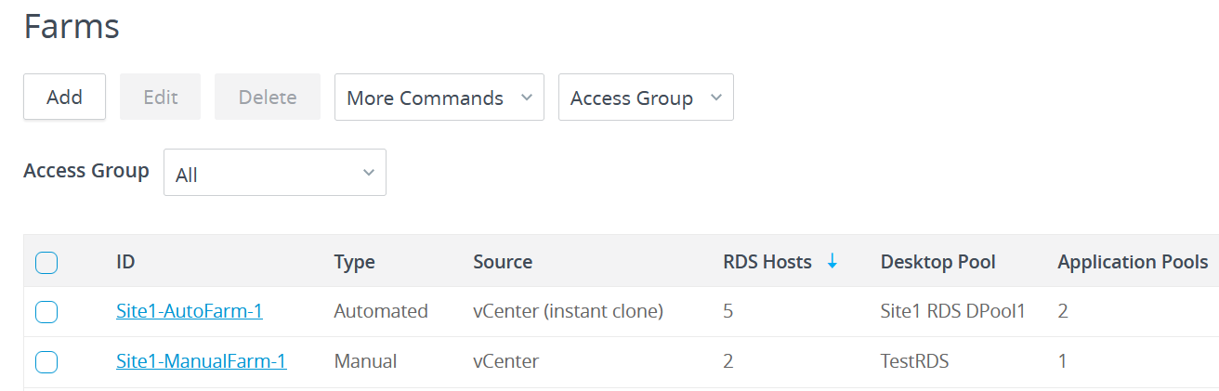

From the farm, you can

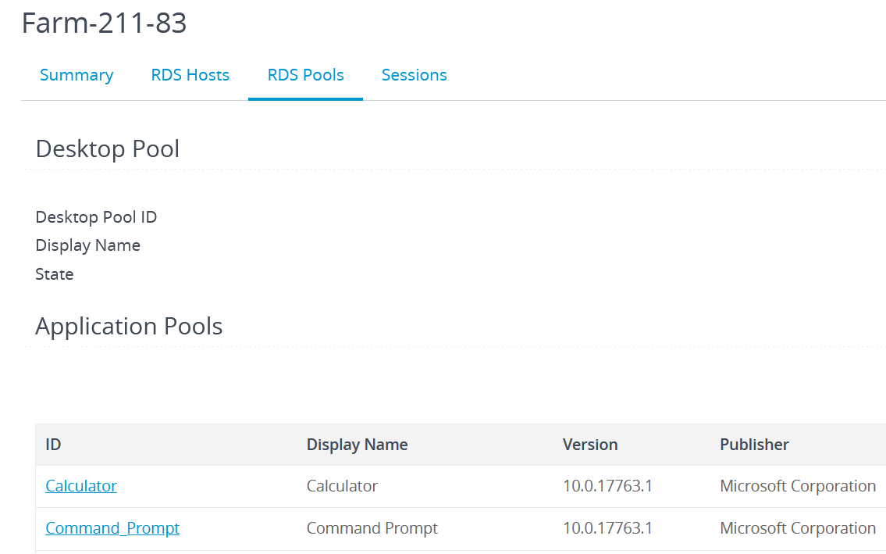

Metric wise, as RDS Farm is nothing but a collection of RDS Hosts + RDS Sessions, the metrics are derived from these objects.

##### KPI Metrics

As RDS Farm is a higher level objects, with potentially hundreds of members, the KPI metrics become a necessity in large scale monitoring.

For RDS Host, we take the worst value among the hosts as leading indicator. The reason is a farm typically consists of a dozen of so hosts, not hundreds. For RDS Session, taking the worst is good but need to be complemented with the worst 5th percentile() or count-not-green() as there can be hundreds of sessions, and a single session could be an outlier.

The following KPI metrics are provided to troubleshoot further if the Network KPI (%) and DC KPI (%) metrics shows bad value.

|  |  |
| --- | --- |
| Worst Network KPI among Sessions (%)  Worst DC KPI among Hosts (%) | The first metric you want to see is the KPI metrics. One for DC and one for Network.  Check these 2 KPI metrics as they are at session level (for network) and RDS Host level (for DC). If they are not red, then the 2 metrics below will be 0. |

The above is what you need to monitor. If the number is bad, then check the following:

|  |  |
| --- | --- |
| RDS Hosts with Red DC KPI  RDS Sessions with Red Network KPI | Check these metrics if the above is showing red. They tell the severity of the situation by showing how many hosts are affected. |
| Worst 5th percentile DC KPI (%)  Worst 5th percentile Network KPI (%) | If there is no session or host in the red, it does not mean they are not in orange level. Use these metrics to check.  Note that if there are < 20 hosts in a farm, the worst 5th percentile is basically the worst counter.  Take note that for rolling up to Pod and World level, the worst 5th percentile is a more balanced than worst() formula. |

##### Contention Metrics

KPI metrics are suitable for monitoring, not troubleshooting, as it’s an aggregate of metrics. To troubleshoot, you need contention metric-type.

It’s easier to troubleshoot at Farm level than individual host or session, as you can see the larger picture. There is no point troubleshooting a particular host or session if the whole farm is on fire. Different hosts and sessions can have different problems, and these metrics will capture them all as it’s worst among all members.

Use the Worst() metrics-type as they are the leading indicators. It shows the worst value among the RDS Hosts or RDS Sessions in the farm. They show the *depth* of a problem. If they show good value, no need to troubleshoot further as the worst is good.

First, check if there is a problem inside Windows.

|  |  |
| --- | --- |
| Worst CPU Queue | See RDS Host for more information. |
| Worst CPU Context Switch  Worst Memory Page-in Rate  Worst Disk Queue | See RDS Host for more information. |

Next, check if there is a problem outside Windows, meaning at the VM or below.

|  |  |
| --- | --- |
| Worst CPU Co-stop (%)  Worst CPU Ready (%)  Worst Memory Contention  Worst vDisk Read Latency  Worst vDisk Write Latency | See RDS Host for more information. |

The above is for Data Center, check if there is a problem in the network.

|  |  |
| --- | --- |
| Worst Protocol Latency (ms)  Worst Protocol Received Packet Loss (%)  Worst Protocol Transmit Packet Loss (%)  Worst time taken to load profile  Worst time taken to logon | See RDS Session for more information. |

If the Worst() metric-type show something is wrong, then you want to know many hosts or sessions are affected. This is where the Count() metric-type come in.

|  |  |
| --- | --- |
| RDS Hosts with high disk latency | Number of hosts with disk latency > 20 ms |
| RDS Sessions with protocol latency  RDS Sessions with protocol receive dropped packet  RDS Sessions with protocol transmit dropped packet | The threshold used is above 50 ms  The threshold used is above 0.5%  The threshold used is above 0.5% |

##### Utilization Metrics

One common reason behind contention is high utilization. Not all usage metrics are relevant to performance, so the following only lists the relevant ones.

We take the same approach we did for contention metrics, which is start with Worst() then follow by Count(). The following are the Worst() metric type:

|  |  |
| --- | --- |
| Peak CPU Utilization among RDS Hosts (%)  Lowest Free Memory among RDS Hosts (MB) | See RDS Sessions for more information |

If the above shows something is wrong, then you want to know many hosts are affected. This is where the Count() metric-type come in.

|  |  |
| --- | --- |
| RDS Hosts with high CPU utilization  RDS Hosts with low available memory | The threshold used is above 95%  The threshold used is above 500 MB |

The problem could be caused by imbalance among the RDS Hosts. The imbalance metric-type shows that.

|  |  |
| --- | --- |
| Memory Usage Disparity among RDS Hosts (MB)  CPU Usage Disparity among RDS Hosts (%) | The metrics reveal if the load is well balanced.  Note that Load Balancer does not actually balance load. All it does is balance the number of connections. The problem is load on each session varies. Ideally, load balancer balanced on the RDS Host KPI. |

Finally, the high utilization could be caused by farm-wide spike. The average will tell us this.

|  |  |
| --- | --- |
| Average CPU Usage  Average Memory Usage | These are lagging indicators, so use this as the last resort.  If the number is high, and the disparity is high, one of them host is likely saturated. |

Metric wise, RDS Farm differs to RDS Host as it has network metrics. As usual, check the worst first, then the average.

|  |  |
| --- | --- |
| Lowest Frame Rate | See RDS Host for more information. |
| Average Frame Rate | Is this is below 15 the user experience is affected. |
| Average Transmit Bandwidth | Average among all the sessions. We do not provide the highest among them. If you need it, let us know with the exact problem that requires you to need the information at this level. In the mean time, use super metric. |

Disk utilization is less useful in performance troubleshooting for the reason documented in RDS Host object.

|  |  |
| --- | --- |
| Read IOPS  Write IOPS  Read Throughput  Write Throughput | Sum, not average, from all RDS hosts. See RDS Host for more information.  Make sure this is within what your storage subsystem can handle |

#### VDI Session

VDI Session is a VM with Horizon protocol, so the metrics are basically Windows and vSphere metrics.

##### Contention Metrics

We included KPI (%) if you need a single metric for ease of reporting or monitoring. It’s the average of DC KPI and Network KPI as both are equally important to the user experience.

VDI Session has the same set of contention metrics as RDS Host object & RDS Session object. So refer to them for the metric description.

|  |  |
| --- | --- |
| Protocol Latency (ms)  Protocol Received Packet Loss (%)  Protocol Transmit Packet Loss (%) | See RDS Session for more information. |
| Time taken to logon | Note login will be faster if the user is reconnecting to the same desktop (disconnect vs logoff) |
| Time taken to load profile | The guidance for performance is   * Green = below 30 seconds * Yellow = 30 - 45 seconds * Orange = 45 - 60 seconds * Red = above 60 seconds |

##### Utilization Metrics

VDI Session has the same utilization metrics as RDS Host object, because both are VM. The difference is it has network metrics, which are covered in RDS Session object.

#### VDI Pool

VDI Pool sports the same set of KPI metrics that RDS Farm has. The only difference is it uses VDI Session as the base object, reflecting the fact that a pool is nothing but a collection of VDI VMs.

Refer to the RDS Farm metric for the explanation. In summary, the metrics are:

* Lowest Network KPI among VDI Sessions (%)
* Worst DC KPI among VDI Sessions (%)
* VDI Sessions with Red DC KPI
* VDI Sessions with Red Network KPI
* Worst 5th Percentile DC KPI (%)
* Worst 5th Percentile Network KPI (%)

##### Contention Metrics

As per RDS Farm, we begin with checking inside Windows.

|  |  |
| --- | --- |
| Worst CPU Queue | The highest CPU Queue among the VDI Sessions. If this is high then look inside Windows. To reduce this you need to increase the number of vCPU, or move the user to a pool with bigger VM. |
| Worst CPU Context Switch  Worst Memory Page-in Rate  Worst Disk Queue | See RDS Farm for more information |

If the above shows something is wrong, then you want to know many VDI Sessions are affected. This is where the Count() metric-type come in

|  |  |
| --- | --- |
| VDI Sessions with CPU Queue  VDI Sessions with Disk Queue | The threshold used Above 2.  The threshold used Above 10 in Windows |

Next, check if there is a problem outside Windows, meaning at the VM or below. Check for both DC and Network

|  |  |
| --- | --- |
| Worst CPU Co-stop (%)  Worst CPU Ready (%)  Worst Memory Contention | See RDS Farm for more information |
| Worst vDisk Latency |  |
| Worst vDisk Read Latency  Worst vDisk Write Latency |  |
| Worst Protocol Latency (ms)  Worst Protocol Received Packet Loss (%)  Worst Protocol Transmit Packet Loss (%)  Worst time taken to load profile  Worst time taken to logon | See RDS Session for more information |

If there is a problem, check how broad the problem is.

|  |  |
| --- | --- |
| VDI Sessions with CPU Ready  VDI Sessions with Memory Contention  VDI Sessions with high Disk Latency  VDI Sessions with protocol latency  VDI Sessions with protocol receive dropped packet  VDI Sessions with protocol transmit dropped packet | The threshold used is above 2.5%  The threshold used is above 1%  The threshold used is above 20 ms  The threshold used is above 50 ms  The threshold used is above 0.5%  The threshold used is above 0.5% |

##### Utilization Metrics

One common reason behind contention is high utilization. Not all usage metrics are relevant to performance, so the following only lists the relevant ones.

|  |  |
| --- | --- |
| Number of Sessions with high utilization | Count of VDI Sessions with CPU Usage > 95%. |
| Peak CPU Utilization among VDI Sessions (%) | Note this metric is yet to be implemented. In the mean time, use super metric.  If this metric hits >95%, one or more users could be needing more CPU, and perhaps should be migrated to VDI Pool with larger VM. |
| Lowest Free Memory among VDI Sessions (MB) | If this metric hits <1200 MB, one or more users could be needing more memory, and perhaps should be migrated to VDI Pool with larger VM. |

If the above shows something is wrong, then you want to know many hosts are affected. This is where the Count() metric-type come in.

|  |  |
| --- | --- |
| VDI Sessions with high CPU utilization  VDI Sessions with low available memory | The threshold used is above 95%  The threshold used is above 500 MB |

For the network metrics, see RDS Farm.

Disk utilization is less useful for the reason explained in RDS Farm.

Note that the metrics Average CPU Usage and Average Memory Usageare intentionally *not* provided as they serve neither performance management nor capacity management.

The disparity metrics are not applicable as there are bounds to be disparity among users.

#### Horizon Pod

Now that we have the KPIs for all key objects, we can roll up. A pod is simply a group of VDI Pool and/or RDS Farm. It has Connection Servers but they are not in the data path once user is authenticated.

##### KPI Metrics

|  |  |
| --- | --- |
| Worst 5th Percentile Network KPI (%)  Worst 5th Percentile DC KPI (%) | The primary metrics.  Based on all the RDS Farms and VDI Pools in the Pod |

If the above is bad, then you dive into the individual farm or pool. If you want to see how bad the situation, use the following

|  |  |
| --- | --- |
| Farms or Pools with Red DC KPI  Farms or Pools with Red Network KPI | Aim for this number to be 0 as the farm KPI or pool KPI is the average of all their members. It’s a lagging indicator. |
| Network KPI (%)  DC KPI (%) | While it’s a lagging indicators, it gives the full picture. |

Since Pod contain Horizon servers, we add Worst 5th Percentile Connection Servers DC KPI (%) metric to help in monitoring. From here, you dive into the individual servers.

##### Contention Metrics

Horizon Pod is too large an object to perform troubleshooting. You need to zoom into a specific farm or pool.

At the pod level, the following is provided as the number of data points is a lot less.

|  |  |
| --- | --- |
| Worst time taken to load profile  Worst time taken to logon | We use the worst instead of the worst 5th percentile as it’s an event, not metric. It does not happen every 5 minutes so the number of data points is a lot less. |

If you have a problem that impacts the entire pod, check at vSphere clusters and DC level as it could be something common.

##### Utilization Metrics

One common reason behind contention is high utilization. As Pod is a large object, its utilization can potentially exceed what the infrastructure is able to deliver. Start with the total utilization:

|  |  |
| --- | --- |
| CPU Utilization | Memory is not included as it’s actually disk space. Disk space impact capacity, not performance. Memory usage matters in resource provider, such as ESXi. |
| Disk IOPS  Disk Throughput | If the number is higher than what you expect, then drill down to read and write. |

The problem could also be caused by high utilization within the VDI VM or RDS Host. You did profile your environment, didn’t you?

Since Pod contain Horizon servers, we add the following metric to help in monitoring. From here, you dive into the individual servers.

* CPU Usage per Connection Server
* Memory Usage per Connection Server

#### Horizon World

We do not aggregate at Horizon Site and Horizon CPA level to minimize footprint of vRealize Operations. If you have the need, let us know with the specific example. In the mean time, use super metric.

Similar to a Pod, start with the main KPI metric, and then you dive into a pod, and then into a farm or pool. You do not do troubleshooting at World or Site level.

### Capacity

Horizon consists of different components, each having their own capacity model. Not all components have capacity need, meaning you do not need to do capacity planning and adjustment.

|  |  |
| --- | --- |
| **User** | **Requirements:**  How much resources do the users need? Focus on CPU and Memory. Disk Space is simple. Network is done at RDS Farm or VDI Pool level.  A user can have >1 sessions. He uses 2 desktops due to application licensing or security policy. He could be oversized on Pool 1 and oversized on Pool 2. This means the sizing has to be done per pool or farm.  We do not size the sessions. We size the users instead.  **Output:**  CPU (GHz), RAM (GB) per pool or farm. |
| **RDS Farm** | **Requirements:**  There are 2 main requirements: internal and external.  Internally, we need to know utilization of the RDS hosts and decide if the RDS Farm is full. Your initial sizing is only a guide. If you undersize then this calculation will prevent you from supporting more than what the farm can actual support. If you oversize, then this calculation will give you confidence to push beyond your plan. Regardless, you then need to update your plan.  Externally, the RDS Farm runs on a vSphere cluster. To add more hosts, you need to know if the underlying cluster is able to support it. This cluster could be a shared cluster, so there are other pools or farms there.  **Output:**  No of RDS Sessions remaining within the farm.  No of RDS Hosts that can be added in the parent cluster. |
| **VDI Pool** | **Requirements:**  Internally, there is no requirement as it’s a simple allocation model. The data provided by Horizon is good enough.  Externally, it’s similar to RDS Farm.  **Output:**  No of VDI VM that can be added in the parent cluster. |
| **Application** | **Requirements:**  How much resources do the application need? Focus on CPU and Memory. Disk Space is simple. Network is covered by the Horizon protocol.  **Output:**  CPU (GHz) and RAM (GB) |

There is no capacity required for the following objects:

|  |  |
| --- | --- |
| **Pod** | It’s just a folder or container of farms and pools. The pools/farms may not be interchangeable so you can’t roll them up.  In a large environment with hundreds of farms and pools, you can use distribution chart to quickly show the farms and pools that are running low on capacity. |
| **Site** | See Pod. |
| **Cloud Pod** | See Pod. |
| **RDS Host** | Capacity is done at RDS Farm. If the host runs out of capacity, you don’t increase the size of the host, rather you add more hosts. The host size is a design decision. |
| **Horizon Servers** | Connection Servers, UAG, App Volume.  They are designed with fixed size. If not enough, add more instance. |

#### RDS Farm

From capacity point of view, RDS Farm is a group of VM providing RDS host services, typically running Windows Server OS. The farm capacity can be automatically adjusted by provisioning new RDS Host VM, up to the limit specified.

While you can have different size of RDS hosts, keep them identical for ease of capacity management.

There is also a setting that caps the number of session per host. This is useful as you can not predict the consumption of each session, even if the users use the same application. For example, a use who opens a very large Microsoft Excel spreadsheet can easily consume multiple physical cores.

The setting “Logoff Disconnected Sessions” is useful. A user may disconnect from Horizon, but the ID remains logged on in Windows. From capacity viewpoint, you want to log off to free up the capacity.

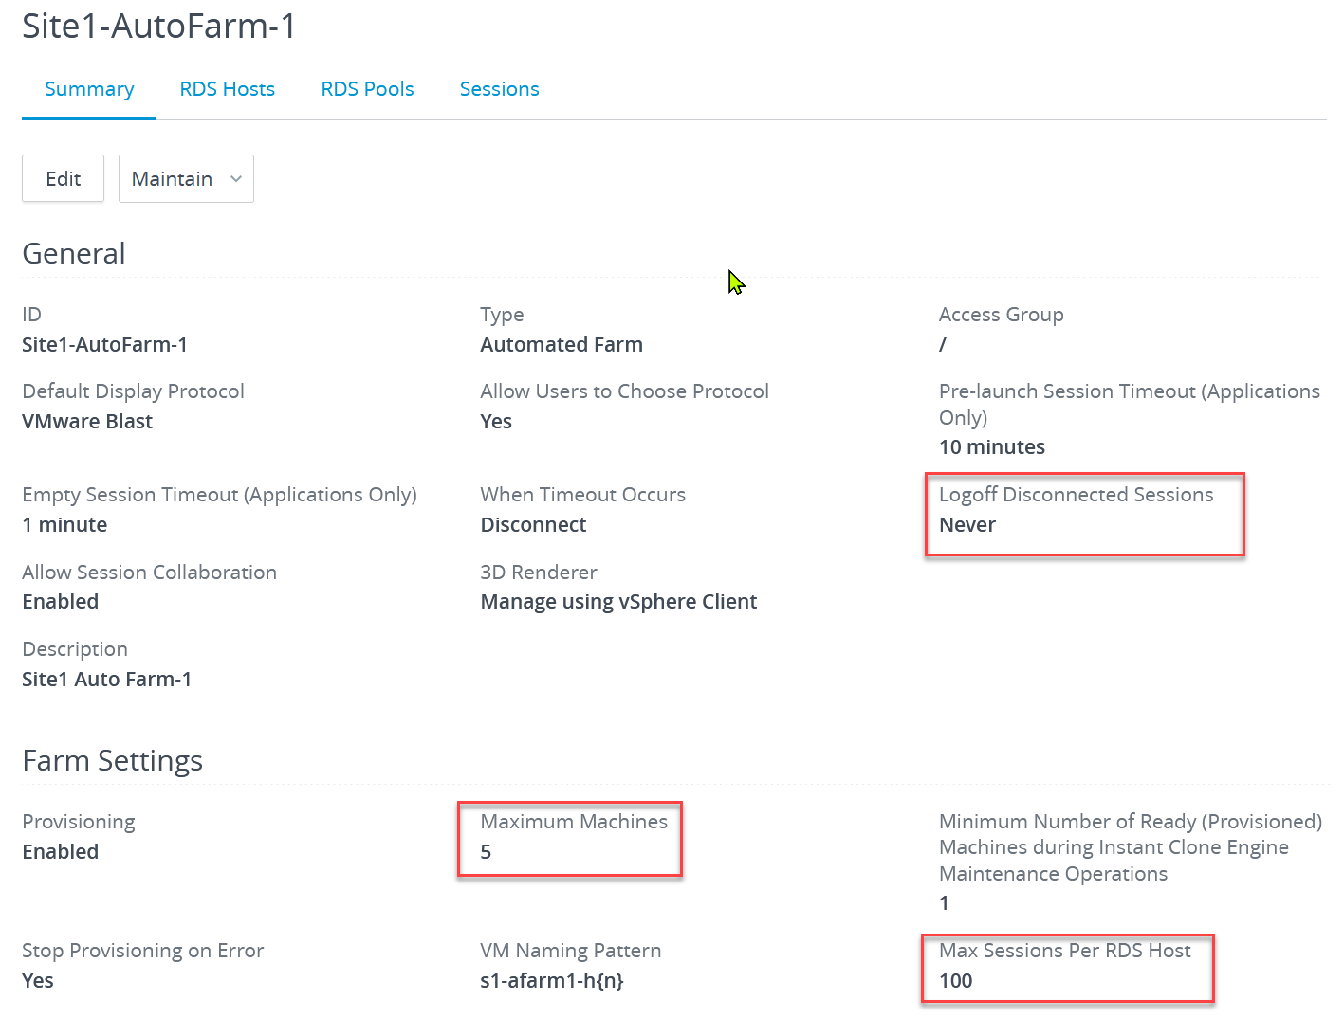

|  |  |
| --- | --- |
| Name | Description |
| Total CPU Usage  Total Memory Usage |  |
| Average Session CPU Usage  Average Session Memory Usage |  |
| Number of Sessions Over Committed on CPU  Number of Sessions Over Committed on Memory |  |
| RDS Host Remaining |  |
| Number of Sessions Remaining  99th Percentile Daily Session Remaining |  |

VDI Pool has Utilization (GHz), which is the total utilization not average.

Total – Unavailable – Bad State = Usable Capacity

* Unavailable (nothing wrong. Intentional or will fix by itself)   
  = Provisioned + In progress + Provisioning + Customizing + Deleting + Waiting for Agent + Maintenance mode + Startup + Agent needs reboot
* Bad state (something wrong. Need manual intervention)   
  = Configuration error + Protocol failure + Domain failure + Agent unreachable + Invalid IP + Unknown + Provisioning error + Agent disabled.

Usable Capacity consists of

* Used = Already Used + Connected + Disconnected + Unassigned user connected + Unassigned user disconnected
* Available = Available

The status **Available** means RDS host is available. If the host is in a farm, and the farm is associated with a published desktop or application pool, it will be used to deliver published desktops or applications to users.

##### Unavailable States

The host is not available, but there is nothing wrong. Typically this is intentional, or something that requires a simple intervention such as reboot.

|  |  |
| --- | --- |
| Disabled | Process of disabling the RDS host is complete. |
| Agent disabled | Occurs if Connection Server disables Horizon Agent. This state ensures that a new desktop or application session cannot be started on the RDS host. |
| Agent needs reboot | component was upgraded, and the RDS host must be restarted to allow Horizon Agent to operate with the upgraded component. |

##### Transient States

These are temporary states. You rarely see them as they only last for a few minutes, and will clear on their own.

|  |  |
| --- | --- |
| Startup | Horizon Agent has started on the RDS host, but other required services such as the display protocol are still starting. The agent start-up period also allows other processes such as protocol services to start up. |
| Disable in progress | RDS host is in the process of being disabled while sessions are still running on the host. When the sessions end, the status changes to Disabled. |
| Validating | Occurs after Connection Server first becomes aware of the RDS host, typically after Connection Server is started or restarted, and before the first successful communication with Horizon Agent on the RDS host.  Typically, this state is transient. This state is not the same as the Agent unreachable state, which indicates a communication problem. |

##### Bad States

These are permanent states, hence need manual intervention.

|  |  |
| --- | --- |
| Agent unreachable | Connection Server cannot establish communication with Horizon Agent on an RDS host. |
| Invalid IP | Subnet mask registry setting is configured on the RDS host, and no active network adapters have an IP address within the configured range. |
| Protocol failure | The RDP display protocol is not running correctly. If RDP is not running and PCoIP is running, clients cannot connect using either RDP or PCoIP. However, if RDP is running and PCoIP is not running, clients can connect using RDP. |
| Domain failure | RDS host encountered a problem reaching the domain. The domain server was not accessible, or the domain authentication failed. |
| Configuration error | RDS role is not enabled on the server. |
| Unknown | RDS host is in an unknown state. |

Reference: RDS host [[status](https://docs.vmware.com/en/Site-Recovery-Manager/8.4/com.vmware.srm.admin.doc/GUID-AF6BF11B-4FB7-4543-A873-329FDF1524A4.html)](https://docs.vmware.com/en/VMware-Horizon/2106/published-desktops-applications/GUID-14702097-AD74-4A5C-8CDC-804EE3079826.html?hWord=N4IghgNiBcIIIHMCmA7ALgAgK4oE5LAGMALMAIwiRAF8g).

#### VDI Pool

From capacity point of view, there are 2 types of VDI Pools: automated and manual.

Manual means you select the desktops that make up the pool. They can be vCenter VM or physical desktops. In this case, the assignment to users are typically 1:1 and hence capacity become manual too.

Automated means the VMs are provisioned automatically. You can have full clones, linked clones or instant clones. You can then assign the user to the desktop, which can be dedicated assignment or floating assignment. In the following screenshot, I’ve selected automated pool, and then chosen floating.

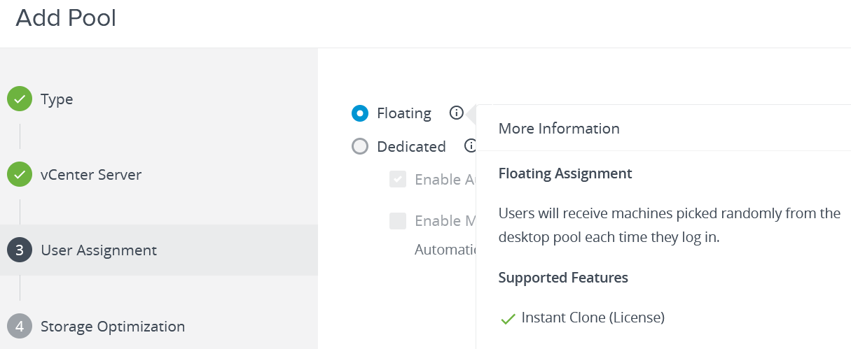

Horizon has a on-demand capacity, which are controlled via minimum, maximum, and spare machine. In the following screenshot, I’ve set the minimum to be 10. This means initially it will provision 10 VM up front.

I’ve also set the number of spare to be 5. So when VM no 6 is taken, Horizon will automatically provision VM no 11. It will continue to do so, keeping 5 spare VM, until it reached 100, which is the absolute limit I set.

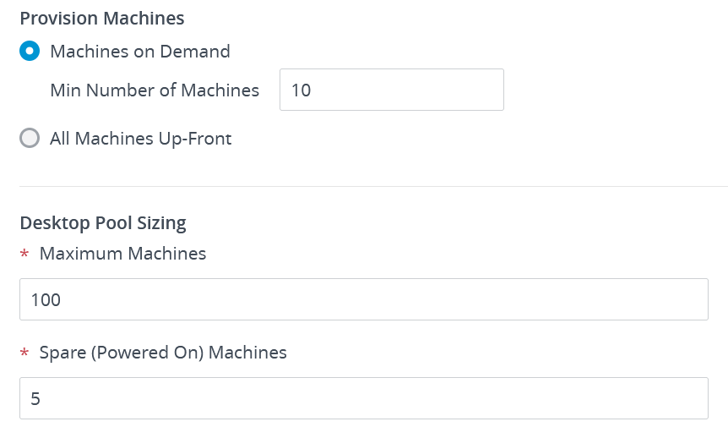

Can you see some complexity on the above?

Yes, it assumes that the underlying infrastructure is ready. You need to have CPU, memory, storage, IP address, Windows license, etc. ready. If you are running in the cloud, you need to have budget ready to buy extra capacity. If you are running on prem, you need to have the capacity ready. If you have many VDI pools sharing the same underlying vSphere and vSAN cluster, you need to ensure they all can fit.

Once the pool is provisioned, it looks like the following on the Horizon admin UI:

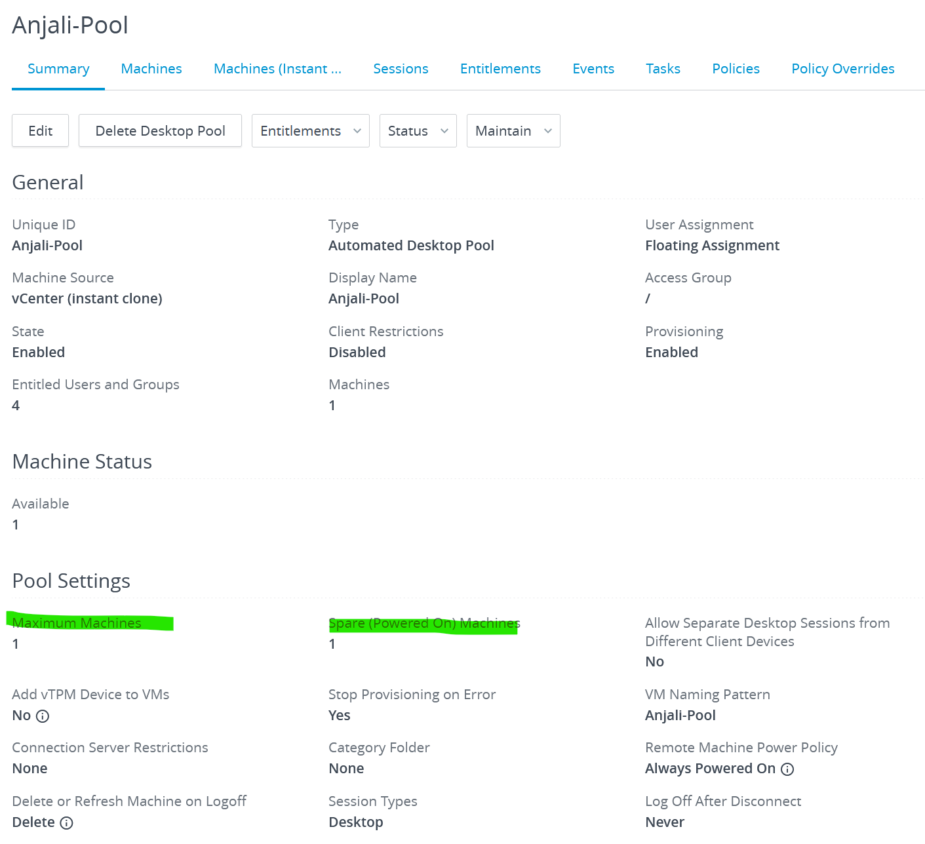

Available Desktop = Total - Used - Unavailable States - Transient States - Bad States

##### Used State

A user is logged into the desktop (Windows or Linux), hence it is considered used. The user may or may not be connected to Horizon. A user could directly login via vSphere Client or RDP.

|  |  |
| --- | --- |
| Unassigned user connected | A user other than the assigned user is logged in to a VM in a dedicated pool.  For example, this state can occur if an administrator starts vSphere Client, opens a console on the VM, and logs in. |
| Unassigned user disconnected | A user other than the assigned user is logged in and disconnected from a VM in a dedicated-assignment pool. |
| Available | The VM is powered on and ready for a connection. In a dedicated pool, the VM is assigned to a user and will start when the user logs in. |
| Connected | The VM is in a session and has a remote connection to the Horizon Client device. |
| Disconnected | The VM is in a session, but it is disconnected from the Horizon Client device. |

##### Unavailable States

The host is not available, but there is nothing wrong. Typically this is intentional, or something that requires a simple intervention such as reboot.

|  |  |
| --- | --- |
| Maintenance mode | The VM is in maintenance mode. Users cannot log in or use the VM. |
| Agent needs reboot | A Horizon component was upgraded, and the VM must be restarted to allow Horizon Agent to operate with the upgraded component. |
| Provisioned | The VM is powered off or suspended. |
| In progress | The VM is in a transitional state during a maintenance operation. |

##### Transient States

These are temporary states. You rarely see them as they only last for a few minutes, and will clear on their own.

|  |  |
| --- | --- |
| Provisioning | The VM is being provisioned. |
| Customizing | The VM in an automated pool is being customized. |
| Deleting | The VM is marked for deletion. Horizon will delete the VM soon |
| Startup | Horizon Agent has started on the VM, but other required services such as the display protocol are still starting. For example, View Agent cannot establish an RDP connection with client computers until RDP has finished starting. The agent startup period allows other processes such as protocol services to start up as well. |
| Agent disabled | This state can occur in 2 cases:   * In a desktop pool with the Delete or refresh machine on logoff or Delete machine after logoff setting enabled, a desktop session is logged out, but the VM is not yet refreshed or deleted. * Connection Server disables the Horizon Agent just before sending a request to power off the VM.   This state ensures that a new desktop session cannot be started on the VM. |
| Already used | In a desktop pool with the Delete or refresh machine on logoff or Delete machine after logoff setting enabled, there is no session on the VM, but the session was not logged off.  This condition might occur if a VM shuts down unexpectedly or the user resets the machine during a session. By default, when a VM is in this state, Horizon 7 prevents any other Horizon Client devices from accessing the desktop. |

##### Bad States

These are permanent states, hence need manual intervention.

|  |  |
| --- | --- |
| Agent unreachable | The Connection Server cannot establish communication with Horizon Agent on a VM. There are a few possibilities why:   * The VM is unresponsive. * Windows or Linux freezes or fails. * Guest OS shuts down or boots up, the agent service is not running. * Incorrect network configuration or connection issues between Connection Server and the Agent. * Lookup failure on the machine for the DNS name of the Connection Server host. * Network issues in the Infra for the VDI network. * DHCP server issues. * The ports for JMS, RDP, or AJP13 communication being blocked by firewall rules. * The failure of the JMS router on the Connection Server host.   Look into the affected VM debug logs to get more insights, and it might differ for every case. |
| Waiting for Agent | The Connection Server is waiting to establish communication with Horizon Agent on a VM in a manual pool. Mostly caused due to blocked network communication between agent and connection server |
| Invalid IP | The subnet mask registry setting is configured on the VM, and no active network adapters have an IP address within the configured range. |
| Protocol failure | A display protocol did not start before the Horizon Agent startup period expired.  Note that if the VM supports multiple protocol, this will still show protocol failure even though the VM is available on other protocol. |
| Domain failure | The VM encountered a problem reaching the domain. The domain server was not accessible, or the domain authentication failed. |
| Configuration error | The display protocol such as RDP or PCoIP is not enabled |
| Provisioning error | An error occurred during provisioning process. I’m unsure if the log reveals more. It’s worth checking with Log Insight at the time when you see this. |
| Error | An unknown error occurred in the VM. This is not normal, so expect this to be 0. |
| Unknown | The VM is in an unknown state. This is not normal, so expect this to be 0. |

Reference: VDI Pool [VM status](https://docs.vmware.com/en/VMware-Horizon-7/7.13/horizon-virtual-desktops/GUID-C66AE54D-21A1-41B3-93A6-8D8E7F448451.html). Horizon 8 does not have the documentation, so I’m using Horizon 7.

#### User Capacity Model

Sizing what a user needs is challenging as each users work differently. In some companies, the official corporate office hours may not apply as users work on the weekends or travel a lot (time zone)

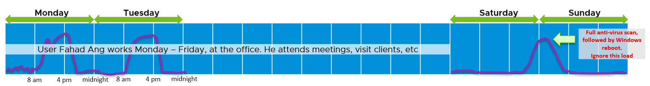

Desktop workload differs to Server workload. The CPU usage is spiky, short-lived and no predictable. The reason is user does not work non-stop. There is a lot of typing time, thinking time, meeting, coffee break, travelling, public holiday, etc., which vary users to users.

There is also non-user workload. The most popular ones are Windows weekly antivirus scan, Windows update (for permanent desktop), Windows patch, VM destroy and create.

You should profile the CPU, memory, disk and network. User can consume high network bandwidth if they are watching full screen video at 4K resolution.

In environment where users have multiple desktops, you need to size for each. A user could be undersized in desktop A and oversized in desktop B, if their usage are not interchangeably.

The sizing naturally differs for VDI and RDS. For VDI, since it’s a VM, the sizing is based per Horizon pool. The underlying engine is based on vSphere VM capacity, hence the metrics provided are identical to VM capacity.

|  |  |
| --- | --- |
| Oversized \ Memory | The degree of oversized in GB for memory and vCPU for CPU. This uses vSphere capacity engine. |
| Oversized \ Virtual CPUs |
| Undersized \ Memory | Same as above, but for undersized.  A VDI user can be undersized in one but oversize on another. |
| Undersized \ Virtual CPUs |
| Recommended CPU | The recommended size from the capacity prediction. |
| Recommended vCPU |
| Recommended Memory |
| Is Oversized | An Boolean indicator, where true = 1 and false = 0. |
| Is Undersized |

## Applications

Application has evolved to the point observability is playing catch up. However, the overall structure of business application 🡪 packaged application 🡪 application service remain the same.

**Part 2 Chapter 10**

### Business Applications

CIO cares about applications more than infrastructure. By that we meant business applications, not individual ISV products (e.g. MongoDB, Apache Tomcat). Since they serve different business purpose, using different software, and potentially run on different infrastructure, how do prove they are all performing well?

A business application typically spans multiple tiers, with each tier consisting of multiple VMs. I’ve worked with a large telco application spanning 5 tiers and 120 VMs. Since you typically have multiple business applications, you need a quick way to check the overall “health” of all of them before diving into a specific business application, and its associated tiers and VMs.

While all production applications are important, some are definitely more important than others. You monitor these critical applications 24 x 7, display them on the big screen, and want to be ahead of your customers in detecting the overall health. The “health” of the applications should be color coded for ease of visualization on the NOC screen.

#### Performance

I documented in Part 1 Chapter 2 Performance Management that there are 3 layers of monitoring.

|  |  |  |
| --- | --- | --- |
| Layer | Owner | Observability |
| Business | Non IT (specific department owning the business function, such as Internet Banking) | Service Response Time. This is business-function specific. For example, if it’s a eCommerce website, a good example of function is the payment of shopping cart. |
| Application | IT (Application Team) | It depends on the application software and codes. Typically requires agents with specific knowledge of that application, as it has unique metrics.  It’s not possible to develop a generic KPI. |
| Infrastructure | IT (Infrastructure Team) | It’s possible to develop a universal KPI that works on all applications as it’s basically about CPU, memory, disk and network.  This is the focus of our work. |

A multi-tier application can suffer from either horizontal or vertical problem:

* By horizontal, I mean a tier has problem. When the web tier is slow, it can slow down the entire application. The speed of a convoy is determined by the slowest car.
* By vertical, I mean something that cut across tier. Storage, for example. If the slowness is caused by something common, there is no need to troubleshoot individual VM, as they are simply victim.

That means we need to check both angles when an application had performance problem:

* Which tier had the problem? Since when? How bad? What was the problem?
* What infra problem did the application had? Storage, Network, CPU, RAM?

The above check makes a good starting point in your analysis. Don’t zoom into a particular VM until you know the overall picture. No point firefighting the kitchen if the whole house is on fire.

##### Infrastructure KPI Modelling

First step in performance dashboard is modelling the KPI. This is required so we show a single number for each business applications, and then drill down from it.

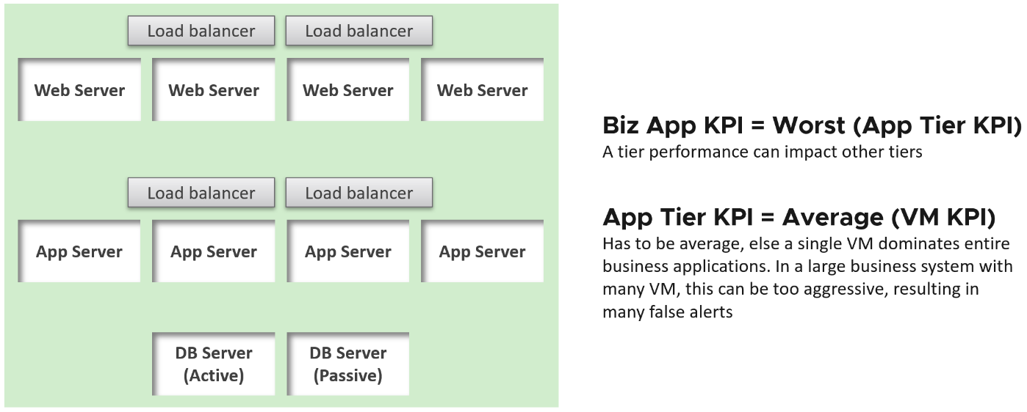

The health of a tier is the average health of its member. This is because a tier scales out. We are not taking the minimum value. This is not a convoy.

“Hold on!” you might say. Since it is scale out, Application Team has catered for this. If they only need 3 web servers, they will deploy 4 or even 5. So both performance and availability are not affected if one web server goes down. The tier performance has to take into account this extra capacity, and not simply doing an average of all members.

This logic sounds reasonable. But is it correct?

It is not actually. This is not about Availability. This is about Performance. All web servers are still up, but if any of the nodes is slower than usual, user experience will be affected.

##### Metrics

There are 3 metrics required

* Business Applications Performance.   
  This is the average of all the business applications. It helps you manage at scale. By plotting this as trend chart, you can see the overall picture over time.
* Business Applications Performance.  
  The performance of a specific business application.
* Business Applications Tier Performance.  
  The performance of a specific tier in a given business application.

The following shows the 3 super metrics created

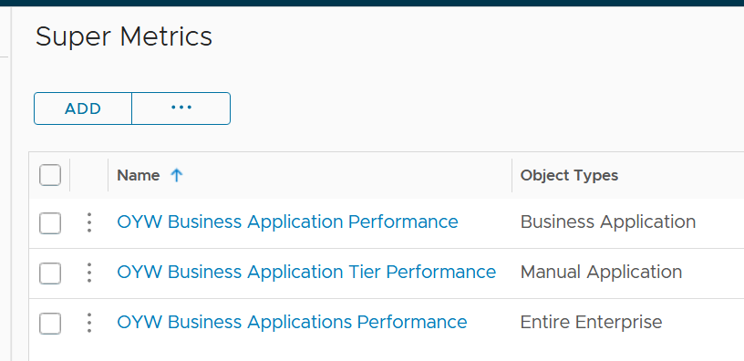

Implementation wise, here are their formula:

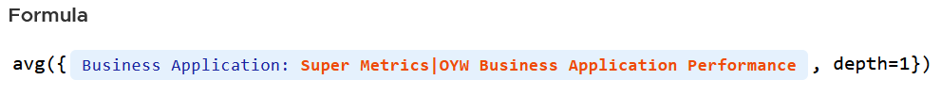



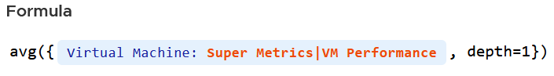

The VM KPI is turn an aggregation of its key performance metrics. We covered it in Part 1 Chapter 2 Performance Management and Part 2 Chapter 7 Operations Metrics.

**Limitation:** Levels are hardcoded to 3 and 3 only. Business Application → Business Application Tier → VM. If you create sub-tier it complicates the super metrics, dashboards and alerts..

#### Capacity

Similar to performance modelling, the capacity for a business application is the lowest of its tier.

Within the tier, the model depends whether it’s active-passive or active active.

* For active-passive, since there is only 1 node active at a time, you take the highest consumption. Take the maximum of CPU and maximum of memory. For disk, it depends whether it’s shared disk or not.
* For active-passive, since there is load balancer assuming even loads, you take the average consumption

# PART 3

Consumption

How do you apply the concepts in Part 1 and metrics in Part 2 in operations management? In this final part, we will cover how you will consume the knowledge via dashboards, alerts and reports. The 3 are essentially the way vRealize Operations communicates to users.

Among the book’s 4 parts, this part will be the one that changes the most from each vRealize Operations release and Operationalize Your World release. My goal is eventually this entire part will move into VMwareOpsGuide.com, so the book size remain manageable.

## The 3-in-1

**Part 3 Chapter 1**

Dashboards, alerts and reports serve the same purpose, which is the way for System to “communicate” with user. It is easy to think that are unrelated and should be designed independently. If we take a step back and look at the big picture, there is actually minimal overlap, as they form a *continuum*.

### Overview

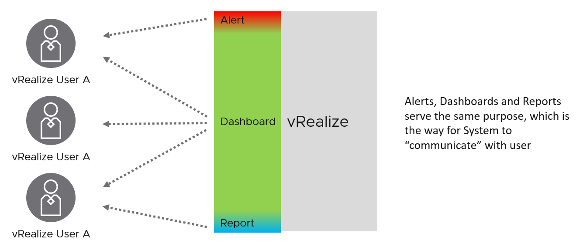

If you apply this thinking, you will vrealize that you can reduce alert storm, because many alerts are better served as parts of a dashboard. Reports will also become minimal and kept for personas with no online access and use cases where no interactivity is needed.

The nature of alert means its use case is narrow. You do not want to run your operations based on alerts. Too many and you’re overwhelmed. Too few and you lack the early warning.

Alert best practice:

|  |  |
| --- | --- |
| Urgent | If time is not an essence, then a regular SOP with dashboard is more effective as you can see the big picture. Avoid sending alerts to personas that do not deal with day-to-day operations. Long term actions such as capacity management is best served with dashboard |
| Problem | If there is nothing wrong, there is no need to trigger an alert. That’s why in general you do not set up an alert on inventory changes, as inventory is merely an account of something. |
| Solvable | If there is nothing you can do immediately to address the issue, why trigger an alert? Use dashboard for such cases. |
| Few | Alert focuses on exception, not the big picture. As a result, you want this to be minimal. If the whole house is on fire, it’s too late for an alert. |

Alert should not replace best practices. For examples, you should ensure [VMware Tools](https://kb.vmware.com/s/article/340) are up to date. If you set an alert for outdated VMware Tools, you become reactive and may get excessive alert. Since it’s not urgent, it’s better to have a daily SOP where you have a list of VMs with outdated VMware Tools. Make sure the list is empty.

At the other end of the spectrum lies **Report**. The nature of report means its use case is also narrow and specific. Modern operations require a richer interaction that report lacks. Report is only applicable in the following situation:

* No interactivity (e.g. users needs it delivered to their email inbox)
* Offline (e.g. users are in a plane)
* No access to Aria Operations
* Printed document. Take note you need to manually design the widget size to fit the paper.
* Historical copies at fixed interval. If you want to compare at fixed and regular interval, such as every week from Monday 00:00 hours to Sunday 00:00 hours, then it’s more convenient via report.
* Time bound (e.g. calendar month). You can do this in dashboard, but more effort.
* Further analysis & reporting (e.g. Finance team wants the data as part of their spreadsheet report)

Dashboards cover the broadest use cases as it’s the most versatile.

The following table details how the 3 ways of engaging are complementary.

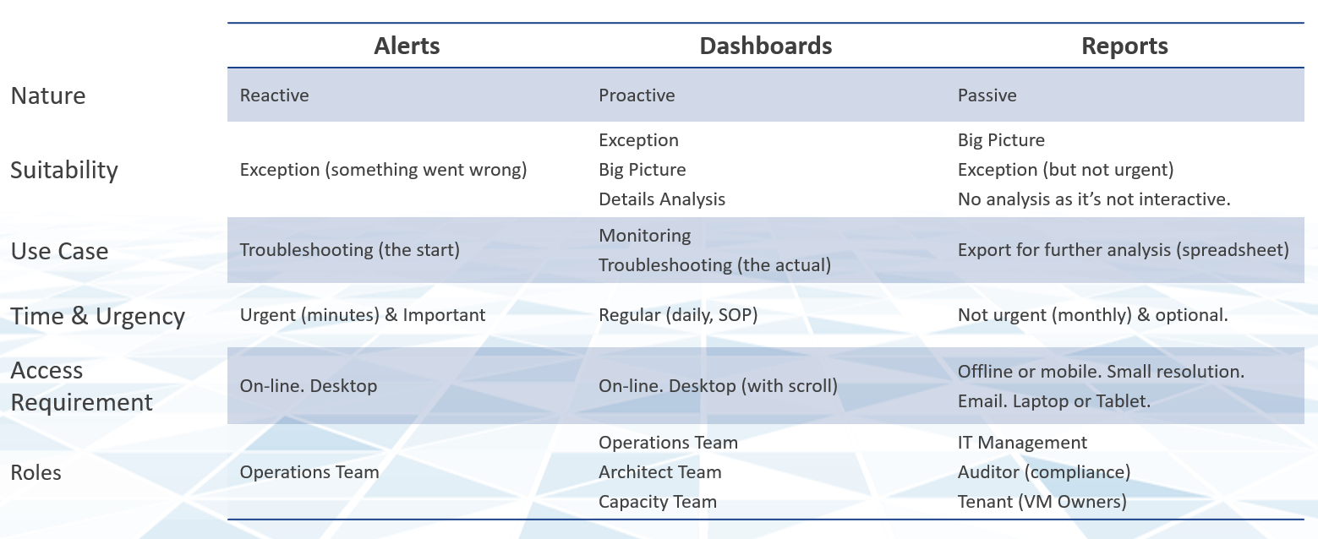

If user has access to the online via their desktop, consider a self-service dashboard as they require no login and it’s much easier to use. You can develop a portal with links to these dashboards and custom guide.

### Dashboard

#### Proactive Daily Check

As insights complements alert, I recommend you open the 2 screens side by side. Simply open 2 browser windows, as shown in the following screenshot.

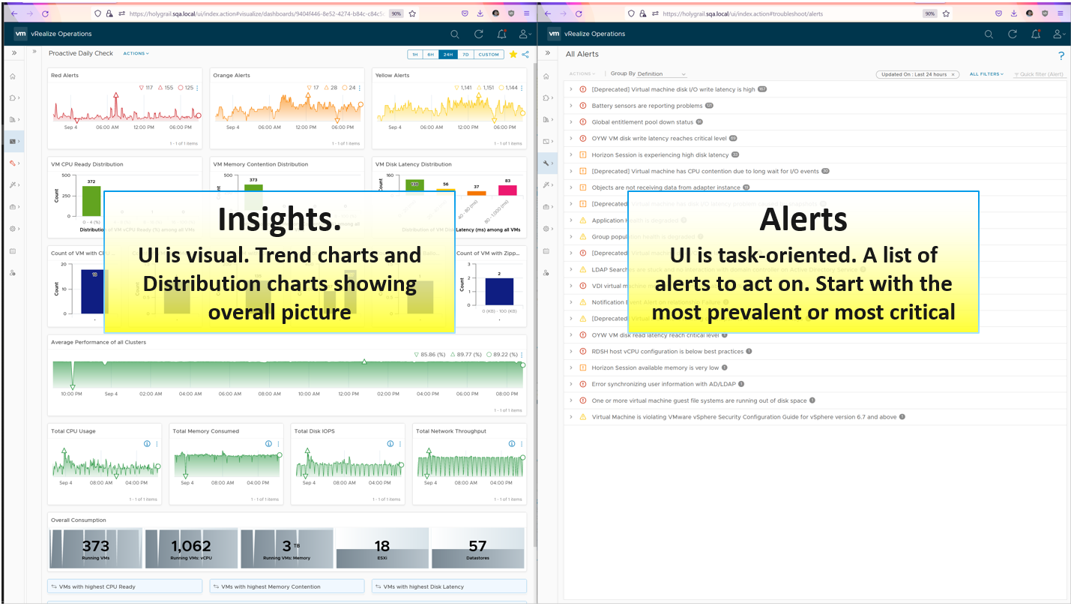

Operations Overview differs to Proactive Daily Check as the former is designed for the manager. It’s designed for someone or persona that are not “ground level”. The requirement varies among the persona if there are >1 level of management.

Proactive Daily Check is designed for seasoned users, who already *know* the environment and are running live operations. It focuses on the day to day operations, not the past nor the future (unless action needs to be taken today to avoid problem in the future). The timeline is practical, so something like -3 to +3 days are good, with default view set to now, or the last 8 hours.

By and large, your environment is good, otherwise you’re not reading this specific chapter 😊. If it is not good, you have some knowledge on the problems as you need to explain it to your management. On this assumption, this dashboard focuses on things that need attention. It complements alerts by showing insights (situation that has not triggered an alert) and show the overall picture. The overall picture is also useful as before you troubleshoot something specific you should ensure the issue is not with the overall environment.

|  |  |
| --- | --- |
| Area | Information that needs to be shown daily |
| Availability | Powered on VM and ESXi hosts. The numbers should be within your expectation. For example, if there is a new cluster or many new VMs being provisioned last night, then they should be reflected accordingly. |
| Performance | Average performance of consumer (VM) and providers (compute, network, storage).  Total CPU, Memory, Disk and network utilization are included as major increase or decrease indicates serious problem. |
| Compliance | Compliance status. Focus on the present, or at least the last 12 or 24 hours. |

To keep the focus, avoid having information that does not need to be acted on that day. Hence cost, capacity or configuration are not something you typically place.

You can see an example of a proactive daily check dashboard in the Horizon chapter. I will cover vSphere daily check here as I don’t know where else to put it ☹

#### vSphere Daily Check

The first thing to check is the trend of alerts. Since you’re checking this daily or even more, the number gives you a good indicator of what’s ahead of you.

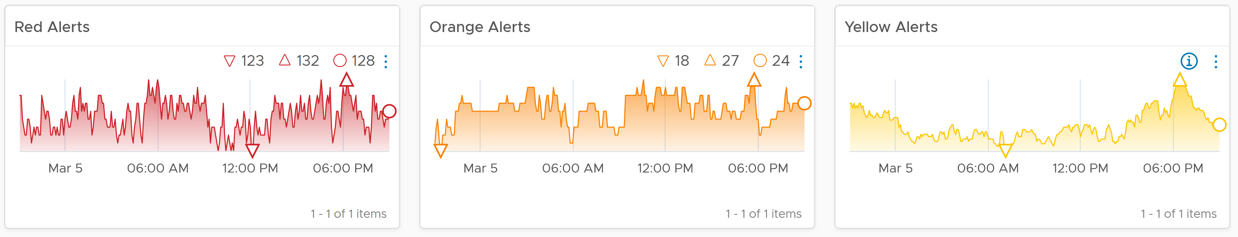

Is the trend unusual? Form an expectation of what’s normal for your environment as it develops pattern. Compare it with what’s happening (e.g. DC upgrade, public holiday).

What’s the overall IaaS performance among all the VMs? Is it a CPU, memory, disk problem? Expect the numbers to be within your expectation of that day.

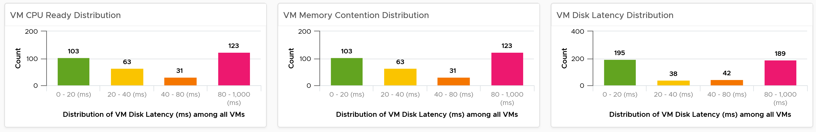

Next is configuration. What are typical misconfiguration that cause performance problems?

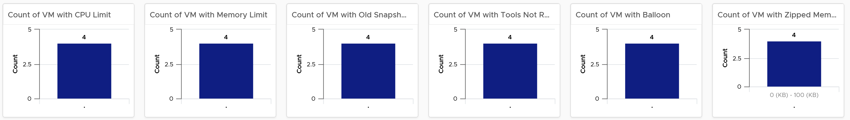

Ideally the above returns 0 VMs.

Customization Tips:

* If you operate a large environment, you can add a table of data centers so you can zoom into specific DC. You can even add vSphere Clusters in the table, just take note the table will be longer.
* One of the table member has to be vSphere World object. This lets you see the overall picture.

The following is an example showing the table driving the 3 charts and 3 scoreboards. If you have the screen real estate, you can even customize to drive all the widgets.

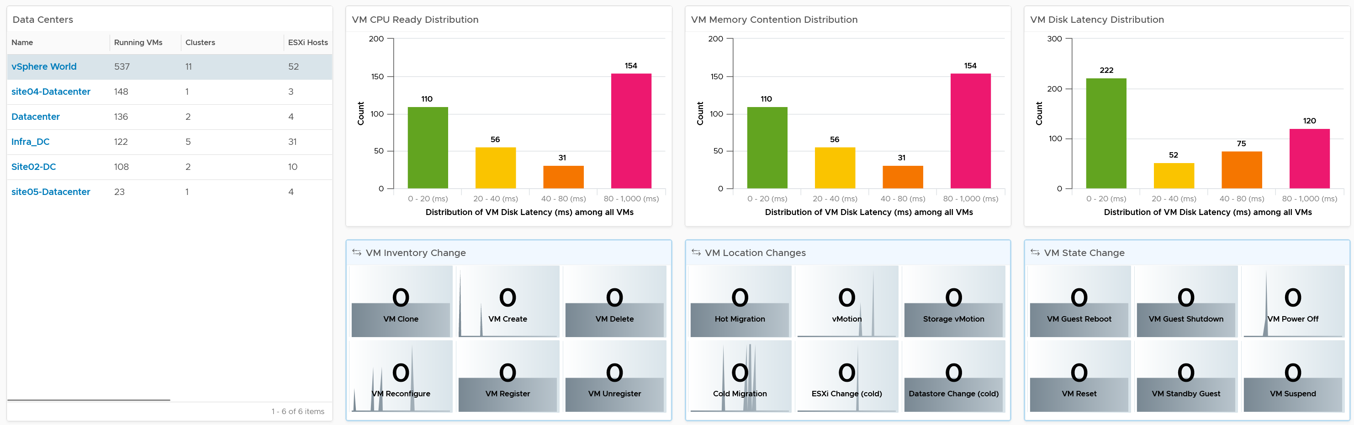

What are the important changes on VMs? Ensure they match the expectation of the day.

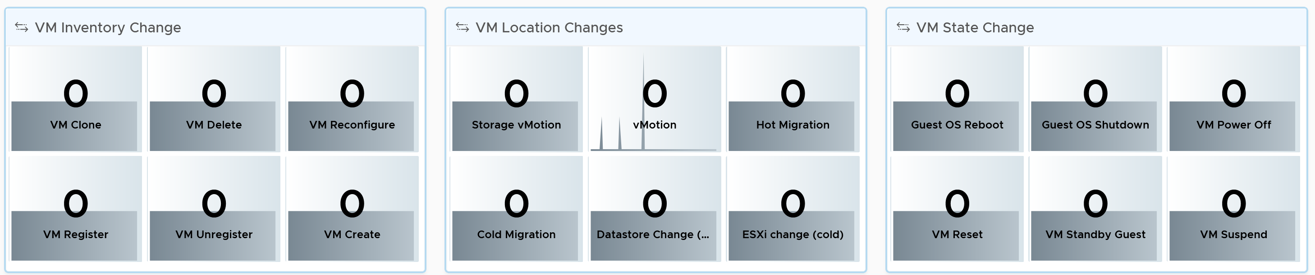

Next is the overall performance. It should be stable or cyclical overtime.

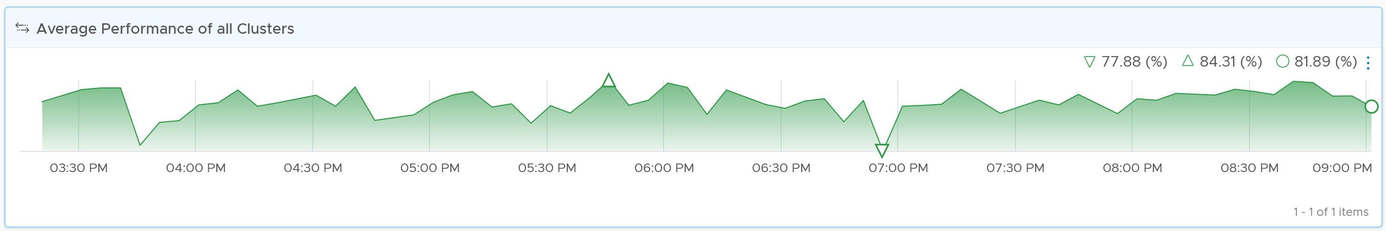

The above metric is explained in Part 2.

To complement the performance, we need to check utilization. We check the 4 elements of infrastructure. Since this is the overall utilization, it should be stable or cyclical overtime. Make sure both the pattern and the amount are in-line with your expectation of that day.

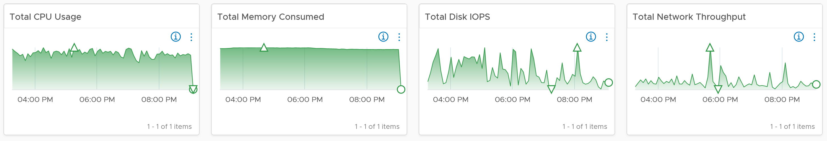

The last part of the dashboards show the basic counters. Again, it should be stable or move as expected

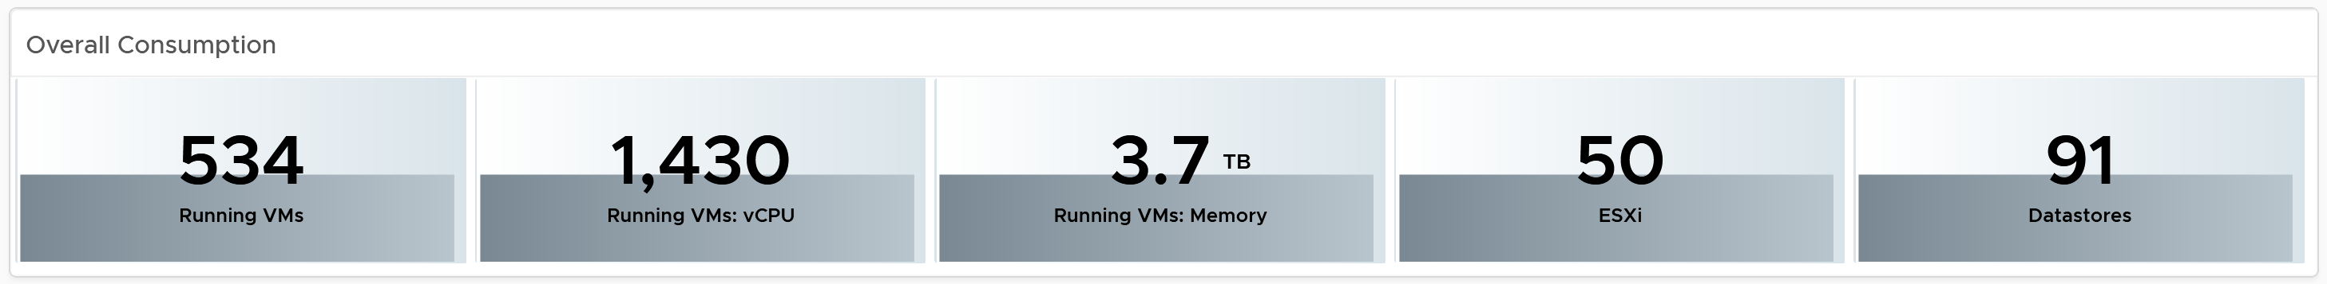

#### vSphere Daily Log Check

A lot of information is only available in the form of logs. Use a daily Log Insight dashboard to perform basic hygiene, such as:

* Undesirable VMs events. Are they inline with your expectation? That means the correct amount and right timing. Harmless events such as VM relocation, snapshot, powered on were filtered out from the dashboard.
* Undesirable VM changes & Snapshot. Are they inline with your expectation? Harmless changes filtered out. Are changes and snapshot taken during office hours?
* Issue. vCenter Alarms, vCenter tasks that ended with error, and ESXi potential problems.
* Security. Any malicious changes? Anyone issuing shell commands at ESXi console? Login by root?
* vMotion. This is a leading indicator of a larger performance issue. Is the bandwidth lower than expected? Is the downtime longer than expected? Some clusters did a lot more vMotion than usual?

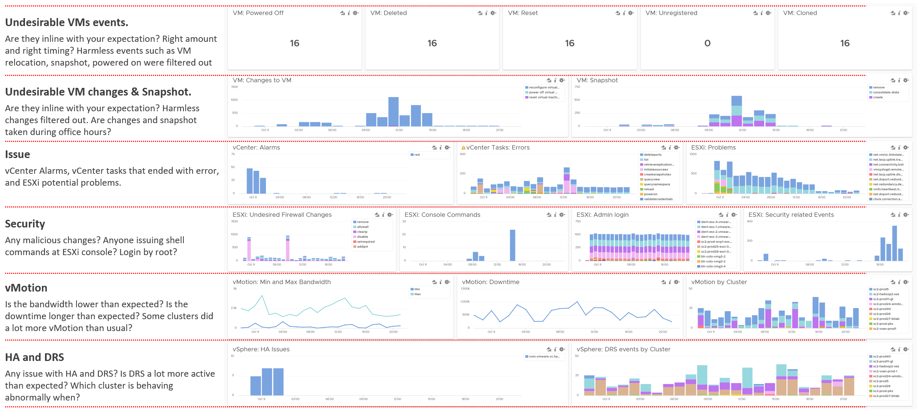

### Alert

Alert should be triggered on all affected objects, both the victims and the villain. It is common that a failure at the lowest ripples through the upper layers. For example, a physical disk failure in an ESXi host in a vSAN cluster. This in turn can bring down an entire vSAN disk group. If the ESXi host has only 1 disk group, it can impact the host as it will have no storage.

For contention, make sure the issue is both acute and sustained over at least 5 minutes

#### Alerts Planning

Your goal is to minimize alerts storm while providing the greatest coverage. This calls for a careful planning on the alert definition, symptom and threshold.

For each alert, ask yourself: what remediation action will be taken by the person seeing the alert?

* If the answer is nothing, then why have the alert? Using a dashboard can give better picture.
* If the answer is something, can that be automated? Be careful of simplified logic as computer has no common sense. An automation that is not fool proof can result in a disaster.

If the answer is escalating to the next level (e.g. Level 2 support) after adding some context and initial analysis, then it depends on the urgency. Generally speaking, L2 has longer time lines and need to see bigger picture. In this case, a daily dashboard that they can check once or twice a day is more effective.

What areas do you want to monitor with alerts? There are 5 pillars of Operations Management, so it’s easy to confuse when designing the alerts definition.

|  |  |
| --- | --- |
| **Availability** | You can minimize reactive operations by tracking soft errors, having proactive hardware replacement and ensuring software stack compatibility. |
| **Performance** | You minimize reactive operations not by using lower threshold, but by tracking early warning metrics. |
| **Capacity** | This is often mistaken as performance problem, as high utilization is a common alert. |
| **Compliance** | This is a subset of configuration check, so limit is to formal security standard. |
| **Configuration** | Configuration is broader than compliance. Configuration mistakes can cause availability, performance, capacity and security. Examples:   * Availability. Incompatibility between software versions could cause an outage. * Capacity. Disabling CPU SMT will reduce the number of logical processor. * Security. Outdated software may contain known security vulnerability |
| **Cost** | You don’t typically set an alert here as insight with dashboards is a better monitoring solution. |
| **Inventory** | You don’t typically set an alert here as inventory it’s merely an account of what you have. There is no good or bad. |

Managing Alerts is not the same as minimizing Alerts. Managing is dealing with alerts that are already triggered. Minimizing takes us towards preventing alerts to begin with. Use insight to minimize alert definition, as alert should be reserved for urgent and important issue.

Here are some examples to minimize alerts.

* Trap soft errors. They are non-critical events that act as early warning. Treat them as insights. If you solve them, the chance of them causing an alerts is reduced.
* Proactive replacement before reaching the manufacturing limit. For example, the SSD disk has limit of number of writes as each write introduces a wear and tear.
* Have redundancy, so unplanned downtime triggers non-critical alerts so long it’s within the allowance set in the design. If you design N+1 availability, then a single downtime is not a major and critical alert.
* Separate formal SLA with internal KPI.
* 1 alert many symptoms instead of 1:1 relationship. This tighten the condition.

In cases where you can’t minimize the alert, you can reduce the scope to only urgent. That means alert is reserved for red, and yellow is shown as insight instead. Design the overall alerts so that 100% of red are alerts and 50% of orange is alert. Insight then cover the remaining orange and 100% yellow.

In cases where you can’t reduce the severity, you can reduce the occurrence of the alert happening in production. You do this by proactive replacement, taken as part of scheduled downtime during green zone. For example, Solid State Drive (SSD) does not have infinite life span in terms of number of writes. The manufacturer has a number in mind for the endurance. If you have thousands of disks, you create a dashboard just to track this limit and schedule proactive replacement for those disks nearing their limit.

#### vSphere VM Alerts

Make sure the contention alert do not occur at the point of low utilisation.

I do not set network alerts due to false positive. I think it’s better we cover this at port group level and cluster level.

##### CPU Alerts

|  |  |
| --- | --- |
| Threshold | Metrics |
| Acute Contention | 20-second average CPU Ready at any vCPU level > 16% |
| Sustained Contention | 5-minute average CPU Ready at VM level > 4% |
| Low Utilization | CPU Usage < 100 MHz  An absolute unit is used as opposed to relative (%) as a small percentage of a monster VM could still be sizable. |

##### Memory Alerts

|  |  |
| --- | --- |
| Threshold | Metrics |
| Acute Contention | 20-second average VM Memory Latency > 16% |
| Sustained Contention | 5-minute average VM Memory Latency > 4% |
| Low Utilization | CPU Usage < 100 MHz  We’re using CPU as memory read/write requires CPU processing and memory behaves like a disk space. |

##### Storage Alerts

We have 2 alerts, one for read and one for write. The reason is their causes are typically different.

The one for Read is based on the following design:

|  |  |
| --- | --- |
| Threshold | Metrics |
| Acute Contention | 20-second average Disk Latency, at any virtual disk level > 160 ms  Yes, 160 ms is very high. But that’s a single virtual disk and for 20 second. In theory I agree we should pick a lower number, but in reality there is hardly any complaint. Try to convince your boss to invest when there is no complaint 😉 |
| Sustained Contention | 5-minute average CPU Ready at VM level > 40 ms |
| Low Utilization | CPU Usage < 100 MHz  An absolute unit is used as opposed to relative (%) as a small percentage of a monster VM could still be sizable. |
| Read Disk IOPS < 3  If you think 3 is too low, 3 IO per second sustained over 300 seconds translate into 900 I/O commands. I  Disk Throughput is not necessary as we’re checking for sign of activity. The size of the activity is not that relevant. |

#### vSphere Cluster Alerts

Separate a Cluster problem vs a host problem. A sign of a host problem is all other hosts in the cluser do not exhibit the problem

#### vSphere Port Group Alerts

Easier at port group than at switch level as we do not have to aggregate

Easier at ESXi level and

### Report

Report should be purpose-built, designed specifically for a persona and use case. A persona may need multiple reports, with different frequency and contents.

For each report, the following must be clear

* Frequency
* Scope
* Expected Outcome

#### IT Senior Management

The most common persona for report is IT senior management. They typically read the information via email, meaning they need offline access. Some may even ask for the information to fit on a mobile phone screen. Different managers are likely having slightly different requirements. Take time to understand the real needs behind the ask. Learn what questions need to be answered, what answers are expected, and what actions are taken based on the answer.

In terms solution, drive towards dashboard as opposed to PDF. This lets you keep less variations and deliver richer information. If you go with reports, you can end up with too many variations to maintain.

If your manager requires off-line access, try to make this a secondary report that is only used when on-line access is not possible. If off-line access is required, verify what screen size. A small screen of 7” can only display a small subset than say a 14” display.

##### Business Applications

This is likely the most important, both from their viewpoint and your viewpoint. You do want to prove that your infrastructure is playing its part well.

The report should provide a summary for all the mission critical business applications. As they are of the same level of importance, the list should be grouped by the business units.

|  |  |
| --- | --- |
| Column Name |  |
| Name | The business application name as per what the business or senior IT leaders call it |
| Availability | Average uptime during the reporting period.  This shows Actual Availability (%), not Operational Availability (%) as the end customers (which are typically external or public) do not care about your scheduled downtime. Majority of websites has 24 x 7 x 365 days availability expectation, even if your customers are not global. |
| Performance |  |
| Compliance |  |

* The list should have.

Inventory

* What do we have in what location? How does it change?
* Senior IT Management may not be familiar with the environment and inventory

Capacity

* What must I approve or review?
* Overall capacity is less useful as VMs can’t be easily migrated. So report per physical DC, or virtual DC.
* List of clusters
* List of datastores

Cost

Compliance

* Industry compliant

Performance

* What’s our performance? Is it degrading?
* Do we report infra performance or VM performance? Why do they want to know the VM name?
* Do we do a

##### Infrastructure

Goal:

Content:

#### Auditor

This role is interested in knowing that the environment is kept secured. They also want to know if there is unauthorised changes, especially by privileged users (read: system administrators, yes, you and your team).

#### Implementation

Since it’s to be read and not presented, report should not use scoreboard. Scoreboard takes up valuable space.

If we use table, how to control the pagination and length? This means it’s a single column. Having 2 widgets can result in different height.

## The Art of Dashboard

There are many considerations required in designing a suite of dashboards that tell a story. The last few releases of vRealize Operations introduces many new capabilities that change the way your dashboards can look. vRealize Operations 8.2 introduces an enhanced dashboard to dashboard navigation, so you can create flow among dashboards. Your dashboards are no longer confined to be standalone dashboard.

**Part 3 Chapter 2**

### Design Consideration

To a few of us who love visualizing information with vRealize Operations, we see the dashboard as a canvas. Granted, the widgets have limitation but that’s part of the art 😊

Creating dashboards is an art as you need to balance many conflicting requirements, such as:

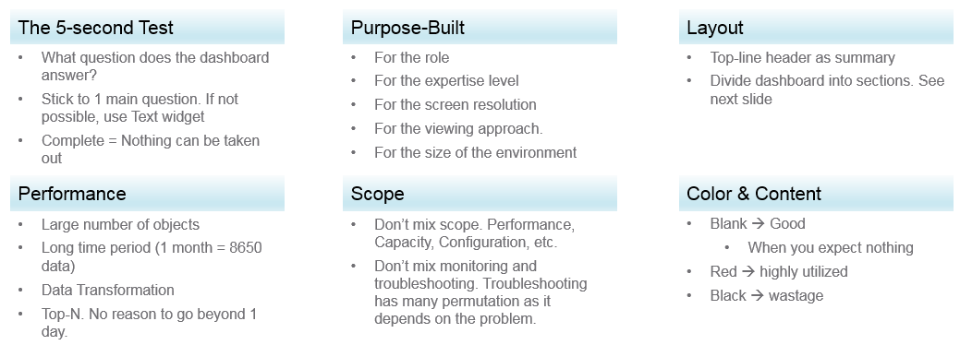

Can the dashboard be understood within 5 seconds? If yes, you buy yourself a few more minutes. The user understands what the dashboard does, and is willing to spend more time mastering it. To pass this test, think of which information, object, metric can you take away from the dashboard? See the [KISS Principle](https://en.wikipedia.org/wiki/KISS_principle), because an uber-dashboard that tries to please everyone and cover all scenarios will end up not being used.

Begin with the end in mind. The purpose dictates the dashboard design. 2 dashboards can have an identical target role, purpose, and use case (e.g. performance), but if the size of the environment differs, the 2 dashboards will be different. An environment with 50,000 VMs is managed differently with an environment of 50 VMs.

A small environment with 100 VMs in just 8 hosts in 1 cluster (hence 1 data center, 1 vCenter) needs less dashboards than an environment with 10,000 VM spread over 800 ESXi hosts, 100 clusters, 10 data centers and 3 vCenters.

#### Dashboard Design Method

This section introduces us to a few considerations surrounding dashboard design. We will walk through a method where we are able to understand the user, the activity, the workflow and the other aspects needed to understand the context before we start.

When we create dashboards that are used by others in our team we have to consider a few aspects that are helpful in making information useful, usable and delightful.

|  |  |
| --- | --- |
| **Who** | Begin with the end in mind. Who are actually using the dashboards you create? What specific role and persona is going to use it?  Start by creating a list of all users who would be accessing and using information in the dashboard  Against this list mention the kind of information they would find useful for the specific persona. |
| **What** | What is the type of activity (granular vs. high level) they will perform?  List next to the task if the information needs to be granular or high level. Sometimes users are looking for just a KPI number, sometimes they are looking for trends. Sometimes users might want to interact with the information, create drill downs etc.  The complexity of the activity will help you identify if you need a complex widget or a simple one. |
| **How** | How (workflow) will they use the dashboard?  List down what happens after they view the information, do they need to use another application, another visualization. Plan accordingly and place navigation to enable this to happen. |
| **When** | How often (hourly, daily, weekly, monthly, quarterly) will they use the dashboard?  Think about the usage of the dashboard, is it a frequent use case needed for daily use to perform work, or is it for monitoring on an irregular basis. |
| **Why** | Why (outcome) do they need the dashboard?  Also list down outcomes from the dashboard usage. What is the usefulness of using the dashboard and what goals or outcomes the user is likely to achieve. |

Once we get this information we can better design dashboards based on the needs of the users. One way could be to plot it on a grid to understand the impact better. Let’s start with a grid like this one.

Now if take the example of Who from different roles/personas

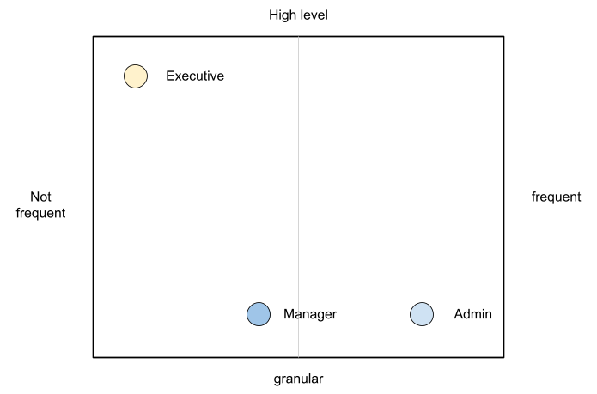

An executive might use the dashboard less frequently and the type of tasks they would perform could be high level. If you make a dashboard that is very granular and requires a lot of effort the executive might not have the time to use the dashboard.

A manager might use the dashboard once a week, or on a monthly timeline, might need information on both granular or high-level.

Similarly an admin agent might use it on a daily basis and might need information at times that needs a lot of effort and at other times just a metric number would do.

Once you have reached a visualisation like this, you can better judge. If it needs to be a single dashboard or multiple based on the persona. What items should you prioritise and what kind of complexity is necessary based on the timeframe and time available with the stakeholder

#### Clean Layout

Divide the screen into sections visually. This makes the dashboard easier to read. Here are some examples of how you can divide the screen.



##### Example 1

Here is a good example of layout from Brock Peterson. Notice how simple it is. It is clear that it has 4 layers as layout is consistent among them.

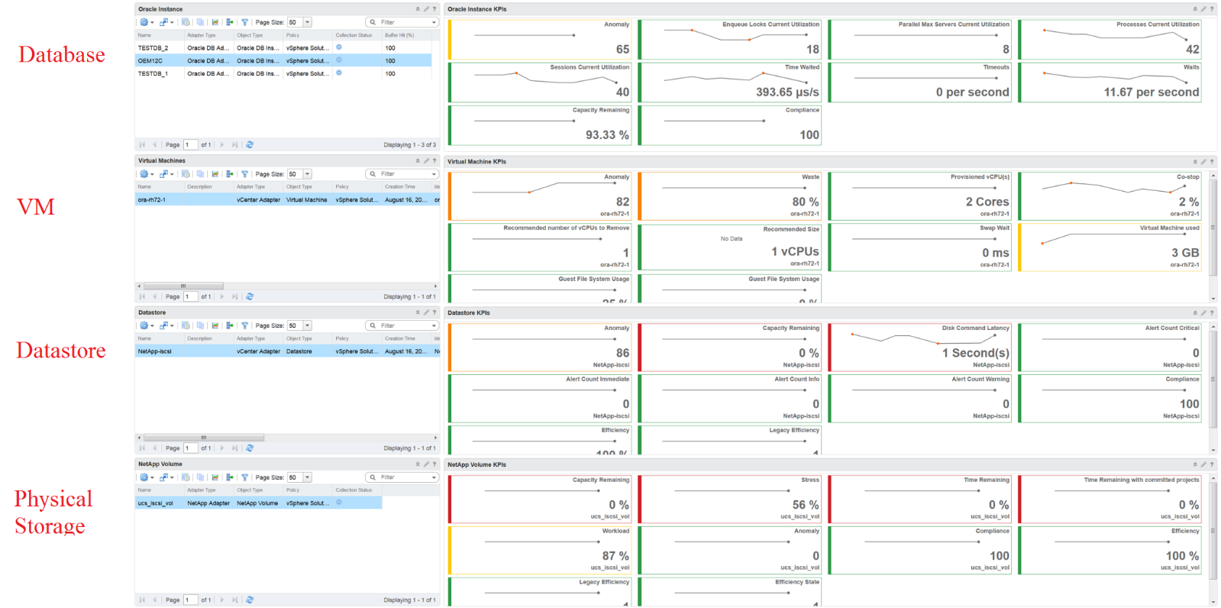

##### Example 2

You should also play with Dark Mode, and see how that looks. The following shows a clean layout in dark mode. Notice how [[Dale Hassinger](https://code.vmware.com/user/2287325117)](https://www.linkedin.com/in/dale-hassinger-5712301b/) has arranged this dashboard well.

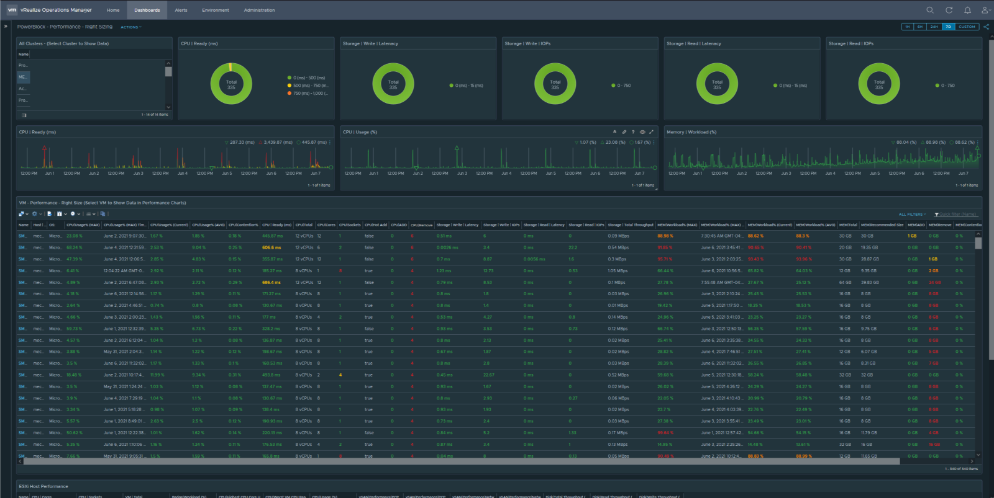

Visually, he has designed the layout “top down”, making it easier to see.

Another technique is to create 2 sections: summary and detail.

* The summary section is typically placed at the top of the dashboard. It gives the big picture.
* The detail section is placed below the summary section. It lets you drill down into a specific object. For example, if it’s a VM performance, you can get the detail performance of a specific VM.

This detail section is also designed with quick context switch, as you may want to check the performance of multiple objects during performance troubleshooting. Take for example VM performance. The dashboard gives you all the VM-specific information and allows you to see the KPIs without changing screens. You can move from one VM to another and view the details without opening multiple windows.

#### Color as Meaning

It’s easier to see color than read numbers, if the color has meaning. There are many occasions in operations that you just need to know if things are good or bad first, before diving into the actual raw value. Color is also easier at a glance, especially if you have read hundreds of numbers inside a large table.

Here is the color I recommend:

|  |  |
| --- | --- |
| **Green –> Yellow –> Orange –> Red** | Green means good, and gradually getting worse as it moves toward red.  Typically used in performance monitoring and compliance. |
| **Dark Grey –> Green … Red** | We use dark grey in Capacity as wastage (unused) is a bigger issue than over utilization. It’s critical to show wastage as it can also impact performance  For performance dashboard, you should consider using red to convey that oversized is bad for performance. |
| **Blue** | Neutral color. Used when it does not have any meaning. |
| **Grey** | System error. The data is missing due to collection error.  Typically happens in heat map. We use a color instead of white as white is hard to read. |

##### Threshold

At which point do you change the color? This is where threshold comes in.

Try to make the scale easy to remember by adopting a consistent scale

* Yellow = 2x Green
* Orange = 2x Yellow
* Red = 2x Orange

The above also results in red being 8x green.

The above does not work when the scale is small. For example, in Horizon, a user typically has 1 – 4 desktops. It’s rare for users to go beyond that. So in this case, your threshold is as follow:

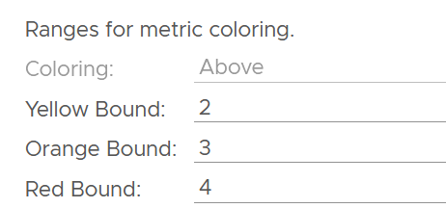

##### Gradient

Gradient can be handy in widget where *relative* comparison among many objects is important. In the following example, the widget is answering the question about the severity of imbalance among vSAN disk groups. What’s your conclusion if you solely rely on the color?

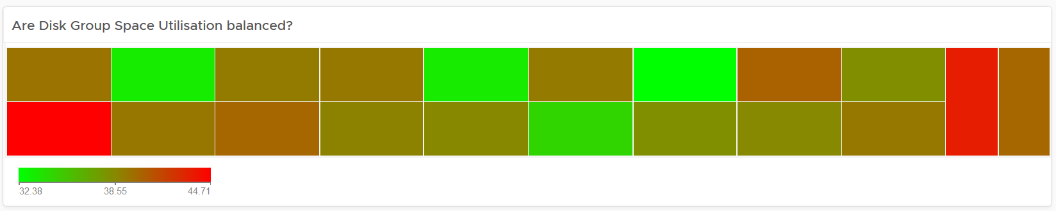

Oh no, they are not balanced. Let’s initiate rebalancing, which can potentially move Terabytes of data!

But wait! We only care about unbalanced when they are significant. Minor unbalance is expected. In fact, if they are perfectly identical, it would be strange.

The problem with the above widget is utilization should only turn red when it reaches 75%.

After fixing the 2 preceding problems, we have a meaningful heat map.

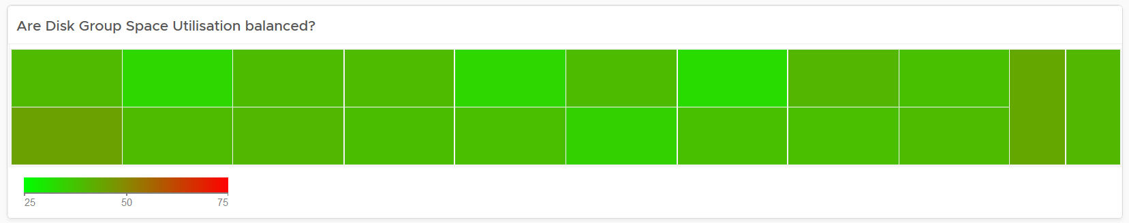

##### Example Implementation

In the Compliance dashboard below, color is used to quickly show the various level of compliance. If all you see is Green, there is no need to look at the numbers & texts!

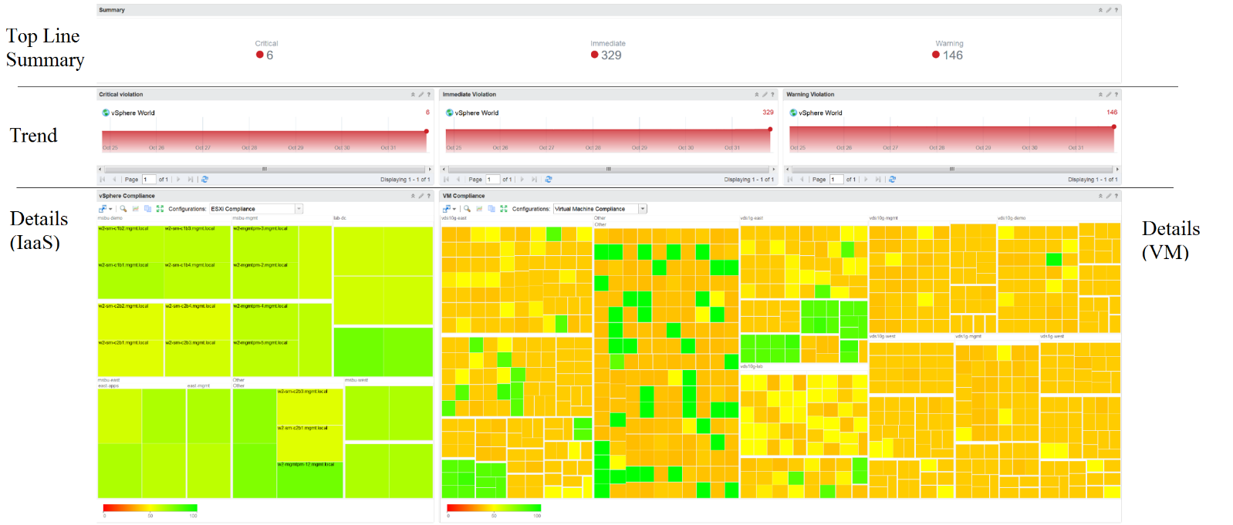

Last but not least, think of users who may not be able to distinguish all the colors. Provide alternative way for them so the functionality is not lost.

#### Past vs Present

Think of what timeline you need to show, as there are use case for both the present and the past. The past useful when the present data does not tell the full picture as it depends on the time you login and see it. If you login at 8 am in the morning to see what’s happening over night, then the value at 8:00 am is not answering your question.

The past is harder to visualize as it has >1 data points. Ideally, you show the data as a *line chart* so you can see the trend. Showing a single data such as the maximum or average can miss critical information such as “is it trending upwards or downwards” and “how long did the peak last?”. The problem with line chart is it takes up screen real estate.

If you need to show a lot of objects or metrics, then you need to summarize. As covered in Leading Indicator, you may need to show 2 numbers, especially if one of them is an average.

#### Summary 🡪 List 🡪 Detail

In most cases, you need to manage a large number of items (e.g. K8 pods, AWS EC2). This means you need a way to summarize the information, so you can work with a subset of the group. Within this subset, you need to know which particular item to work on.

The flow Summary 🡪 List 🡪 Detail is one common technique to achieve the above.

##### Summary

The summary shows the overall picture, not a subset. I find scoreboard is a good way to start, especially if the numbers are suitable for color coding.

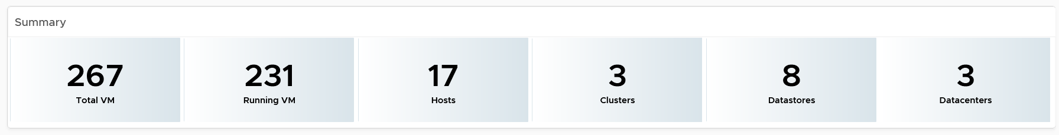

Based on the scoreboard, you may want to drill down to a subset of the environment. Take note that the drill down is based on the object owning the metric.

##### List

The View List widget is a table that lists all the objects. Use a filter if the number of items is large.

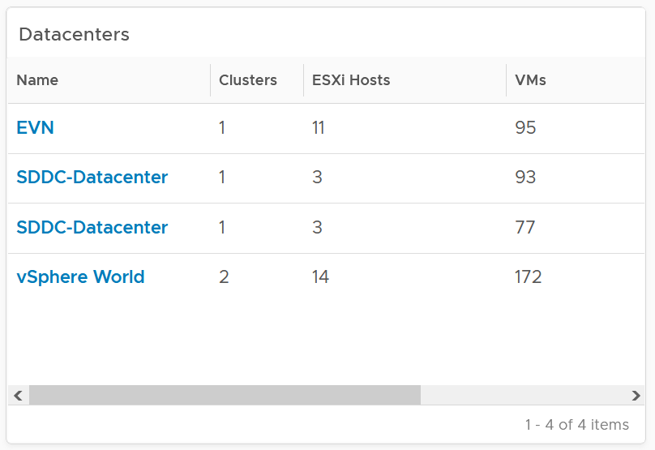

Having a filter also helps the dashboards scalability as showing tens of thousands of objects will impact the dashboard performance. It also improves usability as you can use progressive disclosure, and draw user attention to the big picture first.

##### Detail

At the detail level, you deal with a single item, such as a Horizon session. If the item has large numbers of metrics to show, you need a way to see them before plotting the trend chart. I found the Scoreboard the most suitable as it can be color coded and supports drills down to see the trend chart.

#### Interaction

Interaction allows you to build interaction within the widgets. So it is intra-dashboard, while navigation is inter-dashboard. Take advantage of the interaction & navigation, but keep them consistent so they are not too complex.

Logically design the dashboard first using any drawing tools so you can see the flow of information. I typically use PowerPoint, as shown in the following example.

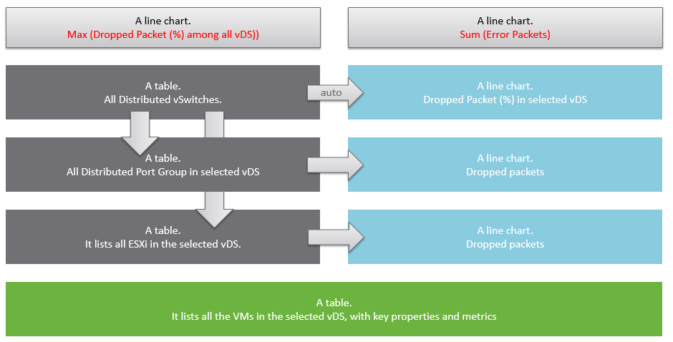

A rich interaction will increase the functionality of the dashboard. Aim for a symmetrical interaction as it’s easier for the dashboard consumer to understand. The following shows 4 heat maps driving 4 line charts in a 4x4 combination. It looks complicated in the screenshot below but feels natural when actually used.

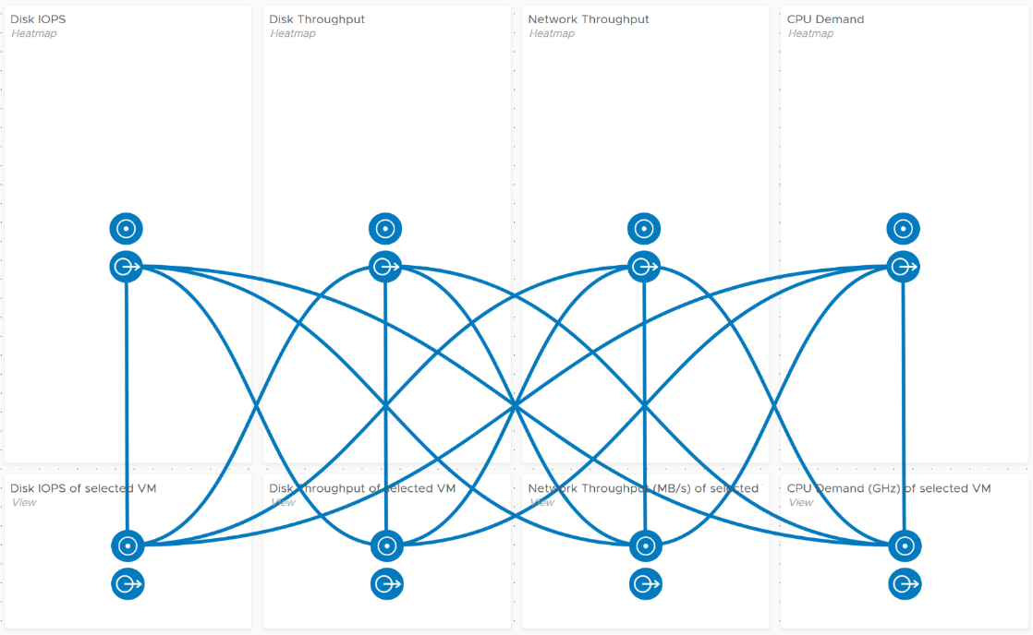

Use progressive disclosure to minimize information overload and ensure the webpage loads fast. On the other hand, so long your browser session remains, it remembers your last selection.

#### Large Environment

The number of dashboards you will have depends on the size of the environment and the number of people managing it. An environment with 100 VMs in just 5 hosts and 1 cluster will need far fewer dashboards than a global environment with 100,000 VMs spread over 5,000 ESXi, 500 clusters, 20 data centers, and 15 vCenter Servers.

In a large environment, where you have many physical data centers and even more vSphere clusters, you will likely need to display the information per physical data center. There are several reasons for this:

* Aggregating data at a global level, which spans many physical data centers, will hide too much information. Presenting data at such a level means you are getting an average of thousands of objects. If your environment is generally healthy (and it should be), the average will logically fall within a healthy range.
* In most cases, the performance in a given physical data center is independent from that of other data centers. For example, your Singapore data center typically does not impact the performance of your London data center. An exception to this case is when you link your data center at the network (stretched L2) and storage layers (synchronous replication). From experience in troubleshooting such a scenario, we recommend you keep the physical layer independent from each other. Assuming your data centers are independent, it makes more sense to display the chart on a per data center basis.
* VMs typically do not move from one physical data center to another (unless they are paired with storage replication and your network is stretched), so an imbalance among multiple data centers does not translate into a realistic rebalancing action.

#### Logical Design

I find it useful to design my dashboards in Microsoft PowerPoint before I implement them, especially if I need to design a suite of dashboards that work together with back-and-forth relationship. I find it helps me see the big picture, as I can see multiple dashboards on one screen and spot any inconsistency among them. It’s also faster to make changes.

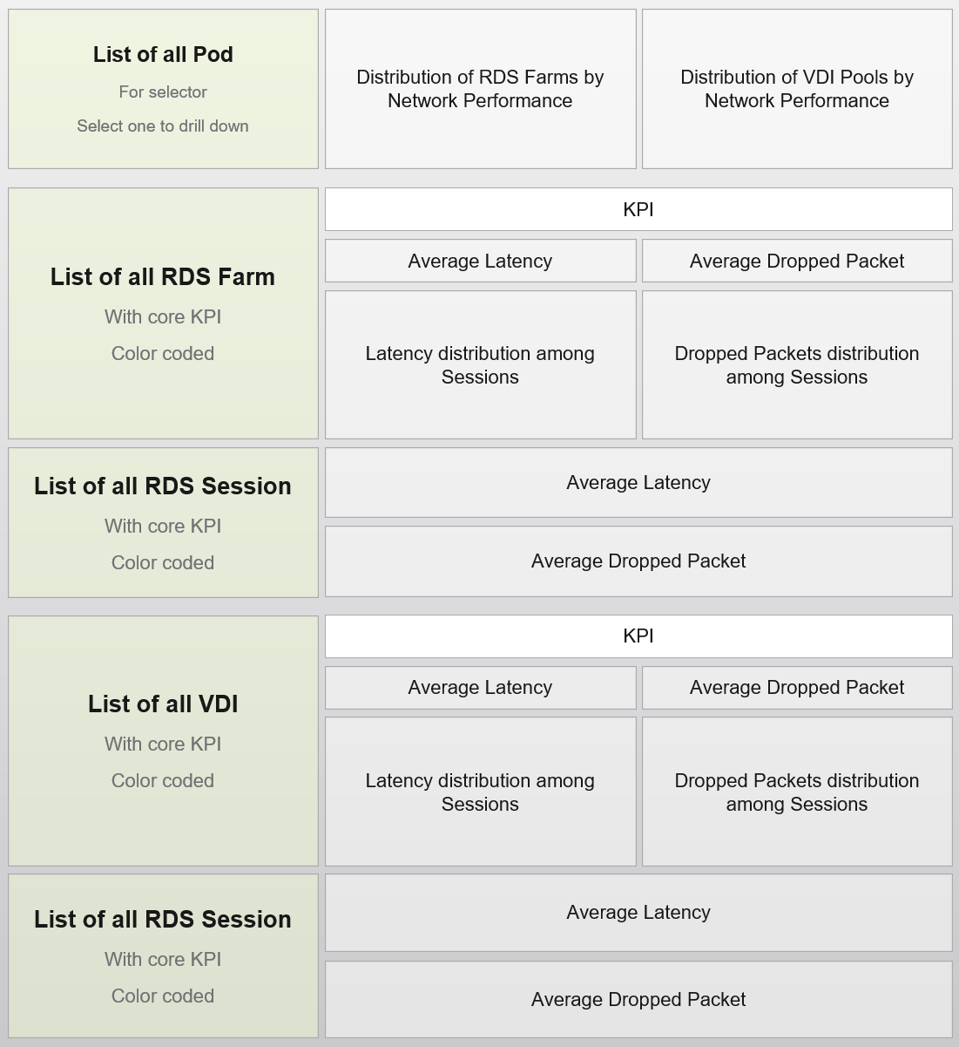

### Widgets

Keep the variants of widgets minimal, as it improves usability, especially when you have multiple dashboard or large dashboard. You notice that I mostly use the same set of widgets in all the dashboards I have created.

I have created many of them since 1.0, and you’d certainly observe that my design change over the years.

The following lists the widgets I use and what I use them for:

|  |  |
| --- | --- |
| Scoreboard | Headline or Banner or Summary. To get attention to the key point, I use large text, space out the content and apply a gradient to make it stand out. I may even use color.  Object Property. To show relevant configuration of an object, I use small font. I keep the visual plain and simple.  Many metrics per object. Being more compact than health chart, it’s handy if you have more metrics than screen real estate. |
| Bar Chart | Absolute distribution. The count value of each bucket is important. |
| Pie Chart | Relative distribution. Look for pattern, such as the number slice matches your design. |
| List | The threshold helps to quickly glance if the table is wide or deep.  I do not use Object List as the View List covers all the use case I needed. View has more features. |
| Heat Map | Use it if there are many objects, and you only need to see the present value. So it’s suitable for capacity, configuration, live NOC, and not suitable for performance (where you need to see trend over time and data older than 5 minutes) |
| Health Chart | Where the color is more important than the value. |
| Trend Chart | I use View Trend Chart as my main line chart. I rarely or do not use other forms of line chart  I rarely use the threshold for visual reason.  I use the Metric Chart only. As a result, I rarely use Metric Chart as most of the time multiple widgets meet the requirements too. |
| Top N | Look for top numbers that are within your expected range. |
| Alert List | Use to show relevant alert. For example, for performance, I only show performance alerts as the full alert is available in the object summary page. |
| Relationship | I use the Advance version of the widget as it’s visually more polished and meets all my requirements. I do not use the simpler version. |
| Text Display | I use it as a “Read Me” to either explain the whole dashboard or certain part of it. |

Practitioners like [[Dale Hassinger](https://code.vmware.com/user/2287325117)](https://www.linkedin.com/in/dale-hassinger-5712301b/) use a lot of Text Widget, because he creates custom web pages. It certainly makes a functioning and cool dashboard!

I rarely use the following

* Metric Picker. I’d use it if I’m unsure of what metrics to use
* Metric Chart. I’d use it if I need to have multiple line charts on a single widget. Using less widget helps simplify the overall dashboard look.
* Object List. I use View List instead. Functionally it’s a superset.
* Scoreboard Health. I normally use heat map.

#### Scoreboard

At the top of the dashboard, it’s useful to provide a banner or headline, giving the big picture or summary. For example, this is what I use for Inventory summary.



The above is not color coded as each number does not have a good or bad meaning. It’s visually less noisy also to have a neutral color.

The limitation is the number you see is the present number.

You can convey meaning by using color. There is also a line chart in the background of each box.

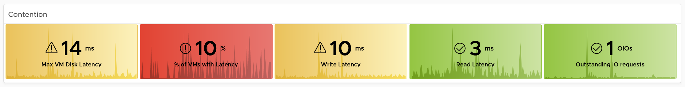

Take note that the background color is also based on this last value, not the average or peak of the monitoring period.

To see a trend chart, double click on it.

#### Table

A table is simply a list, where each row represents an object, and each column shows a *single* *value*. This enables us to list hundreds of rows, with ability to filter and sort. Each cell value can also be color coded.

View List also supports filter. The following screenshot shows Horizon hierarchy, so you can drill down into specific area in the world of Horizon.

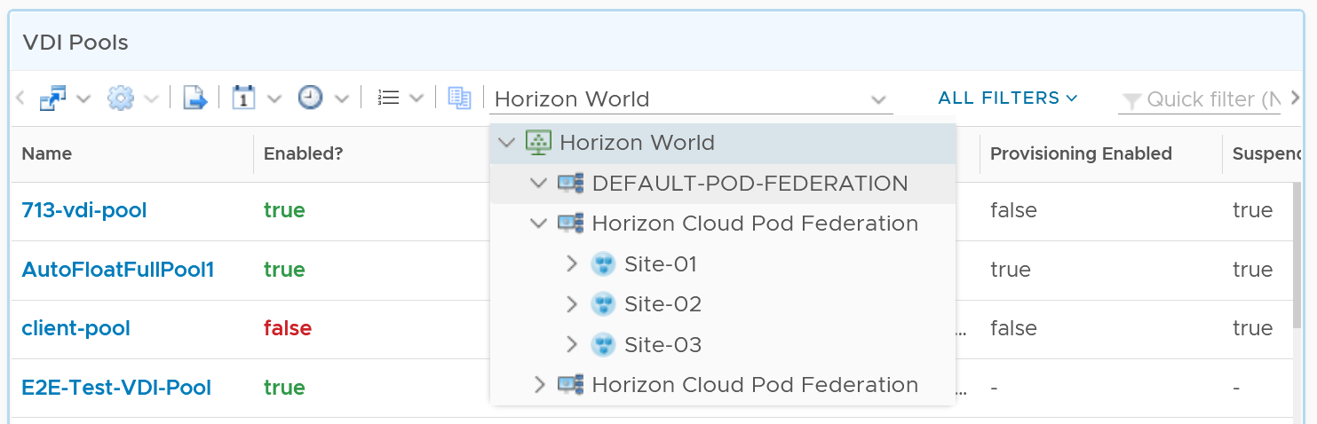

Table is good for details. However, as a *summary*, its main problem is how to give an insight over time as each cell can only hold *1 value*. How to give an insight into what happens in the past? For example, how to see the performance in the last 1 week? There are 2016 datapoints in the last 7 days, which one do you pick to represent?

There are a few possible options in vRealize Operations 8.2

|  |  |
| --- | --- |
| Current | This could the present value or the last known value.  It’s useful to show the present situation. However, this does not tell what happened 5 minutes ago. Its useful in capacity, compliance, configuration. It’s rather limited in performance. |
| Average | The average of the period. Average is a **Lagging Indicator**. By the time the average is bad, roughly 50% of the number is unlikely to be good. It is not suitable for proactive monitoring. |
| Worst | The worst of the period. This is suitable for *daily average*, as there are only 288 data points in 24 hours. If you find that results in outlier, then replace it with 99th percentile. As it only takes 1 peak to set this value, your chance of outlier is 7x higher in a week. It’s great for peak detection, but needs to be complemented with worst 5th percentile when looking at weekly or monthly period |
| Percentile | The worst 5th percentile number. This is a good midpoint between Average and Worst. For performance monitoring, the worst 5th percentile is a better summary than average. Use both the worst and the worst 5th percentile numbers together for better insight. If the numbers are far apart, that indicates the Worst number is likely an outlier. If the numbers are similar, you have a problem |

From the above, we should choose worst and worst 5th percentile.

The following table implements the above concept.

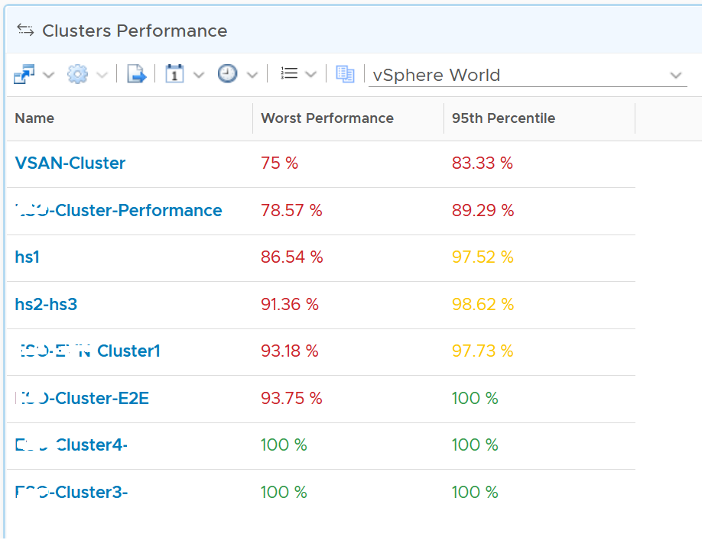

BTW, I vrealize that the threshold colouring works on string, so long it contains number. The following table shows that any version higher than 6.7 is green. The rest follows the logic shows next to this table.

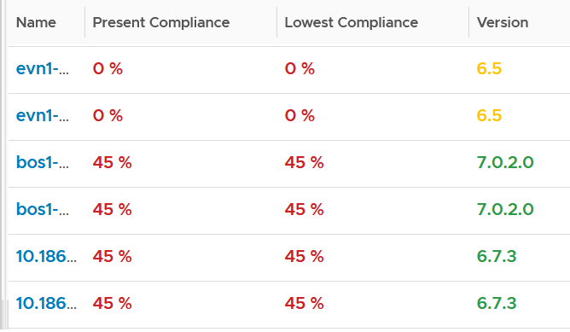 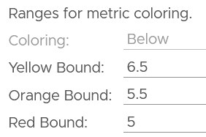

It also works on text.

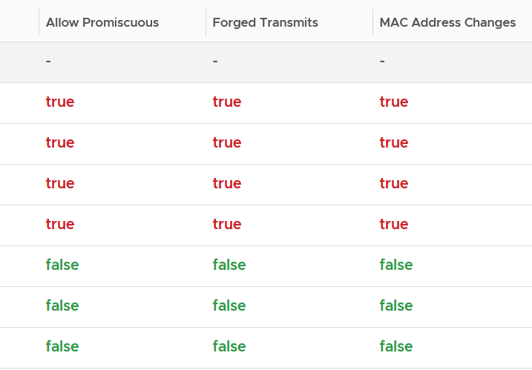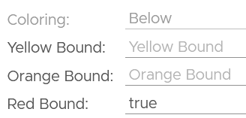

By the way, a little trick from [Robert Mesropyan](https://www.linkedin.com/in/robert-mesropyan/). There are times where you need to hide the object name. To do that, export the view, and change the value below to true.

<Property name="hideObjectNameColumn" value="true"/>

#### Bar Chart

There are 2 types of distribution charts:

* Absolute distribution: bar chart.   
  It’s called absolute as you care about the actual value of each bar.   
  You also call about the order of how they are sequenced. The brackets are linear and follow a step up.
* Relative distribution: pie chart and donut chart.   
  It’s called relative as the number you care is in percentage or ratio. You care about how the numbers are relative to one another. You also do not care about the order they are displayed (the brackets are not in order)

Distribution Charts can be used to give insight to a large dataset, as table will show too many rows. Take the following as an example. It shows vSphere shared datastores by their capacity remaining. They are categorised into 5 buckets, from the lowest capacity remaining to the highest. Each bucket is given a color to convey a meaning. Can you guess why >80% is given a grey color, as opposed to even more green?

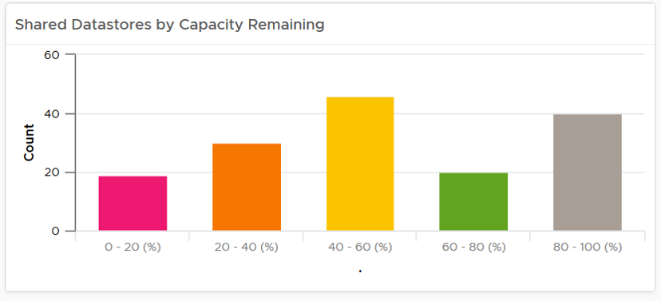

The reason has to do with the reason you bought the capacity in the first place. It’s to be consumed. If the capacity is not well used after months or even years, it’s a wastage. You overbought capacity.

#### Pie Chart

Relative is useful for peer comparison. You want to know what’s the largest slice.

There is another use case, which is showing the number of variants. It’s useful when you have an expectation of what is good or bad. See the following 2 widgets. They show the number of resource pools in a cluster. What does each pie chart tell you?

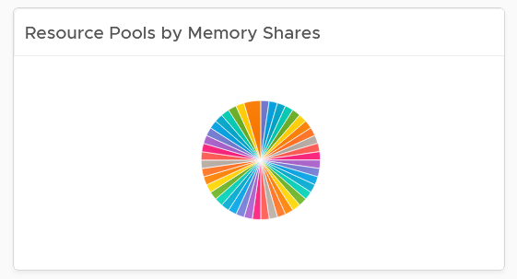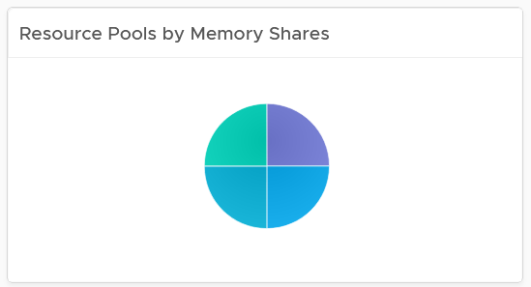

The first cluster has way too many resource pool. This alone will make performance management difficult.

The second cluster has 4 resource pools, but they are of equal share. What’s the point of having resource pool when they are the same share? It looks like a common mistake of using resource pool as folder.

#### Heat Map

Heat Map lets you vary both the color and the size of each object. Fixing the size can be powerful as it shows a different meaning. From the following example, you can see that there are more red than orange + yellow combined. It also makes the overall layout neater, which is always a nice bonus.

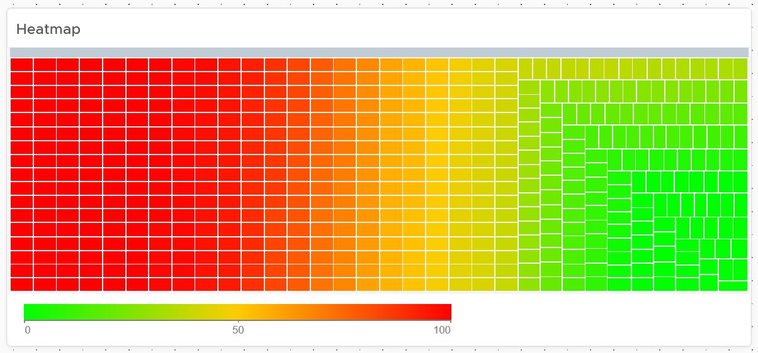

Yes, the sorting by color when the size is identical is a new feature of vRealize Operations 8.4. You are welcome.

#### Limitations

Distribution charts (pie chart, donut chart, bar chart) have the following limitations:

* “No data to display” does not imply that there is something wrong with vRealize Operations data collection process. It might signify that none of the objects meets the filtering criteria of the widget, hence there is really nothing to display.
* To see the content of a slice in a pie-chart or a bucket in a bar-chart, simply click on it. Note that the list cannot be exported.
* The pie-chart and bar-chart cannot drive other widgets. For example, you cannot select one of the pie-slices or buckets, and expect it to act as a filter to a list or a table. What you can do, is to select one of the object in the slice. I use this technique to allow drill down. You can also click on the object name, which will take you to the object summary page. The page provides key configuration information, alongside other summary information.
* You can apply a specific color in a pie chart or distribution chart for a specific numeric value, but not string value. For example, you can’t apply a red color to the value “Not Installed”.

The following widget can only show the present data

* Heat Map
* Scoreboard

Log Insight. Unable to specify color in the bar chart. The color is automatically chosen. It can result in “red” in the legend being shown in green.

### Multi-Dashboard

You typically need more than a few dashboards to achieve a complete operations management. That means dashboard to dashboard (D2D) navigation has to be part of your overall approach. You can drill down in the object hierarchy from one dashboard to another, or move laterally. Note that you cannot go up the parent hierarchy.

D2D capability also helps in avoiding a deep dashboard with many widgets that requires multiple pages of scrolling. They are harder to understand and may suffer from loading time.

Create a set of dashboards that act like one system. This is the principle we use when creating the out of the box dashboards.

Let’s say you’re designing for Capacity management and Performance management, as they often go together. Look at the systems being managed and the major tasks. For the case of vSphere and vSAN, we can group the components into Consumer and Provider. For each, we need to keep the lights on (Operate) and improve (Optimize). Operate covers the capacity and performance management, while Optimize covers reclamation, rightsizing and upgrade. Optimize also applies to infrastructure. You adjust cluster size, upgrade ESXi, migrate from traditional array to vSAN. All these increase efficiency, reduce cost, increase capacity, etc.

You may end up with something like this as your initial overall design.

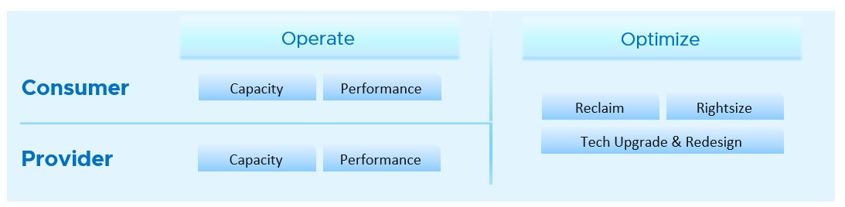

Once you have an overall approach, you can plan your dashboards. Because vSAN has many metrics and components that need further check than a simple datastore, I need to give it its own set of dashboards. There is a drill down from Storage to vSAN as not all datastores are vSAN. By keeping them separate, you can also add physical array dashboards, so your Storage dashboard can drill down to both vSAN and array.

Take time to draw your multi-dashboard solution. I found it helps clarifying my thought. The following example shows an attempt to connect all products, not just vSphere and vSAN. It will be interesting to connect VCF, VMware Clouds on AWS, NSX, Horizon, vSAN and vSphere together!

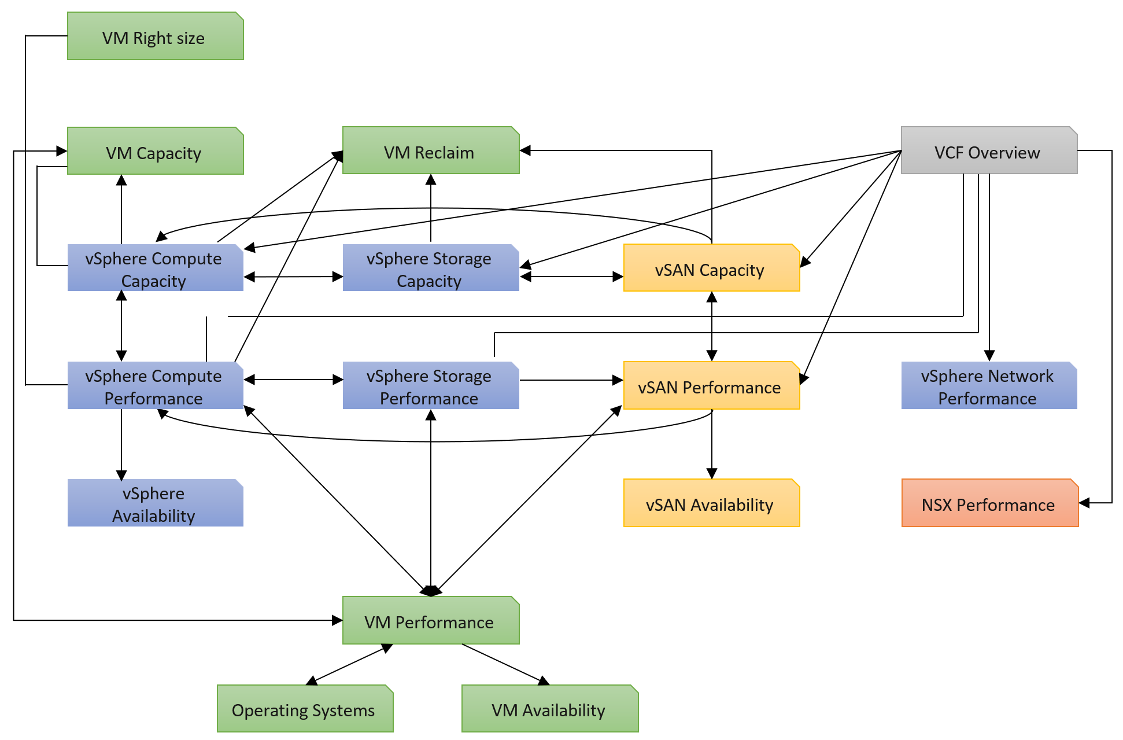

You can and should also organise by function, not just by VMware products. In the following example, I group them into 2 (Provider and Consumer). I added Optimization as the lines became too complex. By working at this logical level, it also helps me spot if there is inconsistency. Having gone multiple rounds, I ended up with something like this.

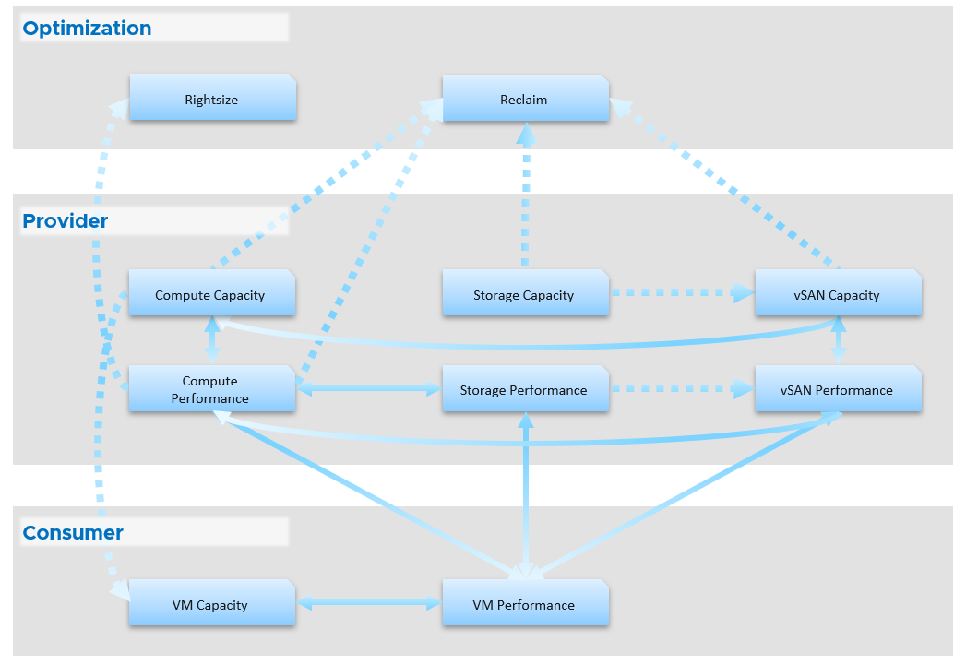

Notice something missing?

I do not have Network. I cover in Part 2 Chapter 5 Network Metric that the nature of network means its capacity model is largely a non issue. You focus more on performance as you do not tolerate network dropped in your data center. I plan to include Network Performance after I consider integrating NSX. If you have an idea on how to enhance the current dashboard, let’s collaborate!

From the above, why are ESXi and Resource Pool missing?

The reason is they are part of cluster. Instead of separate dashboard, I feel adding it into the cluster dashboard will increase usability. The drawback is it does not cover standalone ESXi.

Once you design the overall flow, you implement it on each dashboard. Here is an example, where this dashboard drills down into 6 other dashboards.

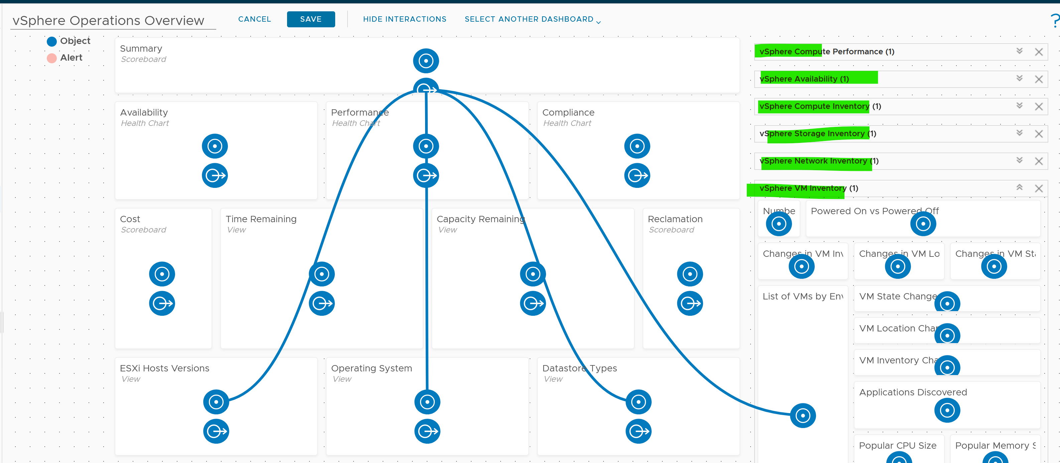

The screenshot shows the drilldown 1 dashboard at a time, hence I chose the last dashboard else the first 5 could not be captured 😊

### Dashboards in Real World

Ok, enough of theory 😊 How do you apply all those in real world operations management when there are many system to manage and many roles are involved?

You need to have some consistency, so users need not learn repeatedly. It will be confusing if each dashboard looks totally different from one another, considering they have the same objective. Apply some design standards for different pillars of operations. After all, performance is performance, whether it’s Kubernetes or Amazon Web Services is a matter of objects and metrics.

#### Performance Dashboards

They are designed for both day-to-day operations (proactive monitoring), and ad-hoc reactive troubleshooting. As a result, it’s an advanced dashboard, not designed for Level 1 Support. The target persona are VMware Administrators or Architects.

The dashboards share the same design principles, hence they are intentionally designed to be similar. It will be confusing if each dashboard looks totally different from one another, considering they have the same objective. To avoid repeating the explanation, read the VM Performance dashboard before reviewing others.

A good dashboard answers a set of questions. So jot down the questions. Be specific, including the metric and threshold. Examples of questions answered by the dashboards:

* Are the K8 pods performing well? If not, which pods are affected by what problems (CPU, Disk, RAM, Network)?
* Is the VM performance caused by IaaS not serving it, or by contention within the Guest OS?
* Are the VMs running high utilization? If yes, which VMs, how high, and what resource (CPU, RAM, Disk, Network)?
* Are they really high relative to the underlying IaaS capacity? That can cause strain in the shared infrastructure.

There are 2 types of performance troubleshooting

* Consumer. You focus on a single VM, container or application. Other consumers do not have a problem, or they are independent.
* Provider. You focus on the shared infrastructure as the problems impact many consumers. It could be hitting them at random, meaning different VMs/Applications got hit at different time.

At the infrastructure layer, we care whether it serves everyone well. Make sure that there is no contention for resource among all the VMs in the platform. Only when the infrastructure is clear from contention can we troubleshoot a particular VM. If the infrastructure is having a hard time serving majority of the VMs, there is no point troubleshooting a particular VM. Notice all the previous sentences are about the VM. Yes, the infrastructure metrics are *not* that relevant.

Monitoring is part of your [Standard Operating Procedure](https://en.wikipedia.org/wiki/Standard_operating_procedure) (SOP).

Design it to be used *daily*, hence the views are set to show data in the last 8 - 24 hours. This is to encourage daily usage, as what happens beyond 24 hours ago may be practically irrelevant from performance troubleshooting viewpoint.

Design so that you can see trend over time, and go back to any point in time. This is important as by the time you have the chance to look at the problem, 5 minutes have passed, or the problem is no longer happening.

Logically split the dashboard into 3 parts:

|  |  |
| --- | --- |
| Contention | This should be the first part, and most visible. |
| Utilization | Once you determine there is contention, use the **Utilization** portion to see if the contention is caused by *very* high utilization. When utilization exceeds 100%, performance can be negatively impacted especially when queue developed inside the Windows or Linux. By default, vRealize Operations has a 5-minute collection interval. For 5 minutes, there may be 300 seconds worth of data points. If a spike is experienced for a few seconds, it may not be visible if the remaining of the 300 seconds is low utilization. |
| Configuration | Only include the relevant settings that can impact performance |

This separation keeps each dashboard simple, while emphasizing the concept of contention as the primary counter for performance. You will notice in the dashboard design that contention is color coded, while utilization is not.

Each of the color is according to the best practice of that counter. You can change it by simply editing the widget. If you are unsure of what suitable numbers to set for your environment, profile the metrics. The Guest OS Performance Profiling dashboard provides an example of how to profile metrics. We also document the steps in Baseline Profiling section of the book.

Take note that health chart is not ideal when the metrics do not have a “ceiling”, meaning we don’t know what “high value” is, as 100% is hard to define. Example of such metrics are disk IOPS and CPU context switch. If your operations team has a standard that utilization should not exceed a certain threshold, you can add that threshold value into the line chart. The threshold line will help less technical teams as they can see how the real value compares with the threshold.

For large vSphere environment, group the VM by clusters of the same class of service (e.g. Gold), so you can see the profile for each environment. I find the Data Center as good boundary. In general, storage, network and compute do not extend beyond a vSphere Data Center object. Performance problems tend to be isolated in a single physical environment, unless the WAN link connecting the 2 data centers are causing the problem. A performance problem in country A typically does not cause performance problem in country B, especially if they share little in common.

#### Capacity Dashboards

You may notice that the performance dashboards and the capacity dashboards share similar layout. The reason is there is commonality in both pillars of operations.

There are various roles in your organisation that are interested in capacity information

|  |  |
| --- | --- |
| **Operations Team** | The team running the day to day, live operations. Not interested in long term, both the past and the future.  Their primary focus is the Consumer. So build your dashboards for them too. |
| **Capacity Team** | The team responsible for overall capacity life cycle, from planning to upgrade. Not interested in day to day, such as a host goes down or put into maintenance. Keen on long term and top down view, as they are planning future expansion and ageing hardware technological refresh.  Their primary focus is the Provider. |
| **Storage Team** | Specialist team. Collaboration become critical if the architecture is “thin on thin”.  The **Storage Capacity** dashboard is also designed for both VMware administrator and Storage administrator, with the goal of fostering closer collaboration between the 2 team. |

There are 2 types of capacity management

* Consumer. You focus on a single VM, container or application. You want to right size them and reclaim unused portion.
* Provider. You focus on the shared infrastructure as the problems impact many consumers.

Not all objects lend themselves for capacity management. Take the data center object for example. It can contain clusters of different purpose, with different performance characteristic. It might not make sense to combine the metrics into a single data center capacity (%) metric, if the member clusters are not interchangeable.

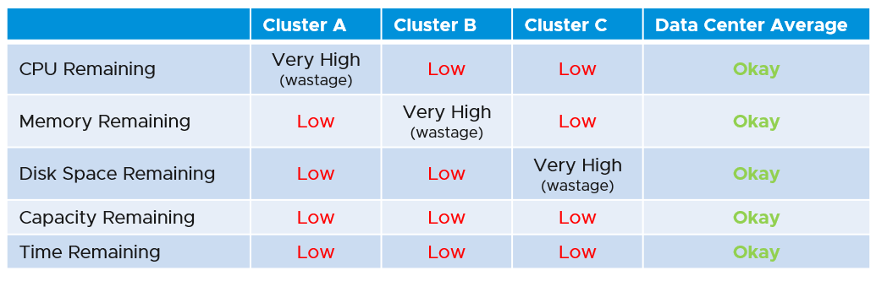

For cluster, special types of cluster alter the capacity model. One example is stretched cluster. It needs its own capacity model and visualization. You will need to have an object or custom group for each site, and then displays them side by side.

##### UI Design

The dashboard is designed “top down”. It has 2 sections: summary and detail.

* The summary section is typically placed at the top of the dashboard. It gives the big picture.
* The detail section is placed below the summary section. It lets you drill down into a specific object. For example, if it’s a VM capacity, you can get the detail capacity of a specific VM. This section is designed with quick context switch, as you may want to check the capacity of multiple objects in the course of capacity analysis. Take for example VM capacity analysis. The dashboard gives you all the VM-specific information and allows you to see the capacity summaries without changing screens. You can move from one VM to another and view the details without opening multiple windows
* UI wise, the dashboard uses progressive disclosure to minimize information overload and ensure the webpage loads fast. On the other hand, so long your browser session remains, it remembers your last selection.

The dashboard is design to complement the out of the box pages by visualizing information differently and giving more choice of customization. For examples, the reclamation size is grouped into buckets so you can focus on the largest reclamation opportunities first, and trend charts are provided so you can quickly see the growth over time, without changing context (e.g. open a new screen).

Wastage is shown by a new color. Dark grey indicates wastage as capacity is not used. In fact, there can be performance problem is the low utilization was caused by bottleneck somewhere else.

#### Configuration Dashboards

Configuration Management dashboards share the same design principles. They show the configuration that needs attention first, before showing overall configuration. The idea is to drive action towards optimizing configuration.

The overall layout is designed to balance ease of use, performance (loading time of the dashboard page) and completeness of configuration check. As a result, not all configuration settings are shown. Lack of screen real estate is another consideration behind the design.

In some dashboards, there are simply too many configuration items to check than the screen real estate provides. If you have a larger screen, add the additional check as you deem fit, or add legends to the pie-charts. For a start, see the list of settings that you may want to check here.

The number of buckets on the pie chart or bar chart are balanced between the available screen estate, ease of use and functionality. Modify the buckets to either reflect your current situation or your desired ideal state.

In a large environment, create a filter for this dashboard. Group by the class of services such as, Gold, silver, and bronze. Default the selection to Gold. In this way, your monitoring is not cluttered with less critical workloads.

##### Empty or Exist

In configuration check, we can encounter a need to check for exception. This is where the Exist or Not Exist check and Empty and Not Empty check can come in handy.

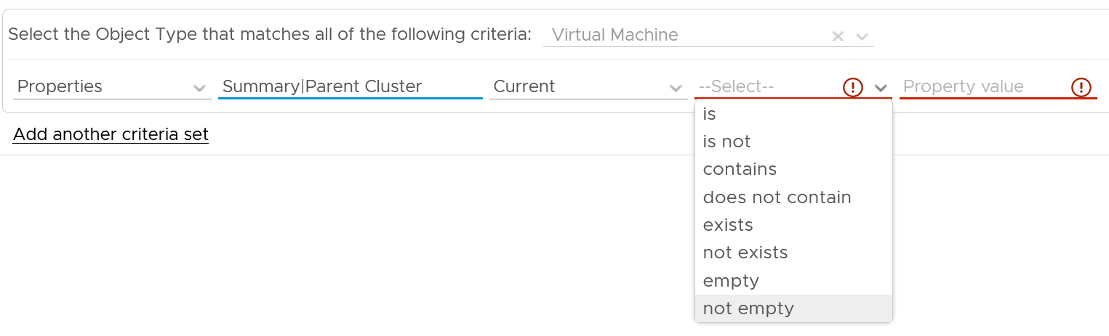

Some ideas are:

* Check for standalone ESXi. It will have no parent cluster
* Check for missing Telegraf agent in critical VM

Anything else? Let’s collaborate to enhance the configuration dashboards!

## Performance

**Part 3 Chapter 3**

The performance dashboards sport KPIs to display the performance of workloads at the consumer layer and the aggregate performance of workloads at the provider layer.

The dashboards cover vSphere and vSAN. In future, I plan to integrate NSX, HCX, and other components so let’s collaborate if you have the domain knowledge.

### Performance Profiling

Why does this chapter begin with this dashboard? Why not start with VM performance dashboard?

Because you want to be proactive. Optimize your environment then it becomes easier to manage.

#### VM Profiling

How to profile if you have thousands of VMs?

One way is to use a distribution chart. Design the buckets to represent the ranges from good to bad. Have 3 buckets for the good, the average and the bad. You then add 1 bucket for the outlier. This gives you a total of 10 buckets.

The following table shows the recommended buckets for CPU and memory.

|  |  |  |  |
| --- | --- | --- | --- |
| Good | Medium | Bad | Outlier |
| 0 – 1%  1 – 2%  2 – 3% | 3 – 4%  4 – 5%  5 – 6% | 6 – 8%  8 – 10%  10 – 12% | 12 – 100% |

Depending on the result, adjust the bucket accordingly. For example, if your environment performance is worse than the above, yet nobody complains, you can adjust the above buckets to something like this:

|  |  |  |  |
| --- | --- | --- | --- |
| Good | Medium | Bad | Outlier |
| 0 – 2%  2 – 4%  4 – 6% | 6 – 8%  8 – 10%  10 – 12% | 12 – 14%  14 – 16%  16 – 18% | 18 – 100% |

The above range give you better visibility into the 10 – 18% range.

The dashboard has 3 bar charts as we need to do profiling for

* CPU Ready
* Memory contention
* Disk latency.

I’d show CPU and Disk as the 3 follow the same technique.

##### CPU Profiling

The following screenshot show a sample profiling. What information do you get out of this distribution chart?

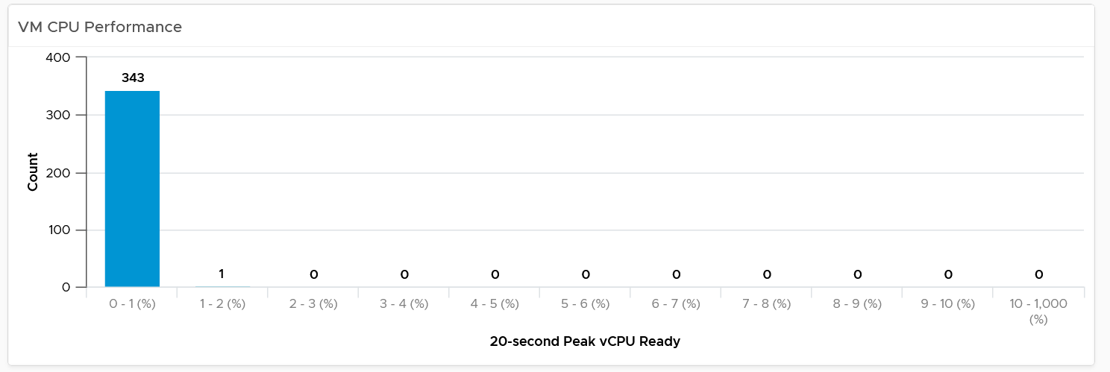

The above is the ideal environment. All the 343 VMs experienced very low CPU ready time. It is possible that either utilization is too low or no overcommit. This means the relative cost is high.

How about this one? What’s your conclusion?

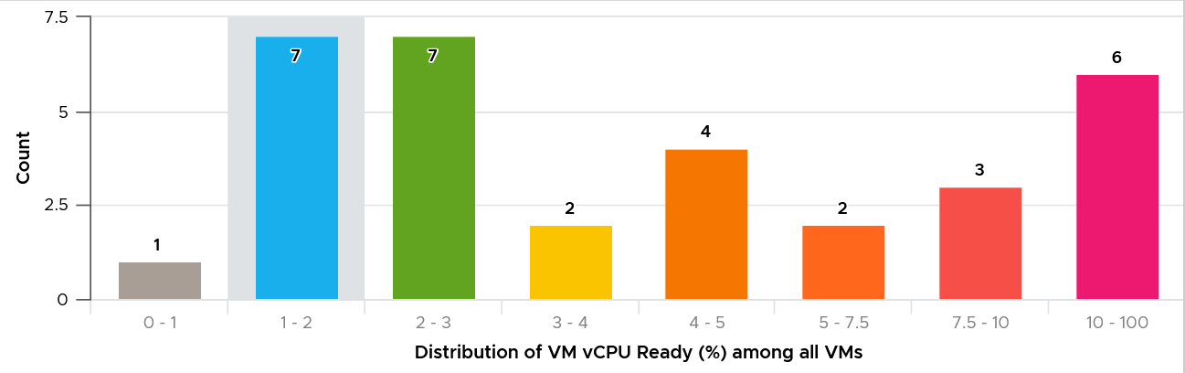

This environment has worse performance. The distribution is evenly spread, meaning many VMs experienced CPU Ready above 5%.

If you have many VM above 10%, you can add more bars or change the range to increment by 2% instead. This gives you better visibility beyond this range.

##### Disk Profiling

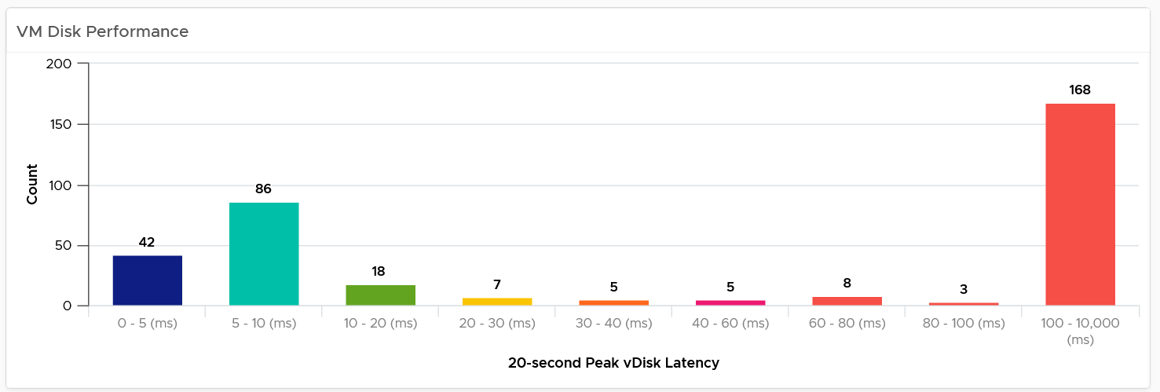

For disk latency, I recommend the following bucket size as default.

* 0 – 5 ms and 5 – 10 ms to gain insight into the low latency
* 10 – 20, 20 – 30, and 30 – 40 ms to gain insight into the medium latency
* 60 – 80 and 80 – 100 to gain insight into the high latency
* > 100 ms to capture the rest.

If you think your customers can tolerate worse latency, use a broader bucket size until there is minimal VM in the last bucket. In the following, I took the same chart above and applied a higher latency bucket.

What do you think of the result?

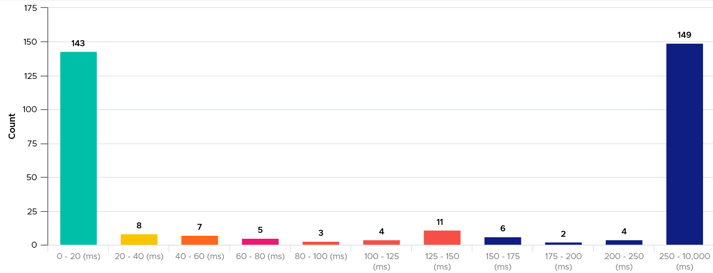

It’s interesting to see the polarizing result! In this case, the lab has 2 different classes of storage. One is SSD the other is magnetic.

BTWm the last bar in the preceding chart should be smaller, as you do not expect many VMs are experiencing > 250 ms disk latency.

##### Extra Analysis

If you have many VMs, export the preceding table to further analyse in a spreadsheet. The following proves in my environment that CPU Ready tend to be short-lived.

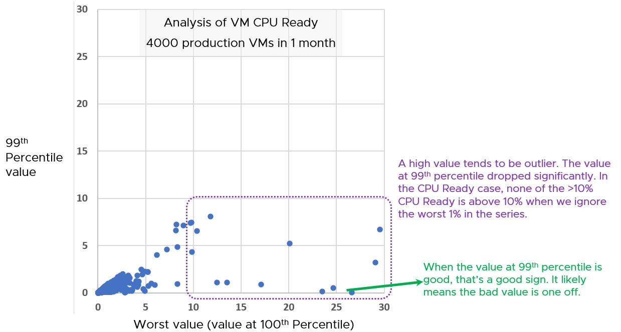

How do I know that?

The value at 99th percentile is much lower.

Working with large data sets also helps in catching rare bugs. A bug may occur once in a million only, but if you profile 50 millions you can confirm the bug exists as there are enough of them to rule out cosmic rays[24].

##### Summary

What’s missing from the above 3 charts?

You’re right. It does not give the *actual number* of the performance. You have to manually look at it and estimate where the performance is. In this case, since every number is the worst for that VM, you should take the average of this number.

Also, it does not tell whether the worst number is really an outlier or not.

So how do you get the number to represent millions of numbers?

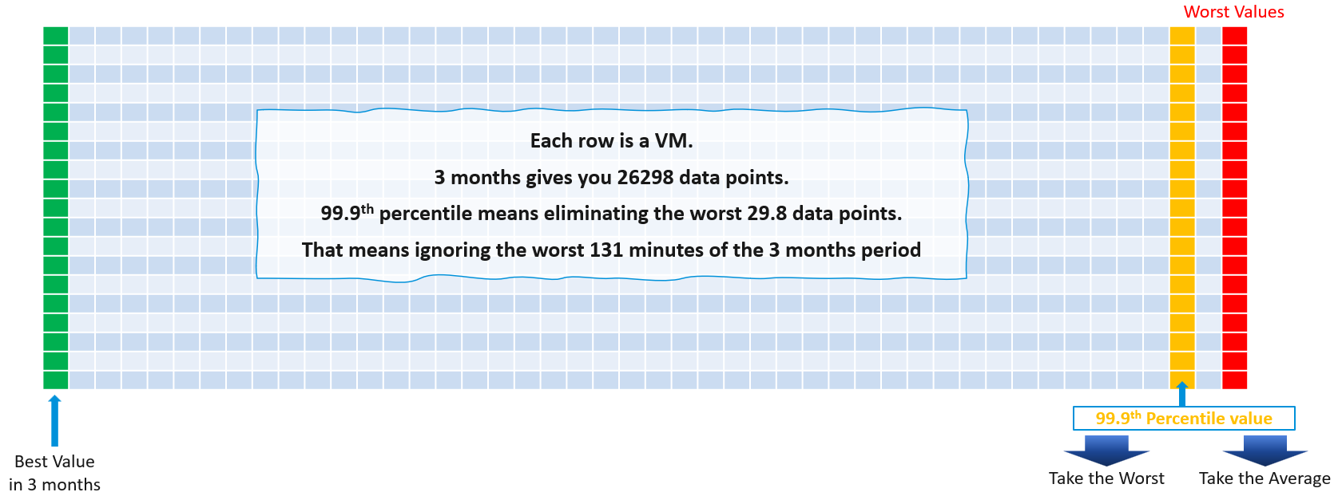

You will need a table for this, showing the 99.9th percentile data.

You sort the list in descending order, so the biggest value appears first. Investigate all those values that are really high, as they are not normal.

Add a summary for the all the VMs by averaging the values and taking the worst. This becomes your **Before Optimization** numbers.

The following screenshot provides an example. What insight do you gain from it?

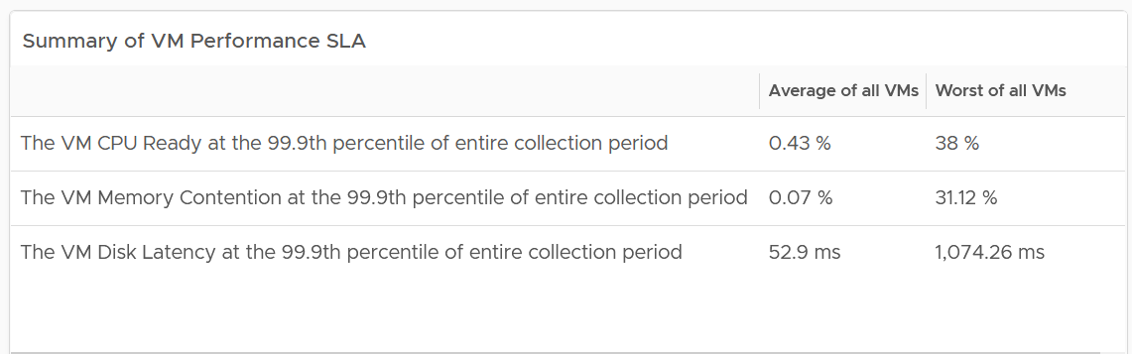

The gap between average and worst is huge!

That means majority of the VMs are being served well, but there is a small percentage that are not getting served. You want to investigate which segment of your IaaS is not performing.

Once you have the numbers, take a screenshot and keep it. This serves as proof. The dashboard is unable to keep versions. The reason is the widgets do not show trend over time. As the improvement you’re implementing takes months, you can’t show the progress over time

##### Validation

You should also compare the numbers with the default threshold used in vRealize Operations, as shown in the following table:

|  |  |  |  |  |
| --- | --- | --- | --- | --- |
| Metric | Green Range | Yellow Range | Orange Range | Red Range |
| CPU Ready | 0 – 2% | 2 – 4% | 4 – 8% | 8 – 16% |
| Memory Contention | 0 – 0.5% | 0.5 – 1% | 1 – 2% | 2 – 4% |
| Disk Latency | 0 – 10 ms | 10 – 20 ms | 20 – 40 ms | 40 – 80 ms |

Generally speaking, for environment where performance is number 1, you want the value to be in the green to yellow range for the Worst and green range for 99th percentile. For environment where cost is number 1, you likely have to lower expectation of your customers.

##### Before vs After

What if you need to show the improvement over time?

What metrics should we use?

We use the same metrics, which are CPU Ready, Memory Contention, Disk Latency. But as your environment changes over time, you need to take the sum of VM Disk IOPS, Disk Throughput, and CPU Usage (GHz).

Wait, where is the memory utilization? Why do we not need it in the comparison?

Memory behaves more like disk space. It’s about capacity not performance.

#### Infrastructure Viewpoint

The preceding technique is all you need to determine the Before Optimization numbers. What’s the limitation of this approach?

It does not tell which clusters and datastore do not deliver the above numbers. In a large environment with many clusters and datastores, the above number is the average number. You may have a few clusters or datastore that fail to deliver the expected performance.

For each cluster, you want to measure both the depth and the breadth. That means tracking 4 metrics

* the worst CPU Ready experienced by any VM
* percentage of VMs experiencing CPU Ready
* the worst Memory Contention experienced by any VM
* percentage of VMs experiencing Memory Contention

For datastore, you take VM disk latency, not outstanding IO.

Having the depth and breadth give you better insight.

Just like the case in VM, take 3 months data.

A cluster with 500 VM will have a metric that represent 500 VM in any given 5-minute interval. Since there are 26298 instances of 5 minutes in 3 months, that means you analyze 26298 x 500 = 13,149,000 data point in that one cluster. Taking the worst among 13+ millions will likely return you with an outlier.

This is why we use the average of worsts. So it’s the average of all data points, where each datapoint is the Worst VM CPU performance data point.

To implement the above comparison for compute, create 1 view that lists the metrics. Color code the table so you can focus on the red ones.

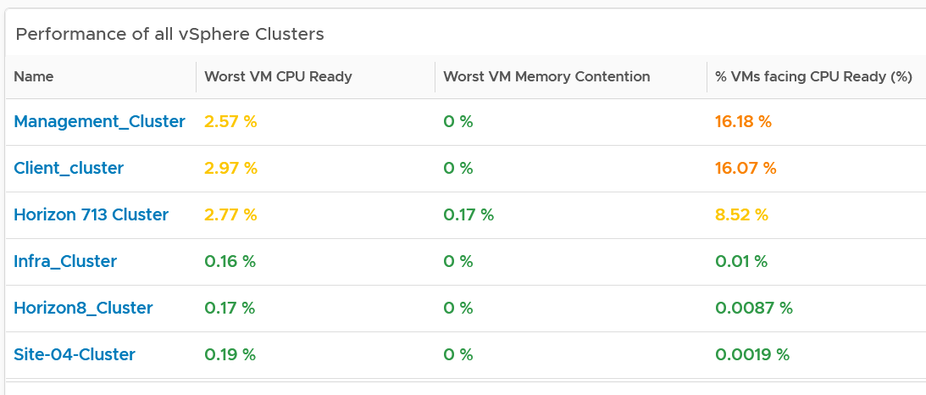

Create a similar table for datastores. I added the percentage of VM facing disk latency just to get some insight into how widespread the problem is.

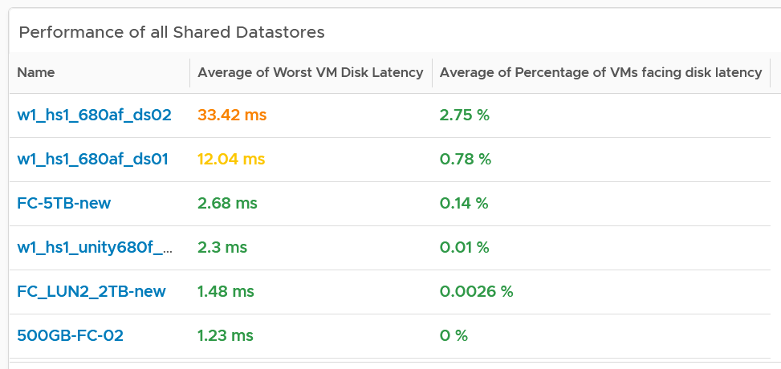

The 2 summary numbers become your **Before Optimization** numbers. Once you optimize the environment, revisit this table and take the new value.

As in the case with VM, compare this with the default threshold used in vRealize Operations, as shown previously.

The above covers “how bad the problem is”. We need to cover “how widespread the problem is”. How many percent of the VM population is experiencing the problem? The range used is

* Green: 0 – 2.5% of the population
* Yellow: 2.5 – 5%
* Orange: 5 – 10%
* Red: more than 10%

##### Analysis

Use both the breadth and depth as input to your decision.

|  |  |  |
| --- | --- | --- |
| Depth | Breadth | Analysis Conclusion |
| Good | Good | Safe to add more load, assuming the utilization is low and overcommit is below your plan |
| Good | Bad | Performance is good but do not add more load as many VMs are experiencing contention already. |
| Bad | Good | Since it’s not widespread, check for common configurations among the impacted VM |
| Bad | Bad | If there has been no complaint for months and business are not impacted, it is possible that you do not have to do anything. Otherwise, proactively plan for improvement as future workload may be more sensitive to latency. IT should be ahead of business. |

Using the above as example, you can see that all the clusters can serve their VMs well, as the highest values are 3.6%. If this is what you want to maintain, then use 3.5% as the threshold. The first cluster is already full. It can’t handle anymore VM as it’s already exceeding 3.5%. The second cluster is near full.

For memory, all the clusters are doing well. If this is what you want to maintain, then set 0.1% as the threshold.

If you want to be more aggressive, then you set 5% for CPU Ready and 1% for Memory Contention.

For better analysis, create a health chart or line chart showing the breadth and depth metric for a selected cluster. This lets you see trend over time. Perhaps the time of performance problem happens during Sunday night where there is hardly any users and you’re doing full back up. In that case, you can adjust your decision.

The following is an example where both CPU and memory are well within the green range.

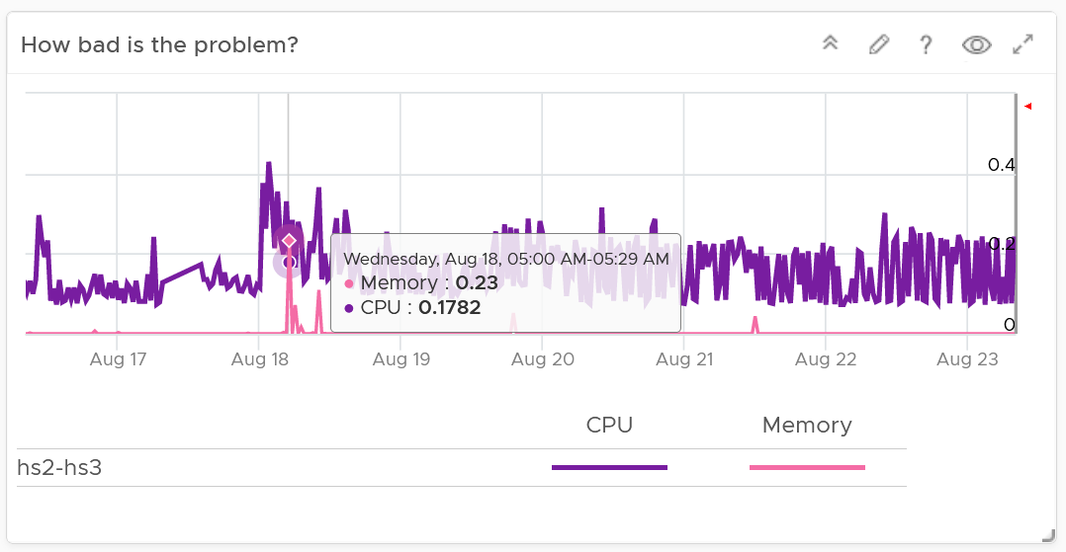

Next, look at the breadth dimension.

In the following example, what problem do you see?

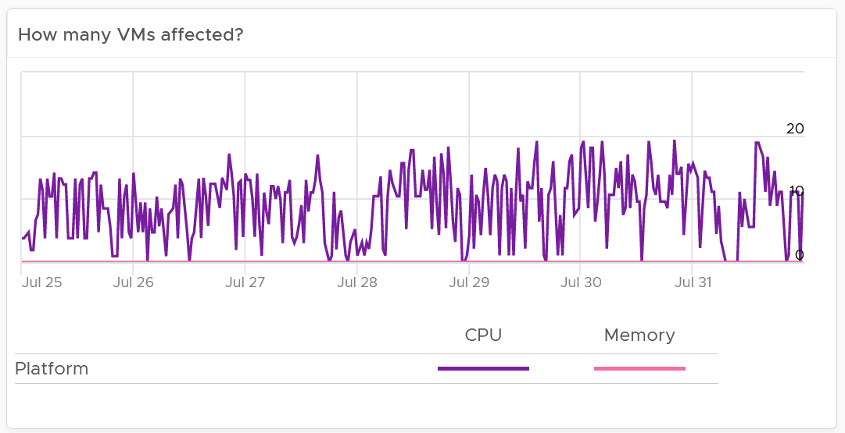

A high percentage of the VM population is experiencing CPU contention. On the other hand, memory is perfect. If it turns out that there is no issue with both the cluster and VM settings, you should consider buying more CPU as your workload turns out to be CPU heavy.

#### Network Profiling

Network is different due to its nature as an interconnect. We cover this in-depth in Part 2 Chapter 5 Network Metrics. As a result, we need to investigate separately. Instead of investigating per VM, we investigate per network. This means per distributed port group.

We should investigate both the VMkernel network and VM network, as both can impact VM performance.

What metric should we choose?

There is no network latency counter. The proxy for it (network dropped packet) tends to have false positive, which makes profiling inaccurate. Luckily the false positive rarely happens. The false positive can be overcome by using 99th percentile metric, as it removes the outlier. The false positive happens more frequently on received side than transmit side. When profiling, we focus on the transmit side.

As there is fewer network than VM, it’s more effective that we use table instead of distribution chart. List all the networks, and show the received dropped packets at 99th percentile. Sort the list in descending order so the problematic network appears at the top.

### VM Performance

The first thing to check when a VM has a performance problem is if other VMs have the same problem. If the problem is widespread the root cause is not with the VM. Hence it’s important to see the big picture, before diving into a specific VM.

#### Overall Analysis

The dashboard uses a list of Data Center as a selector/filter[25]. Select one of the data centers from the table. The following bar charts will be automatically shown.

What does the following 3 bar charts tell you about the environment? They work in tandem to reveal if there is any performance problem, and if yes, what problems and how bad.

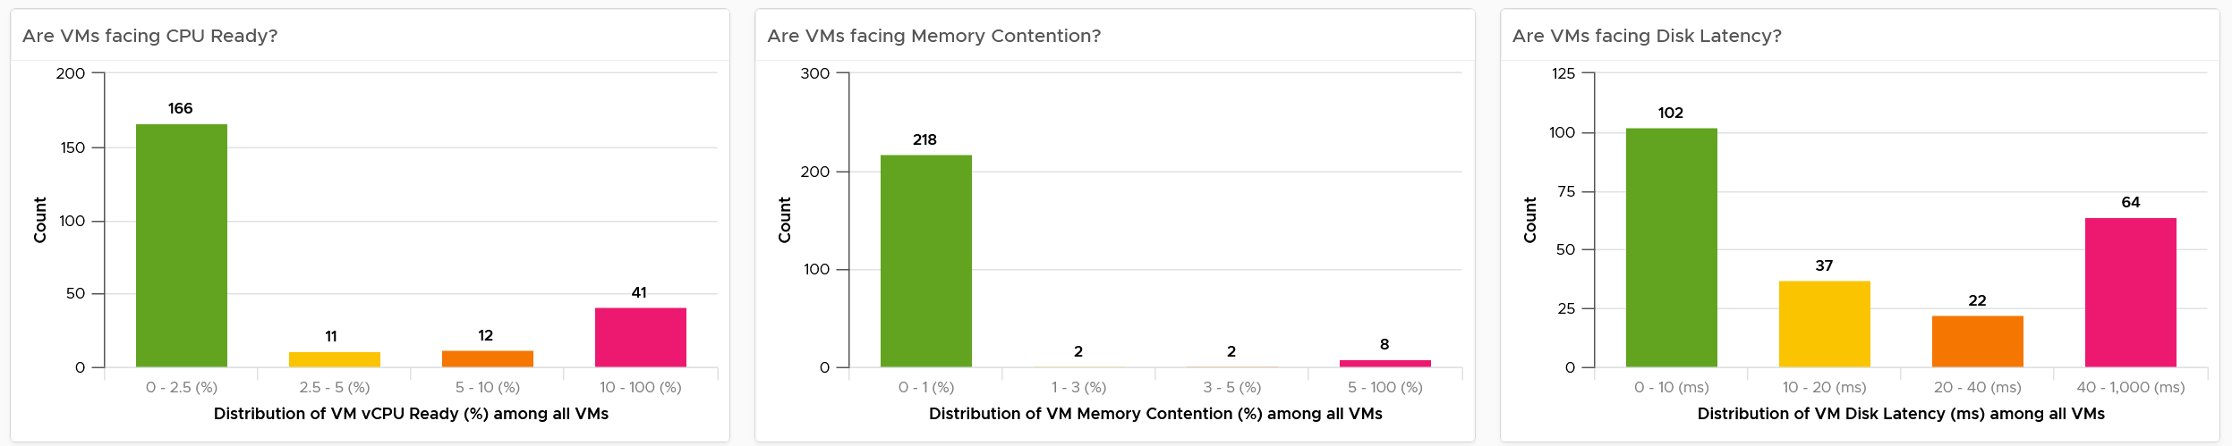

Each chart analyzes how the VMs are served by the cluster. For each VM, it picks the *worst* metric in the last 24 hours. By default, vRealize Operations collects every 5 minutes, so this is the highest value among 288 datapoints. Once it has the value from each VM, the bar charts put each VM in the respective performance buckets. The threshold in the buckets consider best practice, hence they are color coded.

You can change the time period to the period of your interest. The *maximum* number will be reflected accordingly.

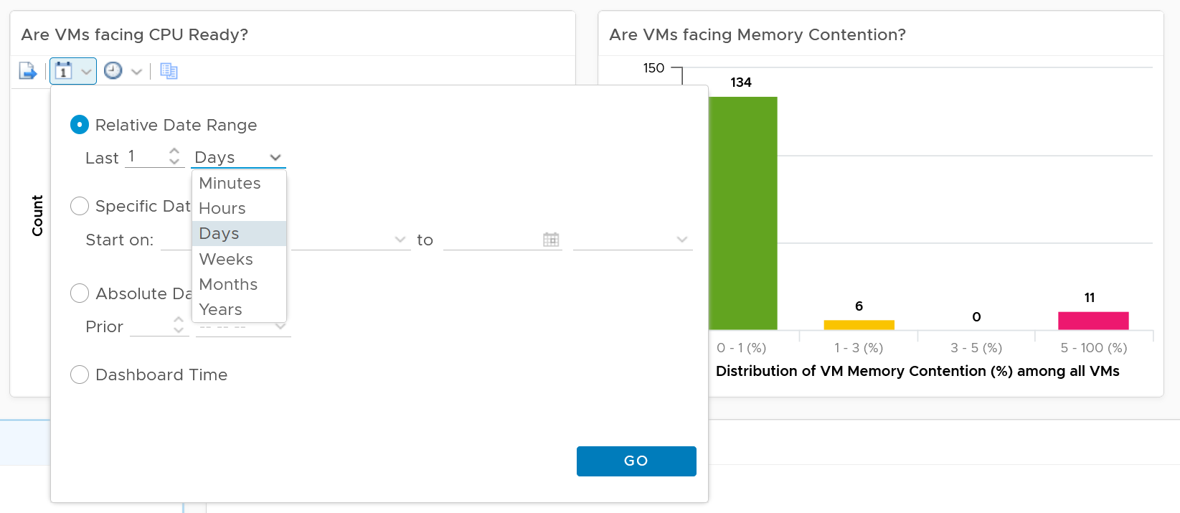

The value is actually the worst 20-second within the 5-minute. Yes, it’s using the peak metrics, covered here in the Troubleshooting Metrics section. Why do I choose the 20-second average instead of the 5-minute average, considering your SLA should be based on 5-minute average?

It’s to give you a heads up. Leading indicators. Otherwise, you get something like this:

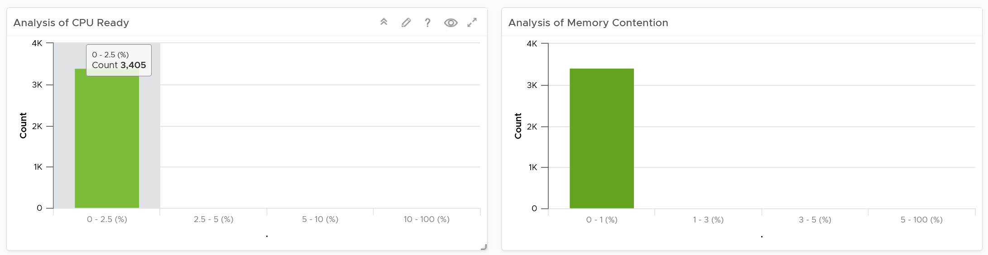

Yes, the above shows 3405 VM. And not a single one of them has CPU Ready > 2.5% and memory contention > 1% in the last 24 hours. It’s not so useful in giving you early warning.

For your mission-critical environment, you should expect that all the VMs are being served well by the IaaS. So expect to see green on both distribution chart. If they are, there is no need to analyze further.

For development, you may tolerate a small amount of contention in both CPU and Memory as you need to balance cost.

If it makes more sense for you, change the filter from data center to cluster. Once you are listing cluster, you can then add the cluster performance (%) metric and sort them in an ascending order. This way the cluster that needs immediate attention is on top.

You can click on any of the bar to see the list of VMs under that performance bucket. From there, you can select a VM and have its KPI automatically shown on the lower section of the dashboard.

#### Multi-VM Analysis

When you select a data center from the table, the table listing all the VMs in the data center is automatically shown. A portion of the table is shown below.

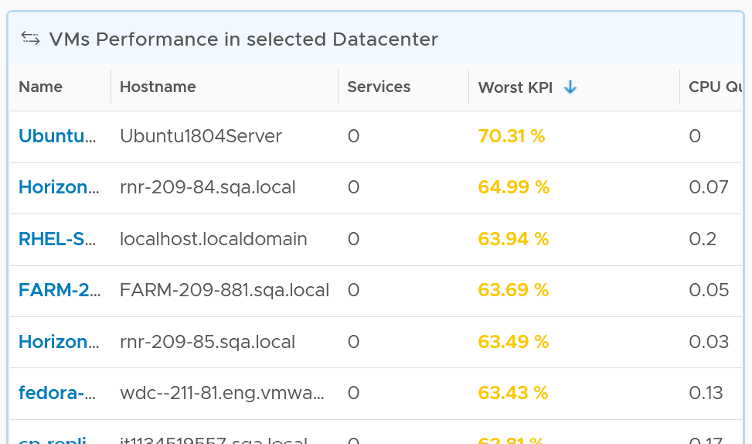

The table shows the hostname as known by Windows or Linux. This is the name that application team or VM owner know, as they may not be familiar with the VM name.

The table is sorted by KPI column, directing your attention to the VMs that are not performing. The column is based on the super metric VM KPI (%), which we covered in Part 2.

BTW, if the KPI is blank, that means at least one of the metrics is blank. Use the dashboard to check which metrics are blank. If not all the Guest OS metric appear, then the VMware Tools is likely outdated.

The rest of the columns show contention metrics. Notice there is no utilization metrics at all. You should know why by now 😊

Because the goal is proactive monitoring, as opposed to reactive troubleshooting, the metrics show the *worst* value instead of the average of the monitoring period. You can see from the following screenshot that the Transformation is set to Maximum, instead of Current.

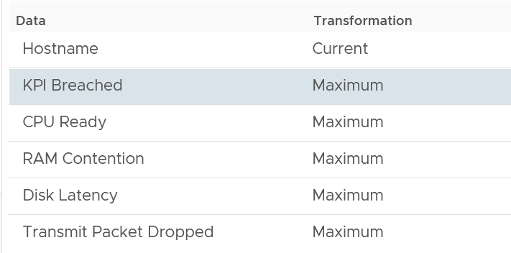

For example, the CPU Ready counter shows the highest CPU ready within the period you specify. The default period is 24 hours, as the dashboard is designed to be part of the daily SOP. The reason 1 week is not chosen is the performance > 24 hours are likely to be less relevant.

Unlike the bar chart, this shows average of 5 minutes. The reason is we’re showing VM, and the VM SLA should be based on 5-minute average.

If you have screen real estate, group the VMs by cluster. In this way, you can quickly see if the problem is in particular cluster. Avoid grouping by ESXi as VMs may relocate.

#### Per-VM Analysis

Choose a VM from the table.

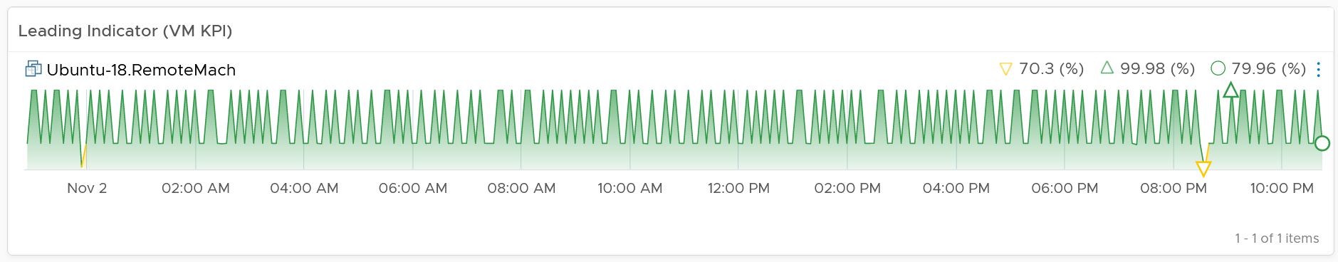

All the CPU, Memory, Disk and Network performance charts are automatically shown, each widget showing the KPIs of that VM.

##### CPU Metrics

The CPU panel sports the following 8 metrics. Review them. Do you know why we pick these 8, and show them in this specific order?

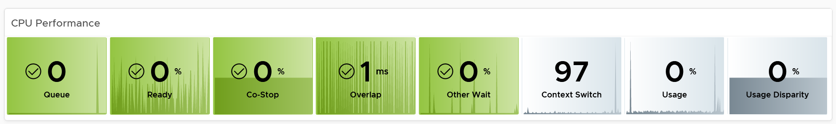

The metrics are shown in the order of importance or urgency. The most important one for Guest OS is CPU Run Queue, while the most important for VM is CPU Ready.

Peak CPU Run Queue. Ideally we divide by the number of vCPU. Create a super metric for that. Good practice 😉

Peak vCPU Ready (%) tracks if any of the virtual CPU is experiencing high CPU Ready. It takes the highest among the vCPU. This can be useful in large VMs with many vCPU.

Why are the last 3 metrics are not color coded?

* CPU Context Switch actually impacts performance. I’m just unsure what to put as it varies among customers. For your environment, set it as appropriate after profiling.
* The CPU Usage (%) is shown ***grey*** as it actually has *negative* corelation with performance. Grey is chosen as it also conveys wastage. Resources that are hardly utilized may not mean performance is at peak. In fact, it could be the opposite. If a VM just need 1+ vCPU, configuring it with 2 CPU will result in better performance than configuring it with 20 CPU.
* The CPU Usage Disparity (%) metric. Color code it based on your expectation

The following screenshot shows the threshold used:

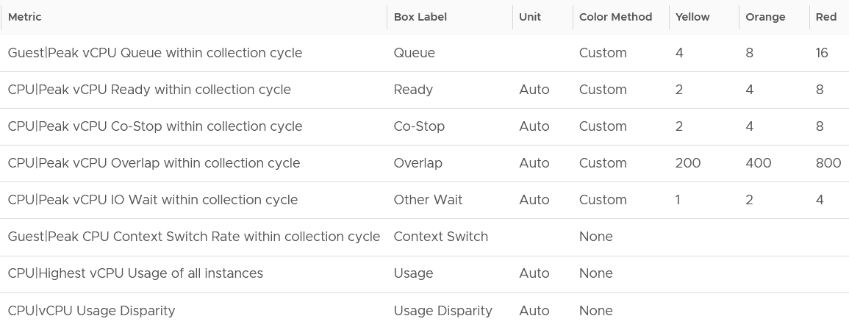

Yes, they are based on the 20-second peak. Read more behind the 20-second metrics here.

The guideline for CPU Run Queue is 1 🡪 2 🡪 4 per vCPU. As the counter is not per vCPU, I take an approximate that the average VM is 4 vCPU. Create a super metric if you need it per vCPU.

CPU Overlap is based in ms. Ideally we have them per vCPU and in %. I’d use 0.5% 🡪 1% and 2% as the threshold.

The chart also displays the present value, so you know if the problem is still happening or not.

Why none of the metrics have decimal point?

I round all the counter because the decimal is not significant and clutters the dashboard with no real value. There is really no difference between 0.1% and 0.9% in all these metrics.

Why CPU Latency or CPU Contention and CPU System metrics are not shown? Refer to the metric chapter for the reason.

Why is CPU Swap Wait not shown? Its value is a subset of Memory Contention.

##### Memory Metrics

Now that you know how the widget is designed, let’s move content from CPU to Memory. Review the following screenshot.

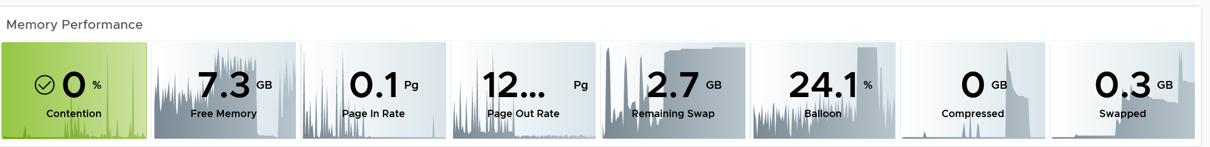

Why is contention the only color coded metric? Balloon, page in rate, page out rate, etc are not. See this example of where severe ballooning did not result in much contention at all.

Because memory is a form of storage. Most metrics measure usage of the disk space, not latency of access. Consider the disk space occupied. A utilization at 90% of the space is not slower than 10% utilization. It’s a capacity issue, not performance.

Why are the memory paging shown in color?

Because they are leading indicator and possible cause of memory performance within Windows or Linux.

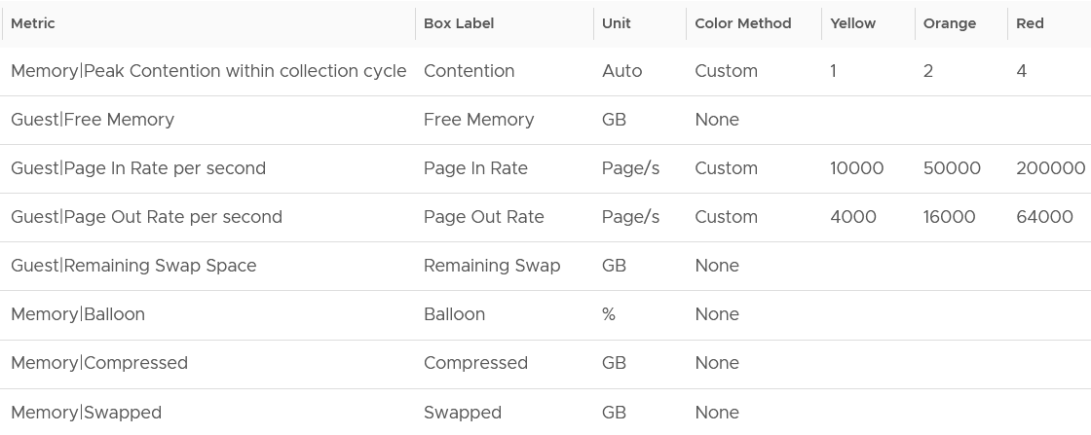

Why is Balloon placed towards the end?

Because that’s a VM level counter. For memory, you want to measure at Windows or Linux level. The following shows the metrics we use. Guest means it’s coming from the Guest OS, not VM.

Why is ballooned, compressed and swapped not shown in color?

Because there presence do not mean the VM has performance problem. They are not metrics for VM performance. That’s a counter for the underlying ESXi and Cluster. As usual, refer to the metric chapter for details 😊

##### Storage Metrics

What do you expect to see for disk? What are the contention metrics, and what are the utilization metrics?

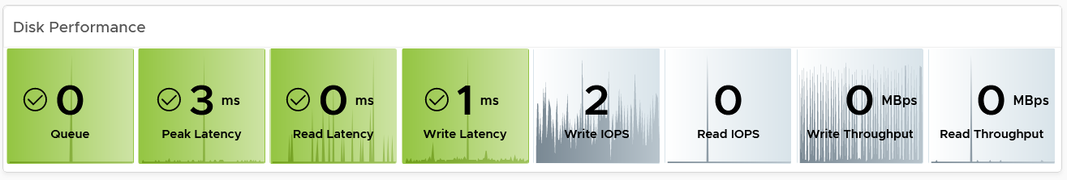

The most important one for Guest OS is Disk Queue, while the most important for VM is the Latency. The latency is based on the 20-second metric. It’s also the highest of read or write.

Peak Virtual Disk Read Latency (ms) and Peak Virtual Disk Write Latency (ms) track whether any of the virtual disks (either VMDK or RDM) is experiencing latency. This can be useful in large VMs with many virtual disks.

I put IOPS before throughput metrics as it’s more popular. Use Disk IOPS and Throughput together, especially for applications that use large block size. An IO with 250x block size (e.g. 1 MB instead of 4 KB) will generate equal throughput at 250x less IOPS, all else being equal.

For throughput, I use byte or bit as it’s the amount of disk space written, not the amount of data travelling in network line.

I use the following threshold. They are based on the profiling result documented in Part 2.

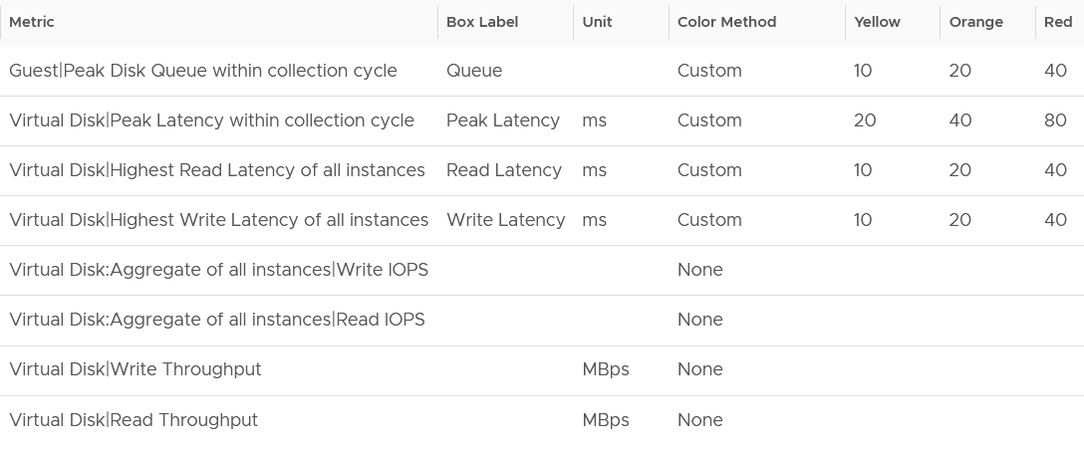

I round all the metrics to the nearest whole number. By now you know why 😊

Why is Outstanding IO metric excluded?

Read the description of the metric in Part 2 😉

##### Network Metrics

The last component is Network. What metrics do you expect?

These are the metrics I use:

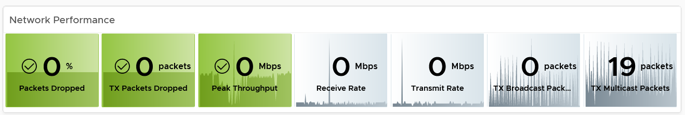

The Packet Dropped (%) formula is (dropped / (dropped + transferred Packets)) * 100%. In a rare case where there is no packet at all, the result shows undefined (blank). This is because the maths of 0 / 0 = undefined.

The following is the threshold I used:

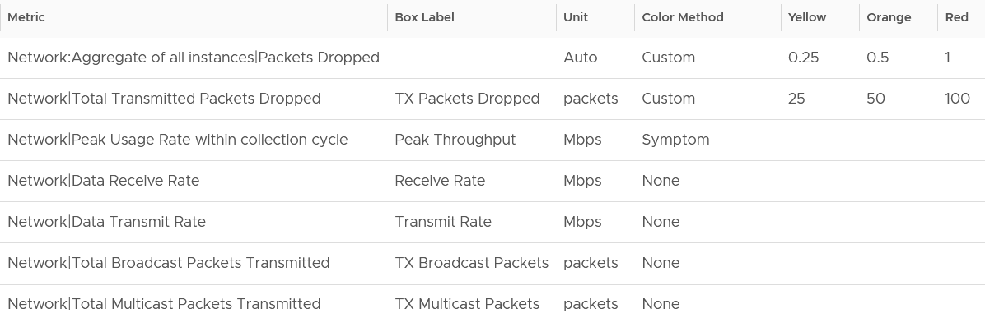

Notice the missing counter?

There is no received packets dropped. The reason is false positive.

If it’s relevant to you, add the packets per second counter.

Broadcast packets and multicast packets metrics are added as most VMs should be unicast. If the number if high, investigate with the application team why the applications are behaving that way.

##### Alerts

The relevant alerts are also automatically shown. You can see the settings by editing the widget, and adjust them accordingly to fit your operational needs.

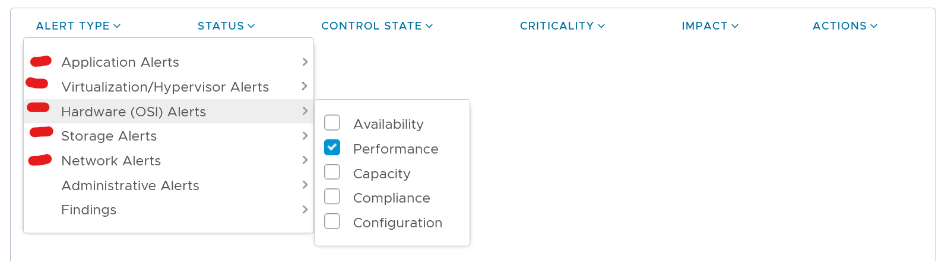

##### Virtual Disks

A VM can have many disks, and it’s possible that these disks have different performance. The following table lists the individual virtual disks and their contention and utilization metrics.

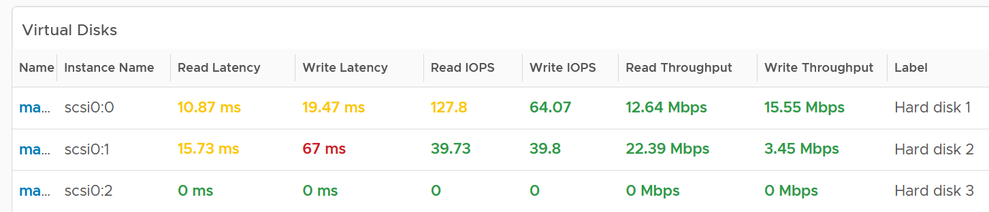

To see a trend over time, you need to go to the VM object, and choose All Metrics.

##### Configuration

The last part of the dashboard has the relevant configuration of selected VM. Customize as you deem appropriate.

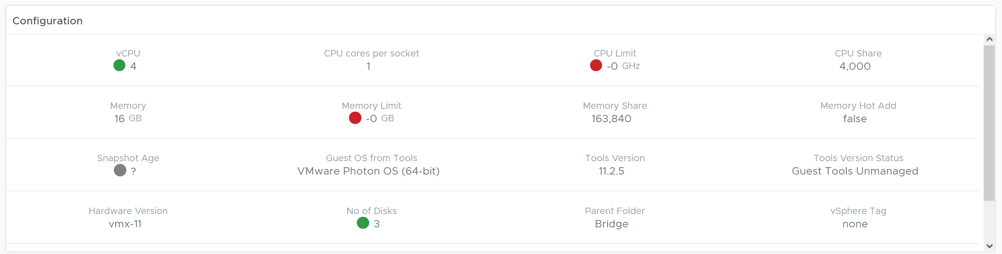

##### Relationship

From the VM, you want to navigate to the parent cluster or datastore. Use the relationship widget to navigate and auto select the associated cluster or datastore.

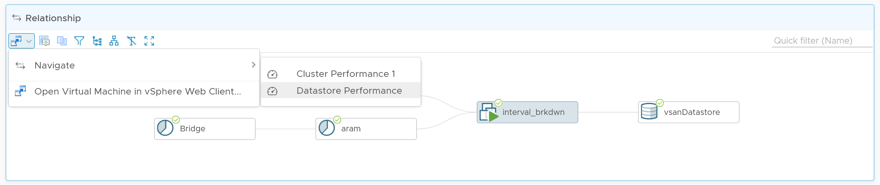

### Guest OS Profiling

I’m covering this dashboard next as they reveal performance issue that application team should consider.

There are metrics that *directly* impact the performance of Windows or Linux, the Operating Systems running inside a VM. These KPIs are outside the control of the hypervisor, meaning ESXi VMkernel is not able to control the increase or decrease of their values. Visibility into these KPIs also requires an agent, such as VMware Tools. As a result, they are typically excluded in performance monitoring.

Because these KPIs are closer to the applications, it is critical to know their values and establish an acceptable range, which will vary in your environment. By profiling the actual performance over time and from of all VMs, you can establish a threshold that is supported by facts. Since there are 8766 instances of 5 minutes in a month, profiling 1000 VM over a month means you are analyzing 8.8 million datapoints, more than enough to draw a conclusion.

Use this dashboard together with application team to determine the acceptable level of these metrics. Once you determine that, add thresholds to the table so you can easily see the VMs that exceed a threshold.

Take note that these guest OS metrics do not appear unless [vSphere prerequisites](https://kb.vmware.com/s/article/55697) have been met.

#### How to Use

Select a data center from the data centers list.

* The three tables listing CPU, memory and Disk will automatically show the VMs in the selected data center or vSphere World.
* Each table shows the highest value in the last 1 week (2016 datapoints based on 5-minute collection cycles), hence their columns are prefixed with Max.

About the CPU table widget

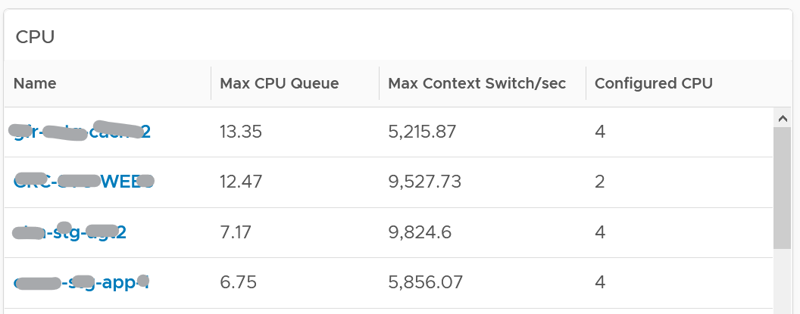

The CPU queue is the sum of all vCPU. A larger VM can tolerate higher queue as it simply has more processors. If you want to compare VMs of different size, create a super metric that calculates the queue per vCPU.

The Max CPU Queue column shows the highest number of processes in the queue during the given period. Best practices indicate you should stay below 3 for each queue. For a VM with 8 CPUs (8 queues), you want to be below 24.

CPU Context Switch. There is cost associated with context switch. The problem is there is no guidance for this number, and it varies widely. This is the very purpose of this dashboard!

Review the Memory list widget below. Why are the Guest OS Paging metrics chosen, as opposed to In Use, Cache or Free memory?

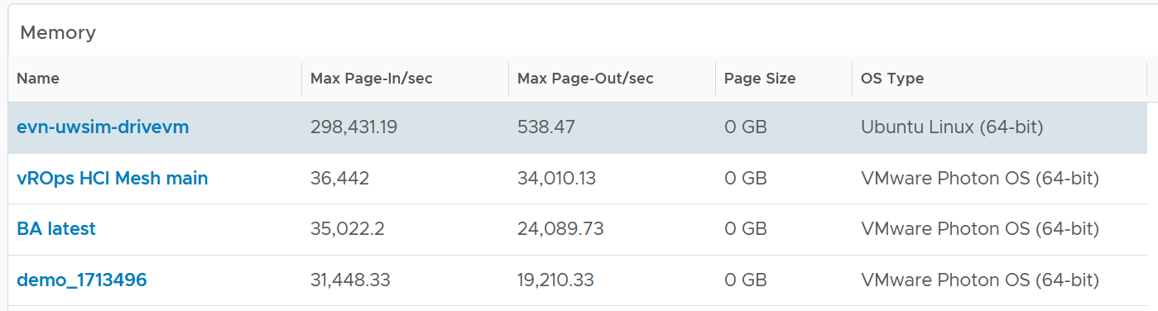

The are measuring rate of change, while the other measures a static disk space consumption.

Review the Disk list widget below. Why are these 3 metrics chosen?

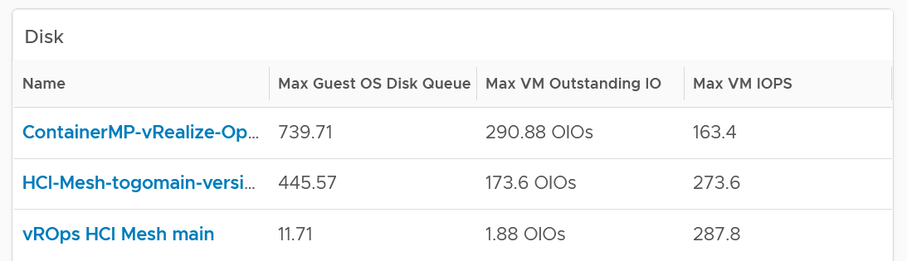

The Guest OS Disk Queue shows potential issue inside Windows or Linux.

The 2 metrics at VM level provides additional contexts. If queue is high inside the Guest, and OIO and IOPS are low at VM level, the problem is at Guest OS layer.

Select any VM from any tables above. The three line charts will appear automatically and will show data from the same VM to facilitate correlation.

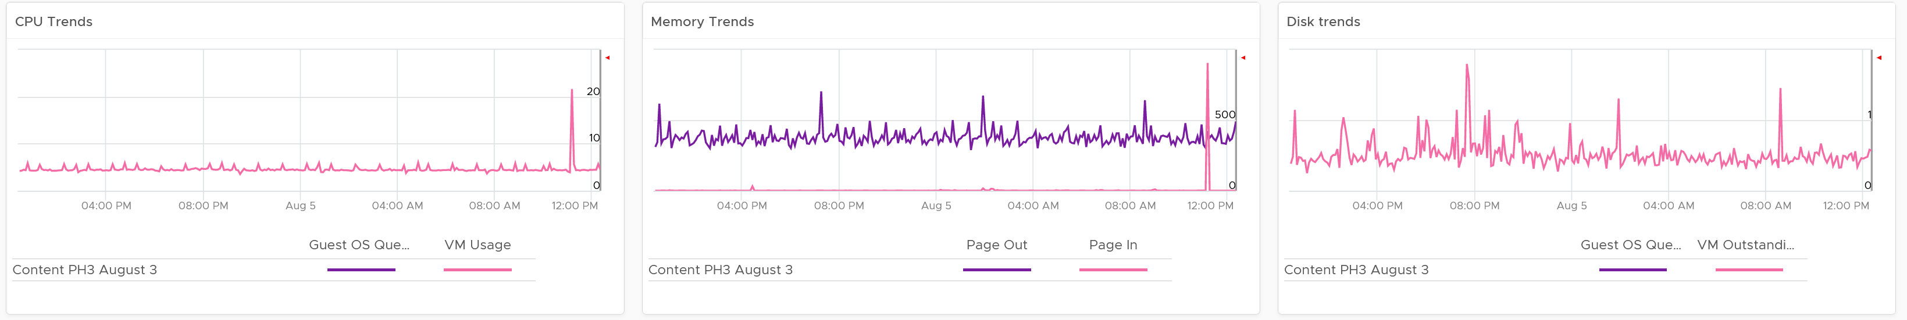

### Heavy Hitters VM

IaaS provides four services, CPU, Memory, Disk, and Network.

* CPU, Memory, and Disk are bound. A VM with 4 vCPU and 16 GB memory cannot consume more than this amount, the same applies to disk space. A VM configured with 100 GB disk space cannot consume more than that.
* Network and Disk utilization are not bound. An active VM can consume all your network bandwidth, packet per second capacity and storage IOPS capacity.

The **Storage Heavy Hitters** dashboard forms a pair with the **Network Top Talkers** dashboard. To understand the IO demands in your environment, use them concurrently. If you are using ethernet based storage, storage traffic will run over the same physical network your ethernet based network traffic is using.

Why not combine into 1 dashboard?

* The remediation actions are different.
* The users are different. Network dashboard may be required by Network Team, while storage dashboard by Storage team.
* The customization is different. You extend each dashboard, going into physical array or NSX.

The dashboards are designed to help you analyze the impact of these VMs on your IaaS. It classifies the workload into two categories: short bursts and sustained hits.

Short burst last for a few minutes, while sustained hits can last much longer. A sustained hit that lasts for an hour can cause serious problems.

A heat map would enable us to visualize the data easier. However, it can’t show the past data, hence it’s not used. If you want see in heat map form, see the Live! Heavy Hitters dashboard.

#### Storage Heavy Hitters

Interpreting IOPs and throughput metrics depends on your underlying physical storage capability. For visibility into this hardware layer, add physical storage arrays and physical network switches metrics to the dashboard.

See the **Network Top Talkers** dashboard as they basically have the same design. The main difference is we show IOPS and throughput. They are related, so use both to gain insight, they should display a similar pattern. If not, that indicates varying block sizes. For example, a throughput spike without an accompanying IOPs spike indicates large block sizes.

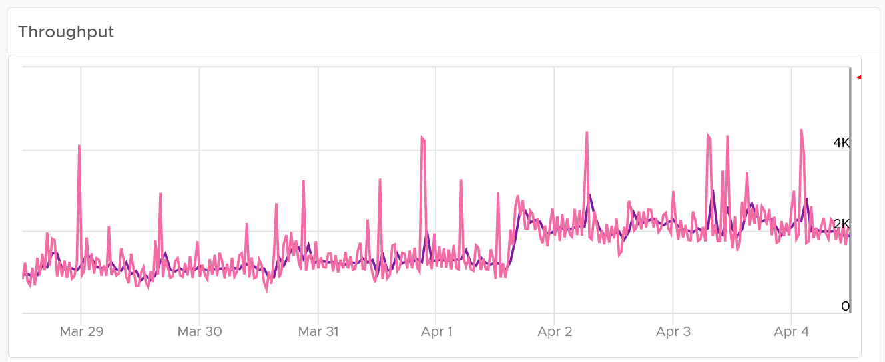

About the “Which VMs hit storage the hardest” table

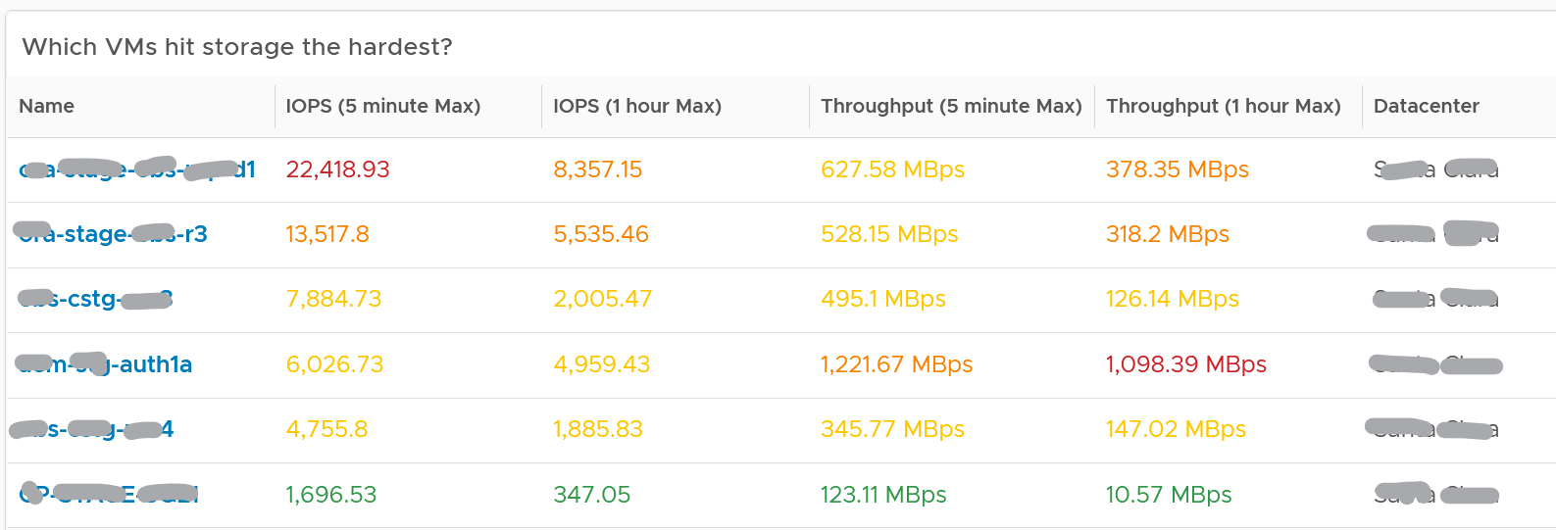

The table shows the most demanding VM. You can identify the villain VM and compare their demands with the capabilities of the underlying IaaS. Knowing the infrastructure capability is important, because different class of SSD have different IOPS and throughput capabilities.

After identifying the villain VM, talk to the VM owners if the numbers are excessive during peak hours and identify the reasons behind the excessive usage. You must ensure that they do not create a hot spot, for example, vSAN cluster with >100 disk can handle numerous IOPS but if the VM objects are only on a few disks, those disks can become a hot spot.

#### Network Top Talkers

Use the Network Top Talkers dashboard to monitor network demand in your IaaS. In a shared environment, a few VMs generating excessive activity can impact the entire data center. While a single VM might not cause a serious problem, a few of them can. Understanding high demand helps you monitor IaaS and allows you to plan capacity.

Network throughput, disk throughput, and disk IOPS can spike as their physical limit is generally very high per VM. This means that IaaS has enough capacity for all workloads and performs well until VMs start consuming abnormally high amounts of network and disk bandwidth.

The dashboard shows the big picture, while allowing you to see the individual VM. It is important to see the VM utilization in the larger context.

The dashboard begins by showing the current workload. This is the total network load (received and transmit) from all vSphere environments monitored by vRealize Operations. The idea is to give you an indicator on how hard the overall load is.

Select a data center from the data centers list.

* The columns show the number of clusters, ESXi Hosts and VM for each Data center. The VM count includes powered off VM. If you need to show only the running VM count, edit the widget.
* If you want to see from all Data center, select the **vSphere World** row.
* Upon selection, the Total Demand line chart and the Top Talkers table will be automatically filled up.

About the Total Demand line chart:

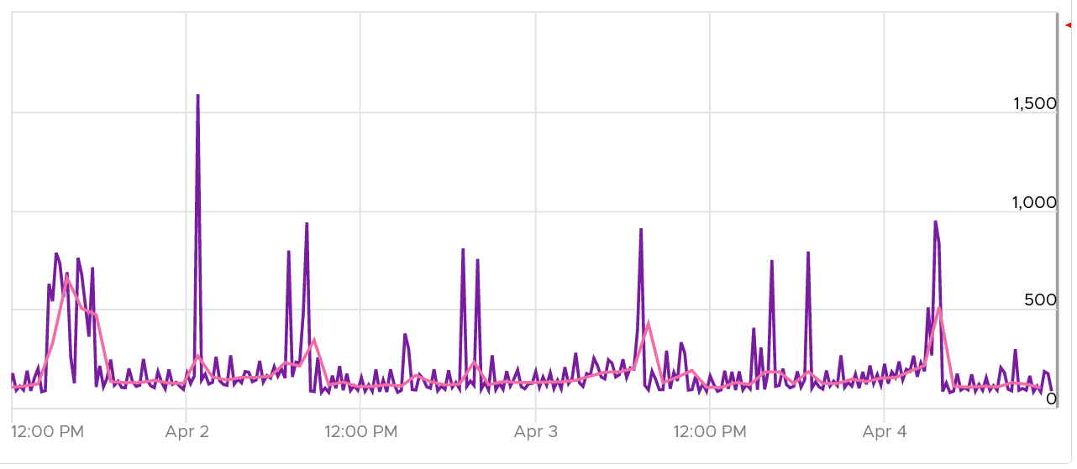

This shows the total throughput (received and transmit) in the selected data center.

It shows both the 5-minute peak and the hourly average into 1 line chart. You would expect that the 5-minute peak is much higher than the hourly average, indicating it is just a short burst. You can click on the metric name to hide the corresponding line chart.

About the Top Talkers table:

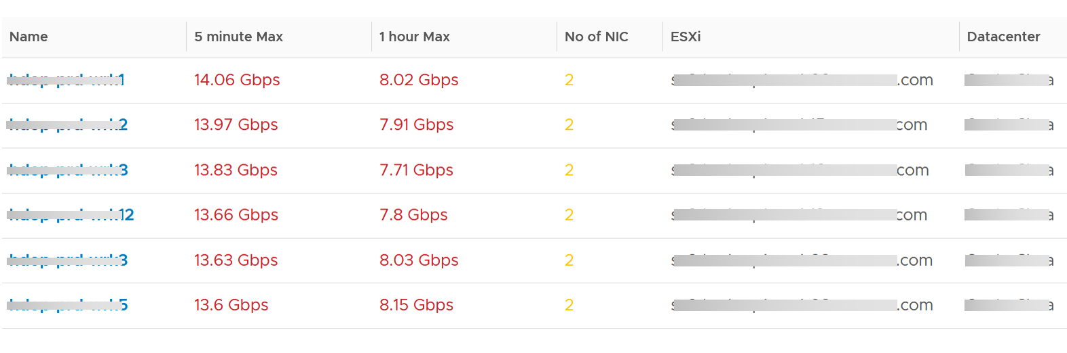

The table shows the most demanding VM. ​To help you focus on the VMs that hit the network hard, VMs that are not hitting the network hard are filtered out. The threshold used is 1 Megabyte/second sustained in the *last* collection cycle. You can change the filter to average of all time if that makes more sense to you.

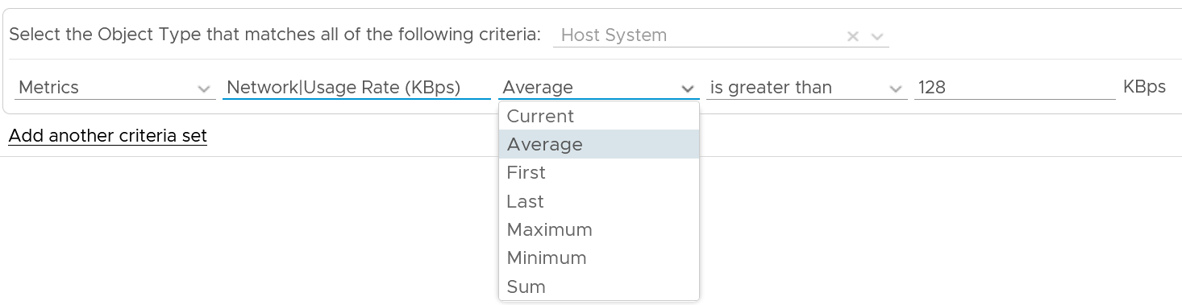

You can identify the villain VM and compare their demands with the capabilities of the underlying IaaS. Knowing the infrastructure capability is important so you know the absolute limit.

After identifying the villain VM, talk to the VM owners if the numbers are excessive during peak hours and identify the reasons behind the excessive usage. You must ensure that they do not create a hot spot, for example, vSAN cluster with >100 disk can handle numerous IOPS but if the VM objects are only on a few disks, those disks can become a hot spot.

#### Points to Note

* add a line chart to automatically show the selected VM usage. Add the CPU usage also to see correlation between disk and CPU.
* Group the VM by clusters of the same class of service (e.g. Gold), so you can see the profile for each environment.
* For smaller environment, change the table from listing data centers to listing clusters.
* For larger environment, add a distribution chart so you can see the spread of the metrics.

### Compute Performance

This dashboard covers vSphere Cluster, ESXi host and resource pools, hence the generic name compute is adopted.

Design wise, while we can further add analysis, I feel it’s not worth the cost of complexity. I understand the very large customers may want to add more analysis. If you are one of those, drop me a note.

#### Overall Analysis

2 color-coded trend chart are provided.

The first one gives the overall performance. Expect this to be steady, especially in a large environment.

The second one complements it by showing the count of clusters that are no longer in the green zone. If your problem is isolated, the first counter may miss.

##### Average Performance

Look at the “Average Cluster Performance (%)” health chart at the top of the dashboard. In a high performing environment, where all the clusters are doing well, you will see something like this.

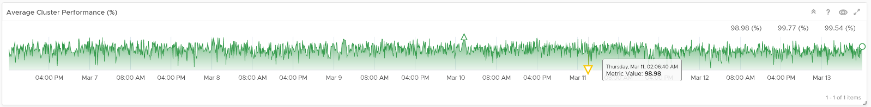

There was only one occurrence where the color is not green. At that time, the actual value is also relatively good.

In this case, all is good and you may not need to look further.

On the other hand, if the clusters are unable to serve the VMs well, you will see something like this.

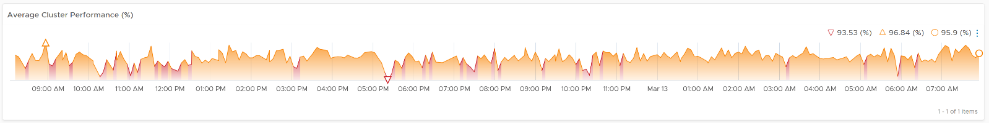

The average among all the clusters is no longer green, with a few occurrences of reds. The good part is the value does not trend downwards. Check if this is normal in your environment.

As this KPI takes into account *every single running VMs* in your environment, the number should be steady, especially in a large environment. The analogy in real life is the stock market index. While individual stocks can be volatile on a 5 minute by 5 minute basis, the overall index should be relatively steady. A big drop is called a market crash and that’s not something you want in your environment. So a drop like the following warrants an immediate investigation.

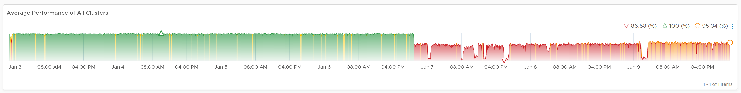

The relative movement of the metric is as important as the absolute value of the metric. Your absolute number may not be as high you wish it to be, but if there have been no complaints for a long time, then perhaps there is no urgent business justification to improve it.

As the chart shows all the clusters, it uses the vSphere World object. This object is the parent of vCenter object, so it will show all clusters from all vCenter, making it suitable when you want to show everything.

The actual metric used is Performance \ Clusters Performance (%), as shown in the following dialog box. This is the primary KPI for your entire IaaS. It plots how your IaaS is performing every 5 minutes, giving you the trend view of overall performance.

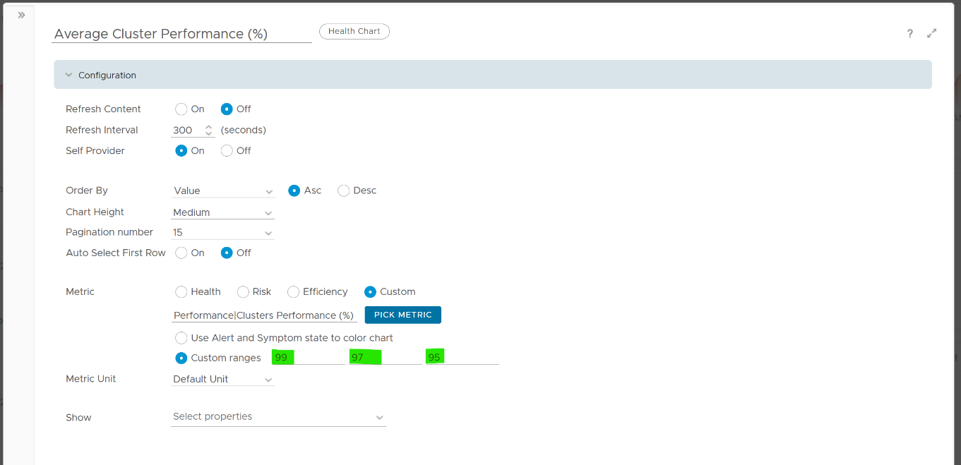

What is this metric based on?

It is simply the average of Cluster KPI \ Performance (%) metric. This performance metric in turn averages the VM Performance \ Number of KPIs Breached metric from all running VMs in the cluster. Hence a value of 100% indicates that every single running VM in the cluster is served well.

More details on the formula were covered earlier here as it’s an important foundation of IaaS performance KPI.

##### Non Green Clusters

This trend charts shows the number of clusters that are no longer in the green zone. Another word, the value of the Cluster KPI \ Performance (%) metric has gone down below 75%.

Review the following chart. What trend do you spot in the last 1 week?

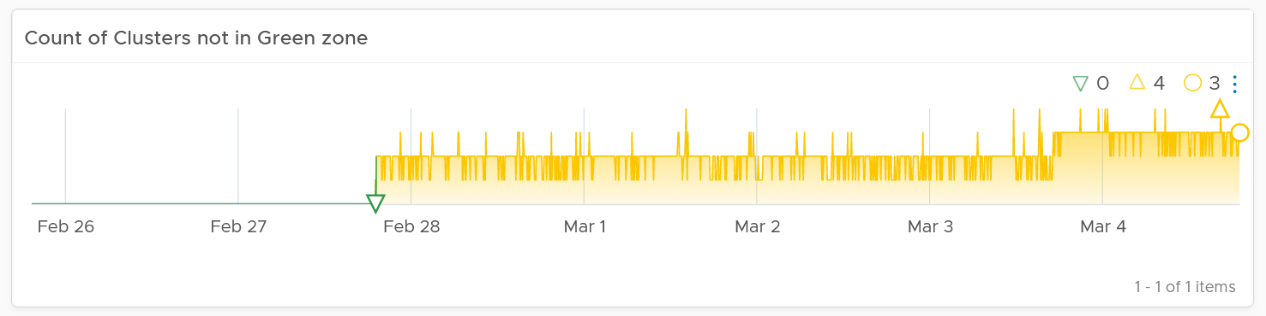

That’s correct, the number of clusters falling below green zone has gone up from 0 to 4.

Earlier, I wrote that this counter complements the first counter. The following chart is what you get from the 1st counter. Notice it’s hard to deduce that 3-4 clusters have fallen below the green zone. In this case, some clusters actually went up as we powered off their VMs, so the overall numbers remain similar.

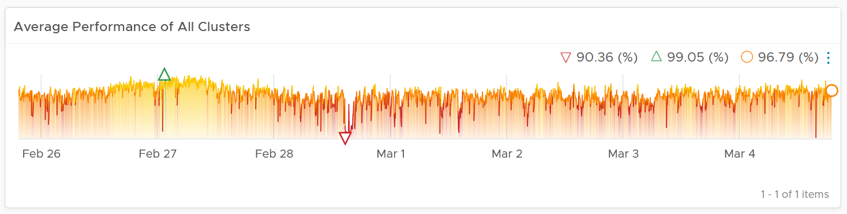

#### Multi-Cluster Analysis

If the chart is showing green, then all is good. If not, you want to know which clusters are not performing. This is where the Clusters Performance table comes in.

The table lists all the clusters, starting with the lowest performance. By default, it’s showing data from the last 24 hours as this dashboard is designed to be part of your daily SOP.

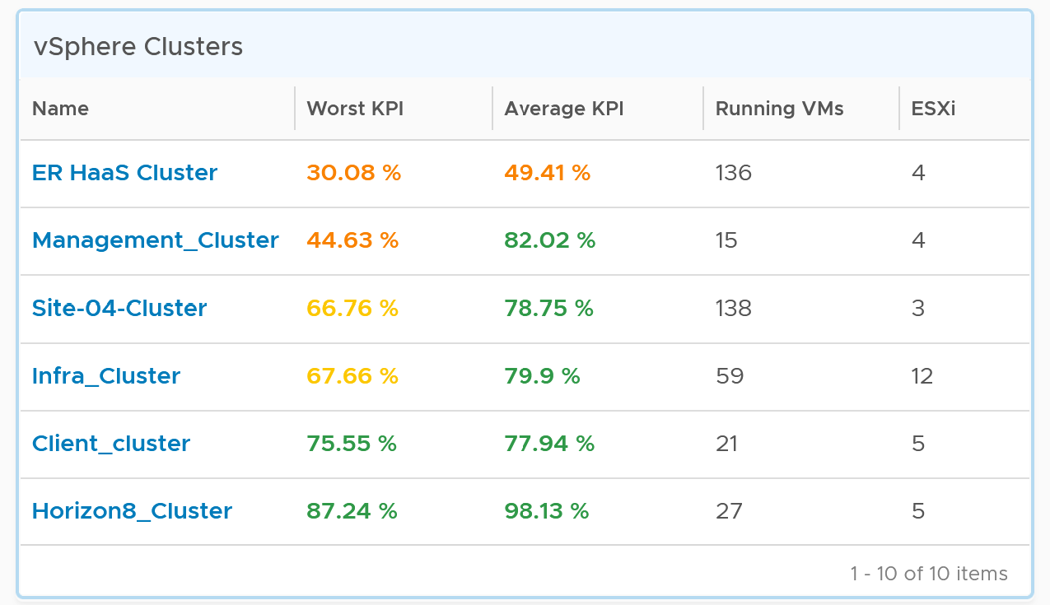

The Worst Performance shows the lowest number in the time period. As vRealize Operations collects every 5 minutes, there are 12 x 24 = 288 data points in a day. This column shows the worst point among 288 datapoints.

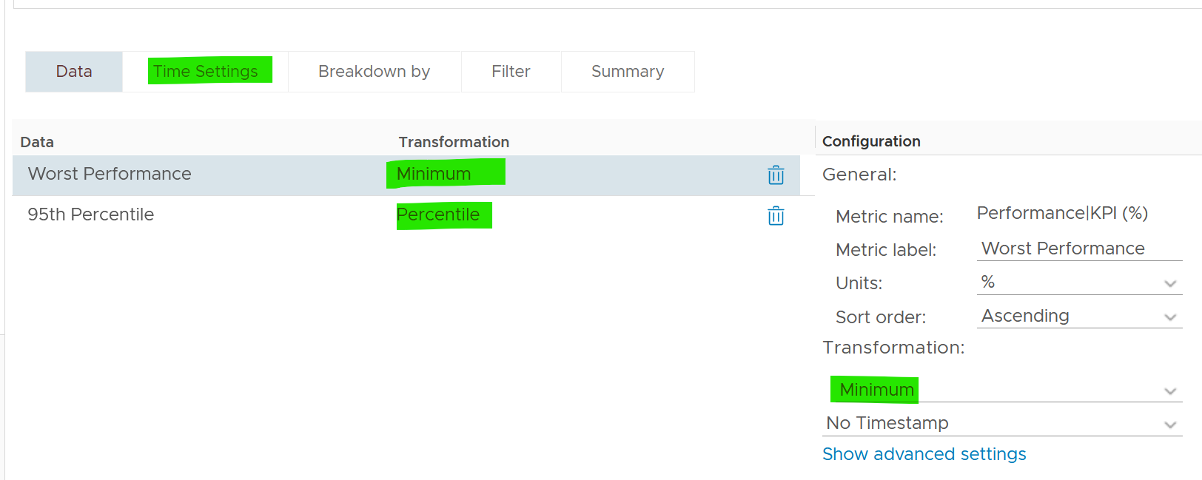

For a very large environment with many clusters, add a grouping to make the list more manageable. Group it by class of service, so you can focus on the more critical clusters. You can then adjust the threshold accordingly. For example, add the column worst 1st percentile to complement the worst and the worst 5th percentile. This is useful if you have clusters with more than 1000 VMs, as 5th can be too late.

You may not be comfortable not seeing utilization metrics. Old habits die hard 😊. Modify the table to add key utilization metrics. The following table shows an example of metrics to add. Notice that I do not color code the disk IOPS and Network Usage.

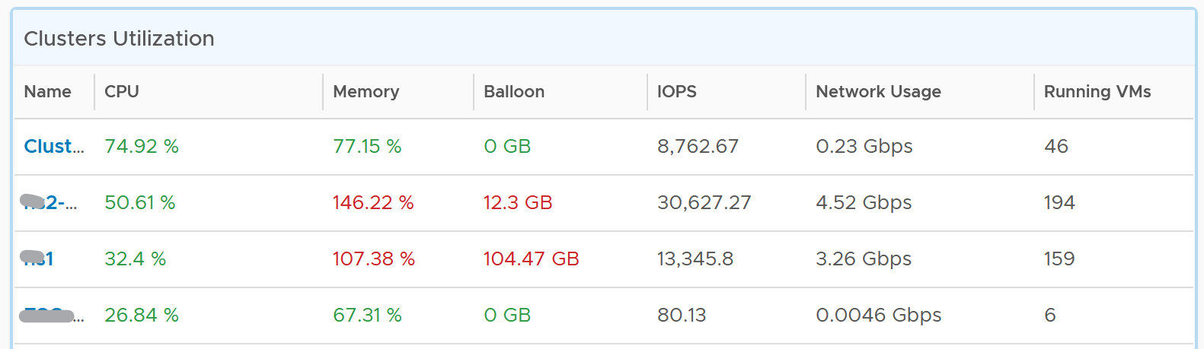

#### Per-Cluster Analysis

The table is accompanied by the health chart. It allows for quick toggling among clusters.

Select a cluster to see the trend over time, and see the Performance (%) health chart.

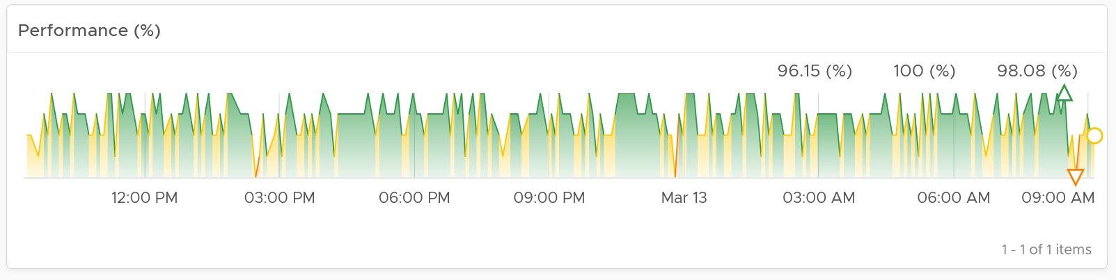

If the cluster has a daily or weekly pattern, increase the dashboard time duration to at least 1 week. Here is an example where the performance problem is clearly shown. You can see the cluster performance has regular drop in the last 7 days.

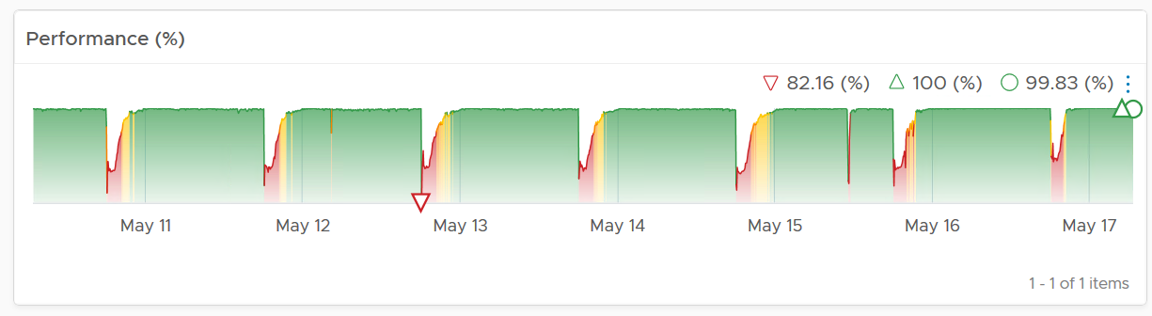

Once you determine the cluster to investigate, review the scoreboards. There are 5 of them:

* CPU
* Memory
* Disk
* Network
* Others

They are shown separately, because you can have one problem and not the other. You may also drill down into a different path (e.g. into vSAN dashboard), and talk to different team (e.g. Network team).

CPU problems tend to be more common than Memory problems, due to lower overcommit ratio in memory in practice among customers. It is common to see customers do 4:1 CPU overcommit and only 2:1 memory overcommit. This conservative practice was due to the inherent higher value of memory counter. vSphere cluster shows high memory value as memory, giving the impression the actual utilization is high. And the reason for high value is modern Operating Systems like ESXi VMkernel uses memory as disk cache.

For performance, it’s important to show both the depth and breadth of the performance problem, as explained here. A problem that impacts 1-2 VMs requires a different troubleshooting process than a problem that impacts all VMs in the cluster.

The depth is shown by reporting the worst among any VM counter. So the highest value of VM CPU Ready, VM Memory contention, VM Disk Latency among all the running VMs are shown. If the worst number is good, then you do not need to look at the rest of the VM.

A large cluster with thousands of VM can have a single VM experiencing poor performance while >99.9% of the VM population is fine. The depth counter will not be able to report that most VMs are fine. It only reports the worst. This is there the breadth metrics comes in.

The breadth metrics report the percentage of the VM population that is experiencing performance problems. The threshold is set to be stringent, as the goal is to provide early warning and enable proactive operations.

##### CPU **Metrics**

This is the first of a series of performance scoreboards.

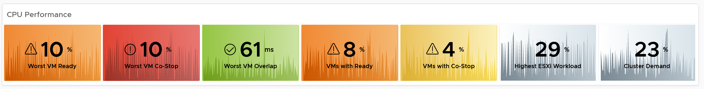

There are 3 metrics measuring the depth of the problem:

* Worst CPU Ready among all the VMs in the cluster.
* Worst CPU Co-stop among all the VMs in the cluster.
* Worst CPU Ready among all the VMs in the cluster.

CPU Ready is the primary counter. Do you why CPU Contention is not used? See CPU Contention metric in Part 2 of the book.

CPU Co-stop is included, but placed at lower priority than Ready because high Co-stop does not mean the ESXi is struggling to serve the VMs. Co-stop can be reduced by right-sizing an oversized VM, so the remediation action is not always on the ESXi Host. CPU Overlap is included as it can happen when there are many active VMs in the cluster.

CPU Overlap is included as it indicates interrupts. A running VM was interrupted because VMkernel needs the physical core to run something else. A high and frequent number of interruptions is not healthy. This can also impact the VM performance. It’s placed third as the value tends to be small.

Here are thresholds used.

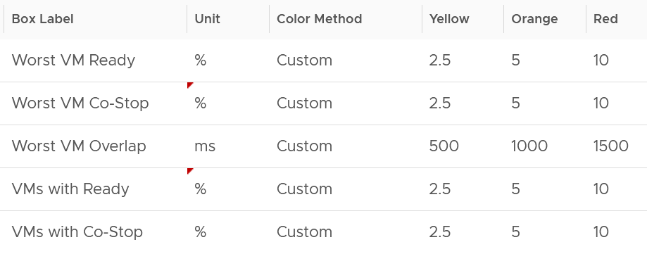

If you find that the CPU Co-Stop values in your environment is much better, adjust it accordingly.

Take note that the Workload metric can exceed 100% because it’s demand / usable capacity * 100. So this could happen if you have 4 hosts in a cluster with each host running at 100% demand and admission control is set to 50%.

If your cluster has many resource pools and Host to VM Affinity, create a super metrics to track the gap between highest and lowest CPU usage among ESXi hosts in the cluster. The reason is imbalance is pretty common, especially in large clusters with many hosts or VMs. There are many settings that can contribute to it (e.g. DRS settings, VM Reservation, VM – Host Affinity, Resource Pool, Stretched Cluster, Large VM).

##### Memory **Metrics**

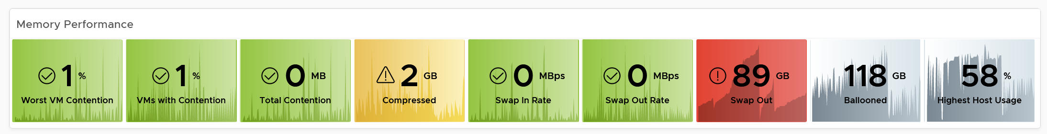

Expect memory utilization to be higher than CPU, as it’s a form of cache. The Memory Consumed counter is used, as it’s more appropriate than the Memory Active counter. If active is low, no need to upgrade RAM as Consumed contains disk cache. For me, it’s fine for Consumed to be 99% so long RAM Contention is 0.

The high utilization metrics are explicitly shown. Balloon, Compressed, Swapped. Notice they can exist even though utilization is not even 90%, indicating there was high pressure in the past. If you look at only utilization, you’d think you are safe!

I use the following settings for the threshold. What do you notice?

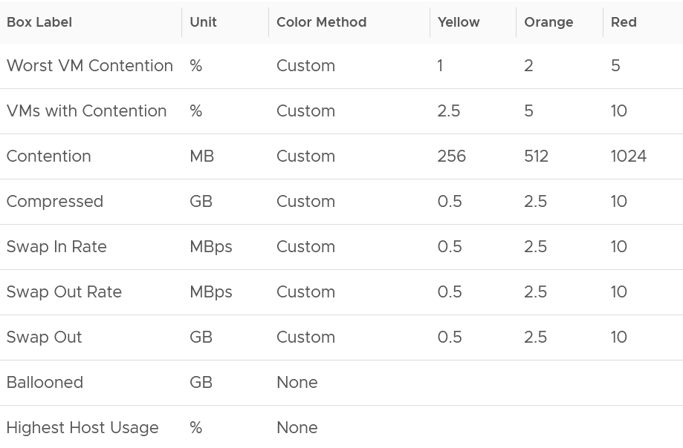

The threshold for contention is much lower than the threshold for other metrics. This is because contention is the only performance metric. The rest is secondary, playing supporting role. You can have 10 GB compressed, so long they are not used, the VM does not experience delay.

##### Storage **Metrics**

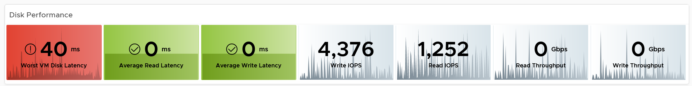

The disk IOPS is split into read & write to gain insight into the behaviour. Look at the values for that cluster. Do they match your expectation?

For throughput, why are the unit set at Gbps? Why not GBps or Mbps?

Because we’re referring to IO commands sent down the cable (your DC is not wireless, yet!). Your ethernet cable or FC cable use bit, such as 25 Gbps or 32 Gbps. [e1: in future change this to MB/second]

Mbps is too small for a cluster. A cluster doing useful work should easily exceed 1 Gbps as it’s just 128 MB/s. If you have distributed storage like vSAN, you can very well exceed 10 Gbps.

If you use VMFS datastores, add the disk contention metrics such as Bus Reset and Aborted Commands. You should expect they return 0 at all times.

##### **Network Metrics**

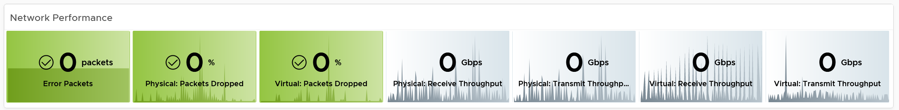

For network dropped packets, there are 2 types: physical (ESXi) and virtual (VM). The physical counter is used as that better represents infrastructure problems. The VM counter may suffer from a [false positive](https://en.wikipedia.org/wiki/False_positives_and_false_negatives). I recommend you customize this dashboard and add it anyway, for completeness.

Expect the network error 1% and dropped packet to be 0 most of the times, if not always. If it’s not, analyze to see if there is any patterns across all ESXi Hosts, and bring it up to your network team.

The network throughput is split into sent (transmit) and received to gain insight into the behaviour. Plus, the total usage can be misleading because it sums send and received traffic. In reality the network pipe is 1x for each direction (due to the full duplex nature of ethernet), not 2x shared by both.

##### Other KPI Metrics

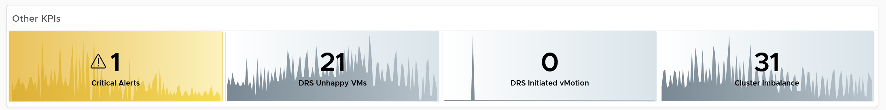

The vMotion line chart is added as a high number of vMotion can indicate the cluster load is volatile, assuming the DRS Automation level is not set to the most sensitive setting.

##### VM Shares

One common root cause for uneven performance problem is uneven shares. This is easy to make a mistake, as shares are relative. So when you see many slices of the pie, ask yourself why you need that many. Each slice should correspond to a Class of Service. So the entire cluster is serving 1 class, then you should see a simple circle with no pizza slice.

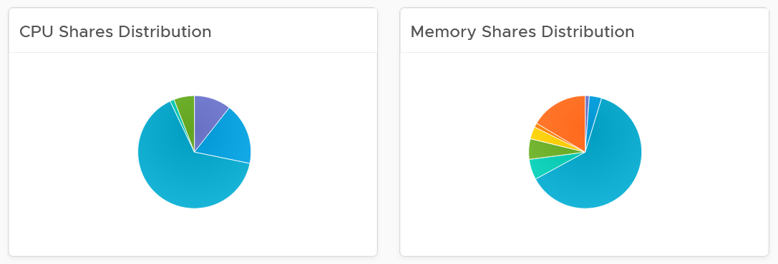

#### Resource Pool Analysis

Resource Pool is another common reason behind uneven VM performance. They can also get complicated as you can cascade resource pool. The following example shows a cluster with way too many resource pools. This alone will make performance management difficult.



The second cluster has 4 resource pools. They are sized by their respective share. A pool with 2x share will have 2x the size. With that in mind, can you spot a problem?



Yes, they are of equal share. What’s the point of having resource pool when they are the same share? It looks like a common mistake of using resource pool as folder.

The dashboard also provides a table listing all the resource pool.

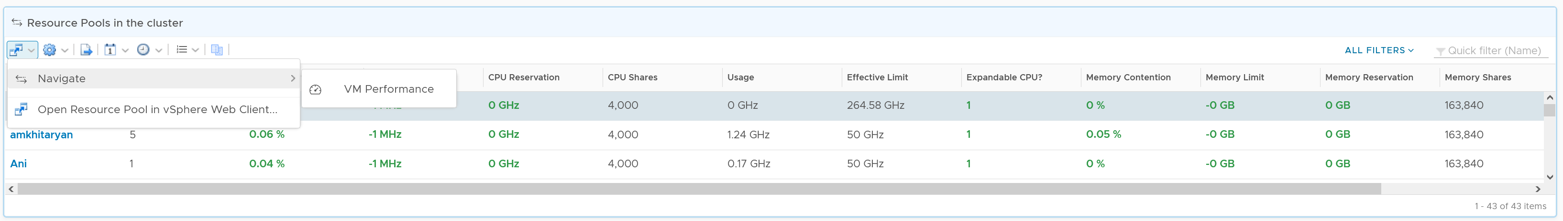

You can navigate to the VM performance dashboard. It will show the VMs in the selected resource pool.

#### ESXi Analysis

At the end of the day, a cluster is just a collection of ESXi. The performance can be caused by uneven performance among the member hosts. You can drill down from cluster to ESXi. The following table lists all the ESXi hosts in the cluster, sorted by the worst performance in the last 24 hours.

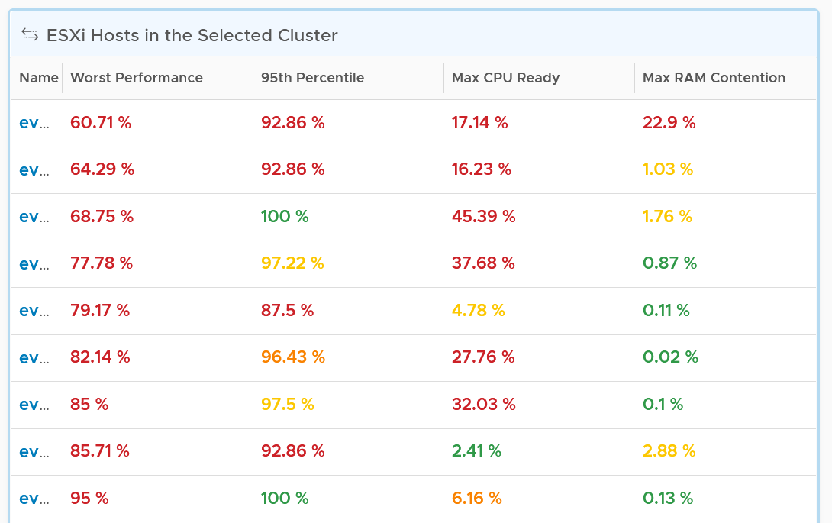

If the table is all showing green, then there is no need to analyze further. The reason 24 hours is chosen instead of 1 week is the performance > 24 hours ago are likely to be irrelevant.

You can change the time period to the period of your interest. The maximum number will be reflected accordingly.

The table helps you quickly compare the performance of each ESXi. You can also see the performance over time, to see a trend. For example, here is the performance of one of the hosts.

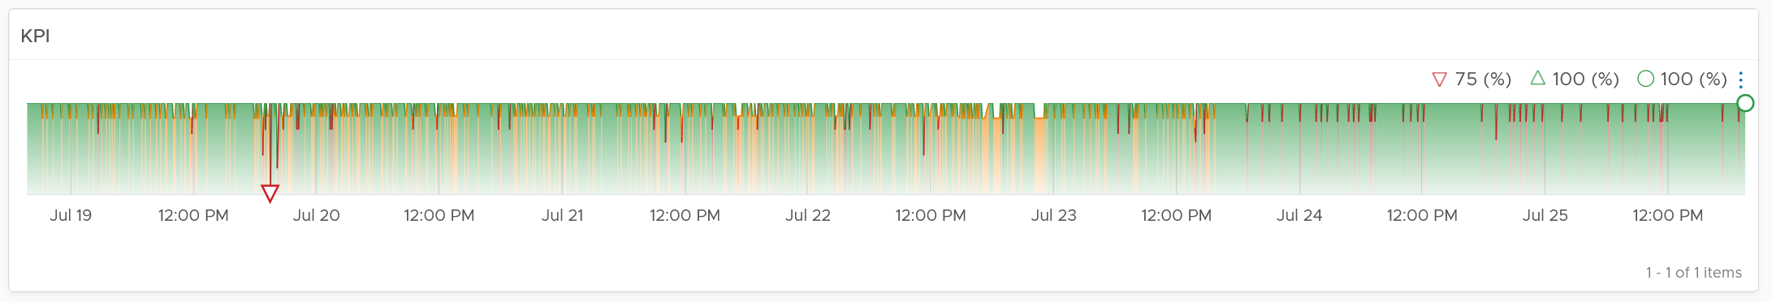

Another ESXi on the same cluster is showing a different experience. What does it tell you?

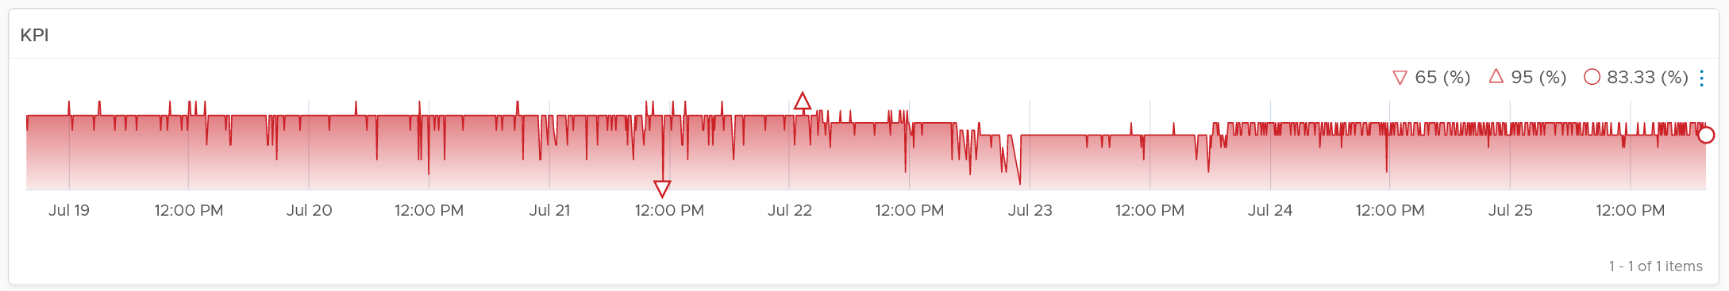

Yes, there is imbalance. A cluster is meant to be balanced, if you enable DRS. The above proves that something has constrained DRS ability.

Just like the cluster KPI, you can also see the KPI of a host. They are similar to the cluster, so to avoid duplication, I’m only covering the difference.

##### CPU Metrics

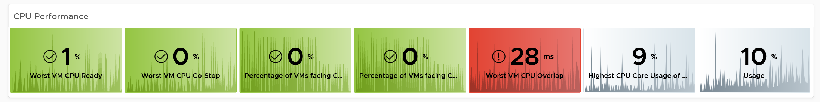

An ESXi typically has a few dozen physical cores, which take turn to run a few dozen VMs. This could create imbalance among the cores. The metric Highest CPU Core Usage tracks the highest utilization among the cores. If this number is consistently near 100%, that indicates at least 1 core is always busy. If this number if much higher than the Usage (%), that indicates imbalance.

##### Memory Metrics

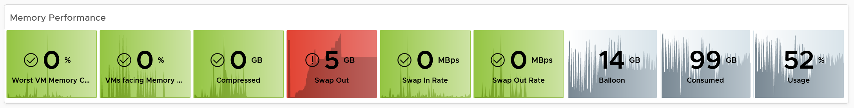

For metrics where the cluster is the sum of its ESXi, the threshold used for ESXi is lower. For example, the red threshold used for cluster for compressed is 10 GB, while the threshold for individual ESXi is 2 GB.

##### Storage Metrics

It’s likely that the ESXi hosts in a cluster will have different disk IOPS pattern. They could be running VMs with different purpose. Even if all the VMs are the same (e.g. they are all from the same VDI pool), the way the users use the applications are different.

For ESXi, we show both the datastore level and adapter level. Why is that so?

Review the Storage Metrics chapter for the detail. In short, an ESXi can mount datastore and non datastore (e.g. RDM) via its storage adapter.

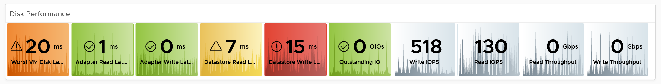

##### Network Metrics

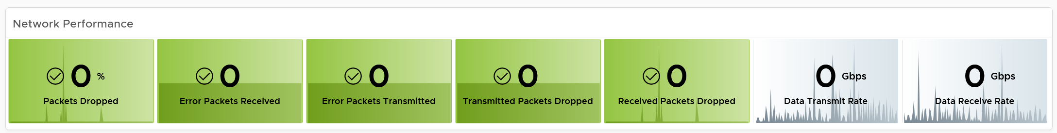

##### Configuration

Certain settings such as power management and hyper threading can impact performance. The configuration widget shows the relevant property of a selected ESXi Host.

#### VM Analysis

Selecting a cluster or ESXi will automatically list the running VMs. Use this table to check if the cluster or host performance problem were caused by VM configuration and usage. Note that it is possible that the VM was not on the same host at the time of problem, due to vMotion.

To drill down into a particular VM, select it and click the double arrow before the widget title. Choose the VM Performance dashboard.

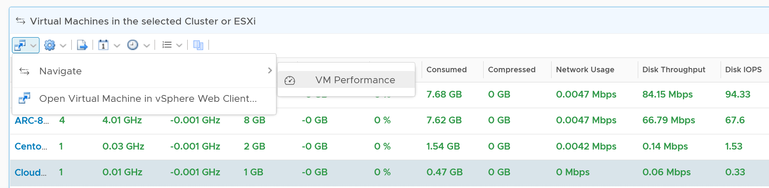

The table is color coded for ease of analysis, as you can have >1K VM in a cluster. Tailor the threshold to your environment.

Each of the column is showing the maximum value of the time period, so you can spot even if there is a short burst.

#### Datastore Analysis

The list of shared datastores accessible by hosts in the cluster is shown. Take note that if your design has M:N relationship between clusters and datastore, then the numbers at datastore level is a number from all clusters.

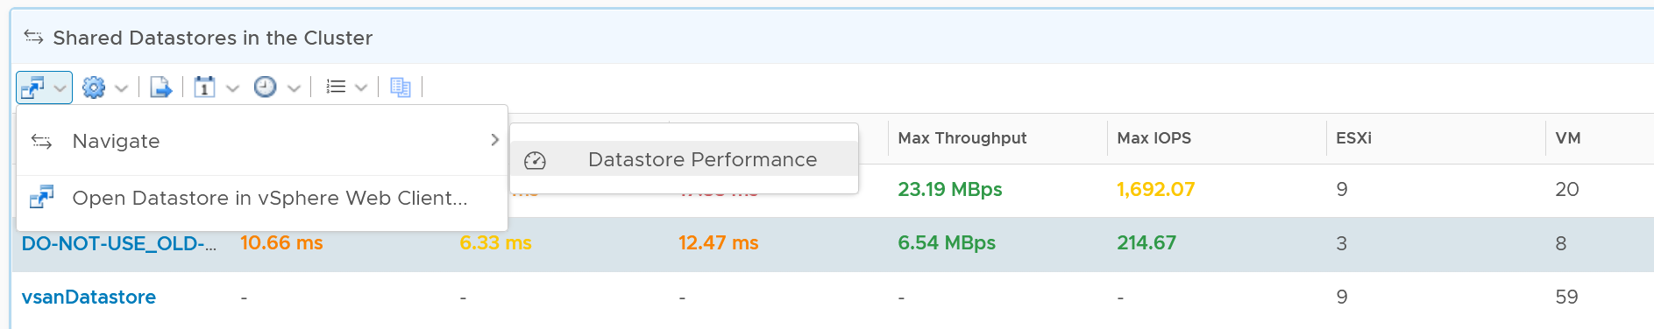

You can also drill down into the selected datastore.

### Storage Performance

Use the Datastore Performance dashboard to view performance problems related to storage such as high latency, high outstanding IO, and low utilization. This dashboard is designed for both VMware administrator and Storage administrator, with the goal of fostering closer collaboration between the 2 team.

Local datastores are treated separately, as they have their own use case.

#### Overall Analysis

The three bar charts provide the overall analysis of the datastore performance in a given vCenter DC or World. They work together to give a better insight. Just like other performance charts, the value shown in the worst value during the time period.

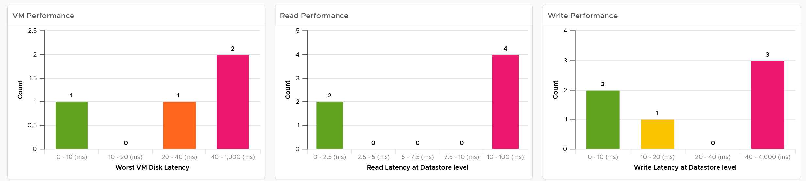

The first one shows how many VMs experience what kind of latency. This is your primary chart as it’s measuring at VM level. The next two charts are measuring at datastore level, which means they are the normalized average of all VMs in that datastore. Expect the first chart to be higher than the last two.

Read and Write latency are shown separately for a better insight. The nature of read and write problem may not be the same so it’s useful to see the difference.

The dashboard does not have datastore clusters. If your environment use it, add a View List right after the list of datacenter, and have it also drives the Datastore Performance view list.

#### Datastore Analysis

A table listing all the shared datastores in the data center or vSphere World will also be automatically shown.

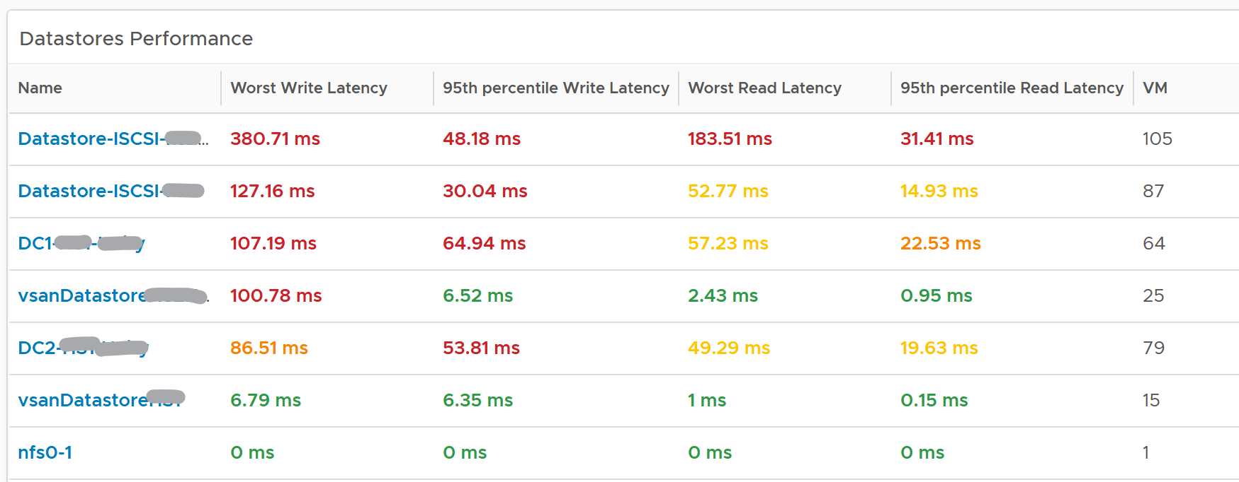

Since it’s a table, we can afford to show multiple numbers. Both the worst (peak) performance and 95thpercentile are shown. If the latter is close to the peak and it’s also high, then it’s a sustained problem. If the latter is low, then it’s a short duration.

The table is color coded. If you require a different threshold, adjust accordingly.

Select a datastore you want to troubleshoot. The relevant metrics and configuration will be shown automatically.



Its latency and outstanding IO is automatically shown.

Note the latency is the normalized average of all VMs in the datastore.

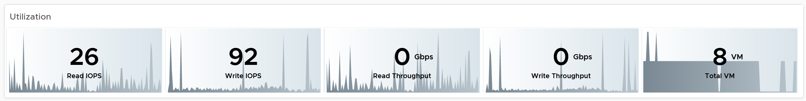

Its IOPS and throughput are also shown. These line charts are not color coded as it varies per customer. Edit the widget and add your expected threshold. It will make it easier for the operations team.

The list of running VMs in the datastore is automatically shown, with the relevant contention and utilization metrics.

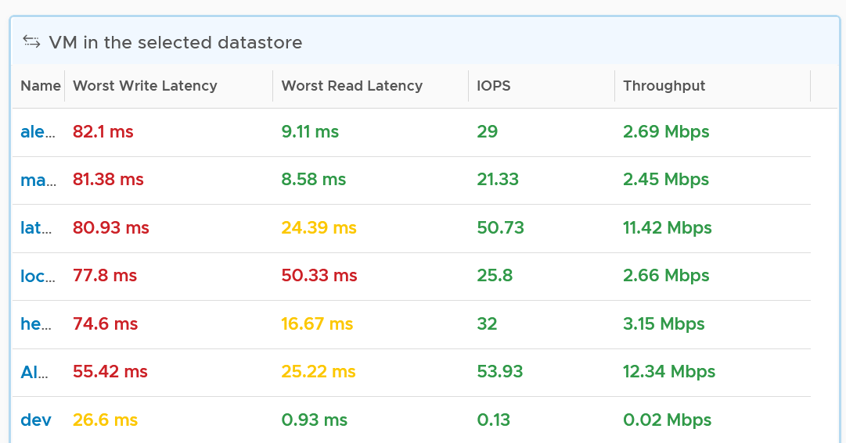

#### VM Analysis

Select a VM you want to troubleshoot. Its contention and utilization are automatically shown.

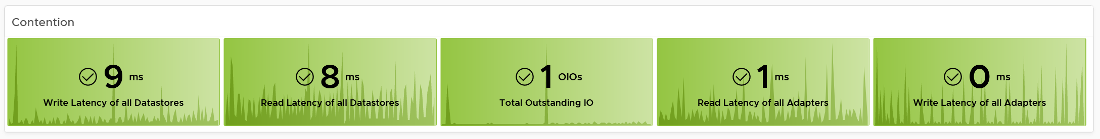

Note that this number is at the VM level. If you suspect one of the virtual disk has high latency, use the counter Peak Virtual Disk Read Latency (ms) and Peak Virtual Disk Write Latency (ms).

For utilization, here are the key metrics.

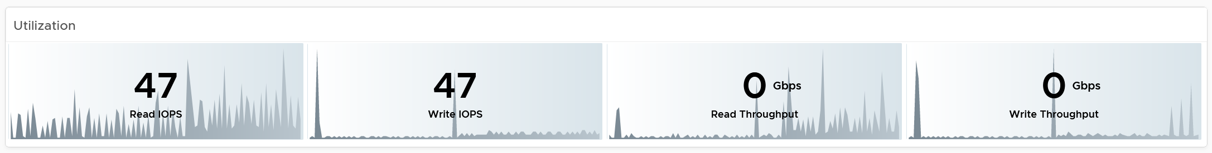

If you have many VMs with virtual disks on multiple datastores, add a View List widget to list the individual virtual disks. Use this list to plot the latency & utilization of individual virtual disk.

#### Relationship

From the datastore, what if you want to check which clusters or hosts are causing the problems? If it’s a vSAN datastore, what other relevant KPIs should you check?

From the relationship widget, select either an ESXi, a vSphere cluster or a vSAN cluster. It’s relevant contention and utilization metrics will be automatically shown.

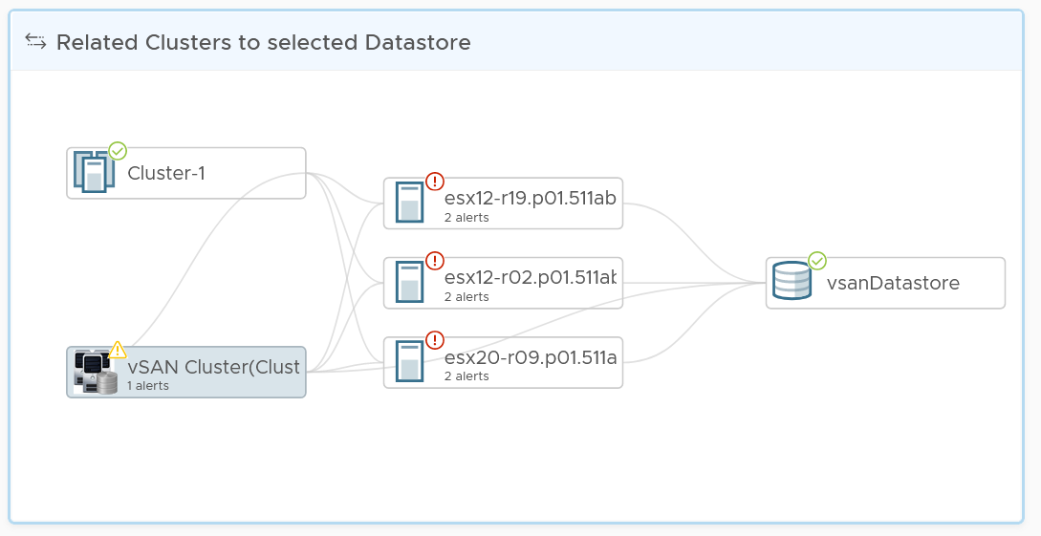

The following table shows the contention metrics for the 3 object types:

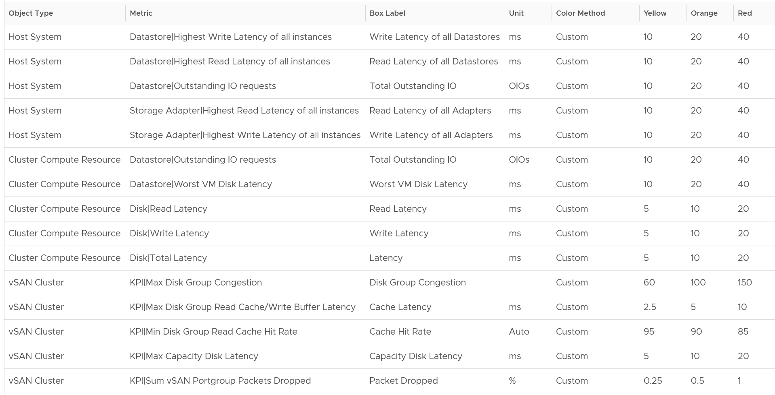

Just like all the contention metrics, they are color coded for ease of analysis.

The following table shows the utilization metrics.

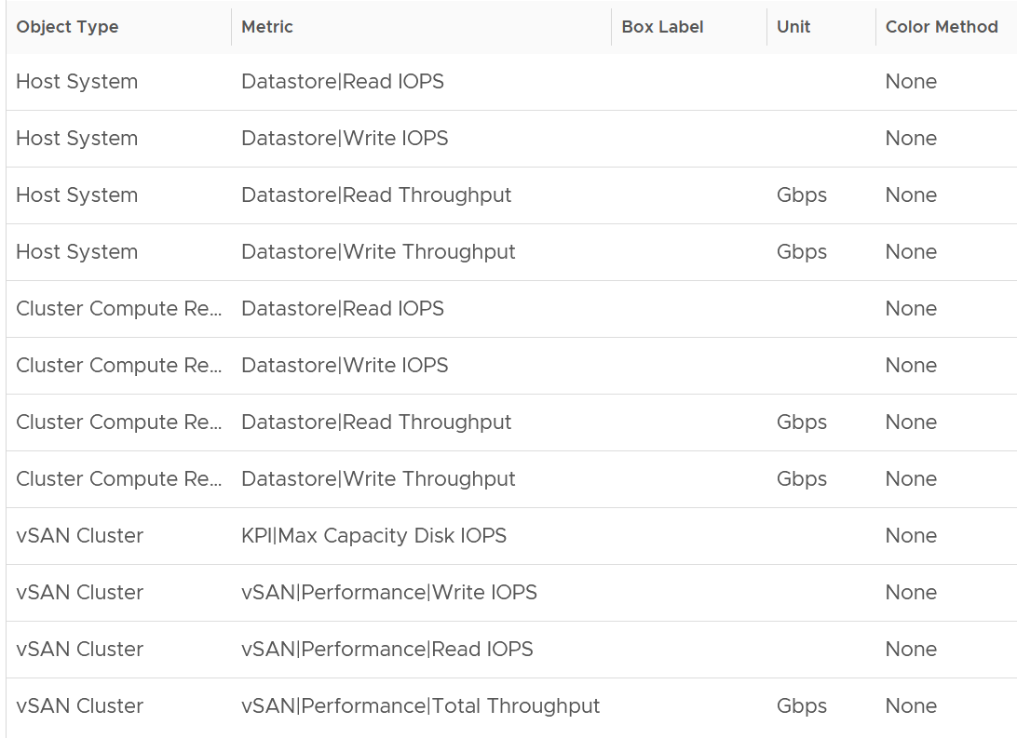

Just like all the utilization metrics, they are not color coded so not to give the wrong conclusion.

### vSAN Performance

This dashboard is designed to complement the vSphere Cluster Capacitydashboard. It focuses on the storage and vSAN specific metrics, and does not repeat what’s already covered. It also does not list non vSAN cluster. That’s a long winded way to say you gotta use both dashboard to manage vSAN performance 😊

#### Cluster Analysis

The table lists all the vSAN clusters, starting with cluster with the highest VM disk latency. By default, it’s showing data from the last 24 hours as this dashboard is designed to be part of your daily SOP.

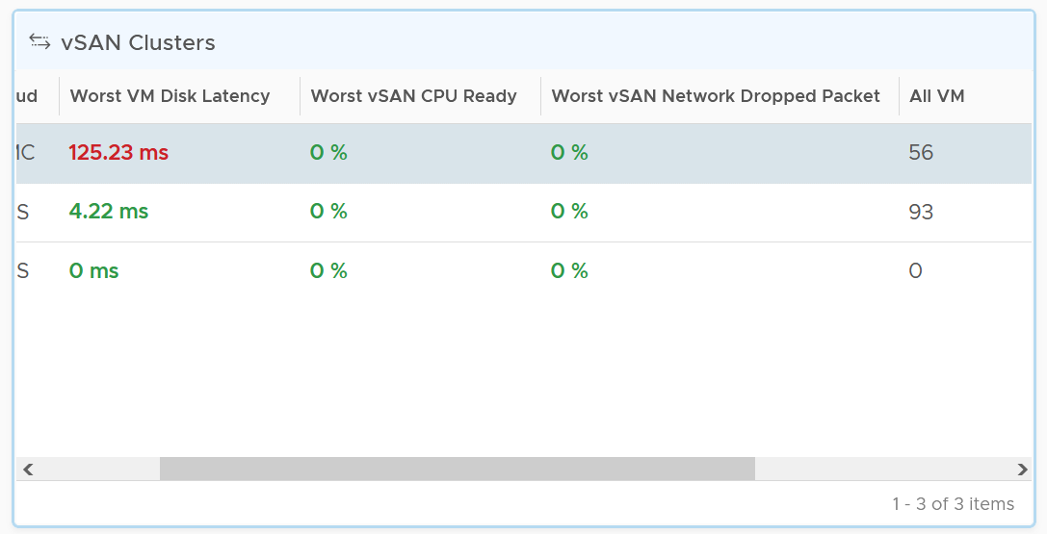

All Flash and Hybrid have different performance. Since there is only 1 benchmark, the all flash will perform better than hybrid, and that’s what you expect to see.

The first column shows if the distribution of disk latency experienced by all the VMs in the cluster. You should expect majority of the VMs to experience latency that matches your expectation. For example, in an all flash systems, the VMs should not be having >10 ms disk latency. If your vSAN environment is all flash, you may need to adjust the distribution bucket to a more stringent set.

The second column shows if any of the vSAN kernel module has to wait for CPU. Expect this number to be near 0% and below 1%, as vSAN should not be waiting for CPU time. vSAN gets higher priority than VM World as it lives in the kernel space.

The third column shows if any of the vSAN cluster is dropping packet in the vSAN network (not the VM network). vSAN relies on network to keep the cluster in-sync. This number should be near 0% and less than 1%.

Select a cluster to investigate further. Its VM latency distribution will be automatically shown.

What can you conclude from the following 2 bar charts?

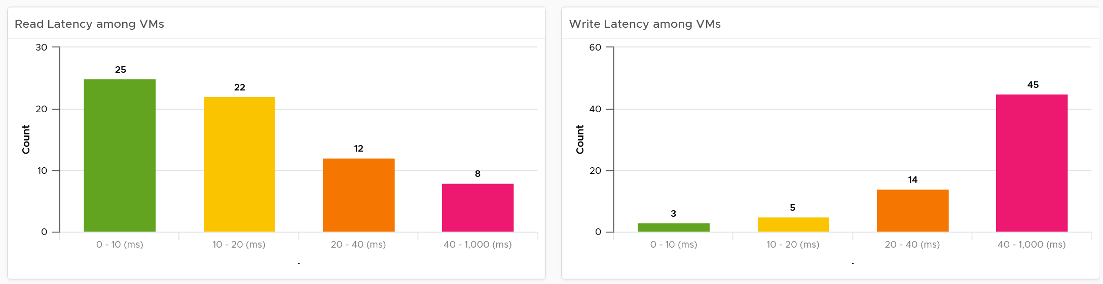

You can tell that most VMs in the selected cluster experience write latency, but not read latency. This helps you choose the right path of investigation.

The latency counter above is not at VM level. It’s at virtual disk level, meaning if a VM has 10 virtual disk, it takes the highest among any of them.

##### Contention

You can see various disk-related contention metrics of the cluster, as shown below.

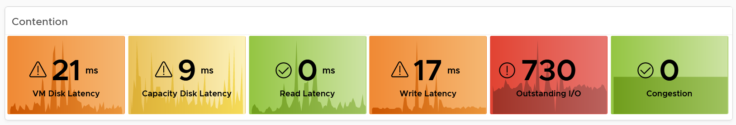

All these metrics are at vSAN cluster level, so there are some roll up involved. Why are the Read Latency and Write Latency not shown as the first metrics?

They are average. By the time the group average is bad, you could have half the population in worse situation. One way to overcome is to use a tighter threshold, as shown in the following table.

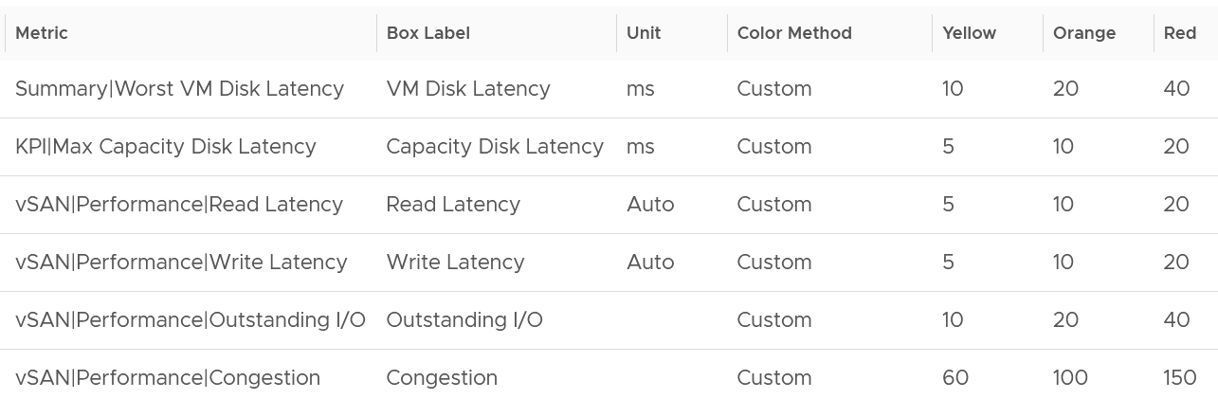

Read and Write are split as they tend to have different patterns.

##### Utilization

As expected, we complement the contention metrics with utilization metrics.

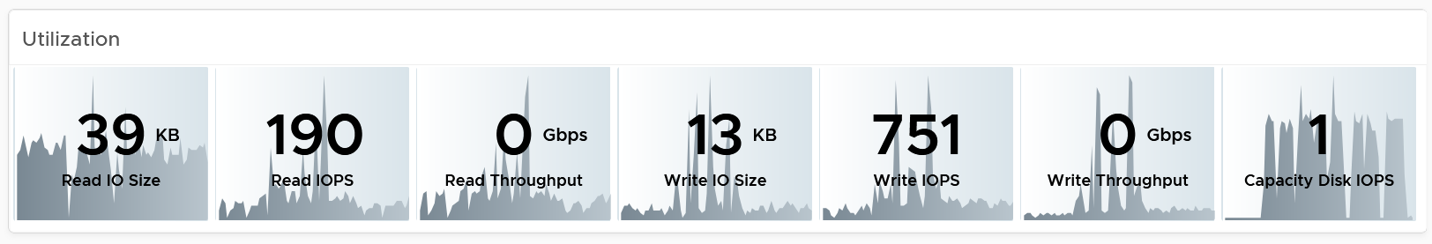

Large block size can result in high throughput in relatively low IOPS. If you are seeing large block size when You are not expecting it, investigate which applications are the using it.

Max IOPS among capacity disk is shown as a disk has a limit, especially magnetic disk. A typical magnetic disk delivers ~200 IOPS, and this can be easily saturated.

##### Disk Groups

You can drill down to the disk group level. All these metrics are the worst value among the disk groups.

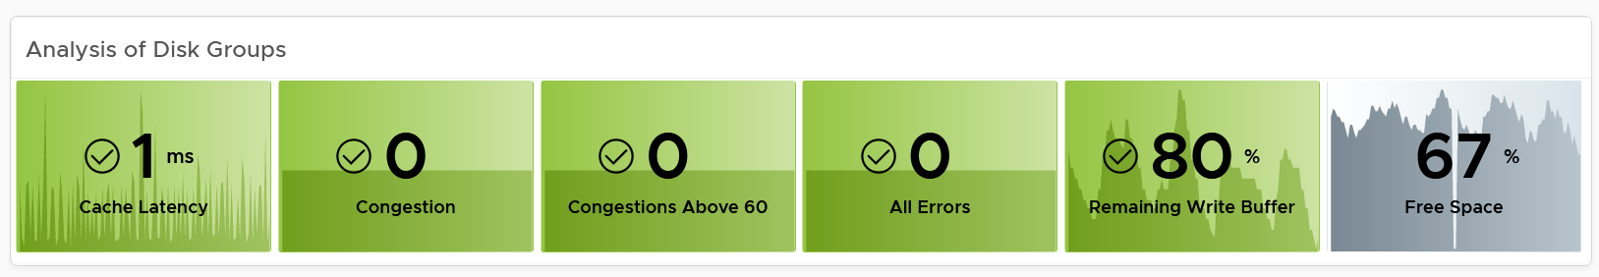

Same thing with the read cache. All the values shown below are the worst value among the disk groups’s read cache

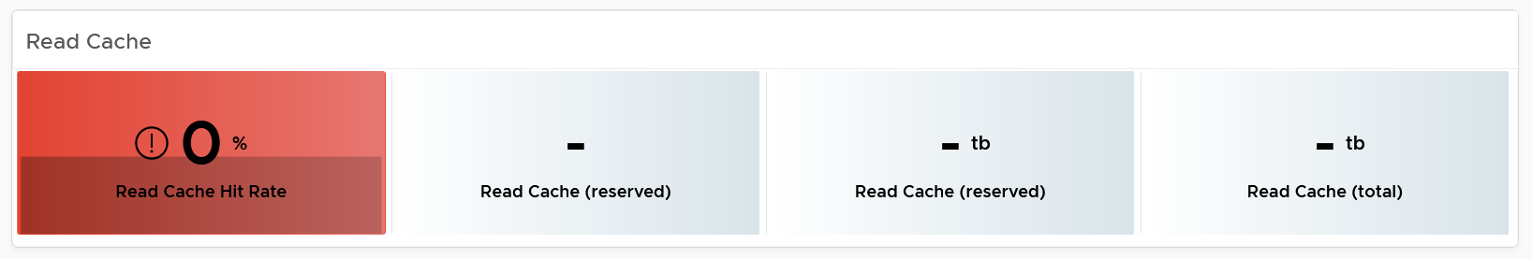

##### Other KPIs

The performance problem could be caused by non storage.

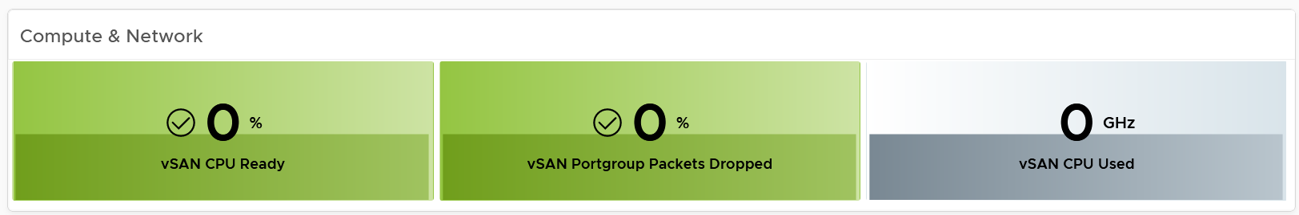

vSAN Resync is a type of utilization metric, but its presence can impact performance. vSAN has two scenarios that trigger rebalance (the reason for resync).

* Proactive: A large variance among devices disk space utilization.
* Reactive: When devices reach a critical capacity threshold (typically ~80%). This adjustment can be in the form of object components moving to other disks, disk groups, or hosts, or even splitting of existing large components into smaller components to achieve the desired result.

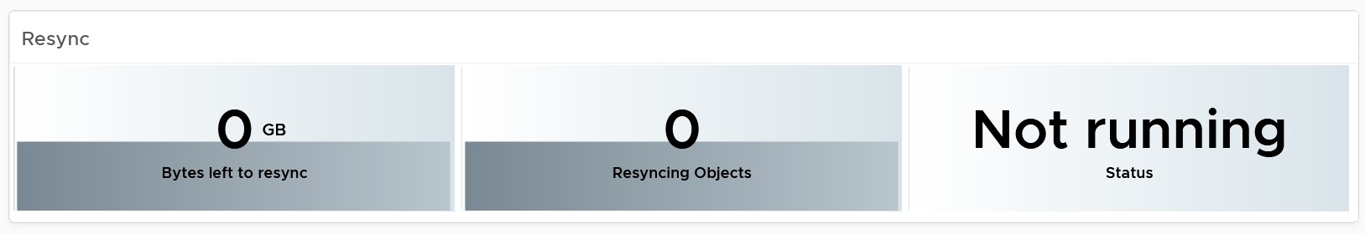

#### Disk Group Analysis

You can drill down into individual disk groups.

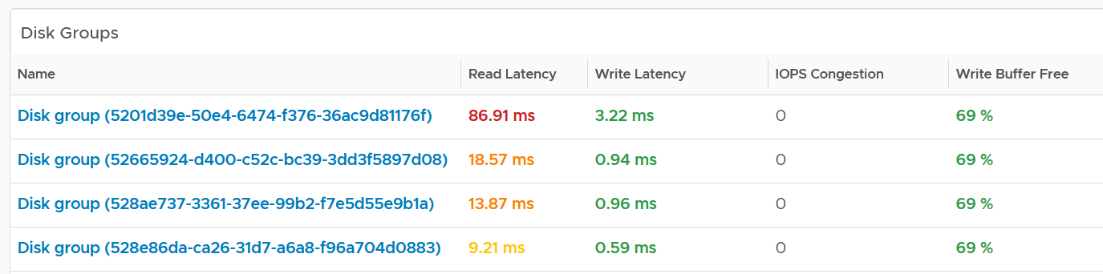

Make sure they are fairly balanced. If not, you have a hot spot.

Select a disk group you want to analyse. Both the contention and utilization metrics are automatically shown.

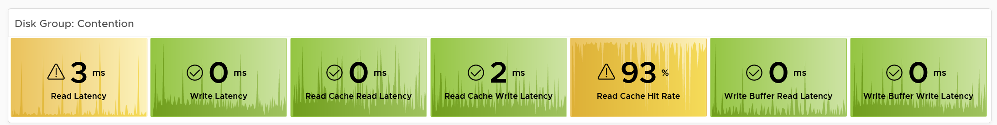

There are more metrics for the utilization. To avoid the name being truncated, I keep them short. To see the full name, simply mouse-hover over the counter name, as shown below.

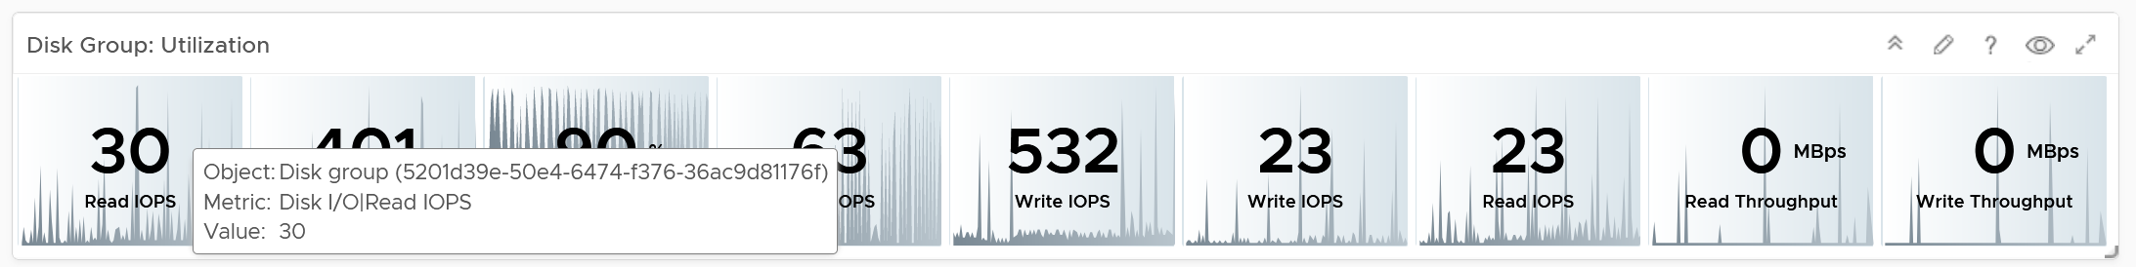

For the throughput metrics, why do I choose bytes instead of bit? I use MBps, not Gbps.

Revisit the Units section in Part 2 Metrics for the answer.

##### Cache Disks

You can drill down into individual disk groups. As this is SSD, you should expect their values to be below 5 ms.

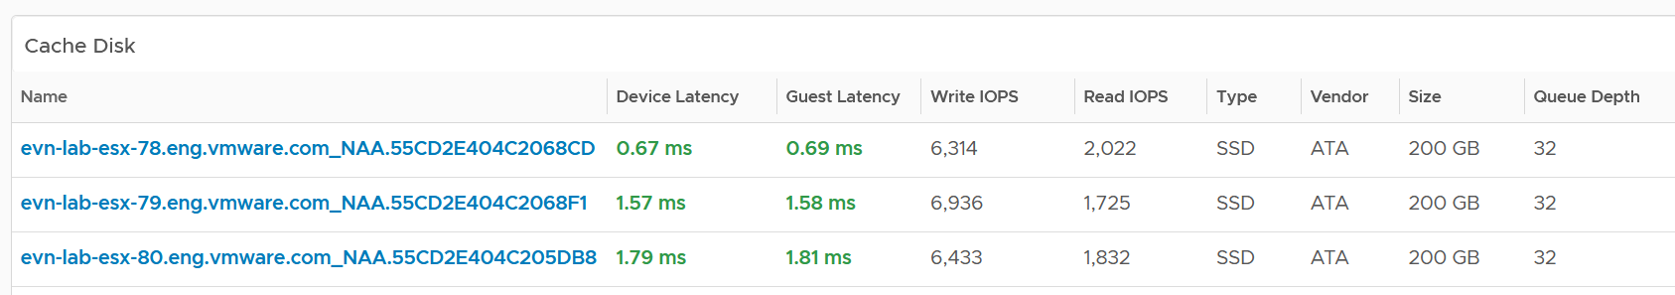

The configuration is also shown. Make sure they are consistent.

Select a cache disk you want to analyse. Both the contention and utilization metrics are automatically shown.

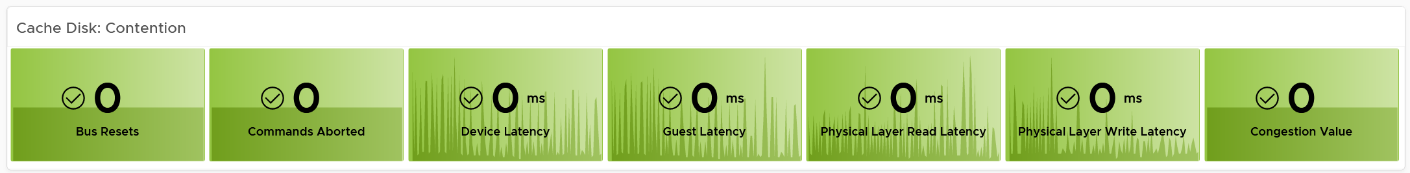

vSAN has various layers, which is covered in Part 2 Chapter 4 Storage Metric.

Congestion is a special derived metric in vSAN.

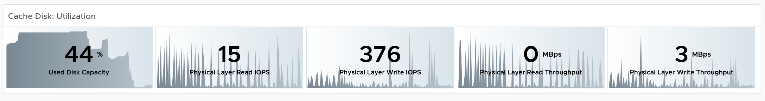

Why is the cache disk space utilization not considered contention?

Because 90% used does not mean it’s faster or slower than 80%. We can’t color code it.

##### Capacity Disks

You can drill down into individual disk groups. The latency value will vary between magnetic and SSD.

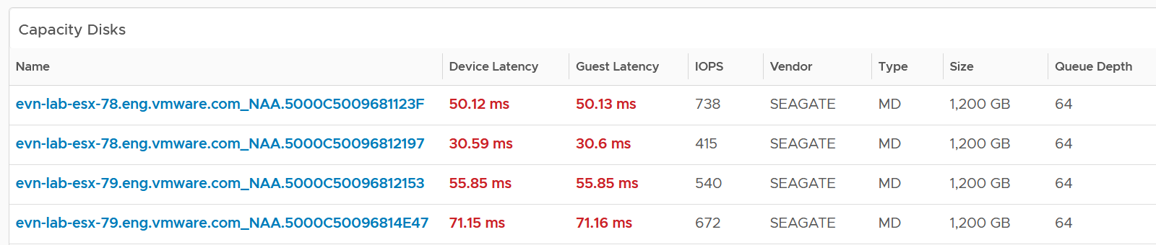

The configuration is also shown. Make sure they are consistent.

Select a capacity disk you want to analyse. Both the contention and utilization metrics are automatically shown.

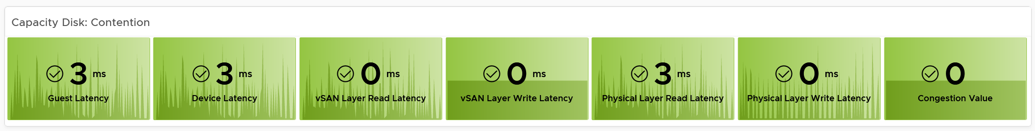

At this level, what you can do is basically observing if there is a hot spot.

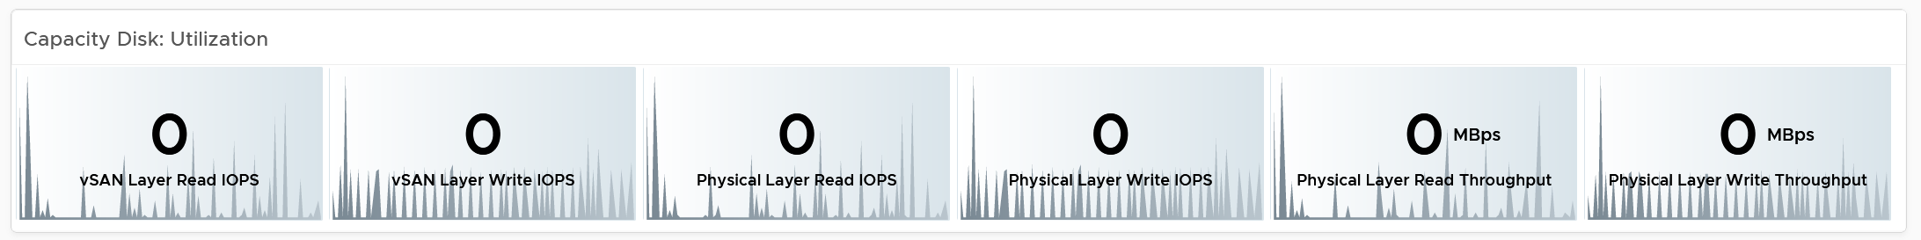

### Network Performance

Use the Network Performance dashboard to view performance problems related to network such as high latency, frequent retransmit, and many dropped packets. This dashboard is designed for both VMware administrator and Network administrator, with the goal of fostering closer collaboration between the 2 team.

The dashboard enables drill down from distributed switch to the ESXi host and port groups in the switch, and then to the VM.

#### How to Use

Review the **Distributed Switches** table

* It lists all the switches, sorted by the highest packet dropped. The table splits the incoming traffic and outgoing traffic for better analysis.
* As the focus is performance and not capacity, the throughput metrics are not shown.

Select a switch from the table

* The health chart will automatically show the dropped packet trend over time.

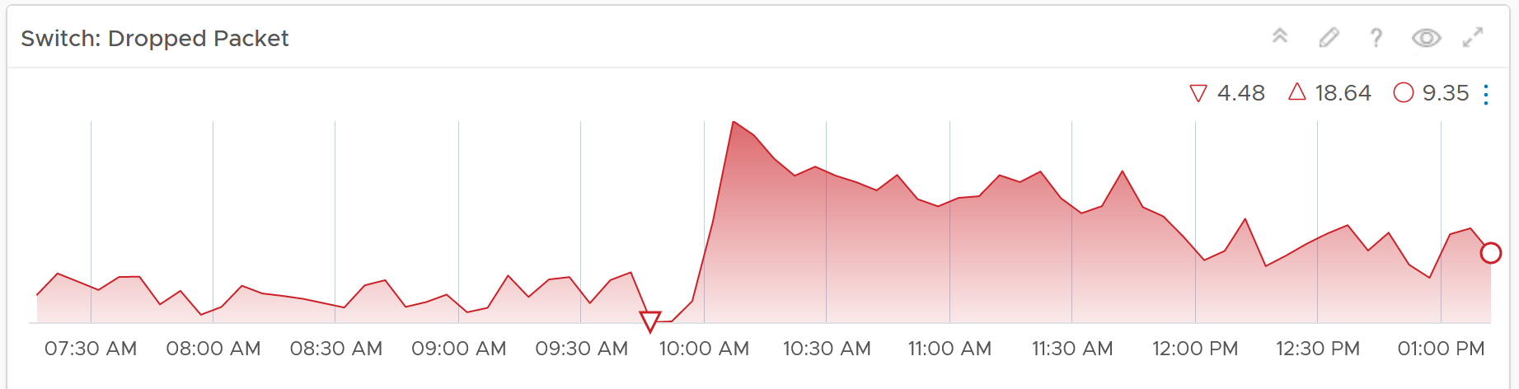

* However, it will not narrow down the list of port groups automatically, as the list of port groups are always showing all the port groups in your environment.
* If necessary, expand the 2 collapsed widgets. They are showing the network throughput and broadcast packets. Utilization is also shown so you can correlate if the dropped packets are due to higher utilization

Review the port groups and ESXi hosts in the selected switch

* They are automatically listed when you selected a switch from the table above.
* Just like the distributed switch, you can also see their relevant countes. The following shows the same chart, except for a single port group.

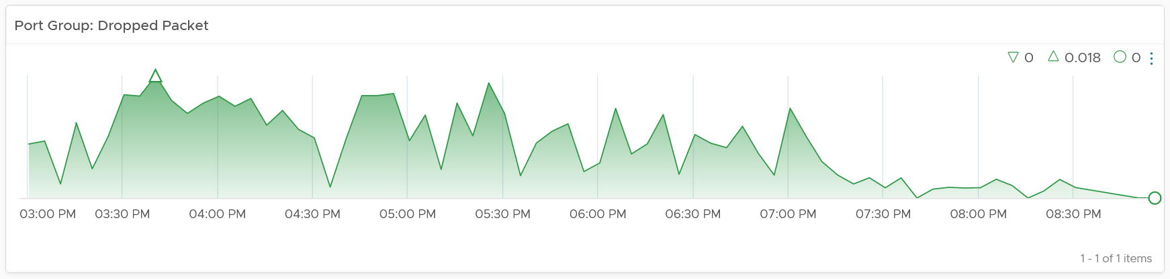

If your environment has unused network switches, you can filter them out from this list, as this dashboard focuses on performance.

#### Points to Note

Network latency within a data center should be below one millisecond. Use vRealize Network Insight to study the latency or the retransmitting problems, caused by moving into the lateral traffic.

Add a physical network using the appropriate management pack, such as True Visibility Suite.

Most packets are unicast, between a pair of sender and receiver. If your environment has many VMs sending broadcast packets to everyone and multicast packets to many targets, add a Top-N widget to find out which VMs are sending these packets.

To prove that Network is performing well:

* No Errors.
  + Not a single ESXi host is experiencing packet drops in any of its NICs (vmnics). If there are, show the ESXi names.
  + Not a single VM is experiencing packet drops.
* Latency
  + Good round trip latency. No network trombone across physical datacenters if NSX is used.
* Utilisation
  + Not a single VM is hitting its limit, be it 1 GE or 10 GE or higher.
  + Not a single ESXi vmnic is hitting its limit.
  + Total bandwitdh hitting the physical switches is below capacity.
* Special network
  + The broadcast network is minimal. For both ESXi and VM.

## Capacity

**Part 3 Chapter 4**

The capacity dashboards aims to implement the capacity concept covered in Capacity Management chapter, and complement the existing product pages.

### Compute Capacity

The compute capacity dashboad covers vSphere clusters with their associated ESXi host and resource pools, as they impact the cluster capacity.

#### Overall Analysis

The 3 bar charts show all the clusters, summarizing the overall situation. The first 2 are shown below.

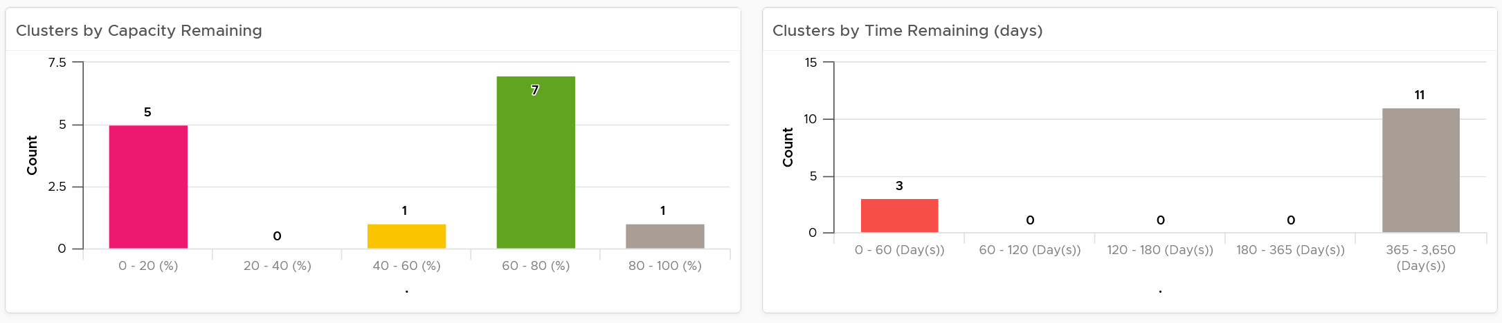

The first two bar charts work *together*. Just because you are running low on capacity does not mean you are running out of time. Cluster with a cyclical load that hits high utilization but never trends toward 100% will have low capacity remaining, but plenty of time remaining.

Generally speaking, the ideal situation is low Capacity Remaining and high Time Remaining. This means your resources are cost effective and working as expected. For clusters where you intentionally need to run at low utilization (e.g. stretched cluster), increase its buffer accordingly so the capacity metrics will reflect that.

The 3rd bar chart is VM Remaining. It gives more complete contexts, as different clusters can have different VM size.

The bar charts can’t show the parent data centers. It also can’t show all the clusters, individually. For a large environment, a heat map comes in handy.

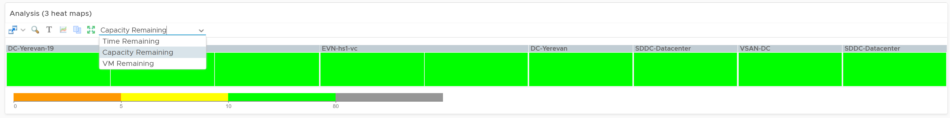

The three heat maps are Time Remaining, Capacity Remaining, and VM Remaining.

The color indicates usage. Low utilization is marked as grey, not green, as it represents waste.

Why is the box size made identical?

For ease of use and better focus on the action to be taken. Otherwise the small clusters will be dwarfed by the large ones.

If your cluster sizes are not standardized, create another heat map, and use the number of ESXi hosts to show the size difference.

A table provides the next level of details.

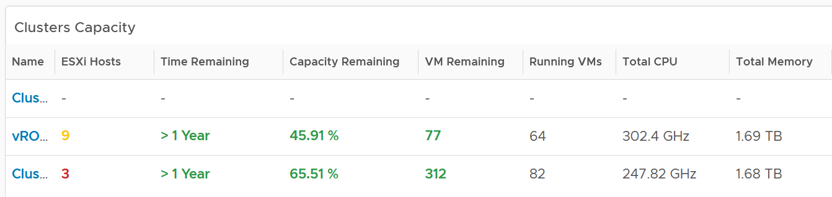

The number of ESXi hosts are color coded as smaller clusters have relatively higher overhead.

#### Cluster Analysis

Select a cluster from the table. Its detail capacity will be automatically shown.

##### Performance

The first thing it shows is the cluster performance. Make sure this is within your expectation.

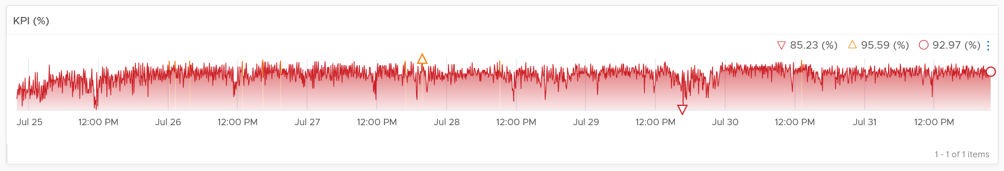

The counter is covered in Performance chapter and Performance dashboard.

##### Utilization

The next chart is utilization. It’s showing in %, as it’s relative to your usable capacity.

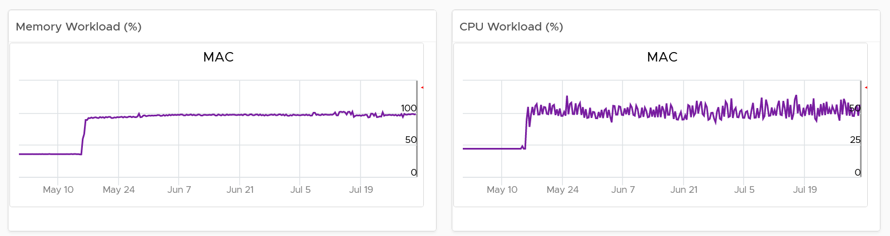

Utilization displayed for three months and not one week. The daily average is displayed and not the hourly average, so you can focus on the overall trend.

For memory, the focus is on consumed memory and not active memory.

If it’s useful to you, add peak to complement average utilization. The peak is defined as the highest among any ESXi hosts. If the peak is higher than the cluster-wide average, then the cluster is imbalance. Find out the cause of imbalance and optimize it.

If you have the screen real estate, add the absolute utilization.

##### Allocation

Next is Allocation, as not all demand is real. You need to use both models.

Workload can be low, but is overcommit ratio high? Newly provisioned VMs tend to be idle for weeks, and suddenly grow.

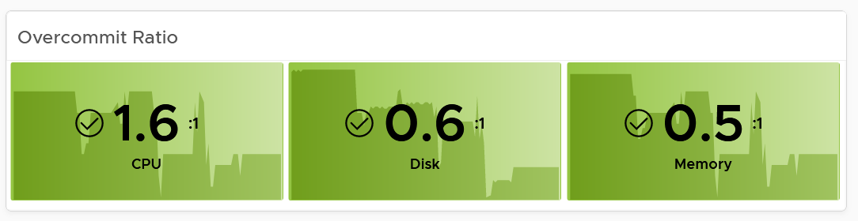

You can see the trend of the 3 components together on a chart if that is relevant to you. In general, your CPU overcommit should be the highest, followed by disk (due to thin provision). Memory overcommit tends to be near 1 due to its nature as cache.

Use the line chart to see the trend. As usual, the data is averaged hourly so you can focus on the big picture.

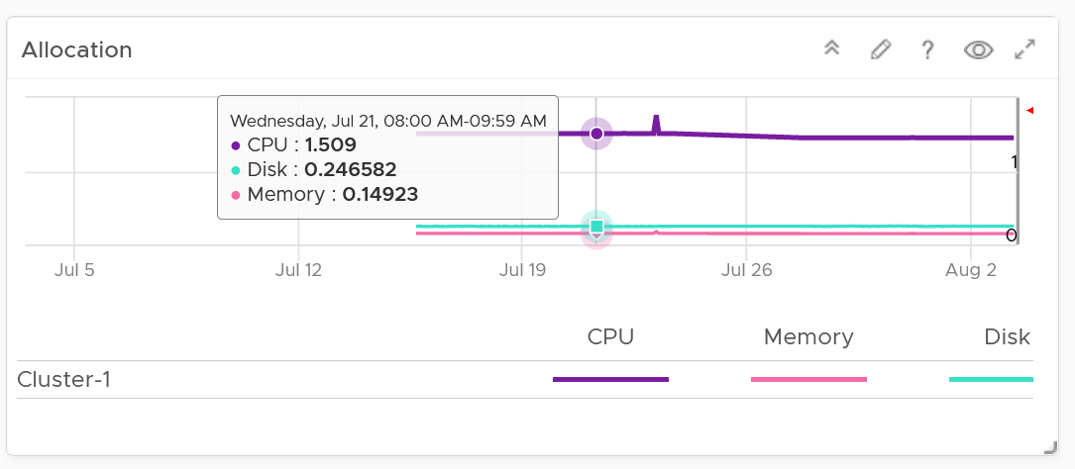

Next is the VM Count. A trend line of number of VM over time is important to spot if there are many newly provisioned VM. If you see VM growing but demand remains low, that's a sign of potential demand coming up in the future.

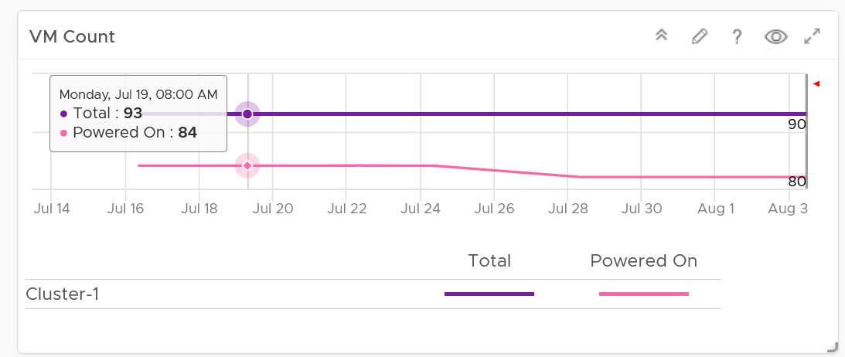

BTW, the overall VM:ESXi ratio is a common numbers cited to senior management. It’s often measured as efficiency proof.

##### Reservation

Reservation can impact the efficiency of your cluster. Why is the cluster low on capacity? Is it because of real workload, or just reservation?

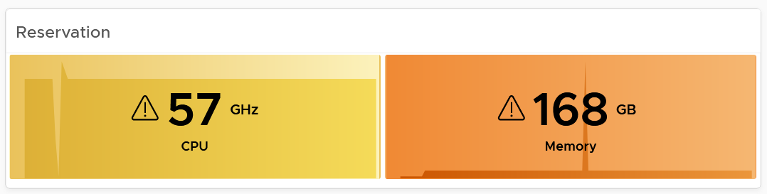

If your cluster size varies, complement the reservation number by showing relative value. Once you have a standardized number, you can visualize them on a heat map! This enhancement requires super metric, good practice! 😊

##### Reclamation

As covered in the Capacity Management chapter, there are 6 types of reclamation. Some of them are shown below.

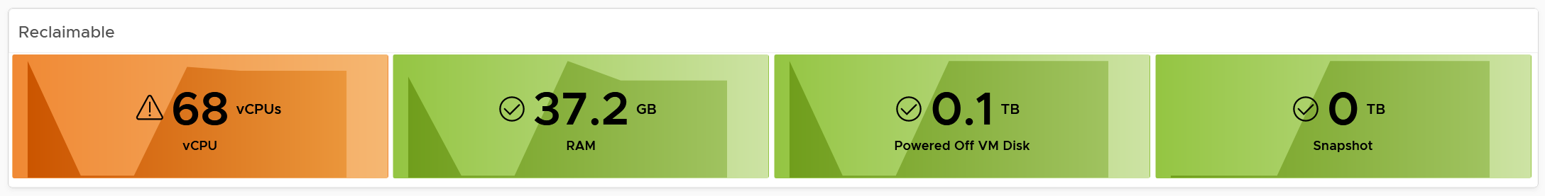

If it’s relevant to your environment, add the number of undersized CPU and undersized memory.

#### ESXi Analysis

Just because the cluster capacity is good, does not mean there is no issue at ESXi level. Imbalance is common issue, especially in large cluster and stretched cluster.

The following table shows all the member ESXi. You can see the imbalance clearly, thanks to the color code.

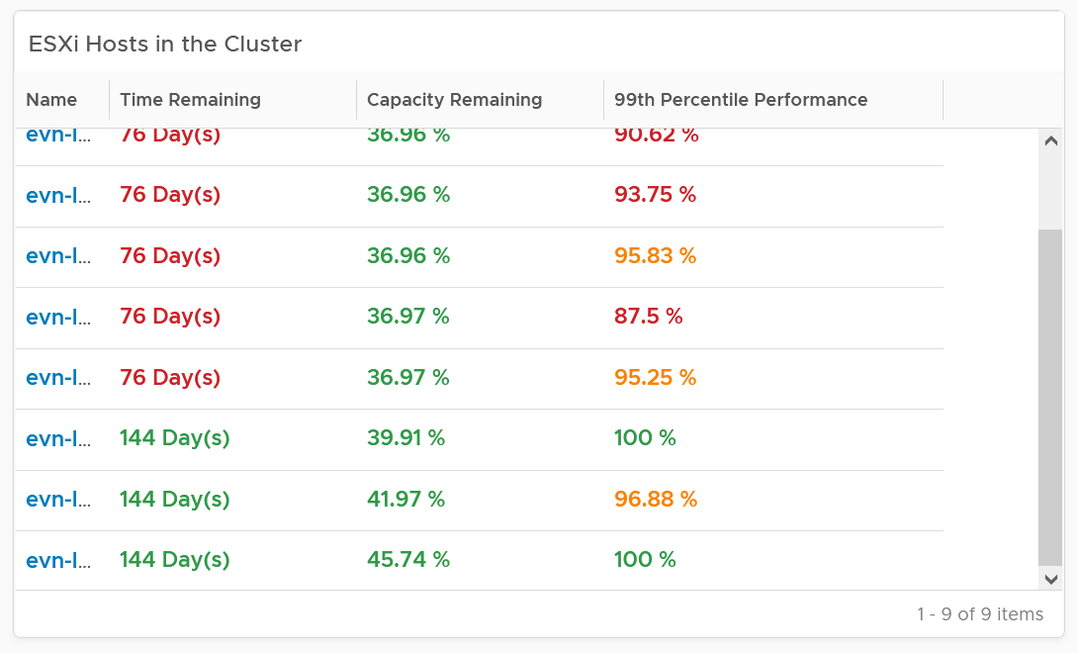

The 99th percentile Performance column takes the 99th percentile value of the ESXi Performance (%) metric. The reason we’re not taking the worst performance (which is equivalent to 100thpercentile) is to rule out outlier. In addition, the performance threshold has been set to be stringent.

Select one of the ESXi. All its detail will be automatically shown.

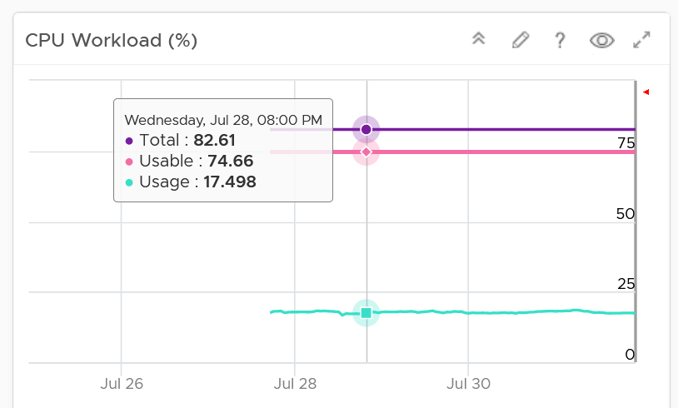 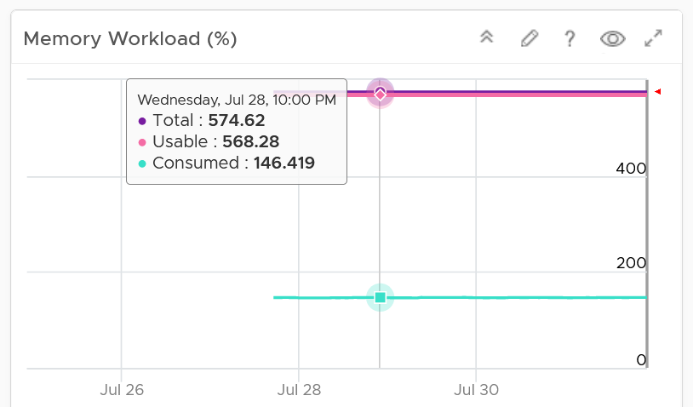

Both CPU and memory trend line charts show if it’s steady demand, cyclical demand, rising demand, or declining demand. The trend is as important as the present value. To see trend, you need to see over longer time. Utilization is displayed for three months and not one week. The daily average is displayed and not the hourly average and the focus is on memory consumed and not memory active. Note that memory consumed includes the total memory consumed, so it includes memory consumed by VMkernel.

Both total and usable utilization in terms of memory and CPU are displayed. This gives you the absolute amount of capacity.

A technology refresh is often used to address capacity shortage. The relevant configuration shows the hardware model and specification to help you determine the age of the hardware.

#### VM Analysis

What’s causing the low capacity remaining? Which VMs are impacting what infrastructure resource (CPU, memory, disk space)?

Use the following table to analyse. It lists either the VMs in the cluster or host.

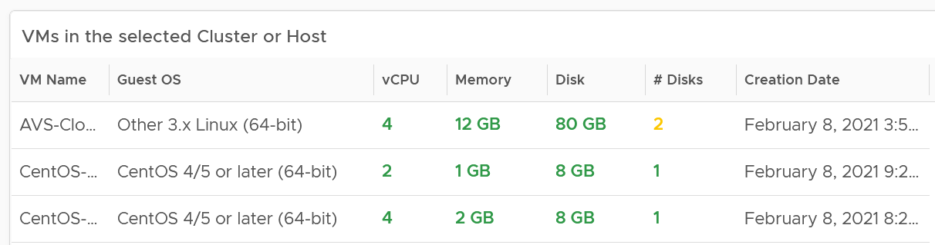

You can select one of the VM, and additional relevant information will be shown.

You can enhance this by using 2 heat maps, one for CPU and one for memory. Shows all the VM, sized by configured and color by capacity remaining. If you see many large VMs running low on capacity, that means you should stop provisioning until you upsize existing VMs first.

### Datastore Capacity

This dashboard complements out of the box capacity pages and dashboard. It focuses on storage, provides overall picture, and highlights the datastores that need attention. ​

#### Overall Analysis

“What do I have in terms of capacity?”

The summary banner answer basic questions like this.



If required, customize it. I keep it simple as you don’t actually have 1 contiguous storage pool. Just because you have 100 TB available in South Pole DC does not mean your servers in North Pole DC can use it, unless you tunnel dark fibre over earth core.

Next is the distribution chart. Do they look familiar?

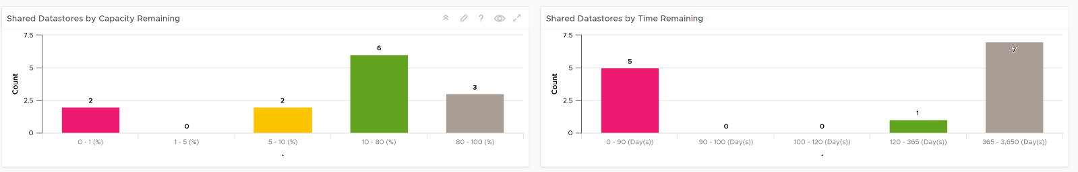

It’s intentionally designed to be consistent with the Cluster Capacity dashboard.

As you can expect by now, next in the dashboard is the heat map.

There are three heat maps, the primary being Remaining Capacity heat map. The 2 other heat maps cover Used Capacity. One of them is designed for environment that use Datastore Clusters.

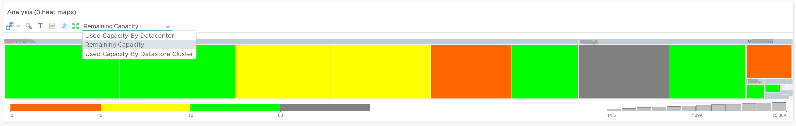

Each box represents a datastore. If you have many datastores, the heat map will group them. You can drill down to see its members. The larger the datastore, the larger its box is. If you have many small datastores, consolidation can make operations easier.

Following the design used in Capacity dashboard, next is the table listing all the **Shared Datastores**.

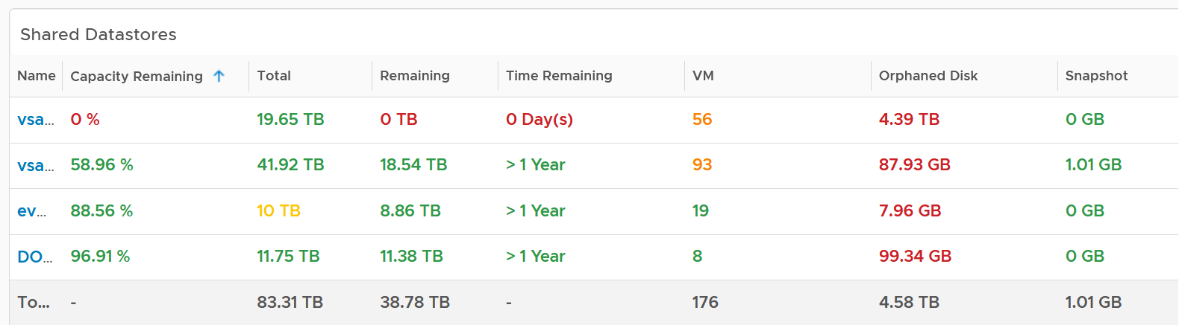

The table provides a summary, showing all datastores a glance. They are grouped by Data center. If you use Datastore Cluster as your standard and it suits you better, replace the grouping with it.

By default, the table is sorted by the least capacity remaining.

There are 3 reclamation opportunities: powered off VM, snapshot, and orphaned VMDK.

Why is Idle VM not included?

Because you should power off first, and let it go through powered off period before deletion.

#### Datastore Analysis

Select a datastore from the table. Its detail capacity will be automatically shown.

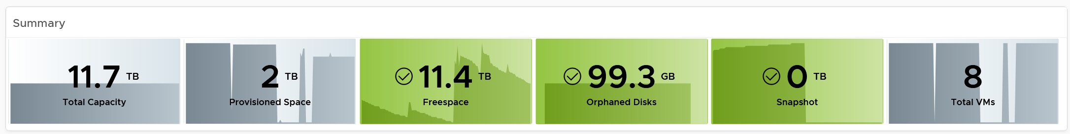

The snapshot should be 0 GB. If it is not 0, then it should be temporary. A snapshot lasting beyond a few days should be investigated.

Orphaned Disks are VMDK files that are not associated to any VM. Expect it to be 0.

For disk space, the total capacity, allocated and actual used are shown. What does it mean when the provisioned disk space metric grow but the actual used does not?

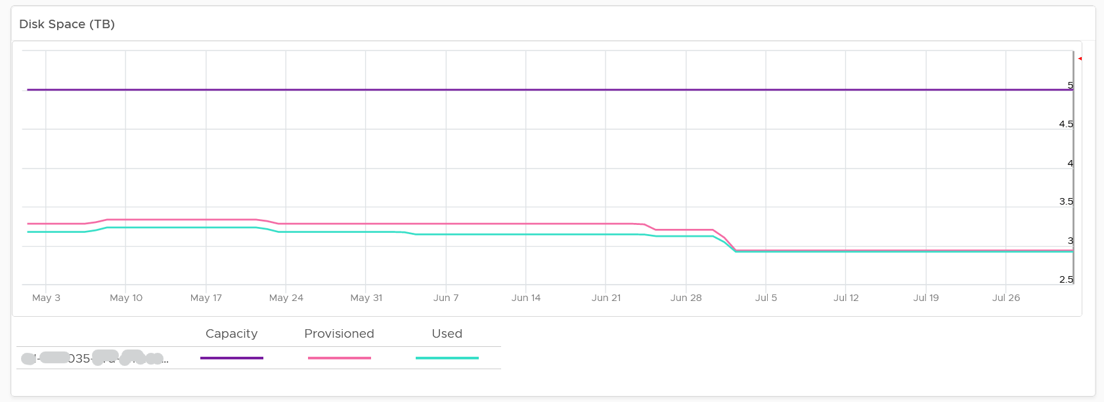

That means the VMs are yet to use it. Watch out, you can run out of space sooner than expected.

The value is daily averaged to show the big picture. Having 5-minute spike can visually make the chart harder to read.

If you use allocation model, add a second line chart showing the allocation over time. Add a threshold so you know how close you are.

#### VM Analysis

If you need to analyse at VM level, review the table listing all the VMs in the datastore.

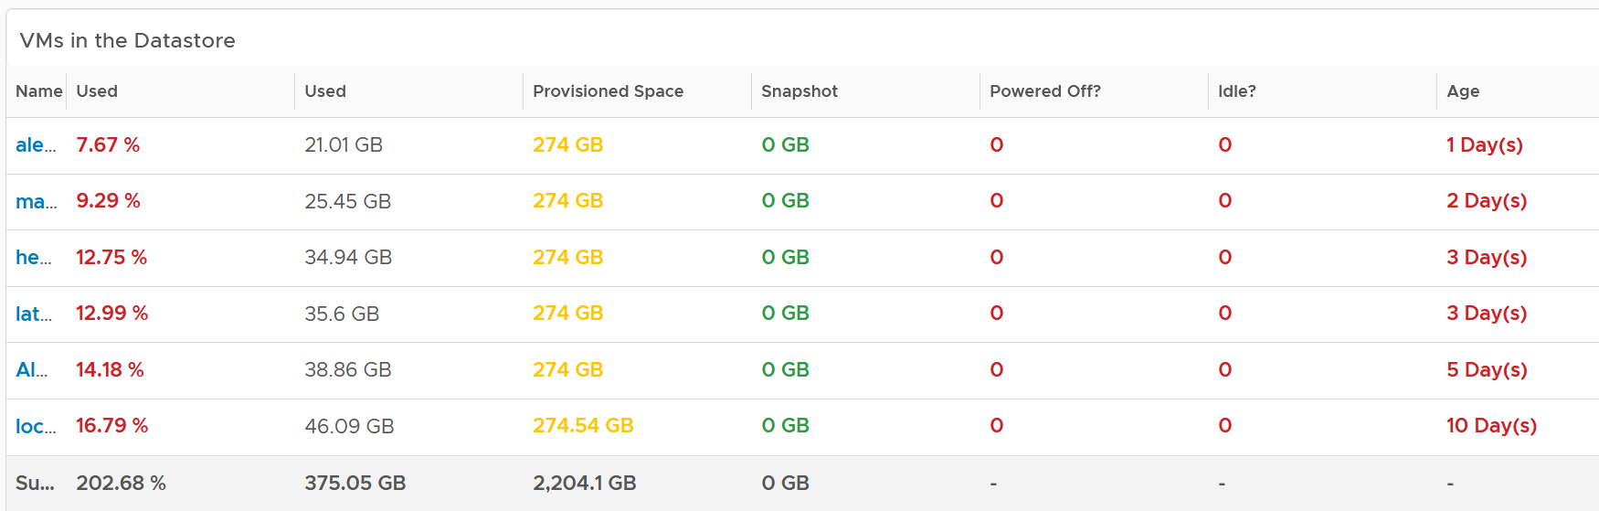

If you have hundreds of VMs, create a heat map showing all the VMs. Color it by the used space so you know if the VM is reaching its full size. Size it by the allocated size so you can see who the big VMs are. If the big VMs have plenty of space to grow, watch out.

Click on the VM you want to investigate further. You get to see its usage over time.

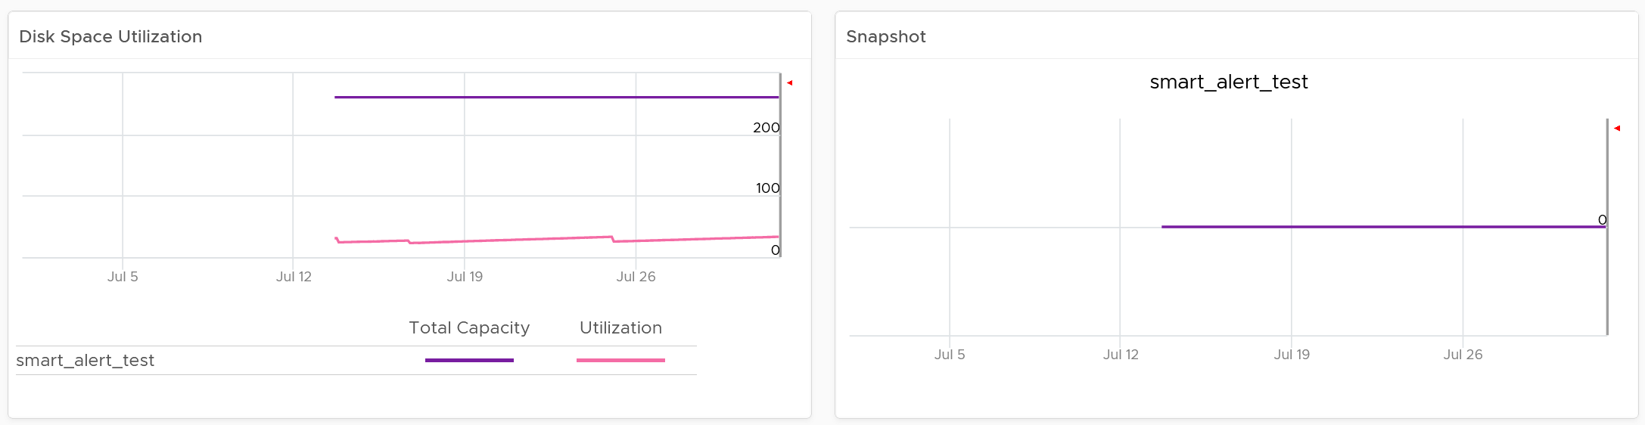

#### Local Datastores

They are shown separately as a table on its own, at the end of this dashboard. Avoid running VMs on local datastores, unless its storage requirements can be met with a local disk and it does not need vmotion.

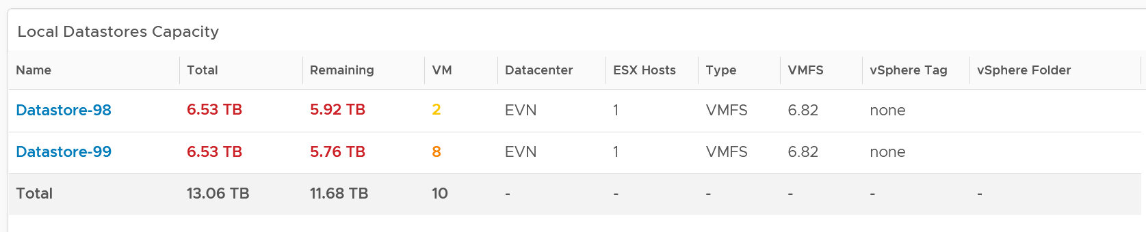

#### Points to Note

If you are using “thin on thin”, meaning the underlying LUN is also thin provisioned, add visibility into the physical array.

The dashboard does not have datastore clusters. If your environment use it, modify this dashboard or create a new one. In a large environment with many datastores and datastore clusters, add a View List to list the datastore clusters so you get summary information. From this list, drives the datastoreview list. Alternatively, create a heat map, listing the datastore clusters.

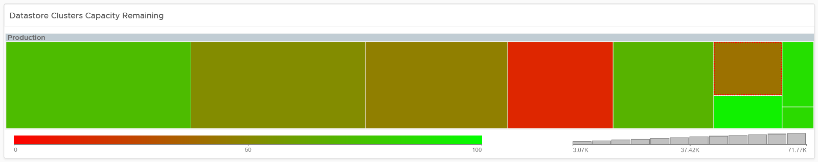

### ­vSAN Capacity

The **vSAN Capacity** dashboard complements the **vSphere** **Cluster Capacity** dashboard by showing vSAN related capacity. It focuses on the storage and vSAN specific metrics, and does not repeat what’s already covered. That’s a long winded way to say you gotta use both dashboards to manage vSAN capacity 😊

Because the metrics are vSAN specific, this dashboard does not list non vSAN cluster.

#### Overall Analysis

The dashboard starts with the familiar bar-chart combo that Cluster Capacity dashboard has. The difference is this focuses on the vSAN disk space, not compute and network.

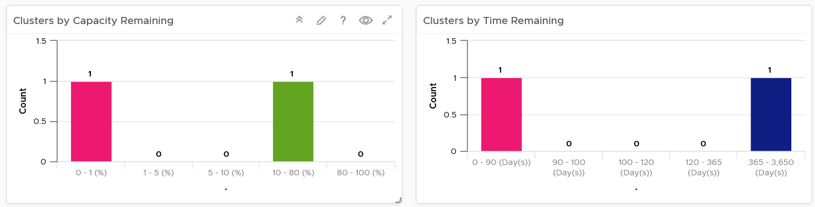

Similar to Cluster Capacity dashboard, next is a heat map. There are 2 heat maps provided.

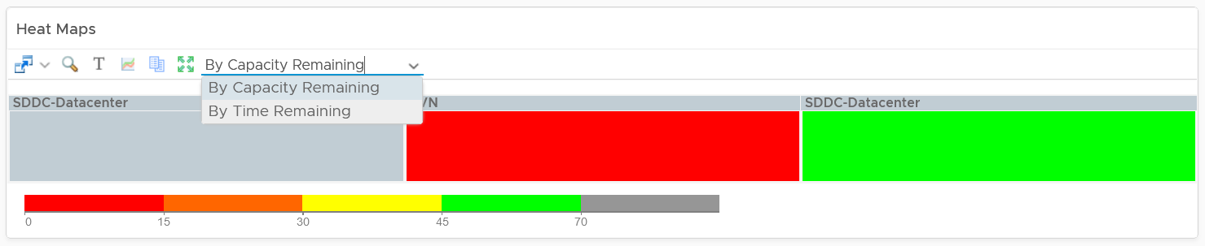

Why is the box size made identical?

Head to the Cluster Capacity dashboard for the explanation.

As you can expect, a table provides the next level of details. The difference is you get vSAN specific metrics.

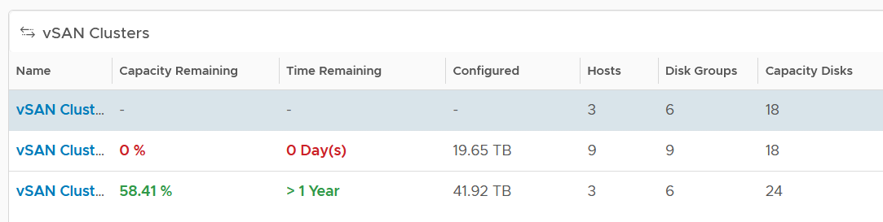

If it’s useful, add metrics such as total disk capacity and used.

#### Cluster Analysis

Select a vSAN cluster from the table. Its detail capacity will be automatically shown.

##### Utilization

It’s showing the utilization for all 3 elements, as you need to consider all three. Network is not shown as typically it’s not an issue and it’s complex to model.

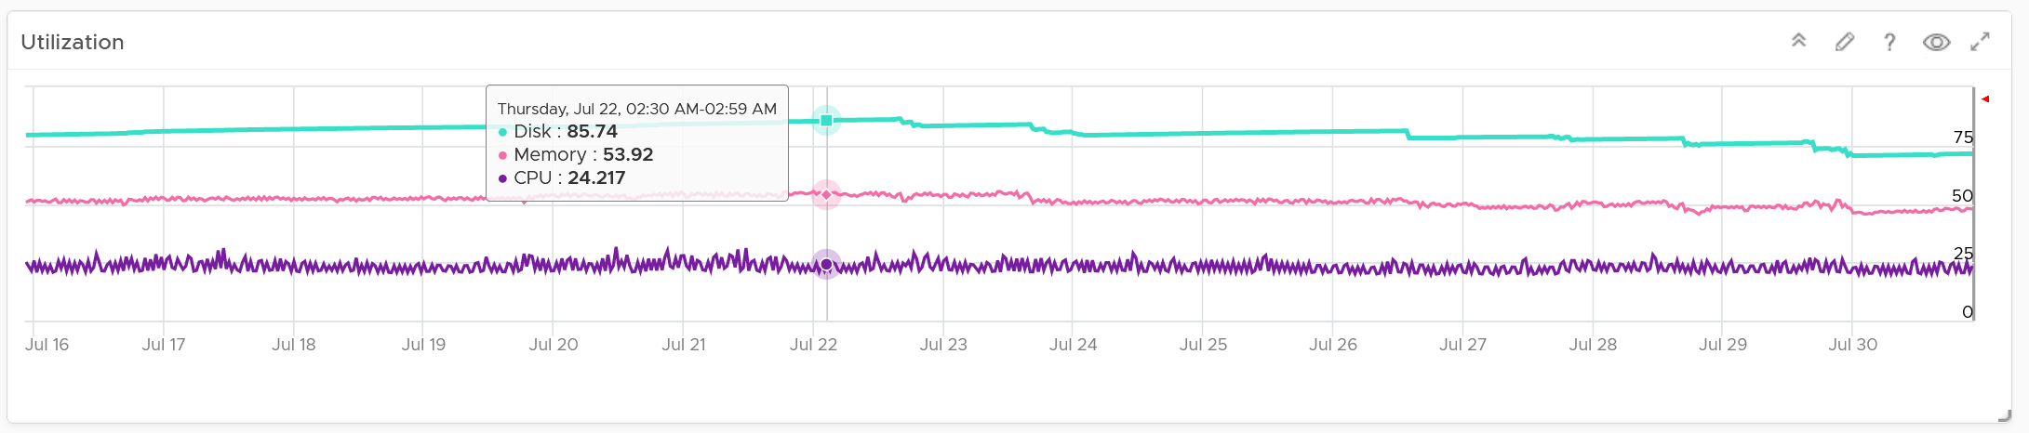

Just like physical array, there can be hot spot and imbalance. The following heat map shows individual disk groups.

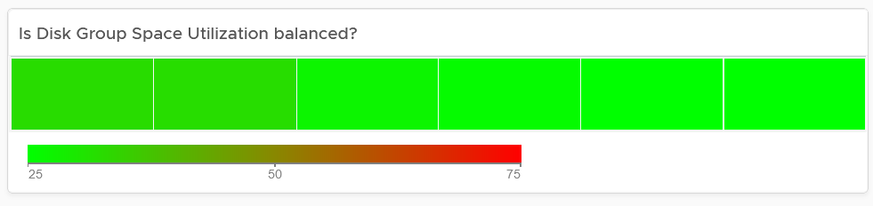

Notice they are all green but not identical. It’s normal for them to have minor variance.

##### Reclaimable

It’s a key component of proactive capacity management. The dashboard shows you both the VMs and non VMs portion.

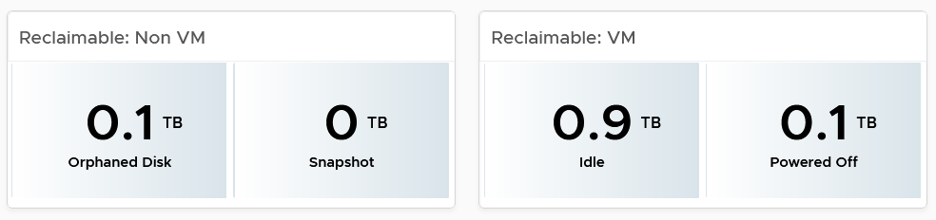

##### Dedupe and Compressed

The scoreboard shows details on this area.

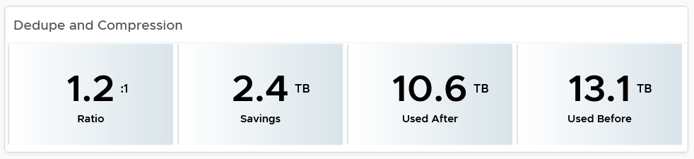

If you are concerned with the CPU usage from the dedupe and compress feature, add a line chart of vSAN CPU usage.

#### Disk Group Analysis

If there is imbalance, you can drill down into each disk group. Otherwise, skip this section.

The following table shows all the disk groups in the cluster. Their usage may not be similar but they should not deviate drastically.

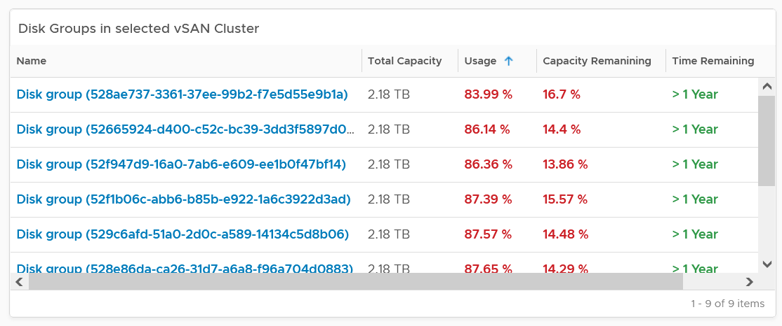

To see any of the disk group usage trend, click on it.

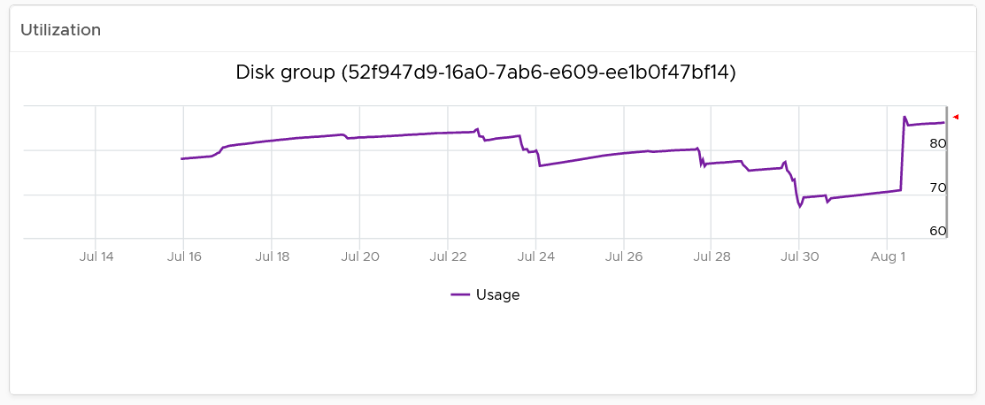

In addition a heat map is provided to see the usage among the capacity disks in the selected disk group. Expect them to be uniformed at this level as it’s RAID striping.

#### VM Analysis

You can get down to individual VMs in the selected cluster, and check their usage and snapshot.

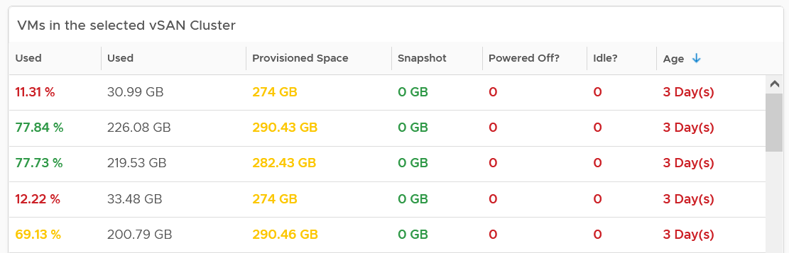

To see the usage trend, select the VM.

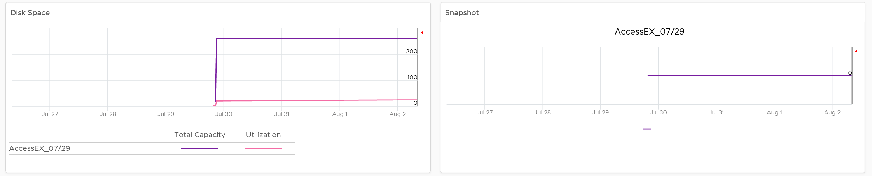

In addition, the relevant configuration of the selected VM is also shown.

### VM Capacity

The dashboard helps you analyse the capacity of all the VMs, with ability to drill down into each VM.

#### Overall Analysis

The dashboard begins with a table listing all your data centers.

vSphere World is also included so you can see all the VMs from all data centers. Unlike infrastructure objects, there are potentially tens of thousands of VM. So take note that the charts will take longer due to refresh if you select vSphere World.

How do the following 2 charts provide insight into the capacity of all the VMs in your environment? What’s the ideal distribution?

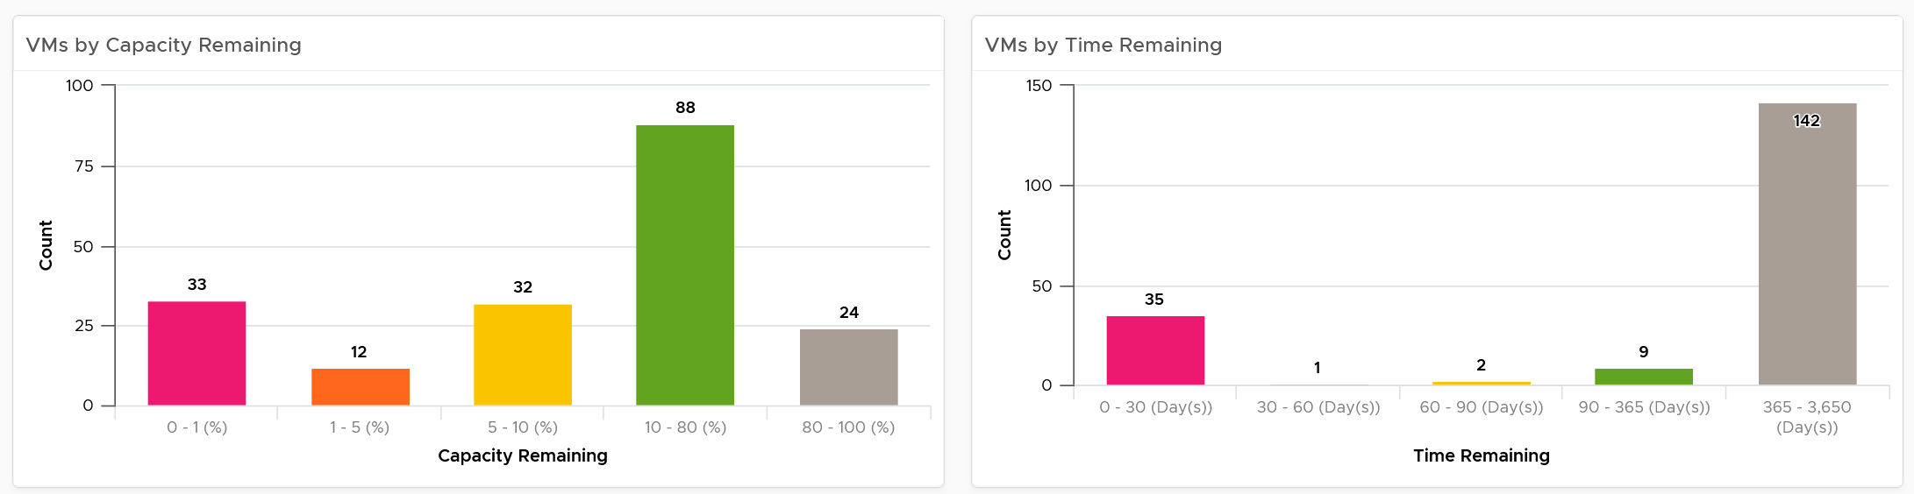

The first chart groups them by capacity remaining, while the second one by time remaining. Ideally, you want all of them to be low on capacity remaining (meaning the given capacity is actually fully used) but high on time remaining (meaning they do not need additional).

The bucket size has been designed to map the default settings in VM capacity policy. If you change it, also change the value in policy so it’s consistent.

The heat map provides additional view by grouping them by cluster. It helps you spot which cluster is at risk (majority of its VMs need more capacity) and which cluster can provide extra resource (majority of its VMs are not using their capacity).

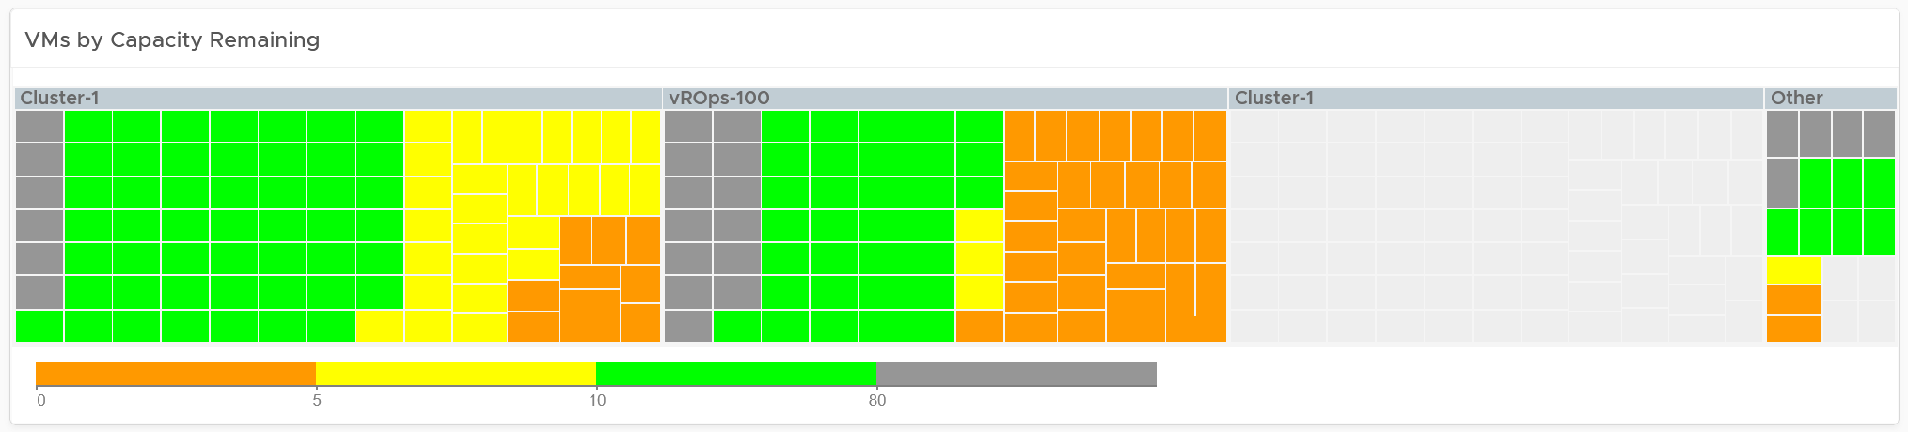

Review the heat map. It provides the next level of details by grouping the VMs by clusters, so you can see which clusters need attention.

Note the VM size has been standardized for better visualization. If it suits your capacity team better, add the size. Note that by doing that you have to pick CPU or Memory, so you may have to create 2 heat maps.

Review the table listing all VMs in the selected data center.

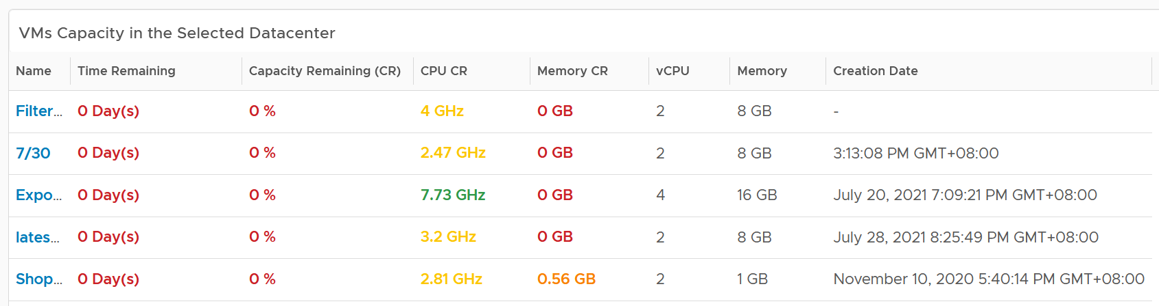

The list is sorted by the VM with the least capacity remaining. If sorting by Time Remaining suits your operations better, modify the dashboard.

The table is also color coded. Take note that the threshold is unable to show the grey (wastage) color.

The creation date is added for the same reason in idle VM case.

#### VM Analysis

Select a VM from the table. Its detail capacity will be automatically shown.

You get both the CPU and memory trend over time. 3 months data is shown, and they are averaged to hourly so you can see the overall trend instead of spiky chart.

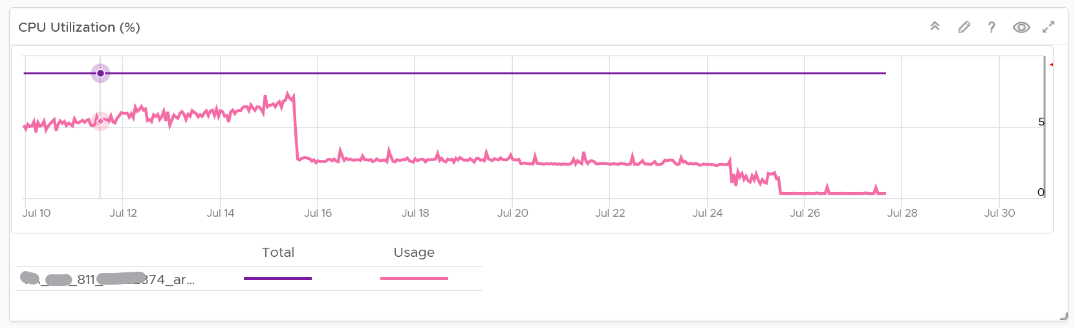

For memory, it uses Guest OS, for the same reason explained in VM Rightsizing dashboard.

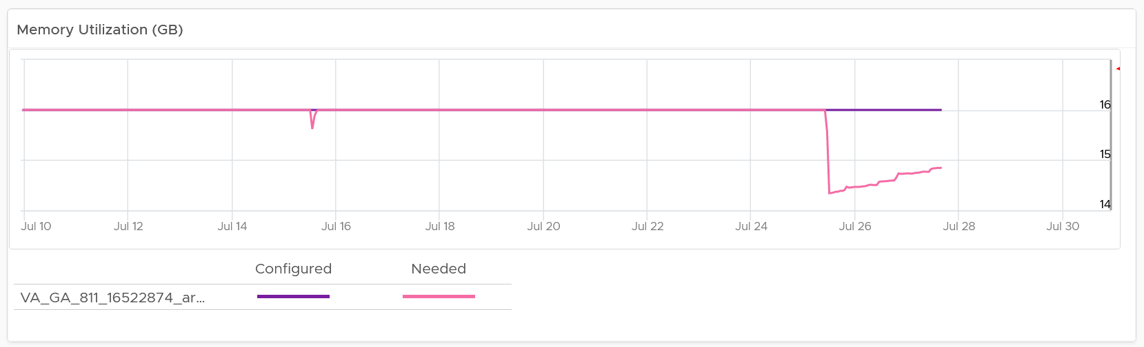

For the disk, it uses the Guest OS partition. Do not use VM virtual disk as there may not be 1:1 mapping to the actual partition.

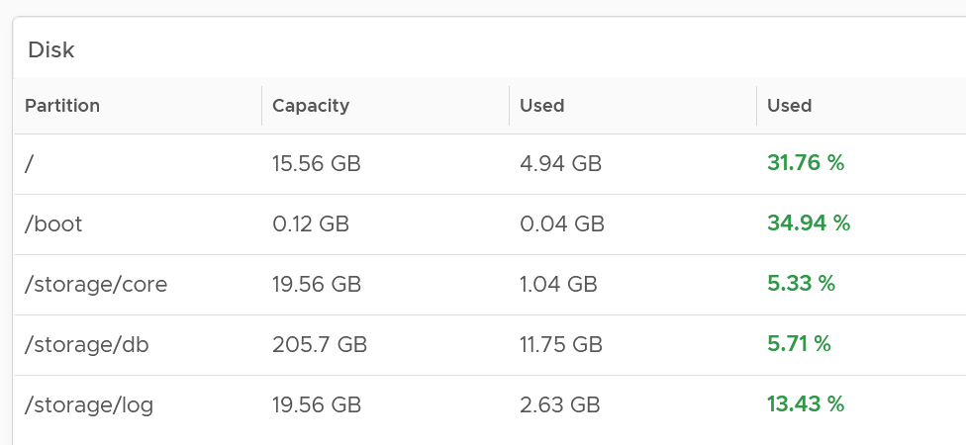

Right-sizing recommendation is also shown for both CPU and Memory. Unlike physical server, it's important to right-size VM for the benefits listed here.

For CPU, the CPU Usage counter is used instead of Demand. Use the knowledge you learned here to figure out why.

For disk, it’s showing at the Guest OS partition level. There is no overall capacity at VM level because different partitions have different capacity.

##### Relevant Configuration

The relevant configuration is automatically shown to give context to the VM.

Information such as VM Owner and business units can be useful in the analysis.

### Reclamation

The Reclamation dashboard helps you managing various types of reclamation that can be done on VMs and datastore. It is designed for both the Capacity team and the Operations team.

#### Overall Analysis

The scoreboard provides a summary of the total reclamation. Guest what infrastructure resource is missing from the scoreboard?

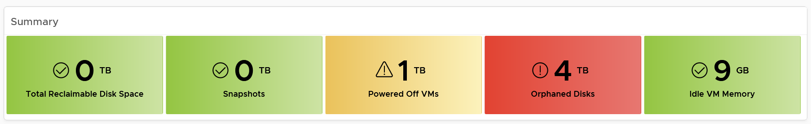

CPU is missing. Because you’re reclaiming blank air.

You can drill down at either Data Center level, cluster level or datastore level. Datastore level is required as orphaned disk does not have VM association, hence it’s not related to any cluster.

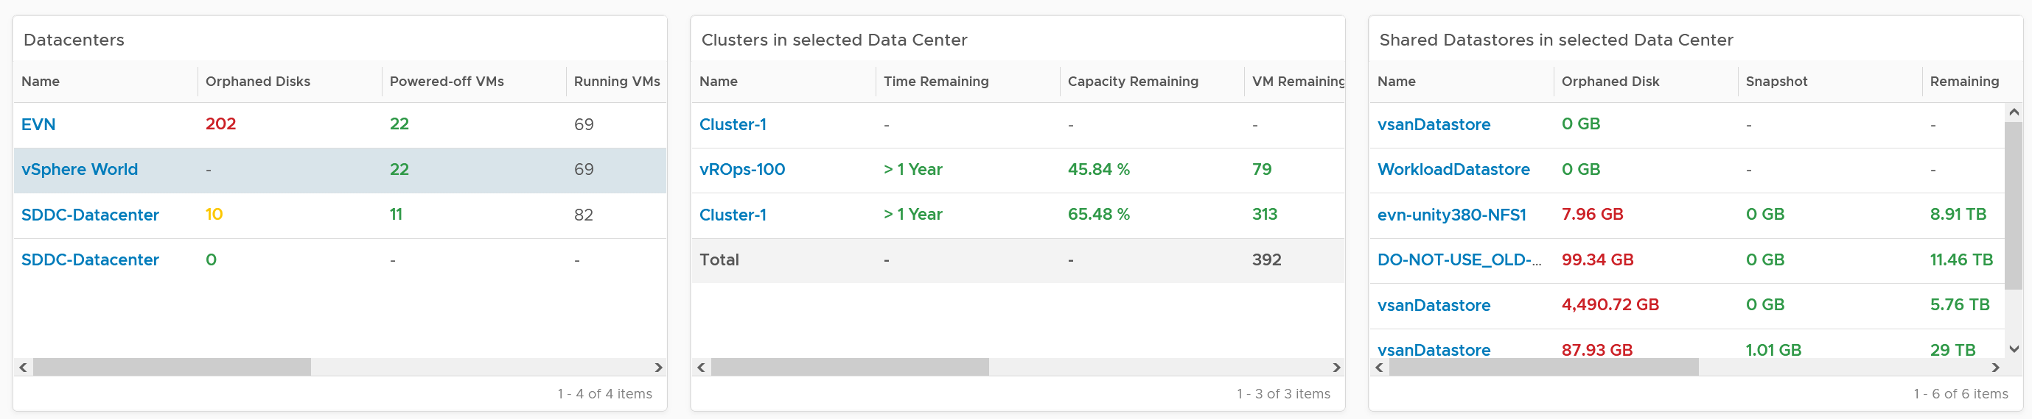

The table above can drive all the charts underneath them, shown below, giving you a flexible way to slice the information. Take note that the datastore table *only* drives the snapshot table. The reason is traversal spec. The view widget can only use 1 traversal spec.

The summary information will be automatically shown. To show from all clusters, select vSphere World. This object covers all clusters. Take note that the charts will take longer due to refresh due to higher amount of data.

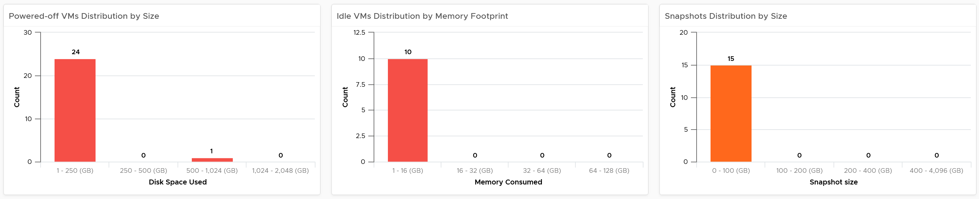

If necessary, adjust the bucket size in the charts to suit your operational requirements.

The reclamation potentials are presented as 3 bar charts, each corresponds to an area you can reclaim:

* Powered off VMs that are no longer needed contribute to wasted disk usage. Consider deleting them to free up space or moving them to archival storage.
* Idle VMs are running, but not being used actively. These VMs consume memory that may be used by active VMs. Consider removing these VMs to reduce memory contention. Guess why is VM-level metric used instead of Guest OS metric?   
  Memory reclamation is based on the memory footprint at the parent ESXi. The value inside the Guest is not what is being reclaimed, and so it is irrelevant
* Snapshots are meant to be temporary and can cause performance issues and waste disk space if not deleted after a few days.

Focus on snapshot first, as it does not involve changing VM.

Next is powered off VM. The longer it has been powered off, the lower the risk of deletion. Ideally, you want a confirmation from the owner, and have a back up outside vSphere. This is why it’s important to have meta tag such as VM Owner email address. Note if the VM has snapshot, it’s included in the calculation, so there can be *double counting* since the VM also appears in the snapshot table.

##### Idle VM

As the VM is still running, it’s relatively harder to reclaim as shutting it down may require approval from the VM Owner.

BTW, if there is nothing to reclaim, you get a blank table. The following example shows no VM meets the criteria for either powered off or idle. If you suspect the table is wrong, review your criteria.

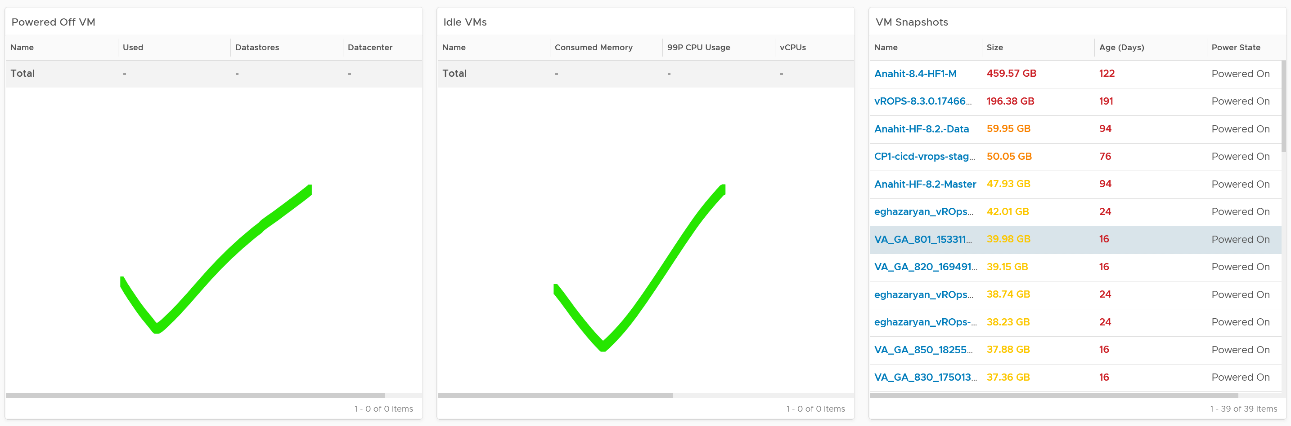

We discussed in Capacity chapter that both metrics need to be true to ensure the list does not contain VMs that has recently become active.

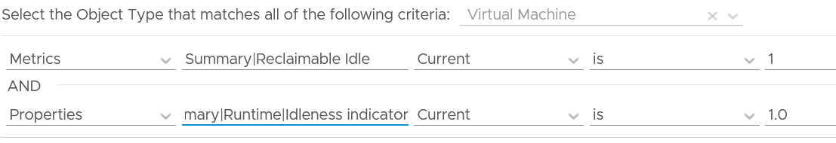

Let’s drill down into idle VM as that’s the most complex part. Guess why we show the 99th percentile CPU usage?

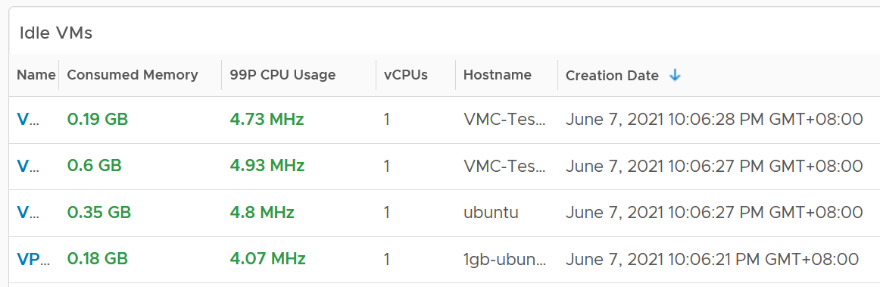

The 99P CPU Usage shows the CPU usage at 99th percentile during the time period. It’s a handy way to check if it’s indeed idle. Essentially, if it the CPU utilization is low for 99% of the time, the VM could indeed be idle.

Why is the Creation Date especially important for Idle VM case?

The answer is newly provisioned VM may remain unused for months. The following show how to set it.

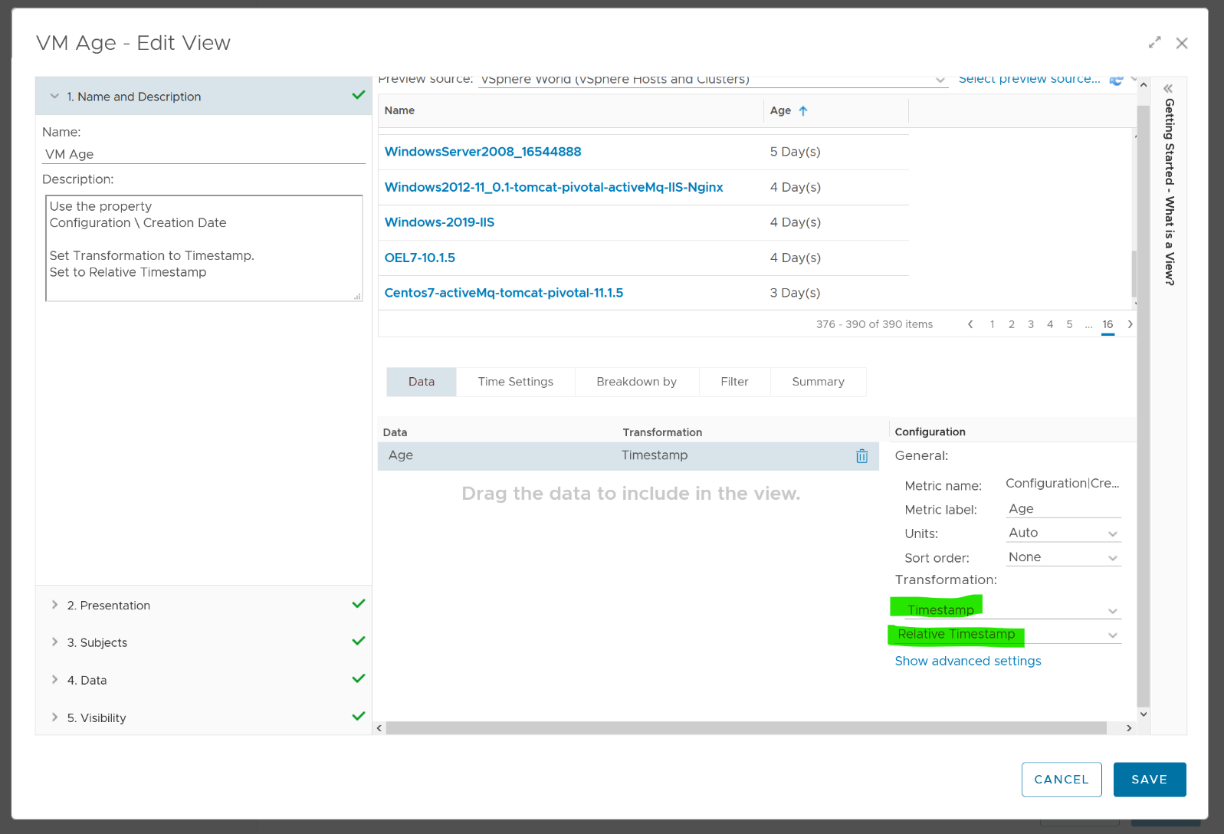

Choose VM property Configuration \ Creation Date, then choose the Transformation: Timestamp and then Relative Timestamp.

#### VM Analysis

To analyze VMs for reclamation opportunities, select a VM from one of the three tables (Powered Off VM, Idle VMs or VM Snapshots). Its detail value over time will be automatically shown. Notice the VM name is the same in all the 3 charts.

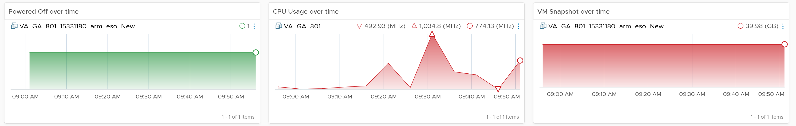

Powered off over time shows VM status (on/off) over time. 1 = true, meaning the machine is powered on.

CPU Usage over time provides insights into the aggregate CPU usage, including peak usage periods. This way you can validate that an idle VM has not had any brief usage. What you want to see is green over a long period of time, as shown in the following example.

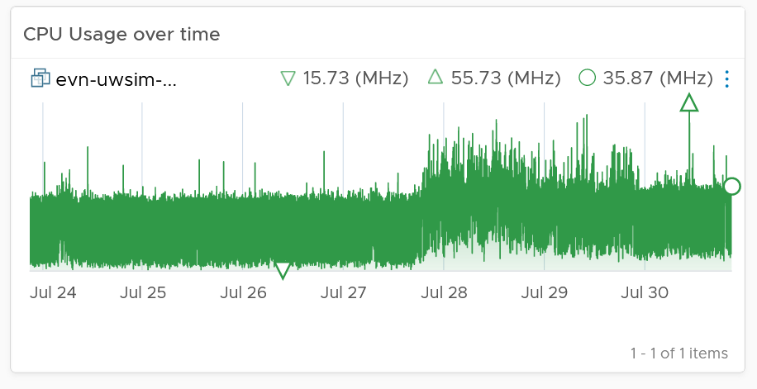

If the snapshot is expanding rapidly, ensure that the VM disk is small (relative to size of the underlying datastore) as it can fill up the datastore.

Lastly, the relevant configuration of the VM is also shown to give context.

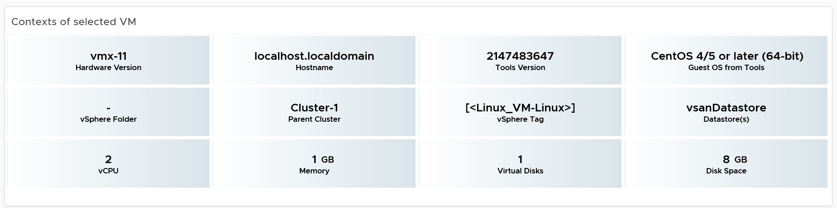

#### Points to Note

If your environment is large, change the dashboard filter to a functional filter. Group by the class of services such as gold, silver, and bronze and default the selection to the least critical environment. In this way, you can be more active in reclamation.

If reclaiming is a long drawn manual process in your organization, add a filter by department or VM owners. To organize your reclaim efforts it is helpful to create custom groups to make it easier to filter by department or VM owner. This can make it easier to seek approvals and communicate with anyone who may be impacted.

You should enhance this to include [Trim and Unmap](https://en.wikipedia.org/wiki/Trim_(computing)). Happy to collaborate and make this into the product. We need to check on only the thin provisioned disk. We should also check at the array level, using the TVS adapter.

### VM Rightsizing

The VM Rightsizing dashboard helps you in adjusting the VM size for best long term performance at lowest cost. It covers both undersized and oversized scenarios. It’s not designed for short term, 5-minute performance burst. The reason is high utilization is actually good for performance. As a result, this dashboard is categorized under Capacity and not performance.

It is designed primarily for Capacity team, not day to day operations team.

#### Overall Analysis

The scoreboard provides a summary of the total undersized and oversized CPU and memory.

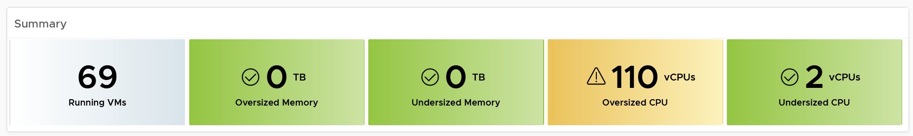

If the number is acceptable to you, that’s it. No need to further analyze.

The reason why I’m not adding the number of VMs that are undersize or oversized is screen real estate. It needs 4 metrics to account for all the combination.

You can drill down at either Data Center level or cluster level. In most cases, rightsizing analysis should be done at Cluster level as VMs typically do not move inter-cluster. At cluster level, the table looks like the following. Guess why are the cluster capacity metrics shown?

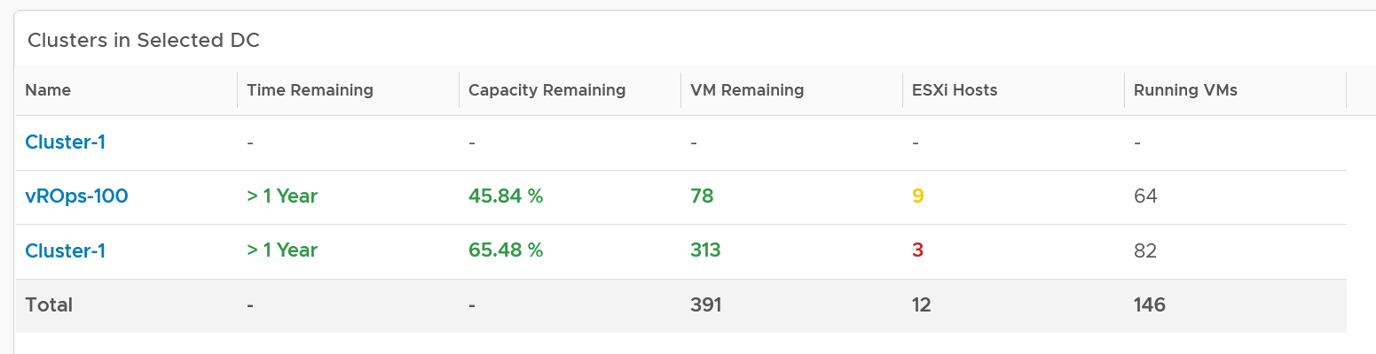

The metrics are shown to give better context. Focus on reclaiming on cluster that is low on capacity remaining. For upsizing VMs, ensure the parent clusters have good capacity remaining.

The distribution charts showing the rightsizing is automatically shown. Let’s dive into the undersized first as it’s more common. Why are the vCPU to add focused on the first 8 vCPU, and memory to add focused on the first 16 GB?

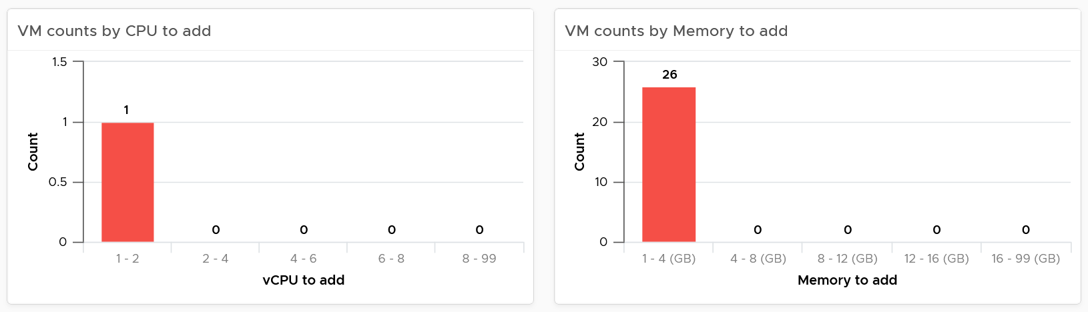

The main reason is you want to avoid adding large amount without strong justification.

For CPU, the primary justification is the CPU run queue counter, not the CPU usage. Even if the CPU Usage is flat out 100%, if the CPU run queue is below 2 per vCPU, you don’t need to add many vCPU.

For memory, Guest OS does not provide deep visibility into the depth of memory shortage. Adding memory may also requires changing application setting so it can take advantage of it.

Do the same capping for oversized VM. To make a drastic reduction, discuss with the VM Owner. Reducing memory may also requires changing application setting, especially application that manage its own memory such as JVM and DB.

Other than the bar charts, you also get the table listing the actual VM. You have 2 tables, one for undersized and one for oversized. Why can’t we just use 1 table?

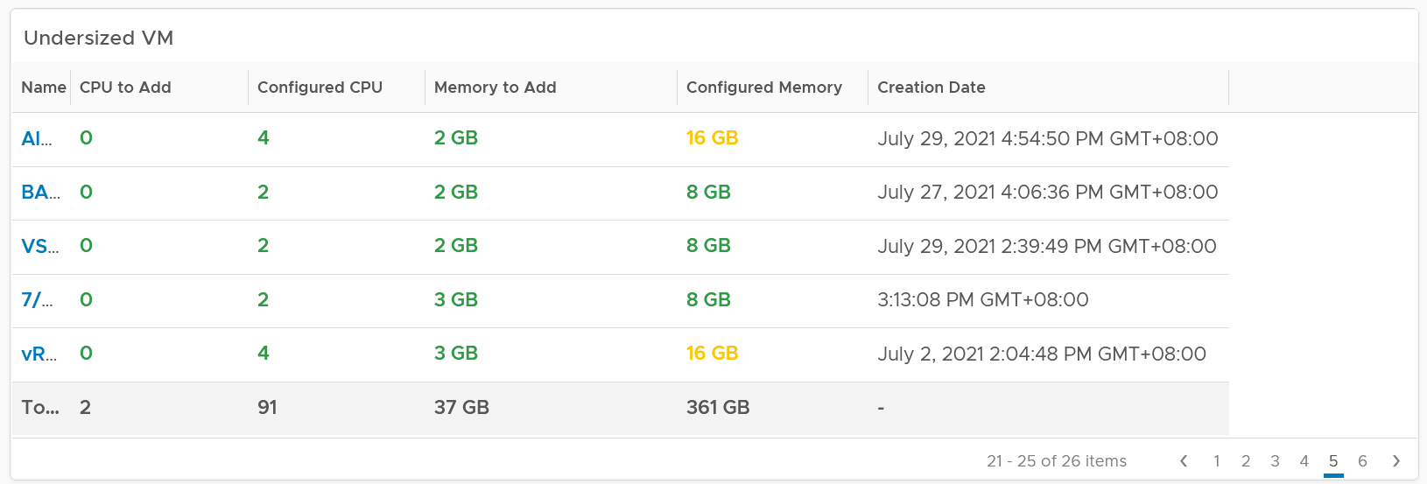

The reason for separate table is the business processes for oversized and undersized VMs are different, as one requires the affected VM to be shut down and the VM Owner to give back resources. For upsize, you want to add incrementally or even automate this process. For downsize, you want to remove in one change window as the effort to reduce is the same and there will be only one downtime.

CPU/Memory to remove is color coded to help you prioritize. Red color means they are excessively oversized.

Configured CPU/Memory is color coded to help you focus on the large VM. They are shown in red.

Take note that a VM can appear in both tables. It can be undersized for CPU, oversized for memory, and vice versa.

Here is the table for oversized.

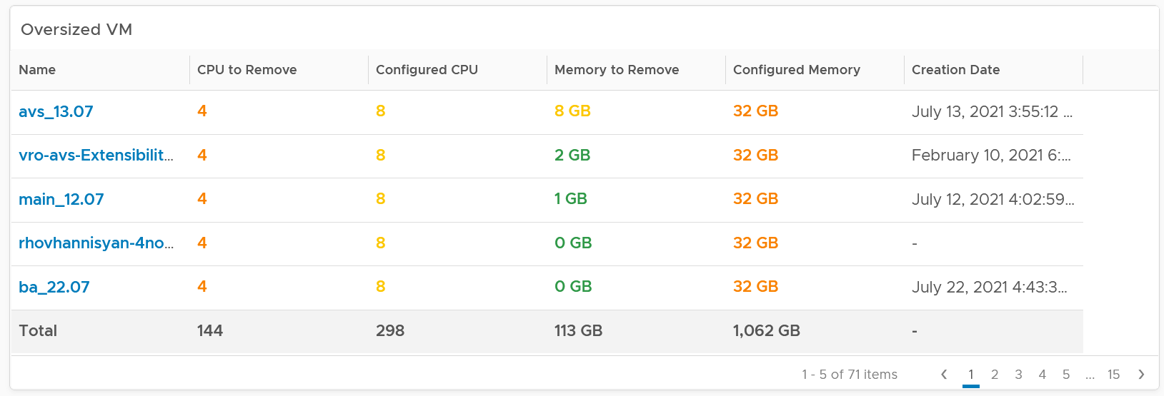

The metrics used are Summary \ Oversized \ Virtual CPUs and Summary \ Undersized \ Virtual CPUs. It stores the capacity engine calculation on recommended number of vCPUs that must be removed or added.

#### VM Analysis

Select a VM to investigate further. You get its utilization automatically shown. Naturally, you expect the utilization to go higher if the VM is reduced.

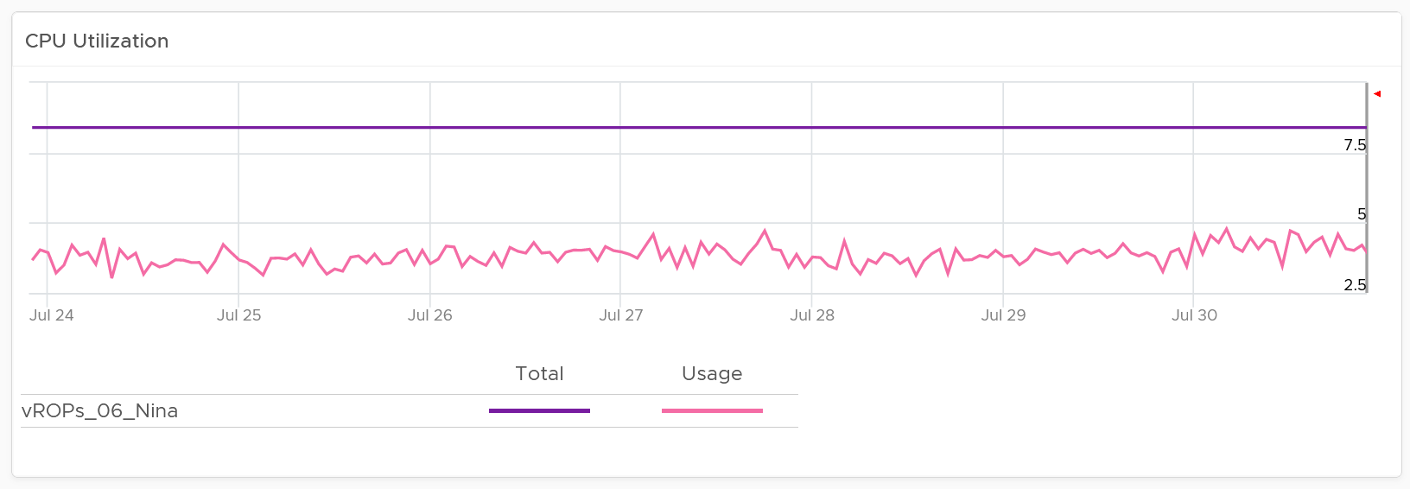

Take note since the purpose here is capacity and not performance, you should not dive into individual vCPU utilization, nor increase collection granularity to shorter than 5 minute (e.g. to 20 second).

Having said that, rightsizing a VM can help improve its performance, or maintain its current performance. How do you prove that?

You show the performance bottlenecks, such as CPU ready and CPU run queue. The following is what you get out of the box.

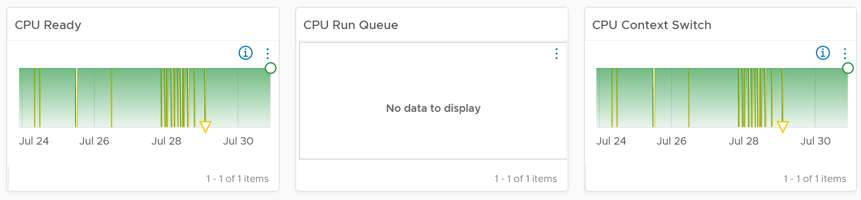

You should expect the VM contention metrics such as CPU Ready and Co-stop to either drop or remain the same.

You should expect the Guest OS CPU Run Queue to remain the same. It might go up a bit, so long it is lower than 3 per vCPU, no need to increase CPU size despite it’s running high. If you want to be safer, modify the widget to use the 20-second counter.

You should expect CPU Context Switch to be less, as there are less CPU to switch. All else being equal, this is a positive change.

If you have the need, add more metrics such as Co-stop.

Memory utilization is collected from the Guest OS. If guest OS metrics are not available, then you will only see the **Configured** counter. Guess why isn’t there a fall back to VM level memory?

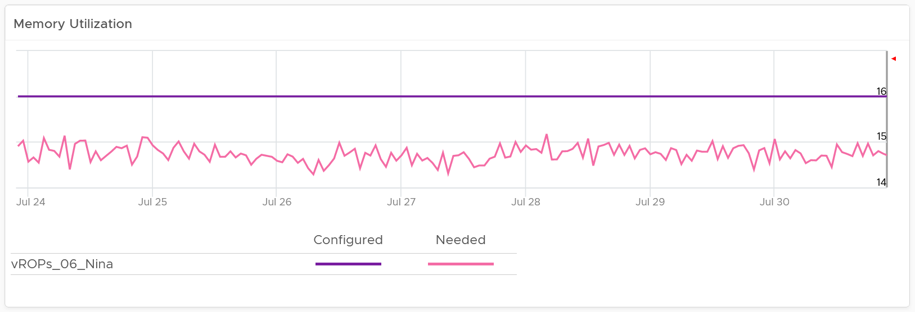

It does not fall back to VM level counter as it’s not a good replacement. See Part 2 Metrics Chapter 3 Memory Metrics.

Rightsizing memory improves performance by reducing memory ballooning and contention. For example, VMs with overprovisioned memory are more likely to experience ballooning

If you want to be conservative, add the free memory counter. If this never touch 0.5 GB, you do not need to add RAM despite its utilization.

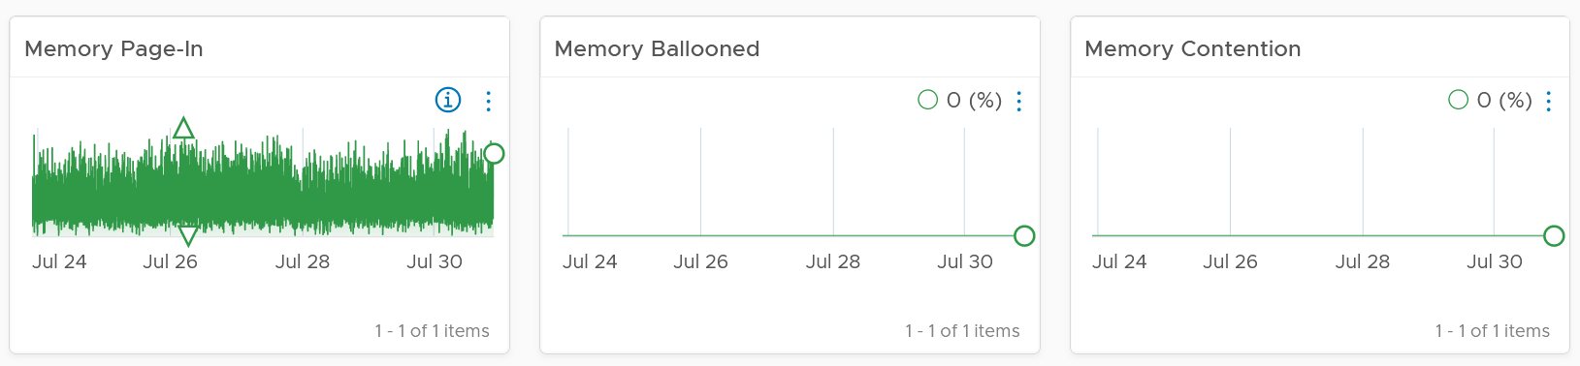

If you have the need, add more metrics such as Page-Out rate.

Relevant configuration for the purpose of right sizing

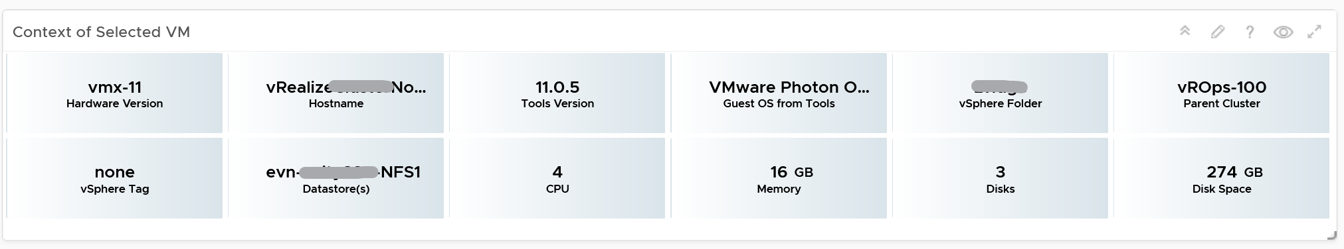

#### Points to Note

If your environment is large, change the dashboard filter to a functional filter. Group by the class of services such as gold, silver, and bronze and default the selection to the least critical environment. In this way, you can be more active in reducing the oversized VMs.

For another example, see [[Dale Hassinger](https://code.vmware.com/user/2287325117)](https://www.linkedin.com/in/dale-hassinger-5712301b/) at code.vmware.com, where he has more data showing the proof that performance can improve with reduced size.

##### Monster VMs

You can enhance the dashboard if you need to convey the overall situation to senior management. You plot every single powered-on VM in the environment, sized by their vCPU. In this way, the monster VMs will be highlighted. A 64 vCPU VM will appear 64x larger than a single vCPU VM. This is good as the focus should be on the large VM, as discussed here.

The heat map colors the VM by its capacity remaining. A VM with high capacity remaining means it has plenty of wastage resources.

What would it look like on an environment with many monster VMs that are oversized? You get something like this. The grey boxes dominate the space of the heat map. One of the boxes consist of 48 VMs with total > 1000 GHz. All of them have 87.79% capacity remaining. Another word, they are oversized.

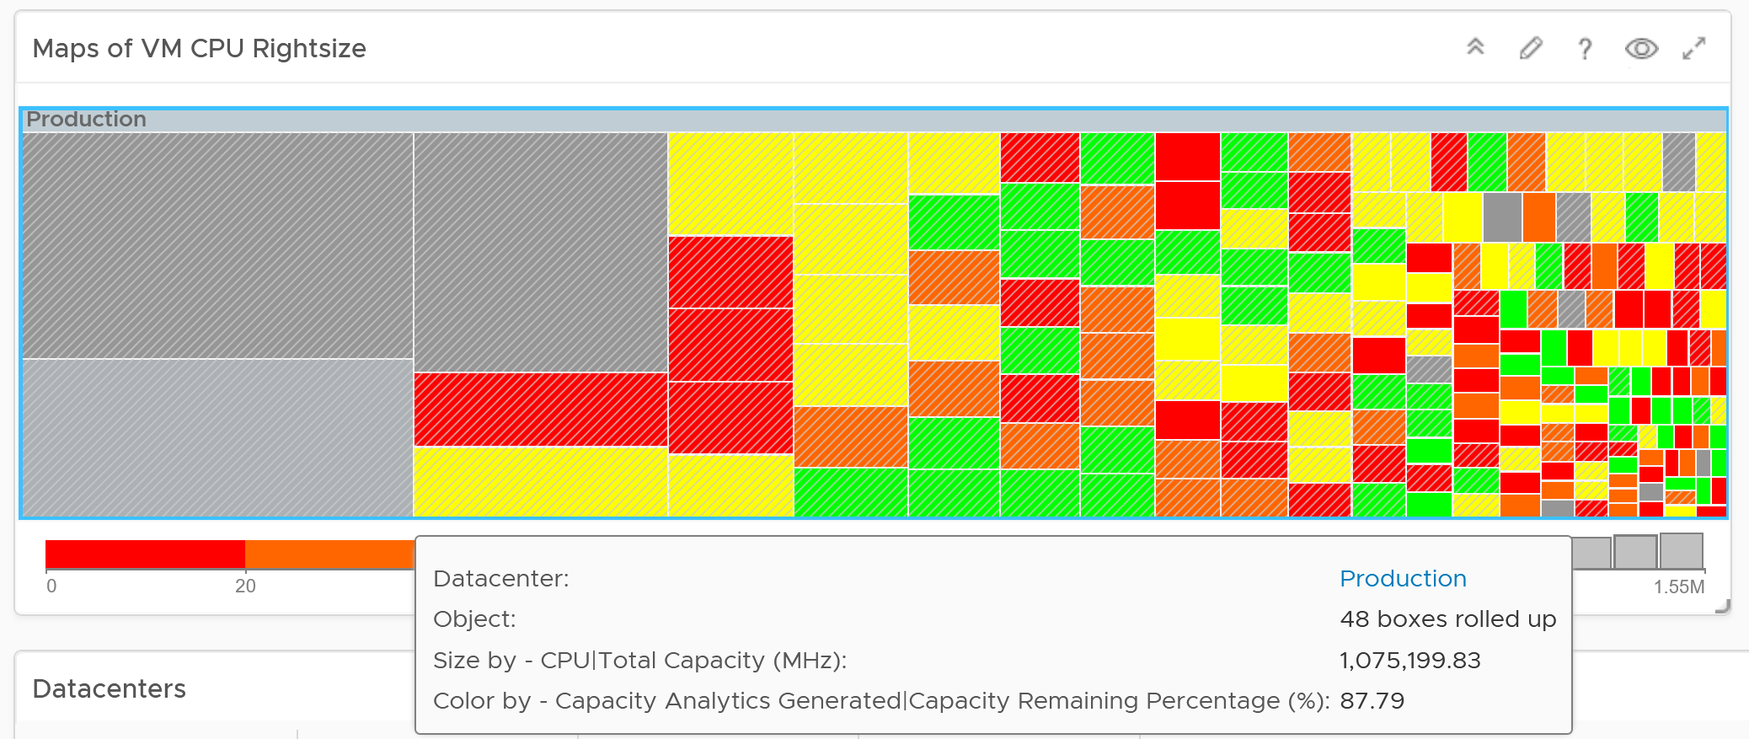

You may want to do the same for memory.

You can also focus on the large VM by specifying a filter. In the following example, I set to 16 vCPU or more, and the VM has to be powered on at present.

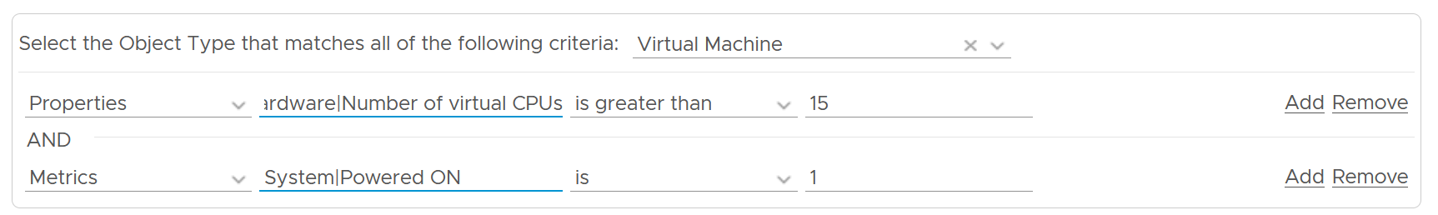

Since we only have the large VM, we can further refine the heat map. The size remains by vCPU size. However, the color changes to the number of oversized vCPU. The more I can reclaim the more red the color shows, and anything above 14 vCPU is red.

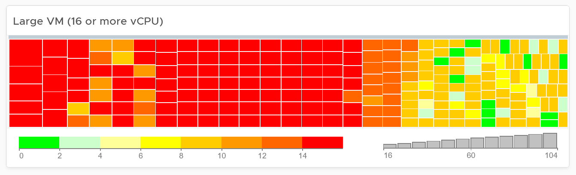

## Inventory

**Part 3 Chapter 5**

Inventory is related, but not identical to configuration.

Inventory is an account of what you have where. So the location & count matter. Configuration is the properties of your inventory. The location is just another property of the object. The majority of properties/settings managed by configuration are not relevant to inventory.

Inventory dashboards share the same design principles. They show the hierarchy and count of objects in the hierarchy. Ideally, it shows the movement of the inventory.

### VM Inventory

VM is more volatile than infrastructure, so it’s important to track their changes.

#### Summary section

The summary section consists of 2 rows of widgets. It’s designed to help you see the big picture.

Check that these numbers are within your expectation.

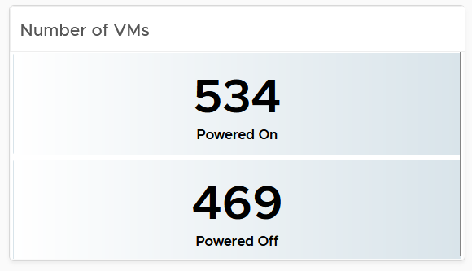

If the number of powered off VM is relatively high, navigate to the VM Reclamation dashboard to see if they can be deleted and taken off the systems.

Review if the numbers over time match your expectation. For example, if there was an activity last night that impacted the number of powered off VM, yet the actual number differs, perhaps the activity was not executed as per plan.

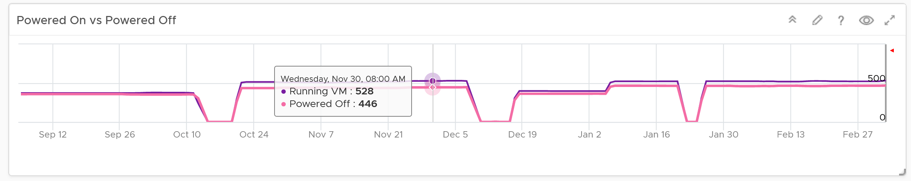

The 2nd row of widget consists of 3 charts. They summarize the overall movement of all the VMs in your environment. Make sure the amount and the pattern both match your expectation.

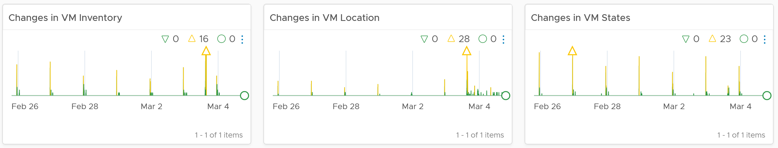

The above 3 charts are based of the VM Operations metrics, covered in Part 2 Chapter 6. Look for Event Metrics.

You should customize the thresholds, so it’s easier to see if the values exceeds what’s acceptable in your day to day operations. The value is every 5 minutes, so if 100 changes of states is definitely not something you can ignore, set the threshold of yellow, orange and red accordingly.

#### Detail section

The detail section has interaction where you can zoom into specific data center or clusters.

The first row is always the total. vSphere World object covers all the clusters, so its numbers are the summation of all clusters.

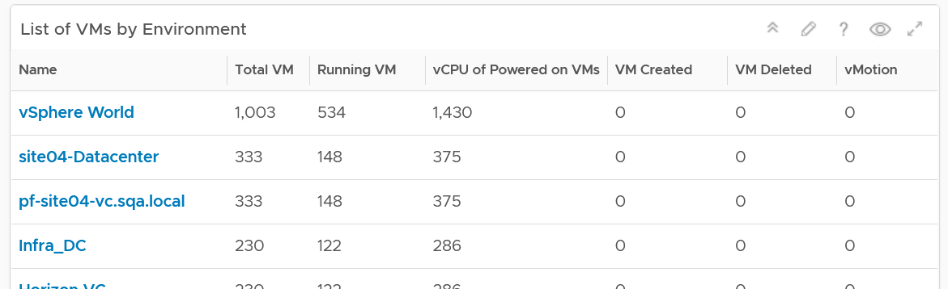

To see a trend, click on any of the row. The 3 sets of scoreboards will automatically show the details.

The first scoreboard is about the availability state. Try to customize the threshold so it’s easier to see at a glance. I’ve set the threshold for the VM Reset as that’s an abnormal operations.

When you customize, consider the steady clusters. They will have a lower threshold as there are relatively less changes or movement. If you set a threshold based on your busy customers, these small clusters will tend to show green.

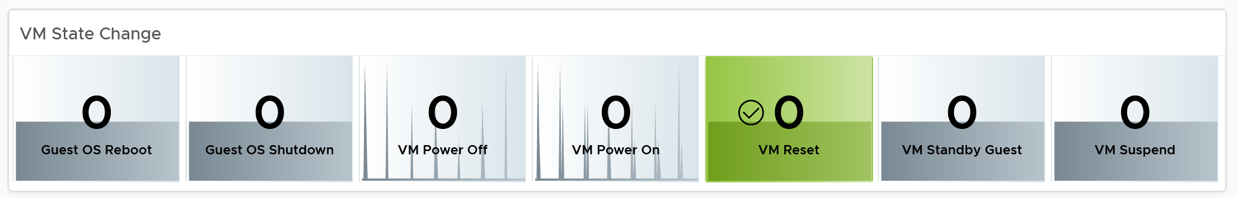

The next 2 scoreboards cover the location change and inventory change. Again, customize accordingly.

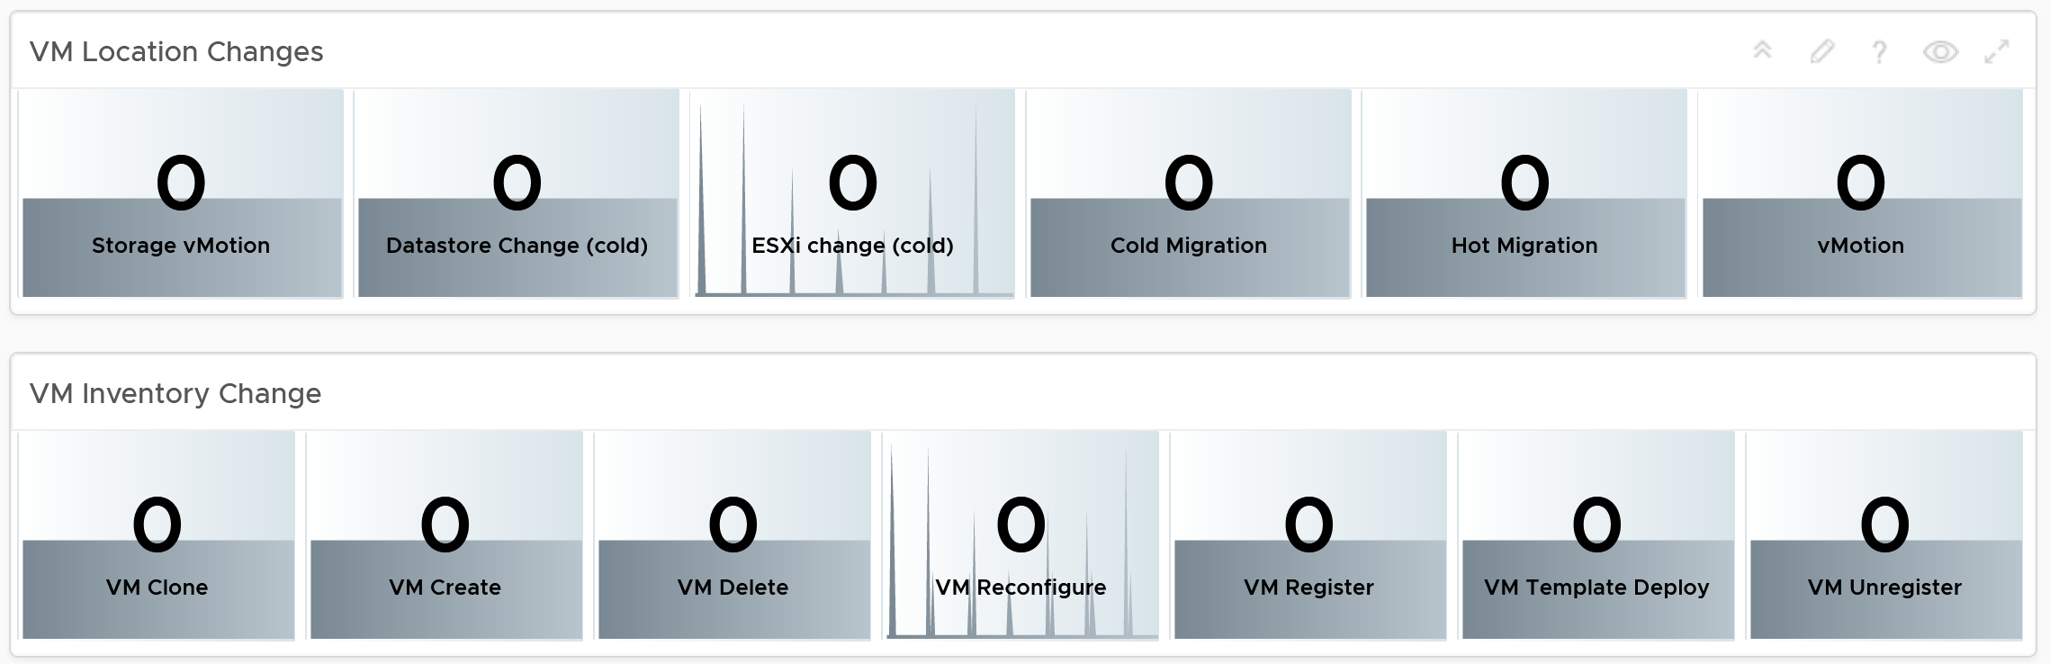

The dashboard lets you see the applications running inside the VM on any part of your environment. This can be handy if you have policy that certain applications should only run on certain clusters, for either cost or compliance reason.

Note: This requires Service Discovery adapter.

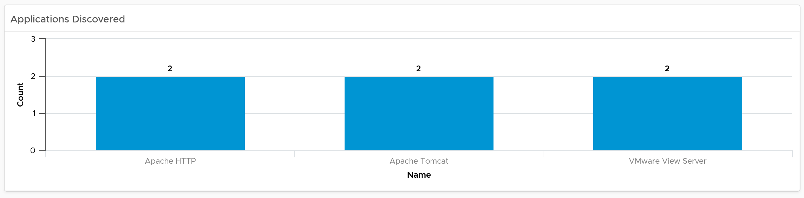

Since this is about inventory and not configuration, the following pie charts focus on the *popular* size (most common). If this was a configuration dashboard, we would have ordered them based on the configured size.

Customize the pie charts if you need to see more than 5 sizes. I find 5 is a good balance since I can see the details in the next table below the pie charts).

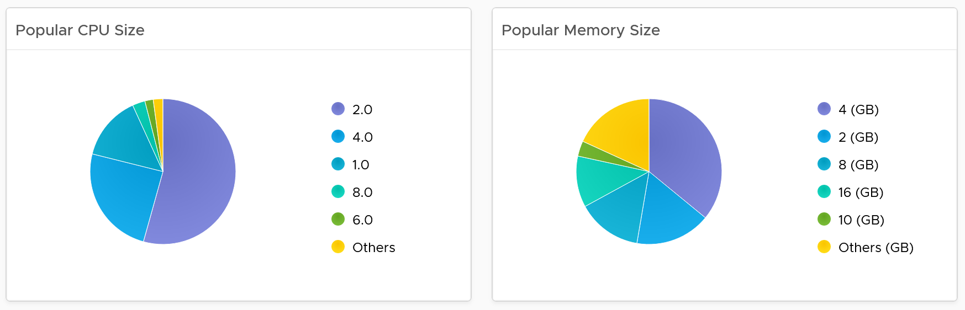

The next pie chart shows the OS distribution, again sorted by the most popular.

They should match your expectation. For example, if you separate Windows and Red Hat into different clusters, then you expect not to see one of them when you select a particular cluster.

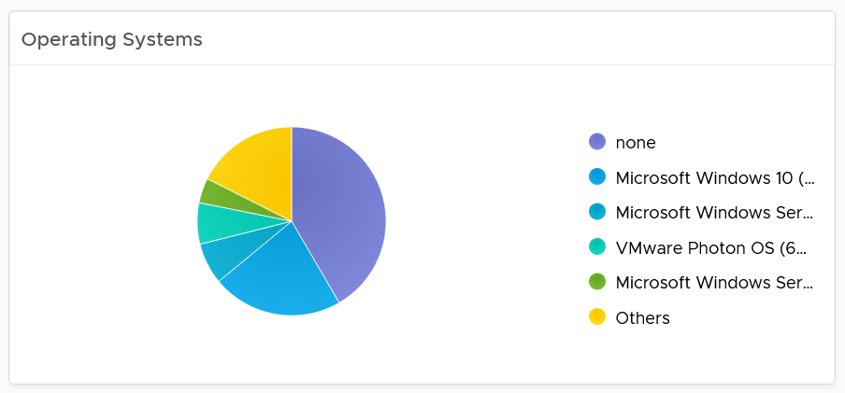

If you see the value “none” under Operating System, that means the VM does not have Tools. I chose the value from Tools instead of vCenter as that’s more accurate.

The last pie chart shows by the number of disks.

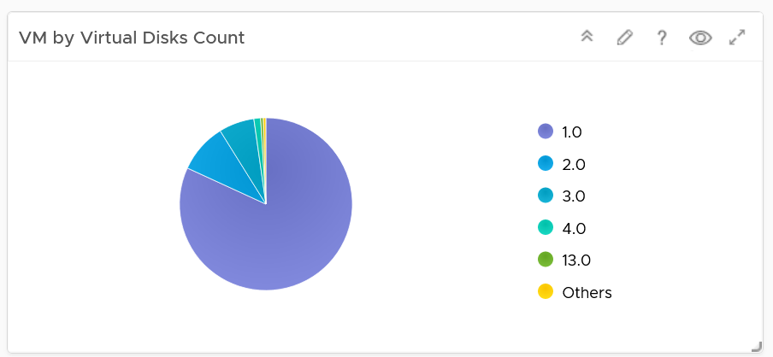

Since a VM needs to have at least 1 disk, I've excluded VM with just 1 virtual disk so those with many are more visible. You’re welcome.

#### Individual VM Section

The last section shows the individual VMs, and you can drill down to see its details. This is why I keep the pie charts to just show 5 as this table lets me sort in any columns.

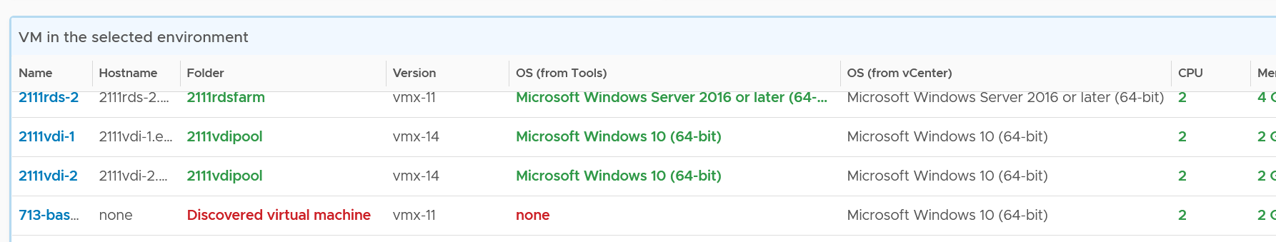

Select a VM, and you can drill down to see its capacity and performance.

Add or remove columns to suit your environment.

Customize the table further by color-coding the values. I’ve color coded the following:

* VMs that are not properly placed in a folder. They will appear under the “Discovered virtual machine” folder.
* VMs that are not reporting its operating system. They will report the value “none”.
* VMs with large CPU, memory or disk. Tailor this to your environment.

Select a VM, and its details of virtual disk, operating system partitions and network cards are automatically shown.

Limitation: It is not possible to see the mapping between virtual disk and partition. A partition or drive can spans multiple virtual disk, and a virtual disk can contain multiple partitions. This is why it’s best to keep the relationship simple (1:1).

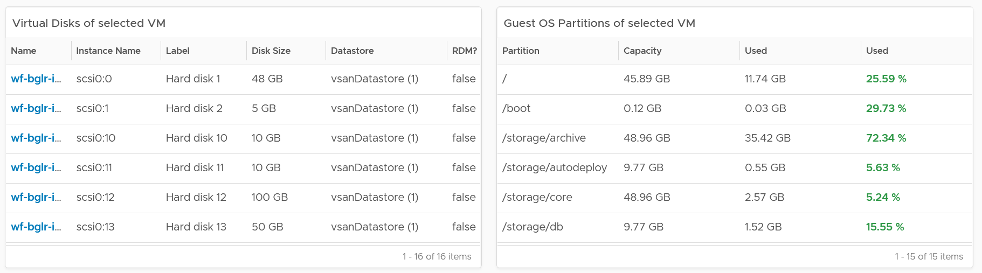

### vSphere Inventory

There are 3 dashboards

* Compute
* Storage
* Network

They have a fairly similar design. The compute has more details because it has more things to manage.

The design has 4 sections, as shown in the following screenshot

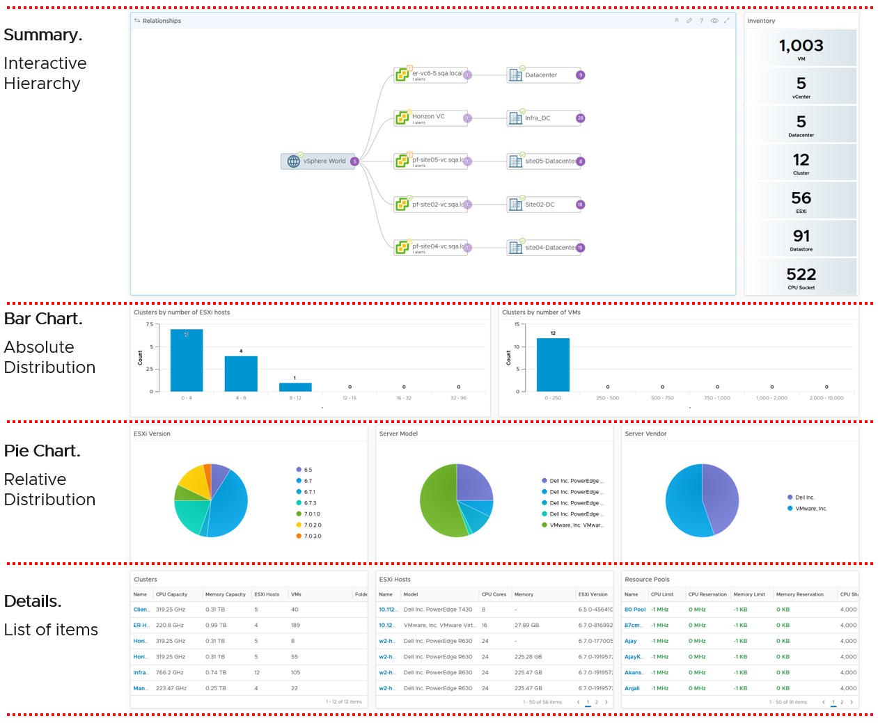

If you think their design copies the Horizon Inventory dashboard, you’re right! That dashboard was basically the 2.0 of the vSphere inventory dashboards, so now you’re seeing vSphere delivers the 3.0.

They can also navigate to one another. The relationship widget below sports the navigation. Pick an object and then choose the dashboard navigation.

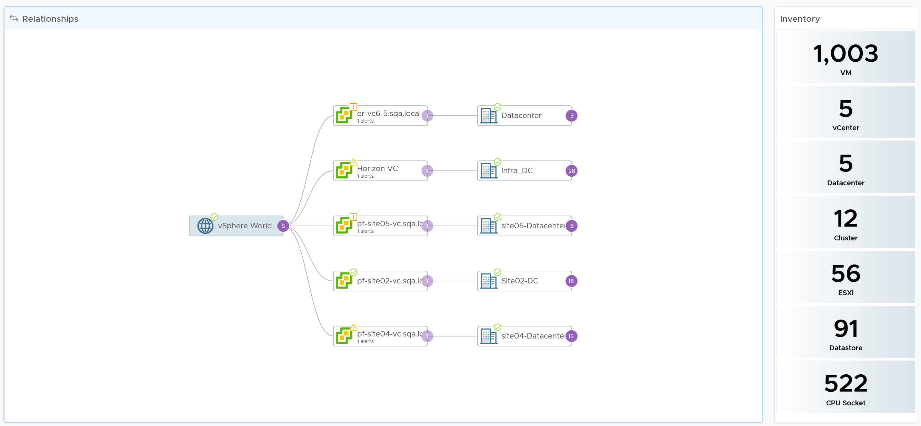

The next row is a set of distribution chart. Due to limited space, I’ve provided only 2 charts, focusing on the cluster object. Since this inventory and not configuration, we should focus on the count of members.

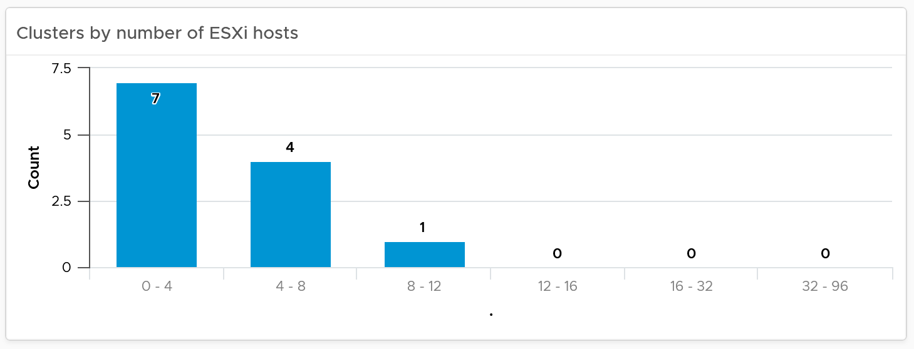

The next row is a set of pie charts. Kindly let me know if you have better suggestions on what the top 3 things you want to be shown as pie charts.

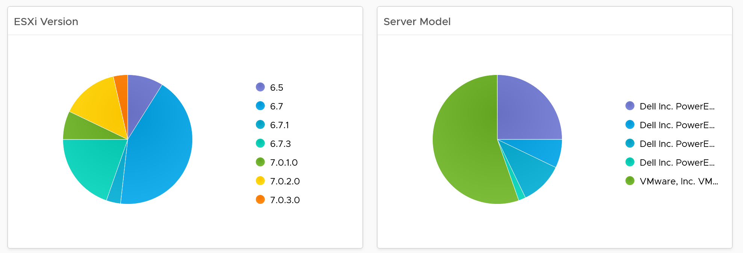

If you have larger screen real estate, add more pie chart for better insight into the type of items you have in your inventory.

The last row is always the lowest level of details, hence a table is chosen. For the compute inventory, we need to cover cluster, ESXi host and resource pools. That’s why you notice 3 tables, one for cluster, one for ESXi and one for resource pools.

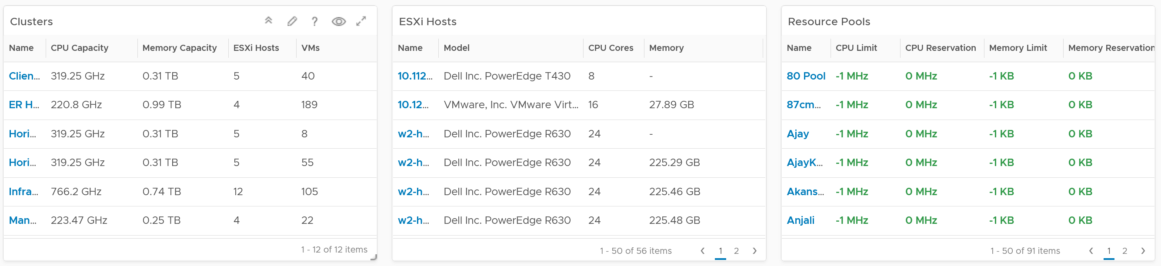

I added a navigation from the cluster table into the cluster performance and cluster capacity dashboard.

## Configuration

**Part 3 Chapter 6**

The configuration dashboards aims to implement the concept covered in Configuration Management chapter.

Each operation is like a fingerprint. While there are commonalities, each customer runs their operations a little differently. Hence it’s not possible to design one dashboard that meet every customer’s operational needs. A configuration that is important for one may not even be relevant for another. We encourage you to tailor this dashboard to your unique environment. If needed, widgets can be collapsed or expanded allowing more relevant data to be displayed.

### VM Configuration

Use the VM Configuration dashboard to view the overall configuration of VMs in your environment, especially for areas that need attention.

See the Configuration Dashboard page for common design consideration among all the dashboards for configuration management.

#### How to Use

Select a data center from the **Data center** table

* In a large environment, loading thousands of VMs increase the web page loading time. As a result, the VM is grouped by data center. In addition, it may make sense to review the VM configuration per data center.
* For a small environment, the vSphere World is provided so you can see all the VMs in the environment.

The dashboard is organized into 3 sections for ease of use.

* All 3 sections will automatically display the VM configuration in the selected data center

The first section covers limit, share and reservation

* Limit should not be used, as explained previously here.

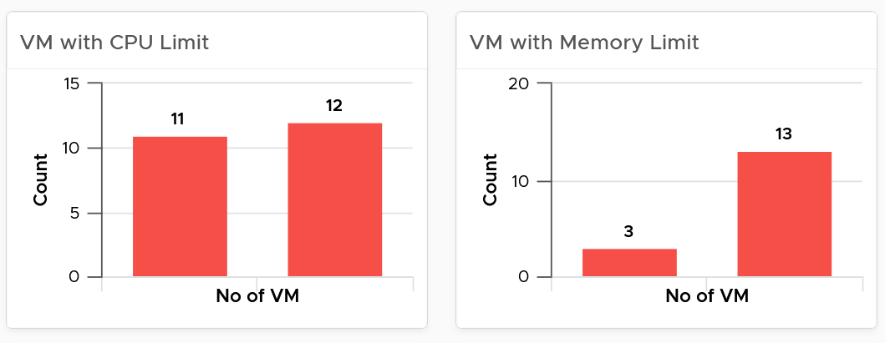

* Their share and reservation values can easily become inconsistent among VMs, especially in an environment with multiple vCenter Servers. The following shows an environment with far too many variations in shares.

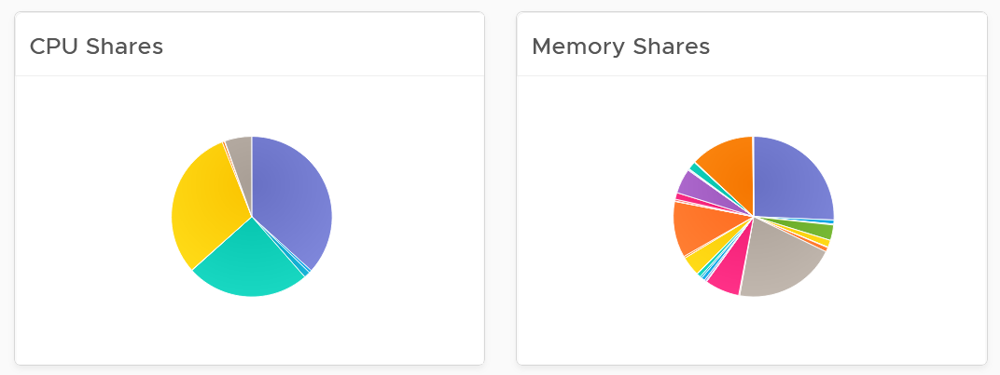

* Shares should be mapped to a service level, to provide a larger proportion of shared resources to those VMs who pay more. This means that you should only have as many shares as your service levels. If your IaaS provides Gold, silver, and bronze, then you should have only three types of shares.
* The value of share is relative. If you move a VM from one cluster to another (be it in the same or different vCenter Server), you may have to adjust the shares.
* Reservation impacts your capacity. Memory reservation works differently from CPU reservation, it’s more permanent.

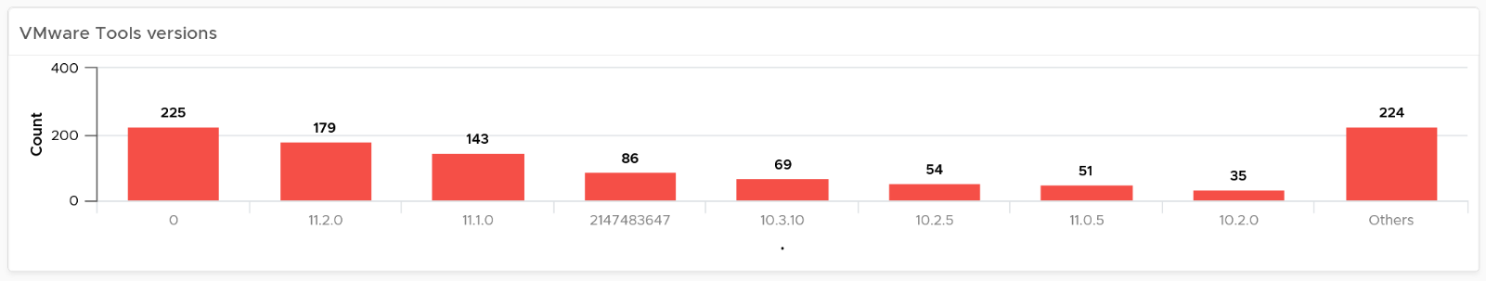

The second section covers VMware Tools

* Tools is a key component of any VM, and should be kept running and up to date.
* The distribution chart shows the various versions. You should keep them minimal

The third section covers other VM key configuration

* Keep the configuration consistent by minimizing variants. This helps to reduce complexity.
* Pay attention to VMs with many virtual disks or many virtual network cards.

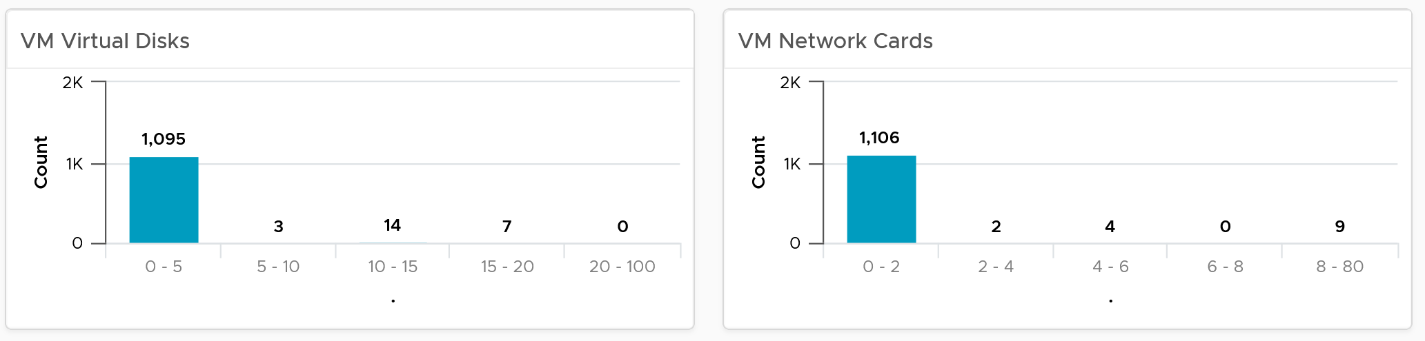

* Keep the number of VM hardware versions minimal, and keep them current.

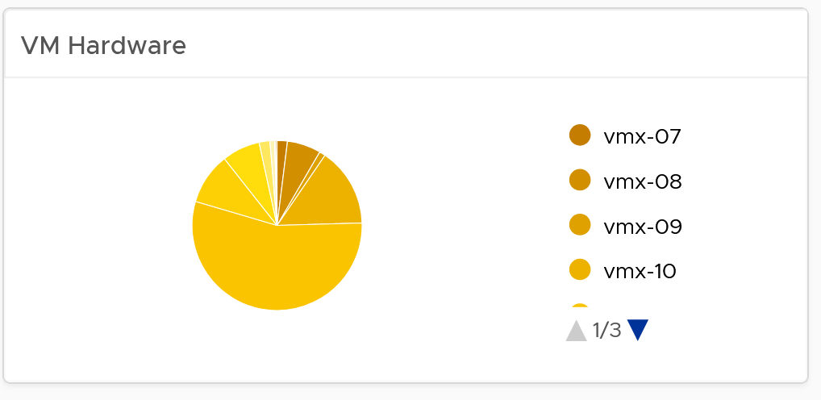

* VM Network Card widget. It you suspect your environment may have VM with no NIC card, consider adding it as dedicated bucket.

The last part of the dashboard is collapsed by default.

* It shows all the VMs with their key configuration.
* You can sort the columns and export the result into spreadsheet for further analysis.

### Cluster Configuration

The dashboard is organized into sections for ease of use.

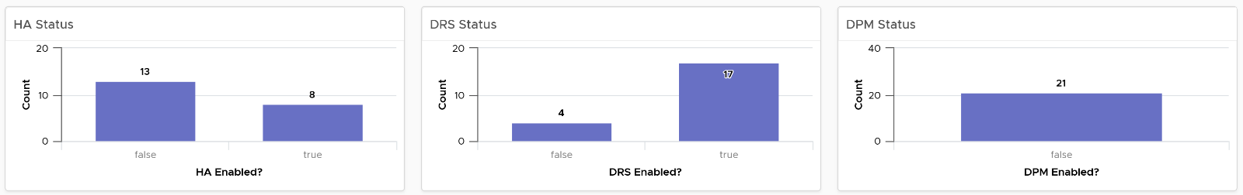

The first section shows 3 bar charts. They correspond to the 3 main features of vSphere clusters, namely High Availability HA, Dynamic Resource Scheduler DRS and Distributed Power Management DPM.

* **HA**: The best practice is to enable HA admission control. You can specify the Admission control Policy in vCenter and the threshold for failover shares.
* **DRS**: The best practice is to have DRS enabled. Think of a vSphere cluster as a single logical computer that balance within itself.
* **DPM**: The best practice is to enable DPM in an environment where environmental concern is the top priority or the high peak rarely occurs (most of the time You are running very low utilization).

The second section of the dashboard shows 8 pie charts. They show the relative distribution of key configurations.

* 2 bar charts cover Admission Control. You should enable admission control. The pie chart displays the policy code instead of the policy name, as it is based on the property Cluster Configuration | Das Configuration | Active Admission Control Policy.
* 2 bar charts cover the HA Failover Share, one for CPU and one for memory.
* 2 bar charts cover DRS setting. Generally speaking, you want to have DRS fully automated, meaning no operator intervention is required for both initial VM placement and subsequent load balancing, but with a moderate migration threshold (value = 3.0). The value range from 1.0 to 5.0.
* There are 2 pie charts showing reservation, one for CPU and one for memory. Minimize the total reservation value as it prevents overcommit of resources and hence results in a less optimal utilization. Memory reservation can remain and occupy the memory space of the ESXi host even though the VM does not use the memory anymore. Consider the analogy of unused files that you have not opened for months in your laptop c:\ drive. They still take up space of the hard disk. Keep the number of distinct shares below three (or at a minimum), matching the distinct classes of service.

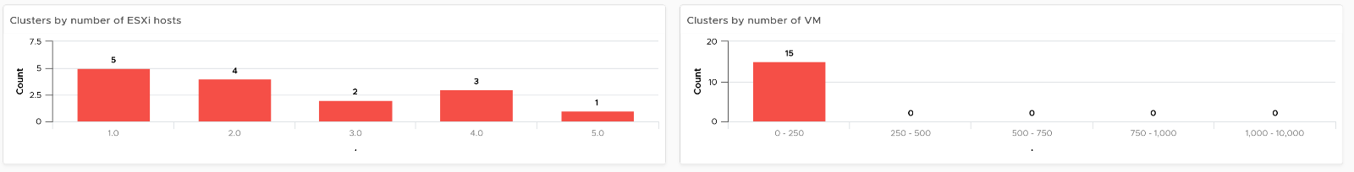

The third section of the dashboard shows 2 bar charts. They show the absolute distribution of cluster.

* The first shows the cluster grouped by the number of ESXi Hosts. Ensure this matches your plan and cluster sizing standards.
* Small clusters (defined as having less ESXi hosts) have higher overhead while large clusters have a higher risk in case of cluster-wide outages. For large cluster, have a disaster recovery plan an unexpected cluster-wide outage can impact many VMs.
* Performance risk is lower in large clusters partly because there are more nodes that DRS can tap on, but if there is an actual problem troubleshooting can be harder (because there are more nodes to analyze).
* In large environment, small clusters can result in cluster sprawl.

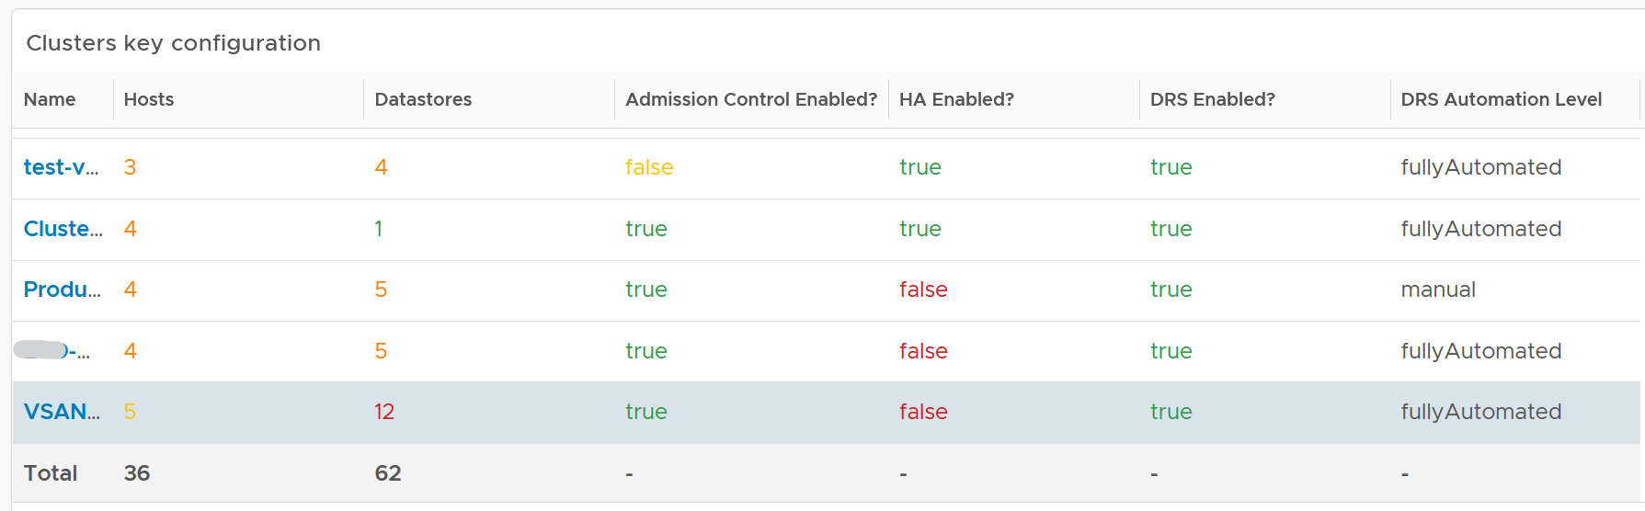

The fourth section of the dashboard lets you drill down into individual cluster.

* It begins with a table listing all the clusters with their key configuration. You can export this list as a spreadsheet for further analysis or reporting.
* Select a cluster. The list of ESXi Hosts under the cluster, along with shares and resource pools information, is automatically filled up. Ensure as all its ESXi Hosts have identical configuration.
* Keep the number of distinct shares below three (or at minimum), matching the distinct classes of service. You should avoid giving different service level to individual VMs as that increase the complexity of the cluster performance.
* Verify that Shares are used consistently throughout your entire vSphere environment. Do note that they are relative numbers, not absolute. Ideally, avoid using it altogether as it's easy to overlook. When you move VM to another cluster or vCenter, you may forget to set the new share appropriately.

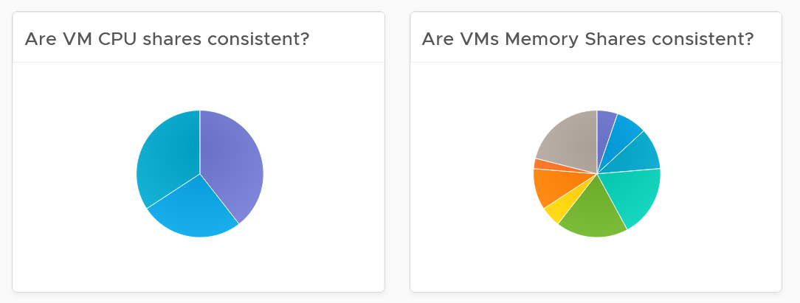

* Keep the number of resource pools minimal. Resource Pools can impact performance, if the number of VMs in the pool do not match its intended shares. The new **Scalable Shares** feature in vSphere 7 automates this adjustment, which has to be done in older version. More about it [here](http://www.yellow-bricks.com/2020/03/16/vsphere-7-and-drs-scalable-shares-how-are-they-calculated/).
* Some of the columns are color coded to facilitate quick reviews. Adjust their threshold to either reflect your current situation or your desired ideal state

#### Points to Note

* You might notice that the **DRS Migration Threshold** widget is using the property **DRS vMotion Rate**. This is the correct property. We will correct the property name so it’s less confusing.
* The **HA Memory Failover Shares** widget should be named **HA Memory Failover percentage.** This is a known typo.
* The **HA CPU Failover Shares** widget should be named **HA CPU Failover percentage.** This is a known typo.

### ESXi Configuration

For a more complete visibility, consider adding physical server monitoring by using the appropriate management pack. More info [here](https://www.vmware.com/products/vrealize-operations.html).

The dashboard is organized into sections for ease of use.

The upper part of the dashboard displays basic ESXi configurations that should be standardized for ease of operations.

* There are six pie-charts that are displayed as one set because there is a relationship in their values. There should be a correlation between them. Ideally, the ESXi version, the ESXi build, and the BIOS should be identical across all ESXi hosts in a cluster”. Keep the variations of hardware model, NIC speed, and storage path minimal. The more complex the pie chart, the more variants you have. This results in complex operations, potentially resulting in increased OPEX.
* The configurations should reflect your current architecture standard. Each pie-chart counts the occurrence of a particular value. A large slice signifies that the value is the most common value, and if that is not your current standard, then you must address it.

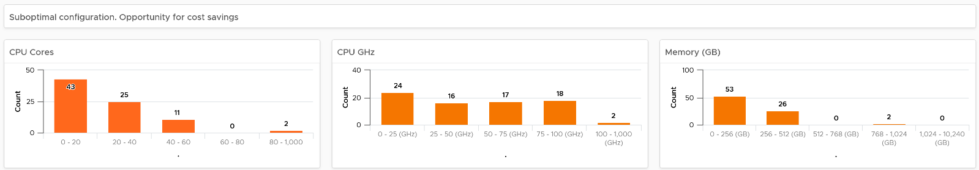

The second section of the dashboard displays configurations that are potentially suboptimal.

* The three bar-charts display various size dimensions of the ESXi hosts. The bar-charts are designed to be seen as one set. Ensure minimal number of variations to reduce complexity.
* Smaller ESXi hosts have a relatively higher overhead, and are limited in running larger VMs. If they have a low core count, they could be using outdated CPU. Small ESXi hosts are more expensive on a per core, per GB, per rack unit basis than larger ones if they occupy the same space. On the other hand, a 4-CPU socket ESXi host is likely to be too large, resulting in a concentration risk (too many VMs in a single ESXi host). Maintain a good balance that balance your budget and risk constraints . You should adjust the distribution chart bucket size to fit your environment.

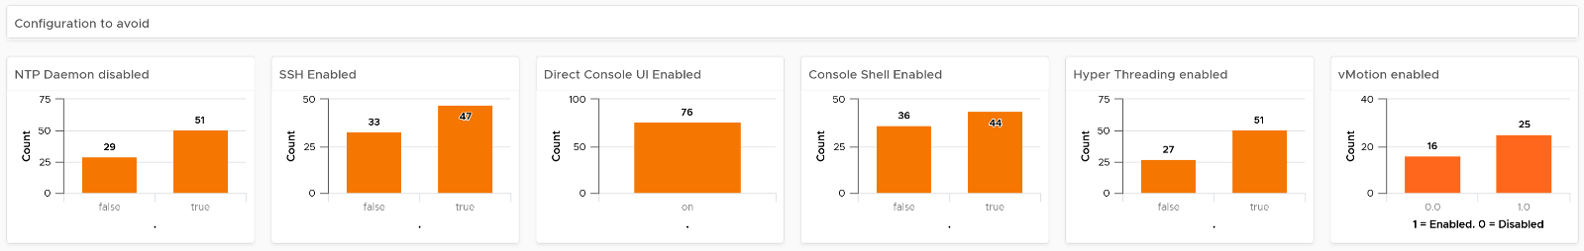

The third section of the dashboard displays configurations that you may want to avoid.

* The six bar-charts focus on security, availability, and capacity settings that you can set as a standard. For example, you should consider enabling the NTP daemon for consistent time, which is critical for logging and troubleshooting.
* The three tables list the actual ESXi hosts that are in a non-productive state. They can be in maintenance mode, powered off, or in a disconnected state.
* BTW, I’ve modified the last one to show information, to show an example if that makes sense for your operations. I do not do it for the out of the box version as visually it will look awkward as the first 5 charts do not need it 😊

The last part displays all the ESXi hosts in your environment.

* You can sort the columns and export the result into spreadsheet for further analysis.
* Some of the columns are color coded to facilitate quick reviews. Adjust their threshold to either reflect your current situation or your desired ideal state

### Network Configuration

For a more complete visibility, consider adding physical network device monitoring by using the appropriate management pack. More info [here](https://www.vmware.com/products/vrealize-operations.html).

The dashboard is organized into 2 sections for ease of use.

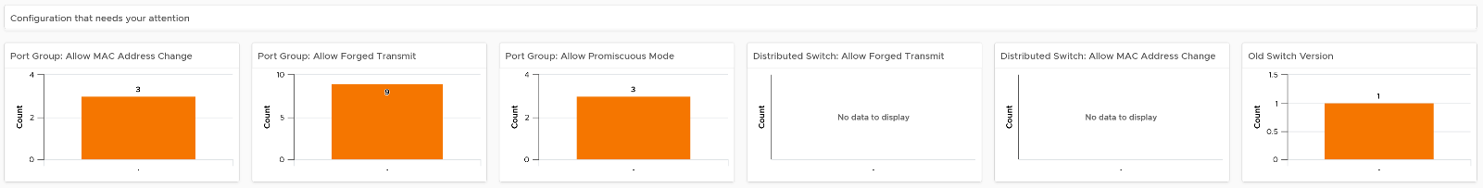

The first section displays network configurations that needs your attention

* There are 5 bar charts that focuses on critical security settings.
* The last bar chat shows the version of the vSphere Distribution Switch. Aim to keep the version current, or matching your vSphere version.

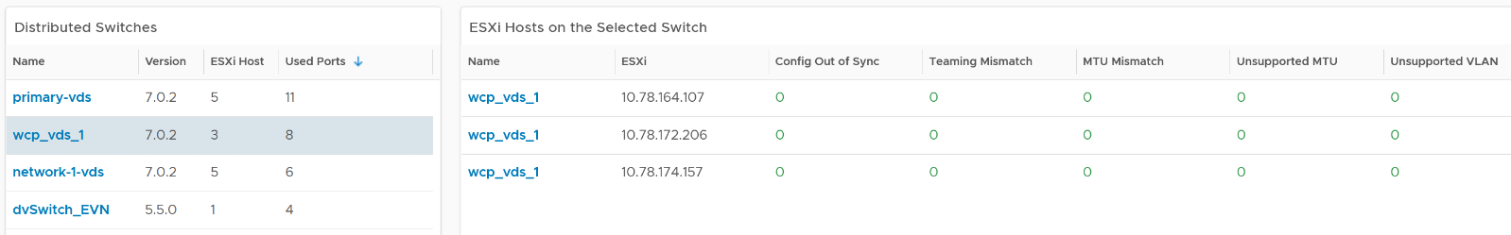

The second section provides overall configuration, with ability to drill down into a particular switch

* Start by selecting a switch from the list.
* The ESXi Hosts, port groups and VMs on the switch will automatically be shown.
* Review each of the tables. For the ESXi Host table, ensure their settings are consistent.
* Some of the columns are color coded to facilitate quick reviews. Adjust their threshold to either reflect your current situation or your desired ideal state.
* You can sort the columns and export the result into spreadsheet for further analysis.

### Storage Configuration

The dashboard covers both vSAN and non vSAN.

The dashboard is organized into 3 sections for ease of use.

The first section displays 6 pie charts

* There are 5 bar charts that focuses on critical security settings. Their values should match your security policy.
* The last bar chat shows the version of the vSphere Distribution Switch. Aim to keep the version current, or matching your vSphere version.

The second section displays 3 bar charts

* Together, they provide good overview of the vSAN key capacity configuration. By seeing the distribution, you can see if you have capacity configuration that is outside your expectation.

The last part of the dashboard shows all the vSAN clusters with their key configuration.

* Some of the columns are color coded to facilitate quick reviews. Adjust their threshold to either reflect your current situation or your desired ideal state
* You can sort the columns and export the result into spreadsheet for further analysis.

### Optimize Configuration

Part 2 Chapter 4 Configuration Management covers the flow to optimize configuration. It follows the following 4-steps, where each step reviews both the Consumer (e.g. VM, Container) and Provider (e.g. Cluster, ESXi, Datastore).



To keep the solution extendable yet simple, the above flow is implemented in 8 dashboards that are designed as a set. Use them together as you go through the optimization review process. The dashboards are:

* Consumer \ Correct it?
* Consumer \ Update it?
* Consumer \ Simplify it?
* Consumer \ Optimize it?
* Provider \ Correct it?
* Provider \ Update it?
* Provider \ Simplify it?
* Provider \ Optimize it?

The dashboards complements the main configuration dashboard by displaying the actual object names, along with their relevant information. It is designed for vSphere administrator and platform team, to facilitate the follow-up action with the VM owners.

The dashboard is designed to focus on objects that need attention. A list is used to keep it simple, and show actual objects. The list is easy to be tailored by filter and custom group. The list can also be exported for an offline discussion. Each dashboard is just a collection of tables (List View), which can be reviewed independently. There is no flow among them.

It’s also designed to be extendable, reflecting the reality that different customers will have a different set of settings to verify. Since the dashboard layout is just a collection of tables (View List), you can extend it by simply adding more tables. Simply add more View List widget to check the object configuration that your operations require.

To investigate further, click the object name to navigate to the Object Summary page to view more configurations. There can be valid reasons why specific configurations are not followed. It is recommended that you discuss best practices with VMware. If you prefer a quick context, add a property widget that lists the selected object properties. In this way you can check the property of your interest without the need to leave the screen. Note that multiple View List widget can drive the same property widget, so you do not have to create 1 property widget for each View List.

In a very large environment, create a filter for this dashboard to enable you to focus on a segment of the environment. Group it by a class of service such as, Gold, silver, and bronze. Default the selection to Gold, your most important environment. In this way, your monitoring is not cluttered with less critical workloads.

There are other VM configuration that maybe relevant to your environment. Review the list of VM settings that you may want to add to this dashboard here.

#### Consumer \ Update it?

About Outdated Tools table

* It lists all the VMware Tools version that is still supported. You should tailor the filter to fit your operational needs.

About Outdated VM Hardware

* It lists all the VM vmx versions that are not 13, 14, 15, or 16. You should tailor the filter to fit your operational needs.

About the outdated Windows and Red Hat

* It lists all Microsoft Windows client version that are not version 10
* It lists all Microsoft Windows server version that are not version 2016 and 2019.
* It lists all Red Hat Enterprise Linux version that are not version 7 or 8.
* If you run other Operating Systems like Ubuntu, clone the widget. Or repurpose the widget if you don’t run RHEL and MS Windows

#### Provider \ Correct it?

The dashboard is organized into 3 sections for ease of use.

* The first section covers vSphere clusters configuration
* The second section covers ESXi host configuration
* The third section covers ESXi host configuration that need to be consistent within a cluster

If you have standalone ESXi and you plan to replace them with clustered ESXi host, add a table to list them.

#### Provider \ Update it?

About the outdated vSphere components

* It lists all the vCenter Server that are not 6.7 or 7.0.
* It lists all the ESXi Host that are not 6.5, 6.7 or 7.0
* It lists all the vSAN ESXi Host that are not 6.7 or 7.0. A more stringent filter is applied for vSAN due to relatively higher maturity in the latest release. Specifically from vRealize Operations and Log Insight, there are more metrics, properties and events that improve monitoring and troubleshooting.
* It lists all the vSphere Distributed Switch, regardless of version.
* You should tailor the filter to fit your operational needs.

About Outdated Server BIOS

* It lists all the ESXi regardless of the BIOS version. Edit the widget and tailor the filter to fit your operational needs.

Other than customizing the existing widgets, consider adding the following checks.

* ESXi hosts with outdated hardware, using a filter based on your environment.
* ESXi hosts that are no longer on warranty. Create a custom property to capture the end of warranty.
* Physical storage arrays with outdated firmware, model and expiring warranty expire.
* Physical network switch with outdated OS version and hardware model

Note that the last 2 items above requires you to install relevant management pack.

#### Provider \ Simplify it?

Select one of the cluster from the table.

Review the Resource Pools list.

* Ensure that the number of VMs in each resource pool reflects the intended settings for the resource pool. The resource pool value is divided and shared among the VMs. The more the VMs, the lesser the resources allotted to each VM.
* Verify if there are VMs who are sibling to the resource pools.
* Verify if the resource pools are further split into sub resource pools.

Review the CPU Share and Memory shares pie charts

* Multiple combinations of shares, especially both CPU and memory, makes troubleshooting difficult.

Review the CPU Reservation and Memory Reservation tables

#### Provider \ Optimize it?

The dashboard is organized into 3 sections for ease of use.

* The first section cover vSphere clusters configuration
* The second section cover ESXi Host configuration
  + ESXi powered off. You can mark the ESXi hosts for decommissioning using the custom property feature of vRealize Operations. You can then create a separate list so they are not overlooked.
* The third section cover storage and network

## Availability

**Part 3 Chapter 7**

The availability dashboards aims to implement the capacity concept covered in Availability Management chapter. They are rather limited, hence if you have something let’s collaborate!

### VM Availability

Use the VM Availability dashboard to calculate the availability of the Guest OS. The availability of the Guest OS is calculated because the Guest OS might not be running even when the VM is powered on. There are two layers of Availability, that is, the Consumer layer and the Provider layer. This dashboard covers the Consumer layer. You can view VMs in the selected data center, uptime trend for a selected cluster, and so on.

#### Design Consideration

The dashboard is designed to help check the availability (uptime in percentage) of VMs, as availability is typically a part of services provided by the IaaS provider.

This dashboard does not check the application up time. It is possible that the application (e.g. a database, web server) is down while the underlying Windows or Linus is up. Generally, the service provided by IaaS team is only until Windows or Linux. To check application level, use network ping or application specific agent (e.g. Telegraf)

#### How to Use

Start in **Data centers** widget by selecting one of the data centers listed.

* In small environment, or if you want to see overall, you click the **vSphere World** object.
* The above action will update other widgets automatically.
* Think of creating a filter for this table that reflect your class of service. Group by the class of services such as Gold, silver, and bronze and default the selection to Gold. In this way, the monitoring is not cluttered with less critical workloads, and you can focus on the important VMs. One way to achieve this is by creating a vRealize Operations custom group for each class of service

About the VMs by Uptime in the last 30 days bar chart

* It displays the average uptime of VMs grouped by their availability. The bucket distribution is designed to cater for a wide array of environment. If You are monitoring only production VMs, where uptime is expected to be near 100% all the time, edit the bucket to meet your operational need.

About the VMs in the Selected Data center table

* It lists all VMs currently deployed to the data center. Average Uptime is displayed for the last 1 month of data. Expect this number to be 100% or near there for production VM.
* Note that the **Services** column will be blank unless Service Discovery is enabled and services/processes were discovered on a specific VM.
* The column **VMs** includes all VMs including powered off VMs.

Select a VM from the above table.

* The remaining widgets will automatically show the detail of the selected VM.
* Selected VM Uptime Trend displays the selected VM’s Guest Tool Uptime (%) across the last 30 days.

Expand the 2 collapsed widgets

* If Guest OS services or processes are discovered inside a VM, their availability is analyzed. Service ‘state’ over time is displayed in Guest OS: Services.
* The dashboard displays the process or services running inside the Guest OS. This requires the Service Discovery Management Pack.
* The ESXi Host where the VM has run widget can show historical migration of the VM. This can be useful in determining the cause of a VM downtime.

#### Points to Note

* The metric is only tracking the availability of VMware Tools, not the entire Guest OS. If Tools is not up, it assumes the Guest OS is down. To help you check that this is not a false negative, add a few line charts that shows sign of life. A good counter is IO metrics such as Disk IOPS, Disk Throughput and Network Transmit Throughput, because IO requires CPU processing. CPU Usage is not a reliable counter as work by VMkernel on the VM is charged to the CPU metrics.
* vRealize Operations 8.2 sports a new ping adapter. This means you can enhance the accuracy of the uptime measurement by creating a super metric that adds the ping information or checking the process (needs an agent, such as Telegraf).
* Add a property widget that lists the selected VM properties to give you more context about the VM. In large environment, it is possible that the VM name alone may not be providing enough context.

### vSphere Availability

There are two layers of Availability, that is, the Consumer layer and the Provider layer. The vSphere Availability dashboard covers the Provider layer. This dashboard includes a cluster and not an ESXi host because the cluster is operationally a single compute provider. This dashboard considers the N+1 design, where the cluster can withstand one host failure. Logically, a cluster with fewer hosts has a higher risk.

The dashboard is designed to help you analyze and report the uptime, as availability is typically part of official business SLA. It’s also often required in the monthly operational summary report.

The dashboard is not designed for live monitoring of the uptime. An NOC style of dashboard is better suited for that use case. Tools such as vRealize Log Insight should also be leveraged as fault is typically preceded with soft errors.

#### How to Use

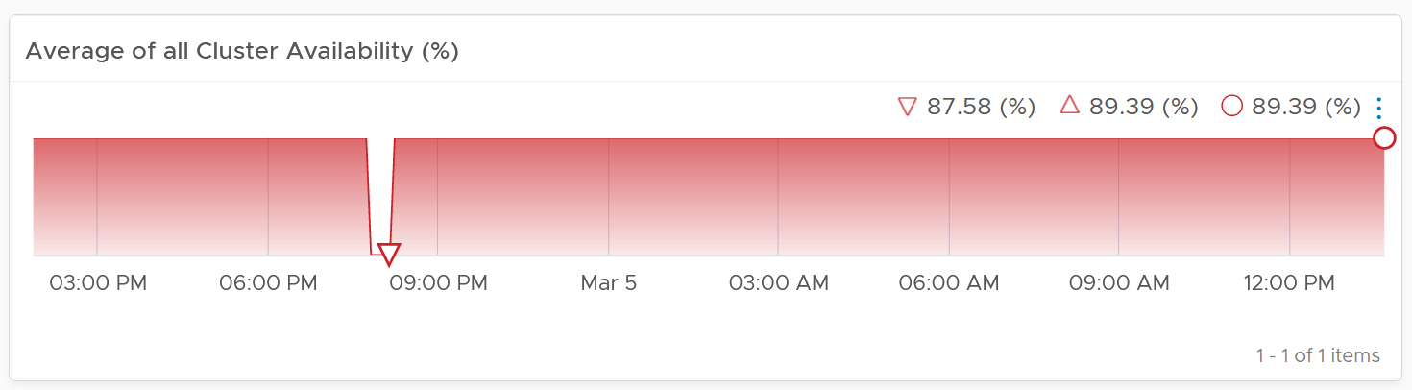

D

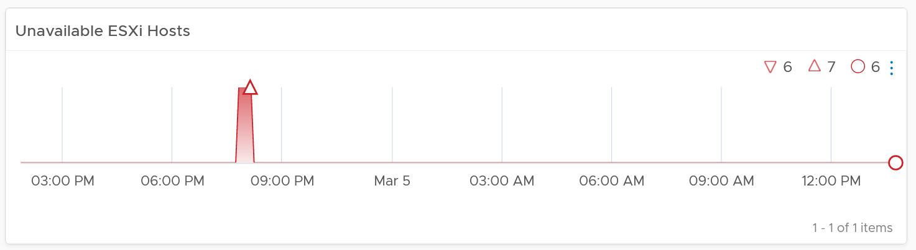

The table Clusters lists all the clusters in your environment. In a very large environment, creating a filter for the list of clusters can make it more manageable. One is is to group the clusters by their class of services. Group your clusters into Gold, silver, and bronze and default the selection to Gold. In this way, you can see your Gold clusters more easily.

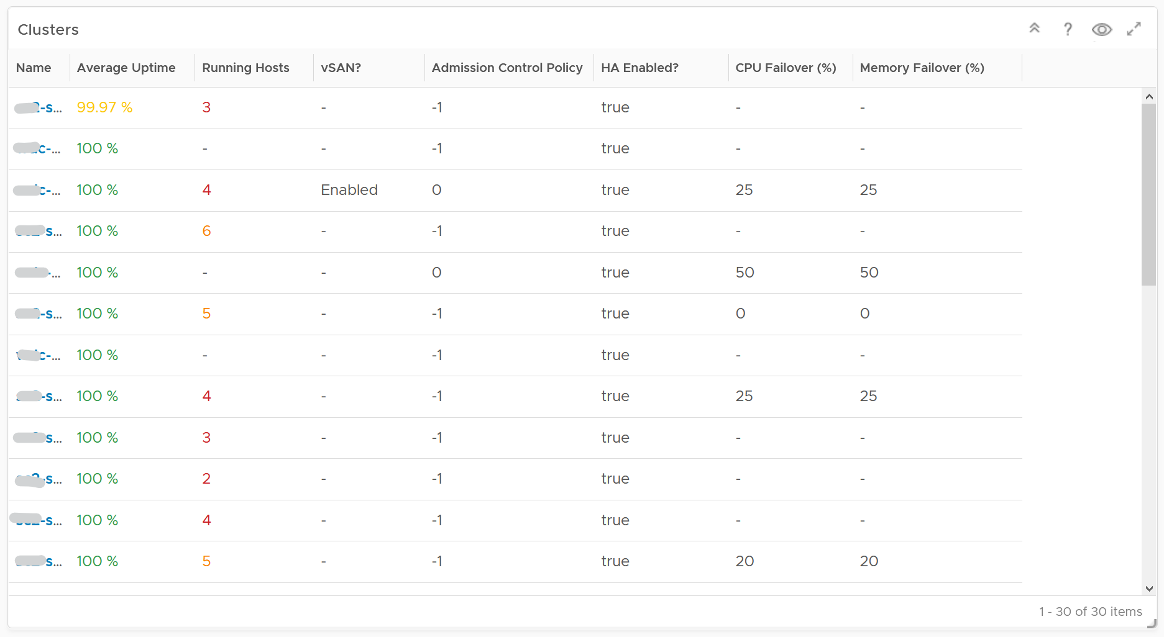

It is sorted by the lowest uptime, so your attention is drawn to the cluster with the lowest uptime in the last 1 month. The column is based on the *average* of the last 1 month as availability SLA is should be calculated per month (but reported much more frequently)

The metric used is Summary \ Cluster Availability (%), which assumes N+1 design. That means if there is 1 node failure, the metric is still showing 100%.

The column **Running Hosts** are color coded as logically a smaller cluster has higher risk. A single host failure results in relatively higher capacity degradation.

The column **vSAN?** Is added as hyper-converged means you need to consider both the compute part and the storage part.

The Admission Control Policy is based on the property Cluster Configuration \ DAS Configuration \ Active. The mapping between code to name is

* -1 = Disabled
* 0 = Cluster Resource percentage
* 1 = Slot Policy (Powered-on VMs)
* 2 = Dedicated Failover Hosts

The cluster failover percentage columns map to the following values in vCenter client UI.

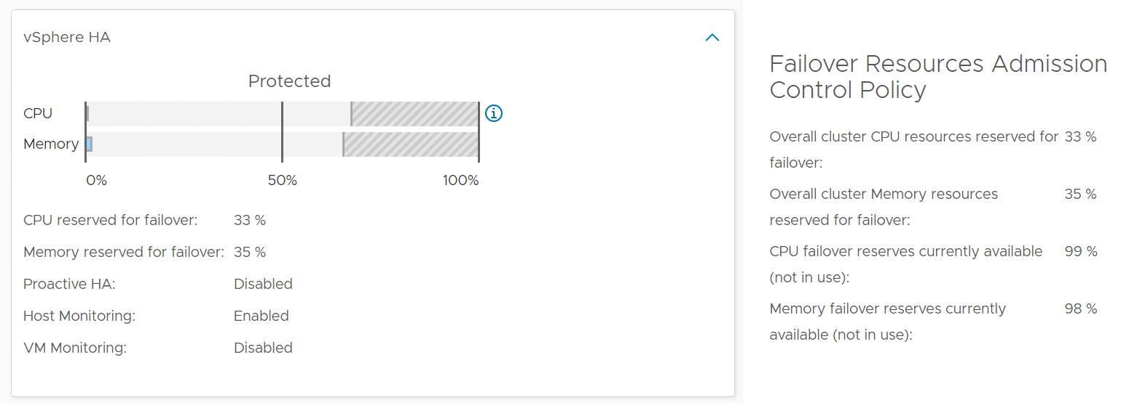

Select a cluster from the above

* The cluster uptime will be automatically plotted. It’s using 25%, 50%, and 75% as the threshold for red, orange and yellow respectively. The reason for low threshold is the 5 minute window. A complete 5 minute downtime is only 0.0116% when measured against a 30-day SLA. If the uptime was 100%, it will only go down to 99.9884%
* The ESXi in the selected cluster table will be automatically filled up. For more context, you can add a property widget that lists the selected ESXi Host properties.
* The 'Connected to vCenter' and 'Maintenance State' columns are not the average values, as both are string. However, they display the last state in the selected period. This allows you to go back to a specific point in time and view availability at that point.

About the “Datastore not available” list

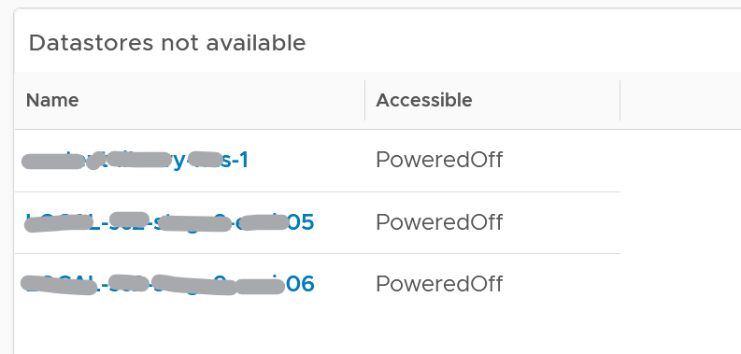

* It filters to only those datastores with status powered off. This covers both local and shared datastore. To add context, consider adding extra column such as the data center where it resides, and the datastore type (e.g. NFS, VMFS)

About the Port Group availability list

* This lists port groups which at present has uptime of less than 100%.
* To add context, consider adding extra column such as the data center where it resides, used number of ports and maximum number of ports

#### Points to Note

Consider adding vCenter Server availability and NSX components availability. This requires the VMware SDDC Health monitoring solution.

## VDI & DaaS

While VMware Horizon provides the same business functionalities with products such as Citrix, it requires a monitoring and troubleshooting solution that is aware of its objects, metrics, logs and events. In this chapter we will cover the Horizon-specific operations management.

**Part 4 Chapter 8**

The following shows the dashboards that support Horizon operations management. They eventually connect to the object summary page of each type of object.

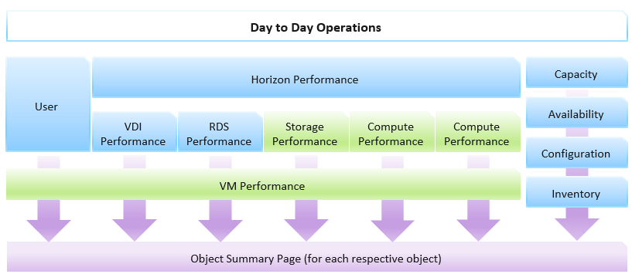

The dashboards form a set. There is 1 dashboard for each of the following pillar: capacity, availability, configuration and inventory.

Performance needs 3 dashboards as there are too many information to be squeezed in 1 dashboard. Also, each dashboard is giving a different the vantage point. As Horizon runs on top of vSphere, there is a drill down into vSphere. An overall VM performance dashboard is provided to tie all these dashboards together, as both RDS hosts and VDI sessions eventually run on VM.

User is given a separate dashboard as your operations should be user-centric. To your users, this is the only thing they care.

For the NOC team, 2 dashboards are created. One looks from consumer, one looks from provider. They follow the design principle for NOC dashboards documented here.

### Day-to-Day Operations Dashboard

As covered in Part 3 Dashboard Design Considerations, this dashboard serves as the main dashboard used by someone who runs the day to day operations. It focuses on area that either change often, or should not have major change. For example, if you expect around 10K users connected and you only see 1K, expect to see major downtime somewhere that prevent that many users unable to connect.

In DaaS, you’re outnumbered by your users. There are more users than administrators, and problems can also come from non users. As a result, there is a good chance that by the time you look into the problem, 5 minute have passed or the problem no longer happens. This means the dashboard should show you a trend, not just the present time or a point in time in the past.

#### Summary Section

The summary section consists of 4 scoreboard, aligned in 2x2 layout. They provide the top of the news type of information.

##### Overall KPI

This is the first of 4 widgets that shows the summary of the live environment. It focuses on the major indicators of your DaaS environment.

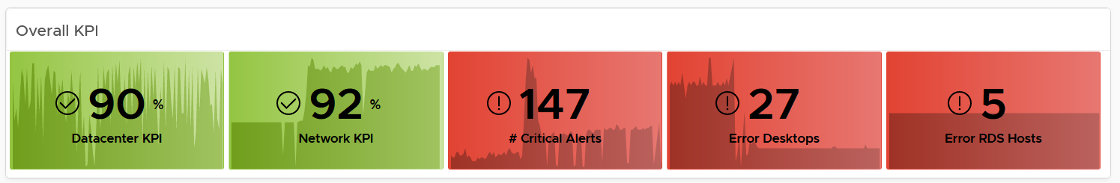

The widget shows 3 types of information

* The first one is performance. It shows the overall Data Center KPI and Network KPI. Expect this number to be steady, and in the green zone.
* Alert. It focuses on critical alert (red level). Expect this to be low number, appropriate for the size of your environment. Review the alerts definition and fine tune so they are not too sensitive or too late for your environment.
* Availability. This covers both RDS and VDI. If you only use one of them, delete the one you don’t use and set this to 4 columns

##### Overall Utilization

DaaS involves users, which have normal working hours. After a while, you establish an expected level of usage.

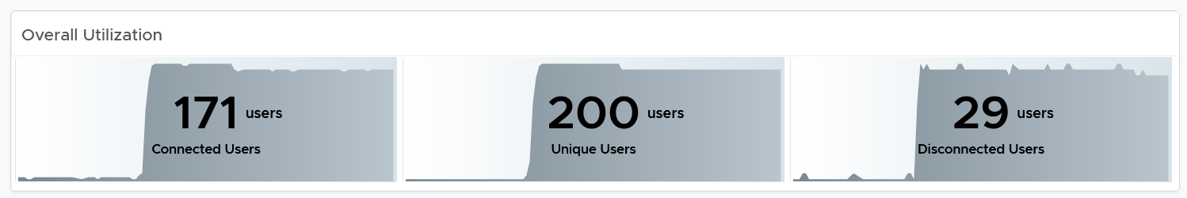

We include this widget as a big and unexpected drop in number of users could be sign of catastrophic failure. Something major must have prevented your users from connecting.

##### Performance

The overall KPI is a summary number, which consists of multiple component. An improvement in one component can mask out degradation in others. The performance widget breaks down the number into CPU, memory, disk and network.

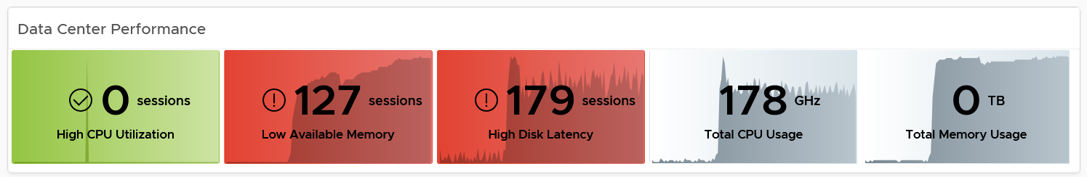

Take note that RDS session is just a group of process that belong to a Windows user, so the concept of high CPU, low memory do not apply. There is no disk latency counter per process either. So the first 3 metrics are only for VDI. The threshold settings are as follow. Adjust them accordingly.

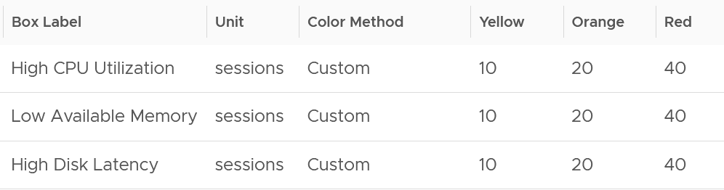

The next metrics include both VDI sessions and RDS hosts. They have no threshold as higher does not mean worse or better.

If you have more screen real estate, consider adding the following metrics

* Datacenter KPI (%).
* Disk IOPS
* Disk Throughput

Network is given its own widget as DaaS is essentially desktop over the network

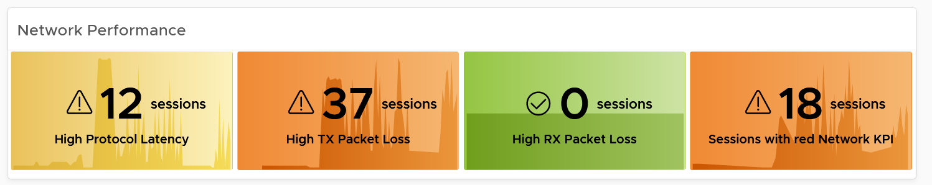

The threshold settings are as follow. Adjust them accordingly. If you have mixed LAN users and WAN users, the threshold will naturally be dominated by your remote users. You can ignore LAN users as they should not be experiencing any network problem, unless your office Wi-Fi unable to cope or provide higher service to VDI protocol.

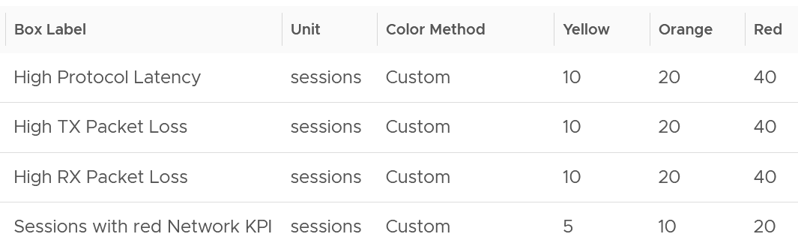

If you have more screen real estate, consider adding the following metrics

* Network KPI (%).
* No of RDS sessions with red network KPI.

#### Performance Section

The summary section does not show individual session. The performance section complements it by showing the distribution of the sessions, and you can drill down into specific session.

As you can expect, there are 2 distribution charts. One for the data center, and one for the network. The one for DC only covers VDI, while the one for the network covers both VDI and RDS.

The following screenshot shows the network one.

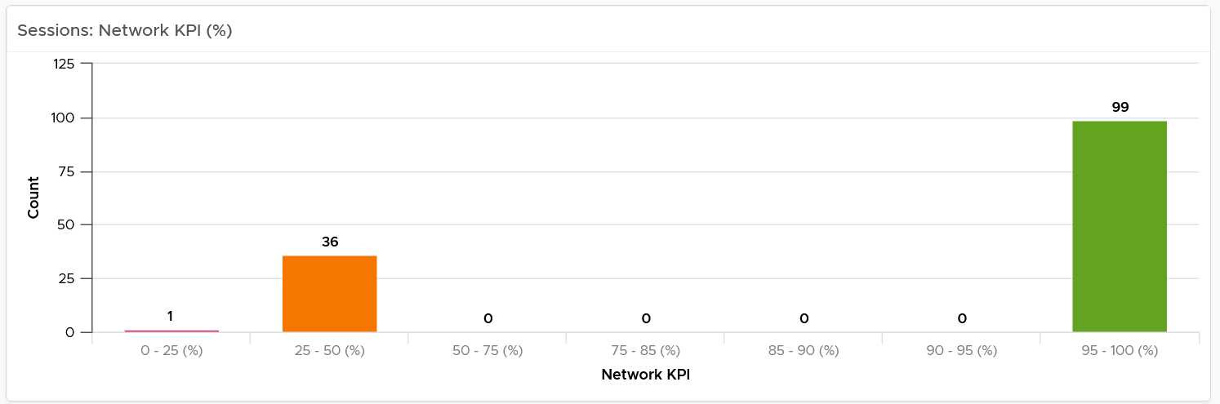

They follow the KPI, which has 4 equal-distribution (Green is 75-100%, while Red is 0 – 25%). The chart provides more breakdown for the green range as majority of the values should be here (above screenshot was from a lab), giving you a finer visibility so you can see if they are closer to 75% or 100%.

The number shown is the worst number in the last 24 hours.

You can click on each of the bucket to see the actual session.

#### VDI Pool and RDS Farm Section

This section complements the above by focusing on the provider of the resource, as there can be many to many relationship between users and pool/farm. There can be times where you want to view pool by pool, or farm by farm.

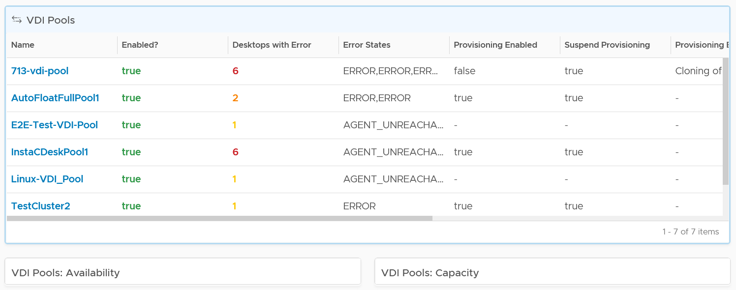

Under the table, the dashboard sports 4 widgets. They widgets are collapsed by default as they provide secondary information to the preceding table. They are for convenient, especially in large environment with hundreds of pools and farms.

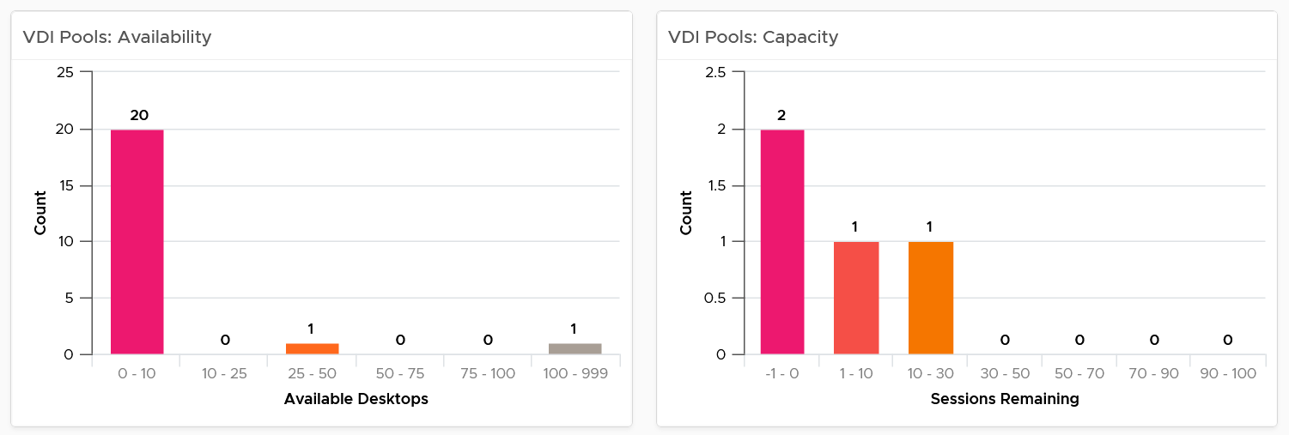

The column bucket is color coded, from red to green. Why is the last color grey?

It shows excess capacity. Too much excess it becomes a wastage.

#### Horizon Servers Section

The last section focuses on the infrastructure. You will notice that we typically place the “kitchen” matters last. You should focus on the user first, then Pool/Farm, then your vSphere and Horizon infrastructure.

It shows 3 widgets, as Connection Server does not have a network KPI metric (it is not that relevant as protocol traffic does not pass through connection server).

The following screenshot shows 2 of the 3 widgets.

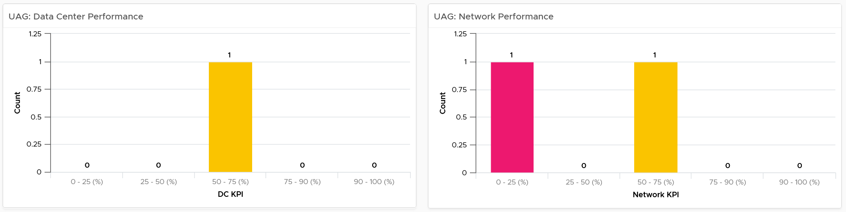

### User Dashboard

The dashboard provides a user-centric view. It’s designed when you know the specific user, or you want to view from users perspective. Generally, you want to ensure a good experience for the user, which means providing sufficient capacity and speedy response time. To user, capacity and performance are the same thing, as what they want is fast computer.

User does not want to wait for 1 hour when performance issue happens. Alert has to be in place that react within reasonable time (10 – 20 minutes) so their productivity is not impacted. One way is to have an on-demand CPU and memory hot add. Upsize CPU or RAM independently as they may not be corelated. User A may have CPU issue, while User B may have RAM issue.

If users are allowed to install their own applications, or there are many applications, you have higher risk of runaway process. A process going into CPU look can chew up CPU for >10 minutes.

#### Summary Section

This section gives a bird-eye overview. It sports 3 widgets, 1 focuses on overall consumption and 2 focus on performance.

Overall consumption is a primary counter. Make sure the sets of numbers are within your expectation.

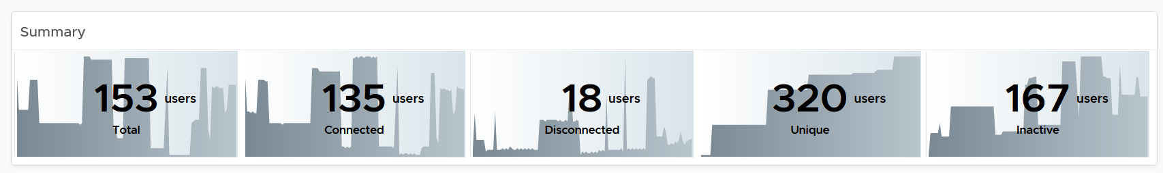

As you can expect, the performance-oriented widgets focus on network and data center. The following screenshot shows the network one.

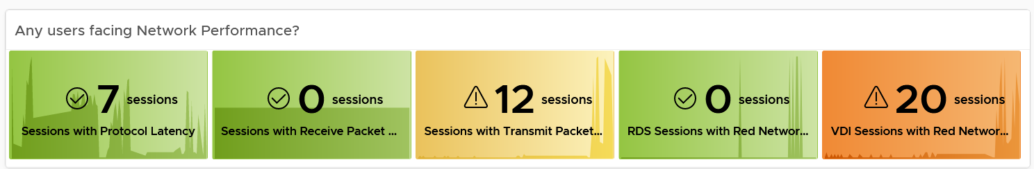

Why do we count sessions instead of users?

Because a user can have many sessions. In a class-room setting, the entire class could be sharing 1 account.

The widget shows the following metrics:

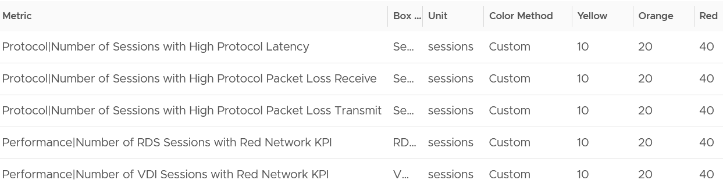

Adjust the threshold accordingly. Factors that impact the threshold is the size of your environment, the number of concurrent users, and your promised SLA.

The above is for the network. For the DC, the dashboard shows the following information.

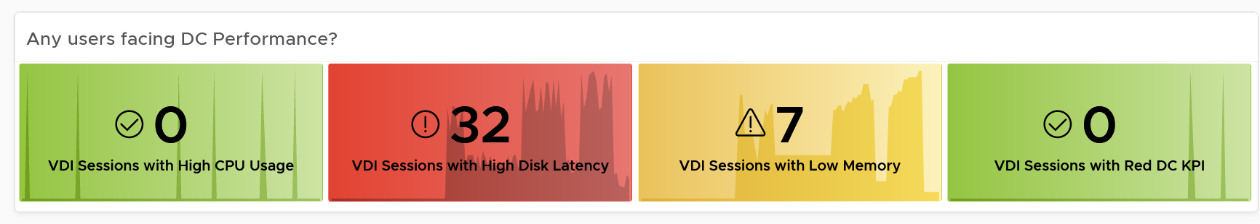

The widget shows the following metrics:

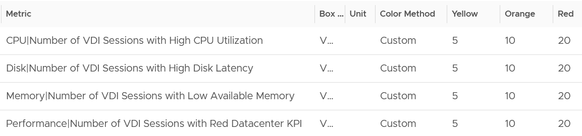

Notice the threshold are different to network, as the data center infrastructure is within your control. For network, you typically share the network with other non VDI load. Even on VDI, the protocol packets share with the non-protocol packets.

#### Performance Section

The summary section does not show individual users. The performance section complements it by showing the distribution of the users, and you can drill down into specific users.

A user can have >1 sessions. In this case, the metric shows the worst among all the sessions, not the average. A user with 2 sessions can have bad CPU on session 1 and bad network on session 2. The metric at user level will capture both as it takes the worst of each session.

This section follows the design that is used in the Day to Day Operations dashboard. The difference is it shows the users, not the session. This is useful if your environment allows a user to have >1 session.

The following screenshot shows the network one.

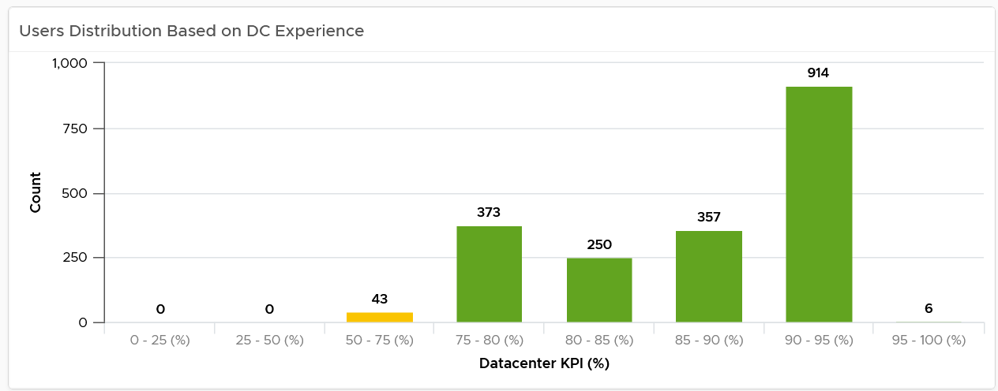

#### User-level Analysis

This section starts with a table listing all the users (not the sessions).

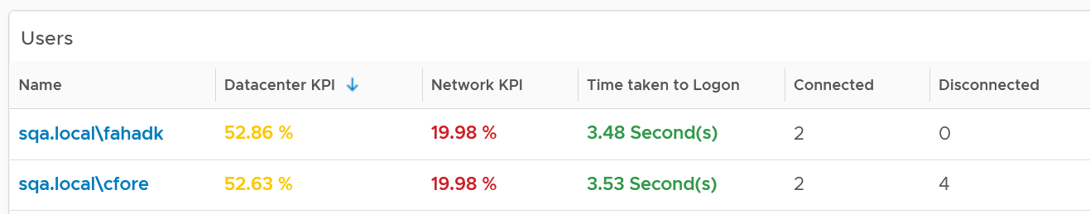

If your environment allows multiple sessions per user, consider sorting by number of connected session to see users with the most session.

The time range is set to 8 hours so that you're not looking at yesterday data. The idea is you look at this dashboard during the day (8 am to 8 pm). Adjust the time setting according to your need from the toolbar.

Select a user from the table. The following detail metrics will automatically be shown. Let’s go through them.

##### Protocol

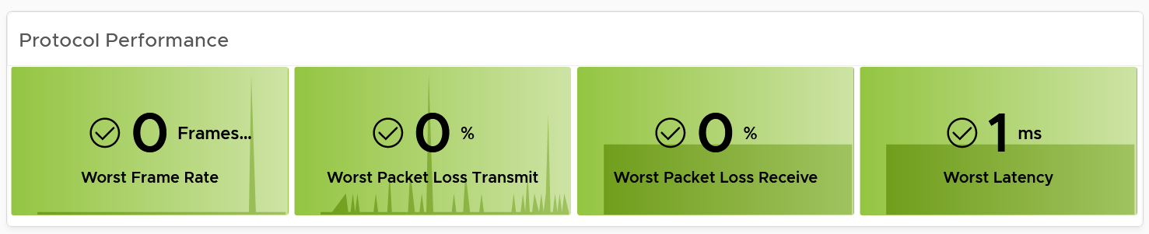

The metric is called protocol as it only measures the Horizon PCoIP, Blast or RDP traffic. If a user uses Windows to download large file, that TCP traffic is not included.

##### CPU Performance

There are 2 widgets, one for CPU and one for memory.

Take note that this only applies to VDI session. RDS session only has the CPU Usage. If you use RDS, it’s better to monitor at RDS host levels as there is lack of metrics at process level.

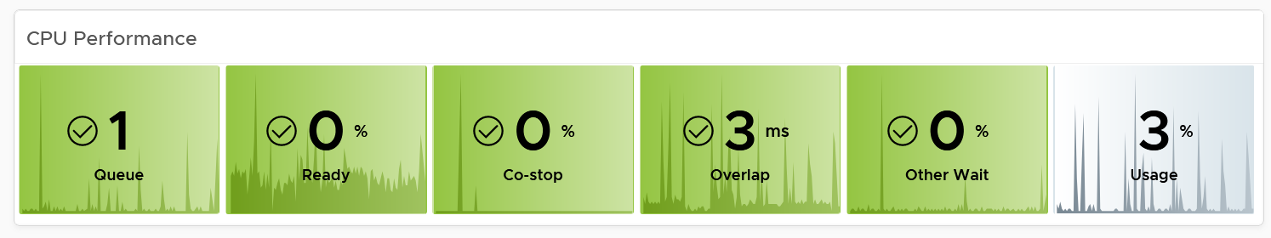

As they are VM, the follow the same design. Review the following table. What changes do you spot?

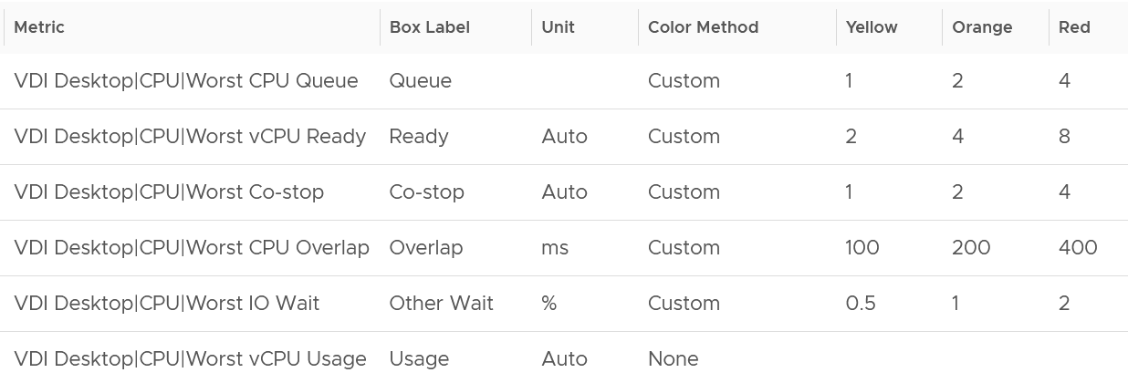

I had to change the threshold for CPU Overlap and CPU Run Queue to adjust for smaller VM in VDI.

I removed CPU Usage Disparity as they matter less in VDI as the VM size is smaller.

Another difference between the User object and the VM object is these metrics in User object automatically switch to the 20-second peak metric if you enable them in vRealize Operations policy. There is a logic built to detect the presence of 20-second peak.

##### Memory Performance

Just like the CPU widget, the memory widget follows the same design used in VM Performance dashboard. Review the following table. What changes do you spot?

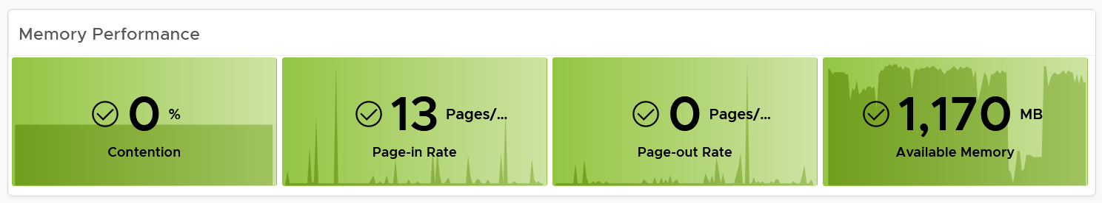

I move the paging rate metrics before utilization. Because VDI is relatively uniformed, you should be able to profile and establish the healthy range.

I do not have the following metrics, as they are signed of underlying infrastructure capacity. In the case of VDI, you should manage this at pool, farm or cluster level. This is especially true in pools where users don’t have permanent assignment to a VM.

* Balloon
* Compressed
* Swapped

##### Disk Performance

Just like the CPU widget, the memory widget follows the same design used in VM Performance dashboard. Review the following table. What changes do you spot?

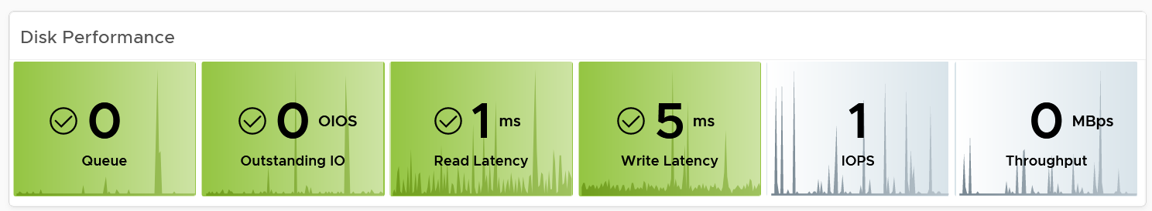

I combine Read IOPS and Write IOPS into IOPS, and combine Read Throughput and Write Throughput as Throughput. The reason is the numbers are expected to be small.

I also halve the threshold for Disk Queue and Outstanding IO, as I want to be conservative. Once I have enough data in production, I’d adjust them accordingly.

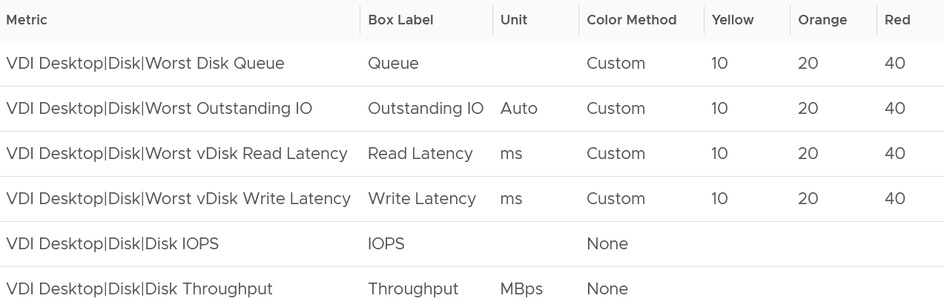

##### Context

Lastly, the dashboard provides context around the user by showing the relevant configuration. You can also drill down from the users to the session. If it’s VDI session, you can drill down to the actual VM, by navigating to the VM Performance dashboard.

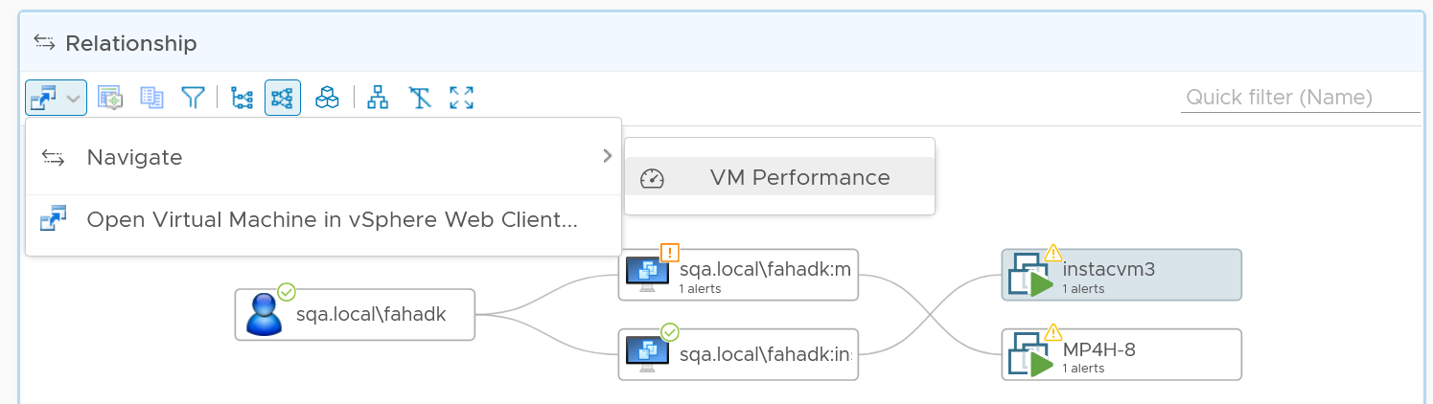

### Performance Dashboards

The performance dashboard follows the design principles for performance dashboard, documented here.

There are 6 dashboards for performance management, 3 from Horizon and 3 from vSphere. To tie them, the Horizon Performance dashboard acts as the starting point. However, each dashboard can also be standalone, meaning you can skip the overall dashboard if you already know the specific area to look into.

#### Horizon Performance Dashboard

The dashboard is designed to provide a quick overview, enabling convenient access to cycle among pods, farms and pools as you try to establish the performance issue. It’s not suitable when you already know the farm or pool with problem. If you already know the specific, then simply go direct to the VDI dashboard, RDS dashboard, or User Dashboard.

The dashboard needs to cover

* Data Center Performance
* Network Performance
* Performance from users point of view

To complete the picture, the dashboard should enable you to see from vSphere viewpoint, because a problem at lower layer can impact upper layer. This is especially important in Horizon as you will overcommit the underlying ESXi.

##### Navigation

The Horizon Performance dashboard acts as the starting line. Use this dashboard to drill down into 6 specific dashboards (as marked by the right-turning arrow).

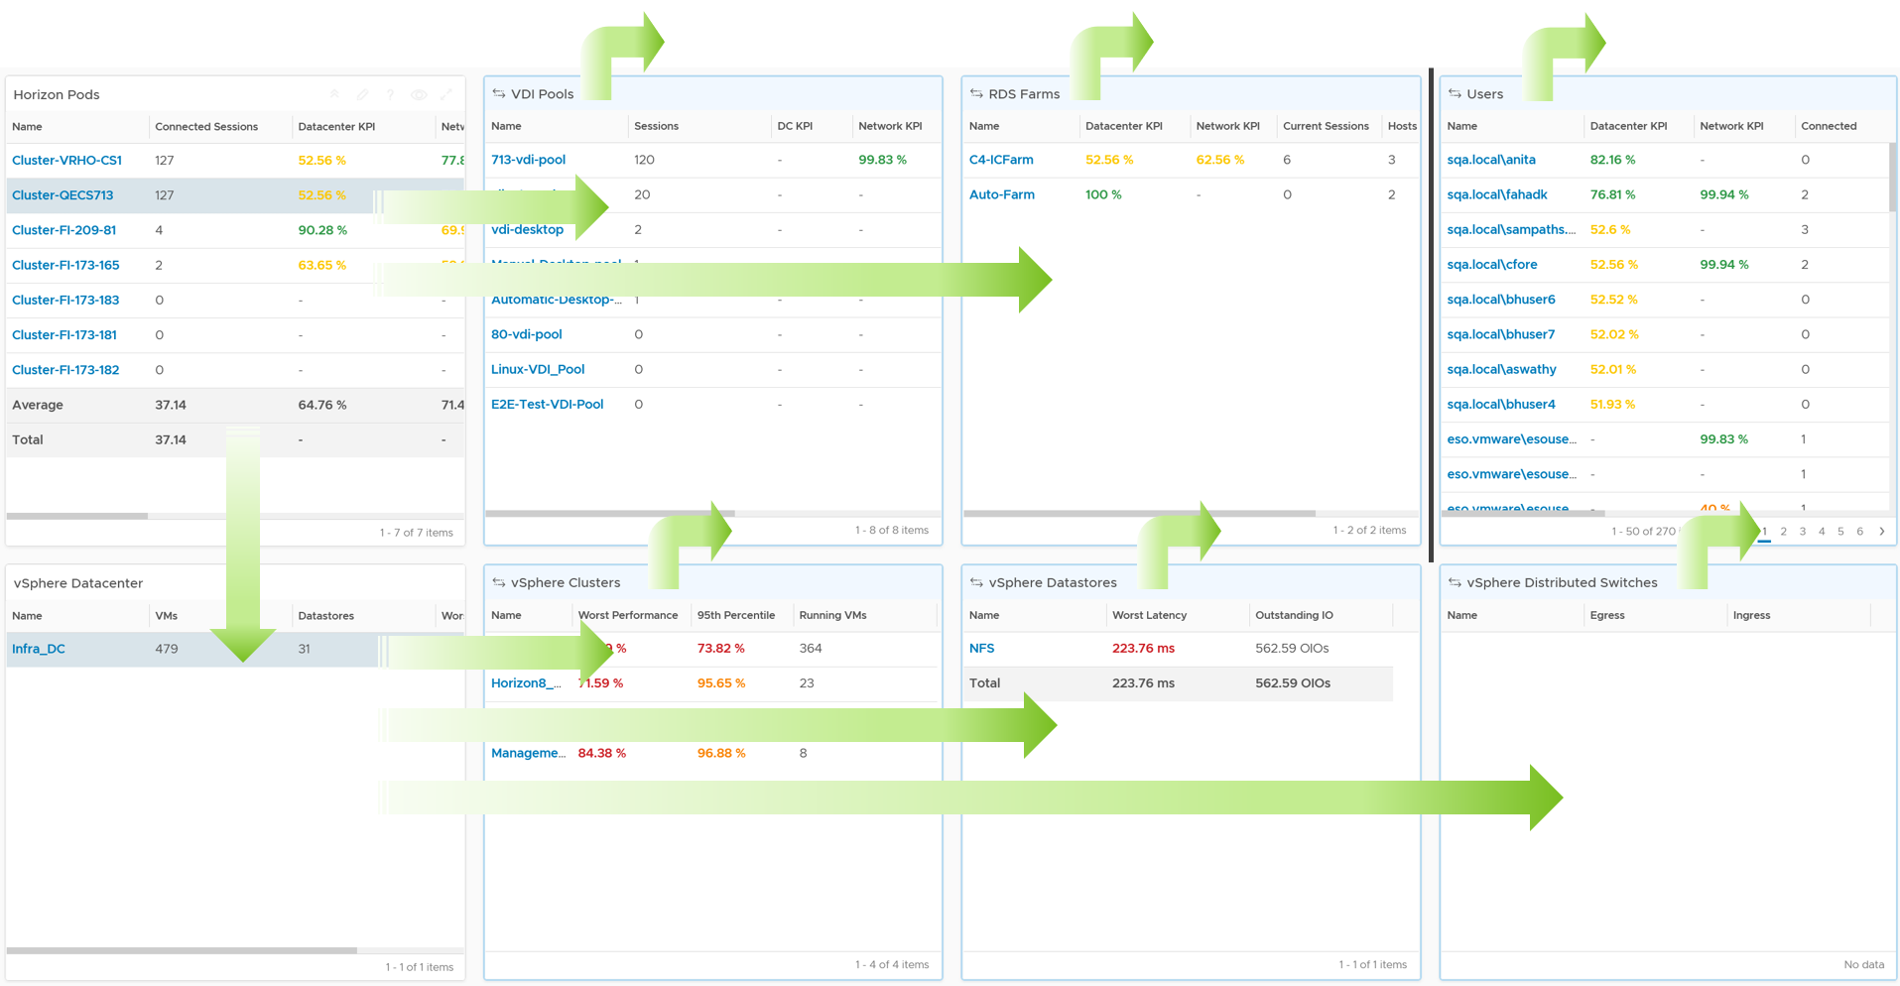

You can also drill down into specific Connection Server or Universal Access Gateway. You find their list at the bottom of the dashboard. They are not shown above as the drill down takes you to the object summary page itself. There is no dashboard for them as the object summary page meets the need.

Within the dashboard, you can drill down within a pod, as shown by the straight arrow. Take note there is no arrow from Pod to User. I added a black vertical line to show that users are not part of pod.

##### Summary Section

The top part of the dashboard shows the overall performance. In large environment with thousand of sessions, these metrics should be relatively steady.

2 health charts are provided, one for data center and one for network. This lets you quickly see which main area is the problem.

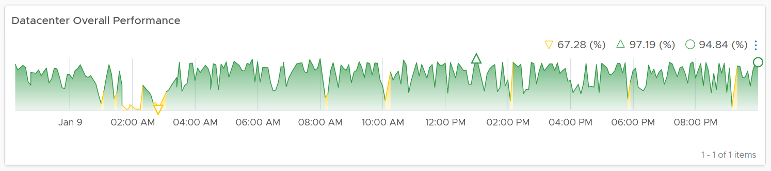

We can see that the data center has some dip, as the color turned yellow.

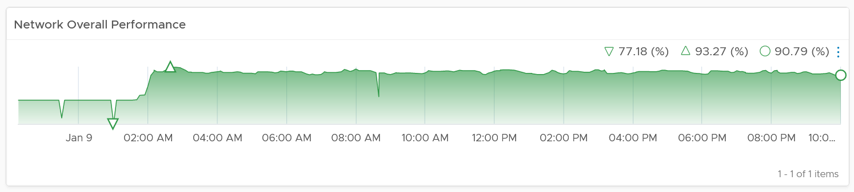

On the other hand, the network remained on the green territory. It has in fact improved.

If you have the screen real estate, consider adding the number of connected session. The reason is the chart should have some correlation to the demand. If the performance dropped when utilization did not go increase, something amiss happened.

##### Horizon Section

The next section covers the Horizon layers. It uses Pod as the starting line. If your environment is large, considering using Site or Cloud Pod as the starting line.

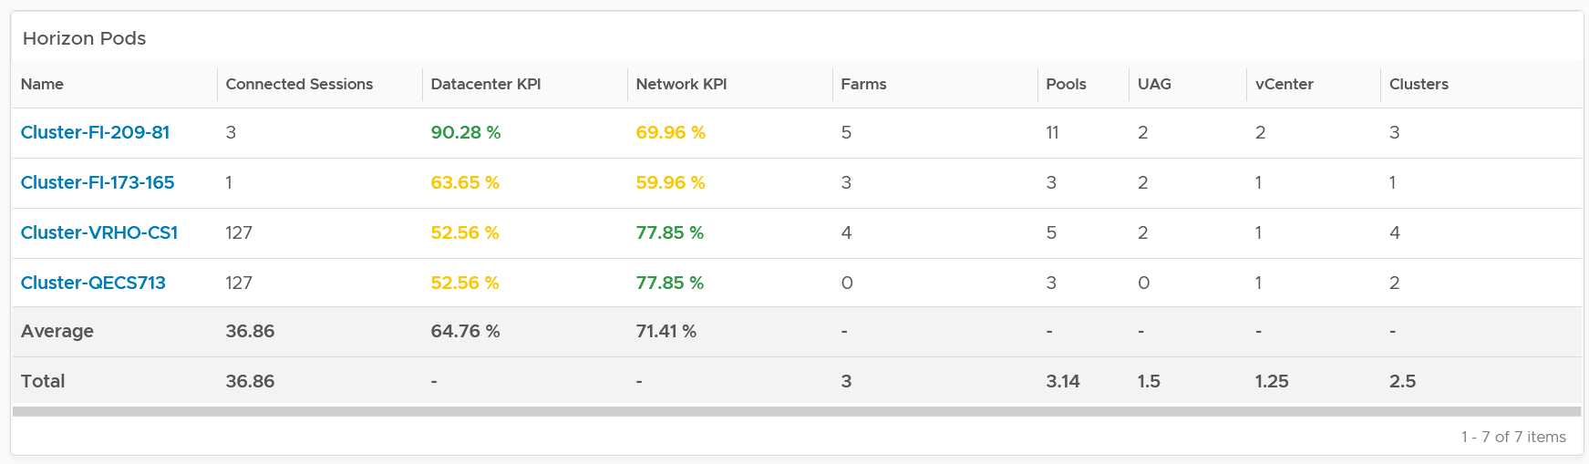

For each pod, it shows the worst performance, meaning the lowest value of the Pod DC KPI (%) any given 5 minute in the last 24 hours. To change to other time period, click on the date icon. To determine if the worst performance is just a one time blip, use the worst 5th percentile metric.

The columns Farms and Pools show the numbers at present. Customize this table with information that you need.

From the Pod, you can drill down into its RDS Farms or VDI Pools. Select a pod, and its children pools, farms and vSphere Data Centers will be automatically shown.

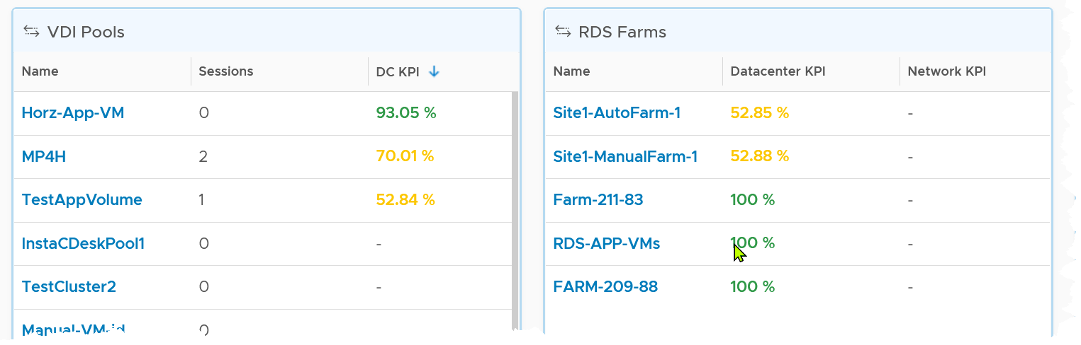

The column Sessions show the numbers at present. It’s not the highest number of sessions in the last 24 hours.

The table has a blue border as you can drill down into the RDS Farm dashboard. To troubleshoot further, select a farm and then navigate to RDS Performance dashboard. The selected farm will be passed as a context.

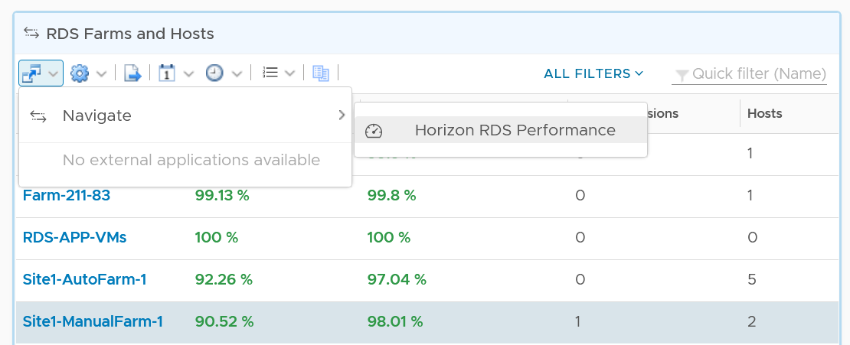

For VDI Pool, select a pool and navigate to the VDI Performance dashboard. The experience is ***consistent*** with RDS.

##### vSphere Section

From the pod, you can also drill down into specific vSphere Data Center. It shows the list of data center in the selected pod.

From a data center, you can further drill down into the selected cluster (compute), datastore (storage) and distributed switch (network).

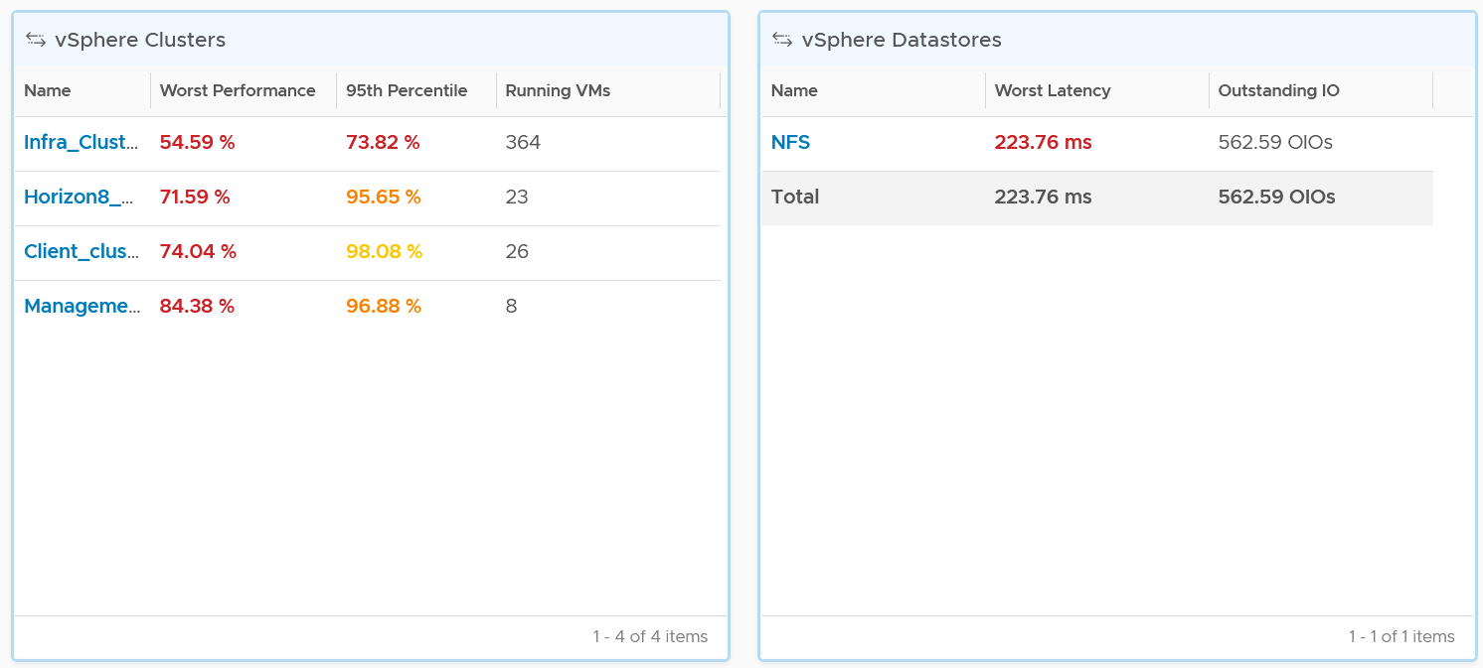

##### Horizon Servers

The last part of the dashboard lists the Connection Server and Universal Access Gateway, along with relevant information.

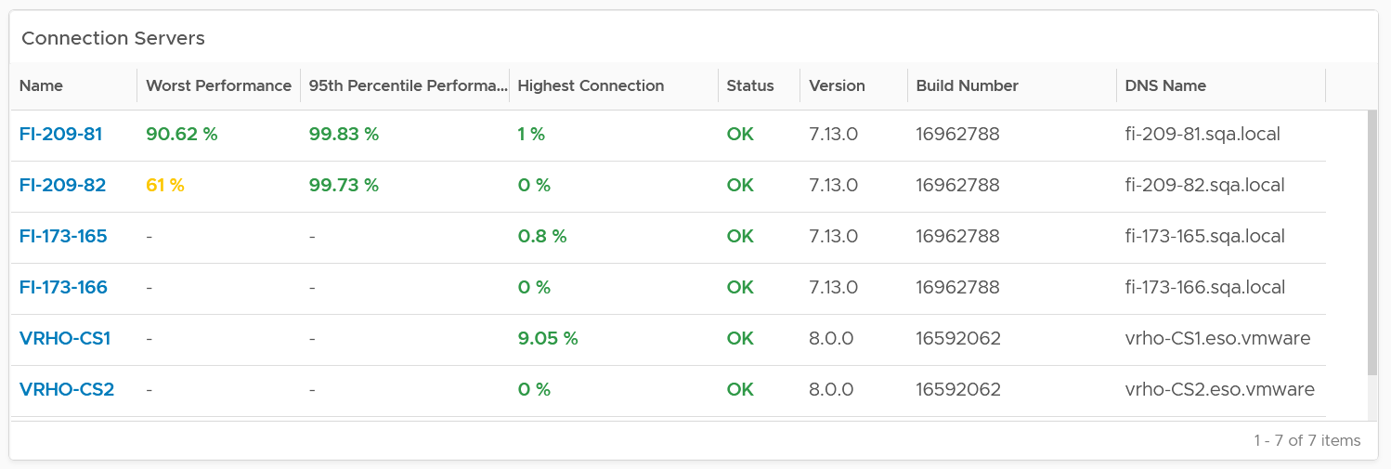

#### RDS Performance Dashboard

The RDS Performance dashboard complements the Horizon Performance dashboard by providing more details, all the way down to hosts and sessions.

##### Widget Interactions

The dashboard sports drill down from Farm to Host to Session. For host, you can also drill down to the underlying VM, navigating into the vSphere VM Performance dashboard.

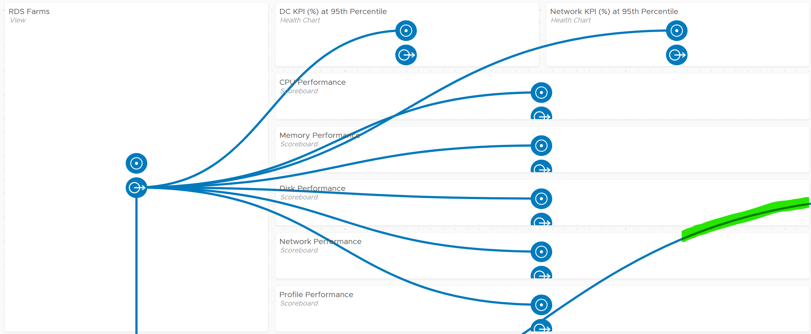

The partially visible line, marked with green, is a drill down from RDS Host into the underlying VM. You’ll in the following screenshot that the line starts from the host.

From the Farm, you can drill down into the hosts and the sessions in the farm. The following shows the host section of the dashboard. Selecting a host will automatically shows all the relevant metrics of the host.

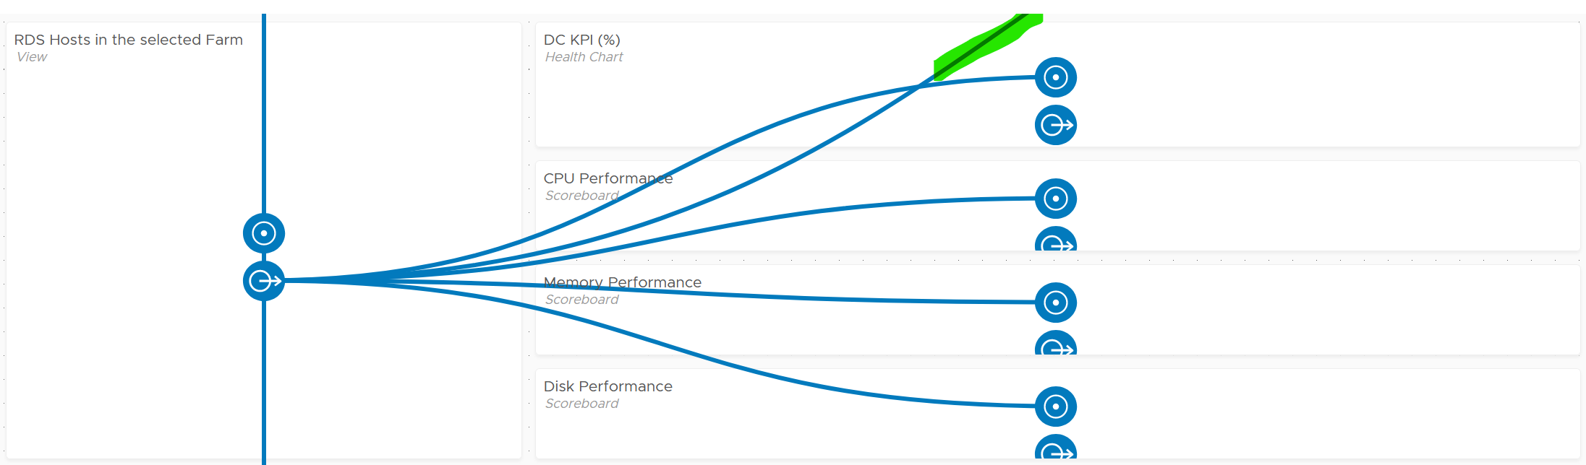

And here is the session portion of the dashboard. Selecting a session will automatically shows all the relevant metrics of the session.

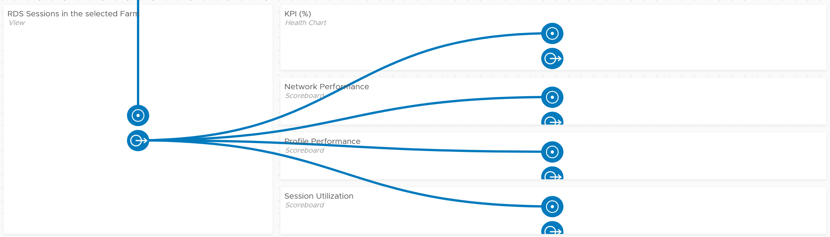

##### Summary Section

This section is especially useful in large environment, where you have many farms. It lets you see quickly the overall performance of all the farms.

There are 4 distribution charts, covering network, CPU, memory and storage. I’m only showing 3 of them below due to limited space on “book” (designed to be tall, while monitor screen is wide). You will see later in the VDI Performance dashboard, where I show 4 of them.

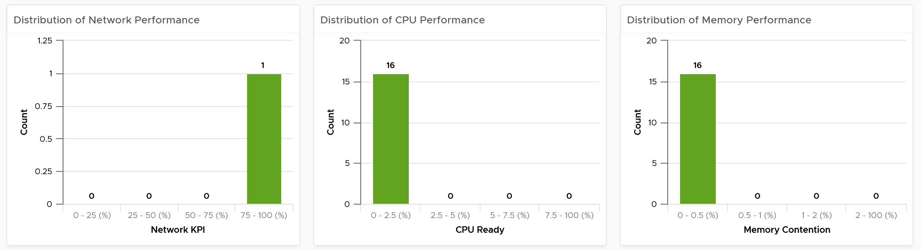

For CPU, while there are many metrics, I pick CPU Ready as that’s the most likely. I’m keen to hear your thought if we should build a model for each component, meaning 1 for network, 1 for CPU, 1 for memory and 1 for disk.

##### Farm-level Analysis

The section begins by listing all the farms in a table, color coded by performance. You can sort them by their performance, number of active sessions, etc.

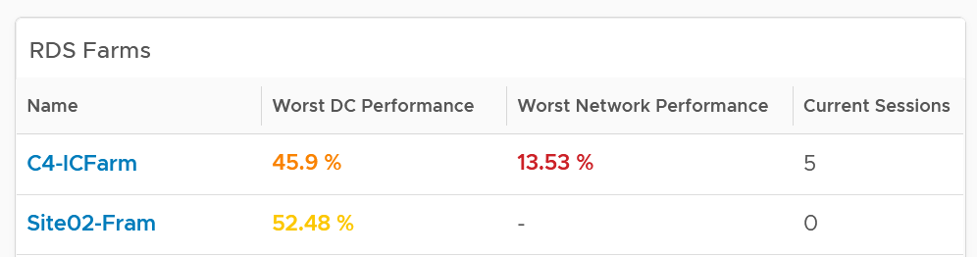

Why are they sorted by DC KPI, and not Network KPI?

Because the network will be dominated by the farm serving the WAN or remote users. Network is also something you have less control as it’s a shared resource.

Selecting a farm with automatically show the KPI. This helps you cycle quickly among many farms.

When you select a farm, check the farm DC KPI and Network KPI over time. If there is issue, there is no need to look further.

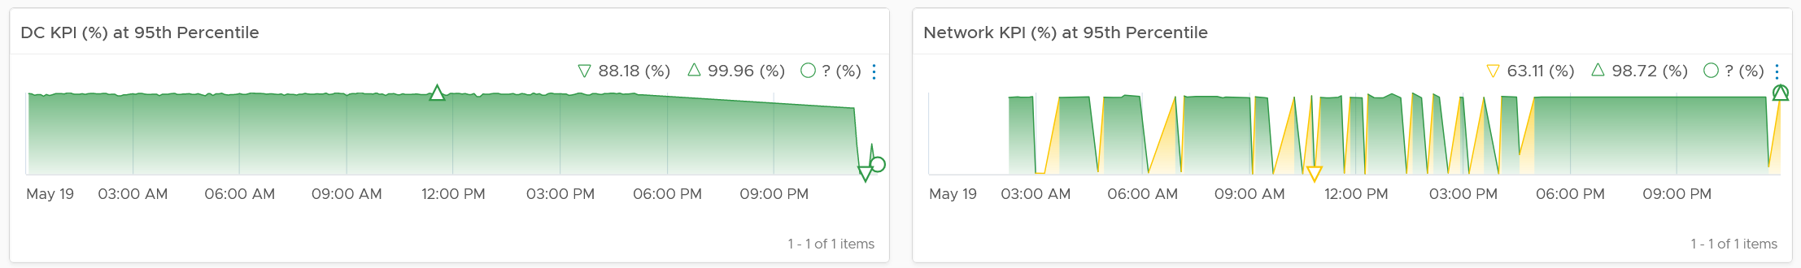

I have used the worst 5th percentile for both. If you want a safer leading indicator, which is more sensitive to degradation, then change them with the worst value. Take note that a single session or host will dictate the value basically.

If the above is lower than your normal numbers, meaning there is a significant dip, then you drill down into specific area (CPU, Memory, Disk, Network, User Profile). We cover these metrics in the RDS Farm metrics here.

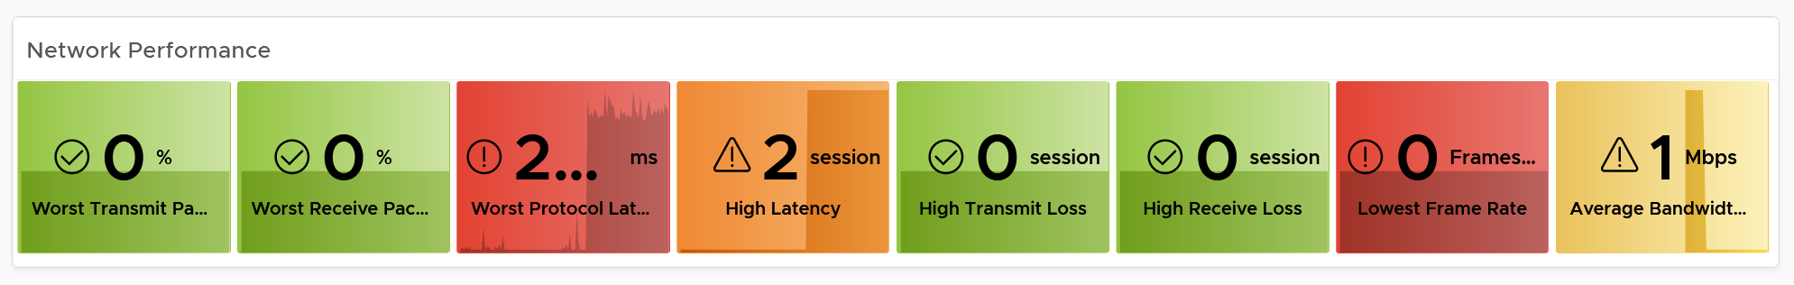

For network, I use the following threshold:

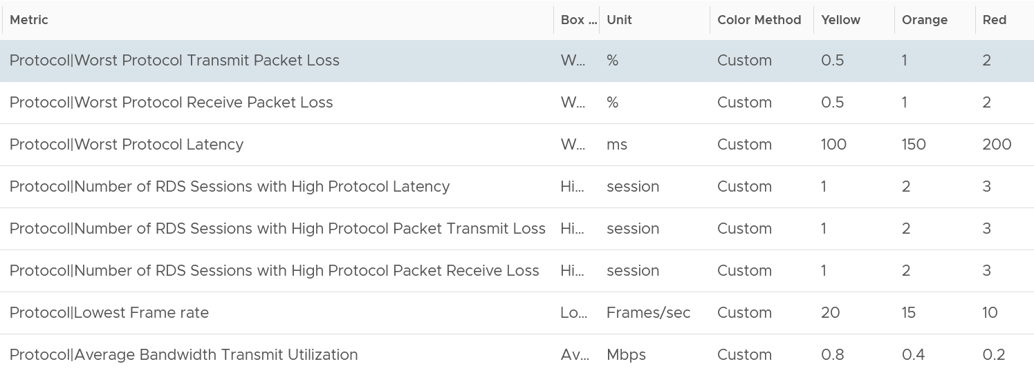

For CPU, it’s about the RDS host not the individual session.

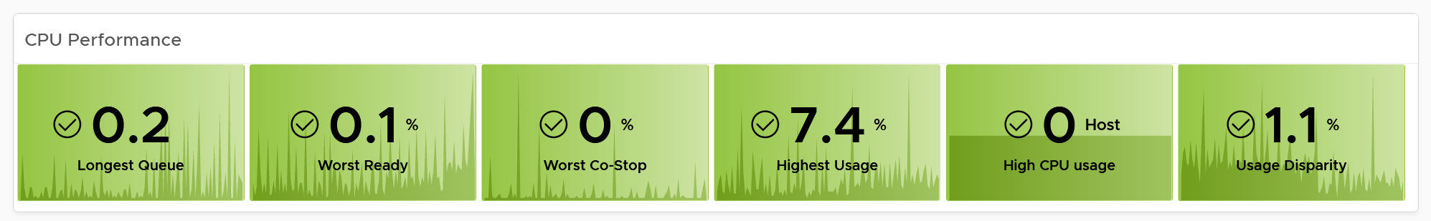

This is the threshold I use:

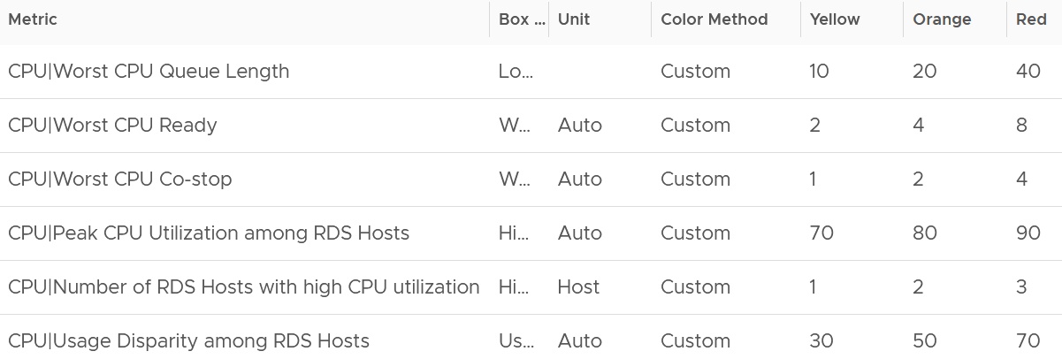

For CPU Queue, I use 8 vCPU as the average RDS Host size.

The threshold for CPU Ready and CPU Co-Stop are following the guidelines specified in [VM KPI (%) metric](#_VM_KPI_(%)).

For CPU Utilization, I choose 70 🡪 80 🡪 90% to give you more reaction time as VDI demand tends to be spiky.

As a farm may not have many RDS hosts, I choose 1 🡪 2 🡪 3 as the threshold. If your farm is larger, you can change as appropriate.

The metrics for memory is also about RDS Hosts, not sessions.

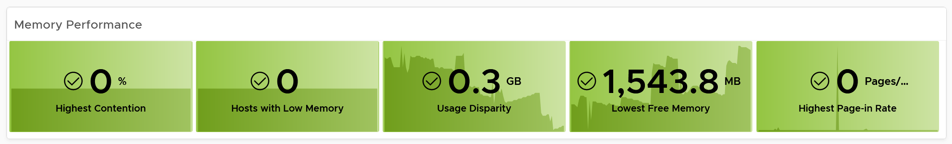

This is the threshold I use:

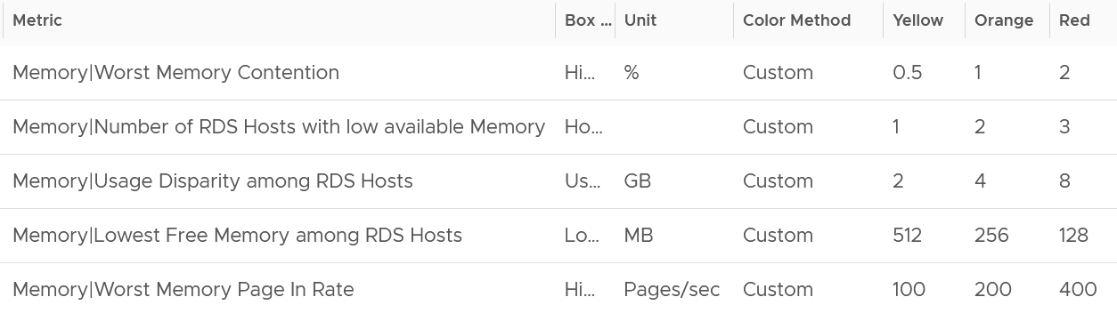

The threshold for Memory Contention is following the guidelines specified in [VM KPI (%) metric](#_VM_KPI_(%)).

I use 32 GB as the average RDS Host size.

The metrics for disk is also about RDS Host.

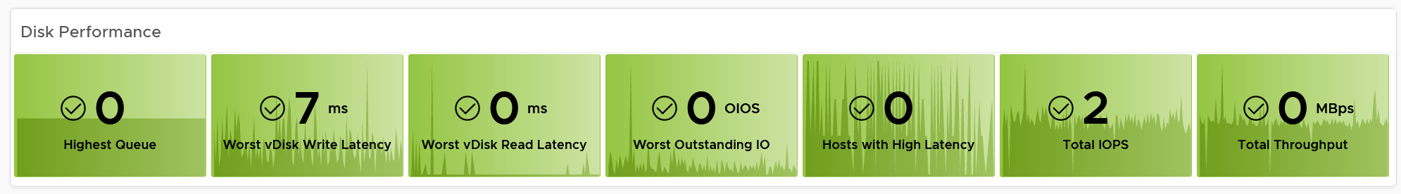

This is the threshold I use:

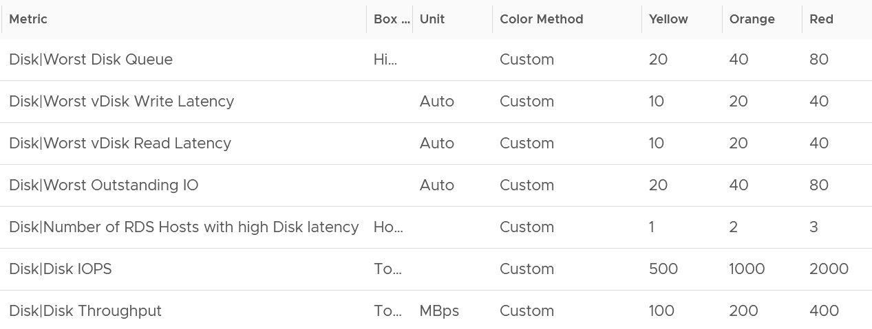

The threshold for Queue, Latency and Outstanding IO are following the guidelines specified in [VM KPI (%) metric](#_VM_KPI_(%)).

For IOPS and Throughput, I added a threshold so you can see more easily if there is any unexpected load. Change the threshold according to your environment.

It’s important to check if there is issue with the user profile.

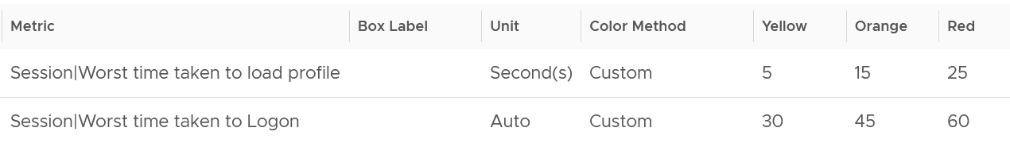

The performance could be caused by unavailability of RDS Host. The following widget checks the various status.

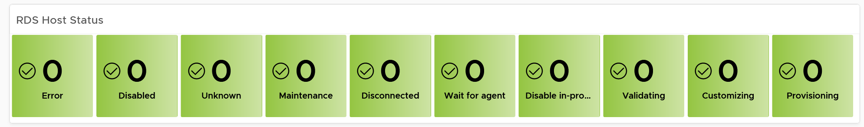

The farm key properties will also be shown for better context.

Lastly, you can check if there is imbalance among the RDS hosts. The following line chart compares their performance. If you have many imbalances, it’s worth to create a dashboard to aid in the troubleshooting.

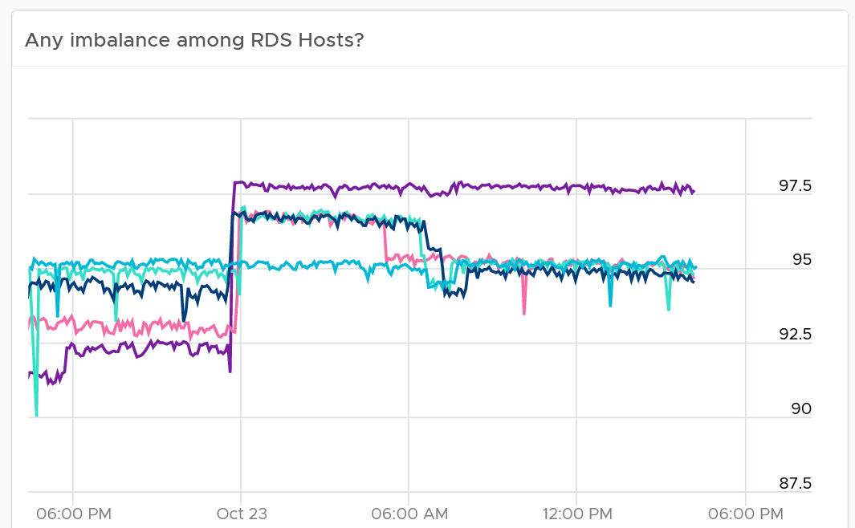

The dashboard is kept simple so it’s easy to use. Add necessary widgets to tailor to your need. For example, if you think the performance is caused by high utilization, add the utilization metrics. Do not color coded as high utilization can be healthy (productive). The following screenshot provides a sample implementation.

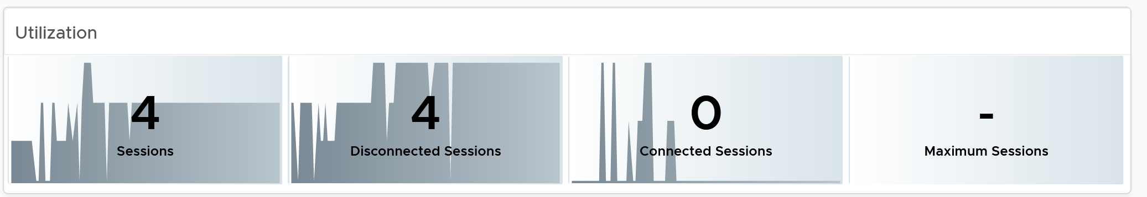

##### Host-level Analysis

From the farm, you can drill down to the hosts. The list of hosts in the farm is automatically shown.

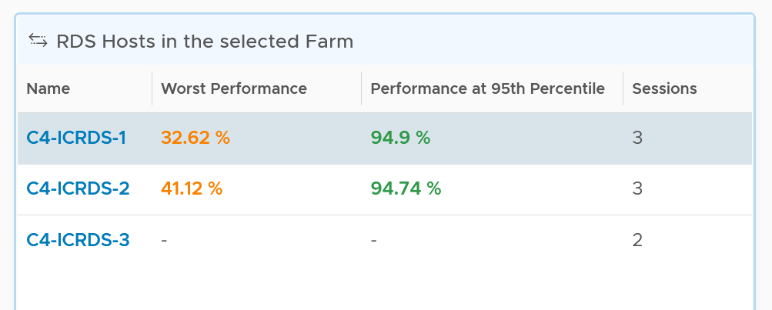

The usual KPI (%) is shown, both at its worst and worst 5th percentile during the last 24 hours.

As you can expect, selecting a host shows you the host performance over time.

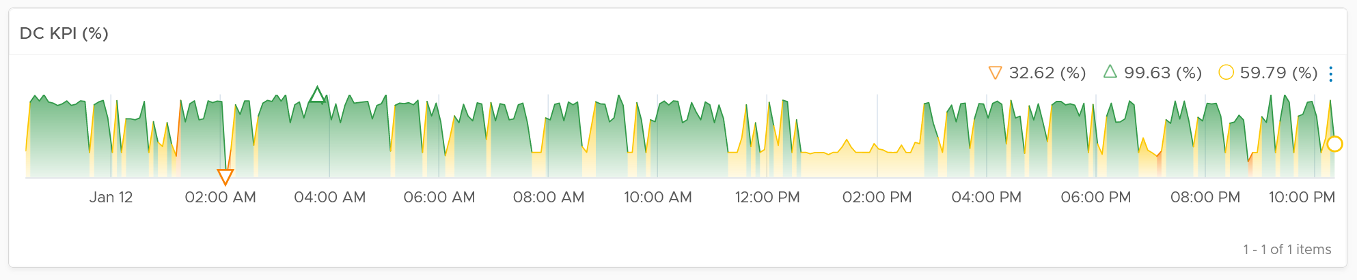

You get the usual raw detail metrics associated with the host. I’m showing CPU as an example below.

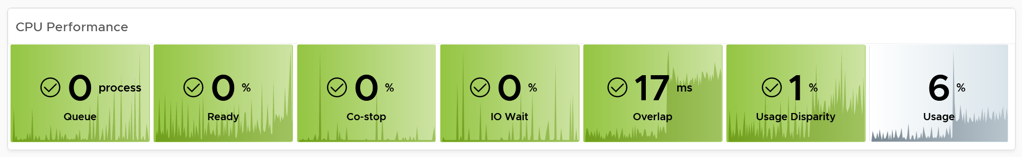

As RDS Host is just a VM, you should use the same metric to monitor it.

As context matters, the dashboard provides relevant configuration for both the RDS Host object and the underlying vSphere VM object.

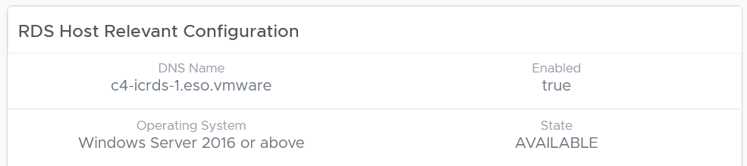

##### Session-level Analysis

From the farm or host, you can drill down to the sessions.

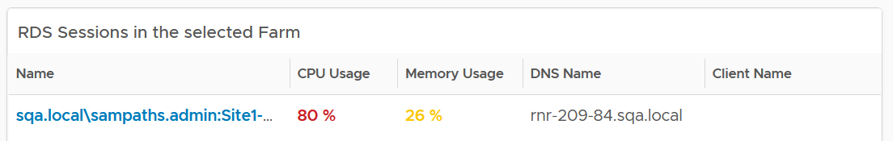

As you can expect, selecting a session shows you the host performance over time. You also get the usual raw detail metrics associated with the session. As covered earlier here, there are limited visibility into an RDS session.

The context surrounding a session is important, so the dashboard provides the following information.

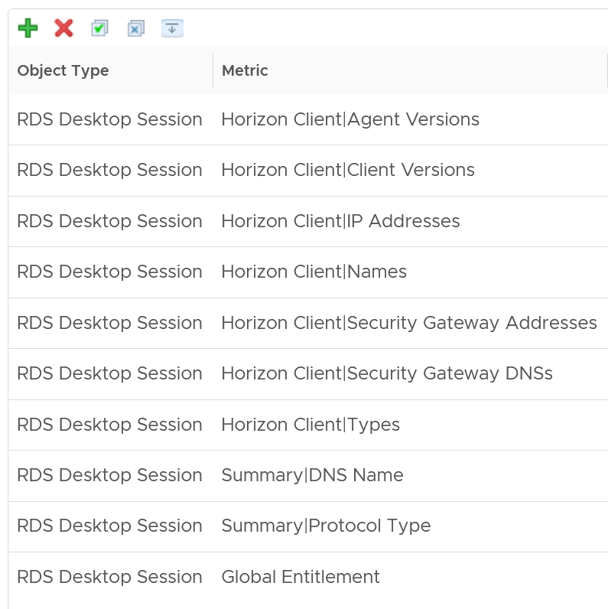

#### VDI Performance Dashboard

The VDI dashboard has the same design principle with RDS. The main difference lies in the metrics.

##### Widget Interactions

As you can expect, you have the same layout and interaction. VDI being a simple structure, only has pool and VM.

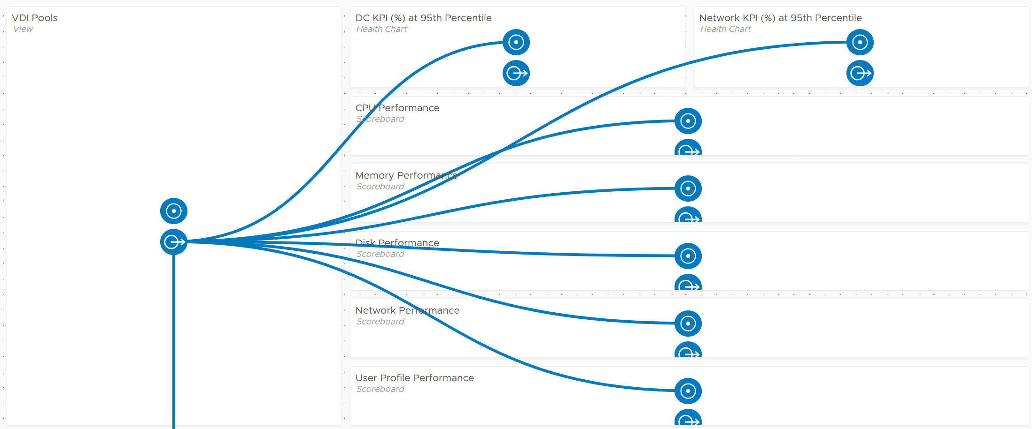

From one of the pools, you can drill down to the session. From the session, you can drill down to the vSphere VM where the session is running.

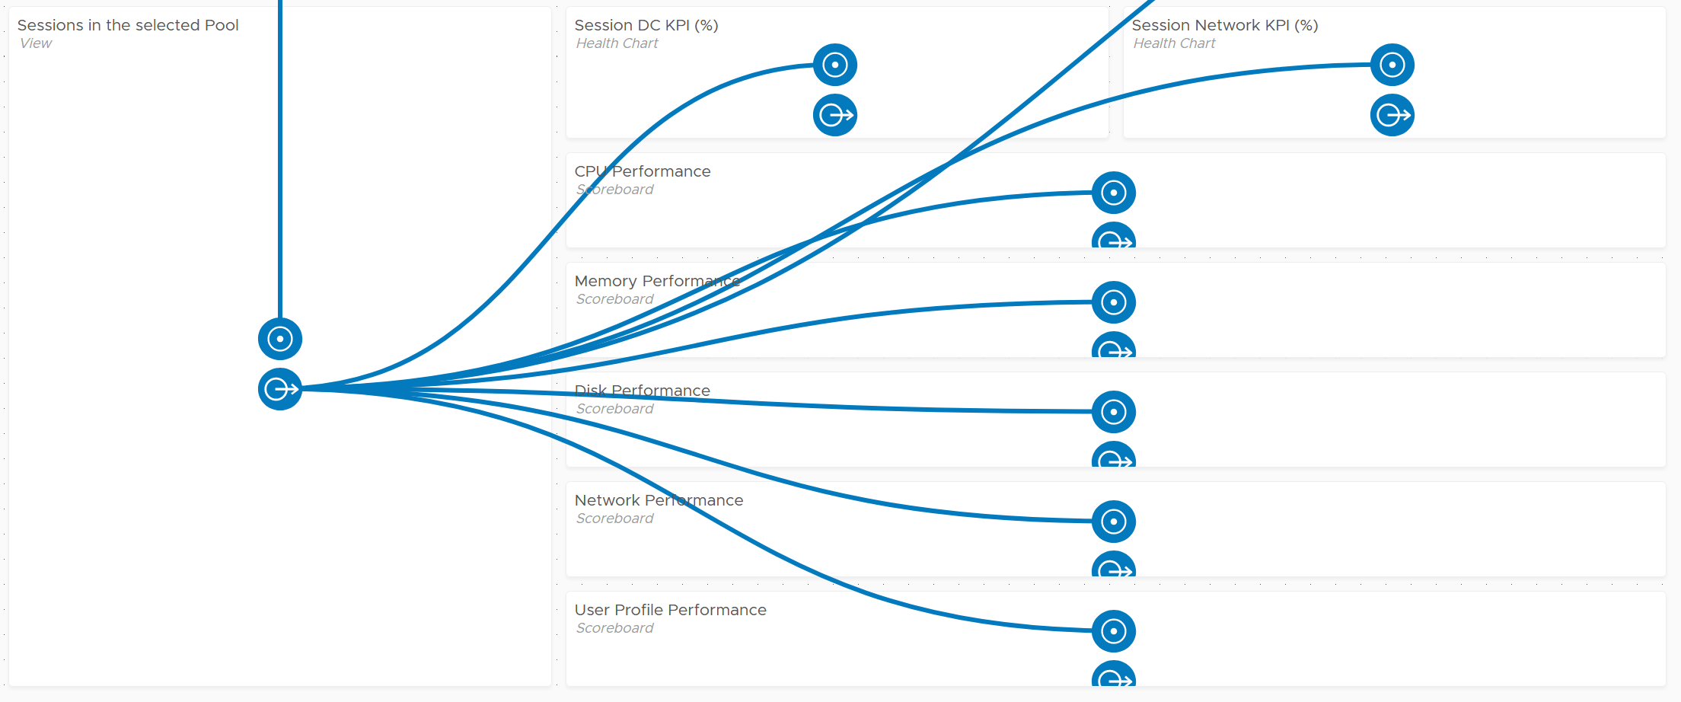

##### Summary Section

Just like the RDS Performance dashboard, there are 4 distribution charts. To avoid duplication, please read the RDS Performance dashboard for the documentation.

Unlike in the RDS Performance dashboard, I’m showing all 4 charts. As you can see, the color and consistent distribution of the bar buckets make it easier to see overall performance at a glance.

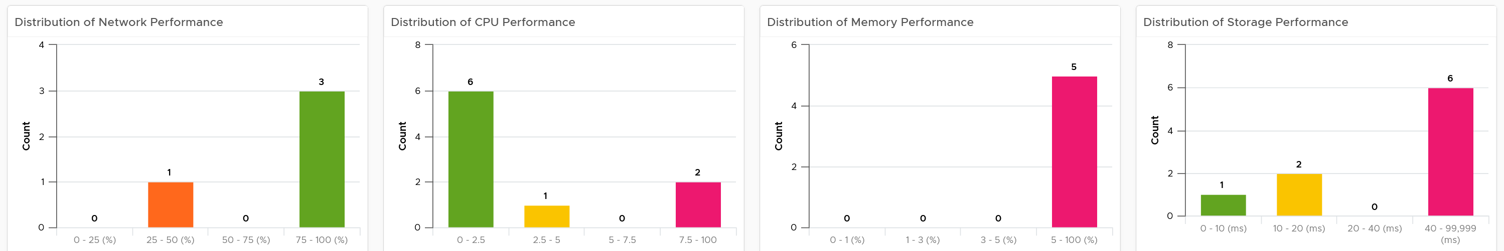

##### Pool-level Analysis

Just like the RDS Performance dashboard, it begins with a table, listing of VDI Pools in the environment.

Select of one of the pool. Both the network and datacenter metrics scoreboards will be automatically shown. They show the same set of metrics. Here are the metrics for DC:

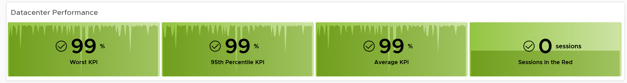

Why are they shown in that order?

The above order is from the most sensitive (leading indicator) to the least sensitive (lagging indicator).

* Worst takes the worst value of any session. So if you have many sessions, it just take 1 bad session. So long there is 1 session getting bad data, this will show bad data. Your next question is logically, how many are affected?
* 95th percentile sorts all the sessions, then take the 95th percentile.
* Average is a lagging indicator. By the time this number is bad, around half the sessions are probably not getting good experience.
* You can have many sessions with yellow or orange, but none of them should drop to red. Expect this to be 0.

This is the threshold I use:

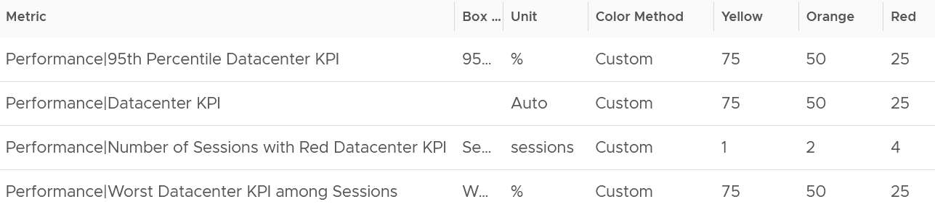

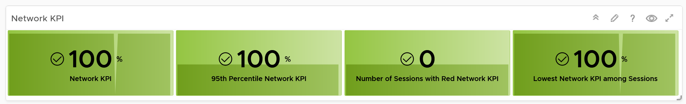

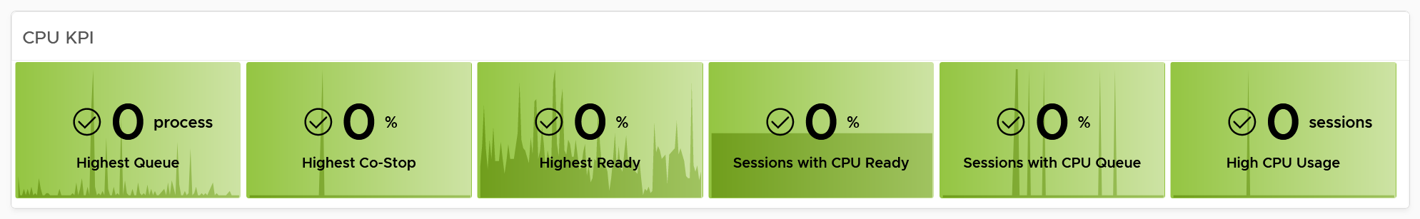

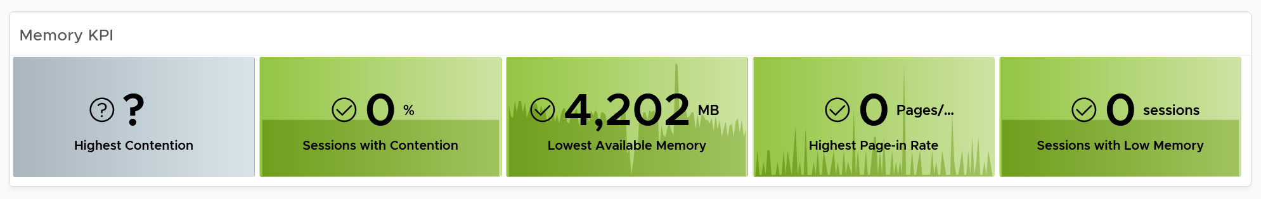

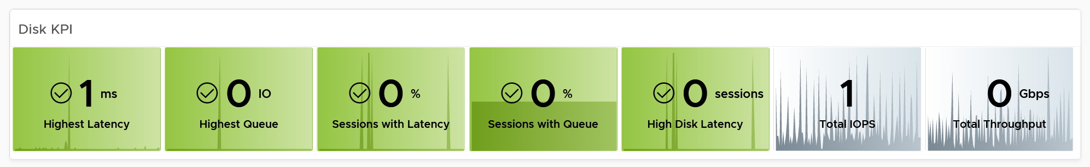

As context matters, the dashboard provides relevant configuration for the VDI Pool object. Here are the properties shown. Customize them accordingly.

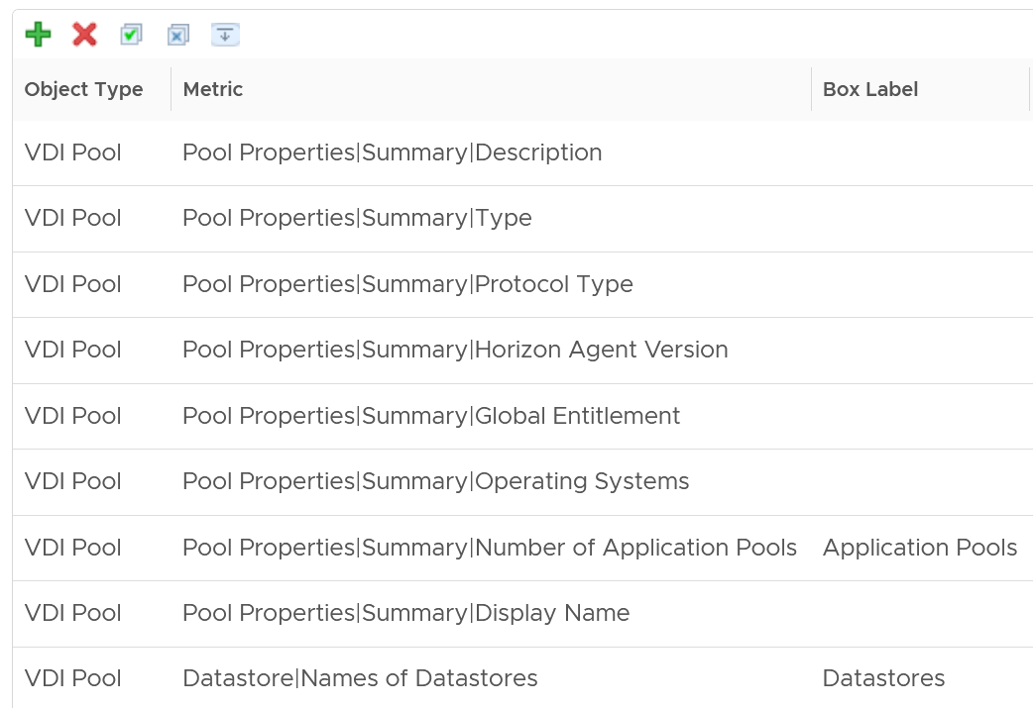

Environmental context is also importat. You can navigate into the vSphere cluster where the VDI Pool resides

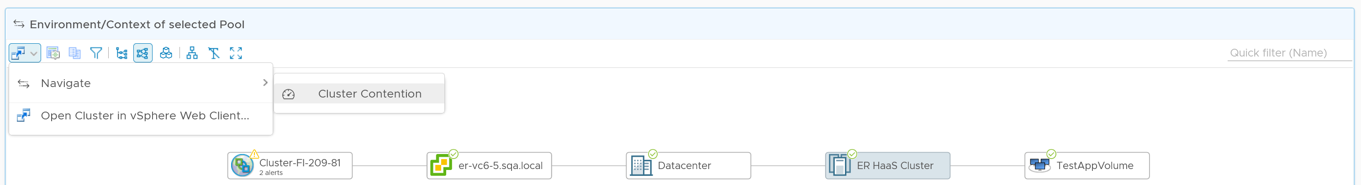

##### Session-level Analysis

You get the usual raw detail metrics associated with the host. I’m showing CPU as an example below.

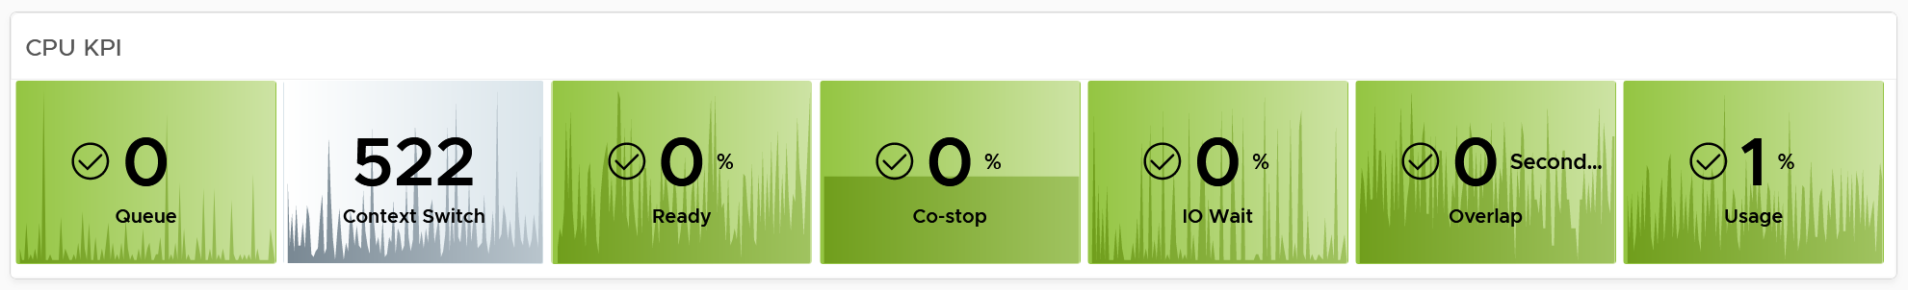

As context matters, the dashboard provides relevant configuration for the VDI Pool object. Here are the properties shown.

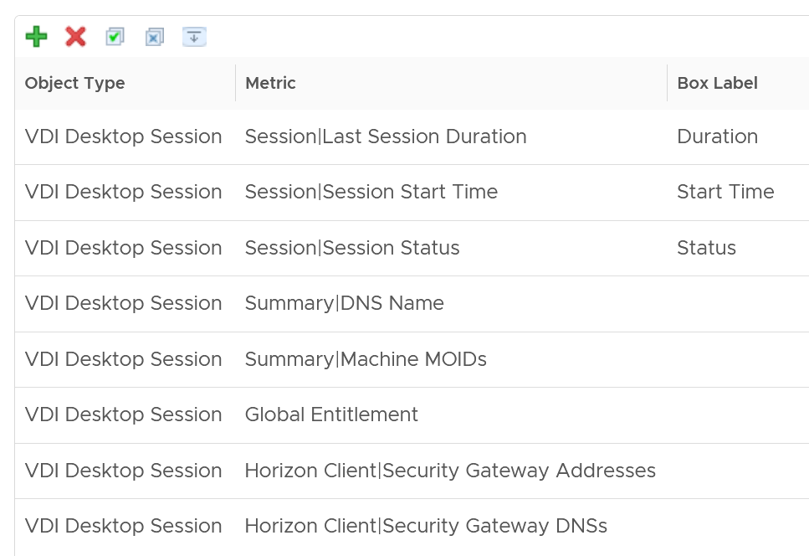

#### NOC Dashboards

A VDI user will not be happy experiencing bad performance for hours. As timely response matters, your NOC team needs a dashboard showing the live situation, projected on a big screen for support team convenience.

There are 2 dashboards provided. One looks from session view point, the other from infrastructure viewpoint.

The dashboard follows the design covered in NOC Dashboard chapter here. You will see consistent layout among them.

The dashboard focuses on urgent information, hence they focus on performance. In future, I’m going to add availability, so let’s collaborate.

##### Live! Horizon DaaS Performance Dashboard

This dashboard shows from the big picture point of view. They are useful to determine the health of overall situation.

The health chart shows trend so you can see if the situation is deteriorating, unpredictable, or just a one off incident.

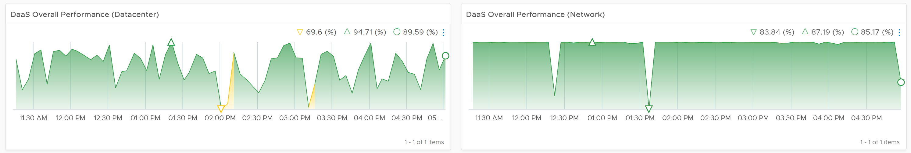

If there is something wrong, the health chart can’t show which farm or pool. This is where the heat map comes in. You get 4 heat maps, covering both data center and network for RDS and VDI.

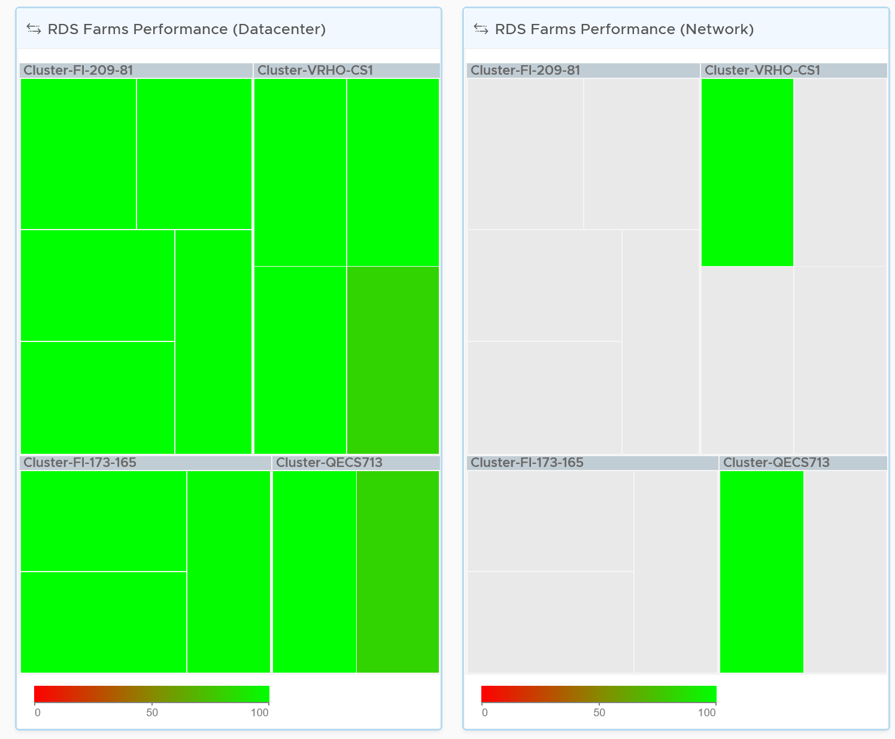

Click on any of the heat map. The historical trend over time is automatically shown.

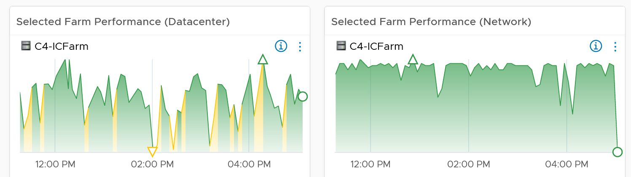

##### Live! Horizon Session Performance Dashboard

This dashboard focuses on the session. There are 6 heat maps



Why 6?

vRealize Operations separate Desktop session and Application session. So we have the following:

* VDI Desktop DC KPI
* VDI Desktop Network KPI
* VDI Application DC KPI
* VDI Application Network KPI
* RDS Desktop Network KPI
* RDS Application Network KPI

RDS does not have DC KPI.

The widget interactivity shows the above visually. As you can see below, the first 4 heat maps belong to VDI, and the last 2 belong to RDS.

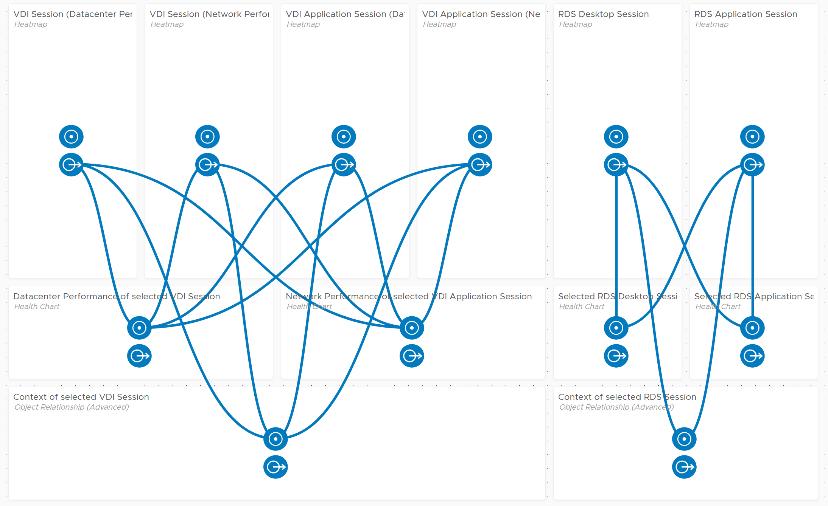

The heat map drives the relevant health chart on the 2nd row of the dashboard.

Click on the session you’re interested in any of the heat map. Its detail performance over time will be shown in the health chart underneath the heat map. The following shows an example for VDI Desktop session:

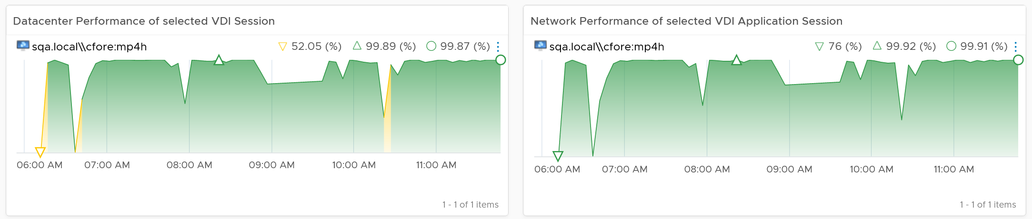

### Capacity Dashboard

The capacity dashboard follows the design principles for Capacity dashboard, documented here.

Capacity considers longer time horizon than performance.

Make sure the sets of numbers are within your expectation. Also, check that their pattern is matching the “working hours” defined in your architecture.

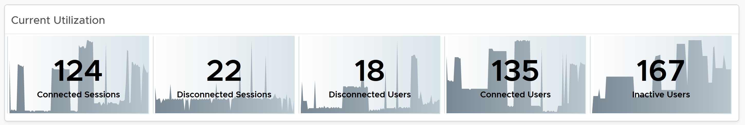

Check that the number matches the “working hours” defined in your architecture.

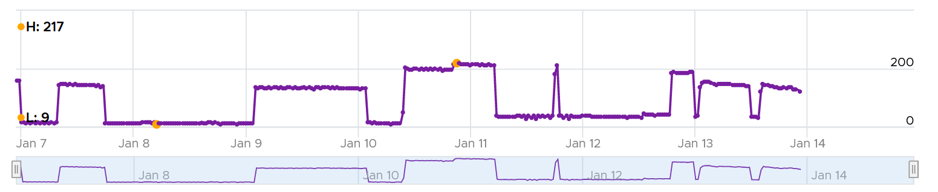

#### Farms and Pools

In capacity, we’re interested in the present number first, before diving into the past. That’s why a heat map is a convenient way of presenting the information.

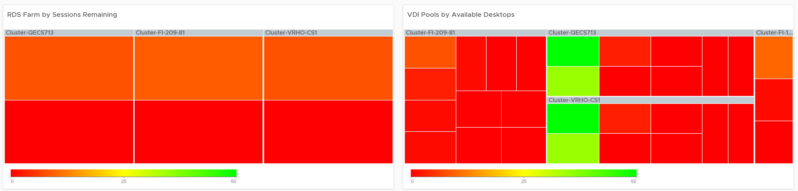

Adjust the color threshold accordingly.

Context is important, so the dashboard provides the following properties of selected RDS Farm. A similar set of properties are also provided for VDI Pool.

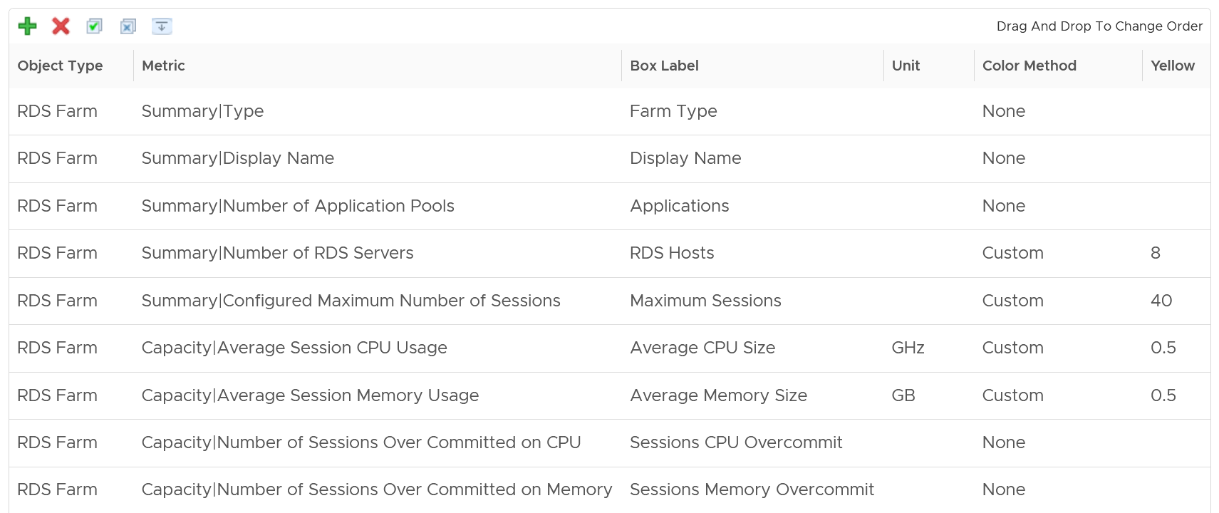

Select a pool to see its usage over time. The following chart shows a pool with erratic usage pattern. In general, it should match the expected usage pattern documented in your architecture. For example, it matches your office hours.

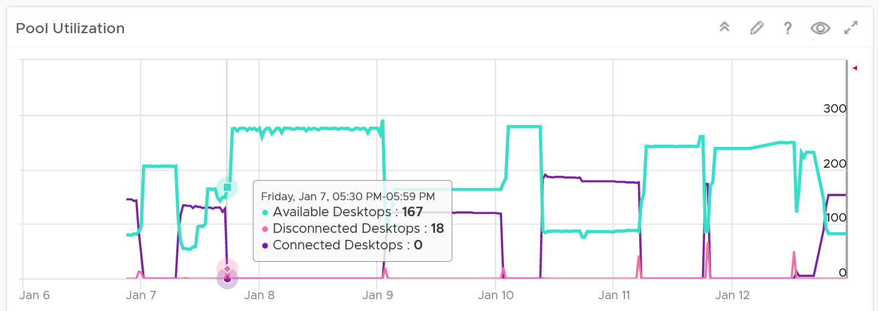

### Availability Dashboard

We covered in Part 1 Chapter 1 that Availability can impact Performance and Capacity, but need to be measured separately as the remediation action is different.

Horizon consists of different components, each having their own availability metrics.

|  |  |
| --- | --- |
| **RDS Farm** | Number of RDS Hosts in Bad State  Aim for this number to be 0 at all times |
| **VDI Pool** | Number of VMs in the pool that is not used yet not available. The metric Desktop in Bad State can be unavailable because they are in one of these state   * Provisioning | Customizing | Starting Up | Deleting | Waiting for Agent * Maintenance mode | In Progress * Agent disabled | Agent unreachable | Agent needs reboot * Invalid IP | Protocol failure | Domain failure * Configuration error | Provisioning error | Error |Unknown   For the description, see [this](https://docs.vmware.com/en/VMware-Horizon-7/7.13/horizon-virtual-desktops/GUID-C66AE54D-21A1-41B3-93A6-8D8E7F448451.html). |
| **Horizon Server** | Connection Servers. Number of Servers that are not available in a pod. The formula depends on the design. If it is N+1, then the availability will be affected when there is >1 unavailable server.  UAG Servers |

#### Pods

The pod provides a convenient summary, before diving into individual pool, farm and Horizon servers.

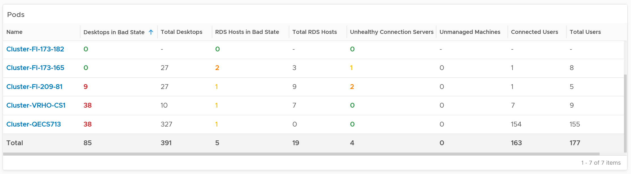

For Horizon Servers within the pod, it’s covered under Horizon Server section.

#### RDS Farms

Availability at Pod level is about the number of unavailable RDS Host.

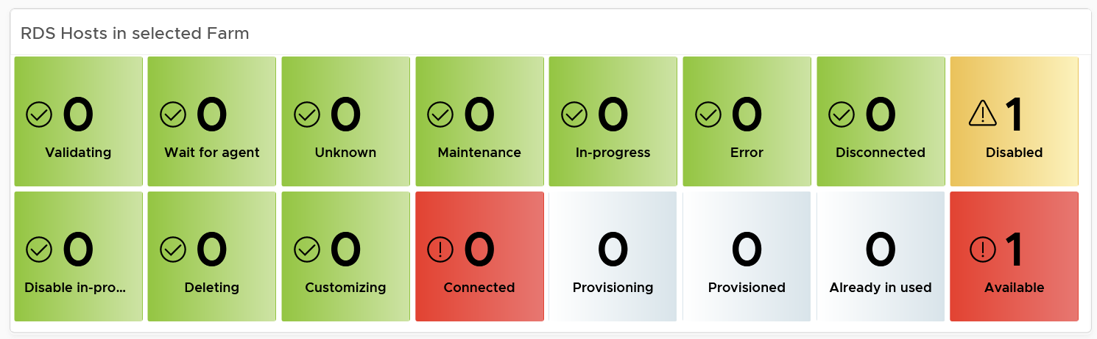

The last part if the host status. This scoreboard focuses on the host status that needs attention. There are more status that can fit here, so if you want to see them all, customize this and make it 2 rows.

#### VDI Pool

Availability at VDI Pool level is about the number of unavailable VDI desktops.

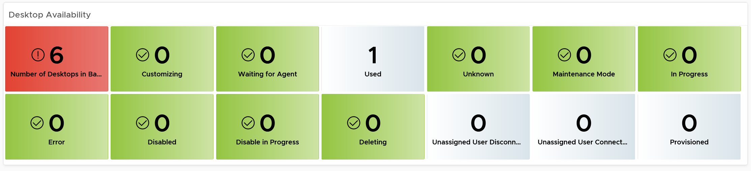

Desktop availability can be caused by Horizon agent.

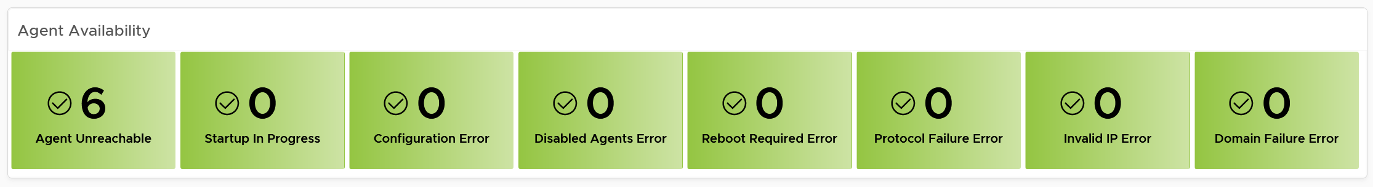

#### Horizon Servers

The dashboard covers Connection Servers and UAG. In future, we should add App Volume Managers. In the mean time, use custom group and super metrics

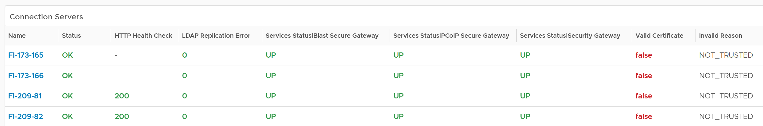

### Configuration Dashboard

Consistent configuration is important in DaaS, which is made of many software (Horizon, vSphere, NSX, vSAN, physical network, client, etc.). We’re following the configuration dashboard best practices documented here. The following table summarizes the type of configuration issues we’re managing for DaaS.

|  |  |
| --- | --- |
| **Incorrect Configuration** | Address settings that are incorrect, insecure, not following your corporate standards or against Horizon best practice. |
| **Outdated Configuration** | The settings are correct, but on older version. It’s hard to keep up with all the vendors releases, so you should prioritize those oldest versions, especially those no longer supported. |
| **Complex Configuration** | The settings are correct and up to date, but they complicates your DaaS operations. |
| **Inefficient Configuration** | The last step is about cost and capacity, as there is nothing wrong already. You want to maximize the usage of your resources while minimizing your cost. |

#### Horizon Client

While the server-side is under your control as Horizon administrator, the client-side depends on users cooperation. Using a pie chart, you can see what are the most common type of client, and their version of Horizon client software.

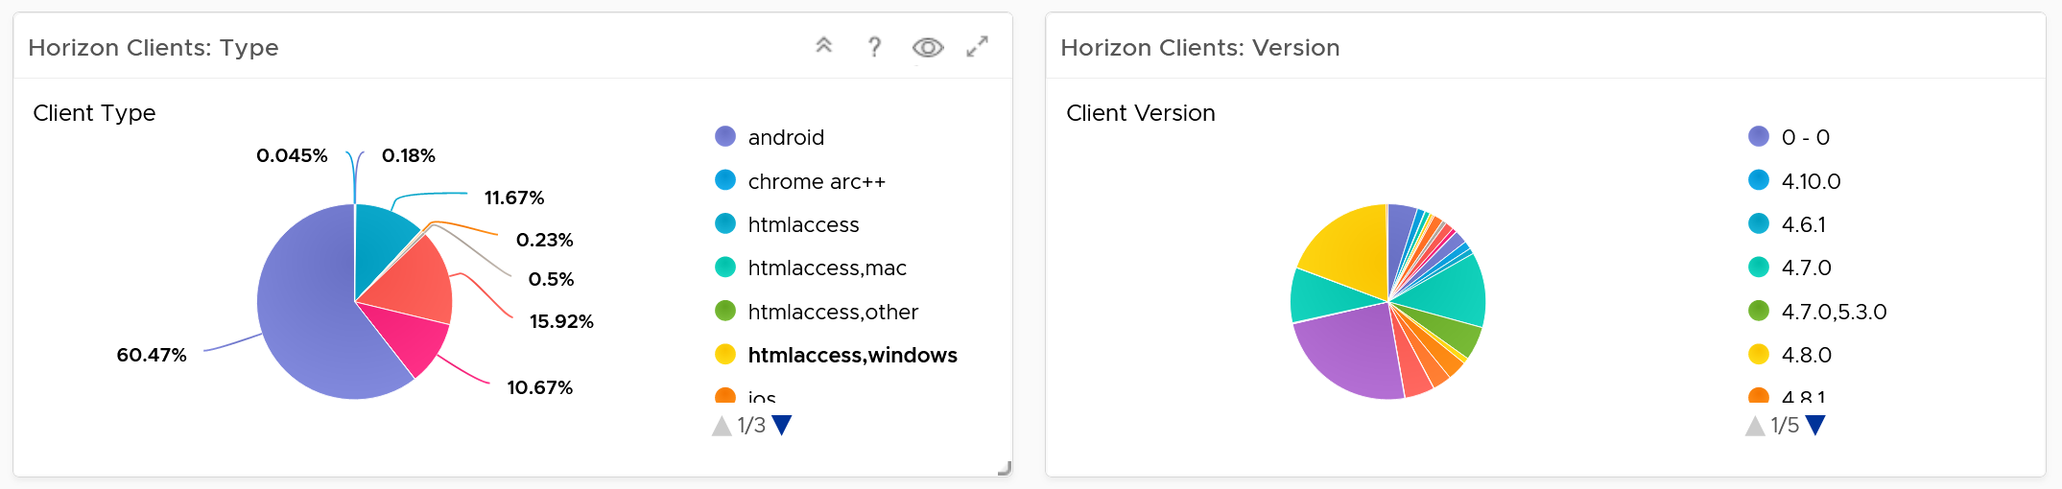

Ensure that the client version and type match your architecture documentation.

At the server-side, ensure your Horizon agents software are up to date.

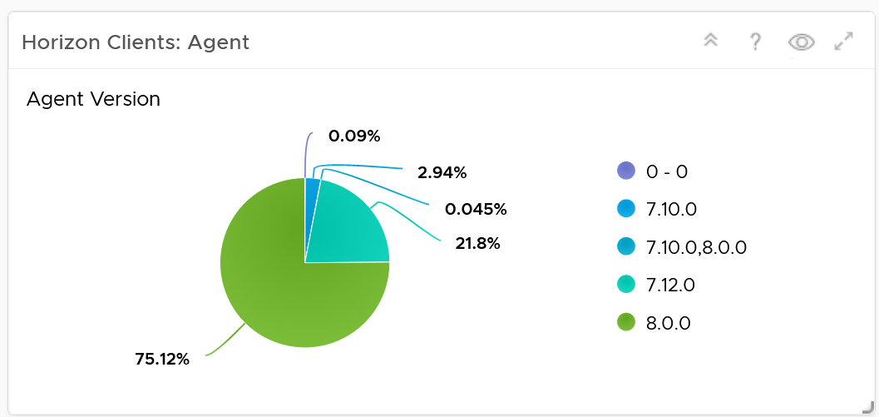

BTW, the agents reporting version 0 – 0 could be test agent. Don’t worry about them.

#### Horizon Infrastructure

The simplest form of configuration widget is a table that lists the settings you’re interested. The dashboard starts with the list of pods. 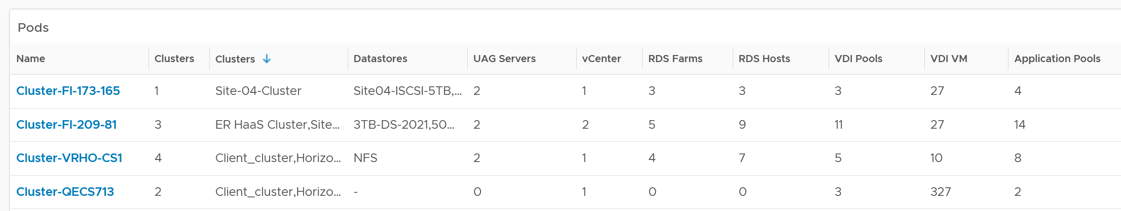

In large environment, consider adding interaction, so the list of pools and farms are only showing the list from the selected pod.

The following table shows an example for VDI Pool configuration.

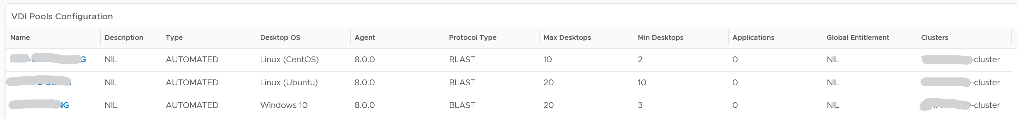

And here is the example for RDS Farm

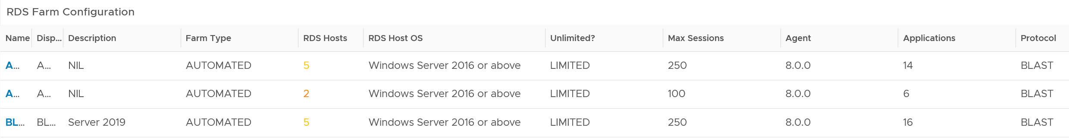

For Connection Servers, consider checking the following.

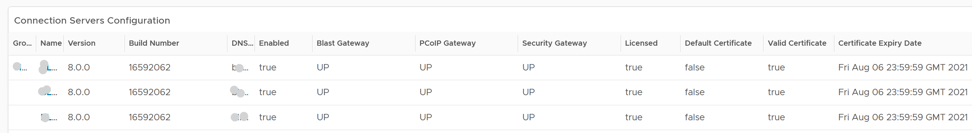

Why are they grouped by Pod?

The servers within a pod should be consistent. Their build numbers, certificates and other settings should be identical.

If performance matters, check the power management of ESXi Host. For the clusters hosting the actual sessions, set it to high performance, and not balanced. Take note that this means you forgot Turbo Boost.

### Inventory Dashboard

The inventory dashboard follows the same design with vSphere inventory dashboards. The goal is to see the changes in inventory count (as opposed to configuration drift).

Inventory is easily confused with configuration as they do overlap, and both contribute to capacity. A VDI Pool configured with 200 VM. If these 200 were provisioned, the pool does have an inventory of 200 VM. You then inventorise them, categorizing them into available (for users to use), used (a session is logged in) or unavailable (errors or under maintenance).

The dashboard sports a headline number, providing quick summary of what you have.

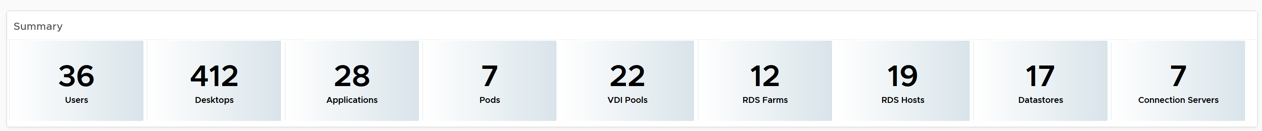

Below the table, you will find the usual relationship widget that you expect from all inventory dashboards. Relationship matters in inventory, as inventory is about what you have where (in which location).

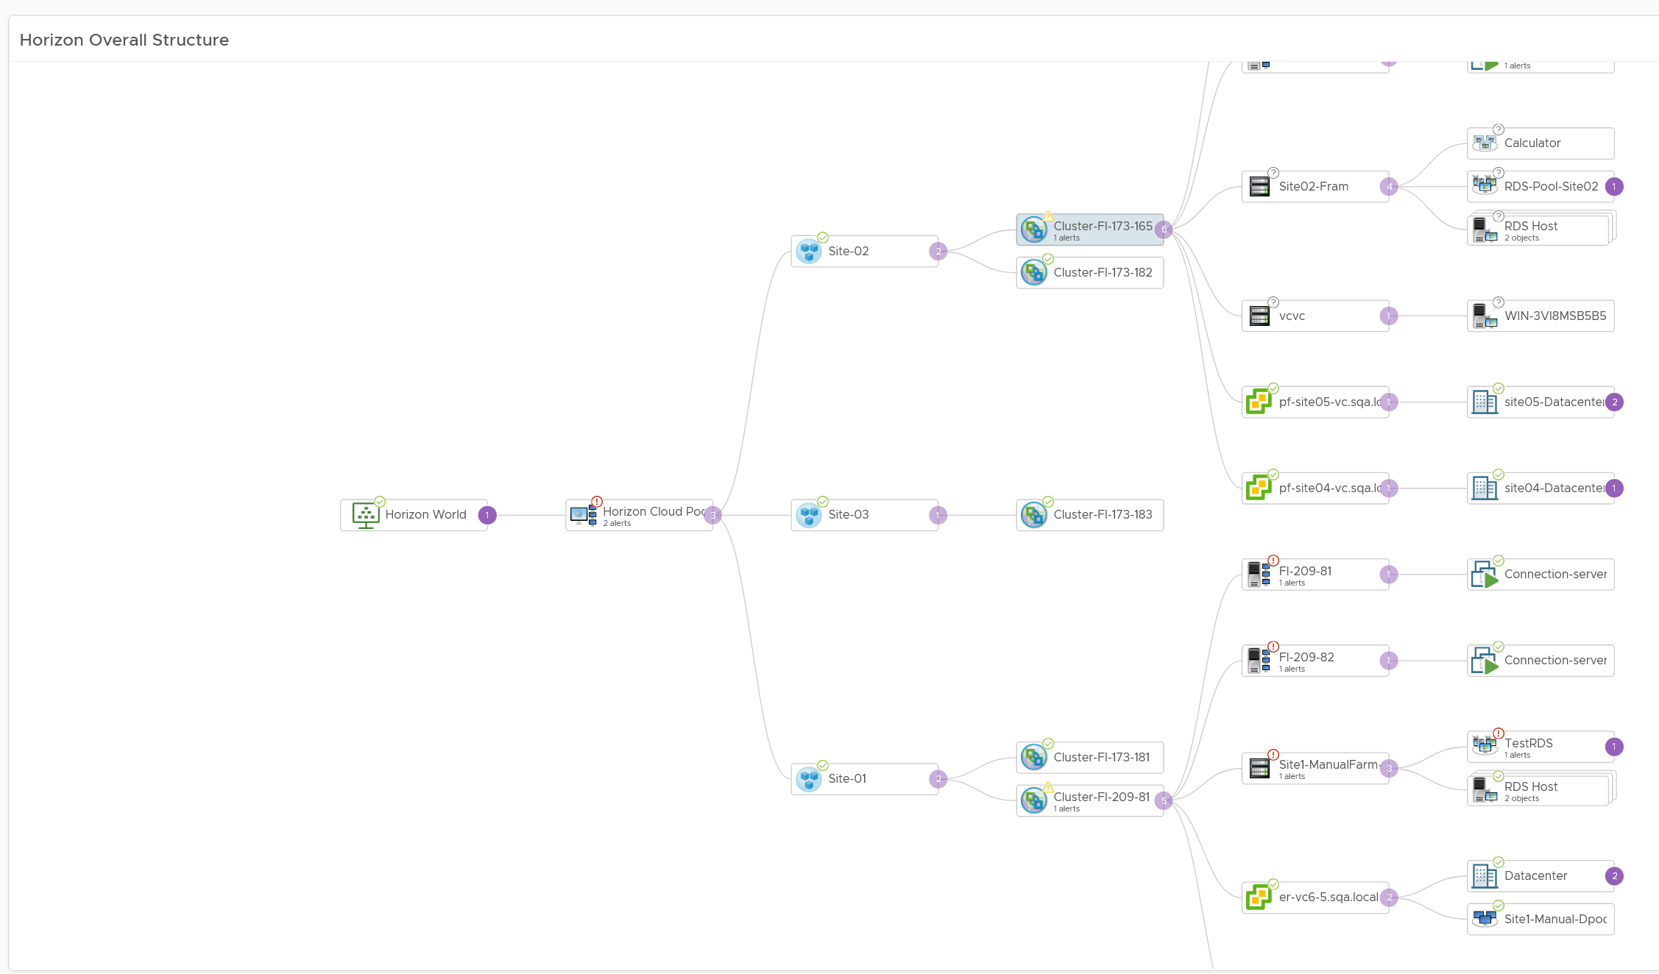

What inventory should we track for VDI Pools?

It’s a little tricky as it overlaps with configuration and capacity.

At overall levels:

|  |  |
| --- | --- |
| **Number of pools** | Yes, you configure this by design, but it’s also part of your inventory. |
| **Number of RDS Farms** |
| **Total users** |  |
| **Active users** |  |
| **Client Types** | Types of clients (thin client, mobile, tablet, etc.) |

At individual VDI Pool level:

|  |  |
| --- | --- |
| **Available desktops** | how many desktops are used vs unused. For the unused, have the breakdown (error, under maintenance, available). |
| **Used desktops** |
| **Error desktops** |

At individual RDS Farm level:

|  |  |
| --- | --- |
| **No of Hosts** |  |
| **No of sessions** |  |

## Others Consumption

**Part 3 Chapter 9**

These dashboards are not part of vRealize Operations, yet! We can’t possibly ship every dashboard for each roles and use case, so I provided them here as examples to show case the possibilities. They are available at the exchange repository on [code.vmware.com](https://code.vmware.com/).

### Business Applications

|  |  |
| --- | --- |
| Business application is not an object that belongs to vSphere or VMware. It can potentially contain object outside VMware objects. So the parent object is different. It’s called Entire Enterprise Applications, as shown below.  In the screenshot, you can see the structure that it’s a parent of 4 business applications.  I’ve expanded the last business applications to show that it’s parent of 4 application tiers.  Each of this tier has to map to Aria Operations group. The group membership in turns maps to vCenter folders. |  |

You can also see the relationship under the Entire Enterprise Applications object, as shown below.

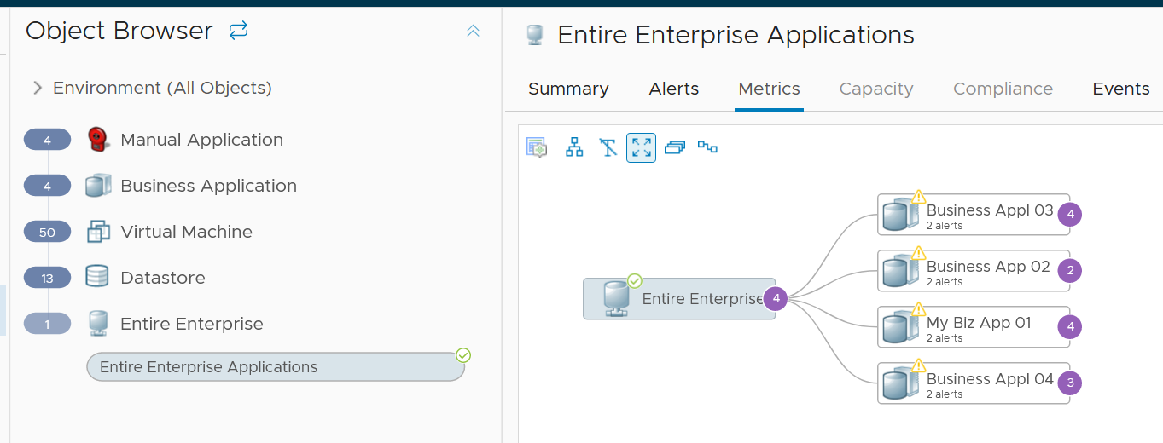

#### Application Tier

To create a business application, we must create its application tier first.

To define the tier object, create a group in Aria Operations.

In the following screenshot, I’ve created an object called Biz App 01 DB Tier. I’ve defined its members as any VMs which is a child of a specific vCenter folder. This is why your vCenter folder needs to be unique. One way is to create prefix for each business applications.

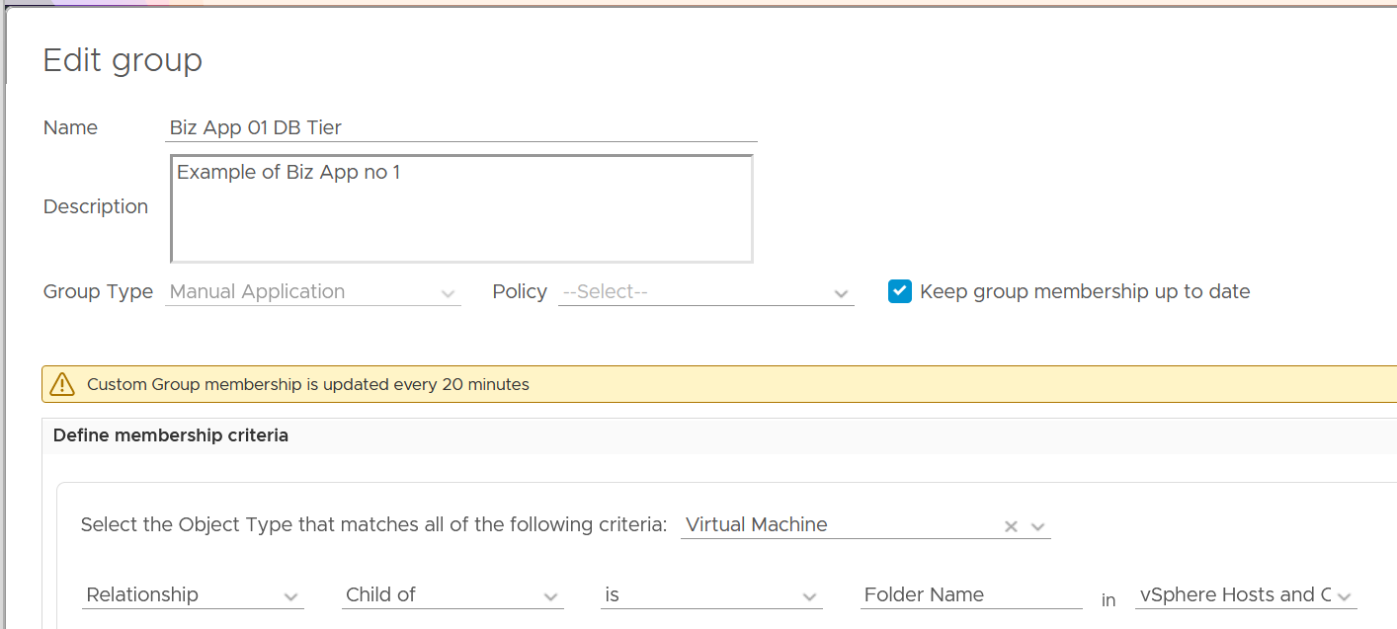

The reason I chose group is the members can be dynamic. This gives you flexibility as application team may add or reduce the number of VMs.

The Group Type has to be Manual Application. The reason is the super metric is applied to it. I chose Manual Application as it’s already defined out of the box.

Once you create the tiers, you can see them in the Custom Groups page. Ensure the value of Dynamic Membership is true.

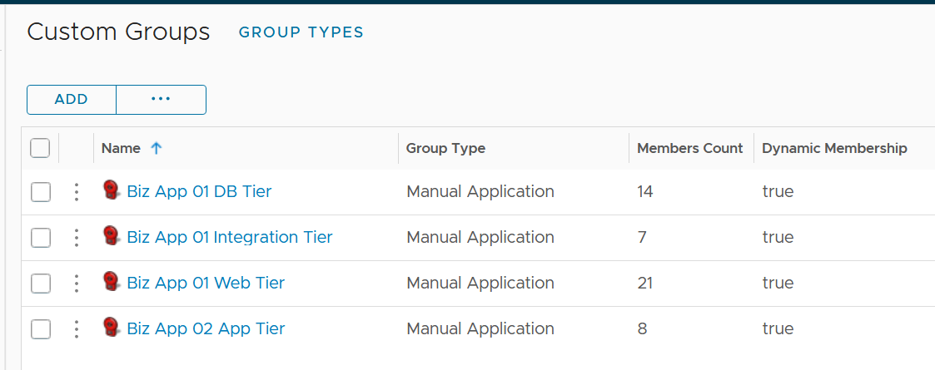

##### Capacity

You need to know whether it is active-passive or active-active.

CPU Consumption =

(

If Active-Active then Average (VM Member CPU Usage) Else Max (VM Member CPU Usage)

)

/

Min (VM Member Total Capacity) * 100%

The above gives you a number in percentage, making it easier to see across many tiers. Let me know if you find a use case for absolute numbers (in GHz for CPU and GB for memory)

For total capacity, we take the lowest value among the members VM.

#### Business Application Object

Once you create the application tiers, you’re ready to create the parent business applications.

Create the object for each business applications by choosing Business Application from the side menu.

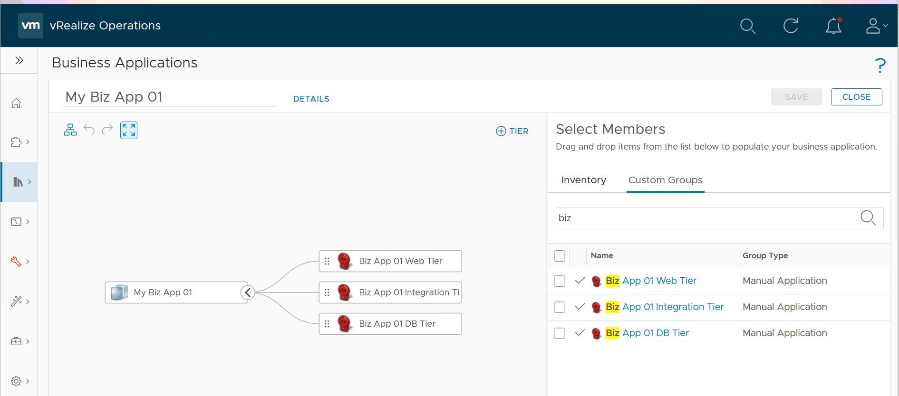

To add the members, choose Custom Groups and find the tiers you created earlier.

**Limitation:** The tiers are manually added. It has no dynamic membership the way Custom Groups has.

#### Dashboard Design

The dashboard focuses on Performance. To some extent, if the Guest OS is down, the dashboard below will detect it. If you enhance it to include availability and compliance, let me know!

The top part of the dashboard shows the overall trend.

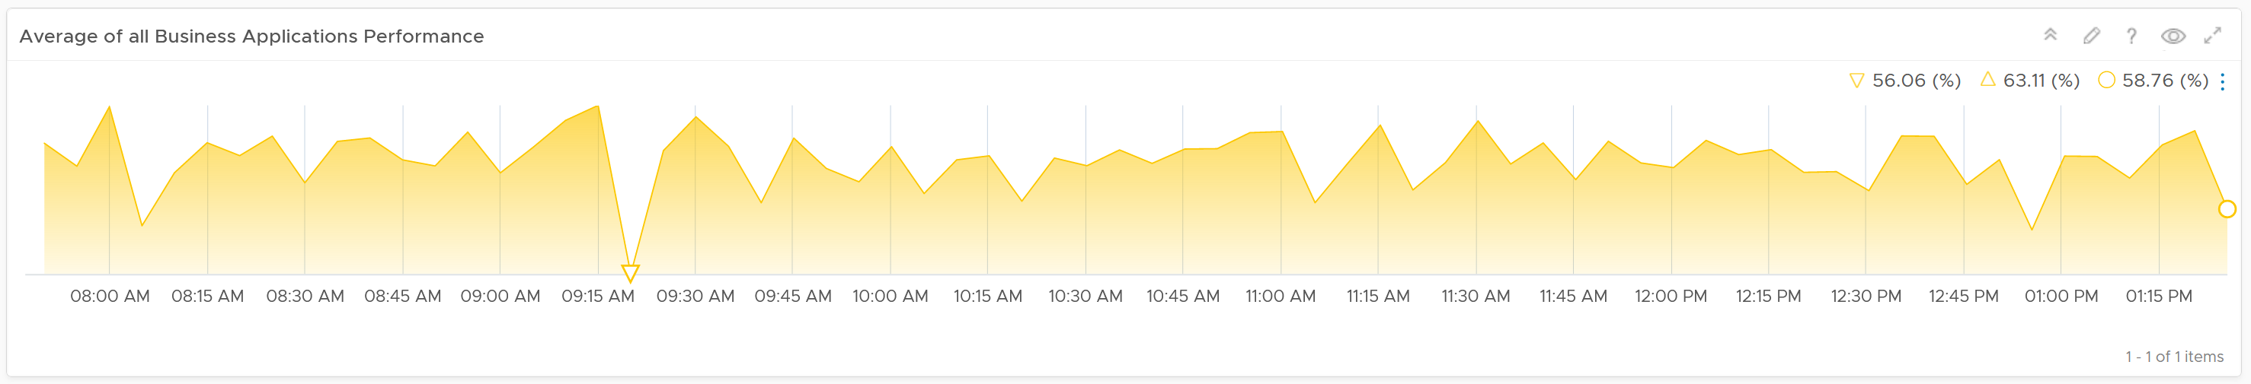

Assuming you only list your mission critical applications, you should expect the value to be good and match business reality.

The problem with average is it might mask a problem. For example, you have 2 mission critical applications. 1 has is value goes up (for whatever reason) while the other goes down. The average will fail to show it.

This is why the next row on the dashboard complements the overall picture. It has 3 columns

* The 1st column shows all the business applications. It’s sorted by the worst performing app, judged from the most recent value.
* The 2nd colums shows the tiers within the selected business application.
* The 3rd colums shows the VMs within the tiers.

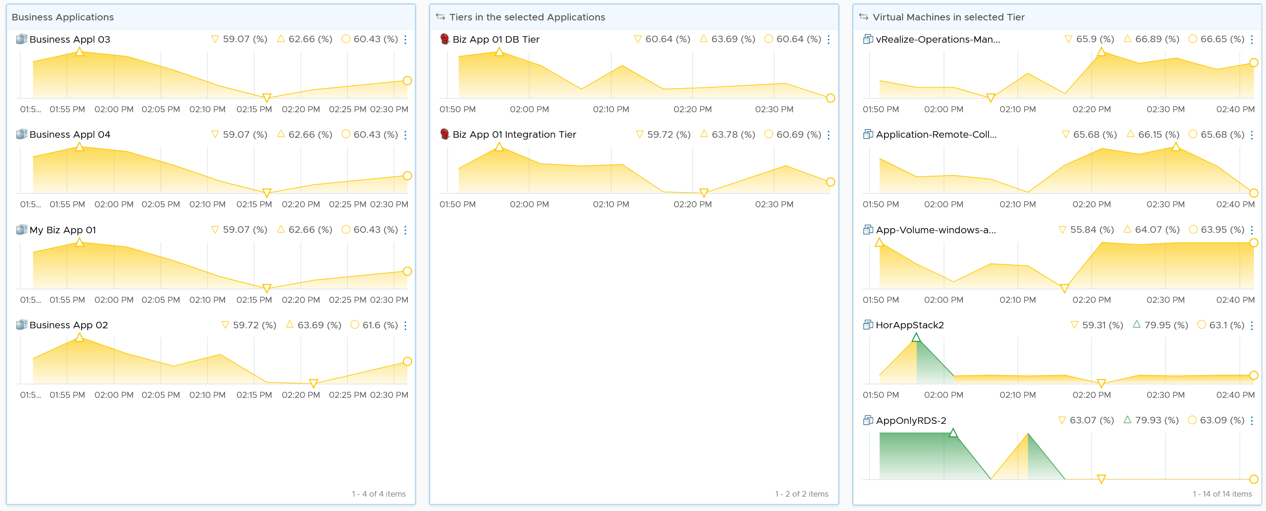

**Business Applications 🡪 Tier 🡪 VM**

The columns also support drill down into VM Performance dashboard and VM Capacity dashboard.

The last column, because it’s a list of virtual machine, also sports a drill down into the guest operating systems. Take note this requires telegraf agent.

The 3 columns also drives the table underneath them. The table lists all the VMs for ease of analysis.

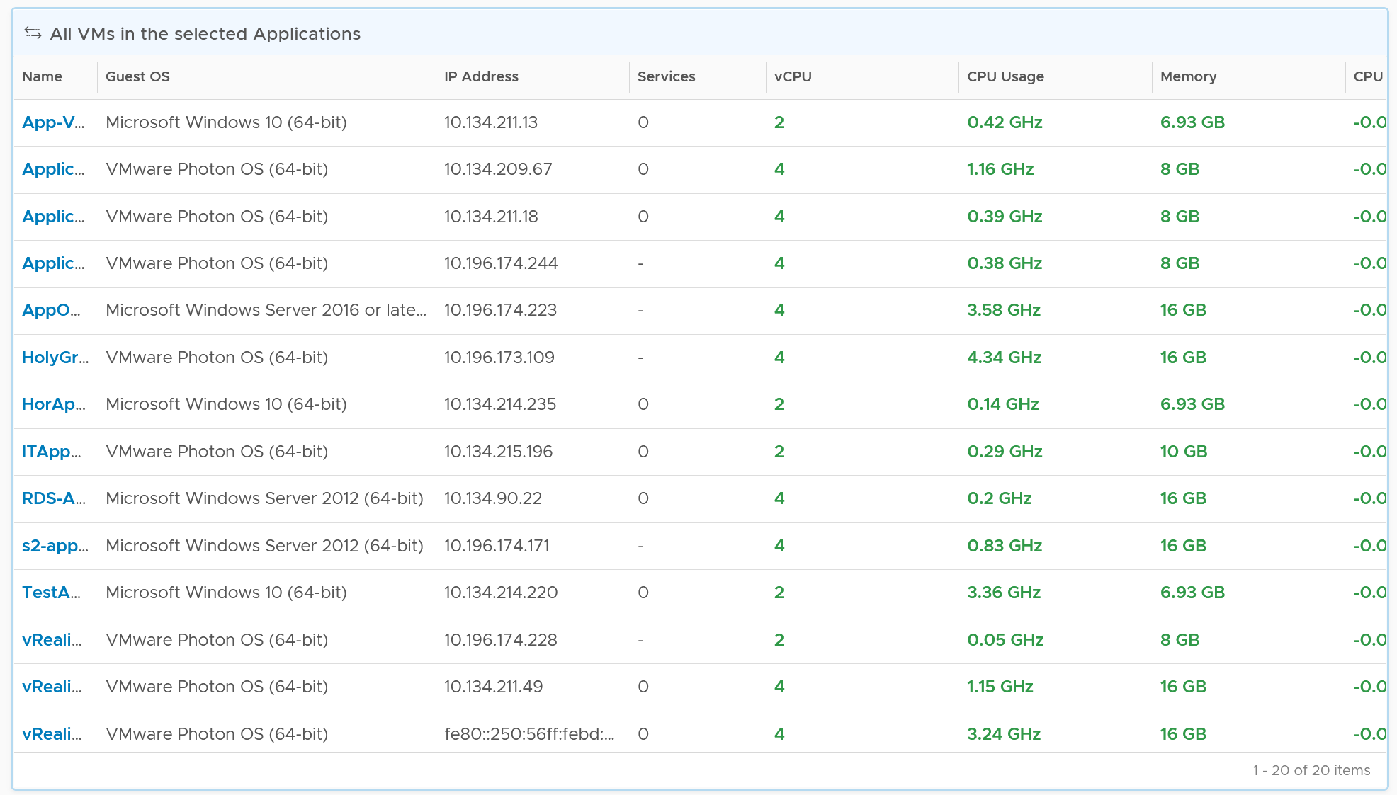

You can enhance the visibility by corelation. For example, you can compare the application-level metric with infrastructure metric. CPU is a good general candidate. For example, you compare the number of web server session with the CPU Usage in GHz. If application developer releases an improved code that enable the web server to serve more users with the same resource, but the reality is the opposite, then they have something to troubleshoot.

You can enhance this by adding process-level metric. This requires you to install Telegraf agent.

### NOC Dashboards

[Network Operations Center](https://en.wikipedia.org/wiki/Network_operations_center) has specific requirements and constraints, hence it’s covered as a separate chapter. As requirements vary widely among customers, what is provided out of the box are examples to show case the possibilities.

#### Design Considerations

A dashboard projected on the large screen serves a different business purpose than a dashboard on your laptop or desktop. It is placed strategically because it displays a *time sensitive* information. The information presented is more urgent in nature than alerts (otherwise you simply use alerts!) and is used to complement alerts.

These dashboards are specifically designed for your Network or Server Operations team, who are typically stationed at the. NOC Dashboards aid your operations team to proactively monitor the health & availability of the VMware cloud infrastructure in near real time. Due to the specific purpose of it, not all operational use cases are suitable for these. For examples, Capacity and Cost use cases are not highly time critical. They tend to stay static for hours, rendering them unsuitable for live screen.

The following five principals are used to design the predefined Network Operation Center dashboards.

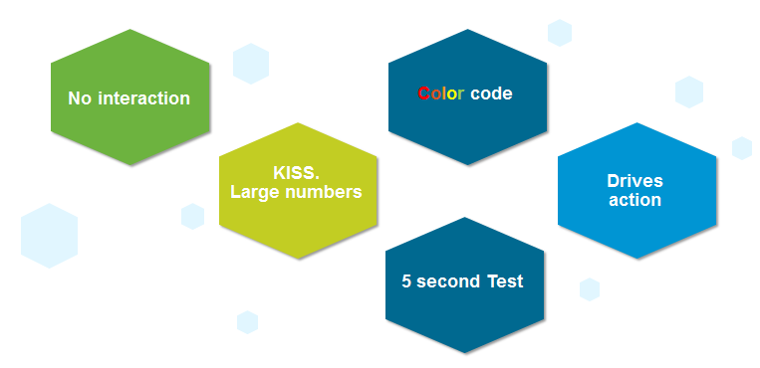

**Color Coded**: All the information is color coded to classify the severity of the issue.

* Color is easier to digest than text, as you don’t even need to read. Lots of text can confuse viewers. Text can be hard to read from afar.
* Use key colors (green, yellow, amber, and red).
* By default all green. Can’t have red staying for hours (use alerts for something less urgent)

No interaction on the projected screen

* 0 interaction, because there is no mouse and keyboard.
* Toolbars & buttons should not be used as they add confusion as there is no way to use them.
* Most widgets are not suitable as a result.

KISS (Keep It Simple Show)

* These dashboards are designed to show you minimal & critical information only. It should follow the [KISS principle](https://en.wikipedia.org/wiki/KISS_principle).
* Don’t show detailed charts as that is hard to read from afar. Be aware of how far the info needs to be displayed. 9 point Calibri at laptop is clear, but not at the projector screen.
* Ideally, all the numbers are in %, with 0 being bad and 100 being perfect.
* In cases like Utilization, you should use the following marker.
  + 50% = good, balanced utilization. Ideally, this should be 75%.
  + 0% = wastage
  + 100% = highly utilized.

Remember the 5-second test

* All NOC dashboards should be easy to interpret, user friendly and do not require an explanation.

Choose content that drives immediate **Actions**

* Focuses on immediate remediation. Remediation action has to be immediate (within the same hours). If something can’t be fixed within the same day, why show it live? Remediation that takes >1 day should not be shown, as the dashboard will be red for hours. It is better to use alerts for longer remediation window.
* If you display something that is red most of the time, after a while the viewer will ignore it. This defeats the very purpose of displaying on the big screen.
* When something on the big screen is red, you want action to be taken. And it’s immediate, not tomorrow.
* It’s showing 5 minute data. Live! The history not so relevant, because it focuses on urgent remediation.
* Problems that don’t require immediate attention should be avoided, as they are distraction.
* Examples of suitable actions: stop provisioning of new VM, take action on VMs that abuse the shared infrastructure.
* Examples of not suitable actions: Increase supply of infrastructure, such as adding hardware.

Designed to be displayed on a big screen.

* Configure them to auto-rotate in a logical flow.
* Each dashboard is designed to fit the screen & no scrolling is required.

The above principle applies to the part of the dashboard that is projected on the big screen. You can dual-purpose the same dashboard, to cater for the operators in the NOC room. These help desk administrators should have the same dashboard on their desktop or laptop. They can then use keyboard and mouse to interact with the dashboard, enabling them to drill down and find out more information.

vRealize Operations provides 3 sample dashboards in this release. Tailor them to your operational needs.

Availability is not part of them because there is no information to distinguish between planned downtime and outage. A planned downtime can last hours, making the NOC screen displaying red for too long. If you have a set of mission critical VMs or clusters that need to be up all the time, then create a group.

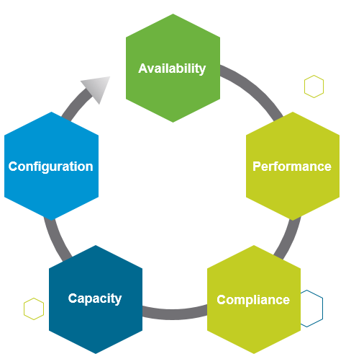

#### Live! Cluster Performance Dashboard

This dashboard provides live information on whether the requests of the VMs are met by their underlying compute clusters. This dashboard focuses on the compute resources (CPU or Memory), and show if the cluster is performing well (i.e. meeting the demand). Use this dashboard to view if there is any problem in meeting the demands of the VMs.

This the primary dashboard for performance. It is complemented by the **Live! Cluster Performance** dashboard. This secondary dashboard complements it by showing if the performance problem (read: contention) was caused by high utilization. The primary dashboard answers the question “Is our IaaS performing?”, while the secondary dashboard answers the question “Is our IaaS working hard?”.

##### Design Consideration

The dashboard shows 3 heat maps side by side. They complement each other and should be used together. The location of each cluster and ESXi hosts within those clusters is identical in all heat maps. This fixed positioning enables viewers to compare if the problem is caused by memory contention, CPU ready or CPU Co-stop.

The size of each cluster and ESXi hosts are designed to be constant. Variable sizing creates a distraction, as the focus here is not capacity. Variable sizing can potentially result in small boxes, making it hard to read from a far.

The focus of performance is on population, not a single VM. This is not a single VM troubleshooting dashboard. We are looking at infra problem, not a single VM problem. As the infra counter is mathematically an aggregation of VM metrics, we need to pick the right roll up strategy. As the goal is to provide early warning, we’re not using average as the roll up technique, as it is too late as early warning. We use percentage of population exceeding a threshold. The threshold is set to be stringent so we can get early warning.

##### How to Use

Look at the 3 heat maps and see if there is any color other than green.

* While each box is an ESXi, the counter is coming from all the VM in the host. It’s not taking ESXi level counter at all. The metrics used are % VMs facing CPU Ready, % VMs facing CPU Co-stop, % VMs facing RAM Contention.
* The color is by percentage of VMs not being served well. We are not using Max among the VM as it's too extreme, placing too much focus on a single VM. On the other hand, we're not doing ESXi wide average, as that will be too late.
* Green indicates that almost 100% of the VMs are getting the CPU and memory they are asking. The threshold is set such that if 10% of the VM population is not getting the resources they are asking, the heat map will turn full red.
* Red indicates an early warning. Stringent thresholds are used to enable proactive attention & remediation operations. Because high standard is applied, it is possible that the heat map is showing red, but there is no complaint from VM owner yet.
* Light grey likely means there is no VM running on the host, hence the metric is not computing.

Check if there is imbalance.

* There are 2 types of imbalance: cluster imbalance and resource type imbalance
* The ESXi hosts are grouped together by the cluster, so imbalance within a cluster can be seen easily. Cluster imbalance is a real possibility that is best monitored and not just assumed.
* If the 3 heat maps are quite different, there is resource imbalance. For example, if the memory contention is mostly red, but the 2 CPU heat maps are green, that means you have imbalance between memory and CPU.
* If a single ESXi host is displaying a different color across 3 heat maps, it indicates imbalance between CPU and memory resources in the host.

For NOC Operator, drill down by selecting one of the ESXi on the heat map

* The “Trends of selected ESXi Host” will automatically show the performance metrics
* It’s showing from all 3 heat maps, so you can correlate. To hide any metric, simply click on its name on the legend.

As part of the deployment, it is best that you configure auto rotate among the NOC dashboard. If you only want to show 1 dashboard, you can remove vRealize Operations menu by using URL sharing feature. This will make the overall UI clean, enabling viewers to just focus on the dashboard.

##### Points to Note

If you have the screen real estate, add a Heat Map for Disk Latency. Use the counter “Percentage of Consumers facing Disk Latency (%)”. It is part of datastore object, not cluster, as a VM in a cluster can have disks across multiple datastores. Organize this storage performance by data center and not by cluster.

#### Live! Cluster Utilization Dashboard

This dashboard complements **Live! Cluster Performance** dashboard. It shares the same design consideration. Use it to view the clusters and ESXi hosts within those clusters that are working excessively and are close to their physical limit. This dashboard displays ESXi hosts which have CPU or Memory saturation, and which can lead to performance issues for the VMs running on the host.

2 metrics for Memory are used as Consumed metric alone is not enough. It could be mostly cache or historical data. Balloon also persist (past data), but at least it gives an insight of ESXi under memory pressure.

##### How to Use

As this dashboard has identical design with the **Live! Cluster Performance** dashboard, it has the same usage procedure.

The dashboard help answer the following questions:

* Is the IaaS running very high utilization right now?
* Do we size ESXi correctly, meaning balanced usage of CPU and Memory?
* Are the clusters balanced? Are load distributed equally among member ESXi hosts?
* Is all ESXi contributing? Light grey box indicates that the host is part of the cluster but there is no utilization. It is likely the host is in maintenance mode or is powered off.

The following heat maps are designed to work as one set. Notice the arrangement of the boxes are identical across the 3 heat maps. If you guess that an object is placed in the same location in all the heat maps, you are right! This identical position means you can quickly see if a particular ESXi or cluster is having what problem.

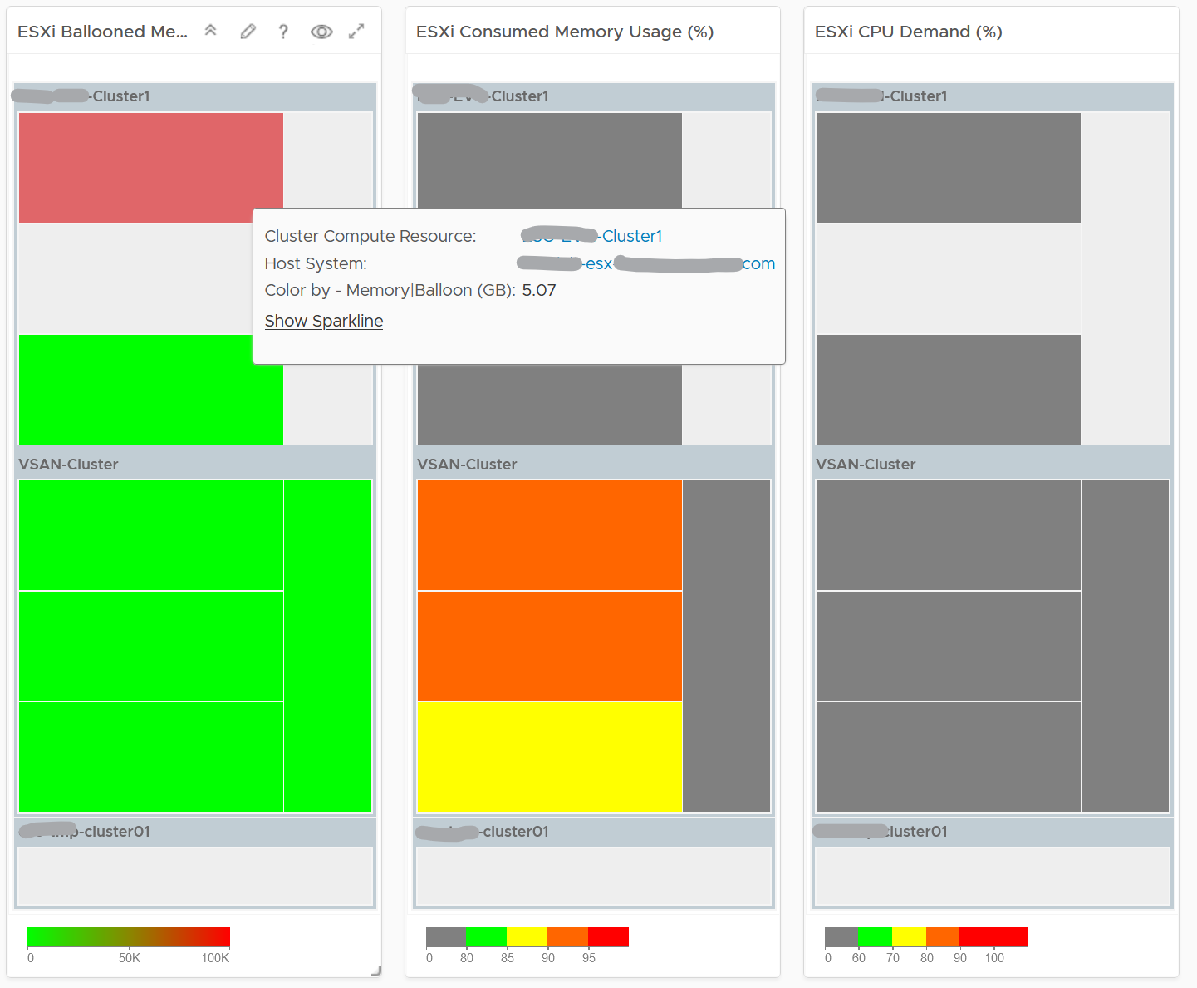

Unlike the heat maps in the **Live! Cluster Performance** dashboard, the 3 heat maps in this dashboard has a different scale, reflecting the different nature of the metrics.

Logically, memory is a form of storage. It acts as a cache to disk as it’s much faster. Hence a high utilization is better, as that means more data is being cached. The ideal situation is when ESXi Consumed metric is red but ESXi Ballooned metric is green. When Ballooned is red and Consumed is grey, it means it was likely high in the past but not anymore. The reason the ballooned stays red because the ballooned pages were never requested back.

Ballooned memory counter was chosen over the swapped or compressed memory metrics as it’s a better leading indicator. Because all 3 can co-exist at the same time, all 3 are shown in the line chart. Ballooned is shown in absolute amount and not percentage, as the higher the size the higher the chance it might impact a VM. If you feel using percentage is easier for your operations, create a super metric to translates the value.

Quiz Time: why is the heat map showing grey and light grey?

The heat map is showing dark grey and light grey to convey wastage and data error, respectively. While the use case is performance, there is a need to educate that oversized VM cause performance issue.

##### Points to Note

ESXi choose swapping over compression if the compression ratio is less than 4x.

If you have the screen real estate and your network is highly utilized, add a Heat Map to check the ESXi physical NIC Network Throughput.

#### Live! Heavy Hitter Dashboard

This dashboard helps you analyze the misuse of the shared infrastructure. This dashboard displays details of VMs misusing the shared infrastructure and if that has caused performance problems to the other VMs. The cause for excessive load might be due to security attacks, for example, denial of service, process runaway, or mass activation of agents.

##### Design Consideration

See the Performance Dashboard page for common design consideration among all the dashboards for performance management.

In shared environment, it is possible to have victim-villain problem. In the heat map, the villain VM is the one with the largest box size, while the victim is the one with red box. If a handful of VMs are dominating the shared infrastructure, their collective size will be highly visible on the dashboard.

There are 4 areas where a monster VM can impact its neighbours.

* CPU.
* Disk IOPS. Any VM with PVSCSI can generate very high IOPS. Since this hits the underlying physical storage, the view is grouped by Data center, not Datastore or Cluster.
* Disk Throughput. Applications with large block size (e.g. 4 MB) can consume bandwidth without generating high IOPS
* Network.

Memory is not needed as it’s rare for Guest OS to actively read/write from DIMM. It’s mostly cache. Think of it like disk space (passive).

​Remediation Action you should take: Check why the VMs are generating excessive load.

##### How to Use

There are 4 heat maps, showing the 4 different loads that can be excessive. The heat map displays the relative value and not the absolute value. A VM does not generate a high load in the absolute term just because it has large configuration.

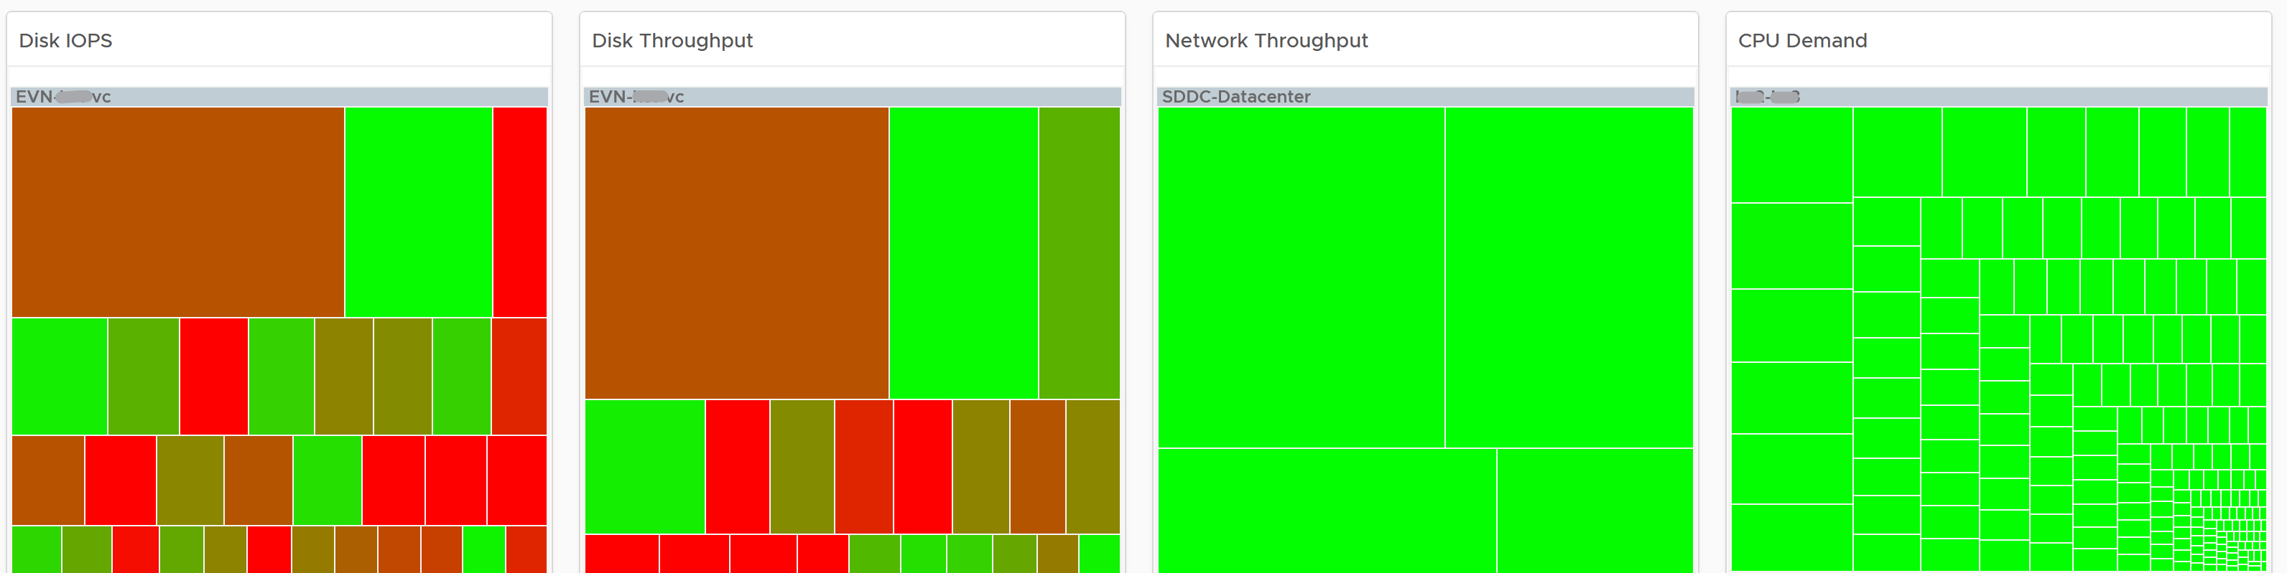

Each heat map has their own color threshold, reflecting the nature of the contention metrics used in each of them.

For NOC Operator, who have access to mouse and keyboard on their desk, they can drill down by selecting one of the VM on the heat map.

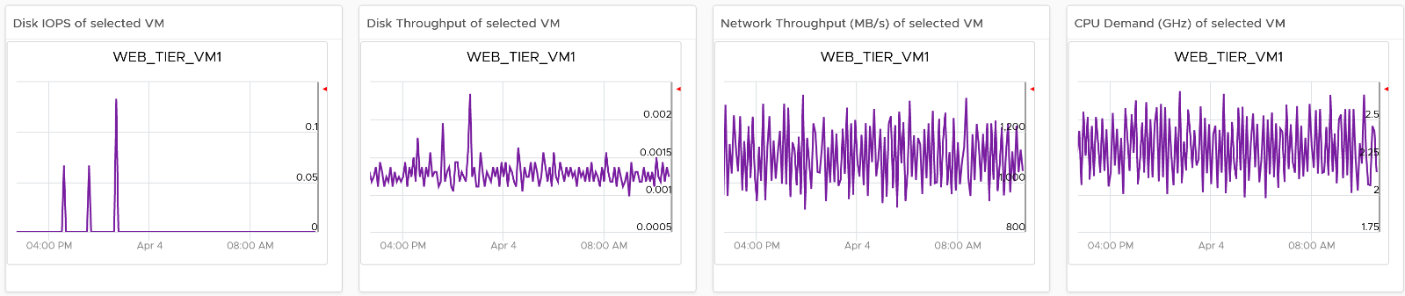

All the 4 line charts are automatically showing, enabling you to get a more complete picture of the selected VM.

##### Points to Note

Memory is not shown as it’s a form of storage. The memory metrics are space utilization, not speed. Think of disk space instead of IOPS. It can cause capacity problem on the shared ESXi host, but not performance problem to other VMs.

In a large environment, it might be difficult to view a small victim VM. Consider having multiple dashboards and rotate among them.

### Executive Summary

IT Senior Management has a different set requirements, and may even prefer information to be emailed.

#### Design Considerations

CIO, Head of Global Infrastructure, and other IT Senior Management have a different requirement than technical folks. Generally they want the big picture, not details. Or at the very least, the big picture is presented first, and then drill down is provided.

As part of showing the big picture, trend should be included. Show the situation in the last few months, ideally coupled with projection. The data should be averaged out, so that a 5-minute spike should not show up.

Exception. Things that they need their attention. Complete means nothing else can be taken out. Which information, object, metric can you take out from the dashboard?

No technical info. Ideally, present in business terms, not IT jargons. Terminology such as datastore, distributed switch may need to be replaced with something suitable in your organization.

UI that is easy to understand. So keep each dashboard to a specific question. Make sur the dashboard is easy to use. So keep the interaction, clicking, zooming, sorting, etc. minimal.

Can the dashboard be understood within 5 seconds?

If yes, you buy yourself a few more minutes. Your IT Management has understood what the dashboard does, and is willing to spend more time appreciating its full capabilities.

Take note of the “size” of your dashboard. A dashboard that has many widgets and scrolls deep is harder to understand.

KISS. Keep it simple solution. Keep the interaction, clicking, zooming, sorting, etc. minimal. Use larger fonts, round numbers (law of [significant figure](https://en.wikipedia.org/wiki/Significant_figures)).

If they ask for a self-service portal, then make it easy to access. They may not want to login to vRealize Operations. If they do, they may forget their password, so the portal should not require a password.

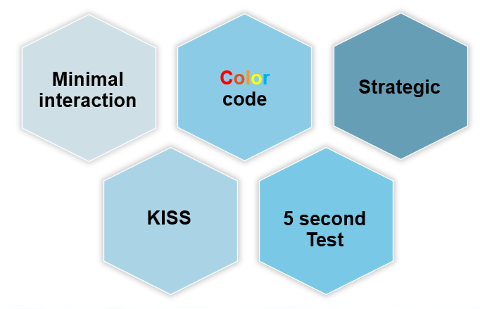

That’s what *they*want from you. You also need to think of what you want from them.

You also want to show them problems that you can get help, which is budget and resource. You do this by showing data. By giving visibility into live environment to senior management, you prove that you do need additional hardware. If there is wastage to be reclaim, you also prove on where and how large the wastage is.

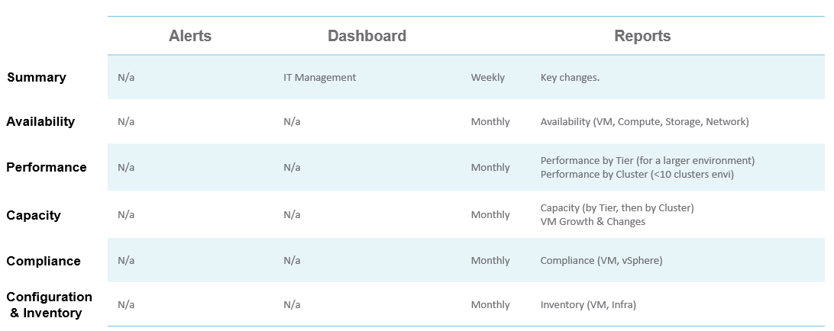

vRealize Operations provide two example dashboards to get you started. They are designed for you to present live information to your senior management. They are not designed as self service.

As each executive may have a unique requirements and preferences, customize the dashboard accordingly.

#### Operations Overview

This dashboard is used by the Ops team to provide the overall picture to the IT Management team. This dashboard works together with the set of inventory dashboards. The inventory provides details on available resources and what is running on these resources.

It also works with the capacity summary dashboard, which provides details on the resources remaining capacity and time remaining to act.

#### Capacity Summary

This dashboard is used by the Ops team to explain capacity to the IT Management team. It works together with the **Inventory Summary** dashboard. The inventory provides details on available resources and what is running on these resources. The capacity provides details on the remaining capacity and time.

See the Executive Summary Dashboards page for common design consideration among all the dashboards for IT senior management.

##### How to Use

The dashboard has 2 sections.

* The top section provides summary at the vSphere World level.
* The bottom section enables drill down into individual compute or storage capacity

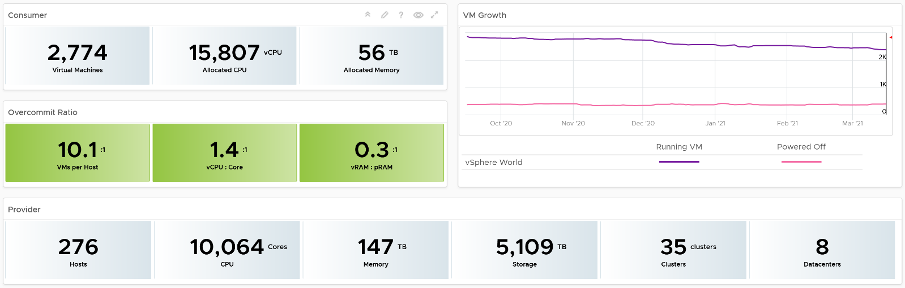

The weekly average of VM growth is displayed to provide holistic visibility of overall growth across all Data centers for both running and powered off workloads. If the increase in VM count is not accompanied by corresponding increase in utilization, these newly provisioned VMs are likely not yet used.

Overcommit Ratio highlights the efficiency gained by vSphere virtualization running multiple workloads on shared infrastructure. It is important to note that overcommitment needs to be further reviewed in conjunction with elevated resource contention (refer to contention dashboards) to understand the performance impact when running VMs competing for resources. In general, Overcommit is required to be financially more economical than the public cloud. As a reference, AWS typically overcommits CPU 2:1 by counting the hyper-threading and does not overcommit memory. Note: vRealize Operations uses Physical CPU Cores not Logical Cores (Hyper-threading) for all CPU-based capacity calculations

The bottom part of the dashboard is split into 2 columns:

* compute
* storage.

Network is not added due to its nature. It’s an interconnect, not nodes, so capacity is much harder to compute.

The dashboard uses the term compute (and not vSphere Cluster) and storage (and not vSphere datastore) to keep the visual simple.

The two columns have identical design. The heat map displays capacity by size and colored by time remaining. However, for compute the size of each box in the heat map is fixed as there is no single metric to represent the size. A cluster size can be measured in 4 different ways (No of ESXi Hosts, Total CPU GHz, Total CPU cores, and Total Memory).

Here is what the compute portion looks like. The heat map is interactive. By selecting one of the cluster, you can further drill-down to clearly understand remaining capacity and time (in days).

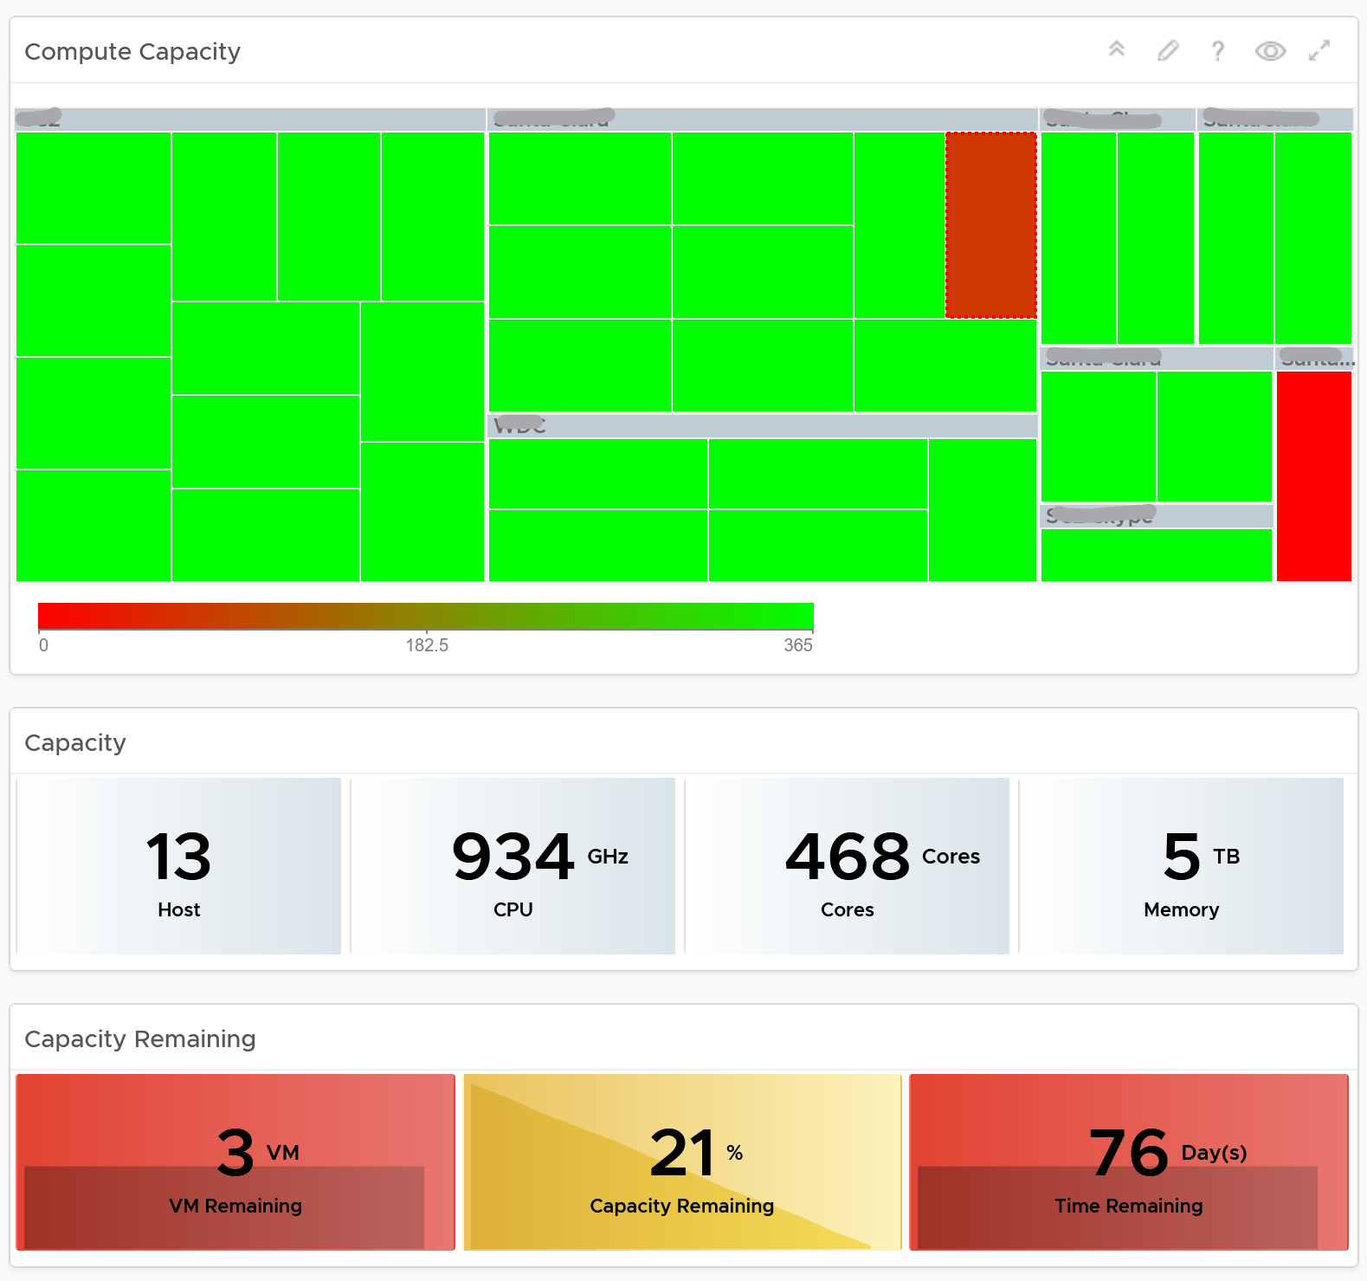

Here is what the storage portion looks like. They are designed to be similar

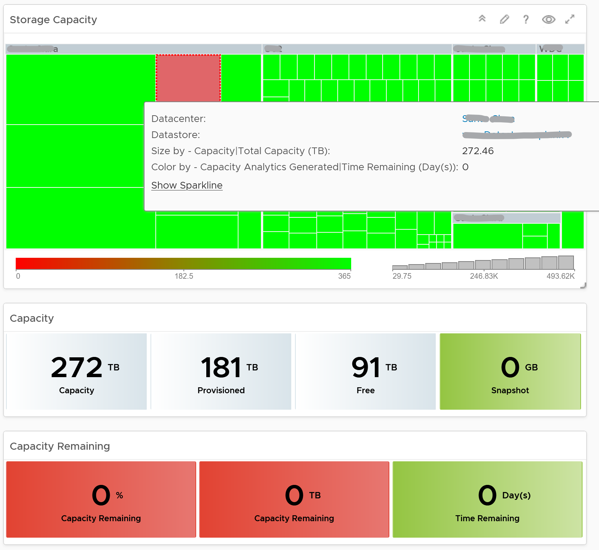

##### Points to Note

* Capacity Remaining is not shown at the world level as it could be misleading, especially in global or large infrastructure. Clusters also tend to serve different purpose, and they are not interchangeable.
* If you are using both on-prem and external cloud, for example, VMware on AWS, consider splitting the dashboard into 2 columns. You would need extra screen real estate though.

### Role-based Dashboard

Different team in organisation are interested in different things, so creating a purpose-built dashboard helps them.

#### Storage Team

Ask any Storage Team and Platform Team whether the collaboration between them can be improved by a mile, and you are likely to get a nod. One reason for this issue is there is lack of common visibility. You need to see the same thing if you want to collaborate. Storage Team do not get always get access vSphere. Even if they do, vCenter UI is not designed for Storage team. It is designed for VMware Admin.

vRealize Operations and Log Insight can bridge that providing a set of read-only, purpose-built dashboards, that answer common questions such as:

* When a VM Owner complains, can we agree if it’s a storage issue within 1 minute? This will help reducing the ping pong game between VM Owner, vSphere Admin, and Storage Admin.
* Is the Storage serving all the VMs well? If not, who are affected, when and how bad? Read or Write? The answer has to be tier based, as Tier 1 VM expects lower latency than Tier 3.
* What’s the total demand hitting the array? Are they growing fast and becoming a risk? Who are the heavy hitters among the VMs?
* When & where are we running out of capacity? How much disk space can be reclaimed? From which VMs?
* What have we got? Are they consistently configured?

The questions above cover the main areas of SDDC Operations, such as performance, capacity, configuration and availability. They enable joint troubleshooting, capacity planning, performance monitoring. For better collaboration, add physical array monitoring into vRealize Operations and Log Insight, so you can analyze physical arrays and fabrics, and then correlate back with vSphere.

The dashboards should provide overall visibility to Storage team. They give insight into the SDDC by showing relevant objects by:

* quickly showing the summary of key information.
* showing VM, datastore, datastore clusters, compute cluster, and data center. It shows their relationship, which you can interact and drill down.
* showing all the VMs, where they are located, how much space they are allocated, and how they are using it.
* Showing physical arrays inventory and how they map into vSphere.

#### Network Team

Similar to the problem face between Storage Team and Platform Team, VMware Admin needs to reach out to Network Team. A set of purpose-built dashboards will enable both teams to look at issue from the same point of view.

The world of network is highly complex, given its nature as interconnect.

The dashboards must answer the following basic questions for Network Team:

* What have I got in this virtual environment?
  + What is the virtual network configuration? What are the networks, and how big are they?
  + We have NSX, Distributed Virtual Switches, Distributed Port Group, Data center, Cluster, ESXi, etc. How are they related? Distributed Switch does not span beyond vSphere Data Center. So data center is a logical choice to start analysing the relationship.
  + Who are the consumers of my network? Where are they located?
* Are they healthy?
  + Do we have any errors in our networks? Which port groups see packets dropped? If there is problem, which VMs or ESXi, are affected?
  + Do we have too many special packets? Broadcast, multicast and unknown packets. Who generates them and when?
  + The two primary metrics are bandwidth and latency. [Bruce Davie](https://www.linkedin.com/in/bruce-davie/) explains both in this book[26], specifically this [page](https://book.systemsapproach.org/foundation/performance.html), that the two metrics work together. The reason is some applications are latency sensitive, while others are bandwidth hungry.
* Are they optimized?
  + Just because something is healthy does not mean they are optimized. Look for opportunity to right size.

Once Network Admin know what they are facing, they are in better position to analyze:

* Performance
  + When VM Owner thinks Network is the culprit, can both Network Team and Platform verify that quickly?
* Configuration
  + Is the configuration consistent across objects of the same kind? Do they follow best practice?
  + What are the virtual networks, and how do they map into the physical top-of-rack switches?
* Capacity
  + Is any VM or ESXi near its peak in network? Which VXLAN is the busiest? Does it match their expectation?
  + Who are the top consumers for each physical data center? What’s their workload pattern?
  + How is the workload distributed in this shared environment?
  + Which networks are not being used? Why? Could we decommission them as they could become security risk?

#### Application Team

A common request among VMware Admin is to give their customers a self-service access to their own VMs. The VM Owners should be given a simple portal, where they can easily see all their VMs and its performance. You can use the dashboard sharing feature of vRealize Operations for a login-less access.

But what if you have many tenants? You don’t want to create a dashboard for each of them one by one. The challenge here is how to use the same dashboard for multiple applications teams, assuming they are not allowed to see one another VMs. This requires a security mapping. Each tenant needs to have a login ID, which must be mapped to their VM.

|  |  |
| --- | --- |
| **Role** | The first step is to create a role and give it limited access. All tenants user accounts will be mapped to this role. This role should not be able to browse the inventory. Its only access is to the group of tenants. |
| **Dashboard** | Create a common dashboard and map to the role. This role can’t see any other dashboards |
| **Tenant** | For each tenant, you need to create a user ID. This ID is then mapped to a group. The group has the tenant VMs. In this way, the tenant ID will not be able to see other VMs. |

#### Small IT Organization

The [Small Medium Business](https://www.investopedia.com/terms/s/smallandmidsizeenterprises.asp) segment is a world of its own. There are roles and processes that are useful in Enterprise segment, but are detrimental in SMB segment. As a result, products should be tailored for that market segment. You can create a set of consolidated dashboards for this market, as the environment is smaller.

Let’s look at some unique characteristics of operations in this small environment:

* 1-2 guys doing everything. No siloes in the team. You and your best friends take care of the whole darn IT from application to infrastructure.
* You only have a few clusters. Each cluster only has a few ESXi Host.
* You know all the details of your entire environment well because it’s small. They all fit into 1 rack. Architecture is simple. You have a mental picture of it in your head as they rarely change.
* You don’t buy hardware or VMware every quarter. In fact, it’s more like every 3 years. Capacity planning and monitoring become simple as you can do it manually using a simple spreadsheet.
* The workload is quite stable. You are not adding/removing/changing VM every day. Automation is often too expensive.
* Service Tier is an overkill as you only have 1-2 clusters for all workloads.

You still need to cover all the key areas of operations, from availability to performance to compliance. As self-service is expected, you need to provide a dashboard for application team.

You do not need a dashboard for Head of IT and management as they can simply use what you have.

##### Application-centric dashboard

This is for the application team. It’s a shared dashboard for everyone.

It covers all the applications. For each application, you show their configuration, performance, capacity and availability

##### Infrastructure-centric dashboard

Since you likely have <100 VM, the dashboard should go straight at the VM level.

It shows end to end visibility to physical network and physical storage.

### Migration Dashboards

|  |  |
| --- | --- |
| **Migration Sign Off** | Purpose is to get a sign off from VM Owner. |
| **Migration Tracking** | Purpose is to show overall progress of a long migration project to senior IT leaders |

#### Migration Sign Off

Since we do not know which VMs are being migrated, we need to use Aria Operations group. Since the dashboard needs to know the group ID, I need to create the group in advance. You have to import the group, and not create your own. If you do, then you need to modify the dashboard to use yours.

##### Summary Section

The dashboard section starts with a list of all the migration VM groups.

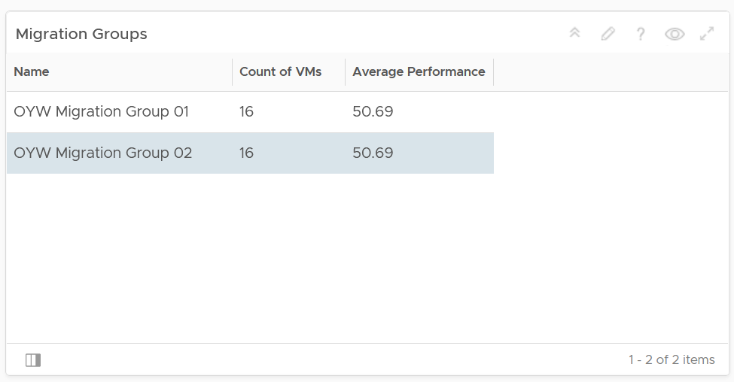

To see a group details, select the row. All the other widgets will be automatically refreshed.

The first thing to check is the health chart. As we need something to show over time that the migration is successful, we pick a color coded chart. The chart shows the average performance of all VMs in the group. You should expect the value to be same or better after migration.

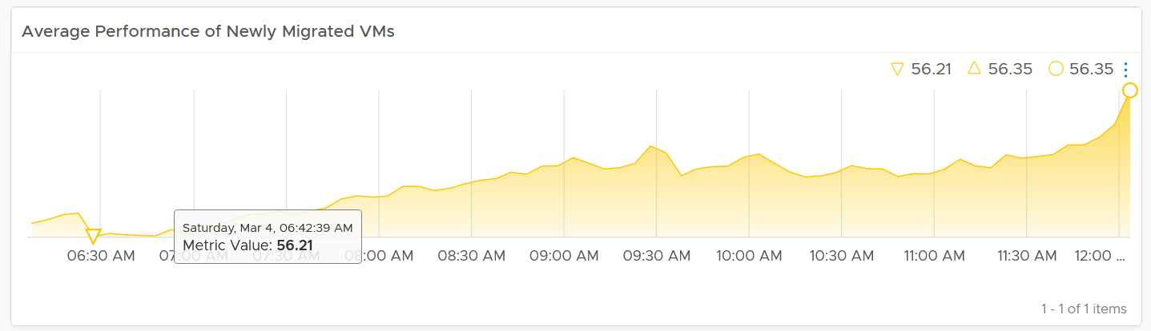

In migration, you want to have visibility into the application of services. I added a bar chart to show the services discovered by the Service Discovery adapter.

Ideally, install Telegraf agent so you have process-level metrics.

##### Detail Section

We need to use 2 separate tables due to limitation. You need to set the 2 dates manually as different migration groups have different migration dates.

The tables list all the VMs in the selected migration group, along with their relevant contention metrics, consumption metrics and business context.

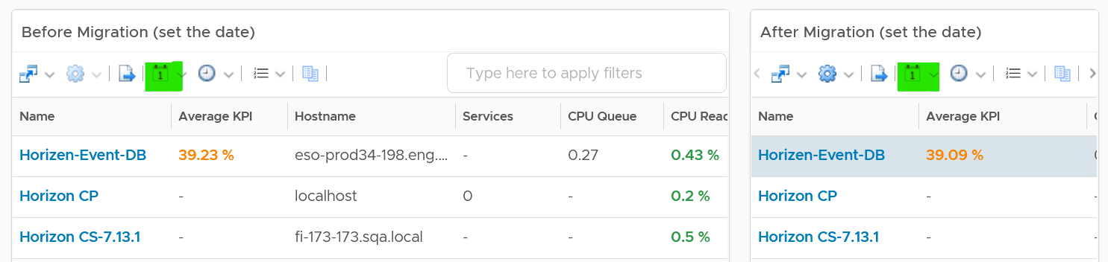

|  |  |
| --- | --- |
| CPU Ready, CPU Co-Stop and Memory Contention should go down, unless the numbers are already very good to begin with.  The numbers are taken at 20-second average, so they report much higher number than the 5-minute average.  Any numbers less than 2% is not something to worry about.  Disk Latency and Disk Queue should remain low even with more IOPS, assuming the new DC has much better storage subsystem.  CPU Context Switch could go up if the CPU Usage goes up, as there are more threads or execution to be done.  CPU Queue could go up if the CPU Usage goes up. So long the value is less than 3 per vCPU, there is no need to add more vCPU |  |
| I added a set of consumption metrics as we expect the consumption to go up.  For CPU, we need to use GHz and not percentage as the 2 datacenter could use a different CPU speed.  CPU Usage could be tricky to compare if the new datacenter uses a different CPU architecture, meaning 1 GHz in the old DC does not equate to same amount of CPU processing with 1 GHz in the new DC.  For memory, we have to use the one inside Guest OS. The counter at VM level is not relevant. For details, refer to the memory chapter.  For disk, we use both IOPS and throughput.  For network, we use network throughput. You can add packets per second if you think the behaviour changes. |  |

#### Migration Tracking

The dashboard should compare both datacenters. The layout should be 2 equal columns (Old DC and New DC). This is relevant in the case of 1:1 migration and a huge chunk of the VMs in the old DC are being migrated. If the old DC will continue having new VMs, then the comparison will be invalid.

The first row shows a summary

* Number of running VM. This shows you the overall progress. You expect the number on the old DC to go down over time. I exclude powered off VMs as you may not be keen on migrating them.
* Overall CPU Utilization. You should expect the number in the new DC to go up while the number in the old DC to go down
* Overall Memory Utilization
* Overall Disk IOPS
* Overall Disk Throughput
* Overall Network Throughput
* Overall Network Packets/second.

The second row shows the list of clusters

* If you select a cluster, you can drill down into its performance and capacity.

The third row shows the list of VMs

* If you select a VM, you can drill down into its performance and capacity.

The fourth row shows the list of datastores

* If you select a datastore, you can drill down into its performance and capacity.

The following table shows a sample design of a comparison dashboard. It has two identical columns, allowing you to do show before vs after comparison.

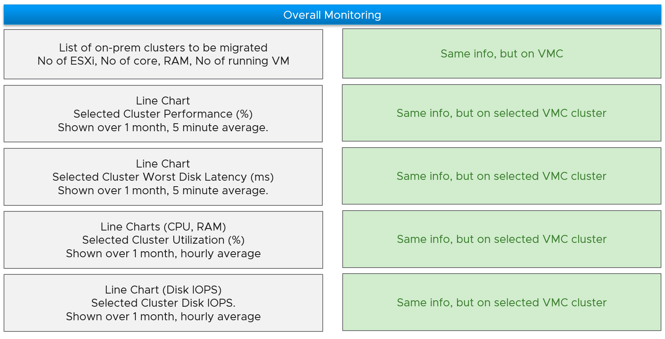

### Sustainability

Sustainable operations is a journey. So you need to be able to cover both the past and the future.

|  |  |
| --- | --- |
| **Past** | What has been achieved.  Demonstrates their savings and achievement to date. They want both the relative comparison and absolute value. The relative is show case they leading their peers in the industry, and performs better than public cloud. The absolute shows the hard numbers on their green impact to the environment. |
| **Future** | What can be achieved  Find and realize future potential environmental benefits by optimizing their virtual environment and virtualizing their remaining physical environment. Optimization covers a wide range of wastage and efficiency, such as zombie VM and EC2, oversized datastores, and islands of clusters. Virtualizing is not limited to server, but include storage, back up, security, network, and non x86 workload. |

As the past is history, the focus is certainly on what you can further optimize.

There are 3 aspects of **Sustainable Operations** where you can optimize:

|  |  |
| --- | --- |
| **Clean Demand** | This means genuine demand, required by either business or IT.  The following lists the objects or situation that may not be part of clean demand.   * Orphaned files, VMDK, VM, LUN. They may not even appear in the inventory. * Powered off VM. Not orphaned as it appears in Inventory. * Snapshot, both at VM level and storage level. * Idle VM. Cover AWS EC2, Azure VM, GCP VM. * Unused VM (cover AWS EC2, Azure VM, GCP VM). They may not be idle, but no business usage anymore. The VM owner may have left the company * Unused AWS storage files or K8 shared volume. The VM no longer uses them. * Oversized VM. Cover AWS EC2, Azure VM, GCP VM (could be worse due to their fixed size). * Runaway VM or EC2. They consume excessive resource due, typically due to software bug such as memory leak or CPU lock * Unmap files at storage level. * Reduction of agents. While each agent maybe light in resource, collectively they can result in high overhead. |
| **Green Supply** | Hardware & Software infrastructure that is optimized.  Projects you can consider to optimize the supply   * Fibre Channel → Ethernet consolidation. No need 2 separate network for storage and server. * Physical Array → vSAN migration. HCI consumes less power and DC footprint. * Physical Network → NSX migration. Physical FW, LB, etc * Islands of hardware due to physical air gaps → NSX * Ageing hardware. Newer CPU has more cores and more power efficient * Physical Desktop → VDI with thin client. This also improves security. * Reduce DC physical footprint.   Configuration you should review   * Incorrect power management settings. Unless it’s proven, avoid setting power management to Max as that’s legacy of old best practice. * Oversized cluster, datastore, storage arrays, physical switches, SAN fabric, network devices. * Small clusters. vSphere Cluster with less ESXi has higher HA overhead relative to its total capacity. * Unused resource (physical servers, network devices, network ports). Old equipment is easily forgotten in large environment. |
| **Lean Operations** | Run with minimal overhead and buffer.  Opportunity to optimize the operations itself (process, people, tools)   * SLA-based Operations. Customers can go beyond the simple Availability SLA and introduce Performance SLA and Compliance SLA. Using the Class of Service feature, they provide differentiated services. * Business-aware Operations. Using a proper inventory of VM, grouped by Business Units and Applications, customers can show how the business runs on the IaaS platform. * On-Demand scaling. Some customers in FSI in Singapore implemented on-demand scaling for VDI. On the weekend it's reset back to original size. * Correct utilization metrics. Current metrics are legacy of Virtual Center 1.0, they have not changed in 17 years. Virtualization has matured but we still use the highly conservative metrics, resulting in excess hardware. By using the correct metrics for the correct use case, customers can run higher utilization. |

### vSAN File Services

Typical applications of file share are Windows User home directories, Horizon VDI user profiles, K8 shared storage needs. Basically, any physical or virtual workloads needing file services. vSAN Virtual Distributed File System (VDFS) presents the mount point via SMB2, SMB3, NFSv3 or NFSv4.1 protocol.

This dashboard helps VMware administrator monitor the file services running in their vSAN environment. It is designed to complement the vSAN file services management provided by vCenter Server. It does not duplicate information already provided, and each tool has their purpose. vCenter is more of an administrative tool, while vRealize Operations is more of an operations tool.

vSAN File Servers and vSAN File Shares are 2 new objects in vRealize Operations vSAN management pack.

#### How to Use

Review the “**File Shares by Used Space and Latency**” heat map

* It shows all the file shares in your environment.
* The greater the usage (consumption), the greater the box, so you can easily see the most consumed ones.
* They are coloured by latency. Pay attention to the box with red color.

Review the “**vSAN Clusters with File Services enabled**” table

* It lists all the vSAN clusters with file services enabled, giving a convenient view to see which clusters have these settings turned on.

Select a vSAN cluster from the table

* The file servers in the selected vSAN cluster will be automatically shown. Selecting a file server will filter the file shares list to only show the file shares in the selected file server.
* The file shares in the selected vSAN cluster will be automatically shown. Selecting a file share will display all the relevant KPI on the file share.

Customize this dashboard to add capacity. vSAN provides a disk space warning threshold and the hard quota limit. More info [here](https://core.vmware.com/resource/vsan-file-services-tech-note#sec6936-sub5).

## Logs Analysis

**Operationalize Your World** workshop solves the issues below. It’s a one-day workshop for a small group of VMware customers. Ideally they are operating a similar scale environment, as group sharing provide valuable insight.

**Part 3 Chapter 10**

### vSphere

Log Insight provides the ability to slice and dice vCenter events, tasks and alarms. This can be handy in audit investigation.

#### vCenter Events Analysis

To see all the vCenter events, all we need is to select a built-in variable called VC Event Type. A log entry that has this field exist will appear.

From the following chart, we can see there are steady stream of events every 10 minutes. You can change the data granularity.

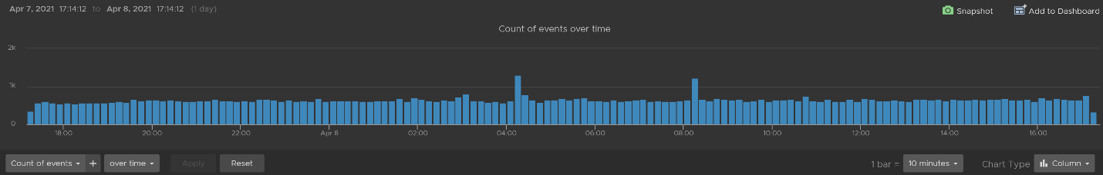

We can see actual event names by changing into a table. We can sort it to show the top events if required.

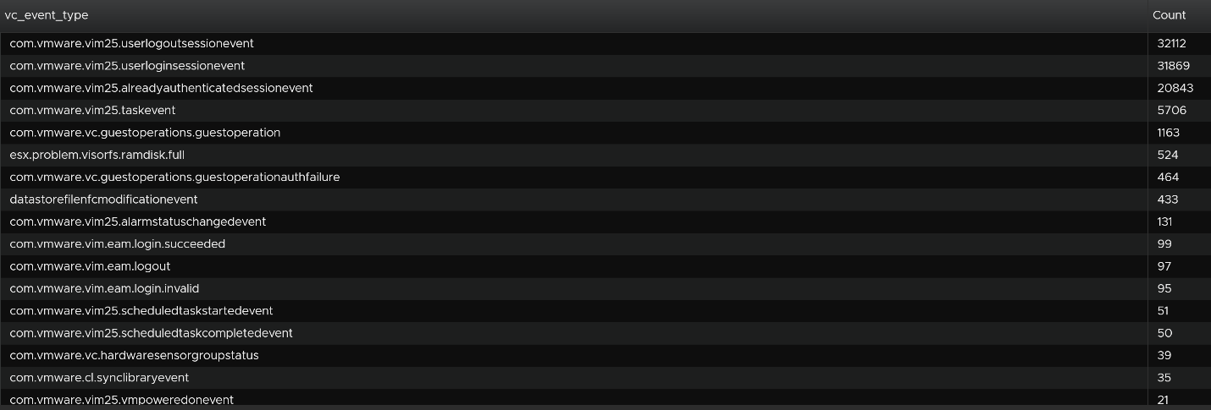

We are interested in events impacting our consumer (VMs), so let’s filter it out. The filter is vim25.vm* as that is what vCenter shows in its log as we can see from the above table. I did not know that vCenter uses **vim25.vm**\*, but looking at the table above I could make an educated guess.

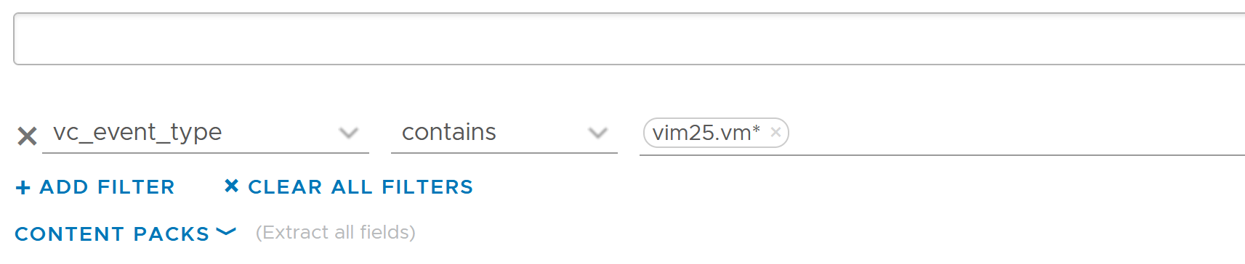

Once the above filter is set, I rerun the search and get all events impacting VM.

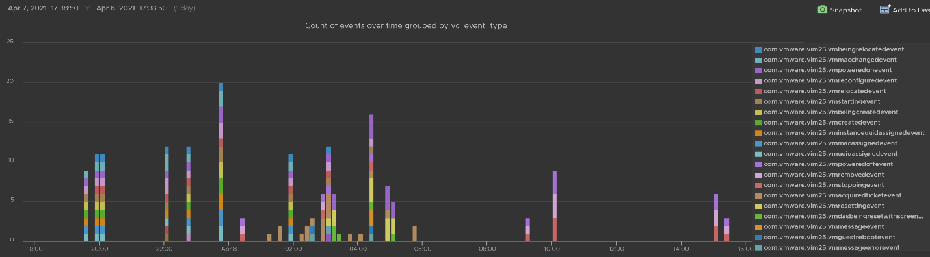

Let’s zoom into one of the events. Let’s say we’re interested in VM configuration event and want to know what exactly was changed. So let’s zoom into that event and group it by the user who changed it. We get the following chart, showing the user in the legend.

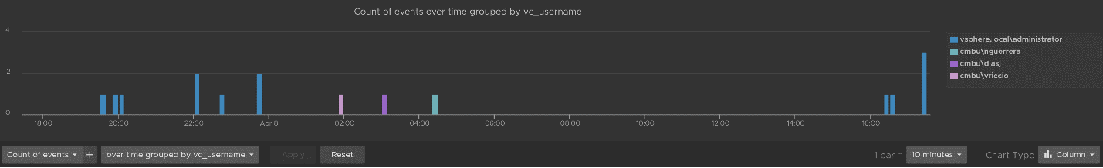

You can group the data by VM name to see which VM were changed when. I’ve cropped the VM name in the legend.

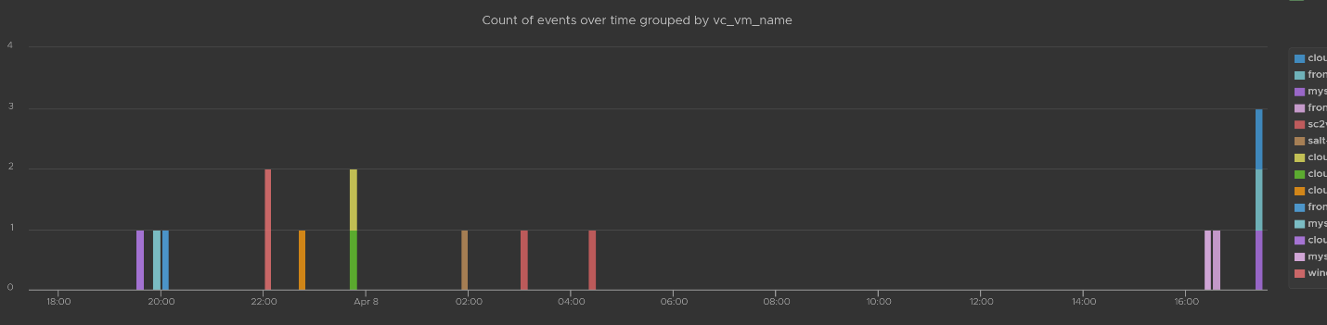

You can see the result in tabular format. You have the VM name, user name and additional context such as the parent ESXi host at the time of the change.

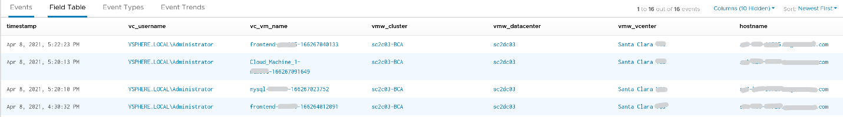

Last but not least, you can see the actual change, as higlighted in green.

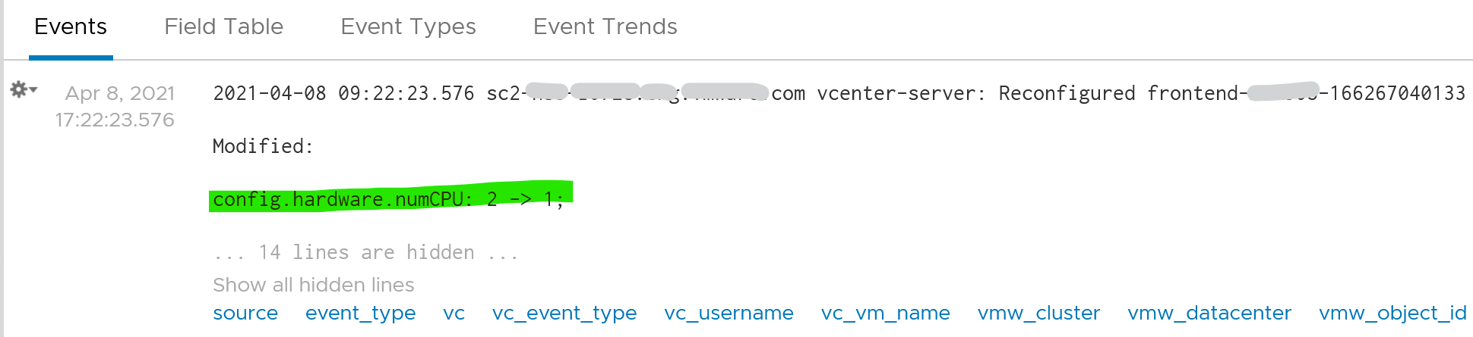

#### vCenter Tasks Analysis

To see all the vCenter Tasks, all we need is to select a built-in variable called VC Task Type. A log entry that has this field exist will appear.

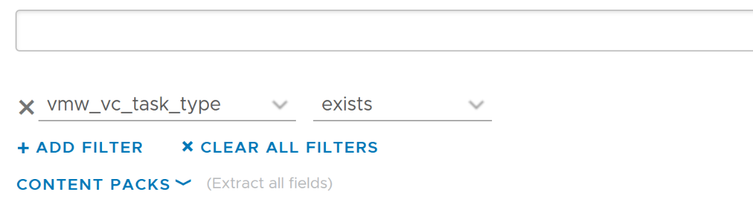

We can see that there is a regular stream of events throughout the day. The pattern looks normal.

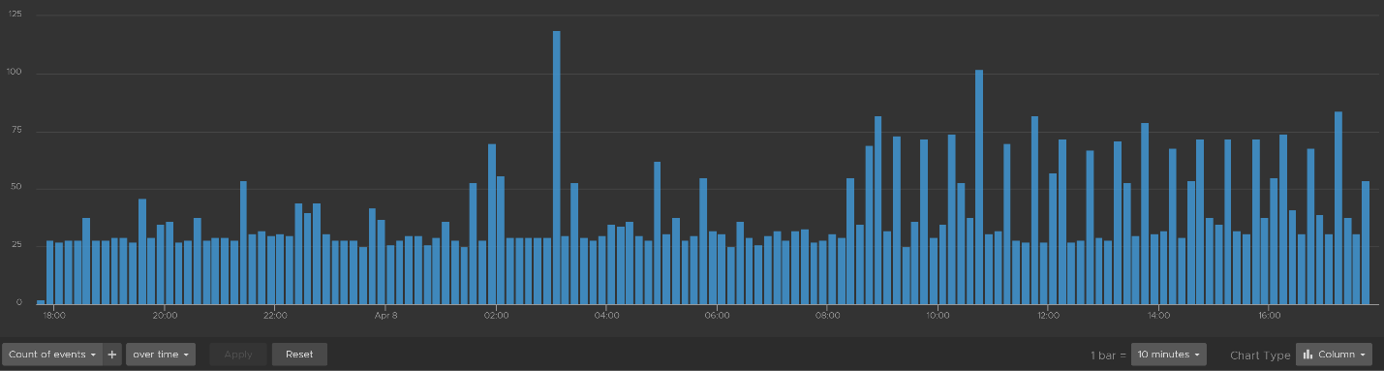

Let’s show the top tasks by showing the result in table format.

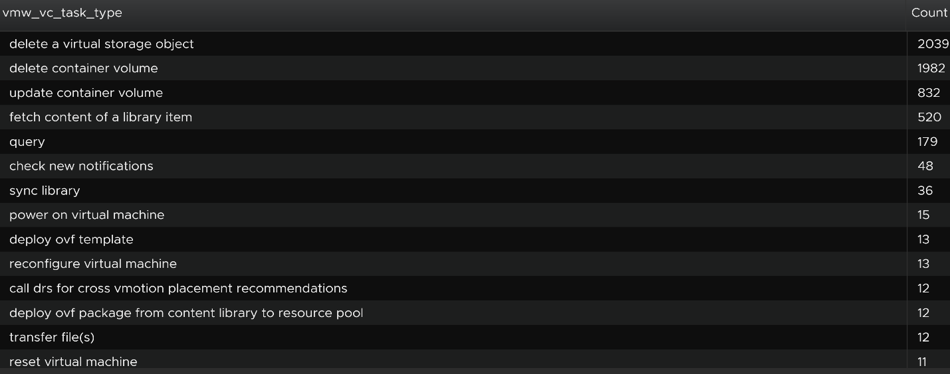

To zoom into any of the tasks, we specify the task name. I only specify one below, but it can take multiple.

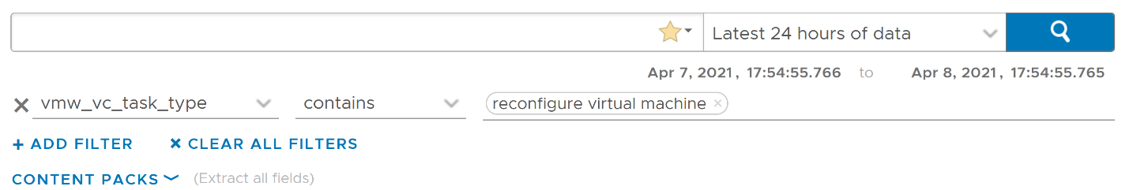

Using the above, and limiting the result to a narrower time window, we can zoom into the nearest minute.

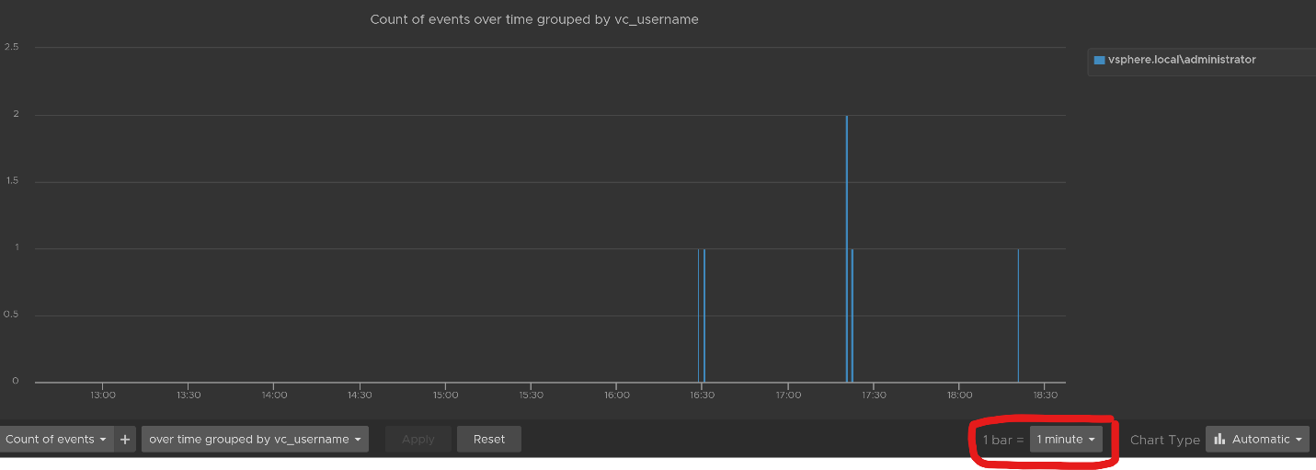

#### Snapshot Analysis

You can visually see all the snapshot operations with a single filter **vmw_esxi_snapshot_operation**. Just use the **exist** operator.

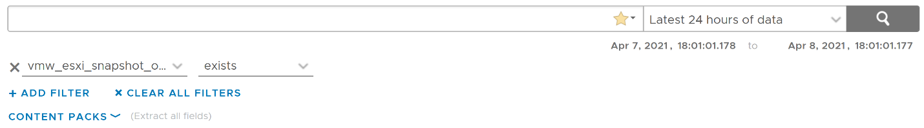

Group the data by the operations and you will get something like this. I can see there are 3 snapshots created but only two were removed. So one of the VM still has a snapshot.

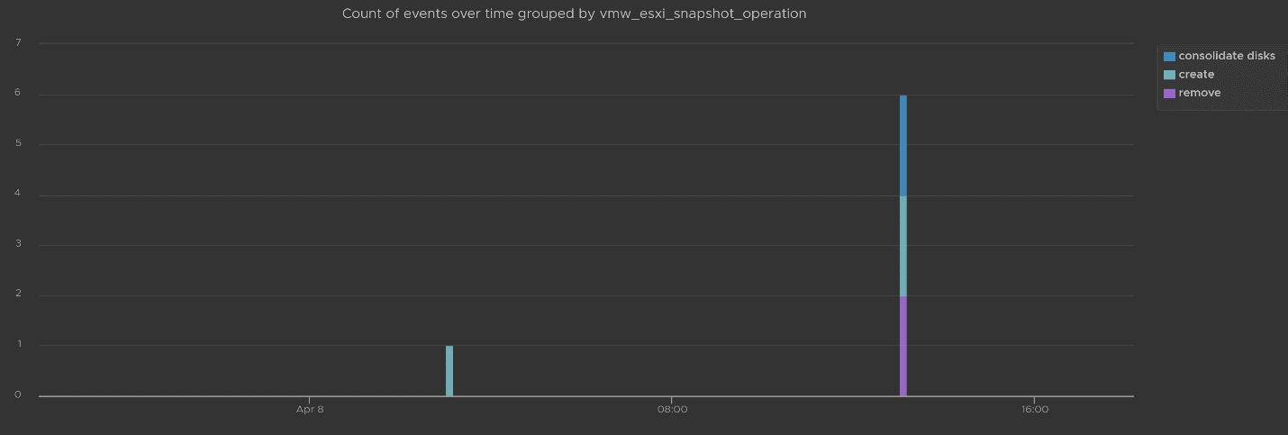

The above shows the time too. In production, you should not take snapshot during busy hours, especially on mission critical VM. So if you run the query in the last 1 week, you should expect no data during the busy hours, and all the daily back up should appear within the backup window.

You can see the details such as the VM name and other context, so see which VM did not have its snapshot removed.

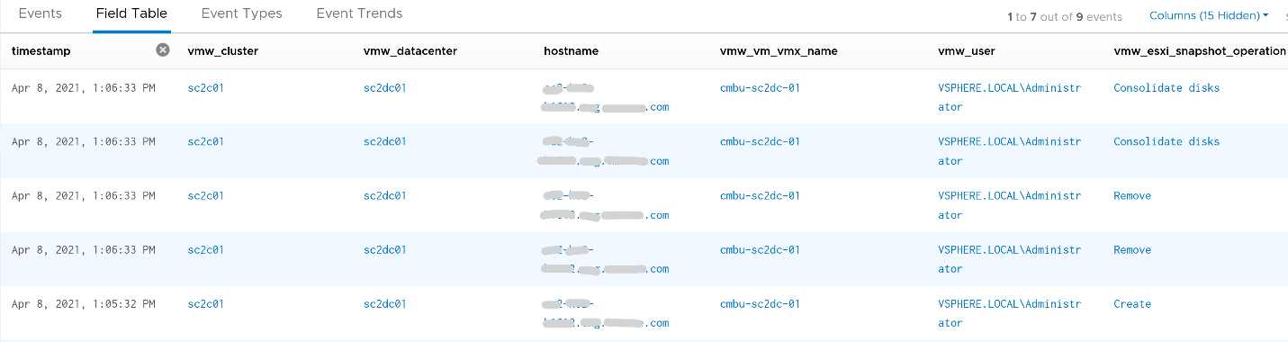

You can check the snapshot name (partially masked out in grey) and whether the snapshot include memory.



#### Template Analysis

How do you prove to auditor that your templates have not been modified by unauthorised person. If a template has been modified, you want to know who did it.

The good thing is there are only a few things you can change to a template. You can rename the template, change the permission, and convert it into a VM. All other changes require the template to be converted into a VM first. That means we can focus on this conversion.

The vCenter logs the entry as “mark virtual machine as template” when you convert a VM into a template. When it is converted back to, it writes “mark as virtual machine”. So it’s a matter of tracking these 2 entries.

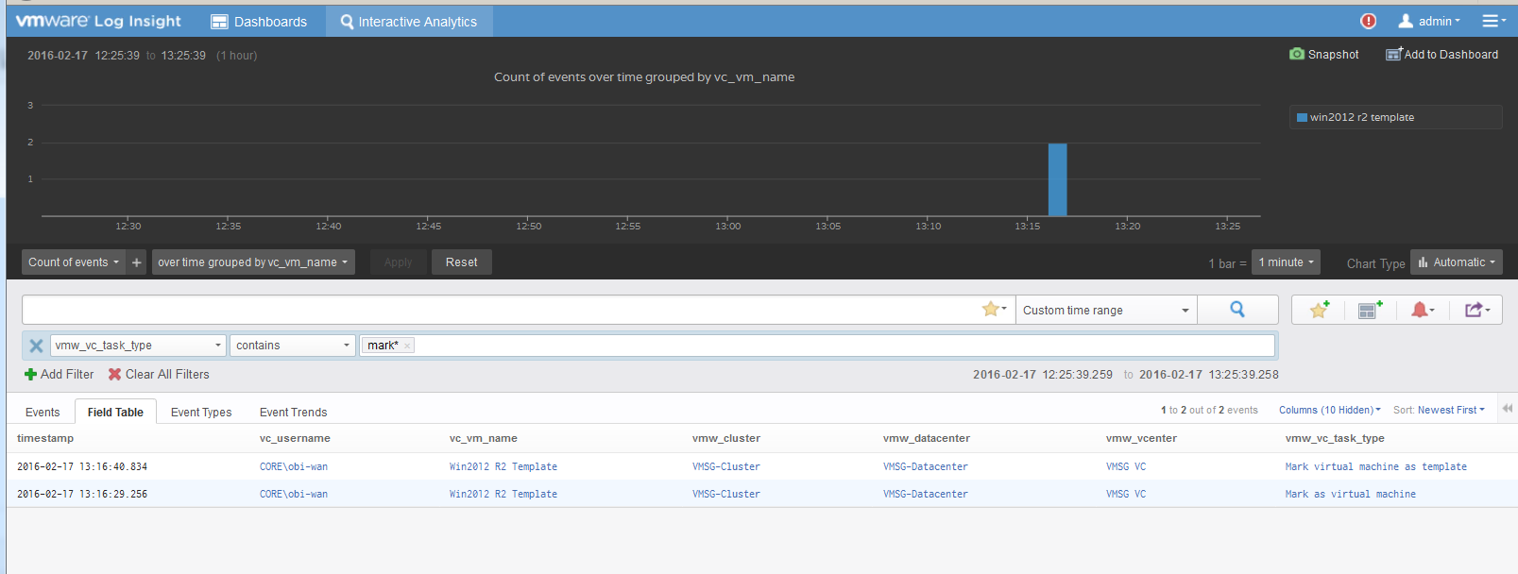

#### vSphere Health

In general, you know that you did a good job with your vSphere IaaS as the VM owners are happy with the performance of their VMs. The business is powered by the VMware infrastructure that you design and operate. However, there is a chance that the vSphere, NSX, vSAN logs bear evidence of hidden issues which are not visible from the UI.

As VMware professionals, we know vSphere well and probably have years of experience working with vSphere. We can architect, design, implement, upgrade, and troubleshoot it.

The same thing cannot be said about the logs. Generally speaking, deep knowledge of vSphere logs belongs to [VMware GSS](https://www.vmware.com/support/services/compare) engineers, as they read logs on a daily basis, and perform all kinds of troubleshooting activities. That knowledge has been transitioned to Log Insight release after release in the form of a vSphere content pack.

One common question I get from customers is how to prove that there are not hidden warning lurking around in the log files. As you know, vSphere produces a lot of logs.

Your first stop should be the General Problems dashboard in Log Insight. This dashboard checks the health of your vSphere using 8 queries. You expect a flying color, meaning it should be blank like this. That means vSphere has not logged any issues.

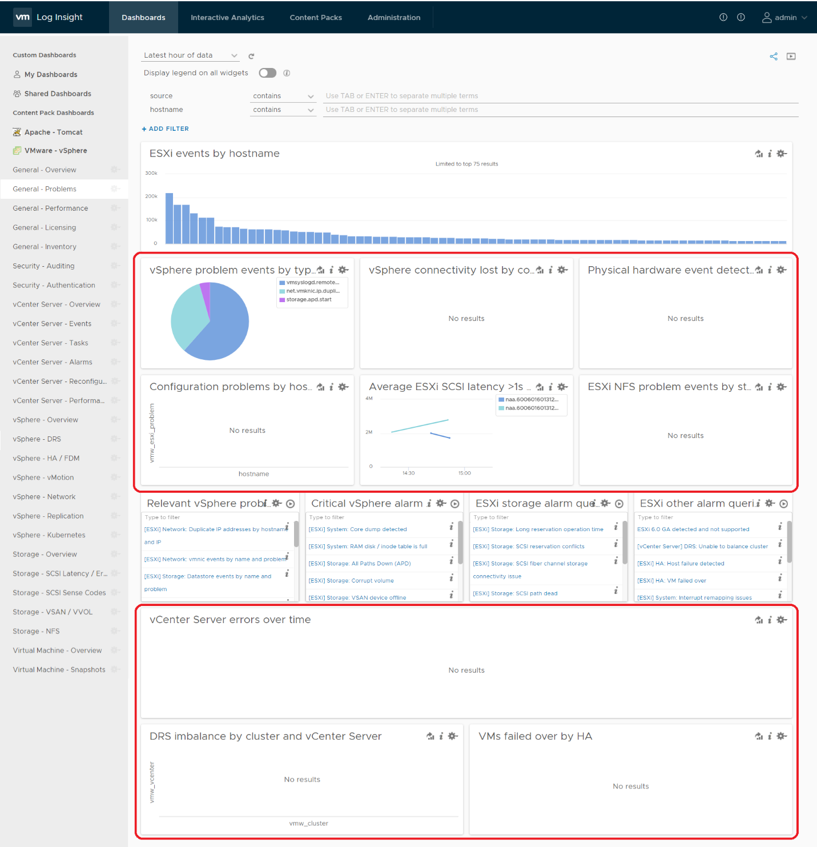

Let’s look at some of the queries that Log Insight runs. The SCSI latency is based on 1 second, which is 1,000,000 microseconds. Here is what the query looks like:

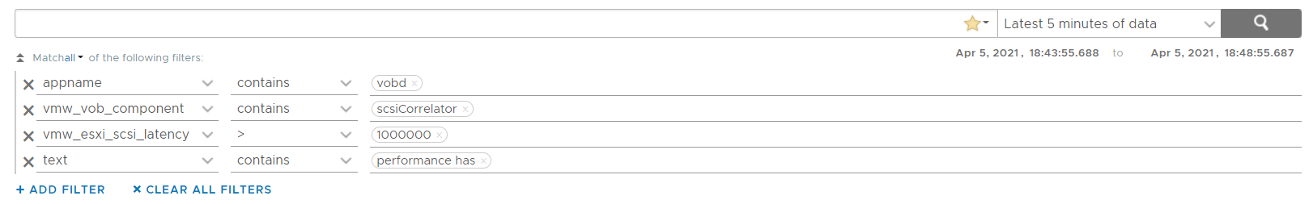

1 second is on the high side; you can change it to a lower number. Do note that this is from VMkernel viewpoint and it’s taking 1 SCSI operation (1 read or 1 write), so the number will be much higher than vCenter average. I’ve seen 12 ms value in vCenter (from the real time chart, so it is a 20 second average) became 600 ms. For details, see [this](http://virtual-red-dot.info/vsphere-storage-latency-view-from-the-vmkernel/).

The above query is pretty simple, as it’s looking for a specific item. Here is a much broader health check.

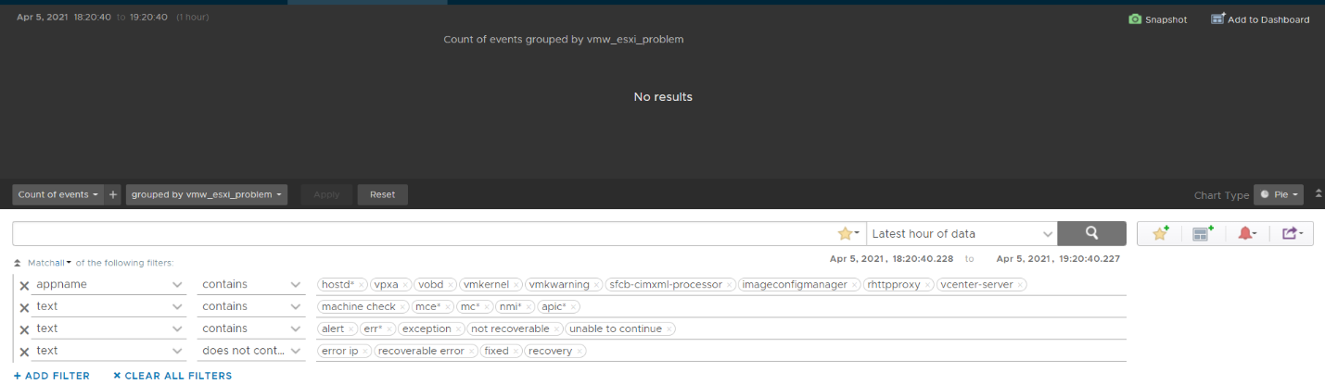

The example below checks for any errors in the vCenter which have not yet been reported as an alarm.

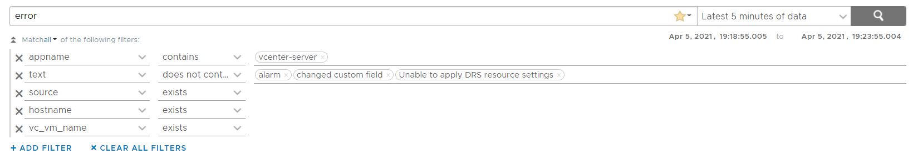

This query below checks for cluster imbalance.



And this query tracks for VM which were rebooted due to HA.



All the above widgets are what you would check out first. You might also want to ensure that there are no errors across major vSphere components.

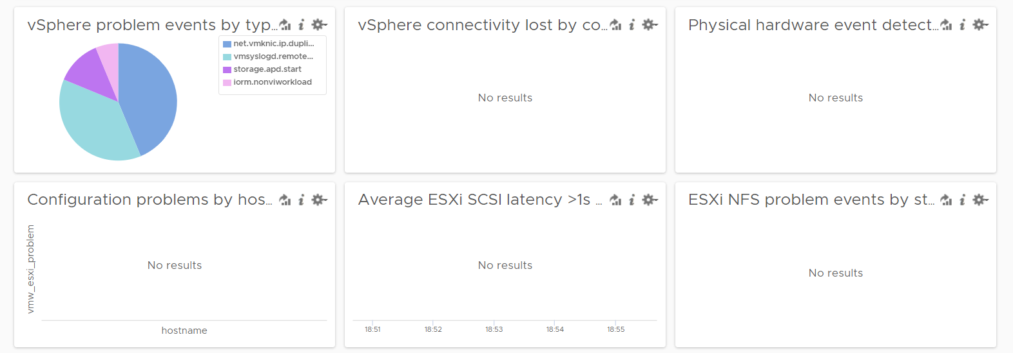

#### VM Log File

The file **vmware.log** contains detailed VM activity messages including reconfiguration events, vmotions, VMware tools messages, memory state, power on/off events, features enabled, API requests, etc. It can be used to troubleshoot events leading up to core dumps or kernel panics.

For more information, read [this blog](https://blogs.vmware.com/management/2020/10/configure-a-vms-vmware-log-file-to-send-messages-to-vrealize-log-insight.html) by [Julie Roman](https://blogs.vmware.com/management/author/julie_roman).

END OF PART 3  
I hope one day part 4 graduates from the book and live in VmwareOpsGuide.com completely…

# PART 4

Miscellaneous

This part is the place for a variety of stuff. Some of them may grow into their own chapters or parts in the future. It also covers basic knowledge that maybe useful for those without computer science background. Lastly, there are some personal sharing from me about the life of an infrastructure architect.

## Operational Maturity

**Operationalize Your World** workshop solves the issues below. It’s a one-day workshop for a small group of VMware customers. Ideally they are operating a similar scale environment, as group sharing provide valuable insight.

**Part 4 Chapter 1**

For each issue/question below, the ideal answer is provided in light grey so you know what it should be. Replace it with your own so the gap can be addressed.

|  |  |
| --- | --- |
| Performance | |
| 1. Do your business units (your customers) blame the infrastructure first? If yes, why? 2. Is that because you have not defined the performance they can expect? 3. How do you know when your IaaS is **not** serving the VM well? Do you depend on complaint to know if your IaaS isn’t performing? 4. How can you move toward proactive operations? What metrics do you use to measure IaaS performance? 5. Does Help Desk provide a good first level defence? Or does it simply pass through to the next level? | Business Units (Applications Team) do not blame us because there is transparency on how each of their VM is being served. There is a formal SLA on both Performance and Availability, which is applied to each VM based on the class of service they buy. Both SLA are clearly defined and measured every 5 minutes. For Performance SLA, we check CPU, RAM, Disk and network.  Our operations do not depend on complain. SLA enables us to be proactive and provide early warning to CIO. We track the threshold and act before complaint is made.  Help Desk uses the SLA, with a custom dashboard given to them. They encourage Application Team to self-service as the same dashboard is provided.  Our operations is VM-centric and application-centric, even though we are the infrastructure team. |
| Capacity / Hardware Justification | |
| 1. Can you justify new infrastructure when utilization is **not yet high**? This is not referring to additional money that comes with a new project, this is referring to existing clusters/storage. 2. It takes time to buy hardware. Do you have an **early warning** in place? Other than utilization, what other metrics do you consider? | Yes. We maximize utilization without compromising performance. Performance is at the heart of our capacity management. We also consider concentration risk, and do not exceed the limit set in business continuity policy.  As it takes time to buy hardware, Performance SLA breach serves as early warning as they happen before VM Owner complains. |
| VM Right-Sizing | |
| 1. Do you have many over-provisioned VMs? Do you know how much to reclaim, and from which VMs? 2. Are the VM Owners convinced on your recommendation? If not, why? 3. How do you right-size without impacting performance? | No. We do not interfere with application team business. They are paying for each vCPU, vRAM and vDisk. There is progressive pricing and a discount for a small VM. These 2 factors make larger VMs much more expensive, hence encouraging right sizing right from the start. If an LOB wants to waste their money, that’s certainly their right. We do highlight how much they can save if they right-size.  We may advise, but never dictate VM size, as it all depends on the applications. |
| Configuration | |
| 1. Do you know who changed what in your infrastructure? Does the Auditor ask for such information? 2. Do you need to implement the vSphere Hardening Guide? 3. Do you have to comply with industry specific security (e.g. PCI DSS, HIPAA)? | Yes. We mine vCenter logs, tasks and events. We provide the Auditor with a custom portal using Log Insight.  Yes. We implement the vSphere Hardening Guide. The compliance dashboard is made available for customers to see, demonstrating transparency in our IaaS platform. |
| Troubleshooting | |
| 1. On issue that spans multiple teams, do you use a set of common tools to perform joint analysis? Or each team use their own, working in silo? 2. Does Network Team and Storage Team have good visibility into the VMware environment? Do you have good visibility into Network and Storage? 3. As part of Root Cause Analysis, do you setup alert so issue can be detected faster if it happens again? | Yes. The Storage and Network teams have custom access to both vCenter and vRealize. For vRealize Operations and Log Insight, we created custom dashboards, so they are not overwhelmed with unnecessary information.  Yes. Storage, Network, and Compute have access to one another’s tools. We use the True Visibility Suite to correlate with Network and Storage, so everyone is looking at the same information.  Yes. Alerts are mandatory as exit criteria in RCA. |
| Availability | |
| 1. Guest OS Availability differs from VM Availability and Infra Availability. How do you report Guest OS Availability for **each VM**? 2. What is your Availability SLA for Guest OS? How often is this tracked? | We use VMware Tools for heartbeat. If Tools are not reporting, we check for signs of life (e.g. disk and network activity)  We deliver 99.99% per month for each Tier 1 VM, tracked every 5 minutes. We do not track lower tiers as developers may reboot their VMs. |
| Application | |
| 1. Do you have visibility into what applications are running on each VMs? 2. Can you map the Business Units and their Applications into each VM in vSphere? Can you report performance by applications? | To some extent, as our policy is not to install agents on each VM. Agents create maintenance, and at times interferes with VM performance. We use network analysis to detect common applications.  Yes, we can. We organize our vCenter folders to reflect the BU, applications and tiers within the apps. |
| Business Management | |
| 1. Is your chargeback or billing operationalized? Do your customers see your billing model as fair & competitive? 2. Can you justify the pricing of each service tier to your customers? How does it compare with the public cloud? 3. Do you have challenges ensuring predictable billing for your cloud? | Yes. Our pricing model is much simpler than AWS/Azure pricing. The model is simpler, and we have less choice versus public cloud. We publish the comparison for our internal customers to see.  We bill by allocation (what is configured to each VM), not by actual utilization. This is in-line with AWS billing model. This helps to make billing more predictable. Coupled with annual billing, we can predict revenue and plan our break-even accordingly. |
| Public Cloud | |
| 1. Does Application Team use AWS/Azure, bypassing IT? Why? 2. Is your IaaS cheaper and better than public cloud, especially VMware on AWS? If yes, quantify it. 3. If you use public cloud, do you know when VMs are not performing? If yes, what metrics do you track since AWS/Azure has limited metrics? | As Enterprise IT, we are in the business of being a multi-cloud broker. We have both our on-prem cloud, and public cloud (VMware on Amazon, Azure and Amazon).  Our on-prem is 25% cheaper than VMware on AWS and 40% cheaper than Amazon. This is in-line with other industry, where owning is cheaper than renting.  AWS and Azure do not provide visibility on how our VM compete with other VMs. This prevents applications from making the right scaling decision. |
| Network Operations Center (NOC) | |
| 1. Do you have a set of big screen dashboards that provides live information into the environment? 2. What information is provided? How useful is the information? | Yes. We rotate a few screens showing critical information such as Availability, Performance, Security (compliance), Capacity. We look at Applications, VMs and IaaS. |

## SDDC vs IaaS

What you architected is SDDC, but what you operate is IaaS. You buy system, you sell service.

**Part 4 Chapter 2**

This chapter provides an introduction to how IaaS management differ to the physical infrastructure management. It is placed at the end as this is now considered a basic knowledge. I still find it useful in explaining why the complexity goes up significantly. IDC actually predicts this back in 2012. The [link](http://www.apmdigest.com/idc-prediction-predictive-analytics-goes-mainstream-in-2012) from APM Digest website states that “operational complexity in virtualized, scale-out, and cloud environments and composite Web-based applications will drive demand” for a new type of tools that can “rapidly sort through hundreds of thousands of monitor variables, alerts and events”.

### VM, it is not what you think!

In this chapter, we will dive into why seemingly simple technology, an X86 machine virtualized, has a large ramification for the IT industry. In fact, it is turning a lot of things upside down and breaking down silos that have existed for decades in large IT organizations. We will cover the following topics:

* Why virtualization is not what we think it is
* Virtualization vs Partitioning
* A comparison between a physical server and a virtual machine

#### Journey into the Virtual World

It is the era of the cloud. Who does not know what a VM is? Even a business user who has never seen one knows what it is. It is just a physical server, virtualized. Nothing more.

Wise men say that small leaks sink the ship. We think that’s a good way to explain why IT departments who manage physical servers well struggle when the same servers were virtualized.

We can also use Pareto principle (80/20) rule. 80% of a VM is identical to physical server. But it’s the 20% differences that hit you. We will highlight some of this “20% portion”, focusing on areas that impact data center management.

The change caused by virtualization is much larger than the changes brought forward by previous technologies. In the past two or more decades, we transitioned from mainframes to the client/server-based model to the web-based model. These are commonly agreed upon as the main evolutions in IT architecture. However, all of these are just technological changes. It changes the architecture, yes, but it does not change the operation in a fundamental way. Both the client-server and web shifts did not talk about the "journey". There was no journey to the client-server based model. However, with virtualization, we talk about the virtualization journey. It is a journey because the changes are massive and involve a lot of people. That’s why the evolution toward multi-cloud operations is also called a journey.

Gartner correctly predicted the impact of virtualization in 2007. More than 1 decade later we still have not completed the journey. Proving how pervasive the change is, here is the following summary on the article[27] from Gartner:

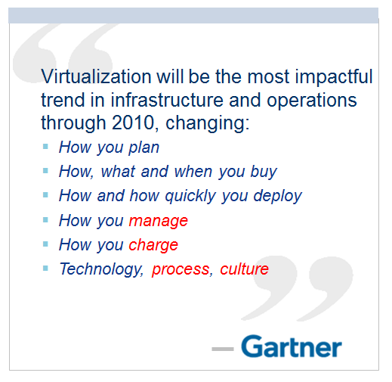

Notice how Gartner talks about change in culture. So, virtualization has a cultural impact too. In fact, if your virtualization journey is not fast enough, look at your organization's structure and culture. Have you broken the silos? Do you empower your people to take risk and do things that have never been done before? Are you willing to flatten the organization chart?

The siloes that have served you well is likely your #1 barrier to multi-cloud.

So why exactly is virtualization causing such a fundamental shift? To understand this, we need to go back to the basics, which is what exactly virtualization is. It's pretty common that senior IT management have a misconception about what this actually is.

Take a look at the following comments. Have you seen them in your organization?

* "VM is just Physical Machine virtualized. Even VMware said the Guest OS is not aware it's virtualized and it does not run differently."
* "It is still about monitoring CPU, RAM, Disk, Network. No difference."
* "It is a technology change. Our management process does not have to change."
* "All of these VMs must still feed into our main Enterprise IT Management system. This is how we have run our business for decades and it works."

If only life was that simple, we would all be 100 percent virtualized and have no headaches! Virtualization has been around for decades, and yet most organizations have not mastered it. The proof of mastering if you have completed the journey and have reached the highest level of virtualization maturity model.

Although virtualization looks similar on the cover to a physical world, it is completely re-architected *under the hood*.

#### Virtual Machine vs Physical Machine

VM is not just a physical server virtualized. Yes, there is a P2V process. However, once it is virtualized, it takes on a new shape. That shape has many new and changed properties, and some old properties are no longer applicable or available. The following is an old screenshot, taken years ago. Can you spot properties that do not exist in physical server?

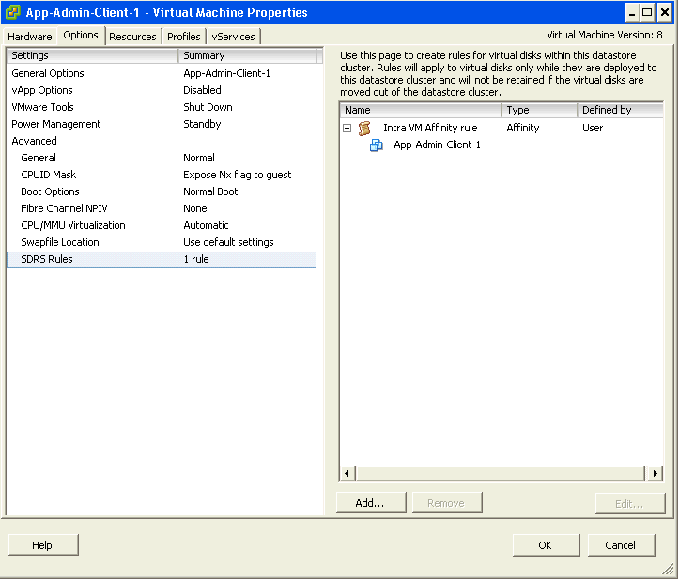

Let’s highlight some of the properties that do not exist in a physical server. I'll focus on those properties that have an impact on management, as management is the topic of this book.

|  |  |  |  |
| --- | --- | --- | --- |
| **Properties** | **Physical Server** | | **VM** |
| BIOS | A unique BIOS for every brand and model. Even the same model (for example, HP DL 380 Generation 9) can have multiple versions of BIOS.  BIOS needs updates and management, often with physical access to a data center. This requires downtime. | This is standardized in a VM. There is only one type, which is the VMware motherboard. This is independent from the ESXi motherboard.  VM BIOS needs far less updates and management. The inventory management system no longer needs the BIOS management module. | |
| Virtual HW | Not applicable | This is a new layer below BIOS.  It needs an update on every vSphere release. A data center management system needs to be aware of this as it requires a deep knowledge of vSphere. For example, to upgrade the Virtual Hardware, the VM has to be in the power-off stage. | |
| Drivers | Many drivers are loaded and bundled with the OS. Often, you need to get from respective hardware vendors for the latest drivers.  All these drivers need to be managed. This can be complex operation, as they vary from model to model and brand to brand. The management tool has rich functionalities, such as checking compatibility, rolling out drivers, rolling back if there is an issue, and so on. | Relatively fewer drivers are loaded with the Guest OS; some drivers are replaced by the ones provided by VMware Tools.  Even with NPIV, the VM does not need the FC HBA driver. VMware Tools needs to be managed, with vCenter being the most common management tool. | |

With all the above differences, how does it impact the hardware upgrade process?

|  |  |
| --- | --- |
| **Physical Server** | **VM** |
| Downtime required. It is done offline and is complex.  OS reinstallation and updates are required, hence it is a complex project in the physical world. Sometimes, a hardware upgrade is not even possible without upgrading the application. | It is done online and is simple. Virtualization decouples the application from hardware dependency.  A VM can be upgraded from a 5-year-old hardware to a new one, moving from the local SCSI disk to 50 Gb FCoE, from dual core to a 24-core CPU. So yes, MS-DOS can run on 50 Gb Ethernet accessing SSD storage via the PCIe lane. You just need to perform vMotion to the new hardware. As a result, the operation is drastically simplified. |

##### Storage

In the preceding table, we compared the core properties of a physical server with a VM. Every server needs storage, so let’s compare the storage properties.

|  |  |
| --- | --- |
| Physical Server | VM |
| For servers connected to SAN, they can see the SAN and FC fabric. They need HBA drivers and have FC PCI cards, and have multipathing software installed.  Normally needs an advanced filesystem or volume manager to RAID local disk. | No VM is connected to FC fabric or the SAN. VM only sees the local disk. Even with N_Port ID Virtualization (NPIV) and physical RDM, the VM does not send FC frames. Multipathing is provided by vSphere, transparent to VM.  There is no need for RAID local disk. It is one virtual disk, not two. Availability is provided at the hardware layer. |
| Backup agent and backup LAN needed in the majority of cases. | Not needed in the majority of cases, as backup is done via vSphere VADP API. Agent is only required for application-level backup. |

##### Network and Security

Big difference in storage. How about Network and Security?

In vSphere, a VM is connected to a distributed virtual switch. It is not directly connected to the physical NIC in your ESXi host. The ESXi host’s physical NICs become the virtual switch's uplinks instead. This means that the traditional top-of-rack (TOR) switch has been entirely virtualized. It runs completely as software. This means the management software needs to understand the distributed vSwitch and its features.

|  |  |
| --- | --- |
| **Physical Server** | **VM** |
| NIC teaming is common. Typically needs two cables per server. | NIC teaming provided by ESXi. VM is not aware and only sees one vNIC. |
| Guest OS is VLAN aware. It is configured inside the OS. Moving VLAN requires reconfiguration. | VLAN is generally provided by vSphere, and not done inside the Guest OS. This means VM can be moved from one VLAN to another with no downtime.  With network virtualization, VM is moving from VLAN to VXLAN. |
| The AV agent is installed on Guest, and can be seen by the attacker. | An AV agent runs on the ESXi host as a VM (one per ESXi). It cannot be seen by the attacker from inside the Guest OS. |
| AV consumes OS resources. AV signature updates cause high storage throughput. | AV consumes minimal Guest OS resources as it is offloaded to the ESXi Agent VM. AV signature updates do not require high IOPS inside the Guest OS. The total IOPS is also lower at the ESXi host level as it is not done per VM. |

##### Management

Lastly, let's take a look at the impact on management. As can be seen next, even the way we manage a server changes once it is converted into a VMs

|  |  |  |
| --- | --- | --- |
| **Property** | **Physical Server** | **VM** |
| Approach on Monitoring | An agent is commonly deployed. It is typical for a server to have multiple agents.  In-Guest metrics are accurate as the OS can see the physical hardware.  A physical server has an average of 5 percent CPU utilization due to the multicore chip. As a result, there is no need to monitor it closely. | An agent is typically not deployed. Certain areas such as application and Guest OS monitoring are still best served by an agent.  The key in-Guest metrics are not accurate as Guest OS does not see the physical hardware.  A VM has an average of 50 percent CPU utilization as it is right sized. This is 10 times higher when compared with a physical server. As a result, there is a need to monitor closely, especially when physical resources are oversubscribed. Capacity management becomes a discipline in itself. |
| Approach on Availability | HA is provided by clusterware such as Microsoft Windows Server Failover Clusters (WSFC) and Veritas Cluster Server (VCS). Clusterware tends to be complex and expensive.  Cloning a physical server is a complex task and requires the boot drive to be on the SAN or LAN, which is not typical.  Snapshot is rarely done, due to cost and complexity. We find only very large IT departments practice physical server snapshot. | HA is a built-in core component of vSphere. From what we see, most clustered physical servers end up as just a single VM as vSphere HA is good enough.  Cloning can be done easily. It can even be done live. The drawback is that the clone becomes a new area of management.  Snapshot can be done easily. In fact, this is done every time as part of backup process. Snapshot also becomes a new area of management as they tend to be forgotten. |
| Company Asset | The physical server is a company asset and it has book value in the accounting system. It needs proper asset management as components vary among servers.  Here, the annual stock-take process is required. | VM is not an asset as it has no accounting value. A VM is like a document. It is technically a folder with files in it.  Stock-take process is no longer required as the VM cannot exist outside vSphere. |

### SDDC vs HDDC

We covered how a VM differs drastically to a physical server. Now let's take a look at the big picture, which is at the data center level. A data center consists of three major functions—compute, network, and storage. Security is not a function on its own, but a key property that each function has to deliver. We use the term compute to represent processing power namely CPU and Memory. In today’s data centers Compute is also used when referencing converged infrastructure, where the server and storage have physically converged into one box. The industry term for this is Hyper-Converged Infrastructure (HCI). You will see later in the book that this convergence impacts how you architect and operate SDDC.

VMware has moved to virtualize the network and storage functions as well, resulting in a data center that is fully virtualized and thus defined in the software. The software is the data center. This has resulted in the term SDDC. The book will make extensive comparison with the physical data center. For ease of reference, let’s call the physical data center Hardware-Defined Data Center (HDDC).

In SDDC, we no longer define the architecture in the physical layer. The physical layer is just there to provide resources. These resources are not aware of one another. The stickiness is reduced, and they become a commodity. In many cases, the hardware can even be replaced without incurring downtime to the VMs running on top.

The next diagram shows one possibility of a data center that is defined in the software. We have drawn the diagram to state a point, so don't take this as the best practice for SDDC architecture. In the diagram, there are many virtual data centers (we draw three due to space in the book). Each virtual data center has its own set of virtual infrastructure (server, storage, network and security). They are independent of one another.

A virtual data center is no longer contained in a single building bound by a physical boundary. Although long distance WAN bandwidth and latency are still limiting factors in 2021, the main thing here is you can architect your physical data centers as one or more logical data centers. You should be able to automatically, with just a few clicks in VMware Site Recovery Manager, move thousands of servers from data center A to data center B; alternatively, you can perform DR from four branch sites to a common HQ data center.

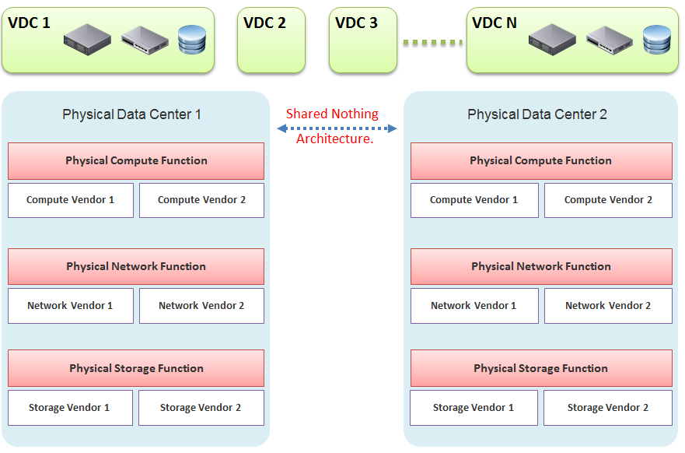

In our example, the virtual data centers run on top of two physical data centers. Large enterprises will probably have more than that (whether it is outsourced or not is a different matter). The two physical data centers are completely independent. Their hardware is not dependent on one another.

* In the Compute function, there is no stretched cluster between 2 physical sites. Each site has its own vCenter. There is no need to protect vCenter with DR.
* In the Network function, there is no stretched VLAN between 2 physical sites. You do not have to worry about spanning tree or broadcast storm hitting multiple data centers. The physical sites can even be on a different network. Site 1 might be 10.10.x.x network, while Site 2 might be 20.20.x.x.
* In the Storage function, there is no array-based replication. Replication can be done independently from a storage protocol (FC, iSCSI, or NFS) and VMDK type (thick or thin). vSphere has built-in host-based replication via TCP/IP, named simply vSphere Replication. It can replicate individual VMs, and provides finer granularity than LUN-based replication. You might decide to keep the same storage vendor and protocol, but that's your choice, not something forced upon you.

We have drawn two vendors for each layer to show the message that hardware does not define the architecture. They are there to support the function of that layer (for example, Compute Function). So, you can have 10 vSphere clusters: 3 clusters could be Vendor A, and 7 clusters could be Vendor B.

We are taking the “shared-nothing architecture” approach. This is a good thing, because you contain the failure domain. [Ivan Pepelnjak](https://www.linkedin.com/in/ivanpepelnjak/), an authority on data center networking architecture, states [here](http://blog.ipspace.net/2012/10/if-something-can-fail-it-will.html) that “Interconnected things tend to fail at the same time.”

Let’s summarize the key differences between SDDC and HDDC. To highlight the differences, We’re assuming in this comparison the physical data center is 0% virtualized and the virtual data center is 100% virtualized. For the virtual data center, we’re assuming you have also adjusted your operation, because operating a virtual data center with a physical operation mindset results in a lot of frustration and suboptimal virtualization. This means your processes and organization chart have been adapted to a virtual data center.

#### Disaster Recovery

As data center wide Disaster Recovery (DR) is the litmus test that defines whether your data center is HDDC or SDDC, let’s start with this.

|  |  |
| --- | --- |
| **HDDC** | **SDDC** |
| Data center migration is a major and expensive project. | The entire Virtual DC can be replicated and migrated. We have a customer who performed long distance vMotion over 8 weekends, hence achieving data center migration with 0 downtime. |
| Architecturally, DR is done on a per-application basis. Every application has its own bespoke solution. | DR is provided as a *service* by the platform. It is one solution for all applications. This enables data center-wide DR. |
| The standby server on the DR site is required. This increases the cost. Because the server has to be compatible with the associated production server, this increases complexity in a large environment. | No need for a standby server. The vSphere cluster on the DR site typically runs the non-production workload, which can be suspended (hibernate mode) during DR. The DR site can be of a different server brand and CPU. |
| DR is a manual process, relying on a run book written manually. It also requires all hands on deck. An unavailability of key IT resources when disaster strikes can impact the organization's ability to recover. | The entire DR steps can be automated. Once management decides to trigger DR, all that needs to be done is to execute the right recovery process in VMware Site Recovery Manager (SRM). No manual intervention. |
| A complete DR dry run is rarely done, as it is time consuming and requires production to be down. | A DR dry run can be done frequently, as it does not impact the production system. This is made by possible by having a virtual network that isolate the VMs participating in DR dry run. As a result, the dry run can even be done on the day before the actual planned DR. |
| The report produced after a DR exercise is manually typed. It is not possible to prove that what is documented in the Microsoft Word or Excel document is what actually happened in the data center. | The report is automatically generated, with no human intervention. It timestamps every step, and provides a status whether it was successful or not. The report can be used as audit proof |

#### Compute Function

|  |  |
| --- | --- |
| **HDDC** | **SDDC** |
| 1,000 physical servers (just an example, so we can provide a comparison). | The number of VM will be more than 1,000. It may even reach 2,000 VMs . The number of VMs is higher for multiple reasons: VM sprawl; the physical server tends to run multiple applications or instances whereas VM runs only one; DR is much easier and hence, more VMs are protected. |
| Growth is relatively static and predictable, and normally it is just one way (adding more servers). | The number of VMs can go up and down due to dynamic provisioning. |
| Downtime for hardware maintenance or a technology refresh is a common job in a large environment due to component failure. | Planned downtime is eliminated with vMotion and storage vMotion. |
| 5% to 10% average CPU utilization, especially in the CPU with a high core count. | ~50% utilization for both VM and ESXi. |
| Racks of physical boxes, often with a top-of-rack access switch and UPS. The data center is a large consumer of power. | Rack space requirements shrink drastically as servers are consolidated and the infrastructure is converged. There is a drastic reduction in overall space and power, although power consumption per rack is higher. |
| Low complexity. Lots of repetitive work and coordination work, but not a lot of expertise required. | High complexity. Less quantity, but deep expertise required. A lot less number of people, but each one is an expert. |
| Availability and performance monitored by management tools, which normally uses an agent. It is typical for a server to have many agents. | Availability and performance monitoring happens via vCenter Server, and it's agentless for the infrastructure. All other management tools get their data from vCenter Server, not individual ESXi or VM. Application-level monitoring is typically done using agents within the Guest OS. |
| The word cluster generally means two or more servers joined with a heartbeat and shared storage, which is typically SAN.  In another context, the word cluster means a single application using shared-nothing hardware. A typical example here is Hadoop cluster. | The word cluster has a different meaning. It's a group of ESXi hosts sharing the workload. Normally, 8 to 16 hosts, not 2 - 4. |
| High Availability (HA) is provided by clusterware, such as Microsoft MSCS and Veritas. Every cluster pair needs a shared storage, which is typically SAN. Typically, one service needs two physical servers with a physical network heartbeat; hence, most servers are not clustered as the cost and complexity is high. | HA is provided by vSphere HA. All VMs are protected, not just a small percentage. The need for traditional clustering software has reduced, and a new kind of clustering software emerges. It has full awareness of virtualization, and integrates with vSphere using vSphere API. |
| Fault Tolerance is rarely used due to cost and complexity. You need specialized hardware to achieve it. | Fault tolerance is an on-demand feature as it is software-based. For example, you can temporarily turn it on during batch jobs run. |
| Anti-Virus is installed on every server. Management is harder in a large environment. | Anti-Virus runs as an Agent VM per ESXi Host. It is agentless to the Guest OS and hence, is no longer visible by malware. A popular solution is Trend Micro Deep Security. |

#### Storage Function

|  |  |
| --- | --- |
| **HDDC** | **SDDC** |
| 1,000 physical servers (just an example, so we can provide a comparison), where IOPS and capacity do not impact each another. A relatively static environment from a storage point of view because normally, only 10 percent of these machines are on SAN/NAS due to cost. | It has a maximum of 2,000 interdependent VMs, which impact one another. A very dynamic environment where management becomes critical because almost all VMs are on a shared storage, including distributed storage. |
| Every server on SAN has its own dedicated LUN. Some data centers, such as databases, may have multiple LUNs. | Most VMs do not use RDM. They use VMDK and share the VMFS or NFS datastore. The VMDK files may reside in different datastores. |
| Storage migration is a major downtime, even within the same array. A lot of manual work is required. | Storage migration is live with storage vMotion. Intra-array is faster due to VAAI API. |
| Backup, especially in the x64 architecture, is done with backup agents. As SAN is relatively more expensive and SAN boot is complex at scale, backup is done via the backup LAN and with the agent installed. This creates its own problem as the backup agents have to be deployed, patched, upgraded, and managed. | The backup service is provided by the hypervisor. It is agentless as far as the VM is concerned. Most backup softwares use VMware VADP API to back up by taking snapshot. Windows Volume Shadow Services (VSS) provides application-consistent backups through quiesing application during backup execution. Non-VSS environments can use pre-post thaw scripts to stop necessary services prior to VM snapshot to provide crash-consistent backups of applications and underlying OS. |
| The backup process creates high disk I/O, impacting the application performance. Because the backup traffic is network intensive and carries sensitive data, an entire network is born for backup purposes. | Because backup is performed outside the VM, there is no performance impact on the application or Guest OS. There is also no security risk, as the Guest OS Admin cannot see the backup network. |
| Storage's QoS is taken care of by an array, although the array has no control over the demand of IOPS coming from servers. | Storage's QoS is taken care of by vSphere Storage I/O Control, which has full control over every VM. |

#### Network Function

|  |  |
| --- | --- |
| **HDDC** | **SDDC** |
| The access network is typically 1 GE, as it is sufficient for most servers. Typically, it is a top-of-rack entry-level switch. | The top-of-rack switch is generally replaced with the end-of-row distribution switch, as the access switch is completely virtualized. ESXi typically uses 10 GE, with some having 4x 10 GE connection. |
| VLAN is normally used for segregation. This results in VLAN complexity. | VLAN is not required (traffic within the same VLAN can be controlled) for segregation by NSX. |
| Impacted by the spanning tree. | No Spanning Tree. |
| A switch must learn the MAC address as it comes with the server. | No need to learn the MAC address as it's given by vSphere. |
| Network QoS is provided by core switches. | Network QoS by vSphere and NSX. |
| DMZ Zone is physically separate. Separation is done at the IP layer. IDS/IPS deployment is normally limited in DMZ due to cost and complexity. | DMZ Zone is logically separate. Separation is not limited to IP and done at the hypervisor layer. IDS/IPS is deployed in all zones as it is also hypervisor-based. |
| No DR Test network is required. As a result, the same hostname cannot exist on DR Site, making a true DR Test *impossible* without shutting down production servers. | DR Test Network is required. The same hostname can exist on any site as a result. This means DR Test can be done anytime as it does not impact production. |
| Firewall is not part of the server. It is typically centrally located. It is not aware of the servers as it's completely independent from it. | Firewall becomes a built-in property of the VM. The firewall policy follows the VM. When a VM is vMotion-ed to another host, the policy *follows* it and is enforced by the hypervisor. |
| Firewall scales vertically and independently from the workload (demand from servers). This makes sizing difficult. IT ends up buying the biggest firewall they can afford, hence increasing the cost. | Firewall scales horizontally. It grows with demand, since it is deployed as part of the hypervisor (using NSX). Upfront cost is lower as there is no need to buy a pair of high-end firewall upfront. |
| Traffic has to be deliberately directed to the firewall. Without it, the traffic "escapes" the firewall. | All traffic passes the firewall as it's embedded into the VM and hypervisor. It cannot "escape" the firewall. |
| Firewall rules are typically based on the IP address. Changing the IP address equals changing the rules. This results in a database of long and complicated rules. After a while, the firewall admin dare not delete any rules as the database becomes huge and unmanageable. | Rules are not tied to the IP address or hostname. This makes rules much easier. For example, we can say that all VMs in the Contractor Desktop pool cannot talk to each other. This is just one rule. When a VM gets added to this pool, the rule is applied to it. |
| Load Balancer is typically centrally located. Just like the firewall, sizing becomes difficult and the cost goes higher. | Load Balancer is distributed. It scales with the demand. Adding hypervisor means adding load balancer capacity. |

#### People & Process

How many people does it take to manage 1 rack worth of hardware?

Your answer is likely “not many.” After all, it is just 1 standard rack. The entire thing barely occupies a small server room.

If your entire data center can fit inside 1 standard rack of equipment, that makes a small operation. It is indeed a small operation in physical world. However, in SDDC, you can achieve 2000 VM per rack from performance point of view. We are using a standard 30:1 consolidation ratio, which is possible with the latest Intel or AMD. From networking viewpoint, [Ivan Pepelnjak](https://www.ipspace.net/About_Ivan_Pepelnjak) has in fact shared back in October 2014 that “2000 VMs can easily fit onto 40 servers”. He elaborates the calculation [here](http://blog.ipspace.net/2014/10/all-you-need-are-two-top-of-rack.html). He further [updates](http://blog.ipspace.net/2015/11/1000-vm-per-rack-is-perfectly-realistic.html) that in November 2015.

The above calculation takes into account your Infrastructure VM. Infrastructure functions that used to be provided by hardware (e.g. storage replication, firewall, load balancer) are now delivered as VM. You may run 100 of such VMs, depending on the type of services that your SDDC needs to provide.

|  |  |
| --- | --- |
| HDDC | SDDC |
| There's a clear silo between the compute, storage, and network teams. In organizations where the IT team is big, the DR team, Windows team, and Linux team could also be separate teams. There is also a separation between the engineering, integration (projects), and operations (business as usual) teams. The team, in turn, needs layers of management. This results in rigidity in IT. | With virtualization, IT is taking the game to the next level. It's a lot more powerful than the previous architecture. When you take the game to the next level, the enemy is also stronger. In this case, the expertise required is deeper and the experience requirement is more extensive. |
| Relatively more headcount required in IT, with lower skills set. | Earlier, you may have needed 10 people to manage 1,000 physical servers. With virtualization, you might only need 3 people to manage 3000 VMs on 50 ESXi hosts. However, these 3 people have deeper expertise and longer experience than the 10 people combined. |
| DevOps is a concept that applies to developers or application team. It does not apply to Infrastructure team. | The IaaS team needs to have its own “DevOps” too. As the infrastructure becomes software, there is a need for continuous flow from Architect à Engineer à Implement à Operate à Upgrade |

I’ll end this chapter with a From the main menu, click Administration and in the left pane click Configuration à Super Metrics.

## Infrastructure Architect

I see myself as an Infrastructure Architect. After almost a decade in application world, I entered the weird and wonderful world of enterprise IT infrastructure, starting as a presales with [Sun Microsystems](https://en.wikipedia.org/wiki/Sun_Microsystems) in 2003. My job titles, roles and departments have changed many times since then, but fundamentally it’s about architecting enterprise infrastructure.

**Part 4 Chapter 3**

### The Chef and His Cooking



This is a story of the life of a VMware Admin that I shared as an impromptu presentation at our VMUG Singapore back in 2014 and it still resonates until today.

The restaurant business provides a good analogy to our IaaS business. We, the infrastructure architect, are the Chef. In that end-user environment where you work, you are the expert in producing what your customers want. You architect and design a solid platform, where your customers can confidently run their VMs. If there is an issue, you often get involved, restoring their confidence in your creation. You are seen as the VMware expert, or the virtualization expert. Yes, you may engage VMware Professional Services or Support, but they are not employees of you company. You are the employee. As far as your customers concern, the buck stops at you.

You do not sell hardware nor software; you charge your customers per VM. In fact, to ensure that your customers order the right kind of VM, you need to charge per vCPU, per vRAM and per vDisk. The chargeback model is something that I very rarely see discussed. We tend to stay in technical discussions. We need to realise we are no longer just a System Builder. We are Service Provider. By not extending our circle of influence into how Application Teams should pay for our service, we created the issue we have today (Oversized VMs, dormant VMs, VM sprawl). We need to “step out from the kitchen” from time to time. We need to be like the Chef who steps out into the dining area, building relationships with his customers, explaining the reason behind his cooking.

As the Architect, we are the best person to determine how much to charge for these. We built this environment. We know the costs, and we know the capacity. Not convinced? Put it this way, would you rather someone else determine how much your creation is worth?

We all know that IT exists because of Business. It starts with the Business. Some of the issues we have are caused by unsuitable chargeback models and incorrect Service Tiering. The VM in Tier 1 (mission critical) platform cannot cost the same as the VM in Tier 3 (non-production). I’d make sure there is distinct difference in quality between Tier 1, Tier 2 and Tier 3, so it’s easy for business to choose. Need a good example? Review this.

Using the restaurant analogy, say you cook fried rice. It’s your dish. You need to determine the price of the fried rice. You also need to be able to justify why you have normal fried rice and special fried rice, and why the special one costs a lot more for the same amount of food.

To me, the Chargeback model and the Service Tiering serve as Key Drivers to our Architecture. I will not consider my architecture complete unless I include these 2 in my design. We are architecting to meet the business requirements, which are “defined” in the chargeback model (e.g. the business wants a $100 VM per month, not a $100K VM per month), and service tiering (e.g. the business wants 99.999% and 3% CPU Ready).

As shared, I see a chance for us to **step up** and **step out**.

* Step out of the kitchen and network with your customers (the Application team). Educate and fix the problem at the source.
* Step up from pure IT architecture to business architecture. Architect your pricing strategy and service tiering.

The good thing about pricing is…. your benchmark is already set.

Azure, AWS, Google, and many Service Providers have already set the benchmark. Your private cloud cannot be too far from it. Too low and you will likely make a loss (it’s almost impossible to beat their efficiency). Too high and you will get a complain. Another source of benchmark is to consider what it would cost to run the same applications on physical servers

If you are pricing your VDI, the cost of a PC sets your benchmark. You can be higher, but not by a huge gap. A PC costs $800 with Windows + 3 year warranty + 21” monitor. Add your IT Desktop cost, and you meet your benchmark.

I hope you enjoyed it and do share your life story!

### About the Author

Wow, you made it to the end of the book! If you have read this far I certainly want to know more about you. Connect with [me at LinkedIn](https://www.linkedin.com/in/e1ang/) and let me know your feedback!

In the meantime, here is a bit about me. I was born in the beautiful island of [Lombok](http://www.lonelyplanet.com/indonesia/lombok)(Indonesia), grew up in Surabaya (Indonesia), studied in Australia, and since 1994 I live in Singapore with my family.

I graduated from [Bond University](https://bond.edu.au/) in 1994, then migrated to Singapore and started working in IT. I still remember that I carried [Apple Mac LC](https://en.wikipedia.org/wiki/Macintosh_LC) (yup, with the 12″ monitor) to Singapore in June 1994. The immigration officer asked me why I brought a computer. I said I needed it as I’m still looking for a job. I couldn’t afford a printer, Apple wasn’t common, but resume still had to be printed back then, so the kindness of some resellers helped me.

My first job was a COBOL programmer, then C programmer with embedded SQL.

First 9 years of my career was at the Application layer, doing business process innovation and application development. Lettuce Node, I mean Lotus Notus, was and is still dear to my heart. The views and form UI concept in the product remain relevant until today.

I moved to infrastructure world in 2003, focusing on UNIX by joining Sun Microsystems. I joined without knowing what UNIX was and basically zero knowledge of infrastructure. SAN, NAS, HBA, filesystem were aliens to me. I came to join as SE with no presales experience. My previous manager Seet Pheng Kue recommended me, together with the head-hunter FA Mok, and Kim Boo Png made the hiring decision. I’m always grateful for what they have done as that forever changed my career. From high level programming to low level hard code infrastructure!

In 2008 I applied to VMware as I wanted to follow my sales Chan Seng Chye. Poh Wah Lee convinced me to join VMware as part his team, and until today I still see him as my elder and leader.

My mobile is +65.9119.9226. WhatsApp is the fastest to reach me.

You can see more of my works on the Internet. Google has somehow tracked it 😊



1. I do understand the difference between SLI, SLO, SLA, KAI and KPI. Not using SLO for PCMCIA reason (People Can’t Manage Computer Industry Acronyms). Being precise is good. But using jargons when it’s not required is adding complexity. Yes, I have read [this](https://cloud.google.com/blog/products/devops-sre/sre-fundamentals-slis-slas-and-slos) and many other articles. Happy to discuss my documented analysis.
2. A good definition of IT Architecture Design is covered [here](https://vchips.net/2021/12/it-architecture-design-is/) by [Jason Yeo](https://www.linkedin.com/in/jasonyzs/).
3. Marketing architecture. A jovial reference to beautiful PowerPoint based diagram that lacks details to be implemented.
4. Day 2 will eventually hit technology refresh, which could be major overhaul in architecture. This will take you back to Day 0 as you need to plan for the new world.
5. For consistency with other VCDX, we should call it VCDX Operations Management. I use VCTX to drive a point. Certification wise, it can start at VCP level, such as VCP Operations Management.
6. Sunny and I went back a long way. We both came from the field and eventually became Product Managers
7. I like the name [The USE Method](https://www.brendangregg.com/usemethod.html) by Brendan and [The RED Method](https://www.weave.works/blog/the-red-method-key-metrics-for-microservices-architecture/) by Weave Works, hence I call mine **The Triple C Method**. It stands for contention, consumption and context
8. I’m TOGAF Certified, but it’s a long time ago in a galaxy far away. I believe in the principle of enterprise architecture, but implementation can’t be too heavy.
9. You see, I’m not opposed to jargons 😊 so long they are actually used in live operations. If it’s just a goal, then no need to label with jargon, else we have to create jargon for every single type of goals.
10. Your anti-walware may classify it as a threat even though it is obviously not a malware. Malware uses psexec, a component of sysinternal, to execute commands on remote machines. Some of the executables also behave in such a way that anti-malware software classify them as malicious.
11. Pronounced as V S I S H, not vSish. It stands for VMkernel System Information Shell
12. If you suspect that I can’t create professional graphic like this, you are right! That’s done by [Abhishek Chouksey](https://www.linkedin.com/in/abhishek-chouksey-75615161/)
13. Understanding how an OS works is paramount and well worth it. Here is a [3.5 hour lecture](https://www.youtube.com/watch?v=mXw9ruZaxzQ) by
14. Designing an OS for multiple hardware classes is hard. Notice Apple MacOS, iPhone OS, and iPad OS. Google has Android and ChromeOS.
15. Courtesy of [Hiroki Horikawa](https://www.linkedin.com/in/hiroki-horikawa-5915511bb/) from the land of the rising sun.
16. Other documents use the term Guest Physical Page and Machine Page. I find it unnecessarily confusing, so I just call it VM pages and ESXi pages. IMHO, physical is something you can hold in your hand.
17. The name of this Internet giant is irrelevant for this purpose, as it could have happened to anyone. It happens more often on smaller companies. BTW, notice how they made the text grey so it’s harder to read!
18. Asked to me by Valentin Bondzio in one of the VMworld where we got to meet. Those were the days!
19. Both 6.5 and 6.7 have End of General Support on 15 October 2022 and End of Technical Guidance on 15 November 2023
20. Based on [this KB article](https://kb.vmware.com/s/article/2000058?lang=en_US), snapshot increases the read operations as every snapshot has to read to ensure you’re fetching the correct data. Write is not impacted as you simply write a new block and not updating existing one.
21. Provided by Valentin Bondzio
22. I use 20 second as it’s a familiar number. That’s what you see in the real time chart in vCenter client, and 20000 ms is often used as the 100% when converting millisecond unit to percentage.
23. 16 Source: VMworld presentation HCP2583 by Richard Lu and Qasim Ali
24. The cosmic array is an old joke I learned at Sun Microsystems. We blamed the cosmic rays when we couldn’t figure out the hardware bug 😊
25. See Part 3 Chapter 1 Design Consideration for details on selector/filter
26. The book is freely available, and that’s part of the reason why I decided to make mine free.
27. The link from Gartner no longer works, so I guess you gotta trust me now 😉